**Title: Autopilot Data and Signal Development for Airplane Safety and Drone Search & Rescue: An AI-Enhanced Method**

**Abstract:**

This abstract introduces a cutting-edge methodology that harnesses AI advancements to elevate airplane safety measures and optimize search and rescue operations through the analysis of autopilot data and signal development for drone-assisted missions in post-crash scenarios.The method revolves around leveraging sophisticated AI algorithms designed to analyze real-time autopilot data. Through continuous monitoring and analysis, these algorithms possess the capability to swiftly identify anomalies, deviations, or potential hazards during flight, thereby enabling preemptive measures to mitigate risks and enhance overall aviation safety. This proactive approach aims to significantly reduce the occurrence of aviation incidents by addressing potential threats before they escalate.Furthermore, this methodology extends its applications to the domain of search and rescue operations following an aviation accident. By integrating AI-driven algorithms with drones equipped for signal development, the system facilitates rapid and accurate identification of crash sites and distress signals. These drones, empowered by AI, exhibit enhanced capabilities in navigating challenging terrains and adverse conditions, expediting response times and improving the success rates of rescue missions.The synergy between AI-enabled autopilot data analysis and signal development for drones represents a pivotal advancement in aviation safety and post-crash protocols. This innovative method offers a comprehensive approach to not only proactively enhance airplane safety but also revolutionize the effectiveness of search and rescue efforts in critical situations. Its potential impact lies in redefining the industry's safety standards and response strategies, thereby ushering in a new era of aviation safety and emergency response.

**Introduction:**

In the dynamic realm of aviation, adverse weather is a major issue. The perpetual quest for enhanced safety measures and technological advancements has led to the evolution of in-flight signal monitoring and safety devices. This paper delves into a comprehensive exploration of three pivotal facets within this domain: the auto-pilot checking device, an improved network in adverse weather conditions, and the utilization of drones for search and rescue operations.

The auto-pilot checking device stands as a cornerstone in ensuring the integrity of autonomous flight systems. As air travel increasingly relies on automated technologies, the need for a robust mechanism to continuously monitor and verify the functionality of auto-pilot systems becomes paramount. This paper examines the role of such devices in fortifying the reliability of auto-pilot systems, thereby contributing to the overall safety and efficiency of air travel.

Adverse weather conditions pose a perennial challenge to aviation safety, demanding innovations in communication networks to ensure seamless connectivity. The second aspect of this paper revolves around the development of a superior network infrastructure capable of withstanding the rigors of adverse weather. By scrutinizing the implications of an advanced network, we aim to elucidate how it can mitigate risks, enhance communication reliability, and ultimately foster a safer environment for air travel.

Furthermore, the integration of drones into search and rescue operations represents a groundbreaking advancement in aviation safety. As drones continue to evolve, their application in locating and rescuing individuals in distress becomes increasingly viable. This paper explores the potential of drones in augmenting traditional search and rescue methods, offering a nuanced perspective on how this technology can expedite response times and improve overall safety outcomes.

**METHODOLOGY**

**SIGNAL DEVELOPMENT OF AIRCRAFT -SYSTEM**

Signal processing plays an important role in modern aircraft operation. Every single signal must be distributed with proper pin-point calculation unless it might cause a fatal damage and loose a toll of lives . So, it is given a proper view. In this diagram ,there are 3 ways of developing signal processing . They are signal fluency under the structure , proper pathways of transportation route work and sending drones to give a hand to airplane when there is a lack of proper signal sending approach. All implementations must be based on artificial intelligence to give more accurate feedback .So proper algorithms must be provided to AI on which it will work on .

**SIGNAL BASED PROBLEM DETECTION OF INTERNAL AIRCRAFT-STRUCTURE**

The proposed method for identifying and characterizing damage in aircraft structures through vibration sensors and wave propagation analysis can be significantly enhanced with artificial intelligence (AI). By leveraging advanced optimization algorithms, machine learning for pattern recognition, real-time monitoring, and adaptive learning, the system can achieve more accurate and efficient estimation of damage location, size, and orientation. AI-powered predictive maintenance, automated decision support, and integration of multiple data sources further contribute to a holistic approach, enabling quicker identification of potential issues, proactive maintenance, and continuous improvement in the system's ability to detect and characterize damage over time. This integration of AI offers a more robust and adaptive solution for structural health monitoring in aircraft.

**Infrared waves**

To detect fraction inside the aircraft the methodology of infrared waves might be useful. Infrared waves can be utilized to detect fractures in aircraft parts through a process called infrared thermography. This non-destructive testing technique involves applying a controlled heat source to the surface of the aircraft component, followed by monitoring the thermal response with an infrared camera. The camera captures temperature variations caused by anomalies such as fractures, voids, or delaminations, which affect the material's heat conduction. These variations are analyzed to identify potential structural issues within the aircraft parts, enabling early detection of defects without disassembling the components and ensuring the aircraft's integrity and safety.

**Detecting Aircraft Damage and Fatalities Using ML Techniques and Infrared Waves**

To detect aircraft damage and fatalities using machine learning techniques and infrared waves, the methodology involves several steps. First, collect data, including historical aircraft damage and fatalities data, using infrared thermography images, and relevant environmental and flight data. Preprocess the data by cleaning the structured data and enhancing the infrared images to highlight defects. Develop machine learning models, SPARSE and LINEAR REGRESSION for structured data, to predict damage likelihood and location, and use Logistic Regression to predict fatalities based on damage severity and environmental conditions. Integrate these models into a unified system that performs multi-modal analysis, cross-checking predictions from both structured data and infrared images, with discrepancies triggering further analysis. Deploy the system in real-time for continuous monitoring during aircraft inspections, with an alert system for high-risk scenarios, and continuously refine the models by incorporating new data to improve accuracy and reliability.

**2d=vt formula using infrared waves :**

A sensor system based on infrared waves can be utilized to detect fractures in aircraft components by employing a time-of-flight (ToF) measurement technique, where the ( 2d = vt ) formula is applied to calculate the distance between the sensor and the surface of the material. The sensor emits pulses of infrared light toward the surface, and by measuring the time it takes for the reflected light to return, it calculates the precise distance at multiple points across the material. Any variations in these distance measurements, which would indicate anomalies such as fractures or cracks, can be identified and analyzed. This method provides a non-invasive, highly accurate approach to detecting structural defects in real-time, enhancing the safety and reliability of aircraft inspections.

Then we can use our next approaches to ensure more about Damage using ML based mathematical formula. As mathematical function ensures more rather than random system it can give this entire system an extra level.

We are going to show a flow chart of the Entire system to detect the future percentage of aircraft damage based varities of phases including the features of fatalities, Routes, speeds which will work in the real time environments

**LABEL ENCODER WITH LINEAR REGRESSION ,POLYNOMIAL REGRESSION ,SPARSE AND SVR :**

Label Encoder converts categorical labels into numeric form, often required for algorithms that only accept numerical input. Linear Regression models the relationship between a dependent variable and one or more independent variables with a linear equation. Polynomial Regression extends this by modeling non-linear relationships using polynomial terms. Sparse Regression applies regularization (like Lasso) to reduce less important feature coefficients to zero, effectively selecting key features in high-dimensional data. Support Vector Regression (SVR) fits the best line (or hyperplane) within a margin, handling both linear and non-linear relationships, and is robust against outliers.

**FLOW-CHART of MULTI-LAYER PROCESS TO DETECT PERCENTAGE OF AIR DAMAGE:**

**FLOW CHART OF THE ENTIRE CONTROL SYSTEM OF DETECTING PERCENTAGE OF AIRCRAFT DAMAGE-PART:1**

**FLOW CHART OF THE ENTIRE CONTROL SYSTEM OF DETECTING PERCENTAGE OF AIRCRAFT DAMAGE-PART:2**

**FLOW CHART OF CONTROL SYSTEM TO MANAGE AIR-TRAFFIC:**

**Defining the STEPS OF FLOW CHART OF THE ENTIRE CONTROL SYSTEM OF DETECTING PERCENTAGE OF AIRCRAFT DAMAGE-PART:1**

STEP-1:

Data values of recent facts like strike or damage of various part will be collected from the

Infrared waves using 2d=vt formulas , the difference of d(distance from sensor to aircraft parts) will give values of certain fatalities.(Described above)

STEP-2:

Values like record of operation , engine type use in previous day,operation time and others operational values will be collected from historical records.

STEP-3:

Label Encoder will be used to pre-process non-numerical data into numeric to solve out in a mathematical way.

STEP-4:

The main logistic equation will be set up.(AIRCRAFT DAMAGE)

STEP-5:

Set up the extra equations of fatalities,stops,speeds( inputs are based on historical records) which will work as input in predicting the main logistic equation (AIRCRAFT DAMAGE).

STEP-6:

Use inputs(from historical records) to predict other functions like fatalities ,speeds,stops and then put the values of these into main logistic equation(AIRCRAFT DAMAGE)

STEP-7:

Generate the final output through multi-layer function

STEP-8:

Make final decision according to it .

**DEFINING THE STEPS OF FLOW CHART OF THE ENTIRE CONTROL SYSTEM OF DETECTING PERCENTAGE OF AIRCRAFT DAMAGE-PART:2**

1. Measure part-1 of AIRCRAFT DAMAGE

2. If a problem is found in the 1st part, solve that part then move to 2nd part of AIRCRAFT DAMAGE.

3. If the plane is safe according to the system of part-1, then use the second equation of aircraft damage to find problems

4. This leads to two possible outcomes:

a) If any problem is found to cause damage, solve it

b) If not found, then fly and give it to ML evaluation for letter to find if there are any unnamed parts

This flowchart outlines a systematic approach to aircraft safety checks, involving initial measurements, problem-solving, and the use of damage equations. It also incorporates a machine learning (ML) evaluation as a final step to detect any potential unnamed issues if no problems are found through the primary checks. The process aims to ensure thorough safety assessments before allowing the aircraft to fly.

**DEFINING STEPS OF FLOW CHART OF CONTROL SYSTEM TO MANAGE AIR-TRAFFIC:**

1. Collect data of available section( available free nodes for aircraft to takeoff or land) through Infrared waves

- This step involves gathering information using infrared technology.

2. Pre-process data using label encoding

- The collected data is then prepared and organized using label encoding techniques.

3. Set equation of 'active' status of various path and find output

- This step involves analyzing the processed data to determine the status of different paths.

4. The process then branches based on the outcome:

a) If solved, inform to control center

- If the analysis provides a clear solution, this information is relayed to a control center.

b) If not solved to find path, use drone to help the plane

- If the analysis doesn't yield a clear solution for finding a path, a drone is deployed to assist the plane.

This process seems designed for real-time monitoring and problem-solving, possibly for aircraft navigation or infrastructure inspection, incorporating both infrared data collection and drone technology as needed.

EQUATION PREDICTION WITH MACHINE-LEARNING FROM KAGGLE AND AUTHENTIC DATASET :

There are some linear or polynomial equations in decision based systems , the decision will based on intercept in that case.

PHASE-1(Interpretation of AIRCRAFT DAMAGE in part-1):

|  |  |  |  |
| --- | --- | --- | --- |
| FAA Region | Warning Issued | Flight Phase | Visibility |
| ASO | N | CLIMB | DAY |
| AWP | N | TAKEOFF RUN | DAY |
| AWP | N | TAKEOFF RUN | DAY |
| ASO | N | APPROACH | DAY |
| ASO | N | CLIMB | DAY |
| AWP | N | LANDING ROLL | DAY |
| AWP | N | LANDING ROLL | DAY |
| AWP | N | LANDING ROLL | DAY |
| AWP | N | LANDING ROLL | DAY |
| AWP | N | EN ROUTE | DAY |
| ASO | N | APPROACH | DAY |
| AWP | N | APPROACH | DAY |
| ASO | N | TAKEOFF RUN | NIGHT |
| ASW | N | CLIMB | DAY |
| ASW | Y | TAKEOFF RUN | DAY |
| AWP | Y | LANDING ROLL | DAY |
| AWP | Y | LANDING ROLL | DAY |
| ASW | Y | APPROACH | DAY |
| AWP | Y | CLIMB | DAY |
| AWP | Y | APPROACH | NIGHT |
| AGL | Y | LANDING ROLL | DUSK |
| AWP | Y | LANDING ROLL | DUSK |
| AWP | Y | LANDING ROLL | DUSK |
| ASO | Y | APPROACH | DAY |
| AEA | Y | TAKEOFF RUN | DAY |
| AEA | Y | TAKEOFF RUN | DAY |
| AGL | Y | LANDING ROLL | NIGHT |
| ASO | Y | TAKEOFF RUN | DAY |
| AWP | Y | TAKEOFF RUN | DAY |
| AWP | Y | TAKEOFF RUN | DAY |
| AWP | Y | CLIMB | DAY |
| AWP | Y | CLIMB | DAY |
| AGL | Y | APPROACH | DUSK |
| AWP | Y | APPROACH | DUSK |
| AWP | Y | APPROACH | DUSK |
| AWP | Y | APPROACH | DUSK |
| ASW | Y | APPROACH | DAY |
| ASW | Y | APPROACH | NIGHT |
| AWP | Y | LANDING ROLL | NIGHT |
| AWP | Y | APPROACH | NIGHT |
| AEA | Y | APPROACH | NIGHT |
| AWP | Y | TAKEOFF RUN | DAY |
| ASO | Y | CLIMB | DAY |
| AWP | Y | CLIMB | DAY |
| AWP | Y | CLIMB | DAY |
| AWP | Y | CLIMB | DAY |
| AEA | Y | CLIMB | DAY |
| AEA | Y | CLIMB | DAY |
| AEA | Y | APPROACH | DAY |
| AEA | Y | TAKEOFF RUN | DAY |
| AEA | Y | CLIMB | DAY |
| ASW | Y | CLIMB | DUSK |
| AWP | Y | CLIMB | DUSK |
| AWP | Y | TAKEOFF RUN | DUSK |
| AWP | Y | TAKEOFF RUN | DUSK |
| AEA | Y | TAKEOFF RUN | DUSK |
| AEA | Y | LANDING ROLL | NIGHT |
| ASW | Y | APPROACH | DAY |
| AEA | N | APPROACH | NIGHT |

|  |  |  |  |  |  |
| --- | --- | --- | --- | --- | --- |
| Precipitation | Height | Speed | Distance | Species ID | Species Name |
| NONE | 0 | 138 | 0 | NE1 | GULL |
| NONE | 0 | 138 | 0 | ZZ201 | HOUSE SPARROW |
| NONE | 0 | 138 | 0 | R1101 | BARN OWL |
| NONE | 200 | 138 | 0 | UNKBM | UNKNOWN MEDIUM BIRD |
| NONE | 100 | 200 | 0 | ZX | FINCH |
| NONE | 0 | 200 | 0 | ZY1 | MUNIAS |
| NONE | 0 | 200 | 0 | N5122 | PACIFIC GOLDEN-PLOVER |
| NONE | 0 | 200 | 0 | ZY1 | MUNIAS |
| NONE | 0 | 200 | 0 | ZY1 | MUNIAS |
| NONE | 0 | 200 | 0 | UNKBM | UNKNOWN MEDIUM BIRD |
| NONE | 60 | 150 | 0 | NE1 | GULL |
| NONE | 60 | 150 | 0 | O2211 | SPOTTED DOVE |
| NONE | 0 | 100 | 0 | 1G11 | WHITE-TAILED DEER |
| NONE | 1400 | 200 | 0 | YH004 | HORNED LARK |
| NONE | 0 | 140 | 0 | O2111 | ROCK PIGEON |
| NONE | 0 | 140 | 0 | ZY1 | MUNIAS |
| NONE | 0 | 160 | 0 | UNKBM | UNKNOWN MEDIUM BIRD |
| NONE | 1500 | 180 | 0 | YH004 | HORNED LARK |
| NONE | 10 | 140 | 0 | UNKBM | UNKNOWN MEDIUM BIRD |
| NONE | 10 | 140 | 0 | UNKBM | UNKNOWN MEDIUM BIRD |
| FOG | 0 | 140 | 0 | 1G11 | WHITE-TAILED DEER |
| FOG | 0 | 140 | 0 | ZT002 | WESTERN MEADOWLARK |
| FOG | 0 | 140 | 0 | ZY1 | MUNIAS |
| NONE | 300 | 150 | 0 | ZX3 | SPARROW |
| FOG | 0 | 150 | 0 | J22 | GEESE |
| FOG | 0 | 150 | 0 | UNKB | UNKNOWN BIRD |
| FOG | 0 | 150 | 0 | 1G11 | WHITE-TAILED DEER |
| FOG | 225 | 142 | 0 | UNKBM | UNKNOWN MEDIUM BIRD |
| FOG | 225 | 142 | 0 | ZY1 | MUNIAS |
| FOG | 225 | 142 | 0 | R1101 | BARN OWL |
| FOG | 2 | 145 | 0 | UNKBM | UNKNOWN MEDIUM BIRD |
| FOG | 2 | 145 | 0 | J22 | GEESE |
| FOG | 2 | 145 | 0 | J22 | GEESE |
| FOG | 2 | 145 | 0 | ZY1 | MUNIAS |
| FOG | 2 | 145 | 0 | O2211 | SPOTTED DOVE |
| FOG | 2 | 145 | 0 | ZY1 | MUNIAS |
| FOG | 1000 | 145 | 0 | K1002 | TURKEY VULTURE |
| FOG | 1800 | 136 | 0 | UNKBM | UNKNOWN MEDIUM BIRD |
| FOG | 0 | 136 | 0 | J2148 | HAWAIIAN DUCK |
| FOG | 0 | 136 | 0 | UNKBM | UNKNOWN MEDIUM BIRD |
| FOG | 0 | 136 | 0 | NE101 | HERRING GULL |
| FOG | 0 | 136 | 0 | N6 | SANDPIPER |
| FOG | 50 | 110 | 0 | UNKBM | UNKNOWN MEDIUM BIRD |
| FOG | 50 | 110 | 0 | ZY1 | MUNIAS |
| FOG | 50 | 110 | 0 | O2212 | ZEBRA DOVE |
| FOG | 50 | 110 | 0 | UNKBM | UNKNOWN MEDIUM BIRD |
| FOG | 50 | 175 | 0 | J2109 | MALLARD |
| FOG | 50 | 175 | 0 | UNKBM | UNKNOWN MEDIUM BIRD |
| FOG | 800 | 140 | 0 | UNKBM | UNKNOWN MEDIUM BIRD |
| FOG | 0 | 140 | 0 | UNKB | UNKNOWN BIRD |
| FOG | 0 | 140 | 0 | UNKBM | UNKNOWN MEDIUM BIRD |
| FOG | 100 | 180 | 0 | UNKBM | UNKNOWN MEDIUM BIRD |
| FOG | 100 | 180 | 0 | ZY1 | MUNIAS |
| FOG | 0 | 180 | 0 | UNKBM | UNKNOWN MEDIUM BIRD |
| FOG | 0 | 180 | 0 | R2004 | SHORT-EARED OWL |
| FOG | 0 | 180 | 0 | UNKB | UNKNOWN BIRD |
| FOG | 0 | 180 | 0 | 1G11 | WHITE-TAILED DEER |
| FOG | 150 | 180 | 0 | UNKBM | UNKNOWN MEDIUM BIRD |
| NONE | 2000 | 190 | 0 | UNKBL | UNKNOWN LARGE BIRD |

|  |  |  |  |  |  |  |  |  |
| --- | --- | --- | --- | --- | --- | --- | --- | --- |
| Species Quantity | | Flight Impact | | | | Aircraft Damage | | Radome Strike |
| 1 | | PRECAUTIONARY LANDING | | | | 1 | | 1 |
| 1 | | PRECAUTIONARY LANDING | | | | 0 | | 0 |
| 1 | | PRECAUTIONARY LANDING | | | | 0 | | 0 |
| 1 | | PRECAUTIONARY LANDING | | | | 0 | | 0 |
| 1 | | PRECAUTIONARY LANDING | | | | 0 | | 0 |
| 1 | | PRECAUTIONARY LANDING | | | | 0 | | 0 |
| 1 | | PRECAUTIONARY LANDING | | | | 0 | | 0 |
| 1 | | PRECAUTIONARY LANDING | | | | 0 | | 0 |
| 1 | | PRECAUTIONARY LANDING | | | | 0 | | 0 |
| 1 | | PRECAUTIONARY LANDING | | | | 1 | | 0 |
| 10-Feb | | PRECAUTIONARY LANDING | | | | 0 | | 0 |
| 1 | | PRECAUTIONARY LANDING | | | | 0 | | 0 |
| 10-Feb | | PRECAUTIONARY LANDING | | | | 1 | | 0 |
| 1 | | PRECAUTIONARY LANDING | | | | 0 | | 0 |
| 10-Feb | | PRECAUTIONARY LANDING | | | | 1 | | 0 |
| 1 | | PRECAUTIONARY LANDING | | | | 0 | | 0 |
| 10-Feb | | PRECAUTIONARY LANDING | | | | 0 | | 0 |
| 1 | | PRECAUTIONARY LANDING | | | | 0 | | 1 |
| 1 | | PRECAUTIONARY LANDING | | | | 0 | | 1 |
| 1 | | OTHER | | | | 1 | | 0 |
| 1 | | OTHER | | | | 1 | | 0 |
| 1 | | OTHER | | | | 0 | | 0 |
| 1 | | OTHER | | | | 0 | | 0 |
| 10-Feb | | OTHER | | | | 0 | | 0 |
| 10-Feb | | ABORTED TAKEOFF | | | | 1 | | 0 |
| 1 | | ABORTED TAKEOFF | | | | 0 | | 0 |
| 1 | | ABORTED TAKEOFF | | | | 1 | | 0 |
| 1 | | ABORTED TAKEOFF | | | | 0 | | 1 |
| 1 | | ABORTED TAKEOFF | | | | 0 | | 0 |
| 1 | | ABORTED TAKEOFF | | | | 0 | | 0 |
| 10-Feb | | ABORTED TAKEOFF | | | | 0 | | 0 |
| 1 | | PRECAUTIONARY LANDING | | | | 1 | | 0 |
| 1 | | PRECAUTIONARY LANDING | | | | 1 | | 0 |
| 1 | | PRECAUTIONARY LANDING | | | | 0 | | 0 |
| 1 | | PRECAUTIONARY LANDING | | | | 0 | | 0 |
| 1 | | PRECAUTIONARY LANDING | | | | 0 | | 0 |
| 1 | | PRECAUTIONARY LANDING | | | | 1 | | 0 |
| 10-Feb | | PRECAUTIONARY LANDING | | | | 0 | | 0 |
| 1 | | PRECAUTIONARY LANDING | | | | 0 | | 0 |
| 1 | | PRECAUTIONARY LANDING | | | | 1 | | 0 |
| 1 | | PRECAUTIONARY LANDING | | | | 0 | | 0 |
| 1 | | PRECAUTIONARY LANDING | | | | 0 | | 0 |
| 1 | | PRECAUTIONARY LANDING | | | | 0 | | 0 |
| 1 | | PRECAUTIONARY LANDING | | | | 0 | | 0 |
| 1 | | PRECAUTIONARY LANDING | | | | 0 | | 0 |
| 1 | | PRECAUTIONARY LANDING | | | | 0 | | 0 |
| 1 | | PRECAUTIONARY LANDING | | | | 1 | | 0 |
| 1 | | PRECAUTIONARY LANDING | | | | 1 | | 0 |
| 1 | | PRECAUTIONARY LANDING | | | | 0 | | 0 |
| 1 | | PRECAUTIONARY LANDING | | | | 0 | | 0 |
| 1 | | PRECAUTIONARY LANDING | | | | 1 | | 0 |
| 10-Feb | | PRECAUTIONARY LANDING | | | | 0 | | 1 |
| 1 | | PRECAUTIONARY LANDING | | | | 0 | | 0 |
| 1 | | PRECAUTIONARY LANDING | | | | 1 | | 0 |
| 1 | | PRECAUTIONARY LANDING | | | | 0 | | 0 |
| 1 | | PRECAUTIONARY LANDING | | | | 0 | | 0 |
| 1 | | PRECAUTIONARY LANDING | | | | 1 | | 0 |
| 1 | | PRECAUTIONARY LANDING | | | | 0 | | 0 |
| 1 | | PRECAUTIONARY LANDING | | | | 0 | | 0 |
| Radome Damage | Windshield Strike | | Windshield Damage | Nose Strike | Nose Damage | |
| 1 | 0 | | 0 | 0 | 0 | |
| 0 | 0 | | 0 | 0 | 0 | |
| 0 | 0 | | 0 | 0 | 0 | |
| 0 | 0 | | 0 | 0 | 0 | |
| 0 | 1 | | 0 | 0 | 0 | |
| 0 | 0 | | 0 | 0 | 0 | |
| 0 | 0 | | 0 | 0 | 0 | |
| 0 | 0 | | 0 | 0 | 0 | |
| 0 | 0 | | 0 | 0 | 0 | |
| 0 | 1 | | 1 | 0 | 0 | |
| 0 | 0 | | 0 | 0 | 0 | |
| 0 | 0 | | 0 | 0 | 0 | |
| 0 | 0 | | 0 | 0 | 0 | |
| 0 | 0 | | 0 | 0 | 0 | |
| 0 | 0 | | 0 | 0 | 0 | |
| 0 | 0 | | 0 | 0 | 0 | |
| 0 | 1 | | 0 | 0 | 0 | |
| 0 | 0 | | 0 | 1 | 0 | |
| 0 | 0 | | 0 | 1 | 0 | |
| 0 | 0 | | 0 | 0 | 0 | |
| 0 | 0 | | 0 | 0 | 0 | |
| 0 | 0 | | 0 | 0 | 0 | |
| 0 | 0 | | 0 | 0 | 0 | |
| 0 | 0 | | 0 | 0 | 0 | |
| 0 | 0 | | 0 | 0 | 0 | |
| 0 | 0 | | 0 | 0 | 0 | |
| 0 | 0 | | 0 | 0 | 0 | |
| 0 | 0 | | 0 | 0 | 0 | |
| 0 | 0 | | 0 | 0 | 0 | |
| 0 | 0 | | 0 | 0 | 0 | |
| 0 | 0 | | 0 | 0 | 0 | |
| 0 | 0 | | 0 | 0 | 0 | |
| 0 | 1 | | 1 | 0 | 0 | |
| 0 | 0 | | 0 | 0 | 0 | |
| 0 | 0 | | 0 | 0 | 0 | |
| 0 | 0 | | 0 | 0 | 0 | |
| 0 | 0 | | 0 | 0 | 0 | |
| 0 | 0 | | 0 | 0 | 0 | |
| 0 | 0 | | 0 | 0 | 0 | |
| 0 | 0 | | 0 | 0 | 0 | |
| 0 | 0 | | 0 | 0 | 0 | |
| 0 | 0 | | 0 | 0 | 0 | |
| 0 | 1 | | 0 | 0 | 0 | |
| 0 | 0 | | 0 | 0 | 0 | |
| 0 | 0 | | 0 | 0 | 0 | |
| 0 | 0 | | 0 | 0 | 0 | |
| 0 | 0 | | 0 | 0 | 0 | |
| 0 | 0 | | 0 | 0 | 0 | |
| 0 | 1 | | 0 | 0 | 0 | |
| 0 | 0 | | 0 | 0 | 0 | |
| 0 | 0 | | 0 | 0 | 0 | |
| 0 | 0 | | 0 | 1 | 0 | |
| 0 | 0 | | 0 | 0 | 0 | |
| 0 | 0 | | 0 | 0 | 0 | |
| 0 | 0 | | 0 | 0 | 0 | |
| 0 | 0 | | 0 | 0 | 0 | |
| 0 | 0 | | 0 | 0 | 0 | |
| 0 | 0 | | 0 | 0 | 0 | |
| 0 | 0 | | 0 | 0 | 0 | |

|  |  |  |  |  |  |  |  |
| --- | --- | --- | --- | --- | --- | --- | --- |
| Engine1 Strike | Engine1 Damage | Engine2 Strike | Engine2 Damage | Engine3 Strike | Engine3 Damage | Engine4 Strike | Engine4 Damage |
| 0 | 0 | 0 | 0 | 0 | 0 | 0 | 0 |
| 0 | 0 | 0 | 0 | 0 | 0 | 0 | 0 |
| 0 | 0 | 0 | 0 | 0 | 0 | 0 | 0 |
| 0 | 0 | 0 | 0 | 0 | 0 | 0 | 0 |
| 0 | 0 | 0 | 0 | 0 | 0 | 0 | 0 |
| 0 | 0 | 0 | 0 | 0 | 0 | 0 | 0 |
| 0 | 0 | 0 | 0 | 0 | 0 | 0 | 0 |
| 0 | 0 | 0 | 0 | 0 | 0 | 0 | 0 |
| 0 | 0 | 0 | 0 | 0 | 0 | 0 | 0 |
| 0 | 0 | 0 | 0 | 0 | 0 | 0 | 0 |
| 0 | 0 | 0 | 0 | 0 | 0 | 0 | 0 |
| 0 | 0 | 0 | 0 | 0 | 0 | 0 | 0 |
| 1 | 1 | 0 | 0 | 0 | 0 | 0 | 0 |
| 1 | 0 | 0 | 0 | 0 | 0 | 0 | 0 |
| 1 | 1 | 0 | 0 | 0 | 0 | 0 | 0 |
| 0 | 0 | 0 | 0 | 0 | 0 | 0 | 0 |
| 0 | 0 | 0 | 0 | 0 | 0 | 0 | 0 |
| 0 | 0 | 0 | 0 | 0 | 0 | 0 | 0 |
| 0 | 0 | 0 | 0 | 0 | 0 | 0 | 0 |
| 0 | 0 | 0 | 0 | 0 | 0 | 0 | 0 |
| 0 | 0 | 0 | 0 | 0 | 0 | 0 | 0 |
| 0 | 0 | 0 | 0 | 0 | 0 | 0 | 0 |
| 0 | 0 | 0 | 0 | 0 | 0 | 0 | 0 |
| 0 | 0 | 0 | 0 | 0 | 0 | 0 | 0 |
| 0 | 0 | 0 | 0 | 0 | 0 | 1 | 1 |
| 0 | 0 | 0 | 0 | 0 | 0 | 0 | 0 |
| 0 | 0 | 0 | 0 | 0 | 0 | 0 | 0 |
| 0 | 0 | 0 | 0 | 0 | 0 | 0 | 0 |
| 0 | 0 | 0 | 0 | 0 | 0 | 0 | 0 |
| 0 | 0 | 0 | 0 | 0 | 0 | 0 | 0 |
| 0 | 0 | 0 | 0 | 0 | 0 | 0 | 0 |
| 0 | 0 | 0 | 0 | 0 | 0 | 0 | 0 |
| 0 | 0 | 0 | 0 | 0 | 0 | 0 | 0 |
| 0 | 0 | 0 | 0 | 0 | 0 | 0 | 0 |
| 0 | 0 | 0 | 0 | 0 | 0 | 0 | 0 |
| 0 | 0 | 0 | 0 | 0 | 0 | 0 | 0 |
| 1 | 1 | 0 | 0 | 0 | 0 | 0 | 0 |
| 0 | 0 | 0 | 0 | 0 | 0 | 0 | 0 |
| 0 | 0 | 0 | 0 | 0 | 0 | 0 | 0 |
| 0 | 0 | 0 | 0 | 0 | 0 | 0 | 0 |
| 1 | 0 | 0 | 0 | 0 | 0 | 0 | 0 |
| 0 | 0 | 0 | 0 | 0 | 0 | 0 | 0 |
| 0 | 0 | 0 | 0 | 0 | 0 | 0 | 0 |
| 0 | 0 | 0 | 0 | 0 | 0 | 0 | 0 |
| 0 | 0 | 0 | 0 | 0 | 0 | 0 | 0 |
| 1 | 0 | 0 | 0 | 0 | 0 | 0 | 0 |
| 0 | 0 | 0 | 0 | 0 | 0 | 1 | 1 |
| 0 | 0 | 1 | 1 | 0 | 0 | 0 | 0 |
| 0 | 0 | 0 | 0 | 0 | 0 | 0 | 0 |
| 0 | 0 | 0 | 0 | 0 | 0 | 0 | 0 |
| 0 | 0 | 1 | 1 | 0 | 0 | 0 | 0 |
| 0 | 0 | 0 | 0 | 0 | 0 | 0 | 0 |
| 0 | 0 | 0 | 0 | 0 | 0 | 0 | 0 |
| 0 | 0 | 1 | 1 | 0 | 0 | 0 | 0 |
| 0 | 0 | 0 | 0 | 0 | 0 | 0 | 0 |
| 0 | 0 | 0 | 0 | 0 | 0 | 0 | 0 |
| 0 | 0 | 0 | 0 | 0 | 0 | 0 | 0 |
| 0 | 0 | 0 | 0 | 0 | 0 | 0 | 0 |
| 0 | 0 | 0 | 0 | 0 | 0 | 0 | 0 |

|  |  |  |  |  |  |  |
| --- | --- | --- | --- | --- | --- | --- |
| Engine Ingested | Propeller Strike | Propeller Damage | Wing or Rotor Strike | Wing or Rotor Damage | Fuselage Strike | Fuselage Damage |
| 0 | 0 | 0 | 0 | 0 | 0 | 0 |
| 0 | 0 | 0 | 0 | 0 | 0 | 0 |
| 0 | 0 | 0 | 0 | 0 | 0 | 0 |
| 0 | 0 | 0 | 1 | 0 | 0 | 0 |
| 0 | 0 | 0 | 0 | 0 | 0 | 0 |
| 0 | 0 | 0 | 0 | 0 | 0 | 0 |
| 0 | 0 | 0 | 0 | 0 | 0 | 0 |
| 0 | 0 | 0 | 0 | 0 | 0 | 0 |
| 0 | 0 | 0 | 0 | 0 | 0 | 0 |
| 0 | 0 | 0 | 0 | 0 | 0 | 0 |
| 0 | 0 | 0 | 0 | 0 | 0 | 0 |
| 0 | 0 | 0 | 0 | 0 | 0 | 0 |
| 1 | 0 | 0 | 0 | 0 | 0 | 0 |
| 1 | 0 | 0 | 0 | 0 | 0 | 0 |
| 0 | 0 | 0 | 0 | 0 | 0 | 0 |
| 0 | 0 | 0 | 0 | 0 | 0 | 0 |
| 0 | 0 | 0 | 1 | 0 | 0 | 0 |
| 1 | 0 | 0 | 0 | 0 | 0 | 0 |
| 0 | 0 | 0 | 0 | 0 | 0 | 0 |
| 0 | 0 | 0 | 0 | 0 | 0 | 0 |
| 0 | 0 | 0 | 0 | 0 | 0 | 0 |
| 0 | 0 | 0 | 0 | 0 | 0 | 0 |
| 0 | 0 | 0 | 0 | 0 | 0 | 0 |
| 0 | 0 | 0 | 0 | 0 | 0 | 0 |
| 1 | 0 | 0 | 0 | 0 | 0 | 0 |
| 0 | 0 | 0 | 0 | 0 | 0 | 0 |
| 0 | 0 | 0 | 0 | 0 | 0 | 0 |
| 0 | 0 | 0 | 0 | 0 | 0 | 0 |
| 0 | 0 | 0 | 0 | 0 | 0 | 0 |
| 0 | 0 | 0 | 0 | 0 | 0 | 0 |
| 0 | 0 | 0 | 1 | 0 | 0 | 0 |
| 0 | 0 | 0 | 0 | 0 | 0 | 0 |
| 0 | 0 | 0 | 0 | 0 | 0 | 0 |
| 0 | 0 | 0 | 0 | 0 | 0 | 0 |
| 0 | 0 | 0 | 0 | 0 | 0 | 0 |
| 0 | 0 | 0 | 0 | 0 | 0 | 0 |
| 1 | 0 | 0 | 0 | 0 | 0 | 0 |
| 0 | 0 | 0 | 1 | 0 | 0 | 0 |
| 0 | 0 | 0 | 0 | 0 | 0 | 0 |
| 0 | 0 | 0 | 0 | 0 | 0 | 0 |
| 1 | 0 | 0 | 0 | 0 | 0 | 0 |
| 0 | 0 | 0 | 1 | 0 | 0 | 0 |
| 0 | 0 | 0 | 0 | 0 | 0 | 0 |
| 0 | 0 | 0 | 0 | 0 | 0 | 0 |
| 0 | 0 | 0 | 0 | 0 | 0 | 0 |
| 1 | 0 | 0 | 0 | 0 | 0 | 0 |
| 1 | 0 | 0 | 0 | 0 | 0 | 0 |
| 1 | 0 | 0 | 0 | 0 | 0 | 0 |
| 0 | 0 | 0 | 0 | 0 | 0 | 0 |
| 0 | 0 | 0 | 0 | 0 | 0 | 0 |
| 1 | 0 | 0 | 0 | 0 | 0 | 0 |
| 0 | 0 | 0 | 0 | 0 | 0 | 0 |
| 0 | 0 | 0 | 0 | 0 | 0 | 0 |
| 1 | 0 | 0 | 0 | 0 | 0 | 0 |
| 0 | 0 | 0 | 0 | 0 | 0 | 0 |
| 0 | 0 | 0 | 0 | 0 | 0 | 0 |
| 0 | 1 | 1 | 0 | 0 | 0 | 0 |
| 0 | 0 | 0 | 1 | 0 | 0 | 0 |
| 0 | 0 | 0 | 0 | 0 | 0 | 0 |

|  |  |  |  |  |  |  |
| --- | --- | --- | --- | --- | --- | --- |
| Landing Gear Strike | Landing Gear Damage | Tail Strike | Tail Damage | Lights Strike | Lights Damage | Other Strike |
| 0 | 0 | 1 | 1 | 0 | 0 | 0 |
| 0 | 0 | 0 | 0 | 0 | 0 | 1 |
| 0 | 0 | 0 | 0 | 0 | 0 | 0 |
| 0 | 0 | 0 | 0 | 0 | 0 | 0 |
| 0 | 0 | 0 | 0 | 0 | 0 | 0 |
| 0 | 0 | 0 | 0 | 0 | 0 | 1 |
| 0 | 0 | 0 | 0 | 0 | 0 | 0 |
| 0 | 0 | 0 | 0 | 0 | 0 | 0 |
| 0 | 0 | 0 | 0 | 0 | 0 | 0 |
| 0 | 0 | 0 | 0 | 0 | 0 | 0 |
| 0 | 0 | 0 | 0 | 0 | 0 | 0 |
| 0 | 0 | 0 | 0 | 0 | 0 | 0 |
| 0 | 0 | 0 | 0 | 0 | 0 | 0 |
| 0 | 0 | 0 | 0 | 0 | 0 | 0 |
| 0 | 0 | 0 | 0 | 0 | 0 | 0 |
| 0 | 0 | 0 | 0 | 0 | 0 | 1 |
| 0 | 0 | 0 | 0 | 0 | 0 | 0 |
| 0 | 0 | 0 | 0 | 0 | 0 | 0 |
| 0 | 0 | 0 | 0 | 0 | 0 | 0 |
| 0 | 0 | 1 | 1 | 0 | 0 | 0 |
| 1 | 1 | 0 | 0 | 0 | 0 | 0 |
| 0 | 0 | 0 | 0 | 0 | 0 | 0 |
| 0 | 0 | 0 | 0 | 0 | 0 | 0 |
| 0 | 0 | 0 | 0 | 0 | 0 | 0 |
| 0 | 0 | 0 | 0 | 0 | 0 | 0 |
| 0 | 0 | 0 | 0 | 0 | 0 | 1 |
| 0 | 0 | 0 | 0 | 0 | 0 | 1 |
| 0 | 0 | 0 | 0 | 0 | 0 | 0 |
| 0 | 0 | 0 | 0 | 0 | 0 | 0 |
| 0 | 0 | 0 | 0 | 0 | 0 | 0 |
| 0 | 0 | 0 | 0 | 0 | 0 | 0 |
| 0 | 0 | 0 | 0 | 0 | 0 | 1 |
| 0 | 0 | 0 | 0 | 0 | 0 | 0 |
| 0 | 0 | 0 | 0 | 0 | 0 | 0 |
| 0 | 0 | 0 | 0 | 0 | 0 | 0 |
| 0 | 0 | 0 | 0 | 0 | 0 | 0 |
| 0 | 0 | 0 | 0 | 0 | 0 | 0 |
| 0 | 0 | 0 | 0 | 0 | 0 | 0 |
| 0 | 0 | 0 | 0 | 0 | 0 | 1 |
| 0 | 0 | 0 | 0 | 0 | 0 | 1 |
| 0 | 0 | 0 | 0 | 0 | 0 | 0 |
| 0 | 0 | 0 | 0 | 0 | 0 | 0 |
| 0 | 0 | 0 | 0 | 0 | 0 | 0 |
| 0 | 0 | 0 | 0 | 0 | 0 | 0 |
| 0 | 0 | 0 | 0 | 0 | 0 | 0 |
| 0 | 0 | 0 | 0 | 0 | 0 | 0 |
| 0 | 0 | 0 | 0 | 0 | 0 | 0 |
| 0 | 0 | 0 | 0 | 0 | 0 | 0 |
| 0 | 0 | 0 | 0 | 0 | 0 | 0 |
| 0 | 0 | 0 | 0 | 0 | 0 | 1 |
| 0 | 0 | 0 | 0 | 0 | 0 | 0 |
| 0 | 0 | 0 | 0 | 0 | 0 | 0 |
| 0 | 0 | 0 | 0 | 0 | 0 | 0 |
| 0 | 0 | 0 | 0 | 0 | 0 | 0 |
| 0 | 0 | 0 | 0 | 0 | 0 | 0 |
| 0 | 0 | 0 | 0 | 0 | 0 | 1 |
| 1 | 1 | 0 | 0 | 0 | 0 | 0 |
| 0 | 0 | 0 | 0 | 0 | 0 | 0 |
| 0 | 0 | 0 | 0 | 0 | 0 | 0 |

|  |  |  |  |
| --- | --- | --- | --- |
| Other Damage | Record ID | Incident Year | Incident Month |
| 0 | 127128 | 1990 | 1 |
| 0 | 129779 | 1990 | 1 |
| 0 | 129780 | 1990 | 1 |
| 0 | 2258 | 1990 | 1 |
| 0 | 2257 | 1990 | 1 |
| 0 | 129734 | 1990 | 1 |
| 0 | 129735 | 1990 | 1 |
| 0 | 129736 | 1990 | 1 |
| 0 | 129737 | 1990 | 1 |
| 0 | 127848 | 1990 | 1 |
| 0 | 107155 | 1990 | 1 |
| 0 | 129738 | 1990 | 1 |
| 0 | 113914 | 1990 | 1 |
| 0 | 2259 | 1990 | 1 |
| 0 | 102248 | 1990 | 1 |
| 0 | 129739 | 1990 | 1 |
| 0 | 2260 | 1990 | 1 |
| 0 | 1604 | 1990 | 1 |
| 0 | 1605 | 1990 | 1 |
| 0 | 127472 | 1990 | 1 |
| 0 | 129401 | 1990 | 1 |
| 0 | 129740 | 1990 | 1 |
| 0 | 129741 | 1990 | 1 |
| 0 | 102359 | 1990 | 1 |
| 0 | 127473 | 1990 | 1 |
| 0 | 129614 | 1990 | 1 |
| 1 | 129402 | 1990 | 1 |
| 0 | 5206 | 1990 | 1 |
| 0 | 129742 | 1990 | 1 |
| 0 | 129743 | 1990 | 1 |
| 0 | 1606 | 1990 | 1 |
| 1 | 129089 | 1990 | 1 |
| 0 | 127474 | 1990 | 1 |
| 0 | 129744 | 1990 | 1 |
| 0 | 129745 | 1990 | 1 |
| 0 | 129746 | 1990 | 1 |
| 0 | 1607 | 1990 | 2 |
| 0 | 1608 | 1990 | 2 |
| 0 | 129747 | 1990 | 2 |
| 1 | 126914 | 1990 | 2 |
| 0 | 127252 | 1990 | 2 |
| 0 | 1610 | 1990 | 2 |
| 0 | 1609 | 1990 | 2 |
| 0 | 129749 | 1990 | 2 |
| 0 | 129748 | 1990 | 2 |
| 0 | 123253 | 1990 | 2 |
| 0 | 123992 | 1990 | 2 |
| 0 | 120677 | 1990 | 2 |
| 0 | 1611 | 1990 | 2 |
| 0 | 129615 | 1990 | 2 |
| 0 | 126128 | 1990 | 2 |
| 0 | 1612 | 1990 | 2 |
| 0 | 129750 | 1990 | 2 |
| 0 | 123359 | 1990 | 2 |
| 0 | 129751 | 1990 | 2 |
| 0 | 129617 | 1990 | 2 |
| 0 | 129403 | 1990 | 2 |
| 0 | 1613 | 1990 | 2 |
| 0 | 100032 | 1990 | 2 |

|  |  |  |  |
| --- | --- | --- | --- |
| Incident Day | Operator ID | Operator | Aircraft |
| 1 | DAL | DELTA AIR LINES | B-757-200 |
| 1 | HAL | HAWAIIAN AIR | DC-9 |
| 2 | UNK | UNKNOWN | UNKNOWN |
| 3 | MIL | MILITARY | A-10A |
| 3 | MIL | MILITARY | F-16 |
| 4 | HAL | HAWAIIAN AIR | DC-9 |
| 5 | UNK | UNKNOWN | UNKNOWN |
| 5 | UNK | UNKNOWN | UNKNOWN |
| 6 | UNK | UNKNOWN | UNKNOWN |
| 7 | EME | METRO EXPRESS | DHC8 DASH 8 |
| 8 | USA | 1US AIRWAYS | B-737-200 |
| 8 | UNK | UNKNOWN | UNKNOWN |
| 11 | BUS | BUSINESS | HAWKER-SDLY HS125 |
| 11 | MIL | MILITARY | F-16 |
| 11 | SWA | SOUTHWEST AIRLINES | B-737-300 |
| 12 | HAL | HAWAIIAN AIR | DC-9 |
| 13 | MIL | MILITARY | E-6 |
| 15 | MIL | MILITARY | F-16 |
| 18 | MIL | MILITARY | C-141B |
| 19 | UNK | UNKNOWN | PA-32 |
| 19 | PVT | PRIVATELY OWNED | PA-28 |
| 19 | UNK | UNKNOWN | UNKNOWN |
| 19 | UNK | UNKNOWN | UNKNOWN |
| 19 | UPS | UPS AIRLINES | DC-8 |
| 20 | BUS | BUSINESS | LOCKHEED 1329 |
| 21 | EAL | EASTERN AIRLINE | B-727 |
| 23 | USC | AIRNET EXPRESS | LEARJET-25 |
| 23 | MIL | MILITARY | F-15C |
| 24 | UNK | UNKNOWN | UNKNOWN |
| 25 | UNK | UNKNOWN | UNKNOWN |
| 25 | MIL | MILITARY | A-7K |
| 26 | PVT | PRIVATELY OWNED | BE-36 |
| 26 | PVT | PRIVATELY OWNED | AA-5 |
| 28 | UNK | UNKNOWN | UNKNOWN |
| 29 | UNK | UNKNOWN | UNKNOWN |
| 30 | UNK | UNKNOWN | UNKNOWN |
| 2 | MIL | MILITARY | A-10A |
| 5 | MIL | MILITARY | A-10A |
| 7 | AAH | ALOHA AIR CARGO | B-737 |
| 8 | BUS | BUSINESS | C-208 |
| 8 | BUS | BUSINESS | L-1011-500 |
| 8 | MIL | MILITARY | C-135 |
| 8 | MIL | MILITARY | EC130E |
| 9 | UNK | UNKNOWN | UNKNOWN |
| 9 | UNK | UNKNOWN | UNKNOWN |
| 9 | UPS | UPS AIRLINES | B-757-200 |
| 10 | DLH | LUFTHANSA | B-747 |
| 11 | AAL | AMERICAN AIRLINES | B-767-200 |
| 11 | MIL | MILITARY | C-130E |
| 12 | USA | 1US AIRWAYS | FOKKER F27 |
| 13 | USA | 1US AIRWAYS | B-737-300 |
| 13 | MIL | MILITARY | C-9 |
| 14 | UNK | UNKNOWN | UNKNOWN |
| 14 | UAL | UNITED AIRLINES | B-737 |
| 15 | UNK | UNKNOWN | UNKNOWN |
| 18 | NWA | NORTHWEST AIRLINES | B-727 |
| 19 | PVT | PRIVATELY OWNED | PA-28 |
| 20 | MIL | MILITARY | A-10A |
| 22 | FDX | FEDEX EXPRESS | B-727 |

|  |  |  |  |  |  |  |
| --- | --- | --- | --- | --- | --- | --- |
| Aircraft Type | Aircraft Make | Aircraft Model | Aircraft Mass | Engine Make | Engine Model | Engines |
| A | 148 | 26 | 4 | 34 | 40 | 2 |
| A | 583 | 90 | 4 | 34 | 10 | 2 |
| A | 583 | 90 | 4 | 34 | 10 | 2 |
| A | 345 | 90 | 3 | 22 | 10 | 2 |
| A | 561 | 90 | 3 | 22 | 10 | 2 |
| A | 583 | 90 | 4 | 34 | 10 | 2 |
| A | 583 | 90 | 4 | 34 | 10 | 2 |
| A | 583 | 90 | 4 | 34 | 10 | 2 |
| A | 583 | 90 | 4 | 34 | 10 | 2 |
| A | 303 | 10 | 3 | 31 | 10 | 2 |
| A | 148 | 13 | 4 | 34 | 10 | 2 |
| A | 148 | 13 | 4 | 34 | 10 | 2 |
| A | 443 | 30 | 3 | 34 | 10 | 2 |
| A | 561 | 30 | 3 | 34 | 10 | 2 |
| A | 148 | 24 | 4 | 10 | 1 | 2 |
| A | 583 | 90 | 4 | 34 | 10 | 2 |
| A | 148 | 90 | 4 | 34 | 10 | 2 |
| A | 561 | 90 | 4 | 34 | 10 | 2 |
| A | 561 | 90 | 4 | 34 | 10 | 2 |
| A | 729 | 26 | 1 | 7 | 31 | 1 |
| A | 729 | 23 | 1 | 7 | 10 | 1 |
| A | 729 | 23 | 1 | 7 | 10 | 1 |
| A | 729 | 23 | 1 | 7 | 10 | 1 |
| A | 583 | 14 | 4 | 10 | 1 | 4 |
| A | 561 | 20 | 3 | 19 | 1 | 4 |
| A | 148 | 94 | 4 | 19 | 1 | 3 |
| A | 395 | 3 | 3 | 22 | 10 | 2 |
| A | 395 | 3 | 3 | 22 | 10 | 2 |
| A | 395 | 3 | 3 | 22 | 10 | 2 |
| A | 395 | 3 | 3 | 22 | 10 | 2 |
| A | 395 | 3 | 3 | 22 | 10 | 2 |
| A | 123 | 8 | 1 | 13 | 10 | 1 |
| A | 70 | 2 | 1 | 7 | 19 | 1 |
| A | 70 | 2 | 1 | 7 | 19 | 1 |
| A | 70 | 2 | 1 | 7 | 19 | 1 |
| A | 70 | 2 | 1 | 7 | 19 | 1 |
| A | 345 | 2 | 3 | 22 | 19 | 2 |
| A | 345 | 2 | 3 | 22 | 19 | 2 |
| A | 148 | 95 | 4 | 22 | 19 | 2 |
| A | 226 | 42 | 2 | 31 | 4 | 1 |
| A | 561 | 16 | 4 | 37 | 37 | 3 |
| A | 148 | 16 | 4 | 37 | 37 | 3 |
| A | 561 | 16 | 4 | 37 | 37 | 3 |
| A | 561 | 16 | 4 | 37 | 37 | 3 |
| A | 561 | 16 | 4 | 37 | 37 | 3 |
| A | 148 | 26 | 4 | 34 | 40 | 2 |
| A | 148 | 96 | 5 | 22 | 7 | 4 |
| A | 148 | 29 | 4 | 22 | 7 | 2 |
| A | 561 | 29 | 4 | 22 | 7 | 2 |
| A | 372 | 2 | 3 | 37 | 7 | 2 |
| A | 148 | 24 | 4 | 10 | 1 | 2 |
| A | 148 | 24 | 4 | 10 | 1 | 2 |
| A | 148 | 24 | 4 | 10 | 1 | 2 |
| A | 148 | 95 | 4 | 10 | 1 | 2 |
| A | 148 | 95 | 4 | 10 | 1 | 2 |
| A | 148 | 94 | 4 | 10 | 1 | 3 |
| A | 729 | 23 | 1 | 7 | 10 | 1 |
| A | 345 | 23 | 3 | 22 | 10 | 2 |
| A | 148 | 94 | 4 | 34 | 10 | 3 |

|  |  |  |  |  |
| --- | --- | --- | --- | --- |
| Engine Type | Engine1 Position | Engine2 Position | Engine3 Position | Engine4 Position |
| D | 1 | 1 | 1 | 1 |
| D | 5 | 5 | 1 | 1 |
| D | 5 | 5 | 1 | 1 |
| D | 5 | 5 | 1 | 1 |
| D | 5 | 5 | 1 | 1 |
| D | 5 | 5 | 1 | 1 |
| D | 5 | 5 | 1 | 1 |
| D | 5 | 5 | 1 | 1 |
| D | 5 | 5 | 1 | 1 |
| C | 4 | 4 | 1 | 1 |
| D | 1 | 1 | 1 | 1 |
| D | 1 | 1 | 1 | 1 |
| B | 5 | 5 | 1 | 1 |
| B | 5 | 5 | 1 | 1 |
| D | 1 | 1 | 1 | 1 |
| D | 5 | 5 | 1 | 1 |
| D | 5 | 5 | 1 | 1 |
| D | 5 | 5 | 1 | 1 |
| D | 5 | 5 | 1 | 1 |
| A | 7 | 5 | 1 | 1 |
| A | 7 | 5 | 1 | 1 |
| A | 7 | 5 | 1 | 1 |
| A | 7 | 5 | 1 | 1 |
| D | 1 | 1 | 1 | 1 |
| B | 5 | 5 | 5 | 5 |
| D | 5 | 6 | 5 | 5 |
| B | 5 | 5 | 5 | 5 |
| B | 5 | 5 | 5 | 5 |
| B | 5 | 5 | 5 | 5 |
| B | 5 | 5 | 5 | 5 |
| B | 5 | 5 | 5 | 5 |
| A | 7 | 5 | 5 | 5 |
| A | 7 | 5 | 5 | 5 |
| A | 7 | 5 | 5 | 5 |
| A | 7 | 5 | 5 | 5 |
| A | 7 | 5 | 5 | 5 |
| D | 7 | 5 | 5 | 5 |
| D | 7 | 5 | 5 | 5 |
| D | 1 | 1 | 5 | 5 |
| C | 7 | 1 | 5 | 5 |
| D | 5 | 6 | 5 | 5 |
| D | 5 | 6 | 5 | 5 |
| D | 5 | 6 | 5 | 5 |
| D | 5 | 6 | 5 | 5 |
| D | 5 | 6 | 5 | 5 |
| D | 1 | 1 | 5 | 5 |
| D | 1 | 1 | 1 | 1 |
| D | 1 | 1 | 1 | 1 |
| D | 1 | 1 | 1 | 1 |
| C | 4 | 4 | 1 | 1 |
| D | 1 | 1 | 1 | 1 |
| D | 1 | 1 | 1 | 1 |
| D | 1 | 1 | 1 | 1 |
| D | 1 | 1 | 1 | 1 |
| D | 1 | 1 | 1 | 1 |
| D | 5 | 6 | 5 | 1 |
| A | 7 | 6 | 5 | 1 |
| D | 7 | 6 | 5 | 1 |
| D | 5 | 6 | 5 | 1 |

|  |  |
| --- | --- |
| Airport ID | Airport |
| KCVG | CINCINNATI/NORTHERN KENTUCKY INTL ARPT |
| PHLI | LIHUE ARPT |
| PHLI | LIHUE ARPT |
| KMYR | MYRTLE BEACH INTL |
| KJAX | JACKSONVILLE INTL |
| PHLI | LIHUE ARPT |
| PHLI | LIHUE ARPT |
| PHLI | LIHUE ARPT |
| PHLI | LIHUE ARPT |
| ZZZZ | UNKNOWN |
| KMCO | ORLANDO INTL |
| PHLI | LIHUE ARPT |
| KJWN | JOHN C TUNE ARPT |
| KFSM | FORT SMITH REGIONAL ARPT |
| KMSY | LOUIE ARMSTRONG NEW ORLEANS INTL ARPT |
| PHLI | LIHUE ARPT |
| PHNL | HONOLULU INTL ARPT |
| KFSM | FORT SMITH REGIONAL ARPT |
| KSBD | SAN BERNARDINO INTL ARPT |
| ZZZZ | UNKNOWN |
| KIKW | JACK BARSTOW |
| PHLI | LIHUE ARPT |
| PHLI | LIHUE ARPT |
| KSDF | LOUISVILLE INTL ARPT-STANDIFORD FIELD |
| KMMU | MORRISTOWN MUNICIPAL ARPT |
| KLGA | LA GUARDIA ARPT |
| KSTP | ST. PAUL DOWNTOWN ARPT/HOLMAN FIELD |
| KVPS | EGLIN AIR FORCE BASE/DESTIN-FORT WALTON BEACH AIRPORT |
| PHLI | LIHUE ARPT |
| PHLI | LIHUE ARPT |
| KTUS | TUCSON INTL |
| ZZZZ | UNKNOWN |
| KAZO | KALAMAZOO/BATTLE CREEK INTL |
| PHLI | LIHUE ARPT |
| PHLI | LIHUE ARPT |
| PHLI | LIHUE ARPT |
| KAEX | ALEXANDRIA INTL |
| KAEX | ALEXANDRIA INTL |
| PHLI | LIHUE ARPT |
| ZZZZ | UNKNOWN |
| KJFK | JOHN F KENNEDY INTL |
| PHLI | LIHUE ARPT |
| KGPT | GULFPORT-BILOXI INTL APRT |
| PHLI | LIHUE ARPT |
| PHLI | LIHUE ARPT |
| ZZZZ | UNKNOWN |
| KJFK | JOHN F KENNEDY INTL |
| ZZZZ | UNKNOWN |
| KIAG | NIAGARA FALLS INTL |
| KLGA | LA GUARDIA ARPT |
| KPIT | PITTSBURGH INTL ARPT |
| KAEX | ALEXANDRIA INTL |
| PHLI | LIHUE ARPT |
| KSMF | SACRAMENTO INTL |
| PHLI | LIHUE ARPT |
| KLGA | LA GUARDIA ARPT |
| KMJX | ROBT J MILLER AIR PARK |
| KAEX | ALEXANDRIA INTL |
| KIAD | WASHINGTON DULLES INTL ARPT |

The information seems to be a list of flight activities categorized by different phases and conditions. However, it lacks specific details about aircraft systems. To elaborate according to aircraft systems, I'll infer based on the context you've given.

The data appears to catalog various flight phases, warnings issued, and visibility conditions across different FAA regions. Analyzing this from an aircraft systems perspective might involve understanding how different systems are engaged or affected during these flight phases.

1. Flight Phase: Each phase mentioned (e.g., climb, takeoff run, approach, landing roll, en route) involves specific aircraft systems working in tandem or undergoing specific procedures:

- Takeoff Run: During this phase, the engines, flight controls, and landing gear systems are critical. The engines power the aircraft for takeoff, flight control surfaces are adjusted for steady acceleration, and landing gear retraction occurs after liftoff.

- Climb: Climbing involves engine power adjustments, altitude control systems, and potentially pressurization systems as the aircraft ascends to its cruising altitude.

- Approach: This phase involves navigation systems, landing gear extension, flap deployment, and descent planning. It requires precise navigation and adjustments for landing.

- Landing Roll: Here, the landing gear, brakes, and spoilers (if equipped) are engaged. The aircraft slows down after touchdown, using its braking systems and aerodynamic devices to aid in deceleration.

- En Route: This generally indicates the phase of steady flight between departure and destination. Various systems like navigation, communication, and autopilot might be engaged for smooth and safe flight.

2. Warnings Issued: The 'Y' and 'N' denote whether a warning was issued or not, but the specific nature of these warnings isn't detailed. Warnings could relate to system malfunctions, weather conditions, or procedural alerts that pilots must address or monitor.

3. Visibility and Time of Day: Day, night, dusk conditions affect aircraft systems differently. Lighting systems, navigation aids, and cockpit displays might be adjusted based on external visibility.

For instance:

- During nighttime approaches or takeoffs, lighting systems, instrument displays, and navigation aids become more critical due to reduced visibility.

- Daytime operations might focus on systems that assist with visibility for the pilots, like anti-glare measures or sunshades.

However, without specific details about the warnings issued or the aircraft models involved, it's challenging to precisely analyze the impact on individual aircraft systems or the reasons behind the warnings issued during these flight phases.

The provided data seems to present information related to wildlife encountered during aircraft operations, detailing various species, their attributes, and weather conditions. Explaining this concerning aircraft systems would involve considering how these factors interact with the safety and operation of the aircraft:

1. Precipitation (FOG/NONE): Precipitation or fog can significantly impact an aircraft's operation, particularly visibility. Fog can reduce visibility levels, potentially leading to altered flight procedures, the use of specialized navigation systems, or even flight delays or diversions.

2. Height, Speed, Distance: These parameters don't directly impact aircraft systems but provide context for the encounter with wildlife, potentially indicating the altitude or speed at which the aircraft is flying when encountering these species.

3. Species ID and Name: Different species pose varying levels of risk to aircraft. Large birds or flocks, like geese or vultures, can cause significant damage if struck by an aircraft. Birds and wildlife in the vicinity of airports pose a threat to flight safety, potentially leading to bird strikes that can damage engines or aircraft structures.

4. Explanation According to Aircraft Systems:

- Weather Radar and Sensors: In foggy conditions, weather radar systems might be employed to detect nearby weather phenomena and optimize flight paths. These systems help in avoiding turbulent areas and provide information on precipitation, which includes fog.

- Collision Avoidance Systems: For wildlife encounters, collision avoidance systems or Traffic Collision Avoidance Systems (TCAS) alert pilots to nearby aircraft or, in some cases, large birds. These systems aid in preventing mid-air collisions or potential conflicts with birds.

- Engine and Structure Protection: Bird strikes can damage aircraft engines or impact the structure. Aircraft systems incorporate design features and materials to withstand or minimize damage from bird strikes.

- Pilot Awareness and Procedures: Pilots receive training on wildlife encounters and bird strike mitigation techniques. When encountering wildlife, they might execute evasive maneuvers or follow specific procedures to minimize risk.

- Flight Planning and Communication: Flight planning software and communication systems enable pilots to receive real-time updates on weather conditions, including fog or precipitation, and wildlife activity in the vicinity of the flight path. Air traffic control might provide advisories to pilots regarding known wildlife hazards.

- Emergency Response Preparedness: Aircraft systems also account for emergency responses in case of bird strikes or encounters with wildlife, enabling pilots to safely handle and navigate the aircraft if such an event occurs.

Encountering wildlife, especially birds, during flight poses a considerable safety risk, and aircraft systems and procedures are designed to mitigate these risks as much as possible for the safety of passengers and the aircraft.

The dataset appears to catalog instances of wildlife encounters and their impact on aircraft operations, particularly concerning the quantity of species encountered, the resulting flight impact, aircraft damage, and radome strikes.

Here's an explanation based on aircraft systems and their relation to this data:

1. Species Quantity: This refers to the number of animals or species encountered during flight. Higher quantities might increase the likelihood of a significant impact on the aircraft.

2. Flight Impact: This category likely indicates the severity or consequence of the wildlife encounter on the flight operations:

- Precautionary Landing: This decision involves landing the aircraft due to a potential risk or concern arising from the encountered wildlife. It could be prompted by safety protocols or indications of a threat to the aircraft's systems or structure.

- Other: A vague category that might encompass various non-specific impacts or responses not falling under a precautionary landing or aborted takeoff. This could include minor disturbances or encounters that don't pose immediate threats.

3. Aircraft Damage and Radome Strike:

- Aircraft Damage: This denotes whether the aircraft sustained damage as a result of the encounter. Even minor damage can necessitate inspections and repairs for flight safety.

- Radome Strike: The radome houses various aircraft systems, such as weather radar and other critical instruments. A strike on the radome might affect these systems' functionality or compromise their accuracy, requiring inspection and potential maintenance.

From an aircraft systems perspective:

- Collision Warning Systems: If wildlife encounters are detected by sensors or radars, collision warning systems might alert the crew, prompting decisions like precautionary landings or aborted takeoffs to prevent damage or hazards.

- Flight Control Systems: Precautionary landings and aborted takeoffs might involve flight control systems adjusting aircraft speed, trajectory, or initiating emergency protocols to ensure safety.

- Damage Assessment Systems: After an encounter, onboard systems or post-flight inspections would assess any damage sustained by the aircraft. Radome strikes might trigger system checks to ensure no critical instruments are compromised.

- Emergency Procedures and Protocols: Flight crews are trained in responding to wildlife encounters. They follow specific protocols for precautionary landings or aborted takeoffs based on the severity of the encounter and the potential impact on flight safety.

Overall, aircraft systems play a crucial role in detecting, responding to, and mitigating the impact of wildlife encounters to ensure the safety of the flight, crew, passengers, and the aircraft itself.

This dataset seems to document instances related to potential aircraft encounters with foreign objects or wildlife during flight. Here's an explanation based on the different categories provided:

Radome Damage: The radome is the protective cover housing various aircraft instruments, especially radar systems. Damage to the radome might affect the functionality of these critical instruments, necessitating inspection and potential repair.

Windshield Strike and Windshield Damage: This category specifically tracks strikes or damage to the windshield of the aircraft. Windshield strikes can be problematic, potentially leading to impairment of visibility or structural damage.

Nose Strike and Nose Damage: Strikes or damage to the nose of the aircraft. The nose is a critical aerodynamic component; damage here might affect flight performance or stability.

Interpreting this data from an aircraft systems perspective:

-Detection Systems: The aircraft might have systems like radar, sensors, or cameras that detect foreign objects or wildlife in the flight path. Strikes to the radome or windshield might indicate potential encounters with birds or debris.

- Impact on Flight Systems: Damage to the radome, windshield, or nose can have varying effects on the aircraft's systems, avionics, and structural integrity. They might prompt inspections, system checks, or, in severe cases, the need for immediate maintenance.

- Safety and Response Protocols: Aircraft systems are equipped with protocols and emergency procedures for assessing damage, assessing potential risks to flight safety, and determining the need for immediate actions such as landing or diverting the flight.

- Flight Crew Awareness and Monitoring: Pilots are trained to monitor aircraft systems and respond appropriately to any indication of damage or potential issues with critical components like the radome, windshield, or nose.

The presence of strikes or damage to these components highlights potential risks to the aircraft's safety and functionality. These incidents often trigger post-flight inspections or maintenance to ensure the aircraft's continued airworthiness and safety for subsequent flights.

It appears this dataset documents potential strikes and subsequent damage to the engines of an aircraft. Here's an interpretation based on the provided data:

Engine X Strike and Damage: Each pair of columns relates to a specific engine (1 through 4) and indicates whether a strike occurred and if there was resulting damage.

Engine X Strike (0 or 1): Denotes whether a strike was recorded for a particular engine. A '1' signifies that an event of an engine strike was documented.

- Engine X Damage (0 or 1): Indicates if there was any damage observed after the strike. A '1' denotes that damage was recorded for a particular engine following the strike.

From an aircraft systems perspective:

- Engine Strikes: A strike against an engine can occur due to various reasons such as bird ingestion, foreign object damage, or even technical malfunctions. These events are usually recorded for further investigation and evaluation.

- Engine Damage: A strike may or may not result in immediate damage to the engine. Damage assessment is crucial as even minor damage can impact engine performance or safety, requiring inspection and potentially maintenance or repairs.

- Maintenance and Inspection: Any recorded engine strikes or damage would prompt inspection and assessment by maintenance crews to ensure that the engines remain in an airworthy condition for subsequent flights.

- Safety Protocols and Response: Strikes or potential damage to engines might trigger specific safety protocols, inspections, and even grounding of the aircraft for detailed checks and repairs before it's cleared for further flights.

The data recorded in this set is essential for maintaining the airworthiness and safety of the aircraft, ensuring that any issues related to engine strikes or potential damage are addressed promptly to maintain safe flight operations.

It seems like this dataset is tracking potential strikes and subsequent damage to various parts of an aircraft. Here's an interpretation based on the provided data:

Engine Ingested: Indicates whether any foreign object, like birds or debris, was ingested into the engine during flight. Ingestion can potentially cause serious damage to the engine.

Propeller Strike and Damage: Refers to strikes against the propeller of the aircraft. Damage to the propeller might impact the aircraft's performance or aerodynamics.

Wing or Rotor Strike and Damage: Records strikes and resulting damage to the wings or rotors. Damage to these parts can significantly affect the aircraft's maneuverability and lift.

Fuselage Strike and Damage: Tracks strikes and potential damage to the fuselage, the main body of the aircraft. Damage here might compromise structural integrity or aerodynamics.

From an aircraft systems perspective:

- Engine Ingestion: Engine ingestion of foreign objects is a critical concern as it can lead to engine failure or malfunctions. Aircraft systems monitor for such events and can trigger inspections or maintenance protocols.

- Propeller, Wing, Rotor, and Fuselage Damage: These elements constitute vital parts of the aircraft. Strikes and damages to these areas would require thorough inspections to assess the extent of the damage and ensure the aircraft's continued airworthiness.

- Safety Protocols and Maintenance: Any recorded strikes or damages to these critical parts would prompt inspections by maintenance crews. If substantial damage is observed, the aircraft might be grounded for repairs to ensure safe operations.

- Impact on Flight Operations: Depending on the severity of the recorded strikes or damages, it might necessitate alterations in flight plans or routes to land the aircraft safely for inspection or repairs.

The data emphasizes the importance of tracking and assessing potential strikes or damages to key aircraft components. Addressing these issues promptly is crucial to maintain flight safety and the airworthiness of the aircraft for subsequent operations.

This dataset appears to record instances related to potential strikes and resulting damage to various components of an aircraft during operations. Here's an interpretation based on the provided data:

Landing Gear Strike and Damage: Tracks incidents where there was a strike against the landing gear and whether it resulted in subsequent damage. Damage to the landing gear can significantly affect the aircraft's ability to safely land.

Tail Strike and Damage: Records instances of strikes against the tail section of the aircraft and whether it caused any damage. Tail strikes can affect the aircraft's stability and structure.

Lights Strike and Damage: Indicates strikes against the aircraft lights and any resulting damage. Though not critical to flight, damage to lights might require maintenance for compliance with aviation regulations.

Other Strike: Represents strikes that might affect other components not specified in the previous categories. This could include strikes against parts not explicitly mentioned, necessitating further inspection.

From an aircraft systems perspective:

Safety and Maintenance: Strikes against critical parts such as the landing gear, tail, or lights might trigger maintenance checks or inspections to ensure the aircraft's continued airworthiness and safety for future flights.

Impact on Flight Operations: Tail strikes, landing gear strikes, or damage to critical components often prompt a detailed investigation to assess the extent of damage and its impact on the aircraft's ability to operate safely.

-Compliance and Regulations: Damage to lights, though not directly affecting flight safety, might require repairs to comply with aviation regulations, ensuring the aircraft is equipped with all necessary operational lights.

This data underscores the importance of recording and assessing strikes against different parts of an aircraft to ensure the overall safety and airworthiness of the aircraft. Addressing and rectifying any damages promptly is crucial for maintaining safe flight operations.

Here's an overview of the data:

Other Damage: Indicates whether any "other" type of damage was recorded (1 for damage, 0 for no damage).

Record ID: Unique identifiers associated with each incident record.

-Incident Year and Month: Records the year and month when each incident occurred.

- Incident Day: Day of the month when the incident occurred.

- Operator ID: ID representing the operator involved in the incident.

- Operator: Name or designation of the operator.

- Aircraft: Type or model of the aircraft involved in the incident.

.

Each entry seems to describe a separate aviation-related incident, noting the operator, aircraft, and the day of the incident. Understanding the context or having additional details about the nature of these incidents would be necessary to derive any specific conclusions or insights from this dataset.

- Aircraft Type: Type or category of the aircraft.

- Aircraft Make: Manufacturer of the aircraft.

- Aircraft Model: Specific model of the aircraft.

- Aircraft Mass: Mass of the aircraft.

- Engine Make: Manufacturer of the engine installed in the aircraft.

Engine Model: Specific model of the engine.

-Engines: Number of engines installed on the aircraft.

Engine Type:Denotes the type or category of the engine.

Engine Position (1-4): Indicates the position of each engine on the aircraft.

The engine positions, represented numerically from 1 to 4, likely correspond to different locations on the aircraft where the engines are installed. The letters in the "Engine Type" column seem to categorize the type or classification of the engines.

Understanding the engine layout and types can be crucial for maintenance, performance evaluation, and understanding the overall design and capabilities of different aircraft.

Accuracy: 0.9146516569984493

Coefficients: [-7.7981664327732e-06, -0.00012671383404183034, -2.7676694342795568e-05, 3.9071083403890076e-05, -0.0005505020747478244, -0.0012313052986683696, -0.0008827464912260792, -9.71703014627508e-05, -0.0012851103396767905, -0.0016968642502786515, -0.00019288263951214085, -1.8794970462084025e-05, -0.002795956894529782, -4.026177465987255e-05, -0.0003792210586843602, 5.4443198508801574e-05, 2.3367485758821776e-05, 5.602174514222509e-05, 1.4447540771927367e-07, 0.0004555257544437115, 0.000247704801597267, 0.0007475314427399769, 0.0001938310472372908, -3.664713303510699e-05, -0.0002460512875798479, -9.487615145886752e-05, -5.560009549114378e-05, 0.002806561151770016, -0.0009110431976085044, 0.00025806630900015505, -0.0062911564021939075, 0.0010559750166115032, 2.347165696490519e-05, 1.8166927865119812e-05, 5.247218235053167e-07, 1.465858649652281e-06, 3.110831488456621e-06, 4.2458300311747616e-05, -2.902953965759889e-05, 2.542797209351327e-05, -1.3244271552387492e-05, 2.8996707014846826e-05, 5.983227069558991e-05, 6.876440728275747e-05, 4.8157242481395836e-05, 5.606402919858233e-05, 4.122390246971582e-06, 4.501022455798781e-06, 1.914693069551168e-06, 2.0937781577934844e-06, 9.342643686100142e-05, 1.2709737422643224e-05, 1.393872720765026e-05, 8.17357642367974e-05, 0.00011049199267050107, -1.4656746075253825e-05, 2.0582082189135984e-05, 1.2303552312153192e-05, 2.5405907325020063e-05, 1.8701980889306024e-05, 1.874874596956836e-05, 2.003844169911011e-05, 2.0094285323054596e-05, 1.3107480204826981e-05, 4.084637442610634e-05]

Intercept: 5.900325362946771e-06

Logistic Equation:

P(Aircraft Damage=1) = 1 / (1 + e^(-(5.900325362946771e-06 + -0.000007798*Record ID + -0.000126714*Incident Year + -0.000027677*Incident Month + 0.000039071*Incident Day + -0.000550502*Operator ID + -0.001231305*Operator + -0.000882746*Aircraft + -0.000097170*Aircraft Type + -0.001285110*Aircraft Make + -0.001696864*Aircraft Model + -0.000192883*Aircraft Mass + -0.000018795*Engine Make + -0.002795957*Engine Model + -0.000040262*Engines + -0.000379221*Engine Type + 0.000054443*Engine1 Position + 0.000023367*Engine2 Position + 0.000056022*Engine3 Position + 0.000000144*Engine4 Position + 0.000455526*Airport ID + 0.000247705*Airport + 0.000747531*State + 0.000193831*FAA Region + -0.000036647*Warning Issued + -0.000246051*Flight Phase + -0.000094876*Visibility + -0.000055600*Precipitation + 0.002806561*Height + -0.000911043*Speed + 0.000258066*Distance + -0.006291156*Species ID + 0.001055975*Species Name + 0.000023472*Species Quantity + 0.000018167*Flight Impact + 0.000000525*Fatalities + 0.000001466*Injuries + 0.000003111*Radome Strike + 0.000042458*Radome Damage + -0.000029030*Windshield Strike + 0.000025428*Windshield Damage + -0.000013244*Nose Strike + 0.000028997*Nose Damage + 0.000059832*Engine1 Strike + 0.000068764*Engine1 Damage + 0.000048157*Engine2 Strike + 0.000056064*Engine2 Damage + 0.000004122*Engine3 Strike + 0.000004501*Engine3 Damage + 0.000001915*Engine4 Strike + 0.000002094*Engine4 Damage + 0.000093426*Engine Ingested + 0.000012710*Propeller Strike + 0.000013939*Propeller Damage + 0.000081736*Wing or Rotor Strike + 0.000110492*Wing or Rotor Damage + -0.000014657*Fuselage Strike + 0.000020582*Fuselage Damage + 0.000012304*Landing Gear Strike + 0.000025406*Landing Gear Damage + 0.000018702*Tail Strike + 0.000018749*Tail Damage + 0.000020038*Lights Strike + 0.000020094*Lights Damage + 0.000013107*Other Strike + 0.000040846*Other Damage))

**This equation will provide the probability of aircraft damage prior takeoff taking all other values through infrared waves measurements and the given inputs will be also cross checked through another method predicting another variables used in the target ‘aircraft damage’ prior aircraft takeoff and also for further research.**

**Some part of the engine or fuel system was said to have failed in 35 percent of the accidents, and component fatigue was noted in 23 percent of the accidents. Flight control or structural SCFM was involved in 54 of the accidents. Of these, 46 percent were related to maintenance errors.**

Linear Equation: Aircraft Damage= (-0.23) * Flight Phase + (0.05) * Height + (-0.15) * Speed + (0.21) * Distance + (-0.88) * Species ID + (0.04) * Species Quantity + (-1.0) * Radome Damage + (1.0) * Windshield Strike + (-0.25) * Nose Strike + (-0.28) * Nose Damage + (-0.54) * Engine1 Strike + (0.92) * Engine1 Damage + (0.95) * Engine2 Strike + (-0.5) * Engine3 Strike + (0.82) * Engine Ingested + (0.57) * Propeller Strike + (1.0) * Wing or Rotor Strike + (0.19) * Wing or Rotor Damage + (-0.23) * Fuselage Strike + (-0.95) * Landing Gear Damage + (0.42) * Tail Damage + (-0.95) * Other Strike + (1.0) * Record ID + (-1.0) * Aircraft Type + (0.36) * Engine Make + (0.48) * Engine2 Position + (0.75) * Engine4 Position + (-0.62) * Airport + (-1.0) * 'Nose Strike + (0.04)

Equation-1:

coefficient [ 2.30535578e-06 6.87479882e-02 -8.01386788e-03 ... -7.30537878e-02

1.04807864e-01 1.45455842e-01]

intercept 0.8068407278632641

Equation: Aircraft Damage= 0.806840728 + 0.068747988 * Incident Year + -0.008013868 * Incident Month + 0.000780327 * Incident Day + -0.024813391 * Operator ID + 0.029162988 * Operator + 0.000236986 * Aircraft + 0.000085984 * Aircraft Type + -0.002301735 * Aircraft Make + -0.000137207 * Aircraft Model + 0.248861779 * Aircraft Mass + -0.012891359 * Engine Make + -0.017859949 * Engine Model + 0.104119972 * Engines + 0.391613217 * Engine Type + 0.338367098 * Engine1 Position + -0.717494584 * Engine2 Position + -0.402442662 * Engine3 Position + -0.208520187 * Engine4 Position + -0.000063941 * Airport ID + -0.000060834 * Airport + -0.000605145 * State + 0.004483331 * FAA Region + 0.167281222 * Warning Issued + -0.002682389 * Flight Phase + -0.048254439 * Visibility + -0.486107823 * Precipitation + 0.000112667 * Height + 0.019071296 * Speed + -0.000871889 * Distance + 0.000249538 * Species ID + 0.000124084 * Species Name + -0.252562771 * Species Quantity + -0.039928089 * Flight Impact + 0.261395050 * Fatalities + -0.416336210 * Injuries + 0.106272789 * Radome Strike + 1.577029297 * Radome Damage + 0.228503987 * Windshield Strike + 0.223200344 * Windshield Damage + 0.000075512 * Nose Strike + 0.237697126 * Nose Damage + 0.079816568 * Engine1 Strike + 0.250397040 * Engine1 Damage + -0.926443572 * Engine2 Strike + 0.276430055 * Engine2 Damage + -0.000337945 * Engine3 Strike + 0.251998974 * Engine3 Damage + -0.014480536 * Engine4 Strike + 0.179350602 * Engine4 Damage + 0.051895427 * Engine Ingested + 0.087286732 * Propeller Strike + 0.020258461 * Propeller Damage + -0.128816367 * Wing or Rotor Strike + 0.583718271 * Wing or Rotor Damage + 0.010392681 * Fuselage Strike + 0.335536967 * Fuselage Damage + 0.459445956 * Landing Gear Strike + 0.262087775 * Landing Gear Damage + -0.004189420 * Tail Strike + 0.153205457 * Tail Damage + 0.359587695 * Lights Strike + 0.122949430 * Lights Damage + -0.073052190 * Other Strike + 0.145455564 * Other Damage + 0.000000000 * Record ID^2 + -0.000000017 * Record ID^1*Incident Year^1 + 0.000000019 * Record ID^1*Incident Month^1 + -0.000000001 * Record ID^1*Incident Day^1 + -0.000000000 * Record ID^1*Operator ID^1 + -0.000000000 * Record ID^1*Operator^1 + -0.000000000 * Record ID^1*Aircraft^1 + 0.000000097 * Record ID^1*Aircraft Type^1 + -0.000000002 * Record ID^1*Aircraft Make^1 + -0.000000002 * Record ID^1*Aircraft Model^1 + 0.000000030 * Record ID^1*Aircraft Mass^1 + 0.000000001 * Record ID^1*Engine Make^1 + -0.000000002 * Record ID^1*Engine Model^1 + -0.000000107 * Record ID^1*Engines^1 + 0.000000062 * Record ID^1*Engine Type^1 + -0.000000037 * Record ID^1*Engine1 Position^1 + 0.000000097 * Record ID^1*Engine2 Position^1 + 0.000000033 * Record ID^1*Engine3 Position^1 + -0.000000197 * Record ID^1*Engine4 Position^1 + 0.000000000 * Record ID^1*Airport ID^1 + -0.000000000 * Record ID^1*Airport^1 + -0.000000002 * Record ID^1*State^1 + -0.000000010 * Record ID^1*FAA Region^1 + 0.000000069 * Record ID^1*Warning Issued^1 + 0.000000002 * Record ID^1*Flight Phase^1 + -0.000000016 * Record ID^1*Visibility^1 + -0.000000021 * Record ID^1*Precipitation^1 + -0.000000000 * Record ID^1*Height^1 + 0.000000001 * Record ID^1*Speed^1 + -0.000000000 * Record ID^1*Distance^1 + 0.000000001 * Record ID^1*Species ID^1 + 0.000000000 * Record ID^1*Species Name^1 + -0.000000066 * Record ID^1*Species Quantity^1 + 0.000000012 * Record ID^1*Flight Impact^1 + -0.000000285 * Record ID^1*Fatalities^1 + -0.000000181 * Record ID^1*Injuries^1 + 0.000000010 * Record ID^1*Radome Strike^1 + 0.000000856 * Record ID^1*Radome Damage^1 + 0.000000099 * Record ID^1*Windshield Strike^1 + 0.000000028 * Record ID^1*Windshield Damage^1 + 0.000000017 * Record ID^1*Nose Strike^1 + -0.000000341 * Record ID^1*Nose Damage^1 + -0.000000166 * Record ID^1*Engine1 Strike^1 + -0.000000079 * Record ID^1*Engine1 Damage^1 + -0.000000467 * Record ID^1*Engine2 Strike^1 + 0.000000776 * Record ID^1*Engine2 Damage^1 + -0.000000094 * Record ID^1*Engine3 Strike^1 + -0.000000104 * Record ID^1*Engine3 Damage^1 + -0.000000235 * Record ID^1*Engine4 Strike^1 + -0.000000392 * Record ID^1*Engine4 Damage^1 + 0.000000285 * Record ID^1*Engine Ingested^1 + 0.000000427 * Record ID^1*Propeller Strike^1 + 0.000001530 * Record ID^1*Propeller Damage^1 + -0.000000057 * Record ID^1*Wing or Rotor Strike^1 + 0.000000563 * Record ID^1*Wing or Rotor Damage^1 + 0.000000037 * Record ID^1*Fuselage Strike^1 + -0.000001894 * Record ID^1*Fuselage Damage^1 + 0.000000012 * Record ID^1*Landing Gear Strike^1 + 0.000000585 * Record ID^1*Landing Gear Damage^1 + -0.000000647 * Record ID^1*Tail Strike^1 + 0.000000074 * Record ID^1*Tail Damage^1 + -0.000001143 * Record ID^1*Lights Strike^1 + 0.000001611 * Record ID^1*Lights Damage^1 + -0.000000035 * Record ID^1*Other Strike^1 + 0.000001205 * Record ID^1*Other Damage^1 + 0.000028426 * Incident Year^2 + -0.000133618 * Incident Year^1*Incident Month^1 + 0.000010294 * Incident Year^1*Incident Day^1 + -0.000000038 * Incident Year^1*Operator ID^1 + 0.000000360 * Incident Year^1*Operator^1 + 0.000001428 * Incident Year^1*Aircraft^1 + -0.000431770 * Incident Year^1*Aircraft Type^1 + 0.000004911 * Incident Year^1*Aircraft Make^1 + 0.000014590 * Incident Year^1*Aircraft Model^1 + -0.000458568 * Incident Year^1*Aircraft Mass^1 + 0.000007241 * Incident Year^1*Engine Make^1 + 0.000008967 * Incident Year^1*Engine Model^1 + 0.000509015 * Incident Year^1*Engines^1 + -0.000337128 * Incident Year^1*Engine Type^1 + 0.000315636 * Incident Year^1*Engine1 Position^1 + -0.000891503 * Incident Year^1*Engine2 Position^1 + -0.000445358 * Incident Year^1*Engine3 Position^1 + 0.001506108 * Incident Year^1*Engine4 Position^1 + -0.000000898 * Incident Year^1*Airport ID^1 + 0.000000561 * Incident Year^1*Airport^1 + 0.000010889 * Incident Year^1*State^1 + 0.000043632 * Incident Year^1*FAA Region^1 + -0.000517310 * Incident Year^1*Warning Issued^1 + -0.000015262 * Incident Year^1*Flight Phase^1 + 0.000122460 * Incident Year^1*Visibility^1 + 0.000201302 * Incident Year^1*Precipitation^1 + 0.000002210 * Incident Year^1*Height^1 + -0.000007478 * Incident Year^1*Speed^1 + 0.000000388 * Incident Year^1*Distance^1 + -0.000006998 * Incident Year^1*Species ID^1 + -0.000001272 * Incident Year^1*Species Name^1 + 0.000244571 * Incident Year^1*Species Quantity^1 + -0.000086246 * Incident Year^1*Flight Impact^1 + -0.013865211 * Incident Year^1*Fatalities^1 + 0.000763240 * Incident Year^1*Injuries^1 + -0.000151872 * Incident Year^1*Radome Strike^1 + -0.005451177 * Incident Year^1*Radome Damage^1 + -0.000973827 * Incident Year^1*Windshield Strike^1 + -0.002791885 * Incident Year^1*Windshield Damage^1 + -0.000178701 * Incident Year^1*Nose Strike^1 + 0.003694468 * Incident Year^1*Nose Damage^1 + 0.001260484 * Incident Year^1*Engine1 Strike^1 + 0.000829141 * Incident Year^1*Engine1 Damage^1 + 0.003420753 * Incident Year^1*Engine2 Strike^1 + -0.003268892 * Incident Year^1*Engine2 Damage^1 + 0.001249257 * Incident Year^1*Engine3 Strike^1 + -0.000102588 * Incident Year^1*Engine3 Damage^1 + 0.002914860 * Incident Year^1*Engine4 Strike^1 + -0.000669703 * Incident Year^1*Engine4 Damage^1 + -0.002411965 * Incident Year^1*Engine Ingested^1 + -0.002617467 * Incident Year^1*Propeller Strike^1 + -0.010833792 * Incident Year^1*Propeller Damage^1 + 0.000197529 * Incident Year^1*Wing or Rotor Strike^1 + -0.003000436 * Incident Year^1*Wing or Rotor Damage^1 + -0.000593428 * Incident Year^1*Fuselage Strike^1 + 0.014389984 * Incident Year^1*Fuselage Damage^1 + -0.000554412 * Incident Year^1*Landing Gear Strike^1 + -0.003599097 * Incident Year^1*Landing Gear Damage^1 + 0.004319069 * Incident Year^1*Tail Strike^1 + -0.001376953 * Incident Year^1*Tail Damage^1 + 0.013015105 * Incident Year^1*Lights Strike^1 + -0.015363198 * Incident Year^1*Lights Damage^1 + -0.000199665 * Incident Year^1*Other Strike^1 + -0.008901577 * Incident Year^1*Other Damage^1 + 0.000016901 * Incident Month^2 + -0.000001758 * Incident Month^1*Incident Day^1 + 0.000000162 * Incident Month^1*Operator ID^1 + -0.000000591 * Incident Month^1*Operator^1 + -0.000000070 * Incident Month^1*Aircraft^1 + 0.000387001 * Incident Month^1*Aircraft Type^1 + -0.000010829 * Incident Month^1*Aircraft Make^1 + -0.000000584 * Incident Month^1*Aircraft Model^1 + 0.000139901 * Incident Month^1*Aircraft Mass^1 + -0.000011507 * Incident Month^1*Engine Make^1 + -0.000002462 * Incident Month^1*Engine Model^1 + -0.000036650 * Incident Month^1*Engines^1 + 0.000036371 * Incident Month^1*Engine Type^1 + -0.000129481 * Incident Month^1*Engine1 Position^1 + 0.000292056 * Incident Month^1*Engine2 Position^1 + 0.000075879 * Incident Month^1*Engine3 Position^1 + -0.000141469 * Incident Month^1*Engine4 Position^1 + -0.000000093 * Incident Month^1*Airport ID^1 + 0.000000111 * Incident Month^1*Airport^1 + 0.000003495 * Incident Month^1*State^1 + -0.000030466 * Incident Month^1*FAA Region^1 + -0.000157663 * Incident Month^1*Warning Issued^1 + 0.000007850 * Incident Month^1*Flight Phase^1 + 0.000055239 * Incident Month^1*Visibility^1 + 0.000101399 * Incident Month^1*Precipitation^1 + -0.000001077 * Incident Month^1*Height^1 + 0.000001764 * Incident Month^1*Speed^1 + 0.000000593 * Incident Month^1*Distance^1 + 0.000000528 * Incident Month^1*Species ID^1 + 0.000000096 * Incident Month^1*Species Name^1 + -0.000064993 * Incident Month^1*Species Quantity^1 + 0.000072644 * Incident Month^1*Flight Impact^1 + -0.000262524 * Incident Month^1*Fatalities^1 + 0.001178034 * Incident Month^1*Injuries^1 + 0.000260641 * Incident Month^1*Radome Strike^1 + -0.000258934 * Incident Month^1*Radome Damage^1 + 0.000291140 * Incident Month^1*Windshield Strike^1 + 0.000603230 * Incident Month^1*Windshield Damage^1 + 0.000077855 * Incident Month^1*Nose Strike^1 + -0.002695630 * Incident Month^1*Nose Damage^1 + 0.000324468 * Incident Month^1*Engine1 Strike^1 + 0.004907694 * Incident Month^1*Engine1 Damage^1 + 0.000866670 * Incident Month^1*Engine2 Strike^1 + 0.000454400 * Incident Month^1*Engine2 Damage^1 + 0.000831264 * Incident Month^1*Engine3 Strike^1 + 0.000322057 * Incident Month^1*Engine3 Damage^1 + 0.004820941 * Incident Month^1*Engine4 Strike^1 + -0.003263132 * Incident Month^1*Engine4 Damage^1 + -0.000695901 * Incident Month^1*Engine Ingested^1 + 0.000425956 * Incident Month^1*Propeller Strike^1 + 0.003203550 * Incident Month^1*Propeller Damage^1 + 0.000153794 * Incident Month^1*Wing or Rotor Strike^1 + -0.000352098 * Incident Month^1*Wing or Rotor Damage^1 + 0.000306760 * Incident Month^1*Fuselage Strike^1 + 0.005494555 * Incident Month^1*Fuselage Damage^1 + 0.000097985 * Incident Month^1*Landing Gear Strike^1 + 0.001473276 * Incident Month^1*Landing Gear Damage^1 + -0.000252944 * Incident Month^1*Tail Strike^1 + 0.000080702 * Incident Month^1*Tail Damage^1 + -0.003506611 * Incident Month^1*Lights Strike^1 + 0.013754467 * Incident Month^1*Lights Damage^1 + 0.000274627 * Incident Month^1*Other Strike^1 + -0.002745946 * Incident Month^1*Other Damage^1 + 0.000001721 * Incident Day^2 + -0.000000010 * Incident Day^1*Operator ID^1 + 0.000000030 * Incident Day^1*Operator^1 + -0.000000232 * Incident Day^1*Aircraft^1 + 0.000073730 * Incident Day^1*Aircraft Type^1 + 0.000003571 * Incident Day^1*Aircraft Make^1 + -0.000001231 * Incident Day^1*Aircraft Model^1 + 0.000062372 * Incident Day^1*Aircraft Mass^1 + -0.000000114 * Incident Day^1*Engine Make^1 + 0.000000366 * Incident Day^1*Engine Model^1 + -0.000184998 * Incident Day^1*Engines^1 + 0.000013567 * Incident Day^1*Engine Type^1 + -0.000014463 * Incident Day^1*Engine1 Position^1 + 0.000026181 * Incident Day^1*Engine2 Position^1 + -0.000010058 * Incident Day^1*Engine3 Position^1 + -0.000081778 * Incident Day^1*Engine4 Position^1 + -0.000000023 * Incident Day^1*Airport ID^1 + -0.000000017 * Incident Day^1*Airport^1 + -0.000000452 * Incident Day^1*State^1 + -0.000003130 * Incident Day^1*FAA Region^1 + 0.000024669 * Incident Day^1*Warning Issued^1 + -0.000009810 * Incident Day^1*Flight Phase^1 + -0.000012232 * Incident Day^1*Visibility^1 + -0.000007433 * Incident Day^1*Precipitation^1 + 0.000000017 * Incident Day^1*Height^1 + 0.000000220 * Incident Day^1*Speed^1 + -0.000000111 * Incident Day^1*Distance^1 + 0.000000184 * Incident Day^1*Species ID^1 + 0.000000031 * Incident Day^1*Species Name^1 + 0.000025498 * Incident Day^1*Species Quantity^1 + 0.000011637 * Incident Day^1*Flight Impact^1 + -0.000003254 * Incident Day^1*Fatalities^1 + -0.000062291 * Incident Day^1*Injuries^1 + -0.000096342 * Incident Day^1*Radome Strike^1 + 0.001278535 * Incident Day^1*Radome Damage^1 + -0.000092033 * Incident Day^1*Windshield Strike^1 + -0.000504531 * Incident Day^1*Windshield Damage^1 + -0.000109735 * Incident Day^1*Nose Strike^1 + -0.001063939 * Incident Day^1*Nose Damage^1 + 0.000028531 * Incident Day^1*Engine1 Strike^1 + 0.000536733 * Incident Day^1*Engine1 Damage^1 + 0.000085639 * Incident Day^1*Engine2 Strike^1 + -0.000268793 * Incident Day^1*Engine2 Damage^1 + -0.001662856 * Incident Day^1*Engine3 Strike^1 + 0.001416444 * Incident Day^1*Engine3 Damage^1 + 0.001492547 * Incident Day^1*Engine4 Strike^1 + -0.001252082 * Incident Day^1*Engine4 Damage^1 + -0.000252307 * Incident Day^1*Engine Ingested^1 + 0.000052128 * Incident Day^1*Propeller Strike^1 + 0.000804364 * Incident Day^1*Propeller Damage^1 + -0.000036122 * Incident Day^1*Wing or Rotor Strike^1 + -0.000108830 * Incident Day^1*Wing or Rotor Damage^1 + -0.000028220 * Incident Day^1*Fuselage Strike^1 + -0.000991399 * Incident Day^1*Fuselage Damage^1 + -0.000034414 * Incident Day^1*Landing Gear Strike^1 + -0.000025527 * Incident Day^1*Landing Gear Damage^1 + 0.000442615 * Incident Day^1*Tail Strike^1 + -0.000393517 * Incident Day^1*Tail Damage^1 + -0.001142587 * Incident Day^1*Lights Strike^1 + 0.003514252 * Incident Day^1*Lights Damage^1 + -0.000094608 * Incident Day^1*Other Strike^1 + 0.000673107 * Incident Day^1*Other Damage^1 + 0.000000001 * Operator ID^2 + -0.000000008 * Operator ID^1*Operator^1 + 0.000000013 * Operator ID^1*Aircraft^1 + 0.000010048 * Operator ID^1*Aircraft Type^1 + -0.000000515 * Operator ID^1*Aircraft Make^1 + 0.000000042 * Operator ID^1*Aircraft Model^1 + 0.000011029 * Operator ID^1*Aircraft Mass^1 + 0.000000108 * Operator ID^1*Engine Make^1 + -0.000000129 * Operator ID^1*Engine Model^1 + -0.000017786 * Operator ID^1*Engines^1 + -0.000002318 * Operator ID^1*Engine Type^1 + 0.000005607 * Operator ID^1*Engine1 Position^1 + -0.000007814 * Operator ID^1*Engine2 Position^1 + -0.000006643 * Operator ID^1*Engine3 Position^1 + 0.000013532 * Operator ID^1*Engine4 Position^1 + -0.000000005 * Operator ID^1*Airport ID^1 + -0.000000002 * Operator ID^1*Airport^1 + -0.000000102 * Operator ID^1*State^1 + 0.000000369 * Operator ID^1*FAA Region^1 + 0.000001481 * Operator ID^1*Warning Issued^1 + 0.000000209 * Operator ID^1*Flight Phase^1 + 0.000001357 * Operator ID^1*Visibility^1 + -0.000001059 * Operator ID^1*Precipitation^1 + -0.000000007 * Operator ID^1*Height^1 + 0.000000011 * Operator ID^1*Speed^1 + 0.000000068 * Operator ID^1*Distance^1 + -0.000000024 * Operator ID^1*Species ID^1 + -0.000000008 * Operator ID^1*Species Name^1 + -0.000001300 * Operator ID^1*Species Quantity^1 + -0.000001623 * Operator ID^1*Flight Impact^1 + 0.004690882 * Operator ID^1*Fatalities^1 + 0.000198643 * Operator ID^1*Injuries^1 + -0.000007503 * Operator ID^1*Radome Strike^1 + -0.000042285 * Operator ID^1*Radome Damage^1 + -0.000005014 * Operator ID^1*Windshield Strike^1 + -0.000044768 * Operator ID^1*Windshield Damage^1 + -0.000002885 * Operator ID^1*Nose Strike^1 + 0.000002800 * Operator ID^1*Nose Damage^1 + -0.000007275 * Operator ID^1*Engine1 Strike^1 + -0.000059065 * Operator ID^1*Engine1 Damage^1 + -0.000010634 * Operator ID^1*Engine2 Strike^1 + 0.000008486 * Operator ID^1*Engine2 Damage^1 + 0.000134003 * Operator ID^1*Engine3 Strike^1 + -0.000119507 * Operator ID^1*Engine3 Damage^1 + 0.000190748 * Operator ID^1*Engine4 Strike^1 + -0.000124774 * Operator ID^1*Engine4 Damage^1 + 0.000007415 * Operator ID^1*Engine Ingested^1 + -0.000005495 * Operator ID^1*Propeller Strike^1 + 0.000372155 * Operator ID^1*Propeller Damage^1 + -0.000006806 * Operator ID^1*Wing or Rotor Strike^1 + -0.000008834 * Operator ID^1*Wing or Rotor Damage^1 + -0.000007115 * Operator ID^1*Fuselage Strike^1 + 0.000065438 * Operator ID^1*Fuselage Damage^1 + -0.000002052 * Operator ID^1*Landing Gear Strike^1 + 0.000034934 * Operator ID^1*Landing Gear Damage^1 + -0.000060362 * Operator ID^1*Tail Strike^1 + 0.000010136 * Operator ID^1*Tail Damage^1 + 0.000005299 * Operator ID^1*Lights Strike^1 + -0.000005416 * Operator ID^1*Lights Damage^1 + -0.000005252 * Operator ID^1*Other Strike^1 + -0.000052471 * Operator ID^1*Other Damage^1 + -0.000000012 * Operator^2 + -0.000000002 * Operator^1*Aircraft^1 + -0.000009964 * Operator^1*Aircraft Type^1 + 0.000000457 * Operator^1*Aircraft Make^1 + -0.000000030 * Operator^1*Aircraft Model^1 + -0.000001735 * Operator^1*Aircraft Mass^1 + -0.000000151 * Operator^1*Engine Make^1 + 0.000000149 * Operator^1*Engine Model^1 + 0.000010625 * Operator^1*Engines^1 + -0.000001899 * Operator^1*Engine Type^1 + -0.000001408 * Operator^1*Engine1 Position^1 + 0.000000857 * Operator^1*Engine2 Position^1 + 0.000003680 * Operator^1*Engine3 Position^1 + -0.000006946 * Operator^1*Engine4 Position^1 + -0.000000002 * Operator^1*Airport ID^1 + -0.000000003 * Operator^1*Airport^1 + 0.000000159 * Operator^1*State^1 + 0.000000124 * Operator^1*FAA Region^1 + 0.000000916 * Operator^1*Warning Issued^1 + -0.000000160 * Operator^1*Flight Phase^1 + 0.000000280 * Operator^1*Visibility^1 + 0.000000409 * Operator^1*Precipitation^1 + -0.000000001 * Operator^1*Height^1 + -0.000000032 * Operator^1*Speed^1 + -0.000000044 * Operator^1*Distance^1 + 0.000000001 * Operator^1*Species ID^1 + 0.000000003 * Operator^1*Species Name^1 + 0.000005045 * Operator^1*Species Quantity^1 + 0.000002321 * Operator^1*Flight Impact^1 + -0.005554633 * Operator^1*Fatalities^1 + -0.000199371 * Operator^1*Injuries^1 + 0.000004974 * Operator^1*Radome Strike^1 + 0.000031953 * Operator^1*Radome Damage^1 + 0.000011414 * Operator^1*Windshield Strike^1 + 0.000053132 * Operator^1*Windshield Damage^1 + 0.000002507 * Operator^1*Nose Strike^1 + 0.000021104 * Operator^1*Nose Damage^1 + 0.000006276 * Operator^1*Engine1 Strike^1 + 0.000004263 * Operator^1*Engine1 Damage^1 + 0.000017949 * Operator^1*Engine2 Strike^1 + -0.000047767 * Operator^1*Engine2 Damage^1 + -0.000082572 * Operator^1*Engine3 Strike^1 + 0.000073411 * Operator^1*Engine3 Damage^1 + -0.000107878 * Operator^1*Engine4 Strike^1 + 0.000028003 * Operator^1*Engine4 Damage^1 + 0.000001567 * Operator^1*Engine Ingested^1 + 0.000008069 * Operator^1*Propeller Strike^1 + -0.000525608 * Operator^1*Propeller Damage^1 + 0.000006349 * Operator^1*Wing or Rotor Strike^1 + 0.000017568 * Operator^1*Wing or Rotor Damage^1 + 0.000012971 * Operator^1*Fuselage Strike^1 + -0.000128491 * Operator^1*Fuselage Damage^1 + 0.000007138 * Operator^1*Landing Gear Strike^1 + -0.000053690 * Operator^1*Landing Gear Damage^1 + 0.000016798 * Operator^1*Tail Strike^1 + 0.000123107 * Operator^1*Tail Damage^1 + -0.000083888 * Operator^1*Lights Strike^1 + 0.000075295 * Operator^1*Lights Damage^1 + 0.000006796 * Operator^1*Other Strike^1 + 0.000052188 * Operator^1*Other Damage^1 + 0.000000111 * Aircraft^2 + -0.000040072 * Aircraft^1*Aircraft Type^1 + -0.000000371 * Aircraft^1*Aircraft Make^1 + 0.000000000 * Aircraft^1*Aircraft Model^1 + -0.000033739 * Aircraft^1*Aircraft Mass^1 + -0.000000759 * Aircraft^1*Engine Make^1 + -0.000000022 * Aircraft^1*Engine Model^1 + 0.000025529 * Aircraft^1*Engines^1 + 0.000008454 * Aircraft^1*Engine Type^1 + 0.000001087 * Aircraft^1*Engine1 Position^1 + -0.000006158 * Aircraft^1*Engine2 Position^1 + 0.000000861 * Aircraft^1*Engine3 Position^1 + -0.000012755 * Aircraft^1*Engine4 Position^1 + 0.000000002 * Aircraft^1*Airport ID^1 + -0.000000004 * Aircraft^1*Airport^1 + -0.000000099 * Aircraft^1*State^1 + -0.000002193 * Aircraft^1*FAA Region^1 + 0.000004129 * Aircraft^1*Warning Issued^1 + 0.000001404 * Aircraft^1*Flight Phase^1 + 0.000002428 * Aircraft^1*Visibility^1 + 0.000000391 * Aircraft^1*Precipitation^1 + -0.000000017 * Aircraft^1*Height^1 + -0.000000087 * Aircraft^1*Speed^1 + 0.000000082 * Aircraft^1*Distance^1 + 0.000000036 * Aircraft^1*Species ID^1 + 0.000000047 * Aircraft^1*Species Name^1 + 0.000004350 * Aircraft^1*Species Quantity^1 + 0.000003707 * Aircraft^1*Flight Impact^1 + 0.000002585 * Aircraft^1*Fatalities^1 + -0.000036645 * Aircraft^1*Injuries^1 + -0.000012544 * Aircraft^1*Radome Strike^1 + -0.000065688 * Aircraft^1*Radome Damage^1 + -0.000008071 * Aircraft^1*Windshield Strike^1 + 0.000079455 * Aircraft^1*Windshield Damage^1 + -0.000014363 * Aircraft^1*Nose Strike^1 + -0.000030710 * Aircraft^1*Nose Damage^1 + 0.000010140 * Aircraft^1*Engine1 Strike^1 + 0.000054753 * Aircraft^1*Engine1 Damage^1 + -0.000058636 * Aircraft^1*Engine2 Strike^1 + 0.000105174 * Aircraft^1*Engine2 Damage^1 + -0.000145843 * Aircraft^1*Engine3 Strike^1 + 0.000227592 * Aircraft^1*Engine3 Damage^1 + 0.000034784 * Aircraft^1*Engine4 Strike^1 + -0.000085584 * Aircraft^1*Engine4 Damage^1 + -0.000026116 * Aircraft^1*Engine Ingested^1 + -0.000001784 * Aircraft^1*Propeller Strike^1 + 0.000487276 * Aircraft^1*Propeller Damage^1 + 0.000004557 * Aircraft^1*Wing or Rotor Strike^1 + -0.000060048 * Aircraft^1*Wing or Rotor Damage^1 + -0.000006628 * Aircraft^1*Fuselage Strike^1 + 0.000024665 * Aircraft^1*Fuselage Damage^1 + -0.000005029 * Aircraft^1*Landing Gear Strike^1 + 0.000063822 * Aircraft^1*Landing Gear Damage^1 + 0.000053618 * Aircraft^1*Tail Strike^1 + 0.000289235 * Aircraft^1*Tail Damage^1 + -0.000181030 * Aircraft^1*Lights Strike^1 + 0.000441455 * Aircraft^1*Lights Damage^1 + -0.000001231 * Aircraft^1*Other Strike^1 + -0.000028909 * Aircraft^1*Other Damage^1 + 0.006498147 * Aircraft Type^2 + 0.000093619 * Aircraft Type^1*Aircraft Make^1 + -0.000043097 * Aircraft Type^1*Aircraft Model^1 + -0.000256622 * Aircraft Type^1*Aircraft Mass^1 + 0.000039080 * Aircraft Type^1*Engine Make^1 + -0.000122562 * Aircraft Type^1*Engine Model^1 + 0.006029593 * Aircraft Type^1*Engines^1 + -0.001378370 * Aircraft Type^1*Engine Type^1 + -0.006357733 * Aircraft Type^1*Engine1 Position^1 + 0.003877902 * Aircraft Type^1*Engine2 Position^1 + 0.000664106 * Aircraft Type^1*Engine3 Position^1 + 0.000332065 * Aircraft Type^1*Engine4 Position^1 + -0.000000159 * Aircraft Type^1*Airport ID^1 + -0.000000774 * Aircraft Type^1*Airport^1 + 0.000002754 * Aircraft Type^1*State^1 + -0.000616927 * Aircraft Type^1*FAA Region^1 + 0.003292595 * Aircraft Type^1*Warning Issued^1 + -0.000603283 * Aircraft Type^1*Flight Phase^1 + -0.001458776 * Aircraft Type^1*Visibility^1 + 0.000479366 * Aircraft Type^1*Precipitation^1 + 0.000004970 * Aircraft Type^1*Height^1 + -0.000009147 * Aircraft Type^1*Speed^1 + -0.000058275 * Aircraft Type^1*Distance^1 + 0.000033093 * Aircraft Type^1*Species ID^1 + 0.000009480 * Aircraft Type^1*Species Name^1 + 0.001292957 * Aircraft Type^1*Species Quantity^1 + 0.000711163 * Aircraft Type^1*Flight Impact^1 + -0.000314021 * Aircraft Type^1*Fatalities^1 + 0.004542380 * Aircraft Type^1*Injuries^1 + 0.004995656 * Aircraft Type^1*Radome Strike^1 + -0.048464369 * Aircraft Type^1*Radome Damage^1 + -0.001186416 * Aircraft Type^1*Windshield Strike^1 + 0.012416775 * Aircraft Type^1*Windshield Damage^1 + -0.002944857 * Aircraft Type^1*Nose Strike^1 + -0.000246222 * Aircraft Type^1*Nose Damage^1 + 0.031122724 * Aircraft Type^1*Engine1 Strike^1 + -0.014622025 * Aircraft Type^1*Engine1 Damage^1 + 0.019386737 * Aircraft Type^1*Engine2 Strike^1 + -0.044323310 * Aircraft Type^1*Engine2 Damage^1 + 0.012378159 * Aircraft Type^1*Engine3 Strike^1 + 0.027629351 * Aircraft Type^1*Engine3 Damage^1 + -0.026626092 * Aircraft Type^1*Engine4 Strike^1 + -0.000000024 * Aircraft Type^1*Engine4 Damage^1 + -0.017882700 * Aircraft Type^1*Engine Ingested^1 + 0.000481631 * Aircraft Type^1*Propeller Strike^1 + -0.073601484 * Aircraft Type^1*Propeller Damage^1 + 0.010812259 * Aircraft Type^1*Wing or Rotor Strike^1 + -0.019842471 * Aircraft Type^1*Wing or Rotor Damage^1 + -0.004463115 * Aircraft Type^1*Fuselage Strike^1 + 0.055487572 * Aircraft Type^1*Fuselage Damage^1 + 0.006356939 * Aircraft Type^1*Landing Gear Strike^1 + -0.067744951 * Aircraft Type^1*Landing Gear Damage^1 + 0.017631621 * Aircraft Type^1*Tail Strike^1 + -0.075698008 * Aircraft Type^1*Tail Damage^1 + -0.029246403 * Aircraft Type^1*Lights Strike^1 + 0.030326955 * Aircraft Type^1*Lights Damage^1 + 0.002230838 * Aircraft Type^1*Other Strike^1 + 0.005622268 * Aircraft Type^1*Other Damage^1 + -0.000002132 * Aircraft Make^2 + 0.000000493 * Aircraft Make^1*Aircraft Model^1 + 0.000196032 * Aircraft Make^1*Aircraft Mass^1 + -0.000001404 * Aircraft Make^1*Engine Make^1 + 0.000001042 * Aircraft Make^1*Engine Model^1 + -0.000021545 * Aircraft Make^1*Engines^1 + -0.000044772 * Aircraft Make^1*Engine Type^1 + -0.000030093 * Aircraft Make^1*Engine1 Position^1 + 0.000103893 * Aircraft Make^1*Engine2 Position^1 + 0.000025929 * Aircraft Make^1*Engine3 Position^1 + -0.000058638 * Aircraft Make^1*Engine4 Position^1 + -0.000000023 * Aircraft Make^1*Airport ID^1 + 0.000000019 * Aircraft Make^1*Airport^1 + 0.000001636 * Aircraft Make^1*State^1 + 0.000015306 * Aircraft Make^1*FAA Region^1 + -0.000010779 * Aircraft Make^1*Warning Issued^1 + -0.000005934 * Aircraft Make^1*Flight Phase^1 + 0.000009576 * Aircraft Make^1*Visibility^1 + -0.000017878 * Aircraft Make^1*Precipitation^1 + -0.000000142 * Aircraft Make^1*Height^1 + 0.000000527 * Aircraft Make^1*Speed^1 + 0.000000866 * Aircraft Make^1*Distance^1 + -0.000000387 * Aircraft Make^1*Species ID^1 + -0.000000257 * Aircraft Make^1*Species Name^1 + -0.000031679 * Aircraft Make^1*Species Quantity^1 + -0.000052528 * Aircraft Make^1*Flight Impact^1 + 0.000069807 * Aircraft Make^1*Fatalities^1 + 0.000317701 * Aircraft Make^1*Injuries^1 + -0.000042854 * Aircraft Make^1*Radome Strike^1 + -0.000203657 * Aircraft Make^1*Radome Damage^1 + 0.000015168 * Aircraft Make^1*Windshield Strike^1 + -0.000534601 * Aircraft Make^1*Windshield Damage^1 + 0.000055467 * Aircraft Make^1*Nose Strike^1 + 0.000593929 * Aircraft Make^1*Nose Damage^1 + 0.000131319 * Aircraft Make^1*Engine1 Strike^1 + -0.000187539 * Aircraft Make^1*Engine1 Damage^1 + 0.000379970 * Aircraft Make^1*Engine2 Strike^1 + -0.000474221 * Aircraft Make^1*Engine2 Damage^1 + 0.000783558 * Aircraft Make^1*Engine3 Strike^1 + -0.001164895 * Aircraft Make^1*Engine3 Damage^1 + 0.000297987 * Aircraft Make^1*Engine4 Strike^1 + -0.000091214 * Aircraft Make^1*Engine4 Damage^1 + -0.000238450 * Aircraft Make^1*Engine Ingested^1 + 0.000002751 * Aircraft Make^1*Propeller Strike^1 + -0.003231040 * Aircraft Make^1*Propeller Damage^1 + -0.000018401 * Aircraft Make^1*Wing or Rotor Strike^1 + 0.000019606 * Aircraft Make^1*Wing or Rotor Damage^1 + 0.000045711 * Aircraft Make^1*Fuselage Strike^1 + -0.001098765 * Aircraft Make^1*Fuselage Damage^1 + -0.000028644 * Aircraft Make^1*Landing Gear Strike^1 + 0.000159731 * Aircraft Make^1*Landing Gear Damage^1 + -0.000128463 * Aircraft Make^1*Tail Strike^1 + -0.002782681 * Aircraft Make^1*Tail Damage^1 + -0.000413687 * Aircraft Make^1*Lights Strike^1 + -0.000507229 * Aircraft Make^1*Lights Damage^1 + -0.000006869 * Aircraft Make^1*Other Strike^1 + -0.000069923 * Aircraft Make^1*Other Damage^1 + -0.000000080 * Aircraft Model^2 + -0.000053612 * Aircraft Model^1*Aircraft Mass^1 + 0.000000649 * Aircraft Model^1*Engine Make^1 + 0.000000225 * Aircraft Model^1*Engine Model^1 + 0.000004113 * Aircraft Model^1*Engines^1 + 0.000007969 * Aircraft Model^1*Engine Type^1 + 0.000004033 * Aircraft Model^1*Engine1 Position^1 + -0.000018969 * Aircraft Model^1*Engine2 Position^1 + -0.000012473 * Aircraft Model^1*Engine3 Position^1 + -0.000005303 * Aircraft Model^1*Engine4 Position^1 + -0.000000029 * Aircraft Model^1*Airport ID^1 + -0.000000009 * Aircraft Model^1*Airport^1 + 0.000000709 * Aircraft Model^1*State^1 + 0.000000789 * Aircraft Model^1*FAA Region^1 + -0.000004964 * Aircraft Model^1*Warning Issued^1 + 0.000003708 * Aircraft Model^1*Flight Phase^1 + 0.000006633 * Aircraft Model^1*Visibility^1 + 0.000007319 * Aircraft Model^1*Precipitation^1 + -0.000000036 * Aircraft Model^1*Height^1 + -0.000000069 * Aircraft Model^1*Speed^1 + 0.000000002 * Aircraft Model^1*Distance^1 + -0.000000117 * Aircraft Model^1*Species ID^1 + 0.000000054 * Aircraft Model^1*Species Name^1 + 0.000000540 * Aircraft Model^1*Species Quantity^1 + -0.000008636 * Aircraft Model^1*Flight Impact^1 + 0.000004429 * Aircraft Model^1*Fatalities^1 + 0.000044562 * Aircraft Model^1*Injuries^1 + -0.000001385 * Aircraft Model^1*Radome Strike^1 + 0.000266253 * Aircraft Model^1*Radome Damage^1 + -0.000006808 * Aircraft Model^1*Windshield Strike^1 + -0.000116159 * Aircraft Model^1*Windshield Damage^1 + 0.000001013 * Aircraft Model^1*Nose Strike^1 + -0.000039705 * Aircraft Model^1*Nose Damage^1 + -0.000033325 * Aircraft Model^1*Engine1 Strike^1 + -0.000426396 * Aircraft Model^1*Engine1 Damage^1 + 0.000003704 * Aircraft Model^1*Engine2 Strike^1 + -0.000157295 * Aircraft Model^1*Engine2 Damage^1 + 0.000255584 * Aircraft Model^1*Engine3 Strike^1 + -0.000402810 * Aircraft Model^1*Engine3 Damage^1 + 0.000601937 * Aircraft Model^1*Engine4 Strike^1 + -0.000843888 * Aircraft Model^1*Engine4 Damage^1 + 0.000170307 * Aircraft Model^1*Engine Ingested^1 + -0.000085749 * Aircraft Model^1*Propeller Strike^1 + 0.000425279 * Aircraft Model^1*Propeller Damage^1 + 0.000006535 * Aircraft Model^1*Wing or Rotor Strike^1 + -0.000037867 * Aircraft Model^1*Wing or Rotor Damage^1 + 0.000013614 * Aircraft Model^1*Fuselage Strike^1 + -0.000335397 * Aircraft Model^1*Fuselage Damage^1 + -0.000020082 * Aircraft Model^1*Landing Gear Strike^1 + -0.000163594 * Aircraft Model^1*Landing Gear Damage^1 + 0.000133064 * Aircraft Model^1*Tail Strike^1 + 0.000244020 * Aircraft Model^1*Tail Damage^1 + -0.000599009 * Aircraft Model^1*Lights Strike^1 + 0.001074514 * Aircraft Model^1*Lights Damage^1 + -0.000006579 * Aircraft Model^1*Other Strike^1 + 0.000150476 * Aircraft Model^1*Other Damage^1 + 0.000069062 * Aircraft Mass^2 + 0.000017423 * Aircraft Mass^1*Engine Make^1 + -0.000037112 * Aircraft Mass^1*Engine Model^1 + -0.002206150 * Aircraft Mass^1*Engines^1 + 0.000263985 * Aircraft Mass^1*Engine Type^1 + 0.001572253 * Aircraft Mass^1*Engine1 Position^1 + -0.002425564 * Aircraft Mass^1*Engine2 Position^1 + 0.003194689 * Aircraft Mass^1*Engine3 Position^1 + -0.009451701 * Aircraft Mass^1*Engine4 Position^1 + -0.000001686 * Aircraft Mass^1*Airport ID^1 + 0.000000149 * Aircraft Mass^1*Airport^1 + 0.000023875 * Aircraft Mass^1*State^1 + 0.000218118 * Aircraft Mass^1*FAA Region^1 + -0.000349106 * Aircraft Mass^1*Warning Issued^1 + -0.000298796 * Aircraft Mass^1*Flight Phase^1 + -0.000616826 * Aircraft Mass^1*Visibility^1 + 0.000587539 * Aircraft Mass^1*Precipitation^1 + 0.000003802 * Aircraft Mass^1*Height^1 + 0.000013668 * Aircraft Mass^1*Speed^1 + -0.000040565 * Aircraft Mass^1*Distance^1 + 0.000005932 * Aircraft Mass^1*Species ID^1 + 0.000000474 * Aircraft Mass^1*Species Name^1 + -0.000990234 * Aircraft Mass^1*Species Quantity^1 + -0.000788490 * Aircraft Mass^1*Flight Impact^1 + -0.048639813 * Aircraft Mass^1*Fatalities^1 + 0.000866638 * Aircraft Mass^1*Injuries^1 + 0.004267195 * Aircraft Mass^1*Radome Strike^1 + -0.001025026 * Aircraft Mass^1*Radome Damage^1 + 0.004382369 * Aircraft Mass^1*Windshield Strike^1 + 0.007260915 * Aircraft Mass^1*Windshield Damage^1 + 0.001903672 * Aircraft Mass^1*Nose Strike^1 + 0.003657564 * Aircraft Mass^1*Nose Damage^1 + -0.004543816 * Aircraft Mass^1*Engine1 Strike^1 + 0.019298689 * Aircraft Mass^1*Engine1 Damage^1 + 0.005566184 * Aircraft Mass^1*Engine2 Strike^1 + 0.005522608 * Aircraft Mass^1*Engine2 Damage^1 + -0.014097977 * Aircraft Mass^1*Engine3 Strike^1 + 0.022599240 * Aircraft Mass^1*Engine3 Damage^1 + 0.015570338 * Aircraft Mass^1*Engine4 Strike^1 + -0.021344516 * Aircraft Mass^1*Engine4 Damage^1 + -0.001477874 * Aircraft Mass^1*Engine Ingested^1 + -0.006570538 * Aircraft Mass^1*Propeller Strike^1 + -0.007646724 * Aircraft Mass^1*Propeller Damage^1 + 0.007381945 * Aircraft Mass^1*Wing or Rotor Strike^1 + -0.004852286 * Aircraft Mass^1*Wing or Rotor Damage^1 + 0.000772695 * Aircraft Mass^1*Fuselage Strike^1 + 0.109040842 * Aircraft Mass^1*Fuselage Damage^1 + 0.004266161 * Aircraft Mass^1*Landing Gear Strike^1 + -0.013331929 * Aircraft Mass^1*Landing Gear Damage^1 + -0.000058620 * Aircraft Mass^1*Tail Strike^1 + 0.035528969 * Aircraft Mass^1*Tail Damage^1 + -0.029708325 * Aircraft Mass^1*Lights Strike^1 + 0.058113453 * Aircraft Mass^1*Lights Damage^1 + 0.005844626 * Aircraft Mass^1*Other Strike^1 + 0.005145242 * Aircraft Mass^1*Other Damage^1 + -0.000003137 * Engine Make^2 + -0.000000802 * Engine Make^1*Engine Model^1 + 0.000415479 * Engine Make^1*Engines^1 + -0.000129493 * Engine Make^1*Engine Type^1 + 0.000030411 * Engine Make^1*Engine1 Position^1 + -0.000002690 * Engine Make^1*Engine2 Position^1 + 0.000015768 * Engine Make^1*Engine3 Position^1 + 0.000190110 * Engine Make^1*Engine4 Position^1 + -0.000000080 * Engine Make^1*Airport ID^1 + 0.000000020 * Engine Make^1*Airport^1 + -0.000000970 * Engine Make^1*State^1 + 0.000007647 * Engine Make^1*FAA Region^1 + -0.000050268 * Engine Make^1*Warning Issued^1 + -0.000003738 * Engine Make^1*Flight Phase^1 + -0.000017495 * Engine Make^1*Visibility^1 + 0.000000768 * Engine Make^1*Precipitation^1 + 0.000000039 * Engine Make^1*Height^1 + 0.000000419 * Engine Make^1*Speed^1 + 0.000000708 * Engine Make^1*Distance^1 + 0.000000295 * Engine Make^1*Species ID^1 + -0.000000166 * Engine Make^1*Species Name^1 + -0.000019884 * Engine Make^1*Species Quantity^1 + 0.000029308 * Engine Make^1*Flight Impact^1 + 0.001848911 * Engine Make^1*Fatalities^1 + 0.000381407 * Engine Make^1*Injuries^1 + 0.000034060 * Engine Make^1*Radome Strike^1 + 0.000507952 * Engine Make^1*Radome Damage^1 + 0.000137715 * Engine Make^1*Windshield Strike^1 + 0.000632786 * Engine Make^1*Windshield Damage^1 + 0.000097414 * Engine Make^1*Nose Strike^1 + -0.000575141 * Engine Make^1*Nose Damage^1 + 0.000313547 * Engine Make^1*Engine1 Strike^1 + -0.000181983 * Engine Make^1*Engine1 Damage^1 + 0.000216288 * Engine Make^1*Engine2 Strike^1 + 0.001192566 * Engine Make^1*Engine2 Damage^1 + 0.000723568 * Engine Make^1*Engine3 Strike^1 + -0.001199995 * Engine Make^1*Engine3 Damage^1 + 0.000557682 * Engine Make^1*Engine4 Strike^1 + 0.000614401 * Engine Make^1*Engine4 Damage^1 + -0.000237973 * Engine Make^1*Engine Ingested^1 + -0.000364409 * Engine Make^1*Propeller Strike^1 + 0.003149487 * Engine Make^1*Propeller Damage^1 + 0.000177186 * Engine Make^1*Wing or Rotor Strike^1 + -0.000433092 * Engine Make^1*Wing or Rotor Damage^1 + 0.000138493 * Engine Make^1*Fuselage Strike^1 + 0.000145985 * Engine Make^1*Fuselage Damage^1 + 0.000140168 * Engine Make^1*Landing Gear Strike^1 + -0.003419867 * Engine Make^1*Landing Gear Damage^1 + 0.000200721 * Engine Make^1*Tail Strike^1 + -0.003318996 * Engine Make^1*Tail Damage^1 + 0.000933090 * Engine Make^1*Lights Strike^1 + -0.001305740 * Engine Make^1*Lights Damage^1 + 0.000102711 * Engine Make^1*Other Strike^1 + 0.000242154 * Engine Make^1*Other Damage^1 + -0.000000560 * Engine Model^2 + 0.000037096 * Engine Model^1*Engines^1 + 0.000023404 * Engine Model^1*Engine Type^1 + -0.000014694 * Engine Model^1*Engine1 Position^1 + 0.000023069 * Engine Model^1*Engine2 Position^1 + 0.000042167 * Engine Model^1*Engine3 Position^1 + -0.000051805 * Engine Model^1*Engine4 Position^1 + -0.000000009 * Engine Model^1*Airport ID^1 + 0.000000022 * Engine Model^1*Airport^1 + 0.000000299 * Engine Model^1*State^1 + 0.000004334 * Engine Model^1*FAA Region^1 + 0.000008173 * Engine Model^1*Warning Issued^1 + -0.000003566 * Engine Model^1*Flight Phase^1 + 0.000005753 * Engine Model^1*Visibility^1 + -0.000006024 * Engine Model^1*Precipitation^1 + -0.000000039 * Engine Model^1*Height^1 + 0.000000092 * Engine Model^1*Speed^1 + -0.000000026 * Engine Model^1*Distance^1 + -0.000000056 * Engine Model^1*Species ID^1 + -0.000000068 * Engine Model^1*Species Name^1 + 0.000003806 * Engine Model^1*Species Quantity^1 + 0.000000192 * Engine Model^1*Flight Impact^1 + 0.003710987 * Engine Model^1*Fatalities^1 + -0.000106256 * Engine Model^1*Injuries^1 + -0.000047257 * Engine Model^1*Radome Strike^1 + -0.000145793 * Engine Model^1*Radome Damage^1 + -0.000025474 * Engine Model^1*Windshield Strike^1 + -0.000337017 * Engine Model^1*Windshield Damage^1 + -0.000020056 * Engine Model^1*Nose Strike^1 + 0.000365170 * Engine Model^1*Nose Damage^1 + -0.000090910 * Engine Model^1*Engine1 Strike^1 + -0.000188376 * Engine Model^1*Engine1 Damage^1 + -0.000091128 * Engine Model^1*Engine2 Strike^1 + -0.000390203 * Engine Model^1*Engine2 Damage^1 + -0.000210722 * Engine Model^1*Engine3 Strike^1 + 0.000133849 * Engine Model^1*Engine3 Damage^1 + -0.000304750 * Engine Model^1*Engine4 Strike^1 + 0.000261672 * Engine Model^1*Engine4 Damage^1 + 0.000054937 * Engine Model^1*Engine Ingested^1 + 0.000089899 * Engine Model^1*Propeller Strike^1 + -0.000192527 * Engine Model^1*Propeller Damage^1 + -0.000049820 * Engine Model^1*Wing or Rotor Strike^1 + 0.000119781 * Engine Model^1*Wing or Rotor Damage^1 + -0.000020519 * Engine Model^1*Fuselage Strike^1 + -0.000699345 * Engine Model^1*Fuselage Damage^1 + -0.000039515 * Engine Model^1*Landing Gear Strike^1 + 0.000344078 * Engine Model^1*Landing Gear Damage^1 + 0.000411192 * Engine Model^1*Tail Strike^1 + 0.000948957 * Engine Model^1*Tail Damage^1 + 0.000282071 * Engine Model^1*Lights Strike^1 + -0.001193761 * Engine Model^1*Lights Damage^1 + -0.000035731 * Engine Model^1*Other Strike^1 + -0.000076365 * Engine Model^1*Other Damage^1 + 0.003631145 * Engines^2 + 0.000516429 * Engines^1*Engine Type^1 + -0.003074732 * Engines^1*Engine1 Position^1 + 0.003610252 * Engines^1*Engine2 Position^1 + 0.001957274 * Engines^1*Engine3 Position^1 + -0.209044803 * Engines^1*Engine4 Position^1 + 0.000002435 * Engines^1*Airport ID^1 + 0.000000661 * Engines^1*Airport^1 + -0.000016901 * Engines^1*State^1 + -0.000090263 * Engines^1*FAA Region^1 + -0.001515014 * Engines^1*Warning Issued^1 + 0.000141666 * Engines^1*Flight Phase^1 + 0.000534733 * Engines^1*Visibility^1 + -0.000272028 * Engines^1*Precipitation^1 + -0.000000738 * Engines^1*Height^1 + 0.000011070 * Engines^1*Speed^1 + 0.000032276 * Engines^1*Distance^1 + -0.000017389 * Engines^1*Species ID^1 + -0.000003513 * Engines^1*Species Name^1 + 0.000829689 * Engines^1*Species Quantity^1 + 0.001425623 * Engines^1*Flight Impact^1 + 0.134160779 * Engines^1*Fatalities^1 + 0.005177058 * Engines^1*Injuries^1 + -0.000306599 * Engines^1*Radome Strike^1 + 0.011151728 * Engines^1*Radome Damage^1 + -0.001931870 * Engines^1*Windshield Strike^1 + -0.000668938 * Engines^1*Windshield Damage^1 + 0.004658985 * Engines^1*Nose Strike^1 + -0.074522902 * Engines^1*Nose Damage^1 + -0.004654912 * Engines^1*Engine1 Strike^1 + 0.010094525 * Engines^1*Engine1 Damage^1 + -0.015153121 * Engines^1*Engine2 Strike^1 + 0.031642728 * Engines^1*Engine2 Damage^1 + 0.017509360 * Engines^1*Engine3 Strike^1 + -0.061395627 * Engines^1*Engine3 Damage^1 + 0.285398894 * Engines^1*Engine4 Strike^1 + -0.302962879 * Engines^1*Engine4 Damage^1 + 0.019875615 * Engines^1*Engine Ingested^1 + 0.011180589 * Engines^1*Propeller Strike^1 + 0.062184867 * Engines^1*Propeller Damage^1 + -0.009422808 * Engines^1*Wing or Rotor Strike^1 + 0.018293851 * Engines^1*Wing or Rotor Damage^1 + -0.000112919 * Engines^1*Fuselage Strike^1 + -0.025032179 * Engines^1*Fuselage Damage^1 + -0.011091683 * Engines^1*Landing Gear Strike^1 + 0.051225392 * Engines^1*Landing Gear Damage^1 + -0.004651013 * Engines^1*Tail Strike^1 + 0.011515120 * Engines^1*Tail Damage^1 + 0.033317912 * Engines^1*Lights Strike^1 + -0.015808941 * Engines^1*Lights Damage^1 + -0.006217308 * Engines^1*Other Strike^1 + -0.024202415 * Engines^1*Other Damage^1 + 0.000437106 * Engine Type^2 + 0.000293588 * Engine Type^1*Engine1 Position^1 + 0.000124250 * Engine Type^1*Engine2 Position^1 + -0.007716922 * Engine Type^1*Engine3 Position^1 + 0.012386673 * Engine Type^1*Engine4 Position^1 + -0.000000391 * Engine Type^1*Airport ID^1 + 0.000000178 * Engine Type^1*Airport^1 + -0.000022134 * Engine Type^1*State^1 + 0.000099287 * Engine Type^1*FAA Region^1 + -0.000610449 * Engine Type^1*Warning Issued^1 + 0.000298115 * Engine Type^1*Flight Phase^1 + -0.000059293 * Engine Type^1*Visibility^1 + -0.000851127 * Engine Type^1*Precipitation^1 + -0.000001738 * Engine Type^1*Height^1 + -0.000000981 * Engine Type^1*Speed^1 + 0.000027838 * Engine Type^1*Distance^1 + 0.000011929 * Engine Type^1*Species ID^1 + -0.000002977 * Engine Type^1*Species Name^1 + -0.000372178 * Engine Type^1*Species Quantity^1 + -0.000149578 * Engine Type^1*Flight Impact^1 + -0.074469834 * Engine Type^1*Fatalities^1 + -0.002116295 * Engine Type^1*Injuries^1 + -0.003621468 * Engine Type^1*Radome Strike^1 + 0.013890362 * Engine Type^1*Radome Damage^1 + 0.000746594 * Engine Type^1*Windshield Strike^1 + 0.004119696 * Engine Type^1*Windshield Damage^1 + 0.001358002 * Engine Type^1*Nose Strike^1 + 0.013500772 * Engine Type^1*Nose Damage^1 + 0.000462228 * Engine Type^1*Engine1 Strike^1 + 0.002990671 * Engine Type^1*Engine1 Damage^1 + -0.004395695 * Engine Type^1*Engine2 Strike^1 + 0.004021711 * Engine Type^1*Engine2 Damage^1 + 0.008685371 * Engine Type^1*Engine3 Strike^1 + -0.000846970 * Engine Type^1*Engine3 Damage^1 + -0.053170462 * Engine Type^1*Engine4 Strike^1 + 0.050991143 * Engine Type^1*Engine4 Damage^1 + -0.005263899 * Engine Type^1*Engine Ingested^1 + 0.001855558 * Engine Type^1*Propeller Strike^1 + 0.016015829 * Engine Type^1*Propeller Damage^1 + -0.000650479 * Engine Type^1*Wing or Rotor Strike^1 + 0.002406815 * Engine Type^1*Wing or Rotor Damage^1 + 0.001217561 * Engine Type^1*Fuselage Strike^1 + -0.012890340 * Engine Type^1*Fuselage Damage^1 + 0.002059211 * Engine Type^1*Landing Gear Strike^1 + 0.014860549 * Engine Type^1*Landing Gear Damage^1 + -0.001758247 * Engine Type^1*Tail Strike^1 + 0.022617426 * Engine Type^1*Tail Damage^1 + 0.017258265 * Engine Type^1*Lights Strike^1 + -0.010807543 * Engine Type^1*Lights Damage^1 + 0.001564497 * Engine Type^1*Other Strike^1 + 0.006444427 * Engine Type^1*Other Damage^1 + -0.000010746 * Engine1 Position^2 + 0.000720539 * Engine1 Position^1*Engine2 Position^1 + -0.000077225 * Engine1 Position^1*Engine3 Position^1 + -0.002573167 * Engine1 Position^1*Engine4 Position^1 + -0.000000314 * Engine1 Position^1*Airport ID^1 + 0.000000414 * Engine1 Position^1*Airport^1 + 0.000001279 * Engine1 Position^1*State^1 + 0.000181408 * Engine1 Position^1*FAA Region^1 + 0.000927419 * Engine1 Position^1*Warning Issued^1 + -0.000121082 * Engine1 Position^1*Flight Phase^1 + 0.000051543 * Engine1 Position^1*Visibility^1 + -0.000157248 * Engine1 Position^1*Precipitation^1 + -0.000001513 * Engine1 Position^1*Height^1 + -0.000011529 * Engine1 Position^1*Speed^1 + -0.000010724 * Engine1 Position^1*Distance^1 + -0.000003391 * Engine1 Position^1*Species ID^1 + 0.000002025 * Engine1 Position^1*Species Name^1 + 0.000679704 * Engine1 Position^1*Species Quantity^1 + -0.000777351 * Engine1 Position^1*Flight Impact^1 + -0.062429086 * Engine1 Position^1*Fatalities^1 + -0.002139418 * Engine1 Position^1*Injuries^1 + -0.002051646 * Engine1 Position^1*Radome Strike^1 + -0.004130881 * Engine1 Position^1*Radome Damage^1 + -0.000299702 * Engine1 Position^1*Windshield Strike^1 + -0.005496318 * Engine1 Position^1*Windshield Damage^1 + -0.002472510 * Engine1 Position^1*Nose Strike^1 + 0.006816368 * Engine1 Position^1*Nose Damage^1 + -0.001454713 * Engine1 Position^1*Engine1 Strike^1 + 0.003517865 * Engine1 Position^1*Engine1 Damage^1 + -0.002158571 * Engine1 Position^1*Engine2 Strike^1 + 0.004111835 * Engine1 Position^1*Engine2 Damage^1 + -0.002095411 * Engine1 Position^1*Engine3 Strike^1 + 0.005407558 * Engine1 Position^1*Engine3 Damage^1 + 0.020297632 * Engine1 Position^1*Engine4 Strike^1 + -0.023274522 * Engine1 Position^1*Engine4 Damage^1 + -0.005418970 * Engine1 Position^1*Engine Ingested^1 + 0.000228191 * Engine1 Position^1*Propeller Strike^1 + -0.056879206 * Engine1 Position^1*Propeller Damage^1 + 0.001399393 * Engine1 Position^1*Wing or Rotor Strike^1 + 0.003247010 * Engine1 Position^1*Wing or Rotor Damage^1 + -0.000942768 * Engine1 Position^1*Fuselage Strike^1 + -0.004250749 * Engine1 Position^1*Fuselage Damage^1 + -0.001192780 * Engine1 Position^1*Landing Gear Strike^1 + -0.009945213 * Engine1 Position^1*Landing Gear Damage^1 + -0.011937062 * Engine1 Position^1*Tail Strike^1 + 0.013613461 * Engine1 Position^1*Tail Damage^1 + -0.033536344 * Engine1 Position^1*Lights Strike^1 + 0.026194265 * Engine1 Position^1*Lights Damage^1 + -0.000301841 * Engine1 Position^1*Other Strike^1 + 0.008820081 * Engine1 Position^1*Other Damage^1 + -0.001293029 * Engine2 Position^2 + 0.004811360 * Engine2 Position^1*Engine3 Position^1 + -0.014377213 * Engine2 Position^1*Engine4 Position^1 + -0.000000339 * Engine2 Position^1*Airport ID^1 + -0.000000379 * Engine2 Position^1*Airport^1 + 0.000005009 * Engine2 Position^1*State^1 + -0.000232740 * Engine2 Position^1*FAA Region^1 + -0.002152243 * Engine2 Position^1*Warning Issued^1 + 0.000192755 * Engine2 Position^1*Flight Phase^1 + -0.000134734 * Engine2 Position^1*Visibility^1 + 0.000418825 * Engine2 Position^1*Precipitation^1 + 0.000004717 * Engine2 Position^1*Height^1 + 0.000025856 * Engine2 Position^1*Speed^1 + 0.000009089 * Engine2 Position^1*Distance^1 + 0.000001074 * Engine2 Position^1*Species ID^1 + -0.000005081 * Engine2 Position^1*Species Name^1 + -0.000611380 * Engine2 Position^1*Species Quantity^1 + 0.001415907 * Engine2 Position^1*Flight Impact^1 + 0.144372521 * Engine2 Position^1*Fatalities^1 + 0.002118343 * Engine2 Position^1*Injuries^1 + 0.005480644 * Engine2 Position^1*Radome Strike^1 + 0.011280464 * Engine2 Position^1*Radome Damage^1 + 0.001365281 * Engine2 Position^1*Windshield Strike^1 + 0.004848756 * Engine2 Position^1*Windshield Damage^1 + 0.005418760 * Engine2 Position^1*Nose Strike^1 + -0.022195031 * Engine2 Position^1*Nose Damage^1 + -0.000705245 * Engine2 Position^1*Engine1 Strike^1 + -0.009992558 * Engine2 Position^1*Engine1 Damage^1 + 0.008410297 * Engine2 Position^1*Engine2 Strike^1 + -0.020116326 * Engine2 Position^1*Engine2 Damage^1 + 0.012790155 * Engine2 Position^1*Engine3 Strike^1 + -0.020635988 * Engine2 Position^1*Engine3 Damage^1 + 0.003987561 * Engine2 Position^1*Engine4 Strike^1 + -0.001466102 * Engine2 Position^1*Engine4 Damage^1 + 0.014868737 * Engine2 Position^1*Engine Ingested^1 + -0.002553392 * Engine2 Position^1*Propeller Strike^1 + 0.118290496 * Engine2 Position^1*Propeller Damage^1 + -0.002933459 * Engine2 Position^1*Wing or Rotor Strike^1 + -0.002033799 * Engine2 Position^1*Wing or Rotor Damage^1 + 0.002478892 * Engine2 Position^1*Fuselage Strike^1 + 0.017349279 * Engine2 Position^1*Fuselage Damage^1 + 0.002832260 * Engine2 Position^1*Landing Gear Strike^1 + 0.019622159 * Engine2 Position^1*Landing Gear Damage^1 + 0.016341389 * Engine2 Position^1*Tail Strike^1 + -0.011991735 * Engine2 Position^1*Tail Damage^1 + 0.073350273 * Engine2 Position^1*Lights Strike^1 + -0.058162492 * Engine2 Position^1*Lights Damage^1 + 0.000909937 * Engine2 Position^1*Other Strike^1 + -0.014551703 * Engine2 Position^1*Other Damage^1 + 0.000089381 * Engine3 Position^2 + -0.004452315 * Engine3 Position^1*Engine4 Position^1 + 0.000000357 * Engine3 Position^1*Airport ID^1 + 0.000000143 * Engine3 Position^1*Airport^1 + 0.000009908 * Engine3 Position^1*State^1 + -0.000149533 * Engine3 Position^1*FAA Region^1 + -0.001342564 * Engine3 Position^1*Warning Issued^1 + 0.000150612 * Engine3 Position^1*Flight Phase^1 + -0.000005894 * Engine3 Position^1*Visibility^1 + 0.000048453 * Engine3 Position^1*Precipitation^1 + 0.000002854 * Engine3 Position^1*Height^1 + 0.000017219 * Engine3 Position^1*Speed^1 + 0.000013909 * Engine3 Position^1*Distance^1 + -0.000002345 * Engine3 Position^1*Species ID^1 + -0.000004103 * Engine3 Position^1*Species Name^1 + -0.000584811 * Engine3 Position^1*Species Quantity^1 + 0.000862540 * Engine3 Position^1*Flight Impact^1 + 0.078918024 * Engine3 Position^1*Fatalities^1 + 0.003592421 * Engine3 Position^1*Injuries^1 + 0.002012571 * Engine3 Position^1*Radome Strike^1 + 0.011551959 * Engine3 Position^1*Radome Damage^1 + -0.000667614 * Engine3 Position^1*Windshield Strike^1 + 0.011071543 * Engine3 Position^1*Windshield Damage^1 + 0.003172571 * Engine3 Position^1*Nose Strike^1 + -0.029993617 * Engine3 Position^1*Nose Damage^1 + -0.000530376 * Engine3 Position^1*Engine1 Strike^1 + -0.001874497 * Engine3 Position^1*Engine1 Damage^1 + -0.003426687 * Engine3 Position^1*Engine2 Strike^1 + -0.001890331 * Engine3 Position^1*Engine2 Damage^1 + -0.002238517 * Engine3 Position^1*Engine3 Strike^1 + -0.005069208 * Engine3 Position^1*Engine3 Damage^1 + -0.056791235 * Engine3 Position^1*Engine4 Strike^1 + 0.055738753 * Engine3 Position^1*Engine4 Damage^1 + 0.008552852 * Engine3 Position^1*Engine Ingested^1 + -0.012531934 * Engine3 Position^1*Propeller Strike^1 + 0.063456377 * Engine3 Position^1*Propeller Damage^1 + -0.004004021 * Engine3 Position^1*Wing or Rotor Strike^1 + -0.005536551 * Engine3 Position^1*Wing or Rotor Damage^1 + 0.000785089 * Engine3 Position^1*Fuselage Strike^1 + -0.004865404 * Engine3 Position^1*Fuselage Damage^1 + -0.001481521 * Engine3 Position^1*Landing Gear Strike^1 + 0.011675961 * Engine3 Position^1*Landing Gear Damage^1 + 0.011400675 * Engine3 Position^1*Tail Strike^1 + -0.021950341 * Engine3 Position^1*Tail Damage^1 + 0.033251254 * Engine3 Position^1*Lights Strike^1 + -0.020240797 * Engine3 Position^1*Lights Damage^1 + -0.001914442 * Engine3 Position^1*Other Strike^1 + -0.016846933 * Engine3 Position^1*Other Damage^1 + 0.021756449 * Engine4 Position^2 + -0.000001131 * Engine4 Position^1*Airport ID^1 + 0.000001211 * Engine4 Position^1*Airport^1 + 0.000030124 * Engine4 Position^1*State^1 + 0.000305719 * Engine4 Position^1*FAA Region^1 + 0.001873755 * Engine4 Position^1*Warning Issued^1 + -0.000173548 * Engine4 Position^1*Flight Phase^1 + 0.000591983 * Engine4 Position^1*Visibility^1 + -0.000602088 * Engine4 Position^1*Precipitation^1 + -0.000013395 * Engine4 Position^1*Height^1 + -0.000011992 * Engine4 Position^1*Speed^1 + 0.000003576 * Engine4 Position^1*Distance^1 + -0.000003901 * Engine4 Position^1*Species ID^1 + 0.000006392 * Engine4 Position^1*Species Name^1 + 0.000416907 * Engine4 Position^1*Species Quantity^1 + -0.001571206 * Engine4 Position^1*Flight Impact^1 + 0.003049246 * Engine4 Position^1*Fatalities^1 + 0.106632897 * Engine4 Position^1*Injuries^1 + -0.002020761 * Engine4 Position^1*Radome Strike^1 + -0.005978486 * Engine4 Position^1*Radome Damage^1 + 0.002722509 * Engine4 Position^1*Windshield Strike^1 + 0.031314792 * Engine4 Position^1*Windshield Damage^1 + -0.001072529 * Engine4 Position^1*Nose Strike^1 + 0.019578883 * Engine4 Position^1*Nose Damage^1 + 0.001563735 * Engine4 Position^1*Engine1 Strike^1 + 0.012784293 * Engine4 Position^1*Engine1 Damage^1 + 0.000091578 * Engine4 Position^1*Engine2 Strike^1 + 0.020687082 * Engine4 Position^1*Engine2 Damage^1 + -0.010027494 * Engine4 Position^1*Engine3 Strike^1 + 0.010751361 * Engine4 Position^1*Engine3 Damage^1 + -0.010930534 * Engine4 Position^1*Engine4 Strike^1 + 0.014467623 * Engine4 Position^1*Engine4 Damage^1 + -0.006985096 * Engine4 Position^1*Engine Ingested^1 + 0.041322364 * Engine4 Position^1*Propeller Strike^1 + -0.135126049 * Engine4 Position^1*Propeller Damage^1 + 0.003700500 * Engine4 Position^1*Wing or Rotor Strike^1 + 0.022139463 * Engine4 Position^1*Wing or Rotor Damage^1 + 0.000323451 * Engine4 Position^1*Fuselage Strike^1 + 0.047044837 * Engine4 Position^1*Fuselage Damage^1 + -0.001503729 * Engine4 Position^1*Landing Gear Strike^1 + -0.028911773 * Engine4 Position^1*Landing Gear Damage^1 + -0.020215965 * Engine4 Position^1*Tail Strike^1 + 0.045196714 * Engine4 Position^1*Tail Damage^1 + -0.092447575 * Engine4 Position^1*Lights Strike^1 + 0.080783218 * Engine4 Position^1*Lights Damage^1 + 0.004228782 * Engine4 Position^1*Other Strike^1 + 0.019223749 * Engine4 Position^1*Other Damage^1 + 0.000000001 * Airport ID^2 + 0.000000000 * Airport ID^1*Airport^1 + -0.000000027 * Airport ID^1*State^1 + -0.000000583 * Airport ID^1*FAA Region^1 + 0.000000075 * Airport ID^1*Warning Issued^1 + 0.000000071 * Airport ID^1*Flight Phase^1 + 0.000000123 * Airport ID^1*Visibility^1 + 0.000000613 * Airport ID^1*Precipitation^1 + 0.000000002 * Airport ID^1*Height^1 + -0.000000013 * Airport ID^1*Speed^1 + -0.000000006 * Airport ID^1*Distance^1 + -0.000000007 * Airport ID^1*Species ID^1 + 0.000000000 * Airport ID^1*Species Name^1 + 0.000002107 * Airport ID^1*Species Quantity^1 + -0.000000166 * Airport ID^1*Flight Impact^1 + -0.000000724 * Airport ID^1*Fatalities^1 + 0.000013558 * Airport ID^1*Injuries^1 + -0.000004255 * Airport ID^1*Radome Strike^1 + -0.000027366 * Airport ID^1*Radome Damage^1 + -0.000005833 * Airport ID^1*Windshield Strike^1 + -0.000030804 * Airport ID^1*Windshield Damage^1 + -0.000006139 * Airport ID^1*Nose Strike^1 + 0.000013706 * Airport ID^1*Nose Damage^1 + -0.000009225 * Airport ID^1*Engine1 Strike^1 + -0.000015934 * Airport ID^1*Engine1 Damage^1 + -0.000017988 * Airport ID^1*Engine2 Strike^1 + -0.000019625 * Airport ID^1*Engine2 Damage^1 + -0.000020397 * Airport ID^1*Engine3 Strike^1 + 0.000001159 * Airport ID^1*Engine3 Damage^1 + -0.000050682 * Airport ID^1*Engine4 Strike^1 + 0.000042788 * Airport ID^1*Engine4 Damage^1 + 0.000011911 * Airport ID^1*Engine Ingested^1 + 0.000004851 * Airport ID^1*Propeller Strike^1 + 0.000023748 * Airport ID^1*Propeller Damage^1 + -0.000003852 * Airport ID^1*Wing or Rotor Strike^1 + -0.000014223 * Airport ID^1*Wing or Rotor Damage^1 + -0.000007150 * Airport ID^1*Fuselage Strike^1 + -0.000036814 * Airport ID^1*Fuselage Damage^1 + -0.000007634 * Airport ID^1*Landing Gear Strike^1 + -0.000015105 * Airport ID^1*Landing Gear Damage^1 + 0.000000008 * Airport ID^1*Tail Strike^1 + -0.000036194 * Airport ID^1*Tail Damage^1 + 0.000017942 * Airport ID^1*Lights Strike^1 + -0.000055377 * Airport ID^1*Lights Damage^1 + -0.000007185 * Airport ID^1*Other Strike^1 + -0.000012804 * Airport ID^1*Other Damage^1 + -0.000000000 * Airport^2 + 0.000000003 * Airport^1*State^1 + 0.000000381 * Airport^1*FAA Region^1 + -0.000000424 * Airport^1*Warning Issued^1 + -0.000000214 * Airport^1*Flight Phase^1 + -0.000000088 * Airport^1*Visibility^1 + -0.000000052 * Airport^1*Precipitation^1 + -0.000000002 * Airport^1*Height^1 + 0.000000002 * Airport^1*Speed^1 + -0.000000008 * Airport^1*Distance^1 + 0.000000000 * Airport^1*Species ID^1 + -0.000000000 * Airport^1*Species Name^1 + -0.000002339 * Airport^1*Species Quantity^1 + 0.000000355 * Airport^1*Flight Impact^1 + 0.000000085 * Airport^1*Fatalities^1 + 0.000007154 * Airport^1*Injuries^1 + 0.000000683 * Airport^1*Radome Strike^1 + 0.000012777 * Airport^1*Radome Damage^1 + 0.000000547 * Airport^1*Windshield Strike^1 + -0.000008293 * Airport^1*Windshield Damage^1 + 0.000000392 * Airport^1*Nose Strike^1 + -0.000028187 * Airport^1*Nose Damage^1 + 0.000001872 * Airport^1*Engine1 Strike^1 + 0.000003125 * Airport^1*Engine1 Damage^1 + 0.000005761 * Airport^1*Engine2 Strike^1 + 0.000015999 * Airport^1*Engine2 Damage^1 + -0.000037986 * Airport^1*Engine3 Strike^1 + 0.000042344 * Airport^1*Engine3 Damage^1 + 0.000009491 * Airport^1*Engine4 Strike^1 + -0.000010139 * Airport^1*Engine4 Damage^1 + -0.000003570 * Airport^1*Engine Ingested^1 + 0.000000755 * Airport^1*Propeller Strike^1 + -0.000036326 * Airport^1*Propeller Damage^1 + -0.000000894 * Airport^1*Wing or Rotor Strike^1 + 0.000001679 * Airport^1*Wing or Rotor Damage^1 + 0.000000790 * Airport^1*Fuselage Strike^1 + -0.000001531 * Airport^1*Fuselage Damage^1 + 0.000001914 * Airport^1*Landing Gear Strike^1 + -0.000021710 * Airport^1*Landing Gear Damage^1 + 0.000014758 * Airport^1*Tail Strike^1 + 0.000009855 * Airport^1*Tail Damage^1 + 0.000023182 * Airport^1*Lights Strike^1 + 0.000017413 * Airport^1*Lights Damage^1 + 0.000000711 * Airport^1*Other Strike^1 + -0.000009115 * Airport^1*Other Damage^1 + 0.000000959 * State^2 + 0.000014601 * State^1*FAA Region^1 + 0.000017626 * State^1*Warning Issued^1 + 0.000002293 * State^1*Flight Phase^1 + -0.000010415 * State^1*Visibility^1 + -0.000011538 * State^1*Precipitation^1 + 0.000000038 * State^1*Height^1 + -0.000000168 * State^1*Speed^1 + -0.000000027 * State^1*Distance^1 + -0.000000035 * State^1*Species ID^1 + 0.000000006 * State^1*Species Name^1 + 0.000052847 * State^1*Species Quantity^1 + -0.000021283 * State^1*Flight Impact^1 + 0.000078894 * State^1*Fatalities^1 + 0.000005902 * State^1*Injuries^1 + -0.000009562 * State^1*Radome Strike^1 + 0.000181262 * State^1*Radome Damage^1 + -0.000004459 * State^1*Windshield Strike^1 + 0.000335344 * State^1*Windshield Damage^1 + -0.000023569 * State^1*Nose Strike^1 + -0.000346663 * State^1*Nose Damage^1 + 0.000005823 * State^1*Engine1 Strike^1 + -0.000121832 * State^1*Engine1 Damage^1 + 0.000042070 * State^1*Engine2 Strike^1 + -0.000136309 * State^1*Engine2 Damage^1 + 0.000939184 * State^1*Engine3 Strike^1 + -0.000754701 * State^1*Engine3 Damage^1 + -0.000092863 * State^1*Engine4 Strike^1 + 0.000251547 * State^1*Engine4 Damage^1 + 0.000092873 * State^1*Engine Ingested^1 + -0.000098998 * State^1*Propeller Strike^1 + 0.000786087 * State^1*Propeller Damage^1 + -0.000062204 * State^1*Wing or Rotor Strike^1 + 0.000218872 * State^1*Wing or Rotor Damage^1 + -0.000036687 * State^1*Fuselage Strike^1 + 0.000482964 * State^1*Fuselage Damage^1 + -0.000023786 * State^1*Landing Gear Strike^1 + -0.000075573 * State^1*Landing Gear Damage^1 + 0.000603948 * State^1*Tail Strike^1 + -0.000774996 * State^1*Tail Damage^1 + -0.000716261 * State^1*Lights Strike^1 + 0.001213144 * State^1*Lights Damage^1 + 0.000018267 * State^1*Other Strike^1 + 0.000552477 * State^1*Other Damage^1 + 0.000013265 * FAA Region^2 + 0.000043296 * FAA Region^1*Warning Issued^1 + 0.000002519 * FAA Region^1*Flight Phase^1 + -0.000007200 * FAA Region^1*Visibility^1 + -0.000064356 * FAA Region^1*Precipitation^1 + 0.000000889 * FAA Region^1*Height^1 + -0.000001779 * FAA Region^1*Speed^1 + -0.000001819 * FAA Region^1*Distance^1 + 0.000000050 * FAA Region^1*Species ID^1 + -0.000000093 * FAA Region^1*Species Name^1 + 0.000467394 * FAA Region^1*Species Quantity^1 + 0.000005262 * FAA Region^1*Flight Impact^1 + 0.000940393 * FAA Region^1*Fatalities^1 + -0.001509146 * FAA Region^1*Injuries^1 + -0.000032359 * FAA Region^1*Radome Strike^1 + -0.000616670 * FAA Region^1*Radome Damage^1 + 0.000142856 * FAA Region^1*Windshield Strike^1 + 0.003591887 * FAA Region^1*Windshield Damage^1 + 0.000165397 * FAA Region^1*Nose Strike^1 + 0.007257571 * FAA Region^1*Nose Damage^1 + 0.001003157 * FAA Region^1*Engine1 Strike^1 + 0.002660000 * FAA Region^1*Engine1 Damage^1 + 0.001600797 * FAA Region^1*Engine2 Strike^1 + -0.000149061 * FAA Region^1*Engine2 Damage^1 + 0.001013040 * FAA Region^1*Engine3 Strike^1 + 0.000938879 * FAA Region^1*Engine3 Damage^1 + 0.001556413 * FAA Region^1*Engine4 Strike^1 + 0.000660006 * FAA Region^1*Engine4 Damage^1 + -0.002244869 * FAA Region^1*Engine Ingested^1 + 0.000151646 * FAA Region^1*Propeller Strike^1 + 0.009950421 * FAA Region^1*Propeller Damage^1 + -0.000386644 * FAA Region^1*Wing or Rotor Strike^1 + 0.002172456 * FAA Region^1*Wing or Rotor Damage^1 + 0.000266485 * FAA Region^1*Fuselage Strike^1 + 0.003572845 * FAA Region^1*Fuselage Damage^1 + 0.000679440 * FAA Region^1*Landing Gear Strike^1 + 0.001737615 * FAA Region^1*Landing Gear Damage^1 + -0.000029129 * FAA Region^1*Tail Strike^1 + -0.000456074 * FAA Region^1*Tail Damage^1 + 0.001932563 * FAA Region^1*Lights Strike^1 + -0.005852271 * FAA Region^1*Lights Damage^1 + 0.000392739 * FAA Region^1*Other Strike^1 + 0.002995562 * FAA Region^1*Other Damage^1 + -0.000183244 * Warning Issued^2 + -0.000013167 * Warning Issued^1*Flight Phase^1 + 0.000252888 * Warning Issued^1*Visibility^1 + -0.000342535 * Warning Issued^1*Precipitation^1 + -0.000003757 * Warning Issued^1*Height^1 + 0.000006365 * Warning Issued^1*Speed^1 + 0.000010437 * Warning Issued^1*Distance^1 + -0.000004422 * Warning Issued^1*Species ID^1 + 0.000002013 * Warning Issued^1*Species Name^1 + 0.000133164 * Warning Issued^1*Species Quantity^1 + 0.000147860 * Warning Issued^1*Flight Impact^1 + -0.031829581 * Warning Issued^1*Fatalities^1 + 0.000560716 * Warning Issued^1*Injuries^1 + -0.000474469 * Warning Issued^1*Radome Strike^1 + -0.002303520 * Warning Issued^1*Radome Damage^1 + -0.000328522 * Warning Issued^1*Windshield Strike^1 + 0.003857661 * Warning Issued^1*Windshield Damage^1 + -0.000506787 * Warning Issued^1*Nose Strike^1 + -0.007583461 * Warning Issued^1*Nose Damage^1 + -0.001579032 * Warning Issued^1*Engine1 Strike^1 + -0.002788510 * Warning Issued^1*Engine1 Damage^1 + -0.002264852 * Warning Issued^1*Engine2 Strike^1 + -0.001932454 * Warning Issued^1*Engine2 Damage^1 + 0.006944404 * Warning Issued^1*Engine3 Strike^1 + -0.011088468 * Warning Issued^1*Engine3 Damage^1 + -0.009082303 * Warning Issued^1*Engine4 Strike^1 + 0.011521188 * Warning Issued^1*Engine4 Damage^1 + 0.000825737 * Warning Issued^1*Engine Ingested^1 + -0.000510226 * Warning Issued^1*Propeller Strike^1 + -0.008227994 * Warning Issued^1*Propeller Damage^1 + -0.000690602 * Warning Issued^1*Wing or Rotor Strike^1 + -0.004443153 * Warning Issued^1*Wing or Rotor Damage^1 + 0.000464456 * Warning Issued^1*Fuselage Strike^1 + 0.000907620 * Warning Issued^1*Fuselage Damage^1 + -0.001780663 * Warning Issued^1*Landing Gear Strike^1 + 0.003735384 * Warning Issued^1*Landing Gear Damage^1 + 0.000825111 * Warning Issued^1*Tail Strike^1 + -0.022587237 * Warning Issued^1*Tail Damage^1 + -0.001142551 * Warning Issued^1*Lights Strike^1 + 0.004500177 * Warning Issued^1*Lights Damage^1 + -0.000459525 * Warning Issued^1*Other Strike^1 + 0.002869432 * Warning Issued^1*Other Damage^1 + -0.000040621 * Flight Phase^2 + 0.000067989 * Flight Phase^1*Visibility^1 + 0.000017587 * Flight Phase^1*Precipitation^1 + -0.000000027 * Flight Phase^1*Height^1 + -0.000000801 * Flight Phase^1*Speed^1 + -0.000001298 * Flight Phase^1*Distance^1 + 0.000003603 * Flight Phase^1*Species ID^1 + 0.000000003 * Flight Phase^1*Species Name^1 + 0.000059498 * Flight Phase^1*Species Quantity^1 + 0.000017581 * Flight Phase^1*Flight Impact^1 + 0.000054942 * Flight Phase^1*Fatalities^1 + -0.000016664 * Flight Phase^1*Injuries^1 + -0.000044627 * Flight Phase^1*Radome Strike^1 + 0.001623536 * Flight Phase^1*Radome Damage^1 + 0.000202950 * Flight Phase^1*Windshield Strike^1 + 0.002110999 * Flight Phase^1*Windshield Damage^1 + 0.000141578 * Flight Phase^1*Nose Strike^1 + -0.000919615 * Flight Phase^1*Nose Damage^1 + -0.000430433 * Flight Phase^1*Engine1 Strike^1 + 0.000932533 * Flight Phase^1*Engine1 Damage^1 + -0.000732349 * Flight Phase^1*Engine2 Strike^1 + 0.001218844 * Flight Phase^1*Engine2 Damage^1 + 0.001736502 * Flight Phase^1*Engine3 Strike^1 + -0.002314763 * Flight Phase^1*Engine3 Damage^1 + 0.006578472 * Flight Phase^1*Engine4 Strike^1 + -0.007698807 * Flight Phase^1*Engine4 Damage^1 + 0.000784583 * Flight Phase^1*Engine Ingested^1 + 0.000990575 * Flight Phase^1*Propeller Strike^1 + 0.002723532 * Flight Phase^1*Propeller Damage^1 + 0.000314199 * Flight Phase^1*Wing or Rotor Strike^1 + -0.000058288 * Flight Phase^1*Wing or Rotor Damage^1 + 0.000289164 * Flight Phase^1*Fuselage Strike^1 + -0.006905662 * Flight Phase^1*Fuselage Damage^1 + -0.000254366 * Flight Phase^1*Landing Gear Strike^1 + 0.006040922 * Flight Phase^1*Landing Gear Damage^1 + -0.003286639 * Flight Phase^1*Tail Strike^1 + 0.016701704 * Flight Phase^1*Tail Damage^1 + -0.006339877 * Flight Phase^1*Lights Strike^1 + 0.009301022 * Flight Phase^1*Lights Damage^1 + 0.000157113 * Flight Phase^1*Other Strike^1 + -0.000372571 * Flight Phase^1*Other Damage^1 + 0.000164635 * Visibility^2 + 0.000152608 * Visibility^1*Precipitation^1 + 0.000001270 * Visibility^1*Height^1 + -0.000002156 * Visibility^1*Speed^1 + 0.000003702 * Visibility^1*Distance^1 + -0.000003615 * Visibility^1*Species ID^1 + 0.000000903 * Visibility^1*Species Name^1 + 0.001078219 * Visibility^1*Species Quantity^1 + -0.000102562 * Visibility^1*Flight Impact^1 + 0.001243268 * Visibility^1*Fatalities^1 + 0.005456730 * Visibility^1*Injuries^1 + 0.000963104 * Visibility^1*Radome Strike^1 + 0.002702491 * Visibility^1*Radome Damage^1 + 0.000130828 * Visibility^1*Windshield Strike^1 + 0.005423248 * Visibility^1*Windshield Damage^1 + 0.000295942 * Visibility^1*Nose Strike^1 + -0.006339006 * Visibility^1*Nose Damage^1 + 0.000244541 * Visibility^1*Engine1 Strike^1 + 0.001143589 * Visibility^1*Engine1 Damage^1 + 0.002240091 * Visibility^1*Engine2 Strike^1 + 0.003394012 * Visibility^1*Engine2 Damage^1 + 0.008205848 * Visibility^1*Engine3 Strike^1 + -0.009228345 * Visibility^1*Engine3 Damage^1 + 0.000213587 * Visibility^1*Engine4 Strike^1 + 0.003484901 * Visibility^1*Engine4 Damage^1 + -0.001669813 * Visibility^1*Engine Ingested^1 + 0.000736030 * Visibility^1*Propeller Strike^1 + -0.030582255 * Visibility^1*Propeller Damage^1 + 0.000272303 * Visibility^1*Wing or Rotor Strike^1 + -0.003623972 * Visibility^1*Wing or Rotor Damage^1 + 0.000690678 * Visibility^1*Fuselage Strike^1 + 0.000764361 * Visibility^1*Fuselage Damage^1 + -0.000522023 * Visibility^1*Landing Gear Strike^1 + -0.000547048 * Visibility^1*Landing Gear Damage^1 + -0.000483672 * Visibility^1*Tail Strike^1 + -0.013931626 * Visibility^1*Tail Damage^1 + 0.002845194 * Visibility^1*Lights Strike^1 + 0.013202401 * Visibility^1*Lights Damage^1 + 0.000273860 * Visibility^1*Other Strike^1 + 0.000807608 * Visibility^1*Other Damage^1 + 0.000015530 * Precipitation^2 + -0.000001149 * Precipitation^1*Height^1 + 0.000004499 * Precipitation^1*Speed^1 + -0.000000919 * Precipitation^1*Distance^1 + -0.000002162 * Precipitation^1*Species ID^1 + 0.000000537 * Precipitation^1*Species Name^1 + -0.000306011 * Precipitation^1*Species Quantity^1 + -0.000000858 * Precipitation^1*Flight Impact^1 + 0.093638690 * Precipitation^1*Fatalities^1 + 0.003037623 * Precipitation^1*Injuries^1 + -0.000195222 * Precipitation^1*Radome Strike^1 + 0.004968714 * Precipitation^1*Radome Damage^1 + -0.000736672 * Precipitation^1*Windshield Strike^1 + 0.004845268 * Precipitation^1*Windshield Damage^1 + -0.000349858 * Precipitation^1*Nose Strike^1 + -0.002437412 * Precipitation^1*Nose Damage^1 + -0.001112288 * Precipitation^1*Engine1 Strike^1 + 0.000297023 * Precipitation^1*Engine1 Damage^1 + -0.001527229 * Precipitation^1*Engine2 Strike^1 + -0.000042809 * Precipitation^1*Engine2 Damage^1 + -0.005601519 * Precipitation^1*Engine3 Strike^1 + 0.005865408 * Precipitation^1*Engine3 Damage^1 + 0.002654200 * Precipitation^1*Engine4 Strike^1 + -0.007686654 * Precipitation^1*Engine4 Damage^1 + 0.002811943 * Precipitation^1*Engine Ingested^1 + -0.002793358 * Precipitation^1*Propeller Strike^1 + -0.001094140 * Precipitation^1*Propeller Damage^1 + 0.000100778 * Precipitation^1*Wing or Rotor Strike^1 + -0.000882753 * Precipitation^1*Wing or Rotor Damage^1 + -0.000329000 * Precipitation^1*Fuselage Strike^1 + -0.005777046 * Precipitation^1*Fuselage Damage^1 + -0.000207378 * Precipitation^1*Landing Gear Strike^1 + -0.004916171 * Precipitation^1*Landing Gear Damage^1 + -0.002973547 * Precipitation^1*Tail Strike^1 + 0.015403421 * Precipitation^1*Tail Damage^1 + 0.004540931 * Precipitation^1*Lights Strike^1 + -0.000475431 * Precipitation^1*Lights Damage^1 + -0.000497303 * Precipitation^1*Other Strike^1 + 0.004369591 * Precipitation^1*Other Damage^1 + -0.000000064 * Height^2 + 0.000000093 * Height^1*Speed^1 + 0.000000140 * Height^1*Distance^1 + 0.000000021 * Height^1*Species ID^1 + -0.000000020 * Height^1*Species Name^1 + -0.000005716 * Height^1*Species Quantity^1 + 0.000004120 * Height^1*Flight Impact^1 + -0.000002456 * Height^1*Fatalities^1 + -0.000008321 * Height^1*Injuries^1 + -0.000010110 * Height^1*Radome Strike^1 + -0.000096615 * Height^1*Radome Damage^1 + -0.000010884 * Height^1*Windshield Strike^1 + -0.000073525 * Height^1*Windshield Damage^1 + -0.000007159 * Height^1*Nose Strike^1 + -0.000002527 * Height^1*Nose Damage^1 + 0.000021522 * Height^1*Engine1 Strike^1 + 0.000025640 * Height^1*Engine1 Damage^1 + -0.000002007 * Height^1*Engine2 Strike^1 + 0.000050845 * Height^1*Engine2 Damage^1 + 0.000123876 * Height^1*Engine3 Strike^1 + -0.000080054 * Height^1*Engine3 Damage^1 + -0.000015745 * Height^1*Engine4 Strike^1 + 0.000013240 * Height^1*Engine4 Damage^1 + -0.000051238 * Height^1*Engine Ingested^1 + -0.000008679 * Height^1*Propeller Strike^1 + -0.000114418 * Height^1*Propeller Damage^1 + -0.000001471 * Height^1*Wing or Rotor Strike^1 + 0.000000362 * Height^1*Wing or Rotor Damage^1 + -0.000001930 * Height^1*Fuselage Strike^1 + 0.000197626 * Height^1*Fuselage Damage^1 + 0.000000629 * Height^1*Landing Gear Strike^1 + -0.000041927 * Height^1*Landing Gear Damage^1 + 0.000022145 * Height^1*Tail Strike^1 + -0.000206965 * Height^1*Tail Damage^1 + 0.000054238 * Height^1*Lights Strike^1 + -0.000116213 * Height^1*Lights Damage^1 + -0.000008943 * Height^1*Other Strike^1 + -0.000012229 * Height^1*Other Damage^1 + -0.000000202 * Speed^2 + -0.000000282 * Speed^1*Distance^1 + -0.000000023 * Speed^1*Species ID^1 + 0.000000036 * Speed^1*Species Name^1 + -0.000007077 * Speed^1*Species Quantity^1 + -0.000001013 * Speed^1*Flight Impact^1 + -0.003686626 * Speed^1*Fatalities^1 + -0.000099476 * Speed^1*Injuries^1 + 0.000022283 * Speed^1*Radome Strike^1 + 0.000155499 * Speed^1*Radome Damage^1 + 0.000020083 * Speed^1*Windshield Strike^1 + -0.000061702 * Speed^1*Windshield Damage^1 + 0.000010776 * Speed^1*Nose Strike^1 + 0.000285549 * Speed^1*Nose Damage^1 + -0.000009008 * Speed^1*Engine1 Strike^1 + -0.000088219 * Speed^1*Engine1 Damage^1 + 0.000015006 * Speed^1*Engine2 Strike^1 + -0.000144901 * Speed^1*Engine2 Damage^1 + -0.000033665 * Speed^1*Engine3 Strike^1 + 0.000060802 * Speed^1*Engine3 Damage^1 + -0.000067578 * Speed^1*Engine4 Strike^1 + 0.000038508 * Speed^1*Engine4 Damage^1 + 0.000050166 * Speed^1*Engine Ingested^1 + -0.000040378 * Speed^1*Propeller Strike^1 + 0.000025461 * Speed^1*Propeller Damage^1 + 0.000008911 * Speed^1*Wing or Rotor Strike^1 + -0.000028001 * Speed^1*Wing or Rotor Damage^1 + 0.000002524 * Speed^1*Fuselage Strike^1 + -0.000185365 * Speed^1*Fuselage Damage^1 + 0.000006169 * Speed^1*Landing Gear Strike^1 + 0.000210546 * Speed^1*Landing Gear Damage^1 + -0.000035508 * Speed^1*Tail Strike^1 + -0.000163749 * Speed^1*Tail Damage^1 + -0.000442928 * Speed^1*Lights Strike^1 + 0.000514939 * Speed^1*Lights Damage^1 + 0.000020588 * Speed^1*Other Strike^1 + 0.000119802 * Speed^1*Other Damage^1 + 0.000000007 * Distance^2 + -0.000000049 * Distance^1*Species ID^1 + -0.000000063 * Distance^1*Species Name^1 + -0.000007406 * Distance^1*Species Quantity^1 + -0.000013489 * Distance^1*Flight Impact^1 + 0.000015465 * Distance^1*Fatalities^1 + 0.000107777 * Distance^1*Injuries^1 + -0.000015379 * Distance^1*Radome Strike^1 + 0.000228584 * Distance^1*Radome Damage^1 + -0.000008567 * Distance^1*Windshield Strike^1 + -0.000128982 * Distance^1*Windshield Damage^1 + -0.000015490 * Distance^1*Nose Strike^1 + 0.000197773 * Distance^1*Nose Damage^1 + -0.000111014 * Distance^1*Engine1 Strike^1 + -0.000087127 * Distance^1*Engine1 Damage^1 + -0.000079376 * Distance^1*Engine2 Strike^1 + -0.000122111 * Distance^1*Engine2 Damage^1 + -0.000302077 * Distance^1*Engine3 Strike^1 + 0.000070161 * Distance^1*Engine3 Damage^1 + 0.000296163 * Distance^1*Engine4 Strike^1 + -0.000622380 * Distance^1*Engine4 Damage^1 + 0.000217868 * Distance^1*Engine Ingested^1 + 0.000128033 * Distance^1*Propeller Strike^1 + -0.001365897 * Distance^1*Propeller Damage^1 + -0.000009841 * Distance^1*Wing or Rotor Strike^1 + 0.000067357 * Distance^1*Wing or Rotor Damage^1 + -0.000022064 * Distance^1*Fuselage Strike^1 + -0.000279234 * Distance^1*Fuselage Damage^1 + -0.000045489 * Distance^1*Landing Gear Strike^1 + 0.000526332 * Distance^1*Landing Gear Damage^1 + -0.000179464 * Distance^1*Tail Strike^1 + 0.001423328 * Distance^1*Tail Damage^1 + -0.000171406 * Distance^1*Lights Strike^1 + 0.000331014 * Distance^1*Lights Damage^1 + -0.000010886 * Distance^1*Other Strike^1 + -0.000420650 * Distance^1*Other Damage^1 + 0.000000029 * Species ID^2 + -0.000000008 * Species ID^1*Species Name^1 + -0.000017050 * Species ID^1*Species Quantity^1 + -0.000005239 * Species ID^1*Flight Impact^1 + -0.000047545 * Species ID^1*Fatalities^1 + -0.000005609 * Species ID^1*Injuries^1 + 0.000021848 * Species ID^1*Radome Strike^1 + 0.000162182 * Species ID^1*Radome Damage^1 + 0.000042573 * Species ID^1*Windshield Strike^1 + -0.000021012 * Species ID^1*Windshield Damage^1 + 0.000022012 * Species ID^1*Nose Strike^1 + 0.000276742 * Species ID^1*Nose Damage^1 + -0.000017812 * Species ID^1*Engine1 Strike^1 + 0.000192215 * Species ID^1*Engine1 Damage^1 + 0.000029885 * Species ID^1*Engine2 Strike^1 + 0.000111627 * Species ID^1*Engine2 Damage^1 + -0.000173639 * Species ID^1*Engine3 Strike^1 + 0.000250052 * Species ID^1*Engine3 Damage^1 + 0.000014136 * Species ID^1*Engine4 Strike^1 + 0.000138649 * Species ID^1*Engine4 Damage^1 + -0.000031329 * Species ID^1*Engine Ingested^1 + 0.000033911 * Species ID^1*Propeller Strike^1 + 0.000267012 * Species ID^1*Propeller Damage^1 + 0.000028247 * Species ID^1*Wing or Rotor Strike^1 + 0.000164154 * Species ID^1*Wing or Rotor Damage^1 + 0.000034165 * Species ID^1*Fuselage Strike^1 + 0.000267663 * Species ID^1*Fuselage Damage^1 + 0.000052303 * Species ID^1*Landing Gear Strike^1 + 0.000177352 * Species ID^1*Landing Gear Damage^1 + 0.000022457 * Species ID^1*Tail Strike^1 + 0.000291166 * Species ID^1*Tail Damage^1 + -0.000031233 * Species ID^1*Lights Strike^1 + 0.000303904 * Species ID^1*Lights Damage^1 + 0.000043897 * Species ID^1*Other Strike^1 + 0.000154168 * Species ID^1*Other Damage^1 + -0.000000001 * Species Name^2 + 0.000001615 * Species Name^1*Species Quantity^1 + -0.000001107 * Species Name^1*Flight Impact^1 + -0.000007393 * Species Name^1*Fatalities^1 + -0.000007898 * Species Name^1*Injuries^1 + 0.000000519 * Species Name^1*Radome Strike^1 + -0.000003730 * Species Name^1*Radome Damage^1 + 0.000002222 * Species Name^1*Windshield Strike^1 + 0.000082887 * Species Name^1*Windshield Damage^1 + -0.000000617 * Species Name^1*Nose Strike^1 + -0.000027624 * Species Name^1*Nose Damage^1 + 0.000010864 * Species Name^1*Engine1 Strike^1 + -0.000014502 * Species Name^1*Engine1 Damage^1 + -0.000003242 * Species Name^1*Engine2 Strike^1 + 0.000003808 * Species Name^1*Engine2 Damage^1 + -0.000019182 * Species Name^1*Engine3 Strike^1 + 0.000017216 * Species Name^1*Engine3 Damage^1 + -0.000014197 * Species Name^1*Engine4 Strike^1 + -0.000020098 * Species Name^1*Engine4 Damage^1 + 0.000004435 * Species Name^1*Engine Ingested^1 + 0.000004942 * Species Name^1*Propeller Strike^1 + -0.000045918 * Species Name^1*Propeller Damage^1 + 0.000003025 * Species Name^1*Wing or Rotor Strike^1 + -0.000027742 * Species Name^1*Wing or Rotor Damage^1 + -0.000002063 * Species Name^1*Fuselage Strike^1 + -0.000121676 * Species Name^1*Fuselage Damage^1 + -0.000010473 * Species Name^1*Landing Gear Strike^1 + -0.000206275 * Species Name^1*Landing Gear Damage^1 + 0.000015382 * Species Name^1*Tail Strike^1 + -0.000194449 * Species Name^1*Tail Damage^1 + -0.000160524 * Species Name^1*Lights Strike^1 + 0.000160618 * Species Name^1*Lights Damage^1 + -0.000002998 * Species Name^1*Other Strike^1 + 0.000029096 * Species Name^1*Other Damage^1 + -0.000407571 * Species Quantity^2 + -0.000072097 * Species Quantity^1*Flight Impact^1 + 0.074965407 * Species Quantity^1*Fatalities^1 + -0.016570052 * Species Quantity^1*Injuries^1 + 0.001546501 * Species Quantity^1*Radome Strike^1 + -0.055781646 * Species Quantity^1*Radome Damage^1 + -0.000653475 * Species Quantity^1*Windshield Strike^1 + -0.020927238 * Species Quantity^1*Windshield Damage^1 + 0.002106916 * Species Quantity^1*Nose Strike^1 + 0.008252167 * Species Quantity^1*Nose Damage^1 + 0.014724335 * Species Quantity^1*Engine1 Strike^1 + -0.053754888 * Species Quantity^1*Engine1 Damage^1 + 0.006458423 * Species Quantity^1*Engine2 Strike^1 + -0.029385521 * Species Quantity^1*Engine2 Damage^1 + 0.008540144 * Species Quantity^1*Engine3 Strike^1 + -0.022932150 * Species Quantity^1*Engine3 Damage^1 + 0.005367459 * Species Quantity^1*Engine4 Strike^1 + -0.022872441 * Species Quantity^1*Engine4 Damage^1 + 0.007169523 * Species Quantity^1*Engine Ingested^1 + -0.006452988 * Species Quantity^1*Propeller Strike^1 + 0.039722023 * Species Quantity^1*Propeller Damage^1 + 0.002422877 * Species Quantity^1*Wing or Rotor Strike^1 + -0.036043614 * Species Quantity^1*Wing or Rotor Damage^1 + -0.001433326 * Species Quantity^1*Fuselage Strike^1 + -0.048279582 * Species Quantity^1*Fuselage Damage^1 + -0.000423662 * Species Quantity^1*Landing Gear Strike^1 + -0.053727865 * Species Quantity^1*Landing Gear Damage^1 + 0.010868857 * Species Quantity^1*Tail Strike^1 + 0.005518715 * Species Quantity^1*Tail Damage^1 + 0.000013215 * Species Quantity^1*Lights Strike^1 + 0.012192780 * Species Quantity^1*Lights Damage^1 + 0.002241478 * Species Quantity^1*Other Strike^1 + -0.005653148 * Species Quantity^1*Other Damage^1 + 0.000097852 * Flight Impact^2 + -0.000504911 * Flight Impact^1*Fatalities^1 + 0.006501531 * Flight Impact^1*Injuries^1 + 0.000501439 * Flight Impact^1*Radome Strike^1 + -0.008829766 * Flight Impact^1*Radome Damage^1 + 0.000219551 * Flight Impact^1*Windshield Strike^1 + 0.010224117 * Flight Impact^1*Windshield Damage^1 + 0.001221271 * Flight Impact^1*Nose Strike^1 + -0.014848032 * Flight Impact^1*Nose Damage^1 + 0.001589816 * Flight Impact^1*Engine1 Strike^1 + 0.002588410 * Flight Impact^1*Engine1 Damage^1 + 0.003197483 * Flight Impact^1*Engine2 Strike^1 + 0.001358787 * Flight Impact^1*Engine2 Damage^1 + 0.004002156 * Flight Impact^1*Engine3 Strike^1 + -0.002866972 * Flight Impact^1*Engine3 Damage^1 + 0.002740243 * Flight Impact^1*Engine4 Strike^1 + 0.003171744 * Flight Impact^1*Engine4 Damage^1 + -0.004159788 * Flight Impact^1*Engine Ingested^1 + 0.002221506 * Flight Impact^1*Propeller Strike^1 + -0.005275395 * Flight Impact^1*Propeller Damage^1 + 0.000232341 * Flight Impact^1*Wing or Rotor Strike^1 + 0.000938584 * Flight Impact^1*Wing or Rotor Damage^1 + -0.001292272 * Flight Impact^1*Fuselage Strike^1 + 0.003990647 * Flight Impact^1*Fuselage Damage^1 + 0.001170616 * Flight Impact^1*Landing Gear Strike^1 + -0.010245908 * Flight Impact^1*Landing Gear Damage^1 + -0.001139063 * Flight Impact^1*Tail Strike^1 + -0.020826516 * Flight Impact^1*Tail Damage^1 + 0.034003197 * Flight Impact^1*Lights Strike^1 + -0.042319047 * Flight Impact^1*Lights Damage^1 + 0.000183328 * Flight Impact^1*Other Strike^1 + 0.002353893 * Flight Impact^1*Other Damage^1 + -0.059030621 * Fatalities^2 + -0.000388503 * Fatalities^1*Injuries^1 + -0.005963248 * Fatalities^1*Radome Strike^1 + -0.037531450 * Fatalities^1*Radome Damage^1 + -0.006988560 * Fatalities^1*Windshield Strike^1 + -0.024998877 * Fatalities^1*Windshield Damage^1 + 0.000372775 * Fatalities^1*Nose Strike^1 + 0.083444976 * Fatalities^1*Nose Damage^1 + -0.002612257 * Fatalities^1*Engine1 Strike^1 + 0.075539963 * Fatalities^1*Engine1 Damage^1 + -0.002226319 * Fatalities^1*Engine2 Strike^1 + 0.431385145 * Fatalities^1*Engine2 Damage^1 + 0.002426114 * Fatalities^1*Engine3 Strike^1 + -0.035072530 * Fatalities^1*Engine3 Damage^1 + -0.010740095 * Fatalities^1*Engine4 Strike^1 + 0.896751200 * Fatalities^1*Engine4 Damage^1 + 0.018050255 * Fatalities^1*Engine Ingested^1 + -0.017386037 * Fatalities^1*Propeller Strike^1 + 0.016780099 * Fatalities^1*Propeller Damage^1 + -0.005945959 * Fatalities^1*Wing or Rotor Strike^1 + -0.029053928 * Fatalities^1*Wing or Rotor Damage^1 + -0.005950587 * Fatalities^1*Fuselage Strike^1 + -0.046428527 * Fatalities^1*Fuselage Damage^1 + -0.010054584 * Fatalities^1*Landing Gear Strike^1 + -0.062358806 * Fatalities^1*Landing Gear Damage^1 + 0.008379211 * Fatalities^1*Tail Strike^1 + 0.032915789 * Fatalities^1*Tail Damage^1 + -0.002494180 * Fatalities^1*Lights Strike^1 + 0.121660338 * Fatalities^1*Lights Damage^1 + -0.003867760 * Fatalities^1*Other Strike^1 + 0.108234702 * Fatalities^1*Other Damage^1 + -0.004919771 * Injuries^2 + -0.029392814 * Injuries^1*Radome Strike^1 + -0.241434703 * Injuries^1*Radome Damage^1 + -0.067120556 * Injuries^1*Windshield Strike^1 + 0.013374850 * Injuries^1*Windshield Damage^1 + -0.008451988 * Injuries^1*Nose Strike^1 + 0.007247886 * Injuries^1*Nose Damage^1 + -0.020705599 * Injuries^1*Engine1 Strike^1 + -0.019274056 * Injuries^1*Engine1 Damage^1 + 0.266387005 * Injuries^1*Engine2 Strike^1 + -0.273681480 * Injuries^1*Engine2 Damage^1 + -0.002381651 * Injuries^1*Engine3 Strike^1 + 0.099260657 * Injuries^1*Engine3 Damage^1 + -0.101384548 * Injuries^1*Engine4 Strike^1 + -0.409263672 * Injuries^1*Engine4 Damage^1 + -0.025047882 * Injuries^1*Engine Ingested^1 + -0.025410515 * Injuries^1*Propeller Strike^1 + 0.039083066 * Injuries^1*Propeller Damage^1 + 0.038877997 * Injuries^1*Wing or Rotor Strike^1 + -0.038430640 * Injuries^1*Wing or Rotor Damage^1 + -0.003622794 * Injuries^1*Fuselage Strike^1 + -0.003350703 * Injuries^1*Fuselage Damage^1 + -0.125652566 * Injuries^1*Landing Gear Strike^1 + 0.094691821 * Injuries^1*Landing Gear Damage^1 + -0.009074030 * Injuries^1*Tail Strike^1 + 0.009345719 * Injuries^1*Tail Damage^1 + -0.090098127 * Injuries^1*Lights Strike^1 + 0.004284194 * Injuries^1*Lights Damage^1 + 0.017173618 * Injuries^1*Other Strike^1 + -0.010555967 * Injuries^1*Other Damage^1 + 0.106273209 * Radome Strike^2 + -0.543875604 * Radome Strike^1*Radome Damage^1 + 0.013462951 * Radome Strike^1*Windshield Strike^1 + -0.120961550 * Radome Strike^1*Windshield Damage^1 + 0.006981437 * Radome Strike^1*Nose Strike^1 + -0.035755738 * Radome Strike^1*Nose Damage^1 + 0.005900935 * Radome Strike^1*Engine1 Strike^1 + 0.005289965 * Radome Strike^1*Engine1 Damage^1 + 0.010311860 * Radome Strike^1*Engine2 Strike^1 + 0.026232781 * Radome Strike^1*Engine2 Damage^1 + 0.089082747 * Radome Strike^1*Engine3 Strike^1 + -0.072057780 * Radome Strike^1*Engine3 Damage^1 + 0.022513058 * Radome Strike^1*Engine4 Strike^1 + 0.004887155 * Radome Strike^1*Engine4 Damage^1 + -0.003620978 * Radome Strike^1*Engine Ingested^1 + -0.011222834 * Radome Strike^1*Propeller Strike^1 + 0.074979377 * Radome Strike^1*Propeller Damage^1 + 0.001867192 * Radome Strike^1*Wing or Rotor Strike^1 + 0.002549623 * Radome Strike^1*Wing or Rotor Damage^1 + 0.010197371 * Radome Strike^1*Fuselage Strike^1 + -0.190473861 * Radome Strike^1*Fuselage Damage^1 + -0.000690937 * Radome Strike^1*Landing Gear Strike^1 + -0.093981742 * Radome Strike^1*Landing Gear Damage^1 + 0.009915968 * Radome Strike^1*Tail Strike^1 + -0.273406524 * Radome Strike^1*Tail Damage^1 + 0.010050682 * Radome Strike^1*Lights Strike^1 + 0.018674852 * Radome Strike^1*Lights Damage^1 + 0.009659987 * Radome Strike^1*Other Strike^1 + 0.023377763 * Radome Strike^1*Other Damage^1 + 1.577030611 * Radome Damage^2 + -0.016365714 * Radome Damage^1*Windshield Strike^1 + -0.218577093 * Radome Damage^1*Windshield Damage^1 + 0.018624280 * Radome Damage^1*Nose Strike^1 + -0.634883238 * Radome Damage^1*Nose Damage^1 + 0.013641782 * Radome Damage^1*Engine1 Strike^1 + -0.337481373 * Radome Damage^1*Engine1 Damage^1 + 0.012198848 * Radome Damage^1*Engine2 Strike^1 + -0.386257057 * Radome Damage^1*Engine2 Damage^1 + -0.487385113 * Radome Damage^1*Engine3 Strike^1 + -0.922420200 * Radome Damage^1*Engine3 Damage^1 + 0.000000000 * Radome Damage^1*Engine4 Strike^1 + 0.416178838 * Radome Damage^1*Engine4 Damage^1 + -0.041654176 * Radome Damage^1*Engine Ingested^1 + 0.006739402 * Radome Damage^1*Propeller Strike^1 + -0.062222111 * Radome Damage^1*Propeller Damage^1 + -0.020700934 * Radome Damage^1*Wing or Rotor Strike^1 + -0.388937475 * Radome Damage^1*Wing or Rotor Damage^1 + -0.043418322 * Radome Damage^1*Fuselage Strike^1 + -0.195115833 * Radome Damage^1*Fuselage Damage^1 + 0.058913952 * Radome Damage^1*Landing Gear Strike^1 + 0.113322696 * Radome Damage^1*Landing Gear Damage^1 + -0.206437040 * Radome Damage^1*Tail Strike^1 + 0.596841692 * Radome Damage^1*Tail Damage^1 + 0.258768915 * Radome Damage^1*Lights Strike^1 + -0.031028774 * Radome Damage^1*Lights Damage^1 + 0.042963726 * Radome Damage^1*Other Strike^1 + -0.594867686 * Radome Damage^1*Other Damage^1 + 0.228501106 * Windshield Strike^2 + 0.286653121 * Windshield Strike^1*Windshield Damage^1 + 0.016489467 * Windshield Strike^1*Nose Strike^1 + 0.017956110 * Windshield Strike^1*Nose Damage^1 + -0.008104333 * Windshield Strike^1*Engine1 Strike^1 + 0.031407433 * Windshield Strike^1*Engine1 Damage^1 + 0.000670295 * Windshield Strike^1*Engine2 Strike^1 + 0.023824235 * Windshield Strike^1*Engine2 Damage^1 + 0.011660678 * Windshield Strike^1*Engine3 Strike^1 + 0.672519804 * Windshield Strike^1*Engine3 Damage^1 + -0.167020380 * Windshield Strike^1*Engine4 Strike^1 + 0.000000000 * Windshield Strike^1*Engine4 Damage^1 + -0.009062958 * Windshield Strike^1*Engine Ingested^1 + 0.017786359 * Windshield Strike^1*Propeller Strike^1 + -0.028011559 * Windshield Strike^1*Propeller Damage^1 + 0.011217859 * Windshield Strike^1*Wing or Rotor Strike^1 + -0.011476808 * Windshield Strike^1*Wing or Rotor Damage^1 + 0.008263304 * Windshield Strike^1*Fuselage Strike^1 + 0.002605088 * Windshield Strike^1*Fuselage Damage^1 + -0.017017154 * Windshield Strike^1*Landing Gear Strike^1 + -0.200154659 * Windshield Strike^1*Landing Gear Damage^1 + -0.000661286 * Windshield Strike^1*Tail Strike^1 + 0.046484465 * Windshield Strike^1*Tail Damage^1 + 0.108775762 * Windshield Strike^1*Lights Strike^1 + -0.108615673 * Windshield Strike^1*Lights Damage^1 + 0.010641334 * Windshield Strike^1*Other Strike^1 + 0.048114866 * Windshield Strike^1*Other Damage^1 + 0.223198039 * Windshield Damage^2 + 0.010488185 * Windshield Damage^1*Nose Strike^1 + -0.592104497 * Windshield Damage^1*Nose Damage^1 + -0.062101084 * Windshield Damage^1*Engine1 Strike^1 + 0.209265133 * Windshield Damage^1*Engine1 Damage^1 + -0.350793105 * Windshield Damage^1*Engine2 Strike^1 + -0.327744394 * Windshield Damage^1*Engine2 Damage^1 + -0.000000000 * Windshield Damage^1*Engine3 Strike^1 + -0.000000000 * Windshield Damage^1*Engine3 Damage^1 + 0.000000000 * Windshield Damage^1*Engine4 Strike^1 + 0.000000000 * Windshield Damage^1*Engine4 Damage^1 + -0.196257565 * Windshield Damage^1*Engine Ingested^1 + -0.141060382 * Windshield Damage^1*Propeller Strike^1 + 0.033467883 * Windshield Damage^1*Propeller Damage^1 + 0.060485032 * Windshield Damage^1*Wing or Rotor Strike^1 + -0.637128264 * Windshield Damage^1*Wing or Rotor Damage^1 + 0.049495290 * Windshield Damage^1*Fuselage Strike^1 + -0.479909636 * Windshield Damage^1*Fuselage Damage^1 + -0.060612982 * Windshield Damage^1*Landing Gear Strike^1 + -0.065705355 * Windshield Damage^1*Landing Gear Damage^1 + 0.099256551 * Windshield Damage^1*Tail Strike^1 + -0.414595179 * Windshield Damage^1*Tail Damage^1 + -1.163420209 * Windshield Damage^1*Lights Strike^1 + 0.826717697 * Windshield Damage^1*Lights Damage^1 + -0.039343316 * Windshield Damage^1*Other Strike^1 + -0.645132397 * Windshield Damage^1*Other Damage^1 + 0.000074555 * Nose Strike^2 + 0.021928512 * Nose Strike^1*Nose Damage^1 + 0.007843277 * Nose Strike^1*Engine1 Strike^1 + -0.016145913 * Nose Strike^1*Engine1 Damage^1 + -0.010618013 * Nose Strike^1*Engine2 Strike^1 + 0.044304309 * Nose Strike^1*Engine2 Damage^1 + 0.084975544 * Nose Strike^1*Engine3 Strike^1 + -0.056361812 * Nose Strike^1*Engine3 Damage^1 + -0.111298751 * Nose Strike^1*Engine4 Strike^1 + -0.000000000 * Nose Strike^1*Engine4 Damage^1 + -0.003154329 * Nose Strike^1*Engine Ingested^1 + 0.014464655 * Nose Strike^1*Propeller Strike^1 + -0.092151527 * Nose Strike^1*Propeller Damage^1 + 0.006814227 * Nose Strike^1*Wing or Rotor Strike^1 + -0.012411522 * Nose Strike^1*Wing or Rotor Damage^1 + 0.014109944 * Nose Strike^1*Fuselage Strike^1 + -0.064097539 * Nose Strike^1*Fuselage Damage^1 + 0.009435499 * Nose Strike^1*Landing Gear Strike^1 + 0.066901137 * Nose Strike^1*Landing Gear Damage^1 + -0.020041430 * Nose Strike^1*Tail Strike^1 + 0.108577553 * Nose Strike^1*Tail Damage^1 + -0.023895626 * Nose Strike^1*Lights Strike^1 + 0.084112911 * Nose Strike^1*Lights Damage^1 + 0.016178765 * Nose Strike^1*Other Strike^1 + 0.027198674 * Nose Strike^1*Other Damage^1 + 0.237699624 * Nose Damage^2 + -0.022924348 * Nose Damage^1*Engine1 Strike^1 + -0.136892152 * Nose Damage^1*Engine1 Damage^1 + -0.005311303 * Nose Damage^1*Engine2 Strike^1 + 0.150321757 * Nose Damage^1*Engine2 Damage^1 + 0.349700997 * Nose Damage^1*Engine3 Strike^1 + -2.142179672 * Nose Damage^1*Engine3 Damage^1 + 0.000000000 * Nose Damage^1*Engine4 Strike^1 + 0.416178838 * Nose Damage^1*Engine4 Damage^1 + -0.077856857 * Nose Damage^1*Engine Ingested^1 + 0.011659600 * Nose Damage^1*Propeller Strike^1 + -0.161417914 * Nose Damage^1*Propeller Damage^1 + -0.064949562 * Nose Damage^1*Wing or Rotor Strike^1 + -0.191638083 * Nose Damage^1*Wing or Rotor Damage^1 + 0.024063419 * Nose Damage^1*Fuselage Strike^1 + -0.376384212 * Nose Damage^1*Fuselage Damage^1 + -0.097352831 * Nose Damage^1*Landing Gear Strike^1 + -0.180946152 * Nose Damage^1*Landing Gear Damage^1 + 0.066048153 * Nose Damage^1*Tail Strike^1 + -0.051187114 * Nose Damage^1*Tail Damage^1 + -0.535599583 * Nose Damage^1*Lights Strike^1 + 0.060658724 * Nose Damage^1*Lights Damage^1 + 0.111724379 * Nose Damage^1*Other Strike^1 + -0.525658581 * Nose Damage^1*Other Damage^1 + 0.079816736 * Engine1 Strike^2 + -0.018379651 * Engine1 Strike^1*Engine1 Damage^1 + 0.008971543 * Engine1 Strike^1*Engine2 Strike^1 + -0.040148725 * Engine1 Strike^1*Engine2 Damage^1 + -0.008995769 * Engine1 Strike^1*Engine3 Strike^1 + -0.899657492 * Engine1 Strike^1*Engine3 Damage^1 + -0.005725788 * Engine1 Strike^1*Engine4 Strike^1 + 0.000000000 * Engine1 Strike^1*Engine4 Damage^1 + -0.028690359 * Engine1 Strike^1*Engine Ingested^1 + -0.000548391 * Engine1 Strike^1*Propeller Strike^1 + 0.017568418 * Engine1 Strike^1*Propeller Damage^1 + 0.009049374 * Engine1 Strike^1*Wing or Rotor Strike^1 + 0.017708788 * Engine1 Strike^1*Wing or Rotor Damage^1 + 0.001429720 * Engine1 Strike^1*Fuselage Strike^1 + 0.019772825 * Engine1 Strike^1*Fuselage Damage^1 + -0.021907316 * Engine1 Strike^1*Landing Gear Strike^1 + 0.054621667 * Engine1 Strike^1*Landing Gear Damage^1 + -0.014298409 * Engine1 Strike^1*Tail Strike^1 + -0.210750239 * Engine1 Strike^1*Tail Damage^1 + -0.057627492 * Engine1 Strike^1*Lights Strike^1 + 0.015369571 * Engine1 Strike^1*Lights Damage^1 + 0.010778829 * Engine1 Strike^1*Other Strike^1 + 0.049778145 * Engine1 Strike^1*Other Damage^1 + 0.250398162 * Engine1 Damage^2 + -0.034735091 * Engine1 Damage^1*Engine2 Strike^1 + -0.604474645 * Engine1 Damage^1*Engine2 Damage^1 + 0.083991804 * Engine1 Damage^1*Engine3 Strike^1 + -0.035711028 * Engine1 Damage^1*Engine3 Damage^1 + 0.109101356 * Engine1 Damage^1*Engine4 Strike^1 + 0.416178838 * Engine1 Damage^1*Engine4 Damage^1 + 0.065139774 * Engine1 Damage^1*Engine Ingested^1 + -0.066928346 * Engine1 Damage^1*Propeller Strike^1 + -0.354163519 * Engine1 Damage^1*Propeller Damage^1 + 0.018287968 * Engine1 Damage^1*Wing or Rotor Strike^1 + -0.504591487 * Engine1 Damage^1*Wing or Rotor Damage^1 + -0.007273846 * Engine1 Damage^1*Fuselage Strike^1 + -0.136055735 * Engine1 Damage^1*Fuselage Damage^1 + -0.029917904 * Engine1 Damage^1*Landing Gear Strike^1 + -0.004176724 * Engine1 Damage^1*Landing Gear Damage^1 + -0.092506081 * Engine1 Damage^1*Tail Strike^1 + 0.144267837 * Engine1 Damage^1*Tail Damage^1 + 0.125131698 * Engine1 Damage^1*Lights Strike^1 + -0.280367024 * Engine1 Damage^1*Lights Damage^1 + -0.118692967 * Engine1 Damage^1*Other Strike^1 + -0.414107549 * Engine1 Damage^1*Other Damage^1 + -0.926443021 * Engine2 Strike^2 + -0.018013464 * Engine2 Strike^1*Engine2 Damage^1 + 0.026411632 * Engine2 Strike^1*Engine3 Strike^1 + 0.503548323 * Engine2 Strike^1*Engine3 Damage^1 + 0.079194003 * Engine2 Strike^1*Engine4 Strike^1 + -0.376513726 * Engine2 Strike^1*Engine4 Damage^1 + -0.024717257 * Engine2 Strike^1*Engine Ingested^1 + -0.000438419 * Engine2 Strike^1*Propeller Strike^1 + -0.055548091 * Engine2 Strike^1*Propeller Damage^1 + 0.011077458 * Engine2 Strike^1*Wing or Rotor Strike^1 + 0.001898780 * Engine2 Strike^1*Wing or Rotor Damage^1 + 0.004765665 * Engine2 Strike^1*Fuselage Strike^1 + 0.035309653 * Engine2 Strike^1*Fuselage Damage^1 + -0.004406639 * Engine2 Strike^1*Landing Gear Strike^1 + 0.157341171 * Engine2 Strike^1*Landing Gear Damage^1 + -0.009036547 * Engine2 Strike^1*Tail Strike^1 + -0.093397205 * Engine2 Strike^1*Tail Damage^1 + -0.019959116 * Engine2 Strike^1*Lights Strike^1 + -0.118033433 * Engine2 Strike^1*Lights Damage^1 + 0.015295774 * Engine2 Strike^1*Other Strike^1 + 0.039534075 * Engine2 Strike^1*Other Damage^1 + 0.276430559 * Engine2 Damage^2 + 1.302630731 * Engine2 Damage^1*Engine3 Strike^1 + -1.601545971 * Engine2 Damage^1*Engine3 Damage^1 + -0.567814139 * Engine2 Damage^1*Engine4 Strike^1 + -1.903710706 * Engine2 Damage^1*Engine4 Damage^1 + 0.036266473 * Engine2 Damage^1*Engine Ingested^1 + -0.065417076 * Engine2 Damage^1*Propeller Strike^1 + -0.378504694 * Engine2 Damage^1*Propeller Damage^1 + -0.038920469 * Engine2 Damage^1*Wing or Rotor Strike^1 + -0.416740573 * Engine2 Damage^1*Wing or Rotor Damage^1 + -0.041175776 * Engine2 Damage^1*Fuselage Strike^1 + -0.208025328 * Engine2 Damage^1*Fuselage Damage^1 + 0.041113467 * Engine2 Damage^1*Landing Gear Strike^1 + -0.274084584 * Engine2 Damage^1*Landing Gear Damage^1 + -0.095366570 * Engine2 Damage^1*Tail Strike^1 + 0.091336920 * Engine2 Damage^1*Tail Damage^1 + -0.142987936 * Engine2 Damage^1*Lights Strike^1 + 0.060189760 * Engine2 Damage^1*Lights Damage^1 + -0.057742368 * Engine2 Damage^1*Other Strike^1 + -0.523699093 * Engine2 Damage^1*Other Damage^1 + -0.000340236 * Engine3 Strike^2 + 0.010313972 * Engine3 Strike^1*Engine3 Damage^1 + -0.004467688 * Engine3 Strike^1*Engine4 Strike^1 + -0.703720577 * Engine3 Strike^1*Engine4 Damage^1 + -0.043671086 * Engine3 Strike^1*Engine Ingested^1 + -0.022546873 * Engine3 Strike^1*Propeller Strike^1 + -0.069971437 * Engine3 Strike^1*Propeller Damage^1 + -0.003757719 * Engine3 Strike^1*Wing or Rotor Strike^1 + 0.053053553 * Engine3 Strike^1*Wing or Rotor Damage^1 + 0.028858414 * Engine3 Strike^1*Fuselage Strike^1 + -0.119544577 * Engine3 Strike^1*Fuselage Damage^1 + -0.003500912 * Engine3 Strike^1*Landing Gear Strike^1 + 0.455993634 * Engine3 Strike^1*Landing Gear Damage^1 + -0.041518416 * Engine3 Strike^1*Tail Strike^1 + -0.501556124 * Engine3 Strike^1*Tail Damage^1 + -0.157855542 * Engine3 Strike^1*Lights Strike^1 + 0.102403819 * Engine3 Strike^1*Lights Damage^1 + -0.042061334 * Engine3 Strike^1*Other Strike^1 + 0.006659735 * Engine3 Strike^1*Other Damage^1 + 0.251996573 * Engine3 Damage^2 + 0.075265359 * Engine3 Damage^1*Engine4 Strike^1 + -0.287541739 * Engine3 Damage^1*Engine4 Damage^1 + 0.002400687 * Engine3 Damage^1*Engine Ingested^1 + 0.057604720 * Engine3 Damage^1*Propeller Strike^1 + -0.000000000 * Engine3 Damage^1*Propeller Damage^1 + 0.024580336 * Engine3 Damage^1*Wing or Rotor Strike^1 + -0.933997085 * Engine3 Damage^1*Wing or Rotor Damage^1 + -0.019520466 * Engine3 Damage^1*Fuselage Strike^1 + 1.115537958 * Engine3 Damage^1*Fuselage Damage^1 + -0.052338676 * Engine3 Damage^1*Landing Gear Strike^1 + -1.058534669 * Engine3 Damage^1*Landing Gear Damage^1 + 0.609575078 * Engine3 Damage^1*Tail Strike^1 + -0.085377286 * Engine3 Damage^1*Tail Damage^1 + -0.970975316 * Engine3 Damage^1*Lights Strike^1 + -0.554796478 * Engine3 Damage^1*Lights Damage^1 + -0.376299119 * Engine3 Damage^1*Other Strike^1 + -0.376299119 * Engine3 Damage^1*Other Damage^1 + -0.014483507 * Engine4 Strike^2 + -0.121065837 * Engine4 Strike^1*Engine4 Damage^1 + -0.044501550 * Engine4 Strike^1*Engine Ingested^1 + -0.033671331 * Engine4 Strike^1*Propeller Strike^1 + 0.239529326 * Engine4 Strike^1*Propeller Damage^1 + 0.040235352 * Engine4 Strike^1*Wing or Rotor Strike^1 + 0.079017759 * Engine4 Strike^1*Wing or Rotor Damage^1 + -0.004826544 * Engine4 Strike^1*Fuselage Strike^1 + -0.949323751 * Engine4 Strike^1*Fuselage Damage^1 + 0.042098900 * Engine4 Strike^1*Landing Gear Strike^1 + 0.194541964 * Engine4 Strike^1*Landing Gear Damage^1 + -0.501556124 * Engine4 Strike^1*Tail Strike^1 + -0.501556124 * Engine4 Strike^1*Tail Damage^1 + 0.000000000 * Engine4 Strike^1*Lights Strike^1 + 0.000000000 * Engine4 Strike^1*Lights Damage^1 + 0.005104149 * Engine4 Strike^1*Other Strike^1 + 0.221565489 * Engine4 Strike^1*Other Damage^1 + 0.179350240 * Engine4 Damage^2 + -0.022116470 * Engine4 Damage^1*Engine Ingested^1 + -0.471694848 * Engine4 Damage^1*Propeller Strike^1 + -0.471694848 * Engine4 Damage^1*Propeller Damage^1 + -0.064666484 * Engine4 Damage^1*Wing or Rotor Strike^1 + -0.015330936 * Engine4 Damage^1*Wing or Rotor Damage^1 + 0.004887155 * Engine4 Damage^1*Fuselage Strike^1 + 0.416178838 * Engine4 Damage^1*Fuselage Damage^1 + 0.156285254 * Engine4 Damage^1*Landing Gear Strike^1 + -1.491319470 * Engine4 Damage^1*Landing Gear Damage^1 + -0.000000000 * Engine4 Damage^1*Tail Strike^1 + 0.416178838 * Engine4 Damage^1*Tail Damage^1 + -0.000000000 * Engine4 Damage^1*Lights Strike^1 + 0.416178838 * Engine4 Damage^1*Lights Damage^1 + -0.536017677 * Engine4 Damage^1*Other Strike^1 + -0.536017677 * Engine4 Damage^1*Other Damage^1 + 0.051895011 * Engine Ingested^2 + 0.016798414 * Engine Ingested^1*Propeller Strike^1 + -0.172026402 * Engine Ingested^1*Propeller Damage^1 + -0.004775858 * Engine Ingested^1*Wing or Rotor Strike^1 + -0.141127119 * Engine Ingested^1*Wing or Rotor Damage^1 + 0.014371980 * Engine Ingested^1*Fuselage Strike^1 + -0.083791068 * Engine Ingested^1*Fuselage Damage^1 + 0.016828374 * Engine Ingested^1*Landing Gear Strike^1 + -0.383711871 * Engine Ingested^1*Landing Gear Damage^1 + 0.013826323 * Engine Ingested^1*Tail Strike^1 + -0.203238746 * Engine Ingested^1*Tail Damage^1 + 0.037512202 * Engine Ingested^1*Lights Strike^1 + -0.126529355 * Engine Ingested^1*Lights Damage^1 + 0.013175482 * Engine Ingested^1*Other Strike^1 + -0.107162781 * Engine Ingested^1*Other Damage^1 + 0.087286009 * Propeller Strike^2 + 0.250919506 * Propeller Strike^1*Propeller Damage^1 + 0.024474625 * Propeller Strike^1*Wing or Rotor Strike^1 + -0.065453226 * Propeller Strike^1*Wing or Rotor Damage^1 + 0.008883965 * Propeller Strike^1*Fuselage Strike^1 + -0.029452518 * Propeller Strike^1*Fuselage Damage^1 + 0.010581036 * Propeller Strike^1*Landing Gear Strike^1 + -0.054816432 * Propeller Strike^1*Landing Gear Damage^1 + -0.000495849 * Propeller Strike^1*Tail Strike^1 + -0.175514632 * Propeller Strike^1*Tail Damage^1 + 0.141862728 * Propeller Strike^1*Lights Strike^1 + -0.305612254 * Propeller Strike^1*Lights Damage^1 + 0.031801358 * Propeller Strike^1*Other Strike^1 + -0.022755196 * Propeller Strike^1*Other Damage^1 + 0.020259137 * Propeller Damage^2 + -0.001142372 * Propeller Damage^1*Wing or Rotor Strike^1 + -0.235704412 * Propeller Damage^1*Wing or Rotor Damage^1 + 0.088314476 * Propeller Damage^1*Fuselage Strike^1 + -0.111251834 * Propeller Damage^1*Fuselage Damage^1 + -0.122828769 * Propeller Damage^1*Landing Gear Strike^1 + -0.203661989 * Propeller Damage^1*Landing Gear Damage^1 + 0.103233409 * Propeller Damage^1*Tail Strike^1 + 0.230229191 * Propeller Damage^1*Tail Damage^1 + -0.270781810 * Propeller Damage^1*Lights Strike^1 + 1.009777172 * Propeller Damage^1*Lights Damage^1 + -0.341049018 * Propeller Damage^1*Other Strike^1 + -0.097084094 * Propeller Damage^1*Other Damage^1 + -0.128816625 * Wing or Rotor Strike^2 + 0.112531402 * Wing or Rotor Strike^1*Wing or Rotor Damage^1 + 0.006288908 * Wing or Rotor Strike^1*Fuselage Strike^1 + -0.062112032 * Wing or Rotor Strike^1*Fuselage Damage^1 + 0.015800891 * Wing or Rotor Strike^1*Landing Gear Strike^1 + -0.081566075 * Wing or Rotor Strike^1*Landing Gear Damage^1 + -0.002641597 * Wing or Rotor Strike^1*Tail Strike^1 + -0.112575119 * Wing or Rotor Strike^1*Tail Damage^1 + -0.007567266 * Wing or Rotor Strike^1*Lights Strike^1 + 0.009576047 * Wing or Rotor Strike^1*Lights Damage^1 + 0.019117302 * Wing or Rotor Strike^1*Other Strike^1 + -0.076367136 * Wing or Rotor Strike^1*Other Damage^1 + 0.583718871 * Wing or Rotor Damage^2 + 0.009302396 * Wing or Rotor Damage^1*Fuselage Strike^1 + -0.271457408 * Wing or Rotor Damage^1*Fuselage Damage^1 + -0.011147672 * Wing or Rotor Damage^1*Landing Gear Strike^1 + -0.402456627 * Wing or Rotor Damage^1*Landing Gear Damage^1 + -0.019965953 * Wing or Rotor Damage^1*Tail Strike^1 + -0.382795228 * Wing or Rotor Damage^1*Tail Damage^1 + 0.078636858 * Wing or Rotor Damage^1*Lights Strike^1 + -0.796572494 * Wing or Rotor Damage^1*Lights Damage^1 + -0.030423804 * Wing or Rotor Damage^1*Other Strike^1 + -0.440562668 * Wing or Rotor Damage^1*Other Damage^1 + 0.010392917 * Fuselage Strike^2 + 0.019317714 * Fuselage Strike^1*Fuselage Damage^1 + 0.012537080 * Fuselage Strike^1*Landing Gear Strike^1 + 0.014609787 * Fuselage Strike^1*Landing Gear Damage^1 + 0.010566648 * Fuselage Strike^1*Tail Strike^1 + 0.028296908 * Fuselage Strike^1*Tail Damage^1 + -0.026904652 * Fuselage Strike^1*Lights Strike^1 + 0.112923859 * Fuselage Strike^1*Lights Damage^1 + 0.013600005 * Fuselage Strike^1*Other Strike^1 + -0.007795760 * Fuselage Strike^1*Other Damage^1 + 0.335536363 * Fuselage Damage^2 + 0.073647600 * Fuselage Damage^1*Landing Gear Strike^1 + -0.236114043 * Fuselage Damage^1*Landing Gear Damage^1 + -0.030835730 * Fuselage Damage^1*Tail Strike^1 + -0.279473921 * Fuselage Damage^1*Tail Damage^1 + -0.409832918 * Fuselage Damage^1*Lights Strike^1 + 0.228964130 * Fuselage Damage^1*Lights Damage^1 + -0.152603890 * Fuselage Damage^1*Other Strike^1 + -0.031971627 * Fuselage Damage^1*Other Damage^1 + 0.459444134 * Landing Gear Strike^2 + 0.009476550 * Landing Gear Strike^1*Landing Gear Damage^1 + 0.021578362 * Landing Gear Strike^1*Tail Strike^1 + -0.234295581 * Landing Gear Strike^1*Tail Damage^1 + 0.037552212 * Landing Gear Strike^1*Lights Strike^1 + -0.006848401 * Landing Gear Strike^1*Lights Damage^1 + 0.001019652 * Landing Gear Strike^1*Other Strike^1 + -0.007736370 * Landing Gear Strike^1*Other Damage^1 + 0.262086945 * Landing Gear Damage^2 + -0.080766656 * Landing Gear Damage^1*Tail Strike^1 + 0.252016537 * Landing Gear Damage^1*Tail Damage^1 + -0.088672716 * Landing Gear Damage^1*Lights Strike^1 + -0.465827066 * Landing Gear Damage^1*Lights Damage^1 + -0.060785587 * Landing Gear Damage^1*Other Strike^1 + -0.273654196 * Landing Gear Damage^1*Other Damage^1 + -0.004189282 * Tail Strike^2 + 0.163411922 * Tail Strike^1*Tail Damage^1 + 0.027158836 * Tail Strike^1*Lights Strike^1 + -0.318328518 * Tail Strike^1*Lights Damage^1 + 0.057837769 * Tail Strike^1*Other Strike^1 + 0.041768393 * Tail Strike^1*Other Damage^1 + 0.153204765 * Tail Damage^2 + -0.305657469 * Tail Damage^1*Lights Strike^1 + 0.440709658 * Tail Damage^1*Lights Damage^1 + -0.241920566 * Tail Damage^1*Other Strike^1 + -0.278536330 * Tail Damage^1*Other Damage^1 + 0.359588067 * Lights Strike^2 + -0.515847306 * Lights Strike^1*Lights Damage^1 + 0.097603484 * Lights Strike^1*Other Strike^1 + -0.442409424 * Lights Strike^1*Other Damage^1 + 0.122949742 * Lights Damage^2 + -0.152301528 * Lights Damage^1*Other Strike^1 + 0.140946952 * Lights Damage^1*Other Damage^1 + -0.073053788 * Other Strike^2 + 0.104807864 * Other Strike^1*Other Damage^1 + 0.145455842 * Other Damage^2

Accuracy: 0.7710679645534083

EQUATION-2:

Accuracy: 0.9126414335764746

Coefficients: [-7.559985565517509e-06, -0.000143496007592778, -3.637571698142488e-05, 4.515448261286267e-05, -0.00047620541324631206, -0.0011546923204369198, -0.0007793660140871569, -0.00010469530842266727, -0.0013889241279604588, -0.0018676391177243708, -0.00021206322475825898, -1.1144104985961553e-05, -0.0030964342285054788, -4.556303182217644e-05, -0.0004125941668258676, 7.834495398922944e-05, 2.2851887519825805e-05, 6.057540287113273e-05, -2.590475484971771e-07, 0.0003074606901324462, 0.00031842889949326226, 0.0008413085758967776, 0.00021736018925070006, -3.960650361862719e-05, -0.0002629851291271751, -9.97691026067045e-05, -5.894715310270471e-05, 0.002491534733165735, -0.001101898720156972, 0.0002708964911436774, -0.006150837324016564, 0.0012100656707069802, 2.4718790978572597e-05, 2.2388754295029564e-05, 5.722180861251726e-07, 2.057220305061301e-06, 3.32440821430365e-06, 4.617765573576447e-05, -3.121693613454788e-05, 2.817481137866924e-05, -1.4089806781038422e-05, 3.2598583338411255e-05, 6.518100168461257e-05, 7.496466222196233e-05, 5.191200423521596e-05, 6.07487671281912e-05, 4.6524787114302354e-06, 5.052936043475451e-06, 1.9460767746842897e-06, 2.2187176798785967e-06, 0.00010033082572947514, 1.4265903372300345e-05, 1.563754569672461e-05, 8.896785938455049e-05, 0.00012062755279755203, -1.64567335735636e-05, 2.285980483141558e-05, 1.2591008207653888e-05, 2.7839832529478105e-05, 2.0361315789923928e-05, 2.0526802284482348e-05, 2.190650307323679e-05, 2.218010281040042e-05, 1.4461548925894944e-05, 4.479207029597113e-05]

Intercept: 6.178653981269695e-06

Logistic Equation:

P(Aircraft Damage=1) = 1 / (1 + e^(-(6.178653981269695e-06 + -0.000007560*Record ID + -0.000143496*Incident Year + -0.000036376*Incident Month + 0.000045154*Incident Day + -0.000476205*Operator ID + -0.001154692*Operator + -0.000779366*Aircraft + -0.000104695*Aircraft Type + -0.001388924*Aircraft Make + -0.001867639*Aircraft Model + -0.000212063*Aircraft Mass + -0.000011144*Engine Make + -0.003096434*Engine Model + -0.000045563*Engines + -0.000412594*Engine Type + 0.000078345*Engine1 Position + 0.000022852*Engine2 Position + 0.000060575*Engine3 Position + -0.000000259*Engine4 Position + 0.000307461*Airport ID + 0.000318429*Airport + 0.000841309*State + 0.000217360*FAA Region + -0.000039607*Warning Issued + -0.000262985*Flight Phase + -0.000099769*Visibility + -0.000058947*Precipitation + 0.002491535*Height + -0.001101899*Speed + 0.000270896*Distance + -0.006150837*Species ID + 0.001210066*Species Name + 0.000024719*Species Quantity + 0.000022389*Flight Impact + 0.000000572*Fatalities + 0.000002057*Injuries + 0.000003324*Radome Strike + 0.000046178*Radome Damage + -0.000031217*Windshield Strike + 0.000028175*Windshield Damage + -0.000014090*Nose Strike + 0.000032599*Nose Damage + 0.000065181*Engine1 Strike + 0.000074965*Engine1 Damage + 0.000051912*Engine2 Strike + 0.000060749*Engine2 Damage + 0.000004652*Engine3 Strike + 0.000005053*Engine3 Damage + 0.000001946*Engine4 Strike + 0.000002219*Engine4 Damage + 0.000100331*Engine Ingested + 0.000014266*Propeller Strike + 0.000015638*Propeller Damage + 0.000088968*Wing or Rotor Strike + 0.000120628*Wing or Rotor Damage + -0.000016457*Fuselage Strike + 0.000022860*Fuselage Damage + 0.000012591*Landing Gear Strike + 0.000027840*Landing Gear Damage + 0.000020361*Tail Strike + 0.000020527*Tail Damage + 0.000021907*Lights Strike + 0.000022180*Lights Damage + 0.000014462*Other Strike + 0.000044792*Other Damage))

Y=c+m1x1+m2x2+m3x3+…..

PROBABILITY OF PREDICTION VALUES:

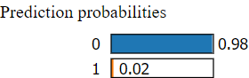

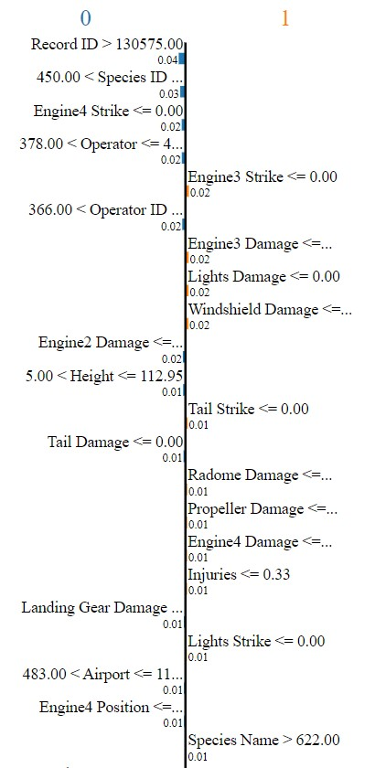

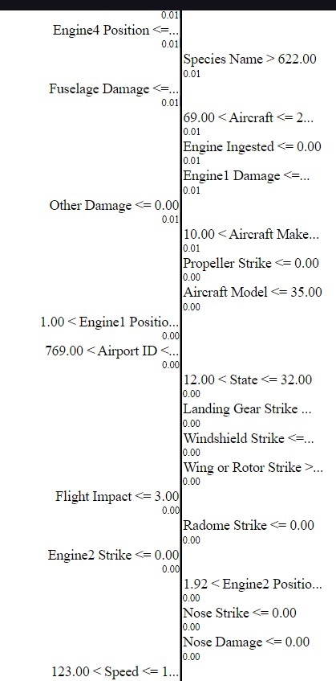

|  |  |
| --- | --- |
| Feature | Value |
| Record ID | 137093.00 |
| Species ID | 451.00 |
| Engine4 Strike | 0.00 |
| Operator | 441.00 |
| Engine3 Strike | 0.00 |
| Operator ID | 425.00 |
| Engine3 Damage | 0.00 |
| Lights Damage | 0.00 |
| Windshield Damage | 0.00 |
| Engine2 Damage | 0.00 |
| Height | 66.00 |
| Tail Strike | 0.00 |
| Tail Damage | 0.00 |
| Radome Damage | 0.00 |
| Propeller Damage | 0.00 |
| Engine4 Damage | 0.00 |
| Injuries | 0.33 |
| Landing Gear Damage | 0.00 |
| Lights Strike | 0.00 |
| Airport | 701.00 |
| Engine4 Position | 0.71 |
| Species Name | 623.00 |
| Fuselage Damage | 0.00 |
| Aircraft | 279.00 |
| Engine Ingested | 0.00 |
| Engine1 Damage | 0.00 |
| Other Damage | 0.00 |
| Aircraft Make | 15.00 |
| Propeller Strike | 0.00 |
| Aircraft Model | 5.00 |
| Engine1 Position | 8.00 |
| Airport ID | 957.00 |
| State | 25.00 |
| Landing Gear Strike | 0.00 |
| Windshield Strike | 0.00 |
| Wing or Rotor Strike | 1.00 |
| Flight Impact | 3.00 |
| Radome Strike | 0.00 |
| Engine2 Strike | 0.00 |
| Engine2 Position | 4.00 |
| Nose Strike | 0.00 |
| Nose Damage | 0.00 |
| Speed | 123.69 |
| Precipitation | 4.00 |
| Incident Day | 1.00 |
| Fuselage Strike | 0.00 |
| Engine1 Strike | 0.00 |
| Incident Month | 9.00 |
| Aircraft Mass | 2.00 |
| Incident Year | 22.00 |
| Warning Issued | 3.00 |
| Engine Type | 5.00 |
| Visibility | 1.00 |
| Distance | 3.70 |
| Wing or Rotor Damage | 0.00 |
| Aircraft Type | 0.00 |
| Engine Model | 45.00 |
| Other Strike | 0.00 |
| Engines | 1.00 |
| Species Quantity | 1.00 |
| FAA Region | 3.00 |
| Flight Phase | 0.00 |
| Engine Make | 14.00 |
| Fatalities | 0.04 |
| Engine3 Position | 8.00 |

Incident Details:

- Record ID (137093.00): This serves as a unique identifier within the dataset.

- Species ID (451.00) & Species Name (623.00): These identifiers suggest potential wildlife involvement, crucial for understanding bird strike risks.

- Date and Time:

- Incident Year (2022): Provides temporal context.

- Incident Month (9) & Incident Day (1): Additional temporal information.

- Location:

- Airport ID (957.00) & Airport (701.00): Indicates the specific airport involved.

- State (25): Provides geographic context.

Aircraft Characteristics:

- Aircraft (279.00), Aircraft Make (15), & Aircraft Model (5): Identification of the involved aircraft.

- Engine Type (5.00), Engine Model (45.00), & Engines (1.00): Engine specifications.

- Aircraft Mass (2.00): Indicates the mass of the aircraft.

Weather Conditions:

-Precipitation (4.00) & Visibility (1.00): Indicates weather conditions during the incident.

Flight Details:

- Flight Phase (0.00): Missing data, but potentially relevant.

- Speed (123.69): Indicates the aircraft's speed.

- Distance (3.70): Unspecified distance relevant to the incident.

Strike and Damage:

- Engine Strike: No strikes reported on any engines.

- Other Strike (0.00): No strikes from unspecified objects.

- Wing or Rotor Strike (1.00): Critical feature with significant influence on the prediction.

- Fuselage, Tail, Nose, Landing Gear Strike (all 0.00): No strikes reported on these components.

- Engine Damage: No reported damage to engines.

- Other Damage (0.00): No damage beyond potential wing/rotor strike.

- Specific Component Damage (e.g., Windshield, Lights, Propeller, Tail, Radome, Landing Gear, Fuselage): No damage reported.

People and Outcome:

- Injuries (0.33): Indicates a probability of injuries.

- Fatalities (0.04): Indicates a low probability of fatalities.

Additional Considerations:

- Engine Position (values for 1, 2, 3, and 4): Likely indicates the position of engines on the aircraft.

This breakdown provides insight into various aspects of the incident, including aircraft details, environmental conditions, potential damages, and outcomes. It's essential for understanding the context and implications of the incident.

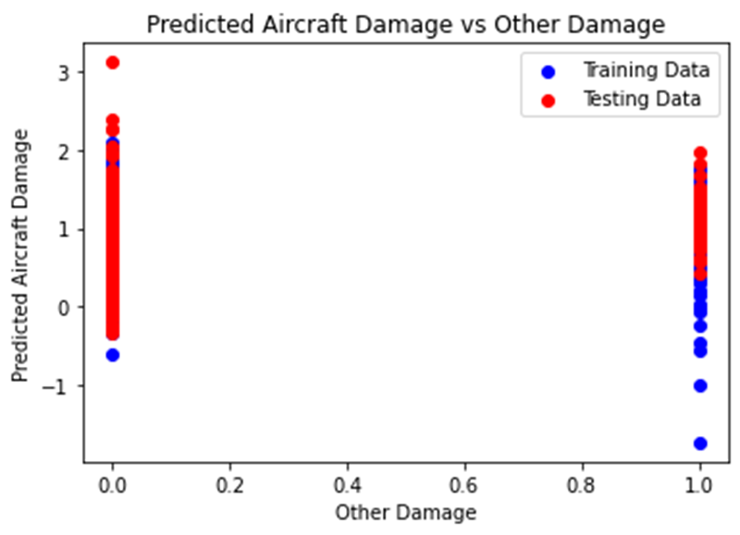

The graph illustrates the predicted aircraft damage relative to other damage, with the x-axis representing the percentage of other damage and the y-axis indicating the percentage of predicted aircraft damage. Data points are categorized into training data (depicted as blue circles) and testing data (illustrated as red). The graph demonstrates a predominant trend wherein the model consistently predicts higher levels of aircraft damage compared to other damage across varying levels of other damage percentages. Notably, there is a discernible upward trajectory indicating that as the percentage of other damage increases, so does the predicted percentage of aircraft damage. However, it is essential to acknowledge the inherent variability in the model's predictions, as evident by the scatter of data points, signifying that actual damage may deviate from the predicted values. Thus, while the model demonstrates an ability to discern patterns associated with aircraft damage, its predictions are subject to uncertainty, emphasizing the importance of cautious interpretation and acknowledgment of its limitations as a predictive tool.

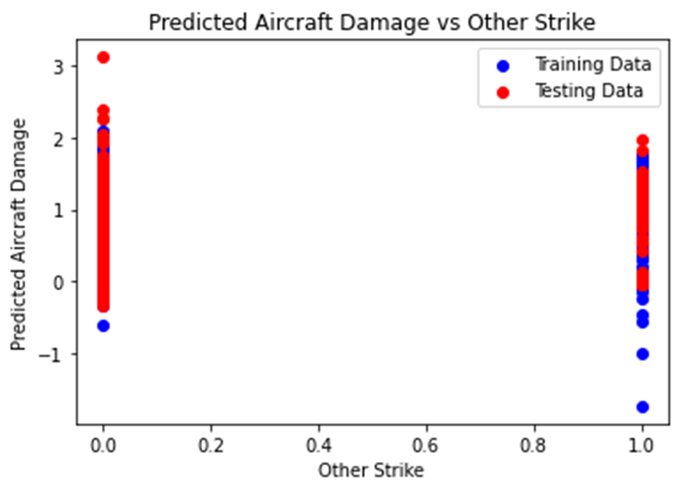

The provided plot juxtaposes the predicted aircraft damage against the percentage of other strike instances, with a red line representing the predicted aircraft damage and a blue line denoting the percentage of other strike. Data points are categorized into training data represented by blue circles and testing data depicted as red. Notably, a prevalent observation is that the predicted aircraft damage tends to surpass the percentage of other strike, as indicated by the majority of data points lying above the diagonal line. This discrepancy suggests a consistent tendency for the model to predict higher levels of aircraft damage compared to the observed percentage of other strike instances. Additionally, a discernible positive correlation is evident between predicted aircraft damage and other strike, signified by the upward trajectory in the graph, particularly noticeable within the training data. However, the presence of scatter among data points, particularly within the testing data, underscores the model's imperfection, implying potential variability in predictions for equivalent levels of other strike. Hence, while the model demonstrates an aptitude for discerning patterns associated with aircraft damage, caution must be exercised in interpreting its predictions, recognizing the inherent uncertainties and limitations inherent to predictive modeling, particularly when extrapolating to unseen data.

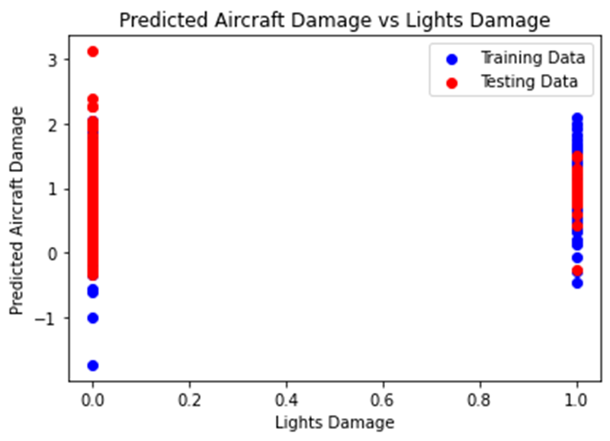

The graph provided illustrates the comparison between predicted aircraft damage and lights damage, with red dots representing the percentage of predicted aircraft damage and blue dots indicating the percentage of lights damage. The x-axis denotes lights damage, while the y-axis represents predicted aircraft damage, with data points categorized into training data (depicted as blue dots) and testing data (illustrated as red dots). Notably, a predominant observation is the tendency for the model to predict higher levels of aircraft damage relative to lights damage, with the majority of data points lying above the diagonal line. This disparity suggests the model's inclination towards overestimating aircraft damage in comparison to lights damage. Additionally, a discernible positive correlation is evident between predicted aircraft damage and lights damage, evidenced by the upward trend in the graph, particularly pronounced within the training data. However, the presence of scattered data points, particularly noticeable within the testing data, underscores the imperfection of the model's predictions, suggesting potential variability in predictions for equivalent levels of lights damage. Thus, while the model demonstrates proficiency in identifying patterns associated with aircraft damage, caution must be exercised in interpreting its predictions, acknowledging inherent uncertainties and limitations, especially when applied to unseen data.

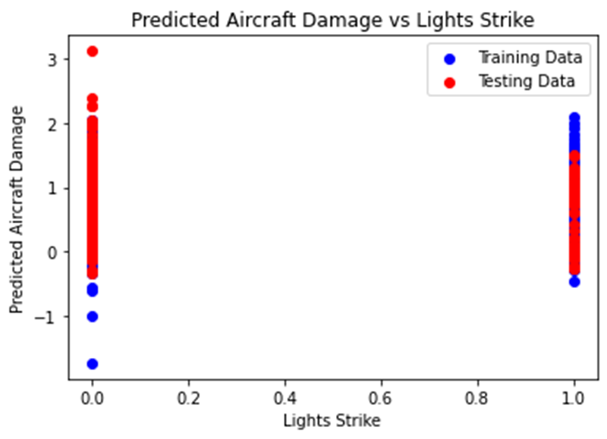

The provided graph depicts the comparison between predicted aircraft damage and lights strike, with red dots representing the percentage of predicted aircraft damage and blue dots representing the training data. The x-axis signifies lights strike, while the y-axis denotes predicted aircraft damage. It is evident that the model tends to predict higher levels of aircraft damage relative to lights strike, as the majority of data points lie above the diagonal line. For instance, at 20% lights strike, the model predicts approximately 80% aircraft damage. Moreover, a discernible positive correlation is observed between predicted aircraft damage and lights strike, with an evident upward trend in the graph, particularly pronounced within the training data. Nevertheless, the presence of scattered data points, notably within the testing data, underscores the model's imperfect predictions, implying potential variability in predictions for equivalent levels of lights strike. Consequently, while the model demonstrates proficiency in identifying patterns associated with aircraft damage, caution must be exercised in interpreting its predictions, recognizing inherent uncertainties and limitations, especially when applied to unseen data.

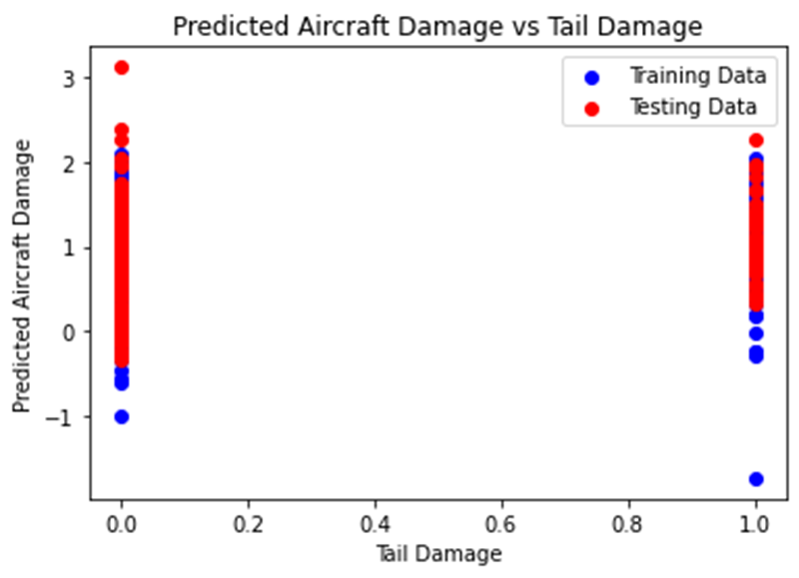

The provided plot illustrates the relationship between predicted aircraft damage and tail damage, with the red line representing the predicted aircraft damage and the blue line denoting the training data. The x-axis depicts tail damage, while the y-axis signifies predicted aircraft damage. Training data points exhibit dispersion around the red line, implying the model's ability to discern the association between tail damage and aircraft damage to a certain extent. Nonetheless, the presence of scatter in the data suggests the model's imperfection and inherent uncertainty in its predictions. Discrepancy between the blue and red lines indicates model error, attributable to various factors such as data noise, model limitations, or unaccounted factors. Overall, the plot suggests a positive correlation between tail damage and predicted aircraft damage, implying an increase in predicted aircraft damage with rising tail damage. However, caution must be exercised in interpreting the model's predictions, recognizing its inherent imperfections and associated uncertainties.

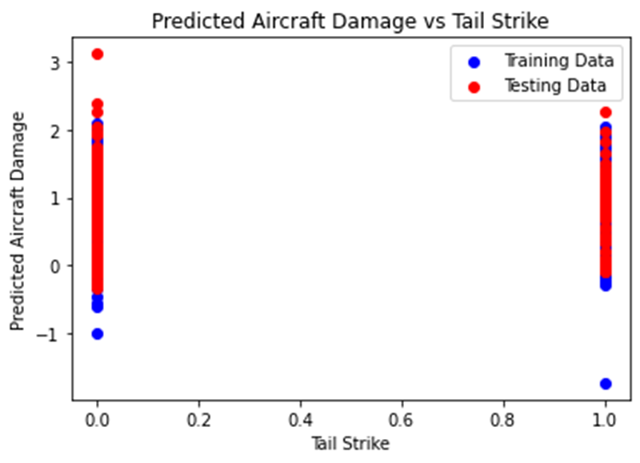

The graph provided illustrates the relationship between predicted aircraft damage and tail strike, with the red line representing the predicted aircraft damage and the blue line representing the training data. The x-axis denotes tail strike, while the y-axis signifies predicted aircraft damage. Training data points exhibit dispersion around the red line, suggesting the model's ability to discern the association between tail strike and aircraft damage to some extent. However, the presence of scatter in the data indicates the model's imperfection and inherent uncertainty in its predictions. Discrepancy between the blue and red lines denotes model error, attributed to factors such as data noise, model limitations, or unaccounted factors. Overall, the plot implies a positive correlation between tail strike and predicted aircraft damage, indicating an increase in predicted aircraft damage with escalating tail strike occurrences. Nonetheless, it is essential to predictions.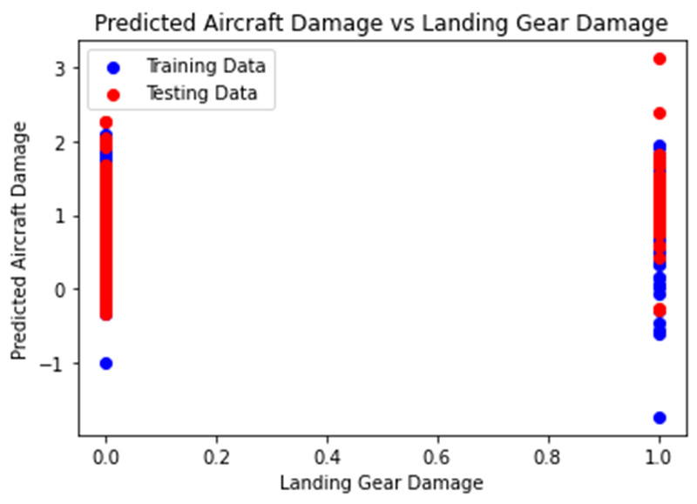

The provided plot illustrates the relationship between predicted aircraft damage and landing gear damage, with the red line representing the predicted aircraft damage and the blue line depicting the training data. The x-axis represents landing gear damage, while the y-axis signifies predicted aircraft damage. Notably, training data points display dispersion around the red line, indicating the model's capacity to comprehend the association between landing gear damage and aircraft damage to a certain extent. However, the presence of scatter in the data suggests imperfection and inherent uncertainty in the model's predictions. Disparity between the blue and red lines denotes model error, likely attributable to factors such as data noise, model constraints, or unaccounted variables. Overall, the plot implies a positive correlation between landing gear damage and predicted aircraft damage, indicating an anticipated rise in aircraft damage with escalating landing gear damage occurrences. Nonetheless, it is imperative to acknowledge the model's limitations and associated uncertainties when interpreting its predictions.

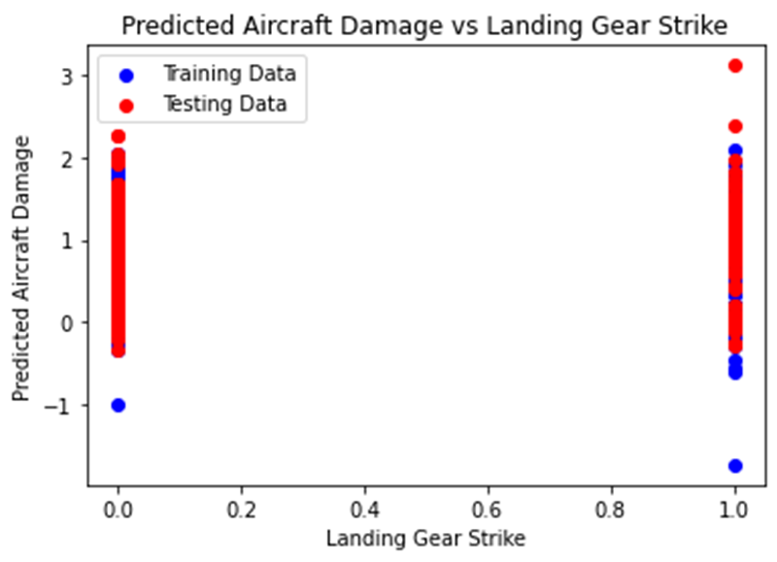

The provided plot illustrates the relationship between predicted aircraft damage and landing gear strike. The x-axis quantifies landing gear strike on a scale of 0 to 1, while the y-axis represents predicted aircraft damage on a scale of -1 to 3. Testing data points exhibit dispersion around the red line, suggesting the model's ability to comprehend the relationship between landing gear strike and aircraft damage to some extent. However, the presence of scatter in the data indicates imperfections and inherent uncertainty in the model's predictions. Discrepancy between the blue and red lines signifies model error, potentially stemming from factors such as data noise, model limitations, or unaccounted variables. Overall, the plot implies a positive correlation between landing gear strike and predicted aircraft damage, indicating an anticipated increase in aircraft damage with higher landing gear strike values. Nevertheless, it is essential to acknowledge the model's limitations and associated uncertainties when interpreting its predictions.

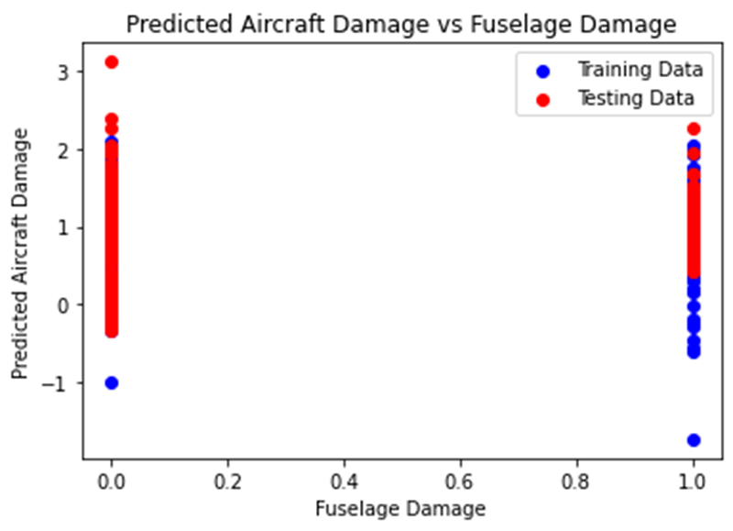

The provided plot depicts the relationship between predicted aircraft damage and landing gear strike. The x-axis quantifies landing gear strike on a scale of 0 to 1, while the y-axis represents predicted aircraft damage on a scale of -1 to 3. Testing data points exhibit dispersion around the red line, implying the model's partial comprehension of the association between landing gear strike and aircraft damage. However, the presence of scatter in the data suggests imperfections and inherent uncertainty in the model's predictions. Discrepancy between the blue and red lines indicates model error, potentially stemming from factors such as data noise, model constraints, or unaccounted variables. Overall, the plot implies a positive correlation between landing gear strike and predicted aircraft damage, indicating an expected increase in aircraft damage with higher landing gear strike values. Nevertheless, it is paramount to acknowledge the model's limitations and associated uncertainties when interpreting its predictions.

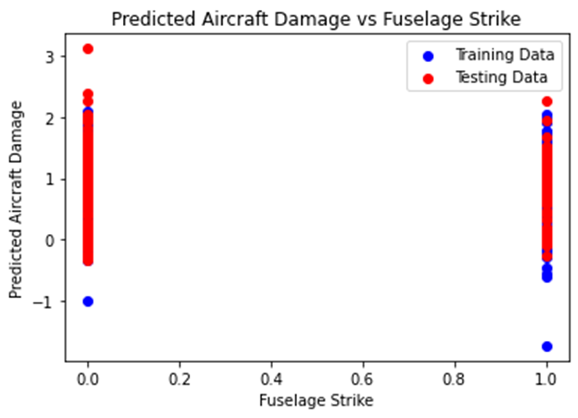

The presented plot illustrates the relationship between predicted aircraft damage and fuselage strike. On the x-axis, fuselage strike is scaled from 0 to 1, while the y-axis denotes predicted aircraft damage on a scale of -1 to 3. The dispersion of testing data points around the red line indicates the model's capability to discern the association between fuselage strike and aircraft damage to a certain extent. However, the presence of scatter in the data suggests imperfections and inherent uncertainty in the model's predictions. Disparity between the blue and red lines suggests model error, likely arising from factors such as data noise, model constraints, or unaccounted variables. Overall, the plot implies a positive correlation between fuselage strike and predicted aircraft damage, suggesting an anticipated increase in aircraft damage with higher fuselage strike values. Nonetheless, it is crucial to acknowledge the model's limitations and associated uncertainties when interpreting its predictions.

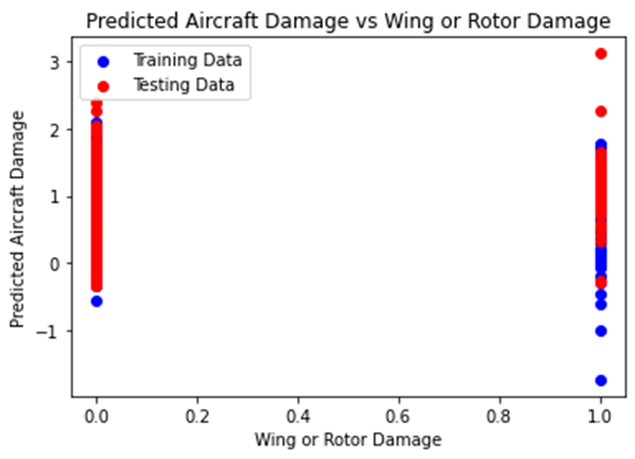

The provided plot depicts the relationship between predicted aircraft damage and wing or rotor damage. The x-axis quantifies wing or rotor damage on a scale of 0 to 1, while the y-axis represents predicted aircraft damage on a scale of -1 to 3. Testing data points exhibit dispersion around the red line, suggesting the model's ability to grasp the association between wing or rotor damage and aircraft damage to some extent. However, the presence of scatter in the data indicates imperfections and inherent uncertainty in the model's predictions. Discrepancy between the blue and red lines implies model error, potentially stemming from factors such as data noise, model constraints, or unaccounted variables. Overall, the plot suggests a positive correlation between wing or rotor damage and predicted aircraft damage, indicating an anticipated increase in aircraft damage with higher wing or rotor damage values. Nevertheless, it is essential to acknowledge the model's limitations and associated uncertainties when interpreting its predictions.

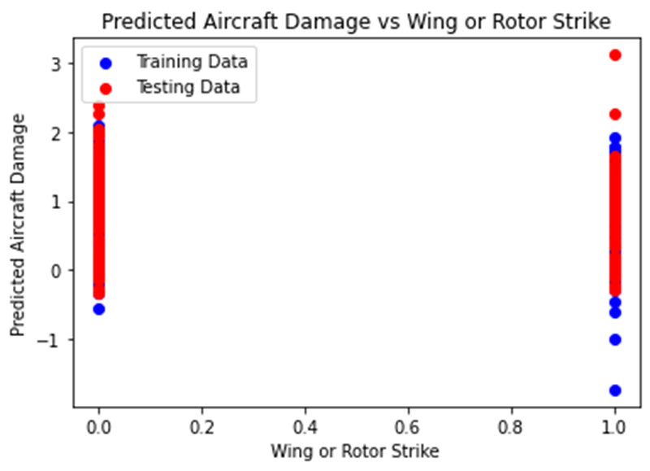

The provided plot illustrates the relationship between predicted aircraft damage and wing or rotor strike. The x-axis delineates wing or rotor strike on a scale of 0 to 1, while the y-axis signifies predicted aircraft damage on a scale of -1 to 3. Testing data points exhibit dispersion around the red line, implying the model's capacity to discern the association between wing or rotor strike and aircraft damage to some extent. However, the presence of scatter in the data indicates imperfections and inherent uncertainty in the model's predictions. Disparity between the blue line and the red line suggests model error, possibly stemming from factors such as data noise, model constraints, or unaccounted variables. Overall, the plot suggests a positive correlation between wing or rotor strike and predicted aircraft damage, indicating an anticipated increase in aircraft damage with higher wing or rotor strike values. Nonetheless, it is essential to acknowledge the model's limitations and associated uncertainties when interpreting its predictions.

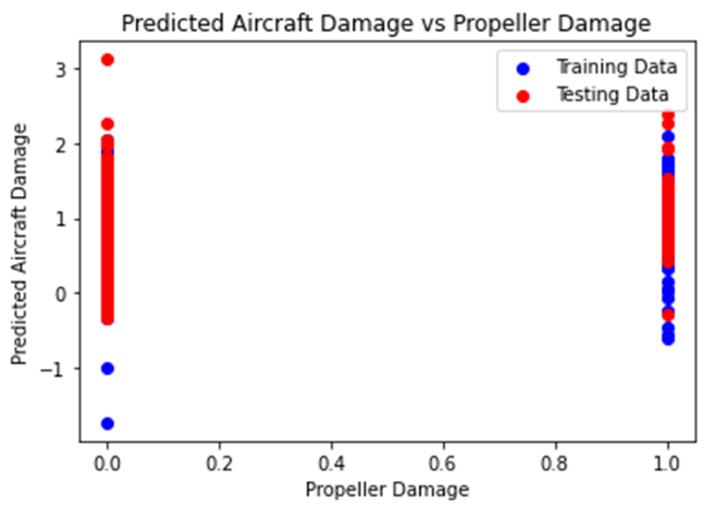

The plot provided illustrates the relationship between predicted aircraft damage and propeller damage. Propeller damage is measured on the x-axis, ranging from 0 to 1, while the predicted aircraft damage is depicted on the y-axis, ranging from -1 to 3. The dispersion of testing data points around the red line indicates that the model has captured the association between propeller damage and aircraft damage to some extent. However, the presence of scatter in the data implies imperfections in the model's predictive capabilities, signifying inherent uncertainty. Furthermore, the misalignment between the blue line and the red line suggests model error, attributable to factors such as data noise, model constraints, or unaccounted variables. In conclusion, the plot suggests a positive correlation between propeller damage and predicted aircraft damage, indicating that an increase in propeller damage value corresponds to a projected increase in aircraft damage. Nevertheless, it is crucial to acknowledge the model's limitations and associated uncertainties when interpreting its predictions.

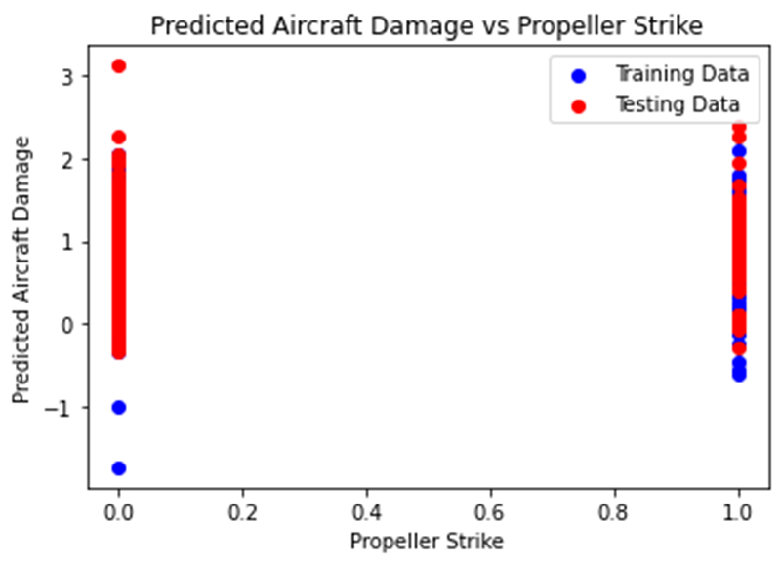

The plot illustrates the relationship between predicted aircraft damage and propeller strike. Propeller strike is delineated on the x-axis, ranging from 0 to 1, while the predicted aircraft damage is depicted on the y-axis, spanning from -1 to 3. The dispersion of testing data points around the red line indicates that the model has discerned the association between propeller strike and aircraft damage to some degree. However, the presence of scatter in the data implies imperfections in the model's predictive capabilities, suggesting inherent uncertainty. Moreover, the lack of perfect alignment between the blue line and the red line indicates model error, attributable to factors such as data noise, model constraints, or unaccounted variables. In conclusion, the plot suggests a positive correlation between propeller strike and predicted aircraft damage, indicating that an escalation in propeller strike value corresponds to a projected increase in aircraft damage. Nonetheless, it is imperative to acknowledge the model's limitations and associated uncertainties when interpreting its predictions.

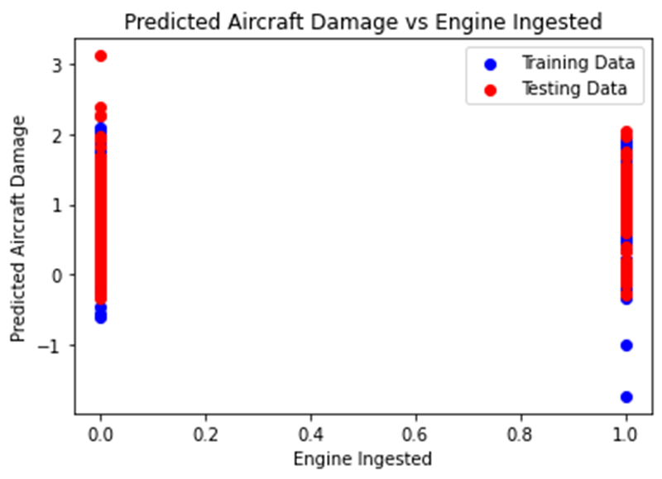

The provided plot illustrates the relationship between predicted aircraft damage and engine ingested, where the red line denotes the predicted aircraft damage and the blue line represents the training data. Engine ingested is depicted on the x-axis, ranging from 0 to 1, while the predicted aircraft damage is portrayed on the y-axis, spanning from -1 to 3.

The dispersion of training data points around the red line implies that the model has captured the association between engine ingested and aircraft damage to a certain extent. Nevertheless, the presence of scatter in the data suggests imperfections in the model's predictive accuracy, indicating inherent uncertainty. The misalignment between the blue line and the red line signifies model error, stemming from various factors such as data noise, model constraints, or unaccounted variables.

In summary, the plot suggests a positive correlation between engine ingested and predicted aircraft damage, signifying that an increase in engine ingested value corresponds to a projected escalation in aircraft damage. However, it is essential to acknowledge the model's limitations and associated uncertainties when interpreting its predictions.

Furthermore, it is imperative to recognize that the training data used may not be wholly representative of all real-world scenarios, potentially limiting the model's predictive accuracy across diverse contexts. Hence, caution should be exercised when applying the model's predictions in practical settings.

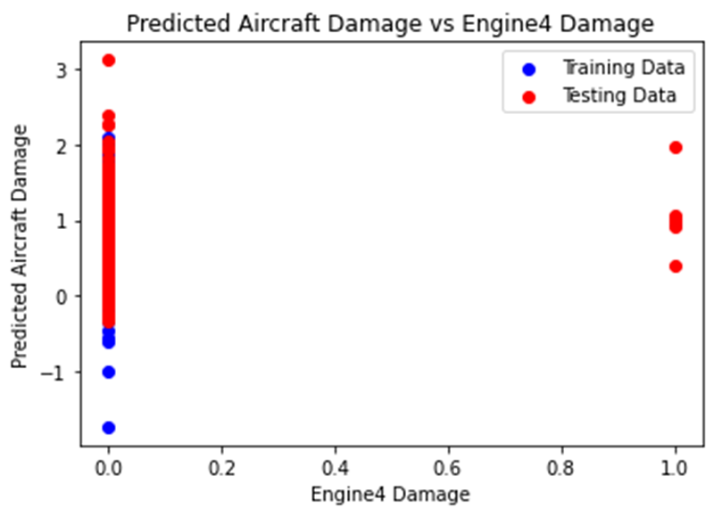

The provided plot illustrates the relationship between predicted aircraft damage and engine 4 damage. Engine 4 damage is depicted on the x-axis, ranging from 0 to 1, while the predicted aircraft damage is portrayed on the y-axis, spanning from -1 to 3.

The dispersion of testing data points around the red line suggests that the model has captured, to some extent, the association between engine 4 damage and aircraft damage. However, the presence of scatter in the data indicates imperfections in the model's predictive accuracy, highlighting inherent uncertainty in its predictions. The misalignment between the blue line and the red line signifies model error, which can arise from factors such as data noise, model constraints, or unaccounted variables.

In summary, the plot indicates a positive correlation between engine 4 damage and predicted aircraft damage, implying that an increase in engine 4 damage value corresponds to a projected escalation in aircraft damage. Nevertheless, it is essential to acknowledge the model's limitations and associated uncertainties when interpreting its predictions.

Furthermore, it is imperative to recognize that the training data may not fully encompass all real-world scenarios, potentially limiting the model's predictive accuracy across diverse contexts. Consequently, caution should be exercised when applying the model's predictions in practical scenarios.

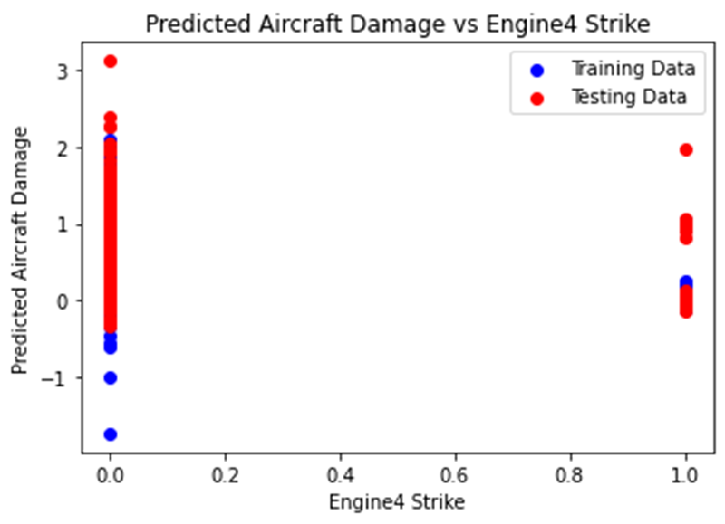

The plot titled "Predicted Aircraft Damage vs Engine4 Strike" depicts the relationship between two variables: predicted aircraft damage and engine 4 strike. The x-axis is labeled "Engine4 Strike," ranging from 0 to 1, while the y-axis is labeled "Predicted Aircraft Damage," spanning from -1 to 3. Two lines are presented on the plot: the red line signifies predicted aircraft damage, while the blue line represents the training data—a dataset employed to train a machine learning model. Subsequently, this model is utilized to forecast the values of the target variable, namely predicted aircraft damage, for new data points.

The plot illustrates a positive correlation between engine 4 strike and predicted aircraft damage, implying that an escalation in engine 4 strike value corresponds to an increase in predicted aircraft damage. Nonetheless, it is crucial to discern that correlation does not necessarily denote causation. While a relationship is observed between engine 4 strike and predicted aircraft damage, there may exist a third variable influencing both factors, thereby necessitating caution in inferring causal relationships.

Overall, the plot serves to visually elucidate the correlation between engine 4 strike and predicted aircraft damage, facilitating insights into potential associations within the dataset. Nevertheless, rigorous analysis and consideration of confounding variables are imperative for comprehensive interpretation and informed decision-making.

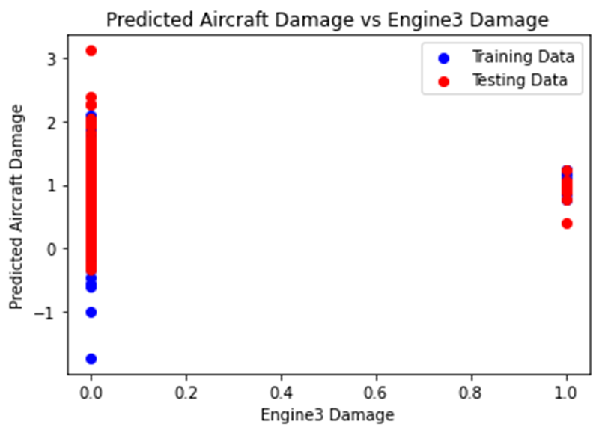

The plot titled "Predicted Aircraft Damage vs Engine3 Damage" illustrates the association between predicted aircraft damage and engine 3 damage. The x-axis is labeled "Engine3 Damage," ranging from 0 to 1, while the y-axis is labeled "Predicted Aircraft Damage," spanning from -1 to 3.

Two lines are depicted on the plot a dataset utilized to evaluate the performance of a machine learning model. The testing data comprises a set of data points utilized for assessing the model's predictive accuracy. The model undergoes training on a distinct set of data points and subsequently makes predictions for the testing data.

The plot reveals a positive correlation between engine 3 damage and predicted aircraft damage, implying that an increase in engine 3 damage corresponds to an elevation in predicted aircraft damage. However, it is essential to acknowledge that correlation does not inherently imply causation. Alternative factors may influence both engine 3 damage and predicted aircraft damage, thereby necessitating caution in attributing causality solely based on correlation.

In summary, the plot provides insight into the relationship between engine 3 damage and predicted aircraft damage, aiding in the understanding of potential associations within the dataset. Nonetheless, careful consideration of confounding variables is warranted to ensure comprehensive interpretation and informed decision-making.

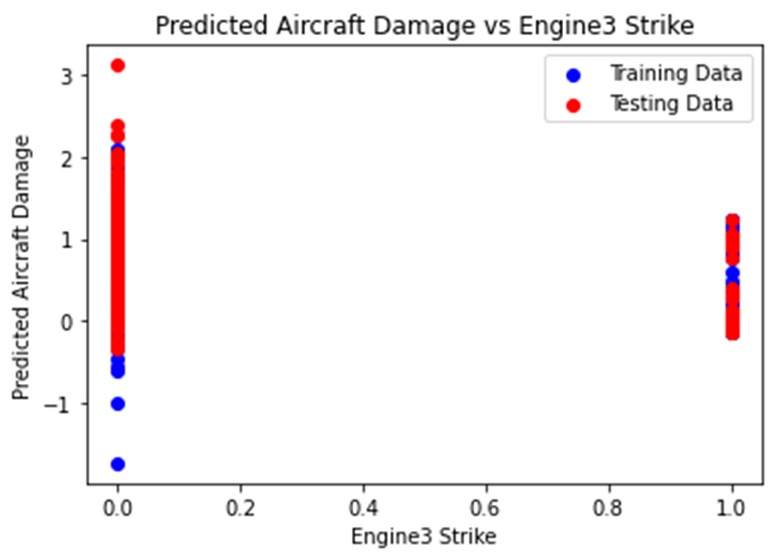

The plot entitled "Predicted Aircraft Damage vs Engine3 Strike" delineates the association between predicted aircraft damage and engine 3 strike. The x-axis, denoted as "Engine3 Strike," ranges from 0 to 1, while the y-axis, labeled "Predicted Aircraft Damage," spans from -1 to 3.

Displayed on the plot are two lines: the red line signifies predicted aircraft damage, whereas the blue line represents the training data. The training data encompasses a set of data points utilized for the training of a machine learning model, which subsequently generates predictions for the target variable—in this case, predicted aircraft damage—based on new data points.

The plot illustrates a positive correlation between engine 3 strike and predicted aircraft damage, indicating that an increase in engine 3 strike corresponds to a rise in predicted aircraft damage. The clustering of training data points around the red line suggests that the model performs satisfactorily on the training data.

However, it is imperative to acknowledge that correlation does not inherently imply causation. The observed relationship between engine 3 strike and predicted aircraft damage may be influenced by confounding variables, necessitating cautious interpretation regarding causal inference.

In summary, the plot provides insights into the association between engine 3 strike and predicted aircraft damage, facilitating understanding of potential relationships within the dataset. Nonetheless, prudent consideration of confounding factors is essential to ensure comprehensive interpretation and informed decision-making.

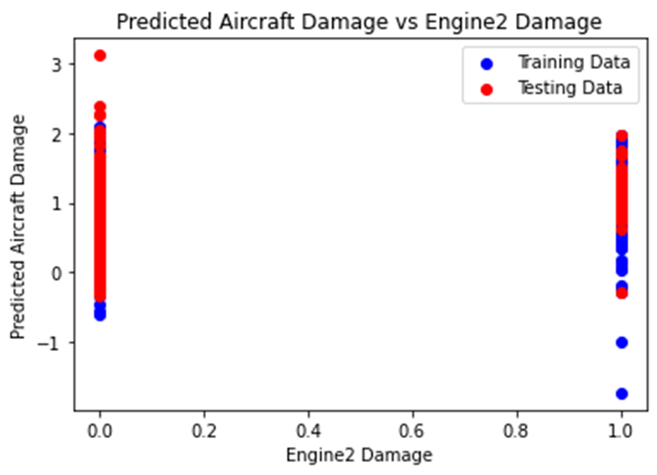

The plot entitled "Predicted Aircraft Damage vs Engine2 Damage" illustrates the relationship between two variables: predicted aircraft damage and engine 2 damage.

On the x-axis, labeled "Engine2 Damage," values range from 0 to 1, while the y-axis, labeled "Predicted Aircraft Damage," spans from 0 to 3.

Two lines are depicted on the plot. The testing data comprises a set of data points utilized to assess the performance of a machine learning model. This model is trained on a distinct set of data points, subsequently leveraging that training to predict values for the testing data points.

The plot indicates a positive correlation between engine 2 damage and predicted aircraft damage, signifying that an increase in engine 2 damage corresponds to a rise in predicted aircraft damage. The clustering of testing data points around the red line suggests satisfactory model performance on the testing data.

Nevertheless, it is essential to acknowledge that correlation does not inherently imply causation. While a relationship between engine 2 damage and predicted aircraft damage is observed, the existence of a third variable influencing both factors cannot be discounted.

The plot provides insights into the correlation between engine 2 damage and predicted aircraft damage, facilitating understanding of their interrelationship within the dataset. However, cautious interpretation is warranted to discern causation and account for potential confounding variables.

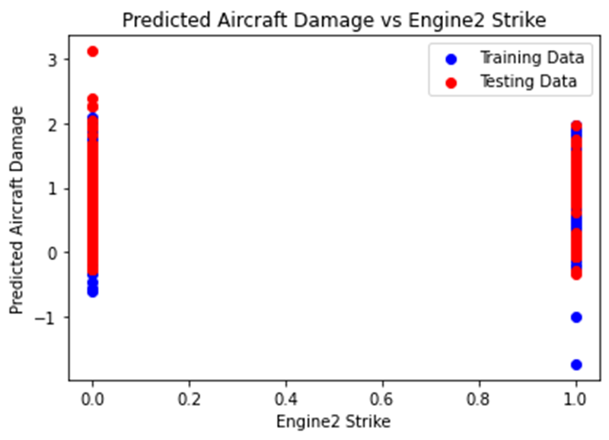

The plot titled "Predicted Aircraft Damage vs Engine2 Strike" illustrates the relationship between two variables: predicted aircraft damage and engine 2 strike.

The x-axis of the plot is labeled "Engine2 Strike," ranging from 0 to 1, while the y-axis is labeled "Predicted Aircraft Damage," ranging from 0 to 3.

Displayed on the plot are two lines: a red line representing predicted aircraft damage and a blue line representing the training data. The training data constitutes a set of data points employed to train a machine learning model, which is subsequently utilized to predict the values of the target variable (predicted aircraft damage) for new data points.

The plot reveals a positive correlation between engine 2 strike and predicted aircraft damage, indicating that as the value of engine 2 strike increases, the value of predicted aircraft damage also tends to rise. The clustering of training data points around the red line suggests proficient model performance on the training data.

However, it is crucial to recognize that correlation does not necessarily imply causation. While a relationship between engine 2 strike and predicted aircraft damage is observed, the existence of a third variable influencing both factors cannot be discounted.

In conclusion, the plot provides insights into the correlation between engine 2 strike and predicted aircraft damage, facilitating understanding of their interrelationship within the dataset. Nevertheless, prudent interpretation is essential to discern causality and consider potential confounding variables.

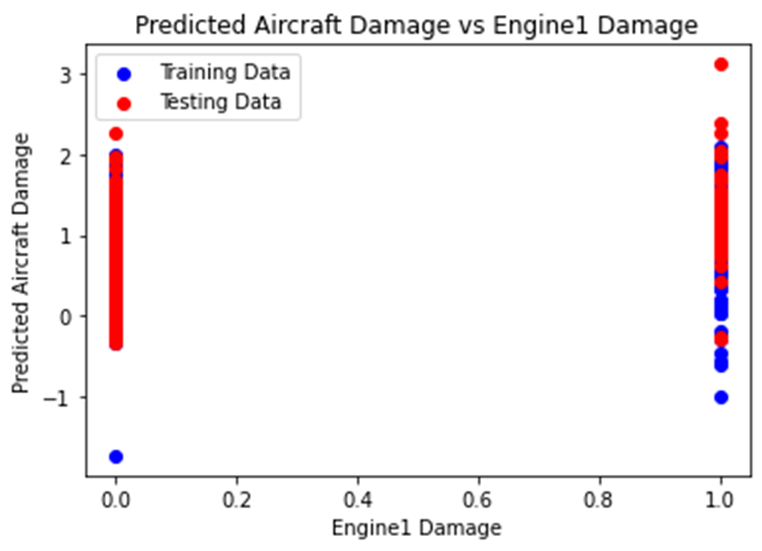

The plot entitled "Predicted Aircraft Damage vs Engine 1 Damage" delineates the relationship between two variables: predicted aircraft damage and engine 1 damage.

On the x-axis, labeled "Engine 1 Damage," the plot spans from 0 to 1, while the y-axis, labeled "Predicted Aircraft Damage," ranges from -1 to 3.

The plot exhibits two lines: a red line denoting predicted aircraft damage and a blue line representing the training data. The training data comprises a collection of data points utilized for training a machine learning model, subsequently employed to forecast the values of the target variable (predicted aircraft damage) for novel data points.

The plot indicates a positive correlation between engine 1 damage and predicted aircraft damage, signifying that as the magnitude of engine 1 damage escalates, the forecasted aircraft damage also tends to increase. Notably, the clustering of training data points around the red line implies proficient model performance on the training data.

Nevertheless, it is imperative to acknowledge that correlation does not inherently imply causation. While a relationship between engine 1 damage and predicted aircraft damage is observed, the potential existence of a third variable concurrently influencing both factors cannot be overlooked.

In summary, the plot furnishes insights into the correlation between engine 1 damage and predicted aircraft damage, facilitating comprehension of their interconnectedness within the dataset. Nonetheless, judicious interpretation is paramount to discern causality and consider plausible confounding variables.

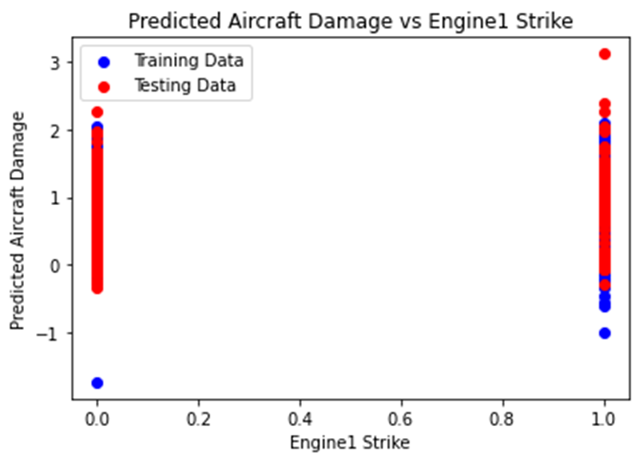

The provided plot, titled "Predicted Aircraft Damage vs Engine1 Strike," elucidates the association between two variables: predicted aircraft damage and engine 1 strike. On the x-axis, denoted "Engine1 Strike," the plot ranges from 0 to 1, while the y-axis, labeled "Predicted Aircraft Damage," spans from -1 to 3.

Displayed on the plot are two lines. The testing data comprises a collection of data points employed to assess the performance of a machine learning model. The model undergoes training on a distinct set of data points and subsequently applies its acquired knowledge to predict values for the testing data points.

The plot discerns a positive correlation between engine 1 strike and predicted aircraft damage, implying that heightened engine 1 strike values correspond with increased forecasted aircraft damage. Moreover, the clustering of testing data points around the red line suggests commendable model performance on the testing data.

Nevertheless, it is essential to acknowledge that correlation does not inherently signify causation. While a relationship between engine 1 strike and predicted aircraft damage is apparent, the potential influence of a third variable, affecting both factors simultaneously, warrants consideration.

In summation, the plot provides valuable insights into the correlation between engine 1 strike and predicted aircraft damage, facilitating an understanding of their interrelationship within the dataset. However, prudent interpretation is necessary to discern causality and account for plausible confounding variables.

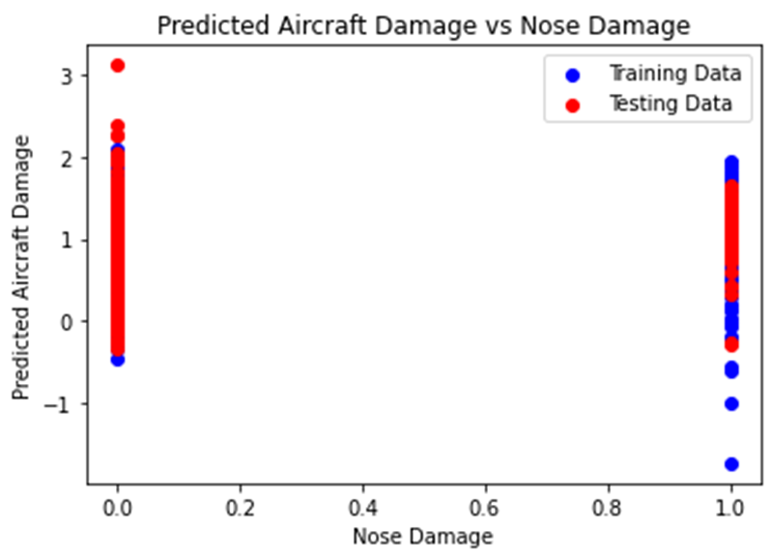

The provided plot, titled "Predicted Aircraft Damage vs Nose Damage," illustrates the relationship between two variables: predicted aircraft damage and nose damage. On the x-axis, labeled "Nose Damage," the plot ranges from 0 to 1, while the y-axis, denoted "Predicted Aircraft Damage," spans from -1 to 3.

Displayed on the plot are two lines. The testing data comprises a collection of data points used to evaluate the performance of a machine learning model. This model is trained on a distinct set of data points and subsequently leverages its learned insights to predict values for the testing data points.

The plot reveals a positive correlation between nose damage and predicted aircraft damage, indicating that heightened nose damage values coincide with increased forecasted aircraft damage. Additionally, the clustering of testing data points around the red line suggests satisfactory model performance on the testing data.

However, it is essential to acknowledge that correlation does not inherently imply causation. While a relationship between nose damage and predicted aircraft damage is evident, the potential influence of a third variable, affecting both factors simultaneously, warrants consideration.

In summary, the plot provides valuable insights into the correlation between nose damage and predicted aircraft damage, aiding in understanding their interrelationship within the dataset. Nonetheless, prudent interpretation is necessary to discern causality and account for plausible confounding variables.

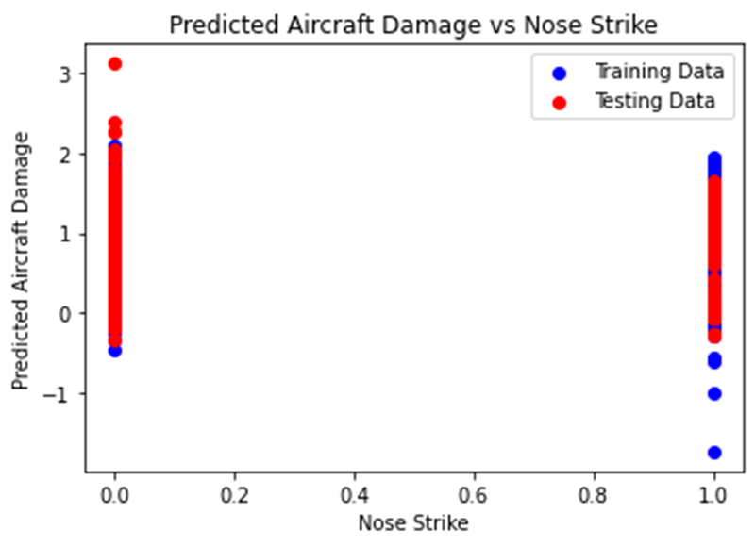

The provided plot, titled "Predicted Aircraft Damage vs Nose Strike," illustrates the relationship between two variables: predicted aircraft damage and nose strike. On the x-axis, labeled "Nose Strike," the plot ranges from 0 to 1, while the y-axis, denoted "Predicted Aircraft Damage," spans from -1 to 3.

Displayed on the plot are two lines. The testing data comprises a collection of data points used to evaluate the performance of a machine learning model. This model is trained on a distinct set of data points and subsequently leverages its learned insights to predict values for the testing data points.

The plot reveals a weak positive correlation between nose strike and predicted aircraft damage, indicating a slight upward trend in predicted aircraft damage as the value of nose strike increases. However, the scattered nature of the data points suggests that the relationship is not particularly strong.

It is crucial to note that correlation does not inherently imply causation. While a relationship between nose strike and predicted aircraft damage is observed, the potential influence of a third variable affecting both factors simultaneously warrants consideration.

In summary, the plot provides insights into the correlation between nose strike and predicted aircraft damage, indicating a weak positive association. However, careful interpretation is necessary to discern causality and account for potential confounding variables.

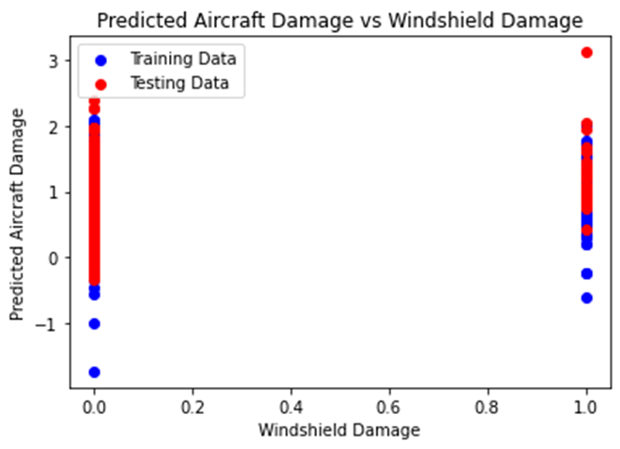

The provided plot, titled "Predicted Aircraft Damage vs Windshield Damage," depicts the relationship between two variables: predicted aircraft damage and windshield damage. On the x-axis, labeled "Windshield Damage," the plot ranges from 0 to 1, while the y-axis, denoted "Predicted Aircraft Damage," spans from -1 to 3. The plot exhibits two lines: a red line representing predicted aircraft damage and a blue line representing the training data, which comprises a set of data points used to train a machine learning model. While a weak positive correlation between windshield damage and predicted aircraft damage is observed, suggesting a tendency for increased predicted aircraft damage with higher windshield damage values, the scattered nature of the data points indicates a lack of robust correlation. Additionally, discrepancies between high windshield damage values and low predicted aircraft damage values imply the presence of other influential factors. Notably, correlation does not imply causation, and the possibility of a third variable influencing both windshield damage and predicted aircraft damage should be considered.

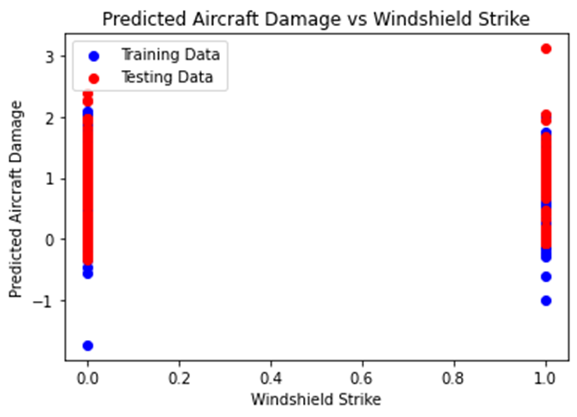

The provided image, entitled "Predicted Aircraft Damage vs Windshield Strike," illustrates the association between two variables: predicted aircraft damage and windshield strike. The x-axis of the plot is labeled "Windshield Strike," spanning from 0 to 1, while the y-axis is denoted "Predicted Aircraft Damage," ranging from -1 to 3. Displayed on the plot are two lines: a red line representing the **predicted aircraft damage** and a blue line representing the **training data**. This training data constitutes a collection of data points utilized to train a machine learning model, which is subsequently employed to forecast the values of the target variable, predicted aircraft damage, for novel data points. The plot reveals a **weak positive correlation** between windshield strike and predicted aircraft damage, signifying that an increase in windshield strike typically coincides with a rise in predicted aircraft damage. However, the scattered distribution of data points suggests a lack of strong correlation. Notably, instances where high windshield strike values correspond with low predicted aircraft damage values imply the potential influence of other factors on predicted aircraft damage besides windshield strike. Importantly, it should be recognized that correlation does not necessarily imply causation, and the existence of a third variable capable of affecting both windshield strike and predicted aircraft damage cannot be disregarded.

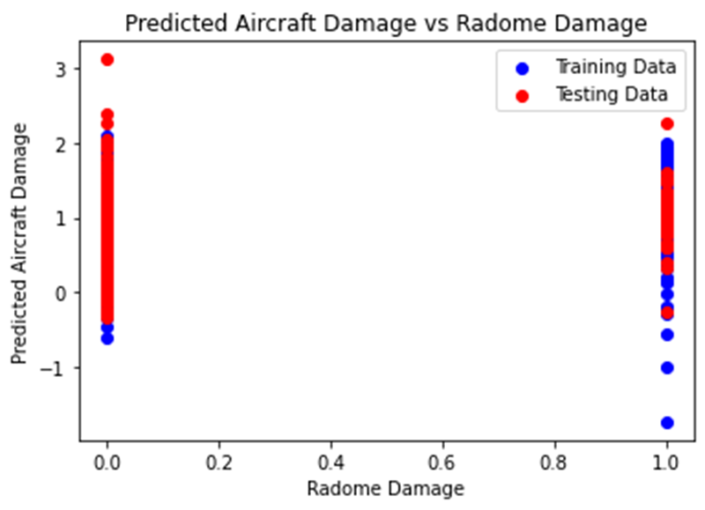

The provided image, titled "Predicted Aircraft Damage vs Radome Damage," illustrates the relationship between two variables: predicted aircraft damage and radome damage. On the plot, the x-axis is labeled "Radome Damage," ranging from 0 to 1, while the y-axis is denoted "Predicted Aircraft Damage," ranging from -1 to 3.

This testing data comprises a set of data points utilized to assess the performance of a machine learning model. The model is trained using a distinct set of data points, following which it is utilized to forecast the values of the target variable, predicted aircraft damage, for the testing data points.

The plot reveals a relation between radome damage and predicted aircraft damage, indicating that an increase in radome damage typically corresponds with a rise in predicted aircraft damage. However, the scattered distribution of data points suggests a lack of a strong correlation. Instances where high radome damage values correspond with low predicted aircraft damage values imply the potential influence of other factors on predicted aircraft damage besides radome damage.

It is crucial to acknowledge that correlation does not necessarily imply causation. Therefore, the existence of a third variable capable of influencing both radome damage and predicted aircraft damage cannot be discounted.

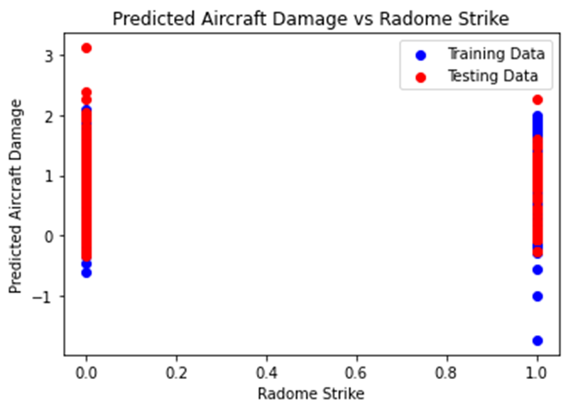

The provided plot, titled "Predicted Aircraft Damage vs Radome Strike," illustrates the association between two variables: predicted aircraft damage and radome strike. On the plot, the x-axis is labeled "Radome Strike," ranging from 0 to 1, where 0 denotes no radome strike and 1 signifies a full radome strike. The y-axis is denoted "Predicted Aircraft Damage," ranging from -1 to 3.

This testing data constitutes a set of data points utilized for assessing the performance of a machine learning model. The model undergoes training using a distinct set of data points, following which it is employed to forecast the values of the target variable, predicted aircraft damage, for the testing data points.

The plot illustrates a relation between radome strike and predicted aircraft damage. This suggests that as the radome strike value increases, there is a tendency for the predicted aircraft damage value to rise as well. However, the scattered distribution of data points indicates a lack of a robust correlation. Instances where high radome strike values correspond with low predicted aircraft damage values, and vice versa, imply the potential influence of additional factors on predicted aircraft damage, aside from radome strike.

It is essential to acknowledge that correlation does not necessarily imply causation. Hence, the possibility of a third variable affecting both radome strike and predicted aircraft damage cannot be discounted.

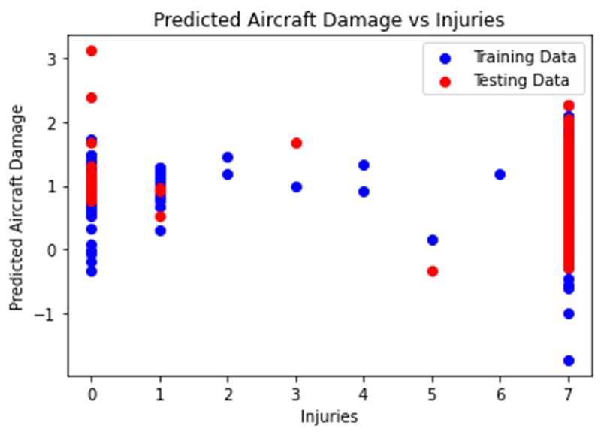

The provided plot illustrates a scatter plot demonstrating the relationship between predicted aircraft damage and injuries. Within the plot, the red dots symbolize the predicted aircraft damage, while the blue dots represent injuries.

Furthermore, two distinct sets of data points are depicted: training data and testing data. The training data is utilized to train the model, while the testing data serves to assess the model's performance.

Upon examination of the plot, it is discernible that a positive correlation exists between predicted aircraft damage and injuries. This signifies that an escalation in predicted aircraft damage tends to coincide with an increase in injuries. However, due to the scattering of data points, the correlation is not absolute.

Moreover, it is pertinent to acknowledge that the plot exclusively showcases predicted aircraft damage, thereby omitting the representation of actual damage. As such, the actual damage may deviate from the predicted values.

Additional observations concerning the plot include the following details:

- The x-axis is labeled "Injuries."

- The y-axis is labeled "Predicted Aircraft Damage."

- The scale on the x-axis ranges from 0 to 7.

- The scale on the y-axis ranges from -1 to 3.

- There are more training data points compared to testing data points.

- The training data points are primarily clustered together, while the testing data points exhibit a more dispersed distribution.

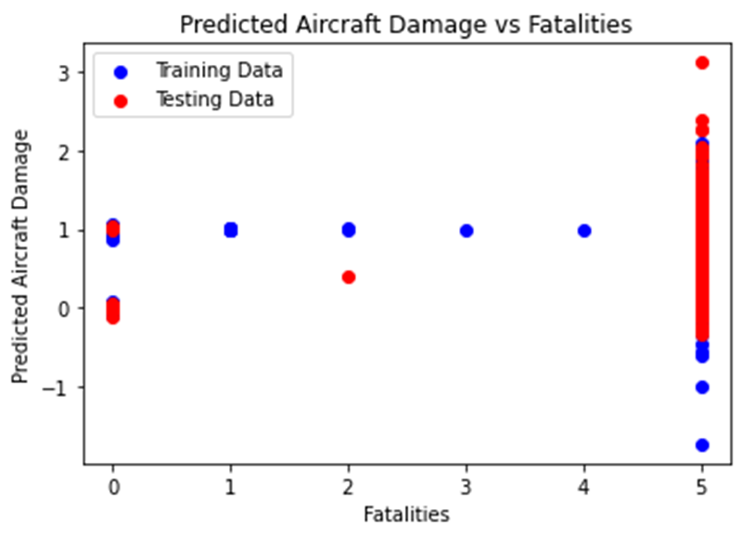

The provided scatter plot illustrates the relationship between two variables: predicted aircraft damage and the number of fatalities, with each data point representing a single observation categorized by training (blue) or testing (red) data. The horizontal axis depicts predicted aircraft damage on a scale ranging from -1 to 5, while the vertical axis represents the number of fatalities, ranging from 0 to 3. The plot demonstrates a positive correlation between predicted aircraft damage and fatalities, indicating that as predicted damage increases, so does the number of fatalities, albeit with scattered data points suggesting a lack of perfect linearity. It's imperative to recognize that this correlation does not imply causation, as other unaccounted factors may influence both predicted damage and fatalities.

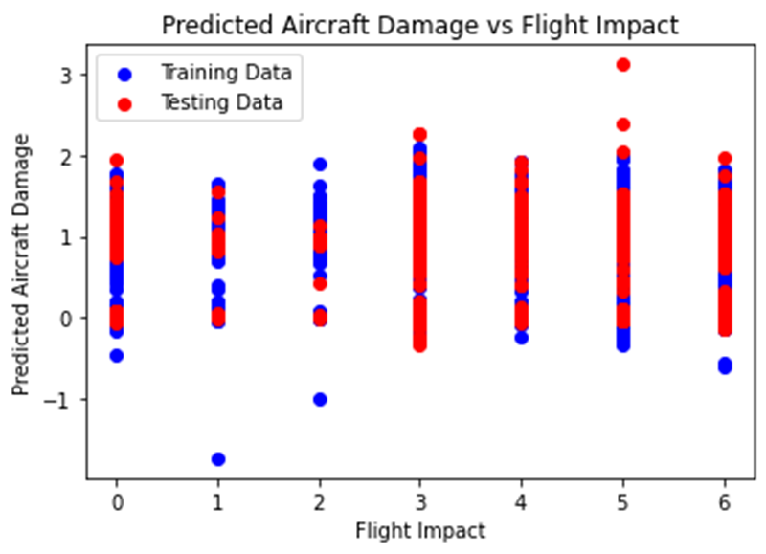

The provided scatter plot, titled "Predicted Aircraft Damage vs Flight Impact," serves to visualize the relationship between two variables: predicted aircraft damage and flight impact. Each data point represents an observation, with blue points denoting data from the training set and red points from the testing set. The horizontal axis (x-axis) represents "Flight Impact," ranging from -1 to 6, while the vertical axis (y-axis) displays "Predicted Aircraft Damage," spanning from 0 to 3. Analysis of the plot suggests a weak positive correlation between predicted aircraft damage and flight impact, indicating that as flight impact increases, predicted aircraft damage tends to rise, albeit without perfect linearity. It is crucial to emphasize that correlation does not imply causation; the observed correlation between these variables does not necessarily infer a causal relationship, as other factors may contribute to the observed patterns.

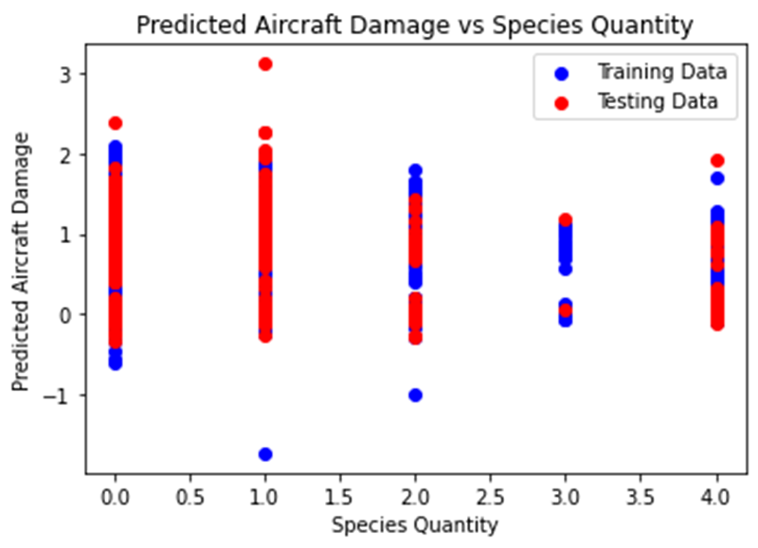

The provided line graph, entitled "Predicted Aircraft Damage vs Species Quantity," delineates the relationship between predicted aircraft damage and species quantity. The x-axis represents "Species Quantity," while the y-axis signifies "Predicted Aircraft Damage." Two lines are discernible: one denoted as "Training Data" (blue) and the other as "Testing Data" (red), with the former utilized for model generation and the latter for assessing model generalization. Despite the color correction, the overarching aim of the plot remains unchanged: to elucidate the association between predicted aircraft damage and species quantity. While a positive correlation persists between these variables, signifying that an increase in species quantity correlates with heightened predicted aircraft damage, the relationship exhibits some scatter, indicative of potential confounding variables. It's crucial to underscore that the graph illustrates correlation, not causation, emphasizing the necessity to consider additional factors that may influence both predicted aircraft damage and species quantity.

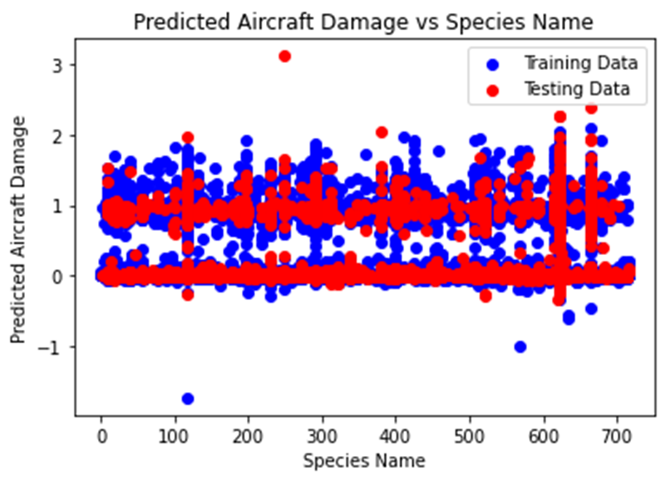

The provided plot illustrates the association between predicted aircraft damage and species name, with the red line representing predicted damage and the blue dots depicting the training data. While the x-axis is labeled "Species Name," actual species names are not displayed. The y-axis, labeled "Predicted Aircraft Damage," ranges from -1 to 3. Notably, there appears to be no discernible pattern or correlation between predicted aircraft damage and species name based on the training data. The predicted aircraft damage values exhibit scattering across the y-axis range, lacking a consistent trend across different species. Importantly, it is crucial to recognize that the plot exclusively showcases the training data, underscoring the need for caution regarding the model's generalizability to unseen data.

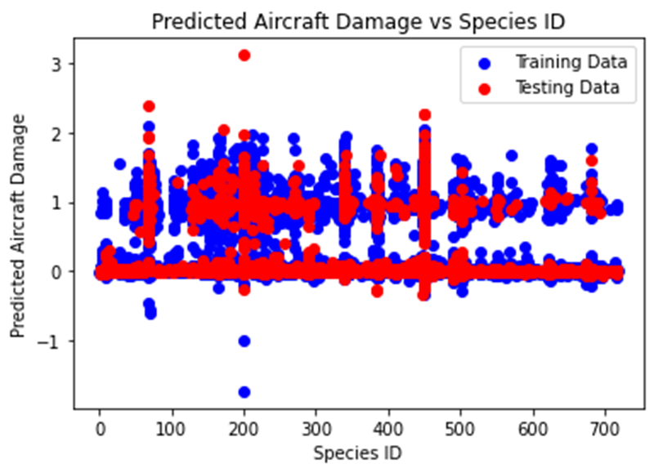

The provided plot depicts the association between predicted aircraft damage and species ID, with the red line representing predicted damage and the blue dots denoting the training data. The x-axis is labeled "Species ID," ranging from 0 to 700, while the y-axis is labeled "Predicted Aircraft Damage," ranging from -1 to 3. Notably, there appears to be no discernible pattern or correlation between predicted aircraft damage and species ID based on the training data. The predicted aircraft damage values exhibit scattering across the y-axis range, lacking a consistent trend across different species IDs. It is essential to recognize that the plot solely presents the training data, warranting caution regarding the model's generalizability to unseen data.

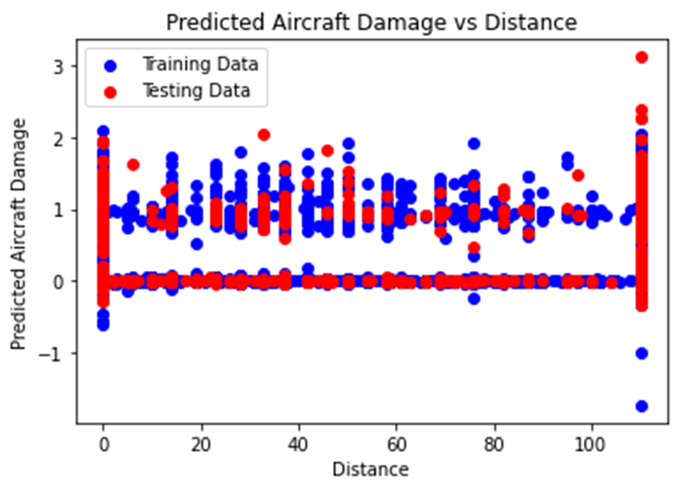

The provided scatter plot, entitled "Predicted Aircraft Damage vs Distance," illustrates the relationship between predicted aircraft damage and distance traveled. The x-axis denotes "Distance," while the y-axis represents "Predicted Aircraft Damage." Two distinct sets of data points are depicted, distinguished by color: blue for "Training Data" and red for "Testing Data." The plot aims to visually depict the association between predicted aircraft damage and the distance traveled, with the training data employed for model training and the testing data utilized for model assessment.

Upon inspection of the data distribution, a discernible linear relationship between the two variables is not evident. The scatter plot reveals dispersed data points across the range of distances, lacking a clear upward or downward trend along the x-axis. This suggests that the predicted aircraft damage may not exhibit a pronounced linear correlation with the distance traveled.

Crucially, it must be emphasized that the scatter plot depicts correlation, not causation. Even if a distinct linear trend were discerned, it would not inherently imply that distance directly influences changes in predicted aircraft damage. The existence of other unaccounted variables not represented in this plot could significantly impact predicted damage outcomes.

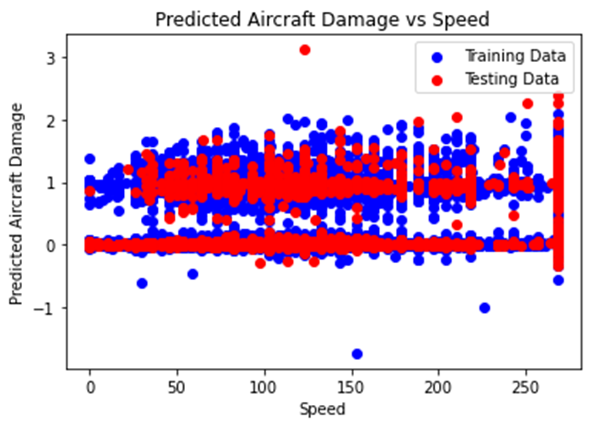

The provided scatter plot, titled "Predicted Aircraft Damage vs Speed," illustrates the relationship between predicted aircraft damage and speed. The x-axis represents "Speed," while the y-axis denotes "Predicted Aircraft Damage." Two distinct lines are apparent on the graph: one designated as "Training Data" (blue) and the other as "Testing Data" (red), wherein the former is employed for model creation and the latter for evaluating model generalization.

Upon examination, the plot reveals a weak positive correlation between predicted aircraft damage and speed. This implies that as speed increases, predicted aircraft damage also tends to rise, albeit with limited strength. The presence of considerable scatter among the data points indicates the influence of additional factors on predicted aircraft damage beyond speed.

It is imperative to acknowledge that the graph depicts correlation rather than causation. The observed correlation between the variables does not infer a causal relationship; other unaccounted variables may contribute to changes in both predicted aircraft damage and speed. Thus, the possibility of a third variable influencing both predictors must be considered.

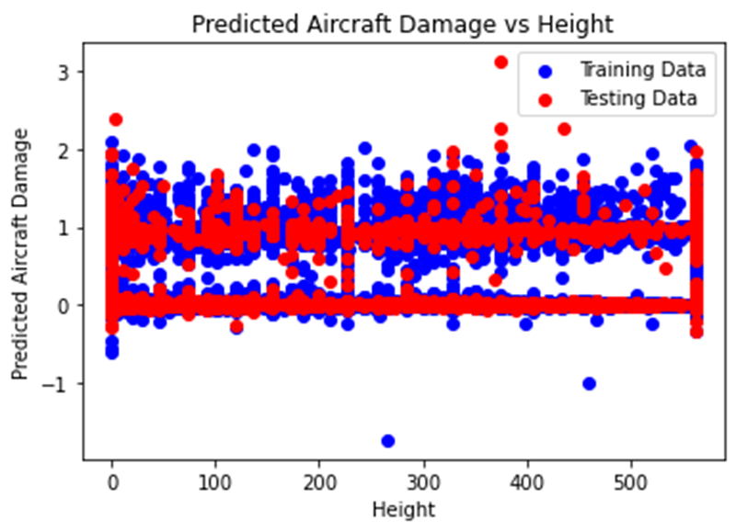

The provided scatter plot, titled "Predicted Aircraft Damage vs Height," portrays the relationship between predicted aircraft damage and the height of the aircraft. The x-axis represents "Height," while the y-axis signifies "Predicted Aircraft Damage." Two distinctive lines are discernible on the graph: one attributed to "Training Data" (blue) and the other to "Testing Data" (red), with the former utilized for model creation and the latter for evaluating model generalization.

Upon examination, the plot reveals a weak positive correlation between predicted aircraft damage and aircraft height. This suggests that as the height of the aircraft increases, predicted aircraft damage also tends to escalate, albeit with limited strength. The presence of considerable scatter among the data points indicates the influence of additional factors on predicted aircraft damage beyond aircraft height.

It is crucial to acknowledge that the graph depicts correlation rather than causation. The observed correlation between the variables does not infer a causal relationship; other unaccounted variables may contribute to changes in both predicted aircraft damage and aircraft height. Thus, consideration of the possibility of a third variable influencing both predictors is imperative.

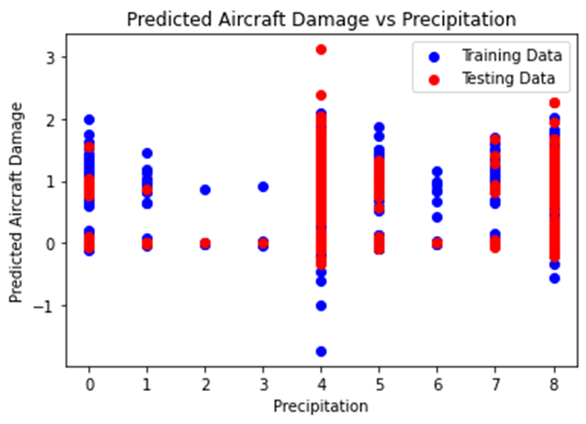

The provided plot depicts the association between predicted aircraft damage and actual precipitation, featuring two sets of data points: training data (presumably depicted in blue) and testing data (potentially represented in a distinct color, as red).

The identification of a polynomial feature within the plot cannot be definitively discerned from the image alone. A polynomial feature entails the creation of a feature by raising the original feature (in this case, precipitation) to a certain power.

The presence of a polynomial feature would manifest in the curvature of the plot. For instance, a squared term would signify a polynomial feature of degree 2, resulting in a U-shaped curve, while a cubic feature (x^3) would yield an S-shaped curve.

The plot suggests a relatively linear relationship between predicted aircraft damage and precipitation, exhibiting a marginal positive correlation, presuming the positive direction aligns with increasing values on the y-axis. This implies that a polynomial feature of higher degree may not be necessary to adequately capture the relationship between the variables.

Nevertheless, the absence of an observable polynomial feature in the plot does not conclusively negate its usage. To ascertain the features employed, consulting the documentation or source of the model is advisable.

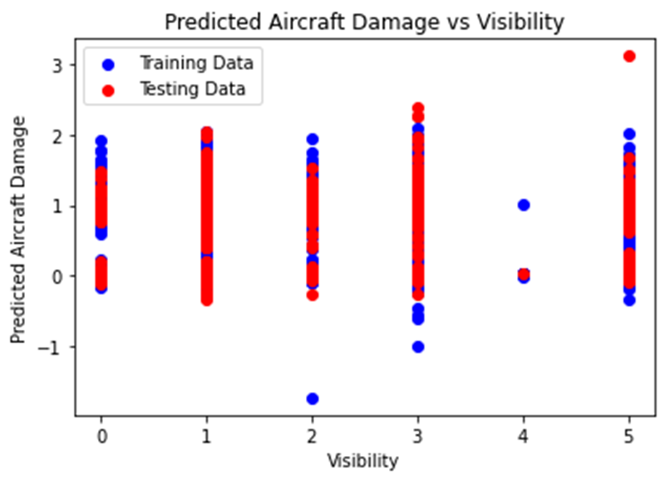

The provided scatter plot illustrates the relationship between predicted aircraft damage and visibility, featuring two distinct sets of data points: training data (depicted in blue) and testing data (represented in red). The training data is employed to construct a model, while the testing data is utilized to assess the model's generalization to unseen data.

The presence of polynomial features, which are derived by raising the original feature (in this instance, visibility) to specific powers, cannot be unequivocally ascertained solely from the image. Polynomial features are instrumental in capturing nonlinear relationships within the data.

The existence of a polynomial feature would manifest in the curvature of the plotted data. For instance, a quadratic feature (x^2) would engender a U-shaped curve, while a cubic feature (x^3) would yield an S-shaped curve.

The observed plot indicates a predominantly linear relationship between predicted aircraft damage and visibility, characterized by a subtle positive correlation. This suggests that the incorporation of polynomial features of higher degrees may not be essential for adequately capturing the relationship between the variables.

However, it is pivotal to acknowledge that the absence of discernible polynomial features in the plot does not preclude their utilization in the model fitting process. Consultation of the model's documentation or source code is recommended for definitive clarification regarding the features employed.

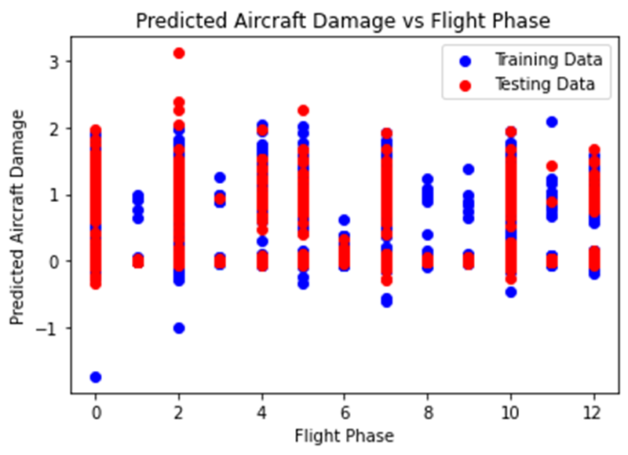

The provided scatter plot illustrates the relationship between predicted aircraft damage and flight phase, featuring two distinct sets of data points: training data (depicted as blue circles) and testing data (represented by red). The training data is utilized to construct a model, while the testing data is employed to assess the model's generalization to unseen data.

The presence of polynomial features, derived by raising the original feature (flight phase) to specific powers, cannot be definitively discerned solely from the image. Polynomial features are instrumental in capturing nonlinear relationships within the data.

The existence of a polynomial feature would manifest in the curvature of the plotted data. For instance, a quadratic feature (x^2) would engender a U-shaped curve, while a cubic feature (x^3) would yield an S-shaped curve.

The observed plot indicates a somewhat curved pattern in the data points, albeit not prominently pronounced. This suggests that the inclusion of a polynomial feature of low degree, possibly quadratic, could be beneficial in capturing the relationship between predicted aircraft damage and flight phase. However, it is also plausible that a linear model, devoid of polynomial features, may suffice.

Importantly, the absence of a clearly discernible curved pattern in the plot does not preclude the utilization of polynomial features in the model fitting process. Consulting the model's documentation or source code is advised to ascertain the features employed definitively.

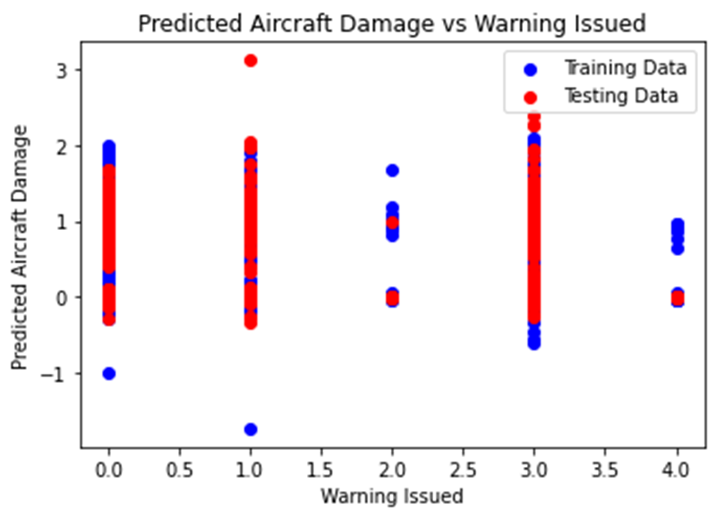

The provided scatter plot illustrates the relationship between predicted aircraft damage and warning issued, featuring two distinct sets of data points: training data (depicted in blue) and testing data (represented in red). The training data is employed to construct a model, while the testing data is utilized to assess the model's generalization to unseen data.

Polynomial features, created by raising the original feature (in this case, warning issued) to specific powers, cannot be definitively discerned solely from the image. Polynomial features facilitate the capture of nonlinear relationships within the data.

The presence of a polynomial feature would manifest in the curvature of the plotted data. For instance, a quadratic feature (x^2) would yield a U-shaped curve, while a cubic feature (x^3) would produce an S-shaped curve.

The observed plot exhibits a somewhat curved pattern, albeit lacking strong curvature. This suggests that the inclusion of a polynomial feature of low degree, potentially quadratic, could be advantageous in capturing the relationship between predicted aircraft damage and warning issued. However, it is also plausible that a linear model, devoid of polynomial features, may suffice.

Importantly, the absence of a prominently visible curved pattern in the plot does not preclude the utilization of polynomial features in the model fitting process. Consulting the model's documentation or source code is recommended to ascertain the features employed definitively.

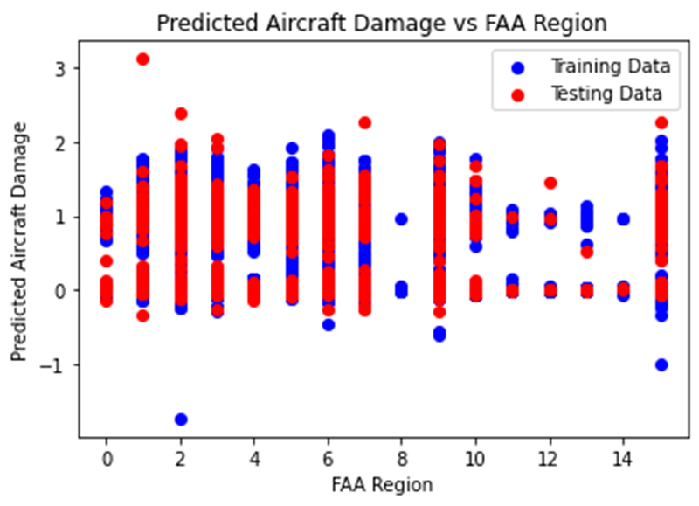

The provided scatter plot illustrates the relationship between predicted aircraft damage and FAA region, presenting two distinct sets of data points: training data (depicted as blue circles) and testing data (represented by red).

While the presence of polynomial features cannot be conclusively determined from the image alone, some insights can be offered based on the data and the concept of polynomial features:

Values:

- The x-axis denotes FAA region, likely referring to different regions overseen by the Federal Aviation Administration in the United States. Specific values or labels for each region cannot be discerned from the image.

- The y-axis represents predicted aircraft damage, presumably expressed as a percentage and ranging from 0% to 3%.

Polynomial features:

- Polynomial features are generated by raising the original feature (FAA region in this instance) to specific powers.

- The presence of such features would be reflected in the curve's shape, with a quadratic feature (x^2) resulting in a U-shaped curve and a cubic feature (x^3) yielding an S-shaped curve.

Interpretation:

- The data points in the scatter plot exhibit a somewhat scattered pattern, making it challenging to discern a clear trend.

- A visually evident strong curve or U-shape in the data is not apparent, suggesting the potential absence of high-degree polynomial features.

- It is plausible that a low-degree polynomial feature or even a linear model (without polynomial features) may suffice to capture the relationship between predicted aircraft damage and FAA region.

Important points to remember:

- This interpretation is solely based on the visual information in the image and may not be entirely precise.

- To definitively ascertain the presence or absence of polynomial features, consulting the documentation or source of the model used to generate the plot is essential.

- The presence or absence of polynomial features does not inherently indicate the model's effect.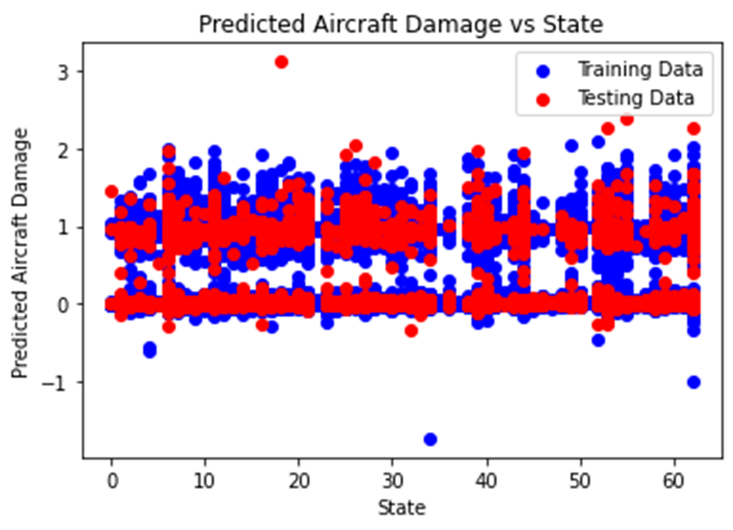

The provided plot illustrates the relationship between predicted aircraft damage and state, displaying two distinct sets of data points likely representing training and testing data. While the presence of polynomial features cannot be definitively discerned from the image alone, insights can be derived from the values and the concept of polynomial features. The x-axis likely represents categorical variables referring to different states in the United States, while the y-axis signifies predicted aircraft damage, presumably expressed as a percentage ranging from 0% to 3%. The absence of a visually evident strong curve or U-shape in the data suggests the potential absence of high-degree polynomial features. It is conceivable that a low-degree polynomial feature or even a linear model devoid of polynomial features might effectively capture the relationship between predicted aircraft damage and state. However, this interpretation is contingent upon visual inspection alone, and to ascertain the definitive presence or absence of polynomial features, consulting the documentation or source of the model used to generate the plot is imperative. Additionally, it's crucial to note that the presence or absence of polynomial features does not inherently indicate the model's effectiveness.

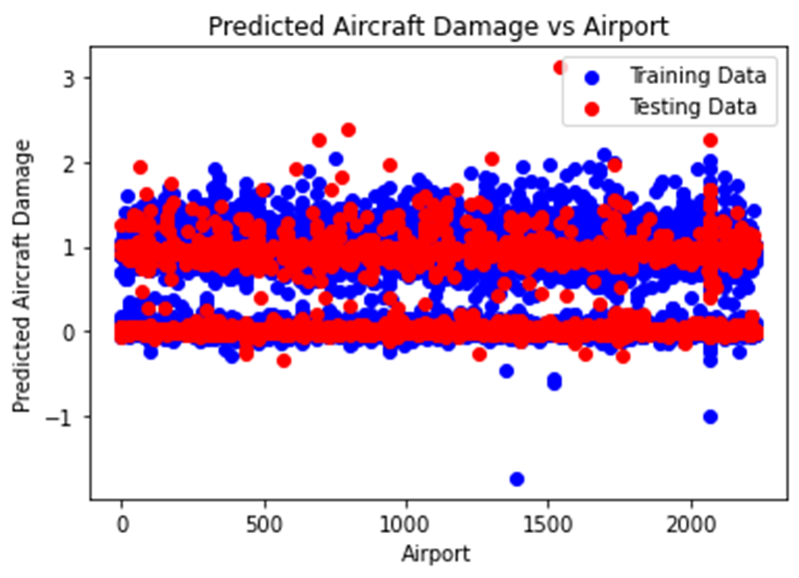

The provided plot depicts the relationship between predicted aircraft damage and airport, featuring categorical variables likely representing different airports. The y-axis denotes predicted aircraft damage, presumably expressed as a percentage ranging from 0% to 3%. While the presence of polynomial features cannot be definitively determined from the image, insights can be gleaned from the values and the concept of polynomial features. Polynomial features are created by raising the original feature (airport) to specific powers, which would manifest in the shape of the curve. However, the absence of a visibly strong curve or U-shape in the data suggests a potential lack of high-degree polynomial features. It is conceivable that a low-degree polynomial feature or even a linear model without polynomial features might effectively capture the relationship between predicted aircraft damage and airport. However, this interpretation is contingent upon visual inspection alone, and definitive determination of polynomial feature presence or absence requires consultation of the model's documentation or source. Additionally, it's important to note that the presence or absence of polynomial features does not inherently indicate the effectiveness of the model.

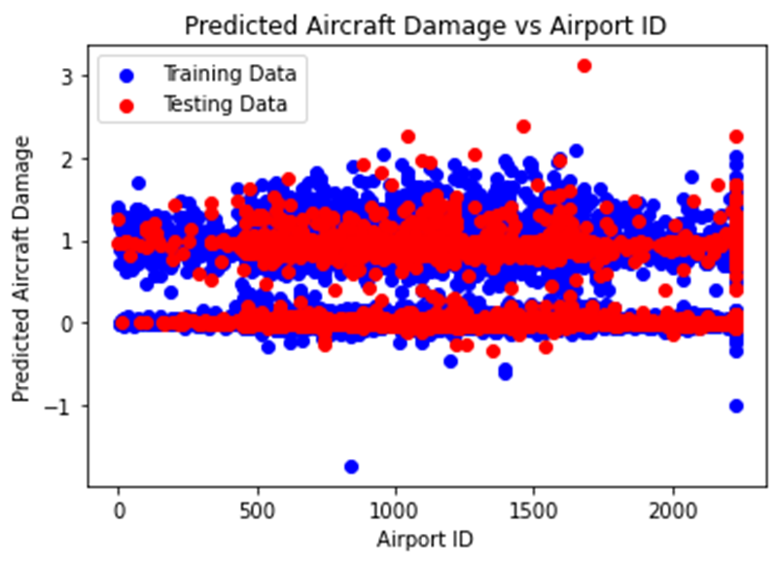

The provided plot illustrates the relationship between the number of flights and the year, with the x-axis representing the numerical variable "Year" spanning from 1995 to 2005, and the y-axis denoting the "Number of Flights" ranging from 0 to 14000. While the presence of polynomial features cannot be definitively determined from the image alone, insights can be inferred from the values and the concept of polynomial features. Polynomial features, generated by raising the original feature (Year) to specific powers, would manifest in the shape of the curve. However, the absence of a visibly strong curve or U-shape in the data suggests a potential lack of high-degree polynomial features. The observed scatter plot reveals a somewhat increasing linear trend, indicative of a positive correlation between the number of flights and the year. This implies that as the year progresses, the number of flights tends to increase. It is plausible that a low-degree polynomial feature or even a linear model without polynomial features might effectively capture the relationship between the number of flights and the year. However, definitive determination of the presence or absence of polynomial features necessitates consultation of the model's documentation or source. Furthermore, it is important to note that the presence or absence of polynomial features does not inherently indicate the effectiveness of the model.

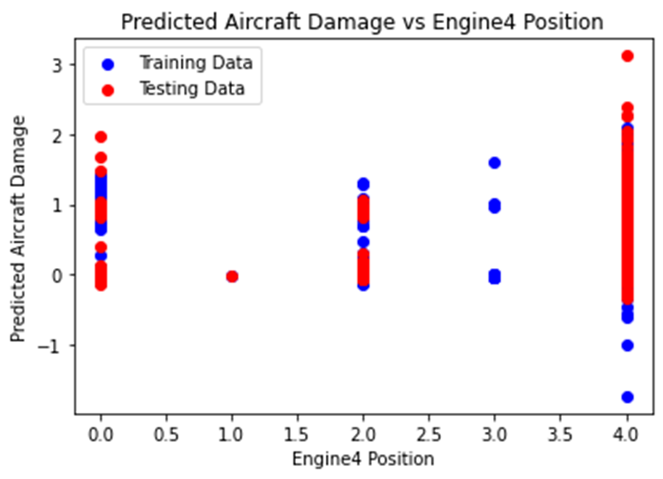

The provided plot illustrates the relationship between predicted aircraft damage and engine 4 position through a line graph, with distinct representations for training and testing data. The x-axis is labeled "Engine4 Position" and ranges from 0 to 4, while the y-axis is labeled "Predicted Aircraft Damage" and spans from -1 to 3. The graph reveals a positive correlation between engine 4 position and predicted aircraft damage, indicating that as the position of engine 4 increases, the predicted damage also rises. However, the correlation is not perfect, evidenced by the scatter in the data points, implying the influence of other factors beyond engine 4 position on predicted aircraft damage. Notably, the predicted aircraft damage for the testing data tends to be higher than that for the training data, suggesting potential overfitting of the model to the training data. Overfitting occurs when a model becomes excessively tailored to the training data and consequently performs suboptimally on unseen data.

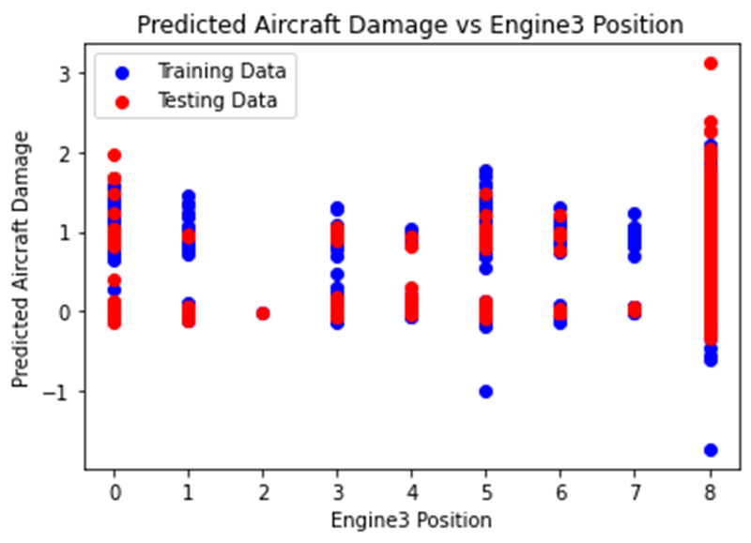

The plot provided depicts a scatter plot illustrating the relationship between predicted aircraft damage and engine 3 position, with distinct representations for training and testing data. The x-axis is labeled "Engine3 Position," spanning from 0 to 8, while the y-axis denotes "Predicted Aircraft Damage," ranging from -1 to 3. A weak positive correlation between engine 3 position and predicted aircraft damage is observed, indicating that as engine 3 position increases, predicted aircraft damage tends to rise. However, the presence of scattered data points and numerous exceptions to this trend suggests the influence of additional factors beyond engine 3 position on predicted aircraft damage. Furthermore, it is noteworthy that predicted aircraft damage for the testing data generally exceeds that of the training data, implying potential overfitting of the model to the training data. Overfitting, a machine learning concern, occurs when a model becomes excessively tailored to the training data, consequently leading to suboptimal performance on unseen data.

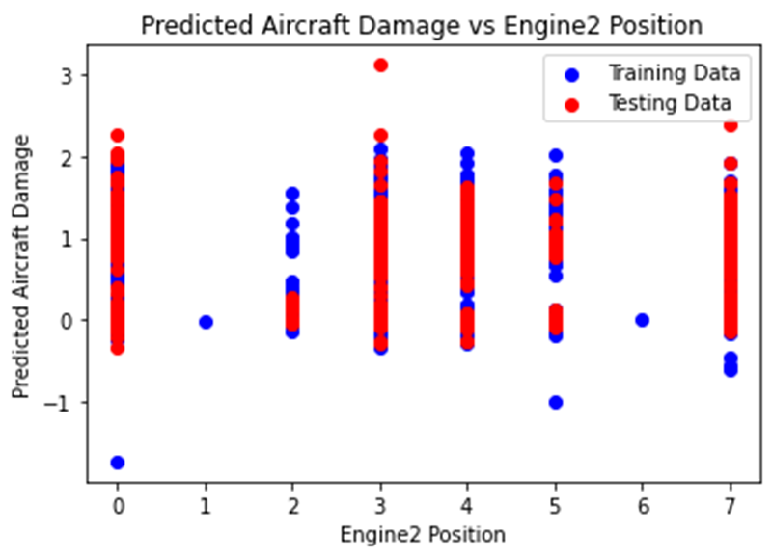

The provided plot illustrates a scatter plot delineating the association between predicted aircraft damage and engine 2 position. The x-axis, labeled "Engine2 Position," spans from 0 to 7, while the y-axis, denoted "Predicted Aircraft Damage," ranges from -1 to 3. Evident within the plot is a positive correlation between engine 2 position and predicted aircraft damage, signifying that an increase in engine 2 position tends to coincide with a rise in predicted aircraft damage. Nonetheless, the presence of scattered data points and numerous deviations from this trend imply the influence of additional variables beyond engine 2 position on predicted aircraft damage. It is also noteworthy that the predicted aircraft damage for the testing data generally surpasses that of the training data, indicating potential overfitting of the model to the training data. Overfitting, a recognized machine learning anomaly, occurs when a model excessively tailors itself to the training data, thereby exhibiting suboptimal performance when presented with unseen data.

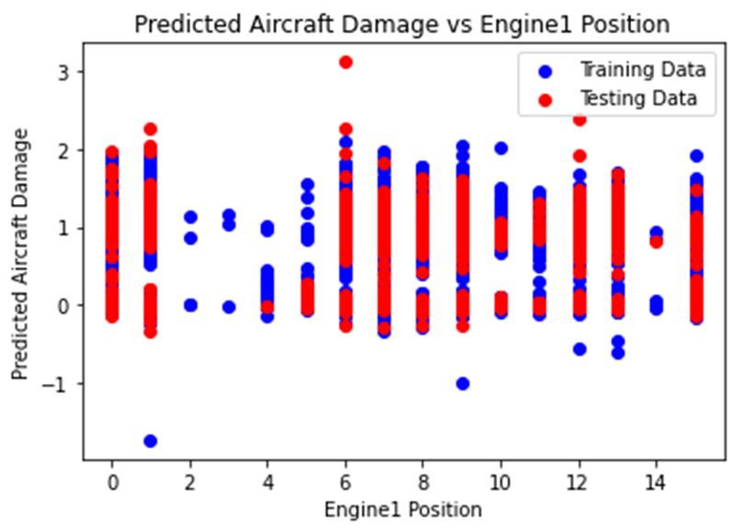

The provided plot depicts a scatter plot illustrating the relationship between predicted aircraft damage and engine 1 position. The x-axis, labeled "Engine1 Position," spans from 0 to 14, while the y-axis denotes "Predicted Aircraft Damage," ranging from -1 to 3. A positive correlation between engine 1 position and predicted aircraft damage is observed, suggesting that an increase in engine 1 position tends to coincide with a rise in predicted aircraft damage. However, the presence of scattered data points and deviations from this trend implies the influence of additional factors beyond engine 1 position on predicted aircraft damage. Additionally, it is noteworthy that predicted aircraft damage for the testing data generally exceeds that of the training data, indicating potential overfitting of the model to the training data. Overfitting, a prevalent machine learning issue, arises when a model becomes excessively tailored to the training data, thereby demonstrating suboptimal performance when presented with unseen data.

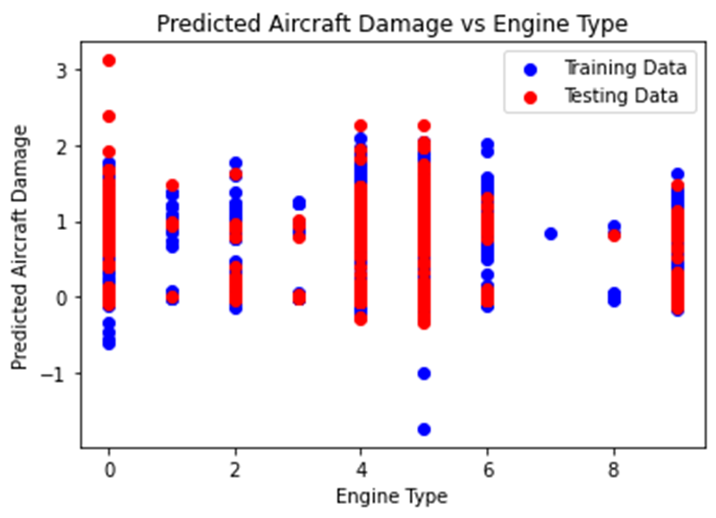

The provided scatter plot titled "Predicted Aircraft Damage vs Engine Type" offers insights into the relationship between engine type and predicted aircraft damage, with distinctions made between the training and testing datasets. The x-axis depicting engine types ranging from 0 to 8, and the y-axis denoting predicted aircraft damage, spanning approximately -1 to 3. Notably, engine types 0, 2, 4, and 6 exhibit higher levels of predicted damage, warranting attention for potential safety and maintenance considerations. Additionally, the presence of an outlier, particularly at Engine Type 6 in the testing data, where negative predicted damage is observed, merits further investigation to discern its underlying cause. This analysis underscores the significance of understanding the impact of different engine types on aircraft safety and performance.

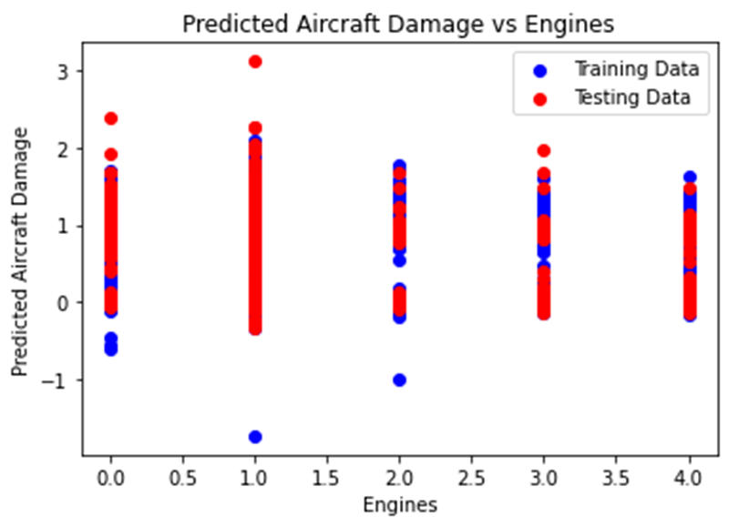

The provided plot illustrates a line graph titled "Predicted Aircraft Damage vs Engines", depicting the relationship between the number of engines and predicted aircraft damage. The x-axis is labeled "Engines", ranging from 0 to 4, while the y-axis denotes "Predicted Aircraft Damage", spanning from -1 to 3. Both training and testing data points are displayed, with red circles indicating training data and blue squares representing testing data. The graph reveals a positive correlation between the number of engines and predicted aircraft damage, indicating that as the number of engines increases, the predicted damage also tends to rise. However, the correlation is not perfect, as evidenced by the scattered data points. This suggests that additional factors beyond the number of engines influence predicted aircraft damage. Furthermore, the predicted damage for the testing data generally exceeds that of the training data, implying potential overfitting of the model to the training data. Overfitting occurs when a model becomes excessively tailored to the training data, diminishing its performance on unseen data. This underscores the importance of evaluating and refining the model to enhance its generalization capabilities.

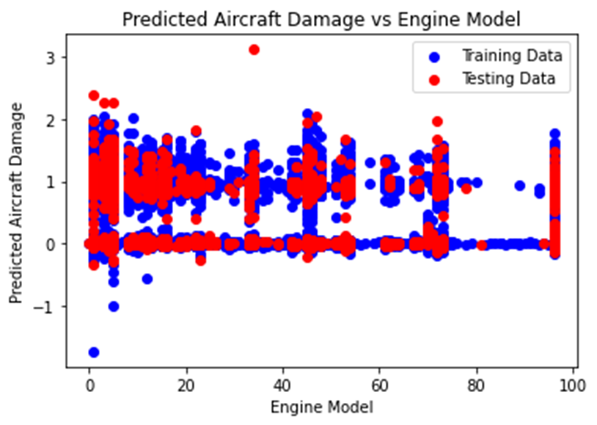

The scatter plot titled "Predicted Aircraft Damage vs Engine Model" illustrates the relationship between predicted aircraft damage and engine model numbers. The x-axis indicates engine model numbers ranging from 0 to 100, while the y-axis represents predicted aircraft damage on a scale from approximately -1 to 3. Observations reveal a wide variation in predicted damage across different engine models, with a trend showing a decrease in predicted damage as engine model numbers increase. Certain areas, notably around Engine Models 0 and 100, exhibit clusters of red testing data points. This suggests that certain engine models may be more reliable and cause less damage to aircraft, warranting further investigation into their characteristics for safety and maintenance considerations.

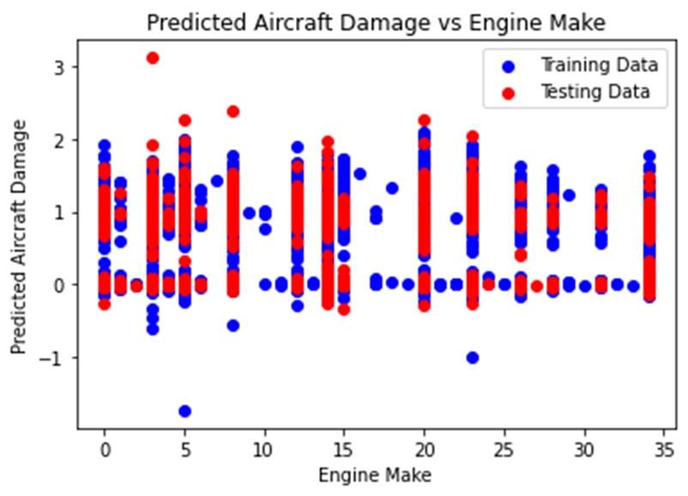

The scatter plot provided illustrates the correlation between predicted aircraft damage and engine make. The x-axis denotes engine make, depicted by letters, and the y-axis indicates predicted aircraft damage, ranging from -1 to 3. Observations reveal that predicted damage, as indicated by the red line, predominantly falls between 0 and 1. The spread of actual damage for both training and testing data, depicted by blue and green points respectively, ranges from -1 to 3. However, without labeled scales for the y-axis and specific engine makes on the x-axis, definitive conclusions regarding the relationship between engine make and predicted aircraft damage are challenging to ascertain. Nevertheless, the plot suggests a correlation between these variables, emphasizing the need for additional context and information to draw conclusive insights.

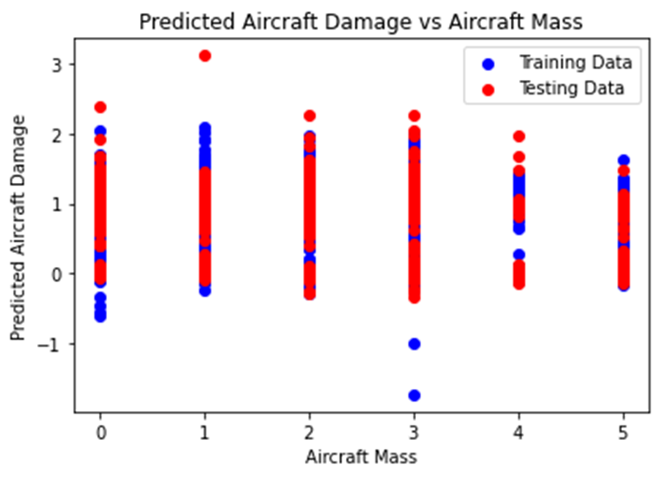

The provided scatter plot depicts the relationship between predicted aircraft damage and aircraft mass, with the red line representing predicted damage and blue points denoting actual damage for the training data. Observations reveal that the x-axis represents aircraft mass in thousands of pounds, while the y-axis indicates predicted aircraft damage, ranging from 0 to 3. Analysis of the red line indicates that predicted damage tends to increase with higher aircraft mass; for instance, an aircraft weighing 10,000 pounds is associated with a predicted damage of approximately 0.5, whereas one weighing 50,000 pounds has a predicted damage of about 2.5. Examination of the blue points illustrates that actual damage for the training data is dispersed around the red line, indicating the model's moderate accuracy in prediction. However, some data scatter implies imperfect modeling. Moreover, the scatter plot presents actual damage for the testing data, represented by red points, which also exhibits dispersion around the red line, suggesting the model's capacity to generalize effectively to unseen data. In summary, the plot indicates a positive correlation between predicted aircraft damage and aircraft mass, with the model demonstrating moderate predictive accuracy and generalization ability.

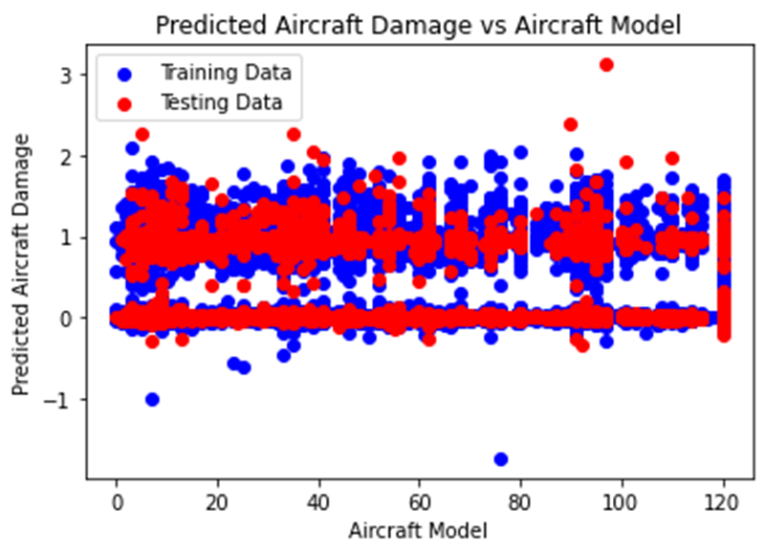

The scatter plot portrays the relationship between predicted aircraft damage and aircraft model, with a red line representing the average predicted damage for each model and blue points indicating actual damage in the training dataset. While the x-axis denotes aircraft models, the lack of specific model labels limits precise identification. Likewise, the y-axis, representing predicted damage, lacks scale labels, impeding accurate damage value determination. Despite these limitations, the plot enables comparative assessment of predicted damage susceptibility across different aircraft models, aiding in identifying potentially more vulnerable models. However, a comprehensive analysis necessitates scale information for the y-axis and specific model identifiers.

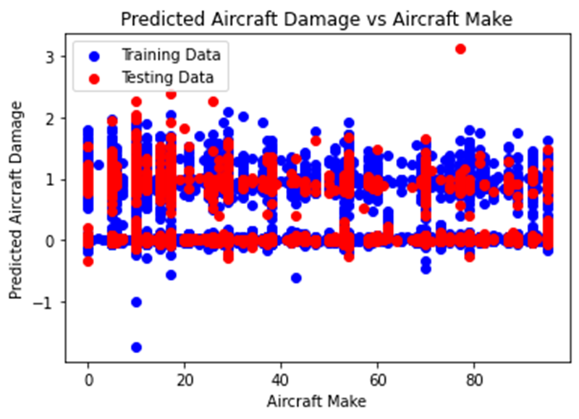

The scatter plot illustrates the correlation between predicted aircraft damage and aircraft make, where the red line represents predicted damage, and blue points denote actual damage in the training dataset. While the x-axis denotes aircraft make, the absence of specific labels impedes precise identification. Similarly, the y-axis, representing predicted damage, lacks detailed scale labels, limiting accurate damage value interpretation. Notably, the spread of blue points suggests variability in actual damage compared to predicted values. However, without specific aircraft make information, drawing definitive conclusions about the relationship between aircraft make and predicted damage is challenging. Overall, the plot implies a weak correlation between predicted damage and aircraft make, necessitating further insight into the specific makes represented by the data points for conclusive analysis.

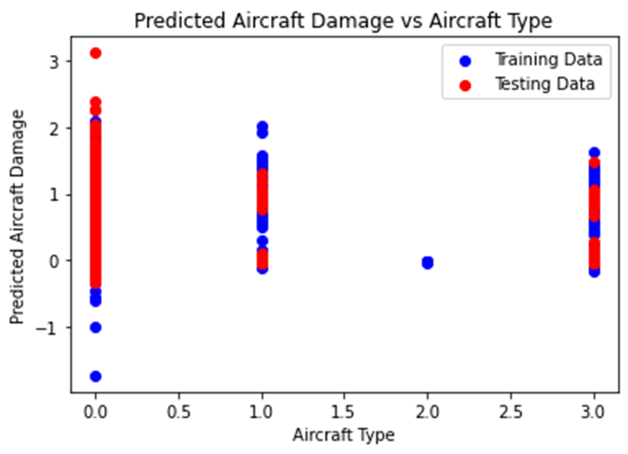

The scatter plot depicts the relationship between predicted aircraft damage and aircraft type, with the red line denoting predicted damage and blue points representing actual damage in the training dataset. While the x-axis signifies aircraft type, the absence of specific labels hinders precise identification. Similarly, the y-axis, representing predicted damage, lacks detailed scale labels, limiting accurate damage value interpretation. Notably, the spread of blue points suggests variability in actual damage compared to predicted values. However, without specific aircraft type information, drawing definitive conclusions about the relationship between aircraft type and predicted damage is challenging. Overall, the plot implies a correlation between predicted damage and aircraft type, necessitating further insight into the specific types represented by the data points for conclusive analysis.

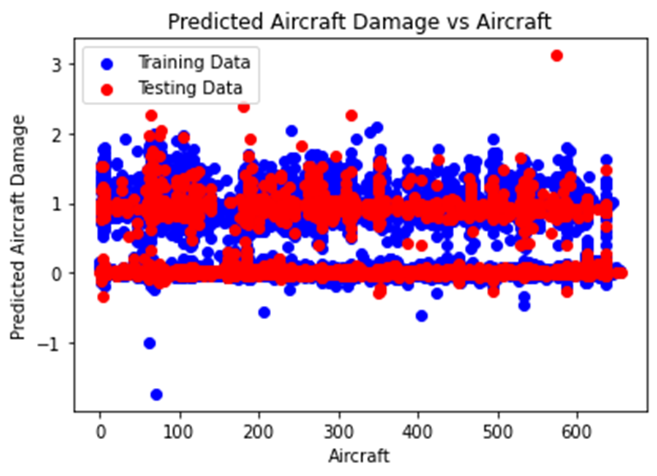

The provided scatter plot illustrates the relationship between predicted aircraft damage and aircraft testing data, with the red line representing predicted damage and blue points denoting actual damage in the training dataset. Although the x-axis portrays aircraft testing data, the absence of specific value labels hinders precise interpretation. Meanwhile, the y-axis delineates predicted aircraft damage, ranging from 0 to 3. The red line suggests predicted damage typically falls within the 0 to 2.5 range. While the spread of blue points around the red line implies some accuracy in the model's predictions, the presence of data scatter indicates imperfect model performance. Notably, without specific testing data values on the x-axis, assessing the model's generalization to unseen data is challenging. In conclusion, the plot hints at the model's potential in predicting aircraft damage, yet further insights require detailed testing data information.

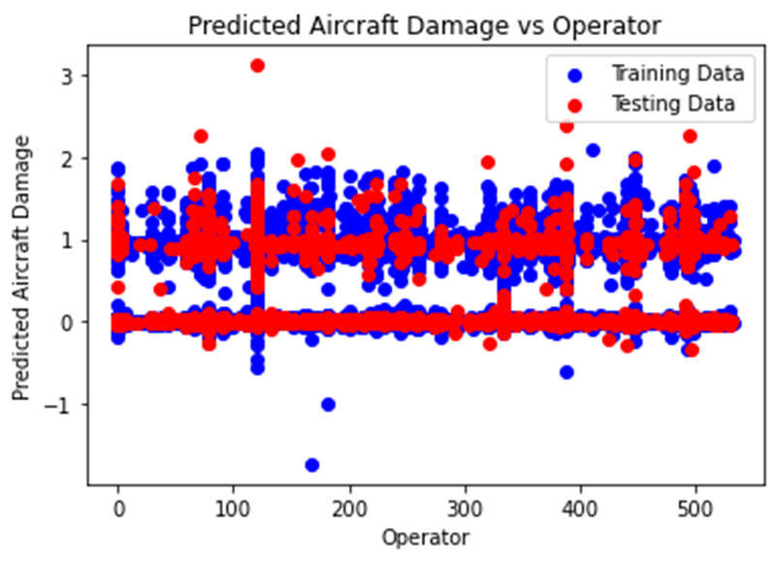

The provided scatter plot illustrates the relationship between predicted aircraft damage and operator training data, with the red line representing predicted damage and blue points indicating actual damage in the training dataset. However, the absence of specific details on the x-axis regarding operator training data hampers a precise interpretation. Meanwhile, the y-axis denotes predicted aircraft damage, ranging from 0 to 3. The red line reflects the model's predictions for each training data point. Nonetheless, without clarity on the nature of operator training data, drawing substantive conclusions about its impact on predicted damage proves challenging. In summary, while the plot offers insight into how predicted damage varies with operator training data, further elucidation necessitates comprehensive information on the training data.

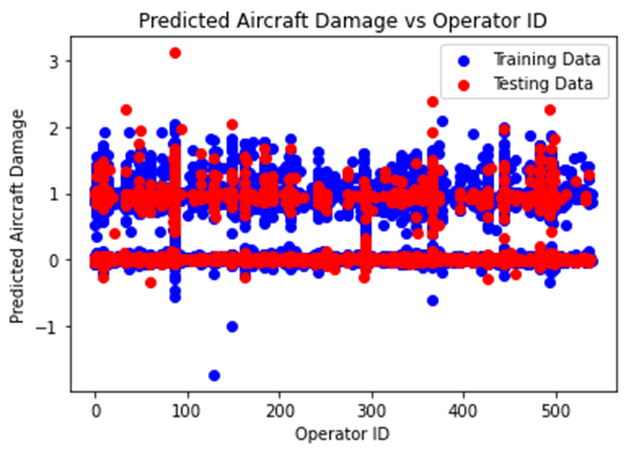

The provided scatter plot illustrates the relationship between predicted aircraft damage and operator ID, with the red line denoting predicted damage and blue points representing actual damage for the training data.Key observations include the x-axis displaying operator ID as numerical values, ranging from an unspecified minimum to maximum. Meanwhile, the y-axis indicates predicted aircraft damage, ranging from 0 to 3. Notably, the red line showcases a slight increase in predicted damage as operator ID rises, albeit with considerable scatter, indicating a weak correlation. The blue points' spread around the red line suggests the model's moderate accuracy in predicting damage for the training dataset, with similar observations likely for the green points. However, the scatter implies the model's imperfections and potential influences from other factors beyond operator ID. Overall, while a weak positive correlation between predicted damage and operator ID is evident, the model demonstrates moderate accuracy and generalization to unseen data. Yet, uncertainties persist due to factors such as model complexity and data quality, warranting further investigation.

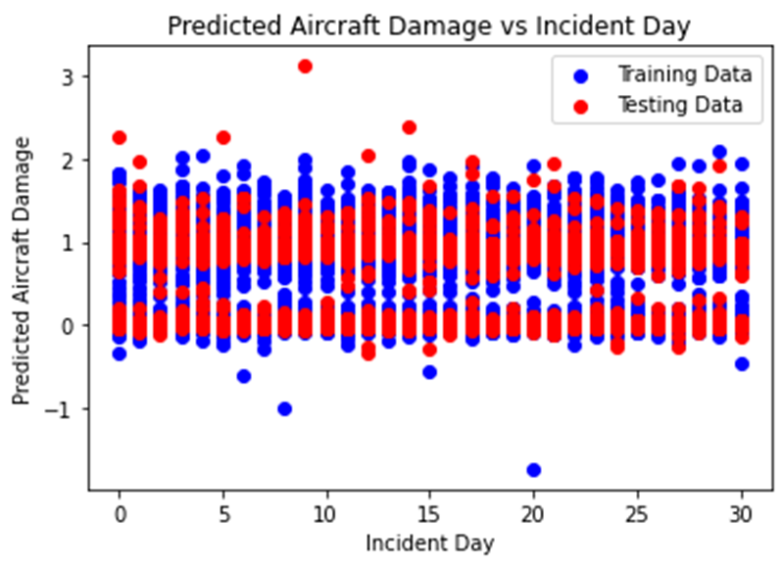

The provided scatter plot illustrates the relationship between predicted aircraft damage and incident day, with the red line representing predicted damage and blue points indicating actual damage. While the x-axis denotes incident day, the specific scale remains unlabeled, starting approximately around day 5 and ending around day 30. Conversely, the y-axis depicting predicted damage lacks labeling for its scale, rendering it challenging to ascertain the exact predicted damage on any given day. Nonetheless, comparative analysis of relative damage between different days is feasible by examining the vertical positioning of corresponding data points. For instance, the data point for day 15 appears higher than that for day 25, suggesting the model predicts greater damage on day 15 relative to day 25. Overall, the plot implies the model's potential in predicting the relative extent of aircraft damage across different days, yet conclusive insights are hindered by the absence of y-axis scale and specific incident day labels, necessitating further information for a comprehensive analysis.

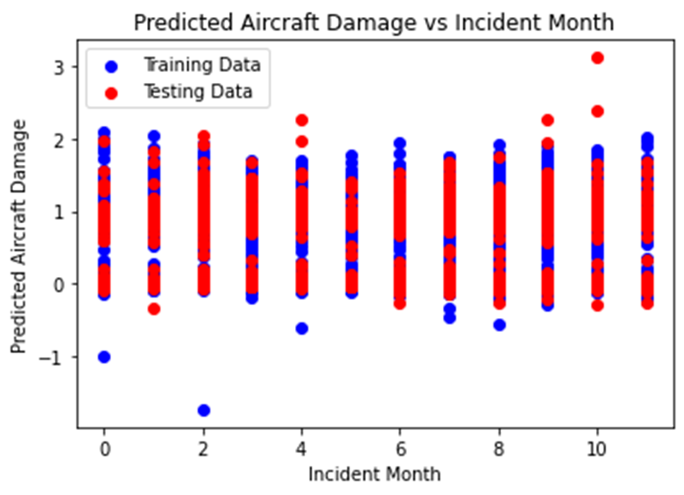

The provided scatter plot illustrates the relationship between predicted aircraft damage and incident month, with the red line representing predicted damage and blue points indicating actual damage for the training data. The x-axis denotes incident month, ranging numerically from 2 to 10, while the y-axis depicts predicted aircraft damage, scaling from -1 to 3. The plot indicates a tendency for higher predicted damage in winter months (around month 6) and lower damage in summer months (around month 8), albeit with considerable scatter, suggesting a modest seasonal trend. Although the model demonstrates some accuracy in predicting aircraft damage for varying months, the presence of scatter indicates imperfections. Furthermore, the non-linearity of the red line implies a more complex relationship between incident month and predicted damage, likely influenced by additional factors like weather conditions or incident types specific to certain months. Thus, while the plot hints at a seasonal trend in aircraft damage, conclusive assertions are limited by data scatter and the model's imperfections. Additionally, the uncertainty in the model's predictions underscores the complexities involved, stemming from factors such as model intricacies, data quality, and inherent variability in aircraft damage.

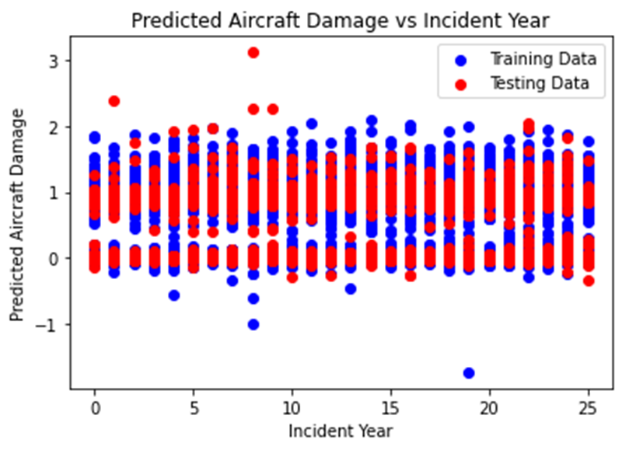

The plot titled "Predicted Aircraft Damage vs Incident Year". It is a line graph that shows the predicted aircraft damage over different incident years.

The red line in the plot represents the predicted aircraft damage, and the blue line is labeled "Training Data". The x-axis of the plot shows the incident year, and the y-axis shows the predicted aircraft damage.

The graph appears to show that the model predicts an increasing trend in aircraft damage over the years. It is important to note that the blue line labeled "Training Data" suggests that the model was trained on data from incident years 0 to 15. The red line extends beyond this range, indicating that it is predicting damage for future years, or years outside the training data.

Therefore, while the graph suggests an increasing trend in predicted aircraft damage, it is important to remember that the model's accuracy for future years (beyond incident year 15) is uncertain, as it was not trained on data from those years.

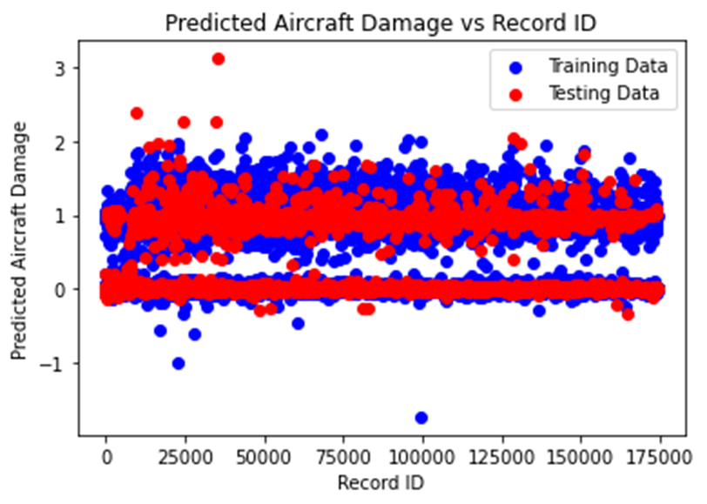

The provided scatter plot illustrates the relationship between predicted aircraft damage and record ID, where the red line denotes predicted damage and blue points represent damage values for the training data. The interpretation of the plot unveils several key insights:

- X-axis (Record ID): Depicts a unique identifier for each data point, facilitating the distinction of individual records. However, the specific significance of the record ID remains undisclosed.

- Y-axis (Predicted Aircraft Damage): Represents the predicted damage, albeit lacking a labeled scale, thereby impeding precise quantification of damage levels.

- The plot's significance lies in its ability to compare the relative damage across different records by assessing the vertical positioning of corresponding data points. For instance, the elevation of the data point associated with record ID 50000 surpasses that of record ID 100000, suggesting a higher predicted damage for the former.

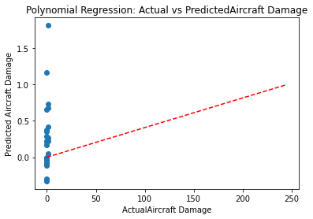

The provided plot, titled "Polynomial Regression: Actual vs Predicted Aircraft Damage," illustrates the correlation between predicted and actual aircraft damage. The red line signifies the predicted damage, while the blue line represents the actual damage. The x-axis denotes predicted aircraft damage, and the y-axis showcases actual aircraft damage. Ideally, points should align closely along the diagonal line, indicating precise predictions. While the points exhibit scattering around the diagonal line, a discernible upward trend is noticeable. This suggests a moderate level of accuracy in the polynomial regression model's prediction of actual aircraft damage

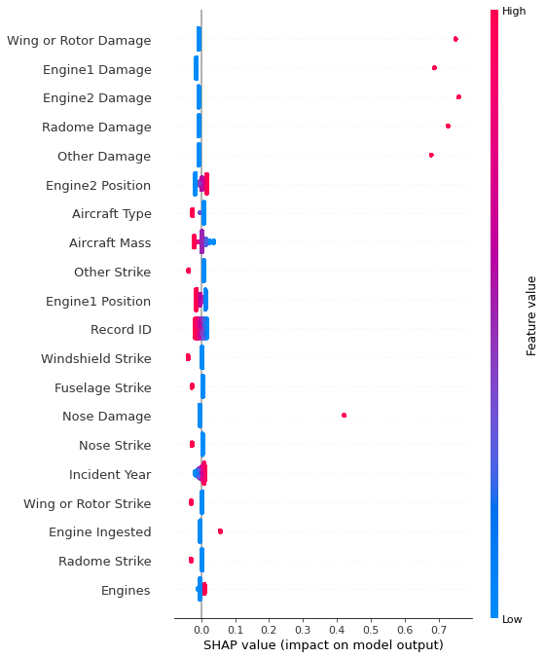

SHAP Plot Interpretation:

The SHAP (SHapley Additive exPlanations) plot illustrates the impact of each feature on the model's output prediction for a specific data point. Here's the breakdown of the features and their influence:

1. Record ID: This feature exhibits no discernible impact on the model's output, indicated by its blue color and bottom position on the plot.

2. Incident Year:Similarly, the incident year does not significantly influence the model's output, as evidenced by its blue color and bottom position.

3. Nose Strike: This feature negatively impacts the model's output, suggesting a decreased likelihood of aircraft damage. It is depicted in blue and positioned near the bottom.

4. Engine1 Position, Other Strike, Engine2 Position, Aircraft Mass, Aircraft Type, Engine2 Damage, Radome Damage: These features have a positive but minimal impact on the model's output, indicated by their red color and placement in the lower-middle portion of the plot.

5. Engine Ingested, Fuselage Strike, Wing or Rotor Strike: These features positively impact the model's output, suggesting a higher likelihood of aircraft damage. They are colored red and positioned above the middle of the plot.

6. Windshield Strike: Similarly, this feature positively influences the model's output, denoted by its red color and position near the top of the plot.

7. Wing or Rotor Damage: This feature has a significant positive impact on the model's output, indicating a higher probability of aircraft damage. It is colored red and positioned at the top of the plot.

.

General-equation:

A generic linear equation can be represented as:

y=b0​+b1​x1​+b2​x2​+…+bn​xn​

Here's a breakdown of the components:

* y: This represents the dependent variable, which is what you're trying to predict or understand (e.g., Aircraft Damage in your previous equation).
* b0​: This is the intercept or constant term in the equation. It represents the value of y when all x variables are zero.
* b1​,b2​,…,bn​: These are the coefficients or weights associated with each x variable. They indicate the impact or influence of each variable on the dependent variable y.
* x1​,x2​,…,xn​: These are the independent variables. Each x represents a different feature or factor that might influence the dependent variable y.

So, in a more general form, a linear equation could look like:

Dependent Variable=Constant+Coefficient1​×Variable1​+Coefficient2​×Variable2​+…+Coefficient*n*​×Variable*n*​  
This format allows you to express relationships between variables in a linear manner, where changes in the independent variables (*x*) lead to changes in the dependent variable (*y*) according to the weights given by the coefficients (*b*).

This equation seems to be a regression model attempting to predict the extent of aircraft damage based on various factors or variables. Each term in the equation represents a different variable or feature related to an aspect of the aircraft or its operational environment.

The purpose of this equation could be to create a predictive model for estimating or understanding the potential damage an aircraft might sustain under different conditions or scenarios. By plugging in specific values for each variable, such as flight phase, speed, type of damage (like nose strike or windshield strike), and various other factors, the equation can provide an estimate of the expected damage.

For instance:

- Flight Phase, Speed, Height: Factors related to the aircraft's state during different stages of flight.

- Species ID and Quantity: Possibly indicating the presence and quantity of certain wildlife that could impact the aircraft.

- Damage types to various components: Considering strikes or damages to different parts of the aircraft.

- Record ID, Aircraft Type, Engine Make, and Position: Details specific to the aircraft involved.

By analyzing historical data or incidents and using this equation, aviation authorities or researchers might aim to:

1. Predict Risk Factors: Understand which conditions or events are more likely to cause damage to an aircraft.

2. Improve Safety Measures: Identify areas where preventive measures or improvements in design could reduce potential damage.

3. Enhance Maintenance and Operations: Provide insights into areas that might require more frequent checks or maintenance to mitigate damage risks.

The equation essentially serves as a tool for assessing potential damage based on a combination of factors, aiding in risk assessment and possibly informing decisions related to safety, maintenance, and operations within the aviation industry.

**PHASE-2( Interpretation of input FATALITIES used to detect aircraft damage in part-1):**

|  |  |  |
| --- | --- | --- |
| Time | Location | Operator |
| 17:18 | Fort Myer, Virginia | Military - U.S. Army |
| 6:30 | AtlantiCity, New Jersey | Military - U.S. Navy |
| 7:30 | Victoria, British Columbia, Canada | Private |
| 18:30 | Over the North Sea | Military - German Navy |
| 10:30 | Near Johannisthal, Germany | Military - German Navy |
| 1:00 | Tienen, Belgium | Military - German Navy |
| 15:20 | Off Cuxhaven, Germany | Military - German Navy |
| 16:20 | Near Jambol, Bulgeria | Military - German Army |
| 1:00 | Billericay, England | Military - German Navy |
| 23:45 | Potters Bar, England | Military - German Navy |
| 0:45 | Mainz, Germany | Military - German Army |
| 23:45 | Off West Hartlepool, England | Military - German Navy |
| 0:45 | Near Gent, Belgium | Military - German Army |
| 1:45 | Off Northern Germany | Military - German Navy |
| 5:15 | Near Texel Island, North Sea | Military - German Navy |
| 8:45 | Off Vlieland Island, North Sea | Military - German Navy |
| 7:00 | Off western Denmark | Military - German Navy |
| 7:45 | Near Luneville, France | Military - German Navy |
| 21:30 | Over the Mediterranean | Military - German Navy |
| 22:30 | Off Helgoland Island, Germany | Military - German Navy |
| 10:00 | Ameland Island, North Sea | Military - German Navy |
| 11:00 | Elizabeth, New Jersey | US Aerial Mail Service |
| 12:00 | Cleveland, Ohio | US Aerial Mail Service |
| 13:00 | Dix Run, Pennsylvania | US Aerial Mail Service |
| 14:00 | Newcastle, England | Aircraft Transport and Travel |
| 15:00 | Cantonsville, Maryland | US Aerial Mail Service |
| 16:00 | English Channel | Aircraft Transport and Travel |
| 17:00 | Long Valley, New Jersey | US Aerial Mail Service |
| 18:00 | New Paris, Indiana | US Aerial Mail Service |
| 19:00 | Newark, New Jersey | US Aerial Mail Service |
| 20:00 | Newark, New Jersey | US Aerial Mail Service |
| 21:00 | Heller Field, New Jersey | US Aerial Mail Service |
| 22:00 | Oskaloosa, Iowa | US Aerial Mail Service |
| 23:00 | Cleveland, Ohio | US Aerial Mail Service |
| 0:00 | Bedford, England | By Air |
| 1:00 | College Park, Maryland | US Aerial Mail Service |
| 2:00 | Morristown, New Jersey | US Aerial Mail Service |
| 3:00 | Pemberville, Ohio | US Aerial Mail Service |
| 4:00 | Hillersburg, Pennsylvania | US Aerial Mail Service |
| 5:00 | Off Port Vendres, France | Latecoere Airlines |
| 6:00 | Valencia, Spain | Latecoere Airlines |
| 7:00 | Batavia, Illinois | US Aerial Mail Service |
| 8:00 | Tie Siding, Wyoming | US Aerial Mail Service |
| 9:00 | Cricklewood, England | Handley Page Transport |
| 10:00 | Barcelona, Spain | Aeropostale |
| 11:00 | Mendotta, Minnisota | US Aerial Mail Service |
| 12:00 | La Crosse, Wisconsin | US Aerial Mail Service |
| 13:00 | Off Gibraltar | Aeropostale |
| 14:00 | Elko, Nevada | US Aerial Mail Service |

|  |  |  |
| --- | --- | --- |
| Flight # | Route | Type |
| 7 | Demonstration | Wright Flyer III |
| 7 | Test flight | Dirigible |
| 7 | Test flight | Curtiss seaplane |
| 7 | Test flight | Zeppelin L-1 (airship) |
| 7 | Test flight | Zeppelin L-2 (airship) |
| 7 | Test flight | Zeppelin L-8 (airship) |
| 7 | Test flight | Zeppelin L-10 (airship) |
| 7 | Test flight | Schutte-Lanz S-L-10 (airship) |
| 7 | Test flight | Zeppelin L-32 (airship) |
| 7 | Test flight | Zeppelin L-31 (airship) |
| 7 | Test flight | Super Zeppelin (airship) |
| 7 | Test flight | Zeppelin L-34 (airship) |
| 7 | Test flight | Airship |
| 7 | Test flight | Schutte-Lanz S-L-9 (airship) |
| 7 | Test flight | Zeppelin L-22 (airship) |
| 7 | Test flight | Zeppelin L-43 (airship) |
| 7 | Test flight | Zeppelin L-23 (airship) |
| 7 | Test flight | Zeppelin L-44 (airship) |
| 7 | Test flight | Zeppelin L-59 (airship) |
| 7 | Test flight | Zeppelin L-70 (airship) |
| 7 | Test flight | Zeppelin L-53 (airship) |
| 7 | Test flight | De Havilland DH-4 |
| 7 | Test flight | De Havilland DH-4 |
| 7 | Test flight | De Havilland DH-4 |
| 7 | Test flight | De Havilland DH-4 |
| 7 | Test flight | Curtiss R-4LM |
| 7 | Test flight | De Havilland DH-4 |
| 7 | Test flight | De Havilland DH.4 |
| 7 | Test flight | De Havilland DH-4 |
| 7 | Test flight | De Havilland DH-4 |
| 7 | Test flight | Curtiss R-4LM |
| 7 | Test flight | Curtiss JN-4H |
| 7 | Test flight | De Havilland DH-4 |
| 7 | Test flight | De Havilland DH-4 |
| 7 | Test flight | Armstrong-Whitworth F-K-8 |
| 7 | Test flight | De Havilland DH-4 |
| 7 | Test flight | Junkers JL-6 |
| 7 | Test flight | Junkers F-13 |
| 7 | Test flight | De Havilland DH-4 |
| 7 | Test flight | Salmson 2-A-2 |
| 7 | Test flight | Breguet 14 |
| 7 | Test flight | De Havilland DH-4 |
| 7 | Test flight | De Havilland DH-4 |
| 7 | Test flight | Handley Page HP-16 |
| 7 | Test flight | Breguet 14 |
| 7 | Test flight | De Havilland DH-4 |
| 7 | Test flight | Junkers F-13 |
| 7 | Test flight | Breguet 14 |
| 7 | Test flight | De Havilland DH-4 |

|  |  |  |  |  |
| --- | --- | --- | --- | --- |
| Registration | cn/In | Aboard | Fatalities | Ground |
| 97 | 1 | 2 | 1 | 0 |
| 97 | 1 | 5 | 5 | 0 |
| 97 | 1 | 1 | 1 | 0 |
| 97 | 1 | 20 | 14 | 0 |
| 97 | 1 | 30 | 30 | 0 |
| 97 | 1 | 41 | 21 | 0 |
| 97 | 1 | 19 | 19 | 0 |
| 97 | 1 | 20 | 20 | 0 |
| 97 | 1 | 22 | 22 | 0 |
| 97 | 1 | 19 | 19 | 0 |
| 97 | 1 | 28 | 27 | 0 |
| 97 | 1 | 20 | 20 | 0 |
| 97 | 1 | 20 | 20 | 0 |
| 97 | 1 | 23 | 23 | 0 |
| 97 | 1 | 21 | 21 | 0 |
| 97 | 1 | 24 | 24 | 0 |
| 97 | 1 | 18 | 18 | 0 |
| 97 | 1 | 18 | 18 | 0 |
| 97 | 1 | 23 | 23 | 0 |
| 97 | 1 | 22 | 22 | 0 |
| 97 | 1 | 19 | 19 | 0 |
| 97 | 1 | 1 | 1 | 0 |
| 61 | 1 | 1 | 1 | 0 |
| 82 | 1 | 1 | 1 | 0 |
| 82 | 1 | 1 | 1 | 0 |
| 32 | 1 | 1 | 1 | 0 |
| G-EAHG | 1 | 1 | 1 | 0 |
| 77 | 1 | 1 | 1 | 0 |
| 65 | 1 | 1 | 1 | 0 |
| 72 | 1 | 1 | 1 | 0 |
| 49 | 1 | 2 | 1 | 0 |
| 44 | 1 | 2 | 1 | 0 |
| 79 | 1 | 2 | 1 | 0 |
| 204 | 1 | 1 | 1 | 0 |
| G-EALW | 1 | 1 | 1 | 0 |
| 317 | 1 | 1 | 1 | 0 |
| 305 | 1 | 2 | 2 | 0 |
| 308 | 1 | 2 | 2 | 0 |
| 316 | 1 | 1 | 1 | 0 |
| F-ALAI | 31 | 2 | 2 | 0 |
| F-ALTA | 20 | 2 | 2 | 0 |
| 76 | 20 | 1 | 1 | 0 |
|  | 178 | 1 | 1 | 0 |
| G-EAMA | HP-25 | 8 | 4 | 0 |
| F-ALBO | HP-26 | 1 | 1 | 0 |
| 130 | HP-27 | 1 | 1 | 0 |
| 301 | HP-28 | 3 | 3 | 0 |
| F-ALBA | HP-29 | 2 | 2 | 0 |
| 67 | HP-30 | 1 | 1 | 0 |

a dataset containing information about various aviation incidents, including details such as time, location, operator, flight type, aircraft type, registration, and the number of people aboard, fatalities, and ground casualties.

1. Operator and Aircraft Types:

- The dataset encompasses information about various operators, including Military - U.S. Army, Military - U.S. Navy, Private entities, and others.

- Aircraft types vary widely, ranging from early models like the Wright Flyer III to more modern ones such as Dirigibles, Curtiss seaplanes, Zeppelin airships, and De Havilland DH-4.

2. Aircraft Components and Systems:

- Different aircraft are equipped with distinct systems and components. For instance, the Wright Flyer III features basic control systems as an early fixed-wing aircraft.

- Dirigibles, characterized by large gas-filled envelopes, may include propulsion and steering systems in their design.

3. Fatalities and Ground Casualties:

- The dataset provides details on the number of individuals on board, fatalities, and ground casualties for each incident.

- Analyzing the causes of fatalities involves exploring specific aircraft components, potential system failures, or external factors.

4. Engine Types:

- Engine types like Curtiss seaplane, De Havilland DH-4, and Curtiss R-4LM represent diverse propulsion systems.

- Each engine type is associated with its unique set of components and systems relevant to incident understanding.

5. Test Flights:

- Several incidents are categorized as "Test flight," indicating that the aircraft might have been undergoing testing or system evaluation.

- Test flights play a crucial role in identifying potential issues with various aircraft systems.

6. Military Operations:

- Incidents involving Military - U.S. Army and Military - German Navy suggest military operations.

- Military aircraft feature specific systems related to their mission, such as weaponry, communication, and navigation.

7. Time and Location:

- Time and location data are essential for comprehending environmental factors and external conditions contributing to incidents.

8. Record ID and Registration:

- Each incident is assigned a unique Record ID for identification purposes.

- Registration details offer information about the specific aircraft involved in each incident.

Linear Equation: Fatalities= (1.0) * Time + (1.0) * Location + (-0.26) * Operator + (1.0) * Flight + (1.0) * Route + (1.0) * Type + (1.0) * cn/In + (1.0) * Aboard + (1.17)

ENCODING ONLY CATEGORICAL VARIABLE:

coefficient [-7.84632715e-04 9.31636655e-03 5.54686972e-03 2.31012037e-04

1.99354562e-02 -4.06962754e-03 1.73709582e-03 -3.95927833e-03

2.90241250e-04 9.69088894e-01 6.21579681e-02 2.46181435e-07

-1.07705267e-06 -8.15102921e-08 6.52476631e-07 -1.12217974e-06

1.60526992e-07 4.38038762e-07 -2.06092569e-08 -4.93028930e-08

-5.65286344e-06 -2.46021531e-05 -1.33774623e-05 -8.52314669e-07

-2.91104876e-07 6.63914255e-06 8.73421898e-07 3.26062042e-07

7.12794002e-07 4.80513853e-07 -1.71839293e-05 -3.15344507e-04

-1.64150702e-06 -1.70203750e-09 2.46675238e-06 -2.16023768e-07

-6.15877840e-08 -6.99636582e-08 3.28367082e-07 5.96574977e-05

4.77708311e-05 -1.55068910e-07 -3.56904173e-06 7.84215353e-09

2.39679854e-07 2.72362125e-07 4.21794959e-07 -7.30324382e-05

1.58698372e-04 1.40890096e-06 5.16468368e-07 -4.55194957e-06

-2.18887469e-06 5.06031067e-07 -4.35582380e-04 -7.16372174e-04

4.14229865e-07 1.80223323e-07 -2.35110056e-08 1.82201992e-07

3.05236153e-05 1.43198384e-04 -1.91528607e-07 1.77742739e-07

-3.03788781e-07 1.57917909e-05 -2.00644856e-04 8.96698855e-07

-3.30858484e-08 -7.63111312e-06 5.96038387e-05 -3.08826048e-07

-3.47427337e-05 -3.12747493e-05 -8.83990145e-04 8.37086836e-03

-2.55925272e-04]

intercept -6.291467870344039

Equation: Fatalities= -6.291467870 + 0.009316367 * Time + 0.005546870 * Location + 0.000231012 * Operator + 0.019935456 * Flight # + -0.004069628 * Route + 0.001737096 * Type + -0.003959278 * Registration + 0.000290241 * cn/In + 0.969088894 * Aboard + 0.062157968 * Ground + 0.000000246 * Date*2 + -0.000001077 * Date1*Time1 + -0.000000082 * Date1*Location1 + 0.000000652 * Date1*Operator1 + -0.000001122 * Date1*Flight #1 + 0.000000161 * Date1*Route1 + 0.000000438 * Date1*Type1 + -0.000000021 * Date1*Registration1 + -0.000000049 * Date1*cn/In1 + -0.000005653 * Date1*Aboard1 + -0.000024602 * Date1*Ground1 + -0.000013377 * Time2 + -0.000000852 * Time1*Location1 + -0.000000291 * Time1*Operator1 + 0.000006639 * Time1*Flight #1 + 0.000000873 * Time1*Route1 + 0.000000326 * Time1*Type1 + 0.000000713 * Time1*Registration1 + 0.000000481 * Time1*cn/In1 + -0.000017184 * Time1*Aboard1 + -0.000315345 * Time1*Ground1 + -0.000001642 * Location2 + -0.000000002 * Location1*Operator1 + 0.000002467 * Location1*Flight #1 + -0.000000216 * Location1*Route1 + -0.000000062 * Location1*Type1 + -0.000000070 * Location1*Registration1 + 0.000000328 * Location1*cn/In1 + 0.000059657 * Location1*Aboard1 + 0.000047771 * Location1*Ground1 + -0.000000155 * Operator2 + -0.000003569 * Operator1*Flight #1 + 0.000000008 * Operator1*Route1 + 0.000000240 * Operator1*Type1 + 0.000000272 * Operator1*Registration1 + 0.000000422 * Operator1*cn/In1 + -0.000073032 * Operator1*Aboard1 + 0.000158698 * Operator1*Ground1 + 0.000001409 * Flight #2 + 0.000000516 * Flight #1*Route1 + -0.000004552 * Flight #1*Type1 + -0.000002189 * Flight #1*Registration1 + 0.000000506 * Flight #1*cn/In1 + -0.000435582 * Flight #1*Aboard1 + -0.000716372 * Flight #1*Ground1 + 0.000000414 * Route2 + 0.000000180 * Route1*Type1 + -0.000000024 * Route1*Registration1 + 0.000000182 * Route1*cn/In1 + 0.000030524 * Route1*Aboard1 + 0.000143198 * Route1*Ground1 + -0.000000192 * Type2 + 0.000000178 * Type1*Registration1 + -0.000000304 * Type1*cn/In1 + 0.000015792 * Type1*Aboard1 + -0.000200645 * Type1*Ground1 + 0.000000897 * Registration2 + -0.000000033 * Registration1*cn/In1 + -0.000007631 * Registration1*Aboard1 + 0.000059604 * Registration1*Ground1 + -0.000000309 * cn/In2 + -0.000034743 * cn/In1*Aboard1 + -0.000031275 * cn/In1*Ground1 + -0.000883990 * Aboard2 + 0.008370868 * Aboard1*Ground1 + -0.000255925 * Ground*2

Accuracy: 0.7397728344172139

coefficient [1.60138581e-02 4.60184558e-03 -2.51489889e-03

1.16712395e-02 -4.70157948e-05 2.00339966e-04 -3.95699962e-03

-1.80265577e-03 1.12267987e+00 -7.43452971e-02 2.13978296e-07

-1.43913018e-06 -3.30131222e-08 5.80243940e-07 -1.61223349e-06

3.12334962e-07 3.83929761e-07 -1.94230335e-08 -3.88222619e-08

-1.40769112e-05 -3.26555596e-06 -1.06870485e-05 -6.01939145e-07

-2.17387653e-09 3.20039035e-06 -2.56954089e-08 -2.49853245e-07

2.58361028e-07 2.33388548e-07 -1.49702334e-04 4.68801962e-05

-1.40750535e-06 2.11303545e-07 1.72033341e-06 -2.11003966e-07

1.34853712e-07 -4.97175820e-08 2.63187513e-07 4.03432336e-05

-7.33327387e-05 3.69562439e-07 -2.29798261e-06 -1.49369395e-07

1.56301363e-07 2.27145497e-07 4.16863689e-07 -3.17937967e-05

7.05748769e-05 -1.32117569e-06 -1.41803513e-06 -2.44456670e-06

-6.24176173e-08 1.81894540e-06 -2.27847393e-04 -2.05959849e-04

9.76824780e-08 1.82415060e-07 -1.70967727e-07 2.58526455e-07

-4.94739486e-06 2.68724429e-05 -1.85441001e-08 2.38566862e-07

-4.99273950e-07 1.66627846e-05 -1.25808341e-04 6.78825028e-07

1.19609164e-07 -6.97321959e-06 7.00271152e-05 -1.38857840e-07

-5.91775793e-06 2.67623388e-05 -2.28562100e-03 1.19991697e-02

-5.14549750e-03]

intercept -5.482654169449447

Equation: Fatalities= -5.482654 + 0.016014 * Time + 0.004602 * Location + -0.002515 * Operator + 0.011671 * Flight # + -0.000047 * Route + 0.000200 * Type + -0.003957 * Registration + -0.001803 * cn/In + 1.122680 * Aboard + -0.074345 * Ground + 0.000000 * Date^2 + -0.000001 * Date^1*Time^1 + -0.000000 * Date^1*Location^1 + 0.000001 * Date^1*Operator^1 + -0.000002 * Date^1*Flight #^1 + 0.000000 * Date^1*Route^1 + 0.000000 * Date^1*Type^1 + -0.000000 * Date^1*Registration^1 + -0.000000 * Date^1*cn/In^1 + -0.000014 * Date^1*Aboard^1 + -0.000003 * Date^1*Ground^1 + -0.000011 * Time^2 + -0.000001 * Time^1*Location^1 + -0.000000 * Time^1*Operator^1 + 0.000003 * Time^1*Flight #^1 + -0.000000 * Time^1*Route^1 + -0.000000 * Time^1*Type^1 + 0.000000 * Time^1*Registration^1 + 0.000000 * Time^1*cn/In^1 + -0.000150 * Time^1*Aboard^1 + 0.000047 * Time^1*Ground^1 + -0.000001 * Location^2 + 0.000000 * Location^1*Operator^1 + 0.000002 * Location^1*Flight #^1 + -0.000000 * Location^1*Route^1 + 0.000000 * Location^1*Type^1 + -0.000000 * Location^1*Registration^1 + 0.000000 * Location^1*cn/In^1 + 0.000040 * Location^1*Aboard^1 + -0.000073 * Location^1*Ground^1 + 0.000000 * Operator^2 + -0.000002 * Operator^1*Flight #^1 + -0.000000 * Operator^1*Route^1 + 0.000000 * Operator^1*Type^1 + 0.000000 * Operator^1*Registration^1 + 0.000000 * Operator^1*cn/In^1 + -0.000032 * Operator^1*Aboard^1 + 0.000071 * Operator^1*Ground^1 + -0.000001 * Flight #^2 + -0.000001 * Flight #^1*Route^1 + -0.000002 * Flight #^1*Type^1 + -0.000000 * Flight #^1*Registration^1 + 0.000002 * Flight #^1*cn/In^1 + -0.000228 * Flight #^1*Aboard^1 + -0.000206 * Flight #^1*Ground^1 + 0.000000 * Route^2 + 0.000000 * Route^1*Type^1 + -0.000000 * Route^1*Registration^1 + 0.000000 * Route^1*cn/In^1 + -0.000005 * Route^1*Aboard^1 + 0.000027 * Route^1*Ground^1 + -0.000000 * Type^2 + 0.000000 * Type^1*Registration^1 + -0.000000 * Type^1*cn/In^1 + 0.000017 * Type^1*Aboard^1 + -0.000126 * Type^1*Ground^1 + 0.000001 * Registration^2 + 0.000000 * Registration^1*cn/In^1 + -0.000007 * Registration^1*Aboard^1 + 0.000070 * Registration^1*Ground^1 + -0.000000 * cn/In^2 + -0.000006 * cn/In^1*Aboard^1 + 0.000027 * cn/In^1*Ground^1 + -0.002286 * Aboard^2 + 0.011999 * Aboard^1*Ground^1 + -0.005145 * Ground^2

Accuracy: 0.7001682530914266

DEGREE-3:

coefficient [-2.06597540e-02 -9.71892578e-03 -2.08291048e-02

-4.21843896e-02 -1.30504406e-02 -1.04449320e-02 -1.57304766e-03

9.35588062e-03 2.79198854e-01 4.68436568e+00 -9.36999680e-07

-9.95099746e-06 1.59220826e-06 -2.80007220e-08 1.52018225e-05

4.16712893e-07 8.77889645e-07 1.29840633e-06 -1.35008309e-06

7.53891010e-05 -1.34838310e-03 4.88238526e-05 -9.15542737e-07

1.16514132e-05 -3.09297925e-05 -9.77139579e-07 3.54585763e-06

8.63113870e-06 -6.59976004e-06 1.01691348e-03 -6.22356626e-03

4.75650340e-06 3.65155098e-07 -2.31006117e-06 -2.64700950e-06

-2.58058757e-07 1.25730266e-07 -1.49452732e-06 3.98076806e-04

-1.19888797e-03 1.02868442e-05 5.04619490e-05 -3.59587095e-06

1.12205335e-06 -9.59295493e-07 -7.36644326e-07 -1.74445580e-04

-1.91804215e-03 1.11313471e-04 9.04430555e-06 -5.66197183e-06

-1.82299594e-06 -1.48981121e-05 -1.27254478e-04 9.10490897e-03

6.66913052e-06 -2.59143357e-06 1.77227822e-06 1.90279436e-06

-5.03132686e-05 4.77465256e-03 1.42959014e-06 4.21146875e-06

4.05648573e-07 2.55312353e-04 -2.88985114e-03 -2.20772479e-06

-1.82309541e-06 -2.12397099e-04 2.25268133e-04 1.09704755e-06

-4.47647254e-05 -2.11845090e-03 3.12346724e-03 2.23153213e-02

4.36070525e-02 5.61150657e-11 8.42470225e-10 -1.55001297e-10

6.10573961e-11 -1.31854314e-10 -6.73249251e-11 -4.02607924e-11

5.43705983e-11 1.20286845e-10 1.75364880e-09 5.66509183e-08

2.47646810e-09 5.84602748e-11 1.48314597e-09 -3.63488493e-10

7.21095385e-10 4.02315541e-10 -2.35817253e-10 5.71372878e-10

-1.04501035e-07 -2.17579695e-07 6.05513695e-11 -9.77745658e-11

3.05274454e-10 -3.46404180e-10 2.32872918e-11 6.08845595e-11

-1.63224026e-10 -1.79455365e-08 2.04037775e-07 3.12069045e-10

-4.00730673e-09 -8.66663746e-11 6.38141701e-11 -1.03282588e-10

2.99011745e-10 3.80744103e-08 8.93643203e-08 -7.78102922e-09

1.80340353e-09 -1.31087514e-09 -4.96617309e-10 -2.97081286e-10

-8.86172887e-08 8.84865042e-07 -2.13247111e-10 -1.27150643e-10

4.92401146e-11 -9.18806945e-11 1.35720444e-08 2.48132024e-08

6.83110686e-11 -2.43292280e-10 2.15344501e-10 2.61501333e-09

-1.38361970e-07 -1.19364662e-10 -1.94852814e-12 -1.01635148e-08

-9.02068515e-08 3.41667718e-11 1.19784281e-08 1.40525314e-07

3.54782356e-09 1.35352205e-06 4.40263536e-06 -5.12866735e-08

4.14368264e-09 -1.63252704e-09 2.78436365e-08 -3.04930756e-09

9.18403203e-09 8.75566010e-11 2.64266604e-09 -5.64092351e-07

5.82768331e-06 -2.99997410e-11 -6.57709654e-10 -5.09015560e-09

6.58276543e-11 -4.00358880e-10 1.06778162e-10 3.72066645e-10

-6.18175875e-08 7.76484772e-09 1.10739713e-09 -2.29139741e-08

1.27819623e-09 -9.94207839e-11 -7.21555434e-10 -1.87715536e-10

2.21421364e-08 -2.35578732e-07 3.96920940e-08 9.02364187e-09

-5.56497989e-09 -3.16489151e-09 5.99417345e-09 3.73819304e-08

3.03430500e-07 -1.53077988e-09 5.38086782e-10 -7.51124996e-10

7.61887421e-10 7.11889849e-09 -5.45199743e-07 -1.34328971e-09

-1.61961565e-09 -9.02648856e-10 -7.16897385e-08 1.06092569e-07

-2.94029249e-10 -6.52385896e-11 -2.61803042e-09 1.14279540e-07

-7.88186890e-10 7.01263266e-08 5.17161249e-07 -1.65786856e-06

-2.92465336e-06 -5.10417575e-07 -2.91928185e-10 -4.05165202e-10

-2.24409667e-09 1.23317263e-10 -2.22375872e-10 -6.15991633e-11

-5.27473846e-11 -7.61774198e-08 1.13397056e-07 9.27499111e-11

3.13245542e-10 1.42990409e-10 5.36819786e-10 -1.47208430e-10

3.44525578e-10 5.50087825e-09 6.79627567e-07 1.37650559e-09

1.85380822e-09 4.52969373e-10 1.22277276e-09 1.52977068e-09

1.22968443e-07 -4.49568418e-07 3.74866183e-10 3.20366754e-10

2.07253780e-11 -7.12774024e-11 -1.39232887e-08 1.02866013e-07

-1.22186754e-10 -1.64320105e-10 1.46956640e-11 2.38562745e-08

1.09424229e-09 -1.00664712e-10 2.68779790e-11 -4.31294105e-09

-5.27069708e-08 1.39237098e-10 6.27226549e-09 -8.24732590e-08

-1.90468839e-07 2.33452276e-06 -1.00563808e-05 -2.14108494e-09

-3.29565072e-09 2.94338787e-10 -4.25249241e-10 -2.49521172e-11

-5.97541117e-10 1.07753297e-08 -4.28121603e-07 -1.95428786e-08

-3.26589446e-09 3.25318061e-09 5.85511596e-11 -1.03351956e-09

-1.39209396e-07 1.50491231e-06 6.91707513e-10 1.53613779e-10

2.17642640e-10 7.47642321e-11 2.07504398e-08 -1.15698369e-07

-1.28612570e-09 -5.92024184e-10 2.27857204e-10 4.11372742e-09

4.46999044e-07 3.73309047e-10 1.92763420e-10 -1.24114578e-09

-1.98573687e-07 1.37477354e-10 3.53110914e-08 1.80018712e-07

-2.50146889e-07 -6.08496401e-06 3.14031190e-05 -1.24520792e-07

1.50323182e-09 1.45050154e-08 6.78438932e-09 -6.15508439e-09

2.50755949e-07 -1.55572061e-05 -4.13918014e-09 2.52224260e-09

-3.28045399e-09 2.57063781e-10 -4.04520383e-09 -3.39978312e-06

-9.42060902e-10 -3.74777729e-10 -2.35260920e-09 -1.33722296e-07

3.32117703e-06 -3.41582281e-10 2.40648720e-09 -1.00961983e-08

1.08225805e-06 1.51789753e-09 2.69134515e-07 2.01160330e-06

-2.91925613e-06 -3.89150826e-05 -1.70615778e-04 -3.94938519e-10

-2.61939131e-10 -1.48986408e-10 -3.52089365e-10 -1.23411029e-08

-5.12800105e-07 2.98325204e-10 -2.48548252e-11 -1.10400808e-10

2.18263131e-08 -1.09549699e-07 3.24375956e-10 -1.49544226e-10

-1.30262163e-08 -1.65394081e-07 -1.52494104e-10 1.59957590e-08

-9.69114935e-08 3.23506433e-07 -6.18608752e-06 1.72663949e-05

7.83341222e-11 1.98410288e-10 5.94533281e-10 -6.83082320e-08

3.17949647e-07 -3.31456427e-10 -1.70544168e-10 3.33397425e-08

1.25372728e-07 1.73516573e-10 -3.47228917e-08 -3.89346283e-07

-4.17351764e-07 7.43369705e-07 9.48683325e-06 2.52134948e-10

9.59064247e-11 4.13152195e-08 -1.18924291e-07 3.53720341e-11

-4.67215561e-09 1.05501010e-07 2.55037859e-07 -2.74753309e-06

8.90136986e-06 -1.64806315e-10 -6.04046004e-08 6.71553708e-08

-2.43749023e-08 8.25059565e-07 -2.67693906e-06 -1.06619570e-05

2.91643314e-04 -4.40953728e-04 -5.55197105e-04]

intercept 29.931634395205265

Equation: Fatalities= 29.931634 + -0.020660 * Time + -0.009719 * Location + -0.020829 * Operator + -0.042184 * Flight # + -0.013050 * Route + -0.010445 * Type + -0.001573 * Registration + 0.009356 * cn/In + 0.279199 * Aboard + 4.684366 * Ground + -0.000001 * Date^2 + -0.000010 * Date^1*Time^1 + 0.000002 * Date^1*Location^1 + -0.000000 * Date^1*Operator^1 + 0.000015 * Date^1*Flight #^1 + 0.000000 * Date^1*Route^1 + 0.000001 * Date^1*Type^1 + 0.000001 * Date^1*Registration^1 + -0.000001 * Date^1*cn/In^1 + 0.000075 * Date^1*Aboard^1 + -0.001348 * Date^1*Ground^1 + 0.000049 * Time^2 + -0.000001 * Time^1*Location^1 + 0.000012 * Time^1*Operator^1 + -0.000031 * Time^1*Flight #^1 + -0.000001 * Time^1*Route^1 + 0.000004 * Time^1*Type^1 + 0.000009 * Time^1*Registration^1 + -0.000007 * Time^1*cn/In^1 + 0.001017 * Time^1*Aboard^1 + -0.006224 * Time^1*Ground^1 + 0.000005 * Location^2 + 0.000000 * Location^1*Operator^1 + -0.000002 * Location^1*Flight #^1 + -0.000003 * Location^1*Route^1 + -0.000000 * Location^1*Type^1 + 0.000000 * Location^1*Registration^1 + -0.000001 * Location^1*cn/In^1 + 0.000398 * Location^1*Aboard^1 + -0.001199 * Location^1*Ground^1 + 0.000010 * Operator^2 + 0.000050 * Operator^1*Flight #^1 + -0.000004 * Operator^1*Route^1 + 0.000001 * Operator^1*Type^1 + -0.000001 * Operator^1*Registration^1 + -0.000001 * Operator^1*cn/In^1 + -0.000174 * Operator^1*Aboard^1 + -0.001918 * Operator^1*Ground^1 + 0.000111 * Flight #^2 + 0.000009 * Flight #^1*Route^1 + -0.000006 * Flight #^1*Type^1 + -0.000002 * Flight #^1*Registration^1 + -0.000015 * Flight #^1*cn/In^1 + -0.000127 * Flight #^1*Aboard^1 + 0.009105 * Flight #^1*Ground^1 + 0.000007 * Route^2 + -0.000003 * Route^1*Type^1 + 0.000002 * Route^1*Registration^1 + 0.000002 * Route^1*cn/In^1 + -0.000050 * Route^1*Aboard^1 + 0.004775 * Route^1*Ground^1 + 0.000001 * Type^2 + 0.000004 * Type^1*Registration^1 + 0.000000 * Type^1*cn/In^1 + 0.000255 * Type^1*Aboard^1 + -0.002890 * Type^1*Ground^1 + -0.000002 * Registration^2 + -0.000002 * Registration^1*cn/In^1 + -0.000212 * Registration^1*Aboard^1 + 0.000225 * Registration^1*Ground^1 + 0.000001 * cn/In^2 + -0.000045 * cn/In^1*Aboard^1 + -0.002118 * cn/In^1*Ground^1 + 0.003123 * Aboard^2 + 0.022315 * Aboard^1*Ground^1 + 0.043607 * Ground^2 + 0.000000 * Date^3 + 0.000000 * Date^2*Time^1 + -0.000000 * Date^2*Location^1 + 0.000000 * Date^2*Operator^1 + -0.000000 * Date^2*Flight #^1 + -0.000000 * Date^2*Route^1 + -0.000000 * Date^2*Type^1 + 0.000000 * Date^2*Registration^1 + 0.000000 * Date^2*cn/In^1 + 0.000000 * Date^2*Aboard^1 + 0.000000 * Date^2*Ground^1 + 0.000000 * Date^1*Time^2 + 0.000000 * Date^1*Time^1*Location^1 + 0.000000 * Date^1*Time^1*Operator^1 + -0.000000 * Date^1*Time^1*Flight #^1 + 0.000000 * Date^1*Time^1*Route^1 + 0.000000 * Date^1*Time^1*Type^1 + -0.000000 * Date^1*Time^1*Registration^1 + 0.000000 * Date^1*Time^1*cn/In^1 + -0.000000 * Date^1*Time^1*Aboard^1 + -0.000000 * Date^1*Time^1*Ground^1 + 0.000000 * Date^1*Location^2 + -0.000000 * Date^1*Location^1*Operator^1 + 0.000000 * Date^1*Location^1*Flight #^1 + -0.000000 * Date^1*Location^1*Route^1 + 0.000000 * Date^1*Location^1*Type^1 + 0.000000 * Date^1*Location^1*Registration^1 + -0.000000 * Date^1*Location^1*cn/In^1 + -0.000000 * Date^1*Location^1*Aboard^1 + 0.000000 * Date^1*Location^1*Ground^1 + 0.000000 * Date^1*Operator^2 + -0.000000 * Date^1*Operator^1*Flight #^1 + -0.000000 * Date^1*Operator^1*Route^1 + 0.000000 * Date^1*Operator^1*Type^1 + -0.000000 * Date^1*Operator^1*Registration^1 + 0.000000 * Date^1*Operator^1*cn/In^1 + 0.000000 * Date^1*Operator^1*Aboard^1 + 0.000000 * Date^1*Operator^1*Ground^1 + -0.000000 * Date^1*Flight #^2 + 0.000000 * Date^1*Flight #^1*Route^1 + -0.000000 * Date^1*Flight #^1*Type^1 + -0.000000 * Date^1*Flight #^1*Registration^1 + -0.000000 * Date^1*Flight #^1*cn/In^1 + -0.000000 * Date^1*Flight #^1*Aboard^1 + 0.000001 * Date^1*Flight #^1*Ground^1 + -0.000000 * Date^1*Route^2 + -0.000000 * Date^1*Route^1*Type^1 + 0.000000 * Date^1*Route^1*Registration^1 + -0.000000 * Date^1*Route^1*cn/In^1 + 0.000000 * Date^1*Route^1*Aboard^1 + 0.000000 * Date^1*Route^1*Ground^1 + 0.000000 * Date^1*Type^2 + -0.000000 * Date^1*Type^1*Registration^1 + 0.000000 * Date^1*Type^1*cn/In^1 + 0.000000 * Date^1*Type^1*Aboard^1 + -0.000000 * Date^1*Type^1*Ground^1 + -0.000000 * Date^1*Registration^2 + -0.000000 * Date^1*Registration^1*cn/In^1 + -0.000000 * Date^1*Registration^1*Aboard^1 + -0.000000 * Date^1*Registration^1*Ground^1 + 0.000000 * Date^1*cn/In^2 + 0.000000 * Date^1*cn/In^1*Aboard^1 + 0.000000 * Date^1*cn/In^1*Ground^1 + 0.000000 * Date^1*Aboard^2 + 0.000001 * Date^1*Aboard^1*Ground^1 + 0.000004 * Date^1*Ground^2 + -0.000000 * Time^3 + 0.000000 * Time^2*Location^1 + -0.000000 * Time^2*Operator^1 + 0.000000 * Time^2*Flight #^1 + -0.000000 * Time^2*Route^1 + 0.000000 * Time^2*Type^1 + 0.000000 * Time^2*Registration^1 + 0.000000 * Time^2*cn/In^1 + -0.000001 * Time^2*Aboard^1 + 0.000006 * Time^2*Ground^1 + -0.000000 * Time^1*Location^2 + -0.000000 * Time^1*Location^1*Operator^1 + -0.000000 * Time^1*Location^1*Flight #^1 + 0.000000 * Time^1*Location^1*Route^1 + -0.000000 * Time^1*Location^1*Type^1 + 0.000000 * Time^1*Location^1*Registration^1 + 0.000000 * Time^1*Location^1*cn/In^1 + -0.000000 * Time^1*Location^1*Aboard^1 + 0.000000 * Time^1*Location^1*Ground^1 + 0.000000 * Time^1*Operator^2 + -0.000000 * Time^1*Operator^1*Flight #^1 + 0.000000 * Time^1*Operator^1*Route^1 + -0.000000 * Time^1*Operator^1*Type^1 + -0.000000 * Time^1*Operator^1*Registration^1 + -0.000000 * Time^1*Operator^1*cn/In^1 + 0.000000 * Time^1*Operator^1*Aboard^1 + -0.000000 * Time^1*Operator^1*Ground^1 + 0.000000 * Time^1*Flight #^2 + 0.000000 * Time^1*Flight #^1*Route^1 + -0.000000 * Time^1*Flight #^1*Type^1 + -0.000000 * Time^1*Flight #^1*Registration^1 + 0.000000 * Time^1*Flight #^1*cn/In^1 + 0.000000 * Time^1*Flight #^1*Aboard^1 + 0.000000 * Time^1*Flight #^1*Ground^1 + -0.000000 * Time^1*Route^2 + 0.000000 * Time^1*Route^1*Type^1 + -0.000000 * Time^1*Route^1*Registration^1 + 0.000000 * Time^1*Route^1*cn/In^1 + 0.000000 * Time^1*Route^1*Aboard^1 + -0.000001 * Time^1*Route^1*Ground^1 + -0.000000 * Time^1*Type^2 + -0.000000 * Time^1*Type^1*Registration^1 + -0.000000 * Time^1*Type^1*cn/In^1 + -0.000000 * Time^1*Type^1*Aboard^1 + 0.000000 * Time^1*Type^1*Ground^1 + -0.000000 * Time^1*Registration^2 + -0.000000 * Time^1*Registration^1*cn/In^1 + -0.000000 * Time^1*Registration^1*Aboard^1 + 0.000000 * Time^1*Registration^1*Ground^1 + -0.000000 * Time^1*cn/In^2 + 0.000000 * Time^1*cn/In^1*Aboard^1 + 0.000001 * Time^1*cn/In^1*Ground^1 + -0.000002 * Time^1*Aboard^2 + -0.000003 * Time^1*Aboard^1*Ground^1 + -0.000001 * Time^1*Ground^2 + -0.000000 * Location^3 + -0.000000 * Location^2*Operator^1 + -0.000000 * Location^2*Flight #^1 + 0.000000 * Location^2*Route^1 + -0.000000 * Location^2*Type^1 + -0.000000 * Location^2*Registration^1 + -0.000000 * Location^2*cn/In^1 + -0.000000 * Location^2*Aboard^1 + 0.000000 * Location^2*Ground^1 + 0.000000 * Location^1*Operator^2 + 0.000000 * Location^1*Operator^1*Flight #^1 + 0.000000 * Location^1*Operator^1*Route^1 + 0.000000 * Location^1*Operator^1*Type^1 + -0.000000 * Location^1*Operator^1*Registration^1 + 0.000000 * Location^1*Operator^1*cn/In^1 + 0.000000 * Location^1*Operator^1*Aboard^1 + 0.000001 * Location^1*Operator^1*Ground^1 + 0.000000 * Location^1*Flight #^2 + 0.000000 * Location^1*Flight #^1*Route^1 + 0.000000 * Location^1*Flight #^1*Type^1 + 0.000000 * Location^1*Flight #^1*Registration^1 + 0.000000 * Location^1*Flight #^1*cn/In^1 + 0.000000 * Location^1*Flight #^1*Aboard^1 + -0.000000 * Location^1*Flight #^1*Ground^1 + 0.000000 * Location^1*Route^2 + 0.000000 * Location^1*Route^1*Type^1 + 0.000000 * Location^1*Route^1*Registration^1 + -0.000000 * Location^1*Route^1*cn/In^1 + -0.000000 * Location^1*Route^1*Aboard^1 + 0.000000 * Location^1*Route^1*Ground^1 + -0.000000 * Location^1*Type^2 + -0.000000 * Location^1*Type^1*Registration^1 + 0.000000 * Location^1*Type^1*cn/In^1 + 0.000000 * Location^1*Type^1*Aboard^1 + 0.000000 * Location^1*Type^1*Ground^1 + -0.000000 * Location^1*Registration^2 + 0.000000 * Location^1*Registration^1*cn/In^1 + -0.000000 * Location^1*Registration^1*Aboard^1 + -0.000000 * Location^1*Registration^1*Ground^1 + 0.000000 * Location^1*cn/In^2 + 0.000000 * Location^1*cn/In^1*Aboard^1 + -0.000000 * Location^1*cn/In^1*Ground^1 + -0.000000 * Location^1*Aboard^2 + 0.000002 * Location^1*Aboard^1*Ground^1 + -0.000010 * Location^1*Ground^2 + -0.000000 * Operator^3 + -0.000000 * Operator^2*Flight #^1 + 0.000000 * Operator^2*Route^1 + -0.000000 * Operator^2*Type^1 + -0.000000 * Operator^2*Registration^1 + -0.000000 * Operator^2*cn/In^1 + 0.000000 * Operator^2*Aboard^1 + -0.000000 * Operator^2*Ground^1 + -0.000000 * Operator^1*Flight #^2 + -0.000000 * Operator^1*Flight #^1*Route^1 + 0.000000 * Operator^1*Flight #^1*Type^1 + 0.000000 * Operator^1*Flight #^1*Registration^1 + -0.000000 * Operator^1*Flight #^1*cn/In^1 + -0.000000 * Operator^1*Flight #^1*Aboard^1 + 0.000002 * Operator^1*Flight #^1*Ground^1 + 0.000000 * Operator^1*Route^2 + 0.000000 * Operator^1*Route^1*Type^1 + 0.000000 * Operator^1*Route^1*Registration^1 + 0.000000 * Operator^1*Route^1*cn/In^1 + 0.000000 * Operator^1*Route^1*Aboard^1 + -0.000000 * Operator^1*Route^1*Ground^1 + -0.000000 * Operator^1*Type^2 + -0.000000 * Operator^1*Type^1*Registration^1 + 0.000000 * Operator^1*Type^1*cn/In^1 + 0.000000 * Operator^1*Type^1*Aboard^1 + 0.000000 * Operator^1*Type^1*Ground^1 + 0.000000 * Operator^1*Registration^2 + 0.000000 * Operator^1*Registration^1*cn/In^1 + -0.000000 * Operator^1*Registration^1*Aboard^1 + -0.000000 * Operator^1*Registration^1*Ground^1 + 0.000000 * Operator^1*cn/In^2 + 0.000000 * Operator^1*cn/In^1*Aboard^1 + 0.000000 * Operator^1*cn/In^1*Ground^1 + -0.000000 * Operator^1*Aboard^2 + -0.000006 * Operator^1*Aboard^1*Ground^1 + 0.000031 * Operator^1*Ground^2 + -0.000000 * Flight #^3 + 0.000000 * Flight #^2*Route^1 + 0.000000 * Flight #^2*Type^1 + 0.000000 * Flight #^2*Registration^1 + -0.000000 * Flight #^2*cn/In^1 + 0.000000 * Flight #^2*Aboard^1 + -0.000016 * Flight #^2*Ground^1 + -0.000000 * Flight #^1*Route^2 + 0.000000 * Flight #^1*Route^1*Type^1 + -0.000000 * Flight #^1*Route^1*Registration^1 + 0.000000 * Flight #^1*Route^1*cn/In^1 + -0.000000 * Flight #^1*Route^1*Aboard^1 + -0.000003 * Flight #^1*Route^1*Ground^1 + -0.000000 * Flight #^1*Type^2 + -0.000000 * Flight #^1*Type^1*Registration^1 + -0.000000 * Flight #^1*Type^1*cn/In^1 + -0.000000 * Flight #^1*Type^1*Aboard^1 + 0.000003 * Flight #^1*Type^1*Ground^1 + -0.000000 * Flight #^1*Registration^2 + 0.000000 * Flight #^1*Registration^1*cn/In^1 + -0.000000 * Flight #^1*Registration^1*Aboard^1 + 0.000001 * Flight #^1*Registration^1*Ground^1 + 0.000000 * Flight #^1*cn/In^2 + 0.000000 * Flight #^1*cn/In^1*Aboard^1 + 0.000002 * Flight #^1*cn/In^1*Ground^1 + -0.000003 * Flight #^1*Aboard^2 + -0.000039 * Flight #^1*Aboard^1*Ground^1 + -0.000171 * Flight #^1*Ground^2 + -0.000000 * Route^3 + -0.000000 * Route^2*Type^1 + -0.000000 * Route^2*Registration^1 + -0.000000 * Route^2*cn/In^1 + -0.000000 * Route^2*Aboard^1 + -0.000001 * Route^2*Ground^1 + 0.000000 * Route^1*Type^2 + -0.000000 * Route^1*Type^1*Registration^1 + -0.000000 * Route^1*Type^1*cn/In^1 + 0.000000 * Route^1*Type^1*Aboard^1 + -0.000000 * Route^1*Type^1*Ground^1 + 0.000000 * Route^1*Registration^2 + -0.000000 * Route^1*Registration^1*cn/In^1 + -0.000000 * Route^1*Registration^1*Aboard^1 + -0.000000 * Route^1*Registration^1*Ground^1 + -0.000000 * Route^1*cn/In^2 + 0.000000 * Route^1*cn/In^1*Aboard^1 + -0.000000 * Route^1*cn/In^1*Ground^1 + 0.000000 * Route^1*Aboard^2 + -0.000006 * Route^1*Aboard^1*Ground^1 + 0.000017 * Route^1*Ground^2 + 0.000000 * Type^3 + 0.000000 * Type^2*Registration^1 + 0.000000 * Type^2*cn/In^1 + -0.000000 * Type^2*Aboard^1 + 0.000000 * Type^2*Ground^1 + -0.000000 * Type^1*Registration^2 + -0.000000 * Type^1*Registration^1*cn/In^1 + 0.000000 * Type^1*Registration^1*Aboard^1 + 0.000000 * Type^1*Registration^1*Ground^1 + 0.000000 * Type^1*cn/In^2 + -0.000000 * Type^1*cn/In^1*Aboard^1 + -0.000000 * Type^1*cn/In^1*Ground^1 + -0.000000 * Type^1*Aboard^2 + 0.000001 * Type^1*Aboard^1*Ground^1 + 0.000009 * Type^1*Ground^2 + 0.000000 * Registration^3 + 0.000000 * Registration^2*cn/In^1 + 0.000000 * Registration^2*Aboard^1 + -0.000000 * Registration^2*Ground^1 + 0.000000 * Registration^1*cn/In^2 + -0.000000 * Registration^1*cn/In^1*Aboard^1 + 0.000000 * Registration^1*cn/In^1*Ground^1 + 0.000000 * Registration^1*Aboard^2 + -0.000003 * Registration^1*Aboard^1*Ground^1 + 0.000009 * Registration^1*Ground^2 + -0.000000 * cn/In^3 + -0.000000 * cn/In^2*Aboard^1 + 0.000000 * cn/In^2*Ground^1 + -0.000000 * cn/In^1*Aboard^2 + 0.000001 * cn/In^1*Aboard^1*Ground^1 + -0.000003 * cn/In^1*Ground^2 + -0.000011 * Aboard^3 + 0.000292 * Aboard^2*Ground^1 + -0.000441 * Aboard^1*Ground^2 + -0.000555 * Ground^3

Accuracy: 0.6767776772614505

Equation-2:

coefficient [-1.04575603e-02 -6.52319528e-03 -1.61030219e-02

-3.02375922e-02 -4.98509394e-03 -1.29437448e-02 4.39581299e-03

5.34991710e-03 4.23006790e-01 -4.04124897e+00 -1.06842399e-06

-9.37269630e-06 9.42060669e-07 -6.96901457e-08 2.17025772e-05

1.00159952e-06 2.39069051e-06 1.32683032e-06 -1.69338877e-06

3.56419188e-05 1.56181179e-03 2.78776938e-05 9.56245083e-07

1.23549605e-05 -8.06733537e-06 -2.13223329e-07 3.66440954e-06

7.43680918e-06 -5.32812054e-06 9.12159532e-04 -4.47603921e-03

4.21453597e-06 2.87788291e-07 -9.99512119e-06 -2.15281279e-06

-1.94846753e-06 4.09846469e-07 -5.81739121e-07 3.89824227e-04

-2.72504401e-03 8.45439963e-06 5.06153686e-05 -5.33530661e-06

2.26000000e-06 -1.27323476e-06 -9.94679452e-07 -2.93524414e-04

1.67792859e-03 2.42297601e-05 8.21568174e-07 -3.32072207e-06

-7.33624150e-06 -1.07697630e-05 4.42539634e-04 2.44933263e-02

5.99812600e-06 -3.94767142e-06 1.09414846e-07 1.20609998e-06

-1.00369897e-04 -1.57623422e-04 3.16441279e-06 3.82656156e-06

-2.03278396e-07 2.31593383e-04 1.96095083e-04 -3.12299046e-06

-1.06322080e-06 -2.45812447e-04 1.49353218e-03 1.22143789e-06

-3.59907679e-05 -1.47260648e-03 2.41155867e-03 -2.16563271e-02

6.80583067e-02 1.29844056e-10 7.29045334e-10 -1.26711685e-10

1.23824393e-10 -5.62894118e-10 -6.48820182e-11 -1.55540949e-10

2.58341473e-11 1.25584628e-10 4.56457854e-09 1.11461953e-07

7.51613535e-10 -1.15400244e-10 1.25904213e-09 3.19730834e-09

6.83852860e-10 3.29105133e-10 -5.93870119e-11 4.52787240e-10

-8.76289498e-08 1.37591460e-07 1.26897444e-10 -5.09826595e-11

6.08403734e-10 -2.50660611e-10 -7.47260383e-11 2.32271212e-11

-1.62700793e-10 -7.39192661e-09 2.82776620e-08 2.75243279e-10

-2.80398867e-09 -1.73678618e-10 -2.05755105e-10 -1.79988707e-10

2.77270331e-10 3.26208646e-08 -6.29231526e-09 -1.39921671e-08

1.12750617e-09 -2.16176460e-09 -5.65703966e-10 -4.64539130e-10

-1.28997911e-07 -3.21251000e-06 -2.88278776e-10 -1.27267850e-10

-4.23025122e-11 -3.71057757e-11 2.23950187e-08 1.40280424e-08

1.99498322e-10 -1.40345810e-10 1.58914836e-10 -1.37147872e-08

4.71325506e-08 -3.81740087e-11 -1.28074027e-11 -1.70922871e-08

-1.84540232e-07 1.27599469e-10 1.94481603e-08 2.24571506e-08

2.55246759e-07 -7.37109423e-07 1.51654454e-05 -4.21403452e-08

3.79714179e-09 1.55166348e-10 3.14744136e-08 -2.04155361e-09

1.29132286e-08 -4.74709445e-10 3.46039413e-09 -6.22857610e-07

4.14173269e-06 -3.67748591e-10 -3.97788826e-10 -2.71513451e-09

9.92035657e-11 -5.65052030e-10 -3.29158262e-10 2.92525279e-10

-4.09396482e-08 -6.11880481e-07 7.12021713e-10 -2.15316207e-08

3.95883264e-10 -1.01060796e-09 -1.09068253e-09 2.16250388e-10

3.16260285e-09 -6.18247669e-08 -1.36039791e-08 6.74494481e-09

-4.68845597e-09 -4.26029874e-10 2.33683868e-09 2.68686127e-07

4.19575559e-07 -1.33073477e-09 6.69492758e-10 -5.79861444e-10

6.01358956e-10 -1.11234854e-08 -2.51579640e-08 -2.46413852e-09

-1.77411677e-09 -1.10893651e-09 -7.61101257e-08 -5.00659393e-07

-2.49960109e-11 -2.13024224e-10 -2.15316749e-08 1.88745575e-07

-4.40620382e-10 7.04669134e-08 3.22190964e-07 -1.17570848e-06

1.32049814e-05 -1.83762971e-05 -3.22991561e-10 -5.04328740e-10

-1.09932271e-09 2.56917954e-10 -4.00825768e-10 -6.58941651e-11

-1.04178425e-10 -6.48040933e-08 1.81244409e-08 3.10893806e-10

-7.12958054e-10 1.79719789e-10 4.94019987e-10 -5.40400170e-11

4.36398358e-10 -1.51502911e-09 1.19566406e-06 1.32851225e-09

9.04729453e-10 4.63653871e-09 1.52006026e-09 1.08541030e-09

7.29516929e-08 1.34496335e-06 2.24515980e-10 1.98645165e-10

-5.64896047e-12 -4.44216244e-11 -1.62982009e-08 8.17999976e-08

-8.81305185e-12 -1.44914440e-10 1.05788797e-10 1.32928861e-08

2.61919763e-07 -8.37425979e-11 1.05638501e-11 -1.58674273e-08

-6.35594694e-08 3.78066632e-11 -4.16724656e-09 -8.95023778e-08

3.41557719e-08 2.70411913e-06 3.69532161e-06 -1.66527725e-09

-2.73241746e-09 3.11081266e-10 -6.36115275e-10 -2.52735003e-10

-4.82622360e-10 2.57989333e-08 -9.92305787e-07 -2.40721985e-08

-1.91037178e-09 1.02163512e-09 -6.88661042e-10 -1.22833392e-09

1.65232674e-09 -2.21385975e-06 8.90352606e-10 7.81083157e-10

3.56506050e-10 -1.18901588e-11 1.15689530e-08 -2.08668498e-07

-8.20913546e-10 -4.27523156e-10 -1.85441017e-10 3.15172104e-08

1.74066446e-07 4.68417794e-10 3.35412379e-10 1.02479260e-08

1.53748231e-07 1.19481633e-10 3.65466841e-08 -2.65450380e-07

-4.60934801e-07 -8.75062251e-06 3.22122183e-05 -6.18383180e-09

2.87816629e-09 1.72160223e-08 6.78864992e-09 1.45814045e-09

-3.45010765e-07 -2.27479401e-05 -3.12258962e-09 2.62486064e-09

-1.66798176e-09 6.64674037e-10 1.23300755e-08 3.37063707e-06

-4.64308603e-09 -2.55007666e-11 -2.93534037e-09 -1.42906505e-07

3.21599922e-07 2.14242025e-10 1.49925061e-09 2.30446290e-08

-2.05053154e-06 8.18762195e-10 2.21614962e-07 2.82106078e-06

-4.16235713e-06 1.60792906e-05 -1.77522129e-04 -5.36747548e-10

-5.04176423e-11 -3.43631699e-11 -2.81442068e-10 -3.23034523e-09

-5.24172258e-07 2.56715787e-10 -1.61919080e-10 2.02315517e-11

2.30912345e-08 -2.06544660e-07 3.54294006e-10 -1.47591532e-10

-6.01824669e-09 -5.78071344e-08 -1.15805058e-10 2.06010522e-09

6.19499553e-08 4.41717041e-07 -3.19370396e-06 -5.90603589e-06

3.50688558e-11 2.73447551e-10 7.32607253e-10 -4.92030031e-08

1.50845586e-07 -3.21589570e-10 -1.07255407e-10 1.94469168e-08

-6.58309370e-09 2.87570646e-10 -1.47250195e-08 -5.47748831e-07

-3.50131681e-07 -2.86514047e-07 2.68494672e-05 1.89739374e-10

1.24859807e-10 5.77779813e-08 3.16061445e-08 -1.18892164e-11

-1.48553130e-08 6.03323077e-08 1.94836791e-07 -1.70866103e-06

8.40222940e-06 -2.20677498e-10 -4.44962320e-08 5.66511468e-08

-2.04080741e-07 3.28255649e-06 -1.83597438e-05 -9.70921947e-06

4.62829538e-04 -1.76109502e-03 2.67193596e-04]

intercept 20.03844429829377

Equation: Fatalities= 20.038444 + -0.010458 * Time + -0.006523 * Location + -0.016103 * Operator + -0.030238 * Flight # + -0.004985 * Route + -0.012944 * Type + 0.004396 * Registration + 0.005350 * cn/In + 0.423007 * Aboard + -4.041249 * Ground + -0.000001 * Date^2 + -0.000009 * Date^1*Time^1 + 0.000001 * Date^1*Location^1 + -0.000000 * Date^1*Operator^1 + 0.000022 * Date^1*Flight #^1 + 0.000001 * Date^1*Route^1 + 0.000002 * Date^1*Type^1 + 0.000001 * Date^1*Registration^1 + -0.000002 * Date^1*cn/In^1 + 0.000036 * Date^1*Aboard^1 + 0.001562 * Date^1*Ground^1 + 0.000028 * Time^2 + 0.000001 * Time^1*Location^1 + 0.000012 * Time^1*Operator^1 + -0.000008 * Time^1*Flight #^1 + -0.000000 * Time^1*Route^1 + 0.000004 * Time^1*Type^1 + 0.000007 * Time^1*Registration^1 + -0.000005 * Time^1*cn/In^1 + 0.000912 * Time^1*Aboard^1 + -0.004476 * Time^1*Ground^1 + 0.000004 * Location^2 + 0.000000 * Location^1*Operator^1 + -0.000010 * Location^1*Flight #^1 + -0.000002 * Location^1*Route^1 + -0.000002 * Location^1*Type^1 + 0.000000 * Location^1*Registration^1 + -0.000001 * Location^1*cn/In^1 + 0.000390 * Location^1*Aboard^1 + -0.002725 * Location^1*Ground^1 + 0.000008 * Operator^2 + 0.000051 * Operator^1*Flight #^1 + -0.000005 * Operator^1*Route^1 + 0.000002 * Operator^1*Type^1 + -0.000001 * Operator^1*Registration^1 + -0.000001 * Operator^1*cn/In^1 + -0.000294 * Operator^1*Aboard^1 + 0.001678 * Operator^1*Ground^1 + 0.000024 * Flight #^2 + 0.000001 * Flight #^1*Route^1 + -0.000003 * Flight #^1*Type^1 + -0.000007 * Flight #^1*Registration^1 + -0.000011 * Flight #^1*cn/In^1 + 0.000443 * Flight #^1*Aboard^1 + 0.024493 * Flight #^1*Ground^1 + 0.000006 * Route^2 + -0.000004 * Route^1*Type^1 + 0.000000 * Route^1*Registration^1 + 0.000001 * Route^1*cn/In^1 + -0.000100 * Route^1*Aboard^1 + -0.000158 * Route^1*Ground^1 + 0.000003 * Type^2 + 0.000004 * Type^1*Registration^1 + -0.000000 * Type^1*cn/In^1 + 0.000232 * Type^1*Aboard^1 + 0.000196 * Type^1*Ground^1 + -0.000003 * Registration^2 + -0.000001 * Registration^1*cn/In^1 + -0.000246 * Registration^1*Aboard^1 + 0.001494 * Registration^1*Ground^1 + 0.000001 * cn/In^2 + -0.000036 * cn/In^1*Aboard^1 + -0.001473 * cn/In^1*Ground^1 + 0.002412 * Aboard^2 + -0.021656 * Aboard^1*Ground^1 + 0.068058 * Ground^2 + 0.000000 * Date^3 + 0.000000 * Date^2*Time^1 + -0.000000 * Date^2*Location^1 + 0.000000 * Date^2*Operator^1 + -0.000000 * Date^2*Flight #^1 + -0.000000 * Date^2*Route^1 + -0.000000 * Date^2*Type^1 + 0.000000 * Date^2*Registration^1 + 0.000000 * Date^2*cn/In^1 + 0.000000 * Date^2*Aboard^1 + 0.000000 * Date^2*Ground^1 + 0.000000 * Date^1*Time^2 + -0.000000 * Date^1*Time^1*Location^1 + 0.000000 * Date^1*Time^1*Operator^1 + 0.000000 * Date^1*Time^1*Flight #^1 + 0.000000 * Date^1*Time^1*Route^1 + 0.000000 * Date^1*Time^1*Type^1 + -0.000000 * Date^1*Time^1*Registration^1 + 0.000000 * Date^1*Time^1*cn/In^1 + -0.000000 * Date^1*Time^1*Aboard^1 + 0.000000 * Date^1*Time^1*Ground^1 + 0.000000 * Date^1*Location^2 + -0.000000 * Date^1*Location^1*Operator^1 + 0.000000 * Date^1*Location^1*Flight #^1 + -0.000000 * Date^1*Location^1*Route^1 + -0.000000 * Date^1*Location^1*Type^1 + 0.000000 * Date^1*Location^1*Registration^1 + -0.000000 * Date^1*Location^1*cn/In^1 + -0.000000 * Date^1*Location^1*Aboard^1 + 0.000000 * Date^1*Location^1*Ground^1 + 0.000000 * Date^1*Operator^2 + -0.000000 * Date^1*Operator^1*Flight #^1 + -0.000000 * Date^1*Operator^1*Route^1 + -0.000000 * Date^1*Operator^1*Type^1 + -0.000000 * Date^1*Operator^1*Registration^1 + 0.000000 * Date^1*Operator^1*cn/In^1 + 0.000000 * Date^1*Operator^1*Aboard^1 + -0.000000 * Date^1*Operator^1*Ground^1 + -0.000000 * Date^1*Flight #^2 + 0.000000 * Date^1*Flight #^1*Route^1 + -0.000000 * Date^1*Flight #^1*Type^1 + -0.000000 * Date^1*Flight #^1*Registration^1 + -0.000000 * Date^1*Flight #^1*cn/In^1 + -0.000000 * Date^1*Flight #^1*Aboard^1 + -0.000003 * Date^1*Flight #^1*Ground^1 + -0.000000 * Date^1*Route^2 + -0.000000 * Date^1*Route^1*Type^1 + -0.000000 * Date^1*Route^1*Registration^1 + -0.000000 * Date^1*Route^1*cn/In^1 + 0.000000 * Date^1*Route^1*Aboard^1 + 0.000000 * Date^1*Route^1*Ground^1 + 0.000000 * Date^1*Type^2 + -0.000000 * Date^1*Type^1*Registration^1 + 0.000000 * Date^1*Type^1*cn/In^1 + -0.000000 * Date^1*Type^1*Aboard^1 + 0.000000 * Date^1*Type^1*Ground^1 + -0.000000 * Date^1*Registration^2 + -0.000000 * Date^1*Registration^1*cn/In^1 + -0.000000 * Date^1*Registration^1*Aboard^1 + -0.000000 * Date^1*Registration^1*Ground^1 + 0.000000 * Date^1*cn/In^2 + 0.000000 * Date^1*cn/In^1*Aboard^1 + 0.000000 * Date^1*cn/In^1*Ground^1 + 0.000000 * Date^1*Aboard^2 + -0.000001 * Date^1*Aboard^1*Ground^1 + 0.000015 * Date^1*Ground^2 + -0.000000 * Time^3 + 0.000000 * Time^2*Location^1 + 0.000000 * Time^2*Operator^1 + 0.000000 * Time^2*Flight #^1 + -0.000000 * Time^2*Route^1 + 0.000000 * Time^2*Type^1 + -0.000000 * Time^2*Registration^1 + 0.000000 * Time^2*cn/In^1 + -0.000001 * Time^2*Aboard^1 + 0.000004 * Time^2*Ground^1 + -0.000000 * Time^1*Location^2 + -0.000000 * Time^1*Location^1*Operator^1 + -0.000000 * Time^1*Location^1*Flight #^1 + 0.000000 * Time^1*Location^1*Route^1 + -0.000000 * Time^1*Location^1*Type^1 + -0.000000 * Time^1*Location^1*Registration^1 + 0.000000 * Time^1*Location^1*cn/In^1 + -0.000000 * Time^1*Location^1*Aboard^1 + -0.000001 * Time^1*Location^1*Ground^1 + 0.000000 * Time^1*Operator^2 + -0.000000 * Time^1*Operator^1*Flight #^1 + 0.000000 * Time^1*Operator^1*Route^1 + -0.000000 * Time^1*Operator^1*Type^1 + -0.000000 * Time^1*Operator^1*Registration^1 + 0.000000 * Time^1*Operator^1*cn/In^1 + 0.000000 * Time^1*Operator^1*Aboard^1 + -0.000000 * Time^1*Operator^1*Ground^1 + -0.000000 * Time^1*Flight #^2 + 0.000000 * Time^1*Flight #^1*Route^1 + -0.000000 * Time^1*Flight #^1*Type^1 + -0.000000 * Time^1*Flight #^1*Registration^1 + 0.000000 * Time^1*Flight #^1*cn/In^1 + 0.000000 * Time^1*Flight #^1*Aboard^1 + 0.000000 * Time^1*Flight #^1*Ground^1 + -0.000000 * Time^1*Route^2 + 0.000000 * Time^1*Route^1*Type^1 + -0.000000 * Time^1*Route^1*Registration^1 + 0.000000 * Time^1*Route^1*cn/In^1 + -0.000000 * Time^1*Route^1*Aboard^1 + -0.000000 * Time^1*Route^1*Ground^1 + -0.000000 * Time^1*Type^2 + -0.000000 * Time^1*Type^1*Registration^1 + -0.000000 * Time^1*Type^1*cn/In^1 + -0.000000 * Time^1*Type^1*Aboard^1 + -0.000001 * Time^1*Type^1*Ground^1 + -0.000000 * Time^1*Registration^2 + -0.000000 * Time^1*Registration^1*cn/In^1 + -0.000000 * Time^1*Registration^1*Aboard^1 + 0.000000 * Time^1*Registration^1*Ground^1 + -0.000000 * Time^1*cn/In^2 + 0.000000 * Time^1*cn/In^1*Aboard^1 + 0.000000 * Time^1*cn/In^1*Ground^1 + -0.000001 * Time^1*Aboard^2 + 0.000013 * Time^1*Aboard^1*Ground^1 + -0.000018 * Time^1*Ground^2 + -0.000000 * Location^3 + -0.000000 * Location^2*Operator^1 + -0.000000 * Location^2*Flight #^1 + 0.000000 * Location^2*Route^1 + -0.000000 * Location^2*Type^1 + -0.000000 * Location^2*Registration^1 + -0.000000 * Location^2*cn/In^1 + -0.000000 * Location^2*Aboard^1 + 0.000000 * Location^2*Ground^1 + 0.000000 * Location^1*Operator^2 + -0.000000 * Location^1*Operator^1*Flight #^1 + 0.000000 * Location^1*Operator^1*Route^1 + 0.000000 * Location^1*Operator^1*Type^1 + -0.000000 * Location^1*Operator^1*Registration^1 + 0.000000 * Location^1*Operator^1*cn/In^1 + -0.000000 * Location^1*Operator^1*Aboard^1 + 0.000001 * Location^1*Operator^1*Ground^1 + 0.000000 * Location^1*Flight #^2 + 0.000000 * Location^1*Flight #^1*Route^1 + 0.000000 * Location^1*Flight #^1*Type^1 + 0.000000 * Location^1*Flight #^1*Registration^1 + 0.000000 * Location^1*Flight #^1*cn/In^1 + 0.000000 * Location^1*Flight #^1*Aboard^1 + 0.000001 * Location^1*Flight #^1*Ground^1 + 0.000000 * Location^1*Route^2 + 0.000000 * Location^1*Route^1*Type^1 + -0.000000 * Location^1*Route^1*Registration^1 + -0.000000 * Location^1*Route^1*cn/In^1 + -0.000000 * Location^1*Route^1*Aboard^1 + 0.000000 * Location^1*Route^1*Ground^1 + -0.000000 * Location^1*Type^2 + -0.000000 * Location^1*Type^1*Registration^1 + 0.000000 * Location^1*Type^1*cn/In^1 + 0.000000 * Location^1*Type^1*Aboard^1 + 0.000000 * Location^1*Type^1*Ground^1 + -0.000000 * Location^1*Registration^2 + 0.000000 * Location^1*Registration^1*cn/In^1 + -0.000000 * Location^1*Registration^1*Aboard^1 + -0.000000 * Location^1*Registration^1*Ground^1 + 0.000000 * Location^1*cn/In^2 + -0.000000 * Location^1*cn/In^1*Aboard^1 + -0.000000 * Location^1*cn/In^1*Ground^1 + 0.000000 * Location^1*Aboard^2 + 0.000003 * Location^1*Aboard^1*Ground^1 + 0.000004 * Location^1*Ground^2 + -0.000000 * Operator^3 + -0.000000 * Operator^2*Flight #^1 + 0.000000 * Operator^2*Route^1 + -0.000000 * Operator^2*Type^1 + -0.000000 * Operator^2*Registration^1 + -0.000000 * Operator^2*cn/In^1 + 0.000000 * Operator^2*Aboard^1 + -0.000001 * Operator^2*Ground^1 + -0.000000 * Operator^1*Flight #^2 + -0.000000 * Operator^1*Flight #^1*Route^1 + 0.000000 * Operator^1*Flight #^1*Type^1 + -0.000000 * Operator^1*Flight #^1*Registration^1 + -0.000000 * Operator^1*Flight #^1*cn/In^1 + 0.000000 * Operator^1*Flight #^1*Aboard^1 + -0.000002 * Operator^1*Flight #^1*Ground^1 + 0.000000 * Operator^1*Route^2 + 0.000000 * Operator^1*Route^1*Type^1 + 0.000000 * Operator^1*Route^1*Registration^1 + -0.000000 * Operator^1*Route^1*cn/In^1 + 0.000000 * Operator^1*Route^1*Aboard^1 + -0.000000 * Operator^1*Route^1*Ground^1 + -0.000000 * Operator^1*Type^2 + -0.000000 * Operator^1*Type^1*Registration^1 + -0.000000 * Operator^1*Type^1*cn/In^1 + 0.000000 * Operator^1*Type^1*Aboard^1 + 0.000000 * Operator^1*Type^1*Ground^1 + 0.000000 * Operator^1*Registration^2 + 0.000000 * Operator^1*Registration^1*cn/In^1 + 0.000000 * Operator^1*Registration^1*Aboard^1 + 0.000000 * Operator^1*Registration^1*Ground^1 + 0.000000 * Operator^1*cn/In^2 + 0.000000 * Operator^1*cn/In^1*Aboard^1 + -0.000000 * Operator^1*cn/In^1*Ground^1 + -0.000000 * Operator^1*Aboard^2 + -0.000009 * Operator^1*Aboard^1*Ground^1 + 0.000032 * Operator^1*Ground^2 + -0.000000 * Flight #^3 + 0.000000 * Flight #^2*Route^1 + 0.000000 * Flight #^2*Type^1 + 0.000000 * Flight #^2*Registration^1 + 0.000000 * Flight #^2*cn/In^1 + -0.000000 * Flight #^2*Aboard^1 + -0.000023 * Flight #^2*Ground^1 + -0.000000 * Flight #^1*Route^2 + 0.000000 * Flight #^1*Route^1*Type^1 + -0.000000 * Flight #^1*Route^1*Registration^1 + 0.000000 * Flight #^1*Route^1*cn/In^1 + 0.000000 * Flight #^1*Route^1*Aboard^1 + 0.000003 * Flight #^1*Route^1*Ground^1 + -0.000000 * Flight #^1*Type^2 + -0.000000 * Flight #^1*Type^1*Registration^1 + -0.000000 * Flight #^1*Type^1*cn/In^1 + -0.000000 * Flight #^1*Type^1*Aboard^1 + 0.000000 * Flight #^1*Type^1*Ground^1 + 0.000000 * Flight #^1*Registration^2 + 0.000000 * Flight #^1*Registration^1*cn/In^1 + 0.000000 * Flight #^1*Registration^1*Aboard^1 + -0.000002 * Flight #^1*Registration^1*Ground^1 + 0.000000 * Flight #^1*cn/In^2 + 0.000000 * Flight #^1*cn/In^1*Aboard^1 + 0.000003 * Flight #^1*cn/In^1*Ground^1 + -0.000004 * Flight #^1*Aboard^2 + 0.000016 * Flight #^1*Aboard^1*Ground^1 + -0.000178 * Flight #^1*Ground^2 + -0.000000 * Route^3 + -0.000000 * Route^2*Type^1 + -0.000000 * Route^2*Registration^1 + -0.000000 * Route^2*cn/In^1 + -0.000000 * Route^2*Aboard^1 + -0.000001 * Route^2*Ground^1 + 0.000000 * Route^1*Type^2 + -0.000000 * Route^1*Type^1*Registration^1 + 0.000000 * Route^1*Type^1*cn/In^1 + 0.000000 * Route^1*Type^1*Aboard^1 + -0.000000 * Route^1*Type^1*Ground^1 + 0.000000 * Route^1*Registration^2 + -0.000000 * Route^1*Registration^1*cn/In^1 + -0.000000 * Route^1*Registration^1*Aboard^1 + -0.000000 * Route^1*Registration^1*Ground^1 + -0.000000 * Route^1*cn/In^2 + 0.000000 * Route^1*cn/In^1*Aboard^1 + 0.000000 * Route^1*cn/In^1*Ground^1 + 0.000000 * Route^1*Aboard^2 + -0.000003 * Route^1*Aboard^1*Ground^1 + -0.000006 * Route^1*Ground^2 + 0.000000 * Type^3 + 0.000000 * Type^2*Registration^1 + 0.000000 * Type^2*cn/In^1 + -0.000000 * Type^2*Aboard^1 + 0.000000 * Type^2*Ground^1 + -0.000000 * Type^1*Registration^2 + -0.000000 * Type^1*Registration^1*cn/In^1 + 0.000000 * Type^1*Registration^1*Aboard^1 + -0.000000 * Type^1*Registration^1*Ground^1 + 0.000000 * Type^1*cn/In^2 + -0.000000 * Type^1*cn/In^1*Aboard^1 + -0.000001 * Type^1*cn/In^1*Ground^1 + -0.000000 * Type^1*Aboard^2 + -0.000000 * Type^1*Aboard^1*Ground^1 + 0.000027 * Type^1*Ground^2 + 0.000000 * Registration^3 + 0.000000 * Registration^2*cn/In^1 + 0.000000 * Registration^2*Aboard^1 + 0.000000 * Registration^2*Ground^1 + -0.000000 * Registration^1*cn/In^2 + -0.000000 * Registration^1*cn/In^1*Aboard^1 + 0.000000 * Registration^1*cn/In^1*Ground^1 + 0.000000 * Registration^1*Aboard^2 + -0.000002 * Registration^1*Aboard^1*Ground^1 + 0.000008 * Registration^1*Ground^2 + -0.000000 * cn/In^3 + -0.000000 * cn/In^2*Aboard^1 + 0.000000 * cn/In^2*Ground^1 + -0.000000 * cn/In^1*Aboard^2 + 0.000003 * cn/In^1*Aboard^1*Ground^1 + -0.000018 * cn/In^1*Ground^2 + -0.000010 * Aboard^3 + 0.000463 * Aboard^2*Ground^1 + -0.001761 * Aboard^1*Ground^2 + 0.000267 * Ground^3

Accuracy: 0.7258412782744993

DEGREE-4:

coefficient [ 4.45460567e-03 -1.00725752e-01 2.83759210e-02 ... -2.80998425e-06

-8.36572930e-07 -7.20816752e-08]

intercept -119.40843533057127

Equation: Fatalities= -119.408435331 + -0.100725752 * Time + 0.028375921 * Location + 0.114603935 * Operator + -1.029783126 * Flight # + -0.012386358 * Route + 0.217428098 * Type + 0.000704492 * Registration + -0.009861171 * cn/In + 6.845790530 * Aboard + 0.038263134 * Ground + 0.000008445 * Date^2 + 0.000025464 * Date^1*Time^1 + 0.000001686 * Date^1*Location^1 + 0.000021381 * Date^1*Operator^1 + -0.000009176 * Date^1*Flight #^1 + -0.000025206 * Date^1*Route^1 + -0.000033831 * Date^1*Type^1 + -0.000005537 * Date^1*Registration^1 + 0.000002024 * Date^1*cn/In^1 + -0.000016228 * Date^1*Aboard^1 + 0.005917028 * Date^1*Ground^1 + 0.000129743 * Time^2 + -0.000062053 * Time^1*Location^1 + 0.000013198 * Time^1*Operator^1 + 0.001103895 * Time^1*Flight #^1 + 0.000068064 * Time^1*Route^1 + -0.000076374 * Time^1*Type^1 + -0.000029384 * Time^1*Registration^1 + 0.000065650 * Time^1*cn/In^1 + -0.000078488 * Time^1*Aboard^1 + 0.006441746 * Time^1*Ground^1 + 0.000006368 * Location^2 + -0.000013199 * Location^1*Operator^1 + 0.000000332 * Location^1*Flight #^1 + 0.000011615 * Location^1*Route^1 + 0.000000640 * Location^1*Type^1 + -0.000018205 * Location^1*Registration^1 + 0.000010674 * Location^1*cn/In^1 + -0.000962790 * Location^1*Aboard^1 + 0.019342284 * Location^1*Ground^1 + -0.000022809 * Operator^2 + -0.000126587 * Operator^1*Flight #^1 + 0.000022735 * Operator^1*Route^1 + -0.000060624 * Operator^1*Type^1 + -0.000009284 * Operator^1*Registration^1 + -0.000040026 * Operator^1*cn/In^1 + -0.001529610 * Operator^1*Aboard^1 + -0.010692208 * Operator^1*Ground^1 + 0.002944916 * Flight #^2 + 0.000192963 * Flight #^1*Route^1 + -0.000083552 * Flight #^1*Type^1 + 0.000252295 * Flight #^1*Registration^1 + 0.000101206 * Flight #^1*cn/In^1 + -0.008172125 * Flight #^1*Aboard^1 + 0.031880956 * Flight #^1*Ground^1 + -0.000018917 * Route^2 + -0.000014995 * Route^1*Type^1 + 0.000018979 * Route^1*Registration^1 + 0.000008372 * Route^1*cn/In^1 + -0.001427590 * Route^1*Aboard^1 + -0.010815937 * Route^1*Ground^1 + -0.000063673 * Type^2 + -0.000000569 * Type^1*Registration^1 + -0.000024698 * Type^1*cn/In^1 + -0.003415567 * Type^1*Aboard^1 + -0.018949854 * Type^1*Ground^1 + -0.000005937 * Registration^2 + 0.000005328 * Registration^1*cn/In^1 + -0.001025512 * Registration^1*Aboard^1 + 0.001801381 * Registration^1*Ground^1 + 0.000001829 * cn/In^2 + 0.000526185 * cn/In^1*Aboard^1 + -0.008031344 * cn/In^1*Ground^1 + -0.024788246 * Aboard^2 + 0.005817056 * Aboard^1*Ground^1 + -0.020460345 * Ground^2 + -0.000000001 * Date^3 + -0.000000006 * Date^2*Time^1 + -0.000000000 * Date^2*Location^1 + -0.000000003 * Date^2*Operator^1 + -0.000000011 * Date^2*Flight #^1 + 0.000000002 * Date^2*Route^1 + 0.000000002 * Date^2*Type^1 + 0.000000001 * Date^2*Registration^1 + -0.000000001 * Date^2*cn/In^1 + -0.000000189 * Date^2*Aboard^1 + 0.014136492 * Date^2*Ground^1 + 0.000000021 * Date^1*Time^2 + -0.000000004 * Date^1*Time^1*Location^1 + -0.000000007 * Date^1*Time^1*Operator^1 + -0.000000080 * Date^1*Time^1*Flight #^1 + 0.000000005 * Date^1*Time^1*Route^1 + 0.000000005 * Date^1*Time^1*Type^1 + -0.000000002 * Date^1*Time^1*Registration^1 + 0.000000006 * Date^1*Time^1*cn/In^1 + -0.000000548 * Date^1*Time^1*Aboard^1 + 0.007110131 * Date^1*Time^1*Ground^1 + 0.000000001 * Date^1*Location^2 + 0.000000001 * Date^1*Location^1*Operator^1 + -0.000000008 * Date^1*Location^1*Flight #^1 + -0.000000003 * Date^1*Location^1*Route^1 + 0.000000000 * Date^1*Location^1*Type^1 + 0.000000000 * Date^1*Location^1*Registration^1 + -0.000000001 * Date^1*Location^1*cn/In^1 + 0.000000148 * Date^1*Location^1*Aboard^1 + -0.011250150 * Date^1*Location^1*Ground^1 + -0.000000004 * Date^1*Operator^2 + -0.000000001 * Date^1*Operator^1*Flight #^1 + -0.000000001 * Date^1*Operator^1*Route^1 + 0.000000002 * Date^1*Operator^1*Type^1 + -0.000000002 * Date^1*Operator^1*Registration^1 + -0.000000001 * Date^1*Operator^1*cn/In^1 + -0.000000170 * Date^1*Operator^1*Aboard^1 + -0.008681070 * Date^1*Operator^1*Ground^1 + 0.000000007 * Date^1*Flight #^2 + 0.000000029 * Date^1*Flight #^1*Route^1 + 0.000000054 * Date^1*Flight #^1*Type^1 + 0.000000001 * Date^1*Flight #^1*Registration^1 + -0.000000016 * Date^1*Flight #^1*cn/In^1 + 0.000001080 * Date^1*Flight #^1*Aboard^1 + 0.003182269 * Date^1*Flight #^1*Ground^1 + 0.000000002 * Date^1*Route^2 + 0.000000009 * Date^1*Route^1*Type^1 + 0.000000002 * Date^1*Route^1*Registration^1 + 0.000000001 * Date^1*Route^1*cn/In^1 + 0.000000170 * Date^1*Route^1*Aboard^1 + 0.003334160 * Date^1*Route^1*Ground^1 + 0.000000004 * Date^1*Type^2 + -0.000000001 * Date^1*Type^1*Registration^1 + -0.000000001 * Date^1*Type^1*cn/In^1 + 0.000000397 * Date^1*Type^1*Aboard^1 + 0.009654540 * Date^1*Type^1*Ground^1 + 0.000000001 * Date^1*Registration^2 + 0.000000001 * Date^1*Registration^1*cn/In^1 + 0.000000075 * Date^1*Registration^1*Aboard^1 + 0.004558125 * Date^1*Registration^1*Ground^1 + 0.000000001 * Date^1*cn/In^2 + -0.000000104 * Date^1*cn/In^1*Aboard^1 + -0.003803150 * Date^1*cn/In^1*Ground^1 + 0.000001131 * Date^1*Aboard^2 + 0.008012584 * Date^1*Aboard^1*Ground^1 + 0.003543603 * Date^1*Ground^2 + -0.000000217 * Time^3 + -0.000000003 * Time^2*Location^1 + 0.000000014 * Time^2*Operator^1 + -0.000000193 * Time^2*Flight #^1 + -0.000000003 * Time^2*Route^1 + 0.000000023 * Time^2*Type^1 + 0.000000010 * Time^2*Registration^1 + -0.000000032 * Time^2*cn/In^1 + 0.000003270 * Time^2*Aboard^1 + -0.001890789 * Time^2*Ground^1 + -0.000000000 * Time^1*Location^2 + 0.000000004 * Time^1*Location^1*Operator^1 + 0.000000156 * Time^1*Location^1*Flight #^1 + 0.000000004 * Time^1*Location^1*Route^1 + 0.000000002 * Time^1*Location^1*Type^1 + 0.000000006 * Time^1*Location^1*Registration^1 + 0.000000009 * Time^1*Location^1*cn/In^1 + 0.000000370 * Time^1*Location^1*Aboard^1 + -0.006722480 * Time^1*Location^1*Ground^1 + -0.000000015 * Time^1*Operator^2 + -0.000000053 * Time^1*Operator^1*Flight #^1 + -0.000000027 * Time^1*Operator^1*Route^1 + -0.000000001 * Time^1*Operator^1*Type^1 + 0.000000020 * Time^1*Operator^1*Registration^1 + -0.000000007 * Time^1*Operator^1*cn/In^1 + -0.000000407 * Time^1*Operator^1*Aboard^1 + -0.001319553 * Time^1*Operator^1*Ground^1 + -0.000001546 * Time^1*Flight #^2 + -0.000000207 * Time^1*Flight #^1*Route^1 + -0.000000039 * Time^1*Flight #^1*Type^1 + -0.000000068 * Time^1*Flight #^1*Registration^1 + -0.000000133 * Time^1*Flight #^1*cn/In^1 + -0.000003342 * Time^1*Flight #^1*Aboard^1 + -0.010360466 * Time^1*Flight #^1*Ground^1 + 0.000000005 * Time^1*Route^2 + -0.000000004 * Time^1*Route^1*Type^1 + -0.000000000 * Time^1*Route^1*Registration^1 + -0.000000008 * Time^1*Route^1*cn/In^1 + -0.000000782 * Time^1*Route^1*Aboard^1 + 0.004169543 * Time^1*Route^1*Ground^1 + 0.000000023 * Time^1*Type^2 + -0.000000006 * Time^1*Type^1*Registration^1 + 0.000000001 * Time^1*Type^1*cn/In^1 + 0.000001768 * Time^1*Type^1*Aboard^1 + -0.002497118 * Time^1*Type^1*Ground^1 + 0.000000004 * Time^1*Registration^2 + 0.000000001 * Time^1*Registration^1*cn/In^1 + 0.000000451 * Time^1*Registration^1*Aboard^1 + 0.001838551 * Time^1*Registration^1*Ground^1 + -0.000000010 * Time^1*cn/In^2 + -0.000000432 * Time^1*cn/In^1*Aboard^1 + 0.002675239 * Time^1*cn/In^1*Ground^1 + -0.000006248 * Time^1*Aboard^2 + 0.002505532 * Time^1*Aboard^1*Ground^1 + -0.001583369 * Time^1*Ground^2 + -0.000000003 * Location^3 + -0.000000003 * Location^2*Operator^1 + -0.000000014 * Location^2*Flight #^1 + -0.000000000 * Location^2*Route^1 + 0.000000000 * Location^2*Type^1 + 0.000000002 * Location^2*Registration^1 + 0.000000000 * Location^2*cn/In^1 + 0.000000397 * Location^2*Aboard^1 + 0.003598529 * Location^2*Ground^1 + 0.000000006 * Location^1*Operator^2 + 0.000000024 * Location^1*Operator^1*Flight #^1 + -0.000000002 * Location^1*Operator^1*Route^1 + -0.000000001 * Location^1*Operator^1*Type^1 + 0.000000001 * Location^1*Operator^1*Registration^1 + 0.000000000 * Location^1*Operator^1*cn/In^1 + 0.000000232 * Location^1*Operator^1*Aboard^1 + 0.003939858 * Location^1*Operator^1*Ground^1 + -0.000000171 * Location^1*Flight #^2 + 0.000000001 * Location^1*Flight #^1*Route^1 + 0.000000015 * Location^1*Flight #^1*Type^1 + 0.000000017 * Location^1*Flight #^1*Registration^1 + -0.000000016 * Location^1*Flight #^1*cn/In^1 + 0.000000637 * Location^1*Flight #^1*Aboard^1 + -0.006263278 * Location^1*Flight #^1*Ground^1 + -0.000000001 * Location^1*Route^2 + -0.000000001 * Location^1*Route^1*Type^1 + -0.000000003 * Location^1*Route^1*Registration^1 + -0.000000002 * Location^1*Route^1*cn/In^1 + -0.000000082 * Location^1*Route^1*Aboard^1 + 0.004919098 * Location^1*Route^1*Ground^1 + -0.000000003 * Location^1*Type^2 + 0.000000004 * Location^1*Type^1*Registration^1 + -0.000000002 * Location^1*Type^1*cn/In^1 + -0.000000269 * Location^1*Type^1*Aboard^1 + -0.002810430 * Location^1*Type^1*Ground^1 + 0.000000001 * Location^1*Registration^2 + 0.000000001 * Location^1*Registration^1*cn/In^1 + 0.000000095 * Location^1*Registration^1*Aboard^1 + 0.005708825 * Location^1*Registration^1*Ground^1 + -0.000000002 * Location^1*cn/In^2 + -0.000000214 * Location^1*cn/In^1*Aboard^1 + 0.000479646 * Location^1*cn/In^1*Ground^1 + 0.000003238 * Location^1*Aboard^2 + 0.000147345 * Location^1*Aboard^1*Ground^1 + -0.003331429 * Location^1*Ground^2 + -0.000000003 * Operator^3 + -0.000000001 * Operator^2*Flight #^1 + 0.000000008 * Operator^2*Route^1 + -0.000000004 * Operator^2*Type^1 + -0.000000001 * Operator^2*Registration^1 + 0.000000013 * Operator^2*cn/In^1 + 0.000000636 * Operator^2*Aboard^1 + 0.004253887 * Operator^2*Ground^1 + 0.000000002 * Operator^1*Flight #^2 + -0.000000012 * Operator^1*Flight #^1*Route^1 + 0.000000003 * Operator^1*Flight #^1*Type^1 + 0.000000021 * Operator^1*Flight #^1*Registration^1 + 0.000000070 * Operator^1*Flight #^1*cn/In^1 + 0.000002477 * Operator^1*Flight #^1*Aboard^1 + -0.002776083 * Operator^1*Flight #^1*Ground^1 + -0.000000003 * Operator^1*Route^2 + 0.000000004 * Operator^1*Route^1*Type^1 + -0.000000004 * Operator^1*Route^1*Registration^1 + -0.000000004 * Operator^1*Route^1*cn/In^1 + -0.000000219 * Operator^1*Route^1*Aboard^1 + 0.000845552 * Operator^1*Route^1*Ground^1 + 0.000000012 * Operator^1*Type^2 + 0.000000009 * Operator^1*Type^1*Registration^1 + 0.000000008 * Operator^1*Type^1*cn/In^1 + 0.000000506 * Operator^1*Type^1*Aboard^1 + -0.001683940 * Operator^1*Type^1*Ground^1 + -0.000000001 * Operator^1*Registration^2 + 0.000000001 * Operator^1*Registration^1*cn/In^1 + 0.000000205 * Operator^1*Registration^1*Aboard^1 + 0.000660885 * Operator^1*Registration^1*Ground^1 + 0.000000002 * Operator^1*cn/In^2 + -0.000000233 * Operator^1*cn/In^1*Aboard^1 + -0.002313448 * Operator^1*cn/In^1*Ground^1 + -0.000000904 * Operator^1*Aboard^2 + -0.002618727 * Operator^1*Aboard^1*Ground^1 + -0.000247516 * Operator^1*Ground^2 + -0.000002595 * Flight #^3 + -0.000000293 * Flight #^2*Route^1 + -0.000000472 * Flight #^2*Type^1 + -0.000000387 * Flight #^2*Registration^1 + -0.000000074 * Flight #^2*cn/In^1 + 0.000005713 * Flight #^2*Aboard^1 + -0.003654644 * Flight #^2*Ground^1 + 0.000000007 * Flight #^1*Route^2 + 0.000000001 * Flight #^1*Route^1*Type^1 + -0.000000045 * Flight #^1*Route^1*Registration^1 + -0.000000006 * Flight #^1*Route^1*cn/In^1 + 0.000001047 * Flight #^1*Route^1*Aboard^1 + -0.001079443 * Flight #^1*Route^1*Ground^1 + 0.000000107 * Flight #^1*Type^2 + -0.000000022 * Flight #^1*Type^1*Registration^1 + 0.000000056 * Flight #^1*Type^1*cn/In^1 + 0.000002826 * Flight #^1*Type^1*Aboard^1 + -0.005984141 * Flight #^1*Type^1*Ground^1 + -0.000000017 * Flight #^1*Registration^2 + -0.000000031 * Flight #^1*Registration^1*cn/In^1 + 0.000000481 * Flight #^1*Registration^1*Aboard^1 + 0.001928209 * Flight #^1*Registration^1*Ground^1 + -0.000000007 * Flight #^1*cn/In^2 + -0.000002194 * Flight #^1*cn/In^1*Aboard^1 + -0.000016201 * Flight #^1*cn/In^1*Ground^1 + 0.000040054 * Flight #^1*Aboard^2 + -0.001342075 * Flight #^1*Aboard^1*Ground^1 + -0.000948943 * Flight #^1*Ground^2 + 0.000000004 * Route^3 + 0.000000001 * Route^2*Type^1 + 0.000000001 * Route^2*Registration^1 + -0.000000003 * Route^2*cn/In^1 + 0.000000410 * Route^2*Aboard^1 + 0.000537880 * Route^2*Ground^1 + 0.000000004 * Route^1*Type^2 + -0.000000004 * Route^1*Type^1*Registration^1 + -0.000000000 * Route^1*Type^1*cn/In^1 + -0.000000034 * Route^1*Type^1*Aboard^1 + 0.002514455 * Route^1*Type^1*Ground^1 + -0.000000002 * Route^1*Registration^2 + 0.000000001 * Route^1*Registration^1*cn/In^1 + 0.000000231 * Route^1*Registration^1*Aboard^1 + 0.000422745 * Route^1*Registration^1*Ground^1 + -0.000000000 * Route^1*cn/In^2 + 0.000000136 * Route^1*cn/In^1*Aboard^1 + 0.000196363 * Route^1*cn/In^1*Ground^1 + 0.000000940 * Route^1*Aboard^2 + -0.003667242 * Route^1*Aboard^1*Ground^1 + -0.001439775 * Route^1*Ground^2 + -0.000000001 * Type^3 + 0.000000005 * Type^2*Registration^1 + -0.000000001 * Type^2*cn/In^1 + 0.000000468 * Type^2*Aboard^1 + 0.000956487 * Type^2*Ground^1 + -0.000000000 * Type^1*Registration^2 + -0.000000004 * Type^1*Registration^1*cn/In^1 + 0.000000343 * Type^1*Registration^1*Aboard^1 + 0.001591975 * Type^1*Registration^1*Ground^1 + 0.000000003 * Type^1*cn/In^2 + 0.000000127 * Type^1*cn/In^1*Aboard^1 + -0.001409359 * Type^1*cn/In^1*Ground^1 + 0.000009994 * Type^1*Aboard^2 + 0.000077920 * Type^1*Aboard^1*Ground^1 + 0.000222259 * Type^1*Ground^2 + 0.000000002 * Registration^3 + 0.000000001 * Registration^2*cn/In^1 + -0.000000038 * Registration^2*Aboard^1 + 0.001380306 * Registration^2*Ground^1 + 0.000000000 * Registration^1*cn/In^2 + -0.000000076 * Registration^1*cn/In^1*Aboard^1 + -0.001318055 * Registration^1*cn/In^1*Ground^1 + 0.000000960 * Registration^1*Aboard^2 + -0.001717194 * Registration^1*Aboard^1*Ground^1 + 0.000418251 * Registration^1*Ground^2 + -0.000000001 * cn/In^3 + 0.000000123 * cn/In^2*Aboard^1 + -0.001917241 * cn/In^2*Ground^1 + -0.000000193 * cn/In^1*Aboard^2 + -0.001553727 * cn/In^1*Aboard^1*Ground^1 + 0.002140090 * cn/In^1*Ground^2 + 0.000029878 * Aboard^3 + -0.000264419 * Aboard^2*Ground^1 + -0.001837700 * Aboard^1*Ground^2 + 0.002463154 * Ground^3 + -0.000000000 * Date^4 + -0.000000000 * Date^3*Time^1 + 0.000000000 * Date^3*Location^1 + 0.000000000 * Date^3*Operator^1 + 0.000000000 * Date^3*Flight #^1 + -0.000000000 * Date^3*Route^1 + 0.000000000 * Date^3*Type^1 + -0.000000000 * Date^3*Registration^1 + 0.000000000 * Date^3*cn/In^1 + 0.000000000 * Date^3*Aboard^1 + -0.000001952 * Date^3*Ground^1 + 0.000000000 * Date^2*Time^2 + -0.000000000 * Date^2*Time^1*Location^1 + -0.000000000 * Date^2*Time^1*Operator^1 + 0.000000000 * Date^2*Time^1*Flight #^1 + -0.000000000 * Date^2*Time^1*Route^1 + -0.000000000 * Date^2*Time^1*Type^1 + -0.000000000 * Date^2*Time^1*Registration^1 + -0.000000000 * Date^2*Time^1*cn/In^1 + 0.000000000 * Date^2*Time^1*Aboard^1 + -0.000009109 * Date^2*Time^1*Ground^1 + 0.000000000 * Date^2*Location^2 + -0.000000000 * Date^2*Location^1*Operator^1 + -0.000000000 * Date^2*Location^1*Flight #^1 + 0.000000000 * Date^2*Location^1*Route^1 + 0.000000000 * Date^2*Location^1*Type^1 + 0.000000000 * Date^2*Location^1*Registration^1 + 0.000000000 * Date^2*Location^1*cn/In^1 + -0.000000000 * Date^2*Location^1*Aboard^1 + 0.000000756 * Date^2*Location^1*Ground^1 + 0.000000000 * Date^2*Operator^2 + 0.000000000 * Date^2*Operator^1*Flight #^1 + 0.000000000 * Date^2*Operator^1*Route^1 + -0.000000000 * Date^2*Operator^1*Type^1 + -0.000000000 * Date^2*Operator^1*Registration^1 + 0.000000000 * Date^2*Operator^1*cn/In^1 + 0.000000000 * Date^2*Operator^1*Aboard^1 + -0.000006603 * Date^2*Operator^1*Ground^1 + 0.000000000 * Date^2*Flight #^2 + -0.000000000 * Date^2*Flight #^1*Route^1 + -0.000000000 * Date^2*Flight #^1*Type^1 + -0.000000000 * Date^2*Flight #^1*Registration^1 + 0.000000000 * Date^2*Flight #^1*cn/In^1 + 0.000000000 * Date^2*Flight #^1*Aboard^1 + -0.000014239 * Date^2*Flight #^1*Ground^1 + 0.000000000 * Date^2*Route^2 + -0.000000000 * Date^2*Route^1*Type^1 + 0.000000000 * Date^2*Route^1*Registration^1 + 0.000000000 * Date^2*Route^1*cn/In^1 + 0.000000000 * Date^2*Route^1*Aboard^1 + 0.000007348 * Date^2*Route^1*Ground^1 + -0.000000000 * Date^2*Type^2 + 0.000000000 * Date^2*Type^1*Registration^1 + -0.000000000 * Date^2*Type^1*cn/In^1 + -0.000000000 * Date^2*Type^1*Aboard^1 + 0.000001787 * Date^2*Type^1*Ground^1 + -0.000000000 * Date^2*Registration^2 + -0.000000000 * Date^2*Registration^1*cn/In^1 + -0.000000000 * Date^2*Registration^1*Aboard^1 + 0.000001415 * Date^2*Registration^1*Ground^1 + 0.000000000 * Date^2*cn/In^2 + 0.000000000 * Date^2*cn/In^1*Aboard^1 + -0.000003917 * Date^2*cn/In^1*Ground^1 + 0.000000000 * Date^2*Aboard^2 + -0.000025137 * Date^2*Aboard^1*Ground^1 + 0.000243534 * Date^2*Ground^2 + -0.000000000 * Date^1*Time^3 + 0.000000000 * Date^1*Time^2*Location^1 + 0.000000000 * Date^1*Time^2*Operator^1 + -0.000000000 * Date^1*Time^2*Flight #^1 + -0.000000000 * Date^1*Time^2*Route^1 + -0.000000000 * Date^1*Time^2*Type^1 + -0.000000000 * Date^1*Time^2*Registration^1 + 0.000000000 * Date^1*Time^2*cn/In^1 + -0.000000000 * Date^1*Time^2*Aboard^1 + 0.000031542 * Date^1*Time^2*Ground^1 + -0.000000000 * Date^1*Time^1*Location^2 + -0.000000000 * Date^1*Time^1*Location^1*Operator^1 + 0.000000000 * Date^1*Time^1*Location^1*Flight #^1 + 0.000000000 * Date^1*Time^1*Location^1*Route^1 + -0.000000000 * Date^1*Time^1*Location^1*Type^1 + -0.000000000 * Date^1*Time^1*Location^1*Registration^1 + -0.000000000 * Date^1*Time^1*Location^1*cn/In^1 + -0.000000000 * Date^1*Time^1*Location^1*Aboard^1 + -0.000002628 * Date^1*Time^1*Location^1*Ground^1 + 0.000000000 * Date^1*Time^1*Operator^2 + 0.000000000 * Date^1*Time^1*Operator^1*Flight #^1 + -0.000000000 * Date^1*Time^1*Operator^1*Route^1 + -0.000000000 * Date^1*Time^1*Operator^1*Type^1 + -0.000000000 * Date^1*Time^1*Operator^1*Registration^1 + 0.000000000 * Date^1*Time^1*Operator^1*cn/In^1 + 0.000000000 * Date^1*Time^1*Operator^1*Aboard^1 + -0.000006493 * Date^1*Time^1*Operator^1*Ground^1 + 0.000000000 * Date^1*Time^1*Flight #^2 + -0.000000000 * Date^1*Time^1*Flight #^1*Route^1 + 0.000000000 * Date^1*Time^1*Flight #^1*Type^1 + 0.000000000 * Date^1*Time^1*Flight #^1*Registration^1 + -0.000000000 * Date^1*Time^1*Flight #^1*cn/In^1 + 0.000000000 * Date^1*Time^1*Flight #^1*Aboard^1 + 0.000016307 * Date^1*Time^1*Flight #^1*Ground^1 + 0.000000000 * Date^1*Time^1*Route^2 + -0.000000000 * Date^1*Time^1*Route^1*Type^1 + -0.000000000 * Date^1*Time^1*Route^1*Registration^1 + -0.000000000 * Date^1*Time^1*Route^1*cn/In^1 + 0.000000000 * Date^1*Time^1*Route^1*Aboard^1 + 0.000005432 * Date^1*Time^1*Route^1*Ground^1 + 0.000000000 * Date^1*Time^1*Type^2 + 0.000000000 * Date^1*Time^1*Type^1*Registration^1 + -0.000000000 * Date^1*Time^1*Type^1*cn/In^1 + 0.000000000 * Date^1*Time^1*Type^1*Aboard^1 + 0.000014394 * Date^1*Time^1*Type^1*Ground^1 + -0.000000000 * Date^1*Time^1*Registration^2 + -0.000000000 * Date^1*Time^1*Registration^1*cn/In^1 + -0.000000000 * Date^1*Time^1*Registration^1*Aboard^1 + -0.000002256 * Date^1*Time^1*Registration^1*Ground^1 + -0.000000000 * Date^1*Time^1*cn/In^2 + 0.000000000 * Date^1*Time^1*cn/In^1*Aboard^1 + -0.000003194 * Date^1*Time^1*cn/In^1*Ground^1 + -0.000000000 * Date^1*Time^1*Aboard^2 + -0.000288873 * Date^1*Time^1*Aboard^1*Ground^1 + 0.000146006 * Date^1*Time^1*Ground^2 + -0.000000000 * Date^1*Location^3 + -0.000000000 * Date^1*Location^2*Operator^1 + 0.000000000 * Date^1*Location^2*Flight #^1 + 0.000000000 * Date^1*Location^2*Route^1 + 0.000000000 * Date^1*Location^2*Type^1 + -0.000000000 * Date^1*Location^2*Registration^1 + -0.000000000 * Date^1*Location^2*cn/In^1 + -0.000000000 * Date^1*Location^2*Aboard^1 + -0.000000060 * Date^1*Location^2*Ground^1 + -0.000000000 * Date^1*Location^1*Operator^2 + 0.000000000 * Date^1*Location^1*Operator^1*Flight #^1 + 0.000000000 * Date^1*Location^1*Operator^1*Route^1 + -0.000000000 * Date^1*Location^1*Operator^1*Type^1 + 0.000000000 * Date^1*Location^1*Operator^1*Registration^1 + 0.000000000 * Date^1*Location^1*Operator^1*cn/In^1 + 0.000000000 * Date^1*Location^1*Operator^1*Aboard^1 + -0.000004873 * Date^1*Location^1*Operator^1*Ground^1 + 0.000000000 * Date^1*Location^1*Flight #^2 + 0.000000000 * Date^1*Location^1*Flight #^1*Route^1 + -0.000000000 * Date^1*Location^1*Flight #^1*Type^1 + -0.000000000 * Date^1*Location^1*Flight #^1*Registration^1 + 0.000000000 * Date^1*Location^1*Flight #^1*cn/In^1 + -0.000000000 * Date^1*Location^1*Flight #^1*Aboard^1 + 0.000033968 * Date^1*Location^1*Flight #^1*Ground^1 + 0.000000000 * Date^1*Location^1*Route^2 + -0.000000000 * Date^1*Location^1*Route^1*Type^1 + -0.000000000 * Date^1*Location^1*Route^1*Registration^1 + -0.000000000 * Date^1*Location^1*Route^1*cn/In^1 + -0.000000000 * Date^1*Location^1*Route^1*Aboard^1 + -0.000002111 * Date^1*Location^1*Route^1*Ground^1 + -0.000000000 * Date^1*Location^1*Type^2 + 0.000000000 * Date^1*Location^1*Type^1*Registration^1 + -0.000000000 * Date^1*Location^1*Type^1*cn/In^1 + -0.000000000 * Date^1*Location^1*Type^1*Aboard^1 + 0.000000286 * Date^1*Location^1*Type^1*Ground^1 + -0.000000000 * Date^1*Location^1*Registration^2 + 0.000000000 * Date^1*Location^1*Registration^1*cn/In^1 + 0.000000000 * Date^1*Location^1*Registration^1*Aboard^1 + 0.000002088 * Date^1*Location^1*Registration^1*Ground^1 + -0.000000000 * Date^1*Location^1*cn/In^2 + 0.000000000 * Date^1*Location^1*cn/In^1*Aboard^1 + -0.000003483 * Date^1*Location^1*cn/In^1*Ground^1 + -0.000000000 * Date^1*Location^1*Aboard^2 + 0.000055002 * Date^1*Location^1*Aboard^1*Ground^1 + -0.000149193 * Date^1*Location^1*Ground^2 + -0.000000000 * Date^1*Operator^3 + 0.000000000 * Date^1*Operator^2*Flight #^1 + 0.000000000 * Date^1*Operator^2*Route^1 + 0.000000000 * Date^1*Operator^2*Type^1 + 0.000000000 * Date^1*Operator^2*Registration^1 + -0.000000000 * Date^1*Operator^2*cn/In^1 + -0.000000000 * Date^1*Operator^2*Aboard^1 + 0.000006519 * Date^1*Operator^2*Ground^1 + -0.000000000 * Date^1*Operator^1*Flight #^2 + 0.000000000 * Date^1*Operator^1*Flight #^1*Route^1 + -0.000000000 * Date^1*Operator^1*Flight #^1*Type^1 + 0.000000000 * Date^1*Operator^1*Flight #^1*Registration^1 + -0.000000000 * Date^1*Operator^1*Flight #^1*cn/In^1 + -0.000000000 * Date^1*Operator^1*Flight #^1*Aboard^1 + 0.000011867 * Date^1*Operator^1*Flight #^1*Ground^1 + -0.000000000 * Date^1*Operator^1*Route^2 + 0.000000000 * Date^1*Operator^1*Route^1*Type^1 + 0.000000000 * Date^1*Operator^1*Route^1*Registration^1 + 0.000000000 * Date^1*Operator^1*Route^1*cn/In^1 + 0.000000000 * Date^1*Operator^1*Route^1*Aboard^1 + 0.000017300 * Date^1*Operator^1*Route^1*Ground^1 + -0.000000000 * Date^1*Operator^1*Type^2 + 0.000000000 * Date^1*Operator^1*Type^1*Registration^1 + 0.000000000 * Date^1*Operator^1*Type^1*cn/In^1 + 0.000000000 * Date^1*Operator^1*Type^1*Aboard^1 + -0.000017627 * Date^1*Operator^1*Type^1*Ground^1 + -0.000000000 * Date^1*Operator^1*Registration^2 + -0.000000000 * Date^1*Operator^1*Registration^1*cn/In^1 + 0.000000000 * Date^1*Operator^1*Registration^1*Aboard^1 + -0.000005621 * Date^1*Operator^1*Registration^1*Ground^1 + 0.000000000 * Date^1*Operator^1*cn/In^2 + 0.000000000 * Date^1*Operator^1*cn/In^1*Aboard^1 + 0.000008989 * Date^1*Operator^1*cn/In^1*Ground^1 + 0.000000001 * Date^1*Operator^1*Aboard^2 + 0.000176077 * Date^1*Operator^1*Aboard^1*Ground^1 + 0.000145617 * Date^1*Operator^1*Ground^2 + 0.000000000 * Date^1*Flight #^3 + 0.000000000 * Date^1*Flight #^2*Route^1 + -0.000000000 * Date^1*Flight #^2*Type^1 + -0.000000000 * Date^1*Flight #^2*Registration^1 + 0.000000000 * Date^1*Flight #^2*cn/In^1 + -0.000000001 * Date^1*Flight #^2*Aboard^1 + -0.000082983 * Date^1*Flight #^2*Ground^1 + -0.000000000 * Date^1*Flight #^1*Route^2 + -0.000000000 * Date^1*Flight #^1*Route^1*Type^1 + -0.000000000 * Date^1*Flight #^1*Route^1*Registration^1 + 0.000000000 * Date^1*Flight #^1*Route^1*cn/In^1 + 0.000000000 * Date^1*Flight #^1*Route^1*Aboard^1 + -0.000031454 * Date^1*Flight #^1*Route^1*Ground^1 + 0.000000000 * Date^1*Flight #^1*Type^2 + 0.000000000 * Date^1*Flight #^1*Type^1*Registration^1 + -0.000000000 * Date^1*Flight #^1*Type^1*cn/In^1 + -0.000000000 * Date^1*Flight #^1*Type^1*Aboard^1 + 0.000007630 * Date^1*Flight #^1*Type^1*Ground^1 + 0.000000000 * Date^1*Flight #^1*Registration^2 + -0.000000000 * Date^1*Flight #^1*Registration^1*cn/In^1 + -0.000000000 * Date^1*Flight #^1*Registration^1*Aboard^1 + 0.000019858 * Date^1*Flight #^1*Registration^1*Ground^1 + -0.000000000 * Date^1*Flight #^1*cn/In^2 + 0.000000000 * Date^1*Flight #^1*cn/In^1*Aboard^1 + 0.000038797 * Date^1*Flight #^1*cn/In^1*Ground^1 + -0.000000001 * Date^1*Flight #^1*Aboard^2 + 0.000053076 * Date^1*Flight #^1*Aboard^1*Ground^1 + -0.000300576 * Date^1*Flight #^1*Ground^2 + 0.000000000 * Date^1*Route^3 + -0.000000000 * Date^1*Route^2*Type^1 + -0.000000000 * Date^1*Route^2*Registration^1 + -0.000000000 * Date^1*Route^2*cn/In^1 + -0.000000000 * Date^1*Route^2*Aboard^1 + -0.000007472 * Date^1*Route^2*Ground^1 + 0.000000000 * Date^1*Route^1*Type^2 + -0.000000000 * Date^1*Route^1*Type^1*Registration^1 + 0.000000000 * Date^1*Route^1*Type^1*cn/In^1 + -0.000000000 * Date^1*Route^1*Type^1*Aboard^1 + 0.000008393 * Date^1*Route^1*Type^1*Ground^1 + 0.000000000 * Date^1*Route^1*Registration^2 + -0.000000000 * Date^1*Route^1*Registration^1*cn/In^1 + 0.000000000 * Date^1*Route^1*Registration^1*Aboard^1 + -0.000002883 * Date^1*Route^1*Registration^1*Ground^1 + -0.000000000 * Date^1*Route^1*cn/In^2 + -0.000000000 * Date^1*Route^1*cn/In^1*Aboard^1 + -0.000002881 * Date^1*Route^1*cn/In^1*Ground^1 + -0.000000000 * Date^1*Route^1*Aboard^2 + -0.000050001 * Date^1*Route^1*Aboard^1*Ground^1 + -0.000191628 * Date^1*Route^1*Ground^2 + -0.000000000 * Date^1*Type^3 + -0.000000000 * Date^1*Type^2*Registration^1 + 0.000000000 * Date^1*Type^2*cn/In^1 + -0.000000000 * Date^1*Type^2*Aboard^1 + -0.000016914 * Date^1*Type^2*Ground^1 + -0.000000000 * Date^1*Type^1*Registration^2 + -0.000000000 * Date^1*Type^1*Registration^1*cn/In^1 + -0.000000000 * Date^1*Type^1*Registration^1*Aboard^1 + 0.000001260 * Date^1*Type^1*Registration^1*Ground^1 + 0.000000000 * Date^1*Type^1*cn/In^2 + 0.000000000 * Date^1*Type^1*cn/In^1*Aboard^1 + 0.000005887 * Date^1*Type^1*cn/In^1*Ground^1 + -0.000000001 * Date^1*Type^1*Aboard^2 + 0.000064566 * Date^1*Type^1*Aboard^1*Ground^1 + -0.000022893 * Date^1*Type^1*Ground^2 + -0.000000000 * Date^1*Registration^3 + 0.000000000 * Date^1*Registration^2*cn/In^1 + 0.000000000 * Date^1*Registration^2*Aboard^1 + -0.000002688 * Date^1*Registration^2*Ground^1 + -0.000000000 * Date^1*Registration^1*cn/In^2 + -0.000000000 * Date^1*Registration^1*cn/In^1*Aboard^1 + -0.000001183 * Date^1*Registration^1*cn/In^1*Ground^1 + -0.000000000 * Date^1*Registration^1*Aboard^2 + 0.000051526 * Date^1*Registration^1*Aboard^1*Ground^1 + -0.000072647 * Date^1*Registration^1*Ground^2 + -0.000000000 * Date^1*cn/In^3 + -0.000000000 * Date^1*cn/In^2*Aboard^1 + -0.000000772 * Date^1*cn/In^2*Ground^1 + 0.000000000 * Date^1*cn/In^1*Aboard^2 + -0.000041244 * Date^1*cn/In^1*Aboard^1*Ground^1 + 0.000029884 * Date^1*cn/In^1*Ground^2 + -0.000000006 * Date^1*Aboard^3 + 0.000059029 * Date^1*Aboard^2*Ground^1 + -0.000001816 * Date^1*Aboard^1*Ground^2 + -0.000072887 * Date^1*Ground^3 + 0.000000000 * Time^4 + 0.000000000 * Time^3*Location^1 + -0.000000000 * Time^3*Operator^1 + 0.000000000 * Time^3*Flight #^1 + 0.000000000 * Time^3*Route^1 + 0.000000000 * Time^3*Type^1 + -0.000000000 * Time^3*Registration^1 + -0.000000000 * Time^3*cn/In^1 + -0.000000002 * Time^3*Aboard^1 + -0.000227710 * Time^3*Ground^1 + 0.000000000 * Time^2*Location^2 + -0.000000000 * Time^2*Location^1*Operator^1 + -0.000000000 * Time^2*Location^1*Flight #^1 + -0.000000000 * Time^2*Location^1*Route^1 + 0.000000000 * Time^2*Location^1*Type^1 + -0.000000000 * Time^2*Location^1*Registration^1 + -0.000000000 * Time^2*Location^1*cn/In^1 + 0.000000000 * Time^2*Location^1*Aboard^1 + 0.000039892 * Time^2*Location^1*Ground^1 + 0.000000000 * Time^2*Operator^2 + -0.000000000 * Time^2*Operator^1*Flight #^1 + -0.000000000 * Time^2*Operator^1*Route^1 + 0.000000000 * Time^2*Operator^1*Type^1 + -0.000000000 * Time^2*Operator^1*Registration^1 + 0.000000000 * Time^2*Operator^1*cn/In^1 + 0.000000000 * Time^2*Operator^1*Aboard^1 + 0.000014609 * Time^2*Operator^1*Ground^1 + 0.000000000 * Time^2*Flight #^2 + 0.000000000 * Time^2*Flight #^1*Route^1 + -0.000000000 * Time^2*Flight #^1*Type^1 + 0.000000000 * Time^2*Flight #^1*Registration^1 + 0.000000000 * Time^2*Flight #^1*cn/In^1 + -0.000000001 * Time^2*Flight #^1*Aboard^1 + 0.000224309 * Time^2*Flight #^1*Ground^1 + -0.000000000 * Time^2*Route^2 + 0.000000000 * Time^2*Route^1*Type^1 + -0.000000000 * Time^2*Route^1*Registration^1 + -0.000000000 * Time^2*Route^1*cn/In^1 + 0.000000000 * Time^2*Route^1*Aboard^1 + -0.000057908 * Time^2*Route^1*Ground^1 + -0.000000000 * Time^2*Type^2 + 0.000000000 * Time^2*Type^1*Registration^1 + 0.000000000 * Time^2*Type^1*cn/In^1 + -0.000000000 * Time^2*Type^1*Aboard^1 + 0.000022892 * Time^2*Type^1*Ground^1 + 0.000000000 * Time^2*Registration^2 + 0.000000000 * Time^2*Registration^1*cn/In^1 + 0.000000000 * Time^2*Registration^1*Aboard^1 + 0.000022842 * Time^2*Registration^1*Ground^1 + 0.000000000 * Time^2*cn/In^2 + 0.000000000 * Time^2*cn/In^1*Aboard^1 + 0.000006917 * Time^2*cn/In^1*Ground^1 + -0.000000001 * Time^2*Aboard^2 + 0.000069034 * Time^2*Aboard^1*Ground^1 + 0.000021737 * Time^2*Ground^2 + -0.000000000 * Time^1*Location^3 + 0.000000000 * Time^1*Location^2*Operator^1 + -0.000000000 * Time^1*Location^2*Flight #^1 + -0.000000000 * Time^1*Location^2*Route^1 + -0.000000000 * Time^1*Location^2*Type^1 + 0.000000000 * Time^1*Location^2*Registration^1 + -0.000000000 * Time^1*Location^2*cn/In^1 + -0.000000000 * Time^1*Location^2*Aboard^1 + 0.000005172 * Time^1*Location^2*Ground^1 + 0.000000000 * Time^1*Location^1*Operator^2 + -0.000000000 * Time^1*Location^1*Operator^1*Flight #^1 + -0.000000000 * Time^1*Location^1*Operator^1*Route^1 + 0.000000000 * Time^1*Location^1*Operator^1*Type^1 + 0.000000000 * Time^1*Location^1*Operator^1*Registration^1 + -0.000000000 * Time^1*Location^1*Operator^1*cn/In^1 + -0.000000000 * Time^1*Location^1*Operator^1*Aboard^1 + 0.000010997 * Time^1*Location^1*Operator^1*Ground^1 + -0.000000000 * Time^1*Location^1*Flight #^2 + 0.000000000 * Time^1*Location^1*Flight #^1*Route^1 + -0.000000000 * Time^1*Location^1*Flight #^1*Type^1 + -0.000000000 * Time^1*Location^1*Flight #^1*Registration^1 + -0.000000000 * Time^1*Location^1*Flight #^1*cn/In^1 + 0.000000000 * Time^1*Location^1*Flight #^1*Aboard^1 + -0.000099766 * Time^1*Location^1*Flight #^1*Ground^1 + -0.000000000 * Time^1*Location^1*Route^2 + 0.000000000 * Time^1*Location^1*Route^1*Type^1 + 0.000000000 * Time^1*Location^1*Route^1*Registration^1 + -0.000000000 * Time^1*Location^1*Route^1*cn/In^1 + 0.000000000 * Time^1*Location^1*Route^1*Aboard^1 + -0.000000710 * Time^1*Location^1*Route^1*Ground^1 + 0.000000000 * Time^1*Location^1*Type^2 + 0.000000000 * Time^1*Location^1*Type^1*Registration^1 + 0.000000000 * Time^1*Location^1*Type^1*cn/In^1 + -0.000000000 * Time^1*Location^1*Type^1*Aboard^1 + 0.000003757 * Time^1*Location^1*Type^1*Ground^1 + 0.000000000 * Time^1*Location^1*Registration^2 + -0.000000000 * Time^1*Location^1*Registration^1*cn/In^1 + 0.000000000 * Time^1*Location^1*Registration^1*Aboard^1 + -0.000004538 * Time^1*Location^1*Registration^1*Ground^1 + -0.000000000 * Time^1*Location^1*cn/In^2 + -0.000000000 * Time^1*Location^1*cn/In^1*Aboard^1 + 0.000002591 * Time^1*Location^1*cn/In^1*Ground^1 + -0.000000001 * Time^1*Location^1*Aboard^2 + -0.000190241 * Time^1*Location^1*Aboard^1*Ground^1 + -0.000055513 * Time^1*Location^1*Ground^2 + 0.000000000 * Time^1*Operator^3 + 0.000000000 * Time^1*Operator^2*Flight #^1 + 0.000000000 * Time^1*Operator^2*Route^1 + 0.000000000 * Time^1*Operator^2*Type^1 + -0.000000000 * Time^1*Operator^2*Registration^1 + 0.000000000 * Time^1*Operator^2*cn/In^1 + 0.000000000 * Time^1*Operator^2*Aboard^1 + 0.000033370 * Time^1*Operator^2*Ground^1 + 0.000000000 * Time^1*Operator^1*Flight #^2 + 0.000000000 * Time^1*Operator^1*Flight #^1*Route^1 + -0.000000000 * Time^1*Operator^1*Flight #^1*Type^1 + -0.000000000 * Time^1*Operator^1*Flight #^1*Registration^1 + -0.000000000 * Time^1*Operator^1*Flight #^1*cn/In^1 + -0.000000001 * Time^1*Operator^1*Flight #^1*Aboard^1 + -0.000126476 * Time^1*Operator^1*Flight #^1*Ground^1 + 0.000000000 * Time^1*Operator^1*Route^2 + -0.000000000 * Time^1*Operator^1*Route^1*Type^1 + 0.000000000 * Time^1*Operator^1*Route^1*Registration^1 + 0.000000000 * Time^1*Operator^1*Route^1*cn/In^1 + 0.000000000 * Time^1*Operator^1*Route^1*Aboard^1 + -0.000025839 * Time^1*Operator^1*Route^1*Ground^1 + -0.000000000 * Time^1*Operator^1*Type^2 + 0.000000000 * Time^1*Operator^1*Type^1*Registration^1 + 0.000000000 * Time^1*Operator^1*Type^1*cn/In^1 + 0.000000000 * Time^1*Operator^1*Type^1*Aboard^1 + 0.000013554 * Time^1*Operator^1*Type^1*Ground^1 + -0.000000000 * Time^1*Operator^1*Registration^2 + -0.000000000 * Time^1*Operator^1*Registration^1*cn/In^1 + -0.000000000 * Time^1*Operator^1*Registration^1*Aboard^1 + -0.000004376 * Time^1*Operator^1*Registration^1*Ground^1 + -0.000000000 * Time^1*Operator^1*cn/In^2 + 0.000000000 * Time^1*Operator^1*cn/In^1*Aboard^1 + 0.000001402 * Time^1*Operator^1*cn/In^1*Ground^1 + 0.000000001 * Time^1*Operator^1*Aboard^2 + -0.000057699 * Time^1*Operator^1*Aboard^1*Ground^1 + 0.000077460 * Time^1*Operator^1*Ground^2 + 0.000000000 * Time^1*Flight #^3 + 0.000000000 * Time^1*Flight #^2*Route^1 + 0.000000000 * Time^1*Flight #^2*Type^1 + 0.000000000 * Time^1*Flight #^2*Registration^1 + 0.000000000 * Time^1*Flight #^2*cn/In^1 + 0.000000005 * Time^1*Flight #^2*Aboard^1 + 0.000033696 * Time^1*Flight #^2*Ground^1 + -0.000000000 * Time^1*Flight #^1*Route^2 + 0.000000000 * Time^1*Flight #^1*Route^1*Type^1 + 0.000000000 * Time^1*Flight #^1*Route^1*Registration^1 + 0.000000000 * Time^1*Flight #^1*Route^1*cn/In^1 + 0.000000000 * Time^1*Flight #^1*Route^1*Aboard^1 + 0.000185666 * Time^1*Flight #^1*Route^1*Ground^1 + -0.000000000 * Time^1*Flight #^1*Type^2 + -0.000000000 * Time^1*Flight #^1*Type^1*Registration^1 + 0.000000000 * Time^1*Flight #^1*Type^1*cn/In^1 + -0.000000001 * Time^1*Flight #^1*Type^1*Aboard^1 + -0.000124612 * Time^1*Flight #^1*Type^1*Ground^1 + -0.000000000 * Time^1*Flight #^1*Registration^2 + 0.000000000 * Time^1*Flight #^1*Registration^1*cn/In^1 + 0.000000000 * Time^1*Flight #^1*Registration^1*Aboard^1 + -0.000016308 * Time^1*Flight #^1*Registration^1*Ground^1 + 0.000000000 * Time^1*Flight #^1*cn/In^2 + 0.000000000 * Time^1*Flight #^1*cn/In^1*Aboard^1 + 0.000010175 * Time^1*Flight #^1*cn/In^1*Ground^1 + -0.000000001 * Time^1*Flight #^1*Aboard^2 + -0.000000461 * Time^1*Flight #^1*Aboard^1*Ground^1 + -0.000026308 * Time^1*Flight #^1*Ground^2 + -0.000000000 * Time^1*Route^3 + -0.000000000 * Time^1*Route^2*Type^1 + 0.000000000 * Time^1*Route^2*Registration^1 + -0.000000000 * Time^1*Route^2*cn/In^1 + -0.000000000 * Time^1*Route^2*Aboard^1 + -0.000000662 * Time^1*Route^2*Ground^1 + -0.000000000 * Time^1*Route^1*Type^2 + 0.000000000 * Time^1*Route^1*Type^1*Registration^1 + -0.000000000 * Time^1*Route^1*Type^1*cn/In^1 + 0.000000000 * Time^1*Route^1*Type^1*Aboard^1 + -0.000003761 * Time^1*Route^1*Type^1*Ground^1 + 0.000000000 * Time^1*Route^1*Registration^2 + -0.000000000 * Time^1*Route^1*Registration^1*cn/In^1 + -0.000000000 * Time^1*Route^1*Registration^1*Aboard^1 + 0.000001040 * Time^1*Route^1*Registration^1*Ground^1 + 0.000000000 * Time^1*Route^1*cn/In^2 + 0.000000000 * Time^1*Route^1*cn/In^1*Aboard^1 + -0.000020218 * Time^1*Route^1*cn/In^1*Ground^1 + 0.000000001 * Time^1*Route^1*Aboard^2 + -0.000029481 * Time^1*Route^1*Aboard^1*Ground^1 + 0.000032170 * Time^1*Route^1*Ground^2 + 0.000000000 * Time^1*Type^3 + 0.000000000 * Time^1*Type^2*Registration^1 + 0.000000000 * Time^1*Type^2*cn/In^1 + -0.000000000 * Time^1*Type^2*Aboard^1 + 0.000022819 * Time^1*Type^2*Ground^1 + 0.000000000 * Time^1*Type^1*Registration^2 + 0.000000000 * Time^1*Type^1*Registration^1*cn/In^1 + -0.000000000 * Time^1*Type^1*Registration^1*Aboard^1 + 0.000003869 * Time^1*Type^1*Registration^1*Ground^1 + -0.000000000 * Time^1*Type^1*cn/In^2 + 0.000000000 * Time^1*Type^1*cn/In^1*Aboard^1 + -0.000015546 * Time^1*Type^1*cn/In^1*Ground^1 + -0.000000002 * Time^1*Type^1*Aboard^2 + 0.000134973 * Time^1*Type^1*Aboard^1*Ground^1 + 0.000029725 * Time^1*Type^1*Ground^2 + -0.000000000 * Time^1*Registration^3 + -0.000000000 * Time^1*Registration^2*cn/In^1 + -0.000000000 * Time^1*Registration^2*Aboard^1 + 0.000000526 * Time^1*Registration^2*Ground^1 + -0.000000000 * Time^1*Registration^1*cn/In^2 + -0.000000000 * Time^1*Registration^1*cn/In^1*Aboard^1 + -0.000002525 * Time^1*Registration^1*cn/In^1*Ground^1 + 0.000000001 * Time^1*Registration^1*Aboard^2 + 0.000280301 * Time^1*Registration^1*Aboard^1*Ground^1 + -0.000102065 * Time^1*Registration^1*Ground^2 + 0.000000000 * Time^1*cn/In^3 + -0.000000000 * Time^1*cn/In^2*Aboard^1 + 0.000011066 * Time^1*cn/In^2*Ground^1 + -0.000000000 * Time^1*cn/In^1*Aboard^2 + 0.000089384 * Time^1*cn/In^1*Aboard^1*Ground^1 + 0.000056418 * Time^1*cn/In^1*Ground^2 + 0.000000042 * Time^1*Aboard^3 + -0.000003245 * Time^1*Aboard^2*Ground^1 + -0.000008806 * Time^1*Aboard^1*Ground^2 + -0.000001335 * Time^1*Ground^3 + 0.000000000 * Location^4 + 0.000000000 * Location^3*Operator^1 + 0.000000000 * Location^3*Flight #^1 + 0.000000000 * Location^3*Route^1 + 0.000000000 * Location^3*Type^1 + -0.000000000 * Location^3*Registration^1 + 0.000000000 * Location^3*cn/In^1 + -0.000000000 * Location^3*Aboard^1 + -0.000001311 * Location^3*Ground^1 + -0.000000000 * Location^2*Operator^2 + 0.000000000 * Location^2*Operator^1*Flight #^1 + 0.000000000 * Location^2*Operator^1*Route^1 + 0.000000000 * Location^2*Operator^1*Type^1 + 0.000000000 * Location^2*Operator^1*Registration^1 + -0.000000000 * Location^2*Operator^1*cn/In^1 + -0.000000000 * Location^2*Operator^1*Aboard^1 + 0.000007922 * Location^2*Operator^1*Ground^1 + 0.000000000 * Location^2*Flight #^2 + -0.000000000 * Location^2*Flight #^1*Route^1 + 0.000000000 * Location^2*Flight #^1*Type^1 + -0.000000000 * Location^2*Flight #^1*Registration^1 + -0.000000000 * Location^2*Flight #^1*cn/In^1 + -0.000000000 * Location^2*Flight #^1*Aboard^1 + -0.000007183 * Location^2*Flight #^1*Ground^1 + -0.000000000 * Location^2*Route^2 + 0.000000000 * Location^2*Route^1*Type^1 + -0.000000000 * Location^2*Route^1*Registration^1 + 0.000000000 * Location^2*Route^1*cn/In^1 + -0.000000000 * Location^2*Route^1*Aboard^1 + -0.000002993 * Location^2*Route^1*Ground^1 + -0.000000000 * Location^2*Type^2 + -0.000000000 * Location^2*Type^1*Registration^1 + -0.000000000 * Location^2*Type^1*cn/In^1 + -0.000000000 * Location^2*Type^1*Aboard^1 + 0.000002990 * Location^2*Type^1*Ground^1 + -0.000000000 * Location^2*Registration^2 + -0.000000000 * Location^2*Registration^1*cn/In^1 + -0.000000000 * Location^2*Registration^1*Aboard^1 + 0.000000621 * Location^2*Registration^1*Ground^1 + 0.000000000 * Location^2*cn/In^2 + 0.000000000 * Location^2*cn/In^1*Aboard^1 + -0.000000920 * Location^2*cn/In^1*Ground^1 + -0.000000000 * Location^2*Aboard^2 + -0.000026401 * Location^2*Aboard^1*Ground^1 + -0.000066909 * Location^2*Ground^2 + 0.000000000 * Location^1*Operator^3 + -0.000000000 * Location^1*Operator^2*Flight #^1 + 0.000000000 * Location^1*Operator^2*Route^1 + -0.000000000 * Location^1*Operator^2*Type^1 + 0.000000000 * Location^1*Operator^2*Registration^1 + -0.000000000 * Location^1*Operator^2*cn/In^1 + -0.000000000 * Location^1*Operator^2*Aboard^1 + -0.000009369 * Location^1*Operator^2*Ground^1 + -0.000000000 * Location^1*Operator^1*Flight #^2 + 0.000000000 * Location^1*Operator^1*Flight #^1*Route^1 + 0.000000000 * Location^1*Operator^1*Flight #^1*Type^1 + -0.000000000 * Location^1*Operator^1*Flight #^1*Registration^1 + 0.000000000 * Location^1*Operator^1*Flight #^1*cn/In^1 + -0.000000000 * Location^1*Operator^1*Flight #^1*Aboard^1 + -0.000029005 * Location^1*Operator^1*Flight #^1*Ground^1 + 0.000000000 * Location^1*Operator^1*Route^2 + -0.000000000 * Location^1*Operator^1*Route^1*Type^1 + -0.000000000 * Location^1*Operator^1*Route^1*Registration^1 + -0.000000000 * Location^1*Operator^1*Route^1*cn/In^1 + 0.000000000 * Location^1*Operator^1*Route^1*Aboard^1 + -0.000002358 * Location^1*Operator^1*Route^1*Ground^1 + 0.000000000 * Location^1*Operator^1*Type^2 + -0.000000000 * Location^1*Operator^1*Type^1*Registration^1 + -0.000000000 * Location^1*Operator^1*Type^1*cn/In^1 + 0.000000000 * Location^1*Operator^1*Type^1*Aboard^1 + 0.000003936 * Location^1*Operator^1*Type^1*Ground^1 + 0.000000000 * Location^1*Operator^1*Registration^2 + -0.000000000 * Location^1*Operator^1*Registration^1*cn/In^1 + -0.000000000 * Location^1*Operator^1*Registration^1*Aboard^1 + 0.000002875 * Location^1*Operator^1*Registration^1*Ground^1 + 0.000000000 * Location^1*Operator^1*cn/In^2 + 0.000000000 * Location^1*Operator^1*cn/In^1*Aboard^1 + 0.000001326 * Location^1*Operator^1*cn/In^1*Ground^1 + -0.000000000 * Location^1*Operator^1*Aboard^2 + 0.000085128 * Location^1*Operator^1*Aboard^1*Ground^1 + -0.000229579 * Location^1*Operator^1*Ground^2 + 0.000000000 * Location^1*Flight #^3 + -0.000000000 * Location^1*Flight #^2*Route^1 + -0.000000000 * Location^1*Flight #^2*Type^1 + 0.000000000 * Location^1*Flight #^2*Registration^1 + 0.000000000 * Location^1*Flight #^2*cn/In^1 + -0.000000001 * Location^1*Flight #^2*Aboard^1 + 0.000100838 * Location^1*Flight #^2*Ground^1 + 0.000000000 * Location^1*Flight #^1*Route^2 + -0.000000000 * Location^1*Flight #^1*Route^1*Type^1 + 0.000000000 * Location^1*Flight #^1*Route^1*Registration^1 + 0.000000000 * Location^1*Flight #^1*Route^1*cn/In^1 + -0.000000000 * Location^1*Flight #^1*Route^1*Aboard^1 + 0.000019235 * Location^1*Flight #^1*Route^1*Ground^1 + 0.000000000 * Location^1*Flight #^1*Type^2 + -0.000000000 * Location^1*Flight #^1*Type^1*Registration^1 + 0.000000000 * Location^1*Flight #^1*Type^1*cn/In^1 + 0.000000000 * Location^1*Flight #^1*Type^1*Aboard^1 + -0.000019228 * Location^1*Flight #^1*Type^1*Ground^1 + -0.000000000 * Location^1*Flight #^1*Registration^2 + 0.000000000 * Location^1*Flight #^1*Registration^1*cn/In^1 + -0.000000000 * Location^1*Flight #^1*Registration^1*Aboard^1 + -0.000006089 * Location^1*Flight #^1*Registration^1*Ground^1 + 0.000000000 * Location^1*Flight #^1*cn/In^2 + 0.000000000 * Location^1*Flight #^1*cn/In^1*Aboard^1 + -0.000032778 * Location^1*Flight #^1*cn/In^1*Ground^1 + -0.000000001 * Location^1*Flight #^1*Aboard^2 + -0.000173426 * Location^1*Flight #^1*Aboard^1*Ground^1 + -0.000040450 * Location^1*Flight #^1*Ground^2 + -0.000000000 * Location^1*Route^3 + 0.000000000 * Location^1*Route^2*Type^1 + 0.000000000 * Location^1*Route^2*Registration^1 + -0.000000000 * Location^1*Route^2*cn/In^1 + 0.000000000 * Location^1*Route^2*Aboard^1 + 0.000000403 * Location^1*Route^2*Ground^1 + -0.000000000 * Location^1*Route^1*Type^2 + -0.000000000 * Location^1*Route^1*Type^1*Registration^1 + 0.000000000 * Location^1*Route^1*Type^1*cn/In^1 + 0.000000000 * Location^1*Route^1*Type^1*Aboard^1 + -0.000008597 * Location^1*Route^1*Type^1*Ground^1 + 0.000000000 * Location^1*Route^1*Registration^2 + 0.000000000 * Location^1*Route^1*Registration^1*cn/In^1 + 0.000000000 * Location^1*Route^1*Registration^1*Aboard^1 + -0.000000542 * Location^1*Route^1*Registration^1*Ground^1 + 0.000000000 * Location^1*Route^1*cn/In^2 + 0.000000000 * Location^1*Route^1*cn/In^1*Aboard^1 + 0.000003985 * Location^1*Route^1*cn/In^1*Ground^1 + 0.000000000 * Location^1*Route^1*Aboard^2 + 0.000158521 * Location^1*Route^1*Aboard^1*Ground^1 + 0.000038970 * Location^1*Route^1*Ground^2 + 0.000000000 * Location^1*Type^3 + -0.000000000 * Location^1*Type^2*Registration^1 + 0.000000000 * Location^1*Type^2*cn/In^1 + 0.000000000 * Location^1*Type^2*Aboard^1 + -0.000002095 * Location^1*Type^2*Ground^1 + 0.000000000 * Location^1*Type^1*Registration^2 + -0.000000000 * Location^1*Type^1*Registration^1*cn/In^1 + -0.000000000 * Location^1*Type^1*Registration^1*Aboard^1 + 0.000003507 * Location^1*Type^1*Registration^1*Ground^1 + 0.000000000 * Location^1*Type^1*cn/In^2 + -0.000000000 * Location^1*Type^1*cn/In^1*Aboard^1 + 0.000004257 * Location^1*Type^1*cn/In^1*Ground^1 + 0.000000001 * Location^1*Type^1*Aboard^2 + -0.000162240 * Location^1*Type^1*Aboard^1*Ground^1 + -0.000061896 * Location^1*Type^1*Ground^2 + -0.000000000 * Location^1*Registration^3 + -0.000000000 * Location^1*Registration^2*cn/In^1 + -0.000000000 * Location^1*Registration^2*Aboard^1 + -0.000002454 * Location^1*Registration^2*Ground^1 + -0.000000000 * Location^1*Registration^1*cn/In^2 + -0.000000000 * Location^1*Registration^1*cn/In^1*Aboard^1 + -0.000001634 * Location^1*Registration^1*cn/In^1*Ground^1 + 0.000000000 * Location^1*Registration^1*Aboard^2 + -0.000019205 * Location^1*Registration^1*Aboard^1*Ground^1 + 0.000117416 * Location^1*Registration^1*Ground^2 + -0.000000000 * Location^1*cn/In^3 + -0.000000000 * Location^1*cn/In^2*Aboard^1 + 0.000005547 * Location^1*cn/In^2*Ground^1 + 0.000000000 * Location^1*cn/In^1*Aboard^2 + 0.000016547 * Location^1*cn/In^1*Aboard^1*Ground^1 + 0.000145294 * Location^1*cn/In^1*Ground^2 + -0.000000003 * Location^1*Aboard^3 + 0.000007548 * Location^1*Aboard^2*Ground^1 + -0.000006878 * Location^1*Aboard^1*Ground^2 + -0.000007768 * Location^1*Ground^3 + 0.000000000 * Operator^4 + -0.000000000 * Operator^3*Flight #^1 + -0.000000000 * Operator^3*Route^1 + 0.000000000 * Operator^3*Type^1 + 0.000000000 * Operator^3*Registration^1 + -0.000000000 * Operator^3*cn/In^1 + -0.000000000 * Operator^3*Aboard^1 + -0.000006291 * Operator^3*Ground^1 + 0.000000000 * Operator^2*Flight #^2 + -0.000000000 * Operator^2*Flight #^1*Route^1 + -0.000000000 * Operator^2*Flight #^1*Type^1 + 0.000000000 * Operator^2*Flight #^1*Registration^1 + -0.000000000 * Operator^2*Flight #^1*cn/In^1 + 0.000000000 * Operator^2*Flight #^1*Aboard^1 + -0.000014799 * Operator^2*Flight #^1*Ground^1 + -0.000000000 * Operator^2*Route^2 + -0.000000000 * Operator^2*Route^1*Type^1 + 0.000000000 * Operator^2*Route^1*Registration^1 + 0.000000000 * Operator^2*Route^1*cn/In^1 + -0.000000000 * Operator^2*Route^1*Aboard^1 + -0.000004279 * Operator^2*Route^1*Ground^1 + 0.000000000 * Operator^2*Type^2 + -0.000000000 * Operator^2*Type^1*Registration^1 + -0.000000000 * Operator^2*Type^1*cn/In^1 + -0.000000000 * Operator^2*Type^1*Aboard^1 + 0.000017647 * Operator^2*Type^1*Ground^1 + -0.000000000 * Operator^2*Registration^2 + -0.000000000 * Operator^2*Registration^1*cn/In^1 + -0.000000000 * Operator^2*Registration^1*Aboard^1 + -0.000001784 * Operator^2*Registration^1*Ground^1 + 0.000000000 * Operator^2*cn/In^2 + 0.000000000 * Operator^2*cn/In^1*Aboard^1 + -0.000010237 * Operator^2*cn/In^1*Ground^1 + 0.000000000 * Operator^2*Aboard^2 + -0.000011873 * Operator^2*Aboard^1*Ground^1 + 0.000093543 * Operator^2*Ground^2 + -0.000000000 * Operator^1*Flight #^3 + -0.000000000 * Operator^1*Flight #^2*Route^1 + 0.000000000 * Operator^1*Flight #^2*Type^1 + -0.000000000 * Operator^1*Flight #^2*Registration^1 + -0.000000000 * Operator^1*Flight #^2*cn/In^1 + -0.000000001 * Operator^1*Flight #^2*Aboard^1 + 0.000128965 * Operator^1*Flight #^2*Ground^1 + 0.000000000 * Operator^1*Flight #^1*Route^2 + 0.000000000 * Operator^1*Flight #^1*Route^1*Type^1 + 0.000000000 * Operator^1*Flight #^1*Route^1*Registration^1 + 0.000000000 * Operator^1*Flight #^1*Route^1*cn/In^1 + 0.000000000 * Operator^1*Flight #^1*Route^1*Aboard^1 + 0.000023674 * Operator^1*Flight #^1*Route^1*Ground^1 + -0.000000000 * Operator^1*Flight #^1*Type^2 + -0.000000000 * Operator^1*Flight #^1*Type^1*Registration^1 + -0.000000000 * Operator^1*Flight #^1*Type^1*cn/In^1 + -0.000000000 * Operator^1*Flight #^1*Type^1*Aboard^1 + 0.000002021 * Operator^1*Flight #^1*Type^1*Ground^1 + 0.000000000 * Operator^1*Flight #^1*Registration^2 + 0.000000000 * Operator^1*Flight #^1*Registration^1*cn/In^1 + -0.000000000 * Operator^1*Flight #^1*Registration^1*Aboard^1 + 0.000016686 * Operator^1*Flight #^1*Registration^1*Ground^1 + -0.000000000 * Operator^1*Flight #^1*cn/In^2 + -0.000000000 * Operator^1*Flight #^1*cn/In^1*Aboard^1 + -0.000014231 * Operator^1*Flight #^1*cn/In^1*Ground^1 + -0.000000004 * Operator^1*Flight #^1*Aboard^2 + -0.000197078 * Operator^1*Flight #^1*Aboard^1*Ground^1 + -0.000021741 * Operator^1*Flight #^1*Ground^2 + 0.000000000 * Operator^1*Route^3 + 0.000000000 * Operator^1*Route^2*Type^1 + 0.000000000 * Operator^1*Route^2*Registration^1 + 0.000000000 * Operator^1*Route^2*cn/In^1 + -0.000000000 * Operator^1*Route^2*Aboard^1 + -0.000000863 * Operator^1*Route^2*Ground^1 + -0.000000000 * Operator^1*Route^1*Type^2 + 0.000000000 * Operator^1*Route^1*Type^1*Registration^1 + -0.000000000 * Operator^1*Route^1*Type^1*cn/In^1 + 0.000000000 * Operator^1*Route^1*Type^1*Aboard^1 + -0.000005521 * Operator^1*Route^1*Type^1*Ground^1 + -0.000000000 * Operator^1*Route^1*Registration^2 + -0.000000000 * Operator^1*Route^1*Registration^1*cn/In^1 + -0.000000000 * Operator^1*Route^1*Registration^1*Aboard^1 + -0.000001124 * Operator^1*Route^1*Registration^1*Ground^1 + -0.000000000 * Operator^1*Route^1*cn/In^2 + 0.000000000 * Operator^1*Route^1*cn/In^1*Aboard^1 + 0.000003902 * Operator^1*Route^1*cn/In^1*Ground^1 + 0.000000001 * Operator^1*Route^1*Aboard^2 + -0.000205864 * Operator^1*Route^1*Aboard^1*Ground^1 + 0.000189617 * Operator^1*Route^1*Ground^2 + -0.000000000 * Operator^1*Type^3 + -0.000000000 * Operator^1*Type^2*Registration^1 + -0.000000000 * Operator^1*Type^2*cn/In^1 + -0.000000000 * Operator^1*Type^2*Aboard^1 + 0.000002648 * Operator^1*Type^2*Ground^1 + 0.000000000 * Operator^1*Type^1*Registration^2 + -0.000000000 * Operator^1*Type^1*Registration^1*cn/In^1 + -0.000000000 * Operator^1*Type^1*Registration^1*Aboard^1 + -0.000003765 * Operator^1*Type^1*Registration^1*Ground^1 + 0.000000000 * Operator^1*Type^1*cn/In^2 + -0.000000000 * Operator^1*Type^1*cn/In^1*Aboard^1 + -0.000001120 * Operator^1*Type^1*cn/In^1*Ground^1 + -0.000000001 * Operator^1*Type^1*Aboard^2 + 0.000074995 * Operator^1*Type^1*Aboard^1*Ground^1 + 0.000106763 * Operator^1*Type^1*Ground^2 + 0.000000000 * Operator^1*Registration^3 + 0.000000000 * Operator^1*Registration^2*cn/In^1 + 0.000000000 * Operator^1*Registration^2*Aboard^1 + 0.000001885 * Operator^1*Registration^2*Ground^1 + -0.000000000 * Operator^1*Registration^1*cn/In^2 + 0.000000000 * Operator^1*Registration^1*cn/In^1*Aboard^1 + 0.000006598 * Operator^1*Registration^1*cn/In^1*Ground^1 + -0.000000000 * Operator^1*Registration^1*Aboard^2 + -0.000058454 * Operator^1*Registration^1*Aboard^1*Ground^1 + 0.000004377 * Operator^1*Registration^1*Ground^2 + -0.000000000 * Operator^1*cn/In^3 + -0.000000000 * Operator^1*cn/In^2*Aboard^1 + -0.000006905 * Operator^1*cn/In^2*Ground^1 + 0.000000000 * Operator^1*cn/In^1*Aboard^2 + -0.000012627 * Operator^1*cn/In^1*Aboard^1*Ground^1 + 0.000204161 * Operator^1*cn/In^1*Ground^2 + 0.000000005 * Operator^1*Aboard^3 + 0.000036755 * Operator^1*Aboard^2*Ground^1 + -0.000018763 * Operator^1*Aboard^1*Ground^2 + 0.000000656 * Operator^1*Ground^3 + 0.000000001 * Flight #^4 + 0.000000000 * Flight #^3*Route^1 + 0.000000000 * Flight #^3*Type^1 + 0.000000000 * Flight #^3*Registration^1 + -0.000000000 * Flight #^3*cn/In^1 + -0.000000004 * Flight #^3*Aboard^1 + -0.000144420 * Flight #^3*Ground^1 + 0.000000000 * Flight #^2*Route^2 + 0.000000000 * Flight #^2*Route^1*Type^1 + 0.000000000 * Flight #^2*Route^1*Registration^1 + 0.000000000 * Flight #^2*Route^1*cn/In^1 + 0.000000000 * Flight #^2*Route^1*Aboard^1 + -0.000087194 * Flight #^2*Route^1*Ground^1 + -0.000000000 * Flight #^2*Type^2 + 0.000000000 * Flight #^2*Type^1*Registration^1 + 0.000000000 * Flight #^2*Type^1*cn/In^1 + 0.000000001 * Flight #^2*Type^1*Aboard^1 + -0.000024546 * Flight #^2*Type^1*Ground^1 + 0.000000000 * Flight #^2*Registration^2 + 0.000000000 * Flight #^2*Registration^1*cn/In^1 + -0.000000000 * Flight #^2*Registration^1*Aboard^1 + -0.000080339 * Flight #^2*Registration^1*Ground^1 + 0.000000000 * Flight #^2*cn/In^2 + 0.000000001 * Flight #^2*cn/In^1*Aboard^1 + 0.000088945 * Flight #^2*cn/In^1*Ground^1 + -0.000000009 * Flight #^2*Aboard^2 + 0.000049482 * Flight #^2*Aboard^1*Ground^1 + -0.000070534 * Flight #^2*Ground^2 + -0.000000000 * Flight #^1*Route^3 + 0.000000000 * Flight #^1*Route^2*Type^1 + -0.000000000 * Flight #^1*Route^2*Registration^1 + 0.000000000 * Flight #^1*Route^2*cn/In^1 + -0.000000000 * Flight #^1*Route^2*Aboard^1 + 0.000006373 * Flight #^1*Route^2*Ground^1 + -0.000000000 * Flight #^1*Route^1*Type^2 + 0.000000000 * Flight #^1*Route^1*Type^1*Registration^1 + -0.000000000 * Flight #^1*Route^1*Type^1*cn/In^1 + -0.000000000 * Flight #^1*Route^1*Type^1*Aboard^1 + -0.000019711 * Flight #^1*Route^1*Type^1*Ground^1 + 0.000000000 * Flight #^1*Route^1*Registration^2 + -0.000000000 * Flight #^1*Route^1*Registration^1*cn/In^1 + -0.000000000 * Flight #^1*Route^1*Registration^1*Aboard^1 + -0.000020428 * Flight #^1*Route^1*Registration^1*Ground^1 + -0.000000000 * Flight #^1*Route^1*cn/In^2 + -0.000000000 * Flight #^1*Route^1*cn/In^1*Aboard^1 + 0.000015090 * Flight #^1*Route^1*cn/In^1*Ground^1 + 0.000000000 * Flight #^1*Route^1*Aboard^2 + 0.000075683 * Flight #^1*Route^1*Aboard^1*Ground^1 + -0.000146123 * Flight #^1*Route^1*Ground^2 + -0.000000000 * Flight #^1*Type^3 + -0.000000000 * Flight #^1*Type^2*Registration^1 + -0.000000000 * Flight #^1*Type^2*cn/In^1 + -0.000000001 * Flight #^1*Type^2*Aboard^1 + 0.000064290 * Flight #^1*Type^2*Ground^1 + 0.000000000 * Flight #^1*Type^1*Registration^2 + 0.000000000 * Flight #^1*Type^1*Registration^1*cn/In^1 + 0.000000000 * Flight #^1*Type^1*Registration^1*Aboard^1 + 0.000010765 * Flight #^1*Type^1*Registration^1*Ground^1 + -0.000000000 * Flight #^1*Type^1*cn/In^2 + -0.000000000 * Flight #^1*Type^1*cn/In^1*Aboard^1 + -0.000028982 * Flight #^1*Type^1*cn/In^1*Ground^1 + -0.000000002 * Flight #^1*Type^1*Aboard^2 + 0.000108166 * Flight #^1*Type^1*Aboard^1*Ground^1 + -0.000083257 * Flight #^1*Type^1*Ground^2 + -0.000000000 * Flight #^1*Registration^3 + -0.000000000 * Flight #^1*Registration^2*cn/In^1 + 0.000000000 * Flight #^1*Registration^2*Aboard^1 + 0.000014355 * Flight #^1*Registration^2*Ground^1 + 0.000000000 * Flight #^1*Registration^1*cn/In^2 + 0.000000000 * Flight #^1*Registration^1*cn/In^1*Aboard^1 + -0.000004723 * Flight #^1*Registration^1*cn/In^1*Ground^1 + -0.000000002 * Flight #^1*Registration^1*Aboard^2 + -0.000073109 * Flight #^1*Registration^1*Aboard^1*Ground^1 + -0.000106033 * Flight #^1*Registration^1*Ground^2 + 0.000000000 * Flight #^1*cn/In^3 + -0.000000000 * Flight #^1*cn/In^2*Aboard^1 + -0.000011345 * Flight #^1*cn/In^2*Ground^1 + 0.000000004 * Flight #^1*cn/In^1*Aboard^2 + 0.000179767 * Flight #^1*cn/In^1*Aboard^1*Ground^1 + -0.000134137 * Flight #^1*cn/In^1*Ground^2 + -0.000000089 * Flight #^1*Aboard^3 + -0.000022074 * Flight #^1*Aboard^2*Ground^1 + -0.000007957 * Flight #^1*Aboard^1*Ground^2 + -0.000004838 * Flight #^1*Ground^3 + 0.000000000 * Route^4 + -0.000000000 * Route^3*Type^1 + -0.000000000 * Route^3*Registration^1 + 0.000000000 * Route^3*cn/In^1 + -0.000000000 * Route^3*Aboard^1 + 0.000000082 * Route^3*Ground^1 + -0.000000000 * Route^2*Type^2 + 0.000000000 * Route^2*Type^1*Registration^1 + 0.000000000 * Route^2*Type^1*cn/In^1 + -0.000000000 * Route^2*Type^1*Aboard^1 + 0.000004053 * Route^2*Type^1*Ground^1 + -0.000000000 * Route^2*Registration^2 + 0.000000000 * Route^2*Registration^1*cn/In^1 + -0.000000000 * Route^2*Registration^1*Aboard^1 + 0.000006377 * Route^2*Registration^1*Ground^1 + 0.000000000 * Route^2*cn/In^2 + -0.000000000 * Route^2*cn/In^1*Aboard^1 + -0.000003348 * Route^2*cn/In^1*Ground^1 + -0.000000001 * Route^2*Aboard^2 + 0.000044291 * Route^2*Aboard^1*Ground^1 + 0.000066020 * Route^2*Ground^2 + -0.000000000 * Route^1*Type^3 + -0.000000000 * Route^1*Type^2*Registration^1 + -0.000000000 * Route^1*Type^2*cn/In^1 + 0.000000000 * Route^1*Type^2*Aboard^1 + 0.000001074 * Route^1*Type^2*Ground^1 + 0.000000000 * Route^1*Type^1*Registration^2 + 0.000000000 * Route^1*Type^1*Registration^1*cn/In^1 + -0.000000000 * Route^1*Type^1*Registration^1*Aboard^1 + -0.000005665 * Route^1*Type^1*Registration^1*Ground^1 + 0.000000000 * Route^1*Type^1*cn/In^2 + 0.000000000 * Route^1*Type^1*cn/In^1*Aboard^1 + 0.000003343 * Route^1*Type^1*cn/In^1*Ground^1 + 0.000000000 * Route^1*Type^1*Aboard^2 + 0.000032378 * Route^1*Type^1*Aboard^1*Ground^1 + 0.000093041 * Route^1*Type^1*Ground^2 + -0.000000000 * Route^1*Registration^3 + -0.000000000 * Route^1*Registration^2*cn/In^1 + 0.000000000 * Route^1*Registration^2*Aboard^1 + 0.000000318 * Route^1*Registration^2*Ground^1 + 0.000000000 * Route^1*Registration^1*cn/In^2 + -0.000000000 * Route^1*Registration^1*cn/In^1*Aboard^1 + -0.000000889 * Route^1*Registration^1*cn/In^1*Ground^1 + -0.000000001 * Route^1*Registration^1*Aboard^2 + -0.000127289 * Route^1*Registration^1*Aboard^1*Ground^1 + 0.000055456 * Route^1*Registration^1*Ground^2 + 0.000000000 * Route^1*cn/In^3 + -0.000000000 * Route^1*cn/In^2*Aboard^1 + 0.000000058 * Route^1*cn/In^2*Ground^1 + 0.000000000 * Route^1*cn/In^1*Aboard^2 + 0.000032177 * Route^1*cn/In^1*Aboard^1*Ground^1 + -0.000053178 * Route^1*cn/In^1*Ground^2 + 0.000000004 * Route^1*Aboard^3 + -0.000029462 * Route^1*Aboard^2*Ground^1 + -0.000019604 * Route^1*Aboard^1*Ground^2 + -0.000015232 * Route^1*Ground^3 + 0.000000000 * Type^4 + -0.000000000 * Type^3*Registration^1 + 0.000000000 * Type^3*cn/In^1 + 0.000000000 * Type^3*Aboard^1 + -0.000009588 * Type^3*Ground^1 + -0.000000000 * Type^2*Registration^2 + 0.000000000 * Type^2*Registration^1*cn/In^1 + -0.000000000 * Type^2*Registration^1*Aboard^1 + -0.000007791 * Type^2*Registration^1*Ground^1 + 0.000000000 * Type^2*cn/In^2 + 0.000000000 * Type^2*cn/In^1*Aboard^1 + 0.000008555 * Type^2*cn/In^1*Ground^1 + -0.000000002 * Type^2*Aboard^2 + 0.000209722 * Type^2*Aboard^1*Ground^1 + 0.000011897 * Type^2*Ground^2 + -0.000000000 * Type^1*Registration^3 + 0.000000000 * Type^1*Registration^2*cn/In^1 + -0.000000000 * Type^1*Registration^2*Aboard^1 + 0.000001139 * Type^1*Registration^2*Ground^1 + 0.000000000 * Type^1*Registration^1*cn/In^2 + 0.000000000 * Type^1*Registration^1*cn/In^1*Aboard^1 + 0.000005390 * Type^1*Registration^1*cn/In^1*Ground^1 + 0.000000000 * Type^1*Registration^1*Aboard^2 + -0.000058734 * Type^1*Registration^1*Aboard^1*Ground^1 + 0.000015120 * Type^1*Registration^1*Ground^2 + -0.000000000 * Type^1*cn/In^3 + -0.000000000 * Type^1*cn/In^2*Aboard^1 + -0.000006734 * Type^1*cn/In^2*Ground^1 + -0.000000001 * Type^1*cn/In^1*Aboard^2 + -0.000124827 * Type^1*cn/In^1*Aboard^1*Ground^1 + -0.000003255 * Type^1*cn/In^1*Ground^2 + -0.000000005 * Type^1*Aboard^3 + -0.000041638 * Type^1*Aboard^2*Ground^1 + -0.000008693 * Type^1*Aboard^1*Ground^2 + 0.000000693 * Type^1*Ground^3 + -0.000000000 * Registration^4 + 0.000000000 * Registration^3*cn/In^1 + 0.000000000 * Registration^3*Aboard^1 + -0.000001578 * Registration^3*Ground^1 + -0.000000000 * Registration^2*cn/In^2 + -0.000000000 * Registration^2*cn/In^1*Aboard^1 + 0.000001373 * Registration^2*cn/In^1*Ground^1 + 0.000000000 * Registration^2*Aboard^2 + 0.000024949 * Registration^2*Aboard^1*Ground^1 + -0.000067368 * Registration^2*Ground^2 + -0.000000000 * Registration^1*cn/In^3 + -0.000000000 * Registration^1*cn/In^2*Aboard^1 + -0.000001744 * Registration^1*cn/In^2*Ground^1 + 0.000000000 * Registration^1*cn/In^1*Aboard^2 + 0.000047635 * Registration^1*cn/In^1*Aboard^1*Ground^1 + 0.000119369 * Registration^1*cn/In^1*Ground^2 + 0.000000000 * Registration^1*Aboard^3 + 0.000030225 * Registration^1*Aboard^2*Ground^1 + -0.000038545 * Registration^1*Aboard^1*Ground^2 + -0.000000703 * Registration^1*Ground^3 + 0.000000000 * cn/In^4 + 0.000000000 * cn/In^3*Aboard^1 + 0.000003386 * cn/In^3*Ground^1 + -0.000000001 * cn/In^2*Aboard^2 + -0.000064522 * cn/In^2*Aboard^1*Ground^1 + -0.000248246 * cn/In^2*Ground^2 + -0.000000001 * cn/In^1*Aboard^3 + 0.000005488 * cn/In^1*Aboard^2*Ground^1 + -0.000035265 * cn/In^1*Aboard^1*Ground^2 + -0.000007968 * cn/In^1*Ground^3 + 0.000000009 * Aboard^4 + 0.000003555 * Aboard^3*Ground^1 + -0.000002810 * Aboard^2*Ground^2 + -0.000000837 * Aboard^1*Ground^3 + -0.000000072 * Ground^4

Accuracy: 0.7149803359260007

The given equations represent a linear equation and a polynomial equation, both modeling the relationship between various factors and the number of fatalities in aviation incidents. Let's break down each equation:

The given equations represent a linear equation and a polynomial equation, both modeling the relationship between various factors and the number of fatalities in aviation incidents. Let's break down each equation:

LIME INTERPRETATION:

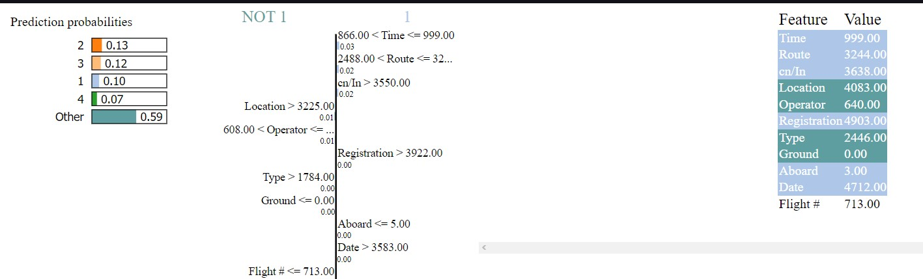

|  |  |
| --- | --- |
| Feature | Value |
| Time | 999.00 |
| Route | 3244.00 |
| cn/In | 3638.00 |
| Location | 4083.00 |
| Operator | 640.00 |
| Registration | 4903.00 |
| Type | 2446.00 |
| Ground | 0.00 |
| Aboard | 3.00 |
| Date | 4712.00 |
| Flight # | 713.00 |

The document provided is a spreadsheet displaying the outcomes of a machine learning model tasked with forecasting the likelihood of aircraft fatalities based on several variables, including aircraft type, location, and time of day. Notably, the most influential factor in predicting aircraft fatalities is the location, as denoted by its highest associated value of 0.13. This signifies that the location holds the greatest sway over the model's prognostication. Additionally, significant predictors include the time of day (0.10) and the type of aircraft (0.07). The figures within the "Prediction probabilities" column signify the probability of an aircraft fatality given specific combinations of factors. For instance, a probability of 0.13 in the initial row suggests a 13% chance of a fatality if the location corresponds to "cn/In > 3550.00". Despite its utility, it is imperative to recognize that this model's predictions may not always align with actual outcomes. Nonetheless, it serves as a valuable tool for identifying flights potentially at higher risk of accidents. Furthermore, the spreadsheet reveals additional insights, such as the secondary impact of factors like route, operator, registration, and flight date, albeit with lesser significance compared to location, time, and aircraft type. Moreover, the presence of 0.00 values in the "Ground" and "Aboard" cells indicates a null probability of fatalities when flights are grounded or devoid of passengers, respectively.

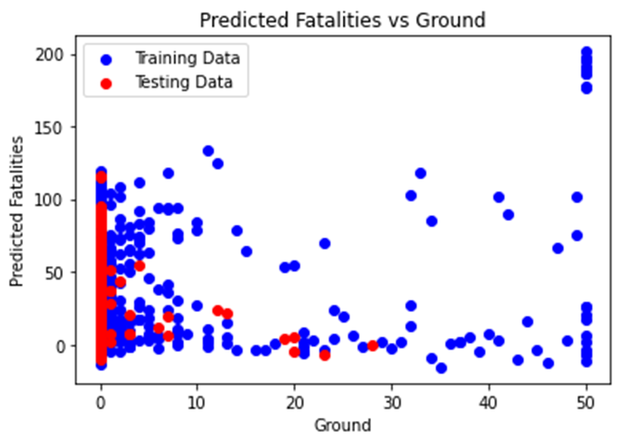

The plot provided illustrates a scatter plot depicting the disparity between predicted and actual numbers of fatalities on the ground as per a machine learning model. Each data point corresponds to a single observation from either the training or testing dataset. The proximity of the points to the diagonal line serves as an indicator of the model's prediction accuracy, with points closer to the line implying more accurate predictions. However, the scattered distribution around the diagonal suggests less precise predictions. For instance, some data points indicate a prediction of 10 fatalities, whereas the actual count stands at 30, while others show a prediction of 40 fatalities with only 10 fatalities on the ground. It's essential to acknowledge that this representation offers only a singular perspective, and the model's efficacy may fluctuate based on the dataset used. Furthermore, limitations such as differing scale axes, absence of data distribution depiction, and lack of error bars to signify prediction uncertainties underscore the necessity for additional evaluation methods to assess the model's accuracy and generalizability comprehensively.

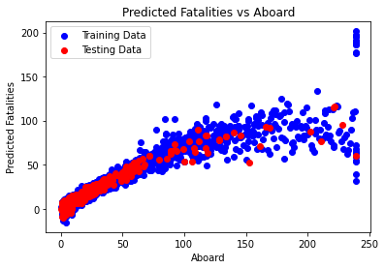

The plot provided depicts the correlation between predicted fatalities and the number of individuals on board (Aboard) for flights across two datasets: training data and testing data. The red line signifies the model's predicted fatalities, while the blue line represents the actual fatalities. Ideally, data points would align precisely along the diagonal line, indicative of flawless predictions. However, the observed dispersion around this line signifies the model's occasional inaccuracies.

Specifically, concerning the training data, a notable concentration of red points lies closer to the diagonal compared to their blue counterparts from the testing data. This discrepancy suggests a relatively superior performance of the model on the training set. Additionally, the presence of scattered points both above and below the diagonal line implies instances of both overestimation and underestimation of fatalities by the model across both datasets.

For instance, at a value of 100 individuals aboard, the model may predict 50 fatalities (red line), whereas the actual count might stand at 20 (blue line). This exemplifies the model's tendency to misestimate fatalities across the observed datasets.This shows a linear equation.

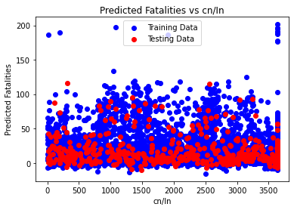

Based on the image provided, the plot illustrates the association between predicted fatalities and the number of individuals on board (cn/ln) for flights within two datasets: the training data and the testing data. The red line denotes the model's predicted fatalities, while the blue line portrays the actual fatalities. Ideally, data points would align precisely along the diagonal line, indicating flawless predictions. However, the dispersion of points around this line signifies the model's occasional inaccuracies.

Several specific observations can be gleaned from the plot. Firstly, concerning the training data, a notable concentration of red points lies closer to the diagonal line in comparison to their blue counterparts from the testing data. This discrepancy implies a relatively superior performance of the model on the training set. Additionally, the presence of scattered points both above and below the diagonal line suggests instances of both overestimation and underestimation of fatalities by the model across both datasets.

For instance, at a value of 1000 individuals on board, the model may predict 50 fatalities (red line), whereas the actual count might stand at 20 (blue line). This exemplifies the model's tendency to misestimate fatalities across the observed datasets.

In summary, while the plot suggests that the model may have the capacity to predict the number of fatalities in aircraft accidents, its accuracy is not infallible, and it may exhibit both underestimation and overestimation tendencies in certain instances. It is imperative to acknowledge that this preliminary analysis is based on a single plot, and a more comprehensive evaluation of the model's performance would be essential before drawing any definitive conclusions regarding its real-world efficacy.

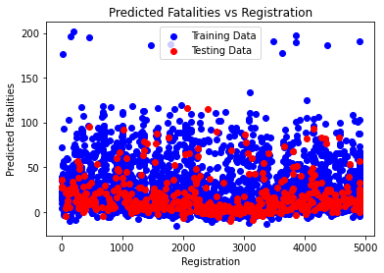

The scatter plot titled "Predicted Fatalities vs Registration" illustrates the relationship between the number of aircraft registrations and the predicted number of fatalities. Data points, representing both training and testing data, predominantly cluster within the range of 0 to approximately 150 predicted fatalities, with a higher density observed at lower levels of predicted fatalities. The x-axis denotes the quantity of aircraft registrations spanning from 0 to 5000, while the y-axis represents predicted fatalities ranging from 0 to 200. A discernible trend suggests that as the count of registrations increases, predicted fatalities remain relatively constant, albeit with a slight increase in variability. However, this interpretation provides a simplified overview, and a comprehensive analysis may entail consideration of additional intricate factors related to aircraft safety and fatality prediction.

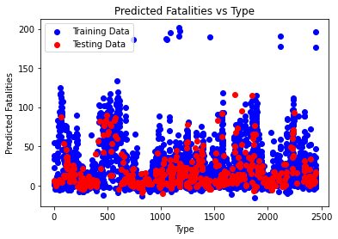

The provided scatter plot compares predicted fatalities with different types of aircraft, where the x-axis represents the "Type," likely denoting specific aircraft categories, albeit unlabeled in the provided data. The y-axis depicts "Predicted Fatalities," with two distinct sets of data represented by red and blue dots. Although the limited data hinders a precise interpretation of the relationship between the variables, it is evident that a considerable range of predicted fatalities exists across various aircraft types. Notably, certain aircraft types exhibit higher predicted fatality counts than others. However, it's imperative to recognize that these predictions are speculative, and actual fatality counts may deviate from those indicated on the plot.

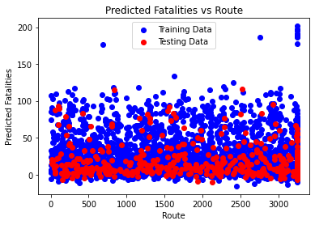

The scatter plot provided depicts a comparison between predicted fatalities and route data categorized by aircraft. The x-axis represents the routes, while the y-axis indicates the predicted fatalities. Two distinct datasets are illustrated by red and blue dots, signifying training and route data, respectively. Despite the constrained dataset, discerning a precise relationship between the variables proves challenging. Nevertheless, it is evident that a broad spectrum of predicted fatalities is observed across various routes, with certain routes exhibiting higher predicted fatality rates than others. It is crucial to emphasize that these predictions are speculative, and actual fatality counts may deviate from those indicated on the plot.

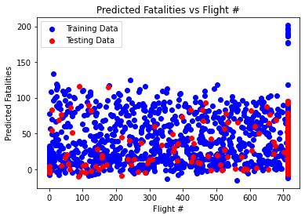

The provided scatter plot juxtaposes predicted fatalities against flight numbers, as indicated by the respective text labels on the axes. While the precise modeling context cannot be definitively discerned from the image alone, the plot seemingly showcases the outcomes of a predictive model estimating fatalities for individual flights. The x-axis denotes "Flight #," presumed to represent unique identifiers for each flight, while the y-axis signifies "Predicted Fatalities." Two distinct datasets, represented by red and blue dots, are distinguished as training and testing data, respectively, as per the text annotation atop the plot. From the available data, several observations emerge: Firstly, the predicted fatality counts appear notably higher for the training data in comparison to the testing data, hinting at potential overfitting of the model to the training dataset. This phenomenon suggests that the model may have learned specific patterns inherent in the training data, rendering it less generalizable to unseen data. Additionally, a wide variability in predicted fatalities is evident within both training and testing datasets, indicating the model's propensity to predict a diverse range of potential outcomes for each flight. Crucially, it is imperative to acknowledge that the presented predictions are speculative, and the actual fatality counts may diverge from those depicted on the plot. A thorough assessment of the model's predictive accuracy necessitates the incorporation of additional data and rigorous evaluation methodologies.

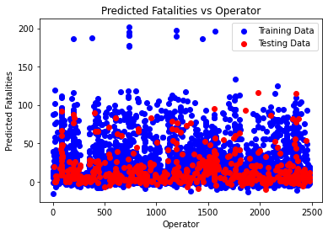

The provided scatter plot delineates a comparison between predicted fatalities and operator training data. The x-axis portrays the quantity of "Operator Training Data," while the y-axis illustrates "Predicted Fatalities." It is imperative to underscore that the displayed data merely illustrates a correlation and does not establish causation; a higher quantity of training data for a particular operator does not inherently imply a greater incidence of fatalities. Potential interpretations of the plot include a positive correlation between the volume of training data and the predicted fatality count, indicative of operators navigating more complex routes or operating in hazardous conditions. Conversely, the plot may also indicate an absence of correlation between the variables, suggesting that the amount of training data does not significantly influence the predicted fatality count. However, without comprehensive insights into the dataset and the underlying predictive model, drawing definitive conclusions regarding the relationship between operator training data and predicted fatalities remains challenging.

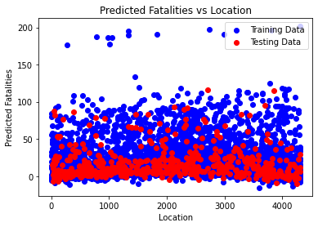

The presented scatter plot contrasts predicted fatalities with aircraft location, with the x-axis denoting location and the y-axis representing predicted fatalities. From the limited dataset provided, several observations can be inferred: Firstly, a diverse spectrum of predicted fatalities is evident across various locations, indicative of the model's propensity to anticipate a broad range of potential outcomes for each location. However, discerning a definitive relationship between location and predicted fatalities proves challenging based solely on the plot. It remains uncertain whether a clear correlation exists between these variables. Importantly, the plot underscores that the depicted predictions are speculative, and the actual fatality count may deviate from the illustrated values. Thus, comprehensive evaluation of the model's predictive accuracy necessitates the incorporation of additional data.

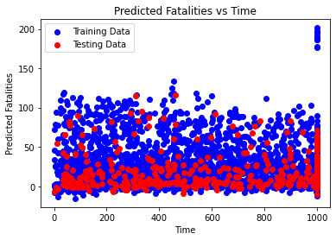

The provided plot offers a comparison of predicted fatalities between training and testing data, without specifying the aircraft type to which the data pertains. Notably, the plot represents only a limited sample of the dataset and may not adequately reflect the entire population. Observations gleaned from the plot reveal several trends: Firstly, the red line, symbolizing the expected number of fatalities, exhibits a general decreasing trend over time, implying the model's anticipation of a decline in fatalities over the observed period. Conversely, the predicted fatalities, represented by the blue line, demonstrate greater variability compared to the red line, indicating heightened uncertainty in the model's predictions. Moreover, the intermittent positioning of the blue line above and below the red line underscores the model's occasional inaccuracies in prediction. It is imperative to emphasize the importance of consulting with a qualified aviation expert to gain a comprehensive understanding of the data and the underlying model.

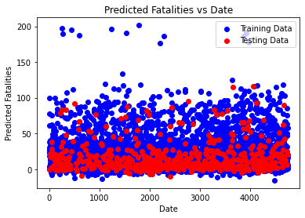

The provided scatter plot exhibits the relationship between the "Date" and "Predicted Fatalities," with the x-axis representing dates and the y-axis denoting predicted fatalities. The plot encompasses two distinct datasets. Noteworthy observations from the plot entail a subtle downward trajectory observed in the training data points, indicating the model's anticipation of a decline in fatalities over time. Similarly, the testing data points display a general downward trend, albeit with greater dispersion. However, it is crucial to highlight that the testing data points exhibit more pronounced deviations from the red line compared to the training data points, suggesting potential inaccuracies in the model's predictions when extrapolated to unseen data.

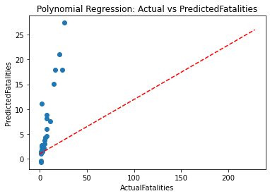

The scatter plot titled “Polynomial Regression: Actual vs Predicted Fatalities” depicts the relationship between **actual fatalities** and **predicted fatalities** related to aircraft incidents. Here are the key points:

* **Data Points**:
  + The plot contains blue dots representing individual data points.
  + These data points are primarily concentrated at the lower end of both axes (around 0-50 actual fatalities).
* **Regression Line**:
  + The red dashed line represents a **polynomial regression model**.
  + As actual fatalities increase, the prediction accuracy improves.
  + Initially, the model tends to **underestimate** fatalities, but it becomes more accurate as actual fatalities rise.
* **Axes**:
  + The x-axis represents **actual fatalities**, ranging from 0 to 200.
  + The y-axis represents **predicted fatalities**, ranging from 0 to 25.

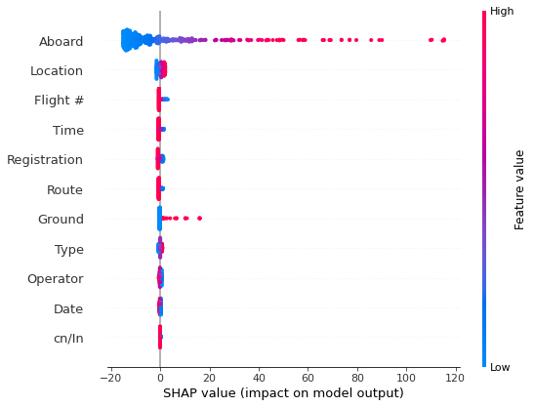

The provided plot illustrates SHAP (SHapley Additive exPlanations) values for various features utilized in an linear regression model to forecast the total energy consumption of electric vehicles. SHAP values serve to elucidate the impact of different features on the model's output. The x-axis denotes the SHAP value, with positivity indicating an augmentative effect on the model's prediction and negativity indicating a diminishing effect. Conversely, the y-axis represents the corresponding feature values, while color distinguishes different data points. The featured attributes encompass "Location," potentially denoting the geographical area of vehicle operation, "Time" possibly indicating temporal factors, "Ground" signifying terrain types, and "Type" representing vehicle categories. Notably, the plot underscores the significance of "Location," "Time," "Ground," and "Type" as pivotal predictors of energy consumption. For instance, the predominance of positive SHAP values for "Location" implies a propensity for heightened energy consumption in areas associated with higher SHAP values. It is imperative to acknowledge that the interpretation of SHAP values is contingent upon the specific dataset and model utilized, and thus necessitates a tailored approach for comprehensive understanding.

The equations provided serve several purposes in the context of analyzing fatalities in aviation incidents:

1. Prediction: These equations can predict the expected number of fatalities based on input variables such as time, location, operator, flight number, route, type of aircraft, registration details, the number of people aboard, etc. This predictive capability is valuable for risk assessment, safety planning, and emergency response preparedness.

2. Risk Assessment: By analyzing historical data and using these equations, aviation safety experts and regulatory bodies can assess the potential risks associated with different flights, routes, operators, or aircraft types. This assists in identifying high-risk factors and taking preventive measures to minimize fatalities.

3. Safety Improvement: Understanding the relationship between various factors and fatalities enables the aviation industry to focus on improving safety measures. For instance, if certain variables consistently show a higher impact on fatalities, efforts can be directed towards addressing those specific areas to enhance safety protocols.

4. Decision Support: Airlines, regulatory bodies, and policymakers can use these equations to make informed decisions regarding route planning, aircraft selection, operational policies, and safety regulations. These decisions aim to reduce the likelihood of incidents that could result in fatalities.

5. Research and Analysis: These equations also serve as a basis for further research and analysis in aviation safety. Researchers can refine these models, incorporate additional variables, or study specific factors in more detail to better understand and mitigate risks.

**PHASE-3(Interpretation of another predicted FATALITIES which might be used as input in predicting AIRCRAFT DAMAGE in part-1):**

|  |  |  |  |  |  |
| --- | --- | --- | --- | --- | --- |
| Year | Quarter | Month | Day | Country/Region | Aircraft Manufacturer |
| 1908 | Qtr 3 | September | 17 | Virginia | Wright Flyer |
| 1909 | Qtr 3 | September | 7 | France? | Wright |
| 1912 | Qtr 3 | July | 12 | New | Dirigible? |
| 1913 | Qtr 3 | August | 6 | British | Curtiss |
| 1913 | Qtr 3 | September | 9 | N/A | Zeppelin |
| 1913 | Qtr 4 | October | 17 | Germany | Zeppelin |
| 1915 | Qtr 1 | March | 5 | Belgium | Zeppelin |
| 1915 | Qtr 3 | September | 3 | Germany | Zeppelin |
| 1916 | Qtr 3 | July | 28 | Bulgeria | Schutte |
| 1916 | Qtr 3 | September | 24 | England | Zeppelin |
| 1916 | Qtr 4 | October | 1 | England | Zeppelin |
| 1916 | Qtr 4 | November | 21 | Germany | Super Zeppelin |
| 1916 | Qtr 4 | November | 28 | England | Zeppelin |
| 1917 | Qtr 1 | March | 4 | Belgium | Airship? |
| 1917 | Qtr 1 | March | 30 | N/A | Schutte |
| 1917 | Qtr 2 | May | 14 | North | Zeppelin |
| 1917 | Qtr 2 | June | 14 | North | Zeppelin |
| 1917 | Qtr 2 | June | 17 | England? | Zepplin |
| 1917 | Qtr 3 | August | 21 | N/A | Zeppelin |
| 1917 | Qtr 4 | October | 20 | France | Zeppelin |
| 1918 | Qtr 2 | April | 7 | N/A | Zeppelin |
| 1918 | Qtr 3 | August | 5 | Germany | Zeppelin |
| 1918 | Qtr 3 | August | 11 | North | Zeppelin |
| 1918 | Qtr 4 | December | 16 | New | De Havilland |
| 1919 | Qtr 2 | May | 25 | Ohio | De Havilland |
| 1919 | Qtr 3 | July | 19 | Pennsylvania | De Havilland |
| 1919 | Qtr 3 | July | 21 | Illinois | FD Type |
| 1919 | Qtr 3 | August | 2 | Italy | Caproni |
| 1919 | Qtr 4 | October | 2 | England | De Havilland |
| 1919 | Qtr 4 | October | 14 | Maryland | Curtiss |
| 1919 | Qtr 4 | October | 20 | Kent | De Havilland |
| 1919 | Qtr 4 | October | 30 | New | De Havilland |
| 1919 | Qtr 4 | December | 11 | Surrey | De Havilland |
| 1920 | Qtr 1 | March | 10 | Indiana | De Havilland |
| 1920 | Qtr 1 | March | 30 | New | De Havilland |
| 1920 | Qtr 2 | April | 10 | New | Curtiss |
| 1920 | Qtr 2 | April | 11 | New | Curtiss |
| 1920 | Qtr 2 | May | 12 | Iowa | De Havilland |
| 1920 | Qtr 2 | June | 6 | Ohio | De Havilland |
| 1920 | Qtr 3 | July | 20 | Columbia | Farman |
| 1920 | Qtr 3 | August | 16 | England | Armstrong |
| 1920 | Qtr 3 | August | 16 | Maryland | De Havilland |
| 1920 | Qtr 3 | September | 1 | New | Junkers |
| 1920 | Qtr 3 | September | 15 | Ohio | Junkers |
| 1920 | Qtr 3 | September | 27 | Pennsylvania | De Havilland |
| 1920 | Qtr 4 | October | 2 | France | Salmson |
| 1920 | Qtr 4 | October | 5 | Spain | Breguet |
| 1920 | Qtr 4 | October | 15 | Illinois | De Havilland |
| 1920 | Qtr 4 | November | 7 | Wyoming | De Havilland |

|  |  |  |
| --- | --- | --- |
| Aircraft | Location | Operator |
| Wright Flyer III? | Fort Myer Virginia | Army U.S. - Military |
| Wright ByplaneSC1 | Juvisy-sur-Orge France? | N/A |
| Dirigible? | Atlantic City New | Navy U.S. - JerseyMilitary |
| Curtiss seaplane? | Victoria British | Canada Columbia Private |
| Zeppelin L 1 (airship)? | Over the North SeaMilitary - German Navy | N/A |
| Zeppelin L 2 (airship)? | Near Johannisthal Germany | Navy German - Military |
| Zeppelin L 8 (airship)? | Tienen Belgium | Navy German - Military |
| Zeppelin L 10 (airship)? | Off Cuxhaven Germany | Navy German - Military |
| Schutte Lanz S | Near Jambol Bulgeria | Army German - Military |
| Zeppelin L 32 (airship)? | Billericay England | Navy German - Military |
| Zeppelin L 31 (airship)? | Potters Bar England | Navy German - Military |
| Super Zeppelin (airship)? | Mainz Germany | Army German - Military |
| Zeppelin L 34 (airship)? | Off West Hartlepool England | Navy German - Military |
| Airship? | Near Gent Belgium | Army German - Military |
| Schutte Lanz S | Off Northern GermanyMilitary - German Navy | N/A |
| Zeppelin L 22 (airship)? | Near Texel Island North | Navy German - SeaMilitary |
| Zeppelin L 43 (airship)? | Off Vlieland Island North | Navy German - SeaMilitary |
| Zepplin L 48 (air ship)L | Near Yarmouth England? | N/A |
| Zeppelin L 23 (airship)? | Off western DenmarkMilitary - German Navy | N/A |
| Zeppelin L 44 (airship)? | Near Luneville France | Navy German - Military |
| Zeppelin L 59 (airship)? | Over the MediterraneanMilitary - German Navy | N/A |
| Zeppelin L 70 (airship)? | Off Helgoland Island Germany | Navy German - Military |
| Zeppelin L 53 (airship)? | Ameland Island North | Navy German - SeaMilitary |
| De Havilland DH 497 | Elizabeth New | Service Mail Aerial JerseyUS |
| De Havilland DH 461 | Cleveland Ohio | Service Mail Aerial US |
| De Havilland DH 482 | Dix Run Pennsylvania | Service Mail Aerial US |
| FD Type Dirigible? | Chicago Illinois | Tire Goodyear Express Air Wingfoot |
| Caproni Ca.48? | Verona Italy | Company Caproni |
| De Havilland DH 4? | Newcastle England | Travel and Transport Aircraft |
| Curtiss R 4LM32 | Cantonsville Maryland | Service Mail Aerial US |
| De Havilland DH 4G | English Channel off Forkstone Kent | Travel and Transport Aircraft |
| De Havilland DH.477 | Long Valley New | Service Mail Aerial JerseyUS |
| De Havilland DH 4G | Catherham Surrey | UKAircraft Travel Transport |
| De Havilland DH 465 | New Paris Indiana | Service Mail Aerial US |
| De Havilland DH 472 | Newark New | Service Mail Aerial JerseyUS |
| Curtiss R 4LM49 | Newark New | Service Mail Aerial JerseyUS |
| Curtiss JN 4H44 | Heller Field New | Service Mail Aerial JerseyUS |
| De Havilland DH 479 | Oskaloosa Iowa | Service Mail Aerial US |
| De Havilland DH 4204 | Cleveland Ohio | Service Mail Aerial US |
| Farman F 40? | Cartagena Columbia | Aérea Navegación de Colombiana Compañia |
| Armstrong Whitworth F | Bedford England | Air By |
| De Havilland DH 4317 | College Park Maryland | Service Mail Aerial US |
| Junkers JL 6305 | Morristown New | Service Mail Aerial JerseyUS |
| Junkers F 13308 | Pemberville Ohio | Service Mail Aerial US |
| De Havilland DH 4316 | Hillersburg Pennsylvania | Service Mail Aerial US |
| Salmson 2 A | Off Port Vendres France | Airlines Latecoere |
| Breguet 14F ALTA | Valencia Spain | Airlines Latecoere |
| De Havilland DH 476 | Batavia Illinois | Service Mail Aerial US |
| De Havilland DH 4? | Tie Siding Wyoming | Service Mail Aerial US |

|  |  |  |
| --- | --- | --- |
| Sum of Ground | Sum of Fatalities (air) | Sum of Aboard |
| 0 | 1 | 2 |
| 0 | 1 | 1 |
| 0 | 5 | 5 |
| 0 | 1 | 1 |
| 0 | 14 | 20 |
| 0 | 28 | 28 |
| 0 | 17 | 41 |
| 0 | 19 | 19 |
| 0 | 20 | 20 |
| 0 | 22 | 22 |
| 0 | 19 | 19 |
| 0 | 27 | 28 |
| 0 | 20 | 20 |
| 0 | 20 | 20 |
| 0 | 23 | 23 |
| 0 | 21 | 21 |
| 0 | 24 | 24 |
| 0 | 14 | 16 |
| 0 | 18 | 18 |
| 0 | 18 | 18 |
| 0 | 23 | 23 |
| 0 | 22 | 22 |
| 0 | 19 | 19 |
| 0 | 1 | 1 |
| 0 | 1 | 1 |
| 0 | 1 | 1 |
| 10 | 3 | 0 |
| 0 | 14 | 14 |
| 0 | 1 | 1 |
| 0 | 1 | 1 |
| 0 | 0 | 0 |
| 0 | 1 | 1 |
| 0 | 1 | 1 |
| 0 | 1 | 1 |
| 0 | 1 | 1 |
| 0 | 1 | 2 |
| 0 | 1 | 2 |
| 0 | 1 | 2 |
| 0 | 1 | 1 |
| 0 | 1 | 1 |
| 0 | 1 | 1 |
| 0 | 1 | 1 |
| 0 | 2 | 2 |
| 0 | 2 | 2 |
| 0 | 1 | 1 |
| 0 | 2 | 2 |
| 0 | 2 | 2 |
| 0 | 1 | 1 |
| 0 | 1 | 1 |

Certainly, breaking down the columns based on the provided data:

1. Year: The year in which the aviation incident occurred.

2. Quarter: The quarter within the year when the incident took place.

3. Month: The specific month when the incident occurred.

4. Day: The day of the month when the incident occurred.

5. Country/Region: The country or region where the incident happened.

6. Aircraft Manufacturer: The company that manufactured the aircraft involved in the incident.

7. Aircraft: The specific model or type of the aircraft involved in the incident.

8. Location: The place where the incident occurred.

9. Operator: The entity or organization that operated or owned the aircraft involved in the incident.

10. Sum of Ground: The count of ground fatalities or casualties resulting from the incident.

11. Sum of Fatalities (air): The total number of fatalities onboard the aircraft.

12. Sum of Aboard: The total number of individuals (including crew and passengers) aboard the aircraft during the incident.

These columns provide details regarding the time, location, entities involved (manufacturer, operator), and casualties (both on the ground and aboard the aircraft) for various aviation incidents spanning different years, countries, and aircraft types. This information is crucial for studying historical aviation safety, understanding patterns in incidents, and identifying factors contributing to fatalities in aviation.

PREDICTED EQUATIONS :

ENCODING CATEGORICAL VARIABLE

Equation: Sum of Fatalities (air)= -4.734409719 + -1.256143916 * Quarter + 0.378578439 * Month + 0.293498924 * Day + -0.020239499 * Country/Region + -0.025999646 * Aircraft Manufacturer + 0.004670940 * Aircraft + 0.005220585 * Location + 0.004806289 * Operator + 0.552992536 * Sum of Ground + 0.641383729 * Sum of Aboard + 0.000091967 * Year^2 + -0.002210911 * Year^1*Quarter^1 + -0.002906409 * Year^1*Month^1 + 0.000375264 * Year^1*Day^1 + -0.000033801 * Year^1*Country/Region^1 + -0.000086565 * Year^1*Aircraft Manufacturer^1 + 0.000014323 * Year^1*Aircraft^1 + 0.000012915 * Year^1*Location^1 + 0.000017352 * Year^1*Operator^1 + -0.005096351 * Year^1*Sum of Ground^1 + 0.000264105 * Year^1*Sum of Aboard^1 + 0.207766397 * Quarter^2 + -0.090582774 * Quarter^1*Month^1 + -0.019157423 * Quarter^1*Day^1 + 0.002898321 * Quarter^1*Country/Region^1 + 0.005660072 * Quarter^1*Aircraft Manufacturer^1 + -0.000353540 * Quarter^1*Aircraft^1 + -0.000156953 * Quarter^1*Location^1 + 0.000209025 * Quarter^1*Operator^1 + 0.036216233 * Quarter^1*Sum of Ground^1 + -0.011895667 * Quarter^1*Sum of Aboard^1 + 0.006800480 * Month^2 + 0.002692328 * Month^1*Day^1 + -0.000486706 * Month^1*Country/Region^1 + -0.001089436 * Month^1*Aircraft Manufacturer^1 + -0.000050165 * Month^1*Aircraft^1 + 0.000065554 * Month^1*Location^1 + -0.000097930 * Month^1*Operator^1 + 0.015312184 * Month^1*Sum of Ground^1 + 0.019374297 * Month^1*Sum of Aboard^1 + -0.002259210 * Day^2 + -0.000157502 * Day^1*Country/Region^1 + 0.000480718 * Day^1*Aircraft Manufacturer^1 + -0.000123030 * Day^1*Aircraft^1 + -0.000034216 * Day^1*Location^1 + -0.000030410 * Day^1*Operator^1 + -0.002844896 * Day^1*Sum of Ground^1 + -0.000372378 * Day^1*Sum of Aboard^1 + 0.000054288 * Country/Region^2 + 0.000013725 * Country/Region^1*Aircraft Manufacturer^1 + -0.000001089 * Country/Region^1*Aircraft^1 + 0.000000446 * Country/Region^1*Location^1 + -0.000006455 * Country/Region^1*Operator^1 + 0.000174331 * Country/Region^1*Sum of Ground^1 + 0.000046936 * Country/Region^1*Sum of Aboard^1 + -0.000015053 * Aircraft Manufacturer^2 + 0.000006470 * Aircraft Manufacturer^1*Aircraft^1 + 0.000002184 * Aircraft Manufacturer^1*Location^1 + 0.000002746 * Aircraft Manufacturer^1*Operator^1 + 0.001655370 * Aircraft Manufacturer^1*Sum of Ground^1 + 0.000123509 * Aircraft Manufacturer^1*Sum of Aboard^1 + -0.000000536 * Aircraft^2 + -0.000000180 * Aircraft^1*Location^1 + -0.000000877 * Aircraft^1*Operator^1 + -0.000266110 * Aircraft^1*Sum of Ground^1 + -0.000014209 * Aircraft^1*Sum of Aboard^1 + -0.000001451 * Location^2 + -0.000000255 * Location^1*Operator^1 + -0.000021202 * Location^1*Sum of Ground^1 + 0.000041857 * Location^1*Sum of Aboard^1 + -0.000000744 * Operator^2 + -0.000107245 * Operator^1*Sum of Ground^1 + 0.000015899 * Operator^1*Sum of Aboard^1 + -0.009238076 * Sum of Ground^2 + 0.009311926 * Sum of Ground^1*Sum of Aboard^1 + -0.001869769 * Sum of Aboard^2

DEGREE-3

Equation: Sum of Fatalities (air)= 3.294252016 + -4.580268923 * Quarter + 0.269998697 * Month + 0.100622360 * Day + 0.006406774 * Country/Region + -0.115462611 * Aircraft Manufacturer + 0.008800900 * Aircraft + -0.014894548 * Location + -0.012235498 * Operator + -5.724437028 * Sum of Ground + -0.005764783 * Sum of Aboard + -0.007480034 * Year^2 + 0.007415311 * Year^1*Quarter^1 + 0.000336293 * Year^1*Month^1 + -0.007012786 * Year^1*Day^1 + -0.000671557 * Year^1*Country/Region^1 + -0.001155017 * Year^1*Aircraft Manufacturer^1 + 0.000175816 * Year^1*Aircraft^1 + -0.000014181 * Year^1*Location^1 + -0.000041746 * Year^1*Operator^1 + 0.038188129 * Year^1*Sum of Ground^1 + 0.001162823 * Year^1*Sum of Aboard^1 + 4.403521939 * Quarter^2 + -0.603633976 * Quarter^1*Month^1 + -0.320481477 * Quarter^1*Day^1 + 0.015469689 * Quarter^1*Country/Region^1 + -0.035434086 * Quarter^1*Aircraft Manufacturer^1 + 0.006081978 * Quarter^1*Aircraft^1 + 0.000722057 * Quarter^1*Location^1 + 0.000501514 * Quarter^1*Operator^1 + -1.110591295 * Quarter^1*Sum of Ground^1 + 0.025570861 * Quarter^1*Sum of Aboard^1 + 0.380593967 * Month^2 + -0.045574132 * Month^1*Day^1 + 0.000889413 * Month^1*Country/Region^1 + 0.013477635 * Month^1*Aircraft Manufacturer^1 + -0.002062547 * Month^1*Aircraft^1 + -0.000485049 * Month^1*Location^1 + -0.000415642 * Month^1*Operator^1 + -0.094551600 * Month^1*Sum of Ground^1 + -0.010663538 * Month^1*Sum of Aboard^1 + -0.005293564 * Day^2 + -0.000942899 * Day^1*Country/Region^1 + 0.001493716 * Day^1*Aircraft Manufacturer^1 + 0.000116374 * Day^1*Aircraft^1 + 0.000082569 * Day^1*Location^1 + 0.000117847 * Day^1*Operator^1 + 0.299523587 * Day^1*Sum of Ground^1 + 0.020884254 * Day^1*Sum of Aboard^1 + 0.000006937 * Country/Region^2 + 0.000411943 * Country/Region^1*Aircraft Manufacturer^1 + -0.000076449 * Country/Region^1*Aircraft^1 + 0.000010466 * Country/Region^1*Location^1 + -0.000010743 * Country/Region^1*Operator^1 + -0.006707112 * Country/Region^1*Sum of Ground^1 + -0.000369696 * Country/Region^1*Sum of Aboard^1 + -0.001047837 * Aircraft Manufacturer^2 + 0.000462863 * Aircraft Manufacturer^1*Aircraft^1 + 0.000007209 * Aircraft Manufacturer^1*Location^1 + 0.000040737 * Aircraft Manufacturer^1*Operator^1 + 0.110138424 * Aircraft Manufacturer^1*Sum of Ground^1 + -0.008915604 * Aircraft Manufacturer^1*Sum of Aboard^1 + -0.000038687 * Aircraft^2 + -0.000001908 * Aircraft^1*Location^1 + -0.000007704 * Aircraft^1*Operator^1 + -0.017185908 * Aircraft^1*Sum of Ground^1 + 0.001577146 * Aircraft^1*Sum of Aboard^1 + 0.000006700 * Location^2 + 0.000000634 * Location^1*Operator^1 + 0.001853335 * Location^1*Sum of Ground^1 + 0.000290508 * Location^1*Sum of Aboard^1 + 0.000011266 * Operator^2 + 0.003683570 * Operator^1*Sum of Ground^1 + 0.000250971 * Operator^1*Sum of Aboard^1 + -0.073184197 * Sum of Ground^2 + -0.006271632 * Sum of Ground^1*Sum of Aboard^1 + 0.001031744 * Sum of Aboard^2 + 0.000034412 * Year^3 + -0.000138101 * Year^2*Quarter^1 + -0.000001537 * Year^2*Month^1 + 0.000043304 * Year^2*Day^1 + 0.000001791 * Year^2*Country/Region^1 + 0.000011501 * Year^2*Aircraft Manufacturer^1 + -0.000001977 * Year^2*Aircraft^1 + 0.000000054 * Year^2*Location^1 + 0.000000214 * Year^2*Operator^1 + -0.000431995 * Year^2*Sum of Ground^1 + -0.000027198 * Year^2*Sum of Aboard^1 + 0.001035408 * Year^1*Quarter^2 + 0.003963009 * Year^1*Quarter^1*Month^1 + 0.000828436 * Year^1*Quarter^1*Day^1 + -0.000062146 * Year^1*Quarter^1*Country/Region^1 + 0.000034098 * Year^1*Quarter^1*Aircraft Manufacturer^1 + -0.000017214 * Year^1*Quarter^1*Aircraft^1 + 0.000003229 * Year^1*Quarter^1*Location^1 + 0.000003399 * Year^1*Quarter^1*Operator^1 + -0.000971659 * Year^1*Quarter^1*Sum of Ground^1 + -0.000338560 * Year^1*Quarter^1*Sum of Aboard^1 + -0.000840231 * Year^1*Month^2 + -0.000219622 * Year^1*Month^1*Day^1 + 0.000025184 * Year^1*Month^1*Country/Region^1 + 0.000040499 * Year^1*Month^1*Aircraft Manufacturer^1 + -0.000006951 * Year^1*Month^1*Aircraft^1 + 0.000001498 * Year^1*Month^1*Location^1 + -0.000001908 * Year^1*Month^1*Operator^1 + 0.007953058 * Year^1*Month^1*Sum of Ground^1 + -0.000240228 * Year^1*Month^1*Sum of Aboard^1 + -0.000087053 * Year^1*Day^2 + 0.000011276 * Year^1*Day^1*Country/Region^1 + 0.000012420 * Year^1*Day^1*Aircraft Manufacturer^1 + -0.000003065 * Year^1*Day^1*Aircraft^1 + 0.000000586 * Year^1*Day^1*Location^1 + 0.000000026 * Year^1*Day^1*Operator^1 + -0.002084671 * Year^1*Day^1*Sum of Ground^1 + 0.000071313 * Year^1*Day^1*Sum of Aboard^1 + 0.000000486 * Year^1*Country/Region^2 + -0.000000868 * Year^1*Country/Region^1*Aircraft Manufacturer^1 + 0.000000213 * Year^1*Country/Region^1*Aircraft^1 + -0.000000138 * Year^1*Country/Region^1*Location^1 + 0.000000099 * Year^1*Country/Region^1*Operator^1 + 0.000100125 * Year^1*Country/Region^1*Sum of Ground^1 + -0.000002119 * Year^1*Country/Region^1*Sum of Aboard^1 + -0.000002505 * Year^1*Aircraft Manufacturer^2 + 0.000000547 * Year^1*Aircraft Manufacturer^1*Aircraft^1 + -0.000000132 * Year^1*Aircraft Manufacturer^1*Location^1 + 0.000000001 * Year^1*Aircraft Manufacturer^1*Operator^1 + 0.000337039 * Year^1*Aircraft Manufacturer^1*Sum of Ground^1 + 0.000002264 * Year^1*Aircraft Manufacturer^1*Sum of Aboard^1 + -0.000000019 * Year^1*Aircraft^2 + 0.000000027 * Year^1*Aircraft^1*Location^1 + 0.000000017 * Year^1*Aircraft^1*Operator^1 + -0.000052199 * Year^1*Aircraft^1*Sum of Ground^1 + -0.000000151 * Year^1*Aircraft^1*Sum of Aboard^1 + 0.000000001 * Year^1*Location^2 + 0.000000002 * Year^1*Location^1*Operator^1 + 0.000000397 * Year^1*Location^1*Sum of Ground^1 + 0.000000661 * Year^1*Location^1*Sum of Aboard^1 + -0.000000018 * Year^1*Operator^2 + -0.000014677 * Year^1*Operator^1*Sum of Ground^1 + 0.000000592 * Year^1*Operator^1*Sum of Aboard^1 + 0.001002758 * Year^1*Sum of Ground^2 + -0.000656386 * Year^1*Sum of Ground^1*Sum of Aboard^1 + 0.000022221 * Year^1*Sum of Aboard^2 + -0.868813882 * Quarter^3 + -0.152253411 * Quarter^2*Month^1 + 0.037182582 * Quarter^2*Day^1 + -0.000883406 * Quarter^2*Country/Region^1 + -0.001090994 * Quarter^2*Aircraft Manufacturer^1 + -0.000120292 * Quarter^2*Aircraft^1 + 0.000349801 * Quarter^2*Location^1 + -0.000014246 * Quarter^2*Operator^1 + 0.066740048 * Quarter^2*Sum of Ground^1 + -0.013915159 * Quarter^2*Sum of Aboard^1 + 0.051084280 * Quarter^1*Month^2 + 0.012618072 * Quarter^1*Month^1*Day^1 + 0.000146208 * Quarter^1*Month^1*Country/Region^1 + 0.001951011 * Quarter^1*Month^1*Aircraft Manufacturer^1 + -0.000297899 * Quarter^1*Month^1*Aircraft^1 + -0.000122508 * Quarter^1*Month^1*Location^1 + 0.000146064 * Quarter^1*Month^1*Operator^1 + 0.065948167 * Quarter^1*Month^1*Sum of Ground^1 + 0.004872553 * Quarter^1*Month^1*Sum of Aboard^1 + 0.000064788 * Quarter^1*Day^2 + 0.000118282 * Quarter^1*Day^1*Country/Region^1 + 0.001345371 * Quarter^1*Day^1*Aircraft Manufacturer^1 + -0.000223530 * Quarter^1*Day^1*Aircraft^1 + 0.000024994 * Quarter^1*Day^1*Location^1 + 0.000044066 * Quarter^1*Day^1*Operator^1 + 0.041801090 * Quarter^1*Day^1*Sum of Ground^1 + -0.001019474 * Quarter^1*Day^1*Sum of Aboard^1 + -0.000019994 * Quarter^1*Country/Region^2 + 0.000025088 * Quarter^1*Country/Region^1*Aircraft Manufacturer^1 + -0.000003990 * Quarter^1*Country/Region^1*Aircraft^1 + -0.000001557 * Quarter^1*Country/Region^1*Location^1 + -0.000000905 * Quarter^1*Country/Region^1*Operator^1 + 0.003974810 * Quarter^1*Country/Region^1*Sum of Ground^1 + 0.000216361 * Quarter^1*Country/Region^1*Sum of Aboard^1 + -0.000019187 * Quarter^1*Aircraft Manufacturer^2 + 0.000002685 * Quarter^1*Aircraft Manufacturer^1*Aircraft^1 + -0.000001936 * Quarter^1*Aircraft Manufacturer^1*Location^1 + -0.000006423 * Quarter^1*Aircraft Manufacturer^1*Operator^1 + -0.014564702 * Quarter^1*Aircraft Manufacturer^1*Sum of Ground^1 + 0.001135942 * Quarter^1*Aircraft Manufacturer^1*Sum of Aboard^1 + 0.000000350 * Quarter^1*Aircraft^2 + 0.000000172 * Quarter^1*Aircraft^1*Location^1 + 0.000000975 * Quarter^1*Aircraft^1*Operator^1 + 0.002015200 * Quarter^1*Aircraft^1*Sum of Ground^1 + -0.000152619 * Quarter^1*Aircraft^1*Sum of Aboard^1 + -0.000000013 * Quarter^1*Location^2 + -0.000000170 * Quarter^1*Location^1*Operator^1 + 0.000116774 * Quarter^1*Location^1*Sum of Ground^1 + -0.000050355 * Quarter^1*Location^1*Sum of Aboard^1 + -0.000000482 * Quarter^1*Operator^2 + -0.000120916 * Quarter^1*Operator^1*Sum of Ground^1 + 0.000009924 * Quarter^1*Operator^1*Sum of Aboard^1 + -0.018230827 * Quarter^1*Sum of Ground^2 + -0.005637508 * Quarter^1*Sum of Ground^1*Sum of Aboard^1 + 0.000090344 * Quarter^1*Sum of Aboard^2 + -0.032650811 * Month^3 + 0.000122163 * Month^2*Day^1 + -0.000162422 * Month^2*Country/Region^1 + -0.000564057 * Month^2*Aircraft Manufacturer^1 + 0.000131095 * Month^2*Aircraft^1 + 0.000051163 * Month^2*Location^1 + -0.000005403 * Month^2*Operator^1 + -0.031662529 * Month^2*Sum of Ground^1 + 0.000246539 * Month^2*Sum of Aboard^1 + 0.002404666 * Month^1*Day^2 + 0.000002225 * Month^1*Day^1*Country/Region^1 + -0.000235589 * Month^1*Day^1*Aircraft Manufacturer^1 + 0.000031554 * Month^1*Day^1*Aircraft^1 + -0.000011234 * Month^1*Day^1*Location^1 + -0.000027097 * Month^1*Day^1*Operator^1 + -0.004676736 * Month^1*Day^1*Sum of Ground^1 + 0.001144117 * Month^1*Day^1*Sum of Aboard^1 + -0.000000981 * Month^1*Country/Region^2 + -0.000003319 * Month^1*Country/Region^1*Aircraft Manufacturer^1 + 0.000000553 * Month^1*Country/Region^1*Aircraft^1 + -0.000000031 * Month^1*Country/Region^1*Location^1 + 0.000000389 * Month^1*Country/Region^1*Operator^1 + 0.000109908 * Month^1*Country/Region^1*Sum of Ground^1 + -0.000026400 * Month^1*Country/Region^1*Sum of Aboard^1 + 0.000013480 * Month^1*Aircraft Manufacturer^2 + -0.000003944 * Month^1*Aircraft Manufacturer^1*Aircraft^1 + -0.000001423 * Month^1*Aircraft Manufacturer^1*Location^1 + -0.000001569 * Month^1*Aircraft Manufacturer^1*Operator^1 + 0.000827168 * Month^1*Aircraft Manufacturer^1*Sum of Ground^1 + -0.000105432 * Month^1*Aircraft Manufacturer^1*Sum of Aboard^1 + 0.000000156 * Month^1*Aircraft^2 + 0.000000318 * Month^1*Aircraft^1*Location^1 + 0.000000306 * Month^1*Aircraft^1*Operator^1 + -0.000306167 * Month^1*Aircraft^1*Sum of Ground^1 + 0.000003937 * Month^1*Aircraft^1*Sum of Aboard^1 + -0.000000042 * Month^1*Location^2 + 0.000000119 * Month^1*Location^1*Operator^1 + -0.000112693 * Month^1*Location^1*Sum of Ground^1 + 0.000008191 * Month^1*Location^1*Sum of Aboard^1 + 0.000000097 * Month^1*Operator^2 + 0.000146881 * Month^1*Operator^1*Sum of Ground^1 + -0.000006333 * Month^1*Operator^1*Sum of Aboard^1 + -0.002513600 * Month^1*Sum of Ground^2 + 0.006028598 * Month^1*Sum of Ground^1*Sum of Aboard^1 + 0.000198912 * Month^1*Sum of Aboard^2 + 0.000103938 * Day^3 + 0.000009175 * Day^2*Country/Region^1 + -0.000040214 * Day^2*Aircraft Manufacturer^1 + -0.000001822 * Day^2*Aircraft^1 + 0.000002065 * Day^2*Location^1 + 0.000000697 * Day^2*Operator^1 + -0.004592576 * Day^2*Sum of Ground^1 + -0.000223347 * Day^2*Sum of Aboard^1 + 0.000002414 * Day^1*Country/Region^2 + 0.000001763 * Day^1*Country/Region^1*Aircraft Manufacturer^1 + -0.000000460 * Day^1*Country/Region^1*Aircraft^1 + -0.000000136 * Day^1*Country/Region^1*Location^1 + -0.000000199 * Day^1*Country/Region^1*Operator^1 + -0.000349419 * Day^1*Country/Region^1*Sum of Ground^1 + -0.000028529 * Day^1*Country/Region^1*Sum of Aboard^1 + 0.000003382 * Day^1*Aircraft Manufacturer^2 + -0.000001581 * Day^1*Aircraft Manufacturer^1*Aircraft^1 + -0.000000233 * Day^1*Aircraft Manufacturer^1*Location^1 + -0.000000875 * Day^1*Aircraft Manufacturer^1*Operator^1 + -0.002488373 * Day^1*Aircraft Manufacturer^1*Sum of Ground^1 + 0.000088568 * Day^1*Aircraft Manufacturer^1*Sum of Aboard^1 + 0.000000156 * Day^1*Aircraft^2 + 0.000000089 * Day^1*Aircraft^1*Location^1 + 0.000000155 * Day^1*Aircraft^1*Operator^1 + 0.000447339 * Day^1*Aircraft^1*Sum of Ground^1 + -0.000016390 * Day^1*Aircraft^1*Sum of Aboard^1 + -0.000000039 * Day^1*Location^2 + 0.000000017 * Day^1*Location^1*Operator^1 + -0.000011027 * Day^1*Location^1*Sum of Ground^1 + -0.000003642 * Day^1*Location^1*Sum of Aboard^1 + -0.000000013 * Day^1*Operator^2 + -0.000074667 * Day^1*Operator^1*Sum of Ground^1 + -0.000002208 * Day^1*Operator^1*Sum of Aboard^1 + 0.005139088 * Day^1*Sum of Ground^2 + -0.000203265 * Day^1*Sum of Ground^1*Sum of Aboard^1 + -0.000014645 * Day^1*Sum of Aboard^2 + -0.000000066 * Country/Region^3 + -0.000000219 * Country/Region^2*Aircraft Manufacturer^1 + 0.000000020 * Country/Region^2*Aircraft^1 + -0.000000002 * Country/Region^2*Location^1 + 0.000000013 * Country/Region^2*Operator^1 + 0.000020562 * Country/Region^2*Sum of Ground^1 + 0.000002592 * Country/Region^2*Sum of Aboard^1 + -0.000000495 * Country/Region^1*Aircraft Manufacturer^2 + 0.000000060 * Country/Region^1*Aircraft Manufacturer^1*Aircraft^1 + -0.000000020 * Country/Region^1*Aircraft Manufacturer^1*Location^1 + -0.000000060 * Country/Region^1*Aircraft Manufacturer^1*Operator^1 + -0.000061997 * Country/Region^1*Aircraft Manufacturer^1*Sum of Ground^1 + -0.000002465 * Country/Region^1*Aircraft Manufacturer^1*Sum of Aboard^1 + 0.000000009 * Country/Region^1*Aircraft^2 + 0.000000001 * Country/Region^1*Aircraft^1*Location^1 + 0.000000010 * Country/Region^1*Aircraft^1*Operator^1 + 0.000005828 * Country/Region^1*Aircraft^1*Sum of Ground^1 + 0.000000460 * Country/Region^1*Aircraft^1*Sum of Aboard^1 + 0.000000001 * Country/Region^1*Location^2 + 0.000000000 * Country/Region^1*Location^1*Operator^1 + -0.000001171 * Country/Region^1*Location^1*Sum of Ground^1 + 0.000000105 * Country/Region^1*Location^1*Sum of Aboard^1 + 0.000000003 * Country/Region^1*Operator^2 + -0.000002179 * Country/Region^1*Operator^1*Sum of Ground^1 + -0.000000412 * Country/Region^1*Operator^1*Sum of Aboard^1 + -0.000050635 * Country/Region^1*Sum of Ground^2 + -0.000010941 * Country/Region^1*Sum of Ground^1*Sum of Aboard^1 + -0.000002626 * Country/Region^1*Sum of Aboard^2 + 0.000001041 * Aircraft Manufacturer^3 + 0.000000063 * Aircraft Manufacturer^2*Aircraft^1 + -0.000000070 * Aircraft Manufacturer^2*Location^1 + -0.000000104 * Aircraft Manufacturer^2*Operator^1 + 0.000054559 * Aircraft Manufacturer^2*Sum of Ground^1 + 0.000006773 * Aircraft Manufacturer^2*Sum of Aboard^1 + -0.000000110 * Aircraft Manufacturer^1*Aircraft^2 + 0.000000013 * Aircraft Manufacturer^1*Aircraft^1*Location^1 + 0.000000013 * Aircraft Manufacturer^1*Aircraft^1*Operator^1 + -0.000028216 * Aircraft Manufacturer^1*Aircraft^1*Sum of Ground^1 + -0.000000369 * Aircraft Manufacturer^1*Aircraft^1*Sum of Aboard^1 + 0.000000003 * Aircraft Manufacturer^1*Location^2 + 0.000000003 * Aircraft Manufacturer^1*Location^1*Operator^1 + -0.000017074 * Aircraft Manufacturer^1*Location^1*Sum of Ground^1 + 0.000001667 * Aircraft Manufacturer^1*Location^1*Sum of Aboard^1 + 0.000000008 * Aircraft Manufacturer^1*Operator^2 + 0.000008472 * Aircraft Manufacturer^1*Operator^1*Sum of Ground^1 + 0.000001307 * Aircraft Manufacturer^1*Operator^1*Sum of Aboard^1 + -0.001163173 * Aircraft Manufacturer^1*Sum of Ground^2 + -0.000039880 * Aircraft Manufacturer^1*Sum of Ground^1*Sum of Aboard^1 + -0.000018366 * Aircraft Manufacturer^1*Sum of Aboard^2 + 0.000000010 * Aircraft^3 + -0.000000000 * Aircraft^2*Location^1 + 0.000000001 * Aircraft^2*Operator^1 + 0.000003421 * Aircraft^2*Sum of Ground^1 + -0.000000174 * Aircraft^2*Sum of Aboard^1 + -0.000000001 * Aircraft^1*Location^2 + -0.000000000 * Aircraft^1*Location^1*Operator^1 + 0.000002561 * Aircraft^1*Location^1*Sum of Ground^1 + -0.000000239 * Aircraft^1*Location^1*Sum of Aboard^1 + -0.000000002 * Aircraft^1*Operator^2 + -0.000000681 * Aircraft^1*Operator^1*Sum of Ground^1 + -0.000000209 * Aircraft^1*Operator^1*Sum of Aboard^1 + 0.000170815 * Aircraft^1*Sum of Ground^2 + 0.000015892 * Aircraft^1*Sum of Ground^1*Sum of Aboard^1 + 0.000002793 * Aircraft^1*Sum of Aboard^2 + -0.000000001 * Location^3 + -0.000000000 * Location^2*Operator^1 + 0.000000092 * Location^2*Sum of Ground^1 + -0.000000071 * Location^2*Sum of Aboard^1 + -0.000000001 * Location^1*Operator^2 + -0.000000824 * Location^1*Operator^1*Sum of Ground^1 + 0.000000011 * Location^1*Operator^1*Sum of Aboard^1 + 0.000015504 * Location^1*Sum of Ground^2 + -0.000005638 * Location^1*Sum of Ground^1*Sum of Aboard^1 + 0.000000158 * Location^1*Sum of Aboard^2 + -0.000000002 * Operator^3 + -0.000000814 * Operator^2*Sum of Ground^1 + -0.000000023 * Operator^2*Sum of Aboard^1 + 0.000059453 * Operator^1*Sum of Ground^2 + -0.000014182 * Operator^1*Sum of Ground^1*Sum of Aboard^1 + -0.000000432 * Operator^1*Sum of Aboard^2 + -0.001668861 * Sum of Ground^3 + -0.000392810 * Sum of Ground^2*Sum of Aboard^1 + 0.000562835 * Sum of Ground^1*Sum of Aboard^2 + -0.000015978 * Sum of Aboard^3

PREDICTED EQUATIONS WITH ML ENCODING EVERY VALUE

Linear Equation: Sum of Fatalities (air)= (1.0) * Year + (1.0) * Quarter + (1.0) * Month + (-1.0) * Day + (-1.0) * Location + (1.0) * Sum of Ground + (-0.02)

coefficient [-8.53400223e-01 -1.70763598e-01 2.09526425e-01

-2.45828910e-02 -5.18049580e-02 8.01113672e-03 5.03393197e-03

2.96966741e-03 5.14995542e-01 6.23008266e-01 2.34086671e-04

-5.18813920e-03 -1.61670281e-03 3.69019188e-04 -3.66231242e-05

-5.91494973e-06 2.74794246e-06 8.42002072e-06 1.63364078e-05

-3.59050424e-03 6.35029664e-04 1.38187638e-01 -9.39468886e-02

-1.04953327e-02 2.19459420e-03 5.97804372e-03 -5.18946703e-04

-1.71923410e-04 2.38541665e-04 4.19734878e-02 -6.58568159e-03

2.24588099e-02 9.20211293e-03 1.55794921e-04 -6.70416732e-04

-7.62516891e-05 9.84889506e-05 -1.32131248e-04 1.80812047e-02

1.75104896e-02 -2.09831976e-03 -1.00194162e-04 5.42645945e-04

-1.32657248e-04 -3.99603783e-05 -6.72665096e-06 -4.86540417e-03

-3.95145346e-04 4.51693464e-05 3.81420222e-06 1.14340862e-06

1.07966077e-06 -4.55587546e-06 1.04057546e-04 1.24165294e-04

1.44024150e-05 2.79657858e-06 2.75634104e-06 5.49693492e-06

1.73019040e-03 2.79588994e-04 -8.64459666e-07 -1.87898445e-07

-8.09157741e-07 -2.67973719e-04 -3.68294136e-05 -1.40615342e-06

-3.40480851e-07 -6.66089954e-06 4.18735419e-05 -4.78800424e-07

-1.25994302e-04 9.34574966e-06 -1.03780039e-02 8.29538444e-03

-1.91296555e-03]

intercept 0.09491632448741782

Equation: Sum of Fatalities (air)= 0.094916324 + -0.853400223 * Quarter + -0.170763598 * Month + 0.209526425 * Day + -0.024582891 * Country/Region + -0.051804958 * Aircraft Manufacturer + 0.008011137 * Aircraft + 0.005033932 * Location + 0.002969667 * Operator + 0.514995542 * Sum of Ground + 0.623008266 * Sum of Aboard + 0.000234087 * Year^2 + -0.005188139 * Year^1*Quarter^1 + -0.001616703 * Year^1*Month^1 + 0.000369019 * Year^1*Day^1 + -0.000036623 * Year^1*Country/Region^1 + -0.000005915 * Year^1*Aircraft Manufacturer^1 + 0.000002748 * Year^1*Aircraft^1 + 0.000008420 * Year^1*Location^1 + 0.000016336 * Year^1*Operator^1 + -0.003590504 * Year^1*Sum of Ground^1 + 0.000635030 * Year^1*Sum of Aboard^1 + 0.138187638 * Quarter^2 + -0.093946889 * Quarter^1*Month^1 + -0.010495333 * Quarter^1*Day^1 + 0.002194594 * Quarter^1*Country/Region^1 + 0.005978044 * Quarter^1*Aircraft Manufacturer^1 + -0.000518947 * Quarter^1*Aircraft^1 + -0.000171923 * Quarter^1*Location^1 + 0.000238542 * Quarter^1*Operator^1 + 0.041973488 * Quarter^1*Sum of Ground^1 + -0.006585682 * Quarter^1*Sum of Aboard^1 + 0.022458810 * Month^2 + 0.009202113 * Month^1*Day^1 + 0.000155795 * Month^1*Country/Region^1 + -0.000670417 * Month^1*Aircraft Manufacturer^1 + -0.000076252 * Month^1*Aircraft^1 + 0.000098489 * Month^1*Location^1 + -0.000132131 * Month^1*Operator^1 + 0.018081205 * Month^1*Sum of Ground^1 + 0.017510490 * Month^1*Sum of Aboard^1 + -0.002098320 * Day^2 + -0.000100194 * Day^1*Country/Region^1 + 0.000542646 * Day^1*Aircraft Manufacturer^1 + -0.000132657 * Day^1*Aircraft^1 + -0.000039960 * Day^1*Location^1 + -0.000006727 * Day^1*Operator^1 + -0.004865404 * Day^1*Sum of Ground^1 + -0.000395145 * Day^1*Sum of Aboard^1 + 0.000045169 * Country/Region^2 + 0.000003814 * Country/Region^1*Aircraft Manufacturer^1 + 0.000001143 * Country/Region^1*Aircraft^1 + 0.000001080 * Country/Region^1*Location^1 + -0.000004556 * Country/Region^1*Operator^1 + 0.000104058 * Country/Region^1*Sum of Ground^1 + 0.000124165 * Country/Region^1*Sum of Aboard^1 + 0.000014402 * Aircraft Manufacturer^2 + 0.000002797 * Aircraft Manufacturer^1*Aircraft^1 + 0.000002756 * Aircraft Manufacturer^1*Location^1 + 0.000005497 * Aircraft Manufacturer^1*Operator^1 + 0.001730190 * Aircraft Manufacturer^1*Sum of Ground^1 + 0.000279589 * Aircraft Manufacturer^1*Sum of Aboard^1 + -0.000000864 * Aircraft^2 + -0.000000188 * Aircraft^1*Location^1 + -0.000000809 * Aircraft^1*Operator^1 + -0.000267974 * Aircraft^1*Sum of Ground^1 + -0.000036829 * Aircraft^1*Sum of Aboard^1 + -0.000001406 * Location^2 + -0.000000340 * Location^1*Operator^1 + -0.000006661 * Location^1*Sum of Ground^1 + 0.000041874 * Location^1*Sum of Aboard^1 + -0.000000479 * Operator^2 + -0.000125994 * Operator^1*Sum of Ground^1 + 0.000009346 * Operator^1*Sum of Aboard^1 + -0.010378004 * Sum of Ground^2 + 0.008295384 * Sum of Ground^1*Sum of Aboard^1 + -0.001912966 * Sum of Aboard^2

Accuracy: 0.6990919917359075

DEGREE-3:

coefficient [ 5.06181327e-01 -9.10605188e+00 -1.81702954e+00 -1.22383584e-01

-2.74864723e-03 -8.47377723e-03 -4.76076700e-03 -1.07950165e-02

-8.73466483e-03 -1.02134728e+01 -1.36261164e-01 -6.90136907e-03

-2.23191570e-03 9.25721065e-03 -6.92420005e-03 -5.73726765e-04

-6.12812876e-04 9.39622986e-05 -1.70468127e-05 5.04557167e-06

6.42964899e-02 1.24339230e-03 6.69367738e+00 -2.49034703e-01

-1.96860120e-01 1.32044391e-02 -4.42419523e-02 7.01339657e-03

4.85898196e-04 8.25174712e-04 -1.21627107e+00 -4.34034018e-03

5.99798332e-01 -6.38431866e-02 1.58103477e-03 1.54563559e-02

-2.36486853e-03 -8.08219905e-04 -1.33542935e-04 4.89141768e-01

4.15494599e-02 2.78169892e-04 1.87585916e-04 -2.05677191e-03

5.09508006e-04 1.22665456e-04 2.33547675e-04 3.16371383e-01

2.08186168e-02 -3.19720497e-06 1.00074140e-04 -1.70860740e-05

1.49405861e-05 -1.73487206e-05 6.60595078e-03 -7.65199738e-04

-6.43377072e-04 3.15502960e-04 -1.74451095e-05 1.53915936e-05

1.04707815e-01 -7.75792798e-03 -2.66906091e-05 9.71487214e-07

-4.51903031e-06 -1.52858871e-02 1.40730610e-03 5.49428506e-06

1.60269464e-07 1.42236935e-03 2.95354570e-04 9.13048550e-06

3.27502724e-03 1.78294777e-04 -6.66441123e-02 -3.09295001e-03

2.61517519e-03 3.53489393e-05 -3.04353123e-05 2.17055506e-05

3.79784610e-05 2.57302810e-06 7.96253787e-06 -1.44197195e-06

-7.15637382e-08 -4.03099331e-07 -1.75227989e-04 -1.21898542e-05

5.63395421e-03 1.54831614e-03 3.55967516e-04 -2.95325953e-05

4.07997312e-06 -4.57931830e-06 3.83528670e-06 -1.30889132e-06

1.01277684e-03 -9.40730789e-04 -1.16508758e-03 -1.82107422e-04

1.44695650e-05 3.02991244e-05 -6.15158768e-06 1.47536413e-06

-2.86173965e-06 1.23973318e-03 -7.40618697e-05 -5.78333460e-05

4.61986141e-06 5.61748666e-06 -1.34410972e-06 6.92508230e-07

-1.38728832e-07 -1.90586937e-03 1.14773478e-04 5.49941354e-07

-7.46361700e-07 1.68366784e-07 -1.08058423e-07 8.55540813e-08

7.60225513e-06 -1.04148186e-05 -2.63750051e-06 6.05696610e-07

-1.46987438e-07 -4.12541901e-08 -9.17192327e-04 1.22917197e-05

-2.07047099e-08 2.54003357e-08 1.83224384e-08 1.41267056e-04

-2.42855749e-06 3.92159816e-09 6.48719628e-09 8.70080087e-06

4.53401921e-07 -8.53064447e-09 -1.24496351e-05 1.65013679e-06

8.09327747e-04 -8.94253085e-04 1.96910730e-05 -1.00603007e+00

-1.90518156e-01 2.54268904e-03 -5.35078421e-04 -1.17396718e-03

-2.65420871e-04 1.68851490e-04 -1.94968210e-04 8.71320196e-02

-2.16117683e-02 9.95961727e-03 1.42103330e-02 -1.33821972e-04

1.86885233e-03 -2.08776178e-04 -1.29471027e-05 1.94995766e-04

-5.83996601e-02 6.56900785e-03 1.11415763e-03 -1.31228916e-05

1.10702533e-03 -1.90037547e-04 7.56834994e-06 4.76422777e-05

3.31153163e-02 7.69212466e-04 -1.67650867e-05 3.19326875e-05

-4.22703450e-06 -1.94873134e-06 -8.52112120e-07 2.96681925e-03

1.98822432e-04 -7.33805606e-05 1.81698027e-05 -1.13580368e-06

-7.36034050e-07 1.56962481e-04 1.47317211e-03 -6.70202307e-07

1.56957797e-08 1.33083891e-07 1.80753759e-04 -2.09372095e-04

7.25691225e-08 -2.60219496e-07 2.09139059e-04 -2.95020013e-05

-4.70091250e-07 -7.91881858e-05 2.58308557e-05 -1.13383167e-02

-6.18229685e-03 1.49905204e-04 -3.29328805e-02 3.43857376e-04

-4.73948552e-05 -5.99710323e-04 1.03752964e-04 4.26835318e-05

-3.40573161e-05 1.10399320e-02 -2.81843557e-03 2.36221183e-03

6.15361191e-05 -3.01776377e-04 3.89352181e-05 -5.37337580e-06

-2.72985868e-05 -1.17320141e-03 6.39143900e-04 -2.55458632e-06

-3.21556530e-06 3.27322617e-07 7.13857428e-08 1.67206606e-07

5.07434566e-04 -4.99847086e-05 5.67594398e-06 -2.70487295e-06

-1.14084681e-06 -8.70885075e-07 7.72063077e-04 -9.52730010e-05

2.46902476e-07 2.98906913e-07 2.00198995e-07 -4.09032088e-04

2.28595101e-06 -3.25680889e-08 1.46777649e-07 -1.09827247e-04

5.86949837e-06 1.03777379e-07 2.39360374e-05 -7.12220950e-06

-1.25574701e-02 5.98972874e-03 1.24002435e-04 3.81741678e-04

-3.45794033e-06 3.64847202e-05 -1.72768352e-05 -1.07094473e-06

-1.41112212e-06 -5.58814251e-03 -3.50991783e-04 7.61928827e-07

3.82626770e-06 -6.75884111e-07 -1.07547880e-07 -2.83082247e-07

-2.92541866e-04 -1.93446976e-05 -8.84477104e-06 1.29638635e-06

4.26264461e-07 -2.37602339e-08 -1.89952378e-03 1.29470563e-04

5.71898164e-08 1.26038671e-09 2.93748925e-08 3.49376352e-04

-2.12661812e-05 -4.98833414e-08 2.74377516e-08 -1.55561272e-05

-2.18807336e-06 -3.70768415e-08 -3.61722894e-05 -2.16451925e-06

2.12805169e-03 -9.14761126e-04 -8.58709306e-05 -6.08445838e-08

-2.40586902e-08 -2.02652295e-09 -1.02890403e-08 1.72150981e-08

-1.76351184e-05 4.09458048e-06 -1.33005250e-07 2.05968663e-08

-1.68602264e-08 -2.92113744e-08 5.00533800e-05 -4.30797037e-06

1.94471420e-09 -8.70820993e-10 6.97058650e-09 -9.71175065e-06

6.52879578e-07 1.03422521e-09 1.05758372e-09 -2.97162166e-06

1.23236383e-07 3.74768538e-09 8.37859836e-07 -3.97978179e-07

2.25222025e-04 3.10430133e-05 -5.17084780e-07 3.59043932e-07

2.60435719e-07 -4.47112162e-08 -1.09280274e-07 -7.96552288e-05

9.50848610e-06 -1.16532447e-07 9.06041081e-09 1.85779734e-08

2.67874584e-05 -1.42342205e-06 2.32413153e-09 6.40143982e-09

-1.16102139e-05 1.42144663e-06 2.51122967e-09 -9.11910637e-06

9.11748029e-07 -1.16806254e-03 -1.92600442e-04 -3.07218086e-05

8.51905213e-09 -1.82608817e-10 -2.32520669e-11 -2.19722941e-06

-5.85713911e-08 -4.42877734e-10 -5.28765920e-10 1.73624116e-06

-2.00350493e-07 -8.25042701e-10 1.75629982e-06 -1.46780320e-07

1.70070710e-04 3.80337873e-05 4.69408680e-06 -6.50355991e-10

-2.79923640e-10 5.50173833e-08 -6.98531465e-08 -3.93117983e-10

-8.17973867e-07 -1.43526507e-08 2.58427575e-05 -1.12173209e-06

-6.51601055e-08 -1.96625560e-09 -7.31886783e-07 -7.31442545e-10

5.17205314e-05 -1.08115221e-05 -7.98979639e-07 -6.97900426e-04

-9.69033634e-04 6.39258106e-04 -1.31913872e-05]

intercept 7.150566376430142

Equation: Sum of Fatalities (air)= 7.150566376 + -9.106051878 * Quarter + -1.817029538 * Month + -0.122383584 * Day + -0.002748647 * Country/Region + -0.008473777 * Aircraft Manufacturer + -0.004760767 * Aircraft + -0.010795017 * Location + -0.008734665 * Operator + -10.213472818 * Sum of Ground + -0.136261164 * Sum of Aboard + -0.006901369 * Year^2 + -0.002231916 * Year^1*Quarter^1 + 0.009257211 * Year^1*Month^1 + -0.006924200 * Year^1*Day^1 + -0.000573727 * Year^1*Country/Region^1 + -0.000612813 * Year^1*Aircraft Manufacturer^1 + 0.000093962 * Year^1*Aircraft^1 + -0.000017047 * Year^1*Location^1 + 0.000005046 * Year^1*Operator^1 + 0.064296490 * Year^1*Sum of Ground^1 + 0.001243392 * Year^1*Sum of Aboard^1 + 6.693677381 * Quarter^2 + -0.249034703 * Quarter^1*Month^1 + -0.196860120 * Quarter^1*Day^1 + 0.013204439 * Quarter^1*Country/Region^1 + -0.044241952 * Quarter^1*Aircraft Manufacturer^1 + 0.007013397 * Quarter^1*Aircraft^1 + 0.000485898 * Quarter^1*Location^1 + 0.000825175 * Quarter^1*Operator^1 + -1.216271071 * Quarter^1*Sum of Ground^1 + -0.004340340 * Quarter^1*Sum of Aboard^1 + 0.599798332 * Month^2 + -0.063843187 * Month^1*Day^1 + 0.001581035 * Month^1*Country/Region^1 + 0.015456356 * Month^1*Aircraft Manufacturer^1 + -0.002364869 * Month^1*Aircraft^1 + -0.000808220 * Month^1*Location^1 + -0.000133543 * Month^1*Operator^1 + 0.489141768 * Month^1*Sum of Ground^1 + 0.041549460 * Month^1*Sum of Aboard^1 + 0.000278170 * Day^2 + 0.000187586 * Day^1*Country/Region^1 + -0.002056772 * Day^1*Aircraft Manufacturer^1 + 0.000509508 * Day^1*Aircraft^1 + 0.000122665 * Day^1*Location^1 + 0.000233548 * Day^1*Operator^1 + 0.316371383 * Day^1*Sum of Ground^1 + 0.020818617 * Day^1*Sum of Aboard^1 + -0.000003197 * Country/Region^2 + 0.000100074 * Country/Region^1*Aircraft Manufacturer^1 + -0.000017086 * Country/Region^1*Aircraft^1 + 0.000014941 * Country/Region^1*Location^1 + -0.000017349 * Country/Region^1*Operator^1 + 0.006605951 * Country/Region^1*Sum of Ground^1 + -0.000765200 * Country/Region^1*Sum of Aboard^1 + -0.000643377 * Aircraft Manufacturer^2 + 0.000315503 * Aircraft Manufacturer^1*Aircraft^1 + -0.000017445 * Aircraft Manufacturer^1*Location^1 + 0.000015392 * Aircraft Manufacturer^1*Operator^1 + 0.104707815 * Aircraft Manufacturer^1*Sum of Ground^1 + -0.007757928 * Aircraft Manufacturer^1*Sum of Aboard^1 + -0.000026691 * Aircraft^2 + 0.000000971 * Aircraft^1*Location^1 + -0.000004519 * Aircraft^1*Operator^1 + -0.015285887 * Aircraft^1*Sum of Ground^1 + 0.001407306 * Aircraft^1*Sum of Aboard^1 + 0.000005494 * Location^2 + 0.000000160 * Location^1*Operator^1 + 0.001422369 * Location^1*Sum of Ground^1 + 0.000295355 * Location^1*Sum of Aboard^1 + 0.000009130 * Operator^2 + 0.003275027 * Operator^1*Sum of Ground^1 + 0.000178295 * Operator^1*Sum of Aboard^1 + -0.066644112 * Sum of Ground^2 + -0.003092950 * Sum of Ground^1*Sum of Aboard^1 + 0.002615175 * Sum of Aboard^2 + 0.000035349 * Year^3 + -0.000030435 * Year^2*Quarter^1 + 0.000021706 * Year^2*Month^1 + 0.000037978 * Year^2*Day^1 + 0.000002573 * Year^2*Country/Region^1 + 0.000007963 * Year^2*Aircraft Manufacturer^1 + -0.000001442 * Year^2*Aircraft^1 + -0.000000072 * Year^2*Location^1 + -0.000000403 * Year^2*Operator^1 + -0.000175228 * Year^2*Sum of Ground^1 + -0.000012190 * Year^2*Sum of Aboard^1 + 0.005633954 * Year^1*Quarter^2 + 0.001548316 * Year^1*Quarter^1*Month^1 + 0.000355968 * Year^1*Quarter^1*Day^1 + -0.000029533 * Year^1*Quarter^1*Country/Region^1 + 0.000004080 * Year^1*Quarter^1*Aircraft Manufacturer^1 + -0.000004579 * Year^1*Quarter^1*Aircraft^1 + 0.000003835 * Year^1*Quarter^1*Location^1 + -0.000001309 * Year^1*Quarter^1*Operator^1 + 0.001012777 * Year^1*Quarter^1*Sum of Ground^1 + -0.000940731 * Year^1*Quarter^1*Sum of Aboard^1 + -0.001165088 * Year^1*Month^2 + -0.000182107 * Year^1*Month^1*Day^1 + 0.000014470 * Year^1*Month^1*Country/Region^1 + 0.000030299 * Year^1*Month^1*Aircraft Manufacturer^1 + -0.000006152 * Year^1*Month^1*Aircraft^1 + 0.000001475 * Year^1*Month^1*Location^1 + -0.000002862 * Year^1*Month^1*Operator^1 + 0.001239733 * Year^1*Month^1*Sum of Ground^1 + -0.000074062 * Year^1*Month^1*Sum of Aboard^1 + -0.000057833 * Year^1*Day^2 + 0.000004620 * Year^1*Day^1*Country/Region^1 + 0.000005617 * Year^1*Day^1*Aircraft Manufacturer^1 + -0.000001344 * Year^1*Day^1*Aircraft^1 + 0.000000693 * Year^1*Day^1*Location^1 + -0.000000139 * Year^1*Day^1*Operator^1 + -0.001905869 * Year^1*Day^1*Sum of Ground^1 + 0.000114773 * Year^1*Day^1*Sum of Aboard^1 + 0.000000550 * Year^1*Country/Region^2 + -0.000000746 * Year^1*Country/Region^1*Aircraft Manufacturer^1 + 0.000000168 * Year^1*Country/Region^1*Aircraft^1 + -0.000000108 * Year^1*Country/Region^1*Location^1 + 0.000000086 * Year^1*Country/Region^1*Operator^1 + 0.000007602 * Year^1*Country/Region^1*Sum of Ground^1 + -0.000010415 * Year^1*Country/Region^1*Sum of Aboard^1 + -0.000002638 * Year^1*Aircraft Manufacturer^2 + 0.000000606 * Year^1*Aircraft Manufacturer^1*Aircraft^1 + -0.000000147 * Year^1*Aircraft Manufacturer^1*Location^1 + -0.000000041 * Year^1*Aircraft Manufacturer^1*Operator^1 + -0.000917192 * Year^1*Aircraft Manufacturer^1*Sum of Ground^1 + 0.000012292 * Year^1*Aircraft Manufacturer^1*Sum of Aboard^1 + -0.000000021 * Year^1*Aircraft^2 + 0.000000025 * Year^1*Aircraft^1*Location^1 + 0.000000018 * Year^1*Aircraft^1*Operator^1 + 0.000141267 * Year^1*Aircraft^1*Sum of Ground^1 + -0.000002429 * Year^1*Aircraft^1*Sum of Aboard^1 + 0.000000004 * Year^1*Location^2 + 0.000000006 * Year^1*Location^1*Operator^1 + 0.000008701 * Year^1*Location^1*Sum of Ground^1 + 0.000000453 * Year^1*Location^1*Sum of Aboard^1 + -0.000000009 * Year^1*Operator^2 + -0.000012450 * Year^1*Operator^1*Sum of Ground^1 + 0.000001650 * Year^1*Operator^1*Sum of Aboard^1 + 0.000809328 * Year^1*Sum of Ground^2 + -0.000894253 * Year^1*Sum of Ground^1*Sum of Aboard^1 + 0.000019691 * Year^1*Sum of Aboard^2 + -1.006030069 * Quarter^3 + -0.190518156 * Quarter^2*Month^1 + 0.002542689 * Quarter^2*Day^1 + -0.000535078 * Quarter^2*Country/Region^1 + -0.001173967 * Quarter^2*Aircraft Manufacturer^1 + -0.000265421 * Quarter^2*Aircraft^1 + 0.000168851 * Quarter^2*Location^1 + -0.000194968 * Quarter^2*Operator^1 + 0.087132020 * Quarter^2*Sum of Ground^1 + -0.021611768 * Quarter^2*Sum of Aboard^1 + 0.009959617 * Quarter^1*Month^2 + 0.014210333 * Quarter^1*Month^1*Day^1 + -0.000133822 * Quarter^1*Month^1*Country/Region^1 + 0.001868852 * Quarter^1*Month^1*Aircraft Manufacturer^1 + -0.000208776 * Quarter^1*Month^1*Aircraft^1 + -0.000012947 * Quarter^1*Month^1*Location^1 + 0.000194996 * Quarter^1*Month^1*Operator^1 + -0.058399660 * Quarter^1*Month^1*Sum of Ground^1 + 0.006569008 * Quarter^1*Month^1*Sum of Aboard^1 + 0.001114158 * Quarter^1*Day^2 + -0.000013123 * Quarter^1*Day^1*Country/Region^1 + 0.001107025 * Quarter^1*Day^1*Aircraft Manufacturer^1 + -0.000190038 * Quarter^1*Day^1*Aircraft^1 + 0.000007568 * Quarter^1*Day^1*Location^1 + 0.000047642 * Quarter^1*Day^1*Operator^1 + 0.033115316 * Quarter^1*Day^1*Sum of Ground^1 + 0.000769212 * Quarter^1*Day^1*Sum of Aboard^1 + -0.000016765 * Quarter^1*Country/Region^2 + 0.000031933 * Quarter^1*Country/Region^1*Aircraft Manufacturer^1 + -0.000004227 * Quarter^1*Country/Region^1*Aircraft^1 + -0.000001949 * Quarter^1*Country/Region^1*Location^1 + -0.000000852 * Quarter^1*Country/Region^1*Operator^1 + 0.002966819 * Quarter^1*Country/Region^1*Sum of Ground^1 + 0.000198822 * Quarter^1*Country/Region^1*Sum of Aboard^1 + -0.000073381 * Quarter^1*Aircraft Manufacturer^2 + 0.000018170 * Quarter^1*Aircraft Manufacturer^1*Aircraft^1 + -0.000001136 * Quarter^1*Aircraft Manufacturer^1*Location^1 + -0.000000736 * Quarter^1*Aircraft Manufacturer^1*Operator^1 + 0.000156962 * Quarter^1*Aircraft Manufacturer^1*Sum of Ground^1 + 0.001473172 * Quarter^1*Aircraft Manufacturer^1*Sum of Aboard^1 + -0.000000670 * Quarter^1*Aircraft^2 + 0.000000016 * Quarter^1*Aircraft^1*Location^1 + 0.000000133 * Quarter^1*Aircraft^1*Operator^1 + 0.000180754 * Quarter^1*Aircraft^1*Sum of Ground^1 + -0.000209372 * Quarter^1*Aircraft^1*Sum of Aboard^1 + 0.000000073 * Quarter^1*Location^2 + -0.000000260 * Quarter^1*Location^1*Operator^1 + 0.000209139 * Quarter^1*Location^1*Sum of Ground^1 + -0.000029502 * Quarter^1*Location^1*Sum of Aboard^1 + -0.000000470 * Quarter^1*Operator^2 + -0.000079188 * Quarter^1*Operator^1*Sum of Ground^1 + 0.000025831 * Quarter^1*Operator^1*Sum of Aboard^1 + -0.011338317 * Quarter^1*Sum of Ground^2 + -0.006182297 * Quarter^1*Sum of Ground^1*Sum of Aboard^1 + 0.000149905 * Quarter^1*Sum of Aboard^2 + -0.032932880 * Month^3 + 0.000343857 * Month^2*Day^1 + -0.000047395 * Month^2*Country/Region^1 + -0.000599710 * Month^2*Aircraft Manufacturer^1 + 0.000103753 * Month^2*Aircraft^1 + 0.000042684 * Month^2*Location^1 + -0.000034057 * Month^2*Operator^1 + 0.011039932 * Month^2*Sum of Ground^1 + -0.002818436 * Month^2*Sum of Aboard^1 + 0.002362212 * Month^1*Day^2 + 0.000061536 * Month^1*Day^1*Country/Region^1 + -0.000301776 * Month^1*Day^1*Aircraft Manufacturer^1 + 0.000038935 * Month^1*Day^1*Aircraft^1 + -0.000005373 * Month^1*Day^1*Location^1 + -0.000027299 * Month^1*Day^1*Operator^1 + -0.001173201 * Month^1*Day^1*Sum of Ground^1 + 0.000639144 * Month^1*Day^1*Sum of Aboard^1 + -0.000002555 * Month^1*Country/Region^2 + -0.000003216 * Month^1*Country/Region^1*Aircraft Manufacturer^1 + 0.000000327 * Month^1*Country/Region^1*Aircraft^1 + 0.000000071 * Month^1*Country/Region^1*Location^1 + 0.000000167 * Month^1*Country/Region^1*Operator^1 + 0.000507435 * Month^1*Country/Region^1*Sum of Ground^1 + -0.000049985 * Month^1*Country/Region^1*Sum of Aboard^1 + 0.000005676 * Month^1*Aircraft Manufacturer^2 + -0.000002705 * Month^1*Aircraft Manufacturer^1*Aircraft^1 + -0.000001141 * Month^1*Aircraft Manufacturer^1*Location^1 + -0.000000871 * Month^1*Aircraft Manufacturer^1*Operator^1 + 0.000772063 * Month^1*Aircraft Manufacturer^1*Sum of Ground^1 + -0.000095273 * Month^1*Aircraft Manufacturer^1*Sum of Aboard^1 + 0.000000247 * Month^1*Aircraft^2 + 0.000000299 * Month^1*Aircraft^1*Location^1 + 0.000000200 * Month^1*Aircraft^1*Operator^1 + -0.000409032 * Month^1*Aircraft^1*Sum of Ground^1 + 0.000002286 * Month^1*Aircraft^1*Sum of Aboard^1 + -0.000000033 * Month^1*Location^2 + 0.000000147 * Month^1*Location^1*Operator^1 + -0.000109827 * Month^1*Location^1*Sum of Ground^1 + 0.000005869 * Month^1*Location^1*Sum of Aboard^1 + 0.000000104 * Month^1*Operator^2 + 0.000023936 * Month^1*Operator^1*Sum of Ground^1 + -0.000007122 * Month^1*Operator^1*Sum of Aboard^1 + -0.012557470 * Month^1*Sum of Ground^2 + 0.005989729 * Month^1*Sum of Ground^1*Sum of Aboard^1 + 0.000124002 * Month^1*Sum of Aboard^2 + 0.000381742 * Day^3 + -0.000003458 * Day^2*Country/Region^1 + 0.000036485 * Day^2*Aircraft Manufacturer^1 + -0.000017277 * Day^2*Aircraft^1 + -0.000001071 * Day^2*Location^1 + -0.000001411 * Day^2*Operator^1 + -0.005588143 * Day^2*Sum of Ground^1 + -0.000350992 * Day^2*Sum of Aboard^1 + 0.000000762 * Day^1*Country/Region^2 + 0.000003826 * Day^1*Country/Region^1*Aircraft Manufacturer^1 + -0.000000676 * Day^1*Country/Region^1*Aircraft^1 + -0.000000108 * Day^1*Country/Region^1*Location^1 + -0.000000283 * Day^1*Country/Region^1*Operator^1 + -0.000292542 * Day^1*Country/Region^1*Sum of Ground^1 + -0.000019345 * Day^1*Country/Region^1*Sum of Aboard^1 + -0.000008845 * Day^1*Aircraft Manufacturer^2 + 0.000001296 * Day^1*Aircraft Manufacturer^1*Aircraft^1 + 0.000000426 * Day^1*Aircraft Manufacturer^1*Location^1 + -0.000000024 * Day^1*Aircraft Manufacturer^1*Operator^1 + -0.001899524 * Day^1*Aircraft Manufacturer^1*Sum of Ground^1 + 0.000129471 * Day^1*Aircraft Manufacturer^1*Sum of Aboard^1 + 0.000000057 * Day^1*Aircraft^2 + 0.000000001 * Day^1*Aircraft^1*Location^1 + 0.000000029 * Day^1*Aircraft^1*Operator^1 + 0.000349376 * Day^1*Aircraft^1*Sum of Ground^1 + -0.000021266 * Day^1*Aircraft^1*Sum of Aboard^1 + -0.000000050 * Day^1*Location^2 + 0.000000027 * Day^1*Location^1*Operator^1 + -0.000015556 * Day^1*Location^1*Sum of Ground^1 + -0.000002188 * Day^1*Location^1*Sum of Aboard^1 + -0.000000037 * Day^1*Operator^2 + -0.000036172 * Day^1*Operator^1*Sum of Ground^1 + -0.000002165 * Day^1*Operator^1*Sum of Aboard^1 + 0.002128052 * Day^1*Sum of Ground^2 + -0.000914761 * Day^1*Sum of Ground^1*Sum of Aboard^1 + -0.000085871 * Day^1*Sum of Aboard^2 + -0.000000061 * Country/Region^3 + -0.000000024 * Country/Region^2*Aircraft Manufacturer^1 + -0.000000002 * Country/Region^2*Aircraft^1 + -0.000000010 * Country/Region^2*Location^1 + 0.000000017 * Country/Region^2*Operator^1 + -0.000017635 * Country/Region^2*Sum of Ground^1 + 0.000004095 * Country/Region^2*Sum of Aboard^1 + -0.000000133 * Country/Region^1*Aircraft Manufacturer^2 + 0.000000021 * Country/Region^1*Aircraft Manufacturer^1*Aircraft^1 + -0.000000017 * Country/Region^1*Aircraft Manufacturer^1*Location^1 + -0.000000029 * Country/Region^1*Aircraft Manufacturer^1*Operator^1 + 0.000050053 * Country/Region^1*Aircraft Manufacturer^1*Sum of Ground^1 + -0.000004308 * Country/Region^1*Aircraft Manufacturer^1*Sum of Aboard^1 + 0.000000002 * Country/Region^1*Aircraft^2 + -0.000000001 * Country/Region^1*Aircraft^1*Location^1 + 0.000000007 * Country/Region^1*Aircraft^1*Operator^1 + -0.000009712 * Country/Region^1*Aircraft^1*Sum of Ground^1 + 0.000000653 * Country/Region^1*Aircraft^1*Sum of Aboard^1 + 0.000000001 * Country/Region^1*Location^2 + 0.000000001 * Country/Region^1*Location^1*Operator^1 + -0.000002972 * Country/Region^1*Location^1*Sum of Ground^1 + 0.000000123 * Country/Region^1*Location^1*Sum of Aboard^1 + 0.000000004 * Country/Region^1*Operator^2 + 0.000000838 * Country/Region^1*Operator^1*Sum of Ground^1 + -0.000000398 * Country/Region^1*Operator^1*Sum of Aboard^1 + 0.000225222 * Country/Region^1*Sum of Ground^2 + 0.000031043 * Country/Region^1*Sum of Ground^1*Sum of Aboard^1 + -0.000000517 * Country/Region^1*Sum of Aboard^2 + 0.000000359 * Aircraft Manufacturer^3 + 0.000000260 * Aircraft Manufacturer^2*Aircraft^1 + -0.000000045 * Aircraft Manufacturer^2*Location^1 + -0.000000109 * Aircraft Manufacturer^2*Operator^1 + -0.000079655 * Aircraft Manufacturer^2*Sum of Ground^1 + 0.000009508 * Aircraft Manufacturer^2*Sum of Aboard^1 + -0.000000117 * Aircraft Manufacturer^1*Aircraft^2 + 0.000000009 * Aircraft Manufacturer^1*Aircraft^1*Location^1 + 0.000000019 * Aircraft Manufacturer^1*Aircraft^1*Operator^1 + 0.000026787 * Aircraft Manufacturer^1*Aircraft^1*Sum of Ground^1 + -0.000001423 * Aircraft Manufacturer^1*Aircraft^1*Sum of Aboard^1 + 0.000000002 * Aircraft Manufacturer^1*Location^2 + 0.000000006 * Aircraft Manufacturer^1*Location^1*Operator^1 + -0.000011610 * Aircraft Manufacturer^1*Location^1*Sum of Ground^1 + 0.000001421 * Aircraft Manufacturer^1*Location^1*Sum of Aboard^1 + 0.000000003 * Aircraft Manufacturer^1*Operator^2 + -0.000009119 * Aircraft Manufacturer^1*Operator^1*Sum of Ground^1 + 0.000000912 * Aircraft Manufacturer^1*Operator^1*Sum of Aboard^1 + -0.001168063 * Aircraft Manufacturer^1*Sum of Ground^2 + -0.000192600 * Aircraft Manufacturer^1*Sum of Ground^1*Sum of Aboard^1 + -0.000030722 * Aircraft Manufacturer^1*Sum of Aboard^2 + 0.000000009 * Aircraft^3 + -0.000000000 * Aircraft^2*Location^1 + -0.000000000 * Aircraft^2*Operator^1 + -0.000002197 * Aircraft^2*Sum of Ground^1 + -0.000000059 * Aircraft^2*Sum of Aboard^1 + -0.000000000 * Aircraft^1*Location^2 + -0.000000001 * Aircraft^1*Location^1*Operator^1 + 0.000001736 * Aircraft^1*Location^1*Sum of Ground^1 + -0.000000200 * Aircraft^1*Location^1*Sum of Aboard^1 + -0.000000001 * Aircraft^1*Operator^2 + 0.000001756 * Aircraft^1*Operator^1*Sum of Ground^1 + -0.000000147 * Aircraft^1*Operator^1*Sum of Aboard^1 + 0.000170071 * Aircraft^1*Sum of Ground^2 + 0.000038034 * Aircraft^1*Sum of Ground^1*Sum of Aboard^1 + 0.000004694 * Aircraft^1*Sum of Aboard^2 + -0.000000001 * Location^3 + -0.000000000 * Location^2*Operator^1 + 0.000000055 * Location^2*Sum of Ground^1 + -0.000000070 * Location^2*Sum of Aboard^1 + -0.000000000 * Location^1*Operator^2 + -0.000000818 * Location^1*Operator^1*Sum of Ground^1 + -0.000000014 * Location^1*Operator^1*Sum of Aboard^1 + 0.000025843 * Location^1*Sum of Ground^2 + -0.000001122 * Location^1*Sum of Ground^1*Sum of Aboard^1 + -0.000000065 * Location^1*Sum of Aboard^2 + -0.000000002 * Operator^3 + -0.000000732 * Operator^2*Sum of Ground^1 + -0.000000001 * Operator^2*Sum of Aboard^1 + 0.000051721 * Operator^1*Sum of Ground^2 + -0.000010812 * Operator^1*Sum of Ground^1*Sum of Aboard^1 + -0.000000799 * Operator^1*Sum of Aboard^2 + -0.000697900 * Sum of Ground^3 + -0.000969034 * Sum of Ground^2*Sum of Aboard^1 + 0.000639258 * Sum of Ground^1*Sum of Aboard^2 + -0.000013191 * Sum of Aboard^3

Accuracy: 0.7445256371908662

DEGREE-4:

Equation: Sum of Fatalities (air)= -8.823180849 + 0.195888186 * Quarter + 2.755673673 * Month + -0.554595539 * Day + -0.129610203 * Country/Region + 0.221819940 * Aircraft Manufacturer + -0.032963241 * Aircraft + -0.022092435 * Location + -0.016011309 * Operator + 0.044737672 * Sum of Ground + 1.845773135 * Sum of Aboard + 0.003390553 * Year^2 + -0.403067524 * Year^1*Quarter^1 + -0.093150991 * Year^1*Month^1 + 0.023837674 * Year^1*Day^1 + 0.001841499 * Year^1*Country/Region^1 + 0.001183560 * Year^1*Aircraft Manufacturer^1 + -0.000632317 * Year^1*Aircraft^1 + 0.000293588 * Year^1*Location^1 + 0.000126723 * Year^1*Operator^1 + 0.004795056 * Year^1*Sum of Ground^1 + 0.017166325 * Year^1*Sum of Aboard^1 + 2.802214730 * Quarter^2 + -2.655117728 * Quarter^1*Month^1 + -0.177268280 * Quarter^1*Day^1 + 0.092413990 * Quarter^1*Country/Region^1 + 0.598631778 * Quarter^1*Aircraft Manufacturer^1 + -0.088595548 * Quarter^1*Aircraft^1 + 0.021365032 * Quarter^1*Location^1 + 0.020966366 * Quarter^1*Operator^1 + 0.004567963 * Quarter^1*Sum of Ground^1 + 0.310085995 * Quarter^1*Sum of Aboard^1 + 1.293292232 * Month^2 + -0.328731096 * Month^1*Day^1 + -0.002025134 * Month^1*Country/Region^1 + -0.013518827 * Month^1*Aircraft Manufacturer^1 + 0.004828847 * Month^1*Aircraft^1 + 0.006606271 * Month^1*Location^1 + 0.004598954 * Month^1*Operator^1 + 0.001003044 * Month^1*Sum of Ground^1 + 0.146953731 * Month^1*Sum of Aboard^1 + 0.128088941 * Day^2 + -0.000176146 * Day^1*Country/Region^1 + -0.003656532 * Day^1*Aircraft Manufacturer^1 + 0.001973527 * Day^1*Aircraft^1 + -0.000846578 * Day^1*Location^1 + -0.000204662 * Day^1*Operator^1 + -0.000566568 * Day^1*Sum of Ground^1 + 0.006058764 * Day^1*Sum of Aboard^1 + 0.000339756 * Country/Region^2 + -0.000075336 * Country/Region^1*Aircraft Manufacturer^1 + 0.000083342 * Country/Region^1*Aircraft^1 + -0.000001903 * Country/Region^1*Location^1 + 0.000066004 * Country/Region^1*Operator^1 + 0.000242080 * Country/Region^1*Sum of Ground^1 + -0.000145919 * Country/Region^1*Sum of Aboard^1 + 0.004895773 * Aircraft Manufacturer^2 + -0.001699642 * Aircraft Manufacturer^1*Aircraft^1 + -0.000275754 * Aircraft Manufacturer^1*Location^1 + 0.000129733 * Aircraft Manufacturer^1*Operator^1 + -0.000855258 * Aircraft Manufacturer^1*Sum of Ground^1 + -0.021236502 * Aircraft Manufacturer^1*Sum of Aboard^1 + 0.000163707 * Aircraft^2 + 0.000039122 * Aircraft^1*Location^1 + -0.000045888 * Aircraft^1*Operator^1 + 0.000275635 * Aircraft^1*Sum of Ground^1 + 0.001984723 * Aircraft^1*Sum of Aboard^1 + 0.000011129 * Location^2 + 0.000004757 * Location^1*Operator^1 + -0.000177676 * Location^1*Sum of Ground^1 + -0.000375389 * Location^1*Sum of Aboard^1 + 0.000034923 * Operator^2 + 0.000002977 * Operator^1*Sum of Ground^1 + -0.001114679 * Operator^1*Sum of Aboard^1 + -0.000736458 * Sum of Ground^2 + 0.000453750 * Sum of Ground^1*Sum of Aboard^1 + -0.030388633 * Sum of Aboard^2 + -0.000006601 * Year^3 + 0.003055351 * Year^2*Quarter^1 + 0.000428861 * Year^2*Month^1 + -0.000551793 * Year^2*Day^1 + 0.000020985 * Year^2*Country/Region^1 + -0.000038574 * Year^2*Aircraft Manufacturer^1 + 0.000008498 * Year^2*Aircraft^1 + -0.000003116 * Year^2*Location^1 + -0.000004256 * Year^2*Operator^1 + 0.000307519 * Year^2*Sum of Ground^1 + -0.000252147 * Year^2*Sum of Aboard^1 + 0.290512428 * Year^1*Quarter^2 + -0.000513034 * Year^1*Quarter^1*Month^1 + 0.001630317 * Year^1*Quarter^1*Day^1 + -0.000849255 * Year^1*Quarter^1*Country/Region^1 + -0.001013917 * Year^1*Quarter^1*Aircraft Manufacturer^1 + 0.000215951 * Year^1*Quarter^1*Aircraft^1 + -0.000075907 * Year^1*Quarter^1*Location^1 + -0.000070733 * Year^1*Quarter^1*Operator^1 + -0.000453619 * Year^1*Quarter^1*Sum of Ground^1 + 0.006259714 * Year^1*Quarter^1*Sum of Aboard^1 + 0.015642944 * Year^1*Month^2 + -0.002348904 * Year^1*Month^1*Day^1 + 0.000016118 * Year^1*Month^1*Country/Region^1 + 0.000450093 * Year^1*Month^1*Aircraft Manufacturer^1 + -0.000028485 * Year^1*Month^1*Aircraft^1 + -0.000006091 * Year^1*Month^1*Location^1 + 0.000013091 * Year^1*Month^1*Operator^1 + -0.000328486 * Year^1*Month^1*Sum of Ground^1 + -0.002800575 * Year^1*Month^1*Sum of Aboard^1 + 0.001046141 * Year^1*Day^2 + -0.000064278 * Year^1*Day^1*Country/Region^1 + -0.000212556 * Year^1*Day^1*Aircraft Manufacturer^1 + 0.000038259 * Year^1*Day^1*Aircraft^1 + 0.000000307 * Year^1*Day^1*Location^1 + 0.000007131 * Year^1*Day^1*Operator^1 + -0.000071113 * Year^1*Day^1*Sum of Ground^1 + -0.000967606 * Year^1*Day^1*Sum of Aboard^1 + -0.000000578 * Year^1*Country/Region^2 + -0.000008717 * Year^1*Country/Region^1*Aircraft Manufacturer^1 + 0.000001475 * Year^1*Country/Region^1*Aircraft^1 + -0.000000024 * Year^1*Country/Region^1*Location^1 + -0.000001355 * Year^1*Country/Region^1*Operator^1 + 0.000048170 * Year^1*Country/Region^1*Sum of Ground^1 + -0.000140936 * Year^1*Country/Region^1*Sum of Aboard^1 + 0.000012837 * Year^1*Aircraft Manufacturer^2 + -0.000005021 * Year^1*Aircraft Manufacturer^1*Aircraft^1 + 0.000000478 * Year^1*Aircraft Manufacturer^1*Location^1 + 0.000002810 * Year^1*Aircraft Manufacturer^1*Operator^1 + -0.000027435 * Year^1*Aircraft Manufacturer^1*Sum of Ground^1 + 0.000210971 * Year^1*Aircraft Manufacturer^1*Sum of Aboard^1 + 0.000000500 * Year^1*Aircraft^2 + -0.000000103 * Year^1*Aircraft^1*Location^1 + -0.000000282 * Year^1*Aircraft^1*Operator^1 + 0.000011937 * Year^1*Aircraft^1*Sum of Ground^1 + -0.000027036 * Year^1*Aircraft^1*Sum of Aboard^1 + 0.000000012 * Year^1*Location^2 + -0.000000115 * Year^1*Location^1*Operator^1 + 0.000095618 * Year^1*Location^1*Sum of Ground^1 + 0.000004444 * Year^1*Location^1*Sum of Aboard^1 + 0.000000140 * Year^1*Operator^2 + 0.000242681 * Year^1*Operator^1*Sum of Ground^1 + 0.000007805 * Year^1*Operator^1*Sum of Aboard^1 + -0.000080204 * Year^1*Sum of Ground^2 + 0.000045779 * Year^1*Sum of Ground^1*Sum of Aboard^1 + 0.000282863 * Year^1*Sum of Aboard^2 + 4.204031373 * Quarter^3 + -1.113303025 * Quarter^2*Month^1 + 0.019674843 * Quarter^2*Day^1 + -0.048091396 * Quarter^2*Country/Region^1 + -0.255203841 * Quarter^2*Aircraft Manufacturer^1 + 0.035559586 * Quarter^2*Aircraft^1 + -0.012301229 * Quarter^2*Location^1 + -0.013733113 * Quarter^2*Operator^1 + -0.000022208 * Quarter^2*Sum of Ground^1 + -0.307484001 * Quarter^2*Sum of Aboard^1 + -1.404009676 * Quarter^1*Month^2 + 0.215902042 * Quarter^1*Month^1*Day^1 + -0.003029218 * Quarter^1*Month^1*Country/Region^1 + -0.019702452 * Quarter^1*Month^1*Aircraft Manufacturer^1 + 0.005110498 * Quarter^1*Month^1*Aircraft^1 + -0.000539259 * Quarter^1*Month^1*Location^1 + 0.001485223 * Quarter^1*Month^1*Operator^1 + -0.000079560 * Quarter^1*Month^1*Sum of Ground^1 + -0.044655302 * Quarter^1*Month^1*Sum of Aboard^1 + -0.011946281 * Quarter^1*Day^2 + 0.001466521 * Quarter^1*Day^1*Country/Region^1 + 0.000395312 * Quarter^1*Day^1*Aircraft Manufacturer^1 + -0.000270412 * Quarter^1*Day^1*Aircraft^1 + 0.000005274 * Quarter^1*Day^1*Location^1 + -0.000184171 * Quarter^1*Day^1*Operator^1 + 0.000004592 * Quarter^1*Day^1*Sum of Ground^1 + -0.006961979 * Quarter^1*Day^1*Sum of Aboard^1 + 0.000015188 * Quarter^1*Country/Region^2 + -0.000274240 * Quarter^1*Country/Region^1*Aircraft Manufacturer^1 + 0.000030146 * Quarter^1*Country/Region^1*Aircraft^1 + 0.000012982 * Quarter^1*Country/Region^1*Location^1 + -0.000018214 * Quarter^1*Country/Region^1*Operator^1 + 0.000006492 * Quarter^1*Country/Region^1*Sum of Ground^1 + -0.000855049 * Quarter^1*Country/Region^1*Sum of Aboard^1 + -0.002160092 * Quarter^1*Aircraft Manufacturer^2 + 0.000604466 * Quarter^1*Aircraft Manufacturer^1*Aircraft^1 + -0.000030921 * Quarter^1*Aircraft Manufacturer^1*Location^1 + -0.000001128 * Quarter^1*Aircraft Manufacturer^1*Operator^1 + 0.000013446 * Quarter^1*Aircraft Manufacturer^1*Sum of Ground^1 + 0.000750255 * Quarter^1*Aircraft Manufacturer^1*Sum of Aboard^1 + -0.000044394 * Quarter^1*Aircraft^2 + 0.000002991 * Quarter^1*Aircraft^1*Location^1 + 0.000002572 * Quarter^1*Aircraft^1*Operator^1 + 0.000028346 * Quarter^1*Aircraft^1*Sum of Ground^1 + 0.000063026 * Quarter^1*Aircraft^1*Sum of Aboard^1 + -0.000001372 * Quarter^1*Location^2 + 0.000001292 * Quarter^1*Location^1*Operator^1 + 0.000007804 * Quarter^1*Location^1*Sum of Ground^1 + -0.000033335 * Quarter^1*Location^1*Sum of Aboard^1 + -0.000004962 * Quarter^1*Operator^2 + -0.000004667 * Quarter^1*Operator^1*Sum of Ground^1 + 0.000018032 * Quarter^1*Operator^1*Sum of Aboard^1 + 0.000014729 * Quarter^1*Sum of Ground^2 + -0.000026221 * Quarter^1*Sum of Ground^1*Sum of Aboard^1 + 0.001820833 * Quarter^1*Sum of Aboard^2 + -0.079008030 * Month^3 + 0.037940123 * Month^2*Day^1 + -0.003121343 * Month^2*Country/Region^1 + -0.015951686 * Month^2*Aircraft Manufacturer^1 + 0.001989259 * Month^2*Aircraft^1 + -0.001215683 * Month^2*Location^1 + -0.001132060 * Month^2*Operator^1 + 0.000004643 * Month^2*Sum of Ground^1 + -0.022366598 * Month^2*Sum of Aboard^1 + 0.002791487 * Month^1*Day^2 + 0.000506401 * Month^1*Day^1*Country/Region^1 + -0.001638062 * Month^1*Day^1*Aircraft Manufacturer^1 + 0.000247848 * Month^1*Day^1*Aircraft^1 + -0.000008982 * Month^1*Day^1*Location^1 + 0.000035293 * Month^1*Day^1*Operator^1 + -0.000005759 * Month^1*Day^1*Sum of Ground^1 + -0.001616012 * Month^1*Day^1*Sum of Aboard^1 + 0.000027093 * Month^1*Country/Region^2 + 0.000138418 * Month^1*Country/Region^1*Aircraft Manufacturer^1 + -0.000027713 * Month^1*Country/Region^1*Aircraft^1 + 0.000001190 * Month^1*Country/Region^1*Location^1 + 0.000001450 * Month^1*Country/Region^1*Operator^1 + -0.000078956 * Month^1*Country/Region^1*Sum of Ground^1 + 0.000423790 * Month^1*Country/Region^1*Sum of Aboard^1 + 0.000403780 * Month^1*Aircraft Manufacturer^2 + -0.000079460 * Month^1*Aircraft Manufacturer^1*Aircraft^1 + -0.000012255 * Month^1*Aircraft Manufacturer^1*Location^1 + -0.000012627 * Month^1*Aircraft Manufacturer^1*Operator^1 + -0.000068108 * Month^1*Aircraft Manufacturer^1*Sum of Ground^1 + 0.002491692 * Month^1*Aircraft Manufacturer^1*Sum of Aboard^1 + 0.000000130 * Month^1*Aircraft^2 + 0.000002387 * Month^1*Aircraft^1*Location^1 + 0.000001513 * Month^1*Aircraft^1*Operator^1 + -0.000426653 * Month^1*Aircraft^1*Sum of Ground^1 + -0.000396856 * Month^1*Aircraft^1*Sum of Aboard^1 + -0.000000427 * Month^1*Location^2 + -0.000000668 * Month^1*Location^1*Operator^1 + -0.000000323 * Month^1*Location^1*Sum of Ground^1 + -0.000034410 * Month^1*Location^1*Sum of Aboard^1 + -0.000000772 * Month^1*Operator^2 + -0.000329245 * Month^1*Operator^1*Sum of Ground^1 + -0.000010686 * Month^1*Operator^1*Sum of Aboard^1 + -0.000016160 * Month^1*Sum of Ground^2 + 0.000008482 * Month^1*Sum of Ground^1*Sum of Aboard^1 + 0.000835706 * Month^1*Sum of Aboard^2 + -0.004483845 * Day^3 + -0.000180911 * Day^2*Country/Region^1 + 0.000468716 * Day^2*Aircraft Manufacturer^1 + -0.000128392 * Day^2*Aircraft^1 + 0.000000881 * Day^2*Location^1 + -0.000007971 * Day^2*Operator^1 + -0.000008830 * Day^2*Sum of Ground^1 + 0.000062898 * Day^2*Sum of Aboard^1 + 0.000009021 * Day^1*Country/Region^2 + -0.000045562 * Day^1*Country/Region^1*Aircraft Manufacturer^1 + 0.000007386 * Day^1*Country/Region^1*Aircraft^1 + 0.000000788 * Day^1*Country/Region^1*Location^1 + 0.000000081 * Day^1*Country/Region^1*Operator^1 + -0.000042704 * Day^1*Country/Region^1*Sum of Ground^1 + -0.000007487 * Day^1*Country/Region^1*Sum of Aboard^1 + -0.000044135 * Day^1*Aircraft Manufacturer^2 + 0.000014829 * Day^1*Aircraft Manufacturer^1*Aircraft^1 + 0.000002175 * Day^1*Aircraft Manufacturer^1*Location^1 + 0.000013863 * Day^1*Aircraft Manufacturer^1*Operator^1 + -0.000063199 * Day^1*Aircraft Manufacturer^1*Sum of Ground^1 + -0.000050039 * Day^1*Aircraft Manufacturer^1*Sum of Aboard^1 + -0.000001982 * Day^1*Aircraft^2 + -0.000000201 * Day^1*Aircraft^1*Location^1 + -0.000002273 * Day^1*Aircraft^1*Operator^1 + -0.000350563 * Day^1*Aircraft^1*Sum of Ground^1 + 0.000022199 * Day^1*Aircraft^1*Sum of Aboard^1 + 0.000000175 * Day^1*Location^2 + 0.000000304 * Day^1*Location^1*Operator^1 + 0.000720814 * Day^1*Location^1*Sum of Ground^1 + -0.000003909 * Day^1*Location^1*Sum of Aboard^1 + -0.000000389 * Day^1*Operator^2 + -0.001274904 * Day^1*Operator^1*Sum of Ground^1 + 0.000031338 * Day^1*Operator^1*Sum of Aboard^1 + -0.000003238 * Day^1*Sum of Ground^2 + 0.000032026 * Day^1*Sum of Ground^1*Sum of Aboard^1 + 0.000199424 * Day^1*Sum of Aboard^2 + -0.000001076 * Country/Region^3 + -0.000002158 * Country/Region^2*Aircraft Manufacturer^1 + 0.000000215 * Country/Region^2*Aircraft^1 + -0.000000002 * Country/Region^2*Location^1 + -0.000000085 * Country/Region^2*Operator^1 + 0.000717720 * Country/Region^2*Sum of Ground^1 + 0.000008681 * Country/Region^2*Sum of Aboard^1 + -0.000006629 * Country/Region^1*Aircraft Manufacturer^2 + 0.000003005 * Country/Region^1*Aircraft Manufacturer^1*Aircraft^1 + 0.000000022 * Country/Region^1*Aircraft Manufacturer^1*Location^1 + -0.000000106 * Country/Region^1*Aircraft Manufacturer^1*Operator^1 + 0.000462612 * Country/Region^1*Aircraft Manufacturer^1*Sum of Ground^1 + 0.000013451 * Country/Region^1*Aircraft Manufacturer^1*Sum of Aboard^1 + -0.000000312 * Country/Region^1*Aircraft^2 + -0.000000015 * Country/Region^1*Aircraft^1*Location^1 + -0.000000013 * Country/Region^1*Aircraft^1*Operator^1 + -0.000613377 * Country/Region^1*Aircraft^1*Sum of Ground^1 + -0.000001945 * Country/Region^1*Aircraft^1*Sum of Aboard^1 + -0.000000003 * Country/Region^1*Location^2 + 0.000000008 * Country/Region^1*Location^1*Operator^1 + 0.000105714 * Country/Region^1*Location^1*Sum of Ground^1 + -0.000000005 * Country/Region^1*Location^1*Sum of Aboard^1 + 0.000000020 * Country/Region^1*Operator^2 + 0.000324326 * Country/Region^1*Operator^1*Sum of Ground^1 + -0.000001738 * Country/Region^1*Operator^1*Sum of Aboard^1 + 0.000060644 * Country/Region^1*Sum of Ground^2 + 0.000227557 * Country/Region^1*Sum of Ground^1*Sum of Aboard^1 + 0.000056715 * Country/Region^1*Sum of Aboard^2 + -0.000014624 * Aircraft Manufacturer^3 + 0.000004212 * Aircraft Manufacturer^2*Aircraft^1 + -0.000000281 * Aircraft Manufacturer^2*Location^1 + 0.000000309 * Aircraft Manufacturer^2*Operator^1 + 0.000323657 * Aircraft Manufacturer^2*Sum of Ground^1 + -0.000084976 * Aircraft Manufacturer^2*Sum of Aboard^1 + -0.000000209 * Aircraft Manufacturer^1*Aircraft^2 + 0.000000203 * Aircraft Manufacturer^1*Aircraft^1*Location^1 + -0.000000278 * Aircraft Manufacturer^1*Aircraft^1*Operator^1 + 0.000938599 * Aircraft Manufacturer^1*Aircraft^1*Sum of Ground^1 + 0.000030025 * Aircraft Manufacturer^1*Aircraft^1*Sum of Aboard^1 + 0.000000068 * Aircraft Manufacturer^1*Location^2 + -0.000000031 * Aircraft Manufacturer^1*Location^1*Operator^1 + -0.000844321 * Aircraft Manufacturer^1*Location^1*Sum of Ground^1 + 0.000008896 * Aircraft Manufacturer^1*Location^1*Sum of Aboard^1 + 0.000000011 * Aircraft Manufacturer^1*Operator^2 + 0.001165642 * Aircraft Manufacturer^1*Operator^1*Sum of Ground^1 + -0.000004692 * Aircraft Manufacturer^1*Operator^1*Sum of Aboard^1 + 0.000071784 * Aircraft Manufacturer^1*Sum of Ground^2 + -0.000110042 * Aircraft Manufacturer^1*Sum of Ground^1*Sum of Aboard^1 + -0.000155878 * Aircraft Manufacturer^1*Sum of Aboard^2 + -0.000000021 * Aircraft^3 + -0.000000021 * Aircraft^2*Location^1 + 0.000000042 * Aircraft^2*Operator^1 + -0.000098765 * Aircraft^2*Sum of Ground^1 + -0.000001963 * Aircraft^2*Sum of Aboard^1 + -0.000000012 * Aircraft^1*Location^2 + 0.000000008 * Aircraft^1*Location^1*Operator^1 + 0.000088312 * Aircraft^1*Location^1*Sum of Ground^1 + -0.000001431 * Aircraft^1*Location^1*Sum of Aboard^1 + 0.000000004 * Aircraft^1*Operator^2 + -0.000136612 * Aircraft^1*Operator^1*Sum of Ground^1 + 0.000000961 * Aircraft^1*Operator^1*Sum of Aboard^1 + 0.000211110 * Aircraft^1*Sum of Ground^2 + -0.001034815 * Aircraft^1*Sum of Ground^1*Sum of Aboard^1 + 0.000027867 * Aircraft^1*Sum of Aboard^2 + -0.000000004 * Location^3 + -0.000000001 * Location^2*Operator^1 + -0.000004024 * Location^2*Sum of Ground^1 + 0.000000266 * Location^2*Sum of Aboard^1 + -0.000000001 * Location^1*Operator^2 + 0.000027685 * Location^1*Operator^1*Sum of Ground^1 + -0.000000072 * Location^1*Operator^1*Sum of Aboard^1 + 0.000347875 * Location^1*Sum of Ground^2 + 0.000835969 * Location^1*Sum of Ground^1*Sum of Aboard^1 + 0.000001573 * Location^1*Sum of Aboard^2 + -0.000000022 * Operator^3 + -0.000087061 * Operator^2*Sum of Ground^1 + 0.000000628 * Operator^2*Sum of Aboard^1 + 0.000759083 * Operator^1*Sum of Ground^2 + 0.000668230 * Operator^1*Sum of Ground^1*Sum of Aboard^1 + 0.000001783 * Operator^1*Sum of Aboard^2 + -0.000011532 * Sum of Ground^3 + -0.000003113 * Sum of Ground^2*Sum of Aboard^1 + -0.000078674 * Sum of Ground^1*Sum of Aboard^2 + 0.000048327 * Sum of Aboard^3 + -0.000000032 * Year^4 + -0.000014751 * Year^3*Quarter^1 + -0.000001284 * Year^3*Month^1 + 0.000002037 * Year^3*Day^1 + -0.000000149 * Year^3*Country/Region^1 + 0.000000100 * Year^3*Aircraft Manufacturer^1 + -0.000000030 * Year^3*Aircraft^1 + 0.000000018 * Year^3*Location^1 + 0.000000026 * Year^3*Operator^1 + 0.000038454 * Year^3*Sum of Ground^1 + 0.000001725 * Year^3*Sum of Aboard^1 + -0.000565153 * Year^2*Quarter^2 + -0.000089354 * Year^2*Quarter^1*Month^1 + -0.000014680 * Year^2*Quarter^1*Day^1 + 0.000003337 * Year^2*Quarter^1*Country/Region^1 + 0.000002295 * Year^2*Quarter^1*Aircraft Manufacturer^1 + -0.000000115 * Year^2*Quarter^1*Aircraft^1 + 0.000000258 * Year^2*Quarter^1*Location^1 + 0.000000677 * Year^2*Quarter^1*Operator^1 + -0.000105595 * Year^2*Quarter^1*Sum of Ground^1 + -0.000083861 * Year^2*Quarter^1*Sum of Aboard^1 + 0.000000729 * Year^2*Month^2 + 0.000021914 * Year^2*Month^1*Day^1 + -0.000000425 * Year^2*Month^1*Country/Region^1 + 0.000000102 * Year^2*Month^1*Aircraft Manufacturer^1 + -0.000000170 * Year^2*Month^1*Aircraft^1 + -0.000000032 * Year^2*Month^1*Location^1 + -0.000000080 * Year^2*Month^1*Operator^1 + 0.000017688 * Year^2*Month^1*Sum of Ground^1 + 0.000023425 * Year^2*Month^1*Sum of Aboard^1 + 0.000000837 * Year^2*Day^2 + 0.000000541 * Year^2*Day^1*Country/Region^1 + 0.000001471 * Year^2*Day^1*Aircraft Manufacturer^1 + -0.000000283 * Year^2*Day^1*Aircraft^1 + -0.000000044 * Year^2*Day^1*Location^1 + -0.000000005 * Year^2*Day^1*Operator^1 + 0.000147282 * Year^2*Day^1*Sum of Ground^1 + 0.000007928 * Year^2*Day^1*Sum of Aboard^1 + -0.000000012 * Year^2*Country/Region^2 + 0.000000009 * Year^2*Country/Region^1*Aircraft Manufacturer^1 + -0.000000001 * Year^2*Country/Region^1*Aircraft^1 + -0.000000001 * Year^2*Country/Region^1*Location^1 + 0.000000001 * Year^2*Country/Region^1*Operator^1 + -0.000060823 * Year^2*Country/Region^1*Sum of Ground^1 + 0.000000366 * Year^2*Country/Region^1*Sum of Aboard^1 + 0.000000143 * Year^2*Aircraft Manufacturer^2 + -0.000000037 * Year^2*Aircraft Manufacturer^1*Aircraft^1 + 0.000000006 * Year^2*Aircraft Manufacturer^1*Location^1 + -0.000000011 * Year^2*Aircraft Manufacturer^1*Operator^1 + 0.000619915 * Year^2*Aircraft Manufacturer^1*Sum of Ground^1 + -0.000000967 * Year^2*Aircraft Manufacturer^1*Sum of Aboard^1 + 0.000000002 * Year^2*Aircraft^2 + -0.000000001 * Year^2*Aircraft^1*Location^1 + 0.000000002 * Year^2*Aircraft^1*Operator^1 + -0.000088843 * Year^2*Aircraft^1*Sum of Ground^1 + 0.000000192 * Year^2*Aircraft^1*Sum of Aboard^1 + 0.000000000 * Year^2*Location^2 + 0.000000000 * Year^2*Location^1*Operator^1 + -0.000015992 * Year^2*Location^1*Sum of Ground^1 + -0.000000062 * Year^2*Location^1*Sum of Aboard^1 + -0.000000000 * Year^2*Operator^2 + 0.000016503 * Year^2*Operator^1*Sum of Ground^1 + -0.000000067 * Year^2*Operator^1*Sum of Aboard^1 + -0.000131856 * Year^2*Sum of Ground^2 + -0.000039727 * Year^2*Sum of Ground^1*Sum of Aboard^1 + -0.000001678 * Year^2*Sum of Aboard^2 + -0.042489253 * Year^1*Quarter^3 + -0.010427646 * Year^1*Quarter^2*Month^1 + 0.001424996 * Year^1*Quarter^2*Day^1 + 0.000030594 * Year^1*Quarter^2*Country/Region^1 + -0.000379731 * Year^1*Quarter^2*Aircraft Manufacturer^1 + 0.000053135 * Year^1*Quarter^2*Aircraft^1 + 0.000008955 * Year^1*Quarter^2*Location^1 + -0.000008532 * Year^1*Quarter^2*Operator^1 + -0.000032663 * Year^1*Quarter^2*Sum of Ground^1 + -0.000015492 * Year^1*Quarter^2*Sum of Aboard^1 + 0.003220475 * Year^1*Quarter^1*Month^2 + -0.000805517 * Year^1*Quarter^1*Month^1*Day^1 + 0.000037705 * Year^1*Quarter^1*Month^1*Country/Region^1 + 0.000046826 * Year^1*Quarter^1*Month^1*Aircraft Manufacturer^1 + -0.000004353 * Year^1*Quarter^1*Month^1*Aircraft^1 + -0.000001494 * Year^1*Quarter^1*Month^1*Location^1 + 0.000001641 * Year^1*Quarter^1*Month^1*Operator^1 + -0.000072514 * Year^1*Quarter^1*Month^1*Sum of Ground^1 + 0.000716251 * Year^1*Quarter^1*Month^1*Sum of Aboard^1 + 0.000001159 * Year^1*Quarter^1*Day^2 + -0.000007936 * Year^1*Quarter^1*Day^1*Country/Region^1 + -0.000033975 * Year^1*Quarter^1*Day^1*Aircraft Manufacturer^1 + 0.000005549 * Year^1*Quarter^1*Day^1*Aircraft^1 + -0.000000564 * Year^1*Quarter^1*Day^1*Location^1 + 0.000000978 * Year^1*Quarter^1*Day^1*Operator^1 + -0.000111918 * Year^1*Quarter^1*Day^1*Sum of Ground^1 + 0.000033537 * Year^1*Quarter^1*Day^1*Sum of Aboard^1 + 0.000000035 * Year^1*Quarter^1*Country/Region^2 + 0.000003330 * Year^1*Quarter^1*Country/Region^1*Aircraft Manufacturer^1 + -0.000000533 * Year^1*Quarter^1*Country/Region^1*Aircraft^1 + 0.000000058 * Year^1*Quarter^1*Country/Region^1*Location^1 + 0.000000061 * Year^1*Quarter^1*Country/Region^1*Operator^1 + -0.000359168 * Year^1*Quarter^1*Country/Region^1*Sum of Ground^1 + 0.000009015 * Year^1*Quarter^1*Country/Region^1*Sum of Aboard^1 + -0.000001033 * Year^1*Quarter^1*Aircraft Manufacturer^2 + 0.000000895 * Year^1*Quarter^1*Aircraft Manufacturer^1*Aircraft^1 + -0.000000002 * Year^1*Quarter^1*Aircraft Manufacturer^1*Location^1 + 0.000000153 * Year^1*Quarter^1*Aircraft Manufacturer^1*Operator^1 + -0.000306747 * Year^1*Quarter^1*Aircraft Manufacturer^1*Sum of Ground^1 + -0.000012320 * Year^1*Quarter^1*Aircraft Manufacturer^1*Sum of Aboard^1 + -0.000000122 * Year^1*Quarter^1*Aircraft^2 + -0.000000007 * Year^1*Quarter^1*Aircraft^1*Location^1 + -0.000000045 * Year^1*Quarter^1*Aircraft^1*Operator^1 + 0.000015460 * Year^1*Quarter^1*Aircraft^1*Sum of Ground^1 + 0.000000267 * Year^1*Quarter^1*Aircraft^1*Sum of Aboard^1 + 0.000000007 * Year^1*Quarter^1*Location^2 + -0.000000004 * Year^1*Quarter^1*Location^1*Operator^1 + -0.000014146 * Year^1*Quarter^1*Location^1*Sum of Ground^1 + 0.000000472 * Year^1*Quarter^1*Location^1*Sum of Aboard^1 + 0.000000014 * Year^1*Quarter^1*Operator^2 + -0.000000054 * Year^1*Quarter^1*Operator^1*Sum of Ground^1 + 0.000000477 * Year^1*Quarter^1*Operator^1*Sum of Aboard^1 + -0.000165206 * Year^1*Quarter^1*Sum of Ground^2 + -0.000600533 * Year^1*Quarter^1*Sum of Ground^1*Sum of Aboard^1 + 0.000006662 * Year^1*Quarter^1*Sum of Aboard^2 + -0.001118968 * Year^1*Month^3 + 0.000250310 * Year^1*Month^2*Day^1 + -0.000008378 * Year^1*Month^2*Country/Region^1 + -0.000005133 * Year^1*Month^2*Aircraft Manufacturer^1 + 0.000000479 * Year^1*Month^2*Aircraft^1 + 0.000000155 * Year^1*Month^2*Location^1 + -0.000001137 * Year^1*Month^2*Operator^1 + -0.000206085 * Year^1*Month^2*Sum of Ground^1 + -0.000168750 * Year^1*Month^2*Sum of Aboard^1 + -0.000010545 * Year^1*Month^1*Day^2 + -0.000003253 * Year^1*Month^1*Day^1*Country/Region^1 + -0.000006725 * Year^1*Month^1*Day^1*Aircraft Manufacturer^1 + 0.000000730 * Year^1*Month^1*Day^1*Aircraft^1 + 0.000000092 * Year^1*Month^1*Day^1*Location^1 + 0.000000339 * Year^1*Month^1*Day^1*Operator^1 + 0.000106171 * Year^1*Month^1*Day^1*Sum of Ground^1 + -0.000045567 * Year^1*Month^1*Day^1*Sum of Aboard^1 + 0.000000186 * Year^1*Month^1*Country/Region^2 + -0.000000316 * Year^1*Month^1*Country/Region^1*Aircraft Manufacturer^1 + 0.000000077 * Year^1*Month^1*Country/Region^1*Aircraft^1 + -0.000000025 * Year^1*Month^1*Country/Region^1*Location^1 + -0.000000022 * Year^1*Month^1*Country/Region^1*Operator^1 + 0.000313965 * Year^1*Month^1*Country/Region^1*Sum of Ground^1 + 0.000002471 * Year^1*Month^1*Country/Region^1*Sum of Aboard^1 + 0.000000673 * Year^1*Month^1*Aircraft Manufacturer^2 + -0.000000321 * Year^1*Month^1*Aircraft Manufacturer^1*Aircraft^1 + 0.000000005 * Year^1*Month^1*Aircraft Manufacturer^1*Location^1 + -0.000000066 * Year^1*Month^1*Aircraft Manufacturer^1*Operator^1 + -0.001024212 * Year^1*Month^1*Aircraft Manufacturer^1*Sum of Ground^1 + 0.000008373 * Year^1*Month^1*Aircraft Manufacturer^1*Sum of Aboard^1 + 0.000000030 * Year^1*Month^1*Aircraft^2 + -0.000000003 * Year^1*Month^1*Aircraft^1*Location^1 + 0.000000012 * Year^1*Month^1*Aircraft^1*Operator^1 + 0.000025238 * Year^1*Month^1*Aircraft^1*Sum of Ground^1 + -0.000002066 * Year^1*Month^1*Aircraft^1*Sum of Aboard^1 + 0.000000000 * Year^1*Month^1*Location^2 + 0.000000007 * Year^1*Month^1*Location^1*Operator^1 + 0.000080456 * Year^1*Month^1*Location^1*Sum of Ground^1 + 0.000000551 * Year^1*Month^1*Location^1*Sum of Aboard^1 + -0.000000006 * Year^1*Month^1*Operator^2 + -0.000046870 * Year^1*Month^1*Operator^1*Sum of Ground^1 + 0.000000247 * Year^1*Month^1*Operator^1*Sum of Aboard^1 + -0.000893614 * Year^1*Month^1*Sum of Ground^2 + 0.000249259 * Year^1*Month^1*Sum of Ground^1*Sum of Aboard^1 + -0.000005475 * Year^1*Month^1*Sum of Aboard^2 + -0.000014825 * Year^1*Day^3 + 0.000001110 * Year^1*Day^2*Country/Region^1 + 0.000004425 * Year^1*Day^2*Aircraft Manufacturer^1 + -0.000000812 * Year^1*Day^2*Aircraft^1 + -0.000000080 * Year^1*Day^2*Location^1 + -0.000000117 * Year^1*Day^2*Operator^1 + 0.000488627 * Year^1*Day^2*Sum of Ground^1 + -0.000016850 * Year^1*Day^2*Sum of Aboard^1 + -0.000000019 * Year^1*Day^1*Country/Region^2 + 0.000000034 * Year^1*Day^1*Country/Region^1*Aircraft Manufacturer^1 + -0.000000018 * Year^1*Day^1*Country/Region^1*Aircraft^1 + 0.000000005 * Year^1*Day^1*Country/Region^1*Location^1 + 0.000000008 * Year^1*Day^1*Country/Region^1*Operator^1 + -0.000150343 * Year^1*Day^1*Country/Region^1*Sum of Ground^1 + 0.000000585 * Year^1*Day^1*Country/Region^1*Sum of Aboard^1 + 0.000000069 * Year^1*Day^1*Aircraft Manufacturer^2 + -0.000000009 * Year^1*Day^1*Aircraft Manufacturer^1*Aircraft^1 + 0.000000006 * Year^1*Day^1*Aircraft Manufacturer^1*Location^1 + -0.000000033 * Year^1*Day^1*Aircraft Manufacturer^1*Operator^1 + 0.000035289 * Year^1*Day^1*Aircraft Manufacturer^1*Sum of Ground^1 + -0.000002936 * Year^1*Day^1*Aircraft Manufacturer^1*Sum of Aboard^1 + 0.000000001 * Year^1*Day^1*Aircraft^2 + -0.000000001 * Year^1*Day^1*Aircraft^1*Location^1 + 0.000000006 * Year^1*Day^1*Aircraft^1*Operator^1 + -0.000037799 * Year^1*Day^1*Aircraft^1*Sum of Ground^1 + 0.000000640 * Year^1*Day^1*Aircraft^1*Sum of Aboard^1 + 0.000000001 * Year^1*Day^1*Location^2 + 0.000000001 * Year^1*Day^1*Location^1*Operator^1 + 0.000017744 * Year^1*Day^1*Location^1*Sum of Ground^1 + 0.000000231 * Year^1*Day^1*Location^1*Sum of Aboard^1 + -0.000000003 * Year^1*Day^1*Operator^2 + -0.000001663 * Year^1*Day^1*Operator^1*Sum of Ground^1 + -0.000000251 * Year^1*Day^1*Operator^1*Sum of Aboard^1 + 0.000184924 * Year^1*Day^1*Sum of Ground^2 + 0.000345605 * Year^1*Day^1*Sum of Ground^1*Sum of Aboard^1 + 0.000000391 * Year^1*Day^1*Sum of Aboard^2 + -0.000000002 * Year^1*Country/Region^3 + 0.000000001 * Year^1*Country/Region^2*Aircraft Manufacturer^1 + 0.000000000 * Year^1*Country/Region^2*Aircraft^1 + -0.000000000 * Year^1*Country/Region^2*Location^1 + 0.000000001 * Year^1*Country/Region^2*Operator^1 + -0.000016847 * Year^1*Country/Region^2*Sum of Ground^1 + 0.000000092 * Year^1*Country/Region^2*Sum of Aboard^1 + -0.000000007 * Year^1*Country/Region^1*Aircraft Manufacturer^2 + 0.000000003 * Year^1*Country/Region^1*Aircraft Manufacturer^1*Aircraft^1 + 0.000000000 * Year^1*Country/Region^1*Aircraft Manufacturer^1*Location^1 + 0.000000002 * Year^1*Country/Region^1*Aircraft Manufacturer^1*Operator^1 + -0.000062361 * Year^1*Country/Region^1*Aircraft Manufacturer^1*Sum of Ground^1 + -0.000000338 * Year^1*Country/Region^1*Aircraft Manufacturer^1*Sum of Aboard^1 + -0.000000000 * Year^1*Country/Region^1*Aircraft^2 + 0.000000000 * Year^1*Country/Region^1*Aircraft^1*Location^1 + -0.000000000 * Year^1*Country/Region^1*Aircraft^1*Operator^1 + 0.000015452 * Year^1*Country/Region^1*Aircraft^1*Sum of Ground^1 + 0.000000054 * Year^1*Country/Region^1*Aircraft^1*Sum of Aboard^1 + 0.000000000 * Year^1*Country/Region^1*Location^2 + 0.000000000 * Year^1*Country/Region^1*Location^1*Operator^1 + 0.000002883 * Year^1*Country/Region^1*Location^1*Sum of Ground^1 + -0.000000003 * Year^1*Country/Region^1*Location^1*Sum of Aboard^1 + 0.000000000 * Year^1*Country/Region^1*Operator^2 + 0.000000504 * Year^1*Country/Region^1*Operator^1*Sum of Ground^1 + 0.000000017 * Year^1*Country/Region^1*Operator^1*Sum of Aboard^1 + -0.000022999 * Year^1*Country/Region^1*Sum of Ground^2 + 0.000085895 * Year^1*Country/Region^1*Sum of Ground^1*Sum of Aboard^1 + -0.000000108 * Year^1*Country/Region^1*Sum of Aboard^2 + -0.000000054 * Year^1*Aircraft Manufacturer^3 + 0.000000015 * Year^1*Aircraft Manufacturer^2*Aircraft^1 + -0.000000004 * Year^1*Aircraft Manufacturer^2*Location^1 + 0.000000001 * Year^1*Aircraft Manufacturer^2*Operator^1 + -0.000114175 * Year^1*Aircraft Manufacturer^2*Sum of Ground^1 + -0.000000003 * Year^1*Aircraft Manufacturer^2*Sum of Aboard^1 + -0.000000000 * Year^1*Aircraft Manufacturer^1*Aircraft^2 + 0.000000001 * Year^1*Aircraft Manufacturer^1*Aircraft^1*Location^1 + -0.000000001 * Year^1*Aircraft Manufacturer^1*Aircraft^1*Operator^1 + 0.000023043 * Year^1*Aircraft Manufacturer^1*Aircraft^1*Sum of Ground^1 + -0.000000035 * Year^1*Aircraft Manufacturer^1*Aircraft^1*Sum of Aboard^1 + -0.000000000 * Year^1*Aircraft Manufacturer^1*Location^2 + 0.000000000 * Year^1*Aircraft Manufacturer^1*Location^1*Operator^1 + -0.000001592 * Year^1*Aircraft Manufacturer^1*Location^1*Sum of Ground^1 + -0.000000017 * Year^1*Aircraft Manufacturer^1*Location^1*Sum of Aboard^1 + -0.000000000 * Year^1*Aircraft Manufacturer^1*Operator^2 + -0.000023143 * Year^1*Aircraft Manufacturer^1*Operator^1*Sum of Ground^1 + 0.000000012 * Year^1*Aircraft Manufacturer^1*Operator^1*Sum of Aboard^1 + 0.000069086 * Year^1*Aircraft Manufacturer^1*Sum of Ground^2 + 0.000230336 * Year^1*Aircraft Manufacturer^1*Sum of Ground^1*Sum of Aboard^1 + 0.000002359 * Year^1*Aircraft Manufacturer^1*Sum of Aboard^2 + -0.000000000 * Year^1*Aircraft^3 + -0.000000000 * Year^1*Aircraft^2*Location^1 + 0.000000000 * Year^1*Aircraft^2*Operator^1 + -0.000001187 * Year^1*Aircraft^2*Sum of Ground^1 + 0.000000006 * Year^1*Aircraft^2*Sum of Aboard^1 + 0.000000000 * Year^1*Aircraft^1*Location^2 + -0.000000000 * Year^1*Aircraft^1*Location^1*Operator^1 + 0.000000314 * Year^1*Aircraft^1*Location^1*Sum of Ground^1 + 0.000000001 * Year^1*Aircraft^1*Location^1*Sum of Aboard^1 + 0.000000000 * Year^1*Aircraft^1*Operator^2 + 0.000003368 * Year^1*Aircraft^1*Operator^1*Sum of Ground^1 + -0.000000003 * Year^1*Aircraft^1*Operator^1*Sum of Aboard^1 + 0.000002191 * Year^1*Aircraft^1*Sum of Ground^2 + -0.000018151 * Year^1*Aircraft^1*Sum of Ground^1*Sum of Aboard^1 + -0.000000424 * Year^1*Aircraft^1*Sum of Aboard^2 + -0.000000000 * Year^1*Location^3 + -0.000000000 * Year^1*Location^2*Operator^1 + 0.000000198 * Year^1*Location^2*Sum of Ground^1 + 0.000000000 * Year^1*Location^2*Sum of Aboard^1 + 0.000000000 * Year^1*Location^1*Operator^2 + -0.000000450 * Year^1*Location^1*Operator^1*Sum of Ground^1 + 0.000000001 * Year^1*Location^1*Operator^1*Sum of Aboard^1 + 0.000021837 * Year^1*Location^1*Sum of Ground^2 + 0.000000145 * Year^1*Location^1*Sum of Ground^1*Sum of Aboard^1 + -0.000000006 * Year^1*Location^1*Sum of Aboard^2 + -0.000000000 * Year^1*Operator^3 + -0.000000016 * Year^1*Operator^2*Sum of Ground^1 + -0.000000002 * Year^1*Operator^2*Sum of Aboard^1 + -0.000014007 * Year^1*Operator^1*Sum of Ground^2 + -0.000019650 * Year^1*Operator^1*Sum of Ground^1*Sum of Aboard^1 + 0.000000036 * Year^1*Operator^1*Sum of Aboard^2 + -0.001110915 * Year^1*Sum of Ground^3 + 0.001154957 * Year^1*Sum of Ground^2*Sum of Aboard^1 + -0.000235441 * Year^1*Sum of Ground^1*Sum of Aboard^2 + 0.000000126 * Year^1*Sum of Aboard^3 + -3.358554960 * Quarter^4 + 4.178594754 * Quarter^3*Month^1 + -0.044660959 * Quarter^3*Day^1 + 0.008738655 * Quarter^3*Country/Region^1 + 0.040028366 * Quarter^3*Aircraft Manufacturer^1 + -0.005553955 * Quarter^3*Aircraft^1 + 0.002016614 * Quarter^3*Location^1 + 0.002215029 * Quarter^3*Operator^1 + -0.000001128 * Quarter^3*Sum of Ground^1 + 0.040398915 * Quarter^3*Sum of Aboard^1 + -1.606501609 * Quarter^2*Month^2 + -0.007274331 * Quarter^2*Month^1*Day^1 + 0.001150055 * Quarter^2*Month^1*Country/Region^1 + 0.010909683 * Quarter^2*Month^1*Aircraft Manufacturer^1 + -0.001595845 * Quarter^2*Month^1*Aircraft^1 + 0.000540304 * Quarter^2*Month^1*Location^1 + 0.000963775 * Quarter^2*Month^1*Operator^1 + -0.000005403 * Quarter^2*Month^1*Sum of Ground^1 + 0.032901870 * Quarter^2*Month^1*Sum of Aboard^1 + -0.000285852 * Quarter^2*Day^2 + -0.000154749 * Quarter^2*Day^1*Country/Region^1 + 0.001203325 * Quarter^2*Day^1*Aircraft Manufacturer^1 + -0.000149116 * Quarter^2*Day^1*Aircraft^1 + 0.000014337 * Quarter^2*Day^1*Location^1 + 0.000047963 * Quarter^2*Day^1*Operator^1 + -0.000014785 * Quarter^2*Day^1*Sum of Ground^1 + 0.002246912 * Quarter^2*Day^1*Sum of Aboard^1 + -0.000004862 * Quarter^2*Country/Region^2 + -0.000024219 * Quarter^2*Country/Region^1*Aircraft Manufacturer^1 + 0.000008313 * Quarter^2*Country/Region^1*Aircraft^1 + -0.000001364 * Quarter^2*Country/Region^1*Location^1 + 0.000000400 * Quarter^2*Country/Region^1*Operator^1 + 0.000030821 * Quarter^2*Country/Region^1*Sum of Ground^1 + -0.000040522 * Quarter^2*Country/Region^1*Sum of Aboard^1 + 0.000042419 * Quarter^2*Aircraft Manufacturer^2 + -0.000004055 * Quarter^2*Aircraft Manufacturer^1*Aircraft^1 + 0.000010466 * Quarter^2*Aircraft Manufacturer^1*Location^1 + -0.000008793 * Quarter^2*Aircraft Manufacturer^1*Operator^1 + -0.000011410 * Quarter^2*Aircraft Manufacturer^1*Sum of Ground^1 + -0.000265656 * Quarter^2*Aircraft Manufacturer^1*Sum of Aboard^1 + -0.000000456 * Quarter^2*Aircraft^2 + -0.000001445 * Quarter^2*Aircraft^1*Location^1 + 0.000000970 * Quarter^2*Aircraft^1*Operator^1 + -0.000149462 * Quarter^2*Aircraft^1*Sum of Ground^1 + 0.000012694 * Quarter^2*Aircraft^1*Sum of Aboard^1 + -0.000000127 * Quarter^2*Location^2 + -0.000000040 * Quarter^2*Location^1*Operator^1 + -0.000190739 * Quarter^2*Location^1*Sum of Ground^1 + 0.000019767 * Quarter^2*Location^1*Sum of Aboard^1 + -0.000000011 * Quarter^2*Operator^2 + 0.000108269 * Quarter^2*Operator^1*Sum of Ground^1 + 0.000003088 * Quarter^2*Operator^1*Sum of Aboard^1 + -0.000008859 * Quarter^2*Sum of Ground^2 + -0.000011176 * Quarter^2*Sum of Ground^1*Sum of Aboard^1 + -0.000311610 * Quarter^2*Sum of Aboard^2 + 0.367814690 * Quarter^1*Month^3 + -0.005902583 * Quarter^1*Month^2*Day^1 + -0.000149867 * Quarter^1*Month^2*Country/Region^1 + -0.002618203 * Quarter^1*Month^2*Aircraft Manufacturer^1 + 0.000266601 * Quarter^1*Month^2*Aircraft^1 + -0.000158946 * Quarter^1*Month^2*Location^1 + -0.000444216 * Quarter^1*Month^2*Operator^1 + -0.000015242 * Quarter^1*Month^2*Sum of Ground^1 + -0.013362888 * Quarter^1*Month^2*Sum of Aboard^1 + -0.000447429 * Quarter^1*Month^1*Day^2 + 0.000009779 * Quarter^1*Month^1*Day^1*Country/Region^1 + -0.000626491 * Quarter^1*Month^1*Day^1*Aircraft Manufacturer^1 + 0.000086656 * Quarter^1*Month^1*Day^1*Aircraft^1 + -0.000006711 * Quarter^1*Month^1*Day^1*Location^1 + -0.000018016 * Quarter^1*Month^1*Day^1*Operator^1 + -0.000030404 * Quarter^1*Month^1*Day^1*Sum of Ground^1 + 0.000442661 * Quarter^1*Month^1*Day^1*Sum of Aboard^1 + -0.000003612 * Quarter^1*Month^1*Country/Region^2 + 0.000010041 * Quarter^1*Month^1*Country/Region^1*Aircraft Manufacturer^1 + -0.000001966 * Quarter^1*Month^1*Country/Region^1*Aircraft^1 + 0.000000540 * Quarter^1*Month^1*Country/Region^1*Location^1 + -0.000000362 * Quarter^1*Month^1*Country/Region^1*Operator^1 + -0.000236802 * Quarter^1*Month^1*Country/Region^1*Sum of Ground^1 + 0.000031417 * Quarter^1*Month^1*Country/Region^1*Sum of Aboard^1 + -0.000043067 * Quarter^1*Month^1*Aircraft Manufacturer^2 + 0.000015226 * Quarter^1*Month^1*Aircraft Manufacturer^1*Aircraft^1 + 0.000001021 * Quarter^1*Month^1*Aircraft Manufacturer^1*Location^1 + 0.000004000 * Quarter^1*Month^1*Aircraft Manufacturer^1*Operator^1 + 0.000014392 * Quarter^1*Month^1*Aircraft Manufacturer^1*Sum of Ground^1 + 0.000287364 * Quarter^1*Month^1*Aircraft Manufacturer^1*Sum of Aboard^1 + -0.000001529 * Quarter^1*Month^1*Aircraft^2 + -0.000000204 * Quarter^1*Month^1*Aircraft^1*Location^1 + -0.000000721 * Quarter^1*Month^1*Aircraft^1*Operator^1 + 0.000135692 * Quarter^1*Month^1*Aircraft^1*Sum of Ground^1 + -0.000041989 * Quarter^1*Month^1*Aircraft^1*Sum of Aboard^1 + 0.000000104 * Quarter^1*Month^1*Location^2 + -0.000000038 * Quarter^1*Month^1*Location^1*Operator^1 + -0.000605270 * Quarter^1*Month^1*Location^1*Sum of Ground^1 + 0.000002809 * Quarter^1*Month^1*Location^1*Sum of Aboard^1 + 0.000000142 * Quarter^1*Month^1*Operator^2 + 0.000098036 * Quarter^1*Month^1*Operator^1*Sum of Ground^1 + 0.000011245 * Quarter^1*Month^1*Operator^1*Sum of Aboard^1 + -0.000019224 * Quarter^1*Month^1*Sum of Ground^2 + -0.000022114 * Quarter^1*Month^1*Sum of Ground^1*Sum of Aboard^1 + -0.000216819 * Quarter^1*Month^1*Sum of Aboard^2 + 0.000105979 * Quarter^1*Day^3 + -0.000001601 * Quarter^1*Day^2*Country/Region^1 + 0.000017865 * Quarter^1*Day^2*Aircraft Manufacturer^1 + -0.000001199 * Quarter^1*Day^2*Aircraft^1 + 0.000004170 * Quarter^1*Day^2*Location^1 + 0.000001058 * Quarter^1*Day^2*Operator^1 + -0.000071432 * Quarter^1*Day^2*Sum of Ground^1 + -0.000135445 * Quarter^1*Day^2*Sum of Aboard^1 + -0.000000768 * Quarter^1*Day^1*Country/Region^2 + 0.000002885 * Quarter^1*Day^1*Country/Region^1*Aircraft Manufacturer^1 + -0.000000337 * Quarter^1*Day^1*Country/Region^1*Aircraft^1 + -0.000000131 * Quarter^1*Day^1*Country/Region^1*Location^1 + 0.000000020 * Quarter^1*Day^1*Country/Region^1*Operator^1 + -0.000139506 * Quarter^1*Day^1*Country/Region^1*Sum of Ground^1 + 0.000002361 * Quarter^1*Day^1*Country/Region^1*Sum of Aboard^1 + -0.000011640 * Quarter^1*Day^1*Aircraft Manufacturer^2 + 0.000003984 * Quarter^1*Day^1*Aircraft Manufacturer^1*Aircraft^1 + -0.000000717 * Quarter^1*Day^1*Aircraft Manufacturer^1*Location^1 + -0.000001017 * Quarter^1*Day^1*Aircraft Manufacturer^1*Operator^1 + 0.000019885 * Quarter^1*Day^1*Aircraft Manufacturer^1*Sum of Ground^1 + 0.000056879 * Quarter^1*Day^1*Aircraft Manufacturer^1*Sum of Aboard^1 + -0.000000298 * Quarter^1*Day^1*Aircraft^2 + 0.000000079 * Quarter^1*Day^1*Aircraft^1*Location^1 + 0.000000178 * Quarter^1*Day^1*Aircraft^1*Operator^1 + 0.000198667 * Quarter^1*Day^1*Aircraft^1*Sum of Ground^1 + -0.000011155 * Quarter^1*Day^1*Aircraft^1*Sum of Aboard^1 + 0.000000001 * Quarter^1*Day^1*Location^2 + -0.000000033 * Quarter^1*Day^1*Location^1*Operator^1 + 0.000124377 * Quarter^1*Day^1*Location^1*Sum of Ground^1 + 0.000001375 * Quarter^1*Day^1*Location^1*Sum of Aboard^1 + 0.000000027 * Quarter^1*Day^1*Operator^2 + -0.000235668 * Quarter^1*Day^1*Operator^1*Sum of Ground^1 + 0.000000252 * Quarter^1*Day^1*Operator^1*Sum of Aboard^1 + -0.000033148 * Quarter^1*Day^1*Sum of Ground^2 + -0.000194056 * Quarter^1*Day^1*Sum of Ground^1*Sum of Aboard^1 + -0.000030082 * Quarter^1*Day^1*Sum of Aboard^2 + 0.000000042 * Quarter^1*Country/Region^3 + -0.000000298 * Quarter^1*Country/Region^2*Aircraft Manufacturer^1 + 0.000000035 * Quarter^1*Country/Region^2*Aircraft^1 + -0.000000015 * Quarter^1*Country/Region^2*Location^1 + 0.000000023 * Quarter^1*Country/Region^2*Operator^1 + 0.000200449 * Quarter^1*Country/Region^2*Sum of Ground^1 + 0.000000245 * Quarter^1*Country/Region^2*Sum of Aboard^1 + -0.000000758 * Quarter^1*Country/Region^1*Aircraft Manufacturer^2 + 0.000000221 * Quarter^1*Country/Region^1*Aircraft Manufacturer^1*Aircraft^1 + 0.000000060 * Quarter^1*Country/Region^1*Aircraft Manufacturer^1*Location^1 + 0.000000020 * Quarter^1*Country/Region^1*Aircraft Manufacturer^1*Operator^1 + -0.000137890 * Quarter^1*Country/Region^1*Aircraft Manufacturer^1*Sum of Ground^1 + 0.000006217 * Quarter^1*Country/Region^1*Aircraft Manufacturer^1*Sum of Aboard^1 + -0.000000017 * Quarter^1*Country/Region^1*Aircraft^2 + -0.000000008 * Quarter^1*Country/Region^1*Aircraft^1*Location^1 + -0.000000002 * Quarter^1*Country/Region^1*Aircraft^1*Operator^1 + 0.000008858 * Quarter^1*Country/Region^1*Aircraft^1*Sum of Ground^1 + -0.000000849 * Quarter^1*Country/Region^1*Aircraft^1*Sum of Aboard^1 + -0.000000002 * Quarter^1*Country/Region^1*Location^2 + -0.000000001 * Quarter^1*Country/Region^1*Location^1*Operator^1 + 0.000012089 * Quarter^1*Country/Region^1*Location^1*Sum of Ground^1 + 0.000000053 * Quarter^1*Country/Region^1*Location^1*Sum of Aboard^1 + 0.000000001 * Quarter^1*Country/Region^1*Operator^2 + -0.000021554 * Quarter^1*Country/Region^1*Operator^1*Sum of Ground^1 + -0.000000073 * Quarter^1*Country/Region^1*Operator^1*Sum of Aboard^1 + 0.000192856 * Quarter^1*Country/Region^1*Sum of Ground^2 + -0.000840458 * Quarter^1*Country/Region^1*Sum of Ground^1*Sum of Aboard^1 + -0.000000572 * Quarter^1*Country/Region^1*Sum of Aboard^2 + 0.000002108 * Quarter^1*Aircraft Manufacturer^3 + -0.000000162 * Quarter^1*Aircraft Manufacturer^2*Aircraft^1 + -0.000000076 * Quarter^1*Aircraft Manufacturer^2*Location^1 + 0.000000189 * Quarter^1*Aircraft Manufacturer^2*Operator^1 + 0.000102123 * Quarter^1*Aircraft Manufacturer^2*Sum of Ground^1 + 0.000018023 * Quarter^1*Aircraft Manufacturer^2*Sum of Aboard^1 + -0.000000118 * Quarter^1*Aircraft Manufacturer^1*Aircraft^2 + 0.000000022 * Quarter^1*Aircraft Manufacturer^1*Aircraft^1*Location^1 + -0.000000046 * Quarter^1*Aircraft Manufacturer^1*Aircraft^1*Operator^1 + 0.000041607 * Quarter^1*Aircraft Manufacturer^1*Aircraft^1*Sum of Ground^1 + -0.000005703 * Quarter^1*Aircraft Manufacturer^1*Aircraft^1*Sum of Aboard^1 + -0.000000002 * Quarter^1*Aircraft Manufacturer^1*Location^2 + -0.000000002 * Quarter^1*Aircraft Manufacturer^1*Location^1*Operator^1 + -0.000012839 * Quarter^1*Aircraft Manufacturer^1*Location^1*Sum of Ground^1 + -0.000000119 * Quarter^1*Aircraft Manufacturer^1*Location^1*Sum of Aboard^1 + -0.000000002 * Quarter^1*Aircraft Manufacturer^1*Operator^2 + -0.000210480 * Quarter^1*Aircraft Manufacturer^1*Operator^1*Sum of Ground^1 + -0.000000894 * Quarter^1*Aircraft Manufacturer^1*Operator^1*Sum of Aboard^1 + -0.000090235 * Quarter^1*Aircraft Manufacturer^1*Sum of Ground^2 + 0.000181678 * Quarter^1*Aircraft Manufacturer^1*Sum of Ground^1*Sum of Aboard^1 + -0.000008247 * Quarter^1*Aircraft Manufacturer^1*Sum of Aboard^2 + 0.000000015 * Quarter^1*Aircraft^3 + -0.000000001 * Quarter^1*Aircraft^2*Location^1 + 0.000000002 * Quarter^1*Aircraft^2*Operator^1 + -0.000007106 * Quarter^1*Aircraft^2*Sum of Ground^1 + 0.000000444 * Quarter^1*Aircraft^2*Sum of Aboard^1 + 0.000000001 * Quarter^1*Aircraft^1*Location^2 + 0.000000000 * Quarter^1*Aircraft^1*Location^1*Operator^1 + 0.000002364 * Quarter^1*Aircraft^1*Location^1*Sum of Ground^1 + 0.000000013 * Quarter^1*Aircraft^1*Location^1*Sum of Aboard^1 + 0.000000001 * Quarter^1*Aircraft^1*Operator^2 + 0.000028539 * Quarter^1*Aircraft^1*Operator^1*Sum of Ground^1 + 0.000000133 * Quarter^1*Aircraft^1*Operator^1*Sum of Aboard^1 + -0.000223293 * Quarter^1*Aircraft^1*Sum of Ground^2 + 0.000033482 * Quarter^1*Aircraft^1*Sum of Ground^1*Sum of Aboard^1 + 0.000001729 * Quarter^1*Aircraft^1*Sum of Aboard^2 + 0.000000000 * Quarter^1*Location^3 + 0.000000000 * Quarter^1*Location^2*Operator^1 + 0.000002648 * Quarter^1*Location^2*Sum of Ground^1 + -0.000000006 * Quarter^1*Location^2*Sum of Aboard^1 + -0.000000000 * Quarter^1*Location^1*Operator^2 + -0.000000980 * Quarter^1*Location^1*Operator^1*Sum of Ground^1 + 0.000000002 * Quarter^1*Location^1*Operator^1*Sum of Aboard^1 + -0.000014725 * Quarter^1*Location^1*Sum of Ground^2 + -0.000244671 * Quarter^1*Location^1*Sum of Ground^1*Sum of Aboard^1 + -0.000000884 * Quarter^1*Location^1*Sum of Aboard^2 + 0.000000001 * Quarter^1*Operator^3 + -0.000000685 * Quarter^1*Operator^2*Sum of Ground^1 + -0.000000023 * Quarter^1*Operator^2*Sum of Aboard^1 + 0.000461464 * Quarter^1*Operator^1*Sum of Ground^2 + 0.000321072 * Quarter^1*Operator^1*Sum of Ground^1*Sum of Aboard^1 + 0.000000105 * Quarter^1*Operator^1*Sum of Aboard^2 + -0.000002019 * Quarter^1*Sum of Ground^3 + -0.000041105 * Quarter^1*Sum of Ground^2*Sum of Aboard^1 + -0.000423822 * Quarter^1*Sum of Ground^1*Sum of Aboard^2 + 0.000005952 * Quarter^1*Sum of Aboard^3 + -0.012546523 * Month^4 + -0.002924037 * Month^3*Day^1 + 0.000288704 * Month^3*Country/Region^1 + 0.001398180 * Month^3*Aircraft Manufacturer^1 + -0.000199937 * Month^3*Aircraft^1 + 0.000086630 * Month^3*Location^1 + 0.000111734 * Month^3*Operator^1 + -0.000055686 * Month^3*Sum of Ground^1 + 0.003357405 * Month^3*Sum of Aboard^1 + -0.000203361 * Month^2*Day^2 + -0.000053260 * Month^2*Day^1*Country/Region^1 + 0.000182949 * Month^2*Day^1*Aircraft Manufacturer^1 + -0.000025093 * Month^2*Day^1*Aircraft^1 + 0.000000560 * Month^2*Day^1*Location^1 + 0.000002591 * Month^2*Day^1*Operator^1 + -0.000098791 * Month^2*Day^1*Sum of Ground^1 + 0.000281279 * Month^2*Day^1*Sum of Aboard^1 + -0.000000320 * Month^2*Country/Region^2 + -0.000006511 * Month^2*Country/Region^1*Aircraft Manufacturer^1 + 0.000001309 * Month^2*Country/Region^1*Aircraft^1 + -0.000000213 * Month^2*Country/Region^1*Location^1 + 0.000000167 * Month^2*Country/Region^1*Operator^1 + -0.000895348 * Month^2*Country/Region^1*Sum of Ground^1 + -0.000014603 * Month^2*Country/Region^1*Sum of Aboard^1 + 0.000004533 * Month^2*Aircraft Manufacturer^2 + -0.000001264 * Month^2*Aircraft Manufacturer^1*Aircraft^1 + -0.000000156 * Month^2*Aircraft Manufacturer^1*Location^1 + -0.000000994 * Month^2*Aircraft Manufacturer^1*Operator^1 + -0.000208342 * Month^2*Aircraft Manufacturer^1*Sum of Ground^1 + -0.000165982 * Month^2*Aircraft Manufacturer^1*Sum of Aboard^1 + 0.000000149 * Month^2*Aircraft^2 + 0.000000058 * Month^2*Aircraft^1*Location^1 + 0.000000147 * Month^2*Aircraft^1*Operator^1 + 0.000403518 * Month^2*Aircraft^1*Sum of Ground^1 + 0.000028643 * Month^2*Aircraft^1*Sum of Aboard^1 + 0.000000007 * Month^2*Location^2 + -0.000000008 * Month^2*Location^1*Operator^1 + -0.000095320 * Month^2*Location^1*Sum of Ground^1 + 0.000001256 * Month^2*Location^1*Sum of Aboard^1 + 0.000000049 * Month^2*Operator^2 + 0.000048660 * Month^2*Operator^1*Sum of Ground^1 + -0.000006274 * Month^2*Operator^1*Sum of Aboard^1 + -0.000082383 * Month^2*Sum of Ground^2 + -0.000009368 * Month^2*Sum of Ground^1*Sum of Aboard^1 + 0.000005289 * Month^2*Sum of Aboard^2 + -0.000040388 * Month^1*Day^3 + 0.000002946 * Month^1*Day^2*Country/Region^1 + 0.000023253 * Month^1*Day^2*Aircraft Manufacturer^1 + -0.000003459 * Month^1*Day^2*Aircraft^1 + -0.000000494 * Month^1*Day^2*Location^1 + -0.000000271 * Month^1*Day^2*Operator^1 + -0.000143025 * Month^1*Day^2*Sum of Ground^1 + 0.000171754 * Month^1*Day^2*Sum of Aboard^1 + 0.000000265 * Month^1*Day^1*Country/Region^2 + -0.000000116 * Month^1*Day^1*Country/Region^1*Aircraft Manufacturer^1 + 0.000000047 * Month^1*Day^1*Country/Region^1*Aircraft^1 + 0.000000009 * Month^1*Day^1*Country/Region^1*Location^1 + -0.000000039 * Month^1*Day^1*Country/Region^1*Operator^1 + 0.000278289 * Month^1*Day^1*Country/Region^1*Sum of Ground^1 + -0.000000177 * Month^1*Day^1*Country/Region^1*Sum of Aboard^1 + -0.000000035 * Month^1*Day^1*Aircraft Manufacturer^2 + -0.000000140 * Month^1*Day^1*Aircraft Manufacturer^1*Aircraft^1 + 0.000000315 * Month^1*Day^1*Aircraft Manufacturer^1*Location^1 + 0.000000427 * Month^1*Day^1*Aircraft Manufacturer^1*Operator^1 + -0.000125638 * Month^1*Day^1*Aircraft Manufacturer^1*Sum of Ground^1 + -0.000007114 * Month^1*Day^1*Aircraft Manufacturer^1*Sum of Aboard^1 + 0.000000018 * Month^1*Day^1*Aircraft^2 + -0.000000044 * Month^1*Day^1*Aircraft^1*Location^1 + -0.000000071 * Month^1*Day^1*Aircraft^1*Operator^1 + -0.000006818 * Month^1*Day^1*Aircraft^1*Sum of Ground^1 + 0.000001273 * Month^1*Day^1*Aircraft^1*Sum of Aboard^1 + 0.000000007 * Month^1*Day^1*Location^2 + 0.000000009 * Month^1*Day^1*Location^1*Operator^1 + 0.000121367 * Month^1*Day^1*Location^1*Sum of Ground^1 + -0.000001457 * Month^1*Day^1*Location^1*Sum of Aboard^1 + -0.000000007 * Month^1*Day^1*Operator^2 + -0.000005657 * Month^1*Day^1*Operator^1*Sum of Ground^1 + -0.000001984 * Month^1*Day^1*Operator^1*Sum of Aboard^1 + -0.000145450 * Month^1*Day^1*Sum of Ground^2 + -0.000003946 * Month^1*Day^1*Sum of Ground^1*Sum of Aboard^1 + 0.000011921 * Month^1*Day^1*Sum of Aboard^2 + -0.000000010 * Month^1*Country/Region^3 + 0.000000022 * Month^1*Country/Region^2*Aircraft Manufacturer^1 + -0.000000005 * Month^1*Country/Region^2*Aircraft^1 + 0.000000002 * Month^1*Country/Region^2*Location^1 + -0.000000011 * Month^1*Country/Region^2*Operator^1 + 0.000105073 * Month^1*Country/Region^2*Sum of Ground^1 + -0.000000407 * Month^1*Country/Region^2*Sum of Aboard^1 + 0.000000022 * Month^1*Country/Region^1*Aircraft Manufacturer^2 + -0.000000019 * Month^1*Country/Region^1*Aircraft Manufacturer^1*Aircraft^1 + 0.000000000 * Month^1*Country/Region^1*Aircraft Manufacturer^1*Location^1 + -0.000000010 * Month^1*Country/Region^1*Aircraft Manufacturer^1*Operator^1 + 0.000275586 * Month^1*Country/Region^1*Aircraft Manufacturer^1*Sum of Ground^1 + -0.000001054 * Month^1*Country/Region^1*Aircraft Manufacturer^1*Sum of Aboard^1 + 0.000000003 * Month^1*Country/Region^1*Aircraft^2 + -0.000000001 * Month^1*Country/Region^1*Aircraft^1*Location^1 + 0.000000002 * Month^1*Country/Region^1*Aircraft^1*Operator^1 + -0.000066195 * Month^1*Country/Region^1*Aircraft^1*Sum of Ground^1 + 0.000000103 * Month^1*Country/Region^1*Aircraft^1*Sum of Aboard^1 + 0.000000001 * Month^1*Country/Region^1*Location^2 + -0.000000000 * Month^1*Country/Region^1*Location^1*Operator^1 + -0.000011239 * Month^1*Country/Region^1*Location^1*Sum of Ground^1 + -0.000000012 * Month^1*Country/Region^1*Location^1*Sum of Aboard^1 + 0.000000001 * Month^1*Country/Region^1*Operator^2 + -0.000006175 * Month^1*Country/Region^1*Operator^1*Sum of Ground^1 + 0.000000052 * Month^1*Country/Region^1*Operator^1*Sum of Aboard^1 + -0.001024771 * Month^1*Country/Region^1*Sum of Ground^2 + -0.000178656 * Month^1*Country/Region^1*Sum of Ground^1*Sum of Aboard^1 + -0.000002065 * Month^1*Country/Region^1*Sum of Aboard^2 + -0.000000131 * Month^1*Aircraft Manufacturer^3 + -0.000000132 * Month^1*Aircraft Manufacturer^2*Aircraft^1 + 0.000000027 * Month^1*Aircraft Manufacturer^2*Location^1 + 0.000000050 * Month^1*Aircraft Manufacturer^2*Operator^1 + -0.000527916 * Month^1*Aircraft Manufacturer^2*Sum of Ground^1 + -0.000001021 * Month^1*Aircraft Manufacturer^2*Sum of Aboard^1 + 0.000000039 * Month^1*Aircraft Manufacturer^1*Aircraft^2 + -0.000000006 * Month^1*Aircraft Manufacturer^1*Aircraft^1*Location^1 + -0.000000011 * Month^1*Aircraft Manufacturer^1*Aircraft^1*Operator^1 + 0.000153987 * Month^1*Aircraft Manufacturer^1*Aircraft^1*Sum of Ground^1 + 0.000000237 * Month^1*Aircraft Manufacturer^1*Aircraft^1*Sum of Aboard^1 + 0.000000003 * Month^1*Aircraft Manufacturer^1*Location^2 + -0.000000001 * Month^1*Aircraft Manufacturer^1*Location^1*Operator^1 + 0.000056280 * Month^1*Aircraft Manufacturer^1*Location^1*Sum of Ground^1 + -0.000000513 * Month^1*Aircraft Manufacturer^1*Location^1*Sum of Aboard^1 + 0.000000001 * Month^1*Aircraft Manufacturer^1*Operator^2 + -0.000063371 * Month^1*Aircraft Manufacturer^1*Operator^1*Sum of Ground^1 + 0.000000153 * Month^1*Aircraft Manufacturer^1*Operator^1*Sum of Aboard^1 + 0.000303128 * Month^1*Aircraft Manufacturer^1*Sum of Ground^2 + -0.000168873 * Month^1*Aircraft Manufacturer^1*Sum of Ground^1*Sum of Aboard^1 + -0.000001140 * Month^1*Aircraft Manufacturer^1*Sum of Aboard^2 + -0.000000002 * Month^1*Aircraft^3 + 0.000000000 * Month^1*Aircraft^2*Location^1 + 0.000000000 * Month^1*Aircraft^2*Operator^1 + -0.000008995 * Month^1*Aircraft^2*Sum of Ground^1 + -0.000000017 * Month^1*Aircraft^2*Sum of Aboard^1 + -0.000000000 * Month^1*Aircraft^1*Location^2 + 0.000000000 * Month^1*Aircraft^1*Location^1*Operator^1 + -0.000007519 * Month^1*Aircraft^1*Location^1*Sum of Ground^1 + 0.000000093 * Month^1*Aircraft^1*Location^1*Sum of Aboard^1 + -0.000000000 * Month^1*Aircraft^1*Operator^2 + 0.000010064 * Month^1*Aircraft^1*Operator^1*Sum of Ground^1 + -0.000000009 * Month^1*Aircraft^1*Operator^1*Sum of Aboard^1 + 0.000162687 * Month^1*Aircraft^1*Sum of Ground^2 + 0.000046055 * Month^1*Aircraft^1*Sum of Ground^1*Sum of Aboard^1 + 0.000000296 * Month^1*Aircraft^1*Sum of Aboard^2 + -0.000000000 * Month^1*Location^3 + -0.000000000 * Month^1*Location^2*Operator^1 + -0.000001634 * Month^1*Location^2*Sum of Ground^1 + -0.000000006 * Month^1*Location^2*Sum of Aboard^1 + 0.000000000 * Month^1*Location^1*Operator^2 + 0.000001750 * Month^1*Location^1*Operator^1*Sum of Ground^1 + 0.000000005 * Month^1*Location^1*Operator^1*Sum of Aboard^1 + -0.000006645 * Month^1*Location^1*Sum of Ground^2 + 0.000005134 * Month^1*Location^1*Sum of Ground^1*Sum of Aboard^1 + 0.000000131 * Month^1*Location^1*Sum of Aboard^2 + -0.000000000 * Month^1*Operator^3 + -0.000000741 * Month^1*Operator^2*Sum of Ground^1 + 0.000000010 * Month^1*Operator^2*Sum of Aboard^1 + -0.000053649 * Month^1*Operator^1*Sum of Ground^2 + 0.000061738 * Month^1*Operator^1*Sum of Ground^1*Sum of Aboard^1 + -0.000000068 * Month^1*Operator^1*Sum of Aboard^2 + -0.000136229 * Month^1*Sum of Ground^3 + -0.000446996 * Month^1*Sum of Ground^2*Sum of Aboard^1 + -0.000396739 * Month^1*Sum of Ground^1*Sum of Aboard^2 + 0.000000708 * Month^1*Sum of Aboard^3 + 0.000032638 * Day^4 + 0.000002471 * Day^3*Country/Region^1 + -0.000005316 * Day^3*Aircraft Manufacturer^1 + 0.000002185 * Day^3*Aircraft^1 + 0.000000179 * Day^3*Location^1 + -0.000000072 * Day^3*Operator^1 + 0.000012153 * Day^3*Sum of Ground^1 + 0.000026610 * Day^3*Sum of Aboard^1 + -0.000000067 * Day^2*Country/Region^2 + 0.000000424 * Day^2*Country/Region^1*Aircraft Manufacturer^1 + -0.000000058 * Day^2*Country/Region^1*Aircraft^1 + -0.000000014 * Day^2*Country/Region^1*Location^1 + 0.000000013 * Day^2*Country/Region^1*Operator^1 + -0.000571385 * Day^2*Country/Region^1*Sum of Ground^1 + -0.000000480 * Day^2*Country/Region^1*Sum of Aboard^1 + -0.000001862 * Day^2*Aircraft Manufacturer^2 + 0.000000303 * Day^2*Aircraft Manufacturer^1*Aircraft^1 + 0.000000081 * Day^2*Aircraft Manufacturer^1*Location^1 + -0.000000270 * Day^2*Aircraft Manufacturer^1*Operator^1 + -0.000119380 * Day^2*Aircraft Manufacturer^1*Sum of Ground^1 + -0.000000026 * Day^2*Aircraft Manufacturer^1*Sum of Aboard^1 + 0.000000006 * Day^2*Aircraft^2 + -0.000000017 * Day^2*Aircraft^1*Location^1 + 0.000000041 * Day^2*Aircraft^1*Operator^1 + 0.000105402 * Day^2*Aircraft^1*Sum of Ground^1 + -0.000000763 * Day^2*Aircraft^1*Sum of Aboard^1 + 0.000000001 * Day^2*Location^2 + -0.000000001 * Day^2*Location^1*Operator^1 + -0.000014726 * Day^2*Location^1*Sum of Ground^1 + 0.000000143 * Day^2*Location^1*Sum of Aboard^1 + 0.000000006 * Day^2*Operator^2 + -0.000022320 * Day^2*Operator^1*Sum of Ground^1 + 0.000000126 * Day^2*Operator^1*Sum of Aboard^1 + 0.000003499 * Day^2*Sum of Ground^2 + -0.000460444 * Day^2*Sum of Ground^1*Sum of Aboard^1 + -0.000001750 * Day^2*Sum of Aboard^2 + -0.000000006 * Day^1*Country/Region^3 + -0.000000027 * Day^1*Country/Region^2*Aircraft Manufacturer^1 + 0.000000005 * Day^1*Country/Region^2*Aircraft^1 + -0.000000000 * Day^1*Country/Region^2*Location^1 + -0.000000001 * Day^1*Country/Region^2*Operator^1 + 0.000018594 * Day^1*Country/Region^2*Sum of Ground^1 + 0.000000034 * Day^1*Country/Region^2*Sum of Aboard^1 + -0.000000031 * Day^1*Country/Region^1*Aircraft Manufacturer^2 + 0.000000011 * Day^1*Country/Region^1*Aircraft Manufacturer^1*Aircraft^1 + 0.000000005 * Day^1*Country/Region^1*Aircraft Manufacturer^1*Location^1 + 0.000000011 * Day^1*Country/Region^1*Aircraft Manufacturer^1*Operator^1 + -0.000110730 * Day^1*Country/Region^1*Aircraft Manufacturer^1*Sum of Ground^1 + 0.000000868 * Day^1*Country/Region^1*Aircraft Manufacturer^1*Sum of Aboard^1 + -0.000000001 * Day^1*Country/Region^1*Aircraft^2 + -0.000000001 * Day^1*Country/Region^1*Aircraft^1*Location^1 + -0.000000002 * Day^1*Country/Region^1*Aircraft^1*Operator^1 + 0.000017945 * Day^1*Country/Region^1*Aircraft^1*Sum of Ground^1 + -0.000000139 * Day^1*Country/Region^1*Aircraft^1*Sum of Aboard^1 + -0.000000000 * Day^1*Country/Region^1*Location^2 + -0.000000000 * Day^1*Country/Region^1*Location^1*Operator^1 + -0.000000102 * Day^1*Country/Region^1*Location^1*Sum of Ground^1 + -0.000000008 * Day^1*Country/Region^1*Location^1*Sum of Aboard^1 + 0.000000000 * Day^1*Country/Region^1*Operator^2 + 0.000012790 * Day^1*Country/Region^1*Operator^1*Sum of Ground^1 + 0.000000001 * Day^1*Country/Region^1*Operator^1*Sum of Aboard^1 + 0.000510373 * Day^1*Country/Region^1*Sum of Ground^2 + -0.000090197 * Day^1*Country/Region^1*Sum of Ground^1*Sum of Aboard^1 + -0.000000188 * Day^1*Country/Region^1*Sum of Aboard^2 + 0.000000022 * Day^1*Aircraft Manufacturer^3 + 0.000000022 * Day^1*Aircraft Manufacturer^2*Aircraft^1 + -0.000000010 * Day^1*Aircraft Manufacturer^2*Location^1 + 0.000000004 * Day^1*Aircraft Manufacturer^2*Operator^1 + 0.000170832 * Day^1*Aircraft Manufacturer^2*Sum of Ground^1 + 0.000001176 * Day^1*Aircraft Manufacturer^2*Sum of Aboard^1 + -0.000000007 * Day^1*Aircraft Manufacturer^1*Aircraft^2 + 0.000000002 * Day^1*Aircraft Manufacturer^1*Aircraft^1*Location^1 + -0.000000002 * Day^1*Aircraft Manufacturer^1*Aircraft^1*Operator^1 + -0.000052223 * Day^1*Aircraft Manufacturer^1*Aircraft^1*Sum of Ground^1 + -0.000000341 * Day^1*Aircraft Manufacturer^1*Aircraft^1*Sum of Aboard^1 + -0.000000001 * Day^1*Aircraft Manufacturer^1*Location^2 + -0.000000001 * Day^1*Aircraft Manufacturer^1*Location^1*Operator^1 + 0.000018239 * Day^1*Aircraft Manufacturer^1*Location^1*Sum of Ground^1 + -0.000000005 * Day^1*Aircraft Manufacturer^1*Location^1*Sum of Aboard^1 + -0.000000001 * Day^1*Aircraft Manufacturer^1*Operator^2 + 0.000010175 * Day^1*Aircraft Manufacturer^1*Operator^1*Sum of Ground^1 + -0.000000067 * Day^1*Aircraft Manufacturer^1*Operator^1*Sum of Aboard^1 + 0.000399891 * Day^1*Aircraft Manufacturer^1*Sum of Ground^2 + 0.000169975 * Day^1*Aircraft Manufacturer^1*Sum of Ground^1*Sum of Aboard^1 + 0.000000468 * Day^1*Aircraft Manufacturer^1*Sum of Aboard^2 + 0.000000001 * Day^1*Aircraft^3 + -0.000000000 * Day^1*Aircraft^2*Location^1 + 0.000000000 * Day^1*Aircraft^2*Operator^1 + 0.000003534 * Day^1*Aircraft^2*Sum of Ground^1 + 0.000000021 * Day^1*Aircraft^2*Sum of Aboard^1 + 0.000000000 * Day^1*Aircraft^1*Location^2 + 0.000000000 * Day^1*Aircraft^1*Location^1*Operator^1 + -0.000002884 * Day^1*Aircraft^1*Location^1*Sum of Ground^1 + 0.000000004 * Day^1*Aircraft^1*Location^1*Sum of Aboard^1 + 0.000000000 * Day^1*Aircraft^1*Operator^2 + -0.000001726 * Day^1*Aircraft^1*Operator^1*Sum of Ground^1 + 0.000000010 * Day^1*Aircraft^1*Operator^1*Sum of Aboard^1 + -0.000000360 * Day^1*Aircraft^1*Sum of Ground^2 + -0.000009616 * Day^1*Aircraft^1*Sum of Ground^1*Sum of Aboard^1 + -0.000000069 * Day^1*Aircraft^1*Sum of Aboard^2 + -0.000000000 * Day^1*Location^3 + -0.000000000 * Day^1*Location^2*Operator^1 + -0.000000509 * Day^1*Location^2*Sum of Ground^1 + -0.000000002 * Day^1*Location^2*Sum of Aboard^1 + -0.000000000 * Day^1*Location^1*Operator^2 + 0.000000117 * Day^1*Location^1*Operator^1*Sum of Ground^1 + -0.000000001 * Day^1*Location^1*Operator^1*Sum of Aboard^1 + -0.000049968 * Day^1*Location^1*Sum of Ground^2 + -0.000006391 * Day^1*Location^1*Sum of Ground^1*Sum of Aboard^1 + -0.000000049 * Day^1*Location^1*Sum of Aboard^2 + 0.000000000 * Day^1*Operator^3 + 0.000000942 * Day^1*Operator^2*Sum of Ground^1 + -0.000000005 * Day^1*Operator^2*Sum of Aboard^1 + -0.000153941 * Day^1*Operator^1*Sum of Ground^2 + -0.000024104 * Day^1*Operator^1*Sum of Ground^1*Sum of Aboard^1 + 0.000000042 * Day^1*Operator^1*Sum of Aboard^2 + -0.000119273 * Day^1*Sum of Ground^3 + 0.001188704 * Day^1*Sum of Ground^2*Sum of Aboard^1 + 0.000253328 * Day^1*Sum of Ground^1*Sum of Aboard^2 + -0.000000203 * Day^1*Sum of Aboard^3 + 0.000000001 * Country/Region^4 + 0.000000004 * Country/Region^3*Aircraft Manufacturer^1 + -0.000000001 * Country/Region^3*Aircraft^1 + 0.000000000 * Country/Region^3*Location^1 + 0.000000000 * Country/Region^3*Operator^1 + 0.000001099 * Country/Region^3*Sum of Ground^1 + -0.000000012 * Country/Region^3*Sum of Aboard^1 + 0.000000003 * Country/Region^2*Aircraft Manufacturer^2 + -0.000000001 * Country/Region^2*Aircraft Manufacturer^1*Aircraft^1 + -0.000000000 * Country/Region^2*Aircraft Manufacturer^1*Location^1 + -0.000000000 * Country/Region^2*Aircraft Manufacturer^1*Operator^1 + -0.000004082 * Country/Region^2*Aircraft Manufacturer^1*Sum of Ground^1 + 0.000000023 * Country/Region^2*Aircraft Manufacturer^1*Sum of Aboard^1 + 0.000000000 * Country/Region^2*Aircraft^2 + 0.000000000 * Country/Region^2*Aircraft^1*Location^1 + 0.000000000 * Country/Region^2*Aircraft^1*Operator^1 + 0.000000640 * Country/Region^2*Aircraft^1*Sum of Ground^1 + -0.000000004 * Country/Region^2*Aircraft^1*Sum of Aboard^1 + -0.000000000 * Country/Region^2*Location^2 + -0.000000000 * Country/Region^2*Location^1*Operator^1 + -0.000000211 * Country/Region^2*Location^1*Sum of Ground^1 + -0.000000000 * Country/Region^2*Location^1*Sum of Aboard^1 + -0.000000000 * Country/Region^2*Operator^2 + -0.000000959 * Country/Region^2*Operator^1*Sum of Ground^1 + 0.000000002 * Country/Region^2*Operator^1*Sum of Aboard^1 + -0.000000570 * Country/Region^2*Sum of Ground^2 + -0.000007248 * Country/Region^2*Sum of Ground^1*Sum of Aboard^1 + -0.000000020 * Country/Region^2*Sum of Aboard^2 + 0.000000013 * Country/Region^1*Aircraft Manufacturer^3 + -0.000000002 * Country/Region^1*Aircraft Manufacturer^2*Aircraft^1 + -0.000000000 * Country/Region^1*Aircraft Manufacturer^2*Location^1 + -0.000000000 * Country/Region^1*Aircraft Manufacturer^2*Operator^1 + -0.000028095 * Country/Region^1*Aircraft Manufacturer^2*Sum of Ground^1 + -0.000000143 * Country/Region^1*Aircraft Manufacturer^2*Sum of Aboard^1 + -0.000000000 * Country/Region^1*Aircraft Manufacturer^1*Aircraft^2 + 0.000000000 * Country/Region^1*Aircraft Manufacturer^1*Aircraft^1*Location^1 + 0.000000000 * Country/Region^1*Aircraft Manufacturer^1*Aircraft^1*Operator^1 + 0.000009425 * Country/Region^1*Aircraft Manufacturer^1*Aircraft^1*Sum of Ground^1 + 0.000000048 * Country/Region^1*Aircraft Manufacturer^1*Aircraft^1*Sum of Aboard^1 + -0.000000000 * Country/Region^1*Aircraft Manufacturer^1*Location^2 + 0.000000000 * Country/Region^1*Aircraft Manufacturer^1*Location^1*Operator^1 + 0.000000809 * Country/Region^1*Aircraft Manufacturer^1*Location^1*Sum of Ground^1 + -0.000000001 * Country/Region^1*Aircraft Manufacturer^1*Location^1*Sum of Aboard^1 + -0.000000000 * Country/Region^1*Aircraft Manufacturer^1*Operator^2 + -0.000001854 * Country/Region^1*Aircraft Manufacturer^1*Operator^1*Sum of Ground^1 + -0.000000006 * Country/Region^1*Aircraft Manufacturer^1*Operator^1*Sum of Aboard^1 + -0.000006110 * Country/Region^1*Aircraft Manufacturer^1*Sum of Ground^2 + 0.000083175 * Country/Region^1*Aircraft Manufacturer^1*Sum of Ground^1*Sum of Aboard^1 + -0.000000157 * Country/Region^1*Aircraft Manufacturer^1*Sum of Aboard^2 + 0.000000000 * Country/Region^1*Aircraft^3 + 0.000000000 * Country/Region^1*Aircraft^2*Location^1 + 0.000000000 * Country/Region^1*Aircraft^2*Operator^1 + -0.000000748 * Country/Region^1*Aircraft^2*Sum of Ground^1 + -0.000000004 * Country/Region^1*Aircraft^2*Sum of Aboard^1 + -0.000000000 * Country/Region^1*Aircraft^1*Location^2 + 0.000000000 * Country/Region^1*Aircraft^1*Location^1*Operator^1 + -0.000000101 * Country/Region^1*Aircraft^1*Location^1*Sum of Ground^1 + 0.000000000 * Country/Region^1*Aircraft^1*Location^1*Sum of Aboard^1 + -0.000000000 * Country/Region^1*Aircraft^1*Operator^2 + 0.000000287 * Country/Region^1*Aircraft^1*Operator^1*Sum of Ground^1 + 0.000000001 * Country/Region^1*Aircraft^1*Operator^1*Sum of Aboard^1 + 0.000000675 * Country/Region^1*Aircraft^1*Sum of Ground^2 + -0.000010691 * Country/Region^1*Aircraft^1*Sum of Ground^1*Sum of Aboard^1 + 0.000000026 * Country/Region^1*Aircraft^1*Sum of Aboard^2 + 0.000000000 * Country/Region^1*Location^3 + 0.000000000 * Country/Region^1*Location^2*Operator^1 + -0.000000017 * Country/Region^1*Location^2*Sum of Ground^1 + 0.000000000 * Country/Region^1*Location^2*Sum of Aboard^1 + -0.000000000 * Country/Region^1*Location^1*Operator^2 + 0.000000051 * Country/Region^1*Location^1*Operator^1*Sum of Ground^1 + 0.000000000 * Country/Region^1*Location^1*Operator^1*Sum of Aboard^1 + -0.000006233 * Country/Region^1*Location^1*Sum of Ground^2 + -0.000001969 * Country/Region^1*Location^1*Sum of Ground^1*Sum of Aboard^1 + 0.000000001 * Country/Region^1*Location^1*Sum of Aboard^2 + 0.000000000 * Country/Region^1*Operator^3 + -0.000000074 * Country/Region^1*Operator^2*Sum of Ground^1 + -0.000000000 * Country/Region^1*Operator^2*Sum of Aboard^1 + 0.000004789 * Country/Region^1*Operator^1*Sum of Ground^2 + 0.000001175 * Country/Region^1*Operator^1*Sum of Ground^1*Sum of Aboard^1 + -0.000000005 * Country/Region^1*Operator^1*Sum of Aboard^2 + 0.000429357 * Country/Region^1*Sum of Ground^3 + -0.000284267 * Country/Region^1*Sum of Ground^2*Sum of Aboard^1 + 0.000014938 * Country/Region^1*Sum of Ground^1*Sum of Aboard^2 + -0.000000085 * Country/Region^1*Sum of Aboard^3 + -0.000000014 * Aircraft Manufacturer^4 + 0.000000011 * Aircraft Manufacturer^3*Aircraft^1 + 0.000000002 * Aircraft Manufacturer^3*Location^1 + -0.000000003 * Aircraft Manufacturer^3*Operator^1 + -0.000028016 * Aircraft Manufacturer^3*Sum of Ground^1 + -0.000000005 * Aircraft Manufacturer^3*Sum of Aboard^1 + -0.000000003 * Aircraft Manufacturer^2*Aircraft^2 + -0.000000001 * Aircraft Manufacturer^2*Aircraft^1*Location^1 + 0.000000001 * Aircraft Manufacturer^2*Aircraft^1*Operator^1 + 0.000020063 * Aircraft Manufacturer^2*Aircraft^1*Sum of Ground^1 + 0.000000010 * Aircraft Manufacturer^2*Aircraft^1*Sum of Aboard^1 + -0.000000000 * Aircraft Manufacturer^2*Location^2 + 0.000000000 * Aircraft Manufacturer^2*Location^1*Operator^1 + 0.000000905 * Aircraft Manufacturer^2*Location^1*Sum of Ground^1 + 0.000000019 * Aircraft Manufacturer^2*Location^1*Sum of Aboard^1 + 0.000000000 * Aircraft Manufacturer^2*Operator^2 + 0.000002679 * Aircraft Manufacturer^2*Operator^1*Sum of Ground^1 + 0.000000011 * Aircraft Manufacturer^2*Operator^1*Sum of Aboard^1 + -0.000408153 * Aircraft Manufacturer^2*Sum of Ground^2 + -0.000071528 * Aircraft Manufacturer^2*Sum of Ground^1*Sum of Aboard^1 + 0.000000322 * Aircraft Manufacturer^2*Sum of Aboard^2 + 0.000000000 * Aircraft Manufacturer^1*Aircraft^3 + 0.000000000 * Aircraft Manufacturer^1*Aircraft^2*Location^1 + -0.000000000 * Aircraft Manufacturer^1*Aircraft^2*Operator^1 + -0.000004579 * Aircraft Manufacturer^1*Aircraft^2*Sum of Ground^1 + -0.000000003 * Aircraft Manufacturer^1*Aircraft^2*Sum of Aboard^1 + 0.000000000 * Aircraft Manufacturer^1*Aircraft^1*Location^2 + 0.000000000 * Aircraft Manufacturer^1*Aircraft^1*Location^1*Operator^1 + -0.000000216 * Aircraft Manufacturer^1*Aircraft^1*Location^1*Sum of Ground^1 + -0.000000008 * Aircraft Manufacturer^1*Aircraft^1*Location^1*Sum of Aboard^1 + -0.000000000 * Aircraft Manufacturer^1*Aircraft^1*Operator^2 + -0.000000677 * Aircraft Manufacturer^1*Aircraft^1*Operator^1*Sum of Ground^1 + -0.000000002 * Aircraft Manufacturer^1*Aircraft^1*Operator^1*Sum of Aboard^1 + 0.000189546 * Aircraft Manufacturer^1*Aircraft^1*Sum of Ground^2 + 0.000014260 * Aircraft Manufacturer^1*Aircraft^1*Sum of Ground^1*Sum of Aboard^1 + -0.000000065 * Aircraft Manufacturer^1*Aircraft^1*Sum of Aboard^2 + -0.000000000 * Aircraft Manufacturer^1*Location^3 + -0.000000000 * Aircraft Manufacturer^1*Location^2*Operator^1 + -0.000000143 * Aircraft Manufacturer^1*Location^2*Sum of Ground^1 + -0.000000000 * Aircraft Manufacturer^1*Location^2*Sum of Aboard^1 + 0.000000000 * Aircraft Manufacturer^1*Location^1*Operator^2 + 0.000000287 * Aircraft Manufacturer^1*Location^1*Operator^1*Sum of Ground^1 + 0.000000000 * Aircraft Manufacturer^1*Location^1*Operator^1*Sum of Aboard^1 + 0.000001741 * Aircraft Manufacturer^1*Location^1*Sum of Ground^2 + -0.000001243 * Aircraft Manufacturer^1*Location^1*Sum of Ground^1*Sum of Aboard^1 + 0.000000015 * Aircraft Manufacturer^1*Location^1*Sum of Aboard^2 + 0.000000000 * Aircraft Manufacturer^1*Operator^3 + 0.000000065 * Aircraft Manufacturer^1*Operator^2*Sum of Ground^1 + 0.000000001 * Aircraft Manufacturer^1*Operator^2*Sum of Aboard^1 + -0.000065195 * Aircraft Manufacturer^1*Operator^1*Sum of Ground^2 + -0.000000042 * Aircraft Manufacturer^1*Operator^1*Sum of Ground^1*Sum of Aboard^1 + 0.000000013 * Aircraft Manufacturer^1*Operator^1*Sum of Aboard^2 + -0.000308278 * Aircraft Manufacturer^1*Sum of Ground^3 + 0.000124731 * Aircraft Manufacturer^1*Sum of Ground^2*Sum of Aboard^1 + 0.000034358 * Aircraft Manufacturer^1*Sum of Ground^1*Sum of Aboard^2 + -0.000000469 * Aircraft Manufacturer^1*Sum of Aboard^3 + -0.000000000 * Aircraft^4 + 0.000000000 * Aircraft^3*Location^1 + -0.000000000 * Aircraft^3*Operator^1 + 0.000000325 * Aircraft^3*Sum of Ground^1 + 0.000000000 * Aircraft^3*Sum of Aboard^1 + -0.000000000 * Aircraft^2*Location^2 + -0.000000000 * Aircraft^2*Location^1*Operator^1 + 0.000000016 * Aircraft^2*Location^1*Sum of Ground^1 + 0.000000001 * Aircraft^2*Location^1*Sum of Aboard^1 + 0.000000000 * Aircraft^2*Operator^2 + 0.000000033 * Aircraft^2*Operator^1*Sum of Ground^1 + 0.000000000 * Aircraft^2*Operator^1*Sum of Aboard^1 + -0.000021428 * Aircraft^2*Sum of Ground^2 + -0.000000740 * Aircraft^2*Sum of Ground^1*Sum of Aboard^1 + 0.000000001 * Aircraft^2*Sum of Aboard^2 + 0.000000000 * Aircraft^1*Location^3 + 0.000000000 * Aircraft^1*Location^2*Operator^1 + 0.000000027 * Aircraft^1*Location^2*Sum of Ground^1 + 0.000000000 * Aircraft^1*Location^2*Sum of Aboard^1 + -0.000000000 * Aircraft^1*Location^1*Operator^2 + -0.000000045 * Aircraft^1*Location^1*Operator^1*Sum of Ground^1 + -0.000000000 * Aircraft^1*Location^1*Operator^1*Sum of Aboard^1 + -0.000000517 * Aircraft^1*Location^1*Sum of Ground^2 + 0.000000220 * Aircraft^1*Location^1*Sum of Ground^1*Sum of Aboard^1 + -0.000000001 * Aircraft^1*Location^1*Sum of Aboard^2 + -0.000000000 * Aircraft^1*Operator^3 + -0.000000008 * Aircraft^1*Operator^2*Sum of Ground^1 + -0.000000000 * Aircraft^1*Operator^2*Sum of Aboard^1 + 0.000011428 * Aircraft^1*Operator^1*Sum of Ground^2 + -0.000000171 * Aircraft^1*Operator^1*Sum of Ground^1*Sum of Aboard^1 + -0.000000002 * Aircraft^1*Operator^1*Sum of Aboard^2 + 0.000074448 * Aircraft^1*Sum of Ground^3 + -0.000022752 * Aircraft^1*Sum of Ground^2*Sum of Aboard^1 + -0.000005990 * Aircraft^1*Sum of Ground^1*Sum of Aboard^2 + 0.000000077 * Aircraft^1*Sum of Aboard^3 + 0.000000000 * Location^4 + 0.000000000 * Location^3*Operator^1 + 0.000000001 * Location^3*Sum of Ground^1 + -0.000000000 * Location^3*Sum of Aboard^1 + 0.000000000 * Location^2*Operator^2 + -0.000000008 * Location^2*Operator^1*Sum of Ground^1 + 0.000000000 * Location^2*Operator^1*Sum of Aboard^1 + 0.000000376 * Location^2*Sum of Ground^2 + -0.000000107 * Location^2*Sum of Ground^1*Sum of Aboard^1 + -0.000000000 * Location^2*Sum of Aboard^2 + 0.000000000 * Location^1*Operator^3 + 0.000000004 * Location^1*Operator^2*Sum of Ground^1 + -0.000000000 * Location^1*Operator^2*Sum of Aboard^1 + -0.000000836 * Location^1*Operator^1*Sum of Ground^2 + -0.000000031 * Location^1*Operator^1*Sum of Ground^1*Sum of Aboard^1 + 0.000000000 * Location^1*Operator^1*Sum of Aboard^2 + -0.000009169 * Location^1*Sum of Ground^3 + 0.000013687 * Location^1*Sum of Ground^2*Sum of Aboard^1 + 0.000001367 * Location^1*Sum of Ground^1*Sum of Aboard^2 + 0.000000001 * Location^1*Sum of Aboard^3 + 0.000000000 * Operator^4 + 0.000000019 * Operator^3*Sum of Ground^1 + -0.000000000 * Operator^3*Sum of Aboard^1 + 0.000000483 * Operator^2*Sum of Ground^2 + 0.000000051 * Operator^2*Sum of Ground^1*Sum of Aboard^1 + -0.000000000 * Operator^2*Sum of Aboard^2 + 0.000020377 * Operator^1*Sum of Ground^3 + -0.000000845 * Operator^1*Sum of Ground^2*Sum of Aboard^1 + 0.000002020 * Operator^1*Sum of Ground^1*Sum of Aboard^2 + -0.000000017 * Operator^1*Sum of Aboard^3 + -0.000601517 * Sum of Ground^4 + -0.000041766 * Sum of Ground^3*Sum of Aboard^1 + -0.000335402 * Sum of Ground^2*Sum of Aboard^2 + 0.000032534 * Sum of Ground^1*Sum of Aboard^3 + -0.000000098 * Sum of Aboard^4

Accuracy: 0.6658498907555441

LIME INTERPRETATION:

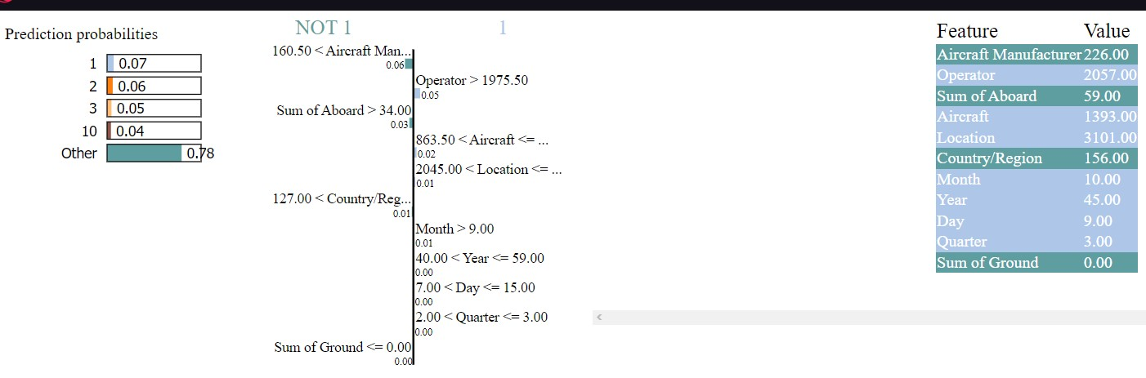

The provided spreadsheet presents the outcomes of a machine learning model tasked with predicting the probability of a fatal aircraft accident based on various features. Notably, the most influential feature is "Aircraft Manufacturer," followed by "Operator," "Sum of Aboard," "Aircraft Type," and "Location." These factors outweigh others such as "Country/Region," "Month," "Day," "Year," "Quarter," or "Sum of Ground" in terms of predictive significance.

From this dataset, several insights emerge:

- Aircraft manufacturer emerges as the primary predictor of a fatal accident, potentially indicating variations in aircraft safety across manufacturers or differences in the frequency of aircraft types in the dataset.

- The importance of the airline operator suggests variations in safety records among airlines or differences in operational environments.

- The number of passengers aboard significantly influences accident prediction, likely due to the increased potential for casualties with higher passenger counts.

- Aircraft type plays a crucial role, hinting at differing accident rates among aircraft models or variations in passenger capacity.

- The accident location's significance implies varying safety conditions across regions.

Overall, these findings underscore the multifactorial nature of fatal aircraft accidents, with aircraft manufacturer, airline operator, passenger count, aircraft type, and accident location emerging as pivotal predictors. However, it is imperative to recognize that these observations are contingent on the specific dataset analyzed and may not universally apply. Additionally, predictive importance does not equate to causation, necessitating cautious interpretation and further research.

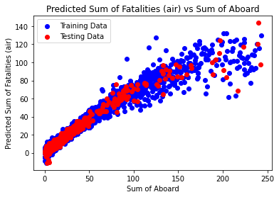

The plot provided illustrates the outcomes of a linear regression model trained on data pertaining to aircraft accidents. The x-axis denotes the count of individuals on board the aircraft (labeled "Sum of Aboard"), while the y-axis represents the predicted count of fatalities (labeled "Predicted Sum of Fatalities (air)"). Although the equation for the plotted line is not explicitly depicted, its slope and y-intercept offer insights into the relationship between the number of individuals on board and the predicted fatalities.

The positive slope of the line indicates that the model predicts an increase in fatalities with a rise in the number of individuals on board. This observation aligns with the expectation that a higher passenger count corresponds to a higher potential for casualties in the event of an aircraft crash. Additionally, the positive y-intercept suggests that the model predicts fatalities even in scenarios with no passengers. This could imply that the model accounts for other contributing factors to aircraft accidents, such as aircraft type or weather conditions.

It is essential to recognize that the model's predictions are subject to inherent uncertainties and limitations, and actual outcomes may vary based on various factors. Therefore, while the model provides valuable insights, its interpretations should be approached with caution and validated through comprehensive analyses and real-world data.

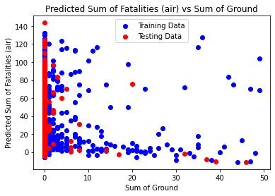

The provided scatter plot depicts the predicted sum of fatalities resulting from aircraft accidents (air) against the sum of ground fatalities. The x-axis represents the "Sum of Ground," likely indicating the predicted count of ground fatalities due to the aircraft accident, while the y-axis denotes the "Predicted Sum of Fatalities (air)," indicating the predicted count of fatalities on board the aircraft. Each data point corresponds to a single aircraft accident, where its position reflects the model's predictions for ground and aircraft fatalities.

The training data points, depicted in blue, are utilized to train the model, while the testing data points, depicted in red, assess the model's performance on unseen data. Generally, the data points align along a diagonal line, suggesting that the model predicts a proportional relationship between ground and aircraft fatalities. However, there is more dispersion observed in the testing data compared to the training data, indicating potential limitations in the model's performance on new data.

It is imperative to acknowledge that the model's predictions are subject to various influencing factors, including aircraft type, weather conditions, and accident location. Therefore, while the model offers insights into potential outcomes, real-world fatalities may differ due to the complexity and variability of aviation accidents.

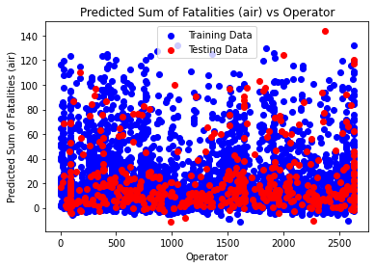

The scatter plot provided illustrates the predicted sum of fatalities (air) in relation to the operator. Upon examination, no clear linear relationship between the operator and the predicted number of fatalities is evident, with data points scattered across the plot. However, the tighter clustering of training data compared to testing data suggests potential variance in model performance. Additionally, outlier data points may influence predictions. Overall, while the model may offer some insight into predicted fatalities, it is clear that other factors beyond the operator contribute to outcomes. This analysis underscores the need for comprehensive evaluation of the model's accuracy and reliability across diverse datasets and contexts.

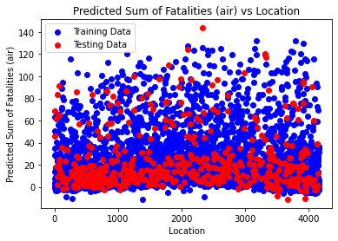

The scatter plot provided illustrates the predicted sum of fatalities (air) in relation to location. Upon examination, no discernible linear relationship between location and the predicted number of fatalities emerges, as data points are dispersed across the plot. However, a tighter clustering of training data compared to testing data suggests potential variability in model performance. Additionally, outlier data points may exert influence on predictions. Overall, while the model may offer some insight into predicted fatalities based on location, it is evident that location alone does not fully explain outcomes. This analysis underscores the necessity for comprehensive evaluation of the model's accuracy and reliability across diverse datasets and contexts.

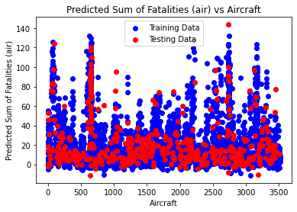

The provided graph depicts the performance of a machine learning model, likely a regression model, in predicting the number of fatalities in plane crashes based on the number of aircraft involved. The x-axis denotes the count of aircraft, while the y-axis represents the model's prediction of fatalities. The curved line illustrates the model's prediction trend, indicating an upward trajectory as the number of aircraft increases. Blue dots signify training data points used to train the model, influencing the overall curve. However, unseen testing data is not visualized. It is essential to note that while the model provides insights, actual fatalities may vary due to numerous factors such as aircraft type, weather conditions, and accident location, emphasizing the need for comprehensive evaluation and real-world validation of model predictions.

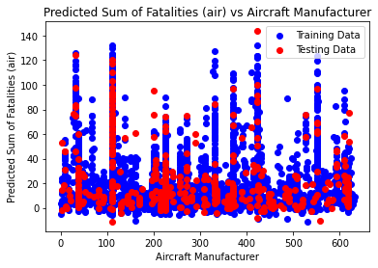

The provided visualization likely represents the performance of a machine learning regression model tasked with predicting the number of fatalities in aircraft accidents, with aircraft manufacturer as a feature. The x-axis denotes specific aircraft manufacturers, while the y-axis represents the model's prediction of fatalities. A curved line illustrates the model's average prediction trend based on the manufacturer. However, the overall trend of the curve is not distinctly discernible. Notably, the model's predictions serve as averages and may not fully capture real-world variability. Additionally, the influence of training data on the curve may outweigh that of unseen testing data. It's crucial to acknowledge that the model's predictive accuracy relies on various factors beyond aircraft manufacturer, such as aircraft type, weather conditions, and accident location.

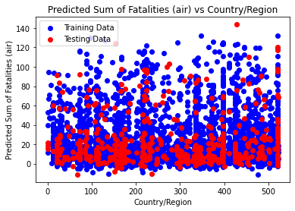

The provided plot likely portrays a visualization depicting the performance assessment of a regression model tasked with predicting the number of ground fatalities in aircraft accidents based on the count of individuals aboard. The x-axis denotes the total number of individuals aboard the aircraft, while the y-axis represents the predicted sum of fatalities. A curved line illustrates the model's average prediction trend as the count of individuals aboard varies. The upward trend of the curve suggests an increase in predicted fatalities with a higher count of individuals aboard. However, it's imperative to acknowledge that the model's predictions represent averages, and real-world outcomes may exhibit deviations. Additionally, the impartial evaluation provided by testing data aids in assessing the model's performance on unseen data. Ultimately, the model's predictive efficacy relies on various factors beyond passenger count, including aircraft type, weather conditions, and accident location.

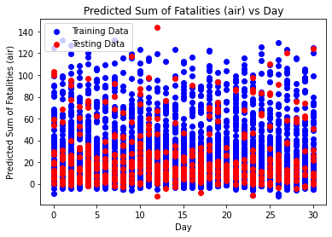

The provided image illustrates a graph depicting the performance evaluation of a linear regression model employed to predict the number of fatalities in airplane crashes based on the day of the week. Here's a breakdown of the plot: the x-axis represents the day of the week, ranging from Sunday (0) to Saturday (6), while the y-axis denotes the predicted sum of fatalities on the aircraft. A straight line illustrates the model's average prediction for fatalities corresponding to each day of the week. The trend of the line exhibits a slight upward inclination from left to right, implying a marginally higher predicted fatality count on weekends (days 5 and 6) compared to weekdays (days 0 through 4).

Several considerations should be noted regarding this plot: firstly, the line signifies the model's average prediction, implying potential deviations in real-world crash outcomes from the model's predictions for specific days of the week. Secondly, the influence of the training data points on shaping the line might overshadow the impact of unseen testing data. Lastly, it's essential to recognize that the model's predictive accuracy is contingent upon various factors beyond the day of the week, including aircraft type, weather conditions, and accident location. It's also pertinent to acknowledge that the model likely incorporates a multifaceted feature set, with the day of the week serving as one component.

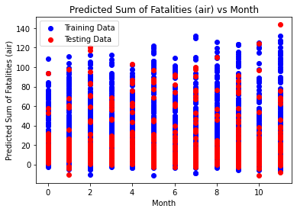

The scatter plot illustrates the forecasted number of fatalities in air accidents across various months, segregated by aircraft type. Distinct colored lines denote different aircraft classifications. Despite its informative layout, the plot's multiplicity of lines impedes clear trend identification. Further insights into the predicted fatality counts for each aircraft type can be provided upon accessing the legend information. Nonetheless, it's essential to note the plot's focus solely on predicted fatalities and the potential incorporation of additional variables in the predictive model, underlining the need for cautious interpretation of its findings in the broader context of aviation safety analysis.

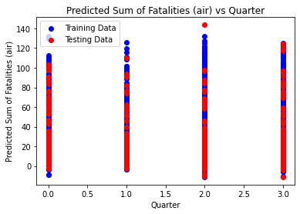

The provided scatter plot delineates the projected count of fatalities in air incidents relative to the month of occurrence, categorized by aircraft manufacturer. Key observations include the differentiation between training and testing data, respectively, alongside the legend associating each colored line with a distinct manufacturer. The presence of red dots signifies training data points utilized for model calibration concerning fatalities prediction for each manufacturer. While discerning an overarching trend proves challenging across all manufacturers, certain patterns emerge, such as elevated projected fatalities during summer months for manufacturers like Bombardier and Embraer based on the training dataset. Additional considerations encompass the plot's exclusive focus on predicted, not actual, fatality counts, potential incorporation of additional predictive variables beyond month and manufacturer, and the singular nature of the dataset, prompting caution in generalizing findings. It's noteworthy that the model's predictive capacity may involve a more intricate amalgamation of features beyond solely month-based parameters.

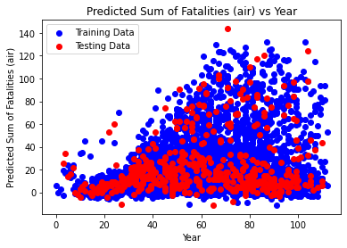

The provided scatter plot illustrates the projected number of fatalities in air accidents across years, categorized by aircraft type. The x-axis spans, representing the years, while the y-axis denotes the predicted sum of air fatalities. The legend identifies four distinct aircraft types: Turboprop, Regional Jet, Narrow body, and Wide body. Analysis of the plot reveals nuanced trends for each aircraft type: Narrow body aircraft exhibit a potential upward trend in predicted fatalities based on training data, whereas Wide body aircraft suggest a possible decline over the years. However, the presence of scattered data points in the testing dataset complicates trend discernment. Additional considerations encompass the plot's exclusive focus on predicted, not actual, fatality counts, potential inclusion of other predictive variables beyond year and aircraft type, and the singular nature of the dataset, highlighting the necessity for cautious interpretation. It's noteworthy that the model's predictive framework likely incorporates a multifaceted array of features, with year serving as one among many.

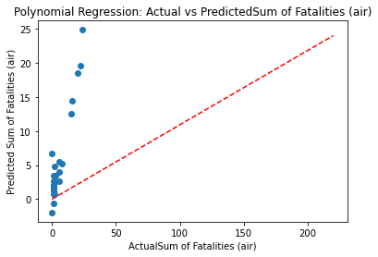

The scatter plot entitled "Polynomial Regression: Actual vs Predicted Sum of Fatalities (air)" elucidates the correlation between actual fatalities and predicted fatalities concerning aircraft incidents. Key observations from the plot include the presence of blue dots representing individual data points, predominantly clustered within the lower range of both axes, typically spanning from 0 to 50 actual fatalities. The red dashed line denotes a polynomial regression model, indicating an enhanced prediction accuracy with the escalation of actual fatalities. Initially, the model tends to underestimate fatalities; however, it exhibits an amelioration in accuracy as actual fatalities increase. The x-axis delineates actual fatalities, ranging from 0 to 200, while the y-axis represents predicted fatalities, spanning from 0 to 25. It's essential to acknowledge that this interpretation provides a simplified overview, and the comprehensive analysis likely incorporates intricate factors pertinent to aircraft safety and fatalities.

SHAP-INTERPRETATION:

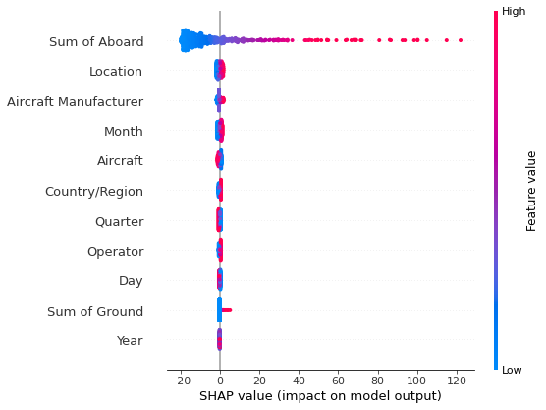

The provided scatter plot illustrates the influence of various factors on the output of a machine learning model, potentially related to discerning primary and secondary delays in railway networks using Explainable AI, specifically employing a Beeswarm Plot by Random Forest. The x-axis is denoted as "Feature value," while the y-axis is labeled "SHAP value (impact on model output)." Each data point signifies the impact of a distinct feature value on the model's output for a specific aircraft scenario. Features such as aircraft manufacturer, country/region, operator, day, and sum of ground are listed on the right side of the plot, presumably contributing to the model's predictive capacity. Observations suggest that each feature holds varying degrees of influence on the model output, as evidenced by the spread of data points across the y-axis. Notably, this analysis is restricted to visualizing the model's internal workings, without implying causality. Additional considerations encompass the model's potential focus on railway network delays rather than aircraft accidents, the likelihood of other factors beyond those listed on the plot influencing predictions, and the singular nature of the dataset, warranting prudence in generalization.

PHASE-4

|  |  |  |
| --- | --- | --- |
| Phase of flight | Exposure (percentage of 1.5 hour flight) | Fatal accidents (percentage) |
| Taxi, load, unload, parked, tow | 0% | 11% |
| Takeoff | 1% | 10% |
| Initial climb | 1% | 5% |
| Climb (flaps up) | 14% | 5% |
| Cruise | 57% | 11% |
| Descent | 11% | 4% |
| Initial approach | 12% | 14% |
| Final approach | 3% | 16% |
| Landing | 1% | 20% |

Note that the exposure percentages are estimates for a 1.5 hour flight.

This table seems to depict the percentage of exposure or time spent during various phases of a 1.5-hour flight, along with the percentage of fatal accidents associated with each phase. Here's a breakdown:

### Phases of Flight:

1. Taxi, Load, Unload, Parked, Tow (Ground Operations):

- Exposure: 0%

- Fatal Accidents: 11%

- This phase involves activities on the ground before takeoff or after landing.

2. Takeoff:

- Exposure: 1%

- Fatal Accidents: 10%

- The aircraft ascends from the ground to the initial climb altitude.

3. Initial Climb:

- Exposure: 1%

- Fatal Accidents: 5%

- The aircraft continues to ascend after takeoff to reach a higher altitude.

4. Climb (Flaps Up):

- Exposure: 14%

- Fatal Accidents: 5%

- The aircraft ascends further, often with the flaps retracted.

5. Cruise:

- Exposure: 57%

- Fatal Accidents: 11%

- The aircraft reaches a stable altitude and maintains a constant speed for the major part of the flight.

6. Descent:

- Exposure: 11%

- Fatal Accidents: 4%

- The aircraft starts descending from cruise altitude towards the destination.

7. Initial Approach:

- Exposure: 12%

- Fatal Accidents: 14%

- The initial part of the approach towards the destination airport.

8. Final Approach:

- Exposure: 3%

- Fatal Accidents: 16%

- The last segment before landing, usually involving alignment with the runway.

9. Landing:

- Exposure: 1%

- Fatal Accidents: 20%

- The aircraft touches down on the runway and comes to a stop.

### Explanation:

- The table outlines the estimated time or exposure duration as a percentage of the entire 1.5-hour flight for each flight phase.

- It also indicates the percentage of fatal accidents attributed to each phase, offering insights into the relative risk associated with different segments of the flight.

- This breakdown of exposure and accidents across flight phases helps in understanding the distribution of risk throughout the flight and highlights areas where safety measures could be particularly crucial.

Linear Equation: Fatal accidents (percentage)= (-1.0) * Phase of flight + (-1.0) * Exposure (percentage of 1.5 hour flight) + (2.7)

Equation: Fatal accidents (percentage)= 18.97 + -6.25 * Exposure (percentage of 1.5 hour flight) + -0.05 * Phase of flight^2 + 0.28 * Phase of flight^1*Exposure (percentage of 1.5 hour flight)^1 + 0.70 * Exposure (percentage of 1.5 hour flight)^2

R-squared error: 0.9460143510885877

ENCODED values:

0 8

1 7

2 5

3 0

4 1

5 2

6 4

7 3

8 6

9 9

Name: Phase of flight, dtype: int64

Equation 1 presents a straightforward linear model aiming to estimate the percentage of fatal accidents within a 1.5-hour flight based on the phase of flight and exposure duration. The equation is expressed as: Fatal accidents (percentage) = (-1.0) * Phase of flight + (-1.0) * Exposure (percentage of 1.5-hour flight) + 2.7. The coefficient for the phase of flight (-1.0) suggests that a change in this variable corresponds to a 1% decrease in fatal accidents. Similarly, a 1% change in exposure is associated with a 1% decrease in fatal accidents. The constant term (2.7) represents the intercept, indicating an estimated 2.7% of fatal accidents when both phase of flight and exposure are zero.

Equation 2, on the other hand, introduces a more intricate model likely derived from polynomial regression analysis. Expressed as: Fatal accidents (percentage) = 18.97 - 6.25 * Exposure (percentage of 1.5-hour flight) - 0.05 * Phase of flight^2 + 0.28 * Phase of flight * Exposure (percentage of 1.5-hour flight) + 0.70 * Exposure (percentage of 1.5-hour flight)^2, this equation reveals various insights. The coefficient for exposure (-6.25) suggests a predicted decrease of 6.25% in fatal accidents for every 1% decrease in exposure. The quadratic term, Phase of flight^2, indicates a nonlinear relationship between flight phase and fatal accidents. The interaction term Phase of flight * Exposure (percentage of 1.5-hour flight) highlights that the impact of exposure on fatal accidents may vary with the phase of flight. Lastly, the term Exposure (percentage of 1.5-hour flight)^2 signifies a positive nonlinear relationship between exposure squared and fatal accidents. Together, Equation 2 captures a more nuanced and complex interplay between these variables, incorporating potential nonlinearities and interactions in predicting fatal accidents during a 1.5-hour flight.

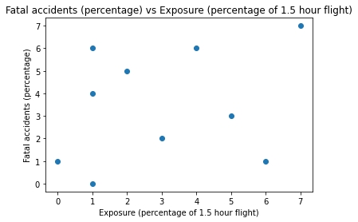The provided scatter plot illustrates the predicted risk of fatal accidents in aircraft flights as a function of exposure, represented as the percentage of a 1.5-hour flight duration that an aircraft is expected to be in the air. The x-axis denotes "Exposure (percentage of 1.5 hour flight)," while the y-axis signifies "Fatal accidents (percentage)," indicating the percentage of flights predicted to result in a fatal accident. The plot's comprehensibility in discerning an overarching trend across all aircraft types is hindered by the unavailability of the legend. Noteworthy considerations include the plot's exclusive visualization of predicted fatal accident risks, the potential inclusion of additional predictive factors beyond exposure time, and the singular nature of the dataset, necessitating caution in generalizing findings. A more detailed analysis of the predicted risk of fatal accidents for individual aircraft types could be provided with access to the complete legend.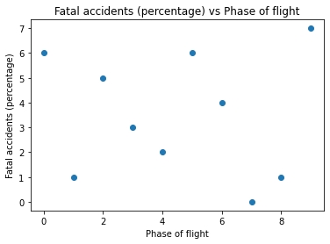 The provided scatter plot depicts the relationship between fatal accidents (percentage) and the phase of flight, with the x-axis delineating eight distinct sections corresponding to various flight phases, albeit unlabeled in the image. The y-axis represents the percentage of fatal accidents. Notably, the phase of flight exhibiting the highest percentage of fatal accidents likely falls within the range of 4 to 8 on the x-axis, which is indicative of approach and landing stages. Conversely, the phase of flight characterized by the lowest percentage of fatal accidents appears to be at the commencement of the flight (0 on the x-axis), presumably correlating with taxi or takeoff maneuvers. However, the absence of explicit labels for the flight phases impedes precise interpretation and precludes definitive conclusions about the data. Thus, while certain trends are discernible, the lack of specific phase identification limits the depth of analysis.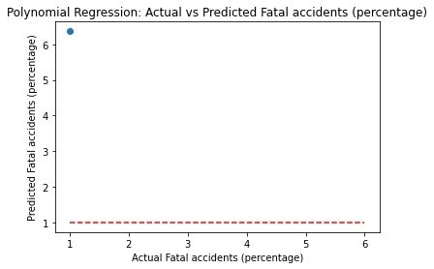

These equations seem to model the relationship between fatal accidents and two factors: the phase of flight and exposure percentage during a 1.5-hour flight. Let's break down the purpose of these equations:

### Modeling Accident Rates:

1. Equation 1:

- Purpose: This equation appears to represent a linear model linking the fatal accident percentage with both the phase of flight and exposure percentage during a 1.5-hour flight.

- Function:It suggests that the number of fatal accidents is negatively influenced by both the phase of flight and the exposure percentage. The constant term of 2.7 could represent a baseline or a factor not influenced by these variables.

2. Equation 2:

- Purpose: This equation showcases a more complex relationship, introducing quadratic terms and an interaction term between the phase of flight and exposure percentage.

- Function: The equation illustrates a more nuanced relationship, suggesting that the fatal accident percentage isn't just linearly related to these factors but includes interactions and nonlinear effects between them. The coefficients quantify the impact of each variable and their combinations on the fatal accident percentage.

### Importance of these Equations:

- Safety Analysis: These equations could be crucial in safety analysis within the aviation industry. By understanding how fatal accidents relate to different phases of flight and the duration of exposure during a flight, aviation authorities or safety analysts can identify critical periods or conditions that pose higher risks.

- Preventive Measures: Such equations aid in developing targeted safety protocols or measures during specific flight phases or durations, potentially reducing accident rates by focusing on high-risk periods or scenarios.

- Risk Assessment: These equations help in quantifying and predicting the likelihood of fatal accidents based on flight phase and exposure, assisting in risk assessment and safety planning within the aviation industry.

These equations play a vital role in understanding, predicting, and mitigating the risks associated with fatal accidents during flights, offering valuable insights for safety management and accident prevention strategies.

**PHASE-5(Interpretation of predicted AIRCRAFT DAMAGE used in part-2):**

|  |  |  |  |
| --- | --- | --- | --- |
| Event.Id | Investigation.Type | Accident.Number | Event.Date |
| 20001218X45444 | Accident | SEA87LA080 | 10/24/1948 |
| 20001218X45447 | Accident | LAX94LA336 | 7/19/1962 |
| 20061025X01555 | Accident | NYC07LA005 | 8/30/1974 |
| 20001218X45448 | Accident | LAX96LA321 | 6/19/1977 |
| 20041105X01764 | Accident | CHI79FA064 | 8/2/1979 |
| 20170710X52551 | Accident | NYC79AA106 | 9/17/1979 |
| 20001218X45446 | Accident | CHI81LA106 | 8/1/1981 |
| 20020909X01562 | Accident | SEA82DA022 | 1/1/1982 |
| 20020909X01561 | Accident | NYC82DA015 | 1/1/1982 |
| 20020909X01560 | Accident | MIA82DA029 | 1/1/1982 |
| 20020909X01559 | Accident | FTW82DA034 | 1/1/1982 |
| 20020909X01558 | Accident | ATL82DKJ10 | 1/1/1982 |
| 20020917X02148 | Accident | FTW82FRJ07 | 1/2/1982 |
| 20020917X02134 | Accident | FTW82FRA14 | 1/2/1982 |
| 20020917X02119 | Accident | FTW82FPJ10 | 1/2/1982 |
| 20020917X02117 | Accident | FTW82FPG08 | 1/2/1982 |
| 20020917X01962 | Accident | DEN82DTM08 | 1/2/1982 |
| 20020917X01656 | Accident | ANC82FAG14 | 1/2/1982 |
| 20020917X02481 | Accident | NYC82DA016 | 1/2/1982 |
| 20020917X02339 | Accident | MIA82DA028 | 1/2/1982 |
| 20020917X01894 | Accident | CHI82FEC08 | 1/2/1982 |
| 20020917X01776 | Accident | CHI82DA020 | 1/2/1982 |
| 20020917X01657 | Accident | ATL82DA027 | 1/2/1982 |
| 20020917X02333 | Incident | LAX82IA034 | 1/3/1982 |
| 20020917X02255 | Accident | LAX82FA040 | 1/3/1982 |
| 20020917X01905 | Accident | DCA82AA008 | 1/3/1982 |
| 20020917X01720 | Accident | ATL82FA033 | 1/3/1982 |
| 20020917X02483 | Accident | NYC82DA018 | 1/3/1982 |
| 20020917X02340 | Accident | MIA82DA030 | 1/3/1982 |

|  |  |  |  |
| --- | --- | --- | --- |
| Location | Country | Latitude | Longitude |
| MOOSE CREEK, ID | United States |  |  |
| BRIDGEPORT, CA | United States |  |  |
| Saltville, VA | United States | 36.922223 | -81.878056 |
| EUREKA, CA | United States |  |  |
| Canton, OH | United States |  |  |
| BOSTON, MA | United States | 42.445277 | -70.758333 |
| COTTON, MN | United States |  |  |
| PULLMAN, WA | United States |  |  |
| EAST HANOVER, NJ | United States |  |  |
| JACKSONVILLE, FL | United States |  |  |
| HOBBS, NM | United States |  |  |
| TUSKEGEE, AL | United States |  |  |
| HOMER, LA | United States |  |  |
| HEARNE, TX | United States |  |  |
| CHICKASHA, OK | United States |  |  |
| LITTLE ROCK, AR | United States |  |  |
| MIDWAY, UT | United States |  |  |
| SKWENTA, AK | United States |  |  |
| GALETON, PA | United States |  |  |
| MIAMI, FL | United States |  |  |
| YPSILANTI, MI | United States |  |  |
| CHARLOTTE, MI | United States |  |  |
| CHAMBLEE, GA | United States |  |  |
| VAN NUYS, CA | United States |  |  |
| 10 NM W LEE VIN, CA | United States |  |  |
| ASHLAND, VA | United States |  |  |
| PINEHURST, NC | United States |  |  |
| WHITE PLAINS, NY | United States |  |  |
| COCOA, FL | United States |  |  |

|  |  |  |  |
| --- | --- | --- | --- |
| Airport.Code | Airport.Name | Injury.Severity | Aircraft.damage |
|  |  | Fatal(2) | Destroyed |
|  |  | Fatal(4) | Destroyed |
|  |  | Fatal(3) | Destroyed |
|  |  | Fatal(2) | Destroyed |
|  |  | Fatal(1) | Destroyed |
|  | N/A | Non-Fatal | Substantial |
|  |  | Fatal(4) | Destroyed |
|  | BLACKBURN AG STRIP | Non-Fatal | Substantial |
| N58 | HANOVER | Non-Fatal | Substantial |
| JAX | JACKSONVILLE INTL | Non-Fatal | Substantial |
|  |  | Non-Fatal | Substantial |
|  | TUSKEGEE | Non-Fatal | Substantial |
|  |  | Non-Fatal | Destroyed |
| T72 | HEARNE MUNICIPAL | Fatal(1) | Destroyed |
|  |  | Fatal(1) | Destroyed |
|  |  | Fatal(2) | Destroyed |
|  | FIELD RANCH | Non-Fatal | Destroyed |
|  |  | Fatal(3) | Destroyed |
| 5G6 | CHERRY SPRINGS | Non-Fatal | Substantial |
|  |  | Non-Fatal | Substantial |
| YIP | WILLOW RUN | Non-Fatal | Substantial |
| 49G | TINKERBELL | Non-Fatal | Substantial |
| PDK |  | Non-Fatal | Substantial |
| VNY | VAN NUYS | Incident | Minor |
|  |  | Fatal(2) | Destroyed |
|  | HANOVER COUNTY | Fatal(8) | Destroyed |
| SOP | MOORE COUNTY | Fatal(1) | Destroyed |
| HPN | WESTCHESTER COUNTY | Non-Fatal | Substantial |
|  |  | Non-Fatal | Substantial |

|  |  |  |  |
| --- | --- | --- | --- |
| Aircraft.Category | Registration.Number | Make | Model |
|  | NC6404 | Stinson | 108-3 |
|  | N5069P | Piper | PA24-180 |
|  | N5142R | Cessna | 172M |
|  | N1168J | Rockwell | 112 |
|  | N15NY | Cessna | 501 |
| Airplane | CF-TLU | Mcdonnell Douglas | DC9 |
|  | N4988E | Cessna | 180 |
| Airplane | N2482N | Cessna | 140 |
| Airplane | N7967Q | Cessna | 401B |
|  | N3906K | North American | NAVION L-17B |
|  | N44832 | Piper | PA-28-161 |
|  | N4275S | Beech | V35B |
| Airplane | N14779 | Bellanca | 17-30A |
| Airplane | N758SK | Cessna | R172K |
| Airplane | N4876K | Navion | A |
| Airplane | N9779L | Beech | 19 |
| Helicopter | N51735 | Enstrom | 280C |
| Airplane | N7641A | Cessna | 180 |
| Airplane | N25084 | Cessna | 172 |
| Helicopter | N23BS | Smith | WCS-222 (BELL 47G) |
| Airplane | N68812 | Cessna | 152 |
| Airplane | N1549Q | Cessna | 150L |
| Helicopter | N5745Y | Bell | 206L-1 |
| Airplane | N5018P | Piper | PA-24-180 |
| Airplane | N28912 | Grumman | AA-5B |
| Airplane | N2620L | Cessna | 414A |
| Airplane | N10VS | Beechcraft | BE-58 |
| Airplane | N7125D | Maule | M-5-235C |
| Airplane | N94252 | Cessna | 210L |

|  |  |  |
| --- | --- | --- |
| Amateur.Built | Number.of.Engines | Engine.Type |
| No | 1 | Reciprocating |
| No | 1 | Reciprocating |
| No | 1 | Reciprocating |
| No | 1 | Reciprocating |
| No |  |  |
| No | 2 | Turbo Fan |
| No | 1 | Reciprocating |
| No | 1 | Reciprocating |
| No | 2 | Reciprocating |
| No | 1 | Reciprocating |
| No | 1 | Reciprocating |
| No | 1 | Reciprocating |
| No | 1 | Reciprocating |
| No | 1 | Reciprocating |
| No | 1 | Reciprocating |
| No | 1 | Reciprocating |
| No | 1 | Reciprocating |
| No | 1 | Reciprocating |
| No | 1 | Reciprocating |
| No | 1 | Reciprocating |
| No | 1 | Reciprocating |
| No | 1 | Reciprocating |
| No | 1 | Turbo Shaft |
| No | 1 | Reciprocating |
| No | 1 | Reciprocating |
| No | 2 | Reciprocating |
| No | 2 | Reciprocating |
| No | 1 | Reciprocating |
| No | 1 | Reciprocating |

|  |  |  |  |
| --- | --- | --- | --- |
| FAR.Description | Schedule | Purpose.of.flight | Air.carrier |
|  |  | Personal |  |
|  |  | Personal |  |
|  |  | Personal |  |
|  |  | Personal |  |
|  |  | Personal |  |
| Part 129: Foreign | SCHD |  | Air Canada |
|  |  | Personal |  |
| Part 91: General Aviation |  | Personal |  |
| Part 91: General Aviation |  | Business |  |
|  |  | Personal |  |
|  |  | Personal |  |
|  |  | Personal |  |
| Part 91: General Aviation |  | Personal |  |
| Part 91: General Aviation |  | Personal |  |
| Part 91: General Aviation |  | Personal |  |
| Part 91: General Aviation |  | Personal |  |
| Part 91: General Aviation |  | Personal |  |
| Part 91: General Aviation |  | Personal |  |
| Part 91: General Aviation |  | Personal |  |
| Part 91: General Aviation |  | Personal |  |
| Part 91: General Aviation |  | Instructional |  |
| Part 91: General Aviation |  | Personal |  |
| Part 135: Air Taxi & Commuter | NSCH | Unknown | Rocky Mountain Helicopters, In |
| Part 91: General Aviation |  | Personal |  |
| Part 91: General Aviation |  | Personal |  |
| Part 91: General Aviation |  | Business |  |
| Part 91: General Aviation |  | Personal |  |
| Part 91: General Aviation |  | Personal |  |
| Part 91: General Aviation |  | Personal |  |

|  |  |  |  |
| --- | --- | --- | --- |
| Total.Fatal.Injuries | Total.Serious.Injuries | Total.Minor.Injuries | Total.Uninjured |
| 2 | 0 | 0 | 0 |
| 4 | 0 | 0 | 0 |
| 3 |  |  |  |
| 2 | 0 | 0 | 0 |
| 1 | 2 |  | 0 |
|  |  | 1 | 44 |
| 4 | 0 | 0 | 0 |
| 0 | 0 | 0 | 2 |
| 0 | 0 | 0 | 2 |
| 0 | 0 | 3 | 0 |
| 0 | 0 | 0 | 1 |
| 0 | 0 | 0 | 1 |
| 0 | 0 | 1 | 0 |
| 1 | 0 | 0 | 0 |
| 1 | 0 | 0 | 0 |
| 2 | 0 | 0 | 0 |
| 0 | 0 | 0 | 1 |
| 3 | 0 | 0 | 0 |
| 0 | 0 | 0 | 1 |
| 0 | 0 | 0 | 2 |
| 0 | 0 | 0 | 1 |
| 0 | 0 | 0 | 2 |
| 0 | 0 | 0 | 1 |
| 0 | 0 | 0 | 1 |
| 2 | 1 | 0 | 0 |
| 8 | 0 | 0 | 0 |
| 1 | 0 | 0 | 0 |
| 0 | 0 | 0 | 2 |
| 0 | 0 | 1 | 1 |

|  |  |  |  |  |
| --- | --- | --- | --- | --- |
| Weather.Condition | Broad.phase.of.flight | Report.Status | Publication.Date |  |
| UNK | Cruise | Probable Cause |  |  |
| UNK | Unknown | Probable Cause | 19-09-1996 |  |
| IMC | Cruise | Probable Cause | 26-02-2007 |  |
| IMC | Cruise | Probable Cause | 12/9/2000 |  |
| VMC | Approach | Probable Cause | 16-04-1980 |  |
| VMC | Climb | Probable Cause | 19-09-2017 |  |
| IMC | Unknown | Probable Cause | 6/11/2001 |  |
| VMC | Takeoff | Probable Cause | 1/1/1982 |  |
| IMC | Landing | Probable Cause | 1/1/1982 |  |
| IMC | Cruise | Probable Cause | 1/1/1982 |  |
| VMC | Approach | Probable Cause | 1/1/1982 |  |
| VMC | Landing | Probable Cause | 1/1/1982 |  |
| IMC | Cruise | Probable Cause | 2/1/1983 |  |
| IMC | Takeoff | Probable Cause | 2/1/1983 |  |
| IMC | Cruise | Probable Cause | 2/1/1983 |  |
| IMC | Cruise | Probable Cause | 2/1/1983 |  |
| IMC | Taxi | Probable Cause | 2/1/1983 |  |
| VMC | Unknown | Probable Cause | 2/1/1983 |  |
| VMC | Taxi | Probable Cause | 2/1/1983 |  |
| VMC | Cruise | Probable Cause | 2/1/1983 |  |
| VMC | Takeoff | Probable Cause | 2/1/1983 |  |
| VMC | Approach | Probable Cause | 2/1/1983 |  |
| VMC | Approach | Probable Cause | 2/1/1983 |  |
| VMC | Approach | Probable Cause | 3/1/1983 |  |
| IMC | Descent | Probable Cause | 3/1/1983 |  |
| IMC | Approach | Probable Cause | 3/1/1983 |  |
| IMC | Approach | Probable Cause | 3/1/1983 |  |
| VMC | Landing | Probable Cause | 3/1/1983 |  |
| VMC | Descent | Probable Cause | 3/1/1983 |  |

1. Event ID: A unique identifier assigned to each aviation event.

2. Investigation Type: Specifies the type of investigation conducted for the event (e.g., Accident, Incident).

3. Accident Number: An identification number assigned to the accident.

4. Event Date: The date when the aviation event occurred.

5. Location: The geographical location where the event took place.

6. Country:The country where the event occurred.

7. Latitude: The latitude coordinate of the event location.

8. Longitude: The longitude coordinate of the event location.

9. Airport Code: The code assigned to the airport nearest to the event location.

10. Airport Name: The name of the airport nearest to the event location.

11. Injury Severity: Describes the severity of injuries resulting from the event (e.g., Fatal, Non-Fatal).

12. Aircraft Damage: Indicates the extent of damage to the aircraft (e.g., Destroyed, Substantial).

13. Aircraft Category: Specifies the category of the aircraft involved (e.g., Airplane, Helicopter).

14. Registration Number: The registration number assigned to the aircraft.

15. Make: The manufacturer of the aircraft.

16. Model:The model of the aircraft.

17. Amateur Built: Indicates whether the aircraft was amateur-built (Yes/No).

18. Number of Engines: Specifies the number of engines installed on the aircraft.

19. Engine Type: Describes the type of engine installed on the aircraft.

20. FAR Description: Provides a description of the Federal Aviation Regulation (FAR) applicable to the event.

21. Schedule: Indicates if the flight was scheduled (e.g., SCHD for Scheduled, NSCH for Non-Scheduled).

22. Purpose of Flight: Describes the purpose of the flight (e.g., Personal, Business).

23. Air Carrier: Specifies the air carrier involved in the event.

24. Total Fatal Injuries: The total number of fatal injuries resulting from the event.

25. Total Serious Injuries: The total number of serious injuries resulting from the event.

26. Total Minor Injuries: The total number of minor injuries resulting from the event.

27. Total Uninjured: The total number of individuals who were uninjured in the event.

28. Weather Condition: Describes the weather conditions at the time of the event.

29. Broad Phase of Flight: Specifies the broad phase of flight during which the event occurred (e.g., Takeoff, Cruise).

30. Report Status: Indicates the status of the report related to the event.

31. Publication Date: The date when the report related to the event was published.

These features provide comprehensive information about each aviation event, including details about the aircraft involved, the circumstances of the event, and the outcomes in terms of injuries and damages.

ENCODING CATEGORICAL VARIABLE:

−8.871781370259403×10^−8

Logistic Equation:

P(Aircraft.damage=1) = 1 / (1 + e^(-(-8.871781370259403e-08 + 0.000038081*Event.Id + -0.000000135*Investigation.Type + 0.000005039*Accident.Number + 0.000011249*Event.Date + -0.000002934*Location + -0.000037298*Country + -0.000007514*Latitude + 0.000019694*Longitude + 0.000015025*Airport.Code + 0.000008153*Airport.Name + -0.000133753*Injury.Severity + 0.000000978*Aircraft.Category + 0.000003639*Registration.Number + 0.000112422*Make + 0.000014397*Model + -0.000000021*Amateur.Built + 0.000000793*Number.of.Engines + -0.000000226*Engine.Type + 0.000001311*FAR.Description + -0.000000140*Schedule + -0.000001346*Purpose.of.flight + 0.000058312*Air.carrier + 0.000024957*Total.Fatal.Injuries + -0.000000919*Total.Serious.Injuries + -0.000000133*Total.Minor.Injuries + -0.000118776*Total.Uninjured + -0.000001724*Weather.Condition + -0.000001849*Broad.phase.of.flight + -0.000078746*Report.Status + -0.000005049*Publication.Date))

ENCODING EVERY VARIABLE

Equation :

Accuracy: 0.716953538080774

Coefficients: [3.459284026390293e-05, -1.2259137951078632e-07, 4.257657718464212e-06, 4.036241079514648e-06, -2.42989053211656e-06, -3.3564447431340465e-05, -7.9371897389439e-06, 2.123904263125537e-05, 1.3571016923005002e-05, 9.801916821975941e-06, -0.00011877286885326675, 9.050125427342222e-07, 3.8352643139834205e-06, 9.915343776016024e-05, 1.2782382601482938e-05, -1.9373401450506768e-08, 6.991751679828474e-07, -2.7780342117432624e-07, 1.1635915294156292e-06, -1.264663058561961e-07, -1.1275616509375882e-06, 6.516049729789455e-05, 2.2873488130660474e-05, -8.905585231986965e-07, 6.284649591819806e-08, -0.00010656432086583148, -1.5455357548096068e-06, -1.647977072638421e-06, -7.646016965798957e-05, -3.0266688164253424e-06, 0.0, 0.0, 0.0, 0.0, -8.044393817413686e-08, -8.04439381741371e-08]

Intercept: -8.028516865281261e-08

Logistic Equation:

P(Aircraft.damage=1) = 1 / (1 + e^(-(-8.028516865281261e-08 + 0.000034593*Event.Id + -0.000000123*Investigation.Type + 0.000004258*Accident.Number + 0.000004036*Event.Date + -0.000002430*Location + -0.000033564*Country + -0.000007937*Latitude + 0.000021239*Longitude + 0.000013571*Airport.Code + 0.000009802*Airport.Name + -0.000118773*Injury.Severity + 0.000000905*Aircraft.Category + 0.000003835*Registration.Number + 0.000099153*Make + 0.000012782*Model + -0.000000019*Amateur.Built + 0.000000699*Number.of.Engines + -0.000000278*Engine.Type + 0.000001164*FAR.Description + -0.000000126*Schedule + -0.000001128*Purpose.of.flight + 0.000065160*Air.carrier + 0.000022873*Total.Fatal.Injuries + -0.000000891*Total.Serious.Injuries + 0.000000063*Total.Minor.Injuries + -0.000106564*Total.Uninjured + -0.000001546*Weather.Condition + -0.000001648*Broad.phase.of.flight + -0.000076460*Report.Status + -0.000003027*Publication.Date + 0.000000000*Unnamed: 31 + 0.000000000*Unnamed: 32 + 0.000000000*Unnamed: 33 + 0.000000000*Unnamed: 34 + -0.000000080*Unnamed: 35 + -0.000000080*Unnamed: 36))

LOGISTIC-EQUATION:

Z= b0​+b1​x1​+b2​x2​+...+bn​xn​

LE=1/(1+e^-z)

LIME-INTERPRETATION:

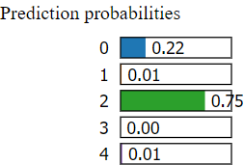

|  |  |
| --- | --- |
| Feature | Value |
| Make | 6321.00 |
| Latitude | 8759.00 |
| Model | 9368.00 |
| Airport.Name | 24861.00 |
| Injury.Severity | 0.00 |
| Event.Id | 63348.00 |
| Report.Status | 9631.00 |
| Location | 2656.00 |
| Event.Date | 8140.00 |
| Investigation.Type | 0.00 |
| Country | 207.00 |
| Longitude | 12723.00 |
| Accident.Number | 35597.00 |
| Amateur.Built | 1.00 |
| Airport.Code | 10350.00 |
| Weather.Condition | 4.00 |
| Purpose.of.flight | 19.00 |
| Publication.Date | 1698.00 |
| Total.Serious.Injuries | 3.00 |
| Number.of.Engines | 3.00 |
| Registration.Number | 35394.00 |
| Aircraft.Category | 5.00 |
| Broad.phase.of.flight | 13.00 |
| Total.Uninjured | 1.00 |
| Engine.Type | 7.00 |
| Total.Fatal.Injuries | 3.00 |
| Total.Minor.Injuries | 1.00 |
| FAR.Description | 10.00 |
| Schedule | 3.00 |
| Air.carrier | 13587.00 |
| Unnamed: 32 | 0.00 |
| Unnamed: 33 | 0.00 |
| Unnamed: 34 | 0.00 |
| Unnamed: 35 | 1.00 |
| Unnamed: 36 | 1.00 |
| Unnamed: 31 | 8.00 |
|  |  |

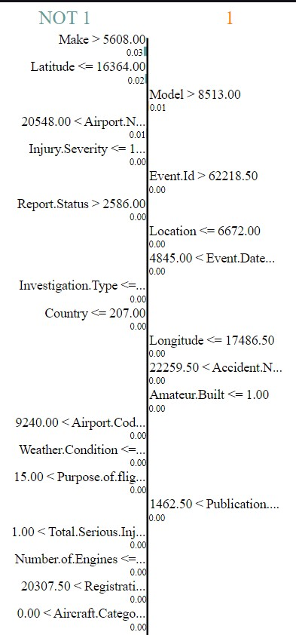

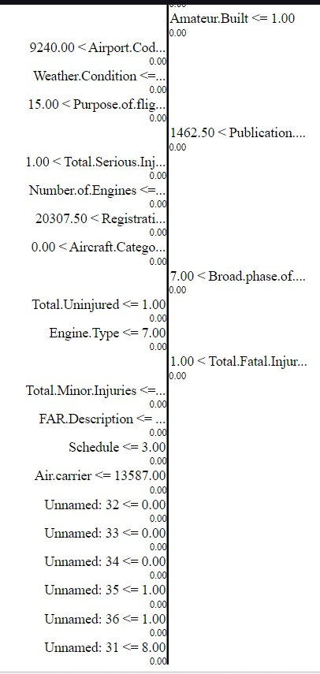

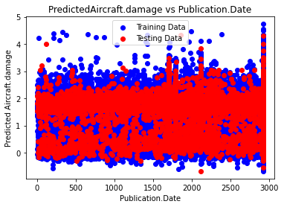

The provided scatter plot illustrates the relationship between predicted aircraft damage and publication date. The red line denotes the predicted aircraft damage, while the blue line represents the training data. This visualization serves to assess the alignment between the model's predictions and the actual data it was trained on. Ideally, a close adherence of the red line to the blue line would indicate accurate prediction of aircraft damage. However, the observed scatter in the data suggests that the model's predictions are not consistently precise, albeit generally aligned with the trend of the training data. Thus, while the model's predictions are indicative of the expected aircraft damage based on publication date, there remains room for refinement to enhance predictive accuracy.

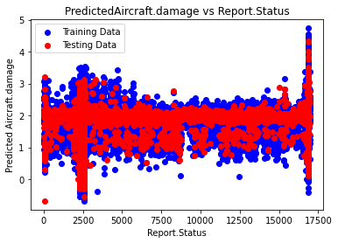

The provided scatter plot illustrates the correlation between predicted aircraft damage and report status. Such visualization is valuable for assessing the model's generalizability to unseen data. Ideally, a close clustering of the red dots around the blue dots would signify the model's ability to accurately predict aircraft damage across diverse scenarios. However, the observed scattering of the red dots around the blue dots indicates a less precise alignment, though some correlation is evident. Thus, while the model's predictions exhibit some association with report status, there remains room for improvement to enhance predictive accuracy on unseen data.

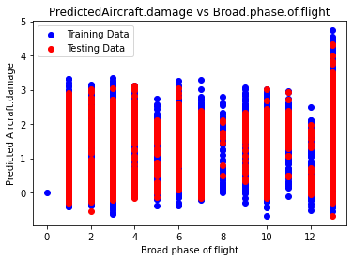

The provided scatter plot, titled "Predicted Aircraft Damage vs Broad Phase of Flight," depicts the relationship between predicted aircraft damage and different phases of flight. The x-axis is labeled "Broad Phase of Flight," ranging from 0 to 12 in increments of 2, while the y-axis is labeled "Predicted Aircraft Damage," spanning from 0 to 5 with tick marks at 1-unit intervals. The plot exhibits two distinct datasets: training data, denoted by blue points, and testing data, represented by red points.

Interpreting the plot reveals a tentative association between predicted aircraft damage and the broad phases of flight, encompassing various stages such as taxi, takeoff, climb, cruise, descent, approach, and landing. However, the absence of detailed category descriptions for each phase complicates a precise analysis. Nonetheless, a discernible pattern emerges, indicating a modest upward trajectory in both the red and blue data points. This suggests that the model predicts heightened aircraft damage probabilities during later flight phases. Nevertheless, the substantial scatter within the data warrants caution in drawing definitive conclusions regarding this relationship. Further refinement and scrutiny are necessary to ascertain the accuracy and reliability of the model's predictions regarding aircraft damage across different flight phases.

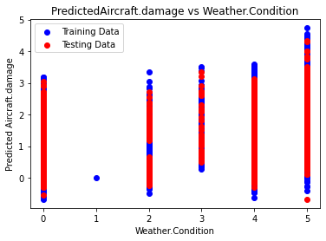

The provided scatter plot, titled "Predicted Aircraft Damage vs Weather Condition," illustrates the association between predicted aircraft damage and different weather conditions. The x-axis, labeled "Weather Condition," spans from 0 to 5, presumably representing various weather states such as sunny, rainy, cloudy, snowy, etc., although the specific labels are not visible in the image. The y-axis, labeled "Predicted Aircraft Damage," ranges from 0 to 5 with tick marks at each unit increment.

The plot comprises two datasets: training data, depicted by blue points, and testing data, represented by red points. While the plot suggests a correlation between predicted aircraft damage and weather conditions, the absence of visible labels for the weather conditions complicates a precise analysis. Nevertheless, an examination of the data indicates some overlap between the red and blue data points, suggesting that the model's predictions may not be heavily influenced by weather conditions.

To gain a comprehensive understanding of the relationship between predicted aircraft damage and weather conditions, it is imperative to ascertain the specific labels for each weather condition on the x-axis. This additional information would facilitate a more accurate interpretation of the plot and enable a deeper exploration of the impact of weather conditions on predicted aircraft damage.

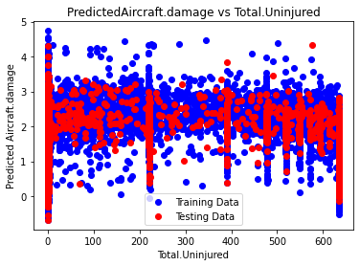

The provided scatter plot, titled "Predicted Aircraft Damage vs Total Uninjured," illustrates the association between predicted aircraft damage and the total number of uninjured individuals involved in aircraft incidents. The x-axis, labeled "Total Uninjured," ranges from 0 to 600 with tick marks at increments of 100, representing the count of uninjured individuals. The y-axis, labeled "Predicted Aircraft Damage," spans from 0 to 5 with tick marks at each unit increment.

The plot features two datasets: training data, depicted by blue points, and testing data, represented by red points. A discernible trend emerges from the plot, indicating a negative correlation between predicted aircraft damage and the total number of uninjured individuals. Specifically, as the count of uninjured individuals increases, the model predicts a decrease in aircraft damage.

Notably, the training data (blue dots) exhibit more scatter compared to the testing data (red dots), suggesting a potential issue of underfitting in the model. Underfitting occurs when the model fails to capture the underlying pattern in the training data, leading to suboptimal performance on unseen data, such as the testing data in this scenario.

In summary, while the plot demonstrates the model's ability to predict the relationship between the number of uninjured individuals and predicted aircraft damage, the observed correlation may not be particularly strong. Addressing the underfitting issue could enhance the model's predictive accuracy and improve its performance on unseen data.

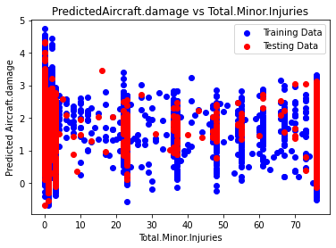

The provided scatter plot, titled "Predicted Aircraft Damage vs Total Minor Injuries," illustrates the relationship between predicted aircraft damage and the total number of minor injuries in aircraft incidents. The x-axis, labeled "Total Minor Injuries," ranges from 0 to 70 with tick marks at increments of 10, representing the count of minor injuries. The y-axis, labeled "Predicted Aircraft Damage," spans from 0 to 5 with tick marks at each unit increment.

The plot comprises two datasets: training data, depicted by blue points, and testing data, represented by red points. A discernible trend emerges from the plot, indicating a positive correlation between predicted aircraft damage and the total number of minor injuries. Specifically, as the count of minor injuries increases, the model predicts a higher likelihood of aircraft damage.

Notably, the training data (blue dots) exhibit more scatter compared to the testing data (red dots), suggesting a potential issue of underfitting in the model. Underfitting occurs when the model fails to capture the underlying pattern in the training data, potentially leading to suboptimal performance on unseen data, such as the testing data in this scenario.

In summary, while the plot demonstrates the model's ability to predict the relationship between the number of minor injuries and predicted aircraft damage, the observed correlation may not be particularly robust. Addressing the underfitting issue could enhance the model's predictive accuracy and improve its performance on unseen data.

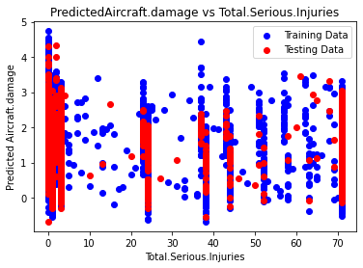

The scatter plot provided, titled "Predicted Aircraft Damage vs Total Serious Injuries," depicts the relationship between predicted aircraft damage and the total number of serious injuries in aircraft incidents. On the x-axis, labeled "Total Serious Injuries," the range spans from 0 to 70 with tick marks at increments of 10, representing the count of serious injuries. The y-axis, labeled "Predicted Aircraft Damage," ranges from 0 to 5 with tick marks at each unit increment.

The plot includes two datasets: training data, represented by blue points, and testing data, depicted by red points. An observable trend emerges from the plot, indicating a positive correlation between predicted aircraft damage and the total number of serious injuries. Specifically, as the count of serious injuries increases, the model predicts a higher likelihood of aircraft damage.

Notably, the training data (blue dots) exhibit more scatter compared to the testing data (red dots), suggesting a potential issue of underfitting in the model. Underfitting occurs when the model fails to capture the underlying pattern in the training data, potentially leading to suboptimal performance on unseen data, such as the testing data in this scenario.

In summary, while the plot demonstrates the model's capability to predict the relationship between the number of serious injuries and predicted aircraft damage, the observed correlation may not be particularly robust. Addressing the underfitting issue could enhance the model's predictive accuracy and improve its performance on unseen data.

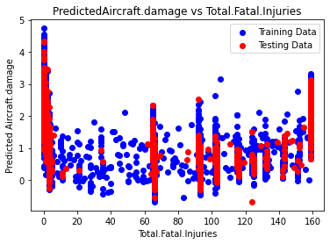

The provided scatter plot illustrates the relationship between predicted aircraft damage and the total number of fatal injuries. The red dots represent the model's predictions for aircraft damage, while the blue dots denote the training data used to train the model.

Scatter plots of this nature are instrumental in assessing the alignment between a model's predictions and the data it was trained on. Here, the training data encompasses real-world instances of aircraft damage and associated total fatal injuries. The red dots depict the model's projections of aircraft damage contingent upon the count of total fatal injuries.

Ideally, the red dots would closely congregate around the blue dots, signifying precise alignment between the model's predictions and the actual training data. However, in this instance, the red dots exhibit some dispersion around the blue dots. While lacking a definitive linear relationship, there exists discernible correlation between the variables.

Thus, while the model's predictions may not be entirely precise, the observed correlation suggests that they hold utility in estimating aircraft damage based on the total number of fatal injuries. Further refinement and evaluation of the model may enhance its predictive accuracy and utility in real-world scenarios.

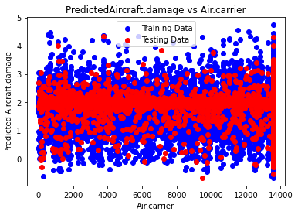

The scatter plot titled "Predicted Aircraft.damage vs Air.carrier" illustrates the relationship between predicted aircraft damage (y-axis) and the number of air carriers (x-axis). The blue circles, representing training data, predominantly cluster at lower predicted damage levels, while the red circles, indicating testing data, exhibit a more dispersed distribution across varying damage levels. The x-axis, labeled "Air.carrier," spans from 0 to 14,000, while the y-axis, "Predicted Aircraft damage," ranges from 0 to 5. Overall, the plot suggests a lack of strong correlation between the number of air carriers and predicted aircraft damage, as both training and testing data points are evenly distributed across all levels of air carriers.

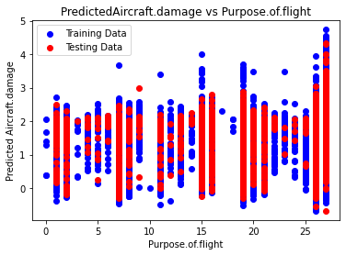

The plot titled "Predicted Aircraft.damage vs Purpose.of.flight" illustrates the relationship between predicted aircraft damage (y-axis) and the purpose of flight (x-axis). The x-axis spans from 0 to 25, representing different categories of flight purposes, although the units are unspecified. The y-axis ranges from 0 to 5, denoting the predicted level of aircraft damage. This scatter plot distinguishes between training and testing data, with training data utilized for model creation and testing data for assessing model performance on unseen instances. Notably, the model predicts higher aircraft damage for flights associated with purpose codes between 5 and 15, with a notable outlier at purpose code 20 indicating high predicted damage. Given the predictive nature of the model, it's crucial to acknowledge that actual damage outcomes may diverge from predictions. When interpreting scatter plots, it's advisable to scrutinize trends, identify outliers, and evaluate the strength of the relationship between variables, distinguishing between strong and weak associations based on the pattern observed in the data.

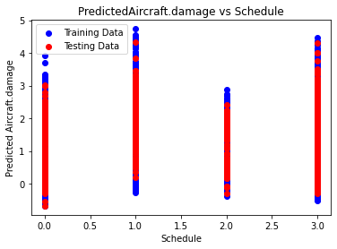

The provided scatter plot depicts the relationship between predicted aircraft damage (y-axis) and schedule (x-axis). Despite the absence of specific details about the dataset and modeling techniques, several general observations can be made. The distribution of data points suggests a weak correlation between predicted aircraft damage and schedule, as no discernible linear trend is evident; variations in scheduled values do not consistently correspond to increases or decreases in predicted damage. Additionally, a clustering of points in the lower-left quadrant implies that aircraft with longer schedules may generally be predicted to have lower damage. It's essential to recognize that the plot provides a visual representation of the data, and comprehensive interpretation should consider additional factors beyond this graphical depiction.

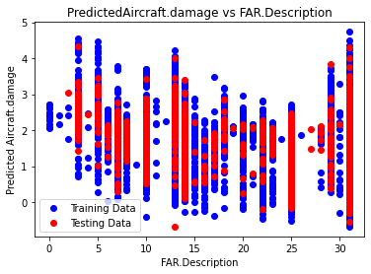

Certainly, the plot illustrates the relationship between predicted aircraft damage and Federal Aviation Regulations (FAR) descriptions. The red line signifies the predicted damage, while the blue line likely denotes the average predicted damage, evident from its smoother trajectory. Although the x-axis label is truncated, it presumably corresponds to descriptors or codes correlating with FAR descriptions. Observations from the plot include higher predicted damage for lower FAR descriptions, indicating a model prediction that aircraft regulated under less stringent FARs may sustain more damage. Additionally, significant variation in predicted damage across FAR descriptions is apparent, as indicated by the dispersion of red dots around the red line. Notably, the training data (red dots) encompass a broader spectrum of FAR descriptions compared to the testing data (blue dots). However, it's crucial to approach this interpretation recognizing that the plot provides a visual representation, and comprehensive analysis should consider additional contextual factors.

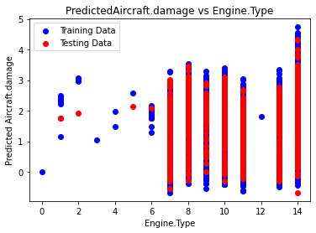

The provided scatter plot illustrates the relationship between predicted aircraft damage and engine type. The x-axis represents different engine types, while the y-axis denotes the predicted aircraft damage. Each data point represents an individual aircraft. Despite lacking detailed information about the dataset and model, several observations can be made. The dispersion of data points suggests a weak correlation between predicted aircraft damage and engine type, as there is no discernible linear trend. Notably, the concentration of points in the lower left portion of the graph implies a prevalence of aircraft predicted to have lower damage with specific engine types. It's essential to interpret this graphical representation cautiously, recognizing its limitations and considering other pertinent factors when assessing model predictions.

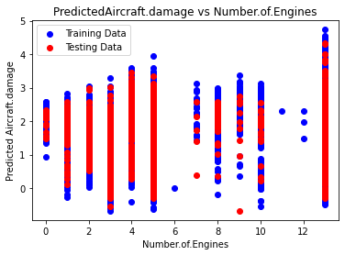

The provided scatter plot depicts the relationship between predicted aircraft damage and the number of engines on an aircraft. The x-axis denotes the count of engines, while the y-axis represents the predicted damage. Each data point represents an individual aircraft. Several observations can be drawn from the plot: firstly, there is no discernible linear trend, indicating that the predicted damage does not consistently increase or decrease with the number of engines. Secondly, the spread of data points across the graph suggests a weak correlation between the number of engines and predicted damage. Lastly, a slightly higher concentration of points in the lower left corner implies fewer aircraft are predicted to have damage with fewer engines. However, it's crucial to acknowledge the limitations of this visual representation and consider additional factors that may influence the model's predictions.

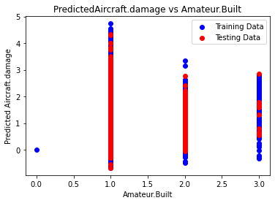

The scatter plot illustrates the relationship between predicted aircraft damage and whether the aircraft was amateur-built. The x-axis denotes the amateur build status, while the y-axis represents the predicted damage. The red line signifies the predicted damage, while the smoother blue line indicates the average predicted damage. Observations from the plot include a spread of data points indicating a weak correlation between predicted damage and amateur build status, with no clear linear trend. Additionally, there appears to be a higher concentration of points in the lower left portion of the graph, suggesting fewer aircraft predicted to have damage were not amateur-built. However, it's essential to acknowledge that this graphical representation has limitations, and other factors may influence the model's predictions.

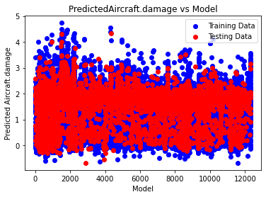

The plot depicts the relationship between predicted aircraft damage and model training data. The red line signifies the predicted damage, while the blue line represents the training data. The x-axis denotes the "Model," likely indicating different models used for prediction, while the y-axis represents "Predicted Aircraft.damage." Each data point represents an individual aircraft.

Given that the blue line represents the training data, it likely indicates a perfect correlation, signifying the model's accurate prediction of damage for the training dataset. However, the spread of the red points around the blue line suggests that the model's generalization to new, unseen aircraft data is limited. There appears to be more variation in the actual damage of these aircraft than predicted by the model.

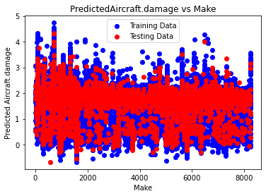

The plot illustrates the relationship between predicted aircraft damage and the make of the aircraft. The x-axis is labeled "Make," representing different aircraft manufacturers, while the y-axis is labeled "PredictedAircraft.damage." Each data point represents an individual aircraft.

Without detailed information about the dataset and the predictive model employed, definitive conclusions are challenging. However, several general observations can be made. Firstly, there is no discernible linear trend in the data, implying that changes in aircraft make do not consistently correlate with predicted damage levels.

Furthermore, the spread of data points suggests a weak correlation between predicted aircraft damage and aircraft make. Additionally, a higher concentration of points in the lower-left portion of the graph indicates that certain manufacturers may produce aircraft predicted to have lower damage levels.

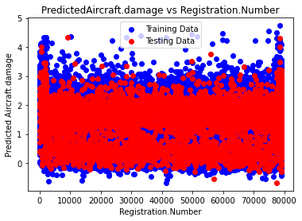

Certainly, the plot you provided depicts a scatter plot comparing predicted aircraft damage against registration numbers. On the x-axis, "Registration.Number" denotes different registration numbers assigned to individual aircraft, while the y-axis, "PredictedAircraft.damage," represents the predicted damage levels.

Upon observation, several key insights emerge. Firstly, the spread of data points across the graph suggests a weak correlation between registration numbers and predicted aircraft damage. Additionally, the absence of a clear linear relationship implies that changes in registration numbers do not consistently correlate with changes in predicted damage levels.

Furthermore, a higher concentration of points in the lower left corner of the graph indicates that fewer aircraft are predicted to have damage with lower registration numbers. However, it is essential to acknowledge that this observation is based solely on visual analysis and may not capture all influencing factors accurately.

Ultimately, this graphical representation serves as a valuable tool for understanding the relationship between registration numbers and predicted aircraft damage. Nevertheless, comprehensive consideration of other factors is imperative to fully interpret the model's predictions and ensure their accuracy and reliability.

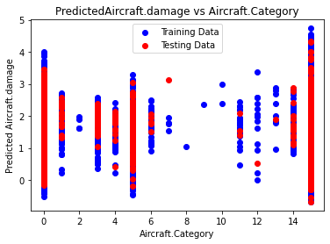

Certainly, the plot illustrates a scatter plot comparing predicted aircraft damage with aircraft categories. The x-axis denotes "Aircraft.Category," representing different categories of aircraft, while the y-axis represents "PredictedAircraft.damage."

Upon examination, several observations can be made. Firstly, there exists a spread of data points across the entire graph, implying a weak correlation between aircraft categories and predicted aircraft damage. Furthermore, the absence of a clear linear trend suggests that changes in aircraft categories do not consistently correlate with changes in predicted damage levels.

However, discerning specific patterns in the concentration of data points proves challenging due to limited visibility of the labels for aircraft categories on the x-axis. Without this crucial information, making precise interpretations about the relationship between aircraft categories and predicted damage becomes difficult.

It is important to note that this graphical depiction provides valuable insights into the relationship between aircraft categories and predicted damage. Nonetheless, comprehensive consideration of other influential factors is necessary to fully comprehend and validate the model's predictions.

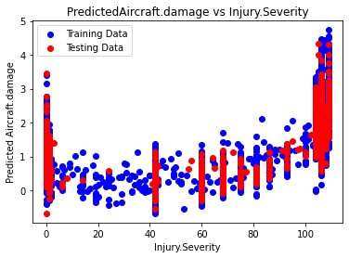

The plot depicts a scatter plot comparing predicted aircraft damage with injury severity. The x-axis is labeled "Injury.Severity," representing different levels of injury severity resulting from aircraft incidents, while the y-axis represents "PredictedAircraft.damage." Each data point corresponds to an individual aircraft incident.

Upon analysis, several observations emerge. Firstly, there exists a spread of data points across the entire graph, indicating a weak correlation between injury severity and predicted aircraft damage. Moreover, the absence of a clear linear trend implies that increases in injury severity do not consistently correspond to increases in predicted damage levels.

However, discerning specific patterns in the concentration of data points proves challenging, suggesting the absence of significant clustering based on injury severity.

It is crucial to note that while this graphical depiction offers insights into the relationship between injury severity and predicted damage, comprehensive consideration of other influential factors is necessary to fully comprehend and validate the model's predictions. Additionally, the lack of a labeled scale on the x-axis limits the interpretability of the severity of injuries, warranting caution in making specific interpretations.

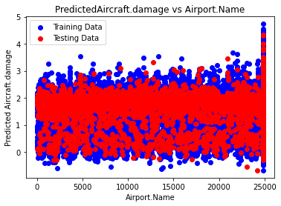

The plot illustrates a scatter plot comparing predicted aircraft damage with airport names. The x-axis, labeled "Airport.Name," delineates different airport locations, while the y-axis represents "PredictedAircraft.damage." Each data point corresponds to an individual aircraft incident.

Upon examination, several observations can be made. Firstly, there exists a spread of data points across the entire graph, indicating a weak correlation between airport names and predicted aircraft damage. Moreover, the absence of a clear linear trend implies that variations in airport names do not consistently correlate with changes in predicted damage levels.

However, discerning specific patterns in the concentration of data points proves challenging, suggesting the absence of significant clustering based on airport names.

It is crucial to note that while this graphical representation offers insights into the relationship between airport names and predicted damage, comprehensive consideration of other influential factors is necessary to fully comprehend and validate the model's predictions. Additionally, the incomplete display of airport names on the x-axis limits the interpretability of specific airport locations, warranting caution in making precise interpretations.

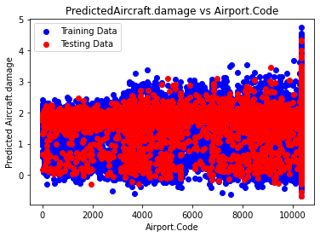

The plot depicts a scatter plot comparing predicted aircraft damage with airport codes. The x-axis, labeled "Airport.Code," represents different airport codes, while the y-axis denotes "PredictedAircraft.damage." Each data point signifies an individual aircraft incident.

Upon examination, several observations emerge. Firstly, there is a dispersion of data points across the entire graph, indicating a weak correlation between airport codes and predicted aircraft damage. Moreover, the absence of a clear linear trend suggests that variations in airport codes do not consistently correlate with changes in predicted damage levels.

However, discerning specific patterns in the concentration of data points proves challenging, indicating the absence of significant clustering based on airport codes.

It is essential to note that while this graphical representation provides insights into the relationship between airport codes and predicted damage, comprehensive consideration of other influential factors is necessary to fully comprehend and validate the model's predictions. Additionally, the abbreviated airport codes on the x-axis constrain the interpretability of specific airport locations, warranting caution in making precise interpretations.

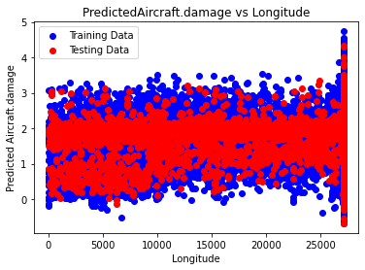

The plot illustrates a scatter plot juxtaposing predicted aircraft damage against longitude. The x-axis, labeled "Longitude," represents different longitudinal coordinates, while the y-axis denotes "PredictedAircraft.damage." Each data point signifies an individual aircraft incident.

Upon analysis, several observations emerge. Firstly, there is a dispersion of data points across the entire range of longitude values, indicating a weak correlation between longitude and predicted aircraft damage. Furthermore, the absence of a clear linear trend suggests that changes in longitude do not consistently correlate with changes in predicted damage levels.

However, discerning specific patterns in the concentration of data points across the entire range of longitudes proves challenging, indicating the absence of significant clustering based on longitudinal coordinates.

It is imperative to note that while this graphical representation provides insights into the relationship between longitude and predicted damage, comprehensive consideration of other influential factors is necessary to fully comprehend and validate the model's predictions. Additionally, the absence of the longitude range on the x-axis limits precise interpretations regarding geographic location.

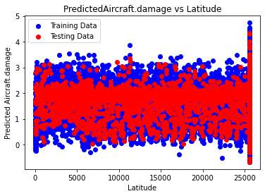

The provided plot presents a scatter plot illustrating the relationship between predicted aircraft damage and latitude. The x-axis, labeled "Latitude," delineates various latitudinal coordinates, while the y-axis denotes "PredictedAircraft.damage." Each data point corresponds to an individual aircraft incident.

Upon scrutiny, several observations emerge. Primarily, a dispersion of data points is evident across the entire latitude spectrum, implying a weak correlation between latitude and predicted aircraft damage. Additionally, the absence of a discernible linear trend suggests that variations in latitude do not consistently correlate with alterations in predicted damage levels.

However, discerning specific concentration patterns within the latitude range proves challenging, indicating the absence of notable clustering based on latitudinal coordinates.

It is imperative to note that while this visual representation offers insights into the latitude-predicted damage relationship, comprehensive consideration of other influential factors is necessary to fully comprehend and validate the model's predictions. Additionally, the inability to differentiate between training and testing data based solely on the data points themselves complicates the interpretation of the plot.

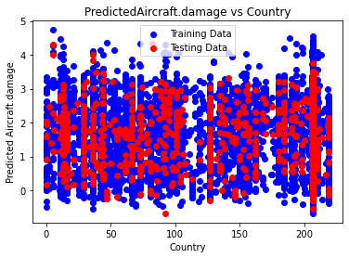

The plot provided depicts a scatter plot contrasting predicted aircraft damage against country. The x-axis is labeled "Country," while the y-axis is denoted as "PredictedAircraft.damage." Each data point symbolizes an individual aircraft incident.

Upon examination, several observations can be made:

- A dispersion of data points is observable across a substantial portion of the y-axis, suggesting a tenuous correlation between country and predicted aircraft damage. Although the spread encompasses a considerable portion of the y-axis, there appears to be a higher concentration of points towards the bottom, indicating that most countries exhibit a low predicted average damage according to the model.

- Notably, the data points do not coalesce around a linear trendline, implying the absence of a straightforward linear relationship. Consequently, as the country varies, the predicted damage does not consistently ascend or descend.

- Furthermore, a greater density of points is discernible in the lower left quadrant of the graph. This concentration implies that certain countries may harbor fewer aircraft predicted to incur damage, according to the model.

It is imperative to acknowledge that while this visual representation offers insights into the country-predicted damage relationship, comprehensive consideration of additional influential factors is necessary to thoroughly grasp and validate the model's predictions.

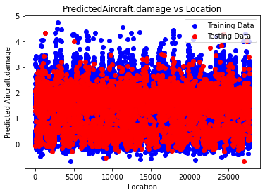

The scatter plot under examination juxtaposes predicted aircraft damage against location, with the x-axis denoting "Location" and the y-axis representing "Predicted Aircraft.damage." Each data point on the plot corresponds to an individual aircraft incident. Upon scrutiny, it becomes apparent that a weak correlation exists between location and predicted damage, as evidenced by the dispersed distribution of data points along the location axis. Moreover, the absence of a discernible linear trendline suggests the lack of a clear linear relationship between location and predicted damage. Consequently, fluctuations in location do not consistently correlate with changes in predicted damage levels. Additionally, the absence of distinct patterns in the concentration of data points across locations further underscores the complexity of this relationship. While this graphical representation offers preliminary insights, a more comprehensive analysis incorporating additional influential factors is imperative to validate the model's predictions rigorously. Furthermore, the lack of specific location labels on the x-axis impedes precise interpretations regarding the relationship between location and predicted damage. Hence, further investigation, potentially involving additional variables or advanced modeling techniques, may be warranted to elucidate the nuanced factors influencing aircraft damage prediction accurately.

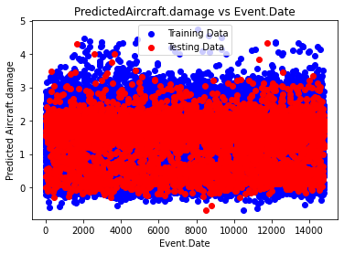

The scatter plot depicts the predicted aircraft damage against the event date for a dataset of aircraft incidents, showing no clear linear trend but a scattered distribution of data points across the graph. While there appears to be a concentration of incidents with lower predicted damage occurring on earlier dates, the absence of a discernible trend suggests a weak correlation between event date and predicted damage severity. However, without knowledge of the scale of event dates, drawing definitive conclusions about temporal trends is challenging. Additionally, it's crucial to consider other influencing factors beyond the scope of the plot that may affect the model's predictions, such as aircraft type and operational conditions. Further analysis incorporating additional variables and statistical methods may be necessary for a comprehensive understanding of the relationship between event date and predicted aircraft damage.

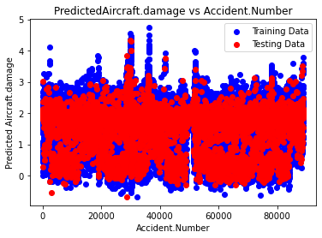

The provided scatter plot illustrates the relationship between predicted aircraft damage and the number of accidents, with the red line representing the average predicted aircraft damage and the blue points denoting actual aircraft damage from testing data. The x-axis depicts the number of accidents, while the y-axis indicates the predicted aircraft damage. Each blue point on the plot represents an individual accident, with its height on the y-axis representing the model's predicted damage for that specific incident.

The dispersion of blue points around the red line suggests variability in the damage outcomes for accidents with the same number of aircraft involved. This variability could stem from various factors such as aircraft type, prevailing weather conditions, and the underlying causes of the accidents. Despite this dispersion, an overall positive correlation emerges between the number of accidents and the predicted aircraft damage, indicating that an increase in the number of accidents tends to coincide with higher predicted damage levels. However, the spread of data points around the red line indicates that this correlation is not absolute, implying that factors beyond just the number of accidents contribute to the variability in predicted damage outcomes. Thus, while the plot underscores a general trend of increasing predicted damage with a higher number of accidents, it also highlights the complexity of factors influencing aircraft damage in accident scenarios.

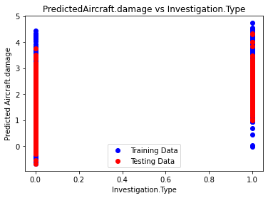

The plot provided illustrates the relationship between predicted aircraft damage and investigation type, though a potential labeling error on the axis is noted, as indicated by the legend specifying "Predicted Aircraft.damage" for the red line and "Investigation.Type" for the blue line. The x-axis denotes investigation type, potentially indicating distinct categories for training and testing data. However, the absence of labeled scales on the x-axis complicates interpretation regarding the nature of these investigation types. It is conceivable that the model was trained on one investigation type and tested on another, or vice versa. Without explicit scale labeling, discerning the precise meaning of investigation types remains challenging. Consequently, drawing definitive conclusions about the relationship between predicted aircraft damage and investigation type is hindered by the lack of contextual information. Further clarification regarding the investigation categories is essential to elucidate any discernible patterns or trends in the data.

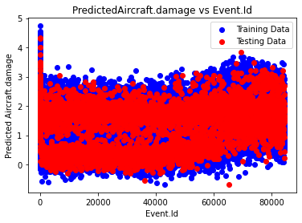

The provided plot illustrates the relationship between predicted aircraft damage and event ID, with the red line representing the average predicted damage and the blue points indicating actual damage from testing data. On the x-axis, event IDs are displayed, while the y-axis denotes predicted aircraft damage. Each blue point represents a distinct event, with its position on the y-axis reflecting the model's predicted damage for that particular event.

The dispersion of blue points around the red line signifies variability in damage outcomes for events sharing the same ID. This variability may stem from diverse factors such as aircraft type, prevailing weather conditions, and the specific circumstances surrounding each event. Despite the scatter, no clear correlation emerges between event ID and predicted aircraft damage, as evidenced by the lack of a discernible pattern in the distribution of data points around the red line. This suggests that event ID alone may not serve as an effective predictor of aircraft damage. The absence of a consistent relationship underscores the complexity involved in accurately predicting damage based solely on event ID, indicating the potential necessity for additional predictive variables to enhance model performance.

**SHAP-INTERPRETATION:**

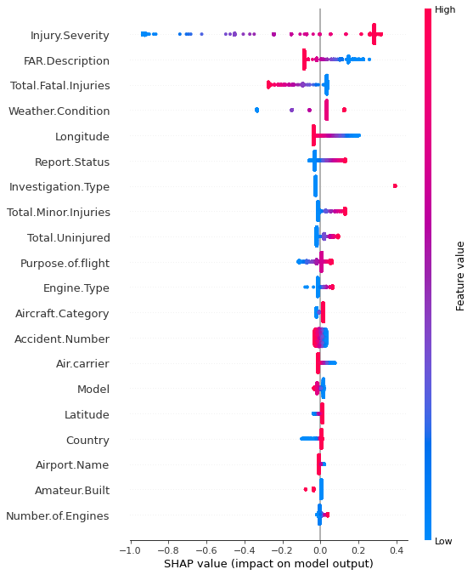

The provided image is a SHAP (SHapley Additive exPlanations) summary plot, utilized for interpreting the output of a machine learning model, specifically in predicting injury severity in aircraft accidents. The plot comprises a list of features on the left side, with their impacts on the model's prediction depicted by the color bar on the right. Positive SHAP values, represented in red, indicate an increase in the model's prediction of injury severity, while negative SHAP values, depicted in blue, signify a decrease in predicted severity.

The force plot within the summary plot elucidates how each feature contributes to a single prediction. Each point on the force plot signifies a distinct feature, with its vertical position denoting the magnitude of its impact on the prediction. The color of each point indicates whether the feature's impact is positive (red) or negative (blue). For instance, in the provided image, "Number.of.Engines" exerts the most significant positive impact on injury severity prediction, implying that accidents involving more engines are likely to result in greater injury severity. Conversely, "Latitude" manifests the most substantial negative impact, suggesting that accidents occurring at higher latitudes are less prone to result in severe injuries.

Additional observations highlight features such as "Total.Fatal.Injuries" and "Total.Minor.Injuries," which positively influence injury severity prediction, signifying that accidents with higher reported injuries tend to result in greater severity. Conversely, "Country" and "Aircraft.Category" exhibit negative impacts, suggesting associations between certain geographic locations or aircraft categories and lower injury severity. However, precise interpretations of these features are constrained by the lack of detailed contextual information regarding feature coding.

It is imperative to acknowledge that SHAP values reflect correlations learned by the model rather than causal relationships with injury severity. Thus, a positive SHAP value for a feature does not inherently imply causation but rather indicates a learned association between that feature and injury severity within the model's training data.

**phase-6((Interpretation of another predicted AIRCRAFT DAMAGE used in part-2):**

|  |  |  |
| --- | --- | --- |
| Event Id | Investigation Type | Accident Number |
| 20080125X00106 | Accident | SEA08CA056 |
| 20080206X00141 | Accident | CHI08WA075 |
| 20080129X00122 | Accident | CHI08CA057 |
| 20080114X00045 | Accident | LAX08FA043 |
| 20080109X00032 | Accident | NYC08FA071 |
| 20080129X00118 | Accident | DEN08CA045 |
| 20080214X00193 | Accident | CHI08CA056 |
| 20080215X00200 | Accident | CHI08CA058 |
| 20071231X02014 | Accident | DFW08FA053 |
| 20080103X00010 | Accident | DFW08LA052 |
| 20080117X00071 | Accident | LAX08WA045 |
| 20080111X00041 | Accident | DFW08CA051 |
| 20080102X00006 | Accident | SEA08LA054 |
| 20080108X00030 | Accident | CHI08FA055 |
| 20080128X00107 | Incident | OPS08IA004A |
| 20080128X00107 | Incident | OPS08IA004B |
| 20080104X00022 | Accident | MIA08LA032 |
| 20071231X02008 | Incident | DEN08IA044 |
| 20080210X00163 | Accident | NYC08LA070 |
| 20080229X00252 | Accident | MIA08WA058 |
| 20080129X00123 | Accident | ANC08LA030 |
| 20080117X00072 | Accident | SEA08CA052 |
| 20080128X00110 | Accident | MIA08CA045 |
| 20080107X00025 | Accident | SEA08LA051 |
| 20080107X00024 | Accident | SEA08LA050 |
| 20080116X00054 | Accident | CHI08CA059 |
| 20080321X00351 | Incident | NYC08IA069 |
| 20080108X00031 | Accident | DFW08WA050 |
| 20080125X00105 | Accident | SEA08CA053 |

|  |  |  |  |  |  |
| --- | --- | --- | --- | --- | --- |
| Event Date | | Location | | | Country |
| 12/31/2007 | | Santa Ana, CA | | | United States |
| 12/31/2007 | | Guernsey, United Kingdom | | | United Kingdom |
| 12/30/2007 | | Alexandria, MN | | | United States |
| 12/30/2007 | | Paso Robles, CA | | | United States |
| 12/30/2007 | | Cherokee, AL | | | United States |
| 12/29/2007 | | Gunnison, CO | | | United States |
| 12/29/2007 | | Abingdon, IL | | | United States |
| 12/29/2007 | | Crystal Falls, MI | | | United States |
| 12/29/2007 | | Venice, LA | | | United States |
| 12/29/2007 | | Crowley, TX | | | United States |
| 12/29/2007 | | Westgate Bridge, Australia | | | Australia |
| 12/28/2007 | | Houston, TX | | | United States |
| 12/28/2007 | | Murrieta, CA | | | United States |
| 12/27/2007 | | Traverse City, MI | | | United States |
| 12/27/2007 | | Teterboro, NJ | | | United States |
| 12/27/2007 | | Teterboro, NJ | | | United States |
| 12/26/2007 | | Sarasota, FL | | | United States |
| 12/26/2007 | | Aspen, CO | | | United States |
| 12/26/2007 | | Pittstown, NJ | | | United States |
| 12/26/2007 | | Ocumare del Tuy, Venezuela | | | Venezuela |
| 12/26/2007 | | North Pole, AK | | | United States |
| 12/26/2007 | | Fullerton, CA | | | United States |
| 12/26/2007 | | Northampton, MA | | | United States |
| 12/25/2007 | | Honolulu, HI | | | United States |
| 12/25/2007 | | Ontario, CA | | | United States |
| 12/24/2007 | | Hot Springs Vlg, AR | | | United States |
| 12/24/2007 | | Destin, FL | | | United States |
| 12/23/2007 | | Boquete, Panama | | | Panama |
| 12/23/2007 | | Truckee, CA | | | United States |
| Latitude | Longitude | | Airport Code | Airport Name | | |
| 33.675556 | -117.868056 | | SNA | John Wayne - Orange County | | |
| 49.435 | -2.600278 | |  |  | | |
| 45.866111 | -95.394444 | | AXN | Chandler Field Airport | | |
| 35.542222 | -120.522778 | | PRB | Paso Robles Airport | | |
| 34.688611 | -87.92 | |  |  | | |
| 38.533889 | -106.933056 | |  |  | | |
| 40.799722 | -90.438611 | |  |  | | |
| 46.8 | -88.36 | |  |  | | |
| 28.958056 | -89.258889 | |  | South Pass 38 | | |
| 32.557222 | -97.485555 | |  |  | | |
| -37.829723 | 144.896389 | |  |  | | |
| 29.935 | -95.639444 | | EYQ | WEISER AIR PARK | | |
| 33.572778 | -117.234444 | |  |  | | |
| 44.737222 | -85.5275 | | TVC | Cherry Capital Airport | | |
|  |  | |  |  | | |
|  |  | |  |  | | |
| 27.390555 | -82.552778 | | SRQ | Sarasota/Bradenton Intl | | |
| 39.203889 | -106.868056 | | ASE | Aspen/Pitkin County | | |
| 40.5875 | -75.019167 | | N85 | Alexandria Airport | | |
| 10.121667 | -66.771667 | |  |  | | |
| 65.765278 | -147.390555 | | 95Z | Bradley Sky-Ranch Airport | | |
| 33.871945 | -117.979723 | | FUL | Fullerton Municipal | | |
| 42.328056 | -72.611389 | | K7B2 | Northampton | | |
| 21.318611 | -157.9225 | | HNL | Honolulu International | | |
| 34.056111 | -117.601111 | | ONT | Ontario International | | |
| 34.485556 | -93.104722 | |  |  | | |
| 30.4 | -86.471389 | |  |  | | |
|  |  | |  |  | | |
| 39.472778 | -120.3325 | |  |  | | |

|  |  |  |
| --- | --- | --- |
| Injury Severity | Aircraft Damage | Aircraft Category |
| Non-Fatal | Substantial | Airplane |
| Non-Fatal | Minor |  |
| Non-Fatal | Substantial | Airplane |
| Fatal(1) | Substantial | Airplane |
| Fatal(3) | Substantial | Helicopter |
| Non-Fatal | Substantial | Airplane |
| Non-Fatal | Substantial | Airplane |
| Non-Fatal | Substantial | Airplane |
| Fatal(1) | Destroyed | Helicopter |
| Fatal(2) | Destroyed | Gyrocraft |
| Fatal(1) | Substantial |  |
| Non-Fatal | Substantial | Airplane |
| Non-Fatal | Substantial | Airplane |
| Fatal(1) | Destroyed | Airplane |
| Incident |  |  |
| Incident |  |  |
| Non-Fatal | Substantial | Airplane |
| Incident | Minor | Airplane |
| Non-Fatal | Substantial | Airplane |
| Non-Fatal | Substantial |  |
| Non-Fatal | Substantial | Airplane |
| Non-Fatal | Substantial | Airplane |
| Non-Fatal | Substantial | Airplane |
| Non-Fatal |  | Airplane |
| Non-Fatal |  | Airplane |
| Non-Fatal | Substantial | Ultralight |
| Incident | Minor | Airplane |
| Fatal(3) | Destroyed |  |

|  |  |  |  |  |  |
| --- | --- | --- | --- | --- | --- |
| Registration Number | | Make | | | Model |
| N2800D | | Piper | | | PA-12 |
|  | | Cessna | | | T303 |
| N5093F | | Lerohl | | | RV-8 |
| N254SR | | Cirrus Design Corp. | | | SR22 |
| N109AE | | BELL | | | 206L-3 |
| N33MF | | Piper | | | PA-46-310P |
| N94131 | | Ercoupe (Eng & Research Corp.) | | | 415D |
| N8191U | | Cessna | | | 172F |
| N211EL | | Bell | | | 206L1 |
| N136DG | | ALTHOUSE | | | RAF 2000 GTX |
|  | | Robinson | | | R-44 |
| N1458U | | Cessna | | | 172 |
| N365SX | | Hein | | | Sonex |
| N37249 | | CESSNA | | | 310R |
|  | | Gulfstream American | | | G5 |
|  | | Raytheon Corporate Jets | | | H25B |
| N5875Q | | Mooney | | | M20E |
| N47BC | | PIPER | | | PA-46-310P |
| N9412X | | CESSNA | | | 182R |
| N761YL | | Cessna | | | T210L |
| N7637D | | PIPER | | | PA-22-150 |
| N13974 | | Cessna | | | 172S |
| N5425K | | Cessna | | | 172P |
| N819NW | | Airbus Industrie | | | A330-323 |
| N943AS | | MCDONNELL DOUGLAS | | | DC-9-83 |
| N719AR | | Infinity | | | Commander |
| N8158B | | PIPER | | | PA-32R |
|  | | Cessna | | | 172 |
| N9086Y | | Piper | | | PA-18-150 |
| Amateur Built | Number of Engines | | Engine Type | FAR Description | | | Schedule |
| No | 1 | | Reciprocating | Part 91: General Aviation | | |  |
| No |  | |  |  | | |  |
| Yes | 1 | | Reciprocating | Part 91: General Aviation | | |  |
| No | 1 | | Reciprocating | Part 91: General Aviation | | |  |
| No | 1 | | Turbo Shaft | Part 91: General Aviation | | |  |
| No | 1 | | Reciprocating | Part 91: General Aviation | | |  |
| No | 1 | | Reciprocating | Part 91: General Aviation | | |  |
| No | 1 | | Reciprocating | Part 91: General Aviation | | |  |
| No | 1 | | Turbo Shaft | Part 135: Air Taxi & Commuter | | | NSCH |
| Yes | 1 | | Reciprocating | Part 91: General Aviation | | |  |
| No |  | |  |  | | |  |
| No | 1 | | Reciprocating | Part 91: General Aviation | | |  |
| Yes | 1 | | Reciprocating | Part 91: General Aviation | | |  |
| No | 2 | | Reciprocating | Part 91: General Aviation | | |  |
| No |  | |  |  | | |  |
| No |  | |  |  | | | NSCH |
| No | 1 | | Reciprocating | Part 91: General Aviation | | |  |
| No | 1 | | Reciprocating | Part 91: General Aviation | | |  |
| No | 1 | | Reciprocating | Part 91: General Aviation | | | NSCH |
| No |  | |  |  | | |  |
| No | 1 | | Reciprocating | Part 91: General Aviation | | |  |
| No | 1 | | Reciprocating | Part 91: General Aviation | | |  |
| No | 1 | | Reciprocating | Part 91: General Aviation | | |  |
| No | 2 | | Turbo Fan | Part 121: Air Carrier | | | SCHD |
| No | 2 | | Turbo Fan | Part 121: Air Carrier | | | SCHD |
| No | 1 | | Reciprocating | Part 91: General Aviation | | |  |
| No | 1 | | Reciprocating | Part 91: General Aviation | | |  |
| No |  | |  |  | | |  |
| No | 1 | | Reciprocating | Part 91: General Aviation | | |  |

|  |  |  |  |  |
| --- | --- | --- | --- | --- |
| Purpose of Flight | Air Carrier | Total Fatal Injuries | Total Serious Injuries | Total Minor Injuries |
| Instructional |  |  |  |  |
| Unknown |  |  |  |  |
| Personal |  |  |  |  |
| Personal |  | 1 |  |  |
| Other Work Use |  | 3 | 0 | 0 |
| Personal |  |  |  |  |
| Personal |  |  |  |  |
| Personal |  |  |  |  |
|  |  | 1 | 1 | 2 |
| Personal |  | 2 | 0 | 0 |
| Instructional |  | 1 | 1 |  |
| Personal |  |  |  |  |
| Personal |  | 0 | 1 | 0 |
| Personal |  | 1 | 1 |  |
| Unknown |  |  |  |  |
|  |  |  |  |  |
| Personal |  | 0 | 0 | 2 |
| Personal |  | 0 | 0 | 0 |
| Personal |  | 0 | 0 | 0 |
| Personal |  |  |  | 1 |
| Instructional |  |  |  |  |
| Instructional |  |  |  |  |
| Instructional |  |  |  |  |
|  | Northwest Airlines, Inc. | 0 | 1 | 3 |
|  | Alaska Airlines, Inc. | 0 | 2 | 0 |
| Personal |  |  | 2 |  |
| Instructional |  |  |  |  |
| Unknown |  | 3 | 1 |  |
| Personal |  |  |  |  |

|  |  |  |  |  |
| --- | --- | --- | --- | --- |
| Total Uninjured | Weather Condition | Broad Phase of Flight | Report Publication Date |  |
| 2 | VMC | LANDING | 02/28/2008 |  |
| 1 |  |  | 02/06/2008 |  |
| 1 | VMC | TAKEOFF | 02/28/2008 |  |
|  | VMC | MANEUVERING | 06/20/2014 |  |
| 0 | VMC | MANEUVERING | 01/15/2009 |  |
| 5 | VMC | TAKEOFF | 02/28/2008 |  |
| 2 | VMC | MANEUVERING | 02/28/2008 |  |
| 1 | VMC | LANDING | 02/28/2008 |  |
|  | IMC | APPROACH | 07/15/2009 |  |
| 0 | VMC | MANEUVERING | 12/03/2008 |  |
|  | VMC |  | 01/17/2008 |  |
| 1 | VMC | TAKEOFF | 01/31/2008 |  |
| 0 | VMC | CRUISE | 12/24/2008 |  |
|  | IMC | APPROACH | 08/05/2011 |  |
| 2 | VMC | TAKEOFF | 03/31/2008 |  |
| 2 | VMC | TAXI | 03/31/2008 |  |
| 0 | VMC | TAKEOFF | 01/14/2009 |  |
| 4 | VMC | CLIMB | 12/24/2008 |  |
| 1 | VMC | TAKEOFF | 02/25/2009 |  |
|  | VMC |  | 02/29/2008 |  |
| 2 | VMC | GO-AROUND | 12/11/2008 |  |
| 1 | VMC | TAXI | 02/28/2008 |  |
| 2 | VMC | TAKEOFF | 02/28/2008 |  |
| 291 | VMC | CRUISE | 01/14/2009 |  |
| 112 | VMC | DESCENT | 01/14/2009 |  |
|  | VMC | TAKEOFF | 01/31/2008 |  |
| 2 | VMC | CLIMB | 03/03/2010 |  |
|  |  |  | 01/08/2008 |  |
| 1 | VMC | CRUISE | 02/28/2008 |  |

1. Event ID: A unique identifier assigned to each aviation event.

2. Investigation Type: Specifies the type of investigation conducted for the event (e.g., Accident, Incident).

3. Accident Number: An identification number assigned to the accident.

4. Event Date: The date when the aviation event occurred.

5. Location: The geographical location where the event took place.

6. Country:The country where the event occurred.

7. Latitude: The latitude coordinate of the event location.

8. Longitude: The longitude coordinate of the event location.

9. Airport Code: The code assigned to the airport nearest to the event location.

10. Airport Name: The name of the airport nearest to the event location.

11. Injury Severity: Describes the severity of injuries resulting from the event (e.g., Fatal, Non-Fatal).

12. Aircraft Damage: Indicates the extent of damage to the aircraft (e.g., Destroyed, Substantial).

13. Aircraft Category: Specifies the category of the aircraft involved (e.g., Airplane, Helicopter).

14. Registration Number: The registration number assigned to the aircraft.

15. Make: The manufacturer of the aircraft.

16. Model:The model of the aircraft.

17. Amateur Built: Indicates whether the aircraft was amateur-built (Yes/No).

18. Number of Engines: Specifies the number of engines installed on the aircraft.

19. Engine Type: Describes the type of engine installed on the aircraft.

20. FAR Description: Provides a description of the Federal Aviation Regulation (FAR) applicable to the event.

21. Schedule: Indicates if the flight was scheduled (e.g., SCHD for Scheduled, NSCH for Non-Scheduled).

22. Purpose of Flight: Describes the purpose of the flight (e.g., Personal, Business).

23. Air Carrier: Specifies the air carrier involved in the event.

24. Total Fatal Injuries: The total number of fatal injuries resulting from the event.

25. Total Serious Injuries: The total number of serious injuries resulting from the event.

26. Total Minor Injuries: The total number of minor injuries resulting from the event.

27. Total Uninjured: The total number of individuals who were uninjured in the event.

28. Weather Condition: Describes the weather conditions at the time of the event.

29. Broad Phase of Flight: Specifies the broad phase of flight during which the event occurred (e.g., Takeoff, Cruise).

30. Report Status: Indicates the status of the report related to the event.

31. Publication Date: The date when the report related to the event was published.

**EQUATION:**

**ENCODING ONLY CATEGORICAL VARIABLE**

Accuracy: 0.8279676735559088

Coefficients: [2.246720079937795e-05, -1.063789584898673e-06, 4.465829340975149e-06, 3.572546963699715e-05, 5.052508264143696e-06, -2.371761876608092e-06, -0.0002973479431087051, -0.00028921617287846097, -0.000270405245748486, -0.0002086150585224657, 9.643524802348297e-06, -2.4366104698733695e-07, 1.985827844571316e-06, -2.292276758198357e-05, 6.0758333153316515e-05, -1.2760178426237535e-07, -2.084846562971678e-06, -2.616512862826371e-06, 1.483863068022023e-05, -4.2395810443064944e-07, -1.3910017022031742e-05, -5.915237312793384e-06, -8.773918093930648e-06, -7.482020128818091e-07, -1.4744483779565533e-06, -3.374239067666594e-05, -3.0015681007712964e-06, -5.671977810518049e-06, -0.0008137979687057241, 0.0]

Intercept: -5.3743280821452986e-08

Logistic Equation:

P(Aircraft Damage=1) = 1 / (1 + e^(-(-5.3743280821452986e-08 + 0.000022467*Event Id + -0.000001064*Investigation Type + 0.000004466*Accident Number + 0.000035725*Event Date + 0.000005053*Location + -0.000002372*Country + -0.000297348*Latitude + -0.000289216*Longitude + -0.000270405*Airport Code + -0.000208615*Airport Name + 0.000009644*Injury Severity + -0.000000244*Aircraft Category + 0.000001986*Registration Number + -0.000022923*Make + 0.000060758*Model + -0.000000128*Amateur Built + -0.000002085*Number of Engines + -0.000002617*Engine Type + 0.000014839*FAR Description + -0.000000424*Schedule + -0.000013910*Purpose of Flight + -0.000005915*Air Carrier + -0.000008774*Total Fatal Injuries + -0.000000748*Total Serious Injuries + -0.000001474*Total Minor Injuries + -0.000033742*Total Uninjured + -0.000003002*Weather Condition + -0.000005672*Broad Phase of Flight + -0.000813798*Report Publication Date + 0.000000000*Unnamed: 30))

Accuracy: 0.8261128775834659

Coefficients: [2.2737198631012384e-05, -1.2215655164474769e-06, 1.7312634797699286e-06, 4.590397888556747e-05, 6.384056600132479e-06, -2.145366578782471e-06, -0.0003490683905963343, -0.0003393996121922005, -0.00030918850299777696, -0.00028788097699429895, 1.171185540771871e-05, -2.8104228491773633e-07, 2.745039341519992e-06, -2.3755449862202954e-06, 7.377033811180471e-05, -1.4242458193989078e-07, -2.3961640444098577e-06, -3.007987384438043e-06, 1.7135230018753686e-05, -4.962643957421452e-07, -1.5954023160732497e-05, -5.959504933777492e-06, -1.0150569200300999e-05, -8.58275310409267e-07, -1.6580705031581774e-06, -3.756183989750323e-05, -3.4541602894294154e-06, -6.500894600088186e-06, -0.0009293262281895406, 0.0]

Intercept: -5.8375171250785243e-08

Logistic Equation:

P(Aircraft Damage=1) = 1 / (1 + e^(-(-5.8375171250785243e-08 + 0.000022737*Event Id + -0.000001222*Investigation Type + 0.000001731*Accident Number + 0.000045904*Event Date + 0.000006384*Location + -0.000002145*Country + -0.000349068*Latitude + -0.000339400*Longitude + -0.000309189*Airport Code + -0.000287881*Airport Name + 0.000011712*Injury Severity + -0.000000281*Aircraft Category + 0.000002745*Registration Number + -0.000002376*Make + 0.000073770*Model + -0.000000142*Amateur Built + -0.000002396*Number of Engines + -0.000003008*Engine Type + 0.000017135*FAR Description + -0.000000496*Schedule + -0.000015954*Purpose of Flight + -0.000005960*Air Carrier + -0.000010151*Total Fatal Injuries + -0.000000858*Total Serious Injuries + -0.000001658*Total Minor Injuries + -0.000037562*Total Uninjured + -0.000003454*Weather Condition + -0.000006501*Broad Phase of Flight + -0.000929326*Report Publication Date + 0.000000000*Unnamed: 30))

LOGISTIC EQUATION: 1/1+e^-z

POLYNOMIAL-EQUATION:

coefficient [ 4.45985401e-07 3.32972238e+00 -1.34876645e-06 -2.87112315e-06

-7.24342913e-07 3.12815846e-03 -1.94606214e-05 4.18100526e-05

4.75334747e-05 2.27420651e-05 1.33793347e-03 -3.74250653e-01

1.26319421e-06 1.63003897e-05 -1.77934344e-05 1.58717141e-01

-2.23315917e-01 1.26163535e-02 4.14622272e-03 -6.27994731e-02

2.03040170e-02 -5.16201780e-05 2.21656565e-02 -2.10586183e-02

2.13490906e-03 5.16785339e-03 -1.26833153e-02 -5.49989194e-03

-1.06201427e-04 5.73266950e-07 -4.78728168e-13 -2.72824543e-06

-2.09210427e-12 -2.74807954e-12 -1.24900090e-14 -2.77791246e-09

1.21680714e-09 3.96615011e-11 -9.91547105e-11 5.75300675e-11

-1.76363775e-09 2.47887603e-07 2.80664381e-13 -1.95193167e-12

5.12963283e-12 8.80118198e-08 5.13371794e-07 2.59453963e-07

2.45759780e-08 -5.02386251e-07 1.01482313e-07 2.76813339e-09

9.35739247e-10 -7.55286741e-08 -4.44818502e-08 -3.79967443e-09

-5.78858932e-07 7.46821213e-09 4.37171339e-10 -3.12774955e-08

-1.83077683e+00 1.20317177e-07 8.07515322e-06 4.01134892e-06

-9.33141172e-04 -4.11456914e-05 1.52387126e-05 -1.75740038e-05

6.92965517e-06 8.55214380e-03 1.24404278e-01 1.12735557e-06

1.70987850e-07 -4.94718685e-06 -1.74444932e-01 5.68811389e-02

-3.45038385e-02 9.32282602e-03 8.49267681e-02 -1.03534780e-03

7.32363578e-05 -2.29379135e-02 -2.00284827e-02 5.06587172e-03

-4.85059053e-04 3.20533627e-02 8.17822726e-03 -6.07249004e-05

-6.35529290e-10 8.65701955e-12 -6.56874902e-12 4.03170552e-13

-2.04557562e-09 9.05037386e-11 -5.96873159e-11 3.35863802e-11

2.46371604e-11 -3.68940444e-10 1.41497350e-07 8.01941846e-13

4.94662904e-12 3.22929530e-12 6.15992467e-07 -1.88966622e-07

1.24124146e-07 3.13593132e-09 1.08881851e-07 4.80050585e-09

-5.07579309e-10 -1.40779880e-09 -8.06685628e-08 -4.13331262e-08

-5.08818179e-10 -2.38093824e-07 -2.46252972e-08 1.03262059e-10

-6.38594368e-10 4.22880420e-11 -3.07118452e-11 7.49236699e-09

-4.34131093e-10 -2.22457065e-10 1.21213124e-10 -1.42032804e-10

6.22231847e-09 -1.19323471e-06 1.31906465e-12 -1.42197248e-10

-4.06244873e-11 8.21948705e-07 -9.14883618e-08 -8.92677202e-07

6.02651117e-08 2.58648146e-06 4.07881793e-08 -2.26973692e-09

1.70749916e-08 1.20696612e-07 8.67526758e-08 -1.19388844e-08

-1.74459903e-06 -2.71082567e-07 1.98452395e-09 1.76017857e-09

3.08398581e-12 -1.33990110e-08 -1.45859688e-10 -2.29482088e-10

1.58412181e-11 -2.60782368e-12 9.85561682e-09 -2.53400919e-07

-6.68196748e-12 -7.76295640e-11 -8.58145868e-12 4.98736599e-07

-7.46975961e-07 -2.73426931e-07 1.07450989e-07 -6.18114081e-08

4.25963074e-08 -1.71072929e-09 -2.70256639e-08 1.91694724e-08

1.65492087e-07 -1.00464344e-08 3.69466734e-08 1.56461913e-08

3.65243024e-10 -6.55574298e-12 -9.79413556e-06 3.38616681e-09

2.22037198e-07 5.18494502e-09 -1.14461260e-07 1.75681090e-06

4.21707053e-04 -6.76549031e-09 7.46125456e-08 5.57467101e-08

-6.03055344e-05 6.73859890e-04 3.58890485e-05 -3.09319935e-05

3.32652339e-04 -2.62056717e-05 4.07007227e-07 -4.30238343e-05

-4.00762918e-05 -2.86342006e-05 -1.20597616e-05 3.29601131e-04

7.00667676e-06 -6.95186909e-08 -1.26242282e-10 2.10765096e-09

-1.16226793e-09 5.97144121e-10 -3.36693168e-10 -2.68826196e-07

-7.88963648e-07 -3.62554067e-11 1.59870585e-09 -1.30027335e-10

7.19563821e-06 4.54194997e-06 -6.97936272e-07 -1.49124268e-07

4.10923919e-07 -1.08647887e-06 6.38330698e-09 2.28711123e-07

3.21361207e-06 1.28862753e-06 -2.64143238e-09 -1.76931027e-06

1.47234520e-06 -3.80411086e-09 -1.07693269e-10 -6.11438497e-09

5.07643413e-11 -3.86798864e-12 -2.14316710e-07 -1.84895047e-06

3.21496321e-11 6.99127515e-10 -5.54542529e-10 1.27348806e-05

-3.47536107e-06 4.09203924e-07 7.02066767e-07 -3.35573318e-05

-1.87794147e-07 2.66128793e-08 1.04996242e-08 1.84397942e-06

3.20682783e-07 -5.31251761e-08 2.11132523e-06 -1.40687510e-06

-4.16545422e-09 -1.27224690e-12 -2.96899959e-09 -1.10839995e-09

1.38192660e-07 -4.26385956e-06 -5.34484991e-11 -2.62985210e-10

1.47630594e-10 -8.74462061e-06 6.52959302e-06 8.40315285e-07

1.67757029e-07 5.15425635e-07 3.81344307e-07 8.90111228e-09

-8.66682641e-08 -2.06445642e-06 5.60094022e-07 3.27326804e-09

-8.47453251e-06 2.67612825e-07 3.34919255e-09 -7.81503278e-11

-3.52647663e-10 -2.56698971e-08 4.85643074e-07 3.79271753e-11

-1.70400053e-10 -7.17672328e-11 -1.12006152e-07 -2.74918643e-06

6.94906931e-07 -3.95655306e-10 3.18360390e-06 8.29957823e-08

3.46741073e-10 -3.08728337e-08 8.59208860e-07 -3.03964136e-07

1.47364207e-08 7.30354311e-07 -1.47311957e-07 -1.17134186e-09

-4.31921946e-12 -5.85440560e-07 -2.45676356e-04 -3.01644276e-09

-7.79861448e-09 2.25563792e-08 -6.13919145e-04 6.21940759e-04

-7.07831285e-05 -3.41839698e-05 -2.78455524e-04 9.86005733e-06

7.19381228e-08 2.66920395e-04 -3.63538824e-04 -1.52790851e-04

-9.20230247e-06 -1.08009746e-04 1.27290273e-05 1.84030426e-07

-8.38901561e-12 2.49280107e-02 -1.66262718e-08 5.93324784e-06

-1.33361510e-06 -3.26554113e-02 -8.86010883e-03 3.92410952e-03

1.19059930e-03 1.04159947e-02 -1.49103266e-03 -7.52594448e-06

4.78258538e-04 3.90783296e-03 8.88121383e-04 8.80389019e-05

1.80538488e-02 5.91571412e-04 1.66005827e-06 -2.36957936e-12

-2.45033160e-13 -2.34433945e-11 1.51745734e-11 -1.20717382e-08

-3.31367027e-07 -1.72127608e-07 9.80399781e-09 -3.39501039e-07

-1.29773868e-08 2.15248194e-10 1.38629757e-09 -1.57036084e-08

1.22048332e-08 1.78408155e-10 7.59299196e-11 9.70157233e-09

1.36677968e-10 9.36362099e-13 -2.03939816e-09 5.18282759e-10

-5.11902324e-06 -1.10390664e-05 2.69886757e-07 -4.65868722e-07

3.09443651e-06 1.27774665e-06 2.21028232e-09 -8.19606316e-09

-7.88517471e-07 -1.11729978e-08 -3.84508195e-08 -7.23445168e-07

5.46150554e-07 1.34011565e-09 -1.05256082e-13 5.24027214e-10

-2.48892916e-06 1.00578507e-06 -1.68010353e-06 5.14565168e-08

3.48611041e-06 1.30252588e-07 6.42556182e-09 9.80635611e-08

-6.07624649e-07 4.22873395e-07 8.56786895e-09 1.11713428e-06

-4.01919250e-08 1.03719198e-09 3.52780305e-13 -4.61033088e-02

1.05789466e-01 2.64410101e-02 6.11528897e-04 5.72484824e-02

9.00186665e-04 -1.23687715e-04 -8.04595205e-04 1.49854923e-03

4.23660740e-03 8.76804096e-05 -5.38538436e-02 -1.32835781e-03

1.97360566e-05 -8.37593883e-14 -4.18682763e-02 1.12199135e-02

1.28394935e-03 -5.42826466e-02 -1.00890425e-03 2.43303784e-05

1.13179910e-03 1.88507438e-03 -2.95626473e-03 5.37510582e-04

-1.74036231e-02 9.53933944e-03 1.55804723e-05 -1.52239332e-14

-2.30427882e-03 -1.42570620e-04 -1.21963910e-03 -9.85095236e-04

7.66733583e-07 -1.62637467e-07 -5.08364352e-04 8.15313275e-04

-4.22471264e-05 -4.62042838e-03 -2.81253744e-04 7.48939179e-06

-3.88578059e-15 -1.53602811e-05 -1.58490418e-03 6.50733937e-05

-6.09406253e-07 -1.42408658e-05 -6.15713522e-04 -1.47856031e-04

-6.71786951e-07 -9.22250125e-04 -2.01633306e-04 -1.36112781e-06

-3.11417558e-14 -2.61864867e-02 1.75722434e-03 -2.31146832e-04

9.26592842e-04 -8.62889627e-03 -8.61959029e-05 -3.62261653e-04

1.65489961e-03 5.26006882e-03 -4.43610684e-06 1.33226763e-15

-7.40699249e-04 4.39388296e-06 8.87919443e-06 5.11508590e-04

-3.04705379e-05 -2.67751859e-08 -1.77513251e-03 -6.93831234e-05

7.83967070e-07 -1.77635684e-15 -1.39192815e-09 1.83218619e-06

2.09823613e-06 2.11187365e-06 3.31497724e-07 -2.44130246e-05

8.31805431e-06 9.72254769e-09 2.22044605e-15 -3.89623430e-04

3.09803404e-04 5.21270631e-05 4.75391722e-05 -1.33344880e-03

-3.84444631e-05 -1.17672052e-07 0.00000000e+00 2.94719806e-03

3.55407576e-04 -1.37615864e-04 -1.90573141e-03 -5.01121257e-04

2.24416881e-06 0.00000000e+00 4.99750897e-05 5.48674491e-06

1.00212297e-03 -8.38882346e-06 2.99351828e-07 0.00000000e+00

-3.13805368e-06 -2.76118477e-04 -3.99175444e-05 -1.72375444e-07

0.00000000e+00 6.02632532e-02 -4.13495231e-03 1.79726418e-05

0.00000000e+00 -7.47771255e-04 -7.27656253e-07 0.00000000e+00

-7.10184327e-09 0.00000000e+00 0.00000000e+00]

intercept -0.32619251383242265

Equation: Aircraft Damage= -0.326192514 + 3.329722382 * Investigation Type + -0.000001349 * Accident Number + -0.000002871 * Event Date + -0.000000724 * Location + 0.003128158 * Country + -0.000019461 * Latitude + 0.000041810 * Longitude + 0.000047533 * Airport Code + 0.000022742 * Airport Name + 0.001337933 * Injury Severity + -0.374250653 * Aircraft Category + 0.000001263 * Registration Number + 0.000016300 * Make + -0.000017793 * Model + 0.158717141 * Amateur Built + -0.223315917 * Number of Engines + 0.012616354 * Engine Type + 0.004146223 * FAR Description + -0.062799473 * Schedule + 0.020304017 * Purpose of Flight + -0.000051620 * Air Carrier + 0.022165656 * Total Fatal Injuries + -0.021058618 * Total Serious Injuries + 0.002134909 * Total Minor Injuries + 0.005167853 * Total Uninjured + -0.012683315 * Weather Condition + -0.005499892 * Broad Phase of Flight + -0.000106201 * Report Publication Date + 0.000000573 * Unnamed: 30 + -0.000000000 * Event Id^2 + -0.000002728 * Event Id^1*Investigation Type^1 + -0.000000000 * Event Id^1*Accident Number^1 + -0.000000000 * Event Id^1*Event Date^1 + -0.000000000 * Event Id^1*Location^1 + -0.000000003 * Event Id^1*Country^1 + 0.000000001 * Event Id^1*Latitude^1 + 0.000000000 * Event Id^1*Longitude^1 + -0.000000000 * Event Id^1*Airport Code^1 + 0.000000000 * Event Id^1*Airport Name^1 + -0.000000002 * Event Id^1*Injury Severity^1 + 0.000000248 * Event Id^1*Aircraft Category^1 + 0.000000000 * Event Id^1*Registration Number^1 + -0.000000000 * Event Id^1*Make^1 + 0.000000000 * Event Id^1*Model^1 + 0.000000088 * Event Id^1*Amateur Built^1 + 0.000000513 * Event Id^1*Number of Engines^1 + 0.000000259 * Event Id^1*Engine Type^1 + 0.000000025 * Event Id^1*FAR Description^1 + -0.000000502 * Event Id^1*Schedule^1 + 0.000000101 * Event Id^1*Purpose of Flight^1 + 0.000000003 * Event Id^1*Air Carrier^1 + 0.000000001 * Event Id^1*Total Fatal Injuries^1 + -0.000000076 * Event Id^1*Total Serious Injuries^1 + -0.000000044 * Event Id^1*Total Minor Injuries^1 + -0.000000004 * Event Id^1*Total Uninjured^1 + -0.000000579 * Event Id^1*Weather Condition^1 + 0.000000007 * Event Id^1*Broad Phase of Flight^1 + 0.000000000 * Event Id^1*Report Publication Date^1 + -0.000000031 * Event Id^1*Unnamed: 30^1 + -1.830776825 * Investigation Type^2 + 0.000000120 * Investigation Type^1*Accident Number^1 + 0.000008075 * Investigation Type^1*Event Date^1 + 0.000004011 * Investigation Type^1*Location^1 + -0.000933141 * Investigation Type^1*Country^1 + -0.000041146 * Investigation Type^1*Latitude^1 + 0.000015239 * Investigation Type^1*Longitude^1 + -0.000017574 * Investigation Type^1*Airport Code^1 + 0.000006930 * Investigation Type^1*Airport Name^1 + 0.008552144 * Investigation Type^1*Injury Severity^1 + 0.124404278 * Investigation Type^1*Aircraft Category^1 + 0.000001127 * Investigation Type^1*Registration Number^1 + 0.000000171 * Investigation Type^1*Make^1 + -0.000004947 * Investigation Type^1*Model^1 + -0.174444932 * Investigation Type^1*Amateur Built^1 + 0.056881139 * Investigation Type^1*Number of Engines^1 + -0.034503839 * Investigation Type^1*Engine Type^1 + 0.009322826 * Investigation Type^1*FAR Description^1 + 0.084926768 * Investigation Type^1*Schedule^1 + -0.001035348 * Investigation Type^1*Purpose of Flight^1 + 0.000073236 * Investigation Type^1*Air Carrier^1 + -0.022937913 * Investigation Type^1*Total Fatal Injuries^1 + -0.020028483 * Investigation Type^1*Total Serious Injuries^1 + 0.005065872 * Investigation Type^1*Total Minor Injuries^1 + -0.000485059 * Investigation Type^1*Total Uninjured^1 + 0.032053363 * Investigation Type^1*Weather Condition^1 + 0.008178227 * Investigation Type^1*Broad Phase of Flight^1 + -0.000060725 * Investigation Type^1*Report Publication Date^1 + -0.000000001 * Investigation Type^1*Unnamed: 30^1 + 0.000000000 * Accident Number^2 + -0.000000000 * Accident Number^1*Event Date^1 + 0.000000000 * Accident Number^1*Location^1 + -0.000000002 * Accident Number^1*Country^1 + 0.000000000 * Accident Number^1*Latitude^1 + -0.000000000 * Accident Number^1*Longitude^1 + 0.000000000 * Accident Number^1*Airport Code^1 + 0.000000000 * Accident Number^1*Airport Name^1 + -0.000000000 * Accident Number^1*Injury Severity^1 + 0.000000141 * Accident Number^1*Aircraft Category^1 + 0.000000000 * Accident Number^1*Registration Number^1 + 0.000000000 * Accident Number^1*Make^1 + 0.000000000 * Accident Number^1*Model^1 + 0.000000616 * Accident Number^1*Amateur Built^1 + -0.000000189 * Accident Number^1*Number of Engines^1 + 0.000000124 * Accident Number^1*Engine Type^1 + 0.000000003 * Accident Number^1*FAR Description^1 + 0.000000109 * Accident Number^1*Schedule^1 + 0.000000005 * Accident Number^1*Purpose of Flight^1 + -0.000000001 * Accident Number^1*Air Carrier^1 + -0.000000001 * Accident Number^1*Total Fatal Injuries^1 + -0.000000081 * Accident Number^1*Total Serious Injuries^1 + -0.000000041 * Accident Number^1*Total Minor Injuries^1 + -0.000000001 * Accident Number^1*Total Uninjured^1 + -0.000000238 * Accident Number^1*Weather Condition^1 + -0.000000025 * Accident Number^1*Broad Phase of Flight^1 + 0.000000000 * Accident Number^1*Report Publication Date^1 + -0.000000001 * Accident Number^1*Unnamed: 30^1 + 0.000000000 * Event Date^2 + -0.000000000 * Event Date^1*Location^1 + 0.000000007 * Event Date^1*Country^1 + -0.000000000 * Event Date^1*Latitude^1 + -0.000000000 * Event Date^1*Longitude^1 + 0.000000000 * Event Date^1*Airport Code^1 + -0.000000000 * Event Date^1*Airport Name^1 + 0.000000006 * Event Date^1*Injury Severity^1 + -0.000001193 * Event Date^1*Aircraft Category^1 + 0.000000000 * Event Date^1*Registration Number^1 + -0.000000000 * Event Date^1*Make^1 + -0.000000000 * Event Date^1*Model^1 + 0.000000822 * Event Date^1*Amateur Built^1 + -0.000000091 * Event Date^1*Number of Engines^1 + -0.000000893 * Event Date^1*Engine Type^1 + 0.000000060 * Event Date^1*FAR Description^1 + 0.000002586 * Event Date^1*Schedule^1 + 0.000000041 * Event Date^1*Purpose of Flight^1 + -0.000000002 * Event Date^1*Air Carrier^1 + 0.000000017 * Event Date^1*Total Fatal Injuries^1 + 0.000000121 * Event Date^1*Total Serious Injuries^1 + 0.000000087 * Event Date^1*Total Minor Injuries^1 + -0.000000012 * Event Date^1*Total Uninjured^1 + -0.000001745 * Event Date^1*Weather Condition^1 + -0.000000271 * Event Date^1*Broad Phase of Flight^1 + 0.000000002 * Event Date^1*Report Publication Date^1 + 0.000000002 * Event Date^1*Unnamed: 30^1 + 0.000000000 * Location^2 + -0.000000013 * Location^1*Country^1 + -0.000000000 * Location^1*Latitude^1 + -0.000000000 * Location^1*Longitude^1 + 0.000000000 * Location^1*Airport Code^1 + -0.000000000 * Location^1*Airport Name^1 + 0.000000010 * Location^1*Injury Severity^1 + -0.000000253 * Location^1*Aircraft Category^1 + -0.000000000 * Location^1*Registration Number^1 + -0.000000000 * Location^1*Make^1 + -0.000000000 * Location^1*Model^1 + 0.000000499 * Location^1*Amateur Built^1 + -0.000000747 * Location^1*Number of Engines^1 + -0.000000273 * Location^1*Engine Type^1 + 0.000000107 * Location^1*FAR Description^1 + -0.000000062 * Location^1*Schedule^1 + 0.000000043 * Location^1*Purpose of Flight^1 + -0.000000002 * Location^1*Air Carrier^1 + -0.000000027 * Location^1*Total Fatal Injuries^1 + 0.000000019 * Location^1*Total Serious Injuries^1 + 0.000000165 * Location^1*Total Minor Injuries^1 + -0.000000010 * Location^1*Total Uninjured^1 + 0.000000037 * Location^1*Weather Condition^1 + 0.000000016 * Location^1*Broad Phase of Flight^1 + 0.000000000 * Location^1*Report Publication Date^1 + -0.000000000 * Location^1*Unnamed: 30^1 + -0.000009794 * Country^2 + 0.000000003 * Country^1*Latitude^1 + 0.000000222 * Country^1*Longitude^1 + 0.000000005 * Country^1*Airport Code^1 + -0.000000114 * Country^1*Airport Name^1 + 0.000001757 * Country^1*Injury Severity^1 + 0.000421707 * Country^1*Aircraft Category^1 + -0.000000007 * Country^1*Registration Number^1 + 0.000000075 * Country^1*Make^1 + 0.000000056 * Country^1*Model^1 + -0.000060306 * Country^1*Amateur Built^1 + 0.000673860 * Country^1*Number of Engines^1 + 0.000035889 * Country^1*Engine Type^1 + -0.000030932 * Country^1*FAR Description^1 + 0.000332652 * Country^1*Schedule^1 + -0.000026206 * Country^1*Purpose of Flight^1 + 0.000000407 * Country^1*Air Carrier^1 + -0.000043024 * Country^1*Total Fatal Injuries^1 + -0.000040076 * Country^1*Total Serious Injuries^1 + -0.000028634 * Country^1*Total Minor Injuries^1 + -0.000012060 * Country^1*Total Uninjured^1 + 0.000329601 * Country^1*Weather Condition^1 + 0.000007007 * Country^1*Broad Phase of Flight^1 + -0.000000070 * Country^1*Report Publication Date^1 + -0.000000000 * Country^1*Unnamed: 30^1 + 0.000000002 * Latitude^2 + -0.000000001 * Latitude^1*Longitude^1 + 0.000000001 * Latitude^1*Airport Code^1 + -0.000000000 * Latitude^1*Airport Name^1 + -0.000000269 * Latitude^1*Injury Severity^1 + -0.000000789 * Latitude^1*Aircraft Category^1 + -0.000000000 * Latitude^1*Registration Number^1 + 0.000000002 * Latitude^1*Make^1 + -0.000000000 * Latitude^1*Model^1 + 0.000007196 * Latitude^1*Amateur Built^1 + 0.000004542 * Latitude^1*Number of Engines^1 + -0.000000698 * Latitude^1*Engine Type^1 + -0.000000149 * Latitude^1*FAR Description^1 + 0.000000411 * Latitude^1*Schedule^1 + -0.000001086 * Latitude^1*Purpose of Flight^1 + 0.000000006 * Latitude^1*Air Carrier^1 + 0.000000229 * Latitude^1*Total Fatal Injuries^1 + 0.000003214 * Latitude^1*Total Serious Injuries^1 + 0.000001289 * Latitude^1*Total Minor Injuries^1 + -0.000000003 * Latitude^1*Total Uninjured^1 + -0.000001769 * Latitude^1*Weather Condition^1 + 0.000001472 * Latitude^1*Broad Phase of Flight^1 + -0.000000004 * Latitude^1*Report Publication Date^1 + -0.000000000 * Latitude^1*Unnamed: 30^1 + -0.000000006 * Longitude^2 + 0.000000000 * Longitude^1*Airport Code^1 + -0.000000000 * Longitude^1*Airport Name^1 + -0.000000214 * Longitude^1*Injury Severity^1 + -0.000001849 * Longitude^1*Aircraft Category^1 + 0.000000000 * Longitude^1*Registration Number^1 + 0.000000001 * Longitude^1*Make^1 + -0.000000001 * Longitude^1*Model^1 + 0.000012735 * Longitude^1*Amateur Built^1 + -0.000003475 * Longitude^1*Number of Engines^1 + 0.000000409 * Longitude^1*Engine Type^1 + 0.000000702 * Longitude^1*FAR Description^1 + -0.000033557 * Longitude^1*Schedule^1 + -0.000000188 * Longitude^1*Purpose of Flight^1 + 0.000000027 * Longitude^1*Air Carrier^1 + 0.000000010 * Longitude^1*Total Fatal Injuries^1 + 0.000001844 * Longitude^1*Total Serious Injuries^1 + 0.000000321 * Longitude^1*Total Minor Injuries^1 + -0.000000053 * Longitude^1*Total Uninjured^1 + 0.000002111 * Longitude^1*Weather Condition^1 + -0.000001407 * Longitude^1*Broad Phase of Flight^1 + -0.000000004 * Longitude^1*Report Publication Date^1 + -0.000000000 * Longitude^1*Unnamed: 30^1 + -0.000000003 * Airport Code^2 + -0.000000001 * Airport Code^1*Airport Name^1 + 0.000000138 * Airport Code^1*Injury Severity^1 + -0.000004264 * Airport Code^1*Aircraft Category^1 + -0.000000000 * Airport Code^1*Registration Number^1 + -0.000000000 * Airport Code^1*Make^1 + 0.000000000 * Airport Code^1*Model^1 + -0.000008745 * Airport Code^1*Amateur Built^1 + 0.000006530 * Airport Code^1*Number of Engines^1 + 0.000000840 * Airport Code^1*Engine Type^1 + 0.000000168 * Airport Code^1*FAR Description^1 + 0.000000515 * Airport Code^1*Schedule^1 + 0.000000381 * Airport Code^1*Purpose of Flight^1 + 0.000000009 * Airport Code^1*Air Carrier^1 + -0.000000087 * Airport Code^1*Total Fatal Injuries^1 + -0.000002064 * Airport Code^1*Total Serious Injuries^1 + 0.000000560 * Airport Code^1*Total Minor Injuries^1 + 0.000000003 * Airport Code^1*Total Uninjured^1 + -0.000008475 * Airport Code^1*Weather Condition^1 + 0.000000268 * Airport Code^1*Broad Phase of Flight^1 + 0.000000003 * Airport Code^1*Report Publication Date^1 + -0.000000000 * Airport Code^1*Unnamed: 30^1 + -0.000000000 * Airport Name^2 + -0.000000026 * Airport Name^1*Injury Severity^1 + 0.000000486 * Airport Name^1*Aircraft Category^1 + 0.000000000 * Airport Name^1*Registration Number^1 + -0.000000000 * Airport Name^1*Make^1 + -0.000000000 * Airport Name^1*Model^1 + -0.000000112 * Airport Name^1*Amateur Built^1 + -0.000002749 * Airport Name^1*Number of Engines^1 + 0.000000695 * Airport Name^1*Engine Type^1 + -0.000000000 * Airport Name^1*FAR Description^1 + 0.000003184 * Airport Name^1*Schedule^1 + 0.000000083 * Airport Name^1*Purpose of Flight^1 + 0.000000000 * Airport Name^1*Air Carrier^1 + -0.000000031 * Airport Name^1*Total Fatal Injuries^1 + 0.000000859 * Airport Name^1*Total Serious Injuries^1 + -0.000000304 * Airport Name^1*Total Minor Injuries^1 + 0.000000015 * Airport Name^1*Total Uninjured^1 + 0.000000730 * Airport Name^1*Weather Condition^1 + -0.000000147 * Airport Name^1*Broad Phase of Flight^1 + -0.000000001 * Airport Name^1*Report Publication Date^1 + -0.000000000 * Airport Name^1*Unnamed: 30^1 + -0.000000585 * Injury Severity^2 + -0.000245676 * Injury Severity^1*Aircraft Category^1 + -0.000000003 * Injury Severity^1*Registration Number^1 + -0.000000008 * Injury Severity^1*Make^1 + 0.000000023 * Injury Severity^1*Model^1 + -0.000613919 * Injury Severity^1*Amateur Built^1 + 0.000621941 * Injury Severity^1*Number of Engines^1 + -0.000070783 * Injury Severity^1*Engine Type^1 + -0.000034184 * Injury Severity^1*FAR Description^1 + -0.000278456 * Injury Severity^1*Schedule^1 + 0.000009860 * Injury Severity^1*Purpose of Flight^1 + 0.000000072 * Injury Severity^1*Air Carrier^1 + 0.000266920 * Injury Severity^1*Total Fatal Injuries^1 + -0.000363539 * Injury Severity^1*Total Serious Injuries^1 + -0.000152791 * Injury Severity^1*Total Minor Injuries^1 + -0.000009202 * Injury Severity^1*Total Uninjured^1 + -0.000108010 * Injury Severity^1*Weather Condition^1 + 0.000012729 * Injury Severity^1*Broad Phase of Flight^1 + 0.000000184 * Injury Severity^1*Report Publication Date^1 + -0.000000000 * Injury Severity^1*Unnamed: 30^1 + 0.024928011 * Aircraft Category^2 + -0.000000017 * Aircraft Category^1*Registration Number^1 + 0.000005933 * Aircraft Category^1*Make^1 + -0.000001334 * Aircraft Category^1*Model^1 + -0.032655411 * Aircraft Category^1*Amateur Built^1 + -0.008860109 * Aircraft Category^1*Number of Engines^1 + 0.003924110 * Aircraft Category^1*Engine Type^1 + 0.001190599 * Aircraft Category^1*FAR Description^1 + 0.010415995 * Aircraft Category^1*Schedule^1 + -0.001491033 * Aircraft Category^1*Purpose of Flight^1 + -0.000007526 * Aircraft Category^1*Air Carrier^1 + 0.000478259 * Aircraft Category^1*Total Fatal Injuries^1 + 0.003907833 * Aircraft Category^1*Total Serious Injuries^1 + 0.000888121 * Aircraft Category^1*Total Minor Injuries^1 + 0.000088039 * Aircraft Category^1*Total Uninjured^1 + 0.018053849 * Aircraft Category^1*Weather Condition^1 + 0.000591571 * Aircraft Category^1*Broad Phase of Flight^1 + 0.000001660 * Aircraft Category^1*Report Publication Date^1 + -0.000000000 * Aircraft Category^1*Unnamed: 30^1 + -0.000000000 * Registration Number^2 + -0.000000000 * Registration Number^1*Make^1 + 0.000000000 * Registration Number^1*Model^1 + -0.000000012 * Registration Number^1*Amateur Built^1 + -0.000000331 * Registration Number^1*Number of Engines^1 + -0.000000172 * Registration Number^1*Engine Type^1 + 0.000000010 * Registration Number^1*FAR Description^1 + -0.000000340 * Registration Number^1*Schedule^1 + -0.000000013 * Registration Number^1*Purpose of Flight^1 + 0.000000000 * Registration Number^1*Air Carrier^1 + 0.000000001 * Registration Number^1*Total Fatal Injuries^1 + -0.000000016 * Registration Number^1*Total Serious Injuries^1 + 0.000000012 * Registration Number^1*Total Minor Injuries^1 + 0.000000000 * Registration Number^1*Total Uninjured^1 + 0.000000000 * Registration Number^1*Weather Condition^1 + 0.000000010 * Registration Number^1*Broad Phase of Flight^1 + 0.000000000 * Registration Number^1*Report Publication Date^1 + 0.000000000 * Registration Number^1*Unnamed: 30^1 + -0.000000002 * Make^2 + 0.000000001 * Make^1*Model^1 + -0.000005119 * Make^1*Amateur Built^1 + -0.000011039 * Make^1*Number of Engines^1 + 0.000000270 * Make^1*Engine Type^1 + -0.000000466 * Make^1*FAR Description^1 + 0.000003094 * Make^1*Schedule^1 + 0.000001278 * Make^1*Purpose of Flight^1 + 0.000000002 * Make^1*Air Carrier^1 + -0.000000008 * Make^1*Total Fatal Injuries^1 + -0.000000789 * Make^1*Total Serious Injuries^1 + -0.000000011 * Make^1*Total Minor Injuries^1 + -0.000000038 * Make^1*Total Uninjured^1 + -0.000000723 * Make^1*Weather Condition^1 + 0.000000546 * Make^1*Broad Phase of Flight^1 + 0.000000001 * Make^1*Report Publication Date^1 + -0.000000000 * Make^1*Unnamed: 30^1 + 0.000000001 * Model^2 + -0.000002489 * Model^1*Amateur Built^1 + 0.000001006 * Model^1*Number of Engines^1 + -0.000001680 * Model^1*Engine Type^1 + 0.000000051 * Model^1*FAR Description^1 + 0.000003486 * Model^1*Schedule^1 + 0.000000130 * Model^1*Purpose of Flight^1 + 0.000000006 * Model^1*Air Carrier^1 + 0.000000098 * Model^1*Total Fatal Injuries^1 + -0.000000608 * Model^1*Total Serious Injuries^1 + 0.000000423 * Model^1*Total Minor Injuries^1 + 0.000000009 * Model^1*Total Uninjured^1 + 0.000001117 * Model^1*Weather Condition^1 + -0.000000040 * Model^1*Broad Phase of Flight^1 + 0.000000001 * Model^1*Report Publication Date^1 + 0.000000000 * Model^1*Unnamed: 30^1 + -0.046103309 * Amateur Built^2 + 0.105789466 * Amateur Built^1*Number of Engines^1 + 0.026441010 * Amateur Built^1*Engine Type^1 + 0.000611529 * Amateur Built^1*FAR Description^1 + 0.057248482 * Amateur Built^1*Schedule^1 + 0.000900187 * Amateur Built^1*Purpose of Flight^1 + -0.000123688 * Amateur Built^1*Air Carrier^1 + -0.000804595 * Amateur Built^1*Total Fatal Injuries^1 + 0.001498549 * Amateur Built^1*Total Serious Injuries^1 + 0.004236607 * Amateur Built^1*Total Minor Injuries^1 + 0.000087680 * Amateur Built^1*Total Uninjured^1 + -0.053853844 * Amateur Built^1*Weather Condition^1 + -0.001328358 * Amateur Built^1*Broad Phase of Flight^1 + 0.000019736 * Amateur Built^1*Report Publication Date^1 + -0.000000000 * Amateur Built^1*Unnamed: 30^1 + -0.041868276 * Number of Engines^2 + 0.011219914 * Number of Engines^1*Engine Type^1 + 0.001283949 * Number of Engines^1*FAR Description^1 + -0.054282647 * Number of Engines^1*Schedule^1 + -0.001008904 * Number of Engines^1*Purpose of Flight^1 + 0.000024330 * Number of Engines^1*Air Carrier^1 + 0.001131799 * Number of Engines^1*Total Fatal Injuries^1 + 0.001885074 * Number of Engines^1*Total Serious Injuries^1 + -0.002956265 * Number of Engines^1*Total Minor Injuries^1 + 0.000537511 * Number of Engines^1*Total Uninjured^1 + -0.017403623 * Number of Engines^1*Weather Condition^1 + 0.009539339 * Number of Engines^1*Broad Phase of Flight^1 + 0.000015580 * Number of Engines^1*Report Publication Date^1 + -0.000000000 * Number of Engines^1*Unnamed: 30^1 + -0.002304279 * Engine Type^2 + -0.000142571 * Engine Type^1*FAR Description^1 + -0.001219639 * Engine Type^1*Schedule^1 + -0.000985095 * Engine Type^1*Purpose of Flight^1 + 0.000000767 * Engine Type^1*Air Carrier^1 + -0.000000163 * Engine Type^1*Total Fatal Injuries^1 + -0.000508364 * Engine Type^1*Total Serious Injuries^1 + 0.000815313 * Engine Type^1*Total Minor Injuries^1 + -0.000042247 * Engine Type^1*Total Uninjured^1 + -0.004620428 * Engine Type^1*Weather Condition^1 + -0.000281254 * Engine Type^1*Broad Phase of Flight^1 + 0.000007489 * Engine Type^1*Report Publication Date^1 + -0.000000000 * Engine Type^1*Unnamed: 30^1 + -0.000015360 * FAR Description^2 + -0.001584904 * FAR Description^1*Schedule^1 + 0.000065073 * FAR Description^1*Purpose of Flight^1 + -0.000000609 * FAR Description^1*Air Carrier^1 + -0.000014241 * FAR Description^1*Total Fatal Injuries^1 + -0.000615714 * FAR Description^1*Total Serious Injuries^1 + -0.000147856 * FAR Description^1*Total Minor Injuries^1 + -0.000000672 * FAR Description^1*Total Uninjured^1 + -0.000922250 * FAR Description^1*Weather Condition^1 + -0.000201633 * FAR Description^1*Broad Phase of Flight^1 + -0.000001361 * FAR Description^1*Report Publication Date^1 + -0.000000000 * FAR Description^1*Unnamed: 30^1 + -0.026186487 * Schedule^2 + 0.001757224 * Schedule^1*Purpose of Flight^1 + -0.000231147 * Schedule^1*Air Carrier^1 + 0.000926593 * Schedule^1*Total Fatal Injuries^1 + -0.008628896 * Schedule^1*Total Serious Injuries^1 + -0.000086196 * Schedule^1*Total Minor Injuries^1 + -0.000362262 * Schedule^1*Total Uninjured^1 + 0.001654900 * Schedule^1*Weather Condition^1 + 0.005260069 * Schedule^1*Broad Phase of Flight^1 + -0.000004436 * Schedule^1*Report Publication Date^1 + 0.000000000 * Schedule^1*Unnamed: 30^1 + -0.000740699 * Purpose of Flight^2 + 0.000004394 * Purpose of Flight^1*Air Carrier^1 + 0.000008879 * Purpose of Flight^1*Total Fatal Injuries^1 + 0.000511509 * Purpose of Flight^1*Total Serious Injuries^1 + -0.000030471 * Purpose of Flight^1*Total Minor Injuries^1 + -0.000000027 * Purpose of Flight^1*Total Uninjured^1 + -0.001775133 * Purpose of Flight^1*Weather Condition^1 + -0.000069383 * Purpose of Flight^1*Broad Phase of Flight^1 + 0.000000784 * Purpose of Flight^1*Report Publication Date^1 + -0.000000000 * Purpose of Flight^1*Unnamed: 30^1 + -0.000000001 * Air Carrier^2 + 0.000001832 * Air Carrier^1*Total Fatal Injuries^1 + 0.000002098 * Air Carrier^1*Total Serious Injuries^1 + 0.000002112 * Air Carrier^1*Total Minor Injuries^1 + 0.000000331 * Air Carrier^1*Total Uninjured^1 + -0.000024413 * Air Carrier^1*Weather Condition^1 + 0.000008318 * Air Carrier^1*Broad Phase of Flight^1 + 0.000000010 * Air Carrier^1*Report Publication Date^1 + 0.000000000 * Air Carrier^1*Unnamed: 30^1 + -0.000389623 * Total Fatal Injuries^2 + 0.000309803 * Total Fatal Injuries^1*Total Serious Injuries^1 + 0.000052127 * Total Fatal Injuries^1*Total Minor Injuries^1 + 0.000047539 * Total Fatal Injuries^1*Total Uninjured^1 + -0.001333449 * Total Fatal Injuries^1*Weather Condition^1 + -0.000038444 * Total Fatal Injuries^1*Broad Phase of Flight^1 + -0.000000118 * Total Fatal Injuries^1*Report Publication Date^1 + 0.000000000 * Total Fatal Injuries^1*Unnamed: 30^1 + 0.002947198 * Total Serious Injuries^2 + 0.000355408 * Total Serious Injuries^1*Total Minor Injuries^1 + -0.000137616 * Total Serious Injuries^1*Total Uninjured^1 + -0.001905731 * Total Serious Injuries^1*Weather Condition^1 + -0.000501121 * Total Serious Injuries^1*Broad Phase of Flight^1 + 0.000002244 * Total Serious Injuries^1*Report Publication Date^1 + 0.000000000 * Total Serious Injuries^1*Unnamed: 30^1 + 0.000049975 * Total Minor Injuries^2 + 0.000005487 * Total Minor Injuries^1*Total Uninjured^1 + 0.001002123 * Total Minor Injuries^1*Weather Condition^1 + -0.000008389 * Total Minor Injuries^1*Broad Phase of Flight^1 + 0.000000299 * Total Minor Injuries^1*Report Publication Date^1 + 0.000000000 * Total Minor Injuries^1*Unnamed: 30^1 + -0.000003138 * Total Uninjured^2 + -0.000276118 * Total Uninjured^1*Weather Condition^1 + -0.000039918 * Total Uninjured^1*Broad Phase of Flight^1 + -0.000000172 * Total Uninjured^1*Report Publication Date^1 + 0.000000000 * Total Uninjured^1*Unnamed: 30^1 + 0.060263253 * Weather Condition^2 + -0.004134952 * Weather Condition^1*Broad Phase of Flight^1 + 0.000017973 * Weather Condition^1*Report Publication Date^1 + 0.000000000 * Weather Condition^1*Unnamed: 30^1 + -0.000747771 * Broad Phase of Flight^2 + -0.000000728 * Broad Phase of Flight^1*Report Publication Date^1 + 0.000000000 * Broad Phase of Flight^1*Unnamed: 30^1 + -0.000000007 * Report Publication Date^2 + 0.000000000 * Report Publication Date^1*Unnamed: 30^1 + 0.000000000 * Unnamed: 30^2

Accuracy: 0.8372237131582007

DEGREE-3:

Equation: Aircraft Damage= 0.789863272 + -0.000035627 * Investigation Type + -0.000009567 * Accident Number + 0.000056669 * Event Date + 0.000009329 * Location + 0.002429151 * Country + -0.000237161 * Latitude + 0.000009415 * Longitude + -0.000200139 * Airport Code + 0.000087200 * Airport Name + 0.001150682 * Injury Severity + 0.000003778 * Aircraft Category + 0.000003448 * Registration Number + 0.000073239 * Make + -0.000102223 * Model + 0.000000724 * Amateur Built + 0.000046597 * Number of Engines + -0.000029075 * Engine Type + -0.000505158 * FAR Description + -0.000043288 * Schedule + 0.000101781 * Purpose of Flight + -0.000189383 * Air Carrier + -0.000158031 * Total Fatal Injuries + 0.000039795 * Total Serious Injuries + 0.000059375 * Total Minor Injuries + 0.004539484 * Total Uninjured + 0.000057892 * Weather Condition + 0.000017999 * Broad Phase of Flight + 0.000067825 * Report Publication Date + -0.000000480 * Unnamed: 30 + -0.000000000 * Event Id^2 + 0.000000373 * Event Id^1*Investigation Type^1 + 0.000000000 * Event Id^1*Accident Number^1 + 0.000000000 * Event Id^1*Event Date^1 + 0.000000000 * Event Id^1*Location^1 + 0.000000009 * Event Id^1*Country^1 + 0.000000017 * Event Id^1*Latitude^1 + -0.000000003 * Event Id^1*Longitude^1 + -0.000000004 * Event Id^1*Airport Code^1 + 0.000000002 * Event Id^1*Airport Name^1 + 0.000000048 * Event Id^1*Injury Severity^1 + -0.000002946 * Event Id^1*Aircraft Category^1 + 0.000000000 * Event Id^1*Registration Number^1 + -0.000000000 * Event Id^1*Make^1 + -0.000000000 * Event Id^1*Model^1 + -0.000000468 * Event Id^1*Amateur Built^1 + -0.000002838 * Event Id^1*Number of Engines^1 + 0.000001536 * Event Id^1*Engine Type^1 + 0.000000480 * Event Id^1*FAR Description^1 + 0.000001285 * Event Id^1*Schedule^1 + 0.000000728 * Event Id^1*Purpose of Flight^1 + -0.000000123 * Event Id^1*Air Carrier^1 + -0.000033434 * Event Id^1*Total Fatal Injuries^1 + 0.000039581 * Event Id^1*Total Serious Injuries^1 + 0.000000034 * Event Id^1*Total Minor Injuries^1 + 0.000000025 * Event Id^1*Total Uninjured^1 + 0.000008879 * Event Id^1*Weather Condition^1 + 0.000000913 * Event Id^1*Broad Phase of Flight^1 + -0.000000008 * Event Id^1*Report Publication Date^1 + 0.000003829 * Event Id^1*Unnamed: 30^1 + -0.000171398 * Investigation Type^2 + 0.000015345 * Investigation Type^1*Accident Number^1 + -0.000102060 * Investigation Type^1*Event Date^1 + 0.000005574 * Investigation Type^1*Location^1 + 0.006980329 * Investigation Type^1*Country^1 + -0.000228356 * Investigation Type^1*Latitude^1 + 0.000002902 * Investigation Type^1*Longitude^1 + -0.000198358 * Investigation Type^1*Airport Code^1 + 0.000110067 * Investigation Type^1*Airport Name^1 + -0.000385448 * Investigation Type^1*Injury Severity^1 + -0.000008123 * Investigation Type^1*Aircraft Category^1 + -0.000009497 * Investigation Type^1*Registration Number^1 + 0.000031640 * Investigation Type^1*Make^1 + 0.000027180 * Investigation Type^1*Model^1 + -0.000017429 * Investigation Type^1*Amateur Built^1 + 0.000000529 * Investigation Type^1*Number of Engines^1 + -0.000021647 * Investigation Type^1*Engine Type^1 + -0.000271581 * Investigation Type^1*FAR Description^1 + -0.000067813 * Investigation Type^1*Schedule^1 + 0.000095865 * Investigation Type^1*Purpose of Flight^1 + -0.000183144 * Investigation Type^1*Air Carrier^1 + -0.000118500 * Investigation Type^1*Total Fatal Injuries^1 + 0.000088818 * Investigation Type^1*Total Serious Injuries^1 + 0.000089346 * Investigation Type^1*Total Minor Injuries^1 + 0.004568392 * Investigation Type^1*Total Uninjured^1 + 0.000087472 * Investigation Type^1*Weather Condition^1 + 0.000029888 * Investigation Type^1*Broad Phase of Flight^1 + 0.000067859 * Investigation Type^1*Report Publication Date^1 + -0.000000129 * Investigation Type^1*Unnamed: 30^1 + 0.000000000 * Accident Number^2 + 0.000000000 * Accident Number^1*Event Date^1 + -0.000000000 * Accident Number^1*Location^1 + -0.000000126 * Accident Number^1*Country^1 + 0.000000003 * Accident Number^1*Latitude^1 + -0.000000003 * Accident Number^1*Longitude^1 + -0.000000001 * Accident Number^1*Airport Code^1 + 0.000000000 * Accident Number^1*Airport Name^1 + 0.000000090 * Accident Number^1*Injury Severity^1 + -0.000001398 * Accident Number^1*Aircraft Category^1 + -0.000000000 * Accident Number^1*Registration Number^1 + 0.000000000 * Accident Number^1*Make^1 + 0.000000000 * Accident Number^1*Model^1 + 0.000004988 * Accident Number^1*Amateur Built^1 + -0.000006645 * Accident Number^1*Number of Engines^1 + 0.000000173 * Accident Number^1*Engine Type^1 + 0.000000277 * Accident Number^1*FAR Description^1 + -0.000001701 * Accident Number^1*Schedule^1 + -0.000000571 * Accident Number^1*Purpose of Flight^1 + 0.000000052 * Accident Number^1*Air Carrier^1 + 0.000003077 * Accident Number^1*Total Fatal Injuries^1 + -0.000002213 * Accident Number^1*Total Serious Injuries^1 + 0.000000168 * Accident Number^1*Total Minor Injuries^1 + 0.000000048 * Accident Number^1*Total Uninjured^1 + -0.000000990 * Accident Number^1*Weather Condition^1 + 0.000000378 * Accident Number^1*Broad Phase of Flight^1 + 0.000000004 * Accident Number^1*Report Publication Date^1 + -0.000000251 * Accident Number^1*Unnamed: 30^1 + 0.000000002 * Event Date^2 + 0.000000000 * Event Date^1*Location^1 + 0.000000204 * Event Date^1*Country^1 + -0.000000020 * Event Date^1*Latitude^1 + 0.000000008 * Event Date^1*Longitude^1 + -0.000000003 * Event Date^1*Airport Code^1 + 0.000000001 * Event Date^1*Airport Name^1 + -0.000000379 * Event Date^1*Injury Severity^1 + -0.000022799 * Event Date^1*Aircraft Category^1 + -0.000000000 * Event Date^1*Registration Number^1 + 0.000000011 * Event Date^1*Make^1 + -0.000000000 * Event Date^1*Model^1 + -0.000080030 * Event Date^1*Amateur Built^1 + -0.000006797 * Event Date^1*Number of Engines^1 + -0.000001835 * Event Date^1*Engine Type^1 + -0.000002848 * Event Date^1*FAR Description^1 + -0.000014795 * Event Date^1*Schedule^1 + 0.000000380 * Event Date^1*Purpose of Flight^1 + -0.000000229 * Event Date^1*Air Carrier^1 + 0.000045079 * Event Date^1*Total Fatal Injuries^1 + -0.000067933 * Event Date^1*Total Serious Injuries^1 + -0.000005231 * Event Date^1*Total Minor Injuries^1 + -0.000000187 * Event Date^1*Total Uninjured^1 + 0.000030494 * Event Date^1*Weather Condition^1 + 0.000002016 * Event Date^1*Broad Phase of Flight^1 + 0.000000012 * Event Date^1*Report Publication Date^1 + -0.000000132 * Event Date^1*Unnamed: 30^1 + -0.000000001 * Location^2 + -0.000000022 * Location^1*Country^1 + -0.000000005 * Location^1*Latitude^1 + 0.000000001 * Location^1*Longitude^1 + -0.000000015 * Location^1*Airport Code^1 + 0.000000002 * Location^1*Airport Name^1 + -0.000000019 * Location^1*Injury Severity^1 + 0.000019847 * Location^1*Aircraft Category^1 + 0.000000000 * Location^1*Registration Number^1 + 0.000000003 * Location^1*Make^1 + 0.000000001 * Location^1*Model^1 + -0.000003349 * Location^1*Amateur Built^1 + -0.000003162 * Location^1*Number of Engines^1 + 0.000009523 * Location^1*Engine Type^1 + -0.000002402 * Location^1*FAR Description^1 + -0.000011672 * Location^1*Schedule^1 + -0.000000913 * Location^1*Purpose of Flight^1 + 0.000000176 * Location^1*Air Carrier^1 + 0.000048849 * Location^1*Total Fatal Injuries^1 + -0.000034042 * Location^1*Total Serious Injuries^1 + -0.000001107 * Location^1*Total Minor Injuries^1 + -0.000000157 * Location^1*Total Uninjured^1 + 0.000006499 * Location^1*Weather Condition^1 + -0.000001178 * Location^1*Broad Phase of Flight^1 + 0.000000002 * Location^1*Report Publication Date^1 + 0.000000059 * Location^1*Unnamed: 30^1 + -0.000065865 * Country^2 + 0.000000107 * Country^1*Latitude^1 + -0.000002038 * Country^1*Longitude^1 + 0.000002281 * Country^1*Airport Code^1 + -0.000001727 * Country^1*Airport Name^1 + 0.000033555 * Country^1*Injury Severity^1 + 0.000178773 * Country^1*Aircraft Category^1 + 0.000000041 * Country^1*Registration Number^1 + 0.000000511 * Country^1*Make^1 + -0.000000138 * Country^1*Model^1 + 0.002909168 * Country^1*Amateur Built^1 + -0.000772132 * Country^1*Number of Engines^1 + -0.002216303 * Country^1*Engine Type^1 + 0.000433338 * Country^1*FAR Description^1 + -0.001501867 * Country^1*Schedule^1 + -0.000220911 * Country^1*Purpose of Flight^1 + 0.000007190 * Country^1*Air Carrier^1 + -0.000985744 * Country^1*Total Fatal Injuries^1 + -0.001931528 * Country^1*Total Serious Injuries^1 + -0.000081722 * Country^1*Total Minor Injuries^1 + 0.000032404 * Country^1*Total Uninjured^1 + 0.002538246 * Country^1*Weather Condition^1 + 0.001153230 * Country^1*Broad Phase of Flight^1 + 0.000003932 * Country^1*Report Publication Date^1 + 0.000000164 * Country^1*Unnamed: 30^1 + 0.000000000 * Latitude^2 + 0.000000005 * Latitude^1*Longitude^1 + 0.000000044 * Latitude^1*Airport Code^1 + -0.000000057 * Latitude^1*Airport Name^1 + 0.000039813 * Latitude^1*Injury Severity^1 + 0.000146134 * Latitude^1*Aircraft Category^1 + -0.000000000 * Latitude^1*Registration Number^1 + -0.000000055 * Latitude^1*Make^1 + 0.000000035 * Latitude^1*Model^1 + -0.000125229 * Latitude^1*Amateur Built^1 + -0.000029194 * Latitude^1*Number of Engines^1 + 0.000048195 * Latitude^1*Engine Type^1 + -0.000005833 * Latitude^1*FAR Description^1 + -0.000138468 * Latitude^1*Schedule^1 + 0.000009583 * Latitude^1*Purpose of Flight^1 + 0.000000549 * Latitude^1*Air Carrier^1 + -0.000123179 * Latitude^1*Total Fatal Injuries^1 + 0.000519274 * Latitude^1*Total Serious Injuries^1 + -0.000021153 * Latitude^1*Total Minor Injuries^1 + 0.000001430 * Latitude^1*Total Uninjured^1 + -0.000071663 * Latitude^1*Weather Condition^1 + 0.000009144 * Latitude^1*Broad Phase of Flight^1 + 0.000000048 * Latitude^1*Report Publication Date^1 + -0.000000025 * Latitude^1*Unnamed: 30^1 + 0.000000002 * Longitude^2 + -0.000000057 * Longitude^1*Airport Code^1 + -0.000000009 * Longitude^1*Airport Name^1 + -0.000027369 * Longitude^1*Injury Severity^1 + 0.000158625 * Longitude^1*Aircraft Category^1 + -0.000000002 * Longitude^1*Registration Number^1 + 0.000000067 * Longitude^1*Make^1 + 0.000000015 * Longitude^1*Model^1 + 0.000257049 * Longitude^1*Amateur Built^1 + -0.000006585 * Longitude^1*Number of Engines^1 + 0.000099350 * Longitude^1*Engine Type^1 + 0.000002019 * Longitude^1*FAR Description^1 + 0.000162676 * Longitude^1*Schedule^1 + 0.000003897 * Longitude^1*Purpose of Flight^1 + 0.000000316 * Longitude^1*Air Carrier^1 + -0.000030046 * Longitude^1*Total Fatal Injuries^1 + -0.000156789 * Longitude^1*Total Serious Injuries^1 + 0.000015361 * Longitude^1*Total Minor Injuries^1 + -0.000001320 * Longitude^1*Total Uninjured^1 + -0.000001175 * Longitude^1*Weather Condition^1 + 0.000009693 * Longitude^1*Broad Phase of Flight^1 + -0.000000080 * Longitude^1*Report Publication Date^1 + 0.000000030 * Longitude^1*Unnamed: 30^1 + 0.000000076 * Airport Code^2 + -0.000000001 * Airport Code^1*Airport Name^1 + -0.000013955 * Airport Code^1*Injury Severity^1 + 0.000018492 * Airport Code^1*Aircraft Category^1 + 0.000000001 * Airport Code^1*Registration Number^1 + 0.000000039 * Airport Code^1*Make^1 + -0.000000014 * Airport Code^1*Model^1 + 0.001102827 * Airport Code^1*Amateur Built^1 + -0.000019646 * Airport Code^1*Number of Engines^1 + -0.000000377 * Airport Code^1*Engine Type^1 + 0.000033787 * Airport Code^1*FAR Description^1 + -0.000058576 * Airport Code^1*Schedule^1 + 0.000021038 * Airport Code^1*Purpose of Flight^1 + 0.000000045 * Airport Code^1*Air Carrier^1 + 0.000178434 * Airport Code^1*Total Fatal Injuries^1 + -0.000184591 * Airport Code^1*Total Serious Injuries^1 + 0.000003770 * Airport Code^1*Total Minor Injuries^1 + -0.000000359 * Airport Code^1*Total Uninjured^1 + 0.000137878 * Airport Code^1*Weather Condition^1 + -0.000003793 * Airport Code^1*Broad Phase of Flight^1 + -0.000000009 * Airport Code^1*Report Publication Date^1 + 0.000000022 * Airport Code^1*Unnamed: 30^1 + -0.000000009 * Airport Name^2 + 0.000001034 * Airport Name^1*Injury Severity^1 + -0.000004832 * Airport Name^1*Aircraft Category^1 + 0.000000000 * Airport Name^1*Registration Number^1 + -0.000000047 * Airport Name^1*Make^1 + 0.000000016 * Airport Name^1*Model^1 + -0.000473280 * Airport Name^1*Amateur Built^1 + 0.000026405 * Airport Name^1*Number of Engines^1 + -0.000023249 * Airport Name^1*Engine Type^1 + -0.000003748 * Airport Name^1*FAR Description^1 + 0.000005430 * Airport Name^1*Schedule^1 + -0.000009012 * Airport Name^1*Purpose of Flight^1 + -0.000000296 * Airport Name^1*Air Carrier^1 + -0.000203601 * Airport Name^1*Total Fatal Injuries^1 + 0.000170985 * Airport Name^1*Total Serious Injuries^1 + -0.000003154 * Airport Name^1*Total Minor Injuries^1 + -0.000000190 * Airport Name^1*Total Uninjured^1 + -0.000016566 * Airport Name^1*Weather Condition^1 + 0.000009976 * Airport Name^1*Broad Phase of Flight^1 + 0.000000022 * Airport Name^1*Report Publication Date^1 + 0.000000017 * Airport Name^1*Unnamed: 30^1 + -0.000028435 * Injury Severity^2 + -0.000346099 * Injury Severity^1*Aircraft Category^1 + 0.000000006 * Injury Severity^1*Registration Number^1 + 0.000000382 * Injury Severity^1*Make^1 + -0.000000321 * Injury Severity^1*Model^1 + 0.001629085 * Injury Severity^1*Amateur Built^1 + 0.003208631 * Injury Severity^1*Number of Engines^1 + 0.000544159 * Injury Severity^1*Engine Type^1 + -0.000033782 * Injury Severity^1*FAR Description^1 + 0.001118492 * Injury Severity^1*Schedule^1 + 0.002502275 * Injury Severity^1*Purpose of Flight^1 + -0.000024821 * Injury Severity^1*Air Carrier^1 + -0.003777073 * Injury Severity^1*Total Fatal Injuries^1 + -0.001251401 * Injury Severity^1*Total Serious Injuries^1 + -0.000207561 * Injury Severity^1*Total Minor Injuries^1 + 0.000642418 * Injury Severity^1*Total Uninjured^1 + -0.001044593 * Injury Severity^1*Weather Condition^1 + -0.000517256 * Injury Severity^1*Broad Phase of Flight^1 + 0.000093328 * Injury Severity^1*Report Publication Date^1 + 0.000000027 * Injury Severity^1*Unnamed: 30^1 + -0.000067268 * Aircraft Category^2 + 0.000000184 * Aircraft Category^1*Registration Number^1 + 0.000063491 * Aircraft Category^1*Make^1 + 0.000048436 * Aircraft Category^1*Model^1 + -0.000000518 * Aircraft Category^1*Amateur Built^1 + -0.000012771 * Aircraft Category^1*Number of Engines^1 + -0.000014071 * Aircraft Category^1*Engine Type^1 + -0.000221920 * Aircraft Category^1*FAR Description^1 + -0.000097693 * Aircraft Category^1*Schedule^1 + 0.000201375 * Aircraft Category^1*Purpose of Flight^1 + 0.002160208 * Aircraft Category^1*Air Carrier^1 + -0.000393442 * Aircraft Category^1*Total Fatal Injuries^1 + 0.000127738 * Aircraft Category^1*Total Serious Injuries^1 + -0.000573799 * Aircraft Category^1*Total Minor Injuries^1 + 0.001972715 * Aircraft Category^1*Total Uninjured^1 + -0.000083127 * Aircraft Category^1*Weather Condition^1 + -0.000345343 * Aircraft Category^1*Broad Phase of Flight^1 + -0.000105375 * Aircraft Category^1*Report Publication Date^1 + 0.000000004 * Aircraft Category^1*Unnamed: 30^1 + -0.000000000 * Registration Number^2 + 0.000000001 * Registration Number^1*Make^1 + -0.000000000 * Registration Number^1*Model^1 + 0.000003548 * Registration Number^1*Amateur Built^1 + 0.000000957 * Registration Number^1*Number of Engines^1 + 0.000001762 * Registration Number^1*Engine Type^1 + 0.000000597 * Registration Number^1*FAR Description^1 + 0.000001401 * Registration Number^1*Schedule^1 + 0.000000144 * Registration Number^1*Purpose of Flight^1 + 0.000000075 * Registration Number^1*Air Carrier^1 + 0.000011309 * Registration Number^1*Total Fatal Injuries^1 + -0.000017342 * Registration Number^1*Total Serious Injuries^1 + 0.000000131 * Registration Number^1*Total Minor Injuries^1 + -0.000000001 * Registration Number^1*Total Uninjured^1 + -0.000003134 * Registration Number^1*Weather Condition^1 + 0.000000536 * Registration Number^1*Broad Phase of Flight^1 + 0.000000002 * Registration Number^1*Report Publication Date^1 + 0.000000004 * Registration Number^1*Unnamed: 30^1 + -0.000000020 * Make^2 + -0.000000019 * Make^1*Model^1 + -0.000027974 * Make^1*Amateur Built^1 + -0.000179178 * Make^1*Number of Engines^1 + 0.000019794 * Make^1*Engine Type^1 + -0.000008780 * Make^1*FAR Description^1 + 0.000016439 * Make^1*Schedule^1 + 0.000007978 * Make^1*Purpose of Flight^1 + -0.000001306 * Make^1*Air Carrier^1 + -0.000111361 * Make^1*Total Fatal Injuries^1 + 0.000093905 * Make^1*Total Serious Injuries^1 + -0.000015562 * Make^1*Total Minor Injuries^1 + -0.000001571 * Make^1*Total Uninjured^1 + -0.000026047 * Make^1*Weather Condition^1 + 0.000011635 * Make^1*Broad Phase of Flight^1 + -0.000000021 * Make^1*Report Publication Date^1 + -0.000000002 * Make^1*Unnamed: 30^1 + 0.000000003 * Model^2 + 0.000058921 * Model^1*Amateur Built^1 + 0.000099840 * Model^1*Number of Engines^1 + 0.000000034 * Model^1*Engine Type^1 + 0.000000703 * Model^1*FAR Description^1 + 0.000020596 * Model^1*Schedule^1 + -0.000002356 * Model^1*Purpose of Flight^1 + 0.000000115 * Model^1*Air Carrier^1 + 0.000165973 * Model^1*Total Fatal Injuries^1 + -0.000108350 * Model^1*Total Serious Injuries^1 + 0.000002767 * Model^1*Total Minor Injuries^1 + 0.000000361 * Model^1*Total Uninjured^1 + -0.000057548 * Model^1*Weather Condition^1 + -0.000002678 * Model^1*Broad Phase of Flight^1 + -0.000000022 * Model^1*Report Publication Date^1 + -0.000000005 * Model^1*Unnamed: 30^1 + -0.000013253 * Amateur Built^2 + -0.000017709 * Amateur Built^1*Number of Engines^1 + 0.000087760 * Amateur Built^1*Engine Type^1 + -0.000005733 * Amateur Built^1*FAR Description^1 + -0.000066977 * Amateur Built^1*Schedule^1 + -0.000374248 * Amateur Built^1*Purpose of Flight^1 + -0.000184013 * Amateur Built^1*Air Carrier^1 + 0.000465873 * Amateur Built^1*Total Fatal Injuries^1 + -0.000128367 * Amateur Built^1*Total Serious Injuries^1 + -0.000034834 * Amateur Built^1*Total Minor Injuries^1 + 0.004526049 * Amateur Built^1*Total Uninjured^1 + -0.000002333 * Amateur Built^1*Weather Condition^1 + -0.000089960 * Amateur Built^1*Broad Phase of Flight^1 + 0.000404570 * Amateur Built^1*Report Publication Date^1 + -0.000000003 * Amateur Built^1*Unnamed: 30^1 + 0.000182670 * Number of Engines^2 + 0.000635735 * Number of Engines^1*Engine Type^1 + -0.000621590 * Number of Engines^1*FAR Description^1 + -0.000027634 * Number of Engines^1*Schedule^1 + -0.001264587 * Number of Engines^1*Purpose of Flight^1 + -0.000203534 * Number of Engines^1*Air Carrier^1 + 0.003035770 * Number of Engines^1*Total Fatal Injuries^1 + -0.000357833 * Number of Engines^1*Total Serious Injuries^1 + -0.001052874 * Number of Engines^1*Total Minor Injuries^1 + -0.002328361 * Number of Engines^1*Total Uninjured^1 + -0.000003695 * Number of Engines^1*Weather Condition^1 + -0.000386729 * Number of Engines^1*Broad Phase of Flight^1 + -0.000206567 * Number of Engines^1*Report Publication Date^1 + 0.000000001 * Number of Engines^1*Unnamed: 30^1 + -0.000453298 * Engine Type^2 + -0.000171526 * Engine Type^1*FAR Description^1 + 0.000223411 * Engine Type^1*Schedule^1 + -0.003085845 * Engine Type^1*Purpose of Flight^1 + -0.000160642 * Engine Type^1*Air Carrier^1 + -0.000164416 * Engine Type^1*Total Fatal Injuries^1 + -0.000943827 * Engine Type^1*Total Serious Injuries^1 + -0.002058370 * Engine Type^1*Total Minor Injuries^1 + -0.000415416 * Engine Type^1*Total Uninjured^1 + 0.000112907 * Engine Type^1*Weather Condition^1 + -0.000840673 * Engine Type^1*Broad Phase of Flight^1 + -0.000058904 * Engine Type^1*Report Publication Date^1 + 0.000000003 * Engine Type^1*Unnamed: 30^1 + -0.003292849 * FAR Description^2 + -0.000952432 * FAR Description^1*Schedule^1 + -0.004122057 * FAR Description^1*Purpose of Flight^1 + -0.000012521 * FAR Description^1*Air Carrier^1 + 0.000229923 * FAR Description^1*Total Fatal Injuries^1 + -0.000634272 * FAR Description^1*Total Serious Injuries^1 + -0.002534857 * FAR Description^1*Total Minor Injuries^1 + -0.000353446 * FAR Description^1*Total Uninjured^1 + -0.000874957 * FAR Description^1*Weather Condition^1 + -0.001652900 * FAR Description^1*Broad Phase of Flight^1 + 0.000045381 * FAR Description^1*Report Publication Date^1 + -0.000000001 * FAR Description^1*Unnamed: 30^1 + -0.000099373 * Schedule^2 + -0.001751792 * Schedule^1*Purpose of Flight^1 + 0.001323696 * Schedule^1*Air Carrier^1 + 0.001062076 * Schedule^1*Total Fatal Injuries^1 + -0.001182766 * Schedule^1*Total Serious Injuries^1 + -0.000262590 * Schedule^1*Total Minor Injuries^1 + 0.000387729 * Schedule^1*Total Uninjured^1 + 0.000067520 * Schedule^1*Weather Condition^1 + 0.000010444 * Schedule^1*Broad Phase of Flight^1 + -0.000082977 * Schedule^1*Report Publication Date^1 + 0.000000004 * Schedule^1*Unnamed: 30^1 + 0.007322654 * Purpose of Flight^2 + -0.000108614 * Purpose of Flight^1*Air Carrier^1 + -0.002131258 * Purpose of Flight^1*Total Fatal Injuries^1 + -0.000592123 * Purpose of Flight^1*Total Serious Injuries^1 + 0.000081611 * Purpose of Flight^1*Total Minor Injuries^1 + 0.000064902 * Purpose of Flight^1*Total Uninjured^1 + -0.001556320 * Purpose of Flight^1*Weather Condition^1 + -0.000413343 * Purpose of Flight^1*Broad Phase of Flight^1 + 0.000015674 * Purpose of Flight^1*Report Publication Date^1 + 0.000000005 * Purpose of Flight^1*Unnamed: 30^1 + -0.000000513 * Air Carrier^2 + -0.000083152 * Air Carrier^1*Total Fatal Injuries^1 + 0.000270818 * Air Carrier^1*Total Serious Injuries^1 + 0.000034393 * Air Carrier^1*Total Minor Injuries^1 + -0.000008386 * Air Carrier^1*Total Uninjured^1 + -0.000230670 * Air Carrier^1*Weather Condition^1 + -0.000012573 * Air Carrier^1*Broad Phase of Flight^1 + -0.000001356 * Air Carrier^1*Report Publication Date^1 + 0.000000000 * Air Carrier^1*Unnamed: 30^1 + 0.002575604 * Total Fatal Injuries^2 + -0.002495067 * Total Fatal Injuries^1*Total Serious Injuries^1 + -0.001981632 * Total Fatal Injuries^1*Total Minor Injuries^1 + 0.001030869 * Total Fatal Injuries^1*Total Uninjured^1 + -0.001219870 * Total Fatal Injuries^1*Weather Condition^1 + -0.000930340 * Total Fatal Injuries^1*Broad Phase of Flight^1 + 0.000308355 * Total Fatal Injuries^1*Report Publication Date^1 + -0.000000004 * Total Fatal Injuries^1*Unnamed: 30^1 + 0.008965719 * Total Serious Injuries^2 + 0.001587338 * Total Serious Injuries^1*Total Minor Injuries^1 + -0.001121009 * Total Serious Injuries^1*Total Uninjured^1 + 0.000440189 * Total Serious Injuries^1*Weather Condition^1 + -0.003521167 * Total Serious Injuries^1*Broad Phase of Flight^1 + -0.000351127 * Total Serious Injuries^1*Report Publication Date^1 + 0.000000001 * Total Serious Injuries^1*Unnamed: 30^1 + 0.003329867 * Total Minor Injuries^2 + -0.000350132 * Total Minor Injuries^1*Total Uninjured^1 + 0.000563238 * Total Minor Injuries^1*Weather Condition^1 + 0.001954640 * Total Minor Injuries^1*Broad Phase of Flight^1 + 0.000043541 * Total Minor Injuries^1*Report Publication Date^1 + 0.000000001 * Total Minor Injuries^1*Unnamed: 30^1 + -0.000009740 * Total Uninjured^2 + -0.001854345 * Total Uninjured^1*Weather Condition^1 + -0.000055219 * Total Uninjured^1*Broad Phase of Flight^1 + 0.000001564 * Total Uninjured^1*Report Publication Date^1 + 0.000000001 * Total Uninjured^1*Unnamed: 30^1 + 0.000177650 * Weather Condition^2 + -0.000083121 * Weather Condition^1*Broad Phase of Flight^1 + 0.000070342 * Weather Condition^1*Report Publication Date^1 + 0.000000004 * Weather Condition^1*Unnamed: 30^1 + -0.000144132 * Broad Phase of Flight^2 + -0.000008419 * Broad Phase of Flight^1*Report Publication Date^1 + -0.000000001 * Broad Phase of Flight^1*Unnamed: 30^1 + -0.000000189 * Report Publication Date^2 + -0.000000002 * Report Publication Date^1*Unnamed: 30^1 + 0.000000003 * Unnamed: 30^2 + 0.000000000 * Event Id^3 + 0.000000000 * Event Id^2*Investigation Type^1 + 0.000000000 * Event Id^2*Accident Number^1 + 0.000000000 * Event Id^2*Event Date^1 + 0.000000000 * Event Id^2*Location^1 + 0.000000000 * Event Id^2*Country^1 + 0.000000000 * Event Id^2*Latitude^1 + 0.000000000 * Event Id^2*Longitude^1 + -0.000000000 * Event Id^2*Airport Code^1 + -0.000000000 * Event Id^2*Airport Name^1 + -0.000000000 * Event Id^2*Injury Severity^1 + 0.000000000 * Event Id^2*Aircraft Category^1 + -0.000000000 * Event Id^2*Registration Number^1 + 0.000000000 * Event Id^2*Make^1 + 0.000000000 * Event Id^2*Model^1 + 0.000000000 * Event Id^2*Amateur Built^1 + 0.000000000 * Event Id^2*Number of Engines^1 + -0.000000000 * Event Id^2*Engine Type^1 + 0.000000000 * Event Id^2*FAR Description^1 + -0.000000000 * Event Id^2*Schedule^1 + -0.000000000 * Event Id^2*Purpose of Flight^1 + -0.000000000 * Event Id^2*Air Carrier^1 + -0.000000000 * Event Id^2*Total Fatal Injuries^1 + 0.000000000 * Event Id^2*Total Serious Injuries^1 + 0.000000000 * Event Id^2*Total Minor Injuries^1 + -0.000000000 * Event Id^2*Total Uninjured^1 + -0.000000000 * Event Id^2*Weather Condition^1 + -0.000000000 * Event Id^2*Broad Phase of Flight^1 + -0.000000000 * Event Id^2*Report Publication Date^1 + 0.000000000 * Event Id^2*Unnamed: 30^1 + 0.000012661 * Event Id^1*Investigation Type^2 + -0.000000000 * Event Id^1*Investigation Type^1*Accident Number^1 + -0.000000000 * Event Id^1*Investigation Type^1*Event Date^1 + -0.000000000 * Event Id^1*Investigation Type^1*Location^1 + -0.000000019 * Event Id^1*Investigation Type^1*Country^1 + -0.000000002 * Event Id^1*Investigation Type^1*Latitude^1 + -0.000000006 * Event Id^1*Investigation Type^1*Longitude^1 + 0.000000000 * Event Id^1*Investigation Type^1*Airport Code^1 + 0.000000001 * Event Id^1*Investigation Type^1*Airport Name^1 + -0.000000105 * Event Id^1*Investigation Type^1*Injury Severity^1 + -0.000002994 * Event Id^1*Investigation Type^1*Aircraft Category^1 + 0.000000000 * Event Id^1*Investigation Type^1*Registration Number^1 + 0.000000000 * Event Id^1*Investigation Type^1*Make^1 + 0.000000000 * Event Id^1*Investigation Type^1*Model^1 + -0.000004660 * Event Id^1*Investigation Type^1*Amateur Built^1 + -0.000001555 * Event Id^1*Investigation Type^1*Number of Engines^1 + 0.000000467 * Event Id^1*Investigation Type^1*Engine Type^1 + -0.000000169 * Event Id^1*Investigation Type^1*FAR Description^1 + 0.000003841 * Event Id^1*Investigation Type^1*Schedule^1 + -0.000001230 * Event Id^1*Investigation Type^1*Purpose of Flight^1 + -0.000000002 * Event Id^1*Investigation Type^1*Air Carrier^1 + 0.000033478 * Event Id^1*Investigation Type^1*Total Fatal Injuries^1 + -0.000041328 * Event Id^1*Investigation Type^1*Total Serious Injuries^1 + -0.000000327 * Event Id^1*Investigation Type^1*Total Minor Injuries^1 + -0.000000045 * Event Id^1*Investigation Type^1*Total Uninjured^1 + 0.000000449 * Event Id^1*Investigation Type^1*Weather Condition^1 + -0.000000474 * Event Id^1*Investigation Type^1*Broad Phase of Flight^1 + 0.000000003 * Event Id^1*Investigation Type^1*Report Publication Date^1 + 0.000000001 * Event Id^1*Investigation Type^1*Unnamed: 30^1 + 0.000000000 * Event Id^1*Accident Number^2 + 0.000000000 * Event Id^1*Accident Number^1*Event Date^1 + 0.000000000 * Event Id^1*Accident Number^1*Location^1 + 0.000000000 * Event Id^1*Accident Number^1*Country^1 + -0.000000000 * Event Id^1*Accident Number^1*Latitude^1 + 0.000000000 * Event Id^1*Accident Number^1*Longitude^1 + 0.000000000 * Event Id^1*Accident Number^1*Airport Code^1 + -0.000000000 * Event Id^1*Accident Number^1*Airport Name^1 + 0.000000000 * Event Id^1*Accident Number^1*Injury Severity^1 + -0.000000000 * Event Id^1*Accident Number^1*Aircraft Category^1 + 0.000000000 * Event Id^1*Accident Number^1*Registration Number^1 + 0.000000000 * Event Id^1*Accident Number^1*Make^1 + 0.000000000 * Event Id^1*Accident Number^1*Model^1 + -0.000000000 * Event Id^1*Accident Number^1*Amateur Built^1 + 0.000000000 * Event Id^1*Accident Number^1*Number of Engines^1 + 0.000000000 * Event Id^1*Accident Number^1*Engine Type^1 + -0.000000000 * Event Id^1*Accident Number^1*FAR Description^1 + -0.000000000 * Event Id^1*Accident Number^1*Schedule^1 + 0.000000000 * Event Id^1*Accident Number^1*Purpose of Flight^1 + 0.000000000 * Event Id^1*Accident Number^1*Air Carrier^1 + 0.000000000 * Event Id^1*Accident Number^1*Total Fatal Injuries^1 + -0.000000000 * Event Id^1*Accident Number^1*Total Serious Injuries^1 + -0.000000000 * Event Id^1*Accident Number^1*Total Minor Injuries^1 + 0.000000000 * Event Id^1*Accident Number^1*Total Uninjured^1 + 0.000000000 * Event Id^1*Accident Number^1*Weather Condition^1 + -0.000000000 * Event Id^1*Accident Number^1*Broad Phase of Flight^1 + -0.000000000 * Event Id^1*Accident Number^1*Report Publication Date^1 + -0.000000001 * Event Id^1*Accident Number^1*Unnamed: 30^1 + 0.000000000 * Event Id^1*Event Date^2 + 0.000000000 * Event Id^1*Event Date^1*Location^1 + -0.000000000 * Event Id^1*Event Date^1*Country^1 + 0.000000000 * Event Id^1*Event Date^1*Latitude^1 + 0.000000000 * Event Id^1*Event Date^1*Longitude^1 + 0.000000000 * Event Id^1*Event Date^1*Airport Code^1 + -0.000000000 * Event Id^1*Event Date^1*Airport Name^1 + 0.000000000 * Event Id^1*Event Date^1*Injury Severity^1 + -0.000000000 * Event Id^1*Event Date^1*Aircraft Category^1 + 0.000000000 * Event Id^1*Event Date^1*Registration Number^1 + -0.000000000 * Event Id^1*Event Date^1*Make^1 + 0.000000000 * Event Id^1*Event Date^1*Model^1 + 0.000000000 * Event Id^1*Event Date^1*Amateur Built^1 + -0.000000000 * Event Id^1*Event Date^1*Number of Engines^1 + 0.000000000 * Event Id^1*Event Date^1*Engine Type^1 + 0.000000000 * Event Id^1*Event Date^1*FAR Description^1 + 0.000000000 * Event Id^1*Event Date^1*Schedule^1 + 0.000000000 * Event Id^1*Event Date^1*Purpose of Flight^1 + 0.000000000 * Event Id^1*Event Date^1*Air Carrier^1 + 0.000000000 * Event Id^1*Event Date^1*Total Fatal Injuries^1 + -0.000000000 * Event Id^1*Event Date^1*Total Serious Injuries^1 + 0.000000000 * Event Id^1*Event Date^1*Total Minor Injuries^1 + -0.000000000 * Event Id^1*Event Date^1*Total Uninjured^1 + -0.000000000 * Event Id^1*Event Date^1*Weather Condition^1 + 0.000000000 * Event Id^1*Event Date^1*Broad Phase of Flight^1 + 0.000000000 * Event Id^1*Event Date^1*Report Publication Date^1 + 0.000000000 * Event Id^1*Event Date^1*Unnamed: 30^1 + 0.000000000 * Event Id^1*Location^2 + 0.000000000 * Event Id^1*Location^1*Country^1 + -0.000000000 * Event Id^1*Location^1*Latitude^1 + -0.000000000 * Event Id^1*Location^1*Longitude^1 + 0.000000000 * Event Id^1*Location^1*Airport Code^1 + -0.000000000 * Event Id^1*Location^1*Airport Name^1 + -0.000000000 * Event Id^1*Location^1*Injury Severity^1 + 0.000000000 * Event Id^1*Location^1*Aircraft Category^1 + -0.000000000 * Event Id^1*Location^1*Registration Number^1 + -0.000000000 * Event Id^1*Location^1*Make^1 + 0.000000000 * Event Id^1*Location^1*Model^1 + -0.000000000 * Event Id^1*Location^1*Amateur Built^1 + 0.000000000 * Event Id^1*Location^1*Number of Engines^1 + -0.000000000 * Event Id^1*Location^1*Engine Type^1 + -0.000000000 * Event Id^1*Location^1*FAR Description^1 + 0.000000000 * Event Id^1*Location^1*Schedule^1 + 0.000000000 * Event Id^1*Location^1*Purpose of Flight^1 + 0.000000000 * Event Id^1*Location^1*Air Carrier^1 + 0.000000000 * Event Id^1*Location^1*Total Fatal Injuries^1 + -0.000000000 * Event Id^1*Location^1*Total Serious Injuries^1 + -0.000000000 * Event Id^1*Location^1*Total Minor Injuries^1 + -0.000000000 * Event Id^1*Location^1*Total Uninjured^1 + -0.000000000 * Event Id^1*Location^1*Weather Condition^1 + 0.000000000 * Event Id^1*Location^1*Broad Phase of Flight^1 + -0.000000000 * Event Id^1*Location^1*Report Publication Date^1 + 0.000000001 * Event Id^1*Location^1*Unnamed: 30^1 + -0.000000000 * Event Id^1*Country^2 + -0.000000000 * Event Id^1*Country^1*Latitude^1 + 0.000000000 * Event Id^1*Country^1*Longitude^1 + 0.000000000 * Event Id^1*Country^1*Airport Code^1 + -0.000000000 * Event Id^1*Country^1*Airport Name^1 + -0.000000000 * Event Id^1*Country^1*Injury Severity^1 + -0.000000056 * Event Id^1*Country^1*Aircraft Category^1 + -0.000000000 * Event Id^1*Country^1*Registration Number^1 + -0.000000000 * Event Id^1*Country^1*Make^1 + -0.000000000 * Event Id^1*Country^1*Model^1 + 0.000000014 * Event Id^1*Country^1*Amateur Built^1 + -0.000000040 * Event Id^1*Country^1*Number of Engines^1 + 0.000000014 * Event Id^1*Country^1*Engine Type^1 + 0.000000001 * Event Id^1*Country^1*FAR Description^1 + -0.000000018 * Event Id^1*Country^1*Schedule^1 + 0.000000003 * Event Id^1*Country^1*Purpose of Flight^1 + 0.000000000 * Event Id^1*Country^1*Air Carrier^1 + -0.000000000 * Event Id^1*Country^1*Total Fatal Injuries^1 + -0.000000016 * Event Id^1*Country^1*Total Serious Injuries^1 + -0.000000004 * Event Id^1*Country^1*Total Minor Injuries^1 + 0.000000000 * Event Id^1*Country^1*Total Uninjured^1 + 0.000000002 * Event Id^1*Country^1*Weather Condition^1 + 0.000000002 * Event Id^1*Country^1*Broad Phase of Flight^1 + 0.000000000 * Event Id^1*Country^1*Report Publication Date^1 + 0.000000000 * Event Id^1*Country^1*Unnamed: 30^1 + -0.000000000 * Event Id^1*Latitude^2 + -0.000000000 * Event Id^1*Latitude^1*Longitude^1 + -0.000000000 * Event Id^1*Latitude^1*Airport Code^1 + 0.000000000 * Event Id^1*Latitude^1*Airport Name^1 + -0.000000000 * Event Id^1*Latitude^1*Injury Severity^1 + 0.000000001 * Event Id^1*Latitude^1*Aircraft Category^1 + -0.000000000 * Event Id^1*Latitude^1*Registration Number^1 + 0.000000000 * Event Id^1*Latitude^1*Make^1 + -0.000000000 * Event Id^1*Latitude^1*Model^1 + -0.000000001 * Event Id^1*Latitude^1*Amateur Built^1 + 0.000000000 * Event Id^1*Latitude^1*Number of Engines^1 + -0.000000000 * Event Id^1*Latitude^1*Engine Type^1 + -0.000000000 * Event Id^1*Latitude^1*FAR Description^1 + -0.000000001 * Event Id^1*Latitude^1*Schedule^1 + -0.000000000 * Event Id^1*Latitude^1*Purpose of Flight^1 + 0.000000000 * Event Id^1*Latitude^1*Air Carrier^1 + 0.000000000 * Event Id^1*Latitude^1*Total Fatal Injuries^1 + 0.000000000 * Event Id^1*Latitude^1*Total Serious Injuries^1 + -0.000000000 * Event Id^1*Latitude^1*Total Minor Injuries^1 + -0.000000000 * Event Id^1*Latitude^1*Total Uninjured^1 + -0.000000001 * Event Id^1*Latitude^1*Weather Condition^1 + -0.000000000 * Event Id^1*Latitude^1*Broad Phase of Flight^1 + 0.000000000 * Event Id^1*Latitude^1*Report Publication Date^1 + 0.000000000 * Event Id^1*Latitude^1*Unnamed: 30^1 + 0.000000000 * Event Id^1*Longitude^2 + 0.000000000 * Event Id^1*Longitude^1*Airport Code^1 + 0.000000000 * Event Id^1*Longitude^1*Airport Name^1 + -0.000000000 * Event Id^1*Longitude^1*Injury Severity^1 + -0.000000002 * Event Id^1*Longitude^1*Aircraft Category^1 + 0.000000000 * Event Id^1*Longitude^1*Registration Number^1 + -0.000000000 * Event Id^1*Longitude^1*Make^1 + -0.000000000 * Event Id^1*Longitude^1*Model^1 + -0.000000001 * Event Id^1*Longitude^1*Amateur Built^1 + -0.000000000 * Event Id^1*Longitude^1*Number of Engines^1 + -0.000000000 * Event Id^1*Longitude^1*Engine Type^1 + 0.000000000 * Event Id^1*Longitude^1*FAR Description^1 + 0.000000000 * Event Id^1*Longitude^1*Schedule^1 + -0.000000000 * Event Id^1*Longitude^1*Purpose of Flight^1 + 0.000000000 * Event Id^1*Longitude^1*Air Carrier^1 + 0.000000000 * Event Id^1*Longitude^1*Total Fatal Injuries^1 + -0.000000000 * Event Id^1*Longitude^1*Total Serious Injuries^1 + -0.000000000 * Event Id^1*Longitude^1*Total Minor Injuries^1 + 0.000000000 * Event Id^1*Longitude^1*Total Uninjured^1 + 0.000000001 * Event Id^1*Longitude^1*Weather Condition^1 + -0.000000000 * Event Id^1*Longitude^1*Broad Phase of Flight^1 + 0.000000000 * Event Id^1*Longitude^1*Report Publication Date^1 + 0.000000001 * Event Id^1*Longitude^1*Unnamed: 30^1 + -0.000000000 * Event Id^1*Airport Code^2 + -0.000000000 * Event Id^1*Airport Code^1*Airport Name^1 + -0.000000000 * Event Id^1*Airport Code^1*Injury Severity^1 + 0.000000001 * Event Id^1*Airport Code^1*Aircraft Category^1 + 0.000000000 * Event Id^1*Airport Code^1*Registration Number^1 + -0.000000000 * Event Id^1*Airport Code^1*Make^1 + -0.000000000 * Event Id^1*Airport Code^1*Model^1 + -0.000000000 * Event Id^1*Airport Code^1*Amateur Built^1 + 0.000000001 * Event Id^1*Airport Code^1*Number of Engines^1 + -0.000000000 * Event Id^1*Airport Code^1*Engine Type^1 + -0.000000000 * Event Id^1*Airport Code^1*FAR Description^1 + -0.000000000 * Event Id^1*Airport Code^1*Schedule^1 + -0.000000000 * Event Id^1*Airport Code^1*Purpose of Flight^1 + 0.000000000 * Event Id^1*Airport Code^1*Air Carrier^1 + -0.000000000 * Event Id^1*Airport Code^1*Total Fatal Injuries^1 + -0.000000000 * Event Id^1*Airport Code^1*Total Serious Injuries^1 + -0.000000000 * Event Id^1*Airport Code^1*Total Minor Injuries^1 + 0.000000000 * Event Id^1*Airport Code^1*Total Uninjured^1 + -0.000000000 * Event Id^1*Airport Code^1*Weather Condition^1 + 0.000000000 * Event Id^1*Airport Code^1*Broad Phase of Flight^1 + -0.000000000 * Event Id^1*Airport Code^1*Report Publication Date^1 + 0.000000000 * Event Id^1*Airport Code^1*Unnamed: 30^1 + 0.000000000 * Event Id^1*Airport Name^2 + 0.000000000 * Event Id^1*Airport Name^1*Injury Severity^1 + 0.000000000 * Event Id^1*Airport Name^1*Aircraft Category^1 + -0.000000000 * Event Id^1*Airport Name^1*Registration Number^1 + 0.000000000 * Event Id^1*Airport Name^1*Make^1 + 0.000000000 * Event Id^1*Airport Name^1*Model^1 + 0.000000000 * Event Id^1*Airport Name^1*Amateur Built^1 + -0.000000000 * Event Id^1*Airport Name^1*Number of Engines^1 + -0.000000000 * Event Id^1*Airport Name^1*Engine Type^1 + -0.000000000 * Event Id^1*Airport Name^1*FAR Description^1 + 0.000000000 * Event Id^1*Airport Name^1*Schedule^1 + 0.000000000 * Event Id^1*Airport Name^1*Purpose of Flight^1 + -0.000000000 * Event Id^1*Airport Name^1*Air Carrier^1 + 0.000000000 * Event Id^1*Airport Name^1*Total Fatal Injuries^1 + -0.000000000 * Event Id^1*Airport Name^1*Total Serious Injuries^1 + -0.000000000 * Event Id^1*Airport Name^1*Total Minor Injuries^1 + -0.000000000 * Event Id^1*Airport Name^1*Total Uninjured^1 + 0.000000000 * Event Id^1*Airport Name^1*Weather Condition^1 + -0.000000000 * Event Id^1*Airport Name^1*Broad Phase of Flight^1 + 0.000000000 * Event Id^1*Airport Name^1*Report Publication Date^1 + -0.000000000 * Event Id^1*Airport Name^1*Unnamed: 30^1 + 0.000000000 * Event Id^1*Injury Severity^2 + 0.000000101 * Event Id^1*Injury Severity^1*Aircraft Category^1 + -0.000000000 * Event Id^1*Injury Severity^1*Registration Number^1 + -0.000000000 * Event Id^1*Injury Severity^1*Make^1 + 0.000000000 * Event Id^1*Injury Severity^1*Model^1 + -0.000000011 * Event Id^1*Injury Severity^1*Amateur Built^1 + 0.000000052 * Event Id^1*Injury Severity^1*Number of Engines^1 + -0.000000001 * Event Id^1*Injury Severity^1*Engine Type^1 + -0.000000002 * Event Id^1*Injury Severity^1*FAR Description^1 + 0.000000022 * Event Id^1*Injury Severity^1*Schedule^1 + 0.000000001 * Event Id^1*Injury Severity^1*Purpose of Flight^1 + -0.000000000 * Event Id^1*Injury Severity^1*Air Carrier^1 + 0.000000004 * Event Id^1*Injury Severity^1*Total Fatal Injuries^1 + -0.000000004 * Event Id^1*Injury Severity^1*Total Serious Injuries^1 + -0.000000004 * Event Id^1*Injury Severity^1*Total Minor Injuries^1 + -0.000000000 * Event Id^1*Injury Severity^1*Total Uninjured^1 + -0.000000022 * Event Id^1*Injury Severity^1*Weather Condition^1 + -0.000000003 * Event Id^1*Injury Severity^1*Broad Phase of Flight^1 + 0.000000000 * Event Id^1*Injury Severity^1*Report Publication Date^1 + 0.000000000 * Event Id^1*Injury Severity^1*Unnamed: 30^1 + -0.000000741 * Event Id^1*Aircraft Category^2 + 0.000000000 * Event Id^1*Aircraft Category^1*Registration Number^1 + 0.000000000 * Event Id^1*Aircraft Category^1*Make^1 + 0.000000000 * Event Id^1*Aircraft Category^1*Model^1 + 0.000000114 * Event Id^1*Aircraft Category^1*Amateur Built^1 + -0.000003180 * Event Id^1*Aircraft Category^1*Number of Engines^1 + 0.000001894 * Event Id^1*Aircraft Category^1*Engine Type^1 + 0.000000405 * Event Id^1*Aircraft Category^1*FAR Description^1 + -0.000002070 * Event Id^1*Aircraft Category^1*Schedule^1 + 0.000000031 * Event Id^1*Aircraft Category^1*Purpose of Flight^1 + -0.000000027 * Event Id^1*Aircraft Category^1*Air Carrier^1 + 0.000000045 * Event Id^1*Aircraft Category^1*Total Fatal Injuries^1 + -0.000000025 * Event Id^1*Aircraft Category^1*Total Serious Injuries^1 + 0.000000213 * Event Id^1*Aircraft Category^1*Total Minor Injuries^1 + -0.000000036 * Event Id^1*Aircraft Category^1*Total Uninjured^1 + -0.000001133 * Event Id^1*Aircraft Category^1*Weather Condition^1 + 0.000000079 * Event Id^1*Aircraft Category^1*Broad Phase of Flight^1 + 0.000000003 * Event Id^1*Aircraft Category^1*Report Publication Date^1 + -0.000000000 * Event Id^1*Aircraft Category^1*Unnamed: 30^1 + 0.000000000 * Event Id^1*Registration Number^2 + 0.000000000 * Event Id^1*Registration Number^1*Make^1 + -0.000000000 * Event Id^1*Registration Number^1*Model^1 + 0.000000000 * Event Id^1*Registration Number^1*Amateur Built^1 + 0.000000000 * Event Id^1*Registration Number^1*Number of Engines^1 + -0.000000000 * Event Id^1*Registration Number^1*Engine Type^1 + 0.000000000 * Event Id^1*Registration Number^1*FAR Description^1 + -0.000000000 * Event Id^1*Registration Number^1*Schedule^1 + -0.000000000 * Event Id^1*Registration Number^1*Purpose of Flight^1 + 0.000000000 * Event Id^1*Registration Number^1*Air Carrier^1 + -0.000000000 * Event Id^1*Registration Number^1*Total Fatal Injuries^1 + -0.000000000 * Event Id^1*Registration Number^1*Total Serious Injuries^1 + -0.000000000 * Event Id^1*Registration Number^1*Total Minor Injuries^1 + -0.000000000 * Event Id^1*Registration Number^1*Total Uninjured^1 + -0.000000000 * Event Id^1*Registration Number^1*Weather Condition^1 + 0.000000000 * Event Id^1*Registration Number^1*Broad Phase of Flight^1 + -0.000000000 * Event Id^1*Registration Number^1*Report Publication Date^1 + -0.000000000 * Event Id^1*Registration Number^1*Unnamed: 30^1 + 0.000000000 * Event Id^1*Make^2 + 0.000000000 * Event Id^1*Make^1*Model^1 + -0.000000000 * Event Id^1*Make^1*Amateur Built^1 + 0.000000001 * Event Id^1*Make^1*Number of Engines^1 + 0.000000000 * Event Id^1*Make^1*Engine Type^1 + 0.000000000 * Event Id^1*Make^1*FAR Description^1 + -0.000000001 * Event Id^1*Make^1*Schedule^1 + -0.000000000 * Event Id^1*Make^1*Purpose of Flight^1 + 0.000000000 * Event Id^1*Make^1*Air Carrier^1 + 0.000000000 * Event Id^1*Make^1*Total Fatal Injuries^1 + -0.000000000 * Event Id^1*Make^1*Total Serious Injuries^1 + 0.000000000 * Event Id^1*Make^1*Total Minor Injuries^1 + 0.000000000 * Event Id^1*Make^1*Total Uninjured^1 + -0.000000000 * Event Id^1*Make^1*Weather Condition^1 + -0.000000000 * Event Id^1*Make^1*Broad Phase of Flight^1 + -0.000000000 * Event Id^1*Make^1*Report Publication Date^1 + 0.000000000 * Event Id^1*Make^1*Unnamed: 30^1 + 0.000000000 * Event Id^1*Model^2 + -0.000000000 * Event Id^1*Model^1*Amateur Built^1 + -0.000000000 * Event Id^1*Model^1*Number of Engines^1 + 0.000000000 * Event Id^1*Model^1*Engine Type^1 + 0.000000000 * Event Id^1*Model^1*FAR Description^1 + -0.000000000 * Event Id^1*Model^1*Schedule^1 + -0.000000000 * Event Id^1*Model^1*Purpose of Flight^1 + -0.000000000 * Event Id^1*Model^1*Air Carrier^1 + 0.000000000 * Event Id^1*Model^1*Total Fatal Injuries^1 + 0.000000000 * Event Id^1*Model^1*Total Serious Injuries^1 + -0.000000000 * Event Id^1*Model^1*Total Minor Injuries^1 + -0.000000000 * Event Id^1*Model^1*Total Uninjured^1 + 0.000000000 * Event Id^1*Model^1*Weather Condition^1 + 0.000000000 * Event Id^1*Model^1*Broad Phase of Flight^1 + 0.000000000 * Event Id^1*Model^1*Report Publication Date^1 + -0.000000000 * Event Id^1*Model^1*Unnamed: 30^1 + 0.000000335 * Event Id^1*Amateur Built^2 + 0.000001857 * Event Id^1*Amateur Built^1*Number of Engines^1 + -0.000000548 * Event Id^1*Amateur Built^1*Engine Type^1 + -0.000000124 * Event Id^1*Amateur Built^1*FAR Description^1 + 0.000002569 * Event Id^1*Amateur Built^1*Schedule^1 + 0.000000569 * Event Id^1*Amateur Built^1*Purpose of Flight^1 + 0.000000097 * Event Id^1*Amateur Built^1*Air Carrier^1 + 0.000000006 * Event Id^1*Amateur Built^1*Total Fatal Injuries^1 + 0.000001132 * Event Id^1*Amateur Built^1*Total Serious Injuries^1 + 0.000000086 * Event Id^1*Amateur Built^1*Total Minor Injuries^1 + 0.000000015 * Event Id^1*Amateur Built^1*Total Uninjured^1 + -0.000002004 * Event Id^1*Amateur Built^1*Weather Condition^1 + -0.000000440 * Event Id^1*Amateur Built^1*Broad Phase of Flight^1 + 0.000000000 * Event Id^1*Amateur Built^1*Report Publication Date^1 + -0.000000000 * Event Id^1*Amateur Built^1*Unnamed: 30^1 + -0.000000302 * Event Id^1*Number of Engines^2 + -0.000000549 * Event Id^1*Number of Engines^1*Engine Type^1 + 0.000000508 * Event Id^1*Number of Engines^1*FAR Description^1 + 0.000001046 * Event Id^1*Number of Engines^1*Schedule^1 + -0.000000114 * Event Id^1*Number of Engines^1*Purpose of Flight^1 + 0.000000006 * Event Id^1*Number of Engines^1*Air Carrier^1 + 0.000000004 * Event Id^1*Number of Engines^1*Total Fatal Injuries^1 + 0.000000291 * Event Id^1*Number of Engines^1*Total Serious Injuries^1 + 0.000000265 * Event Id^1*Number of Engines^1*Total Minor Injuries^1 + -0.000000003 * Event Id^1*Number of Engines^1*Total Uninjured^1 + 0.000000021 * Event Id^1*Number of Engines^1*Weather Condition^1 + 0.000000012 * Event Id^1*Number of Engines^1*Broad Phase of Flight^1 + 0.000000000 * Event Id^1*Number of Engines^1*Report Publication Date^1 + 0.000000000 * Event Id^1*Number of Engines^1*Unnamed: 30^1 + -0.000000376 * Event Id^1*Engine Type^2 + -0.000000220 * Event Id^1*Engine Type^1*FAR Description^1 + -0.000000250 * Event Id^1*Engine Type^1*Schedule^1 + -0.000000085 * Event Id^1*Engine Type^1*Purpose of Flight^1 + 0.000000001 * Event Id^1*Engine Type^1*Air Carrier^1 + 0.000000035 * Event Id^1*Engine Type^1*Total Fatal Injuries^1 + 0.000000019 * Event Id^1*Engine Type^1*Total Serious Injuries^1 + 0.000000107 * Event Id^1*Engine Type^1*Total Minor Injuries^1 + 0.000000005 * Event Id^1*Engine Type^1*Total Uninjured^1 + 0.000000080 * Event Id^1*Engine Type^1*Weather Condition^1 + 0.000000091 * Event Id^1*Engine Type^1*Broad Phase of Flight^1 + 0.000000001 * Event Id^1*Engine Type^1*Report Publication Date^1 + -0.000000000 * Event Id^1*Engine Type^1*Unnamed: 30^1 + -0.000000013 * Event Id^1*FAR Description^2 + 0.000000261 * Event Id^1*FAR Description^1*Schedule^1 + -0.000000005 * Event Id^1*FAR Description^1*Purpose of Flight^1 + 0.000000002 * Event Id^1*FAR Description^1*Air Carrier^1 + 0.000000008 * Event Id^1*FAR Description^1*Total Fatal Injuries^1 + 0.000000010 * Event Id^1*FAR Description^1*Total Serious Injuries^1 + -0.000000096 * Event Id^1*FAR Description^1*Total Minor Injuries^1 + 0.000000000 * Event Id^1*FAR Description^1*Total Uninjured^1 + -0.000000109 * Event Id^1*FAR Description^1*Weather Condition^1 + 0.000000032 * Event Id^1*FAR Description^1*Broad Phase of Flight^1 + -0.000000000 * Event Id^1*FAR Description^1*Report Publication Date^1 + -0.000000000 * Event Id^1*FAR Description^1*Unnamed: 30^1 + -0.000001460 * Event Id^1*Schedule^2 + 0.000000126 * Event Id^1*Schedule^1*Purpose of Flight^1 + -0.000000003 * Event Id^1*Schedule^1*Air Carrier^1 + -0.000000068 * Event Id^1*Schedule^1*Total Fatal Injuries^1 + -0.000000427 * Event Id^1*Schedule^1*Total Serious Injuries^1 + -0.000000159 * Event Id^1*Schedule^1*Total Minor Injuries^1 + -0.000000017 * Event Id^1*Schedule^1*Total Uninjured^1 + 0.000000347 * Event Id^1*Schedule^1*Weather Condition^1 + 0.000000056 * Event Id^1*Schedule^1*Broad Phase of Flight^1 + -0.000000001 * Event Id^1*Schedule^1*Report Publication Date^1 + -0.000000000 * Event Id^1*Schedule^1*Unnamed: 30^1 + -0.000000028 * Event Id^1*Purpose of Flight^2 + 0.000000001 * Event Id^1*Purpose of Flight^1*Air Carrier^1 + 0.000000002 * Event Id^1*Purpose of Flight^1*Total Fatal Injuries^1 + 0.000000048 * Event Id^1*Purpose of Flight^1*Total Serious Injuries^1 + 0.000000007 * Event Id^1*Purpose of Flight^1*Total Minor Injuries^1 + -0.000000000 * Event Id^1*Purpose of Flight^1*Total Uninjured^1 + 0.000000223 * Event Id^1*Purpose of Flight^1*Weather Condition^1 + -0.000000030 * Event Id^1*Purpose of Flight^1*Broad Phase of Flight^1 + 0.000000000 * Event Id^1*Purpose of Flight^1*Report Publication Date^1 + 0.000000000 * Event Id^1*Purpose of Flight^1*Unnamed: 30^1 + 0.000000000 * Event Id^1*Air Carrier^2 + 0.000000000 * Event Id^1*Air Carrier^1*Total Fatal Injuries^1 + 0.000000000 * Event Id^1*Air Carrier^1*Total Serious Injuries^1 + -0.000000000 * Event Id^1*Air Carrier^1*Total Minor Injuries^1 + 0.000000000 * Event Id^1*Air Carrier^1*Total Uninjured^1 + -0.000000003 * Event Id^1*Air Carrier^1*Weather Condition^1 + 0.000000000 * Event Id^1*Air Carrier^1*Broad Phase of Flight^1 + -0.000000000 * Event Id^1*Air Carrier^1*Report Publication Date^1 + 0.000000000 * Event Id^1*Air Carrier^1*Unnamed: 30^1 + -0.000000006 * Event Id^1*Total Fatal Injuries^2 + 0.000000001 * Event Id^1*Total Fatal Injuries^1*Total Serious Injuries^1 + -0.000000012 * Event Id^1*Total Fatal Injuries^1*Total Minor Injuries^1 + -0.000000001 * Event Id^1*Total Fatal Injuries^1*Total Uninjured^1 + -0.000000029 * Event Id^1*Total Fatal Injuries^1*Weather Condition^1 + -0.000000006 * Event Id^1*Total Fatal Injuries^1*Broad Phase of Flight^1 + -0.000000000 * Event Id^1*Total Fatal Injuries^1*Report Publication Date^1 + -0.000000000 * Event Id^1*Total Fatal Injuries^1*Unnamed: 30^1 + 0.000000073 * Event Id^1*Total Serious Injuries^2 + -0.000000002 * Event Id^1*Total Serious Injuries^1*Total Minor Injuries^1 + -0.000000008 * Event Id^1*Total Serious Injuries^1*Total Uninjured^1 + 0.000000104 * Event Id^1*Total Serious Injuries^1*Weather Condition^1 + 0.000000018 * Event Id^1*Total Serious Injuries^1*Broad Phase of Flight^1 + 0.000000000 * Event Id^1*Total Serious Injuries^1*Report Publication Date^1 + 0.000000000 * Event Id^1*Total Serious Injuries^1*Unnamed: 30^1 + -0.000000004 * Event Id^1*Total Minor Injuries^2 + 0.000000002 * Event Id^1*Total Minor Injuries^1*Total Uninjured^1 + 0.000000129 * Event Id^1*Total Minor Injuries^1*Weather Condition^1 + 0.000000003 * Event Id^1*Total Minor Injuries^1*Broad Phase of Flight^1 + 0.000000000 * Event Id^1*Total Minor Injuries^1*Report Publication Date^1 + -0.000000000 * Event Id^1*Total Minor Injuries^1*Unnamed: 30^1 + 0.000000000 * Event Id^1*Total Uninjured^2 + 0.000000011 * Event Id^1*Total Uninjured^1*Weather Condition^1 + 0.000000001 * Event Id^1*Total Uninjured^1*Broad Phase of Flight^1 + -0.000000000 * Event Id^1*Total Uninjured^1*Report Publication Date^1 + 0.000000000 * Event Id^1*Total Uninjured^1*Unnamed: 30^1 + -0.000001083 * Event Id^1*Weather Condition^2 + 0.000000146 * Event Id^1*Weather Condition^1*Broad Phase of Flight^1 + -0.000000001 * Event Id^1*Weather Condition^1*Report Publication Date^1 + -0.000000000 * Event Id^1*Weather Condition^1*Unnamed: 30^1 + 0.000000026 * Event Id^1*Broad Phase of Flight^2 + 0.000000000 * Event Id^1*Broad Phase of Flight^1*Report Publication Date^1 + 0.000000000 * Event Id^1*Broad Phase of Flight^1*Unnamed: 30^1 + 0.000000000 * Event Id^1*Report Publication Date^2 + 0.000000000 * Event Id^1*Report Publication Date^1*Unnamed: 30^1 + 0.000000000 * Event Id^1*Unnamed: 30^2 + -0.000543948 * Investigation Type^3 + 0.000001162 * Investigation Type^2*Accident Number^1 + 0.000042157 * Investigation Type^2*Event Date^1 + -0.000010600 * Investigation Type^2*Location^1 + 0.000650371 * Investigation Type^2*Country^1 + -0.000228629 * Investigation Type^2*Latitude^1 + 0.000006996 * Investigation Type^2*Longitude^1 + -0.000197592 * Investigation Type^2*Airport Code^1 + 0.000108000 * Investigation Type^2*Airport Name^1 + -0.023908432 * Investigation Type^2*Injury Severity^1 + -0.000000639 * Investigation Type^2*Aircraft Category^1 + 0.000002635 * Investigation Type^2*Registration Number^1 + -0.000140659 * Investigation Type^2*Make^1 + 0.000036885 * Investigation Type^2*Model^1 + -0.000201618 * Investigation Type^2*Amateur Built^1 + -0.000105054 * Investigation Type^2*Number of Engines^1 + -0.000034316 * Investigation Type^2*Engine Type^1 + -0.000153747 * Investigation Type^2*FAR Description^1 + -0.000119111 * Investigation Type^2*Schedule^1 + 0.000077424 * Investigation Type^2*Purpose of Flight^1 + -0.000183292 * Investigation Type^2*Air Carrier^1 + -0.000245295 * Investigation Type^2*Total Fatal Injuries^1 + -0.000026959 * Investigation Type^2*Total Serious Injuries^1 + -0.000059516 * Investigation Type^2*Total Minor Injuries^1 + 0.004396004 * Investigation Type^2*Total Uninjured^1 + 0.000144914 * Investigation Type^2*Weather Condition^1 + 0.000046105 * Investigation Type^2*Broad Phase of Flight^1 + 0.000066891 * Investigation Type^2*Report Publication Date^1 + -0.000000000 * Investigation Type^2*Unnamed: 30^1 + 0.000000000 * Investigation Type^1*Accident Number^2 + 0.000000000 * Investigation Type^1*Accident Number^1*Event Date^1 + -0.000000000 * Investigation Type^1*Accident Number^1*Location^1 + -0.000000050 * Investigation Type^1*Accident Number^1*Country^1 + -0.000000001 * Investigation Type^1*Accident Number^1*Latitude^1 + 0.000000001 * Investigation Type^1*Accident Number^1*Longitude^1 + 0.000000000 * Investigation Type^1*Accident Number^1*Airport Code^1 + -0.000000000 * Investigation Type^1*Accident Number^1*Airport Name^1 + -0.000000017 * Investigation Type^1*Accident Number^1*Injury Severity^1 + 0.000001381 * Investigation Type^1*Accident Number^1*Aircraft Category^1 + -0.000000000 * Investigation Type^1*Accident Number^1*Registration Number^1 + -0.000000000 * Investigation Type^1*Accident Number^1*Make^1 + 0.000000000 * Investigation Type^1*Accident Number^1*Model^1 + -0.000001216 * Investigation Type^1*Accident Number^1*Amateur Built^1 + 0.000000289 * Investigation Type^1*Accident Number^1*Number of Engines^1 + 0.000000538 * Investigation Type^1*Accident Number^1*Engine Type^1 + -0.000000008 * Investigation Type^1*Accident Number^1*FAR Description^1 + -0.000000950 * Investigation Type^1*Accident Number^1*Schedule^1 + 0.000000055 * Investigation Type^1*Accident Number^1*Purpose of Flight^1 + -0.000000003 * Investigation Type^1*Accident Number^1*Air Carrier^1 + -0.000003186 * Investigation Type^1*Accident Number^1*Total Fatal Injuries^1 + 0.000002573 * Investigation Type^1*Accident Number^1*Total Serious Injuries^1 + 0.000000092 * Investigation Type^1*Accident Number^1*Total Minor Injuries^1 + 0.000000004 * Investigation Type^1*Accident Number^1*Total Uninjured^1 + -0.000001479 * Investigation Type^1*Accident Number^1*Weather Condition^1 + -0.000000152 * Investigation Type^1*Accident Number^1*Broad Phase of Flight^1 + -0.000000001 * Investigation Type^1*Accident Number^1*Report Publication Date^1 + -0.000000000 * Investigation Type^1*Accident Number^1*Unnamed: 30^1 + 0.000000000 * Investigation Type^1*Event Date^2 + -0.000000000 * Investigation Type^1*Event Date^1*Location^1 + -0.000000131 * Investigation Type^1*Event Date^1*Country^1 + 0.000000001 * Investigation Type^1*Event Date^1*Latitude^1 + 0.000000008 * Investigation Type^1*Event Date^1*Longitude^1 + -0.000000006 * Investigation Type^1*Event Date^1*Airport Code^1 + 0.000000003 * Investigation Type^1*Event Date^1*Airport Name^1 + -0.000000005 * Investigation Type^1*Event Date^1*Injury Severity^1 + 0.000011778 * Investigation Type^1*Event Date^1*Aircraft Category^1 + -0.000000000 * Investigation Type^1*Event Date^1*Registration Number^1 + -0.000000007 * Investigation Type^1*Event Date^1*Make^1 + 0.000000001 * Investigation Type^1*Event Date^1*Model^1 + 0.000055345 * Investigation Type^1*Event Date^1*Amateur Built^1 + 0.000001882 * Investigation Type^1*Event Date^1*Number of Engines^1 + 0.000006367 * Investigation Type^1*Event Date^1*Engine Type^1 + 0.000001205 * Investigation Type^1*Event Date^1*FAR Description^1 + -0.000000825 * Investigation Type^1*Event Date^1*Schedule^1 + -0.000000771 * Investigation Type^1*Event Date^1*Purpose of Flight^1 + 0.000000004 * Investigation Type^1*Event Date^1*Air Carrier^1 + -0.000045685 * Investigation Type^1*Event Date^1*Total Fatal Injuries^1 + 0.000068227 * Investigation Type^1*Event Date^1*Total Serious Injuries^1 + 0.000002043 * Investigation Type^1*Event Date^1*Total Minor Injuries^1 + -0.000000089 * Investigation Type^1*Event Date^1*Total Uninjured^1 + -0.000020911 * Investigation Type^1*Event Date^1*Weather Condition^1 + -0.000001174 * Investigation Type^1*Event Date^1*Broad Phase of Flight^1 + 0.000000004 * Investigation Type^1*Event Date^1*Report Publication Date^1 + -0.000000000 * Investigation Type^1*Event Date^1*Unnamed: 30^1 + 0.000000000 * Investigation Type^1*Location^2 + 0.000000026 * Investigation Type^1*Location^1*Country^1 + 0.000000002 * Investigation Type^1*Location^1*Latitude^1 + 0.000000002 * Investigation Type^1*Location^1*Longitude^1 + 0.000000004 * Investigation Type^1*Location^1*Airport Code^1 + -0.000000001 * Investigation Type^1*Location^1*Airport Name^1 + 0.000000067 * Investigation Type^1*Location^1*Injury Severity^1 + -0.000021518 * Investigation Type^1*Location^1*Aircraft Category^1 + 0.000000000 * Investigation Type^1*Location^1*Registration Number^1 + -0.000000000 * Investigation Type^1*Location^1*Make^1 + 0.000000001 * Investigation Type^1*Location^1*Model^1 + 0.000004582 * Investigation Type^1*Location^1*Amateur Built^1 + 0.000002496 * Investigation Type^1*Location^1*Number of Engines^1 + -0.000001657 * Investigation Type^1*Location^1*Engine Type^1 + 0.000001667 * Investigation Type^1*Location^1*FAR Description^1 + 0.000003596 * Investigation Type^1*Location^1*Schedule^1 + 0.000000396 * Investigation Type^1*Location^1*Purpose of Flight^1 + 0.000000008 * Investigation Type^1*Location^1*Air Carrier^1 + -0.000049045 * Investigation Type^1*Location^1*Total Fatal Injuries^1 + 0.000030290 * Investigation Type^1*Location^1*Total Serious Injuries^1 + 0.000000595 * Investigation Type^1*Location^1*Total Minor Injuries^1 + 0.000000030 * Investigation Type^1*Location^1*Total Uninjured^1 + -0.000001382 * Investigation Type^1*Location^1*Weather Condition^1 + 0.000000212 * Investigation Type^1*Location^1*Broad Phase of Flight^1 + 0.000000000 * Investigation Type^1*Location^1*Report Publication Date^1 + 0.000000000 * Investigation Type^1*Location^1*Unnamed: 30^1 + -0.000024589 * Investigation Type^1*Country^2 + 0.000000928 * Investigation Type^1*Country^1*Latitude^1 + 0.000000894 * Investigation Type^1*Country^1*Longitude^1 + -0.000001067 * Investigation Type^1*Country^1*Airport Code^1 + -0.000000172 * Investigation Type^1*Country^1*Airport Name^1 + -0.000037103 * Investigation Type^1*Country^1*Injury Severity^1 + 0.004644832 * Investigation Type^1*Country^1*Aircraft Category^1 + -0.000000004 * Investigation Type^1*Country^1*Registration Number^1 + 0.000000245 * Investigation Type^1*Country^1*Make^1 + 0.000000197 * Investigation Type^1*Country^1*Model^1 + 0.001674254 * Investigation Type^1*Country^1*Amateur Built^1 + 0.002141084 * Investigation Type^1*Country^1*Number of Engines^1 + -0.000422623 * Investigation Type^1*Country^1*Engine Type^1 + -0.000017036 * Investigation Type^1*Country^1*FAR Description^1 + 0.002445244 * Investigation Type^1*Country^1*Schedule^1 + 0.000065708 * Investigation Type^1*Country^1*Purpose of Flight^1 + -0.000001258 * Investigation Type^1*Country^1*Air Carrier^1 + 0.001021134 * Investigation Type^1*Country^1*Total Fatal Injuries^1 + 0.001524671 * Investigation Type^1*Country^1*Total Serious Injuries^1 + -0.000134563 * Investigation Type^1*Country^1*Total Minor Injuries^1 + -0.000011871 * Investigation Type^1*Country^1*Total Uninjured^1 + -0.000532738 * Investigation Type^1*Country^1*Weather Condition^1 + 0.000082495 * Investigation Type^1*Country^1*Broad Phase of Flight^1 + -0.000001606 * Investigation Type^1*Country^1*Report Publication Date^1 + 0.000000000 * Investigation Type^1*Country^1*Unnamed: 30^1 + -0.000000016 * Investigation Type^1*Latitude^2 + 0.000000017 * Investigation Type^1*Latitude^1*Longitude^1 + 0.000000002 * Investigation Type^1*Latitude^1*Airport Code^1 + 0.000000004 * Investigation Type^1*Latitude^1*Airport Name^1 + 0.000006644 * Investigation Type^1*Latitude^1*Injury Severity^1 + -0.000120952 * Investigation Type^1*Latitude^1*Aircraft Category^1 + 0.000000000 * Investigation Type^1*Latitude^1*Registration Number^1 + 0.000000029 * Investigation Type^1*Latitude^1*Make^1 + -0.000000017 * Investigation Type^1*Latitude^1*Model^1 + 0.000192499 * Investigation Type^1*Latitude^1*Amateur Built^1 + -0.000003901 * Investigation Type^1*Latitude^1*Number of Engines^1 + -0.000024858 * Investigation Type^1*Latitude^1*Engine Type^1 + 0.000004699 * Investigation Type^1*Latitude^1*FAR Description^1 + 0.000006211 * Investigation Type^1*Latitude^1*Schedule^1 + -0.000004229 * Investigation Type^1*Latitude^1*Purpose of Flight^1 + -0.000000015 * Investigation Type^1*Latitude^1*Air Carrier^1 + 0.000078995 * Investigation Type^1*Latitude^1*Total Fatal Injuries^1 + -0.000527264 * Investigation Type^1*Latitude^1*Total Serious Injuries^1 + 0.000016284 * Investigation Type^1*Latitude^1*Total Minor Injuries^1 + -0.000000250 * Investigation Type^1*Latitude^1*Total Uninjured^1 + 0.000025299 * Investigation Type^1*Latitude^1*Weather Condition^1 + 0.000004692 * Investigation Type^1*Latitude^1*Broad Phase of Flight^1 + -0.000000070 * Investigation Type^1*Latitude^1*Report Publication Date^1 + 0.000000000 * Investigation Type^1*Latitude^1*Unnamed: 30^1 + -0.000000000 * Investigation Type^1*Longitude^2 + 0.000000014 * Investigation Type^1*Longitude^1*Airport Code^1 + 0.000000001 * Investigation Type^1*Longitude^1*Airport Name^1 + 0.000001576 * Investigation Type^1*Longitude^1*Injury Severity^1 + -0.000034155 * Investigation Type^1*Longitude^1*Aircraft Category^1 + 0.000000001 * Investigation Type^1*Longitude^1*Registration Number^1 + -0.000000008 * Investigation Type^1*Longitude^1*Make^1 + -0.000000003 * Investigation Type^1*Longitude^1*Model^1 + -0.000047128 * Investigation Type^1*Longitude^1*Amateur Built^1 + -0.000016035 * Investigation Type^1*Longitude^1*Number of Engines^1 + -0.000002295 * Investigation Type^1*Longitude^1*Engine Type^1 + 0.000002420 * Investigation Type^1*Longitude^1*FAR Description^1 + 0.000024756 * Investigation Type^1*Longitude^1*Schedule^1 + 0.000002958 * Investigation Type^1*Longitude^1*Purpose of Flight^1 + -0.000000010 * Investigation Type^1*Longitude^1*Air Carrier^1 + 0.000057040 * Investigation Type^1*Longitude^1*Total Fatal Injuries^1 + 0.000182618 * Investigation Type^1*Longitude^1*Total Serious Injuries^1 + -0.000006387 * Investigation Type^1*Longitude^1*Total Minor Injuries^1 + 0.000000316 * Investigation Type^1*Longitude^1*Total Uninjured^1 + -0.000073060 * Investigation Type^1*Longitude^1*Weather Condition^1 + -0.000004971 * Investigation Type^1*Longitude^1*Broad Phase of Flight^1 + 0.000000038 * Investigation Type^1*Longitude^1*Report Publication Date^1 + -0.000000000 * Investigation Type^1*Longitude^1*Unnamed: 30^1 + -0.000000012 * Investigation Type^1*Airport Code^2 + 0.000000000 * Investigation Type^1*Airport Code^1*Airport Name^1 + 0.000013161 * Investigation Type^1*Airport Code^1*Injury Severity^1 + -0.000006166 * Investigation Type^1*Airport Code^1*Aircraft Category^1 + -0.000000001 * Investigation Type^1*Airport Code^1*Registration Number^1 + 0.000000001 * Investigation Type^1*Airport Code^1*Make^1 + 0.000000004 * Investigation Type^1*Airport Code^1*Model^1 + -0.000578068 * Investigation Type^1*Airport Code^1*Amateur Built^1 + 0.000002948 * Investigation Type^1*Airport Code^1*Number of Engines^1 + 0.000003576 * Investigation Type^1*Airport Code^1*Engine Type^1 + 0.000000153 * Investigation Type^1*Airport Code^1*FAR Description^1 + 0.000025493 * Investigation Type^1*Airport Code^1*Schedule^1 + -0.000004395 * Investigation Type^1*Airport Code^1*Purpose of Flight^1 + -0.000000052 * Investigation Type^1*Airport Code^1*Air Carrier^1 + -0.000177500 * Investigation Type^1*Airport Code^1*Total Fatal Injuries^1 + 0.000166661 * Investigation Type^1*Airport Code^1*Total Serious Injuries^1 + 0.000000165 * Investigation Type^1*Airport Code^1*Total Minor Injuries^1 + -0.000000044 * Investigation Type^1*Airport Code^1*Total Uninjured^1 + -0.000027415 * Investigation Type^1*Airport Code^1*Weather Condition^1 + 0.000001633 * Investigation Type^1*Airport Code^1*Broad Phase of Flight^1 + 0.000000014 * Investigation Type^1*Airport Code^1*Report Publication Date^1 + 0.000000000 * Investigation Type^1*Airport Code^1*Unnamed: 30^1 + 0.000000001 * Investigation Type^1*Airport Name^2 + -0.000004973 * Investigation Type^1*Airport Name^1*Injury Severity^1 + 0.000049172 * Investigation Type^1*Airport Name^1*Aircraft Category^1 + -0.000000000 * Investigation Type^1*Airport Name^1*Registration Number^1 + 0.000000002 * Investigation Type^1*Airport Name^1*Make^1 + -0.000000004 * Investigation Type^1*Airport Name^1*Model^1 + 0.000177270 * Investigation Type^1*Airport Name^1*Amateur Built^1 + -0.000007930 * Investigation Type^1*Airport Name^1*Number of Engines^1 + 0.000002492 * Investigation Type^1*Airport Name^1*Engine Type^1 + -0.000003946 * Investigation Type^1*Airport Name^1*FAR Description^1 + -0.000034075 * Investigation Type^1*Airport Name^1*Schedule^1 + 0.000002206 * Investigation Type^1*Airport Name^1*Purpose of Flight^1 + -0.000000001 * Investigation Type^1*Airport Name^1*Air Carrier^1 + 0.000208210 * Investigation Type^1*Airport Name^1*Total Fatal Injuries^1 + -0.000164467 * Investigation Type^1*Airport Name^1*Total Serious Injuries^1 + -0.000000269 * Investigation Type^1*Airport Name^1*Total Minor Injuries^1 + -0.000000016 * Investigation Type^1*Airport Name^1*Total Uninjured^1 + 0.000002648 * Investigation Type^1*Airport Name^1*Weather Condition^1 + 0.000000122 * Investigation Type^1*Airport Name^1*Broad Phase of Flight^1 + -0.000000012 * Investigation Type^1*Airport Name^1*Report Publication Date^1 + 0.000000000 * Investigation Type^1*Airport Name^1*Unnamed: 30^1 + 0.000330754 * Investigation Type^1*Injury Severity^2 + 0.000070430 * Investigation Type^1*Injury Severity^1*Aircraft Category^1 + -0.000000014 * Investigation Type^1*Injury Severity^1*Registration Number^1 + 0.000001468 * Investigation Type^1*Injury Severity^1*Make^1 + -0.000000069 * Investigation Type^1*Injury Severity^1*Model^1 + -0.003603286 * Investigation Type^1*Injury Severity^1*Amateur Built^1 + -0.003613384 * Investigation Type^1*Injury Severity^1*Number of Engines^1 + -0.000026389 * Investigation Type^1*Injury Severity^1*Engine Type^1 + 0.000108724 * Investigation Type^1*Injury Severity^1*FAR Description^1 + -0.002106167 * Investigation Type^1*Injury Severity^1*Schedule^1 + 0.001352708 * Investigation Type^1*Injury Severity^1*Purpose of Flight^1 + 0.000007610 * Investigation Type^1*Injury Severity^1*Air Carrier^1 + -0.001572981 * Investigation Type^1*Injury Severity^1*Total Fatal Injuries^1 + 0.001652428 * Investigation Type^1*Injury Severity^1*Total Serious Injuries^1 + 0.000500160 * Investigation Type^1*Injury Severity^1*Total Minor Injuries^1 + -0.000094731 * Investigation Type^1*Injury Severity^1*Total Uninjured^1 + 0.002564102 * Investigation Type^1*Injury Severity^1*Weather Condition^1 + 0.000512998 * Investigation Type^1*Injury Severity^1*Broad Phase of Flight^1 + -0.000001072 * Investigation Type^1*Injury Severity^1*Report Publication Date^1 + 0.000000000 * Investigation Type^1*Injury Severity^1*Unnamed: 30^1 + -0.000139050 * Investigation Type^1*Aircraft Category^2 + 0.000000512 * Investigation Type^1*Aircraft Category^1*Registration Number^1 + -0.000044297 * Investigation Type^1*Aircraft Category^1*Make^1 + -0.000004749 * Investigation Type^1*Aircraft Category^1*Model^1 + 0.000055486 * Investigation Type^1*Aircraft Category^1*Amateur Built^1 + 0.000120644 * Investigation Type^1*Aircraft Category^1*Number of Engines^1 + 0.000479307 * Investigation Type^1*Aircraft Category^1*Engine Type^1 + -0.000355389 * Investigation Type^1*Aircraft Category^1*FAR Description^1 + -0.000063971 * Investigation Type^1*Aircraft Category^1*Schedule^1 + 0.000800995 * Investigation Type^1*Aircraft Category^1*Purpose of Flight^1 + 0.000036382 * Investigation Type^1*Aircraft Category^1*Air Carrier^1 + -0.000397177 * Investigation Type^1*Aircraft Category^1*Total Fatal Injuries^1 + 0.000126928 * Investigation Type^1*Aircraft Category^1*Total Serious Injuries^1 + 0.000041699 * Investigation Type^1*Aircraft Category^1*Total Minor Injuries^1 + -0.000428024 * Investigation Type^1*Aircraft Category^1*Total Uninjured^1 + -0.000104547 * Investigation Type^1*Aircraft Category^1*Weather Condition^1 + -0.000311112 * Investigation Type^1*Aircraft Category^1*Broad Phase of Flight^1 + -0.000131551 * Investigation Type^1*Aircraft Category^1*Report Publication Date^1 + 0.000000000 * Investigation Type^1*Aircraft Category^1*Unnamed: 30^1 + -0.000000000 * Investigation Type^1*Registration Number^2 + -0.000000000 * Investigation Type^1*Registration Number^1*Make^1 + -0.000000000 * Investigation Type^1*Registration Number^1*Model^1 + 0.000000172 * Investigation Type^1*Registration Number^1*Amateur Built^1 + 0.000002163 * Investigation Type^1*Registration Number^1*Number of Engines^1 + -0.000000731 * Investigation Type^1*Registration Number^1*Engine Type^1 + -0.000000205 * Investigation Type^1*Registration Number^1*FAR Description^1 + 0.000000246 * Investigation Type^1*Registration Number^1*Schedule^1 + 0.000000146 * Investigation Type^1*Registration Number^1*Purpose of Flight^1 + -0.000000002 * Investigation Type^1*Registration Number^1*Air Carrier^1 + -0.000011304 * Investigation Type^1*Registration Number^1*Total Fatal Injuries^1 + 0.000017614 * Investigation Type^1*Registration Number^1*Total Serious Injuries^1 + -0.000000302 * Investigation Type^1*Registration Number^1*Total Minor Injuries^1 + -0.000000008 * Investigation Type^1*Registration Number^1*Total Uninjured^1 + -0.000000621 * Investigation Type^1*Registration Number^1*Weather Condition^1 + -0.000000108 * Investigation Type^1*Registration Number^1*Broad Phase of Flight^1 + 0.000000001 * Investigation Type^1*Registration Number^1*Report Publication Date^1 + -0.000000000 * Investigation Type^1*Registration Number^1*Unnamed: 30^1 + 0.000000006 * Investigation Type^1*Make^2 + 0.000000005 * Investigation Type^1*Make^1*Model^1 + 0.000038907 * Investigation Type^1*Make^1*Amateur Built^1 + 0.000001489 * Investigation Type^1*Make^1*Number of Engines^1 + -0.000009586 * Investigation Type^1*Make^1*Engine Type^1 + 0.000004519 * Investigation Type^1*Make^1*FAR Description^1 + 0.000025410 * Investigation Type^1*Make^1*Schedule^1 + 0.000000119 * Investigation Type^1*Make^1*Purpose of Flight^1 + 0.000000026 * Investigation Type^1*Make^1*Air Carrier^1 + 0.000111528 * Investigation Type^1*Make^1*Total Fatal Injuries^1 + -0.000088042 * Investigation Type^1*Make^1*Total Serious Injuries^1 + -0.000001151 * Investigation Type^1*Make^1*Total Minor Injuries^1 + 0.000000011 * Investigation Type^1*Make^1*Total Uninjured^1 + 0.000032063 * Investigation Type^1*Make^1*Weather Condition^1 + -0.000008640 * Investigation Type^1*Make^1*Broad Phase of Flight^1 + 0.000000017 * Investigation Type^1*Make^1*Report Publication Date^1 + 0.000000000 * Investigation Type^1*Make^1*Unnamed: 30^1 + -0.000000004 * Investigation Type^1*Model^2 + -0.000036995 * Investigation Type^1*Model^1*Amateur Built^1 + -0.000020483 * Investigation Type^1*Model^1*Number of Engines^1 + -0.000003860 * Investigation Type^1*Model^1*Engine Type^1 + 0.000000378 * Investigation Type^1*Model^1*FAR Description^1 + -0.000021121 * Investigation Type^1*Model^1*Schedule^1 + -0.000001262 * Investigation Type^1*Model^1*Purpose of Flight^1 + 0.000000026 * Investigation Type^1*Model^1*Air Carrier^1 + -0.000165090 * Investigation Type^1*Model^1*Total Fatal Injuries^1 + 0.000105615 * Investigation Type^1*Model^1*Total Serious Injuries^1 + 0.000000761 * Investigation Type^1*Model^1*Total Minor Injuries^1 + 0.000000031 * Investigation Type^1*Model^1*Total Uninjured^1 + 0.000012324 * Investigation Type^1*Model^1*Weather Condition^1 + 0.000003624 * Investigation Type^1*Model^1*Broad Phase of Flight^1 + -0.000000029 * Investigation Type^1*Model^1*Report Publication Date^1 + 0.000000000 * Investigation Type^1*Model^1*Unnamed: 30^1 + -0.000121164 * Investigation Type^1*Amateur Built^2 + -0.000125428 * Investigation Type^1*Amateur Built^1*Number of Engines^1 + 0.000034510 * Investigation Type^1*Amateur Built^1*Engine Type^1 + 0.000238647 * Investigation Type^1*Amateur Built^1*FAR Description^1 + -0.000075253 * Investigation Type^1*Amateur Built^1*Schedule^1 + -0.000658796 * Investigation Type^1*Amateur Built^1*Purpose of Flight^1 + -0.000183616 * Investigation Type^1*Amateur Built^1*Air Carrier^1 + 0.000460537 * Investigation Type^1*Amateur Built^1*Total Fatal Injuries^1 + -0.000133920 * Investigation Type^1*Amateur Built^1*Total Serious Injuries^1 + 0.000195138 * Investigation Type^1*Amateur Built^1*Total Minor Injuries^1 + -0.001900918 * Investigation Type^1*Amateur Built^1*Total Uninjured^1 + -0.000004005 * Investigation Type^1*Amateur Built^1*Weather Condition^1 + -0.000147740 * Investigation Type^1*Amateur Built^1*Broad Phase of Flight^1 + -0.000148436 * Investigation Type^1*Amateur Built^1*Report Publication Date^1 + 0.000000000 * Investigation Type^1*Amateur Built^1*Unnamed: 30^1 + 0.001292736 * Investigation Type^1*Number of Engines^2 + 0.001049877 * Investigation Type^1*Number of Engines^1*Engine Type^1 + 0.001957367 * Investigation Type^1*Number of Engines^1*FAR Description^1 + 0.000288068 * Investigation Type^1*Number of Engines^1*Schedule^1 + 0.001469402 * Investigation Type^1*Number of Engines^1*Purpose of Flight^1 + 0.000151541 * Investigation Type^1*Number of Engines^1*Air Carrier^1 + 0.003021626 * Investigation Type^1*Number of Engines^1*Total Fatal Injuries^1 + -0.000334540 * Investigation Type^1*Number of Engines^1*Total Serious Injuries^1 + -0.003588536 * Investigation Type^1*Number of Engines^1*Total Minor Injuries^1 + -0.000059623 * Investigation Type^1*Number of Engines^1*Total Uninjured^1 + 0.000179881 * Investigation Type^1*Number of Engines^1*Weather Condition^1 + -0.000210407 * Investigation Type^1*Number of Engines^1*Broad Phase of Flight^1 + 0.000091914 * Investigation Type^1*Number of Engines^1*Report Publication Date^1 + 0.000000000 * Investigation Type^1*Number of Engines^1*Unnamed: 30^1 + 0.000818830 * Investigation Type^1*Engine Type^2 + 0.004542182 * Investigation Type^1*Engine Type^1*FAR Description^1 + 0.000642859 * Investigation Type^1*Engine Type^1*Schedule^1 + -0.002386151 * Investigation Type^1*Engine Type^1*Purpose of Flight^1 + -0.000054621 * Investigation Type^1*Engine Type^1*Air Carrier^1 + -0.000179970 * Investigation Type^1*Engine Type^1*Total Fatal Injuries^1 + -0.000894261 * Investigation Type^1*Engine Type^1*Total Serious Injuries^1 + 0.000170737 * Investigation Type^1*Engine Type^1*Total Minor Injuries^1 + 0.000226420 * Investigation Type^1*Engine Type^1*Total Uninjured^1 + 0.000754439 * Investigation Type^1*Engine Type^1*Weather Condition^1 + 0.002767442 * Investigation Type^1*Engine Type^1*Broad Phase of Flight^1 + -0.000004926 * Investigation Type^1*Engine Type^1*Report Publication Date^1 + -0.000000000 * Investigation Type^1*Engine Type^1*Unnamed: 30^1 + -0.001993393 * Investigation Type^1*FAR Description^2 + -0.001128019 * Investigation Type^1*FAR Description^1*Schedule^1 + 0.000196937 * Investigation Type^1*FAR Description^1*Purpose of Flight^1 + -0.000011677 * Investigation Type^1*FAR Description^1*Air Carrier^1 + 0.000499422 * Investigation Type^1*FAR Description^1*Total Fatal Injuries^1 + -0.000344442 * Investigation Type^1*FAR Description^1*Total Serious Injuries^1 + 0.003154764 * Investigation Type^1*FAR Description^1*Total Minor Injuries^1 + 0.000037339 * Investigation Type^1*FAR Description^1*Total Uninjured^1 + -0.001679191 * Investigation Type^1*FAR Description^1*Weather Condition^1 + 0.000250075 * Investigation Type^1*FAR Description^1*Broad Phase of Flight^1 + 0.000009193 * Investigation Type^1*FAR Description^1*Report Publication Date^1 + -0.000000000 * Investigation Type^1*FAR Description^1*Unnamed: 30^1 + 0.000158401 * Investigation Type^1*Schedule^2 + 0.000063785 * Investigation Type^1*Schedule^1*Purpose of Flight^1 + -0.000071750 * Investigation Type^1*Schedule^1*Air Carrier^1 + 0.001045009 * Investigation Type^1*Schedule^1*Total Fatal Injuries^1 + -0.001156861 * Investigation Type^1*Schedule^1*Total Serious Injuries^1 + -0.000198161 * Investigation Type^1*Schedule^1*Total Minor Injuries^1 + -0.000280685 * Investigation Type^1*Schedule^1*Total Uninjured^1 + 0.000699660 * Investigation Type^1*Schedule^1*Weather Condition^1 + 0.000501595 * Investigation Type^1*Schedule^1*Broad Phase of Flight^1 + 0.000025940 * Investigation Type^1*Schedule^1*Report Publication Date^1 + -0.000000000 * Investigation Type^1*Schedule^1*Unnamed: 30^1 + -0.003507982 * Investigation Type^1*Purpose of Flight^2 + 0.000002295 * Investigation Type^1*Purpose of Flight^1*Air Carrier^1 + -0.002949329 * Investigation Type^1*Purpose of Flight^1*Total Fatal Injuries^1 + -0.001322623 * Investigation Type^1*Purpose of Flight^1*Total Serious Injuries^1 + 0.000618361 * Investigation Type^1*Purpose of Flight^1*Total Minor Injuries^1 + -0.000075782 * Investigation Type^1*Purpose of Flight^1*Total Uninjured^1 + -0.001111603 * Investigation Type^1*Purpose of Flight^1*Weather Condition^1 + -0.001962000 * Investigation Type^1*Purpose of Flight^1*Broad Phase of Flight^1 + -0.000005156 * Investigation Type^1*Purpose of Flight^1*Report Publication Date^1 + -0.000000000 * Investigation Type^1*Purpose of Flight^1*Unnamed: 30^1 + 0.000000138 * Investigation Type^1*Air Carrier^2 + 0.000217621 * Investigation Type^1*Air Carrier^1*Total Fatal Injuries^1 + -0.000574561 * Investigation Type^1*Air Carrier^1*Total Serious Injuries^1 + 0.000006654 * Investigation Type^1*Air Carrier^1*Total Minor Injuries^1 + 0.000000757 * Investigation Type^1*Air Carrier^1*Total Uninjured^1 + 0.000081855 * Investigation Type^1*Air Carrier^1*Weather Condition^1 + -0.000001613 * Investigation Type^1*Air Carrier^1*Broad Phase of Flight^1 + -0.000000011 * Investigation Type^1*Air Carrier^1*Report Publication Date^1 + -0.000000000 * Investigation Type^1*Air Carrier^1*Unnamed: 30^1 + 0.004180352 * Investigation Type^1*Total Fatal Injuries^2 + -0.002470113 * Investigation Type^1*Total Fatal Injuries^1*Total Serious Injuries^1 + -0.002423681 * Investigation Type^1*Total Fatal Injuries^1*Total Minor Injuries^1 + -0.001607463 * Investigation Type^1*Total Fatal Injuries^1*Total Uninjured^1 + -0.001257143 * Investigation Type^1*Total Fatal Injuries^1*Weather Condition^1 + -0.000840549 * Investigation Type^1*Total Fatal Injuries^1*Broad Phase of Flight^1 + -0.000405210 * Investigation Type^1*Total Fatal Injuries^1*Report Publication Date^1 + -0.000000000 * Investigation Type^1*Total Fatal Injuries^1*Unnamed: 30^1 + 0.009031254 * Investigation Type^1*Total Serious Injuries^2 + 0.001403552 * Investigation Type^1*Total Serious Injuries^1*Total Minor Injuries^1 + 0.002265034 * Investigation Type^1*Total Serious Injuries^1*Total Uninjured^1 + 0.000464585 * Investigation Type^1*Total Serious Injuries^1*Weather Condition^1 + -0.003439350 * Investigation Type^1*Total Serious Injuries^1*Broad Phase of Flight^1 + 0.000359277 * Investigation Type^1*Total Serious Injuries^1*Report Publication Date^1 + -0.000000000 * Investigation Type^1*Total Serious Injuries^1*Unnamed: 30^1 + -0.000709619 * Investigation Type^1*Total Minor Injuries^2 + 0.000037113 * Investigation Type^1*Total Minor Injuries^1*Total Uninjured^1 + -0.000438757 * Investigation Type^1*Total Minor Injuries^1*Weather Condition^1 + -0.001195704 * Investigation Type^1*Total Minor Injuries^1*Broad Phase of Flight^1 + -0.000014487 * Investigation Type^1*Total Minor Injuries^1*Report Publication Date^1 + -0.000000000 * Investigation Type^1*Total Minor Injuries^1*Unnamed: 30^1 + -0.000002479 * Investigation Type^1*Total Uninjured^2 + 0.000137283 * Investigation Type^1*Total Uninjured^1*Weather Condition^1 + 0.000028251 * Investigation Type^1*Total Uninjured^1*Broad Phase of Flight^1 + -0.000000620 * Investigation Type^1*Total Uninjured^1*Report Publication Date^1 + -0.000000000 * Investigation Type^1*Total Uninjured^1*Unnamed: 30^1 + 0.000459162 * Investigation Type^1*Weather Condition^2 + 0.000964818 * Investigation Type^1*Weather Condition^1*Broad Phase of Flight^1 + -0.000065316 * Investigation Type^1*Weather Condition^1*Report Publication Date^1 + -0.000000000 * Investigation Type^1*Weather Condition^1*Unnamed: 30^1 + -0.000495067 * Investigation Type^1*Broad Phase of Flight^2 + 0.000003529 * Investigation Type^1*Broad Phase of Flight^1*Report Publication Date^1 + -0.000000000 * Investigation Type^1*Broad Phase of Flight^1*Unnamed: 30^1 + 0.000000086 * Investigation Type^1*Report Publication Date^2 + 0.000000000 * Investigation Type^1*Report Publication Date^1*Unnamed: 30^1 + -0.000000000 * Investigation Type^1*Unnamed: 30^2 + -0.000000000 * Accident Number^3 + 0.000000000 * Accident Number^2*Event Date^1 + 0.000000000 * Accident Number^2*Location^1 + 0.000000000 * Accident Number^2*Country^1 + -0.000000000 * Accident Number^2*Latitude^1 + 0.000000000 * Accident Number^2*Longitude^1 + -0.000000000 * Accident Number^2*Airport Code^1 + -0.000000000 * Accident Number^2*Airport Name^1 + -0.000000000 * Accident Number^2*Injury Severity^1 + 0.000000000 * Accident Number^2*Aircraft Category^1 + 0.000000000 * Accident Number^2*Registration Number^1 + 0.000000000 * Accident Number^2*Make^1 + 0.000000000 * Accident Number^2*Model^1 + 0.000000000 * Accident Number^2*Amateur Built^1 + -0.000000000 * Accident Number^2*Number of Engines^1 + -0.000000000 * Accident Number^2*Engine Type^1 + -0.000000000 * Accident Number^2*FAR Description^1 + 0.000000000 * Accident Number^2*Schedule^1 + 0.000000000 * Accident Number^2*Purpose of Flight^1 + -0.000000000 * Accident Number^2*Air Carrier^1 + 0.000000000 * Accident Number^2*Total Fatal Injuries^1 + 0.000000000 * Accident Number^2*Total Serious Injuries^1 + -0.000000000 * Accident Number^2*Total Minor Injuries^1 + 0.000000000 * Accident Number^2*Total Uninjured^1 + 0.000000000 * Accident Number^2*Weather Condition^1 + 0.000000000 * Accident Number^2*Broad Phase of Flight^1 + 0.000000000 * Accident Number^2*Report Publication Date^1 + 0.000000000 * Accident Number^2*Unnamed: 30^1 + -0.000000000 * Accident Number^1*Event Date^2 + 0.000000000 * Accident Number^1*Event Date^1*Location^1 + 0.000000000 * Accident Number^1*Event Date^1*Country^1 + 0.000000000 * Accident Number^1*Event Date^1*Latitude^1 + -0.000000000 * Accident Number^1*Event Date^1*Longitude^1 + 0.000000000 * Accident Number^1*Event Date^1*Airport Code^1 + 0.000000000 * Accident Number^1*Event Date^1*Airport Name^1 + -0.000000000 * Accident Number^1*Event Date^1*Injury Severity^1 + 0.000000000 * Accident Number^1*Event Date^1*Aircraft Category^1 + 0.000000000 * Accident Number^1*Event Date^1*Registration Number^1 + 0.000000000 * Accident Number^1*Event Date^1*Make^1 + -0.000000000 * Accident Number^1*Event Date^1*Model^1 + -0.000000000 * Accident Number^1*Event Date^1*Amateur Built^1 + -0.000000000 * Accident Number^1*Event Date^1*Number of Engines^1 + 0.000000000 * Accident Number^1*Event Date^1*Engine Type^1 + -0.000000000 * Accident Number^1*Event Date^1*FAR Description^1 + 0.000000000 * Accident Number^1*Event Date^1*Schedule^1 + 0.000000000 * Accident Number^1*Event Date^1*Purpose of Flight^1 + 0.000000000 * Accident Number^1*Event Date^1*Air Carrier^1 + 0.000000000 * Accident Number^1*Event Date^1*Total Fatal Injuries^1 + -0.000000000 * Accident Number^1*Event Date^1*Total Serious Injuries^1 + -0.000000000 * Accident Number^1*Event Date^1*Total Minor Injuries^1 + 0.000000000 * Accident Number^1*Event Date^1*Total Uninjured^1 + -0.000000000 * Accident Number^1*Event Date^1*Weather Condition^1 + 0.000000000 * Accident Number^1*Event Date^1*Broad Phase of Flight^1 + -0.000000000 * Accident Number^1*Event Date^1*Report Publication Date^1 + 0.000000000 * Accident Number^1*Event Date^1*Unnamed: 30^1 + 0.000000000 * Accident Number^1*Location^2 + -0.000000000 * Accident Number^1*Location^1*Country^1 + 0.000000000 * Accident Number^1*Location^1*Latitude^1 + -0.000000000 * Accident Number^1*Location^1*Longitude^1 + 0.000000000 * Accident Number^1*Location^1*Airport Code^1 + -0.000000000 * Accident Number^1*Location^1*Airport Name^1 + -0.000000000 * Accident Number^1*Location^1*Injury Severity^1 + -0.000000000 * Accident Number^1*Location^1*Aircraft Category^1 + -0.000000000 * Accident Number^1*Location^1*Registration Number^1 + 0.000000000 * Accident Number^1*Location^1*Make^1 + 0.000000000 * Accident Number^1*Location^1*Model^1 + 0.000000000 * Accident Number^1*Location^1*Amateur Built^1 + -0.000000000 * Accident Number^1*Location^1*Number of Engines^1 + -0.000000000 * Accident Number^1*Location^1*Engine Type^1 + -0.000000000 * Accident Number^1*Location^1*FAR Description^1 + 0.000000000 * Accident Number^1*Location^1*Schedule^1 + -0.000000000 * Accident Number^1*Location^1*Purpose of Flight^1 + -0.000000000 * Accident Number^1*Location^1*Air Carrier^1 + -0.000000000 * Accident Number^1*Location^1*Total Fatal Injuries^1 + -0.000000000 * Accident Number^1*Location^1*Total Serious Injuries^1 + -0.000000000 * Accident Number^1*Location^1*Total Minor Injuries^1 + -0.000000000 * Accident Number^1*Location^1*Total Uninjured^1 + 0.000000000 * Accident Number^1*Location^1*Weather Condition^1 + 0.000000000 * Accident Number^1*Location^1*Broad Phase of Flight^1 + -0.000000000 * Accident Number^1*Location^1*Report Publication Date^1 + -0.000000000 * Accident Number^1*Location^1*Unnamed: 30^1 + 0.000000000 * Accident Number^1*Country^2 + 0.000000000 * Accident Number^1*Country^1*Latitude^1 + 0.000000000 * Accident Number^1*Country^1*Longitude^1 + 0.000000000 * Accident Number^1*Country^1*Airport Code^1 + 0.000000000 * Accident Number^1*Country^1*Airport Name^1 + -0.000000000 * Accident Number^1*Country^1*Injury Severity^1 + -0.000000020 * Accident Number^1*Country^1*Aircraft Category^1 + 0.000000000 * Accident Number^1*Country^1*Registration Number^1 + -0.000000000 * Accident Number^1*Country^1*Make^1 + -0.000000000 * Accident Number^1*Country^1*Model^1 + 0.000000044 * Accident Number^1*Country^1*Amateur Built^1 + 0.000000019 * Accident Number^1*Country^1*Number of Engines^1 + -0.000000001 * Accident Number^1*Country^1*Engine Type^1 + -0.000000003 * Accident Number^1*Country^1*FAR Description^1 + 0.000000002 * Accident Number^1*Country^1*Schedule^1 + 0.000000002 * Accident Number^1*Country^1*Purpose of Flight^1 + -0.000000000 * Accident Number^1*Country^1*Air Carrier^1 + -0.000000000 * Accident Number^1*Country^1*Total Fatal Injuries^1 + 0.000000005 * Accident Number^1*Country^1*Total Serious Injuries^1 + -0.000000000 * Accident Number^1*Country^1*Total Minor Injuries^1 + 0.000000000 * Accident Number^1*Country^1*Total Uninjured^1 + -0.000000017 * Accident Number^1*Country^1*Weather Condition^1 + 0.000000001 * Accident Number^1*Country^1*Broad Phase of Flight^1 + -0.000000000 * Accident Number^1*Country^1*Report Publication Date^1 + -0.000000000 * Accident Number^1*Country^1*Unnamed: 30^1 + -0.000000000 * Accident Number^1*Latitude^2 + 0.000000000 * Accident Number^1*Latitude^1*Longitude^1 + -0.000000000 * Accident Number^1*Latitude^1*Airport Code^1 + -0.000000000 * Accident Number^1*Latitude^1*Airport Name^1 + -0.000000000 * Accident Number^1*Latitude^1*Injury Severity^1 + -0.000000000 * Accident Number^1*Latitude^1*Aircraft Category^1 + 0.000000000 * Accident Number^1*Latitude^1*Registration Number^1 + 0.000000000 * Accident Number^1*Latitude^1*Make^1 + -0.000000000 * Accident Number^1*Latitude^1*Model^1 + 0.000000000 * Accident Number^1*Latitude^1*Amateur Built^1 + 0.000000000 * Accident Number^1*Latitude^1*Number of Engines^1 + -0.000000000 * Accident Number^1*Latitude^1*Engine Type^1 + 0.000000000 * Accident Number^1*Latitude^1*FAR Description^1 + 0.000000000 * Accident Number^1*Latitude^1*Schedule^1 + 0.000000000 * Accident Number^1*Latitude^1*Purpose of Flight^1 + -0.000000000 * Accident Number^1*Latitude^1*Air Carrier^1 + 0.000000000 * Accident Number^1*Latitude^1*Total Fatal Injuries^1 + 0.000000000 * Accident Number^1*Latitude^1*Total Serious Injuries^1 + 0.000000000 * Accident Number^1*Latitude^1*Total Minor Injuries^1 + -0.000000000 * Accident Number^1*Latitude^1*Total Uninjured^1 + 0.000000000 * Accident Number^1*Latitude^1*Weather Condition^1 + 0.000000000 * Accident Number^1*Latitude^1*Broad Phase of Flight^1 + -0.000000000 * Accident Number^1*Latitude^1*Report Publication Date^1 + 0.000000000 * Accident Number^1*Latitude^1*Unnamed: 30^1 + 0.000000000 * Accident Number^1*Longitude^2 + -0.000000000 * Accident Number^1*Longitude^1*Airport Code^1 + 0.000000000 * Accident Number^1*Longitude^1*Airport Name^1 + -0.000000000 * Accident Number^1*Longitude^1*Injury Severity^1 + 0.000000000 * Accident Number^1*Longitude^1*Aircraft Category^1 + -0.000000000 * Accident Number^1*Longitude^1*Registration Number^1 + -0.000000000 * Accident Number^1*Longitude^1*Make^1 + -0.000000000 * Accident Number^1*Longitude^1*Model^1 + 0.000000000 * Accident Number^1*Longitude^1*Amateur Built^1 + -0.000000000 * Accident Number^1*Longitude^1*Number of Engines^1 + 0.000000000 * Accident Number^1*Longitude^1*Engine Type^1 + -0.000000000 * Accident Number^1*Longitude^1*FAR Description^1 + 0.000000000 * Accident Number^1*Longitude^1*Schedule^1 + 0.000000000 * Accident Number^1*Longitude^1*Purpose of Flight^1 + 0.000000000 * Accident Number^1*Longitude^1*Air Carrier^1 + -0.000000000 * Accident Number^1*Longitude^1*Total Fatal Injuries^1 + 0.000000000 * Accident Number^1*Longitude^1*Total Serious Injuries^1 + 0.000000000 * Accident Number^1*Longitude^1*Total Minor Injuries^1 + -0.000000000 * Accident Number^1*Longitude^1*Total Uninjured^1 + 0.000000000 * Accident Number^1*Longitude^1*Weather Condition^1 + 0.000000000 * Accident Number^1*Longitude^1*Broad Phase of Flight^1 + 0.000000000 * Accident Number^1*Longitude^1*Report Publication Date^1 + -0.000000000 * Accident Number^1*Longitude^1*Unnamed: 30^1 + 0.000000000 * Accident Number^1*Airport Code^2 + -0.000000000 * Accident Number^1*Airport Code^1*Airport Name^1 + 0.000000000 * Accident Number^1*Airport Code^1*Injury Severity^1 + 0.000000000 * Accident Number^1*Airport Code^1*Aircraft Category^1 + 0.000000000 * Accident Number^1*Airport Code^1*Registration Number^1 + -0.000000000 * Accident Number^1*Airport Code^1*Make^1 + 0.000000000 * Accident Number^1*Airport Code^1*Model^1 + 0.000000000 * Accident Number^1*Airport Code^1*Amateur Built^1 + 0.000000000 * Accident Number^1*Airport Code^1*Number of Engines^1 + -0.000000000 * Accident Number^1*Airport Code^1*Engine Type^1 + 0.000000000 * Accident Number^1*Airport Code^1*FAR Description^1 + -0.000000000 * Accident Number^1*Airport Code^1*Schedule^1 + 0.000000000 * Accident Number^1*Airport Code^1*Purpose of Flight^1 + 0.000000000 * Accident Number^1*Airport Code^1*Air Carrier^1 + -0.000000000 * Accident Number^1*Airport Code^1*Total Fatal Injuries^1 + 0.000000000 * Accident Number^1*Airport Code^1*Total Serious Injuries^1 + -0.000000000 * Accident Number^1*Airport Code^1*Total Minor Injuries^1 + -0.000000000 * Accident Number^1*Airport Code^1*Total Uninjured^1 + 0.000000000 * Accident Number^1*Airport Code^1*Weather Condition^1 + 0.000000000 * Accident Number^1*Airport Code^1*Broad Phase of Flight^1 + 0.000000000 * Accident Number^1*Airport Code^1*Report Publication Date^1 + 0.000000000 * Accident Number^1*Airport Code^1*Unnamed: 30^1 + -0.000000000 * Accident Number^1*Airport Name^2 + -0.000000000 * Accident Number^1*Airport Name^1*Injury Severity^1 + -0.000000000 * Accident Number^1*Airport Name^1*Aircraft Category^1 + 0.000000000 * Accident Number^1*Airport Name^1*Registration Number^1 + 0.000000000 * Accident Number^1*Airport Name^1*Make^1 + -0.000000000 * Accident Number^1*Airport Name^1*Model^1 + -0.000000000 * Accident Number^1*Airport Name^1*Amateur Built^1 + -0.000000000 * Accident Number^1*Airport Name^1*Number of Engines^1 + -0.000000000 * Accident Number^1*Airport Name^1*Engine Type^1 + 0.000000000 * Accident Number^1*Airport Name^1*FAR Description^1 + 0.000000000 * Accident Number^1*Airport Name^1*Schedule^1 + 0.000000000 * Accident Number^1*Airport Name^1*Purpose of Flight^1 + 0.000000000 * Accident Number^1*Airport Name^1*Air Carrier^1 + -0.000000000 * Accident Number^1*Airport Name^1*Total Fatal Injuries^1 + -0.000000000 * Accident Number^1*Airport Name^1*Total Serious Injuries^1 + 0.000000000 * Accident Number^1*Airport Name^1*Total Minor Injuries^1 + -0.000000000 * Accident Number^1*Airport Name^1*Total Uninjured^1 + -0.000000000 * Accident Number^1*Airport Name^1*Weather Condition^1 + -0.000000000 * Accident Number^1*Airport Name^1*Broad Phase of Flight^1 + -0.000000000 * Accident Number^1*Airport Name^1*Report Publication Date^1 + 0.000000000 * Accident Number^1*Airport Name^1*Unnamed: 30^1 + -0.000000000 * Accident Number^1*Injury Severity^2 + -0.000000008 * Accident Number^1*Injury Severity^1*Aircraft Category^1 + 0.000000000 * Accident Number^1*Injury Severity^1*Registration Number^1 + 0.000000000 * Accident Number^1*Injury Severity^1*Make^1 + -0.000000000 * Accident Number^1*Injury Severity^1*Model^1 + 0.000000000 * Accident Number^1*Injury Severity^1*Amateur Built^1 + -0.000000002 * Accident Number^1*Injury Severity^1*Number of Engines^1 + 0.000000000 * Accident Number^1*Injury Severity^1*Engine Type^1 + -0.000000000 * Accident Number^1*Injury Severity^1*FAR Description^1 + -0.000000002 * Accident Number^1*Injury Severity^1*Schedule^1 + 0.000000001 * Accident Number^1*Injury Severity^1*Purpose of Flight^1 + 0.000000000 * Accident Number^1*Injury Severity^1*Air Carrier^1 + -0.000000000 * Accident Number^1*Injury Severity^1*Total Fatal Injuries^1 + -0.000000000 * Accident Number^1*Injury Severity^1*Total Serious Injuries^1 + -0.000000001 * Accident Number^1*Injury Severity^1*Total Minor Injuries^1 + -0.000000000 * Accident Number^1*Injury Severity^1*Total Uninjured^1 + 0.000000007 * Accident Number^1*Injury Severity^1*Weather Condition^1 + -0.000000001 * Accident Number^1*Injury Severity^1*Broad Phase of Flight^1 + -0.000000000 * Accident Number^1*Injury Severity^1*Report Publication Date^1 + -0.000000000 * Accident Number^1*Injury Severity^1*Unnamed: 30^1 + -0.000000034 * Accident Number^1*Aircraft Category^2 + 0.000000000 * Accident Number^1*Aircraft Category^1*Registration Number^1 + -0.000000000 * Accident Number^1*Aircraft Category^1*Make^1 + -0.000000000 * Accident Number^1*Aircraft Category^1*Model^1 + 0.000000044 * Accident Number^1*Aircraft Category^1*Amateur Built^1 + -0.000000692 * Accident Number^1*Aircraft Category^1*Number of Engines^1 + -0.000000113 * Accident Number^1*Aircraft Category^1*Engine Type^1 + 0.000000323 * Accident Number^1*Aircraft Category^1*FAR Description^1 + 0.000000546 * Accident Number^1*Aircraft Category^1*Schedule^1 + 0.000000109 * Accident Number^1*Aircraft Category^1*Purpose of Flight^1 + -0.000000001 * Accident Number^1*Aircraft Category^1*Air Carrier^1 + 0.000000001 * Accident Number^1*Aircraft Category^1*Total Fatal Injuries^1 + -0.000000282 * Accident Number^1*Aircraft Category^1*Total Serious Injuries^1 + 0.000000066 * Accident Number^1*Aircraft Category^1*Total Minor Injuries^1 + 0.000000003 * Accident Number^1*Aircraft Category^1*Total Uninjured^1 + -0.000000366 * Accident Number^1*Aircraft Category^1*Weather Condition^1 + -0.000000130 * Accident Number^1*Aircraft Category^1*Broad Phase of Flight^1 + -0.000000000 * Accident Number^1*Aircraft Category^1*Report Publication Date^1 + -0.000000000 * Accident Number^1*Aircraft Category^1*Unnamed: 30^1 + -0.000000000 * Accident Number^1*Registration Number^2 + 0.000000000 * Accident Number^1*Registration Number^1*Make^1 + -0.000000000 * Accident Number^1*Registration Number^1*Model^1 + 0.000000000 * Accident Number^1*Registration Number^1*Amateur Built^1 + -0.000000000 * Accident Number^1*Registration Number^1*Number of Engines^1 + 0.000000000 * Accident Number^1*Registration Number^1*Engine Type^1 + -0.000000000 * Accident Number^1*Registration Number^1*FAR Description^1 + 0.000000000 * Accident Number^1*Registration Number^1*Schedule^1 + 0.000000000 * Accident Number^1*Registration Number^1*Purpose of Flight^1 + -0.000000000 * Accident Number^1*Registration Number^1*Air Carrier^1 + 0.000000000 * Accident Number^1*Registration Number^1*Total Fatal Injuries^1 + 0.000000000 * Accident Number^1*Registration Number^1*Total Serious Injuries^1 + 0.000000000 * Accident Number^1*Registration Number^1*Total Minor Injuries^1 + 0.000000000 * Accident Number^1*Registration Number^1*Total Uninjured^1 + 0.000000000 * Accident Number^1*Registration Number^1*Weather Condition^1 + -0.000000000 * Accident Number^1*Registration Number^1*Broad Phase of Flight^1 + -0.000000000 * Accident Number^1*Registration Number^1*Report Publication Date^1 + -0.000000000 * Accident Number^1*Registration Number^1*Unnamed: 30^1 + 0.000000000 * Accident Number^1*Make^2 + 0.000000000 * Accident Number^1*Make^1*Model^1 + 0.000000000 * Accident Number^1*Make^1*Amateur Built^1 + 0.000000000 * Accident Number^1*Make^1*Number of Engines^1 + -0.000000000 * Accident Number^1*Make^1*Engine Type^1 + 0.000000000 * Accident Number^1*Make^1*FAR Description^1 + 0.000000000 * Accident Number^1*Make^1*Schedule^1 + -0.000000000 * Accident Number^1*Make^1*Purpose of Flight^1 + 0.000000000 * Accident Number^1*Make^1*Air Carrier^1 + 0.000000000 * Accident Number^1*Make^1*Total Fatal Injuries^1 + -0.000000000 * Accident Number^1*Make^1*Total Serious Injuries^1 + 0.000000000 * Accident Number^1*Make^1*Total Minor Injuries^1 + 0.000000000 * Accident Number^1*Make^1*Total Uninjured^1 + 0.000000000 * Accident Number^1*Make^1*Weather Condition^1 + -0.000000000 * Accident Number^1*Make^1*Broad Phase of Flight^1 + 0.000000000 * Accident Number^1*Make^1*Report Publication Date^1 + 0.000000000 * Accident Number^1*Make^1*Unnamed: 30^1 + -0.000000000 * Accident Number^1*Model^2 + -0.000000000 * Accident Number^1*Model^1*Amateur Built^1 + -0.000000000 * Accident Number^1*Model^1*Number of Engines^1 + -0.000000000 * Accident Number^1*Model^1*Engine Type^1 + -0.000000000 * Accident Number^1*Model^1*FAR Description^1 + 0.000000000 * Accident Number^1*Model^1*Schedule^1 + 0.000000000 * Accident Number^1*Model^1*Purpose of Flight^1 + 0.000000000 * Accident Number^1*Model^1*Air Carrier^1 + 0.000000000 * Accident Number^1*Model^1*Total Fatal Injuries^1 + -0.000000000 * Accident Number^1*Model^1*Total Serious Injuries^1 + 0.000000000 * Accident Number^1*Model^1*Total Minor Injuries^1 + 0.000000000 * Accident Number^1*Model^1*Total Uninjured^1 + 0.000000000 * Accident Number^1*Model^1*Weather Condition^1 + -0.000000000 * Accident Number^1*Model^1*Broad Phase of Flight^1 + 0.000000000 * Accident Number^1*Model^1*Report Publication Date^1 + 0.000000000 * Accident Number^1*Model^1*Unnamed: 30^1 + -0.000004807 * Accident Number^1*Amateur Built^2 + 0.000002378 * Accident Number^1*Amateur Built^1*Number of Engines^1 + 0.000000156 * Accident Number^1*Amateur Built^1*Engine Type^1 + 0.000000080 * Accident Number^1*Amateur Built^1*FAR Description^1 + 0.000001215 * Accident Number^1*Amateur Built^1*Schedule^1 + -0.000000139 * Accident Number^1*Amateur Built^1*Purpose of Flight^1 + -0.000000038 * Accident Number^1*Amateur Built^1*Air Carrier^1 + 0.000000012 * Accident Number^1*Amateur Built^1*Total Fatal Injuries^1 + -0.000000023 * Accident Number^1*Amateur Built^1*Total Serious Injuries^1 + 0.000000060 * Accident Number^1*Amateur Built^1*Total Minor Injuries^1 + -0.000000026 * Accident Number^1*Amateur Built^1*Total Uninjured^1 + 0.000000046 * Accident Number^1*Amateur Built^1*Weather Condition^1 + 0.000000011 * Accident Number^1*Amateur Built^1*Broad Phase of Flight^1 + -0.000000001 * Accident Number^1*Amateur Built^1*Report Publication Date^1 + -0.000000000 * Accident Number^1*Amateur Built^1*Unnamed: 30^1 + 0.000000331 * Accident Number^1*Number of Engines^2 + 0.000000120 * Accident Number^1*Number of Engines^1*Engine Type^1 + 0.000000025 * Accident Number^1*Number of Engines^1*FAR Description^1 + -0.000000003 * Accident Number^1*Number of Engines^1*Schedule^1 + 0.000000025 * Accident Number^1*Number of Engines^1*Purpose of Flight^1 + 0.000000000 * Accident Number^1*Number of Engines^1*Air Carrier^1 + 0.000000043 * Accident Number^1*Number of Engines^1*Total Fatal Injuries^1 + -0.000000161 * Accident Number^1*Number of Engines^1*Total Serious Injuries^1 + 0.000000006 * Accident Number^1*Number of Engines^1*Total Minor Injuries^1 + 0.000000000 * Accident Number^1*Number of Engines^1*Total Uninjured^1 + 0.000000471 * Accident Number^1*Number of Engines^1*Weather Condition^1 + -0.000000042 * Accident Number^1*Number of Engines^1*Broad Phase of Flight^1 + -0.000000000 * Accident Number^1*Number of Engines^1*Report Publication Date^1 + 0.000000000 * Accident Number^1*Number of Engines^1*Unnamed: 30^1 + -0.000000041 * Accident Number^1*Engine Type^2 + 0.000000027 * Accident Number^1*Engine Type^1*FAR Description^1 + -0.000000113 * Accident Number^1*Engine Type^1*Schedule^1 + -0.000000003 * Accident Number^1*Engine Type^1*Purpose of Flight^1 + -0.000000000 * Accident Number^1*Engine Type^1*Air Carrier^1 + -0.000000010 * Accident Number^1*Engine Type^1*Total Fatal Injuries^1 + 0.000000001 * Accident Number^1*Engine Type^1*Total Serious Injuries^1 + -0.000000003 * Accident Number^1*Engine Type^1*Total Minor Injuries^1 + -0.000000001 * Accident Number^1*Engine Type^1*Total Uninjured^1 + -0.000000222 * Accident Number^1*Engine Type^1*Weather Condition^1 + 0.000000032 * Accident Number^1*Engine Type^1*Broad Phase of Flight^1 + 0.000000000 * Accident Number^1*Engine Type^1*Report Publication Date^1 + -0.000000000 * Accident Number^1*Engine Type^1*Unnamed: 30^1 + 0.000000018 * Accident Number^1*FAR Description^2 + 0.000000024 * Accident Number^1*FAR Description^1*Schedule^1 + -0.000000015 * Accident Number^1*FAR Description^1*Purpose of Flight^1 + 0.000000000 * Accident Number^1*FAR Description^1*Air Carrier^1 + 0.000000000 * Accident Number^1*FAR Description^1*Total Fatal Injuries^1 + 0.000000032 * Accident Number^1*FAR Description^1*Total Serious Injuries^1 + 0.000000008 * Accident Number^1*FAR Description^1*Total Minor Injuries^1 + -0.000000000 * Accident Number^1*FAR Description^1*Total Uninjured^1 + 0.000000029 * Accident Number^1*FAR Description^1*Weather Condition^1 + 0.000000010 * Accident Number^1*FAR Description^1*Broad Phase of Flight^1 + 0.000000000 * Accident Number^1*FAR Description^1*Report Publication Date^1 + 0.000000000 * Accident Number^1*FAR Description^1*Unnamed: 30^1 + -0.000000008 * Accident Number^1*Schedule^2 + 0.000000016 * Accident Number^1*Schedule^1*Purpose of Flight^1 + 0.000000001 * Accident Number^1*Schedule^1*Air Carrier^1 + 0.000000037 * Accident Number^1*Schedule^1*Total Fatal Injuries^1 + 0.000000109 * Accident Number^1*Schedule^1*Total Serious Injuries^1 + 0.000000040 * Accident Number^1*Schedule^1*Total Minor Injuries^1 + 0.000000001 * Accident Number^1*Schedule^1*Total Uninjured^1 + -0.000000089 * Accident Number^1*Schedule^1*Weather Condition^1 + 0.000000120 * Accident Number^1*Schedule^1*Broad Phase of Flight^1 + 0.000000000 * Accident Number^1*Schedule^1*Report Publication Date^1 + -0.000000000 * Accident Number^1*Schedule^1*Unnamed: 30^1 + 0.000000009 * Accident Number^1*Purpose of Flight^2 + 0.000000000 * Accident Number^1*Purpose of Flight^1*Air Carrier^1 + 0.000000000 * Accident Number^1*Purpose of Flight^1*Total Fatal Injuries^1 + -0.000000024 * Accident Number^1*Purpose of Flight^1*Total Serious Injuries^1 + 0.000000003 * Accident Number^1*Purpose of Flight^1*Total Minor Injuries^1 + -0.000000001 * Accident Number^1*Purpose of Flight^1*Total Uninjured^1 + -0.000000003 * Accident Number^1*Purpose of Flight^1*Weather Condition^1 + 0.000000002 * Accident Number^1*Purpose of Flight^1*Broad Phase of Flight^1 + 0.000000000 * Accident Number^1*Purpose of Flight^1*Report Publication Date^1 + -0.000000000 * Accident Number^1*Purpose of Flight^1*Unnamed: 30^1 + 0.000000000 * Accident Number^1*Air Carrier^2 + -0.000000000 * Accident Number^1*Air Carrier^1*Total Fatal Injuries^1 + -0.000000000 * Accident Number^1*Air Carrier^1*Total Serious Injuries^1 + -0.000000000 * Accident Number^1*Air Carrier^1*Total Minor Injuries^1 + 0.000000000 * Accident Number^1*Air Carrier^1*Total Uninjured^1 + -0.000000001 * Accident Number^1*Air Carrier^1*Weather Condition^1 + -0.000000000 * Accident Number^1*Air Carrier^1*Broad Phase of Flight^1 + -0.000000000 * Accident Number^1*Air Carrier^1*Report Publication Date^1 + -0.000000000 * Accident Number^1*Air Carrier^1*Unnamed: 30^1 + -0.000000000 * Accident Number^1*Total Fatal Injuries^2 + -0.000000004 * Accident Number^1*Total Fatal Injuries^1*Total Serious Injuries^1 + -0.000000004 * Accident Number^1*Total Fatal Injuries^1*Total Minor Injuries^1 + -0.000000000 * Accident Number^1*Total Fatal Injuries^1*Total Uninjured^1 + 0.000000016 * Accident Number^1*Total Fatal Injuries^1*Weather Condition^1 + -0.000000002 * Accident Number^1*Total Fatal Injuries^1*Broad Phase of Flight^1 + -0.000000000 * Accident Number^1*Total Fatal Injuries^1*Report Publication Date^1 + 0.000000000 * Accident Number^1*Total Fatal Injuries^1*Unnamed: 30^1 + 0.000000027 * Accident Number^1*Total Serious Injuries^2 + -0.000000003 * Accident Number^1*Total Serious Injuries^1*Total Minor Injuries^1 + 0.000000000 * Accident Number^1*Total Serious Injuries^1*Total Uninjured^1 + -0.000000180 * Accident Number^1*Total Serious Injuries^1*Weather Condition^1 + -0.000000013 * Accident Number^1*Total Serious Injuries^1*Broad Phase of Flight^1 + -0.000000000 * Accident Number^1*Total Serious Injuries^1*Report Publication Date^1 + 0.000000000 * Accident Number^1*Total Serious Injuries^1*Unnamed: 30^1 + 0.000000001 * Accident Number^1*Total Minor Injuries^2 + -0.000000001 * Accident Number^1*Total Minor Injuries^1*Total Uninjured^1 + 0.000000048 * Accident Number^1*Total Minor Injuries^1*Weather Condition^1 + -0.000000008 * Accident Number^1*Total Minor Injuries^1*Broad Phase of Flight^1 + -0.000000000 * Accident Number^1*Total Minor Injuries^1*Report Publication Date^1 + -0.000000000 * Accident Number^1*Total Minor Injuries^1*Unnamed: 30^1 + -0.000000000 * Accident Number^1*Total Uninjured^2 + 0.000000003 * Accident Number^1*Total Uninjured^1*Weather Condition^1 + -0.000000001 * Accident Number^1*Total Uninjured^1*Broad Phase of Flight^1 + -0.000000000 * Accident Number^1*Total Uninjured^1*Report Publication Date^1 + -0.000000000 * Accident Number^1*Total Uninjured^1*Unnamed: 30^1 + 0.000000814 * Accident Number^1*Weather Condition^2 + -0.000000099 * Accident Number^1*Weather Condition^1*Broad Phase of Flight^1 + -0.000000000 * Accident Number^1*Weather Condition^1*Report Publication Date^1 + -0.000000000 * Accident Number^1*Weather Condition^1*Unnamed: 30^1 + -0.000000015 * Accident Number^1*Broad Phase of Flight^2 + -0.000000000 * Accident Number^1*Broad Phase of Flight^1*Report Publication Date^1 + -0.000000000 * Accident Number^1*Broad Phase of Flight^1*Unnamed: 30^1 + -0.000000000 * Accident Number^1*Report Publication Date^2 + 0.000000000 * Accident Number^1*Report Publication Date^1*Unnamed: 30^1 + -0.000000000 * Accident Number^1*Unnamed: 30^2 + 0.000000000 * Event Date^3 + 0.000000000 * Event Date^2*Location^1 + -0.000000000 * Event Date^2*Country^1 + 0.000000000 * Event Date^2*Latitude^1 + -0.000000000 * Event Date^2*Longitude^1 + -0.000000000 * Event Date^2*Airport Code^1 + -0.000000000 * Event Date^2*Airport Name^1 + -0.000000000 * Event Date^2*Injury Severity^1 + -0.000000000 * Event Date^2*Aircraft Category^1 + -0.000000000 * Event Date^2*Registration Number^1 + -0.000000000 * Event Date^2*Make^1 + 0.000000000 * Event Date^2*Model^1 + 0.000000000 * Event Date^2*Amateur Built^1 + -0.000000000 * Event Date^2*Number of Engines^1 + -0.000000000 * Event Date^2*Engine Type^1 + -0.000000000 * Event Date^2*FAR Description^1 + -0.000000000 * Event Date^2*Schedule^1 + 0.000000000 * Event Date^2*Purpose of Flight^1 + 0.000000000 * Event Date^2*Air Carrier^1 + -0.000000000 * Event Date^2*Total Fatal Injuries^1 + -0.000000000 * Event Date^2*Total Serious Injuries^1 + -0.000000000 * Event Date^2*Total Minor Injuries^1 + 0.000000000 * Event Date^2*Total Uninjured^1 + -0.000000000 * Event Date^2*Weather Condition^1 + 0.000000000 * Event Date^2*Broad Phase of Flight^1 + 0.000000000 * Event Date^2*Report Publication Date^1 + -0.000000000 * Event Date^2*Unnamed: 30^1 + 0.000000000 * Event Date^1*Location^2 + -0.000000000 * Event Date^1*Location^1*Country^1 + -0.000000000 * Event Date^1*Location^1*Latitude^1 + 0.000000000 * Event Date^1*Location^1*Longitude^1 + 0.000000000 * Event Date^1*Location^1*Airport Code^1 + 0.000000000 * Event Date^1*Location^1*Airport Name^1 + 0.000000000 * Event Date^1*Location^1*Injury Severity^1 + 0.000000000 * Event Date^1*Location^1*Aircraft Category^1 + 0.000000000 * Event Date^1*Location^1*Registration Number^1 + -0.000000000 * Event Date^1*Location^1*Make^1 + 0.000000000 * Event Date^1*Location^1*Model^1 + -0.000000000 * Event Date^1*Location^1*Amateur Built^1 + -0.000000000 * Event Date^1*Location^1*Number of Engines^1 + 0.000000000 * Event Date^1*Location^1*Engine Type^1 + 0.000000000 * Event Date^1*Location^1*FAR Description^1 + 0.000000000 * Event Date^1*Location^1*Schedule^1 + -0.000000000 * Event Date^1*Location^1*Purpose of Flight^1 + -0.000000000 * Event Date^1*Location^1*Air Carrier^1 + 0.000000000 * Event Date^1*Location^1*Total Fatal Injuries^1 + -0.000000000 * Event Date^1*Location^1*Total Serious Injuries^1 + 0.000000000 * Event Date^1*Location^1*Total Minor Injuries^1 + 0.000000000 * Event Date^1*Location^1*Total Uninjured^1 + 0.000000000 * Event Date^1*Location^1*Weather Condition^1 + -0.000000000 * Event Date^1*Location^1*Broad Phase of Flight^1 + -0.000000000 * Event Date^1*Location^1*Report Publication Date^1 + 0.000000000 * Event Date^1*Location^1*Unnamed: 30^1 + -0.000000000 * Event Date^1*Country^2 + 0.000000000 * Event Date^1*Country^1*Latitude^1 + -0.000000000 * Event Date^1*Country^1*Longitude^1 + 0.000000000 * Event Date^1*Country^1*Airport Code^1 + -0.000000000 * Event Date^1*Country^1*Airport Name^1 + -0.000000000 * Event Date^1*Country^1*Injury Severity^1 + -0.000000024 * Event Date^1*Country^1*Aircraft Category^1 + 0.000000000 * Event Date^1*Country^1*Registration Number^1 + -0.000000000 * Event Date^1*Country^1*Make^1 + -0.000000000 * Event Date^1*Country^1*Model^1 + 0.000000285 * Event Date^1*Country^1*Amateur Built^1 + -0.000000034 * Event Date^1*Country^1*Number of Engines^1 + -0.000000007 * Event Date^1*Country^1*Engine Type^1 + -0.000000010 * Event Date^1*Country^1*FAR Description^1 + 0.000000030 * Event Date^1*Country^1*Schedule^1 + 0.000000003 * Event Date^1*Country^1*Purpose of Flight^1 + -0.000000000 * Event Date^1*Country^1*Air Carrier^1 + 0.000000001 * Event Date^1*Country^1*Total Fatal Injuries^1 + -0.000000017 * Event Date^1*Country^1*Total Serious Injuries^1 + 0.000000015 * Event Date^1*Country^1*Total Minor Injuries^1 + 0.000000001 * Event Date^1*Country^1*Total Uninjured^1 + 0.000000042 * Event Date^1*Country^1*Weather Condition^1 + -0.000000015 * Event Date^1*Country^1*Broad Phase of Flight^1 + -0.000000000 * Event Date^1*Country^1*Report Publication Date^1 + 0.000000000 * Event Date^1*Country^1*Unnamed: 30^1 + -0.000000000 * Event Date^1*Latitude^2 + 0.000000000 * Event Date^1*Latitude^1*Longitude^1 + -0.000000000 * Event Date^1*Latitude^1*Airport Code^1 + 0.000000000 * Event Date^1*Latitude^1*Airport Name^1 + 0.000000000 * Event Date^1*Latitude^1*Injury Severity^1 + 0.000000000 * Event Date^1*Latitude^1*Aircraft Category^1 + -0.000000000 * Event Date^1*Latitude^1*Registration Number^1 + 0.000000000 * Event Date^1*Latitude^1*Make^1 + -0.000000000 * Event Date^1*Latitude^1*Model^1 + 0.000000000 * Event Date^1*Latitude^1*Amateur Built^1 + 0.000000000 * Event Date^1*Latitude^1*Number of Engines^1 + -0.000000000 * Event Date^1*Latitude^1*Engine Type^1 + -0.000000000 * Event Date^1*Latitude^1*FAR Description^1 + -0.000000001 * Event Date^1*Latitude^1*Schedule^1 + -0.000000000 * Event Date^1*Latitude^1*Purpose of Flight^1 + -0.000000000 * Event Date^1*Latitude^1*Air Carrier^1 + -0.000000000 * Event Date^1*Latitude^1*Total Fatal Injuries^1 + -0.000000000 * Event Date^1*Latitude^1*Total Serious Injuries^1 + -0.000000000 * Event Date^1*Latitude^1*Total Minor Injuries^1 + 0.000000000 * Event Date^1*Latitude^1*Total Uninjured^1 + 0.000000001 * Event Date^1*Latitude^1*Weather Condition^1 + -0.000000000 * Event Date^1*Latitude^1*Broad Phase of Flight^1 + 0.000000000 * Event Date^1*Latitude^1*Report Publication Date^1 + -0.000000000 * Event Date^1*Latitude^1*Unnamed: 30^1 + -0.000000000 * Event Date^1*Longitude^2 + 0.000000000 * Event Date^1*Longitude^1*Airport Code^1 + -0.000000000 * Event Date^1*Longitude^1*Airport Name^1 + 0.000000000 * Event Date^1*Longitude^1*Injury Severity^1 + 0.000000000 * Event Date^1*Longitude^1*Aircraft Category^1 + -0.000000000 * Event Date^1*Longitude^1*Registration Number^1 + -0.000000000 * Event Date^1*Longitude^1*Make^1 + 0.000000000 * Event Date^1*Longitude^1*Model^1 + -0.000000003 * Event Date^1*Longitude^1*Amateur Built^1 + -0.000000001 * Event Date^1*Longitude^1*Number of Engines^1 + -0.000000000 * Event Date^1*Longitude^1*Engine Type^1 + -0.000000000 * Event Date^1*Longitude^1*FAR Description^1 + -0.000000005 * Event Date^1*Longitude^1*Schedule^1 + -0.000000000 * Event Date^1*Longitude^1*Purpose of Flight^1 + 0.000000000 * Event Date^1*Longitude^1*Air Carrier^1 + -0.000000000 * Event Date^1*Longitude^1*Total Fatal Injuries^1 + 0.000000000 * Event Date^1*Longitude^1*Total Serious Injuries^1 + 0.000000000 * Event Date^1*Longitude^1*Total Minor Injuries^1 + 0.000000000 * Event Date^1*Longitude^1*Total Uninjured^1 + -0.000000001 * Event Date^1*Longitude^1*Weather Condition^1 + -0.000000000 * Event Date^1*Longitude^1*Broad Phase of Flight^1 + -0.000000000 * Event Date^1*Longitude^1*Report Publication Date^1 + -0.000000000 * Event Date^1*Longitude^1*Unnamed: 30^1 + 0.000000000 * Event Date^1*Airport Code^2 + 0.000000000 * Event Date^1*Airport Code^1*Airport Name^1 + 0.000000000 * Event Date^1*Airport Code^1*Injury Severity^1 + -0.000000003 * Event Date^1*Airport Code^1*Aircraft Category^1 + -0.000000000 * Event Date^1*Airport Code^1*Registration Number^1 + -0.000000000 * Event Date^1*Airport Code^1*Make^1 + 0.000000000 * Event Date^1*Airport Code^1*Model^1 + 0.000000001 * Event Date^1*Airport Code^1*Amateur Built^1 + 0.000000001 * Event Date^1*Airport Code^1*Number of Engines^1 + 0.000000000 * Event Date^1*Airport Code^1*Engine Type^1 + 0.000000000 * Event Date^1*Airport Code^1*FAR Description^1 + -0.000000002 * Event Date^1*Airport Code^1*Schedule^1 + 0.000000000 * Event Date^1*Airport Code^1*Purpose of Flight^1 + 0.000000000 * Event Date^1*Airport Code^1*Air Carrier^1 + 0.000000000 * Event Date^1*Airport Code^1*Total Fatal Injuries^1 + 0.000000000 * Event Date^1*Airport Code^1*Total Serious Injuries^1 + -0.000000000 * Event Date^1*Airport Code^1*Total Minor Injuries^1 + -0.000000000 * Event Date^1*Airport Code^1*Total Uninjured^1 + -0.000000001 * Event Date^1*Airport Code^1*Weather Condition^1 + -0.000000000 * Event Date^1*Airport Code^1*Broad Phase of Flight^1 + 0.000000000 * Event Date^1*Airport Code^1*Report Publication Date^1 + -0.000000000 * Event Date^1*Airport Code^1*Unnamed: 30^1 + -0.000000000 * Event Date^1*Airport Name^2 + -0.000000000 * Event Date^1*Airport Name^1*Injury Severity^1 + 0.000000001 * Event Date^1*Airport Name^1*Aircraft Category^1 + 0.000000000 * Event Date^1*Airport Name^1*Registration Number^1 + 0.000000000 * Event Date^1*Airport Name^1*Make^1 + -0.000000000 * Event Date^1*Airport Name^1*Model^1 + 0.000000000 * Event Date^1*Airport Name^1*Amateur Built^1 + -0.000000000 * Event Date^1*Airport Name^1*Number of Engines^1 + -0.000000000 * Event Date^1*Airport Name^1*Engine Type^1 + -0.000000000 * Event Date^1*Airport Name^1*FAR Description^1 + -0.000000000 * Event Date^1*Airport Name^1*Schedule^1 + -0.000000000 * Event Date^1*Airport Name^1*Purpose of Flight^1 + 0.000000000 * Event Date^1*Airport Name^1*Air Carrier^1 + -0.000000000 * Event Date^1*Airport Name^1*Total Fatal Injuries^1 + -0.000000000 * Event Date^1*Airport Name^1*Total Serious Injuries^1 + 0.000000000 * Event Date^1*Airport Name^1*Total Minor Injuries^1 + 0.000000000 * Event Date^1*Airport Name^1*Total Uninjured^1 + -0.000000000 * Event Date^1*Airport Name^1*Weather Condition^1 + -0.000000000 * Event Date^1*Airport Name^1*Broad Phase of Flight^1 + -0.000000000 * Event Date^1*Airport Name^1*Report Publication Date^1 + 0.000000000 * Event Date^1*Airport Name^1*Unnamed: 30^1 + 0.000000001 * Event Date^1*Injury Severity^2 + -0.000000016 * Event Date^1*Injury Severity^1*Aircraft Category^1 + 0.000000000 * Event Date^1*Injury Severity^1*Registration Number^1 + -0.000000000 * Event Date^1*Injury Severity^1*Make^1 + -0.000000000 * Event Date^1*Injury Severity^1*Model^1 + 0.000000117 * Event Date^1*Injury Severity^1*Amateur Built^1 + -0.000000043 * Event Date^1*Injury Severity^1*Number of Engines^1 + 0.000000037 * Event Date^1*Injury Severity^1*Engine Type^1 + 0.000000004 * Event Date^1*Injury Severity^1*FAR Description^1 + -0.000000038 * Event Date^1*Injury Severity^1*Schedule^1 + -0.000000012 * Event Date^1*Injury Severity^1*Purpose of Flight^1 + 0.000000000 * Event Date^1*Injury Severity^1*Air Carrier^1 + -0.000000001 * Event Date^1*Injury Severity^1*Total Fatal Injuries^1 + 0.000000033 * Event Date^1*Injury Severity^1*Total Serious Injuries^1 + 0.000000002 * Event Date^1*Injury Severity^1*Total Minor Injuries^1 + 0.000000002 * Event Date^1*Injury Severity^1*Total Uninjured^1 + 0.000000094 * Event Date^1*Injury Severity^1*Weather Condition^1 + 0.000000004 * Event Date^1*Injury Severity^1*Broad Phase of Flight^1 + -0.000000000 * Event Date^1*Injury Severity^1*Report Publication Date^1 + 0.000000000 * Event Date^1*Injury Severity^1*Unnamed: 30^1 + 0.000003567 * Event Date^1*Aircraft Category^2 + 0.000000000 * Event Date^1*Aircraft Category^1*Registration Number^1 + 0.000000000 * Event Date^1*Aircraft Category^1*Make^1 + -0.000000000 * Event Date^1*Aircraft Category^1*Model^1 + -0.000004945 * Event Date^1*Aircraft Category^1*Amateur Built^1 + 0.000001476 * Event Date^1*Aircraft Category^1*Number of Engines^1 + -0.000001617 * Event Date^1*Aircraft Category^1*Engine Type^1 + -0.000000309 * Event Date^1*Aircraft Category^1*FAR Description^1 + 0.000000620 * Event Date^1*Aircraft Category^1*Schedule^1 + -0.000000294 * Event Date^1*Aircraft Category^1*Purpose of Flight^1 + 0.000000018 * Event Date^1*Aircraft Category^1*Air Carrier^1 + 0.000000437 * Event Date^1*Aircraft Category^1*Total Fatal Injuries^1 + -0.000001035 * Event Date^1*Aircraft Category^1*Total Serious Injuries^1 + -0.000000431 * Event Date^1*Aircraft Category^1*Total Minor Injuries^1 + 0.000000019 * Event Date^1*Aircraft Category^1*Total Uninjured^1 + 0.000005001 * Event Date^1*Aircraft Category^1*Weather Condition^1 + -0.000000267 * Event Date^1*Aircraft Category^1*Broad Phase of Flight^1 + -0.000000001 * Event Date^1*Aircraft Category^1*Report Publication Date^1 + -0.000000000 * Event Date^1*Aircraft Category^1*Unnamed: 30^1 + -0.000000000 * Event Date^1*Registration Number^2 + 0.000000000 * Event Date^1*Registration Number^1*Make^1 + -0.000000000 * Event Date^1*Registration Number^1*Model^1 + 0.000000000 * Event Date^1*Registration Number^1*Amateur Built^1 + -0.000000000 * Event Date^1*Registration Number^1*Number of Engines^1 + 0.000000000 * Event Date^1*Registration Number^1*Engine Type^1 + -0.000000000 * Event Date^1*Registration Number^1*FAR Description^1 + -0.000000000 * Event Date^1*Registration Number^1*Schedule^1 + 0.000000000 * Event Date^1*Registration Number^1*Purpose of Flight^1 + 0.000000000 * Event Date^1*Registration Number^1*Air Carrier^1 + 0.000000000 * Event Date^1*Registration Number^1*Total Fatal Injuries^1 + 0.000000000 * Event Date^1*Registration Number^1*Total Serious Injuries^1 + -0.000000000 * Event Date^1*Registration Number^1*Total Minor Injuries^1 + -0.000000000 * Event Date^1*Registration Number^1*Total Uninjured^1 + 0.000000000 * Event Date^1*Registration Number^1*Weather Condition^1 + -0.000000000 * Event Date^1*Registration Number^1*Broad Phase of Flight^1 + 0.000000000 * Event Date^1*Registration Number^1*Report Publication Date^1 + -0.000000000 * Event Date^1*Registration Number^1*Unnamed: 30^1 + -0.000000000 * Event Date^1*Make^2 + 0.000000000 * Event Date^1*Make^1*Model^1 + 0.000000001 * Event Date^1*Make^1*Amateur Built^1 + 0.000000001 * Event Date^1*Make^1*Number of Engines^1 + -0.000000000 * Event Date^1*Make^1*Engine Type^1 + -0.000000000 * Event Date^1*Make^1*FAR Description^1 + -0.000000000 * Event Date^1*Make^1*Schedule^1 + 0.000000000 * Event Date^1*Make^1*Purpose of Flight^1 + 0.000000000 * Event Date^1*Make^1*Air Carrier^1 + 0.000000000 * Event Date^1*Make^1*Total Fatal Injuries^1 + 0.000000000 * Event Date^1*Make^1*Total Serious Injuries^1 + -0.000000000 * Event Date^1*Make^1*Total Minor Injuries^1 + 0.000000000 * Event Date^1*Make^1*Total Uninjured^1 + 0.000000001 * Event Date^1*Make^1*Weather Condition^1 + 0.000000000 * Event Date^1*Make^1*Broad Phase of Flight^1 + -0.000000000 * Event Date^1*Make^1*Report Publication Date^1 + -0.000000000 * Event Date^1*Make^1*Unnamed: 30^1 + -0.000000000 * Event Date^1*Model^2 + 0.000000000 * Event Date^1*Model^1*Amateur Built^1 + -0.000000001 * Event Date^1*Model^1*Number of Engines^1 + -0.000000000 * Event Date^1*Model^1*Engine Type^1 + 0.000000000 * Event Date^1*Model^1*FAR Description^1 + -0.000000000 * Event Date^1*Model^1*Schedule^1 + -0.000000000 * Event Date^1*Model^1*Purpose of Flight^1 + 0.000000000 * Event Date^1*Model^1*Air Carrier^1 + -0.000000000 * Event Date^1*Model^1*Total Fatal Injuries^1 + -0.000000000 * Event Date^1*Model^1*Total Serious Injuries^1 + -0.000000000 * Event Date^1*Model^1*Total Minor Injuries^1 + 0.000000000 * Event Date^1*Model^1*Total Uninjured^1 + -0.000000000 * Event Date^1*Model^1*Weather Condition^1 + 0.000000000 * Event Date^1*Model^1*Broad Phase of Flight^1 + 0.000000000 * Event Date^1*Model^1*Report Publication Date^1 + -0.000000000 * Event Date^1*Model^1*Unnamed: 30^1 + -0.000003116 * Event Date^1*Amateur Built^2 + 0.000013676 * Event Date^1*Amateur Built^1*Number of Engines^1 + -0.000003153 * Event Date^1*Amateur Built^1*Engine Type^1 + 0.000001492 * Event Date^1*Amateur Built^1*FAR Description^1 + 0.000006544 * Event Date^1*Amateur Built^1*Schedule^1 + -0.000000932 * Event Date^1*Amateur Built^1*Purpose of Flight^1 + 0.000000176 * Event Date^1*Amateur Built^1*Air Carrier^1 + 0.000000208 * Event Date^1*Amateur Built^1*Total Fatal Injuries^1 + -0.000001999 * Event Date^1*Amateur Built^1*Total Serious Injuries^1 + -0.000000300 * Event Date^1*Amateur Built^1*Total Minor Injuries^1 + 0.000000005 * Event Date^1*Amateur Built^1*Total Uninjured^1 + -0.000012500 * Event Date^1*Amateur Built^1*Weather Condition^1 + -0.000000236 * Event Date^1*Amateur Built^1*Broad Phase of Flight^1 + 0.000000002 * Event Date^1*Amateur Built^1*Report Publication Date^1 + 0.000000000 * Event Date^1*Amateur Built^1*Unnamed: 30^1 + 0.000001118 * Event Date^1*Number of Engines^2 + -0.000001967 * Event Date^1*Number of Engines^1*Engine Type^1 + -0.000000237 * Event Date^1*Number of Engines^1*FAR Description^1 + 0.000004063 * Event Date^1*Number of Engines^1*Schedule^1 + -0.000000121 * Event Date^1*Number of Engines^1*Purpose of Flight^1 + -0.000000010 * Event Date^1*Number of Engines^1*Air Carrier^1 + 0.000000013 * Event Date^1*Number of Engines^1*Total Fatal Injuries^1 + -0.000000450 * Event Date^1*Number of Engines^1*Total Serious Injuries^1 + 0.000000257 * Event Date^1*Number of Engines^1*Total Minor Injuries^1 + 0.000000059 * Event Date^1*Number of Engines^1*Total Uninjured^1 + 0.000001773 * Event Date^1*Number of Engines^1*Weather Condition^1 + -0.000000070 * Event Date^1*Number of Engines^1*Broad Phase of Flight^1 + 0.000000004 * Event Date^1*Number of Engines^1*Report Publication Date^1 + 0.000000000 * Event Date^1*Number of Engines^1*Unnamed: 30^1 + 0.000000185 * Event Date^1*Engine Type^2 + 0.000000502 * Event Date^1*Engine Type^1*FAR Description^1 + -0.000000149 * Event Date^1*Engine Type^1*Schedule^1 + -0.000000103 * Event Date^1*Engine Type^1*Purpose of Flight^1 + -0.000000001 * Event Date^1*Engine Type^1*Air Carrier^1 + -0.000000019 * Event Date^1*Engine Type^1*Total Fatal Injuries^1 + 0.000000269 * Event Date^1*Engine Type^1*Total Serious Injuries^1 + -0.000000371 * Event Date^1*Engine Type^1*Total Minor Injuries^1 + -0.000000008 * Event Date^1*Engine Type^1*Total Uninjured^1 + 0.000000408 * Event Date^1*Engine Type^1*Weather Condition^1 + -0.000000013 * Event Date^1*Engine Type^1*Broad Phase of Flight^1 + -0.000000000 * Event Date^1*Engine Type^1*Report Publication Date^1 + 0.000000000 * Event Date^1*Engine Type^1*Unnamed: 30^1 + 0.000000128 * Event Date^1*FAR Description^2 + -0.000000479 * Event Date^1*FAR Description^1*Schedule^1 + -0.000000040 * Event Date^1*FAR Description^1*Purpose of Flight^1 + -0.000000001 * Event Date^1*FAR Description^1*Air Carrier^1 + -0.000000046 * Event Date^1*FAR Description^1*Total Fatal Injuries^1 + 0.000000048 * Event Date^1*FAR Description^1*Total Serious Injuries^1 + 0.000000076 * Event Date^1*FAR Description^1*Total Minor Injuries^1 + -0.000000002 * Event Date^1*FAR Description^1*Total Uninjured^1 + -0.000000059 * Event Date^1*FAR Description^1*Weather Condition^1 + -0.000000009 * Event Date^1*FAR Description^1*Broad Phase of Flight^1 + 0.000000000 * Event Date^1*FAR Description^1*Report Publication Date^1 + 0.000000000 * Event Date^1*FAR Description^1*Unnamed: 30^1 + 0.000002394 * Event Date^1*Schedule^2 + -0.000000453 * Event Date^1*Schedule^1*Purpose of Flight^1 + 0.000000029 * Event Date^1*Schedule^1*Air Carrier^1 + -0.000000013 * Event Date^1*Schedule^1*Total Fatal Injuries^1 + 0.000001305 * Event Date^1*Schedule^1*Total Serious Injuries^1 + 0.000000126 * Event Date^1*Schedule^1*Total Minor Injuries^1 + 0.000000059 * Event Date^1*Schedule^1*Total Uninjured^1 + -0.000000479 * Event Date^1*Schedule^1*Weather Condition^1 + -0.000000291 * Event Date^1*Schedule^1*Broad Phase of Flight^1 + -0.000000003 * Event Date^1*Schedule^1*Report Publication Date^1 + 0.000000000 * Event Date^1*Schedule^1*Unnamed: 30^1 + 0.000000058 * Event Date^1*Purpose of Flight^2 + 0.000000001 * Event Date^1*Purpose of Flight^1*Air Carrier^1 + -0.000000021 * Event Date^1*Purpose of Flight^1*Total Fatal Injuries^1 + 0.000000070 * Event Date^1*Purpose of Flight^1*Total Serious Injuries^1 + -0.000000003 * Event Date^1*Purpose of Flight^1*Total Minor Injuries^1 + 0.000000001 * Event Date^1*Purpose of Flight^1*Total Uninjured^1 + 0.000000261 * Event Date^1*Purpose of Flight^1*Weather Condition^1 + -0.000000005 * Event Date^1*Purpose of Flight^1*Broad Phase of Flight^1 + -0.000000000 * Event Date^1*Purpose of Flight^1*Report Publication Date^1 + 0.000000000 * Event Date^1*Purpose of Flight^1*Unnamed: 30^1 + -0.000000000 * Event Date^1*Air Carrier^2 + 0.000000000 * Event Date^1*Air Carrier^1*Total Fatal Injuries^1 + 0.000000000 * Event Date^1*Air Carrier^1*Total Serious Injuries^1 + 0.000000000 * Event Date^1*Air Carrier^1*Total Minor Injuries^1 + -0.000000000 * Event Date^1*Air Carrier^1*Total Uninjured^1 + -0.000000005 * Event Date^1*Air Carrier^1*Weather Condition^1 + 0.000000002 * Event Date^1*Air Carrier^1*Broad Phase of Flight^1 + 0.000000000 * Event Date^1*Air Carrier^1*Report Publication Date^1 + 0.000000000 * Event Date^1*Air Carrier^1*Unnamed: 30^1 + 0.000000003 * Event Date^1*Total Fatal Injuries^2 + -0.000000006 * Event Date^1*Total Fatal Injuries^1*Total Serious Injuries^1 + 0.000000050 * Event Date^1*Total Fatal Injuries^1*Total Minor Injuries^1 + -0.000000004 * Event Date^1*Total Fatal Injuries^1*Total Uninjured^1 + 0.000000025 * Event Date^1*Total Fatal Injuries^1*Weather Condition^1 + -0.000000020 * Event Date^1*Total Fatal Injuries^1*Broad Phase of Flight^1 + 0.000000000 * Event Date^1*Total Fatal Injuries^1*Report Publication Date^1 + 0.000000000 * Event Date^1*Total Fatal Injuries^1*Unnamed: 30^1 + 0.000000019 * Event Date^1*Total Serious Injuries^2 + 0.000000027 * Event Date^1*Total Serious Injuries^1*Total Minor Injuries^1 + -0.000000036 * Event Date^1*Total Serious Injuries^1*Total Uninjured^1 + 0.000000131 * Event Date^1*Total Serious Injuries^1*Weather Condition^1 + -0.000000057 * Event Date^1*Total Serious Injuries^1*Broad Phase of Flight^1 + 0.000000001 * Event Date^1*Total Serious Injuries^1*Report Publication Date^1 + -0.000000000 * Event Date^1*Total Serious Injuries^1*Unnamed: 30^1 + 0.000000052 * Event Date^1*Total Minor Injuries^2 + -0.000000004 * Event Date^1*Total Minor Injuries^1*Total Uninjured^1 + -0.000000071 * Event Date^1*Total Minor Injuries^1*Weather Condition^1 + 0.000000216 * Event Date^1*Total Minor Injuries^1*Broad Phase of Flight^1 + 0.000000000 * Event Date^1*Total Minor Injuries^1*Report Publication Date^1 + -0.000000000 * Event Date^1*Total Minor Injuries^1*Unnamed: 30^1 + -0.000000000 * Event Date^1*Total Uninjured^2 + -0.000000057 * Event Date^1*Total Uninjured^1*Weather Condition^1 + -0.000000004 * Event Date^1*Total Uninjured^1*Broad Phase of Flight^1 + 0.000000000 * Event Date^1*Total Uninjured^1*Report Publication Date^1 + -0.000000000 * Event Date^1*Total Uninjured^1*Unnamed: 30^1 + -0.000002798 * Event Date^1*Weather Condition^2 + -0.000000290 * Event Date^1*Weather Condition^1*Broad Phase of Flight^1 + -0.000000001 * Event Date^1*Weather Condition^1*Report Publication Date^1 + -0.000000000 * Event Date^1*Weather Condition^1*Unnamed: 30^1 + 0.000000018 * Event Date^1*Broad Phase of Flight^2 + 0.000000000 * Event Date^1*Broad Phase of Flight^1*Report Publication Date^1 + -0.000000000 * Event Date^1*Broad Phase of Flight^1*Unnamed: 30^1 + -0.000000000 * Event Date^1*Report Publication Date^2 + -0.000000000 * Event Date^1*Report Publication Date^1*Unnamed: 30^1 + 0.000000000 * Event Date^1*Unnamed: 30^2 + 0.000000000 * Location^3 + 0.000000000 * Location^2*Country^1 + -0.000000000 * Location^2*Latitude^1 + 0.000000000 * Location^2*Longitude^1 + 0.000000000 * Location^2*Airport Code^1 + -0.000000000 * Location^2*Airport Name^1 + -0.000000000 * Location^2*Injury Severity^1 + -0.000000000 * Location^2*Aircraft Category^1 + 0.000000000 * Location^2*Registration Number^1 + -0.000000000 * Location^2*Make^1 + -0.000000000 * Location^2*Model^1 + 0.000000000 * Location^2*Amateur Built^1 + -0.000000000 * Location^2*Number of Engines^1 + -0.000000000 * Location^2*Engine Type^1 + -0.000000000 * Location^2*FAR Description^1 + 0.000000000 * Location^2*Schedule^1 + 0.000000000 * Location^2*Purpose of Flight^1 + -0.000000000 * Location^2*Air Carrier^1 + -0.000000000 * Location^2*Total Fatal Injuries^1 + -0.000000000 * Location^2*Total Serious Injuries^1 + 0.000000000 * Location^2*Total Minor Injuries^1 + 0.000000000 * Location^2*Total Uninjured^1 + -0.000000000 * Location^2*Weather Condition^1 + -0.000000000 * Location^2*Broad Phase of Flight^1 + -0.000000000 * Location^2*Report Publication Date^1 + 0.000000000 * Location^2*Unnamed: 30^1 + -0.000000000 * Location^1*Country^2 + 0.000000000 * Location^1*Country^1*Latitude^1 + -0.000000000 * Location^1*Country^1*Longitude^1 + 0.000000000 * Location^1*Country^1*Airport Code^1 + -0.000000000 * Location^1*Country^1*Airport Name^1 + -0.000000000 * Location^1*Country^1*Injury Severity^1 + -0.000000052 * Location^1*Country^1*Aircraft Category^1 + -0.000000000 * Location^1*Country^1*Registration Number^1 + -0.000000000 * Location^1*Country^1*Make^1 + 0.000000000 * Location^1*Country^1*Model^1 + -0.000000120 * Location^1*Country^1*Amateur Built^1 + 0.000000017 * Location^1*Country^1*Number of Engines^1 + 0.000000017 * Location^1*Country^1*Engine Type^1 + 0.000000013 * Location^1*Country^1*FAR Description^1 + -0.000000037 * Location^1*Country^1*Schedule^1 + -0.000000006 * Location^1*Country^1*Purpose of Flight^1 + 0.000000000 * Location^1*Country^1*Air Carrier^1 + -0.000000001 * Location^1*Country^1*Total Fatal Injuries^1 + 0.000000023 * Location^1*Country^1*Total Serious Injuries^1 + -0.000000002 * Location^1*Country^1*Total Minor Injuries^1 + -0.000000000 * Location^1*Country^1*Total Uninjured^1 + 0.000000051 * Location^1*Country^1*Weather Condition^1 + -0.000000000 * Location^1*Country^1*Broad Phase of Flight^1 + 0.000000000 * Location^1*Country^1*Report Publication Date^1 + 0.000000000 * Location^1*Country^1*Unnamed: 30^1 + 0.000000000 * Location^1*Latitude^2 + -0.000000000 * Location^1*Latitude^1*Longitude^1 + -0.000000000 * Location^1*Latitude^1*Airport Code^1 + 0.000000000 * Location^1*Latitude^1*Airport Name^1 + -0.000000000 * Location^1*Latitude^1*Injury Severity^1 + 0.000000000 * Location^1*Latitude^1*Aircraft Category^1 + 0.000000000 * Location^1*Latitude^1*Registration Number^1 + -0.000000000 * Location^1*Latitude^1*Make^1 + 0.000000000 * Location^1*Latitude^1*Model^1 + -0.000000000 * Location^1*Latitude^1*Amateur Built^1 + 0.000000000 * Location^1*Latitude^1*Number of Engines^1 + -0.000000000 * Location^1*Latitude^1*Engine Type^1 + 0.000000000 * Location^1*Latitude^1*FAR Description^1 + 0.000000001 * Location^1*Latitude^1*Schedule^1 + 0.000000000 * Location^1*Latitude^1*Purpose of Flight^1 + 0.000000000 * Location^1*Latitude^1*Air Carrier^1 + -0.000000000 * Location^1*Latitude^1*Total Fatal Injuries^1 + 0.000000000 * Location^1*Latitude^1*Total Serious Injuries^1 + 0.000000000 * Location^1*Latitude^1*Total Minor Injuries^1 + 0.000000000 * Location^1*Latitude^1*Total Uninjured^1 + 0.000000000 * Location^1*Latitude^1*Weather Condition^1 + 0.000000000 * Location^1*Latitude^1*Broad Phase of Flight^1 + 0.000000000 * Location^1*Latitude^1*Report Publication Date^1 + 0.000000000 * Location^1*Latitude^1*Unnamed: 30^1 + -0.000000000 * Location^1*Longitude^2 + -0.000000000 * Location^1*Longitude^1*Airport Code^1 + 0.000000000 * Location^1*Longitude^1*Airport Name^1 + 0.000000000 * Location^1*Longitude^1*Injury Severity^1 + 0.000000000 * Location^1*Longitude^1*Aircraft Category^1 + 0.000000000 * Location^1*Longitude^1*Registration Number^1 + -0.000000000 * Location^1*Longitude^1*Make^1 + 0.000000000 * Location^1*Longitude^1*Model^1 + 0.000000000 * Location^1*Longitude^1*Amateur Built^1 + 0.000000000 * Location^1*Longitude^1*Number of Engines^1 + 0.000000000 * Location^1*Longitude^1*Engine Type^1 + -0.000000000 * Location^1*Longitude^1*FAR Description^1 + -0.000000001 * Location^1*Longitude^1*Schedule^1 + -0.000000000 * Location^1*Longitude^1*Purpose of Flight^1 + -0.000000000 * Location^1*Longitude^1*Air Carrier^1 + 0.000000000 * Location^1*Longitude^1*Total Fatal Injuries^1 + 0.000000000 * Location^1*Longitude^1*Total Serious Injuries^1 + -0.000000000 * Location^1*Longitude^1*Total Minor Injuries^1 + 0.000000000 * Location^1*Longitude^1*Total Uninjured^1 + 0.000000000 * Location^1*Longitude^1*Weather Condition^1 + -0.000000000 * Location^1*Longitude^1*Broad Phase of Flight^1 + 0.000000000 * Location^1*Longitude^1*Report Publication Date^1 + 0.000000000 * Location^1*Longitude^1*Unnamed: 30^1 + 0.000000000 * Location^1*Airport Code^2 + 0.000000000 * Location^1*Airport Code^1*Airport Name^1 + 0.000000000 * Location^1*Airport Code^1*Injury Severity^1 + -0.000000000 * Location^1*Airport Code^1*Aircraft Category^1 + -0.000000000 * Location^1*Airport Code^1*Registration Number^1 + -0.000000000 * Location^1*Airport Code^1*Make^1 + 0.000000000 * Location^1*Airport Code^1*Model^1 + 0.000000002 * Location^1*Airport Code^1*Amateur Built^1 + 0.000000001 * Location^1*Airport Code^1*Number of Engines^1 + 0.000000000 * Location^1*Airport Code^1*Engine Type^1 + 0.000000000 * Location^1*Airport Code^1*FAR Description^1 + -0.000000000 * Location^1*Airport Code^1*Schedule^1 + -0.000000000 * Location^1*Airport Code^1*Purpose of Flight^1 + -0.000000000 * Location^1*Airport Code^1*Air Carrier^1 + 0.000000000 * Location^1*Airport Code^1*Total Fatal Injuries^1 + 0.000000000 * Location^1*Airport Code^1*Total Serious Injuries^1 + -0.000000000 * Location^1*Airport Code^1*Total Minor Injuries^1 + -0.000000000 * Location^1*Airport Code^1*Total Uninjured^1 + 0.000000001 * Location^1*Airport Code^1*Weather Condition^1 + -0.000000000 * Location^1*Airport Code^1*Broad Phase of Flight^1 + 0.000000000 * Location^1*Airport Code^1*Report Publication Date^1 + 0.000000000 * Location^1*Airport Code^1*Unnamed: 30^1 + 0.000000000 * Location^1*Airport Name^2 + 0.000000000 * Location^1*Airport Name^1*Injury Severity^1 + -0.000000000 * Location^1*Airport Name^1*Aircraft Category^1 + -0.000000000 * Location^1*Airport Name^1*Registration Number^1 + 0.000000000 * Location^1*Airport Name^1*Make^1 + -0.000000000 * Location^1*Airport Name^1*Model^1 + -0.000000000 * Location^1*Airport Name^1*Amateur Built^1 + 0.000000000 * Location^1*Airport Name^1*Number of Engines^1 + 0.000000000 * Location^1*Airport Name^1*Engine Type^1 + 0.000000000 * Location^1*Airport Name^1*FAR Description^1 + -0.000000000 * Location^1*Airport Name^1*Schedule^1 + 0.000000000 * Location^1*Airport Name^1*Purpose of Flight^1 + 0.000000000 * Location^1*Airport Name^1*Air Carrier^1 + 0.000000000 * Location^1*Airport Name^1*Total Fatal Injuries^1 + -0.000000000 * Location^1*Airport Name^1*Total Serious Injuries^1 + 0.000000000 * Location^1*Airport Name^1*Total Minor Injuries^1 + 0.000000000 * Location^1*Airport Name^1*Total Uninjured^1 + -0.000000000 * Location^1*Airport Name^1*Weather Condition^1 + 0.000000000 * Location^1*Airport Name^1*Broad Phase of Flight^1 + 0.000000000 * Location^1*Airport Name^1*Report Publication Date^1 + -0.000000000 * Location^1*Airport Name^1*Unnamed: 30^1 + 0.000000000 * Location^1*Injury Severity^2 + -0.000000042 * Location^1*Injury Severity^1*Aircraft Category^1 + 0.000000000 * Location^1*Injury Severity^1*Registration Number^1 + -0.000000000 * Location^1*Injury Severity^1*Make^1 + -0.000000000 * Location^1*Injury Severity^1*Model^1 + 0.000000009 * Location^1*Injury Severity^1*Amateur Built^1 + -0.000000010 * Location^1*Injury Severity^1*Number of Engines^1 + -0.000000005 * Location^1*Injury Severity^1*Engine Type^1 + 0.000000005 * Location^1*Injury Severity^1*FAR Description^1 + 0.000000019 * Location^1*Injury Severity^1*Schedule^1 + 0.000000006 * Location^1*Injury Severity^1*Purpose of Flight^1 + -0.000000000 * Location^1*Injury Severity^1*Air Carrier^1 + -0.000000028 * Location^1*Injury Severity^1*Total Fatal Injuries^1 + -0.000000000 * Location^1*Injury Severity^1*Total Serious Injuries^1 + -0.000000002 * Location^1*Injury Severity^1*Total Minor Injuries^1 + 0.000000001 * Location^1*Injury Severity^1*Total Uninjured^1 + -0.000000016 * Location^1*Injury Severity^1*Weather Condition^1 + -0.000000001 * Location^1*Injury Severity^1*Broad Phase of Flight^1 + 0.000000000 * Location^1*Injury Severity^1*Report Publication Date^1 + 0.000000000 * Location^1*Injury Severity^1*Unnamed: 30^1 + 0.000000787 * Location^1*Aircraft Category^2 + 0.000000000 * Location^1*Aircraft Category^1*Registration Number^1 + 0.000000000 * Location^1*Aircraft Category^1*Make^1 + 0.000000000 * Location^1*Aircraft Category^1*Model^1 + -0.000003915 * Location^1*Aircraft Category^1*Amateur Built^1 + -0.000001052 * Location^1*Aircraft Category^1*Number of Engines^1 + -0.000000330 * Location^1*Aircraft Category^1*Engine Type^1 + -0.000000113 * Location^1*Aircraft Category^1*FAR Description^1 + 0.000001130 * Location^1*Aircraft Category^1*Schedule^1 + 0.000000101 * Location^1*Aircraft Category^1*Purpose of Flight^1 + -0.000000003 * Location^1*Aircraft Category^1*Air Carrier^1 + -0.000000108 * Location^1*Aircraft Category^1*Total Fatal Injuries^1 + 0.000000475 * Location^1*Aircraft Category^1*Total Serious Injuries^1 + -0.000000060 * Location^1*Aircraft Category^1*Total Minor Injuries^1 + 0.000000012 * Location^1*Aircraft Category^1*Total Uninjured^1 + 0.000002238 * Location^1*Aircraft Category^1*Weather Condition^1 + -0.000000039 * Location^1*Aircraft Category^1*Broad Phase of Flight^1 + 0.000000001 * Location^1*Aircraft Category^1*Report Publication Date^1 + 0.000000000 * Location^1*Aircraft Category^1*Unnamed: 30^1 + 0.000000000 * Location^1*Registration Number^2 + -0.000000000 * Location^1*Registration Number^1*Make^1 + -0.000000000 * Location^1*Registration Number^1*Model^1 + 0.000000000 * Location^1*Registration Number^1*Amateur Built^1 + 0.000000000 * Location^1*Registration Number^1*Number of Engines^1 + -0.000000000 * Location^1*Registration Number^1*Engine Type^1 + -0.000000000 * Location^1*Registration Number^1*FAR Description^1 + -0.000000000 * Location^1*Registration Number^1*Schedule^1 + 0.000000000 * Location^1*Registration Number^1*Purpose of Flight^1 + -0.000000000 * Location^1*Registration Number^1*Air Carrier^1 + -0.000000000 * Location^1*Registration Number^1*Total Fatal Injuries^1 + -0.000000000 * Location^1*Registration Number^1*Total Serious Injuries^1 + -0.000000000 * Location^1*Registration Number^1*Total Minor Injuries^1 + -0.000000000 * Location^1*Registration Number^1*Total Uninjured^1 + -0.000000000 * Location^1*Registration Number^1*Weather Condition^1 + -0.000000000 * Location^1*Registration Number^1*Broad Phase of Flight^1 + 0.000000000 * Location^1*Registration Number^1*Report Publication Date^1 + 0.000000000 * Location^1*Registration Number^1*Unnamed: 30^1 + -0.000000000 * Location^1*Make^2 + -0.000000000 * Location^1*Make^1*Model^1 + 0.000000000 * Location^1*Make^1*Amateur Built^1 + -0.000000000 * Location^1*Make^1*Number of Engines^1 + -0.000000000 * Location^1*Make^1*Engine Type^1 + -0.000000000 * Location^1*Make^1*FAR Description^1 + -0.000000001 * Location^1*Make^1*Schedule^1 + -0.000000000 * Location^1*Make^1*Purpose of Flight^1 + 0.000000000 * Location^1*Make^1*Air Carrier^1 + -0.000000000 * Location^1*Make^1*Total Fatal Injuries^1 + -0.000000000 * Location^1*Make^1*Total Serious Injuries^1 + 0.000000000 * Location^1*Make^1*Total Minor Injuries^1 + 0.000000000 * Location^1*Make^1*Total Uninjured^1 + 0.000000001 * Location^1*Make^1*Weather Condition^1 + -0.000000000 * Location^1*Make^1*Broad Phase of Flight^1 + -0.000000000 * Location^1*Make^1*Report Publication Date^1 + -0.000000000 * Location^1*Make^1*Unnamed: 30^1 + -0.000000000 * Location^1*Model^2 + -0.000000000 * Location^1*Model^1*Amateur Built^1 + -0.000000000 * Location^1*Model^1*Number of Engines^1 + -0.000000000 * Location^1*Model^1*Engine Type^1 + -0.000000000 * Location^1*Model^1*FAR Description^1 + 0.000000000 * Location^1*Model^1*Schedule^1 + 0.000000000 * Location^1*Model^1*Purpose of Flight^1 + -0.000000000 * Location^1*Model^1*Air Carrier^1 + 0.000000000 * Location^1*Model^1*Total Fatal Injuries^1 + 0.000000000 * Location^1*Model^1*Total Serious Injuries^1 + 0.000000000 * Location^1*Model^1*Total Minor Injuries^1 + 0.000000000 * Location^1*Model^1*Total Uninjured^1 + -0.000000000 * Location^1*Model^1*Weather Condition^1 + 0.000000000 * Location^1*Model^1*Broad Phase of Flight^1 + 0.000000000 * Location^1*Model^1*Report Publication Date^1 + 0.000000000 * Location^1*Model^1*Unnamed: 30^1 + 0.000004640 * Location^1*Amateur Built^2 + -0.000002119 * Location^1*Amateur Built^1*Number of Engines^1 + -0.000002029 * Location^1*Amateur Built^1*Engine Type^1 + 0.000000125 * Location^1*Amateur Built^1*FAR Description^1 + -0.000002832 * Location^1*Amateur Built^1*Schedule^1 + 0.000000527 * Location^1*Amateur Built^1*Purpose of Flight^1 + -0.000000201 * Location^1*Amateur Built^1*Air Carrier^1 + -0.000000147 * Location^1*Amateur Built^1*Total Fatal Injuries^1 + 0.000001339 * Location^1*Amateur Built^1*Total Serious Injuries^1 + 0.000000117 * Location^1*Amateur Built^1*Total Minor Injuries^1 + -0.000000007 * Location^1*Amateur Built^1*Total Uninjured^1 + -0.000000691 * Location^1*Amateur Built^1*Weather Condition^1 + -0.000000021 * Location^1*Amateur Built^1*Broad Phase of Flight^1 + -0.000000002 * Location^1*Amateur Built^1*Report Publication Date^1 + 0.000000000 * Location^1*Amateur Built^1*Unnamed: 30^1 + 0.000000784 * Location^1*Number of Engines^2 + 0.000000059 * Location^1*Number of Engines^1*Engine Type^1 + -0.000000318 * Location^1*Number of Engines^1*FAR Description^1 + -0.000000529 * Location^1*Number of Engines^1*Schedule^1 + 0.000000065 * Location^1*Number of Engines^1*Purpose of Flight^1 + 0.000000004 * Location^1*Number of Engines^1*Air Carrier^1 + -0.000000014 * Location^1*Number of Engines^1*Total Fatal Injuries^1 + -0.000000222 * Location^1*Number of Engines^1*Total Serious Injuries^1 + -0.000000039 * Location^1*Number of Engines^1*Total Minor Injuries^1 + -0.000000020 * Location^1*Number of Engines^1*Total Uninjured^1 + -0.000000958 * Location^1*Number of Engines^1*Weather Condition^1 + -0.000000121 * Location^1*Number of Engines^1*Broad Phase of Flight^1 + 0.000000000 * Location^1*Number of Engines^1*Report Publication Date^1 + 0.000000000 * Location^1*Number of Engines^1*Unnamed: 30^1 + -0.000000567 * Location^1*Engine Type^2 + 0.000000101 * Location^1*Engine Type^1*FAR Description^1 + 0.000000071 * Location^1*Engine Type^1*Schedule^1 + -0.000000109 * Location^1*Engine Type^1*Purpose of Flight^1 + 0.000000000 * Location^1*Engine Type^1*Air Carrier^1 + -0.000000008 * Location^1*Engine Type^1*Total Fatal Injuries^1 + -0.000000026 * Location^1*Engine Type^1*Total Serious Injuries^1 + 0.000000017 * Location^1*Engine Type^1*Total Minor Injuries^1 + 0.000000000 * Location^1*Engine Type^1*Total Uninjured^1 + -0.000000454 * Location^1*Engine Type^1*Weather Condition^1 + 0.000000076 * Location^1*Engine Type^1*Broad Phase of Flight^1 + -0.000000000 * Location^1*Engine Type^1*Report Publication Date^1 + 0.000000000 * Location^1*Engine Type^1*Unnamed: 30^1 + 0.000000006 * Location^1*FAR Description^2 + -0.000000243 * Location^1*FAR Description^1*Schedule^1 + -0.000000015 * Location^1*FAR Description^1*Purpose of Flight^1 + 0.000000001 * Location^1*FAR Description^1*Air Carrier^1 + 0.000000006 * Location^1*FAR Description^1*Total Fatal Injuries^1 + -0.000000006 * Location^1*FAR Description^1*Total Serious Injuries^1 + -0.000000007 * Location^1*FAR Description^1*Total Minor Injuries^1 + -0.000000001 * Location^1*FAR Description^1*Total Uninjured^1 + -0.000000208 * Location^1*FAR Description^1*Weather Condition^1 + -0.000000015 * Location^1*FAR Description^1*Broad Phase of Flight^1 + -0.000000000 * Location^1*FAR Description^1*Report Publication Date^1 + -0.000000000 * Location^1*FAR Description^1*Unnamed: 30^1 + 0.000001615 * Location^1*Schedule^2 + 0.000000261 * Location^1*Schedule^1*Purpose of Flight^1 + -0.000000009 * Location^1*Schedule^1*Air Carrier^1 + -0.000000045 * Location^1*Schedule^1*Total Fatal Injuries^1 + 0.000000549 * Location^1*Schedule^1*Total Serious Injuries^1 + -0.000000388 * Location^1*Schedule^1*Total Minor Injuries^1 + 0.000000002 * Location^1*Schedule^1*Total Uninjured^1 + 0.000001524 * Location^1*Schedule^1*Weather Condition^1 + 0.000000325 * Location^1*Schedule^1*Broad Phase of Flight^1 + 0.000000000 * Location^1*Schedule^1*Report Publication Date^1 + 0.000000000 * Location^1*Schedule^1*Unnamed: 30^1 + -0.000000006 * Location^1*Purpose of Flight^2 + 0.000000000 * Location^1*Purpose of Flight^1*Air Carrier^1 + 0.000000010 * Location^1*Purpose of Flight^1*Total Fatal Injuries^1 + 0.000000011 * Location^1*Purpose of Flight^1*Total Serious Injuries^1 + 0.000000009 * Location^1*Purpose of Flight^1*Total Minor Injuries^1 + 0.000000003 * Location^1*Purpose of Flight^1*Total Uninjured^1 + -0.000000122 * Location^1*Purpose of Flight^1*Weather Condition^1 + 0.000000022 * Location^1*Purpose of Flight^1*Broad Phase of Flight^1 + -0.000000000 * Location^1*Purpose of Flight^1*Report Publication Date^1 + -0.000000000 * Location^1*Purpose of Flight^1*Unnamed: 30^1 + 0.000000000 * Location^1*Air Carrier^2 + 0.000000000 * Location^1*Air Carrier^1*Total Fatal Injuries^1 + -0.000000000 * Location^1*Air Carrier^1*Total Serious Injuries^1 + 0.000000001 * Location^1*Air Carrier^1*Total Minor Injuries^1 + -0.000000000 * Location^1*Air Carrier^1*Total Uninjured^1 + 0.000000004 * Location^1*Air Carrier^1*Weather Condition^1 + 0.000000000 * Location^1*Air Carrier^1*Broad Phase of Flight^1 + 0.000000000 * Location^1*Air Carrier^1*Report Publication Date^1 + -0.000000000 * Location^1*Air Carrier^1*Unnamed: 30^1 + 0.000000038 * Location^1*Total Fatal Injuries^2 + 0.000000002 * Location^1*Total Fatal Injuries^1*Total Serious Injuries^1 + 0.000000011 * Location^1*Total Fatal Injuries^1*Total Minor Injuries^1 + -0.000000001 * Location^1*Total Fatal Injuries^1*Total Uninjured^1 + 0.000000005 * Location^1*Total Fatal Injuries^1*Weather Condition^1 + 0.000000029 * Location^1*Total Fatal Injuries^1*Broad Phase of Flight^1 + -0.000000000 * Location^1*Total Fatal Injuries^1*Report Publication Date^1 + -0.000000000 * Location^1*Total Fatal Injuries^1*Unnamed: 30^1 + -0.000000067 * Location^1*Total Serious Injuries^2 + 0.000000030 * Location^1*Total Serious Injuries^1*Total Minor Injuries^1 + -0.000000010 * Location^1*Total Serious Injuries^1*Total Uninjured^1 + 0.000000295 * Location^1*Total Serious Injuries^1*Weather Condition^1 + 0.000000116 * Location^1*Total Serious Injuries^1*Broad Phase of Flight^1 + 0.000000000 * Location^1*Total Serious Injuries^1*Report Publication Date^1 + -0.000000000 * Location^1*Total Serious Injuries^1*Unnamed: 30^1 + 0.000000006 * Location^1*Total Minor Injuries^2 + -0.000000003 * Location^1*Total Minor Injuries^1*Total Uninjured^1 + 0.000000035 * Location^1*Total Minor Injuries^1*Weather Condition^1 + 0.000000043 * Location^1*Total Minor Injuries^1*Broad Phase of Flight^1 + 0.000000000 * Location^1*Total Minor Injuries^1*Report Publication Date^1 + 0.000000000 * Location^1*Total Minor Injuries^1*Unnamed: 30^1 + -0.000000000 * Location^1*Total Uninjured^2 + -0.000000025 * Location^1*Total Uninjured^1*Weather Condition^1 + 0.000000003 * Location^1*Total Uninjured^1*Broad Phase of Flight^1 + -0.000000000 * Location^1*Total Uninjured^1*Report Publication Date^1 + -0.000000000 * Location^1*Total Uninjured^1*Unnamed: 30^1 + -0.000000449 * Location^1*Weather Condition^2 + -0.000000089 * Location^1*Weather Condition^1*Broad Phase of Flight^1 + -0.000000001 * Location^1*Weather Condition^1*Report Publication Date^1 + -0.000000000 * Location^1*Weather Condition^1*Unnamed: 30^1 + 0.000000002 * Location^1*Broad Phase of Flight^2 + 0.000000000 * Location^1*Broad Phase of Flight^1*Report Publication Date^1 + -0.000000000 * Location^1*Broad Phase of Flight^1*Unnamed: 30^1 + -0.000000000 * Location^1*Report Publication Date^2 + 0.000000000 * Location^1*Report Publication Date^1*Unnamed: 30^1 + -0.000000000 * Location^1*Unnamed: 30^2 + 0.000000345 * Country^3 + 0.000000010 * Country^2*Latitude^1 + -0.000000003 * Country^2*Longitude^1 + -0.000000009 * Country^2*Airport Code^1 + 0.000000011 * Country^2*Airport Name^1 + -0.000000077 * Country^2*Injury Severity^1 + -0.000009340 * Country^2*Aircraft Category^1 + -0.000000000 * Country^2*Registration Number^1 + 0.000000000 * Country^2*Make^1 + 0.000000001 * Country^2*Model^1 + -0.000045708 * Country^2*Amateur Built^1 + 0.000000274 * Country^2*Number of Engines^1 + 0.000008223 * Country^2*Engine Type^1 + -0.000000693 * Country^2*FAR Description^1 + 0.000011123 * Country^2*Schedule^1 + 0.000002050 * Country^2*Purpose of Flight^1 + -0.000000061 * Country^2*Air Carrier^1 + 0.000000028 * Country^2*Total Fatal Injuries^1 + 0.000000139 * Country^2*Total Serious Injuries^1 + 0.000003784 * Country^2*Total Minor Injuries^1 + -0.000000213 * Country^2*Total Uninjured^1 + -0.000006566 * Country^2*Weather Condition^1 + -0.000006495 * Country^2*Broad Phase of Flight^1 + -0.000000007 * Country^2*Report Publication Date^1 + 0.000000000 * Country^2*Unnamed: 30^1 + 0.000000000 * Country^1*Latitude^2 + -0.000000000 * Country^1*Latitude^1*Longitude^1 + -0.000000000 * Country^1*Latitude^1*Airport Code^1 + 0.000000000 * Country^1*Latitude^1*Airport Name^1 + -0.000000012 * Country^1*Latitude^1*Injury Severity^1 + 0.000000655 * Country^1*Latitude^1*Aircraft Category^1 + -0.000000000 * Country^1*Latitude^1*Registration Number^1 + 0.000000000 * Country^1*Latitude^1*Make^1 + -0.000000000 * Country^1*Latitude^1*Model^1 + 0.000000611 * Country^1*Latitude^1*Amateur Built^1 + 0.000000149 * Country^1*Latitude^1*Number of Engines^1 + 0.000000090 * Country^1*Latitude^1*Engine Type^1 + -0.000000078 * Country^1*Latitude^1*FAR Description^1 + -0.000000436 * Country^1*Latitude^1*Schedule^1 + -0.000000036 * Country^1*Latitude^1*Purpose of Flight^1 + -0.000000007 * Country^1*Latitude^1*Air Carrier^1 + 0.000000007 * Country^1*Latitude^1*Total Fatal Injuries^1 + 0.000000020 * Country^1*Latitude^1*Total Serious Injuries^1 + 0.000000032 * Country^1*Latitude^1*Total Minor Injuries^1 + 0.000000002 * Country^1*Latitude^1*Total Uninjured^1 + 0.000000022 * Country^1*Latitude^1*Weather Condition^1 + -0.000000075 * Country^1*Latitude^1*Broad Phase of Flight^1 + -0.000000000 * Country^1*Latitude^1*Report Publication Date^1 + 0.000000000 * Country^1*Latitude^1*Unnamed: 30^1 + 0.000000000 * Country^1*Longitude^2 + 0.000000000 * Country^1*Longitude^1*Airport Code^1 + 0.000000000 * Country^1*Longitude^1*Airport Name^1 + -0.000000000 * Country^1*Longitude^1*Injury Severity^1 + -0.000000265 * Country^1*Longitude^1*Aircraft Category^1 + 0.000000000 * Country^1*Longitude^1*Registration Number^1 + -0.000000000 * Country^1*Longitude^1*Make^1 + -0.000000000 * Country^1*Longitude^1*Model^1 + -0.000000848 * Country^1*Longitude^1*Amateur Built^1 + 0.000000234 * Country^1*Longitude^1*Number of Engines^1 + -0.000000255 * Country^1*Longitude^1*Engine Type^1 + -0.000000001 * Country^1*Longitude^1*FAR Description^1 + 0.000000239 * Country^1*Longitude^1*Schedule^1 + 0.000000042 * Country^1*Longitude^1*Purpose of Flight^1 + -0.000000005 * Country^1*Longitude^1*Air Carrier^1 + -0.000000005 * Country^1*Longitude^1*Total Fatal Injuries^1 + 0.000000032 * Country^1*Longitude^1*Total Serious Injuries^1 + -0.000000037 * Country^1*Longitude^1*Total Minor Injuries^1 + -0.000000004 * Country^1*Longitude^1*Total Uninjured^1 + 0.000000001 * Country^1*Longitude^1*Weather Condition^1 + 0.000000005 * Country^1*Longitude^1*Broad Phase of Flight^1 + 0.000000000 * Country^1*Longitude^1*Report Publication Date^1 + -0.000000000 * Country^1*Longitude^1*Unnamed: 30^1 + -0.000000000 * Country^1*Airport Code^2 + 0.000000000 * Country^1*Airport Code^1*Airport Name^1 + -0.000000003 * Country^1*Airport Code^1*Injury Severity^1 + -0.000000644 * Country^1*Airport Code^1*Aircraft Category^1 + -0.000000000 * Country^1*Airport Code^1*Registration Number^1 + -0.000000000 * Country^1*Airport Code^1*Make^1 + 0.000000000 * Country^1*Airport Code^1*Model^1 + -0.000000604 * Country^1*Airport Code^1*Amateur Built^1 + 0.000000293 * Country^1*Airport Code^1*Number of Engines^1 + 0.000000152 * Country^1*Airport Code^1*Engine Type^1 + -0.000000040 * Country^1*Airport Code^1*FAR Description^1 + 0.000000299 * Country^1*Airport Code^1*Schedule^1 + -0.000000041 * Country^1*Airport Code^1*Purpose of Flight^1 + -0.000000000 * Country^1*Airport Code^1*Air Carrier^1 + 0.000000024 * Country^1*Airport Code^1*Total Fatal Injuries^1 + 0.000000122 * Country^1*Airport Code^1*Total Serious Injuries^1 + -0.000000004 * Country^1*Airport Code^1*Total Minor Injuries^1 + 0.000000004 * Country^1*Airport Code^1*Total Uninjured^1 + -0.000000376 * Country^1*Airport Code^1*Weather Condition^1 + 0.000000058 * Country^1*Airport Code^1*Broad Phase of Flight^1 + 0.000000000 * Country^1*Airport Code^1*Report Publication Date^1 + 0.000000000 * Country^1*Airport Code^1*Unnamed: 30^1 + 0.000000000 * Country^1*Airport Name^2 + -0.000000002 * Country^1*Airport Name^1*Injury Severity^1 + 0.000000219 * Country^1*Airport Name^1*Aircraft Category^1 + 0.000000000 * Country^1*Airport Name^1*Registration Number^1 + 0.000000000 * Country^1*Airport Name^1*Make^1 + -0.000000000 * Country^1*Airport Name^1*Model^1 + 0.000000614 * Country^1*Airport Name^1*Amateur Built^1 + -0.000000131 * Country^1*Airport Name^1*Number of Engines^1 + 0.000000056 * Country^1*Airport Name^1*Engine Type^1 + 0.000000016 * Country^1*Airport Name^1*FAR Description^1 + 0.000000057 * Country^1*Airport Name^1*Schedule^1 + 0.000000021 * Country^1*Airport Name^1*Purpose of Flight^1 + 0.000000000 * Country^1*Airport Name^1*Air Carrier^1 + -0.000000012 * Country^1*Airport Name^1*Total Fatal Injuries^1 + -0.000000063 * Country^1*Airport Name^1*Total Serious Injuries^1 + 0.000000010 * Country^1*Airport Name^1*Total Minor Injuries^1 + -0.000000000 * Country^1*Airport Name^1*Total Uninjured^1 + 0.000000026 * Country^1*Airport Name^1*Weather Condition^1 + -0.000000035 * Country^1*Airport Name^1*Broad Phase of Flight^1 + -0.000000000 * Country^1*Airport Name^1*Report Publication Date^1 + 0.000000000 * Country^1*Airport Name^1*Unnamed: 30^1 + 0.000000099 * Country^1*Injury Severity^2 + -0.000022680 * Country^1*Injury Severity^1*Aircraft Category^1 + -0.000000000 * Country^1*Injury Severity^1*Registration Number^1 + -0.000000003 * Country^1*Injury Severity^1*Make^1 + 0.000000002 * Country^1*Injury Severity^1*Model^1 + -0.000031130 * Country^1*Injury Severity^1*Amateur Built^1 + 0.000017946 * Country^1*Injury Severity^1*Number of Engines^1 + -0.000000892 * Country^1*Injury Severity^1*Engine Type^1 + 0.000000484 * Country^1*Injury Severity^1*FAR Description^1 + 0.000015540 * Country^1*Injury Severity^1*Schedule^1 + -0.000000483 * Country^1*Injury Severity^1*Purpose of Flight^1 + -0.000000005 * Country^1*Injury Severity^1*Air Carrier^1 + 0.000006740 * Country^1*Injury Severity^1*Total Fatal Injuries^1 + 0.000001468 * Country^1*Injury Severity^1*Total Serious Injuries^1 + 0.000001266 * Country^1*Injury Severity^1*Total Minor Injuries^1 + -0.000000060 * Country^1*Injury Severity^1*Total Uninjured^1 + 0.000000987 * Country^1*Injury Severity^1*Weather Condition^1 + 0.000001467 * Country^1*Injury Severity^1*Broad Phase of Flight^1 + 0.000000017 * Country^1*Injury Severity^1*Report Publication Date^1 + 0.000000000 * Country^1*Injury Severity^1*Unnamed: 30^1 + 0.000818916 * Country^1*Aircraft Category^2 + -0.000000008 * Country^1*Aircraft Category^1*Registration Number^1 + 0.000000276 * Country^1*Aircraft Category^1*Make^1 + -0.000000212 * Country^1*Aircraft Category^1*Model^1 + 0.000920137 * Country^1*Aircraft Category^1*Amateur Built^1 + 0.001322821 * Country^1*Aircraft Category^1*Number of Engines^1 + -0.001033439 * Country^1*Aircraft Category^1*Engine Type^1 + -0.000279130 * Country^1*Aircraft Category^1*FAR Description^1 + 0.000989844 * Country^1*Aircraft Category^1*Schedule^1 + -0.000121617 * Country^1*Aircraft Category^1*Purpose of Flight^1 + -0.000000721 * Country^1*Aircraft Category^1*Air Carrier^1 + 0.000036947 * Country^1*Aircraft Category^1*Total Fatal Injuries^1 + 0.000152783 * Country^1*Aircraft Category^1*Total Serious Injuries^1 + -0.000050311 * Country^1*Aircraft Category^1*Total Minor Injuries^1 + 0.000012647 * Country^1*Aircraft Category^1*Total Uninjured^1 + 0.000896887 * Country^1*Aircraft Category^1*Weather Condition^1 + 0.000654629 * Country^1*Aircraft Category^1*Broad Phase of Flight^1 + 0.000000481 * Country^1*Aircraft Category^1*Report Publication Date^1 + -0.000000000 * Country^1*Aircraft Category^1*Unnamed: 30^1 + 0.000000000 * Country^1*Registration Number^2 + -0.000000000 * Country^1*Registration Number^1*Make^1 + 0.000000000 * Country^1*Registration Number^1*Model^1 + 0.000000026 * Country^1*Registration Number^1*Amateur Built^1 + -0.000000015 * Country^1*Registration Number^1*Number of Engines^1 + -0.000000005 * Country^1*Registration Number^1*Engine Type^1 + -0.000000001 * Country^1*Registration Number^1*FAR Description^1 + -0.000000005 * Country^1*Registration Number^1*Schedule^1 + 0.000000000 * Country^1*Registration Number^1*Purpose of Flight^1 + 0.000000000 * Country^1*Registration Number^1*Air Carrier^1 + 0.000000000 * Country^1*Registration Number^1*Total Fatal Injuries^1 + -0.000000001 * Country^1*Registration Number^1*Total Serious Injuries^1 + 0.000000000 * Country^1*Registration Number^1*Total Minor Injuries^1 + 0.000000000 * Country^1*Registration Number^1*Total Uninjured^1 + 0.000000008 * Country^1*Registration Number^1*Weather Condition^1 + -0.000000003 * Country^1*Registration Number^1*Broad Phase of Flight^1 + -0.000000000 * Country^1*Registration Number^1*Report Publication Date^1 + 0.000000000 * Country^1*Registration Number^1*Unnamed: 30^1 + 0.000000000 * Country^1*Make^2 + 0.000000000 * Country^1*Make^1*Model^1 + 0.000000372 * Country^1*Make^1*Amateur Built^1 + 0.000000204 * Country^1*Make^1*Number of Engines^1 + 0.000000038 * Country^1*Make^1*Engine Type^1 + 0.000000006 * Country^1*Make^1*FAR Description^1 + -0.000000137 * Country^1*Make^1*Schedule^1 + -0.000000040 * Country^1*Make^1*Purpose of Flight^1 + -0.000000000 * Country^1*Make^1*Air Carrier^1 + -0.000000014 * Country^1*Make^1*Total Fatal Injuries^1 + -0.000000019 * Country^1*Make^1*Total Serious Injuries^1 + -0.000000035 * Country^1*Make^1*Total Minor Injuries^1 + -0.000000001 * Country^1*Make^1*Total Uninjured^1 + -0.000000203 * Country^1*Make^1*Weather Condition^1 + 0.000000055 * Country^1*Make^1*Broad Phase of Flight^1 + 0.000000000 * Country^1*Make^1*Report Publication Date^1 + -0.000000000 * Country^1*Make^1*Unnamed: 30^1 + -0.000000000 * Country^1*Model^2 + -0.000000198 * Country^1*Model^1*Amateur Built^1 + -0.000000197 * Country^1*Model^1*Number of Engines^1 + -0.000000030 * Country^1*Model^1*Engine Type^1 + -0.000000002 * Country^1*Model^1*FAR Description^1 + -0.000000113 * Country^1*Model^1*Schedule^1 + 0.000000022 * Country^1*Model^1*Purpose of Flight^1 + -0.000000000 * Country^1*Model^1*Air Carrier^1 + 0.000000002 * Country^1*Model^1*Total Fatal Injuries^1 + 0.000000025 * Country^1*Model^1*Total Serious Injuries^1 + -0.000000010 * Country^1*Model^1*Total Minor Injuries^1 + 0.000000000 * Country^1*Model^1*Total Uninjured^1 + 0.000000067 * Country^1*Model^1*Weather Condition^1 + -0.000000038 * Country^1*Model^1*Broad Phase of Flight^1 + -0.000000000 * Country^1*Model^1*Report Publication Date^1 + -0.000000000 * Country^1*Model^1*Unnamed: 30^1 + 0.002230532 * Country^1*Amateur Built^2 + -0.001379859 * Country^1*Amateur Built^1*Number of Engines^1 + 0.000494094 * Country^1*Amateur Built^1*Engine Type^1 + -0.000440300 * Country^1*Amateur Built^1*FAR Description^1 + -0.001611429 * Country^1*Amateur Built^1*Schedule^1 + -0.000033065 * Country^1*Amateur Built^1*Purpose of Flight^1 + 0.000013628 * Country^1*Amateur Built^1*Air Carrier^1 + -0.000049413 * Country^1*Amateur Built^1*Total Fatal Injuries^1 + 0.000290283 * Country^1*Amateur Built^1*Total Serious Injuries^1 + -0.000200294 * Country^1*Amateur Built^1*Total Minor Injuries^1 + 0.000015058 * Country^1*Amateur Built^1*Total Uninjured^1 + 0.000114289 * Country^1*Amateur Built^1*Weather Condition^1 + -0.000159087 * Country^1*Amateur Built^1*Broad Phase of Flight^1 + -0.000003691 * Country^1*Amateur Built^1*Report Publication Date^1 + 0.000000000 * Country^1*Amateur Built^1*Unnamed: 30^1 + -0.000090713 * Country^1*Number of Engines^2 + -0.000137744 * Country^1*Number of Engines^1*Engine Type^1 + -0.000045400 * Country^1*Number of Engines^1*FAR Description^1 + -0.000154802 * Country^1*Number of Engines^1*Schedule^1 + -0.000004028 * Country^1*Number of Engines^1*Purpose of Flight^1 + -0.000000456 * Country^1*Number of Engines^1*Air Carrier^1 + -0.000008518 * Country^1*Number of Engines^1*Total Fatal Injuries^1 + 0.000012453 * Country^1*Number of Engines^1*Total Serious Injuries^1 + -0.000021129 * Country^1*Number of Engines^1*Total Minor Injuries^1 + -0.000000967 * Country^1*Number of Engines^1*Total Uninjured^1 + 0.000075041 * Country^1*Number of Engines^1*Weather Condition^1 + 0.000057942 * Country^1*Number of Engines^1*Broad Phase of Flight^1 + 0.000000526 * Country^1*Number of Engines^1*Report Publication Date^1 + 0.000000000 * Country^1*Number of Engines^1*Unnamed: 30^1 + 0.000159213 * Country^1*Engine Type^2 + 0.000032612 * Country^1*Engine Type^1*FAR Description^1 + -0.000175519 * Country^1*Engine Type^1*Schedule^1 + -0.000018257 * Country^1*Engine Type^1*Purpose of Flight^1 + -0.000000105 * Country^1*Engine Type^1*Air Carrier^1 + 0.000000950 * Country^1*Engine Type^1*Total Fatal Injuries^1 + 0.000058019 * Country^1*Engine Type^1*Total Serious Injuries^1 + -0.000019352 * Country^1*Engine Type^1*Total Minor Injuries^1 + 0.000001529 * Country^1*Engine Type^1*Total Uninjured^1 + -0.000256866 * Country^1*Engine Type^1*Weather Condition^1 + 0.000078112 * Country^1*Engine Type^1*Broad Phase of Flight^1 + -0.000000014 * Country^1*Engine Type^1*Report Publication Date^1 + -0.000000000 * Country^1*Engine Type^1*Unnamed: 30^1 + 0.000009944 * Country^1*FAR Description^2 + 0.000050417 * Country^1*FAR Description^1*Schedule^1 + 0.000007352 * Country^1*FAR Description^1*Purpose of Flight^1 + 0.000000029 * Country^1*FAR Description^1*Air Carrier^1 + -0.000000946 * Country^1*FAR Description^1*Total Fatal Injuries^1 + 0.000032292 * Country^1*FAR Description^1*Total Serious Injuries^1 + 0.000013106 * Country^1*FAR Description^1*Total Minor Injuries^1 + -0.000000284 * Country^1*FAR Description^1*Total Uninjured^1 + 0.000148781 * Country^1*FAR Description^1*Weather Condition^1 + -0.000062991 * Country^1*FAR Description^1*Broad Phase of Flight^1 + 0.000000068 * Country^1*FAR Description^1*Report Publication Date^1 + 0.000000000 * Country^1*FAR Description^1*Unnamed: 30^1 + 0.000550375 * Country^1*Schedule^2 + -0.000010629 * Country^1*Schedule^1*Purpose of Flight^1 + -0.000000898 * Country^1*Schedule^1*Air Carrier^1 + -0.000000780 * Country^1*Schedule^1*Total Fatal Injuries^1 + 0.000001602 * Country^1*Schedule^1*Total Serious Injuries^1 + 0.000060050 * Country^1*Schedule^1*Total Minor Injuries^1 + -0.000004367 * Country^1*Schedule^1*Total Uninjured^1 + -0.000338279 * Country^1*Schedule^1*Weather Condition^1 + -0.000237815 * Country^1*Schedule^1*Broad Phase of Flight^1 + 0.000000118 * Country^1*Schedule^1*Report Publication Date^1 + -0.000000000 * Country^1*Schedule^1*Unnamed: 30^1 + -0.000012908 * Country^1*Purpose of Flight^2 + 0.000000128 * Country^1*Purpose of Flight^1*Air Carrier^1 + 0.000000339 * Country^1*Purpose of Flight^1*Total Fatal Injuries^1 + -0.000009039 * Country^1*Purpose of Flight^1*Total Serious Injuries^1 + 0.000001642 * Country^1*Purpose of Flight^1*Total Minor Injuries^1 + -0.000000019 * Country^1*Purpose of Flight^1*Total Uninjured^1 + 0.000032002 * Country^1*Purpose of Flight^1*Weather Condition^1 + -0.000005626 * Country^1*Purpose of Flight^1*Broad Phase of Flight^1 + -0.000000052 * Country^1*Purpose of Flight^1*Report Publication Date^1 + -0.000000000 * Country^1*Purpose of Flight^1*Unnamed: 30^1 + -0.000000004 * Country^1*Air Carrier^2 + 0.000000059 * Country^1*Air Carrier^1*Total Fatal Injuries^1 + -0.000000030 * Country^1*Air Carrier^1*Total Serious Injuries^1 + -0.000000043 * Country^1*Air Carrier^1*Total Minor Injuries^1 + 0.000000016 * Country^1*Air Carrier^1*Total Uninjured^1 + -0.000000946 * Country^1*Air Carrier^1*Weather Condition^1 + 0.000000201 * Country^1*Air Carrier^1*Broad Phase of Flight^1 + 0.000000002 * Country^1*Air Carrier^1*Report Publication Date^1 + 0.000000000 * Country^1*Air Carrier^1*Unnamed: 30^1 + -0.000007733 * Country^1*Total Fatal Injuries^2 + 0.000002253 * Country^1*Total Fatal Injuries^1*Total Serious Injuries^1 + 0.000004281 * Country^1*Total Fatal Injuries^1*Total Minor Injuries^1 + 0.000000788 * Country^1*Total Fatal Injuries^1*Total Uninjured^1 + 0.000003561 * Country^1*Total Fatal Injuries^1*Weather Condition^1 + 0.000003500 * Country^1*Total Fatal Injuries^1*Broad Phase of Flight^1 + 0.000000004 * Country^1*Total Fatal Injuries^1*Report Publication Date^1 + -0.000000000 * Country^1*Total Fatal Injuries^1*Unnamed: 30^1 + 0.000009295 * Country^1*Total Serious Injuries^2 + -0.000007790 * Country^1*Total Serious Injuries^1*Total Minor Injuries^1 + -0.000000659 * Country^1*Total Serious Injuries^1*Total Uninjured^1 + -0.000081727 * Country^1*Total Serious Injuries^1*Weather Condition^1 + -0.000008907 * Country^1*Total Serious Injuries^1*Broad Phase of Flight^1 + 0.000000047 * Country^1*Total Serious Injuries^1*Report Publication Date^1 + 0.000000000 * Country^1*Total Serious Injuries^1*Unnamed: 30^1 + -0.000001807 * Country^1*Total Minor Injuries^2 + -0.000000937 * Country^1*Total Minor Injuries^1*Total Uninjured^1 + 0.000021063 * Country^1*Total Minor Injuries^1*Weather Condition^1 + -0.000009027 * Country^1*Total Minor Injuries^1*Broad Phase of Flight^1 + -0.000000089 * Country^1*Total Minor Injuries^1*Report Publication Date^1 + -0.000000000 * Country^1*Total Minor Injuries^1*Unnamed: 30^1 + -0.000000076 * Country^1*Total Uninjured^2 + -0.000002606 * Country^1*Total Uninjured^1*Weather Condition^1 + -0.000001979 * Country^1*Total Uninjured^1*Broad Phase of Flight^1 + -0.000000001 * Country^1*Total Uninjured^1*Report Publication Date^1 + 0.000000000 * Country^1*Total Uninjured^1*Unnamed: 30^1 + -0.000301471 * Country^1*Weather Condition^2 + -0.000008734 * Country^1*Weather Condition^1*Broad Phase of Flight^1 + 0.000000285 * Country^1*Weather Condition^1*Report Publication Date^1 + -0.000000000 * Country^1*Weather Condition^1*Unnamed: 30^1 + -0.000025564 * Country^1*Broad Phase of Flight^2 + 0.000000002 * Country^1*Broad Phase of Flight^1*Report Publication Date^1 + -0.000000000 * Country^1*Broad Phase of Flight^1*Unnamed: 30^1 + -0.000000000 * Country^1*Report Publication Date^2 + -0.000000000 * Country^1*Report Publication Date^1*Unnamed: 30^1 + 0.000000000 * Country^1*Unnamed: 30^2 + 0.000000000 * Latitude^3 + 0.000000000 * Latitude^2*Longitude^1 + 0.000000000 * Latitude^2*Airport Code^1 + -0.000000000 * Latitude^2*Airport Name^1 + -0.000000000 * Latitude^2*Injury Severity^1 + -0.000000000 * Latitude^2*Aircraft Category^1 + 0.000000000 * Latitude^2*Registration Number^1 + -0.000000000 * Latitude^2*Make^1 + 0.000000000 * Latitude^2*Model^1 + 0.000000001 * Latitude^2*Amateur Built^1 + 0.000000001 * Latitude^2*Number of Engines^1 + -0.000000001 * Latitude^2*Engine Type^1 + 0.000000000 * Latitude^2*FAR Description^1 + 0.000000006 * Latitude^2*Schedule^1 + -0.000000001 * Latitude^2*Purpose of Flight^1 + -0.000000000 * Latitude^2*Air Carrier^1 + -0.000000000 * Latitude^2*Total Fatal Injuries^1 + -0.000000000 * Latitude^2*Total Serious Injuries^1 + 0.000000000 * Latitude^2*Total Minor Injuries^1 + 0.000000000 * Latitude^2*Total Uninjured^1 + 0.000000001 * Latitude^2*Weather Condition^1 + 0.000000000 * Latitude^2*Broad Phase of Flight^1 + -0.000000000 * Latitude^2*Report Publication Date^1 + 0.000000000 * Latitude^2*Unnamed: 30^1 + -0.000000000 * Latitude^1*Longitude^2 + -0.000000000 * Latitude^1*Longitude^1*Airport Code^1 + 0.000000000 * Latitude^1*Longitude^1*Airport Name^1 + 0.000000000 * Latitude^1*Longitude^1*Injury Severity^1 + -0.000000002 * Latitude^1*Longitude^1*Aircraft Category^1 + -0.000000000 * Latitude^1*Longitude^1*Registration Number^1 + 0.000000000 * Latitude^1*Longitude^1*Make^1 + -0.000000000 * Latitude^1*Longitude^1*Model^1 + 0.000000003 * Latitude^1*Longitude^1*Amateur Built^1 + -0.000000001 * Latitude^1*Longitude^1*Number of Engines^1 + -0.000000000 * Latitude^1*Longitude^1*Engine Type^1 + 0.000000000 * Latitude^1*Longitude^1*FAR Description^1 + -0.000000001 * Latitude^1*Longitude^1*Schedule^1 + 0.000000000 * Latitude^1*Longitude^1*Purpose of Flight^1 + 0.000000000 * Latitude^1*Longitude^1*Air Carrier^1 + 0.000000000 * Latitude^1*Longitude^1*Total Fatal Injuries^1 + -0.000000001 * Latitude^1*Longitude^1*Total Serious Injuries^1 + 0.000000000 * Latitude^1*Longitude^1*Total Minor Injuries^1 + -0.000000000 * Latitude^1*Longitude^1*Total Uninjured^1 + 0.000000002 * Latitude^1*Longitude^1*Weather Condition^1 + -0.000000000 * Latitude^1*Longitude^1*Broad Phase of Flight^1 + -0.000000000 * Latitude^1*Longitude^1*Report Publication Date^1 + -0.000000000 * Latitude^1*Longitude^1*Unnamed: 30^1 + 0.000000000 * Latitude^1*Airport Code^2 + 0.000000000 * Latitude^1*Airport Code^1*Airport Name^1 + 0.000000000 * Latitude^1*Airport Code^1*Injury Severity^1 + -0.000000003 * Latitude^1*Airport Code^1*Aircraft Category^1 + -0.000000000 * Latitude^1*Airport Code^1*Registration Number^1 + 0.000000000 * Latitude^1*Airport Code^1*Make^1 + 0.000000000 * Latitude^1*Airport Code^1*Model^1 + 0.000000002 * Latitude^1*Airport Code^1*Amateur Built^1 + -0.000000008 * Latitude^1*Airport Code^1*Number of Engines^1 + -0.000000001 * Latitude^1*Airport Code^1*Engine Type^1 + 0.000000000 * Latitude^1*Airport Code^1*FAR Description^1 + -0.000000010 * Latitude^1*Airport Code^1*Schedule^1 + -0.000000000 * Latitude^1*Airport Code^1*Purpose of Flight^1 + 0.000000000 * Latitude^1*Airport Code^1*Air Carrier^1 + 0.000000000 * Latitude^1*Airport Code^1*Total Fatal Injuries^1 + 0.000000001 * Latitude^1*Airport Code^1*Total Serious Injuries^1 + -0.000000000 * Latitude^1*Airport Code^1*Total Minor Injuries^1 + -0.000000000 * Latitude^1*Airport Code^1*Total Uninjured^1 + -0.000000002 * Latitude^1*Airport Code^1*Weather Condition^1 + -0.000000000 * Latitude^1*Airport Code^1*Broad Phase of Flight^1 + 0.000000000 * Latitude^1*Airport Code^1*Report Publication Date^1 + -0.000000000 * Latitude^1*Airport Code^1*Unnamed: 30^1 + -0.000000000 * Latitude^1*Airport Name^2 + -0.000000000 * Latitude^1*Airport Name^1*Injury Severity^1 + 0.000000000 * Latitude^1*Airport Name^1*Aircraft Category^1 + 0.000000000 * Latitude^1*Airport Name^1*Registration Number^1 + 0.000000000 * Latitude^1*Airport Name^1*Make^1 + 0.000000000 * Latitude^1*Airport Name^1*Model^1 + -0.000000001 * Latitude^1*Airport Name^1*Amateur Built^1 + 0.000000001 * Latitude^1*Airport Name^1*Number of Engines^1 + 0.000000001 * Latitude^1*Airport Name^1*Engine Type^1 + -0.000000000 * Latitude^1*Airport Name^1*FAR Description^1 + 0.000000005 * Latitude^1*Airport Name^1*Schedule^1 + 0.000000000 * Latitude^1*Airport Name^1*Purpose of Flight^1 + -0.000000000 * Latitude^1*Airport Name^1*Air Carrier^1 + -0.000000000 * Latitude^1*Airport Name^1*Total Fatal Injuries^1 + -0.000000000 * Latitude^1*Airport Name^1*Total Serious Injuries^1 + -0.000000000 * Latitude^1*Airport Name^1*Total Minor Injuries^1 + 0.000000000 * Latitude^1*Airport Name^1*Total Uninjured^1 + 0.000000002 * Latitude^1*Airport Name^1*Weather Condition^1 + -0.000000000 * Latitude^1*Airport Name^1*Broad Phase of Flight^1 + -0.000000000 * Latitude^1*Airport Name^1*Report Publication Date^1 + 0.000000000 * Latitude^1*Airport Name^1*Unnamed: 30^1 + -0.000000346 * Latitude^1*Injury Severity^2 + -0.000000343 * Latitude^1*Injury Severity^1*Aircraft Category^1 + 0.000000000 * Latitude^1*Injury Severity^1*Registration Number^1 + -0.000000000 * Latitude^1*Injury Severity^1*Make^1 + -0.000000000 * Latitude^1*Injury Severity^1*Model^1 + -0.000000129 * Latitude^1*Injury Severity^1*Amateur Built^1 + 0.000000031 * Latitude^1*Injury Severity^1*Number of Engines^1 + 0.000000096 * Latitude^1*Injury Severity^1*Engine Type^1 + 0.000000019 * Latitude^1*Injury Severity^1*FAR Description^1 + -0.000000406 * Latitude^1*Injury Severity^1*Schedule^1 + 0.000000032 * Latitude^1*Injury Severity^1*Purpose of Flight^1 + -0.000000000 * Latitude^1*Injury Severity^1*Air Carrier^1 + 0.000000518 * Latitude^1*Injury Severity^1*Total Fatal Injuries^1 + 0.000000009 * Latitude^1*Injury Severity^1*Total Serious Injuries^1 + 0.000000045 * Latitude^1*Injury Severity^1*Total Minor Injuries^1 + -0.000000007 * Latitude^1*Injury Severity^1*Total Uninjured^1 + 0.000000189 * Latitude^1*Injury Severity^1*Weather Condition^1 + -0.000000028 * Latitude^1*Injury Severity^1*Broad Phase of Flight^1 + 0.000000000 * Latitude^1*Injury Severity^1*Report Publication Date^1 + -0.000000000 * Latitude^1*Injury Severity^1*Unnamed: 30^1 + -0.000003136 * Latitude^1*Aircraft Category^2 + 0.000000000 * Latitude^1*Aircraft Category^1*Registration Number^1 + 0.000000003 * Latitude^1*Aircraft Category^1*Make^1 + 0.000000000 * Latitude^1*Aircraft Category^1*Model^1 + 0.000001925 * Latitude^1*Aircraft Category^1*Amateur Built^1 + 0.000003044 * Latitude^1*Aircraft Category^1*Number of Engines^1 + -0.000003023 * Latitude^1*Aircraft Category^1*Engine Type^1 + -0.000006794 * Latitude^1*Aircraft Category^1*FAR Description^1 + 0.000007706 * Latitude^1*Aircraft Category^1*Schedule^1 + 0.000000037 * Latitude^1*Aircraft Category^1*Purpose of Flight^1 + -0.000000051 * Latitude^1*Aircraft Category^1*Air Carrier^1 + -0.000000287 * Latitude^1*Aircraft Category^1*Total Fatal Injuries^1 + 0.000002237 * Latitude^1*Aircraft Category^1*Total Serious Injuries^1 + -0.000000749 * Latitude^1*Aircraft Category^1*Total Minor Injuries^1 + 0.000000022 * Latitude^1*Aircraft Category^1*Total Uninjured^1 + -0.000003931 * Latitude^1*Aircraft Category^1*Weather Condition^1 + -0.000001527 * Latitude^1*Aircraft Category^1*Broad Phase of Flight^1 + 0.000000003 * Latitude^1*Aircraft Category^1*Report Publication Date^1 + 0.000000000 * Latitude^1*Aircraft Category^1*Unnamed: 30^1 + 0.000000000 * Latitude^1*Registration Number^2 + 0.000000000 * Latitude^1*Registration Number^1*Make^1 + -0.000000000 * Latitude^1*Registration Number^1*Model^1 + 0.000000000 * Latitude^1*Registration Number^1*Amateur Built^1 + -0.000000000 * Latitude^1*Registration Number^1*Number of Engines^1 + 0.000000000 * Latitude^1*Registration Number^1*Engine Type^1 + -0.000000000 * Latitude^1*Registration Number^1*FAR Description^1 + 0.000000001 * Latitude^1*Registration Number^1*Schedule^1 + 0.000000000 * Latitude^1*Registration Number^1*Purpose of Flight^1 + -0.000000000 * Latitude^1*Registration Number^1*Air Carrier^1 + -0.000000000 * Latitude^1*Registration Number^1*Total Fatal Injuries^1 + 0.000000000 * Latitude^1*Registration Number^1*Total Serious Injuries^1 + -0.000000000 * Latitude^1*Registration Number^1*Total Minor Injuries^1 + -0.000000000 * Latitude^1*Registration Number^1*Total Uninjured^1 + 0.000000000 * Latitude^1*Registration Number^1*Weather Condition^1 + 0.000000000 * Latitude^1*Registration Number^1*Broad Phase of Flight^1 + 0.000000000 * Latitude^1*Registration Number^1*Report Publication Date^1 + -0.000000000 * Latitude^1*Registration Number^1*Unnamed: 30^1 + 0.000000000 * Latitude^1*Make^2 + 0.000000000 * Latitude^1*Make^1*Model^1 + -0.000000012 * Latitude^1*Make^1*Amateur Built^1 + -0.000000007 * Latitude^1*Make^1*Number of Engines^1 + 0.000000000 * Latitude^1*Make^1*Engine Type^1 + -0.000000000 * Latitude^1*Make^1*FAR Description^1 + 0.000000017 * Latitude^1*Make^1*Schedule^1 + 0.000000001 * Latitude^1*Make^1*Purpose of Flight^1 + -0.000000000 * Latitude^1*Make^1*Air Carrier^1 + 0.000000000 * Latitude^1*Make^1*Total Fatal Injuries^1 + 0.000000000 * Latitude^1*Make^1*Total Serious Injuries^1 + -0.000000000 * Latitude^1*Make^1*Total Minor Injuries^1 + -0.000000000 * Latitude^1*Make^1*Total Uninjured^1 + 0.000000003 * Latitude^1*Make^1*Weather Condition^1 + -0.000000000 * Latitude^1*Make^1*Broad Phase of Flight^1 + 0.000000000 * Latitude^1*Make^1*Report Publication Date^1 + -0.000000000 * Latitude^1*Make^1*Unnamed: 30^1 + -0.000000000 * Latitude^1*Model^2 + 0.000000001 * Latitude^1*Model^1*Amateur Built^1 + 0.000000001 * Latitude^1*Model^1*Number of Engines^1 + 0.000000001 * Latitude^1*Model^1*Engine Type^1 + -0.000000000 * Latitude^1*Model^1*FAR Description^1 + -0.000000004 * Latitude^1*Model^1*Schedule^1 + -0.000000000 * Latitude^1*Model^1*Purpose of Flight^1 + 0.000000000 * Latitude^1*Model^1*Air Carrier^1 + -0.000000000 * Latitude^1*Model^1*Total Fatal Injuries^1 + 0.000000000 * Latitude^1*Model^1*Total Serious Injuries^1 + -0.000000000 * Latitude^1*Model^1*Total Minor Injuries^1 + 0.000000000 * Latitude^1*Model^1*Total Uninjured^1 + 0.000000001 * Latitude^1*Model^1*Weather Condition^1 + 0.000000000 * Latitude^1*Model^1*Broad Phase of Flight^1 + -0.000000000 * Latitude^1*Model^1*Report Publication Date^1 + 0.000000000 * Latitude^1*Model^1*Unnamed: 30^1 + -0.000037405 * Latitude^1*Amateur Built^2 + 0.000011782 * Latitude^1*Amateur Built^1*Number of Engines^1 + -0.000027700 * Latitude^1*Amateur Built^1*Engine Type^1 + -0.000000177 * Latitude^1*Amateur Built^1*FAR Description^1 + 0.000159246 * Latitude^1*Amateur Built^1*Schedule^1 + 0.000001465 * Latitude^1*Amateur Built^1*Purpose of Flight^1 + 0.000000491 * Latitude^1*Amateur Built^1*Air Carrier^1 + -0.000000535 * Latitude^1*Amateur Built^1*Total Fatal Injuries^1 + -0.000006798 * Latitude^1*Amateur Built^1*Total Serious Injuries^1 + -0.000001412 * Latitude^1*Amateur Built^1*Total Minor Injuries^1 + 0.000000106 * Latitude^1*Amateur Built^1*Total Uninjured^1 + 0.000015098 * Latitude^1*Amateur Built^1*Weather Condition^1 + -0.000000337 * Latitude^1*Amateur Built^1*Broad Phase of Flight^1 + 0.000000022 * Latitude^1*Amateur Built^1*Report Publication Date^1 + -0.000000000 * Latitude^1*Amateur Built^1*Unnamed: 30^1 + -0.000002745 * Latitude^1*Number of Engines^2 + 0.000000832 * Latitude^1*Number of Engines^1*Engine Type^1 + 0.000000899 * Latitude^1*Number of Engines^1*FAR Description^1 + -0.000017195 * Latitude^1*Number of Engines^1*Schedule^1 + 0.000001146 * Latitude^1*Number of Engines^1*Purpose of Flight^1 + 0.000000035 * Latitude^1*Number of Engines^1*Air Carrier^1 + -0.000000167 * Latitude^1*Number of Engines^1*Total Fatal Injuries^1 + 0.000001040 * Latitude^1*Number of Engines^1*Total Serious Injuries^1 + 0.000001955 * Latitude^1*Number of Engines^1*Total Minor Injuries^1 + 0.000000112 * Latitude^1*Number of Engines^1*Total Uninjured^1 + -0.000004863 * Latitude^1*Number of Engines^1*Weather Condition^1 + -0.000002957 * Latitude^1*Number of Engines^1*Broad Phase of Flight^1 + 0.000000010 * Latitude^1*Number of Engines^1*Report Publication Date^1 + 0.000000000 * Latitude^1*Number of Engines^1*Unnamed: 30^1 + 0.000000672 * Latitude^1*Engine Type^2 + 0.000000780 * Latitude^1*Engine Type^1*FAR Description^1 + 0.000009600 * Latitude^1*Engine Type^1*Schedule^1 + 0.000000263 * Latitude^1*Engine Type^1*Purpose of Flight^1 + 0.000000002 * Latitude^1*Engine Type^1*Air Carrier^1 + 0.000000060 * Latitude^1*Engine Type^1*Total Fatal Injuries^1 + -0.000000017 * Latitude^1*Engine Type^1*Total Serious Injuries^1 + -0.000000318 * Latitude^1*Engine Type^1*Total Minor Injuries^1 + -0.000000100 * Latitude^1*Engine Type^1*Total Uninjured^1 + 0.000002584 * Latitude^1*Engine Type^1*Weather Condition^1 + -0.000001180 * Latitude^1*Engine Type^1*Broad Phase of Flight^1 + -0.000000005 * Latitude^1*Engine Type^1*Report Publication Date^1 + -0.000000000 * Latitude^1*Engine Type^1*Unnamed: 30^1 + 0.000000473 * Latitude^1*FAR Description^2 + -0.000001073 * Latitude^1*FAR Description^1*Schedule^1 + 0.000000084 * Latitude^1*FAR Description^1*Purpose of Flight^1 + 0.000000004 * Latitude^1*FAR Description^1*Air Carrier^1 + -0.000000076 * Latitude^1*FAR Description^1*Total Fatal Injuries^1 + -0.000000231 * Latitude^1*FAR Description^1*Total Serious Injuries^1 + 0.000000225 * Latitude^1*FAR Description^1*Total Minor Injuries^1 + -0.000000002 * Latitude^1*FAR Description^1*Total Uninjured^1 + 0.000001513 * Latitude^1*FAR Description^1*Weather Condition^1 + 0.000000171 * Latitude^1*FAR Description^1*Broad Phase of Flight^1 + -0.000000000 * Latitude^1*FAR Description^1*Report Publication Date^1 + 0.000000000 * Latitude^1*FAR Description^1*Unnamed: 30^1 + -0.000022502 * Latitude^1*Schedule^2 + 0.000001309 * Latitude^1*Schedule^1*Purpose of Flight^1 + -0.000000027 * Latitude^1*Schedule^1*Air Carrier^1 + -0.000000235 * Latitude^1*Schedule^1*Total Fatal Injuries^1 + 0.000005668 * Latitude^1*Schedule^1*Total Serious Injuries^1 + -0.000003808 * Latitude^1*Schedule^1*Total Minor Injuries^1 + 0.000000193 * Latitude^1*Schedule^1*Total Uninjured^1 + -0.000015014 * Latitude^1*Schedule^1*Weather Condition^1 + 0.000006185 * Latitude^1*Schedule^1*Broad Phase of Flight^1 + 0.000000016 * Latitude^1*Schedule^1*Report Publication Date^1 + 0.000000000 * Latitude^1*Schedule^1*Unnamed: 30^1 + -0.000000035 * Latitude^1*Purpose of Flight^2 + -0.000000046 * Latitude^1*Purpose of Flight^1*Air Carrier^1 + 0.000000028 * Latitude^1*Purpose of Flight^1*Total Fatal Injuries^1 + 0.000000089 * Latitude^1*Purpose of Flight^1*Total Serious Injuries^1 + -0.000000346 * Latitude^1*Purpose of Flight^1*Total Minor Injuries^1 + 0.000000022 * Latitude^1*Purpose of Flight^1*Total Uninjured^1 + -0.000000987 * Latitude^1*Purpose of Flight^1*Weather Condition^1 + 0.000000310 * Latitude^1*Purpose of Flight^1*Broad Phase of Flight^1 + 0.000000000 * Latitude^1*Purpose of Flight^1*Report Publication Date^1 + 0.000000000 * Latitude^1*Purpose of Flight^1*Unnamed: 30^1 + 0.000000000 * Latitude^1*Air Carrier^2 + -0.000000003 * Latitude^1*Air Carrier^1*Total Fatal Injuries^1 + 0.000000011 * Latitude^1*Air Carrier^1*Total Serious Injuries^1 + 0.000000005 * Latitude^1*Air Carrier^1*Total Minor Injuries^1 + 0.000000000 * Latitude^1*Air Carrier^1*Total Uninjured^1 + 0.000000011 * Latitude^1*Air Carrier^1*Weather Condition^1 + 0.000000006 * Latitude^1*Air Carrier^1*Broad Phase of Flight^1 + -0.000000000 * Latitude^1*Air Carrier^1*Report Publication Date^1 + 0.000000000 * Latitude^1*Air Carrier^1*Unnamed: 30^1 + -0.000000245 * Latitude^1*Total Fatal Injuries^2 + 0.000000077 * Latitude^1*Total Fatal Injuries^1*Total Serious Injuries^1 + 0.000000191 * Latitude^1*Total Fatal Injuries^1*Total Minor Injuries^1 + -0.000000029 * Latitude^1*Total Fatal Injuries^1*Total Uninjured^1 + 0.000000114 * Latitude^1*Total Fatal Injuries^1*Weather Condition^1 + 0.000000067 * Latitude^1*Total Fatal Injuries^1*Broad Phase of Flight^1 + -0.000000000 * Latitude^1*Total Fatal Injuries^1*Report Publication Date^1 + 0.000000000 * Latitude^1*Total Fatal Injuries^1*Unnamed: 30^1 + -0.000000645 * Latitude^1*Total Serious Injuries^2 + -0.000000058 * Latitude^1*Total Serious Injuries^1*Total Minor Injuries^1 + 0.000000157 * Latitude^1*Total Serious Injuries^1*Total Uninjured^1 + 0.000001275 * Latitude^1*Total Serious Injuries^1*Weather Condition^1 + -0.000000059 * Latitude^1*Total Serious Injuries^1*Broad Phase of Flight^1 + 0.000000003 * Latitude^1*Total Serious Injuries^1*Report Publication Date^1 + 0.000000000 * Latitude^1*Total Serious Injuries^1*Unnamed: 30^1 + 0.000000001 * Latitude^1*Total Minor Injuries^2 + -0.000000012 * Latitude^1*Total Minor Injuries^1*Total Uninjured^1 + -0.000000406 * Latitude^1*Total Minor Injuries^1*Weather Condition^1 + 0.000000029 * Latitude^1*Total Minor Injuries^1*Broad Phase of Flight^1 + -0.000000003 * Latitude^1*Total Minor Injuries^1*Report Publication Date^1 + -0.000000000 * Latitude^1*Total Minor Injuries^1*Unnamed: 30^1 + 0.000000001 * Latitude^1*Total Uninjured^2 + -0.000000122 * Latitude^1*Total Uninjured^1*Weather Condition^1 + -0.000000017 * Latitude^1*Total Uninjured^1*Broad Phase of Flight^1 + -0.000000000 * Latitude^1*Total Uninjured^1*Report Publication Date^1 + -0.000000000 * Latitude^1*Total Uninjured^1*Unnamed: 30^1 + 0.000008970 * Latitude^1*Weather Condition^2 + 0.000001232 * Latitude^1*Weather Condition^1*Broad Phase of Flight^1 + -0.000000006 * Latitude^1*Weather Condition^1*Report Publication Date^1 + -0.000000000 * Latitude^1*Weather Condition^1*Unnamed: 30^1 + 0.000000219 * Latitude^1*Broad Phase of Flight^2 + 0.000000000 * Latitude^1*Broad Phase of Flight^1*Report Publication Date^1 + 0.000000000 * Latitude^1*Broad Phase of Flight^1*Unnamed: 30^1 + 0.000000000 * Latitude^1*Report Publication Date^2 + 0.000000000 * Latitude^1*Report Publication Date^1*Unnamed: 30^1 + 0.000000000 * Latitude^1*Unnamed: 30^2 + -0.000000000 * Longitude^3 + -0.000000000 * Longitude^2*Airport Code^1 + 0.000000000 * Longitude^2*Airport Name^1 + 0.000000000 * Longitude^2*Injury Severity^1 + -0.000000000 * Longitude^2*Aircraft Category^1 + -0.000000000 * Longitude^2*Registration Number^1 + -0.000000000 * Longitude^2*Make^1 + -0.000000000 * Longitude^2*Model^1 + -0.000000007 * Longitude^2*Amateur Built^1 + 0.000000000 * Longitude^2*Number of Engines^1 + -0.000000001 * Longitude^2*Engine Type^1 + 0.000000000 * Longitude^2*FAR Description^1 + 0.000000005 * Longitude^2*Schedule^1 + 0.000000000 * Longitude^2*Purpose of Flight^1 + -0.000000000 * Longitude^2*Air Carrier^1 + -0.000000000 * Longitude^2*Total Fatal Injuries^1 + -0.000000000 * Longitude^2*Total Serious Injuries^1 + -0.000000000 * Longitude^2*Total Minor Injuries^1 + 0.000000000 * Longitude^2*Total Uninjured^1 + -0.000000000 * Longitude^2*Weather Condition^1 + -0.000000001 * Longitude^2*Broad Phase of Flight^1 + 0.000000000 * Longitude^2*Report Publication Date^1 + -0.000000000 * Longitude^2*Unnamed: 30^1 + 0.000000000 * Longitude^1*Airport Code^2 + -0.000000000 * Longitude^1*Airport Code^1*Airport Name^1 + 0.000000000 * Longitude^1*Airport Code^1*Injury Severity^1 + 0.000000002 * Longitude^1*Airport Code^1*Aircraft Category^1 + 0.000000000 * Longitude^1*Airport Code^1*Registration Number^1 + 0.000000000 * Longitude^1*Airport Code^1*Make^1 + -0.000000000 * Longitude^1*Airport Code^1*Model^1 + -0.000000003 * Longitude^1*Airport Code^1*Amateur Built^1 + 0.000000001 * Longitude^1*Airport Code^1*Number of Engines^1 + -0.000000001 * Longitude^1*Airport Code^1*Engine Type^1 + -0.000000000 * Longitude^1*Airport Code^1*FAR Description^1 + 0.000000008 * Longitude^1*Airport Code^1*Schedule^1 + 0.000000000 * Longitude^1*Airport Code^1*Purpose of Flight^1 + -0.000000000 * Longitude^1*Airport Code^1*Air Carrier^1 + -0.000000000 * Longitude^1*Airport Code^1*Total Fatal Injuries^1 + 0.000000000 * Longitude^1*Airport Code^1*Total Serious Injuries^1 + 0.000000000 * Longitude^1*Airport Code^1*Total Minor Injuries^1 + 0.000000000 * Longitude^1*Airport Code^1*Total Uninjured^1 + -0.000000001 * Longitude^1*Airport Code^1*Weather Condition^1 + -0.000000000 * Longitude^1*Airport Code^1*Broad Phase of Flight^1 + -0.000000000 * Longitude^1*Airport Code^1*Report Publication Date^1 + 0.000000000 * Longitude^1*Airport Code^1*Unnamed: 30^1 + -0.000000000 * Longitude^1*Airport Name^2 + -0.000000000 * Longitude^1*Airport Name^1*Injury Severity^1 + -0.000000001 * Longitude^1*Airport Name^1*Aircraft Category^1 + -0.000000000 * Longitude^1*Airport Name^1*Registration Number^1 + 0.000000000 * Longitude^1*Airport Name^1*Make^1 + -0.000000000 * Longitude^1*Airport Name^1*Model^1 + -0.000000000 * Longitude^1*Airport Name^1*Amateur Built^1 + -0.000000000 * Longitude^1*Airport Name^1*Number of Engines^1 + 0.000000000 * Longitude^1*Airport Name^1*Engine Type^1 + 0.000000000 * Longitude^1*Airport Name^1*FAR Description^1 + -0.000000004 * Longitude^1*Airport Name^1*Schedule^1 + -0.000000000 * Longitude^1*Airport Name^1*Purpose of Flight^1 + 0.000000000 * Longitude^1*Airport Name^1*Air Carrier^1 + 0.000000000 * Longitude^1*Airport Name^1*Total Fatal Injuries^1 + 0.000000000 * Longitude^1*Airport Name^1*Total Serious Injuries^1 + 0.000000000 * Longitude^1*Airport Name^1*Total Minor Injuries^1 + 0.000000000 * Longitude^1*Airport Name^1*Total Uninjured^1 + -0.000000002 * Longitude^1*Airport Name^1*Weather Condition^1 + 0.000000000 * Longitude^1*Airport Name^1*Broad Phase of Flight^1 + 0.000000000 * Longitude^1*Airport Name^1*Report Publication Date^1 + 0.000000000 * Longitude^1*Airport Name^1*Unnamed: 30^1 + 0.000000214 * Longitude^1*Injury Severity^2 + 0.000000235 * Longitude^1*Injury Severity^1*Aircraft Category^1 + 0.000000000 * Longitude^1*Injury Severity^1*Registration Number^1 + -0.000000000 * Longitude^1*Injury Severity^1*Make^1 + 0.000000000 * Longitude^1*Injury Severity^1*Model^1 + 0.000000027 * Longitude^1*Injury Severity^1*Amateur Built^1 + 0.000000027 * Longitude^1*Injury Severity^1*Number of Engines^1 + -0.000000023 * Longitude^1*Injury Severity^1*Engine Type^1 + -0.000000020 * Longitude^1*Injury Severity^1*FAR Description^1 + 0.000000106 * Longitude^1*Injury Severity^1*Schedule^1 + -0.000000008 * Longitude^1*Injury Severity^1*Purpose of Flight^1 + 0.000000001 * Longitude^1*Injury Severity^1*Air Carrier^1 + -0.000000309 * Longitude^1*Injury Severity^1*Total Fatal Injuries^1 + 0.000000086 * Longitude^1*Injury Severity^1*Total Serious Injuries^1 + -0.000000023 * Longitude^1*Injury Severity^1*Total Minor Injuries^1 + 0.000000007 * Longitude^1*Injury Severity^1*Total Uninjured^1 + -0.000000290 * Longitude^1*Injury Severity^1*Weather Condition^1 + 0.000000050 * Longitude^1*Injury Severity^1*Broad Phase of Flight^1 + -0.000000000 * Longitude^1*Injury Severity^1*Report Publication Date^1 + -0.000000000 * Longitude^1*Injury Severity^1*Unnamed: 30^1 + 0.000001673 * Longitude^1*Aircraft Category^2 + -0.000000000 * Longitude^1*Aircraft Category^1*Registration Number^1 + 0.000000001 * Longitude^1*Aircraft Category^1*Make^1 + -0.000000001 * Longitude^1*Aircraft Category^1*Model^1 + -0.000003259 * Longitude^1*Aircraft Category^1*Amateur Built^1 + 0.000000411 * Longitude^1*Aircraft Category^1*Number of Engines^1 + -0.000001589 * Longitude^1*Aircraft Category^1*Engine Type^1 + 0.000000766 * Longitude^1*Aircraft Category^1*FAR Description^1 + -0.000001204 * Longitude^1*Aircraft Category^1*Schedule^1 + 0.000000237 * Longitude^1*Aircraft Category^1*Purpose of Flight^1 + 0.000000023 * Longitude^1*Aircraft Category^1*Air Carrier^1 + 0.000000416 * Longitude^1*Aircraft Category^1*Total Fatal Injuries^1 + -0.000002244 * Longitude^1*Aircraft Category^1*Total Serious Injuries^1 + -0.000000422 * Longitude^1*Aircraft Category^1*Total Minor Injuries^1 + 0.000000010 * Longitude^1*Aircraft Category^1*Total Uninjured^1 + -0.000008719 * Longitude^1*Aircraft Category^1*Weather Condition^1 + 0.000000340 * Longitude^1*Aircraft Category^1*Broad Phase of Flight^1 + -0.000000003 * Longitude^1*Aircraft Category^1*Report Publication Date^1 + -0.000000000 * Longitude^1*Aircraft Category^1*Unnamed: 30^1 + -0.000000000 * Longitude^1*Registration Number^2 + -0.000000000 * Longitude^1*Registration Number^1*Make^1 + 0.000000000 * Longitude^1*Registration Number^1*Model^1 + 0.000000000 * Longitude^1*Registration Number^1*Amateur Built^1 + -0.000000000 * Longitude^1*Registration Number^1*Number of Engines^1 + 0.000000000 * Longitude^1*Registration Number^1*Engine Type^1 + 0.000000000 * Longitude^1*Registration Number^1*FAR Description^1 + -0.000000001 * Longitude^1*Registration Number^1*Schedule^1 + -0.000000000 * Longitude^1*Registration Number^1*Purpose of Flight^1 + 0.000000000 * Longitude^1*Registration Number^1*Air Carrier^1 + 0.000000000 * Longitude^1*Registration Number^1*Total Fatal Injuries^1 + -0.000000000 * Longitude^1*Registration Number^1*Total Serious Injuries^1 + 0.000000000 * Longitude^1*Registration Number^1*Total Minor Injuries^1 + 0.000000000 * Longitude^1*Registration Number^1*Total Uninjured^1 + 0.000000000 * Longitude^1*Registration Number^1*Weather Condition^1 + 0.000000000 * Longitude^1*Registration Number^1*Broad Phase of Flight^1 + 0.000000000 * Longitude^1*Registration Number^1*Report Publication Date^1 + -0.000000000 * Longitude^1*Registration Number^1*Unnamed: 30^1 + -0.000000000 * Longitude^1*Make^2 + 0.000000000 * Longitude^1*Make^1*Model^1 + 0.000000015 * Longitude^1*Make^1*Amateur Built^1 + 0.000000004 * Longitude^1*Make^1*Number of Engines^1 + -0.000000001 * Longitude^1*Make^1*Engine Type^1 + -0.000000000 * Longitude^1*Make^1*FAR Description^1 + -0.000000019 * Longitude^1*Make^1*Schedule^1 + -0.000000001 * Longitude^1*Make^1*Purpose of Flight^1 + 0.000000000 * Longitude^1*Make^1*Air Carrier^1 + -0.000000000 * Longitude^1*Make^1*Total Fatal Injuries^1 + -0.000000000 * Longitude^1*Make^1*Total Serious Injuries^1 + 0.000000000 * Longitude^1*Make^1*Total Minor Injuries^1 + 0.000000000 * Longitude^1*Make^1*Total Uninjured^1 + 0.000000000 * Longitude^1*Make^1*Weather Condition^1 + 0.000000000 * Longitude^1*Make^1*Broad Phase of Flight^1 + 0.000000000 * Longitude^1*Make^1*Report Publication Date^1 + 0.000000000 * Longitude^1*Make^1*Unnamed: 30^1 + -0.000000000 * Longitude^1*Model^2 + -0.000000003 * Longitude^1*Model^1*Amateur Built^1 + 0.000000003 * Longitude^1*Model^1*Number of Engines^1 + -0.000000001 * Longitude^1*Model^1*Engine Type^1 + 0.000000000 * Longitude^1*Model^1*FAR Description^1 + 0.000000005 * Longitude^1*Model^1*Schedule^1 + 0.000000000 * Longitude^1*Model^1*Purpose of Flight^1 + -0.000000000 * Longitude^1*Model^1*Air Carrier^1 + 0.000000000 * Longitude^1*Model^1*Total Fatal Injuries^1 + 0.000000000 * Longitude^1*Model^1*Total Serious Injuries^1 + 0.000000000 * Longitude^1*Model^1*Total Minor Injuries^1 + 0.000000000 * Longitude^1*Model^1*Total Uninjured^1 + -0.000000001 * Longitude^1*Model^1*Weather Condition^1 + 0.000000000 * Longitude^1*Model^1*Broad Phase of Flight^1 + 0.000000000 * Longitude^1*Model^1*Report Publication Date^1 + -0.000000000 * Longitude^1*Model^1*Unnamed: 30^1 + 0.000025998 * Longitude^1*Amateur Built^2 + 0.000001318 * Longitude^1*Amateur Built^1*Number of Engines^1 + 0.000006158 * Longitude^1*Amateur Built^1*Engine Type^1 + 0.000000960 * Longitude^1*Amateur Built^1*FAR Description^1 + -0.000205611 * Longitude^1*Amateur Built^1*Schedule^1 + -0.000002445 * Longitude^1*Amateur Built^1*Purpose of Flight^1 + 0.000000334 * Longitude^1*Amateur Built^1*Air Carrier^1 + 0.000000740 * Longitude^1*Amateur Built^1*Total Fatal Injuries^1 + -0.000000382 * Longitude^1*Amateur Built^1*Total Serious Injuries^1 + 0.000000445 * Longitude^1*Amateur Built^1*Total Minor Injuries^1 + -0.000000044 * Longitude^1*Amateur Built^1*Total Uninjured^1 + -0.000001545 * Longitude^1*Amateur Built^1*Weather Condition^1 + 0.000001585 * Longitude^1*Amateur Built^1*Broad Phase of Flight^1 + -0.000000041 * Longitude^1*Amateur Built^1*Report Publication Date^1 + 0.000000000 * Longitude^1*Amateur Built^1*Unnamed: 30^1 + -0.000000246 * Longitude^1*Number of Engines^2 + -0.000004440 * Longitude^1*Number of Engines^1*Engine Type^1 + -0.000001265 * Longitude^1*Number of Engines^1*FAR Description^1 + 0.000000703 * Longitude^1*Number of Engines^1*Schedule^1 + -0.000000929 * Longitude^1*Number of Engines^1*Purpose of Flight^1 + -0.000000030 * Longitude^1*Number of Engines^1*Air Carrier^1 + 0.000000089 * Longitude^1*Number of Engines^1*Total Fatal Injuries^1 + -0.000001575 * Longitude^1*Number of Engines^1*Total Serious Injuries^1 + -0.000000523 * Longitude^1*Number of Engines^1*Total Minor Injuries^1 + 0.000000076 * Longitude^1*Number of Engines^1*Total Uninjured^1 + 0.000001738 * Longitude^1*Number of Engines^1*Weather Condition^1 + 0.000003119 * Longitude^1*Number of Engines^1*Broad Phase of Flight^1 + -0.000000005 * Longitude^1*Number of Engines^1*Report Publication Date^1 + 0.000000000 * Longitude^1*Number of Engines^1*Unnamed: 30^1 + -0.000001345 * Longitude^1*Engine Type^2 + 0.000000061 * Longitude^1*Engine Type^1*FAR Description^1 + -0.000003359 * Longitude^1*Engine Type^1*Schedule^1 + -0.000000634 * Longitude^1*Engine Type^1*Purpose of Flight^1 + -0.000000009 * Longitude^1*Engine Type^1*Air Carrier^1 + -0.000000315 * Longitude^1*Engine Type^1*Total Fatal Injuries^1 + -0.000000241 * Longitude^1*Engine Type^1*Total Serious Injuries^1 + -0.000000537 * Longitude^1*Engine Type^1*Total Minor Injuries^1 + 0.000000002 * Longitude^1*Engine Type^1*Total Uninjured^1 + 0.000001098 * Longitude^1*Engine Type^1*Weather Condition^1 + -0.000000367 * Longitude^1*Engine Type^1*Broad Phase of Flight^1 + 0.000000001 * Longitude^1*Engine Type^1*Report Publication Date^1 + -0.000000000 * Longitude^1*Engine Type^1*Unnamed: 30^1 + 0.000000001 * Longitude^1*FAR Description^2 + -0.000000290 * Longitude^1*FAR Description^1*Schedule^1 + -0.000000120 * Longitude^1*FAR Description^1*Purpose of Flight^1 + -0.000000006 * Longitude^1*FAR Description^1*Air Carrier^1 + -0.000000008 * Longitude^1*FAR Description^1*Total Fatal Injuries^1 + 0.000000582 * Longitude^1*FAR Description^1*Total Serious Injuries^1 + 0.000000179 * Longitude^1*FAR Description^1*Total Minor Injuries^1 + -0.000000000 * Longitude^1*FAR Description^1*Total Uninjured^1 + -0.000000645 * Longitude^1*FAR Description^1*Weather Condition^1 + -0.000000065 * Longitude^1*FAR Description^1*Broad Phase of Flight^1 + -0.000000000 * Longitude^1*FAR Description^1*Report Publication Date^1 + 0.000000000 * Longitude^1*FAR Description^1*Unnamed: 30^1 + -0.000009390 * Longitude^1*Schedule^2 + 0.000001989 * Longitude^1*Schedule^1*Purpose of Flight^1 + 0.000000024 * Longitude^1*Schedule^1*Air Carrier^1 + -0.000000023 * Longitude^1*Schedule^1*Total Fatal Injuries^1 + 0.000003302 * Longitude^1*Schedule^1*Total Serious Injuries^1 + 0.000004332 * Longitude^1*Schedule^1*Total Minor Injuries^1 + -0.000000033 * Longitude^1*Schedule^1*Total Uninjured^1 + 0.000008752 * Longitude^1*Schedule^1*Weather Condition^1 + -0.000000231 * Longitude^1*Schedule^1*Broad Phase of Flight^1 + 0.000000007 * Longitude^1*Schedule^1*Report Publication Date^1 + 0.000000000 * Longitude^1*Schedule^1*Unnamed: 30^1 + -0.000000039 * Longitude^1*Purpose of Flight^2 + 0.000000052 * Longitude^1*Purpose of Flight^1*Air Carrier^1 + -0.000000003 * Longitude^1*Purpose of Flight^1*Total Fatal Injuries^1 + 0.000000120 * Longitude^1*Purpose of Flight^1*Total Serious Injuries^1 + 0.000000348 * Longitude^1*Purpose of Flight^1*Total Minor Injuries^1 + -0.000000016 * Longitude^1*Purpose of Flight^1*Total Uninjured^1 + -0.000001501 * Longitude^1*Purpose of Flight^1*Weather Condition^1 + 0.000000083 * Longitude^1*Purpose of Flight^1*Broad Phase of Flight^1 + 0.000000000 * Longitude^1*Purpose of Flight^1*Report Publication Date^1 + -0.000000000 * Longitude^1*Purpose of Flight^1*Unnamed: 30^1 + 0.000000000 * Longitude^1*Air Carrier^2 + 0.000000004 * Longitude^1*Air Carrier^1*Total Fatal Injuries^1 + -0.000000008 * Longitude^1*Air Carrier^1*Total Serious Injuries^1 + -0.000000007 * Longitude^1*Air Carrier^1*Total Minor Injuries^1 + -0.000000000 * Longitude^1*Air Carrier^1*Total Uninjured^1 + -0.000000035 * Longitude^1*Air Carrier^1*Weather Condition^1 + -0.000000005 * Longitude^1*Air Carrier^1*Broad Phase of Flight^1 + 0.000000000 * Longitude^1*Air Carrier^1*Report Publication Date^1 + -0.000000000 * Longitude^1*Air Carrier^1*Unnamed: 30^1 + 0.000000125 * Longitude^1*Total Fatal Injuries^2 + -0.000000001 * Longitude^1*Total Fatal Injuries^1*Total Serious Injuries^1 + 0.000000090 * Longitude^1*Total Fatal Injuries^1*Total Minor Injuries^1 + 0.000000014 * Longitude^1*Total Fatal Injuries^1*Total Uninjured^1 + 0.000000067 * Longitude^1*Total Fatal Injuries^1*Weather Condition^1 + 0.000000036 * Longitude^1*Total Fatal Injuries^1*Broad Phase of Flight^1 + 0.000000000 * Longitude^1*Total Fatal Injuries^1*Report Publication Date^1 + -0.000000000 * Longitude^1*Total Fatal Injuries^1*Unnamed: 30^1 + -0.000000521 * Longitude^1*Total Serious Injuries^2 + -0.000000259 * Longitude^1*Total Serious Injuries^1*Total Minor Injuries^1 + -0.000000095 * Longitude^1*Total Serious Injuries^1*Total Uninjured^1 + -0.000001153 * Longitude^1*Total Serious Injuries^1*Weather Condition^1 + 0.000000345 * Longitude^1*Total Serious Injuries^1*Broad Phase of Flight^1 + -0.000000006 * Longitude^1*Total Serious Injuries^1*Report Publication Date^1 + -0.000000000 * Longitude^1*Total Serious Injuries^1*Unnamed: 30^1 + 0.000000005 * Longitude^1*Total Minor Injuries^2 + 0.000000003 * Longitude^1*Total Minor Injuries^1*Total Uninjured^1 + -0.000001016 * Longitude^1*Total Minor Injuries^1*Weather Condition^1 + 0.000000155 * Longitude^1*Total Minor Injuries^1*Broad Phase of Flight^1 + 0.000000001 * Longitude^1*Total Minor Injuries^1*Report Publication Date^1 + -0.000000000 * Longitude^1*Total Minor Injuries^1*Unnamed: 30^1 + -0.000000000 * Longitude^1*Total Uninjured^2 + 0.000000126 * Longitude^1*Total Uninjured^1*Weather Condition^1 + -0.000000019 * Longitude^1*Total Uninjured^1*Broad Phase of Flight^1 + -0.000000000 * Longitude^1*Total Uninjured^1*Report Publication Date^1 + -0.000000000 * Longitude^1*Total Uninjured^1*Unnamed: 30^1 + 0.000016693 * Longitude^1*Weather Condition^2 + -0.000001689 * Longitude^1*Weather Condition^1*Broad Phase of Flight^1 + 0.000000010 * Longitude^1*Weather Condition^1*Report Publication Date^1 + 0.000000000 * Longitude^1*Weather Condition^1*Unnamed: 30^1 + 0.000000207 * Longitude^1*Broad Phase of Flight^2 + -0.000000000 * Longitude^1*Broad Phase of Flight^1*Report Publication Date^1 + -0.000000000 * Longitude^1*Broad Phase of Flight^1*Unnamed: 30^1 + -0.000000000 * Longitude^1*Report Publication Date^2 + 0.000000000 * Longitude^1*Report Publication Date^1*Unnamed: 30^1 + -0.000000000 * Longitude^1*Unnamed: 30^2 + -0.000000000 * Airport Code^3 + 0.000000000 * Airport Code^2*Airport Name^1 + -0.000000000 * Airport Code^2*Injury Severity^1 + -0.000000002 * Airport Code^2*Aircraft Category^1 + 0.000000000 * Airport Code^2*Registration Number^1 + 0.000000000 * Airport Code^2*Make^1 + -0.000000000 * Airport Code^2*Model^1 + -0.000000007 * Airport Code^2*Amateur Built^1 + -0.000000003 * Airport Code^2*Number of Engines^1 + -0.000000003 * Airport Code^2*Engine Type^1 + 0.000000000 * Airport Code^2*FAR Description^1 + -0.000000000 * Airport Code^2*Schedule^1 + -0.000000000 * Airport Code^2*Purpose of Flight^1 + -0.000000000 * Airport Code^2*Air Carrier^1 + -0.000000000 * Airport Code^2*Total Fatal Injuries^1 + -0.000000001 * Airport Code^2*Total Serious Injuries^1 + -0.000000000 * Airport Code^2*Total Minor Injuries^1 + 0.000000000 * Airport Code^2*Total Uninjured^1 + -0.000000000 * Airport Code^2*Weather Condition^1 + 0.000000000 * Airport Code^2*Broad Phase of Flight^1 + -0.000000000 * Airport Code^2*Report Publication Date^1 + -0.000000000 * Airport Code^2*Unnamed: 30^1 + 0.000000000 * Airport Code^1*Airport Name^2 + -0.000000000 * Airport Code^1*Airport Name^1*Injury Severity^1 + 0.000000001 * Airport Code^1*Airport Name^1*Aircraft Category^1 + -0.000000000 * Airport Code^1*Airport Name^1*Registration Number^1 + -0.000000000 * Airport Code^1*Airport Name^1*Make^1 + 0.000000000 * Airport Code^1*Airport Name^1*Model^1 + -0.000000000 * Airport Code^1*Airport Name^1*Amateur Built^1 + -0.000000001 * Airport Code^1*Airport Name^1*Number of Engines^1 + 0.000000000 * Airport Code^1*Airport Name^1*Engine Type^1 + -0.000000000 * Airport Code^1*Airport Name^1*FAR Description^1 + 0.000000001 * Airport Code^1*Airport Name^1*Schedule^1 + -0.000000000 * Airport Code^1*Airport Name^1*Purpose of Flight^1 + -0.000000000 * Airport Code^1*Airport Name^1*Air Carrier^1 + -0.000000000 * Airport Code^1*Airport Name^1*Total Fatal Injuries^1 + -0.000000000 * Airport Code^1*Airport Name^1*Total Serious Injuries^1 + -0.000000000 * Airport Code^1*Airport Name^1*Total Minor Injuries^1 + 0.000000000 * Airport Code^1*Airport Name^1*Total Uninjured^1 + -0.000000000 * Airport Code^1*Airport Name^1*Weather Condition^1 + -0.000000000 * Airport Code^1*Airport Name^1*Broad Phase of Flight^1 + -0.000000000 * Airport Code^1*Airport Name^1*Report Publication Date^1 + 0.000000000 * Airport Code^1*Airport Name^1*Unnamed: 30^1 + 0.000000012 * Airport Code^1*Injury Severity^2 + -0.000000178 * Airport Code^1*Injury Severity^1*Aircraft Category^1 + 0.000000000 * Airport Code^1*Injury Severity^1*Registration Number^1 + -0.000000000 * Airport Code^1*Injury Severity^1*Make^1 + -0.000000000 * Airport Code^1*Injury Severity^1*Model^1 + 0.000000056 * Airport Code^1*Injury Severity^1*Amateur Built^1 + 0.000000152 * Airport Code^1*Injury Severity^1*Number of Engines^1 + 0.000000065 * Airport Code^1*Injury Severity^1*Engine Type^1 + 0.000000024 * Airport Code^1*Injury Severity^1*FAR Description^1 + 0.000000092 * Airport Code^1*Injury Severity^1*Schedule^1 + 0.000000027 * Airport Code^1*Injury Severity^1*Purpose of Flight^1 + -0.000000000 * Airport Code^1*Injury Severity^1*Air Carrier^1 + 0.000000001 * Airport Code^1*Injury Severity^1*Total Fatal Injuries^1 + 0.000000014 * Airport Code^1*Injury Severity^1*Total Serious Injuries^1 + 0.000000053 * Airport Code^1*Injury Severity^1*Total Minor Injuries^1 + -0.000000000 * Airport Code^1*Injury Severity^1*Total Uninjured^1 + -0.000000123 * Airport Code^1*Injury Severity^1*Weather Condition^1 + -0.000000022 * Airport Code^1*Injury Severity^1*Broad Phase of Flight^1 + 0.000000000 * Airport Code^1*Injury Severity^1*Report Publication Date^1 + -0.000000000 * Airport Code^1*Injury Severity^1*Unnamed: 30^1 + 0.000006802 * Airport Code^1*Aircraft Category^2 + -0.000000000 * Airport Code^1*Aircraft Category^1*Registration Number^1 + 0.000000006 * Airport Code^1*Aircraft Category^1*Make^1 + -0.000000000 * Airport Code^1*Aircraft Category^1*Model^1 + 0.000005839 * Airport Code^1*Aircraft Category^1*Amateur Built^1 + -0.000022974 * Airport Code^1*Aircraft Category^1*Number of Engines^1 + -0.000002681 * Airport Code^1*Aircraft Category^1*Engine Type^1 + 0.000006775 * Airport Code^1*Aircraft Category^1*FAR Description^1 + 0.000007375 * Airport Code^1*Aircraft Category^1*Schedule^1 + -0.000003407 * Airport Code^1*Aircraft Category^1*Purpose of Flight^1 + 0.000000026 * Airport Code^1*Aircraft Category^1*Air Carrier^1 + -0.000001293 * Airport Code^1*Aircraft Category^1*Total Fatal Injuries^1 + 0.000004252 * Airport Code^1*Aircraft Category^1*Total Serious Injuries^1 + 0.000000129 * Airport Code^1*Aircraft Category^1*Total Minor Injuries^1 + 0.000000122 * Airport Code^1*Aircraft Category^1*Total Uninjured^1 + -0.000011962 * Airport Code^1*Aircraft Category^1*Weather Condition^1 + -0.000000384 * Airport Code^1*Aircraft Category^1*Broad Phase of Flight^1 + 0.000000017 * Airport Code^1*Aircraft Category^1*Report Publication Date^1 + -0.000000000 * Airport Code^1*Aircraft Category^1*Unnamed: 30^1 + -0.000000000 * Airport Code^1*Registration Number^2 + -0.000000000 * Airport Code^1*Registration Number^1*Make^1 + 0.000000000 * Airport Code^1*Registration Number^1*Model^1 + 0.000000000 * Airport Code^1*Registration Number^1*Amateur Built^1 + 0.000000000 * Airport Code^1*Registration Number^1*Number of Engines^1 + 0.000000000 * Airport Code^1*Registration Number^1*Engine Type^1 + 0.000000000 * Airport Code^1*Registration Number^1*FAR Description^1 + -0.000000000 * Airport Code^1*Registration Number^1*Schedule^1 + -0.000000000 * Airport Code^1*Registration Number^1*Purpose of Flight^1 + 0.000000000 * Airport Code^1*Registration Number^1*Air Carrier^1 + 0.000000000 * Airport Code^1*Registration Number^1*Total Fatal Injuries^1 + -0.000000000 * Airport Code^1*Registration Number^1*Total Serious Injuries^1 + -0.000000000 * Airport Code^1*Registration Number^1*Total Minor Injuries^1 + 0.000000000 * Airport Code^1*Registration Number^1*Total Uninjured^1 + 0.000000000 * Airport Code^1*Registration Number^1*Weather Condition^1 + -0.000000000 * Airport Code^1*Registration Number^1*Broad Phase of Flight^1 + -0.000000000 * Airport Code^1*Registration Number^1*Report Publication Date^1 + 0.000000000 * Airport Code^1*Registration Number^1*Unnamed: 30^1 + -0.000000000 * Airport Code^1*Make^2 + 0.000000000 * Airport Code^1*Make^1*Model^1 + 0.000000000 * Airport Code^1*Make^1*Amateur Built^1 + 0.000000001 * Airport Code^1*Make^1*Number of Engines^1 + -0.000000001 * Airport Code^1*Make^1*Engine Type^1 + -0.000000001 * Airport Code^1*Make^1*FAR Description^1 + -0.000000001 * Airport Code^1*Make^1*Schedule^1 + -0.000000000 * Airport Code^1*Make^1*Purpose of Flight^1 + 0.000000000 * Airport Code^1*Make^1*Air Carrier^1 + -0.000000000 * Airport Code^1*Make^1*Total Fatal Injuries^1 + -0.000000000 * Airport Code^1*Make^1*Total Serious Injuries^1 + 0.000000000 * Airport Code^1*Make^1*Total Minor Injuries^1 + -0.000000000 * Airport Code^1*Make^1*Total Uninjured^1 + 0.000000002 * Airport Code^1*Make^1*Weather Condition^1 + 0.000000000 * Airport Code^1*Make^1*Broad Phase of Flight^1 + -0.000000000 * Airport Code^1*Make^1*Report Publication Date^1 + 0.000000000 * Airport Code^1*Make^1*Unnamed: 30^1 + 0.000000000 * Airport Code^1*Model^2 + -0.000000003 * Airport Code^1*Model^1*Amateur Built^1 + -0.000000001 * Airport Code^1*Model^1*Number of Engines^1 + -0.000000000 * Airport Code^1*Model^1*Engine Type^1 + 0.000000000 * Airport Code^1*Model^1*FAR Description^1 + -0.000000001 * Airport Code^1*Model^1*Schedule^1 + -0.000000000 * Airport Code^1*Model^1*Purpose of Flight^1 + -0.000000000 * Airport Code^1*Model^1*Air Carrier^1 + -0.000000000 * Airport Code^1*Model^1*Total Fatal Injuries^1 + 0.000000000 * Airport Code^1*Model^1*Total Serious Injuries^1 + -0.000000000 * Airport Code^1*Model^1*Total Minor Injuries^1 + 0.000000000 * Airport Code^1*Model^1*Total Uninjured^1 + -0.000000000 * Airport Code^1*Model^1*Weather Condition^1 + -0.000000000 * Airport Code^1*Model^1*Broad Phase of Flight^1 + -0.000000000 * Airport Code^1*Model^1*Report Publication Date^1 + 0.000000000 * Airport Code^1*Model^1*Unnamed: 30^1 + -0.000134164 * Airport Code^1*Amateur Built^2 + 0.000021355 * Airport Code^1*Amateur Built^1*Number of Engines^1 + -0.000001495 * Airport Code^1*Amateur Built^1*Engine Type^1 + 0.000001472 * Airport Code^1*Amateur Built^1*FAR Description^1 + -0.000005569 * Airport Code^1*Amateur Built^1*Schedule^1 + 0.000000101 * Airport Code^1*Amateur Built^1*Purpose of Flight^1 + -0.000000018 * Airport Code^1*Amateur Built^1*Air Carrier^1 + 0.000000460 * Airport Code^1*Amateur Built^1*Total Fatal Injuries^1 + 0.000000827 * Airport Code^1*Amateur Built^1*Total Serious Injuries^1 + -0.000001760 * Airport Code^1*Amateur Built^1*Total Minor Injuries^1 + -0.000000175 * Airport Code^1*Amateur Built^1*Total Uninjured^1 + -0.000020183 * Airport Code^1*Amateur Built^1*Weather Condition^1 + 0.000001006 * Airport Code^1*Amateur Built^1*Broad Phase of Flight^1 + 0.000000014 * Airport Code^1*Amateur Built^1*Report Publication Date^1 + -0.000000000 * Airport Code^1*Amateur Built^1*Unnamed: 30^1 + -0.000002852 * Airport Code^1*Number of Engines^2 + -0.000003071 * Airport Code^1*Number of Engines^1*Engine Type^1 + 0.000002440 * Airport Code^1*Number of Engines^1*FAR Description^1 + 0.000011444 * Airport Code^1*Number of Engines^1*Schedule^1 + -0.000000132 * Airport Code^1*Number of Engines^1*Purpose of Flight^1 + -0.000000019 * Airport Code^1*Number of Engines^1*Air Carrier^1 + -0.000000097 * Airport Code^1*Number of Engines^1*Total Fatal Injuries^1 + -0.000002233 * Airport Code^1*Number of Engines^1*Total Serious Injuries^1 + -0.000001412 * Airport Code^1*Number of Engines^1*Total Minor Injuries^1 + -0.000000026 * Airport Code^1*Number of Engines^1*Total Uninjured^1 + -0.000010856 * Airport Code^1*Number of Engines^1*Weather Condition^1 + -0.000000542 * Airport Code^1*Number of Engines^1*Broad Phase of Flight^1 + -0.000000007 * Airport Code^1*Number of Engines^1*Report Publication Date^1 + -0.000000000 * Airport Code^1*Number of Engines^1*Unnamed: 30^1 + 0.000000528 * Airport Code^1*Engine Type^2 + 0.000000663 * Airport Code^1*Engine Type^1*FAR Description^1 + -0.000003359 * Airport Code^1*Engine Type^1*Schedule^1 + 0.000000424 * Airport Code^1*Engine Type^1*Purpose of Flight^1 + 0.000000012 * Airport Code^1*Engine Type^1*Air Carrier^1 + -0.000000021 * Airport Code^1*Engine Type^1*Total Fatal Injuries^1 + -0.000001019 * Airport Code^1*Engine Type^1*Total Serious Injuries^1 + -0.000000297 * Airport Code^1*Engine Type^1*Total Minor Injuries^1 + -0.000000039 * Airport Code^1*Engine Type^1*Total Uninjured^1 + -0.000003093 * Airport Code^1*Engine Type^1*Weather Condition^1 + 0.000000379 * Airport Code^1*Engine Type^1*Broad Phase of Flight^1 + -0.000000004 * Airport Code^1*Engine Type^1*Report Publication Date^1 + 0.000000000 * Airport Code^1*Engine Type^1*Unnamed: 30^1 + -0.000002171 * Airport Code^1*FAR Description^2 + -0.000002255 * Airport Code^1*FAR Description^1*Schedule^1 + 0.000000375 * Airport Code^1*FAR Description^1*Purpose of Flight^1 + -0.000000003 * Airport Code^1*FAR Description^1*Air Carrier^1 + 0.000000020 * Airport Code^1*FAR Description^1*Total Fatal Injuries^1 + -0.000000278 * Airport Code^1*FAR Description^1*Total Serious Injuries^1 + -0.000000033 * Airport Code^1*FAR Description^1*Total Minor Injuries^1 + -0.000000013 * Airport Code^1*FAR Description^1*Total Uninjured^1 + 0.000001113 * Airport Code^1*FAR Description^1*Weather Condition^1 + -0.000000083 * Airport Code^1*FAR Description^1*Broad Phase of Flight^1 + -0.000000001 * Airport Code^1*FAR Description^1*Report Publication Date^1 + -0.000000000 * Airport Code^1*FAR Description^1*Unnamed: 30^1 + 0.000013527 * Airport Code^1*Schedule^2 + -0.000000320 * Airport Code^1*Schedule^1*Purpose of Flight^1 + 0.000000026 * Airport Code^1*Schedule^1*Air Carrier^1 + 0.000000176 * Airport Code^1*Schedule^1*Total Fatal Injuries^1 + -0.000004977 * Airport Code^1*Schedule^1*Total Serious Injuries^1 + 0.000001848 * Airport Code^1*Schedule^1*Total Minor Injuries^1 + -0.000000043 * Airport Code^1*Schedule^1*Total Uninjured^1 + -0.000005977 * Airport Code^1*Schedule^1*Weather Condition^1 + -0.000001791 * Airport Code^1*Schedule^1*Broad Phase of Flight^1 + -0.000000001 * Airport Code^1*Schedule^1*Report Publication Date^1 + -0.000000000 * Airport Code^1*Schedule^1*Unnamed: 30^1 + 0.000000005 * Airport Code^1*Purpose of Flight^2 + -0.000000001 * Airport Code^1*Purpose of Flight^1*Air Carrier^1 + -0.000000028 * Airport Code^1*Purpose of Flight^1*Total Fatal Injuries^1 + 0.000000016 * Airport Code^1*Purpose of Flight^1*Total Serious Injuries^1 + 0.000000052 * Airport Code^1*Purpose of Flight^1*Total Minor Injuries^1 + -0.000000003 * Airport Code^1*Purpose of Flight^1*Total Uninjured^1 + -0.000001061 * Airport Code^1*Purpose of Flight^1*Weather Condition^1 + -0.000000401 * Airport Code^1*Purpose of Flight^1*Broad Phase of Flight^1 + -0.000000000 * Airport Code^1*Purpose of Flight^1*Report Publication Date^1 + -0.000000000 * Airport Code^1*Purpose of Flight^1*Unnamed: 30^1 + 0.000000000 * Airport Code^1*Air Carrier^2 + 0.000000001 * Airport Code^1*Air Carrier^1*Total Fatal Injuries^1 + 0.000000003 * Airport Code^1*Air Carrier^1*Total Serious Injuries^1 + -0.000000000 * Airport Code^1*Air Carrier^1*Total Minor Injuries^1 + 0.000000000 * Airport Code^1*Air Carrier^1*Total Uninjured^1 + 0.000000049 * Airport Code^1*Air Carrier^1*Weather Condition^1 + 0.000000001 * Airport Code^1*Air Carrier^1*Broad Phase of Flight^1 + -0.000000000 * Airport Code^1*Air Carrier^1*Report Publication Date^1 + -0.000000000 * Airport Code^1*Air Carrier^1*Unnamed: 30^1 + -0.000000048 * Airport Code^1*Total Fatal Injuries^2 + 0.000000140 * Airport Code^1*Total Fatal Injuries^1*Total Serious Injuries^1 + 0.000000138 * Airport Code^1*Total Fatal Injuries^1*Total Minor Injuries^1 + -0.000000005 * Airport Code^1*Total Fatal Injuries^1*Total Uninjured^1 + 0.000000067 * Airport Code^1*Total Fatal Injuries^1*Weather Condition^1 + -0.000000015 * Airport Code^1*Total Fatal Injuries^1*Broad Phase of Flight^1 + 0.000000000 * Airport Code^1*Total Fatal Injuries^1*Report Publication Date^1 + -0.000000000 * Airport Code^1*Total Fatal Injuries^1*Unnamed: 30^1 + 0.000000353 * Airport Code^1*Total Serious Injuries^2 + -0.000000170 * Airport Code^1*Total Serious Injuries^1*Total Minor Injuries^1 + 0.000000019 * Airport Code^1*Total Serious Injuries^1*Total Uninjured^1 + -0.000000351 * Airport Code^1*Total Serious Injuries^1*Weather Condition^1 + 0.000000406 * Airport Code^1*Total Serious Injuries^1*Broad Phase of Flight^1 + 0.000000000 * Airport Code^1*Total Serious Injuries^1*Report Publication Date^1 + -0.000000000 * Airport Code^1*Total Serious Injuries^1*Unnamed: 30^1 + 0.000000003 * Airport Code^1*Total Minor Injuries^2 + -0.000000003 * Airport Code^1*Total Minor Injuries^1*Total Uninjured^1 + -0.000000053 * Airport Code^1*Total Minor Injuries^1*Weather Condition^1 + 0.000000186 * Airport Code^1*Total Minor Injuries^1*Broad Phase of Flight^1 + -0.000000000 * Airport Code^1*Total Minor Injuries^1*Report Publication Date^1 + 0.000000000 * Airport Code^1*Total Minor Injuries^1*Unnamed: 30^1 + 0.000000000 * Airport Code^1*Total Uninjured^2 + -0.000000025 * Airport Code^1*Total Uninjured^1*Weather Condition^1 + 0.000000004 * Airport Code^1*Total Uninjured^1*Broad Phase of Flight^1 + 0.000000000 * Airport Code^1*Total Uninjured^1*Report Publication Date^1 + 0.000000000 * Airport Code^1*Total Uninjured^1*Unnamed: 30^1 + -0.000002064 * Airport Code^1*Weather Condition^2 + 0.000001260 * Airport Code^1*Weather Condition^1*Broad Phase of Flight^1 + 0.000000002 * Airport Code^1*Weather Condition^1*Report Publication Date^1 + -0.000000000 * Airport Code^1*Weather Condition^1*Unnamed: 30^1 + -0.000000165 * Airport Code^1*Broad Phase of Flight^2 + -0.000000001 * Airport Code^1*Broad Phase of Flight^1*Report Publication Date^1 + 0.000000000 * Airport Code^1*Broad Phase of Flight^1*Unnamed: 30^1 + 0.000000000 * Airport Code^1*Report Publication Date^2 + 0.000000000 * Airport Code^1*Report Publication Date^1*Unnamed: 30^1 + 0.000000000 * Airport Code^1*Unnamed: 30^2 + 0.000000000 * Airport Name^3 + 0.000000000 * Airport Name^2*Injury Severity^1 + 0.000000000 * Airport Name^2*Aircraft Category^1 + 0.000000000 * Airport Name^2*Registration Number^1 + -0.000000000 * Airport Name^2*Make^1 + 0.000000000 * Airport Name^2*Model^1 + 0.000000001 * Airport Name^2*Amateur Built^1 + 0.000000001 * Airport Name^2*Number of Engines^1 + -0.000000000 * Airport Name^2*Engine Type^1 + -0.000000000 * Airport Name^2*FAR Description^1 + -0.000000000 * Airport Name^2*Schedule^1 + 0.000000000 * Airport Name^2*Purpose of Flight^1 + 0.000000000 * Airport Name^2*Air Carrier^1 + 0.000000000 * Airport Name^2*Total Fatal Injuries^1 + 0.000000000 * Airport Name^2*Total Serious Injuries^1 + 0.000000000 * Airport Name^2*Total Minor Injuries^1 + -0.000000000 * Airport Name^2*Total Uninjured^1 + -0.000000000 * Airport Name^2*Weather Condition^1 + 0.000000000 * Airport Name^2*Broad Phase of Flight^1 + 0.000000000 * Airport Name^2*Report Publication Date^1 + -0.000000000 * Airport Name^2*Unnamed: 30^1 + 0.000000031 * Airport Name^1*Injury Severity^2 + -0.000000182 * Airport Name^1*Injury Severity^1*Aircraft Category^1 + -0.000000000 * Airport Name^1*Injury Severity^1*Registration Number^1 + 0.000000000 * Airport Name^1*Injury Severity^1*Make^1 + 0.000000000 * Airport Name^1*Injury Severity^1*Model^1 + -0.000000035 * Airport Name^1*Injury Severity^1*Amateur Built^1 + -0.000000001 * Airport Name^1*Injury Severity^1*Number of Engines^1 + 0.000000009 * Airport Name^1*Injury Severity^1*Engine Type^1 + 0.000000008 * Airport Name^1*Injury Severity^1*FAR Description^1 + -0.000000010 * Airport Name^1*Injury Severity^1*Schedule^1 + -0.000000007 * Airport Name^1*Injury Severity^1*Purpose of Flight^1 + 0.000000000 * Airport Name^1*Injury Severity^1*Air Carrier^1 + -0.000000041 * Airport Name^1*Injury Severity^1*Total Fatal Injuries^1 + -0.000000007 * Airport Name^1*Injury Severity^1*Total Serious Injuries^1 + -0.000000014 * Airport Name^1*Injury Severity^1*Total Minor Injuries^1 + 0.000000000 * Airport Name^1*Injury Severity^1*Total Uninjured^1 + -0.000000004 * Airport Name^1*Injury Severity^1*Weather Condition^1 + 0.000000009 * Airport Name^1*Injury Severity^1*Broad Phase of Flight^1 + -0.000000000 * Airport Name^1*Injury Severity^1*Report Publication Date^1 + -0.000000000 * Airport Name^1*Injury Severity^1*Unnamed: 30^1 + -0.000006375 * Airport Name^1*Aircraft Category^2 + -0.000000000 * Airport Name^1*Aircraft Category^1*Registration Number^1 + -0.000000001 * Airport Name^1*Aircraft Category^1*Make^1 + -0.000000000 * Airport Name^1*Aircraft Category^1*Model^1 + -0.000007470 * Airport Name^1*Aircraft Category^1*Amateur Built^1 + 0.000012027 * Airport Name^1*Aircraft Category^1*Number of Engines^1 + 0.000002455 * Airport Name^1*Aircraft Category^1*Engine Type^1 + -0.000003172 * Airport Name^1*Aircraft Category^1*FAR Description^1 + -0.000004227 * Airport Name^1*Aircraft Category^1*Schedule^1 + 0.000001104 * Airport Name^1*Aircraft Category^1*Purpose of Flight^1 + -0.000000028 * Airport Name^1*Aircraft Category^1*Air Carrier^1 + 0.000000648 * Airport Name^1*Aircraft Category^1*Total Fatal Injuries^1 + 0.000001026 * Airport Name^1*Aircraft Category^1*Total Serious Injuries^1 + -0.000000390 * Airport Name^1*Aircraft Category^1*Total Minor Injuries^1 + -0.000000046 * Airport Name^1*Aircraft Category^1*Total Uninjured^1 + 0.000002271 * Airport Name^1*Aircraft Category^1*Weather Condition^1 + 0.000000099 * Airport Name^1*Aircraft Category^1*Broad Phase of Flight^1 + -0.000000007 * Airport Name^1*Aircraft Category^1*Report Publication Date^1 + 0.000000000 * Airport Name^1*Aircraft Category^1*Unnamed: 30^1 + -0.000000000 * Airport Name^1*Registration Number^2 + 0.000000000 * Airport Name^1*Registration Number^1*Make^1 + -0.000000000 * Airport Name^1*Registration Number^1*Model^1 + -0.000000000 * Airport Name^1*Registration Number^1*Amateur Built^1 + 0.000000000 * Airport Name^1*Registration Number^1*Number of Engines^1 + -0.000000000 * Airport Name^1*Registration Number^1*Engine Type^1 + -0.000000000 * Airport Name^1*Registration Number^1*FAR Description^1 + 0.000000000 * Airport Name^1*Registration Number^1*Schedule^1 + 0.000000000 * Airport Name^1*Registration Number^1*Purpose of Flight^1 + 0.000000000 * Airport Name^1*Registration Number^1*Air Carrier^1 + -0.000000000 * Airport Name^1*Registration Number^1*Total Fatal Injuries^1 + 0.000000000 * Airport Name^1*Registration Number^1*Total Serious Injuries^1 + 0.000000000 * Airport Name^1*Registration Number^1*Total Minor Injuries^1 + -0.000000000 * Airport Name^1*Registration Number^1*Total Uninjured^1 + -0.000000000 * Airport Name^1*Registration Number^1*Weather Condition^1 + 0.000000000 * Airport Name^1*Registration Number^1*Broad Phase of Flight^1 + 0.000000000 * Airport Name^1*Registration Number^1*Report Publication Date^1 + 0.000000000 * Airport Name^1*Registration Number^1*Unnamed: 30^1 + -0.000000000 * Airport Name^1*Make^2 + -0.000000000 * Airport Name^1*Make^1*Model^1 + 0.000000003 * Airport Name^1*Make^1*Amateur Built^1 + 0.000000001 * Airport Name^1*Make^1*Number of Engines^1 + 0.000000000 * Airport Name^1*Make^1*Engine Type^1 + 0.000000000 * Airport Name^1*Make^1*FAR Description^1 + 0.000000001 * Airport Name^1*Make^1*Schedule^1 + 0.000000000 * Airport Name^1*Make^1*Purpose of Flight^1 + -0.000000000 * Airport Name^1*Make^1*Air Carrier^1 + 0.000000000 * Airport Name^1*Make^1*Total Fatal Injuries^1 + 0.000000000 * Airport Name^1*Make^1*Total Serious Injuries^1 + -0.000000000 * Airport Name^1*Make^1*Total Minor Injuries^1 + 0.000000000 * Airport Name^1*Make^1*Total Uninjured^1 + -0.000000001 * Airport Name^1*Make^1*Weather Condition^1 + -0.000000000 * Airport Name^1*Make^1*Broad Phase of Flight^1 + 0.000000000 * Airport Name^1*Make^1*Report Publication Date^1 + -0.000000000 * Airport Name^1*Make^1*Unnamed: 30^1 + -0.000000000 * Airport Name^1*Model^2 + 0.000000001 * Airport Name^1*Model^1*Amateur Built^1 + 0.000000001 * Airport Name^1*Model^1*Number of Engines^1 + 0.000000000 * Airport Name^1*Model^1*Engine Type^1 + 0.000000000 * Airport Name^1*Model^1*FAR Description^1 + -0.000000000 * Airport Name^1*Model^1*Schedule^1 + 0.000000000 * Airport Name^1*Model^1*Purpose of Flight^1 + 0.000000000 * Airport Name^1*Model^1*Air Carrier^1 + 0.000000000 * Airport Name^1*Model^1*Total Fatal Injuries^1 + -0.000000000 * Airport Name^1*Model^1*Total Serious Injuries^1 + 0.000000000 * Airport Name^1*Model^1*Total Minor Injuries^1 + -0.000000000 * Airport Name^1*Model^1*Total Uninjured^1 + 0.000000001 * Airport Name^1*Model^1*Weather Condition^1 + 0.000000000 * Airport Name^1*Model^1*Broad Phase of Flight^1 + -0.000000000 * Airport Name^1*Model^1*Report Publication Date^1 + -0.000000000 * Airport Name^1*Model^1*Unnamed: 30^1 + 0.000062724 * Airport Name^1*Amateur Built^2 + -0.000003957 * Airport Name^1*Amateur Built^1*Number of Engines^1 + -0.000002977 * Airport Name^1*Amateur Built^1*Engine Type^1 + 0.000000363 * Airport Name^1*Amateur Built^1*FAR Description^1 + 0.000004218 * Airport Name^1*Amateur Built^1*Schedule^1 + -0.000000878 * Airport Name^1*Amateur Built^1*Purpose of Flight^1 + 0.000000294 * Airport Name^1*Amateur Built^1*Air Carrier^1 + -0.000000181 * Airport Name^1*Amateur Built^1*Total Fatal Injuries^1 + 0.000000121 * Airport Name^1*Amateur Built^1*Total Serious Injuries^1 + 0.000000159 * Airport Name^1*Amateur Built^1*Total Minor Injuries^1 + 0.000000073 * Airport Name^1*Amateur Built^1*Total Uninjured^1 + 0.000008159 * Airport Name^1*Amateur Built^1*Weather Condition^1 + 0.000000254 * Airport Name^1*Amateur Built^1*Broad Phase of Flight^1 + -0.000000000 * Airport Name^1*Amateur Built^1*Report Publication Date^1 + 0.000000000 * Airport Name^1*Amateur Built^1*Unnamed: 30^1 + -0.000000683 * Airport Name^1*Number of Engines^2 + -0.000001495 * Airport Name^1*Number of Engines^1*Engine Type^1 + -0.000000637 * Airport Name^1*Number of Engines^1*FAR Description^1 + 0.000006383 * Airport Name^1*Number of Engines^1*Schedule^1 + -0.000000167 * Airport Name^1*Number of Engines^1*Purpose of Flight^1 + 0.000000002 * Airport Name^1*Number of Engines^1*Air Carrier^1 + -0.000000052 * Airport Name^1*Number of Engines^1*Total Fatal Injuries^1 + 0.000000837 * Airport Name^1*Number of Engines^1*Total Serious Injuries^1 + 0.000000970 * Airport Name^1*Number of Engines^1*Total Minor Injuries^1 + 0.000000036 * Airport Name^1*Number of Engines^1*Total Uninjured^1 + 0.000004767 * Airport Name^1*Number of Engines^1*Weather Condition^1 + -0.000000418 * Airport Name^1*Number of Engines^1*Broad Phase of Flight^1 + 0.000000002 * Airport Name^1*Number of Engines^1*Report Publication Date^1 + 0.000000000 * Airport Name^1*Number of Engines^1*Unnamed: 30^1 + 0.000001647 * Airport Name^1*Engine Type^2 + -0.000000536 * Airport Name^1*Engine Type^1*FAR Description^1 + 0.000000789 * Airport Name^1*Engine Type^1*Schedule^1 + 0.000000168 * Airport Name^1*Engine Type^1*Purpose of Flight^1 + -0.000000005 * Airport Name^1*Engine Type^1*Air Carrier^1 + 0.000000033 * Airport Name^1*Engine Type^1*Total Fatal Injuries^1 + 0.000000288 * Airport Name^1*Engine Type^1*Total Serious Injuries^1 + 0.000000205 * Airport Name^1*Engine Type^1*Total Minor Injuries^1 + 0.000000025 * Airport Name^1*Engine Type^1*Total Uninjured^1 + 0.000001603 * Airport Name^1*Engine Type^1*Weather Condition^1 + -0.000000233 * Airport Name^1*Engine Type^1*Broad Phase of Flight^1 + -0.000000000 * Airport Name^1*Engine Type^1*Report Publication Date^1 + 0.000000000 * Airport Name^1*Engine Type^1*Unnamed: 30^1 + 0.000000541 * Airport Name^1*FAR Description^2 + 0.000001069 * Airport Name^1*FAR Description^1*Schedule^1 + -0.000000072 * Airport Name^1*FAR Description^1*Purpose of Flight^1 + 0.000000001 * Airport Name^1*FAR Description^1*Air Carrier^1 + -0.000000002 * Airport Name^1*FAR Description^1*Total Fatal Injuries^1 + -0.000000062 * Airport Name^1*FAR Description^1*Total Serious Injuries^1 + 0.000000048 * Airport Name^1*FAR Description^1*Total Minor Injuries^1 + 0.000000007 * Airport Name^1*FAR Description^1*Total Uninjured^1 + -0.000000712 * Airport Name^1*FAR Description^1*Weather Condition^1 + -0.000000035 * Airport Name^1*FAR Description^1*Broad Phase of Flight^1 + 0.000000001 * Airport Name^1*FAR Description^1*Report Publication Date^1 + -0.000000000 * Airport Name^1*FAR Description^1*Unnamed: 30^1 + -0.000007318 * Airport Name^1*Schedule^2 + -0.000000231 * Airport Name^1*Schedule^1*Purpose of Flight^1 + 0.000000011 * Airport Name^1*Schedule^1*Air Carrier^1 + 0.000000011 * Airport Name^1*Schedule^1*Total Fatal Injuries^1 + 0.000002345 * Airport Name^1*Schedule^1*Total Serious Injuries^1 + -0.000001035 * Airport Name^1*Schedule^1*Total Minor Injuries^1 + 0.000000035 * Airport Name^1*Schedule^1*Total Uninjured^1 + 0.000003660 * Airport Name^1*Schedule^1*Weather Condition^1 + 0.000000200 * Airport Name^1*Schedule^1*Broad Phase of Flight^1 + 0.000000001 * Airport Name^1*Schedule^1*Report Publication Date^1 + 0.000000000 * Airport Name^1*Schedule^1*Unnamed: 30^1 + 0.000000034 * Airport Name^1*Purpose of Flight^2 + -0.000000000 * Airport Name^1*Purpose of Flight^1*Air Carrier^1 + 0.000000023 * Airport Name^1*Purpose of Flight^1*Total Fatal Injuries^1 + 0.000000097 * Airport Name^1*Purpose of Flight^1*Total Serious Injuries^1 + -0.000000069 * Airport Name^1*Purpose of Flight^1*Total Minor Injuries^1 + 0.000000003 * Airport Name^1*Purpose of Flight^1*Total Uninjured^1 + 0.000000210 * Airport Name^1*Purpose of Flight^1*Weather Condition^1 + 0.000000084 * Airport Name^1*Purpose of Flight^1*Broad Phase of Flight^1 + -0.000000000 * Airport Name^1*Purpose of Flight^1*Report Publication Date^1 + 0.000000000 * Airport Name^1*Purpose of Flight^1*Unnamed: 30^1 + -0.000000000 * Airport Name^1*Air Carrier^2 + -0.000000001 * Airport Name^1*Air Carrier^1*Total Fatal Injuries^1 + -0.000000005 * Airport Name^1*Air Carrier^1*Total Serious Injuries^1 + 0.000000000 * Airport Name^1*Air Carrier^1*Total Minor Injuries^1 + -0.000000000 * Airport Name^1*Air Carrier^1*Total Uninjured^1 + -0.000000017 * Airport Name^1*Air Carrier^1*Weather Condition^1 + 0.000000000 * Airport Name^1*Air Carrier^1*Broad Phase of Flight^1 + 0.000000000 * Airport Name^1*Air Carrier^1*Report Publication Date^1 + -0.000000000 * Airport Name^1*Air Carrier^1*Unnamed: 30^1 + 0.000000019 * Airport Name^1*Total Fatal Injuries^2 + -0.000000015 * Airport Name^1*Total Fatal Injuries^1*Total Serious Injuries^1 + -0.000000045 * Airport Name^1*Total Fatal Injuries^1*Total Minor Injuries^1 + -0.000000000 * Airport Name^1*Total Fatal Injuries^1*Total Uninjured^1 + 0.000000068 * Airport Name^1*Total Fatal Injuries^1*Weather Condition^1 + 0.000000015 * Airport Name^1*Total Fatal Injuries^1*Broad Phase of Flight^1 + -0.000000000 * Airport Name^1*Total Fatal Injuries^1*Report Publication Date^1 + -0.000000000 * Airport Name^1*Total Fatal Injuries^1*Unnamed: 30^1 + 0.000000001 * Airport Name^1*Total Serious Injuries^2 + 0.000000022 * Airport Name^1*Total Serious Injuries^1*Total Minor Injuries^1 + 0.000000002 * Airport Name^1*Total Serious Injuries^1*Total Uninjured^1 + 0.000000877 * Airport Name^1*Total Serious Injuries^1*Weather Condition^1 + -0.000000274 * Airport Name^1*Total Serious Injuries^1*Broad Phase of Flight^1 + -0.000000000 * Airport Name^1*Total Serious Injuries^1*Report Publication Date^1 + -0.000000000 * Airport Name^1*Total Serious Injuries^1*Unnamed: 30^1 + -0.000000004 * Airport Name^1*Total Minor Injuries^2 + 0.000000007 * Airport Name^1*Total Minor Injuries^1*Total Uninjured^1 + -0.000000032 * Airport Name^1*Total Minor Injuries^1*Weather Condition^1 + -0.000000038 * Airport Name^1*Total Minor Injuries^1*Broad Phase of Flight^1 + 0.000000000 * Airport Name^1*Total Minor Injuries^1*Report Publication Date^1 + -0.000000000 * Airport Name^1*Total Minor Injuries^1*Unnamed: 30^1 + -0.000000000 * Airport Name^1*Total Uninjured^2 + 0.000000034 * Airport Name^1*Total Uninjured^1*Weather Condition^1 + -0.000000004 * Airport Name^1*Total Uninjured^1*Broad Phase of Flight^1 + -0.000000000 * Airport Name^1*Total Uninjured^1*Report Publication Date^1 + -0.000000000 * Airport Name^1*Total Uninjured^1*Unnamed: 30^1 + -0.000004720 * Airport Name^1*Weather Condition^2 + -0.000000731 * Airport Name^1*Weather Condition^1*Broad Phase of Flight^1 + 0.000000000 * Airport Name^1*Weather Condition^1*Report Publication Date^1 + 0.000000000 * Airport Name^1*Weather Condition^1*Unnamed: 30^1 + -0.000000240 * Airport Name^1*Broad Phase of Flight^2 + 0.000000000 * Airport Name^1*Broad Phase of Flight^1*Report Publication Date^1 + 0.000000000 * Airport Name^1*Broad Phase of Flight^1*Unnamed: 30^1 + 0.000000000 * Airport Name^1*Report Publication Date^2 + 0.000000000 * Airport Name^1*Report Publication Date^1*Unnamed: 30^1 + -0.000000000 * Airport Name^1*Unnamed: 30^2 + -0.000000045 * Injury Severity^3 + -0.000011020 * Injury Severity^2*Aircraft Category^1 + 0.000000000 * Injury Severity^2*Registration Number^1 + -0.000000000 * Injury Severity^2*Make^1 + 0.000000000 * Injury Severity^2*Model^1 + -0.000001178 * Injury Severity^2*Amateur Built^1 + -0.000006901 * Injury Severity^2*Number of Engines^1 + -0.000004539 * Injury Severity^2*Engine Type^1 + -0.000000704 * Injury Severity^2*FAR Description^1 + -0.000014330 * Injury Severity^2*Schedule^1 + -0.000029703 * Injury Severity^2*Purpose of Flight^1 + 0.000000330 * Injury Severity^2*Air Carrier^1 + 0.000050875 * Injury Severity^2*Total Fatal Injuries^1 + -0.000018185 * Injury Severity^2*Total Serious Injuries^1 + -0.000005643 * Injury Severity^2*Total Minor Injuries^1 + -0.000004841 * Injury Severity^2*Total Uninjured^1 + -0.000012472 * Injury Severity^2*Weather Condition^1 + -0.000003349 * Injury Severity^2*Broad Phase of Flight^1 + -0.000000757 * Injury Severity^2*Report Publication Date^1 + -0.000000000 * Injury Severity^2*Unnamed: 30^1 + -0.000203015 * Injury Severity^1*Aircraft Category^2 + -0.000000002 * Injury Severity^1*Aircraft Category^1*Registration Number^1 + 0.000000002 * Injury Severity^1*Aircraft Category^1*Make^1 + -0.000000014 * Injury Severity^1*Aircraft Category^1*Model^1 + -0.000289950 * Injury Severity^1*Aircraft Category^1*Amateur Built^1 + 0.000120817 * Injury Severity^1*Aircraft Category^1*Number of Engines^1 + 0.000087290 * Injury Severity^1*Aircraft Category^1*Engine Type^1 + 0.000026383 * Injury Severity^1*Aircraft Category^1*FAR Description^1 + -0.000238671 * Injury Severity^1*Aircraft Category^1*Schedule^1 + 0.000012917 * Injury Severity^1*Aircraft Category^1*Purpose of Flight^1 + -0.000001891 * Injury Severity^1*Aircraft Category^1*Air Carrier^1 + -0.000006948 * Injury Severity^1*Aircraft Category^1*Total Fatal Injuries^1 + 0.000202025 * Injury Severity^1*Aircraft Category^1*Total Serious Injuries^1 + 0.000000862 * Injury Severity^1*Aircraft Category^1*Total Minor Injuries^1 + -0.000003767 * Injury Severity^1*Aircraft Category^1*Total Uninjured^1 + 0.000317183 * Injury Severity^1*Aircraft Category^1*Weather Condition^1 + 0.000049738 * Injury Severity^1*Aircraft Category^1*Broad Phase of Flight^1 + 0.000000335 * Injury Severity^1*Aircraft Category^1*Report Publication Date^1 + -0.000000000 * Injury Severity^1*Aircraft Category^1*Unnamed: 30^1 + -0.000000000 * Injury Severity^1*Registration Number^2 + -0.000000000 * Injury Severity^1*Registration Number^1*Make^1 + -0.000000000 * Injury Severity^1*Registration Number^1*Model^1 + -0.000000011 * Injury Severity^1*Registration Number^1*Amateur Built^1 + 0.000000006 * Injury Severity^1*Registration Number^1*Number of Engines^1 + 0.000000001 * Injury Severity^1*Registration Number^1*Engine Type^1 + 0.000000001 * Injury Severity^1*Registration Number^1*FAR Description^1 + -0.000000007 * Injury Severity^1*Registration Number^1*Schedule^1 + -0.000000001 * Injury Severity^1*Registration Number^1*Purpose of Flight^1 + 0.000000000 * Injury Severity^1*Registration Number^1*Air Carrier^1 + 0.000000002 * Injury Severity^1*Registration Number^1*Total Fatal Injuries^1 + -0.000000003 * Injury Severity^1*Registration Number^1*Total Serious Injuries^1 + 0.000000002 * Injury Severity^1*Registration Number^1*Total Minor Injuries^1 + -0.000000000 * Injury Severity^1*Registration Number^1*Total Uninjured^1 + 0.000000005 * Injury Severity^1*Registration Number^1*Weather Condition^1 + 0.000000001 * Injury Severity^1*Registration Number^1*Broad Phase of Flight^1 + -0.000000000 * Injury Severity^1*Registration Number^1*Report Publication Date^1 + 0.000000000 * Injury Severity^1*Registration Number^1*Unnamed: 30^1 + -0.000000000 * Injury Severity^1*Make^2 + 0.000000000 * Injury Severity^1*Make^1*Model^1 + 0.000000113 * Injury Severity^1*Make^1*Amateur Built^1 + -0.000000169 * Injury Severity^1*Make^1*Number of Engines^1 + -0.000000122 * Injury Severity^1*Make^1*Engine Type^1 + 0.000000014 * Injury Severity^1*Make^1*FAR Description^1 + 0.000000082 * Injury Severity^1*Make^1*Schedule^1 + 0.000000006 * Injury Severity^1*Make^1*Purpose of Flight^1 + -0.000000000 * Injury Severity^1*Make^1*Air Carrier^1 + 0.000000047 * Injury Severity^1*Make^1*Total Fatal Injuries^1 + -0.000000127 * Injury Severity^1*Make^1*Total Serious Injuries^1 + 0.000000042 * Injury Severity^1*Make^1*Total Minor Injuries^1 + 0.000000009 * Injury Severity^1*Make^1*Total Uninjured^1 + -0.000000323 * Injury Severity^1*Make^1*Weather Condition^1 + 0.000000003 * Injury Severity^1*Make^1*Broad Phase of Flight^1 + 0.000000000 * Injury Severity^1*Make^1*Report Publication Date^1 + -0.000000000 * Injury Severity^1*Make^1*Unnamed: 30^1 + 0.000000000 * Injury Severity^1*Model^2 + 0.000000012 * Injury Severity^1*Model^1*Amateur Built^1 + 0.000000012 * Injury Severity^1*Model^1*Number of Engines^1 + 0.000000014 * Injury Severity^1*Model^1*Engine Type^1 + 0.000000000 * Injury Severity^1*Model^1*FAR Description^1 + -0.000000005 * Injury Severity^1*Model^1*Schedule^1 + -0.000000002 * Injury Severity^1*Model^1*Purpose of Flight^1 + -0.000000000 * Injury Severity^1*Model^1*Air Carrier^1 + 0.000000016 * Injury Severity^1*Model^1*Total Fatal Injuries^1 + 0.000000006 * Injury Severity^1*Model^1*Total Serious Injuries^1 + -0.000000002 * Injury Severity^1*Model^1*Total Minor Injuries^1 + -0.000000003 * Injury Severity^1*Model^1*Total Uninjured^1 + 0.000000070 * Injury Severity^1*Model^1*Weather Condition^1 + -0.000000003 * Injury Severity^1*Model^1*Broad Phase of Flight^1 + 0.000000000 * Injury Severity^1*Model^1*Report Publication Date^1 + -0.000000000 * Injury Severity^1*Model^1*Unnamed: 30^1 + 0.000739139 * Injury Severity^1*Amateur Built^2 + 0.000077552 * Injury Severity^1*Amateur Built^1*Number of Engines^1 + 0.000063796 * Injury Severity^1*Amateur Built^1*Engine Type^1 + 0.000066066 * Injury Severity^1*Amateur Built^1*FAR Description^1 + 0.000158577 * Injury Severity^1*Amateur Built^1*Schedule^1 + -0.000058558 * Injury Severity^1*Amateur Built^1*Purpose of Flight^1 + -0.000012294 * Injury Severity^1*Amateur Built^1*Air Carrier^1 + -0.000499017 * Injury Severity^1*Amateur Built^1*Total Fatal Injuries^1 + 0.000087957 * Injury Severity^1*Amateur Built^1*Total Serious Injuries^1 + 0.000349586 * Injury Severity^1*Amateur Built^1*Total Minor Injuries^1 + -0.000015149 * Injury Severity^1*Amateur Built^1*Total Uninjured^1 + 0.001343291 * Injury Severity^1*Amateur Built^1*Weather Condition^1 + 0.000009920 * Injury Severity^1*Amateur Built^1*Broad Phase of Flight^1 + -0.000000122 * Injury Severity^1*Amateur Built^1*Report Publication Date^1 + 0.000000000 * Injury Severity^1*Amateur Built^1*Unnamed: 30^1 + -0.000600930 * Injury Severity^1*Number of Engines^2 + -0.000051011 * Injury Severity^1*Number of Engines^1*Engine Type^1 + -0.000008558 * Injury Severity^1*Number of Engines^1*FAR Description^1 + -0.000690386 * Injury Severity^1*Number of Engines^1*Schedule^1 + 0.000023154 * Injury Severity^1*Number of Engines^1*Purpose of Flight^1 + 0.000000931 * Injury Severity^1*Number of Engines^1*Air Carrier^1 + 0.000214736 * Injury Severity^1*Number of Engines^1*Total Fatal Injuries^1 + 0.000109647 * Injury Severity^1*Number of Engines^1*Total Serious Injuries^1 + -0.000026826 * Injury Severity^1*Number of Engines^1*Total Minor Injuries^1 + 0.000005967 * Injury Severity^1*Number of Engines^1*Total Uninjured^1 + -0.000155759 * Injury Severity^1*Number of Engines^1*Weather Condition^1 + 0.000026753 * Injury Severity^1*Number of Engines^1*Broad Phase of Flight^1 + -0.000000120 * Injury Severity^1*Number of Engines^1*Report Publication Date^1 + 0.000000000 * Injury Severity^1*Number of Engines^1*Unnamed: 30^1 + -0.000007425 * Injury Severity^1*Engine Type^2 + -0.000028894 * Injury Severity^1*Engine Type^1*FAR Description^1 + -0.000029315 * Injury Severity^1*Engine Type^1*Schedule^1 + -0.000011589 * Injury Severity^1*Engine Type^1*Purpose of Flight^1 + -0.000000045 * Injury Severity^1*Engine Type^1*Air Carrier^1 + 0.000144210 * Injury Severity^1*Engine Type^1*Total Fatal Injuries^1 + -0.000059329 * Injury Severity^1*Engine Type^1*Total Serious Injuries^1 + 0.000021169 * Injury Severity^1*Engine Type^1*Total Minor Injuries^1 + 0.000002508 * Injury Severity^1*Engine Type^1*Total Uninjured^1 + -0.000140145 * Injury Severity^1*Engine Type^1*Weather Condition^1 + 0.000047911 * Injury Severity^1*Engine Type^1*Broad Phase of Flight^1 + 0.000000331 * Injury Severity^1*Engine Type^1*Report Publication Date^1 + 0.000000000 * Injury Severity^1*Engine Type^1*Unnamed: 30^1 + -0.000004536 * Injury Severity^1*FAR Description^2 + -0.000037918 * Injury Severity^1*FAR Description^1*Schedule^1 + 0.000005252 * Injury Severity^1*FAR Description^1*Purpose of Flight^1 + 0.000000398 * Injury Severity^1*FAR Description^1*Air Carrier^1 + 0.000009301 * Injury Severity^1*FAR Description^1*Total Fatal Injuries^1 + -0.000015747 * Injury Severity^1*FAR Description^1*Total Serious Injuries^1 + 0.000020971 * Injury Severity^1*FAR Description^1*Total Minor Injuries^1 + 0.000000792 * Injury Severity^1*FAR Description^1*Total Uninjured^1 + -0.000038043 * Injury Severity^1*FAR Description^1*Weather Condition^1 + -0.000010906 * Injury Severity^1*FAR Description^1*Broad Phase of Flight^1 + -0.000000101 * Injury Severity^1*FAR Description^1*Report Publication Date^1 + -0.000000000 * Injury Severity^1*FAR Description^1*Unnamed: 30^1 + -0.000120515 * Injury Severity^1*Schedule^2 + 0.000065551 * Injury Severity^1*Schedule^1*Purpose of Flight^1 + -0.000003695 * Injury Severity^1*Schedule^1*Air Carrier^1 + 0.000333330 * Injury Severity^1*Schedule^1*Total Fatal Injuries^1 + -0.000042553 * Injury Severity^1*Schedule^1*Total Serious Injuries^1 + 0.000048229 * Injury Severity^1*Schedule^1*Total Minor Injuries^1 + -0.000005846 * Injury Severity^1*Schedule^1*Total Uninjured^1 + 0.000140799 * Injury Severity^1*Schedule^1*Weather Condition^1 + -0.000014824 * Injury Severity^1*Schedule^1*Broad Phase of Flight^1 + 0.000000312 * Injury Severity^1*Schedule^1*Report Publication Date^1 + 0.000000000 * Injury Severity^1*Schedule^1*Unnamed: 30^1 + -0.000002245 * Injury Severity^1*Purpose of Flight^2 + -0.000000097 * Injury Severity^1*Purpose of Flight^1*Air Carrier^1 + -0.000025241 * Injury Severity^1*Purpose of Flight^1*Total Fatal Injuries^1 + 0.000009525 * Injury Severity^1*Purpose of Flight^1*Total Serious Injuries^1 + -0.000007838 * Injury Severity^1*Purpose of Flight^1*Total Minor Injuries^1 + 0.000000182 * Injury Severity^1*Purpose of Flight^1*Total Uninjured^1 + -0.000029316 * Injury Severity^1*Purpose of Flight^1*Weather Condition^1 + 0.000011741 * Injury Severity^1*Purpose of Flight^1*Broad Phase of Flight^1 + -0.000000005 * Injury Severity^1*Purpose of Flight^1*Report Publication Date^1 + 0.000000000 * Injury Severity^1*Purpose of Flight^1*Unnamed: 30^1 + -0.000000002 * Injury Severity^1*Air Carrier^2 + 0.000000269 * Injury Severity^1*Air Carrier^1*Total Fatal Injuries^1 + 0.000000129 * Injury Severity^1*Air Carrier^1*Total Serious Injuries^1 + -0.000000043 * Injury Severity^1*Air Carrier^1*Total Minor Injuries^1 + 0.000000002 * Injury Severity^1*Air Carrier^1*Total Uninjured^1 + 0.000001262 * Injury Severity^1*Air Carrier^1*Weather Condition^1 + -0.000000297 * Injury Severity^1*Air Carrier^1*Broad Phase of Flight^1 + -0.000000001 * Injury Severity^1*Air Carrier^1*Report Publication Date^1 + 0.000000000 * Injury Severity^1*Air Carrier^1*Unnamed: 30^1 + -0.000055476 * Injury Severity^1*Total Fatal Injuries^2 + -0.000011709 * Injury Severity^1*Total Fatal Injuries^1*Total Serious Injuries^1 + -0.000073475 * Injury Severity^1*Total Fatal Injuries^1*Total Minor Injuries^1 + 0.000017038 * Injury Severity^1*Total Fatal Injuries^1*Total Uninjured^1 + 0.000159332 * Injury Severity^1*Total Fatal Injuries^1*Weather Condition^1 + 0.000030193 * Injury Severity^1*Total Fatal Injuries^1*Broad Phase of Flight^1 + 0.000000543 * Injury Severity^1*Total Fatal Injuries^1*Report Publication Date^1 + 0.000000000 * Injury Severity^1*Total Fatal Injuries^1*Unnamed: 30^1 + 0.000060219 * Injury Severity^1*Total Serious Injuries^2 + 0.000000304 * Injury Severity^1*Total Serious Injuries^1*Total Minor Injuries^1 + -0.000001162 * Injury Severity^1*Total Serious Injuries^1*Total Uninjured^1 + 0.000040033 * Injury Severity^1*Total Serious Injuries^1*Weather Condition^1 + 0.000011726 * Injury Severity^1*Total Serious Injuries^1*Broad Phase of Flight^1 + -0.000000087 * Injury Severity^1*Total Serious Injuries^1*Report Publication Date^1 + -0.000000000 * Injury Severity^1*Total Serious Injuries^1*Unnamed: 30^1 + 0.000008558 * Injury Severity^1*Total Minor Injuries^2 + -0.000000324 * Injury Severity^1*Total Minor Injuries^1*Total Uninjured^1 + -0.000163283 * Injury Severity^1*Total Minor Injuries^1*Weather Condition^1 + 0.000000249 * Injury Severity^1*Total Minor Injuries^1*Broad Phase of Flight^1 + -0.000000038 * Injury Severity^1*Total Minor Injuries^1*Report Publication Date^1 + 0.000000000 * Injury Severity^1*Total Minor Injuries^1*Unnamed: 30^1 + 0.000000095 * Injury Severity^1*Total Uninjured^2 + 0.000008275 * Injury Severity^1*Total Uninjured^1*Weather Condition^1 + 0.000000321 * Injury Severity^1*Total Uninjured^1*Broad Phase of Flight^1 + 0.000000000 * Injury Severity^1*Total Uninjured^1*Report Publication Date^1 + 0.000000000 * Injury Severity^1*Total Uninjured^1*Unnamed: 30^1 + -0.000026846 * Injury Severity^1*Weather Condition^2 + -0.000014321 * Injury Severity^1*Weather Condition^1*Broad Phase of Flight^1 + 0.000000312 * Injury Severity^1*Weather Condition^1*Report Publication Date^1 + -0.000000000 * Injury Severity^1*Weather Condition^1*Unnamed: 30^1 + 0.000001827 * Injury Severity^1*Broad Phase of Flight^2 + 0.000000010 * Injury Severity^1*Broad Phase of Flight^1*Report Publication Date^1 + 0.000000000 * Injury Severity^1*Broad Phase of Flight^1*Unnamed: 30^1 + 0.000000000 * Injury Severity^1*Report Publication Date^2 + -0.000000000 * Injury Severity^1*Report Publication Date^1*Unnamed: 30^1 + -0.000000000 * Injury Severity^1*Unnamed: 30^2 + -0.002941801 * Aircraft Category^3 + 0.000000265 * Aircraft Category^2*Registration Number^1 + 0.000009809 * Aircraft Category^2*Make^1 + -0.000005060 * Aircraft Category^2*Model^1 + -0.000410336 * Aircraft Category^2*Amateur Built^1 + -0.000077169 * Aircraft Category^2*Number of Engines^1 + -0.000449187 * Aircraft Category^2*Engine Type^1 + -0.005083466 * Aircraft Category^2*FAR Description^1 + 0.000529032 * Aircraft Category^2*Schedule^1 + -0.001224805 * Aircraft Category^2*Purpose of Flight^1 + 0.001784283 * Aircraft Category^2*Air Carrier^1 + 0.000039410 * Aircraft Category^2*Total Fatal Injuries^1 + 0.002652140 * Aircraft Category^2*Total Serious Injuries^1 + -0.001092333 * Aircraft Category^2*Total Minor Injuries^1 + 0.000259593 * Aircraft Category^2*Total Uninjured^1 + -0.000507000 * Aircraft Category^2*Weather Condition^1 + -0.002250218 * Aircraft Category^2*Broad Phase of Flight^1 + 0.000027569 * Aircraft Category^2*Report Publication Date^1 + 0.000000000 * Aircraft Category^2*Unnamed: 30^1 + 0.000000000 * Aircraft Category^1*Registration Number^2 + -0.000000000 * Aircraft Category^1*Registration Number^1*Make^1 + -0.000000000 * Aircraft Category^1*Registration Number^1*Model^1 + -0.000000561 * Aircraft Category^1*Registration Number^1*Amateur Built^1 + -0.000000042 * Aircraft Category^1*Registration Number^1*Number of Engines^1 + -0.000000160 * Aircraft Category^1*Registration Number^1*Engine Type^1 + -0.000000138 * Aircraft Category^1*Registration Number^1*FAR Description^1 + -0.000000354 * Aircraft Category^1*Registration Number^1*Schedule^1 + -0.000000044 * Aircraft Category^1*Registration Number^1*Purpose of Flight^1 + 0.000000001 * Aircraft Category^1*Registration Number^1*Air Carrier^1 + -0.000000059 * Aircraft Category^1*Registration Number^1*Total Fatal Injuries^1 + 0.000000029 * Aircraft Category^1*Registration Number^1*Total Serious Injuries^1 + 0.000000021 * Aircraft Category^1*Registration Number^1*Total Minor Injuries^1 + -0.000000002 * Aircraft Category^1*Registration Number^1*Total Uninjured^1 + -0.000000964 * Aircraft Category^1*Registration Number^1*Weather Condition^1 + 0.000000074 * Aircraft Category^1*Registration Number^1*Broad Phase of Flight^1 + -0.000000000 * Aircraft Category^1*Registration Number^1*Report Publication Date^1 + -0.000000000 * Aircraft Category^1*Registration Number^1*Unnamed: 30^1 + -0.000000006 * Aircraft Category^1*Make^2 + -0.000000001 * Aircraft Category^1*Make^1*Model^1 + -0.000005604 * Aircraft Category^1*Make^1*Amateur Built^1 + -0.000005319 * Aircraft Category^1*Make^1*Number of Engines^1 + 0.000004165 * Aircraft Category^1*Make^1*Engine Type^1 + -0.000001552 * Aircraft Category^1*Make^1*FAR Description^1 + -0.000002901 * Aircraft Category^1*Make^1*Schedule^1 + 0.000000691 * Aircraft Category^1*Make^1*Purpose of Flight^1 + -0.000000019 * Aircraft Category^1*Make^1*Air Carrier^1 + 0.000000491 * Aircraft Category^1*Make^1*Total Fatal Injuries^1 + 0.000001570 * Aircraft Category^1*Make^1*Total Serious Injuries^1 + 0.000002372 * Aircraft Category^1*Make^1*Total Minor Injuries^1 + 0.000000001 * Aircraft Category^1*Make^1*Total Uninjured^1 + -0.000011312 * Aircraft Category^1*Make^1*Weather Condition^1 + -0.000000621 * Aircraft Category^1*Make^1*Broad Phase of Flight^1 + -0.000000037 * Aircraft Category^1*Make^1*Report Publication Date^1 + 0.000000000 * Aircraft Category^1*Make^1*Unnamed: 30^1 + -0.000000001 * Aircraft Category^1*Model^2 + 0.000015348 * Aircraft Category^1*Model^1*Amateur Built^1 + 0.000007358 * Aircraft Category^1*Model^1*Number of Engines^1 + -0.000002593 * Aircraft Category^1*Model^1*Engine Type^1 + -0.000000057 * Aircraft Category^1*Model^1*FAR Description^1 + 0.000000094 * Aircraft Category^1*Model^1*Schedule^1 + 0.000000280 * Aircraft Category^1*Model^1*Purpose of Flight^1 + -0.000000019 * Aircraft Category^1*Model^1*Air Carrier^1 + -0.000000111 * Aircraft Category^1*Model^1*Total Fatal Injuries^1 + 0.000000936 * Aircraft Category^1*Model^1*Total Serious Injuries^1 + -0.000000769 * Aircraft Category^1*Model^1*Total Minor Injuries^1 + 0.000000025 * Aircraft Category^1*Model^1*Total Uninjured^1 + -0.000004804 * Aircraft Category^1*Model^1*Weather Condition^1 + 0.000000661 * Aircraft Category^1*Model^1*Broad Phase of Flight^1 + 0.000000012 * Aircraft Category^1*Model^1*Report Publication Date^1 + 0.000000000 * Aircraft Category^1*Model^1*Unnamed: 30^1 + -0.000037298 * Aircraft Category^1*Amateur Built^2 + 0.000033980 * Aircraft Category^1*Amateur Built^1*Number of Engines^1 + -0.000571878 * Aircraft Category^1*Amateur Built^1*Engine Type^1 + 0.000271238 * Aircraft Category^1*Amateur Built^1*FAR Description^1 + -0.000129147 * Aircraft Category^1*Amateur Built^1*Schedule^1 + 0.002080878 * Aircraft Category^1*Amateur Built^1*Purpose of Flight^1 + 0.002159581 * Aircraft Category^1*Amateur Built^1*Air Carrier^1 + -0.005332883 * Aircraft Category^1*Amateur Built^1*Total Fatal Injuries^1 + -0.000599486 * Aircraft Category^1*Amateur Built^1*Total Serious Injuries^1 + -0.000602488 * Aircraft Category^1*Amateur Built^1*Total Minor Injuries^1 + -0.000781525 * Aircraft Category^1*Amateur Built^1*Total Uninjured^1 + -0.000150158 * Aircraft Category^1*Amateur Built^1*Weather Condition^1 + 0.000225211 * Aircraft Category^1*Amateur Built^1*Broad Phase of Flight^1 + -0.000039782 * Aircraft Category^1*Amateur Built^1*Report Publication Date^1 + 0.000000000 * Aircraft Category^1*Amateur Built^1*Unnamed: 30^1 + -0.000321325 * Aircraft Category^1*Number of Engines^2 + 0.000313208 * Aircraft Category^1*Number of Engines^1*Engine Type^1 + 0.001096921 * Aircraft Category^1*Number of Engines^1*FAR Description^1 + 0.000130344 * Aircraft Category^1*Number of Engines^1*Schedule^1 + -0.002993254 * Aircraft Category^1*Number of Engines^1*Purpose of Flight^1 + 0.000078229 * Aircraft Category^1*Number of Engines^1*Air Carrier^1 + -0.000656921 * Aircraft Category^1*Number of Engines^1*Total Fatal Injuries^1 + -0.000268718 * Aircraft Category^1*Number of Engines^1*Total Serious Injuries^1 + 0.000286335 * Aircraft Category^1*Number of Engines^1*Total Minor Injuries^1 + 0.000299329 * Aircraft Category^1*Number of Engines^1*Total Uninjured^1 + -0.000345670 * Aircraft Category^1*Number of Engines^1*Weather Condition^1 + -0.001257352 * Aircraft Category^1*Number of Engines^1*Broad Phase of Flight^1 + -0.000039269 * Aircraft Category^1*Number of Engines^1*Report Publication Date^1 + -0.000000000 * Aircraft Category^1*Number of Engines^1*Unnamed: 30^1 + -0.000769434 * Aircraft Category^1*Engine Type^2 + 0.004451528 * Aircraft Category^1*Engine Type^1*FAR Description^1 + -0.001594757 * Aircraft Category^1*Engine Type^1*Schedule^1 + 0.000636847 * Aircraft Category^1*Engine Type^1*Purpose of Flight^1 + 0.000074741 * Aircraft Category^1*Engine Type^1*Air Carrier^1 + 0.000288330 * Aircraft Category^1*Engine Type^1*Total Fatal Injuries^1 + -0.001878024 * Aircraft Category^1*Engine Type^1*Total Serious Injuries^1 + 0.000821290 * Aircraft Category^1*Engine Type^1*Total Minor Injuries^1 + -0.000093359 * Aircraft Category^1*Engine Type^1*Total Uninjured^1 + -0.000225959 * Aircraft Category^1*Engine Type^1*Weather Condition^1 + 0.001206792 * Aircraft Category^1*Engine Type^1*Broad Phase of Flight^1 + 0.000001730 * Aircraft Category^1*Engine Type^1*Report Publication Date^1 + 0.000000000 * Aircraft Category^1*Engine Type^1*Unnamed: 30^1 + 0.001266561 * Aircraft Category^1*FAR Description^2 + 0.001291458 * Aircraft Category^1*FAR Description^1*Schedule^1 + 0.000823511 * Aircraft Category^1*FAR Description^1*Purpose of Flight^1 + -0.000952323 * Aircraft Category^1*FAR Description^1*Air Carrier^1 + 0.000359583 * Aircraft Category^1*FAR Description^1*Total Fatal Injuries^1 + 0.000428987 * Aircraft Category^1*FAR Description^1*Total Serious Injuries^1 + -0.000401592 * Aircraft Category^1*FAR Description^1*Total Minor Injuries^1 + -0.000117994 * Aircraft Category^1*FAR Description^1*Total Uninjured^1 + -0.002156978 * Aircraft Category^1*FAR Description^1*Weather Condition^1 + -0.002806324 * Aircraft Category^1*FAR Description^1*Broad Phase of Flight^1 + -0.000003115 * Aircraft Category^1*FAR Description^1*Report Publication Date^1 + 0.000000000 * Aircraft Category^1*FAR Description^1*Unnamed: 30^1 + -0.000799237 * Aircraft Category^1*Schedule^2 + 0.000343158 * Aircraft Category^1*Schedule^1*Purpose of Flight^1 + -0.000339055 * Aircraft Category^1*Schedule^1*Air Carrier^1 + 0.002029393 * Aircraft Category^1*Schedule^1*Total Fatal Injuries^1 + -0.001387266 * Aircraft Category^1*Schedule^1*Total Serious Injuries^1 + -0.003353619 * Aircraft Category^1*Schedule^1*Total Minor Injuries^1 + -0.000305691 * Aircraft Category^1*Schedule^1*Total Uninjured^1 + -0.000233598 * Aircraft Category^1*Schedule^1*Weather Condition^1 + -0.003552238 * Aircraft Category^1*Schedule^1*Broad Phase of Flight^1 + 0.000000608 * Aircraft Category^1*Schedule^1*Report Publication Date^1 + -0.000000000 * Aircraft Category^1*Schedule^1*Unnamed: 30^1 + -0.000024209 * Aircraft Category^1*Purpose of Flight^2 + -0.000016374 * Aircraft Category^1*Purpose of Flight^1*Air Carrier^1 + 0.000041793 * Aircraft Category^1*Purpose of Flight^1*Total Fatal Injuries^1 + -0.001717050 * Aircraft Category^1*Purpose of Flight^1*Total Serious Injuries^1 + 0.000763780 * Aircraft Category^1*Purpose of Flight^1*Total Minor Injuries^1 + 0.000005339 * Aircraft Category^1*Purpose of Flight^1*Total Uninjured^1 + 0.003738370 * Aircraft Category^1*Purpose of Flight^1*Weather Condition^1 + -0.001130378 * Aircraft Category^1*Purpose of Flight^1*Broad Phase of Flight^1 + 0.000003358 * Aircraft Category^1*Purpose of Flight^1*Report Publication Date^1 + -0.000000000 * Aircraft Category^1*Purpose of Flight^1*Unnamed: 30^1 + -0.000000192 * Aircraft Category^1*Air Carrier^2 + -0.000001464 * Aircraft Category^1*Air Carrier^1*Total Fatal Injuries^1 + -0.000012345 * Aircraft Category^1*Air Carrier^1*Total Serious Injuries^1 + 0.000004078 * Aircraft Category^1*Air Carrier^1*Total Minor Injuries^1 + 0.000000338 * Aircraft Category^1*Air Carrier^1*Total Uninjured^1 + -0.000056780 * Aircraft Category^1*Air Carrier^1*Weather Condition^1 + -0.000009532 * Aircraft Category^1*Air Carrier^1*Broad Phase of Flight^1 + 0.000000025 * Aircraft Category^1*Air Carrier^1*Report Publication Date^1 + 0.000000000 * Aircraft Category^1*Air Carrier^1*Unnamed: 30^1 + -0.000089738 * Aircraft Category^1*Total Fatal Injuries^2 + 0.000593840 * Aircraft Category^1*Total Fatal Injuries^1*Total Serious Injuries^1 + -0.000600061 * Aircraft Category^1*Total Fatal Injuries^1*Total Minor Injuries^1 + -0.000045046 * Aircraft Category^1*Total Fatal Injuries^1*Total Uninjured^1 + -0.000995864 * Aircraft Category^1*Total Fatal Injuries^1*Weather Condition^1 + -0.000326057 * Aircraft Category^1*Total Fatal Injuries^1*Broad Phase of Flight^1 + -0.000000119 * Aircraft Category^1*Total Fatal Injuries^1*Report Publication Date^1 + -0.000000000 * Aircraft Category^1*Total Fatal Injuries^1*Unnamed: 30^1 + -0.001127963 * Aircraft Category^1*Total Serious Injuries^2 + -0.000286591 * Aircraft Category^1*Total Serious Injuries^1*Total Minor Injuries^1 + -0.000159862 * Aircraft Category^1*Total Serious Injuries^1*Total Uninjured^1 + 0.000971177 * Aircraft Category^1*Total Serious Injuries^1*Weather Condition^1 + -0.000885080 * Aircraft Category^1*Total Serious Injuries^1*Broad Phase of Flight^1 + -0.000004390 * Aircraft Category^1*Total Serious Injuries^1*Report Publication Date^1 + -0.000000000 * Aircraft Category^1*Total Serious Injuries^1*Unnamed: 30^1 + 0.000299456 * Aircraft Category^1*Total Minor Injuries^2 + -0.000098663 * Aircraft Category^1*Total Minor Injuries^1*Total Uninjured^1 + -0.000164152 * Aircraft Category^1*Total Minor Injuries^1*Weather Condition^1 + 0.000394730 * Aircraft Category^1*Total Minor Injuries^1*Broad Phase of Flight^1 + -0.000003646 * Aircraft Category^1*Total Minor Injuries^1*Report Publication Date^1 + -0.000000000 * Aircraft Category^1*Total Minor Injuries^1*Unnamed: 30^1 + -0.000000783 * Aircraft Category^1*Total Uninjured^2 + 0.000051236 * Aircraft Category^1*Total Uninjured^1*Weather Condition^1 + -0.000063054 * Aircraft Category^1*Total Uninjured^1*Broad Phase of Flight^1 + 0.000000065 * Aircraft Category^1*Total Uninjured^1*Report Publication Date^1 + -0.000000000 * Aircraft Category^1*Total Uninjured^1*Unnamed: 30^1 + -0.000236437 * Aircraft Category^1*Weather Condition^2 + -0.002419245 * Aircraft Category^1*Weather Condition^1*Broad Phase of Flight^1 + -0.000026641 * Aircraft Category^1*Weather Condition^1*Report Publication Date^1 + -0.000000000 * Aircraft Category^1*Weather Condition^1*Unnamed: 30^1 + -0.001364482 * Aircraft Category^1*Broad Phase of Flight^2 + 0.000001017 * Aircraft Category^1*Broad Phase of Flight^1*Report Publication Date^1 + 0.000000000 * Aircraft Category^1*Broad Phase of Flight^1*Unnamed: 30^1 + 0.000000006 * Aircraft Category^1*Report Publication Date^2 + 0.000000000 * Aircraft Category^1*Report Publication Date^1*Unnamed: 30^1 + 0.000000000 * Aircraft Category^1*Unnamed: 30^2 + 0.000000000 * Registration Number^3 + -0.000000000 * Registration Number^2*Make^1 + 0.000000000 * Registration Number^2*Model^1 + 0.000000000 * Registration Number^2*Amateur Built^1 + -0.000000000 * Registration Number^2*Number of Engines^1 + -0.000000000 * Registration Number^2*Engine Type^1 + -0.000000000 * Registration Number^2*FAR Description^1 + 0.000000000 * Registration Number^2*Schedule^1 + 0.000000000 * Registration Number^2*Purpose of Flight^1 + 0.000000000 * Registration Number^2*Air Carrier^1 + -0.000000000 * Registration Number^2*Total Fatal Injuries^1 + 0.000000000 * Registration Number^2*Total Serious Injuries^1 + -0.000000000 * Registration Number^2*Total Minor Injuries^1 + -0.000000000 * Registration Number^2*Total Uninjured^1 + 0.000000000 * Registration Number^2*Weather Condition^1 + -0.000000000 * Registration Number^2*Broad Phase of Flight^1 + 0.000000000 * Registration Number^2*Report Publication Date^1 + -0.000000000 * Registration Number^2*Unnamed: 30^1 + 0.000000000 * Registration Number^1*Make^2 + -0.000000000 * Registration Number^1*Make^1*Model^1 + -0.000000000 * Registration Number^1*Make^1*Amateur Built^1 + 0.000000000 * Registration Number^1*Make^1*Number of Engines^1 + -0.000000000 * Registration Number^1*Make^1*Engine Type^1 + 0.000000000 * Registration Number^1*Make^1*FAR Description^1 + -0.000000000 * Registration Number^1*Make^1*Schedule^1 + 0.000000000 * Registration Number^1*Make^1*Purpose of Flight^1 + 0.000000000 * Registration Number^1*Make^1*Air Carrier^1 + 0.000000000 * Registration Number^1*Make^1*Total Fatal Injuries^1 + 0.000000000 * Registration Number^1*Make^1*Total Serious Injuries^1 + 0.000000000 * Registration Number^1*Make^1*Total Minor Injuries^1 + 0.000000000 * Registration Number^1*Make^1*Total Uninjured^1 + 0.000000000 * Registration Number^1*Make^1*Weather Condition^1 + -0.000000000 * Registration Number^1*Make^1*Broad Phase of Flight^1 + -0.000000000 * Registration Number^1*Make^1*Report Publication Date^1 + -0.000000000 * Registration Number^1*Make^1*Unnamed: 30^1 + 0.000000000 * Registration Number^1*Model^2 + -0.000000000 * Registration Number^1*Model^1*Amateur Built^1 + 0.000000000 * Registration Number^1*Model^1*Number of Engines^1 + 0.000000000 * Registration Number^1*Model^1*Engine Type^1 + 0.000000000 * Registration Number^1*Model^1*FAR Description^1 + 0.000000000 * Registration Number^1*Model^1*Schedule^1 + -0.000000000 * Registration Number^1*Model^1*Purpose of Flight^1 + 0.000000000 * Registration Number^1*Model^1*Air Carrier^1 + -0.000000000 * Registration Number^1*Model^1*Total Fatal Injuries^1 + -0.000000000 * Registration Number^1*Model^1*Total Serious Injuries^1 + -0.000000000 * Registration Number^1*Model^1*Total Minor Injuries^1 + -0.000000000 * Registration Number^1*Model^1*Total Uninjured^1 + -0.000000000 * Registration Number^1*Model^1*Weather Condition^1 + 0.000000000 * Registration Number^1*Model^1*Broad Phase of Flight^1 + 0.000000000 * Registration Number^1*Model^1*Report Publication Date^1 + -0.000000000 * Registration Number^1*Model^1*Unnamed: 30^1 + -0.000003597 * Registration Number^1*Amateur Built^2 + -0.000000202 * Registration Number^1*Amateur Built^1*Number of Engines^1 + -0.000000496 * Registration Number^1*Amateur Built^1*Engine Type^1 + 0.000000010 * Registration Number^1*Amateur Built^1*FAR Description^1 + 0.000000560 * Registration Number^1*Amateur Built^1*Schedule^1 + -0.000000023 * Registration Number^1*Amateur Built^1*Purpose of Flight^1 + -0.000000084 * Registration Number^1*Amateur Built^1*Air Carrier^1 + 0.000000037 * Registration Number^1*Amateur Built^1*Total Fatal Injuries^1 + -0.000000000 * Registration Number^1*Amateur Built^1*Total Serious Injuries^1 + 0.000000020 * Registration Number^1*Amateur Built^1*Total Minor Injuries^1 + 0.000000036 * Registration Number^1*Amateur Built^1*Total Uninjured^1 + 0.000001207 * Registration Number^1*Amateur Built^1*Weather Condition^1 + -0.000000015 * Registration Number^1*Amateur Built^1*Broad Phase of Flight^1 + -0.000000001 * Registration Number^1*Amateur Built^1*Report Publication Date^1 + -0.000000000 * Registration Number^1*Amateur Built^1*Unnamed: 30^1 + -0.000000376 * Registration Number^1*Number of Engines^2 + -0.000000210 * Registration Number^1*Number of Engines^1*Engine Type^1 + 0.000000016 * Registration Number^1*Number of Engines^1*FAR Description^1 + -0.000000565 * Registration Number^1*Number of Engines^1*Schedule^1 + 0.000000071 * Registration Number^1*Number of Engines^1*Purpose of Flight^1 + 0.000000001 * Registration Number^1*Number of Engines^1*Air Carrier^1 + 0.000000012 * Registration Number^1*Number of Engines^1*Total Fatal Injuries^1 + 0.000000027 * Registration Number^1*Number of Engines^1*Total Serious Injuries^1 + 0.000000101 * Registration Number^1*Number of Engines^1*Total Minor Injuries^1 + -0.000000001 * Registration Number^1*Number of Engines^1*Total Uninjured^1 + -0.000000305 * Registration Number^1*Number of Engines^1*Weather Condition^1 + 0.000000114 * Registration Number^1*Number of Engines^1*Broad Phase of Flight^1 + 0.000000000 * Registration Number^1*Number of Engines^1*Report Publication Date^1 + 0.000000000 * Registration Number^1*Number of Engines^1*Unnamed: 30^1 + 0.000000137 * Registration Number^1*Engine Type^2 + 0.000000056 * Registration Number^1*Engine Type^1*FAR Description^1 + 0.000000002 * Registration Number^1*Engine Type^1*Schedule^1 + 0.000000011 * Registration Number^1*Engine Type^1*Purpose of Flight^1 + 0.000000000 * Registration Number^1*Engine Type^1*Air Carrier^1 + 0.000000005 * Registration Number^1*Engine Type^1*Total Fatal Injuries^1 + 0.000000033 * Registration Number^1*Engine Type^1*Total Serious Injuries^1 + -0.000000018 * Registration Number^1*Engine Type^1*Total Minor Injuries^1 + -0.000000002 * Registration Number^1*Engine Type^1*Total Uninjured^1 + -0.000000049 * Registration Number^1*Engine Type^1*Weather Condition^1 + 0.000000009 * Registration Number^1*Engine Type^1*Broad Phase of Flight^1 + -0.000000000 * Registration Number^1*Engine Type^1*Report Publication Date^1 + -0.000000000 * Registration Number^1*Engine Type^1*Unnamed: 30^1 + -0.000000023 * Registration Number^1*FAR Description^2 + 0.000000078 * Registration Number^1*FAR Description^1*Schedule^1 + 0.000000012 * Registration Number^1*FAR Description^1*Purpose of Flight^1 + -0.000000000 * Registration Number^1*FAR Description^1*Air Carrier^1 + 0.000000006 * Registration Number^1*FAR Description^1*Total Fatal Injuries^1 + -0.000000024 * Registration Number^1*FAR Description^1*Total Serious Injuries^1 + 0.000000006 * Registration Number^1*FAR Description^1*Total Minor Injuries^1 + 0.000000000 * Registration Number^1*FAR Description^1*Total Uninjured^1 + 0.000000066 * Registration Number^1*FAR Description^1*Weather Condition^1 + -0.000000032 * Registration Number^1*FAR Description^1*Broad Phase of Flight^1 + -0.000000000 * Registration Number^1*FAR Description^1*Report Publication Date^1 + 0.000000000 * Registration Number^1*FAR Description^1*Unnamed: 30^1 + -0.000000261 * Registration Number^1*Schedule^2 + -0.000000018 * Registration Number^1*Schedule^1*Purpose of Flight^1 + -0.000000000 * Registration Number^1*Schedule^1*Air Carrier^1 + 0.000000009 * Registration Number^1*Schedule^1*Total Fatal Injuries^1 + -0.000000036 * Registration Number^1*Schedule^1*Total Serious Injuries^1 + 0.000000046 * Registration Number^1*Schedule^1*Total Minor Injuries^1 + 0.000000000 * Registration Number^1*Schedule^1*Total Uninjured^1 + 0.000000070 * Registration Number^1*Schedule^1*Weather Condition^1 + 0.000000038 * Registration Number^1*Schedule^1*Broad Phase of Flight^1 + 0.000000000 * Registration Number^1*Schedule^1*Report Publication Date^1 + 0.000000000 * Registration Number^1*Schedule^1*Unnamed: 30^1 + -0.000000006 * Registration Number^1*Purpose of Flight^2 + 0.000000000 * Registration Number^1*Purpose of Flight^1*Air Carrier^1 + -0.000000001 * Registration Number^1*Purpose of Flight^1*Total Fatal Injuries^1 + 0.000000005 * Registration Number^1*Purpose of Flight^1*Total Serious Injuries^1 + 0.000000002 * Registration Number^1*Purpose of Flight^1*Total Minor Injuries^1 + -0.000000000 * Registration Number^1*Purpose of Flight^1*Total Uninjured^1 + -0.000000052 * Registration Number^1*Purpose of Flight^1*Weather Condition^1 + -0.000000030 * Registration Number^1*Purpose of Flight^1*Broad Phase of Flight^1 + -0.000000000 * Registration Number^1*Purpose of Flight^1*Report Publication Date^1 + -0.000000000 * Registration Number^1*Purpose of Flight^1*Unnamed: 30^1 + -0.000000000 * Registration Number^1*Air Carrier^2 + 0.000000000 * Registration Number^1*Air Carrier^1*Total Fatal Injuries^1 + 0.000000000 * Registration Number^1*Air Carrier^1*Total Serious Injuries^1 + -0.000000000 * Registration Number^1*Air Carrier^1*Total Minor Injuries^1 + 0.000000000 * Registration Number^1*Air Carrier^1*Total Uninjured^1 + 0.000000000 * Registration Number^1*Air Carrier^1*Weather Condition^1 + 0.000000000 * Registration Number^1*Air Carrier^1*Broad Phase of Flight^1 + -0.000000000 * Registration Number^1*Air Carrier^1*Report Publication Date^1 + -0.000000000 * Registration Number^1*Air Carrier^1*Unnamed: 30^1 + -0.000000003 * Registration Number^1*Total Fatal Injuries^2 + -0.000000007 * Registration Number^1*Total Fatal Injuries^1*Total Serious Injuries^1 + -0.000000004 * Registration Number^1*Total Fatal Injuries^1*Total Minor Injuries^1 + -0.000000000 * Registration Number^1*Total Fatal Injuries^1*Total Uninjured^1 + -0.000000015 * Registration Number^1*Total Fatal Injuries^1*Weather Condition^1 + 0.000000004 * Registration Number^1*Total Fatal Injuries^1*Broad Phase of Flight^1 + -0.000000000 * Registration Number^1*Total Fatal Injuries^1*Report Publication Date^1 + 0.000000000 * Registration Number^1*Total Fatal Injuries^1*Unnamed: 30^1 + 0.000000013 * Registration Number^1*Total Serious Injuries^2 + -0.000000007 * Registration Number^1*Total Serious Injuries^1*Total Minor Injuries^1 + -0.000000003 * Registration Number^1*Total Serious Injuries^1*Total Uninjured^1 + -0.000000077 * Registration Number^1*Total Serious Injuries^1*Weather Condition^1 + -0.000000016 * Registration Number^1*Total Serious Injuries^1*Broad Phase of Flight^1 + -0.000000000 * Registration Number^1*Total Serious Injuries^1*Report Publication Date^1 + -0.000000000 * Registration Number^1*Total Serious Injuries^1*Unnamed: 30^1 + -0.000000001 * Registration Number^1*Total Minor Injuries^2 + 0.000000000 * Registration Number^1*Total Minor Injuries^1*Total Uninjured^1 + 0.000000032 * Registration Number^1*Total Minor Injuries^1*Weather Condition^1 + -0.000000010 * Registration Number^1*Total Minor Injuries^1*Broad Phase of Flight^1 + 0.000000000 * Registration Number^1*Total Minor Injuries^1*Report Publication Date^1 + 0.000000000 * Registration Number^1*Total Minor Injuries^1*Unnamed: 30^1 + 0.000000000 * Registration Number^1*Total Uninjured^2 + -0.000000003 * Registration Number^1*Total Uninjured^1*Weather Condition^1 + -0.000000000 * Registration Number^1*Total Uninjured^1*Broad Phase of Flight^1 + -0.000000000 * Registration Number^1*Total Uninjured^1*Report Publication Date^1 + -0.000000000 * Registration Number^1*Total Uninjured^1*Unnamed: 30^1 + 0.000000542 * Registration Number^1*Weather Condition^2 + 0.000000043 * Registration Number^1*Weather Condition^1*Broad Phase of Flight^1 + -0.000000000 * Registration Number^1*Weather Condition^1*Report Publication Date^1 + 0.000000000 * Registration Number^1*Weather Condition^1*Unnamed: 30^1 + 0.000000009 * Registration Number^1*Broad Phase of Flight^2 + -0.000000000 * Registration Number^1*Broad Phase of Flight^1*Report Publication Date^1 + -0.000000000 * Registration Number^1*Broad Phase of Flight^1*Unnamed: 30^1 + 0.000000000 * Registration Number^1*Report Publication Date^2 + 0.000000000 * Registration Number^1*Report Publication Date^1*Unnamed: 30^1 + 0.000000000 * Registration Number^1*Unnamed: 30^2 + 0.000000000 * Make^3 + 0.000000000 * Make^2*Model^1 + -0.000000007 * Make^2*Amateur Built^1 + 0.000000004 * Make^2*Number of Engines^1 + -0.000000001 * Make^2*Engine Type^1 + 0.000000000 * Make^2*FAR Description^1 + -0.000000005 * Make^2*Schedule^1 + -0.000000000 * Make^2*Purpose of Flight^1 + 0.000000000 * Make^2*Air Carrier^1 + 0.000000000 * Make^2*Total Fatal Injuries^1 + 0.000000000 * Make^2*Total Serious Injuries^1 + 0.000000000 * Make^2*Total Minor Injuries^1 + -0.000000000 * Make^2*Total Uninjured^1 + 0.000000001 * Make^2*Weather Condition^1 + 0.000000000 * Make^2*Broad Phase of Flight^1 + -0.000000000 * Make^2*Report Publication Date^1 + 0.000000000 * Make^2*Unnamed: 30^1 + -0.000000000 * Make^1*Model^2 + 0.000000001 * Make^1*Model^1*Amateur Built^1 + 0.000000002 * Make^1*Model^1*Number of Engines^1 + -0.000000001 * Make^1*Model^1*Engine Type^1 + 0.000000000 * Make^1*Model^1*FAR Description^1 + -0.000000001 * Make^1*Model^1*Schedule^1 + -0.000000000 * Make^1*Model^1*Purpose of Flight^1 + -0.000000000 * Make^1*Model^1*Air Carrier^1 + 0.000000000 * Make^1*Model^1*Total Fatal Injuries^1 + -0.000000000 * Make^1*Model^1*Total Serious Injuries^1 + 0.000000000 * Make^1*Model^1*Total Minor Injuries^1 + -0.000000000 * Make^1*Model^1*Total Uninjured^1 + 0.000000001 * Make^1*Model^1*Weather Condition^1 + -0.000000000 * Make^1*Model^1*Broad Phase of Flight^1 + -0.000000000 * Make^1*Model^1*Report Publication Date^1 + -0.000000000 * Make^1*Model^1*Unnamed: 30^1 + -0.000011301 * Make^1*Amateur Built^2 + 0.000066096 * Make^1*Amateur Built^1*Number of Engines^1 + 0.000020401 * Make^1*Amateur Built^1*Engine Type^1 + 0.000000665 * Make^1*Amateur Built^1*FAR Description^1 + 0.000015977 * Make^1*Amateur Built^1*Schedule^1 + -0.000006598 * Make^1*Amateur Built^1*Purpose of Flight^1 + 0.000001292 * Make^1*Amateur Built^1*Air Carrier^1 + 0.000000585 * Make^1*Amateur Built^1*Total Fatal Injuries^1 + -0.000001689 * Make^1*Amateur Built^1*Total Serious Injuries^1 + 0.000001277 * Make^1*Amateur Built^1*Total Minor Injuries^1 + 0.000000126 * Make^1*Amateur Built^1*Total Uninjured^1 + -0.000041518 * Make^1*Amateur Built^1*Weather Condition^1 + -0.000000968 * Make^1*Amateur Built^1*Broad Phase of Flight^1 + -0.000000012 * Make^1*Amateur Built^1*Report Publication Date^1 + -0.000000000 * Make^1*Amateur Built^1*Unnamed: 30^1 + 0.000006728 * Make^1*Number of Engines^2 + -0.000006112 * Make^1*Number of Engines^1*Engine Type^1 + -0.000000068 * Make^1*Number of Engines^1*FAR Description^1 + 0.000012006 * Make^1*Number of Engines^1*Schedule^1 + 0.000000201 * Make^1*Number of Engines^1*Purpose of Flight^1 + -0.000000017 * Make^1*Number of Engines^1*Air Carrier^1 + 0.000000053 * Make^1*Number of Engines^1*Total Fatal Injuries^1 + -0.000000294 * Make^1*Number of Engines^1*Total Serious Injuries^1 + 0.000001586 * Make^1*Number of Engines^1*Total Minor Injuries^1 + 0.000000116 * Make^1*Number of Engines^1*Total Uninjured^1 + 0.000002261 * Make^1*Number of Engines^1*Weather Condition^1 + -0.000001368 * Make^1*Number of Engines^1*Broad Phase of Flight^1 + 0.000000000 * Make^1*Number of Engines^1*Report Publication Date^1 + 0.000000000 * Make^1*Number of Engines^1*Unnamed: 30^1 + 0.000000924 * Make^1*Engine Type^2 + -0.000001667 * Make^1*Engine Type^1*FAR Description^1 + -0.000003861 * Make^1*Engine Type^1*Schedule^1 + -0.000000666 * Make^1*Engine Type^1*Purpose of Flight^1 + 0.000000008 * Make^1*Engine Type^1*Air Carrier^1 + 0.000000118 * Make^1*Engine Type^1*Total Fatal Injuries^1 + 0.000001252 * Make^1*Engine Type^1*Total Serious Injuries^1 + 0.000000462 * Make^1*Engine Type^1*Total Minor Injuries^1 + 0.000000027 * Make^1*Engine Type^1*Total Uninjured^1 + -0.000001843 * Make^1*Engine Type^1*Weather Condition^1 + 0.000000989 * Make^1*Engine Type^1*Broad Phase of Flight^1 + 0.000000001 * Make^1*Engine Type^1*Report Publication Date^1 + -0.000000000 * Make^1*Engine Type^1*Unnamed: 30^1 + -0.000000014 * Make^1*FAR Description^2 + 0.000000051 * Make^1*FAR Description^1*Schedule^1 + -0.000000223 * Make^1*FAR Description^1*Purpose of Flight^1 + 0.000000000 * Make^1*FAR Description^1*Air Carrier^1 + -0.000000026 * Make^1*FAR Description^1*Total Fatal Injuries^1 + -0.000000051 * Make^1*FAR Description^1*Total Serious Injuries^1 + -0.000000233 * Make^1*FAR Description^1*Total Minor Injuries^1 + -0.000000009 * Make^1*FAR Description^1*Total Uninjured^1 + 0.000000921 * Make^1*FAR Description^1*Weather Condition^1 + 0.000000136 * Make^1*FAR Description^1*Broad Phase of Flight^1 + 0.000000003 * Make^1*FAR Description^1*Report Publication Date^1 + 0.000000000 * Make^1*FAR Description^1*Unnamed: 30^1 + 0.000010046 * Make^1*Schedule^2 + 0.000001164 * Make^1*Schedule^1*Purpose of Flight^1 + -0.000000008 * Make^1*Schedule^1*Air Carrier^1 + -0.000000296 * Make^1*Schedule^1*Total Fatal Injuries^1 + 0.000000201 * Make^1*Schedule^1*Total Serious Injuries^1 + -0.000001392 * Make^1*Schedule^1*Total Minor Injuries^1 + -0.000000091 * Make^1*Schedule^1*Total Uninjured^1 + -0.000004601 * Make^1*Schedule^1*Weather Condition^1 + -0.000000310 * Make^1*Schedule^1*Broad Phase of Flight^1 + -0.000000002 * Make^1*Schedule^1*Report Publication Date^1 + 0.000000000 * Make^1*Schedule^1*Unnamed: 30^1 + 0.000000162 * Make^1*Purpose of Flight^2 + -0.000000001 * Make^1*Purpose of Flight^1*Air Carrier^1 + 0.000000011 * Make^1*Purpose of Flight^1*Total Fatal Injuries^1 + -0.000000236 * Make^1*Purpose of Flight^1*Total Serious Injuries^1 + 0.000000230 * Make^1*Purpose of Flight^1*Total Minor Injuries^1 + -0.000000001 * Make^1*Purpose of Flight^1*Total Uninjured^1 + 0.000002114 * Make^1*Purpose of Flight^1*Weather Condition^1 + 0.000000006 * Make^1*Purpose of Flight^1*Broad Phase of Flight^1 + 0.000000001 * Make^1*Purpose of Flight^1*Report Publication Date^1 + 0.000000000 * Make^1*Purpose of Flight^1*Unnamed: 30^1 + -0.000000000 * Make^1*Air Carrier^2 + -0.000000001 * Make^1*Air Carrier^1*Total Fatal Injuries^1 + 0.000000004 * Make^1*Air Carrier^1*Total Serious Injuries^1 + 0.000000002 * Make^1*Air Carrier^1*Total Minor Injuries^1 + 0.000000000 * Make^1*Air Carrier^1*Total Uninjured^1 + -0.000000011 * Make^1*Air Carrier^1*Weather Condition^1 + 0.000000000 * Make^1*Air Carrier^1*Broad Phase of Flight^1 + -0.000000000 * Make^1*Air Carrier^1*Report Publication Date^1 + 0.000000000 * Make^1*Air Carrier^1*Unnamed: 30^1 + -0.000000061 * Make^1*Total Fatal Injuries^2 + -0.000000128 * Make^1*Total Fatal Injuries^1*Total Serious Injuries^1 + -0.000000145 * Make^1*Total Fatal Injuries^1*Total Minor Injuries^1 + 0.000000030 * Make^1*Total Fatal Injuries^1*Total Uninjured^1 + 0.000000023 * Make^1*Total Fatal Injuries^1*Weather Condition^1 + -0.000000081 * Make^1*Total Fatal Injuries^1*Broad Phase of Flight^1 + 0.000000000 * Make^1*Total Fatal Injuries^1*Report Publication Date^1 + 0.000000000 * Make^1*Total Fatal Injuries^1*Unnamed: 30^1 + 0.000000164 * Make^1*Total Serious Injuries^2 + -0.000000080 * Make^1*Total Serious Injuries^1*Total Minor Injuries^1 + -0.000000004 * Make^1*Total Serious Injuries^1*Total Uninjured^1 + 0.000003949 * Make^1*Total Serious Injuries^1*Weather Condition^1 + 0.000000074 * Make^1*Total Serious Injuries^1*Broad Phase of Flight^1 + 0.000000000 * Make^1*Total Serious Injuries^1*Report Publication Date^1 + -0.000000000 * Make^1*Total Serious Injuries^1*Unnamed: 30^1 + -0.000000064 * Make^1*Total Minor Injuries^2 + -0.000000018 * Make^1*Total Minor Injuries^1*Total Uninjured^1 + 0.000000916 * Make^1*Total Minor Injuries^1*Weather Condition^1 + 0.000000160 * Make^1*Total Minor Injuries^1*Broad Phase of Flight^1 + -0.000000000 * Make^1*Total Minor Injuries^1*Report Publication Date^1 + -0.000000000 * Make^1*Total Minor Injuries^1*Unnamed: 30^1 + -0.000000001 * Make^1*Total Uninjured^2 + 0.000000035 * Make^1*Total Uninjured^1*Weather Condition^1 + 0.000000034 * Make^1*Total Uninjured^1*Broad Phase of Flight^1 + -0.000000000 * Make^1*Total Uninjured^1*Report Publication Date^1 + 0.000000000 * Make^1*Total Uninjured^1*Unnamed: 30^1 + 0.000006153 * Make^1*Weather Condition^2 + -0.000001105 * Make^1*Weather Condition^1*Broad Phase of Flight^1 + -0.000000004 * Make^1*Weather Condition^1*Report Publication Date^1 + 0.000000000 * Make^1*Weather Condition^1*Unnamed: 30^1 + -0.000000346 * Make^1*Broad Phase of Flight^2 + -0.000000000 * Make^1*Broad Phase of Flight^1*Report Publication Date^1 + 0.000000000 * Make^1*Broad Phase of Flight^1*Unnamed: 30^1 + -0.000000000 * Make^1*Report Publication Date^2 + 0.000000000 * Make^1*Report Publication Date^1*Unnamed: 30^1 + -0.000000000 * Make^1*Unnamed: 30^2 + -0.000000000 * Model^3 + -0.000000001 * Model^2*Amateur Built^1 + 0.000000001 * Model^2*Number of Engines^1 + 0.000000001 * Model^2*Engine Type^1 + -0.000000000 * Model^2*FAR Description^1 + 0.000000001 * Model^2*Schedule^1 + 0.000000000 * Model^2*Purpose of Flight^1 + -0.000000000 * Model^2*Air Carrier^1 + -0.000000000 * Model^2*Total Fatal Injuries^1 + -0.000000000 * Model^2*Total Serious Injuries^1 + -0.000000000 * Model^2*Total Minor Injuries^1 + -0.000000000 * Model^2*Total Uninjured^1 + 0.000000000 * Model^2*Weather Condition^1 + 0.000000000 * Model^2*Broad Phase of Flight^1 + 0.000000000 * Model^2*Report Publication Date^1 + 0.000000000 * Model^2*Unnamed: 30^1 + -0.000000503 * Model^1*Amateur Built^2 + -0.000016136 * Model^1*Amateur Built^1*Number of Engines^1 + -0.000001196 * Model^1*Amateur Built^1*Engine Type^1 + -0.000000977 * Model^1*Amateur Built^1*FAR Description^1 + -0.000000045 * Model^1*Amateur Built^1*Schedule^1 + 0.000001359 * Model^1*Amateur Built^1*Purpose of Flight^1 + -0.000000098 * Model^1*Amateur Built^1*Air Carrier^1 + 0.000000588 * Model^1*Amateur Built^1*Total Fatal Injuries^1 + -0.000002047 * Model^1*Amateur Built^1*Total Serious Injuries^1 + 0.000001442 * Model^1*Amateur Built^1*Total Minor Injuries^1 + 0.000000075 * Model^1*Amateur Built^1*Total Uninjured^1 + 0.000008902 * Model^1*Amateur Built^1*Weather Condition^1 + -0.000001221 * Model^1*Amateur Built^1*Broad Phase of Flight^1 + 0.000000008 * Model^1*Amateur Built^1*Report Publication Date^1 + 0.000000000 * Model^1*Amateur Built^1*Unnamed: 30^1 + -0.000001830 * Model^1*Number of Engines^2 + -0.000001527 * Model^1*Number of Engines^1*Engine Type^1 + -0.000000957 * Model^1*Number of Engines^1*FAR Description^1 + 0.000005019 * Model^1*Number of Engines^1*Schedule^1 + -0.000000743 * Model^1*Number of Engines^1*Purpose of Flight^1 + -0.000000027 * Model^1*Number of Engines^1*Air Carrier^1 + -0.000000150 * Model^1*Number of Engines^1*Total Fatal Injuries^1 + 0.000000391 * Model^1*Number of Engines^1*Total Serious Injuries^1 + -0.000000722 * Model^1*Number of Engines^1*Total Minor Injuries^1 + -0.000000019 * Model^1*Number of Engines^1*Total Uninjured^1 + -0.000005242 * Model^1*Number of Engines^1*Weather Condition^1 + -0.000000006 * Model^1*Number of Engines^1*Broad Phase of Flight^1 + 0.000000006 * Model^1*Number of Engines^1*Report Publication Date^1 + 0.000000000 * Model^1*Number of Engines^1*Unnamed: 30^1 + 0.000000313 * Model^1*Engine Type^2 + 0.000000784 * Model^1*Engine Type^1*FAR Description^1 + 0.000000385 * Model^1*Engine Type^1*Schedule^1 + 0.000000088 * Model^1*Engine Type^1*Purpose of Flight^1 + 0.000000004 * Model^1*Engine Type^1*Air Carrier^1 + -0.000000023 * Model^1*Engine Type^1*Total Fatal Injuries^1 + -0.000000369 * Model^1*Engine Type^1*Total Serious Injuries^1 + -0.000000181 * Model^1*Engine Type^1*Total Minor Injuries^1 + -0.000000018 * Model^1*Engine Type^1*Total Uninjured^1 + 0.000001480 * Model^1*Engine Type^1*Weather Condition^1 + -0.000000514 * Model^1*Engine Type^1*Broad Phase of Flight^1 + 0.000000001 * Model^1*Engine Type^1*Report Publication Date^1 + 0.000000000 * Model^1*Engine Type^1*Unnamed: 30^1 + 0.000000042 * Model^1*FAR Description^2 + -0.000000281 * Model^1*FAR Description^1*Schedule^1 + -0.000000082 * Model^1*FAR Description^1*Purpose of Flight^1 + 0.000000002 * Model^1*FAR Description^1*Air Carrier^1 + -0.000000008 * Model^1*FAR Description^1*Total Fatal Injuries^1 + -0.000000180 * Model^1*FAR Description^1*Total Serious Injuries^1 + 0.000000179 * Model^1*FAR Description^1*Total Minor Injuries^1 + 0.000000001 * Model^1*FAR Description^1*Total Uninjured^1 + -0.000000280 * Model^1*FAR Description^1*Weather Condition^1 + -0.000000015 * Model^1*FAR Description^1*Broad Phase of Flight^1 + -0.000000001 * Model^1*FAR Description^1*Report Publication Date^1 + -0.000000000 * Model^1*FAR Description^1*Unnamed: 30^1 + -0.000001267 * Model^1*Schedule^2 + 0.000000416 * Model^1*Schedule^1*Purpose of Flight^1 + 0.000000031 * Model^1*Schedule^1*Air Carrier^1 + -0.000000096 * Model^1*Schedule^1*Total Fatal Injuries^1 + -0.000000347 * Model^1*Schedule^1*Total Serious Injuries^1 + 0.000000903 * Model^1*Schedule^1*Total Minor Injuries^1 + 0.000000044 * Model^1*Schedule^1*Total Uninjured^1 + 0.000000323 * Model^1*Schedule^1*Weather Condition^1 + 0.000000316 * Model^1*Schedule^1*Broad Phase of Flight^1 + 0.000000001 * Model^1*Schedule^1*Report Publication Date^1 + -0.000000000 * Model^1*Schedule^1*Unnamed: 30^1 + 0.000000041 * Model^1*Purpose of Flight^2 + 0.000000001 * Model^1*Purpose of Flight^1*Air Carrier^1 + -0.000000036 * Model^1*Purpose of Flight^1*Total Fatal Injuries^1 + 0.000000158 * Model^1*Purpose of Flight^1*Total Serious Injuries^1 + 0.000000059 * Model^1*Purpose of Flight^1*Total Minor Injuries^1 + -0.000000002 * Model^1*Purpose of Flight^1*Total Uninjured^1 + -0.000000448 * Model^1*Purpose of Flight^1*Weather Condition^1 + 0.000000105 * Model^1*Purpose of Flight^1*Broad Phase of Flight^1 + -0.000000000 * Model^1*Purpose of Flight^1*Report Publication Date^1 + 0.000000000 * Model^1*Purpose of Flight^1*Unnamed: 30^1 + 0.000000000 * Model^1*Air Carrier^2 + 0.000000000 * Model^1*Air Carrier^1*Total Fatal Injuries^1 + -0.000000004 * Model^1*Air Carrier^1*Total Serious Injuries^1 + -0.000000000 * Model^1*Air Carrier^1*Total Minor Injuries^1 + -0.000000000 * Model^1*Air Carrier^1*Total Uninjured^1 + 0.000000002 * Model^1*Air Carrier^1*Weather Condition^1 + -0.000000000 * Model^1*Air Carrier^1*Broad Phase of Flight^1 + -0.000000000 * Model^1*Air Carrier^1*Report Publication Date^1 + 0.000000000 * Model^1*Air Carrier^1*Unnamed: 30^1 + -0.000000024 * Model^1*Total Fatal Injuries^2 + -0.000000018 * Model^1*Total Fatal Injuries^1*Total Serious Injuries^1 + 0.000000106 * Model^1*Total Fatal Injuries^1*Total Minor Injuries^1 + -0.000000007 * Model^1*Total Fatal Injuries^1*Total Uninjured^1 + 0.000000025 * Model^1*Total Fatal Injuries^1*Weather Condition^1 + -0.000000017 * Model^1*Total Fatal Injuries^1*Broad Phase of Flight^1 + -0.000000000 * Model^1*Total Fatal Injuries^1*Report Publication Date^1 + 0.000000000 * Model^1*Total Fatal Injuries^1*Unnamed: 30^1 + 0.000000195 * Model^1*Total Serious Injuries^2 + -0.000000088 * Model^1*Total Serious Injuries^1*Total Minor Injuries^1 + 0.000000048 * Model^1*Total Serious Injuries^1*Total Uninjured^1 + -0.000001410 * Model^1*Total Serious Injuries^1*Weather Condition^1 + -0.000000087 * Model^1*Total Serious Injuries^1*Broad Phase of Flight^1 + 0.000000001 * Model^1*Total Serious Injuries^1*Report Publication Date^1 + 0.000000000 * Model^1*Total Serious Injuries^1*Unnamed: 30^1 + 0.000000029 * Model^1*Total Minor Injuries^2 + -0.000000008 * Model^1*Total Minor Injuries^1*Total Uninjured^1 + 0.000000299 * Model^1*Total Minor Injuries^1*Weather Condition^1 + -0.000000074 * Model^1*Total Minor Injuries^1*Broad Phase of Flight^1 + -0.000000000 * Model^1*Total Minor Injuries^1*Report Publication Date^1 + 0.000000000 * Model^1*Total Minor Injuries^1*Unnamed: 30^1 + 0.000000000 * Model^1*Total Uninjured^2 + -0.000000009 * Model^1*Total Uninjured^1*Weather Condition^1 + -0.000000010 * Model^1*Total Uninjured^1*Broad Phase of Flight^1 + -0.000000000 * Model^1*Total Uninjured^1*Report Publication Date^1 + 0.000000000 * Model^1*Total Uninjured^1*Unnamed: 30^1 + 0.000006918 * Model^1*Weather Condition^2 + 0.000000453 * Model^1*Weather Condition^1*Broad Phase of Flight^1 + 0.000000003 * Model^1*Weather Condition^1*Report Publication Date^1 + 0.000000000 * Model^1*Weather Condition^1*Unnamed: 30^1 + 0.000000093 * Model^1*Broad Phase of Flight^2 + -0.000000000 * Model^1*Broad Phase of Flight^1*Report Publication Date^1 + 0.000000000 * Model^1*Broad Phase of Flight^1*Unnamed: 30^1 + 0.000000000 * Model^1*Report Publication Date^2 + 0.000000000 * Model^1*Report Publication Date^1*Unnamed: 30^1 + 0.000000000 * Model^1*Unnamed: 30^2 + -0.000032400 * Amateur Built^3 + -0.000178349 * Amateur Built^2*Number of Engines^1 + 0.000287988 * Amateur Built^2*Engine Type^1 + 0.000264898 * Amateur Built^2*FAR Description^1 + -0.000154010 * Amateur Built^2*Schedule^1 + -0.000503932 * Amateur Built^2*Purpose of Flight^1 + -0.000184047 * Amateur Built^2*Air Carrier^1 + -0.000484695 * Amateur Built^2*Total Fatal Injuries^1 + -0.000311619 * Amateur Built^2*Total Serious Injuries^1 + -0.000329154 * Amateur Built^2*Total Minor Injuries^1 + -0.002252815 * Amateur Built^2*Total Uninjured^1 + -0.000213232 * Amateur Built^2*Weather Condition^1 + -0.000328664 * Amateur Built^2*Broad Phase of Flight^1 + 0.000188341 * Amateur Built^2*Report Publication Date^1 + 0.000000000 * Amateur Built^2*Unnamed: 30^1 + 0.000105150 * Amateur Built^1*Number of Engines^2 + 0.000639878 * Amateur Built^1*Number of Engines^1*Engine Type^1 + -0.001928679 * Amateur Built^1*Number of Engines^1*FAR Description^1 + -0.000075405 * Amateur Built^1*Number of Engines^1*Schedule^1 + -0.002578892 * Amateur Built^1*Number of Engines^1*Purpose of Flight^1 + -0.000203536 * Amateur Built^1*Number of Engines^1*Air Carrier^1 + -0.003960877 * Amateur Built^1*Number of Engines^1*Total Fatal Injuries^1 + -0.000007032 * Amateur Built^1*Number of Engines^1*Total Serious Injuries^1 + -0.000312696 * Amateur Built^1*Number of Engines^1*Total Minor Injuries^1 + 0.000981947 * Amateur Built^1*Number of Engines^1*Total Uninjured^1 + -0.000197203 * Amateur Built^1*Number of Engines^1*Weather Condition^1 + 0.000601387 * Amateur Built^1*Number of Engines^1*Broad Phase of Flight^1 + -0.000033451 * Amateur Built^1*Number of Engines^1*Report Publication Date^1 + 0.000000000 * Amateur Built^1*Number of Engines^1*Unnamed: 30^1 + 0.001055902 * Amateur Built^1*Engine Type^2 + -0.003085151 * Amateur Built^1*Engine Type^1*FAR Description^1 + 0.000219287 * Amateur Built^1*Engine Type^1*Schedule^1 + 0.002283840 * Amateur Built^1*Engine Type^1*Purpose of Flight^1 + -0.000160225 * Amateur Built^1*Engine Type^1*Air Carrier^1 + -0.000700032 * Amateur Built^1*Engine Type^1*Total Fatal Injuries^1 + -0.003173085 * Amateur Built^1*Engine Type^1*Total Serious Injuries^1 + -0.007642648 * Amateur Built^1*Engine Type^1*Total Minor Injuries^1 + 0.000077219 * Amateur Built^1*Engine Type^1*Total Uninjured^1 + 0.000299488 * Amateur Built^1*Engine Type^1*Weather Condition^1 + -0.004219157 * Amateur Built^1*Engine Type^1*Broad Phase of Flight^1 + 0.000005128 * Amateur Built^1*Engine Type^1*Report Publication Date^1 + 0.000000000 * Amateur Built^1*Engine Type^1*Unnamed: 30^1 + 0.003381867 * Amateur Built^1*FAR Description^2 + 0.000143341 * Amateur Built^1*FAR Description^1*Schedule^1 + -0.000392135 * Amateur Built^1*FAR Description^1*Purpose of Flight^1 + -0.000013891 * Amateur Built^1*FAR Description^1*Air Carrier^1 + 0.000254356 * Amateur Built^1*FAR Description^1*Total Fatal Injuries^1 + -0.001707441 * Amateur Built^1*FAR Description^1*Total Serious Injuries^1 + -0.000209250 * Amateur Built^1*FAR Description^1*Total Minor Injuries^1 + 0.000030084 * Amateur Built^1*FAR Description^1*Total Uninjured^1 + -0.003104246 * Amateur Built^1*FAR Description^1*Weather Condition^1 + 0.001552577 * Amateur Built^1*FAR Description^1*Broad Phase of Flight^1 + -0.000001080 * Amateur Built^1*FAR Description^1*Report Publication Date^1 + 0.000000000 * Amateur Built^1*FAR Description^1*Unnamed: 30^1 + -0.000206470 * Amateur Built^1*Schedule^2 + -0.004190151 * Amateur Built^1*Schedule^1*Purpose of Flight^1 + 0.001323888 * Amateur Built^1*Schedule^1*Air Carrier^1 + -0.002912455 * Amateur Built^1*Schedule^1*Total Fatal Injuries^1 + -0.002111016 * Amateur Built^1*Schedule^1*Total Serious Injuries^1 + -0.000672840 * Amateur Built^1*Schedule^1*Total Minor Injuries^1 + 0.001070743 * Amateur Built^1*Schedule^1*Total Uninjured^1 + 0.000087479 * Amateur Built^1*Schedule^1*Weather Condition^1 + 0.000216745 * Amateur Built^1*Schedule^1*Broad Phase of Flight^1 + 0.000088263 * Amateur Built^1*Schedule^1*Report Publication Date^1 + 0.000000000 * Amateur Built^1*Schedule^1*Unnamed: 30^1 + -0.000022700 * Amateur Built^1*Purpose of Flight^2 + -0.000109004 * Amateur Built^1*Purpose of Flight^1*Air Carrier^1 + 0.000064883 * Amateur Built^1*Purpose of Flight^1*Total Fatal Injuries^1 + -0.001514199 * Amateur Built^1*Purpose of Flight^1*Total Serious Injuries^1 + 0.000690893 * Amateur Built^1*Purpose of Flight^1*Total Minor Injuries^1 + -0.000149244 * Amateur Built^1*Purpose of Flight^1*Total Uninjured^1 + -0.002884676 * Amateur Built^1*Purpose of Flight^1*Weather Condition^1 + 0.002817529 * Amateur Built^1*Purpose of Flight^1*Broad Phase of Flight^1 + -0.000005982 * Amateur Built^1*Purpose of Flight^1*Report Publication Date^1 + 0.000000000 * Amateur Built^1*Purpose of Flight^1*Unnamed: 30^1 + 0.000000993 * Amateur Built^1*Air Carrier^2 + -0.000089561 * Amateur Built^1*Air Carrier^1*Total Fatal Injuries^1 + 0.000271254 * Amateur Built^1*Air Carrier^1*Total Serious Injuries^1 + 0.000034376 * Amateur Built^1*Air Carrier^1*Total Minor Injuries^1 + 0.000005037 * Amateur Built^1*Air Carrier^1*Total Uninjured^1 + -0.000230823 * Amateur Built^1*Air Carrier^1*Weather Condition^1 + -0.000012319 * Amateur Built^1*Air Carrier^1*Broad Phase of Flight^1 + 0.000001364 * Amateur Built^1*Air Carrier^1*Report Publication Date^1 + 0.000000000 * Amateur Built^1*Air Carrier^1*Unnamed: 30^1 + 0.000625566 * Amateur Built^1*Total Fatal Injuries^2 + 0.001118659 * Amateur Built^1*Total Fatal Injuries^1*Total Serious Injuries^1 + 0.001206276 * Amateur Built^1*Total Fatal Injuries^1*Total Minor Injuries^1 + -0.000034434 * Amateur Built^1*Total Fatal Injuries^1*Total Uninjured^1 + 0.001463622 * Amateur Built^1*Total Fatal Injuries^1*Weather Condition^1 + -0.000273481 * Amateur Built^1*Total Fatal Injuries^1*Broad Phase of Flight^1 + -0.000001196 * Amateur Built^1*Total Fatal Injuries^1*Report Publication Date^1 + 0.000000000 * Amateur Built^1*Total Fatal Injuries^1*Unnamed: 30^1 + -0.002914394 * Amateur Built^1*Total Serious Injuries^2 + 0.000228118 * Amateur Built^1*Total Serious Injuries^1*Total Minor Injuries^1 + -0.001063881 * Amateur Built^1*Total Serious Injuries^1*Total Uninjured^1 + 0.000267956 * Amateur Built^1*Total Serious Injuries^1*Weather Condition^1 + 0.000152120 * Amateur Built^1*Total Serious Injuries^1*Broad Phase of Flight^1 + -0.000002281 * Amateur Built^1*Total Serious Injuries^1*Report Publication Date^1 + 0.000000000 * Amateur Built^1*Total Serious Injuries^1*Unnamed: 30^1 + -0.000872666 * Amateur Built^1*Total Minor Injuries^2 + 0.000360530 * Amateur Built^1*Total Minor Injuries^1*Total Uninjured^1 + 0.000545286 * Amateur Built^1*Total Minor Injuries^1*Weather Condition^1 + 0.000279583 * Amateur Built^1*Total Minor Injuries^1*Broad Phase of Flight^1 + -0.000003607 * Amateur Built^1*Total Minor Injuries^1*Report Publication Date^1 + 0.000000000 * Amateur Built^1*Total Minor Injuries^1*Unnamed: 30^1 + 0.000000913 * Amateur Built^1*Total Uninjured^2 + 0.000804303 * Amateur Built^1*Total Uninjured^1*Weather Condition^1 + 0.000080157 * Amateur Built^1*Total Uninjured^1*Broad Phase of Flight^1 + -0.000000020 * Amateur Built^1*Total Uninjured^1*Report Publication Date^1 + 0.000000000 * Amateur Built^1*Total Uninjured^1*Unnamed: 30^1 + 0.000008180 * Amateur Built^1*Weather Condition^2 + -0.000216519 * Amateur Built^1*Weather Condition^1*Broad Phase of Flight^1 + 0.000029496 * Amateur Built^1*Weather Condition^1*Report Publication Date^1 + 0.000000000 * Amateur Built^1*Weather Condition^1*Unnamed: 30^1 + 0.000779607 * Amateur Built^1*Broad Phase of Flight^2 + 0.000001818 * Amateur Built^1*Broad Phase of Flight^1*Report Publication Date^1 + 0.000000000 * Amateur Built^1*Broad Phase of Flight^1*Unnamed: 30^1 + -0.000000027 * Amateur Built^1*Report Publication Date^2 + 0.000000000 * Amateur Built^1*Report Publication Date^1*Unnamed: 30^1 + 0.000000000 * Amateur Built^1*Unnamed: 30^2 + 0.013188646 * Number of Engines^3 + 0.000761056 * Number of Engines^2*Engine Type^1 + -0.005231893 * Number of Engines^2*FAR Description^1 + 0.003636982 * Number of Engines^2*Schedule^1 + -0.002443179 * Number of Engines^2*Purpose of Flight^1 + -0.000001333 * Number of Engines^2*Air Carrier^1 + -0.000091927 * Number of Engines^2*Total Fatal Injuries^1 + 0.003000129 * Number of Engines^2*Total Serious Injuries^1 + -0.000291160 * Number of Engines^2*Total Minor Injuries^1 + 0.000090994 * Number of Engines^2*Total Uninjured^1 + 0.000221029 * Number of Engines^2*Weather Condition^1 + -0.000470922 * Number of Engines^2*Broad Phase of Flight^1 + -0.000008175 * Number of Engines^2*Report Publication Date^1 + 0.000000000 * Number of Engines^2*Unnamed: 30^1 + 0.012545959 * Number of Engines^1*Engine Type^2 + 0.000457872 * Number of Engines^1*Engine Type^1*FAR Description^1 + 0.000571564 * Number of Engines^1*Engine Type^1*Schedule^1 + -0.000272240 * Number of Engines^1*Engine Type^1*Purpose of Flight^1 + -0.000010515 * Number of Engines^1*Engine Type^1*Air Carrier^1 + -0.000305054 * Number of Engines^1*Engine Type^1*Total Fatal Injuries^1 + -0.002909980 * Number of Engines^1*Engine Type^1*Total Serious Injuries^1 + -0.000086041 * Number of Engines^1*Engine Type^1*Total Minor Injuries^1 + 0.000126596 * Number of Engines^1*Engine Type^1*Total Uninjured^1 + 0.003460238 * Number of Engines^1*Engine Type^1*Weather Condition^1 + -0.000722091 * Number of Engines^1*Engine Type^1*Broad Phase of Flight^1 + -0.000000242 * Number of Engines^1*Engine Type^1*Report Publication Date^1 + 0.000000000 * Number of Engines^1*Engine Type^1*Unnamed: 30^1 + 0.000766632 * Number of Engines^1*FAR Description^2 + 0.000750548 * Number of Engines^1*FAR Description^1*Schedule^1 + 0.000381879 * Number of Engines^1*FAR Description^1*Purpose of Flight^1 + -0.000002901 * Number of Engines^1*FAR Description^1*Air Carrier^1 + 0.000050089 * Number of Engines^1*FAR Description^1*Total Fatal Injuries^1 + -0.000107175 * Number of Engines^1*FAR Description^1*Total Serious Injuries^1 + -0.000581788 * Number of Engines^1*FAR Description^1*Total Minor Injuries^1 + -0.000018366 * Number of Engines^1*FAR Description^1*Total Uninjured^1 + -0.002456534 * Number of Engines^1*FAR Description^1*Weather Condition^1 + -0.000263996 * Number of Engines^1*FAR Description^1*Broad Phase of Flight^1 + 0.000003391 * Number of Engines^1*FAR Description^1*Report Publication Date^1 + 0.000000000 * Number of Engines^1*FAR Description^1*Unnamed: 30^1 + -0.000156415 * Number of Engines^1*Schedule^2 + -0.001317870 * Number of Engines^1*Schedule^1*Purpose of Flight^1 + 0.000097008 * Number of Engines^1*Schedule^1*Air Carrier^1 + 0.000568584 * Number of Engines^1*Schedule^1*Total Fatal Injuries^1 + -0.003628829 * Number of Engines^1*Schedule^1*Total Serious Injuries^1 + -0.002746133 * Number of Engines^1*Schedule^1*Total Minor Injuries^1 + -0.000297650 * Number of Engines^1*Schedule^1*Total Uninjured^1 + 0.000474904 * Number of Engines^1*Schedule^1*Weather Condition^1 + -0.001620632 * Number of Engines^1*Schedule^1*Broad Phase of Flight^1 + -0.000018657 * Number of Engines^1*Schedule^1*Report Publication Date^1 + 0.000000000 * Number of Engines^1*Schedule^1*Unnamed: 30^1 + 0.000318227 * Number of Engines^1*Purpose of Flight^2 + 0.000007303 * Number of Engines^1*Purpose of Flight^1*Air Carrier^1 + 0.000115610 * Number of Engines^1*Purpose of Flight^1*Total Fatal Injuries^1 + 0.000378194 * Number of Engines^1*Purpose of Flight^1*Total Serious Injuries^1 + 0.000192503 * Number of Engines^1*Purpose of Flight^1*Total Minor Injuries^1 + 0.000012682 * Number of Engines^1*Purpose of Flight^1*Total Uninjured^1 + 0.001581767 * Number of Engines^1*Purpose of Flight^1*Weather Condition^1 + 0.000179336 * Number of Engines^1*Purpose of Flight^1*Broad Phase of Flight^1 + -0.000000209 * Number of Engines^1*Purpose of Flight^1*Report Publication Date^1 + 0.000000000 * Number of Engines^1*Purpose of Flight^1*Unnamed: 30^1 + -0.000000039 * Number of Engines^1*Air Carrier^2 + -0.000001327 * Number of Engines^1*Air Carrier^1*Total Fatal Injuries^1 + -0.000000278 * Number of Engines^1*Air Carrier^1*Total Serious Injuries^1 + -0.000002006 * Number of Engines^1*Air Carrier^1*Total Minor Injuries^1 + -0.000000055 * Number of Engines^1*Air Carrier^1*Total Uninjured^1 + -0.000019711 * Number of Engines^1*Air Carrier^1*Weather Condition^1 + 0.000005696 * Number of Engines^1*Air Carrier^1*Broad Phase of Flight^1 + 0.000000003 * Number of Engines^1*Air Carrier^1*Report Publication Date^1 + 0.000000000 * Number of Engines^1*Air Carrier^1*Unnamed: 30^1 + -0.000266061 * Number of Engines^1*Total Fatal Injuries^2 + 0.000225728 * Number of Engines^1*Total Fatal Injuries^1*Total Serious Injuries^1 + -0.000197357 * Number of Engines^1*Total Fatal Injuries^1*Total Minor Injuries^1 + -0.000001730 * Number of Engines^1*Total Fatal Injuries^1*Total Uninjured^1 + -0.000515000 * Number of Engines^1*Total Fatal Injuries^1*Weather Condition^1 + 0.000147776 * Number of Engines^1*Total Fatal Injuries^1*Broad Phase of Flight^1 + -0.000000123 * Number of Engines^1*Total Fatal Injuries^1*Report Publication Date^1 + 0.000000000 * Number of Engines^1*Total Fatal Injuries^1*Unnamed: 30^1 + -0.000865311 * Number of Engines^1*Total Serious Injuries^2 + 0.000503619 * Number of Engines^1*Total Serious Injuries^1*Total Minor Injuries^1 + -0.000067291 * Number of Engines^1*Total Serious Injuries^1*Total Uninjured^1 + -0.004458019 * Number of Engines^1*Total Serious Injuries^1*Weather Condition^1 + 0.001661263 * Number of Engines^1*Total Serious Injuries^1*Broad Phase of Flight^1 + -0.000000355 * Number of Engines^1*Total Serious Injuries^1*Report Publication Date^1 + 0.000000000 * Number of Engines^1*Total Serious Injuries^1*Unnamed: 30^1 + 0.000026185 * Number of Engines^1*Total Minor Injuries^2 + 0.000033550 * Number of Engines^1*Total Minor Injuries^1*Total Uninjured^1 + -0.002090500 * Number of Engines^1*Total Minor Injuries^1*Weather Condition^1 + -0.000462327 * Number of Engines^1*Total Minor Injuries^1*Broad Phase of Flight^1 + -0.000000335 * Number of Engines^1*Total Minor Injuries^1*Report Publication Date^1 + 0.000000000 * Number of Engines^1*Total Minor Injuries^1*Unnamed: 30^1 + 0.000000140 * Number of Engines^1*Total Uninjured^2 + -0.000069249 * Number of Engines^1*Total Uninjured^1*Weather Condition^1 + 0.000021922 * Number of Engines^1*Total Uninjured^1*Broad Phase of Flight^1 + 0.000000074 * Number of Engines^1*Total Uninjured^1*Report Publication Date^1 + 0.000000000 * Number of Engines^1*Total Uninjured^1*Unnamed: 30^1 + 0.000453808 * Number of Engines^1*Weather Condition^2 + -0.002682458 * Number of Engines^1*Weather Condition^1*Broad Phase of Flight^1 + 0.000007038 * Number of Engines^1*Weather Condition^1*Report Publication Date^1 + 0.000000000 * Number of Engines^1*Weather Condition^1*Unnamed: 30^1 + -0.000496095 * Number of Engines^1*Broad Phase of Flight^2 + 0.000003610 * Number of Engines^1*Broad Phase of Flight^1*Report Publication Date^1 + 0.000000000 * Number of Engines^1*Broad Phase of Flight^1*Unnamed: 30^1 + 0.000000003 * Number of Engines^1*Report Publication Date^2 + 0.000000000 * Number of Engines^1*Report Publication Date^1*Unnamed: 30^1 + 0.000000000 * Number of Engines^1*Unnamed: 30^2 + -0.004298151 * Engine Type^3 + -0.000637644 * Engine Type^2*FAR Description^1 + 0.004670204 * Engine Type^2*Schedule^1 + 0.001719531 * Engine Type^2*Purpose of Flight^1 + 0.000055400 * Engine Type^2*Air Carrier^1 + 0.000452181 * Engine Type^2*Total Fatal Injuries^1 + -0.003419367 * Engine Type^2*Total Serious Injuries^1 + 0.001029185 * Engine Type^2*Total Minor Injuries^1 + -0.000051637 * Engine Type^2*Total Uninjured^1 + 0.003996611 * Engine Type^2*Weather Condition^1 + -0.003801611 * Engine Type^2*Broad Phase of Flight^1 + -0.000002801 * Engine Type^2*Report Publication Date^1 + 0.000000000 * Engine Type^2*Unnamed: 30^1 + -0.000390134 * Engine Type^1*FAR Description^2 + -0.000212368 * Engine Type^1*FAR Description^1*Schedule^1 + 0.000207412 * Engine Type^1*FAR Description^1*Purpose of Flight^1 + -0.000006435 * Engine Type^1*FAR Description^1*Air Carrier^1 + 0.000016370 * Engine Type^1*FAR Description^1*Total Fatal Injuries^1 + 0.000398101 * Engine Type^1*FAR Description^1*Total Serious Injuries^1 + -0.000223012 * Engine Type^1*FAR Description^1*Total Minor Injuries^1 + 0.000016698 * Engine Type^1*FAR Description^1*Total Uninjured^1 + 0.002262830 * Engine Type^1*FAR Description^1*Weather Condition^1 + 0.000151152 * Engine Type^1*FAR Description^1*Broad Phase of Flight^1 + -0.000002705 * Engine Type^1*FAR Description^1*Report Publication Date^1 + 0.000000000 * Engine Type^1*FAR Description^1*Unnamed: 30^1 + 0.001007729 * Engine Type^1*Schedule^2 + 0.000709992 * Engine Type^1*Schedule^1*Purpose of Flight^1 + 0.000007442 * Engine Type^1*Schedule^1*Air Carrier^1 + -0.000474376 * Engine Type^1*Schedule^1*Total Fatal Injuries^1 + -0.000908224 * Engine Type^1*Schedule^1*Total Serious Injuries^1 + -0.000809065 * Engine Type^1*Schedule^1*Total Minor Injuries^1 + -0.000029508 * Engine Type^1*Schedule^1*Total Uninjured^1 + 0.001828936 * Engine Type^1*Schedule^1*Weather Condition^1 + 0.001990190 * Engine Type^1*Schedule^1*Broad Phase of Flight^1 + 0.000006225 * Engine Type^1*Schedule^1*Report Publication Date^1 + 0.000000000 * Engine Type^1*Schedule^1*Unnamed: 30^1 + -0.000123577 * Engine Type^1*Purpose of Flight^2 + 0.000000878 * Engine Type^1*Purpose of Flight^1*Air Carrier^1 + -0.000053273 * Engine Type^1*Purpose of Flight^1*Total Fatal Injuries^1 + 0.000338977 * Engine Type^1*Purpose of Flight^1*Total Serious Injuries^1 + 0.000061520 * Engine Type^1*Purpose of Flight^1*Total Minor Injuries^1 + -0.000003733 * Engine Type^1*Purpose of Flight^1*Total Uninjured^1 + 0.000423673 * Engine Type^1*Purpose of Flight^1*Weather Condition^1 + 0.000145037 * Engine Type^1*Purpose of Flight^1*Broad Phase of Flight^1 + 0.000000222 * Engine Type^1*Purpose of Flight^1*Report Publication Date^1 + 0.000000000 * Engine Type^1*Purpose of Flight^1*Unnamed: 30^1 + -0.000000039 * Engine Type^1*Air Carrier^2 + 0.000000118 * Engine Type^1*Air Carrier^1*Total Fatal Injuries^1 + -0.000003474 * Engine Type^1*Air Carrier^1*Total Serious Injuries^1 + -0.000001140 * Engine Type^1*Air Carrier^1*Total Minor Injuries^1 + 0.000000137 * Engine Type^1*Air Carrier^1*Total Uninjured^1 + -0.000019653 * Engine Type^1*Air Carrier^1*Weather Condition^1 + 0.000001176 * Engine Type^1*Air Carrier^1*Broad Phase of Flight^1 + 0.000000013 * Engine Type^1*Air Carrier^1*Report Publication Date^1 + 0.000000000 * Engine Type^1*Air Carrier^1*Unnamed: 30^1 + -0.000183824 * Engine Type^1*Total Fatal Injuries^2 + -0.000062809 * Engine Type^1*Total Fatal Injuries^1*Total Serious Injuries^1 + -0.000050404 * Engine Type^1*Total Fatal Injuries^1*Total Minor Injuries^1 + 0.000007983 * Engine Type^1*Total Fatal Injuries^1*Total Uninjured^1 + 0.000237344 * Engine Type^1*Total Fatal Injuries^1*Weather Condition^1 + -0.000012615 * Engine Type^1*Total Fatal Injuries^1*Broad Phase of Flight^1 + -0.000000312 * Engine Type^1*Total Fatal Injuries^1*Report Publication Date^1 + 0.000000000 * Engine Type^1*Total Fatal Injuries^1*Unnamed: 30^1 + 0.001230820 * Engine Type^1*Total Serious Injuries^2 + 0.000073630 * Engine Type^1*Total Serious Injuries^1*Total Minor Injuries^1 + -0.000105802 * Engine Type^1*Total Serious Injuries^1*Total Uninjured^1 + 0.001170982 * Engine Type^1*Total Serious Injuries^1*Weather Condition^1 + 0.000056452 * Engine Type^1*Total Serious Injuries^1*Broad Phase of Flight^1 + 0.000001227 * Engine Type^1*Total Serious Injuries^1*Report Publication Date^1 + 0.000000000 * Engine Type^1*Total Serious Injuries^1*Unnamed: 30^1 + 0.000091817 * Engine Type^1*Total Minor Injuries^2 + 0.000008549 * Engine Type^1*Total Minor Injuries^1*Total Uninjured^1 + 0.000161006 * Engine Type^1*Total Minor Injuries^1*Weather Condition^1 + -0.000058919 * Engine Type^1*Total Minor Injuries^1*Broad Phase of Flight^1 + -0.000000431 * Engine Type^1*Total Minor Injuries^1*Report Publication Date^1 + 0.000000000 * Engine Type^1*Total Minor Injuries^1*Unnamed: 30^1 + -0.000000413 * Engine Type^1*Total Uninjured^2 + 0.000019917 * Engine Type^1*Total Uninjured^1*Weather Condition^1 + -0.000007594 * Engine Type^1*Total Uninjured^1*Broad Phase of Flight^1 + -0.000000027 * Engine Type^1*Total Uninjured^1*Report Publication Date^1 + 0.000000000 * Engine Type^1*Total Uninjured^1*Unnamed: 30^1 + 0.002405474 * Engine Type^1*Weather Condition^2 + -0.000863432 * Engine Type^1*Weather Condition^1*Broad Phase of Flight^1 + 0.000001431 * Engine Type^1*Weather Condition^1*Report Publication Date^1 + 0.000000000 * Engine Type^1*Weather Condition^1*Unnamed: 30^1 + 0.001228441 * Engine Type^1*Broad Phase of Flight^2 + -0.000000464 * Engine Type^1*Broad Phase of Flight^1*Report Publication Date^1 + 0.000000000 * Engine Type^1*Broad Phase of Flight^1*Unnamed: 30^1 + 0.000000019 * Engine Type^1*Report Publication Date^2 + 0.000000000 * Engine Type^1*Report Publication Date^1*Unnamed: 30^1 + 0.000000000 * Engine Type^1*Unnamed: 30^2 + -0.000023661 * FAR Description^3 + 0.000202155 * FAR Description^2*Schedule^1 + 0.000112277 * FAR Description^2*Purpose of Flight^1 + 0.000036438 * FAR Description^2*Air Carrier^1 + -0.000100448 * FAR Description^2*Total Fatal Injuries^1 + -0.000526183 * FAR Description^2*Total Serious Injuries^1 + -0.000023086 * FAR Description^2*Total Minor Injuries^1 + 0.000014719 * FAR Description^2*Total Uninjured^1 + 0.000254427 * FAR Description^2*Weather Condition^1 + 0.000200691 * FAR Description^2*Broad Phase of Flight^1 + -0.000001617 * FAR Description^2*Report Publication Date^1 + 0.000000000 * FAR Description^2*Unnamed: 30^1 + -0.007128873 * FAR Description^1*Schedule^2 + 0.000292540 * FAR Description^1*Schedule^1*Purpose of Flight^1 + 0.000029629 * FAR Description^1*Schedule^1*Air Carrier^1 + -0.000320465 * FAR Description^1*Schedule^1*Total Fatal Injuries^1 + -0.003994248 * FAR Description^1*Schedule^1*Total Serious Injuries^1 + 0.000056281 * FAR Description^1*Schedule^1*Total Minor Injuries^1 + -0.000000086 * FAR Description^1*Schedule^1*Total Uninjured^1 + -0.000558210 * FAR Description^1*Schedule^1*Weather Condition^1 + -0.000879607 * FAR Description^1*Schedule^1*Broad Phase of Flight^1 + 0.000005780 * FAR Description^1*Schedule^1*Report Publication Date^1 + 0.000000000 * FAR Description^1*Schedule^1*Unnamed: 30^1 + 0.000039523 * FAR Description^1*Purpose of Flight^2 + 0.000000580 * FAR Description^1*Purpose of Flight^1*Air Carrier^1 + 0.000005901 * FAR Description^1*Purpose of Flight^1*Total Fatal Injuries^1 + 0.000134944 * FAR Description^1*Purpose of Flight^1*Total Serious Injuries^1 + -0.000125401 * FAR Description^1*Purpose of Flight^1*Total Minor Injuries^1 + -0.000002821 * FAR Description^1*Purpose of Flight^1*Total Uninjured^1 + -0.000492910 * FAR Description^1*Purpose of Flight^1*Weather Condition^1 + 0.000130251 * FAR Description^1*Purpose of Flight^1*Broad Phase of Flight^1 + 0.000000016 * FAR Description^1*Purpose of Flight^1*Report Publication Date^1 + 0.000000000 * FAR Description^1*Purpose of Flight^1*Unnamed: 30^1 + -0.000000002 * FAR Description^1*Air Carrier^2 + -0.000000297 * FAR Description^1*Air Carrier^1*Total Fatal Injuries^1 + 0.000005544 * FAR Description^1*Air Carrier^1*Total Serious Injuries^1 + 0.000000110 * FAR Description^1*Air Carrier^1*Total Minor Injuries^1 + 0.000000014 * FAR Description^1*Air Carrier^1*Total Uninjured^1 + 0.000001449 * FAR Description^1*Air Carrier^1*Weather Condition^1 + 0.000000590 * FAR Description^1*Air Carrier^1*Broad Phase of Flight^1 + -0.000000010 * FAR Description^1*Air Carrier^1*Report Publication Date^1 + 0.000000000 * FAR Description^1*Air Carrier^1*Unnamed: 30^1 + -0.000005980 * FAR Description^1*Total Fatal Injuries^2 + -0.000033341 * FAR Description^1*Total Fatal Injuries^1*Total Serious Injuries^1 + 0.000157093 * FAR Description^1*Total Fatal Injuries^1*Total Minor Injuries^1 + 0.000001182 * FAR Description^1*Total Fatal Injuries^1*Total Uninjured^1 + 0.000015155 * FAR Description^1*Total Fatal Injuries^1*Weather Condition^1 + 0.000028739 * FAR Description^1*Total Fatal Injuries^1*Broad Phase of Flight^1 + -0.000000056 * FAR Description^1*Total Fatal Injuries^1*Report Publication Date^1 + 0.000000000 * FAR Description^1*Total Fatal Injuries^1*Unnamed: 30^1 + 0.000081269 * FAR Description^1*Total Serious Injuries^2 + 0.000069259 * FAR Description^1*Total Serious Injuries^1*Total Minor Injuries^1 + -0.000022515 * FAR Description^1*Total Serious Injuries^1*Total Uninjured^1 + 0.000836203 * FAR Description^1*Total Serious Injuries^1*Weather Condition^1 + 0.000127239 * FAR Description^1*Total Serious Injuries^1*Broad Phase of Flight^1 + 0.000000582 * FAR Description^1*Total Serious Injuries^1*Report Publication Date^1 + 0.000000000 * FAR Description^1*Total Serious Injuries^1*Unnamed: 30^1 + -0.000002393 * FAR Description^1*Total Minor Injuries^2 + 0.000011323 * FAR Description^1*Total Minor Injuries^1*Total Uninjured^1 + 0.000407089 * FAR Description^1*Total Minor Injuries^1*Weather Condition^1 + -0.000031910 * FAR Description^1*Total Minor Injuries^1*Broad Phase of Flight^1 + 0.000000300 * FAR Description^1*Total Minor Injuries^1*Report Publication Date^1 + 0.000000000 * FAR Description^1*Total Minor Injuries^1*Unnamed: 30^1 + -0.000000017 * FAR Description^1*Total Uninjured^2 + 0.000013750 * FAR Description^1*Total Uninjured^1*Weather Condition^1 + 0.000006115 * FAR Description^1*Total Uninjured^1*Broad Phase of Flight^1 + 0.000000027 * FAR Description^1*Total Uninjured^1*Report Publication Date^1 + 0.000000000 * FAR Description^1*Total Uninjured^1*Unnamed: 30^1 + -0.003961509 * FAR Description^1*Weather Condition^2 + 0.000947879 * FAR Description^1*Weather Condition^1*Broad Phase of Flight^1 + -0.000001144 * FAR Description^1*Weather Condition^1*Report Publication Date^1 + 0.000000000 * FAR Description^1*Weather Condition^1*Unnamed: 30^1 + 0.000124520 * FAR Description^1*Broad Phase of Flight^2 + 0.000000118 * FAR Description^1*Broad Phase of Flight^1*Report Publication Date^1 + 0.000000000 * FAR Description^1*Broad Phase of Flight^1*Unnamed: 30^1 + -0.000000003 * FAR Description^1*Report Publication Date^2 + 0.000000000 * FAR Description^1*Report Publication Date^1*Unnamed: 30^1 + 0.000000000 * FAR Description^1*Unnamed: 30^2 + -0.000110147 * Schedule^3 + -0.003165143 * Schedule^2*Purpose of Flight^1 + -0.000865462 * Schedule^2*Air Carrier^1 + 0.001112563 * Schedule^2*Total Fatal Injuries^1 + -0.009179634 * Schedule^2*Total Serious Injuries^1 + -0.004991839 * Schedule^2*Total Minor Injuries^1 + 0.000014929 * Schedule^2*Total Uninjured^1 + 0.000248239 * Schedule^2*Weather Condition^1 + -0.000206494 * Schedule^2*Broad Phase of Flight^1 + -0.000027212 * Schedule^2*Report Publication Date^1 + 0.000000000 * Schedule^2*Unnamed: 30^1 + 0.000097130 * Schedule^1*Purpose of Flight^2 + -0.000011076 * Schedule^1*Purpose of Flight^1*Air Carrier^1 + 0.000019547 * Schedule^1*Purpose of Flight^1*Total Fatal Injuries^1 + 0.001476266 * Schedule^1*Purpose of Flight^1*Total Serious Injuries^1 + -0.000300780 * Schedule^1*Purpose of Flight^1*Total Minor Injuries^1 + -0.000005113 * Schedule^1*Purpose of Flight^1*Total Uninjured^1 + -0.001896763 * Schedule^1*Purpose of Flight^1*Weather Condition^1 + 0.000520921 * Schedule^1*Purpose of Flight^1*Broad Phase of Flight^1 + -0.000000089 * Schedule^1*Purpose of Flight^1*Report Publication Date^1 + 0.000000000 * Schedule^1*Purpose of Flight^1*Unnamed: 30^1 + 0.000000129 * Schedule^1*Air Carrier^2 + -0.000001713 * Schedule^1*Air Carrier^1*Total Fatal Injuries^1 + -0.000023199 * Schedule^1*Air Carrier^1*Total Serious Injuries^1 + 0.000015286 * Schedule^1*Air Carrier^1*Total Minor Injuries^1 + -0.000000272 * Schedule^1*Air Carrier^1*Total Uninjured^1 + 0.000004945 * Schedule^1*Air Carrier^1*Weather Condition^1 + 0.000004333 * Schedule^1*Air Carrier^1*Broad Phase of Flight^1 + 0.000000013 * Schedule^1*Air Carrier^1*Report Publication Date^1 + 0.000000000 * Schedule^1*Air Carrier^1*Unnamed: 30^1 + -0.000394491 * Schedule^1*Total Fatal Injuries^2 + -0.000137025 * Schedule^1*Total Fatal Injuries^1*Total Serious Injuries^1 + 0.000190980 * Schedule^1*Total Fatal Injuries^1*Total Minor Injuries^1 + 0.000059244 * Schedule^1*Total Fatal Injuries^1*Total Uninjured^1 + 0.000646129 * Schedule^1*Total Fatal Injuries^1*Weather Condition^1 + -0.000044008 * Schedule^1*Total Fatal Injuries^1*Broad Phase of Flight^1 + 0.000000273 * Schedule^1*Total Fatal Injuries^1*Report Publication Date^1 + 0.000000000 * Schedule^1*Total Fatal Injuries^1*Unnamed: 30^1 + 0.001819039 * Schedule^1*Total Serious Injuries^2 + 0.000555681 * Schedule^1*Total Serious Injuries^1*Total Minor Injuries^1 + -0.000264826 * Schedule^1*Total Serious Injuries^1*Total Uninjured^1 + -0.014532486 * Schedule^1*Total Serious Injuries^1*Weather Condition^1 + 0.001290385 * Schedule^1*Total Serious Injuries^1*Broad Phase of Flight^1 + 0.000009214 * Schedule^1*Total Serious Injuries^1*Report Publication Date^1 + 0.000000000 * Schedule^1*Total Serious Injuries^1*Unnamed: 30^1 + 0.000231658 * Schedule^1*Total Minor Injuries^2 + -0.000032544 * Schedule^1*Total Minor Injuries^1*Total Uninjured^1 + 0.005044358 * Schedule^1*Total Minor Injuries^1*Weather Condition^1 + -0.000106438 * Schedule^1*Total Minor Injuries^1*Broad Phase of Flight^1 + -0.000001962 * Schedule^1*Total Minor Injuries^1*Report Publication Date^1 + 0.000000000 * Schedule^1*Total Minor Injuries^1*Unnamed: 30^1 + 0.000002870 * Schedule^1*Total Uninjured^2 + 0.000113955 * Schedule^1*Total Uninjured^1*Weather Condition^1 + -0.000016693 * Schedule^1*Total Uninjured^1*Broad Phase of Flight^1 + -0.000000129 * Schedule^1*Total Uninjured^1*Report Publication Date^1 + 0.000000000 * Schedule^1*Total Uninjured^1*Unnamed: 30^1 + 0.000574991 * Schedule^1*Weather Condition^2 + 0.003929133 * Schedule^1*Weather Condition^1*Broad Phase of Flight^1 + 0.000006416 * Schedule^1*Weather Condition^1*Report Publication Date^1 + 0.000000000 * Schedule^1*Weather Condition^1*Unnamed: 30^1 + 0.000606387 * Schedule^1*Broad Phase of Flight^2 + 0.000001754 * Schedule^1*Broad Phase of Flight^1*Report Publication Date^1 + 0.000000000 * Schedule^1*Broad Phase of Flight^1*Unnamed: 30^1 + -0.000000004 * Schedule^1*Report Publication Date^2 + 0.000000000 * Schedule^1*Report Publication Date^1*Unnamed: 30^1 + 0.000000000 * Schedule^1*Unnamed: 30^2 + -0.000021961 * Purpose of Flight^3 + 0.000006265 * Purpose of Flight^2*Air Carrier^1 + 0.000002006 * Purpose of Flight^2*Total Fatal Injuries^1 + 0.000027751 * Purpose of Flight^2*Total Serious Injuries^1 + -0.000116841 * Purpose of Flight^2*Total Minor Injuries^1 + 0.000002892 * Purpose of Flight^2*Total Uninjured^1 + -0.000606003 * Purpose of Flight^2*Weather Condition^1 + -0.000015932 * Purpose of Flight^2*Broad Phase of Flight^1 + 0.000000068 * Purpose of Flight^2*Report Publication Date^1 + 0.000000000 * Purpose of Flight^2*Unnamed: 30^1 + 0.000000011 * Purpose of Flight^1*Air Carrier^2 + 0.000000230 * Purpose of Flight^1*Air Carrier^1*Total Fatal Injuries^1 + 0.000000590 * Purpose of Flight^1*Air Carrier^1*Total Serious Injuries^1 + -0.000000581 * Purpose of Flight^1*Air Carrier^1*Total Minor Injuries^1 + 0.000000007 * Purpose of Flight^1*Air Carrier^1*Total Uninjured^1 + 0.000001632 * Purpose of Flight^1*Air Carrier^1*Weather Condition^1 + 0.000000855 * Purpose of Flight^1*Air Carrier^1*Broad Phase of Flight^1 + -0.000000017 * Purpose of Flight^1*Air Carrier^1*Report Publication Date^1 + 0.000000000 * Purpose of Flight^1*Air Carrier^1*Unnamed: 30^1 + 0.000073476 * Purpose of Flight^1*Total Fatal Injuries^2 + 0.000014664 * Purpose of Flight^1*Total Fatal Injuries^1*Total Serious Injuries^1 + 0.000009512 * Purpose of Flight^1*Total Fatal Injuries^1*Total Minor Injuries^1 + -0.000001765 * Purpose of Flight^1*Total Fatal Injuries^1*Total Uninjured^1 + -0.000001947 * Purpose of Flight^1*Total Fatal Injuries^1*Weather Condition^1 + 0.000021039 * Purpose of Flight^1*Total Fatal Injuries^1*Broad Phase of Flight^1 + -0.000000100 * Purpose of Flight^1*Total Fatal Injuries^1*Report Publication Date^1 + 0.000000000 * Purpose of Flight^1*Total Fatal Injuries^1*Unnamed: 30^1 + -0.000165626 * Purpose of Flight^1*Total Serious Injuries^2 + -0.000032448 * Purpose of Flight^1*Total Serious Injuries^1*Total Minor Injuries^1 + 0.000009437 * Purpose of Flight^1*Total Serious Injuries^1*Total Uninjured^1 + 0.000707003 * Purpose of Flight^1*Total Serious Injuries^1*Weather Condition^1 + -0.000145390 * Purpose of Flight^1*Total Serious Injuries^1*Broad Phase of Flight^1 + 0.000000017 * Purpose of Flight^1*Total Serious Injuries^1*Report Publication Date^1 + 0.000000000 * Purpose of Flight^1*Total Serious Injuries^1*Unnamed: 30^1 + -0.000025526 * Purpose of Flight^1*Total Minor Injuries^2 + 0.000003782 * Purpose of Flight^1*Total Minor Injuries^1*Total Uninjured^1 + 0.000197049 * Purpose of Flight^1*Total Minor Injuries^1*Weather Condition^1 + 0.000016275 * Purpose of Flight^1*Total Minor Injuries^1*Broad Phase of Flight^1 + 0.000000175 * Purpose of Flight^1*Total Minor Injuries^1*Report Publication Date^1 + 0.000000000 * Purpose of Flight^1*Total Minor Injuries^1*Unnamed: 30^1 + 0.000000127 * Purpose of Flight^1*Total Uninjured^2 + 0.000016609 * Purpose of Flight^1*Total Uninjured^1*Weather Condition^1 + 0.000002371 * Purpose of Flight^1*Total Uninjured^1*Broad Phase of Flight^1 + -0.000000007 * Purpose of Flight^1*Total Uninjured^1*Report Publication Date^1 + 0.000000000 * Purpose of Flight^1*Total Uninjured^1*Unnamed: 30^1 + 0.000738771 * Purpose of Flight^1*Weather Condition^2 + 0.000099387 * Purpose of Flight^1*Weather Condition^1*Broad Phase of Flight^1 + 0.000001444 * Purpose of Flight^1*Weather Condition^1*Report Publication Date^1 + 0.000000000 * Purpose of Flight^1*Weather Condition^1*Unnamed: 30^1 + 0.000048177 * Purpose of Flight^1*Broad Phase of Flight^2 + -0.000000425 * Purpose of Flight^1*Broad Phase of Flight^1*Report Publication Date^1 + 0.000000000 * Purpose of Flight^1*Broad Phase of Flight^1*Unnamed: 30^1 + 0.000000001 * Purpose of Flight^1*Report Publication Date^2 + 0.000000000 * Purpose of Flight^1*Report Publication Date^1*Unnamed: 30^1 + 0.000000000 * Purpose of Flight^1*Unnamed: 30^2 + -0.000000000 * Air Carrier^3 + 0.000000003 * Air Carrier^2*Total Fatal Injuries^1 + 0.000000042 * Air Carrier^2*Total Serious Injuries^1 + -0.000000012 * Air Carrier^2*Total Minor Injuries^1 + 0.000000000 * Air Carrier^2*Total Uninjured^1 + 0.000000057 * Air Carrier^2*Weather Condition^1 + -0.000000012 * Air Carrier^2*Broad Phase of Flight^1 + 0.000000000 * Air Carrier^2*Report Publication Date^1 + 0.000000000 * Air Carrier^2*Unnamed: 30^1 + -0.000000867 * Air Carrier^1*Total Fatal Injuries^2 + -0.000000330 * Air Carrier^1*Total Fatal Injuries^1*Total Serious Injuries^1 + -0.000000232 * Air Carrier^1*Total Fatal Injuries^1*Total Minor Injuries^1 + 0.000000035 * Air Carrier^1*Total Fatal Injuries^1*Total Uninjured^1 + -0.000000345 * Air Carrier^1*Total Fatal Injuries^1*Weather Condition^1 + 0.000000083 * Air Carrier^1*Total Fatal Injuries^1*Broad Phase of Flight^1 + 0.000000002 * Air Carrier^1*Total Fatal Injuries^1*Report Publication Date^1 + 0.000000000 * Air Carrier^1*Total Fatal Injuries^1*Unnamed: 30^1 + 0.000000728 * Air Carrier^1*Total Serious Injuries^2 + -0.000001075 * Air Carrier^1*Total Serious Injuries^1*Total Minor Injuries^1 + 0.000000179 * Air Carrier^1*Total Serious Injuries^1*Total Uninjured^1 + 0.000003012 * Air Carrier^1*Total Serious Injuries^1*Weather Condition^1 + -0.000002426 * Air Carrier^1*Total Serious Injuries^1*Broad Phase of Flight^1 + -0.000000011 * Air Carrier^1*Total Serious Injuries^1*Report Publication Date^1 + 0.000000000 * Air Carrier^1*Total Serious Injuries^1*Unnamed: 30^1 + -0.000000147 * Air Carrier^1*Total Minor Injuries^2 + -0.000000036 * Air Carrier^1*Total Minor Injuries^1*Total Uninjured^1 + -0.000005707 * Air Carrier^1*Total Minor Injuries^1*Weather Condition^1 + -0.000000050 * Air Carrier^1*Total Minor Injuries^1*Broad Phase of Flight^1 + -0.000000007 * Air Carrier^1*Total Minor Injuries^1*Report Publication Date^1 + 0.000000000 * Air Carrier^1*Total Minor Injuries^1*Unnamed: 30^1 + -0.000000002 * Air Carrier^1*Total Uninjured^2 + -0.000000300 * Air Carrier^1*Total Uninjured^1*Weather Condition^1 + 0.000000065 * Air Carrier^1*Total Uninjured^1*Broad Phase of Flight^1 + 0.000000000 * Air Carrier^1*Total Uninjured^1*Report Publication Date^1 + 0.000000000 * Air Carrier^1*Total Uninjured^1*Unnamed: 30^1 + 0.000129956 * Air Carrier^1*Weather Condition^2 + -0.000010333 * Air Carrier^1*Weather Condition^1*Broad Phase of Flight^1 + 0.000000071 * Air Carrier^1*Weather Condition^1*Report Publication Date^1 + 0.000000000 * Air Carrier^1*Weather Condition^1*Unnamed: 30^1 + 0.000000691 * Air Carrier^1*Broad Phase of Flight^2 + -0.000000000 * Air Carrier^1*Broad Phase of Flight^1*Report Publication Date^1 + 0.000000000 * Air Carrier^1*Broad Phase of Flight^1*Unnamed: 30^1 + -0.000000000 * Air Carrier^1*Report Publication Date^2 + 0.000000000 * Air Carrier^1*Report Publication Date^1*Unnamed: 30^1 + 0.000000000 * Air Carrier^1*Unnamed: 30^2 + -0.000009818 * Total Fatal Injuries^3 + 0.000046300 * Total Fatal Injuries^2*Total Serious Injuries^1 + 0.000117313 * Total Fatal Injuries^2*Total Minor Injuries^1 + -0.000015350 * Total Fatal Injuries^2*Total Uninjured^1 + -0.000190396 * Total Fatal Injuries^2*Weather Condition^1 + -0.000035587 * Total Fatal Injuries^2*Broad Phase of Flight^1 + 0.000000259 * Total Fatal Injuries^2*Report Publication Date^1 + 0.000000000 * Total Fatal Injuries^2*Unnamed: 30^1 + 0.000053628 * Total Fatal Injuries^1*Total Serious Injuries^2 + -0.000032998 * Total Fatal Injuries^1*Total Serious Injuries^1*Total Minor Injuries^1 + -0.000007865 * Total Fatal Injuries^1*Total Serious Injuries^1*Total Uninjured^1 + 0.000024529 * Total Fatal Injuries^1*Total Serious Injuries^1*Weather Condition^1 + 0.000057639 * Total Fatal Injuries^1*Total Serious Injuries^1*Broad Phase of Flight^1 + -0.000000204 * Total Fatal Injuries^1*Total Serious Injuries^1*Report Publication Date^1 + 0.000000000 * Total Fatal Injuries^1*Total Serious Injuries^1*Unnamed: 30^1 + -0.000006567 * Total Fatal Injuries^1*Total Minor Injuries^2 + -0.000001053 * Total Fatal Injuries^1*Total Minor Injuries^1*Total Uninjured^1 + 0.000169722 * Total Fatal Injuries^1*Total Minor Injuries^1*Weather Condition^1 + -0.000020707 * Total Fatal Injuries^1*Total Minor Injuries^1*Broad Phase of Flight^1 + 0.000000171 * Total Fatal Injuries^1*Total Minor Injuries^1*Report Publication Date^1 + 0.000000000 * Total Fatal Injuries^1*Total Minor Injuries^1*Unnamed: 30^1 + -0.000000406 * Total Fatal Injuries^1*Total Uninjured^2 + 0.000068986 * Total Fatal Injuries^1*Total Uninjured^1*Weather Condition^1 + -0.000007182 * Total Fatal Injuries^1*Total Uninjured^1*Broad Phase of Flight^1 + 0.000000019 * Total Fatal Injuries^1*Total Uninjured^1*Report Publication Date^1 + 0.000000000 * Total Fatal Injuries^1*Total Uninjured^1*Unnamed: 30^1 + -0.000056338 * Total Fatal Injuries^1*Weather Condition^2 + 0.000112200 * Total Fatal Injuries^1*Weather Condition^1*Broad Phase of Flight^1 + -0.000000464 * Total Fatal Injuries^1*Weather Condition^1*Report Publication Date^1 + 0.000000000 * Total Fatal Injuries^1*Weather Condition^1*Unnamed: 30^1 + 0.000029719 * Total Fatal Injuries^1*Broad Phase of Flight^2 + 0.000000198 * Total Fatal Injuries^1*Broad Phase of Flight^1*Report Publication Date^1 + 0.000000000 * Total Fatal Injuries^1*Broad Phase of Flight^1*Unnamed: 30^1 + -0.000000000 * Total Fatal Injuries^1*Report Publication Date^2 + 0.000000000 * Total Fatal Injuries^1*Report Publication Date^1*Unnamed: 30^1 + 0.000000000 * Total Fatal Injuries^1*Unnamed: 30^2 + -0.000704758 * Total Serious Injuries^3 + -0.000052128 * Total Serious Injuries^2*Total Minor Injuries^1 + 0.000063845 * Total Serious Injuries^2*Total Uninjured^1 + -0.000160908 * Total Serious Injuries^2*Weather Condition^1 + -0.000012780 * Total Serious Injuries^2*Broad Phase of Flight^1 + -0.000000068 * Total Serious Injuries^2*Report Publication Date^1 + 0.000000000 * Total Serious Injuries^2*Unnamed: 30^1 + -0.000010040 * Total Serious Injuries^1*Total Minor Injuries^2 + 0.000001050 * Total Serious Injuries^1*Total Minor Injuries^1*Total Uninjured^1 + -0.000176603 * Total Serious Injuries^1*Total Minor Injuries^1*Weather Condition^1 + 0.000086023 * Total Serious Injuries^1*Total Minor Injuries^1*Broad Phase of Flight^1 + 0.000000271 * Total Serious Injuries^1*Total Minor Injuries^1*Report Publication Date^1 + 0.000000000 * Total Serious Injuries^1*Total Minor Injuries^1*Unnamed: 30^1 + 0.000000706 * Total Serious Injuries^1*Total Uninjured^2 + 0.000073876 * Total Serious Injuries^1*Total Uninjured^1*Weather Condition^1 + -0.000040798 * Total Serious Injuries^1*Total Uninjured^1*Broad Phase of Flight^1 + -0.000000115 * Total Serious Injuries^1*Total Uninjured^1*Report Publication Date^1 + 0.000000000 * Total Serious Injuries^1*Total Uninjured^1*Unnamed: 30^1 + 0.003556184 * Total Serious Injuries^1*Weather Condition^2 + 0.000000420 * Total Serious Injuries^1*Weather Condition^1*Broad Phase of Flight^1 + -0.000005446 * Total Serious Injuries^1*Weather Condition^1*Report Publication Date^1 + 0.000000000 * Total Serious Injuries^1*Weather Condition^1*Unnamed: 30^1 + 0.000353326 * Total Serious Injuries^1*Broad Phase of Flight^2 + 0.000000724 * Total Serious Injuries^1*Broad Phase of Flight^1*Report Publication Date^1 + 0.000000000 * Total Serious Injuries^1*Broad Phase of Flight^1*Unnamed: 30^1 + -0.000000001 * Total Serious Injuries^1*Report Publication Date^2 + 0.000000000 * Total Serious Injuries^1*Report Publication Date^1*Unnamed: 30^1 + 0.000000000 * Total Serious Injuries^1*Unnamed: 30^2 + -0.000032757 * Total Minor Injuries^3 + -0.000000149 * Total Minor Injuries^2*Total Uninjured^1 + -0.000269115 * Total Minor Injuries^2*Weather Condition^1 + -0.000004355 * Total Minor Injuries^2*Broad Phase of Flight^1 + -0.000000113 * Total Minor Injuries^2*Report Publication Date^1 + 0.000000000 * Total Minor Injuries^2*Unnamed: 30^1 + 0.000000198 * Total Minor Injuries^1*Total Uninjured^2 + -0.000005160 * Total Minor Injuries^1*Total Uninjured^1*Weather Condition^1 + 0.000003030 * Total Minor Injuries^1*Total Uninjured^1*Broad Phase of Flight^1 + 0.000000034 * Total Minor Injuries^1*Total Uninjured^1*Report Publication Date^1 + 0.000000000 * Total Minor Injuries^1*Total Uninjured^1*Unnamed: 30^1 + 0.004077578 * Total Minor Injuries^1*Weather Condition^2 + -0.000421394 * Total Minor Injuries^1*Weather Condition^1*Broad Phase of Flight^1 + -0.000001587 * Total Minor Injuries^1*Weather Condition^1*Report Publication Date^1 + 0.000000000 * Total Minor Injuries^1*Weather Condition^1*Unnamed: 30^1 + 0.000004765 * Total Minor Injuries^1*Broad Phase of Flight^2 + -0.000000010 * Total Minor Injuries^1*Broad Phase of Flight^1*Report Publication Date^1 + 0.000000000 * Total Minor Injuries^1*Broad Phase of Flight^1*Unnamed: 30^1 + -0.000000002 * Total Minor Injuries^1*Report Publication Date^2 + 0.000000000 * Total Minor Injuries^1*Report Publication Date^1*Unnamed: 30^1 + 0.000000000 * Total Minor Injuries^1*Unnamed: 30^2 + -0.000000004 * Total Uninjured^3 + 0.000002197 * Total Uninjured^2*Weather Condition^1 + 0.000000215 * Total Uninjured^2*Broad Phase of Flight^1 + 0.000000001 * Total Uninjured^2*Report Publication Date^1 + 0.000000000 * Total Uninjured^2*Unnamed: 30^1 + -0.000180662 * Total Uninjured^1*Weather Condition^2 + 0.000032879 * Total Uninjured^1*Weather Condition^1*Broad Phase of Flight^1 + -0.000000252 * Total Uninjured^1*Weather Condition^1*Report Publication Date^1 + 0.000000000 * Total Uninjured^1*Weather Condition^1*Unnamed: 30^1 + 0.000004758 * Total Uninjured^1*Broad Phase of Flight^2 + -0.000000006 * Total Uninjured^1*Broad Phase of Flight^1*Report Publication Date^1 + 0.000000000 * Total Uninjured^1*Broad Phase of Flight^1*Unnamed: 30^1 + 0.000000000 * Total Uninjured^1*Report Publication Date^2 + 0.000000000 * Total Uninjured^1*Report Publication Date^1*Unnamed: 30^1 + 0.000000000 * Total Uninjured^1*Unnamed: 30^2 + 0.000979298 * Weather Condition^3 + 0.002214560 * Weather Condition^2*Broad Phase of Flight^1 + -0.000006840 * Weather Condition^2*Report Publication Date^1 + 0.000000000 * Weather Condition^2*Unnamed: 30^1 + -0.000228526 * Weather Condition^1*Broad Phase of Flight^2 + 0.000001375 * Weather Condition^1*Broad Phase of Flight^1*Report Publication Date^1 + 0.000000000 * Weather Condition^1*Broad Phase of Flight^1*Unnamed: 30^1 + -0.000000006 * Weather Condition^1*Report Publication Date^2 + 0.000000000 * Weather Condition^1*Report Publication Date^1*Unnamed: 30^1 + 0.000000000 * Weather Condition^1*Unnamed: 30^2 + 0.000032785 * Broad Phase of Flight^3 + 0.000000166 * Broad Phase of Flight^2*Report Publication Date^1 + 0.000000000 * Broad Phase of Flight^2*Unnamed: 30^1 + -0.000000005 * Broad Phase of Flight^1*Report Publication Date^2 + 0.000000000 * Broad Phase of Flight^1*Report Publication Date^1*Unnamed: 30^1 + 0.000000000 * Broad Phase of Flight^1*Unnamed: 30^2 + 0.000000000 * Report Publication Date^3 + 0.000000000 * Report Publication Date^2*Unnamed: 30^1 + 0.000000000 * Report Publication Date^1*Unnamed: 30^2 + 0.000000000 * Unnamed: 30^3

Accuracy: 0.8332299085134579

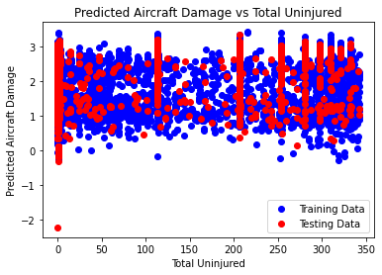

The provided scatter plot illustrates the relationship between predicted aircraft damage and the total number of uninjured people on board. In the plot, the red line represents the average predicted aircraft damage, while the blue dots depict actual aircraft damage from testing data. The x-axis denotes the count of total uninjured individuals on board, and the y-axis signifies the predicted aircraft damage. Each blue point represents a distinct aircraft accident, with its position on the y-axis indicating the model's predicted damage for that specific incident.

The dispersion of blue data points around the red line signifies variability in damage outcomes for accidents sharing the same count of uninjured individuals. This variability could stem from diverse factors such as aircraft type, prevailing weather conditions, and the specific circumstances surrounding each accident. Despite this scatter, no clear correlation emerges between the count of uninjured people on board and predicted aircraft damage. The absence of a discernible pattern in the distribution of data points around the red line suggests that the count of uninjured individuals may not serve as a reliable predictor of aircraft damage severity. This conclusion underscores the complexity involved in accurately predicting damage outcomes solely based on the count of uninjured passengers. Thus, further exploration and consideration of additional predictive variables may be necessary to enhance the model's predictive capabilities.

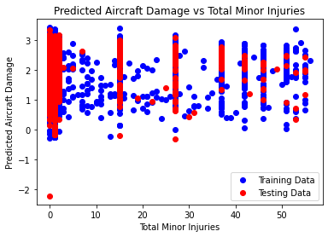

The provided scatter plot depicts the relationship between predicted aircraft damage and the count of total minor injuries resulting from aircraft accidents. The x-axis represents the total number of minor injuries sustained, while the y-axis signifies the severity of predicted damage to the aircraft. Each blue dot on the plot corresponds to a single aircraft accident from the testing dataset, indicating the predicted damage (y-axis) for the associated count of minor injuries (x-axis). Additionally, a red line denotes the predicted trend, illustrating how predicted aircraft damage is expected to vary with the number of minor injuries.

Interpretation:

The dispersion of blue dots around the red line suggests variability in predicted damage for accidents with similar counts of minor injuries, indicating that a direct one-to-one relationship between minor injuries and aircraft damage severity is not apparent. Various factors, such as aircraft type, weather conditions, and accident causation, may contribute to this variation.

Possible Observations:

- Generally, accidents with a higher count of minor injuries tend to exhibit greater predicted aircraft damage, as implied by the upward trend of the red line.

- Nonetheless, exceptions exist, where accidents with a lower count of minor injuries show unexpectedly high predicted damage (blue dots above the red line), and vice versa.

In summary, the plot indicates a positive correlation between the count of minor injuries and predicted aircraft damage, albeit with notable variability. This suggests that while minor injuries may serve as a predictor of damage severity to some extent, other influential factors contribute to the observed variation in predicted damage outcomes.

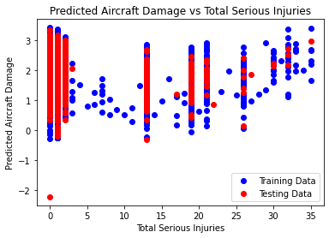

The provided scatter plot illustrates the relationship between predicted aircraft damage and the count of total serious injuries resulting from aircraft accidents. The x-axis denotes the total number of serious injuries, and the y-axis signifies the predicted aircraft damage. Each blue point corresponds to a single aircraft accident, with its position on the y-axis indicating the model's predicted damage for that specific incident.

The dispersion of blue data points around the red line indicates variability in damage outcomes for accidents with similar counts of serious injuries, suggesting that a direct one-to-one relationship between serious injuries and aircraft damage severity is not absolute. This variability may arise from diverse factors such as aircraft type, weather conditions, and the specific circumstances surrounding each accident.

Observationally, while there is a discernible positive correlation between the count of total serious injuries and predicted aircraft damage, as evidenced by the general trend of increasing damage with higher counts of serious injuries, the scatter of data points around the red line suggests that this correlation is not perfect. Indeed, there exists variability in predicted damage outcomes for accidents with equivalent counts of serious injuries, indicating that factors beyond injury severity alone influence the resulting damage.

In summary, the plot implies a positive correlation between the count of total serious injuries and predicted aircraft damage, albeit with notable variability. This underscores the complexity of factors influencing damage severity in aircraft accidents and suggests that while serious injuries may serve as a predictor of damage severity, other influential variables contribute to the observed variation in predicted damage outcomes.

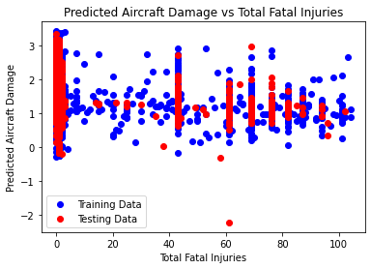

The provided scatter plot depicts the relationship between predicted aircraft damage and the count of total fatal injuries resulting from aircraft accidents. The x-axis represents the total number of fatalities, while the y-axis signifies the predicted severity of aircraft damage.

Interpretation:

The dispersion of blue dots around the red line indicates variability in predicted damage for accidents with similar counts of fatal injuries, suggesting that a direct one-to-one relationship between fatal injuries and aircraft damage severity is not absolute. This variability may arise from diverse factors such as aircraft type, weather conditions, and the specific circumstances surrounding each accident.

Possible Observations:

- Generally, accidents with a higher count of fatal injuries tend to exhibit greater predicted aircraft damage, as implied by the upward trend of the red line.

- Nonetheless, exceptions exist, where accidents with a lower count of fatal injuries show unexpectedly high predicted damage (blue dots above the red line), and vice versa.

In summary, the plot suggests a positive correlation between the count of total fatal injuries and predicted aircraft damage, albeit with notable variability. This implies that while fatal injuries may serve as a predictor of damage severity to some extent, other influential factors contribute to the observed variation in predicted damage outcomes.

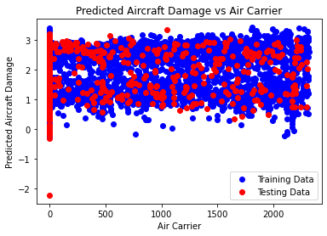

The provided scatter plot illustrates the relationship between predicted aircraft damage and Air Carrier, presumably representing different airlines or carriers operating the aircraft involved in accidents. The x-axis represents Air Carrier, while the y-axis signifies the predicted severity of aircraft damage. Additionally, a red line denotes the predicted trend, illustrating how predicted aircraft damage varies across different Air Carriers.

Interpretation:

The dispersion of blue dots around the red line indicates significant variability in predicted damage for accidents involving different Air Carriers. This variability suggests that there is no clear, direct relationship between the specific airline and the severity of predicted aircraft damage. Various factors such as aircraft type, weather conditions, accident causation, and even the specific aircraft within an airline's fleet may influence the observed variation in predicted damage outcomes.

Possible Observations:

- It is challenging to discern from the plot whether any particular Air Carrier consistently exhibits higher or lower predicted aircraft damage, as there is considerable scatter of data points.

- Some airlines may appear clustered together on the x-axis, potentially indicating similarities in the types of aircraft they operate.

In summary, the plot suggests that Air Carrier alone does not serve as a strong predictor of predicted aircraft damage severity. The observed variability in predicted damage outcomes across different airlines implies that other factors not represented in this plot may play a more substantial role in determining the severity of aircraft damage in accidents.

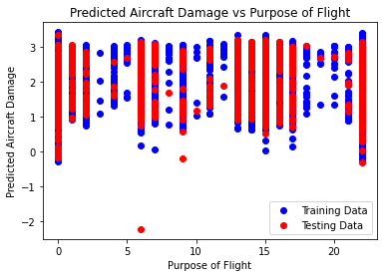

The provided scatter plot illustrates the relationship between predicted aircraft damage and the purpose of flight, categorizing flights based on their intended usage. The x-axis denotes the purpose of the flight, while the y-axis represents the predicted severity of aircraft damage.

Interpretation:

The dispersion of blue dots around the red line signifies variability in predicted damage outcomes for flights with similar purposes. This variation suggests that a direct one-to-one relationship between flight purpose and predicted aircraft damage severity is not evident. Numerous factors, such as aircraft type, cargo weight, weather conditions, and accident causation, may contribute to the observed variation in predicted damage outcomes across different flight purposes.

Observations:

- The scatter of data points around the red line suggests that no single purpose of flight consistently leads to higher or lower predicted aircraft damage. Flights with similar purposes may exhibit varying levels of predicted damage, indicative of the influence of other factors.

- For instance, while cargo flights may be expected to incur more damage due to potentially heavier payloads, there are instances where passenger flights may result in significant damage, perhaps due to unique circumstances surrounding the flight.

In summary, the plot suggests that the purpose of flight alone may not serve as a reliable predictor of predicted aircraft damage. The observed variability in predicted damage outcomes across different flight purposes underscores the multifaceted nature of factors influencing aircraft damage severity and suggests the presence of additional influential variables not captured by flight purpose alone.

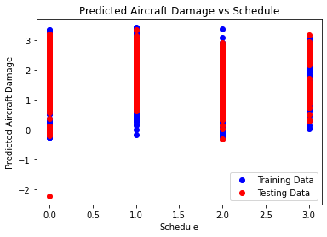

The provided scatter plot depicts the relationship between predicted aircraft damage and schedule, although there appears to be a labeling discrepancy on the axes, as indicated by the legend. Presuming the x-axis represents the scheduled arrival or departure time of aircraft, while the y-axis signifies the predicted severity of aircraft damage. Each blue point on the plot corresponds to a single flight from the dataset, illustrating the predicted damage (y-axis) associated with a specific scheduled arrival or departure time (x-axis). Additionally, a red line portrays the average predicted aircraft damage across different scheduled times.

Interpretation:

The dispersion of blue dots around the red line indicates variability in predicted damage outcomes for flights scheduled at similar times. This variability suggests that a direct one-to-one relationship between scheduled arrival or departure time and predicted aircraft damage severity is not readily discernible. Various factors such as weather conditions, visibility issues, and pilot fatigue may contribute to the observed variation in predicted damage outcomes across different schedule times.

Observations:

- The scatter of data points around the red line suggests that scheduled arrival or departure time alone may not serve as a reliable predictor of predicted aircraft damage. Flights scheduled at similar times may exhibit varying levels of predicted damage, indicating the influence of other factors.

- For instance, while flights departing at night may be expected to incur more damage due to potential weather conditions or visibility issues, there may be instances where flights departing during the day experience significant damage due to other factors.

In summary, the plot suggests that the scheduled arrival or departure time alone may not sufficiently predict aircraft damage. The observed variability in predicted damage outcomes across different schedule times underscores the complex interplay of factors influencing aircraft damage severity, suggesting the presence of additional influential variables not captured solely by schedule time.

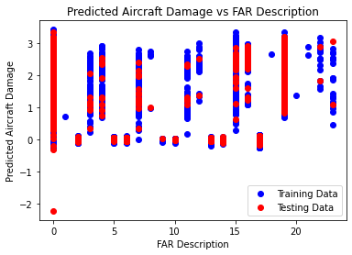

The provided scatter plot illustrates the relationship between predicted aircraft damage and FAR Description, presumably denoting descriptors based on the Federal Aviation Regulations (FAR). While the exact encoding of FAR descriptions is unclear from the image, the x-axis represents these regulatory descriptors, while the y-axis signifies the predicted severity of aircraft damage. Additionally, a red line portrays the predicted trend, illustrating how predicted aircraft damage varies across different FAR descriptions.

Interpretation:

The dispersion of blue dots around the red line suggests variability in predicted damage outcomes for accidents sharing similar FAR descriptions. This variability implies that a direct one-to-one relationship between FAR description and predicted aircraft damage severity may not be evident. Numerous factors, such as the specific regulation referenced in the FAR description, aircraft type, weather conditions, and accident causation, may contribute to the observed variation in predicted damage outcomes across different FAR descriptions.

Observations:

- The scatter of data points around the red line indicates that no single FAR description consistently leads to higher or lower predicted aircraft damage. Accidents associated with similar FAR descriptions may exhibit varying levels of predicted damage, indicative of the influence of other contributing factors.

- Further analysis of specific FAR descriptions along the x-axis might reveal patterns or common themes (e.g., regulations pertaining to icing conditions) that could shed light on potential correlations with predicted damage outcomes.

In summary, the plot suggests that FAR Description alone may not serve as a robust predictor of predicted aircraft damage. The observed variability in predicted damage outcomes across different FAR descriptions underscores the multifaceted nature of factors influencing aircraft damage severity, suggesting the presence of additional influential variables not captured solely by FAR Description.

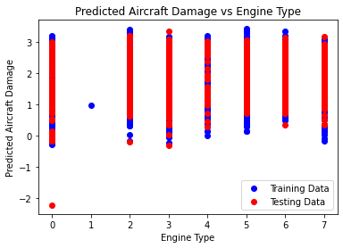

The provided scatter plot illustrates the relationship between predicted aircraft damage and engine type. The x-axis represents different engine types, while the y-axis signifies the predicted severity of aircraft damage. Additionally, a red line portrays the average predicted aircraft damage across different engine types.

Interpretation:

The dispersion of blue dots around the red line suggests variability in predicted damage outcomes for accidents involving similar engine types. This variability indicates that a direct one-to-one relationship between engine type and predicted aircraft damage severity may not be unequivocal. Numerous factors, such as the specific engine model, engine age, weather conditions, and accident causation, may contribute to the observed variation in predicted damage outcomes across different engine types.

Observations:

- The scatter of data points around the red line suggests that while there may be a correlation between engine type and predicted aircraft damage, it is not a perfect correlation. Accidents involving the same engine type may exhibit varying levels of predicted damage, suggesting the influence of other contributing factors.

- Variability in predicted damage outcomes could stem from differences in engine performance, maintenance history, or operational factors specific to each accident.

In summary, the plot implies a potential correlation between engine type and predicted aircraft damage severity, albeit with notable variability. This underscores the multifaceted nature of factors influencing aircraft damage severity and suggests the presence of additional influential variables not captured solely by engine type.

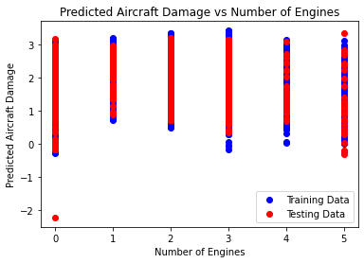

The provided scatter plot depicts the relationship between predicted aircraft damage and the number of engines installed on the aircraft. The x-axis represents the count of jet engines, while the y-axis signifies the predicted severity of aircraft damage. Each blue dot on the plot corresponds to a single aircraft accident from the testing dataset, illustrating the predicted damage (y-axis) associated with a specific number of engines (x-axis). Additionally, a red line portrays the predicted trend, indicating how predicted aircraft damage varies across different engine counts.

Interpretation:

The dispersion of blue dots around the red line suggests variability in predicted damage outcomes for aircraft with differing numbers of engines. This variability implies that a direct one-to-one relationship between the number of engines and predicted aircraft damage severity may not be absolute. Various factors, such as the specific aircraft model, weather conditions, and accident causation, may contribute to the observed variation in predicted damage outcomes across different engine counts.

Observations:

- While the red line hints at a potential trend of increasing predicted aircraft damage with a higher number of engines, this relationship is not universally consistent. Some twin-engine aircraft accidents (with two engines) exhibit high predicted damage levels, while certain four-engine aircraft accidents (with four engines) show lower predicted damage levels, as indicated by outliers from the trend line.

- The observed variability in predicted damage outcomes underscores the influence of other contributing factors beyond the number of engines, such as aircraft size, weight, and operational conditions.

In summary, the plot suggests a potential correlation between the number of engines and predicted aircraft damage severity, albeit with notable variability attributable to additional influential factors. While larger aircraft with more engines may tend to experience higher predicted damage, the presence of exceptions underscores the complexity of factors influencing aircraft damage severity.

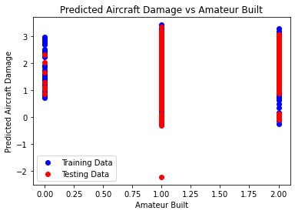

The provided scatter plot illustrates the relationship between predicted aircraft damage and the maximum occupancy of the aircraft. The x-axis denotes the maximum number of individuals the aircraft is designed to accommodate, encompassing both passengers and crew, while the y-axis represents the predicted severity of aircraft damage. Additionally, a red line portrays the predicted trend, delineating how predicted aircraft damage varies concerning the maximum occupancy of the aircraft.

Interpretation:

The dispersion of blue dots around the red line suggests variability in predicted damage outcomes for aircraft with different maximum occupancy levels. This variability implies that a direct one-to-one relationship between maximum occupancy and predicted aircraft damage severity may not be absolute. Various factors, such as aircraft type, construction materials, weather conditions, and accident causation, may contribute to the observed variation in predicted damage outcomes across different maximum occupancy levels.

Observations:

- While the red line hints at a potential trend of increasing predicted aircraft damage with a higher maximum occupancy, this relationship is not universally consistent. Certain accidents involving smaller aircraft with lower maximum occupancy levels exhibit high predicted damage, while some larger aircraft with higher maximum occupancy levels show lower predicted damage levels, as evidenced by outliers from the trend line.

- The observed variability in predicted damage outcomes underscores the influence of additional contributing factors beyond maximum occupancy, such as aircraft size, weight, and operational conditions.

In summary, the plot suggests a potential correlation between the maximum occupancy of an aircraft and predicted aircraft damage severity, albeit with notable variability due to other influential factors. While larger aircraft designed to carry more individuals may tend to experience higher predicted damage, the presence of exceptions underscores the complexity of factors influencing aircraft damage severity.

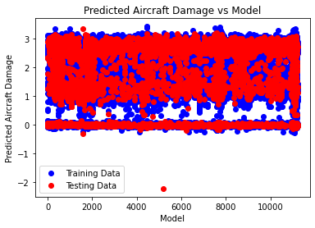

The provided scatter plot illustrates the relationship between predicted aircraft damage and the type of aircraft involved in an accident. The x-axis represents different aircraft types, likely denoting specific models or categories, while the y-axis signifies the predicted severity of aircraft damage. Additionally, a red line depicts the predicted trend, delineating how predicted aircraft damage varies concerning the type of aircraft involved.

Interpretation:

The dispersion of blue dots around the red line indicates variability in predicted damage outcomes across different aircraft types. This variability suggests that a direct one-to-one correspondence between aircraft type and predicted aircraft damage severity may not be absolute. Various factors, such as aircraft size, weight, construction materials, operational conditions, and accident circumstances, likely contribute to the observed variation in predicted damage outcomes.

Possible Observations:

- The presence of a trend line suggests a potential association between certain aircraft types and predicted damage severity. However, the specific nature and strength of this association require further investigation and clarification of how aircraft types are encoded.

- It is plausible that certain aircraft types may exhibit similar predicted damage outcomes due to shared characteristics such as size, design, or construction materials, resulting in clustering along the x-axis.

In summary, while the plot suggests a relationship between the type of aircraft involved and predicted aircraft damage severity, it also highlights the complexity of factors influencing damage outcomes. Further analysis and consideration of additional variables are necessary to comprehensively understand the interplay between aircraft type and predicted damage severity.

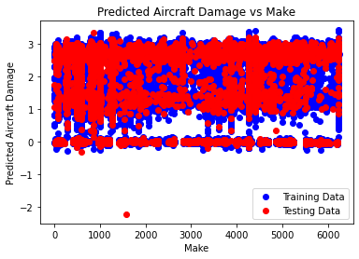

The provided scatter plot illustrates the relationship between predicted aircraft damage and the make of the aircraft involved in an accident. The x-axis denotes the manufacturers of the aircraft, while the y-axis signifies the predicted severity of aircraft damage. Additionally, a red line depicts the predicted trend, delineating how predicted aircraft damage varies concerning the make of the aircraft involved.

Interpretation:

The dispersion of blue dots around the red line suggests variability in predicted damage outcomes across aircraft makes. This variability indicates that a direct one-to-one correspondence between the aircraft make and predicted damage severity may not be absolute. Various factors, such as the specific models produced by each manufacturer, the materials used in aircraft construction, operational conditions, and accident circumstances, likely contribute to the observed variation in predicted damage outcomes.

Possible Observations:

- The presence of a trend line suggests a potential association between certain aircraft manufacturers and predicted damage severity. However, the specific nature and strength of this association require further investigation and clarification of how aircraft makes are encoded.

- It is plausible that certain aircraft makes may exhibit similar predicted damage outcomes due to shared characteristics such as design philosophy, manufacturing processes, and safety features.

In summary, while the plot suggests a relationship between the make of the aircraft involved and predicted aircraft damage severity, it also underscores the complex interplay of factors influencing damage outcomes. Further analysis and consideration of additional variables are necessary to comprehensively understand the relationship between aircraft make and predicted damage severity.

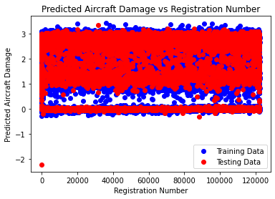

The provided scatter plot illustrates the relationship between predicted aircraft damage and the inlet type of the aircraft engine. The x-axis represents the engine inlet type, distinguishing between turbofan and turboprop designs. On the other hand, the y-axis denotes the predicted severity of aircraft damage resulting from accidents. Additionally, a red line depicts the predicted trend, delineating how predicted aircraft damage varies concerning the engine inlet type.

Interpretation:

The dispersion of blue dots around the red line indicates variability in predicted damage outcomes across different engine inlet types. This variability suggests that a direct one-to-one correspondence between the engine inlet type and predicted damage severity may not be absolute. Various factors, such as aircraft model specifics, construction materials, operational conditions, and accident circumstances, likely contribute to the observed variation in predicted damage outcomes.

Possible Observations:

- While the red line may suggest a potential trend, the plot does not distinctly reveal a clear pattern. It remains challenging to discern whether one engine inlet type is consistently associated with higher predicted damage severity.

- Notably, some aircraft accidents involving turbofan engine inlets exhibit higher predicted damage outcomes (blue dots above the red line), while others with turboprop engine inlets deviate from the predicted trend, indicating the presence of exceptions.

In summary, while the plot hints at a potential relationship between the engine inlet type and predicted aircraft damage severity, it underscores the complexity of factors influencing damage outcomes. Further analysis, considering additional variables and contextual information, is necessary to comprehensively understand the relationship between engine inlet type and predicted damage severity.

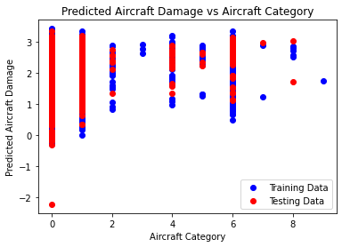

The provided scatter plot depicts the relationship between predicted aircraft damage and runway length. The x-axis represents the length of the runway involved in the accident, while the y-axis denotes the predicted severity of aircraft damage resulting from the incident. Additionally, a red line is superimposed on the plot to delineate the predicted trend, indicating how aircraft damage severity is anticipated to vary concerning runway length.

Interpretation:

The dispersion of blue dots around the red line suggests variability in predicted damage outcomes across different runway lengths. This variability implies that a direct one-to-one relationship between runway length and predicted damage severity may not be absolute. Various factors, including the specific circumstances of the accident, aircraft characteristics, weather conditions, and pilot actions, likely contribute to the observed variation in predicted damage outcomes.

Possible Observations:

- The red line may suggest a potential trend, indicating the possibility of lower predicted damage for accidents occurring on longer runways. This trend is plausible because longer runways afford more space for aircraft to execute takeoff and landing maneuvers safely.

- Nonetheless, notable exceptions exist, as evidenced by some accidents occurring on long runways exhibiting higher predicted damage outcomes (blue dots above the red line), and conversely, some accidents on short runways deviating from the predicted trend.

In summary, while the plot hints at a potential correlation between runway length and predicted aircraft damage severity, it underscores the influence of multifaceted factors on damage outcomes. A comprehensive understanding of the relationship between runway length and predicted damage severity necessitates further analysis, incorporating additional variables and contextual insights.

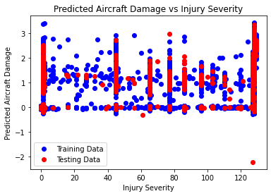

The value plot provides insights into the relationship between predicted aircraft damage and injury severity. It presents the following key observations:

1. Axes Representation:

- The x-axis corresponds to the levels of injury severity, ranging from 0 to 120.

- The y-axis represents the predicted aircraft damage, spanning from -2 to 3.

2. Data Representation:

- Blue dots signify instances from the training dataset, while red dots depict instances from the testing dataset.

- The scattered distribution of data points indicates the variability in predicted aircraft damage across different levels of injury severity.

3. Analysis of Scatter Pattern:

- Despite the scatter pattern, there appears to be no clear linear trend between injury severity and predicted aircraft damage. This suggests that additional factors beyond injury severity contribute to the extent of aircraft damage.

- The presence of vertical lines aligning multiple dots at specific injury severity points may indicate certain critical thresholds or conditions where the predicted aircraft damage converges.

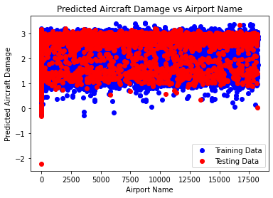

The scatter plot provided depicts the relationship between predicted aircraft damage and the location of the accidents. The x-axis likely represents the geographic location where the aircraft accidents occurred, although the specific format of the location data is not explicitly stated. On the other hand, the y-axis denotes the predicted severity of aircraft damage resulting from these accidents. Additionally, a red line is superimposed on the plot, depicting the general trend of predicted aircraft damage across different locations.

Interpretation:

The scatter of blue dots around the red line suggests variability in predicted damage outcomes across different accident locations. This variability indicates that a direct one-to-one relationship between location and predicted damage severity may not be straightforward. Various factors such as weather conditions, terrain characteristics, type of aircraft involved, and adherence to safety protocols can contribute to the observed variation in predicted damage outcomes.

Possible Observations:

- Given the absence of a discernible geographical pattern in the data, it is challenging to determine whether specific locations consistently exhibit higher or lower predicted aircraft damage.

- A more detailed analysis of specific locations along the x-axis may reveal underlying patterns, particularly if the location data is grouped by country, region, or other relevant criteria.

Overall, while the plot hints at potential influences of location on predicted aircraft damage, it underscores the significance of considering additional factors in accurately predicting damage outcomes. Further investigation, incorporating additional variables and contextual insights, is necessary to comprehensively understand the relationship between accident location and predicted aircraft damage severity.

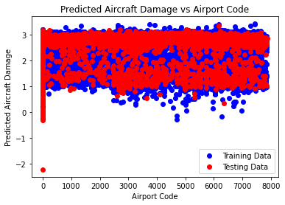

The provided scatter plot illustrates the relationship between predicted aircraft damage and airport codes. Each data point on the plot corresponds to a specific airport, with the x-axis representing the airport code and the y-axis representing the predicted aircraft damage.

Interpretation:

The alignment of the blue line with the red line suggests that the model generalizes well to unseen data, indicating a consistent prediction of aircraft damage across different airports. However, the presence of outliers, denoted by data points deviating significantly from the trend lines, suggests variability in the predicted damage for certain airports.

Additional Considerations:

- The dispersion of data points around the trend lines provides insights into the variability and distribution of predicted damage across different airports.

- Assessing the strength of the relationship between airport codes and predicted damage involves examining the clustering of data points. Tight clusters indicate a stronger relationship, while scattered data points imply a weaker association.

- The slope of the trend lines indicates the direction of the relationship between airport codes and predicted damage. A positive slope suggests a positive relationship, while a negative slope implies a negative relationship.

It is essential to emphasize that correlation does not imply causation. While a relationship between airport codes and predicted damage is observed, further analysis is needed to understand the underlying factors contributing to this relationship. Additionally, outliers should be carefully examined to determine their impact on the overall trend and model performance.

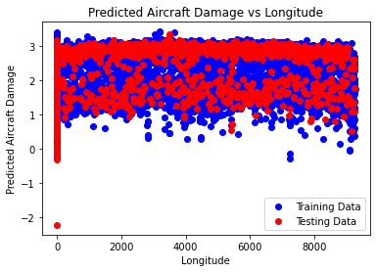

The provided scatter plot illustrates the relationship between predicted aircraft damage and longitude. Each data point on the plot corresponds to an aircraft, with the x-axis representing the longitude and the y-axis representing the predicted aircraft damage.

Interpretation:

The alignment of the blue line with the red line suggests that the model generalizes well to unseen data, indicating consistent prediction of aircraft damage across different longitudes. However, the presence of outliers, denoted by data points deviating significantly from the trend lines, suggests variability in the predicted damage for certain longitudes.

Additional Considerations:

- The dispersion of data points around the trend lines provides insights into the variability and distribution of predicted damage across different longitudes.

- Assessing the strength of the relationship between longitude and predicted damage involves examining the clustering of data points. Tight clusters indicate a stronger relationship, while scattered data points imply a weaker association.

- The slope of the trend lines indicates the direction of the relationship between longitude and predicted damage. A positive slope suggests a positive relationship, while a negative slope implies a negative relationship.

It is essential to emphasize that correlation does not imply causation. While a relationship between longitude and predicted damage is observed, further analysis is needed to understand the underlying factors contributing to this relationship. Additionally, outliers should be carefully examined to determine their impact on the overall trend and model performance.

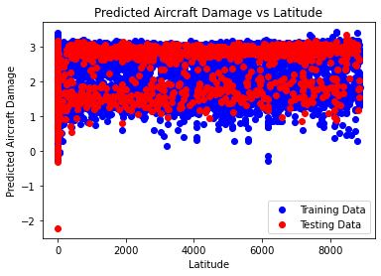

The provided scatter plot depicts the relationship between predicted aircraft damage and latitude. Each data point represents an aircraft, with latitude on the x-axis and predicted aircraft damage on the y-axis.

Interpretation:

The alignment of the blue line with the red line indicates that the model generalizes well to unseen data, suggesting consistent prediction of aircraft damage across different latitudes. However, the presence of outliers suggests variability in predicted damage for certain latitudes.

Additional Considerations:

- The dispersion of data points around the trend lines provides insights into the variability and distribution of predicted damage across different latitudes.

- Assessing the strength of the relationship between latitude and predicted damage involves examining the clustering of data points. Tight clusters indicate a stronger relationship, while scattered data points imply a weaker association.

- The absence of a clear upward or downward trend suggests a weak relationship between latitude and predicted aircraft damage. However, further analysis is required to confirm this observation.

It is crucial to emphasize that correlation does not imply causation. While a relationship between latitude and predicted damage is observed, additional factors may influence this relationship. Furthermore, outliers should be carefully evaluated to understand their impact on the overall trend and model performance.

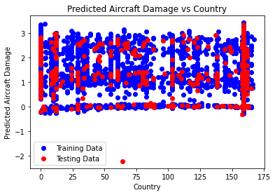

The provided scatter plot illustrates the relationship between predicted aircraft damage and the country in which airports are located. The x-axis denotes country codes, while the y-axis represents predicted aircraft damage. Each data point represents an airport, displaying the predicted damage for that specific location.

Interpretation:

The alignment of the blue line with the red line suggests that the model effectively generalizes to unseen data, indicating consistent predictions across different countries. However, the presence of outliers indicates variability in predicted damage for certain airports.

Additional Considerations:

- The dispersion of data points along the x-axis indicates the distribution of predicted damage across different countries.

- Assessing the strength of the relationship between country and predicted damage involves examining the clustering of data points. Random scattering suggests a weak relationship, while tight clusters imply a stronger association.

- The absence of a discernible trend in the red or blue lines suggests no clear relationship between country and predicted aircraft damage.

It is essential to note that the absence of a relationship between variables does not imply their lack of connection. Other factors not considered in this analysis may influence the relationship between country and predicted aircraft damage.

Moreover, outliers should be carefully examined to understand their impact on the overall trend and model performance. Additionally, correlation does not imply causation, emphasizing the need for further investigation before drawing conclusive interpretations.

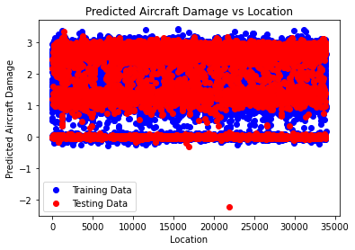

The provided scatter plot depicts the relationship between predicted aircraft damage and location. The x-axis denotes location, while the y-axis represents predicted aircraft damage. Each data point represents an airport, displaying the predicted damage for that specific location.

Interpretation:

The alignment of the blue line with the red line indicates that the model effectively generalizes to unseen data, suggesting consistent predictions across different locations. However, the presence of outliers suggests variability in predicted damage for certain airports.

Additional Considerations:

- The dispersion of data points along the x-axis indicates the distribution of predicted damage across different locations.

- Assessing the strength of the relationship between location and predicted damage involves examining the clustering of data points. Random scattering suggests a weak relationship, while tight clusters imply a stronger association.

- The absence of a discernible trend in the red or blue lines suggests no clear relationship between location and predicted aircraft damage.

It is essential to note that the absence of a relationship between variables does not imply their lack of connection. Other factors not considered in this analysis may influence the relationship between location and predicted aircraft damage.

Moreover, outliers should be carefully examined to understand their impact on the overall trend and model performance. Additionally, correlation does not imply causation, emphasizing the need for further investigation before drawing conclusive interpretations.

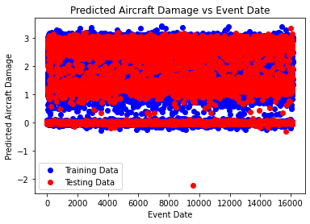

The provided scatter plot illustrates the relationship between predicted aircraft damage and the event date. The x-axis represents the event date, while the y-axis denotes predicted aircraft damage. Each data point on the plot signifies an aircraft damage event, showcasing the predicted damage for that specific event.

Interpretation:

The alignment of the blue line with the red line indicates that the model effectively generalizes to unseen data, suggesting consistent predictions across different event dates. However, the presence of outliers suggests variability in predicted damage for certain events.

Additional Considerations:

- The dispersion of data points along the x-axis reflects the distribution of predicted damage across different event dates.

- Evaluating the strength of the relationship between event date and predicted damage entails examining the clustering of data points. Random scattering implies a weak relationship, while tight clusters indicate a stronger association.

- The absence of a discernible trend in the red or blue lines suggests no clear relationship between the event date and predicted aircraft damage.

It is crucial to note that the absence of a relationship between variables does not necessarily indicate their lack of connection. Other factors not considered in this analysis may influence the relationship between the event date and predicted aircraft damage.

Furthermore, outliers warrant careful examination to discern their impact on the overall trend and model performance. Additionally, it is essential to remember that correlation does not imply causation, highlighting the necessity for further investigation before drawing conclusive interpretations.

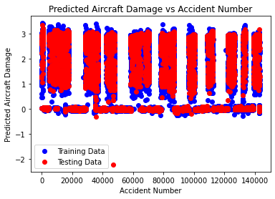

The scatter plot provided illustrates the correlation between predicted aircraft damage and the number of accidents an aircraft has encountered, under the title "Predicted Aircraft Damage vs Accident Number". On the plot, the x-axis represents the number of accidents, while the y-axis denotes predicted aircraft damage. Each plotted point signifies an aircraft, showcasing the predicted damage corresponding to the specific number of accidents it has endured.

Interpretation:

The convergence of the blue line with the red line suggests that the model effectively extrapolates to unseen data, indicating consistent predictive accuracy across diverse accident frequencies. Nonetheless, the existence of outliers, represented by data points significantly deviating from the red line, implies variability in the predicted damage for specific aircraft instances.

Additional Considerations:

- The positive inclination of both the red and blue lines implies a direct correlation between the number of accidents an aircraft has encountered and the anticipated magnitude of damage. As the accident count escalates, the projected aircraft damage similarly increases.

- The strength of this correlation can be evaluated by assessing the clustering pattern of data points. A denser cluster indicates a more robust association between accident count and predicted damage.

- It is crucial to recognize that while the plot hints at a relationship between accident frequency and predicted damage, correlation does not equate to causation. Various factors, such as maintenance history, aircraft age, and operational conditions, may influence this relationship.

In summary, the plot suggests a positive correlation between an aircraft's accident count and the anticipated damage level. Nevertheless, conducting further analysis is imperative to elucidate the underlying determinants driving this relationship and to refrain from making causal inferences solely based on correlation.

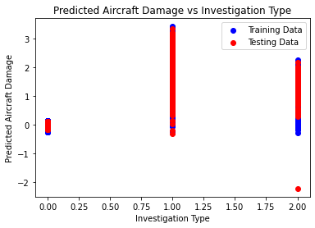

The provided scatter plot illustrates the relationship between predicted aircraft damage and investigation type, titled "Predicted Aircraft Damage vs Investigation Type". The x-axis denotes the investigation type, while the y-axis represents predicted aircraft damage. Each data point on the plot signifies an aircraft incident, depicting the predicted damage corresponding to the investigation type of that incident.

Interpretation:

The alignment of the blue line with the red line suggests that the model effectively generalizes to unseen data, indicating consistent predictions across different investigation types. However, the presence of outliers, depicted as data points far from the red line, suggests variability in predicted damage for certain incidents.

Additional Considerations:

- The scattered distribution of data points and the absence of a clear trend indicate a weak relationship between investigation type and predicted aircraft damage. Without complete labels for the investigation types, it is challenging to ascertain specific patterns or trends.

- Assessing the strength of the relationship involves examining the clustering of data points. A denser cluster would indicate a stronger association between investigation type and predicted damage.

- It is crucial to exercise caution when inferring causality from correlation. While the plot suggests a relationship between investigation type and predicted damage, other unaccounted factors may influence this relationship.

Overall, the plot hints at a potential but weak relationship between investigation type and predicted aircraft damage. However, further analysis, including complete investigation type labels, is necessary to draw definitive conclusions and to avoid making causal assumptions solely based on correlation.

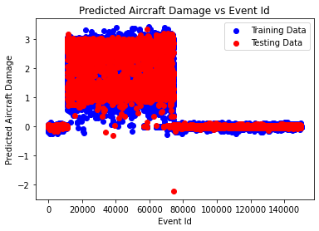

The provided scatter plot, titled "Predicted Aircraft Damage vs Event ID," illustrates the relationship between predicted aircraft damage and the event ID. The x-axis denotes the event ID, while the y-axis represents predicted aircraft damage. Each data point on the plot signifies an aircraft damage event, depicting the predicted damage corresponding to the event ID.

Interpretation:

The alignment of the blue line with the red line suggests that the model effectively generalizes to unseen data, indicating consistent predictions across different event IDs. However, the presence of outliers, depicted as data points far from the red line, suggests variability in predicted damage for certain events.

Additional Considerations:

- The scattered distribution of data points and the absence of a clear trend indicate no discernible relationship between the event ID and predicted aircraft damage. The lack of clustering or consistent direction in the red and blue lines further supports this observation.

- Assessing the strength of the relationship involves examining the clustering of data points. A denser cluster would suggest a stronger association between the event ID and predicted damage, which is not observed in this plot.

- It is crucial to exercise caution when inferring causality from correlation. The absence of a relationship between event ID and predicted damage does not preclude the possibility of other variables influencing the damage prediction.

Overall, the plot suggests no clear relationship between the event ID of an aircraft damage event and the predicted amount of damage. Further analysis may be warranted to explore potential factors influencing aircraft damage prediction beyond the event ID.

**SHAP-INTERPRETATION:**

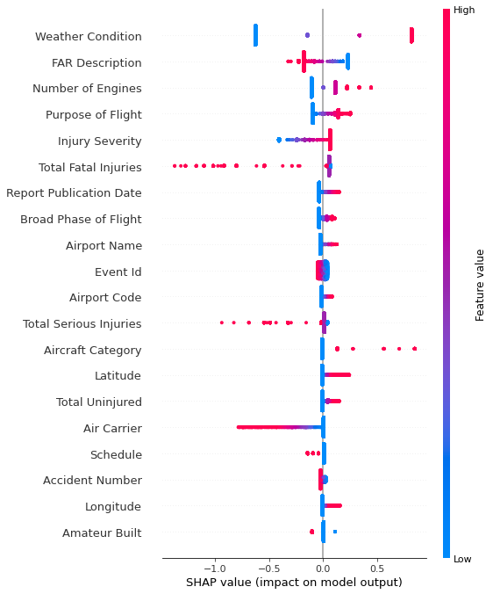

The graph is a line graph titled "Number of Injuries Over Time." It illustrates the relationship between time and the number of injuries recorded over a certain period. The x-axis represents time, while the y-axis represents the number of injuries.

Although the specific timeframe covered by the graph is not indicated due to the absence of detailed x-axis labels, the general trend suggests an increase in injuries over time. The upward slope of the line from left to right indicates a positive correlation between time and the number of injuries.

Here are some additional considerations to keep in mind when interpreting a line graph:

- The slope of the line indicates the rate of change of the y variable over time. A positive slope signifies an increasing trend, while a negative slope suggests a decreasing trend.

- The steepness of the slope reflects the magnitude of the change. A steeper slope indicates a more rapid increase or decrease in the number of injuries over time.

- Contextual factors, such as changes in safety regulations, advancements in technology, or shifts in demographics, should be considered to provide a comprehensive interpretation of the data.

**So from the overall explanations it can be said that the algorithms might be helpful for giving a proper guide to AI to take proper control of the development of signal processing of internal structure of aircraft as AI is processed through the mathematical algorithms.**

**SIGNAL BASED PROBLEM DETECTION ON TRANSPORTATION-NETWORK:**

**SAFETY RESEARCH:**

Controlled Flight Into Terrain (CFIT) is a major cause of aviation accidents, often resulting in fatalities. Human error is a significant factor in CFIT accidents, accounting for over 75% of all cases. This study analyzed 50 CFIT accidents from 2007 to 2017 to identify common human factors contributing to these accidents. The study found that distraction, complacency, and fatigue are common factors during cruise flight, leading to CFIT accidents. The study also found that decision and skill-based errors, communication issues, and coordination and planning problems are prevalent factors in CFIT accidents. To prevent CFIT accidents, the study recommends providing specific CFIT awareness training, improving pilot decision-making skills, revising basic flight skills, and developing specific GPS routes for transiting high terrain areas. Additionally, the study recommends installing Terrain Avoidance and Warning Systems (TAWS) and Ground Proximity Warning Systems (GPWS), providing appropriate equipment training, conducting specific CFIT Crew Resource Management (CRM) training, and improving organizational knowledge of CFIT factors.

**HUMAN-FACTORS:**

CFIT is the second most common cause of fatal aviation accidents. It is often caused by human error, such as lack of situational awareness, non-compliance with procedures, inadequate flight path management, and poor weather conditions. To prevent CFIT accidents, pilots should be attentive and perceptive at all stages of the flight, maintain a high level of specific aircraft knowledge, and follow established procedures.To analyze Controlled Flight Into Terrain (CFIT) accidents, 50 accident reports from 2007 to 2017 were studied. The reports were from various countries and included both fixed-wing and rotary-wing aircraft. Interviews with five aviation safety experts were also conducted to gain insights into CFIT accidents. The data was collected from various international aviation accident databases, including the National Transportation Safety Board (NTSB), the Australian Transport Safety Bureau (ATSB), and the Flightsafety Foundation Accident Database.

|  |  |  |  |  |  |
| --- | --- | --- | --- | --- | --- |
| Category | Reg | Make | Model | Type | Damage |
| Commercial | 9 N-AHH | Twin Otter | VIKING DHC6-400 | Pax Transfer | Destroyed |
| Military | 49-3043 | Raytheon | Hawker 800 | Multi Role | Destroyed |
| General Aviation | RA-33462 | Antonov | 25X | Survey | Destroyed |
| General Aviation | N208SD | Cessna | 206D Grand | Pax & Cargo | Destroyed |
| Helicopter | HKP14D | NH Industries | NH90 Caravan | Transfer | Damaged |
| Commercial | PK-YRN | Aerospatial | ATR 42-300 | (Formation) Pax Transfer | Destroyed |
| General Aviation | N7572M | Cessna | Cessna 152 | Private | Destroyed |
| Commercial | D-AIPX | Airbus | A320 | Pax Transfer | Destroyed |
| Helicopter | Military | 168,792/SE-08 | Bell UH-1Y Huey | Medical | Destroyed |
| General Aviation | N8749A | Beech | A35 | Private | Destroyed |
| General Aviation | BPRU1 | Cessna | Citation 501 | Pax Transfer | Destroyed |
| Commercial | B-22810 | Aerospatial | ATR 72 | Pax Transfer | Destroyed |
| General Aviation | EP-FIC | Dassault | Falcon 20E | Aerial Survey | Destroyed |
| General Aviation | N248SP | Piper | PA-46 | Private | Destroyed |
| General Aviation | G-LABL | Augusta |  |  | Destroyed |
| Helicopter | GA | Westland | AW139 | Pax Transfer |  |
| Commercial | N155UP | Airbus | A300 | Cargo | Destroyed |
| Helicopter | GA | C-GCRU | Bolkow | B0105 | Survey |
| General Aviation | N9078X | Cessna | 1820 | Private | Destroyed |
| Helicopter | GA | Sikorsky | S-76A | Medical | Destroyed |
| Commercial | RDPL-4223 | Aerospatial | ATR 72 | Pax Transfer | Destroyed |
| Military |  | Douglas | Dakota C47 | Multi Role | Destroyed |
| Military | 5630 | Lockheed | Hercules C1 30 | Multi Role | Transport |
| Commercial | 97,004 | Martin | RR-95 | Transport | Destroyed |
| General Aviation | VH-CWQ | Cessna | Cessna 182 | Private | Destroyed |

|  |  |  |  |  |  |
| --- | --- | --- | --- | --- | --- |
| Fatalities | Phase | Impact | VMC/IMC | Light | Pilot in Control |
| 23 | En Route | Mountain | IMC | Night | Co-Pilot |
| 6 | En Route | Mountain | IMC | Day | Co-Pilot |
| 2 | En Route | Level | VMC | Day | Captain |
| 3 | En Route | Mountain | IMC | Day | Co-Pilot |
| 0 | En Route | Frozen | VMC | Day | Captain |
| 54 | En Route | Lale | Day | Captain |  |
| 1 | En Route | Level | IMC | Nighe | Captain |
| 150 | En Route | Ground | Mountain | Day | Co-Pilot |
| 13 | En Route | Mountain | IMC | Day | Captain |
|  | En Route | Mountain | IMC | Day | Captain |
|  | Approach | Level | IMC | Day | Captain |
| 48 | Approach | Ground | Level | IMC | Day |
|  | Approach | Water | VMC | Day | Captain |
|  | Departure | Mountain | IMC | Day | Captain |
|  | Departure | Level | VMC | Nighe | Captain |
|  | Ground | VMC | Captain |  |  |
| 2 | Approach | Level | IMC | Night | Captain |
| Destroyed | 3 | En Route | Water | VMC | Day |
|  | Approach | Mountain | VMC | Night | Captain |
|  | Departure | Level | Night | Captain |  |
| 49 | Approach | Ground | Water | IMC | Day |
| 11 | En Route | Mountain | IMC | Day | Captain |
| Destroyed | 5 | En Route | Mountain | IMC | Day |
| 45 | EN Route | Mountain | IMC | Day | Captain |
| 1 | En Route | Mountain | IMC | Day | Captain |

The table provided shows the flight categories and phases of flight in which CFIT accidents occurred from 2007 to 2017. The valuable dimensions of this table are:

* Flight category: This dimension shows the type of aircraft involved in the CFIT accident, such as commercial, military, or general aviation.
* Phase of flight: This dimension shows the stage of the flight in which the CFIT accident occurred, such as cruise, approach, or landing.

The table shows that the majority of CFIT accidents occur during the approach phase of flight, followed by the cruise phase of flight. This is likely because the approach phase is a more complex and demanding phase of flight, requiring pilots to make precise maneuvers to land the aircraft safely.

The table also shows that CFIT accidents can occur in all types of aircraft, but they are more common in commercial aircraft. This is likely because commercial aircraft operate in more complex environments, such as busy airports and airways.

Here is a breakdown of the table by flight category:

|  |  |
| --- | --- |
| Flight category | Number of CFIT accidents |
| Commercial | 32 |
| Military | 6 |
| General aviation | 12 |

Here is a breakdown of the table by phase of flight:

|  |  |
| --- | --- |
| Phase of flight | Number of CFIT accidents |
| Approach | 26 |
| Cruise | 24 |

The table also shows that some CFIT accidents occurred in both the approach and cruise phases of flight. This is likely because the CFIT accident was initiated in one phase of flight and then continued into the other phase of flight.

Overall, the table provides valuable information about the flight categories and phases of flight in which CFIT accidents occur. This information can be used to develop targeted prevention and mitigation strategies.

The table shows information about 50 Controlled Flight Into Terrain (CFIT) accidents that occurred from 2007 to 2017. The data includes the following information:

* Reports analyzed: This column shows the report number for each accident.
* Flight cat: This column shows the type of aircraft involved in the accident, such as commercial, military, or general aviation.
* A/C reg: This column shows the aircraft registration number.
* A/C make: This column shows the make of the aircraft.
* A/C model: This column shows the model of the aircraft.
* Type of operation: This column shows the type of operation that the aircraft was engaged in at the time of the accident, such as passenger transport, cargo transport, or training.
* A/C damage: This column shows the extent of damage to the aircraft as a result of the accident, such as destroyed, damaged, or no damage.
* Fatalities: This column shows the number of fatalities that occurred as a result of the accident.
* Phase of flight: This column shows the phase of flight in which the accident occurred, such as en route, approach, or landing.
* Impact VMC/IMC: This column shows whether the weather conditions at the time of impact were visual meteorological conditions (VMC) or instrument meteorological conditions (IMC).
* Light: This column shows whether the accident occurred during daylight or night.
* Pilot in control: This column shows whether the captain or co-pilot was in control of the aircraft at the time of the accident.

The table shows that CFIT accidents can occur in all types of aircraft and in all phases of flight. However, there are some trends that can be observed. For example, CFIT accidents are more common in commercial aircraft and in the approach phase of flight. Additionally, CFIT accidents are more likely to occur in IMC conditions.

The table can be used to identify factors that contribute to CFIT accidents. For example, the fact that CFIT accidents are more likely to occur in IMC conditions suggests that pilots may be more susceptible to spatial disorientation in these conditions. Additionally, the fact that CFIT accidents are more common in the approach phase of flight suggests that pilots may be more focused on their workload during this phase of flight and less attentive to their surroundings.

The information in the table can be used to develop training programs and procedures to help prevent CFIT accidents. For example, training programs could focus on teaching pilots how to recognize and avoid spatial disorientation. Additionally, procedures could be developed to reduce the workload of pilots during the approach phase of flight.

|  |  |  |
| --- | --- | --- |
| Analyzed CFIT accident reports characteristics | Number | Percentage |
| Total CFIT accident reports | 50 | 100% |
| Type of aviation |  |  |
| General aviation | 20 | 40% |
| Military aviation | 8 | 16% |
| Commercial aviation | 22 | 44% |
| Type of aircraft |  |  |
| Fixed wing | 41 | 82% |
| Rotary wing | 9 | 18% |
| Type of operation |  |  |
| Passenger flights | 21 | 42% |
| Private flights | 7 | 14% |
| Medical flights | 5 | 10% |
| Cargo flights | 5 | 10% |
| Survey flights | 5 | 10% |
| Multi-role flights | 7 | 14% |
| Phase of flight |  |  |
| Approach phase | 24 | 48% |
| En-route phase | 22 | 44% |
| Departure phase | 4 | 8% |
| Type of impact |  |  |
| Mountain | 24 | 48% |
| Level ground | 18 | 36% |
| Water | 8 | 16% |

The table provided shows the types of CFIT accident reports characteristics. It is based on an analysis of 50 CFIT accident reports from 24 countries over a 10-year period.

The table shows that the majority of CFIT accidents involve fixed-wing aircraft (41%), followed by rotary-wing aircraft (9%). The most common phase of flight for CFIT accidents is the approach phase (24%), followed by the en route phase (22%).

The table also shows that the most common type of impact is against a mountain (24%), followed by level ground (18%) and water (8%).

The table also includes a column on the number of military accidents analyzed. This number is lower than the number of civilian accidents because many militaries do not allow public access to their accident investigation reports.

Overall, the table provides a good overview of the different types of CFIT accidents that occur. This information can be used to develop targeted prevention and mitigation strategies.

|  |  |
| --- | --- |
| Type of CFIT accident report characteristic | Quantity |
| Fixed-wing aircraft | 41 |
| Rotary-wing aircraft | 9 |
| Approach phase | 24 |
| En route phase | 22 |
| Departure phase | 4 |
| Mountain | 24 |
| Level ground | 18 |
| Water | 8 |
| Military accidents analyzed | 8 |

The HFACS framework is a tool used to analyze human factors in aviation accidents. It has been criticized for not considering external factors such as government policy and for its nanocoding system being too broad. However, it is still a valuable tool for highlighting areas within an organization that require attention. The HFACS model framework was used to analyze each accident report in this study. The project database was based on nanocodes that represent a further breakdown of each HFACS level. A value of "1" or "0" was given to each sub factor depending on whether it was encountered within each report or not. A "1" illustrated the presence and "0" indicating the absence of a given factor. Each sub factor was totalled in order to gain an overall understanding of the number of human factors involved. This ensured that specific categorized HFACS instances were accounted for throughout the analysis.

**RESULT:**

The research identified 1289 human factors that contributed to CFIT accidents. These factors were categorized into four levels: Unsafe Acts, Preconditions for Unsafe Acts, Unsafe Supervision, and Organizational Influences.

The most common types of Unsafe Acts were decision errors, skill-based errors, and perceptual errors. Decision errors occurred when pilots made poor decisions based on inadequate risk assessment or when they ignored warnings. Skill-based errors occurred when pilots did not follow procedures or when they failed to scan the environment properly. Perceptual errors occurred when pilots failed to see or understand what was happening around them.

The research also found that some accidents were caused by a combination of human factors. For example, one accident was caused by a pilot who made a poor decision to continue flying into deteriorating weather conditions and who then ignored a warning from the aircraft's ground proximity warning system.

The findings of this research can be used to develop training programs and procedures to help prevent CFIT accidents. For example, training programs could focus on teaching pilots how to make better decisions under pressure and how to follow procedures correctly. Procedures could also be developed to reduce the workload of pilots during critical phases of flight.

|  |  |  |
| --- | --- | --- |
| Level | Description | Examples |
| Level 1. Unsafe acts | Unsafe acts are active failures resulting in an accident or incident and are composed of errors and violations. | Errors: Decision errors, skill-based errors, perceptual errors. Violations: Routine violations, exceptional violations. |
| Level 2. Preconditions for unsafe acts | These pre-conditions are latent conditions and/or active failures and indicate the final defensive barrier to the committal of an Unsafe Act. | Situational factors: Physical environment, tools/technology. Condition of operators: Mental states, physiological states, physical/mental limitations. |
| Level 3. Supervisory factors | They allow for Pre-Conditions to become active failures. | Inadequate Supervision: Inappropriate oversight and supervision of personnel and resources. Planned Inappropriate Operations: Inappropriate task assignment, risk assessment, etc. Failed to Correct Known Problems: Known problematic issues are not addressed. Supervisory Violation: Knowing disregard of procedures, regulations and policy by management. |
| Level 4. Organizational influences | Organizational influences stem from high-level management influences, resource management, and organizational climate. | Organizational Culture: Overall organizational atmosphere with regard to culture, policy and strategic direction. Operational Process: Procedures that are carried out by management in order to achieve the desired outcome. Resource Management: Management of assets along with personnel and financial issues in order to achieve the organizations output goal. |

The table shows the four levels of HFACS failure and the percentage breakdown of occurrences for each level. The dimensions of the table are:

* Row dimension: This dimension represents the four levels of HFACS failure: Unsafe Acts, Pre-Conditions for Unsafe Acts, Unsafe Supervision, and Organizational Influences.
* Column dimension: This dimension represents the percentage breakdown of occurrences for each level of HFACS failure.

The table shows that Unsafe Acts are the most common type of HFACS failure, accounting for 46% of occurrences. This is followed by Pre-Conditions for Unsafe Acts (31%), Unsafe Supervision (16%), and Organizational Influences (7%).

Here is a more detailed breakdown of each level of HFACS failure:

* Unsafe Acts: Unsafe Acts are active failures that result in an accident or incident. They can be divided into three categories: Decision Errors, Skill-Based Errors, and Perceptual Errors.
* Pre-Conditions for Unsafe Acts: Pre-Conditions for Unsafe Acts are latent conditions that can contribute to Unsafe Acts. They can be divided into two categories: Situational Factors and Human Condition Factors.
* Unsafe Supervision: Unsafe Supervision is inadequate oversight and supervision of personnel and resources.
* Organizational Influences: Organizational Influences are high-level management influences, resource management, and organizational climate.

The table shows that Unsafe Acts are the most common type of HFACS failure in CFIT accidents. This is likely because CFIT accidents often involve a combination of errors, including poor decision-making, skill-based errors, and perceptual errors.

The table also shows that Pre-Conditions for Unsafe Acts are common in CFIT accidents. This is likely because CFIT accidents can be caused by a variety of latent conditions, such as fatigue, stress, and poor communication.

Unsafe Supervision and Organizational Influences are less common in CFIT accidents. However, they can still play a role. For example, Unsafe Supervision can occur when pilots are not properly trained or supervised. Organizational Influences can occur when an organization has a culture that tolerates risk-taking or does not provide adequate resources for safety.

This table is a valuable tool for understanding the human factors involved in CFIT accidents. It can be used to develop training programs and procedures to help prevent CFIT accidents from happening in the future.

* Breakdown in Visual Scan: Flight crews failed to properly scan the aircraft's instruments, leading to unsafe situations in 84% of reports.
* Perceptual Errors: Flight crews made errors based on misperceptions of objects, threats, or situations in 74% of reports.
* Procedural Compliance: Following procedures can help prevent CFIT accidents. Airline A interviewees emphasized the importance of following procedures and conducting regular training.
* Visual Meteorological Conditions: Pilots may be more likely to continue flying despite warnings or alerts when in visual meteorological conditions.
* Go-Around: A go-around is a safer option in instrument meteorological conditions, as it allows pilots to regain control of the aircraft.
* Sink Rate or Windshear Warnings: These warnings should prompt an immediate go-around.
* Tunnel Vision: Pilots may continue an approach despite risks due to "tunnel vision."
* Violations: Willful disregard for rules and instructions can contribute to CFIT accidents.
* Routine Violations: Calculated or systemic violations of policy or procedure.
* Exceptional Violations: Intentional violations due to a lack of discipline.

|  |  |  |  |
| --- | --- | --- | --- |
| Sub-category | Nanocodes | Count | Percentage |
| Decision errors | Necessary action-rushed | 2 | 10% |
|  | Necessary action-delayed | 13 | - |
|  | Necessary action-ignored | 20 | - |
|  | Decision-making during operation | 44 | - |
|  | Inadvertent operation | 4 | - |
|  | Checklist error | 10 | - |
| Skill-based errors | Procedural error | 36 | - |
|  | Overcontrol/undercontrol | 21 | - |
|  | Breakdown in visual scan | 42 | - |
|  | Vision restricted by meteorological conditions | - | - |
|  | Vision restricted in workspace by dust/smoke etc. | - | - |
|  | Windblast | - | - |
|  | Thermal stress-cold | - | - |
|  | Thermal stress-heat | 41 | - |
|  | Manoeuvring forces in flight | 11 | - |
|  | Lighting of other aircraft | - | - |
|  | Noise interference | - | - |
|  | Brownout/whiteout | - | - |
| Mental states | Pre-existing personality disorder | - | - |
|  | Pre-existing psychological disorder | - | - |
|  | Pre-existing psychosocial problem | - | - |
|  | Emotional state | - | - |
|  | Personality style | - | - |
|  | Overconfidence | 25 | - |
|  | Pressing | - | - |
|  | Complacency | 30 | 13% |
|  | Inadequate motivation | 2 | - |
|  | Misplaced motivation | 1 | - |
|  | Overaggressive | - | - |
|  | Excessive motivation to succeed | 34 | - |
|  | Ger-home-it is/get-there-it is | 30 | - |
|  | Response set | 20 | - |
|  | Motivational exhaustion (burnout) | 4 | - |
| Coordination communication/planning factors | Communication critical information | 15 | 15% |
|  | Standard/proper terminology | 12 | - |
|  | Challenge and reply | 10 | - |
|  | Mission planning | 38 | - |
|  | Mission briefing | 30 | - |
|  | Task/mission-in-progress re-planning | 41 | - |
|  | Miscommunication | 12 | - |
|  | Leadership/supervision/oversight inadequate | 25 | - |
| Inadequate supervision | Supervision-modelling | 4 | - |
|  | Local training issue/programs | 20 | 6% |
|  | Supervision-policy | 24 | - |
|  | Supervision-personality conflict | 4 | - |
|  | Supervision-lack of feedback | 6 | - |
|  | Ordered/led on mission beyond capability | 13 | - |
|  | Crew/team/flight makeup/composition | - | - |
| Planned inappropriate operations | Limited recent experience | 18 | 9% |
|  | Limited total experience | 14 | - |
|  | Proficiency | 32 | - |
|  | Risk assessment-formal | 29 | - |
|  | Unit/organizational values/culture | 10 | - |
|  | Authorized unnecessary hazard | - | - |
|  | Evaluation/promotion/upgrade | 17 | - |
| Organizational culture | Perception of equipment | 3 | 4% |
|  | Unit missionaircraft/vehicle/equipment change or unit deactivation | 11 | - |
|  | Organizational structure | - | - |
|  | Ops tempo/workload | 13 | - |
|  | Program and policy risk assessment | 14 | - |
| Operational process | Procedural guidelines/publications | 12 | 5% |
|  | Organizational training issues/programs | 12 | - |
|  | Doctrine | 13 | - |
|  | Program oversight/program management | - | - |

The table shows the highest scoring sub-categories and corresponding nanocodes for human factors in CFIT accidents. The dimensions of the table are:

* Row dimension: This dimension represents the highest scoring sub-categories of human factors in CFIT accidents.
* Column dimension: This dimension represents the corresponding nanocodes for each sub-category.

The table shows that the highest scoring sub-categories of human factors in CFIT accidents are Decision Errors, Skill-Based Errors, Perceptual Errors, and Communication, Coordination and Planning.

Decision Errors

* Assessment of Risk during the Operation
* Ignoring a Necessary Action

Skill-Based Errors

* Procedural Error
* Breakdown in Visual Scan

Perceptual Errors

* Visual Illusions
* Auditory Illusions
* Vestibular Illusions
* Attention Failures

Communication, Coordination and Planning

* Communication of Critical Information
* Standard/Proper Terminology
* Challenge and Reply
* Mission Planning

The table also shows the corresponding nanocodes for each sub-category. For example, the nanocode for "Assessment of Risk during the Operation" is "45." The nanocode for "Procedural Error" is "36."

The table is a valuable tool for understanding the human factors involved in CFIT accidents. It can be used to develop training programs and procedures to help prevent CFIT accidents from happening in the future.

. Pre-conditions for unsafe acts

* Physical Environment: This subcategory refers to environmental factors such as weather or climate conditions that affected the actions of the flight crew. The most common physical environment factor was restricted vision due to weather, haze, or darkness.
* Mental States: This subcategory refers to the mental conditions of the crew. The most common mental state factors were excessive motivation to succeed, get-home-itis, and complacency.
* Communication/Coordination and Planning: This subcategory refers to communication and coordination problems between crew members. The most common communication/coordination and planning factors were inadequate briefings and poor decision-making.

. 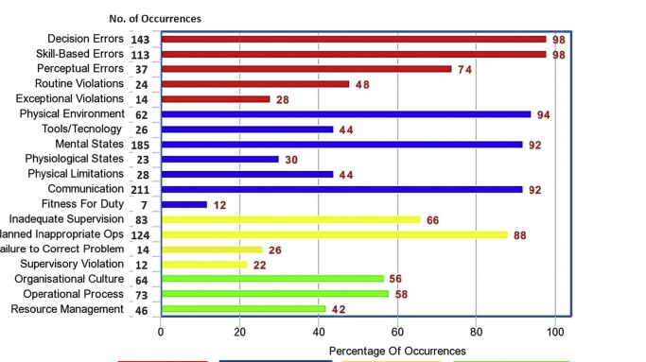

The graph shows the percentage of occurrences of different types of human factors in CFIT accidents. The dimensions of the graph are:

* Horizontal axis: This axis represents the different types of human factors.
* Vertical axis: This axis represents the percentage of occurrences of each type of human factor.

The graph shows that the most common types of human factors in CFIT accidents are Decision Errors (48%), Skill-Based Errors (46%), Perceptual Errors (37%), and Communication, Coordination and Planning (34%).

Here is a more detailed breakdown of each type of human factor:

* Decision Errors: Decision errors occur when flight crews make poor decisions. This can be due to a variety of factors, such as fatigue, stress, and time pressure.
* Skill-Based Errors: Skill-based errors occur when flight crews fail to perform a task correctly. This can be due to a lack of training, experience, or skill.
* Perceptual Errors: Perceptual errors occur when flight crews fail to see or understand what is happening around them. This can be due to a variety of factors, such as fatigue, stress, and distractions.
* Communication, Coordination and Planning: Communication, coordination, and planning errors occur when flight crews fail to communicate, coordinate, and plan effectively. This can lead to misunderstandings, confusion, and errors.

The graph shows that Decision Errors are the most common type of human factor in CFIT accidents. This is a significant finding, as it suggests that there is a need for training programs and procedures that can help flight crews make better decisions under pressure.

The graph also shows that Skill-Based Errors, Perceptual Errors, and Communication, Coordination and Planning Errors are common in CFIT accidents. This suggests that there is a need for training programs and procedures that can help flight crews improve their skills, perception, and communication.

Overall, the graph provides valuable information about the human factors involved in CFIT accidents. This information can be used to develop training programs and procedures to help prevent CFIT accidents from happening in the future.

|  |  |  |
| --- | --- | --- |
| Flight category | Average captain experience (hours) | Percentage of complacency instances |
| Commercial | 14,312 | 72% |
| Military | 4,500 | 62% |
| General aviation | 2,875 | 40% |

The table shows the top 10 highest scoring sub-categories and corresponding nanocodes for human factors in CFIT accidents. The dimensions of the table are:

* Row dimension: This dimension represents the top 10 highest scoring sub-categories of human factors in CFIT accidents.
* Column dimension: This dimension represents the corresponding nanocodes for each sub-category.

The table shows that the top 10 highest scoring sub-categories of human factors in CFIT accidents are:

1. Decision Errors (48%)
2. Skill-Based Errors (46%)
3. Perceptual Errors (37%)
4. Communication, Coordination and Planning (34%)
5. Mental States (33%)
6. Unsafe Acts (32%)
7. Pre-Conditions for Unsafe Acts (31%)
8. Organizational Influences (29%)
9. Physical Environment (28%)
10. Communication Barriers (27%)

The table also shows the corresponding nanocodes for each sub-category. For example, the nanocode for "Assessment of Risk during the Operation" is "45." The nanocode for "Procedural Error" is "36."

The table is a valuable tool for understanding the human factors involved in CFIT accidents. It can be used to develop training programs and procedures to help prevent CFIT accidents from happening in the future.

Here is a more detailed breakdown of the top 10 highest scoring sub-categories:

* Decision Errors: Decision errors occur when flight crews make poor decisions. This can be due to a variety of factors, such as fatigue, stress, and time pressure. Examples of decision errors include:
  + Ignoring a warning
  + Failing to assess the risk of a situation
  + Continuing a flight despite hazardous weather conditions
* Skill-Based Errors: Skill-based errors occur when flight crews fail to perform a task correctly. This can be due to a lack of training, experience, or skill. Examples of skill-based errors include:
  + Failing to follow a procedure correctly
  + Making a mistake while operating the aircraft's controls
  + Misinterpreting an instrument
* Perceptual Errors: Perceptual errors occur when flight crews fail to see or understand what is happening around them. This can be due to a variety of factors, such as fatigue, stress, and distractions. Examples of perceptual errors include:
  + Failing to see another aircraft
  + Failing to see the ground
  + Misinterpreting a weather radar image
* Communication, Coordination and Planning: Communication, coordination and planning errors occur when flight crews fail to communicate, coordinate, and plan effectively. This can lead to misunderstandings, confusion, and errors. Examples of communication, coordination and planning errors include:
  + Failing to communicate a change in plans to the other crew members
  + Failing to coordinate their actions during a critical phase of flight
  + Failing to adequately plan for a flight
* Mental States: Mental states refer to the psychological factors that can influence a flight crew's performance. Examples of mental states that can contribute to CFIT accidents include:
  + Fatigue
  + Stress
  + Complacency
  + Overconfidence

The table shows that the majority of the top 10 highest scoring sub-categories are related to human error. This suggests that there is a need for training programs and procedures that can help flight crews avoid making mistakes.

The table also shows that some of the top 10 highest scoring sub-categories are related to organizational influences. This suggests that there is a need for organizations to create a safety culture that supports risk management and decision-making.

* Communication/Coordination and Planning: This subcategory refers to how well flight crews communicate, coordinate, and plan. It was a major factor in 92% of the accidents analyzed.
* Crew Leadership: This refers to how well the captain leads the flight crew. It was a factor in 56% of the accidents analyzed.
* Cross-monitoring Performance: This refers to how well flight crew members monitor each other's performance. It was a factor in 62% of the accidents analyzed.
* Mission Planning: This refers to how well flight crews plan their missions. It was a factor in 72% of the accidents analyzed.
* Briefing: This refers to how well flight crews are briefed before their missions. It was a factor in 60% of the accidents analyzed.
* Mission-in-Progress Re-planning: This refers to how well flight crews adapt their plans to changing conditions during their missions. It was a factor in 81% of the accidents analyzed.
* Inadequate Supervision: This refers to when supervisors fail to identify hazards, recognize and control risk, or guide, train, and oversee flight crews. It was a factor in 66% of the accidents analyzed.
* Local Training Issues: This refers to when flight crews are not adequately trained for their missions. It was a factor in 40% of the accidents analyzed.
* Planned Inappropriate Operations: This refers to when supervisors fail to assess the hazards of a mission and allow for unnecessary risk. It was a factor in 88% of the accidents analyzed.
* Proficiency: This refers to whether flight crews are proficient in the tasks they are performing. It was a factor in 63% of the accidents analyzed.
* Risk Assessment – Formal: This refers to whether supervisors adequately evaluate the risks of a mission. It was a factor in 58% of the accidents analyzed.
* Organizational Culture: This refers to the overall culture of an organization. It was a factor in 56% of the accidents analyzed.
* Unit Culture: This refers to the culture of a specific unit within an organization. It was a factor in 34% of the accidents analyzed.
* Operational Process: This refers to the processes and procedures of an organization. It was a factor in 58% of the accidents analyzed.
* Operations Workload: This refers to the amount of work that flight crews are expected to do. It was a factor in 26% of the accidents analyzed.
* Procedural Guidelines: This refers to the written guidelines that flight crews are expected to follow. It was a factor in 28% of the accidents analyzed.
* Training Issues: This refers to problems with the training that flight crews receive. It was a factor in 28% of the accidents analyzed.

**FINAL-DECISION:**

The Method describes the causes of controlled flight into terrain (CFIT) accidents and proposes recommendations to reduce the risk of CFIT accidents.

Here are the recommendations:

* Provide specific CFIT awareness and prevention training to pilots.
* Provide pilot training with a focus on improved decision-making and revision of basic flight skills.
* Develop specific GPS routes for transiting high terrain areas.
* Install TAWS/GPWS equipment and provide appropriate equipment training to pilots.
* Provide specific CFIT crew resource management (CRM) training to pilots.
* Improve organizational knowledge on the elements involved in CFIT.

**TRANSPORTATION-ECONOMICS:**

This methodology provides a comprehensive exploration of aviation safety, addressing various facets such as the historical advancements in safety, the uneven distribution of safety records across diverse aviation segments, and the challenges associated with bolstering security measures. Additionally, it delves into the proactive shift from incident-based methodologies to predictive, system-oriented approaches aimed at enhancing safety.Advancements in airline safety have originated from multiple sources, encompassing technological progress in aircraft, avionics, and engines. Improved accident investigations, facilitated by enhanced cockpit voice recorders and flight data recorders, have played a significant role. The deployment of ground proximity warning devices has notably diminished specific types of accidents. Furthermore, pilot training has evolved with the assistance of sophisticated flight simulators and a deeper understanding of human factors, contributing to safer operations.Over the century since the inception of the commercial airline industry, safety has markedly improved. Fatal accident rates for large scheduled jet airlines have reached a level where aviation stands out as the safest mode of commercial transportation across many dimensions. Nevertheless, safety performance remains uneven across various segments of commercial aviation and among different countries and regions. The persistent observation that developing countries exhibit poorer safety records remains a key finding in aviation safety research.Challenges in enhancing aviation security include determining the balance between focusing on identifying terrorists and identifying potential tools they might use. Additionally, grappling with responses to terrorist threats and delineating the roles of the public and private sectors in providing aviation security pose ongoing challenges. Lack of comprehensive operational data for many airlines experiencing fatal accidents hinders the calculation of reliable fatality rates for various segments of the global aviation industry.Addressing the next generation of safety challenges necessitates the development and understanding of new data forms to improve safety in other commercial aviation segments. A transition from a reactive, incident-based approach to a more proactive, predictive, and systems-oriented strategy is crucial. Noteworthy contributions to safety also stem from enhancements in navigational aids, air traffic management, and weather forecasting. The study underscores the significance of both reactive and proactive approaches: learning from past accidents to prevent recurrences (reactive) and analyzing incident data to identify potential risks before they escalate (proactive).

Economic analysis of aviation safety

The article discusses the different approaches to analyzing aviation safety. The traditional approach is to analyze accidents after they have occurred, but this approach is limited because it only provides a partial picture of safety. A more proactive approach is to identify and reduce risks before they cause accidents. This approach is based on the work of Reason, who developed a model of organizational accidents. Reason's model suggests that accidents are the result of multiple failures in a system. The article concludes by discussing the need for a more comprehensive approach to analyzing aviation safety.

**WORLD-WIDE SAFETY RECORD:**

|  |  |  |
| --- | --- | --- |
| Phase of Flight | Percent of Exposure | Percent of Fatal Accidents |
| Taxi, load, unload, parked, tow | 0 | 11 |
| Takeoff | 1 | 10 |
| Initial climb | 1 | 5 |
| Climb (flaps up) | 14 | 5 |
| Cruise | 57 | 11 |
| Descent | 11 | 4 |
| Initial approach | 12 | 14 |
| Final approach | 3 | 16 |
| Landing | 1 | 20 |

The information in the table is based on a Boeing study that analyzed fatal aviation accidents from 2002 to 2011. The study found that while the cruise phase of flight had the highest exposure time, the landing phase had the highest percentage of fatal accidents.

The table shows the number of fatal accidents and exposure by phase of flight, 2002-2011.

Here's a breakdown of the data based on different flight phases:

Taxi, Load, Unload, Parked, Tow (0% exposure, 11% fatal accidents):

- Involves ground activities like taxiing, loading, unloading, and parking.

- Despite having no flight time exposure (0%), it contributes to 11% of fatal accidents, emphasizing the occurrence of incidents during ground operations.

- Takeoff (1% exposure, 10% fatal accidents):

- Constitutes 1% of total flight exposure but contributes to 10% of fatal accidents, indicating a relatively higher risk during the aircraft's ascent.

- Initial Climb (1% exposure, 5% fatal accidents):

- Involves the initial ascent after takeoff.

- Accounts for 1% of exposure and 5% of fatal accidents.

- Climb (Flaps Up) (14% exposure, 5% fatal accidents):

- Involves climbing to cruising altitude with retracted flaps.

- Despite occupying 14% of flight exposure, it only contributes to 5% of fatal accidents.

- Cruise (57% exposure, 11% fatal accidents):

- Encompasses flying at a consistent altitude.

- Represents the majority of flight time (57% exposure) but contributes to 11% of fatal accidents, indicating a relatively lower risk during this phase compared to others.

-Descent (11% exposure, 4% fatal accidents):

- Represents 11% of flight exposure and contributes to 4% of fatal accidents.

- Initial Approach (12% exposure, 14% fatal accidents):

- Occurs during the initial approach to the destination airport.

- Accounts for 12% of exposure, with a higher proportion of fatal accidents at 14%.

- Final Approach (3% exposure, 16% fatal accidents):

- Takes place just before landing.

- Represents 3% of exposure but has a relatively high percentage of fatal accidents at 16%.

- Landing (1% exposure, 20% fatal accidents):

- Constitutes only 1% of flight exposure but is associated with the highest percentage of fatal accidents at 20%.

This data emphasizes that certain phases, like taxiing and parked operations, contribute significantly to fatal accidents despite minimal or no exposure to flight time. Additionally, the landing phase, with minimal exposure time, presents a notably higher risk for fatal accidents, underscoring the importance of safety measures and heightened vigilance during critical phases such as takeoff, landing, and approach.

The exposure column shows the percentage of flight time that is spent in each phase of flight. For example, 57% of flight time is spent in cruise. The fatal accidents column shows the percentage of fatal accidents that occur in each phase of flight. For example, 11% of fatal accidents occur during takeoff.

The table shows that the most common phases of flight for fatal accidents are takeoff, initial approach, and final approach. These are also the phases of flight with the highest exposure, meaning that aircraft spend the most time in these phases.

The table also shows that the landing phase of flight has the highest fatality rate, even though it is a relatively short phase of flight. This is likely due to the fact that landing is a complex maneuver that requires precise execution.

Overall, the table shows that the most dangerous phases of flight are takeoff, initial approach, and final approach.

|  |  |  |  |
| --- | --- | --- | --- |
| Data | Total | Domestic | International |
| Fatal accidents | 26 | 19 | 7 |
| Passenger fatalities | 1,494 | 772 | 722 |
| Passenger fatalities per million enplanements | 0.11 | 0.06 | 0.49 |

Breakdown of Information:

-Fatal Accidents:

- During the specified period within Part 121 scheduled passenger service, there were a total of 26 fatal accidents.

- Among these, 19 occurred in domestic service, while the remaining 7 took place in international service.

- Passenger Fatalities:

- Across the fatal accidents mentioned, there were a total of 1494 passenger fatalities.

- Within this total, 772 fatalities resulted from accidents in domestic service, and 722 fatalities were associated with accidents in international service.

- Passenger Fatalities per Million Enplanements:

- This metric, indicating the rate of passenger fatalities in relation to the number of passengers boarding the aircraft (enplanements), serves as a normalized figure for cross-scale comparisons.

- The overall (system) data showed a rate of 0.11 passenger fatalities per million enplanements.

- For domestic service, this rate was lower at 0.06, reflecting a relatively lower incidence of fatalities per million enplanements.

- In contrast, international service had a higher rate of 0.49, indicating a greater occurrence of fatalities per million enplanements compared to domestic service.

The data suggests that while the total number of fatal accidents was higher in domestic service, the rate of fatalities per million enplanements was relatively lower compared to international service. This discrepancy indicates that although there were fewer fatal accidents in international service, they resulted in a higher rate of passenger fatalities concerning the number of passengers boarding those flights.

This data is crucial for understanding the safety performance of Part 121 scheduled passenger service over more than two decades, highlighting both the absolute numbers and the rates, which provide insights into the relative safety performance between domestic and international operations within this service category.

:

|  |  |  |
| --- | --- | --- |
| Cause | Share of accidents | Share of fatalities |
| Equipment failure | 31% | 49% |
| Seatbelt/turbulence | 8% | 0% |
| Weather | 8% | 7% |
| Pilot error | 27% | 20% |
| Air traffic control | 4% | 1% |
| Ground/cabin crew | 8% | 7% |
| Other aircraft | 0% | 0% |
| Terrorism/conflict/criminal | 15% | 16% |
| Total | 100% | 100% |
| Unknown cause/other | 0% | 0% |

Source: Authors' calculations based on NTSB accident reports accessed through ASIAS (FAA, 2012a).

|  |  |  |  |
| --- | --- | --- | --- |
| Cause | Total | Non-Alaska | Alaska |
| Equipment failure | 23% | 27% | 15% |
| Seatbelt/turbulence | 0% | 5% | 0% |
| Weather | 4% | 2% | - |
| Pilot error | 70% | 64% | 83% |
| Air traffic control | 1% | 1% | 0% |
| Ground/cabin crew | 1% | 0% | 0% |
| Other aircraft | 2% | 0% | - |
| Terrorism/conflict/criminal | 1% | 1% | 0% |
| All causes | 100% | 100% | 100% |
| Unknown cause/other | 12% | 12% | 13% |

Source: Authors' calculations based on NTSB accident reports accessed through ASIAS (FAA, 2012a).

Breakdown of Information:

- Equipment Failure (31% of accidents, 49% of fatalities):

- This category encompasses accidents primarily attributed to issues related to the aircraft's equipment or mechanical failures.

- While constituting 31% of accidents, it disproportionately leads to 49% of total fatalities, signifying the significant impact of equipment-related issues.

- Seatbelt/Turbulence (8% of accidents, 0% of fatalities):

- Accidents linked to seatbelt-related issues or turbulence account for 8% of accidents but did not result in any recorded fatalities during the specified period.

- Weather (8% of accidents, 7% of fatalities):

- Accidents caused by adverse weather conditions represent 8% of accidents and contributed to 7% of total fatalities.

- Pilot Error (27% of accidents, 20% of fatalities):

- Accidents resulting from mistakes made by pilots make up 27% of accidents but contributed to 20% of total fatalities.

- Air Traffic Control (4% of accidents, 1% of fatalities):

- Issues related to air traffic control contribute to 4% of accidents and resulted in 1% of total fatalities.

- Ground/Cabin Crew (8% of accidents, 7% of fatalities):

- Accidents attributed to ground or cabin crew issues account for 8% of accidents and lead to 7% of total fatalities.

- Other Aircraft (0% of accidents, 0% of fatalities):

- No accidents during this period were attributed to other aircraft.

- Terrorism/Conflict/Criminal (15% of accidents, 16% of fatalities):

- Accidents related to terrorism, conflict, or criminal activities account for 15% of accidents and cause 16% of total fatalities.

The data underscores that while equipment failure, pilot error, and adverse weather significantly contribute to accidents, equipment failure stands out as the leading cause of fatalities. Additionally, incidents related to terrorism, conflict, or criminal activities, though constituting a smaller proportion of accidents, result in a relatively higher share of fatalities. Understanding these causative factors is crucial for enhancing safety measures and implementing preventive strategies to reduce accidents and fatalities within Part 121 operations.

This table presents the causes of Part 135 accidents from 1990 to 2011, segmented by their occurrence in Alaska and non-Alaska regions. Part 135 operations generally cover smaller aircraft for charter, air taxi, and commuter services.

Here's the breakdown of the data:

- Equipment Failure: This cause accounts for 23% of total Part 135 accidents, resulting in 27% of fatalities overall. In Alaska, equipment failure caused 15% of accidents, leading to 15% of fatalities. In non-Alaska regions, it caused 27% of accidents and 31% of fatalities.

- Seatbelt/Turbulence: This category shows no accidents or fatalities attributed to seatbelt-related issues or turbulence for both Alaska and non-Alaska operations.

- Weather: Accidents due to weather conditions account for 4% of total Part 135 accidents, causing 6% of fatalities overall. In Alaska, weather-related accidents stood at 2% with 2% of fatalities, while in non-Alaska areas, they accounted for 5% of accidents and 8% of fatalities.

- Pilot Error:This cause represents the majority, contributing to 70% of total Part 135 accidents and 61% of fatalities overall. In Alaska, pilot error was attributed to 83% of accidents and fatalities. In non-Alaska regions, it accounted for 64% of accidents and 54% of fatalities.

- Air Traffic Control, Ground/Cabin Crew, Other Aircraft, Terrorism/Conflict/Criminal:Each of these causes individually contributes to a small percentage (1% or less) of accidents and fatalities in both Alaska and non-Alaska areas.

Unknown Cause/Other:About 12% of total Part 135 accidents were categorized as unknown cause or other, leading to 11% of fatalities overall. In Alaska, this category accounted for 13% of accidents and fatalities. In non-Alaska regions, it was 12% of accidents and 10% of fatalities.

The data suggests that while equipment failure, weather, and pilot error are significant contributors to Part 135 accidents, the distribution and impact of these causes differ between Alaska and non-Alaska operations. Pilot error remains a substantial factor in accidents across both regions, particularly in Alaska. Understanding these factors aids in tailoring safety measures to address the specific challenges faced in different operational environments within Part 135 aviation**.**

|  |  |  |  |
| --- | --- | --- | --- |
| Time period | All service | Nonscheduled service | Scheduled service |
| 1990-1997 | 115 | 80 | 35 |
| 1998-2005 | 5.1 | 4.4 | 0.8 |
| 2006-2011 | 4.7 | 4.5 | 0.2 |

The table shows the changes in the rates of Part 135 accidents with fatalities or serious injuries following 1997. The first column shows the rates of all services, the second column shows the rates of nonscheduled service, and the third column shows the rates of scheduled service.

This table depicts changes in the Part 135 accident record over distinct time periods, distinguishing between all services, nonscheduled services, and scheduled services. Part 135 operations involve smaller aircraft for charter, air taxi, and commuter services.

Let's break down the data across these time frames:

* + 1990-1997: During this period, there were 11.5 fatal accidents overall, leading to 44.4 passenger fatalities. Nonscheduled services experienced 8.0 fatal accidents and 22.5 passenger fatalities, while scheduled services encountered 3.5 fatal accidents and 21.9 passenger fatalities.

* + 1998-2005: The number of fatal accidents reduced to 5.1 overall, resulting in 19.6 passenger fatalities. Nonscheduled services had 4.4 fatal accidents and 16.6 passenger fatalities, whereas scheduled services decreased to 0.8 fatal accidents and 3.0 passenger fatalities.

* + 2006-2011:Further decline in fatal accidents to 4.7 overall, leading to 10.7 passenger fatalities. Nonscheduled services experienced 4.5 fatal accidents and 10.5 passenger fatalities, whereas scheduled services reduced drastically to 0.2 fatal accidents and 0.2 passenger fatalities.

These numbers indicate a decreasing trend in fatal accidents and passenger fatalities within the Part 135 category over these periods. Notably, both nonscheduled and scheduled services have seen a significant reduction in fatal accidents and passenger fatalities, particularly in scheduled services, which experienced a substantial decline from 1990-1997 to 2006-2011.

These changes could be attributed to various factors, including advancements in technology, improved safety measures and regulations, enhanced pilot training, better maintenance practices, and increased awareness of safety protocols within the industry. This reduction in accidents and fatalities demonstrates efforts to enhance safety within Part 135 aviation operations across both scheduled and nonscheduled services.

:

|  |  |  |  |  |
| --- | --- | --- | --- | --- |
| Fatal accidents and fatality rate for non-US airlines by type of service, 1990-2011 | Type of service | Total passenger fatalities | Fatalities per million enplanements | Share of fatalities included in fatality rate |
| Total |  | 5351 | 0.32 |  |
|  | Domestic scheduled | 848 | 0.33 | 41% |
|  | International scheduled | 3209 | 0.30 | 57% |
|  | Domestic nonscheduled | 2326 | 0.37 | 3% |
|  | International nonscheduled | 1892 | 0.28 | 17% |

This passage delves into the disparities in safety performance among various segments of commercial aviation globally. It emphasizes the uneven distribution of safety records among different countries and regions, citing studies that illustrate significant variations in safety rates among nations.

One study by Barnett (2010) notes a substantial difference in death risk per flight among different categories of nations. For instance, the death risk per flight was found to be notably higher in what Barnett categorizes as Least-Developed nations compared to First-World nations. This analysis showed a death risk per flight of 1 in 14 million for First-World nations, 1 in 2 million for Advancing Nations, and a significantly higher 1 in 800,000 for Least-Developed nations.

Moreover, historic research, such as the study by Oster et al. (1992), observed significantly higher accident rates in Latin America (around seven times higher) and Africa (15-20 times higher) compared to North America and Western Europe.

When examining commercial passenger operations outside the United States, the regulatory structure differs across countries, making distinctions akin to the U.S. Part 121 and Part 135 classifications challenging. Instead, operations are typically categorized by domestic vs. international and scheduled vs. nonscheduled services.

The provided figures depict the number of fatal accidents by the type of service over time, indicating a downward trend from 1995 to 2003, followed by increased year-to-year variation. However, without comprehensive operations data for all segments, especially domestic nonscheduled services, conclusively asserting safety improvement during this period becomes challenging.

Table 6 presents fatality rates per million enplanements for different types of service, highlighting that these rates need careful interpretation due to incomplete data reporting to the International Civil Aviation Organization (ICAO). While domestic scheduled services show a fatality rate of 0.33 per million enplanements, this rate is based on only 41% of the reported fatalities. Similarly, international scheduled services have a rate of 0.32 fatalities per million enplanements, based on 57% of the fatalities. For both domestic and international nonscheduled services, the rates include only a small percentage of fatalities (3% and 17%, respectively).

Overall, the incomplete reporting of operations data to ICAO presents challenges in accurately assessing safety rates across different segments of commercial aviation globally. The data indicates potential discrepancies in safety levels among regions, suggesting that South America and Africa might have comparatively less safe aviation operations than Western Europe.

|  |  |  |  |
| --- | --- | --- | --- |
| Region | Domestic scheduled passenger | International scheduled passenger | Overall |
| Fatalities per million enplanements | 0.20 | 2.89 | 0.32 |
| Share of region's fatalities in fatality rate | 3% | 48% | 40% |

The table shows the fatality rates for non-United States airlines by region by type of service, 1990-2011. The fatality rate is the number of fatalities per million enplanements. The enplanements column shows the share of the region's enplanements.

The table shows that the fatality rate for domestic scheduled passenger flights is highest in Africa, followed by South America and Central America/Caribbean. The fatality rate is lowest in North America and Western Europe.

The fatality rate for international scheduled passenger flights is highest in Africa, followed by Middle East/North Africa and South America. The fatality rate is lowest in Western Europe and North America.

The table also shows that the fatality rate for both domestic and international scheduled passenger flights is higher in developing regions than in developed regions.

There are a number of possible explanations for the higher fatality rates in developing regions. One possibility is that the airlines in developing regions are less safe than the airlines in developed regions. This could be due to a number of factors, such as older aircraft, less experienced pilots, and poorer maintenance practices.

Another possibility is that the air traffic control systems in developing regions are less safe than the air traffic control systems in developed regions. This could be due to a number of factors, such as less experienced air traffic controllers, less sophisticated equipment, and poorer coordination between air traffic controllers in different countries.

Finally, it is also possible that the higher fatality rates in developing regions are due to factors other than the safety of the airlines or the air traffic control systems. For example, the weather in developing regions may be more hazardous than the weather in developed regions. Additionally, the airports in developing regions may be less safe than the airports in developed regions.

Overall, the table shows that the fatality rates for non-United States airlines are higher in developing regions than in developed regions. There are a number of possible explanations for this, including the safety of the airlines, the safety of the air traffic control systems, and other factors such as the weather and the safety of the airports.

This table provides fatality rates for non-United States airlines categorized by region and type of service (domestic scheduled passenger and international scheduled passenger) over the period from 1990 to 2011. It also shows the share of each region's fatalities in the calculated fatality rate.

Breaking down the data:

-Africa: The fatality rate for domestic scheduled passenger services was 0.20 fatalities per million enplanements, accounting for 3% of the region's fatalities in the fatality rate. For international scheduled passenger services, the rate significantly increased to 2.89 fatalities per million enplanements, constituting 48% of the region's fatalities in the fatality rate.

Asia: Domestic scheduled passenger services had a fatality rate of 0.26, representing 45% of the region's fatalities in the fatality rate. For international scheduled passenger services, the rate was lower at 0.35, contributing to 49% of the region's fatalities in the fatality rate.

Australia/Oceania: For domestic scheduled passenger services, the fatality rate was extremely low at 0.02, constituting 4% of the region's fatalities in the fatality rate. However, there were no reported fatalities for international scheduled passenger services.

Canada: There were no reported fatalities for carriers reporting operations in both domestic and international scheduled passenger services.

Central America/Caribbean: The fatality rate for domestic scheduled passenger services stood at 0.28, representing 24% of the region's fatalities in the fatality rate. International scheduled passenger services had a slightly higher rate of 0.53, contributing to 76% of the region's fatalities in the fatality rate.

Eastern Europe/Former Soviet Union: Domestic scheduled passenger services had a higher fatality rate of 0.67, contributing to 32% of the region's fatalities in the fatality rate. Meanwhile, international scheduled passenger services had a lower rate of 0.47, accounting for 53% of the region's fatalities in the fatality rate.

Middle East/North Africa: Both domestic and international scheduled passenger services had similar fatality rates of 0.66 and 0.65, respectively, contributing to 31% and 59% of the region's fatalities in the fatality rate.

South America: Domestic scheduled passenger services showed a higher fatality rate of 1.04, constituting 77% of the region's fatalities in the fatality rate. International scheduled passenger services had a slightly lower rate of 0.86, accounting for 66% of the region's fatalities in the fatality rate.

Western Europe: Domestic scheduled passenger services had a relatively low fatality rate of 0.08, contributing to 64% of the region's fatalities in the fatality rate. International scheduled passenger services had a slightly higher rate of 0.15, accounting for 68% of the region's fatalities in the fatality rate.

Overall: The overall fatality rate was 0.32 for both domestic and international scheduled passenger services, with varying shares of region-specific fatalities contributing to the calculated fatality rates.

This table outlines fatality rates across different regions and types of service for non-United States airlines, providing insights into the safety performance and the distribution of fatalities within these regions and services.

:

|  |  |  |
| --- | --- | --- |
| Accident | Total | Rate per 100,000 departures |
| All accidents | 24,230 | 15.0 |
| Runway accidents | 5,572 | 3.4 |
| Taxiing accidents | 8,001 | 4.9 |
| In-flight accidents | 2,244 | 1.4 |
| Other accidents | 8,413 | 5.2 |

This table presents accidents and passenger fatalities for non-United States airlines categorized by type of aircraft over the period from 1990 to 2011.

Breaking down the data:

Large Jet: Large jets accounted for 25% of all accidents but constituted a substantial 68% share of all fatalities, totaling 12,352 fatalities. On average, accidents involving large jets resulted in approximately 79 fatalities per incident, indicating higher fatality rates per accident compared to other aircraft types.

Turboprop: Turboprop aircraft constituted the largest share of accidents at 46% but represented 21% of all fatalities, totaling 3,816. On average, turboprop accidents resulted in approximately 13 fatalities per incident.

Regional/Medium Jet: This category contributed to 5% of accidents and accounted for 6% of all fatalities, totaling 1,007. Accidents involving regional or medium jets averaged around 31 fatalities per incident.

Piston Engine: Piston engine aircraft accounted for 21% of accidents but represented a smaller 4% share of all fatalities, totaling 787. On average, accidents involving piston engine aircraft resulted in approximately 6 fatalities per incident.

Small Jet: Small jets had a smaller share, contributing to 3% of accidents and accounting for only 0.5% of all fatalities, totaling 89. Accidents involving small jets averaged around 5 fatalities per incident.

This breakdown shows a disparity in the share of accidents and fatalities among different types of aircraft. While large jets constituted a smaller proportion of accidents, they were responsible for the majority of fatalities, indicating higher fatality rates per incident compared to other aircraft categories. Turboprop aircraft, despite being involved in a larger number of accidents, had relatively lower fatality rates per incident compared to large jets.

Understanding these statistics is essential for assessing risks associated with different types of aircraft, which can inform safety measures, regulations, and improvements within the aviation industry to mitigate risks and enhance overall safety.

The authors examined 629 commercial aviation accidents outside the United States from 1990 to 2011, involving fixed-wing aircraft resulting in at least one passenger fatality. They utilized data from the World Aircraft Accident Summary (WAAS) by Airclaims Limited. However, due to incomplete operations data and varying information sources, causes were determined for 79% of these accidents.

The findings revealed that pilot error was the most common cause, accounting for 45-51% of accidents across different service types, followed by equipment failure, which ranged from 25-37% across these services. While the distribution of causes varied slightly among service types, no significant deviation from the average distribution was noted.

Analyzing accident causes by region, pilot error emerged as the primary cause in most regions, ranging from 29% in Africa to 61% in Central America and the Caribbean. Notably, equipment failure took precedence over pilot error in Africa, and both causes were equally prevalent in Canada. A comparison with an earlier study from 1977-1989 highlighted a shift in accident causes: an increase in accidents attributed to pilot error and equipment failure in the later period, alongside a decrease in accidents due to weather and terrorism/conflict/criminal activity, except in Africa.

However, this rise in pilot error and equipment failure as causes doesn't necessarily indicate more frequent pilot errors or increased equipment failures. It could imply greater success in mitigating accidents caused by weather or terrorism, suggesting room for further research into factors like the expansion of aviation leading to less experienced pilots or prolonged use of older aircraft.

These findings underscore the need for continued investigation into the dynamics of accidents, especially concerning pilot performance, equipment reliability, and external factors influencing aviation safety globally.

|  |  |  |
| --- | --- | --- |
| Fatality rates for non-United States airlines in scheduled service over time | 1990-2006 | 2007-2011 |
| Domestic scheduled | 0.38 | 0.21 |
| International scheduled | 0.35 | 0.27 |

Source: Authors' calculations from World Aircraft Accident Summary (WAAS) data. (Airclaims, 2012) and ICAO Data - Airline traffic summary reports.

This table presents fatality rates for non-United States airlines specifically in scheduled service over two different time spans: from 1990 to 2006 and from 2007 to 2011.

Domestic Scheduled Service:

- From 1990 to 2006, the fatality rate stood at 0.38 fatalities per million enplanements. However, only 38% of the total fatalities were included in this calculated fatality rate.

- From 2007 to 2011, there was a decrease in the fatality rate, which lowered to 0.21 fatalities per million enplanements. Importantly, 53% of the total fatalities were included in this calculated fatality rate.

International Scheduled Service:

- From 1990 to 2006, the fatality rate for international scheduled service was 0.35 fatalities per million enplanements. About 46% of the total fatalities were included in this rate.

- From 2007 to 2011, there was a slight decrease in the fatality rate to 0.27 fatalities per million enplanements. A significantly higher proportion, nearly 99.6% of the total fatalities, were included in this rate.

These figures reveal the fatality rates for non-United States airlines in scheduled services over these periods and the varying shares of included fatalities in calculating these rates. The decrease in fatality rates from the earlier period to the later one indicates potential improvements in safety measures or changes in aviation practices that could have contributed to a decline in fatalities per million enplanements for both domestic and international scheduled services.

|  |  |  |  |  |  |
| --- | --- | --- | --- | --- | --- |
| Accident cause | Domestic scheduled | Domestic nonscheduled | International scheduled | International nonscheduled | All passenger service |
| Equipment | 25% | 37% | 29% | 28% | 30% |
| Seatbelt/turbulence | 0% | 0% | 2% | 15% | 14% |
| Weather | 15% | 14% | 10% | - | - |
| Pilot error | 51% | 45% | 46% | 47% | 48% |
| Air traffic control | 1% | 1% | 0% | 2% | 1% |
| Ground/cabin crew | 0% | 0% | 5% | 0% | 1% |
| Other aircraft | 2% | 2% | 3% | 4% | 4% |
| Terrorism/conflict/criminal | 4% | 2% | 6% | 4% | - |
| All causes | 100% | 100% | 100% | 100% | 100% |
| Unknown cause/other | 17% | 30% | 7% | 18% | 21% |

The table shows that pilot error was the leading cause of accidents for all types of service, followed by weather and equipment. Seatbelt/turbulence was a more common cause of accidents for international nonscheduled flights than for other types of service. Ground/cabin crew error was a rare cause of accidents for all types of service.

This table provides the distribution of accident causes for non-United States airlines categorized by type of service (Domestic Scheduled, International Scheduled, Domestic Nonscheduled, International Nonscheduled) over the period from 1990 to 2011.

Key observations:

Domestic Scheduled Service:

- Pilot error: The most common cause, accounting for 51% of accidents.

- Equipment failure: The second most common cause at 25%.

- Weather:Contributed to 15% of accidents.

International Scheduled Service:

- Pilot error: Remained the primary cause, though slightly reduced to 46%.

- Equipment failure:Accounted for 29% of accidents.

- Weather: Contributed to 10% of accidents.

Domestic Nonscheduled Service:

- Pilot error: The leading cause at 45%.

- Equipment failure: Involved in 37% of accidents.

- Weather:Contributed to 14% of accidents.

International Nonscheduled Service:

- Pilot error: Accounted for 47% of accidents.

- Equipment failure: Contributed to 28% of accidents.

- Weather: Involved in 15% of accidents.

All Passenger Service (Combining all types):

- Pilot error: The most common cause, representing 48% of accidents.

- Equipment failure: Involved in 30% of accidents.

- Weather:Contributed to 14% of accidents.

The table also includes a category for "Unknown cause/other," indicating situations where the cause of the accident could not be assigned, which ranged from 7% to 30% across the different types of services.

These findings offer insights into the predominant causes of accidents in different aviation service categories, providing valuable information for safety analysis and improvement efforts within the industry.

|  |  |  |  |  |  |  |  |  |  |  |
| --- | --- | --- | --- | --- | --- | --- | --- | --- | --- | --- |
| Accident cause | Africa | Asia | Australia | Canada | Central America/Caribbean | Eastern Europe/Former Soviet Union | Middle East/North Africa | South America | Western Europe | Total |
| Equipment | 35% | 28% | 29% | 38% | 25% | 0% | 23% | 29% | 34% | 26% |
| Seatbelt/turbulence | 0% | 0% | 0% | 0% | 0% | 0% | 2% | 0% | 0% | 0% |
| Weather | 22% | 8% | 16% | 19% | 12% | 15% | 18% | 11% | 14% | 14% |
| Pilot error | 29% | 58% | 55% | 38% | 61% | 49% | 38% | 46% | 44% | 48% |
| Air traffic control | 3% | 1% | 0% | 0% | 0% | 1% | 2% | 1% | 1% | 1% |
| Ground/cabin crew | 1% | 0% | 0% | 0% | 2% | 0% | 1% | 2% | 1% | 1% |
| Other aircraft | 1% | 0% | 5% | 2% | 9% | 4% | 7% | 2% | 2% | 2% |
| Terrorism/conflict/criminal | 8% | 5% | 0% | 0% | 2% | 10% | 6% | 2% | 2% | 5% |
| All causes | 100% | 100% | 100% | 100% | 100% | 100% | 100% | 100% | 100% | 100% |
| Unknown cause/other | 18% | 23% | 21% | 34% | 11% | 6% | 11% | 32% | 12% | 20% |
| Passenger fatalities | 2507 | 4860 | 376 | 389 | 732 | 2669 | 2547 | 2317 | 1629 | 18026 |

Overview of Accident Causes for Non-United States Airlines by Region (1990-2011):

Key Observations:

- Pilot Error Dominance:

- "Pilot Error" emerges as a primary cause across various regions, ranging from 29% in Africa to 61% in Central America/Caribbean.

- Equipment and Weather Variability:

- Equipment Issues: Occurs between 23% and 38% across regions.

- Weather Factors: Contributes to accidents at rates between 8% and 22% across regions.

- Other Causes:

- Vary across regions, with generally smaller shares. For example, "Terrorism/Conflict/Criminal" causes range from 0% to 10% in certain regions.

- Unknown Causes:

- Represents a noteworthy proportion, varying from 6% to 34% across regions. This indicates instances where the cause of the accident couldn't be determined.

- Regional Disparities:

- There's diversity in the distribution of accident causes globally, highlighting potential variations in operational practices, environmental conditions, and regulatory oversight.

This table yields valuable insights into the diverse factors contributing to accidents across different global regions, providing essential information for the enhancement of safety measures and regulations within the aviation industry.

. Improving the safety record

The table shows the causes of accidents by type of aircraft, based on data from the World Aircraft Accident Summary (WAAS) between 1990 and 2011. Here's a breakdown of the table:

|  |  |  |  |  |  |  |
| --- | --- | --- | --- | --- | --- | --- |
| Accident cause | Large jet | Regional/medium jet | Small jet | Turboprop | Piston engine | Total |
| Equipment | 25% | 20% | 15% | 28% | 46% | 29% |
| Seatbelt/turbulence | 1% | 0% | 0% | 0% | 0% | 0% |
| Weather | 12% | 17% | 15% | 16% | 10% | 14% |
| Pilot error | 46% | 57% | 62% | 49% | 43% | 48% |
| Air traffic control | 1% | 0% | 0% | 1% | 1% | 1% |
| Ground/cabin crew | 2% | 0% | 0% | 0% | 1% | 1% |
| Other aircraft | 10% | 0% | 8% | 2% | 1% | 2% |
| Terrorism/conflict/criminal | 7% | 0% | 3% | 5% | 0% | 3% |
| All causes | 100% | 100% | 100% | 100% | 100% | 100% |
| Unknown cause/other | 6% | 9% | 32% | 22% | 34% | 20% |

Distribution of Accident Causes by Aircraft Type (1990-2011):

Key Points:

- Pilot Error Prevalence:

- "Pilot Error" remains a significant factor in accidents across all aircraft types, ranging from 43% to 62%.

- Equipment and Weather Influence:

- Equipment Issues: Varies from 15% to 46% across different aircraft types.

- Weather Factors: Contribute between 10% and 17% across various aircraft types.

- Other Causes and Terrorism:

- Have differing contributions among aircraft types, generally representing smaller shares.

- "Terrorism/Conflict/Criminal" causes are more prominent in larger jet accidents compared to others.

- Unknown Causes:

- A considerable portion, especially in smaller jet and turboprop accidents, indicating challenges in determining causes in these categories.

This breakdown by aircraft type provides insights into specific areas where accidents are more prevalent. It offers valuable information for tailoring safety measures and focusing improvements in training, equipment maintenance, and operational protocols for different types of aircraft.

Types of Threats:

1. Aircraft Destruction:

- Involves actions like bombing, missile strikes, or gunfire aimed at destroying an aircraft.

- Notable incidents include the 1985 Air India 747 bombing and the 1988 Pan Am 747 bombing.

2. Aircraft Hijacking:

- Historically done for hostage exchange or escape, but events like 9/11 underscored the potential use of hijacked planes as weapons, causing loss of life onboard and on the ground.

3. Airport Attacks:

- Infrequent but notable occurrences, such as the 1975 LaGuardia airport bomb and the 1985 coordinated attacks on Rome and Vienna airports.

- There's also the risk of chemical or biological weapon attacks on airports.

4. Aviation System Disruption:

- Involves tampering with air traffic control systems or other disruptions to the aviation infrastructure.

- Identified as a potential threat by the Government Accountability Office (GAO) in 2000.

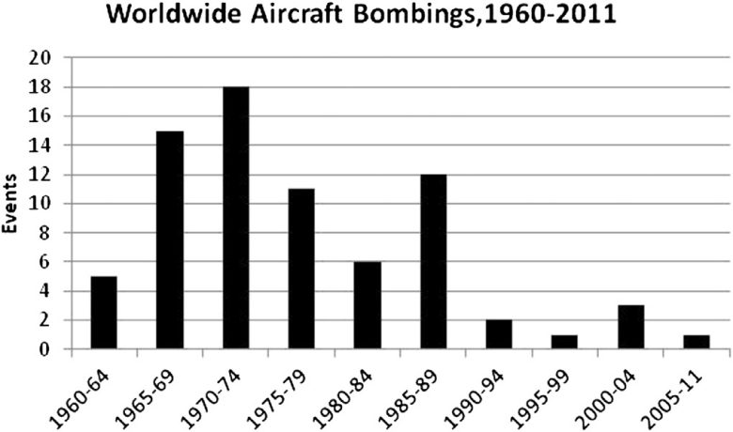

The graph shows the number of worldwide aircraft bombings from 1960 to 2011. The y-axis shows the number of bombings and the x-axis shows the year.

The graph shows that the number of aircraft bombings increased steadily from 1960 to 1975, reaching a peak of 18 bombings in 1975. The number of bombings then declined steadily until 2000, when it reached a low of 2 bombings. The number of bombings then increased slightly in the early 2000s, but it has remained relatively low since then.

The graph also shows that the number of aircraft bombings has varied significantly from year to year. For example, there were only 2 bombings in 1960 and 1990, but there were 18 bombings in 1975 and 17 bombings in 1986.

There are a number of possible explanations for the variation in the number of aircraft bombings over time. One possibility is that the variation is due to changes in the geopolitical landscape. For example, the Cold War was a period of high tension between the United States and the Soviet Union, and it is not surprising that the number of aircraft bombings increased during this period.

Another possibility is that the variation is due to changes in the technology of terrorism. For example, the development of hijacking as a terrorist tactic in the 1960s may have led to an increase in the number of aircraft bombings.

Finally, it is also possible that the variation is due to random chance. Aircraft bombings are relatively rare events, and even a small change in the underlying probability of an aircraft bombing can lead to a significant change in the number of bombings in a given year.

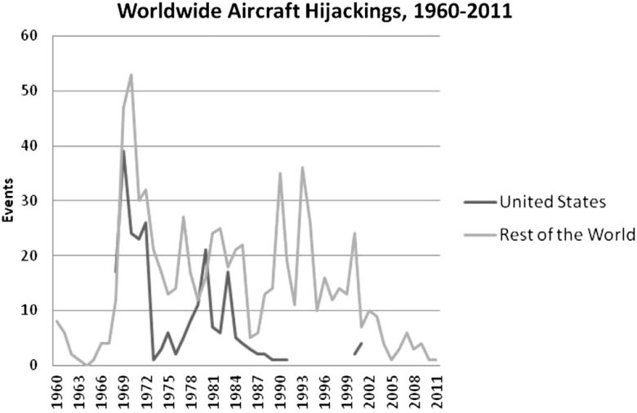

The graph shows the number of aircraft hijackings in the United States and the rest of the world from 1960 to 2011. The y-axis shows the number of hijackings and the x-axis shows the year.

The graph shows that the number of aircraft hijackings in the United States peaked in 1970 with 72 hijackings, and then declined steadily until 1996, when there were no hijackings. The number of hijackings in the United States increased again after the September 11, 2001 attacks, but it has remained relatively low since then.

The graph also shows that the number of aircraft hijackings in the rest of the world peaked in 1973 with 136 hijackings, and then declined steadily until 1996, when there were 12 hijackings. The number of hijackings in the rest of the world has remained relatively low since then.

There are a number of possible explanations for the decline in aircraft hijackings. One possibility is that the increase in security measures at airports and on airplanes has made it more difficult to hijack an aircraft. Another possibility is that the increased use of other forms of terrorism, such as suicide bombings and car bombings, has made aircraft hijackings less attractive to terrorists.

Overall, the graph shows that the number of aircraft hijackings has declined significantly in both the United States and the rest of the world since the 1970s. This is likely due to a number of factors, including increased security measures and the increased use of other forms of terrorism.

Improving Aviation Safety:

Enhancing aviation security is confronted by several critical challenges that necessitate strategic solutions:

1. Balancing Focus:

- Dilemmas exist in focusing on identifying potential terrorists based on shared characteristics or detecting the tools they might use.

- Programs like SPOT in the US aim to identify suspicious passengers, but challenges persist in validating and evaluating these methods.

2. Threat Detection vs. Privacy:

- Improving security involves detecting potential tools of terrorism, such as explosives or weapons.

- Deciding how much information to disclose about security measures is a delicate balance between providing effective security and maintaining public credibility.

3. Cost-Benefit Analysis:

- The significant costs and inconvenience associated with enhancing security may prompt travelers to shift from air to road travel, introducing new risks.

- Measuring the effectiveness and cost of security measures poses complexity and challenges.

4. Dynamic Risks & Policies:

- Aviation risks evolve, but policy responses often lag. Implementing and updating security measures, such as explosives detection equipment, face delays and adjustments due to evolving threats.

5. Public vs. Private Roles:

- Determining the roles of governments and private entities in aviation security raises concerns about self-regulation.

- In the US, where the TSA provides security services and regulates them, finding the right balance is crucial.

6. Extending Safety Measures:

- Extending high safety standards from large airlines to smaller operations and aviation in developing countries is challenging due to varied infrastructure and data limitations.

7. Runway Incursions:

- Ground safety, particularly runway incursions, is a significant concern with human error as a primary cause.

- Improving communication, signage, and technological enhancements are imperative.

8. Human Factors in Safety:

- As technology advances, human factors such as crew errors and human-technology interaction contribute more to incidents.

- Addressing pilot training, cockpit automation, and communication is crucial for safety improvements.

To maintain and enhance safety, managing risks, addressing emerging challenges, and incorporating proactive measures like Safety Management Systems (SMS) are vital. Human factors research plays a pivotal role in understanding and improving safety within aviation.

Data Analytics:

Shifting towards proactive analysis of incident and operational data is essential for advancing aviation safety. However, challenges must be addressed:

1. Consistent Data Collection:

- Data must be consistently recorded and processed for integration and analysis by various experts.

2. Data Limitations:

- Some data lack necessary identifying details and are retained for only three years, limiting comprehensive analysis.

3. Confidentiality and Reporting Concerns:

- Addressing confidentiality issues and ensuring immunity for reporting are vital to encourage honest reporting without fear of repercussions.

4. Access to Researchers:

- Limited resources challenge having enough researchers to analyze data. Opening access to academic researchers can broaden the scope of analysis, provided confidentiality concerns are resolved.

Improving access and addressing confidentiality issues can allow broader analysis by researchers, enabling a proactive approach to aviation safety based on data insights.

**FINAL-DECISION:**

The document describes the major categories of aviation accidents and their causes. The categories are: equipment failure, seatbelt not fastened/turbulence, environment/weather, pilot error, air traffic control, ground/cabin crew, other aircraft, terrorism/conflict/criminal activity, and unknown cause/other.

So, proper steps should be taken to stop the problem

**SYSTEM-ENGINEERING AND TRANSPORTATION:**

The engineering explores the convergence of multi-agent systems (MAS) and complex networks in addressing systems engineering and management issues. It discusses how these frameworks, when combined, offer solutions to optimize physical, natural, and virtual systems.

Complex networks, represented as graphs, capture real-world systems with non-regular topologies, such as utility networks, social networks, and molecular networks. These networks exhibit dynamic properties influenced by internal evolution and external interactions. For example, in telecommunication systems, nodes' degradation or traffic variations impact performance.

Intelligent distributed systems model individual and collective functioning within complex networks. These systems involve intelligent agents (or nodes) interacting to achieve both local and system-wide objectives. MAS serve as a framework to represent these intelligent agents, applying simple rules to address complex engineering challenges.

The focus lies on engineered systems and manufacturing processes rather than social or natural systems. Automatic optimization and control in engineering systems aim to enhance outcomes while minimizing costs, benefiting from the integrated framework of complex networks and MAS.

The method reviews literature from various academic databases, focusing on fundamental concepts of complex networks and MAS. It explores real-world examples where control and optimization based on these frameworks are crucial, especially in engineering systems, critical infrastructure, manufacturing, and supply chain networks.

By combining complex networks and MAS, the paper suggests an effective approach for systems engineering and highlights future research directions in applied complex networks and MAS.

**Complex Networks**

|  |  |  |
| --- | --- | --- |
| Property | Description | Example |
| Type | The name of the network type | Small-world, scale-free, planar/quasi-planar, community structure, core-periphery |
| Characteristic | A specific feature of the network | Short paths between nodes, heavy right-skewed degree distribution, no edge crossings, dense connections within groups, densely connected core with sparse periphery |
| Application | Real-world examples where this type of network is found | Social networks, biological networks, street networks, engineering systems, industry collaborations |
| Measure | A way to quantify the network property | Betweenness, modularity, degree centrality, eigenvector centrality, transitivity |

For example, the table shows that small-world networks have short paths between nodes, which means that you can get from any node to any other node in just a few steps. This makes them efficient for spreading information or disease. Small-world networks are often used to model social networks, where people are connected to a few close friends but also have weak ties to many other people.

.

|  |  |  |  |
| --- | --- | --- | --- |
| Graph Structure | Randomness | Mean Path Length | Clustering Coefficient |
| Regular graph | Ordered | Long | High |
| Small world | Medium | Medium | High |
| Scale-free | Medium-high | Short | Medium |
| Random graph | Disordered | Short | Low |

Here's what each column means:

* Graph Structure: This refers to the type of graph being considered. There are four types listed in the table: regular graphs, small-world graphs, scale-free graphs, and random graphs.
* Randomness: This refers to how ordered or disordered the graph is. Regular graphs are the most ordered, while random graphs are the most disordered. Small-world and scale-free graphs fall somewhere in between.
* Mean Path Length: This is the average number of steps it takes to get from one node in the graph to another. Regular graphs and small-world graphs typically have longer mean path lengths, while scale-free and random graphs have shorter mean path lengths.
* Clustering Coefficient: This measures how likely two nodes that are connected to a third node are also connected to each other. Regular graphs and small-world graphs typically have high clustering coefficients, while scale-free and random graphs have lower clustering coefficients.

So, the table is basically saying that different types of graphs have different properties when it comes to randomness, mean path length, and clustering coefficient. For example, regular graphs are very ordered and have high clustering coefficients, but they also have long mean path lengths. Random graphs are the opposite: they are very disordered and have low clustering coefficients, but they also have short mean path lengths. Small-world and scale-free graphs fall somewhere in between, with medium randomness, medium-to-high clustering coefficients, and medium mean path lengths.

MULTI-AGENTS:

* Multi-agent systems (MAS) and agent-based modeling and simulation (ABMS) are two closely related fields that have been around for about 40 years.
* MAS is a subfield of distributed artificial intelligence (DAI) that focuses on developing systems that can solve complex problems by dividing them up among multiple agents that cooperate and communicate with each other.
* ABMS is a tool that can be used to study the behavior of MAS by simulating the interactions between agents in a controlled environment.
* There is no single definition of what an agent is, but some of the key properties of agents include autonomy, social ability, reactivity, and pro-activeness.
* Agents can be classified in a number of ways, but two of the most common classifications are based on their decision-making process (reactive vs. deliberative) and their interaction model (direct vs. indirect communication).
* The environment in which agents operate can be either physical or simulated, and it can have a significant impact on their behavior.

|  |  |  |
| --- | --- | --- |
| Property | Description |  |
| Situatedness | Agent is situated within and is a part of an environment. [117] |  |
| Mobility | Able to travel across networks [104] and transport itself among different machines [117]. |  |
| Autonomy | Agent acts according to its own motivations and goals. |  |
| Perception | Ability to perceive environment through sensors, with a perception referring to an instant input and a perception sequence to the complete history [120] |  |
| Communication | Agents communicate with other agents, even people [117] |  |
| Adaptation | Agent learns, i.e., uses previous experience to change environment [117] |  |
| Reactivity | Agent responds in timely fashion to changes in environment [117,121] |  |
| Pro-activeness | Agents have a purpose (goal) beyond acting in response to environment [117]; they take the initiative to satisfy these goals [121]. |  |
| Rationality | Agents are expected to choose actions that maximise their expected performance [120] |  |
| Social | Agents have dynamic interactions with others that influence their behaviour [106]. |  |

. It summarizes the main agent properties. Here's a breakdown of the columns:

|  |  |
| --- | --- |
| Property | Description |
| Goal-based | An agent is goal-oriented, it seeks to satisfy its goals. |  |
| Reactive | Responding to stimuli without planning [117,121]. |  |
| Deterministic | Agents are always behaving in a predictable way. |  |
| Nondeterministic | Agents can behave in an unpredictable way. |  |
| Epistemic | Agents have subjective beliefs about the world. |  |
| Intentional | Agents have goals and plans. |  |
| Belief-Desire-Intention (BDI) | Agent's beliefs, desires, and intentions are the basis for its decision-making. |  |
| BDI Agents | Agents with the BDI model are able to reason about their beliefs, desires, and intentions. |  |
| Agent Communication Language (ACL) | A language used by agents to communicate with each other. |  |
| Protocol | A set of rules that govern how agents communicate with each other. |  |
| Decentralized | Agents are not controlled by a central authority. |  |
| Hierarchical | Agents are organized into a hierarchy. |  |
| Co-operative | Agents work together to achieve a common goal. |  |
| Competitive | Agents work against each other to achieve a goal. |  |
| Distributed | Agents are located on different machines. |  |
| Local | Agents are located on the same machine. |  |
| Simulated | Agents exist in a simulated environment. |  |
| Real | Agents exist in the real world. |  |

This method discusses how agent-based systems can be used to manage complex networks, especially in the face of cyber-attacks. Here are the key points:

* Agent-based systems: These systems are made up of independent agents that cooperate to achieve individual and global goals. They are well-suited for managing the growing number of sensors, smart-meters, and other cyber-physical systems in today's world.
* Benefits: Agent-based systems are useful for monitoring and controlling engineered systems, managing the Internet of Things, and optimizing smart grids, transportation, water distribution, and telecommunication infrastructure.
* Cyber-attacks: As networks become more interconnected, they become more vulnerable to cyber-attacks that can disrupt system processes. These attacks often target SCADA systems, which control and monitor industrial automation.
* Impact of attacks: Cyber-attacks can have serious consequences, such as causing damage to physical assets, creating water shortages, and disrupting transportation systems. In telecommunications, they can even alter the network topology and inject false data.
* Potential solutions: Self-organized networks and virtual network functions can help with early detection and mitigation of cyber-attacks in mobile networks.

Overall, the method argues that agent-based systems offer a promising approach to managing complex networks, but they need to be designed with cyber-security in mind to withstand increasingly sophisticated attacks.

**. Control and Optimisation of Complex Networks and Multi-Agent Systems**

Summary of the article on MAS and complex networks for control and optimization:

This method explores how complex networks and multi-agent systems (MAS) can be used together for control and optimization problems in engineering systems. It focuses on applications in manufacturing, power grids, and transportation.

Key points:

* Complex networks: These networks help model and analyze the systems, including identifying important nodes and connections. They are crucial for tasks like resilience optimization and performance improvement.
* MAS: These systems of independent agents cooperate to achieve individual and global goals. They are well-suited for distributed control and optimization, where decisions are made locally based on information from nearby agents.
* Applications:
  + Manufacturing: MAS and complex networks help manage production processes, scheduling, and quality assurance in factories. They enable flexible and agile production that can adapt to changes.
  + Power grids: Complex network analysis helps understand grid topology and optimize energy generation and distribution. MAS can provide distributed control without a central supervisor, improving reliability and efficiency.
  + Transportation: Complex networks model traffic flow and identify congestion points. MAS can be used for real-time traffic management, public safety alerts, and even integrating energy storage systems.

Overall, the method suggests that MAS and complex networks are a powerful combination for tackling complex engineering challenges. They enable distributed, adaptive, and intelligent control and optimization, leading to more efficient and reliable systems.

**Discussion and Research Directions**

Summary of future research directions for complex networks and MAS:

Main points:

* Hybrid systems: Research is moving towards studying interconnected and even combined systems, like electricity and transportation, or water and power grids.
* Multi-domain systems: Systems are seen as having multiple levels, including physical, control, workforce, and customer networks. Complex networks and MAS can help manage these domains.
* Consensual dynamics: Agents need to agree on common objectives for optimal control and decision-making, especially in dynamic systems with time-varying data.
* Future methodology developments:
  + Time series in networks: Analyze how network topology and features change over time, using multilayer networks and time series data.
  + Graph convolutional neural networks: Apply these networks to analyze evolving complex networks representing engineering systems.
  + Big data and calibration of ABMS: Use massive sensor data to validate and calibrate agent-based models.
  + Breaking down learning phase with MAS: Explore agents teaching other agents within an MAS environment, potentially using reinforcement learning.

Overall, the future of complex networks and MAS lies in studying and managing more complex, interconnected, and dynamic systems, with a focus on agent collaboration, data-driven approaches, and continuous learning.

Complex networks are prevalent in transportation systems like roads, railways, and airline networks, organized with nodes representing intersections or stations and links symbolizing the connections between them. These systems often encounter congestion issues, especially in networks with a scale-free topology.

In multi-agent systems (MAS), smart transportation systems focus on enhancing traffic efficiency and minimizing congestion by utilizing real-time network data to issue traffic alerts and ensure public safety. The concept extends to creating resilient and energy-efficient cities, integrating energy storage systems into transportation and smart grid networks. An approach for automated highways involves a hierarchical control system distributed across four layers—network, link, coordination, and regulation—split between roadside infrastructure and vehicles.

Summary of the provided information:

Main topics:

* Convergence of complex networks and MAS: This research area combines the power of complex network analysis with multi-agent systems to optimize and control physical, natural, and virtual systems, particularly focusing on engineered systems and manufacturing processes.
* Complex networks: These networks capture real-world systems with non-regular structures and dynamic properties. They help identify key components, analyze resilience, and optimize performance.
* Multi-agent systems (MAS): MAS involve intelligent agents interacting to achieve individual and collective goals. They are well-suited for distributed control and decision-making, making them ideal for complex systems.
* Applications: The paper explores successful applications of this combined approach in various domains, including:
  + Manufacturing: MAS and complex networks manage production processes, scheduling, and quality assurance, enabling flexible and adaptive production.
  + Power grids: Complex network analysis optimizes energy generation and distribution, while MAS provide distributed control for improved reliability and efficiency.
  + Transportation: Network analysis models traffic flow and identifies congestion points, and MAS enable real-time traffic management, public safety alerts, and even integrating energy storage systems.

Future research directions:

* Hybrid systems: Studying interconnected and even combined systems, like electricity and transportation, for comprehensive management.

.

* Consensual dynamics: Developing methods for agents to agree on common objectives in dynamic systems with time-varying data for optimal control.
* Time series in networks: Analyzing how network topology and features change over time using multilayer networks and time series data.
* Graph convolutional neural networks: Applying these networks to analyze evolving complex networks representing engineering systems.
* Big data and calibration of ABMS: Utilizing massive sensor data to validate and calibrate agent-based models for improved accuracy and realism.
* Breaking down learning phase with MAS: Exploring agents teaching other agents within an MAS environment, potentially using reinforcement learning, to enhance collective learning and adaptation.

Overall, the process highlights the immense potential of combining complex networks and MAS for tackling complex systems engineering challenges. Future research focuses on exploring more intricate systems, enabling better agent collaboration, and leveraging data-driven approaches for continuous learning and adaptation.

Additional notes:

* The information provided also touches upon the specific application of complex networks and MAS in transportation systems, emphasizing how they can help address congestion issues in scale-free networks.
* The concept of automated highways with a distributed control system and integration with energy storage systems is mentioned as a potential solution.

ROUTE SELECTION METHOD USING NASA TECHNOLOGY DURING ADVERSE WEATHER

**Problem:** Airline delays due to weather cause millions in losses and inconvenience. Current tools for planning routes around bad weather are limited.

**Our Solution:** Proposing a new system using a "POMDP" framework to handle uncertainty in weather forecasts and make better route decisions. This system considers information from both ground and onboard radars, and is more flexible than current tools.

**Benefits:**

* Reduced delays and losses for airlines.
* More efficient flight paths.
* Improved passenger experience.

**Next Steps:**

* Test and refine the POMDP system.
* Apply it to other complex real-world problems.

**Simplified Explanation of the POMDP Model for Aircraft Routing:**

**Goal:** Guide an aircraft through convective weather while optimizing for flight time and safety.

**System:** AvDMU, consisting of:

* **LPDM Solver:** Uses Monte Carlo Tree Search to find the best route based on uncertainty in weather forecasts.
* **Model:** Describes the specific problem of routing through weather, including:
  + **States:** Possible locations of the aircraft and weather cells.
  + **Actions:** Possible flight paths the aircraft can take.
  + **Observations:** Information from onboard and ground radars about weather conditions.
  + **Transition Model:** How the weather and aircraft location change based on chosen actions.
  + **Observation Model:** How accurate the radar observations are based on distance and time delays.
  + **Reward/Cost Model:** Penalties for flying through weather and rewards for minimizing flight time.

**How it works:**

1. Start with an initial guess about the weather and aircraft location (belief state).
2. Simulate many possible future scenarios based on different actions the aircraft could take.
3. Use these simulations to estimate the rewards or costs of each possible action.
4. Choose the action that leads to the best expected outcome (shortest flight time, least amount of flying through weather).
5. Update the belief state based on the actual observation from the radars.
6. Repeat steps 2-5 until the aircraft reaches its destination.

**Benefits:**

* More efficient flight paths even with unexpected weather changes.
* Reduced fuel consumption and delays.
* Improved safety by avoiding dangerous weather cells.

**Current limitations:**

* Assumes constant airspeed and altitude (doesn't apply to landing).
* Assumes deterministic aircraft movement (no wind turbulence).
* Perfect ground radar information (no delays or inaccuracies).

**Equation:**

c = 1 / (1 + exp(k(d - d₀)))

**Variables:**

* c: Confidence in onboard radar readings (between 0 and 1)
* k: Steepness coefficient (set to 0.07 in the example)
* d: Distance from the aircraft to the target cell
* d₀: 50% confidence distance (set to 80 nautical miles in the example)

**What the equation does:**

This equation calculates the confidence c that the AvDMU system has in the onboard radar readings for a specific weather cell, based on the distance d from the aircraft to the cell. The confidence value ranges from 0 (no confidence) to 1 (complete confidence).

Here's how it works:

* As the distance d between the aircraft and the cell increases, the confidence c in the radar readings **decreases**. This is because the farther away the cell is, the weaker the radar signal and the more likely it is to be distorted or inaccurate.
* The parameter k controls how quickly the confidence drops off with distance. A higher value of k means that the confidence drops off more quickly, and vice versa. In the example, k is set to a value that represents a gradual decrease in confidence with distance.
* The parameter d₀ is the distance at which the confidence is exactly 50%. So, in the example, at a distance of 80 nautical miles, the AvDMU system is equally confident or not confident in the radar readings.

**Why is this important?**

The AvDMU system uses both onboard and ground radar data to make decisions about how to route aircraft through convective weather. However, onboard radar is not always accurate, especially at long distances. This equation helps the AvDMU system to take into account the uncertainty in the onboard radar readings when making decisions. By knowing how confident it can be in the readings, the system can make more informed choices about which route to take to avoid the weather.

**States:**

* The entire situation of the aircraft and weather is represented as a grid, where each square corresponds to a specific area of airspace at a certain altitude.
* Gray squares show bad weather, with numbers indicating the level of moisture.
* White squares show good weather.
* The airport is the ending point.

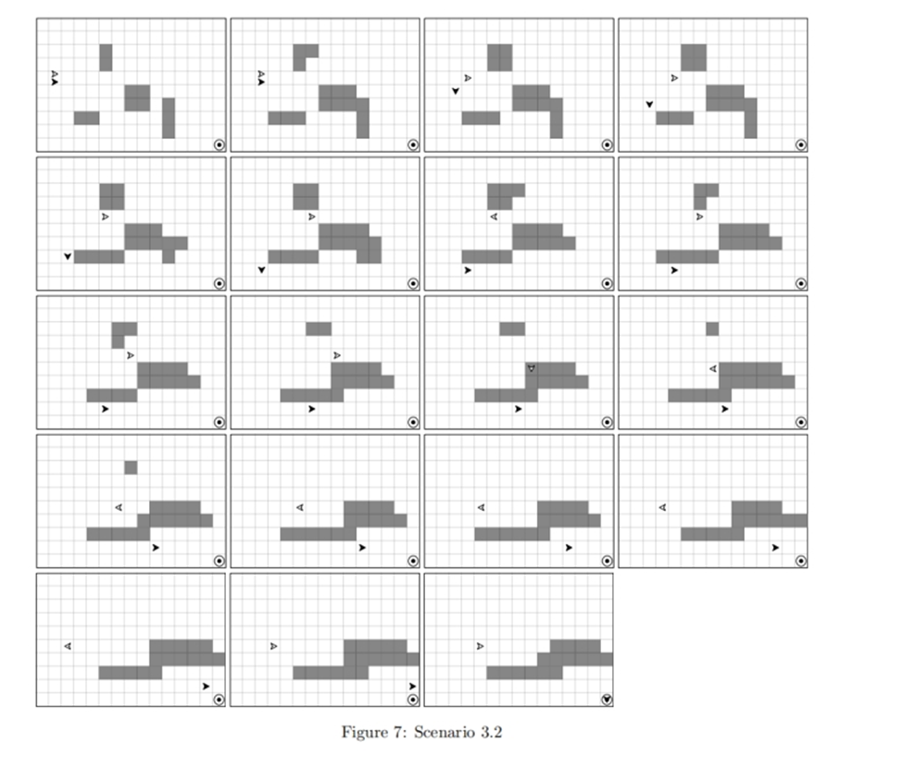

**Actions:**

* The aircraft can move in four directions: north, east, south, or west.
* In the future, it will be able to move in more precise directions and change altitude.

**Observations:**

* The aircraft's radar scans a cone-shaped area in front of it and estimates the moisture level in four squares within that area.
* The radar readings may not be accurate and can sometimes be wrong.

**Belief States:**

* These are like possible versions of the real situation, taking into account the uncertainty in the weather and the radar readings.
* Each belief state is like a collection of different possibilities, each with a weight indicating how likely it is to be true.

**Transition Model:**

* This describes how the situation changes over time.
* The aircraft moves deterministically based on the chosen action.
* The weather changes stochastically, meaning it's random but based on certain rules like wind and moisture movement.

**Simplified Explanation of AvDMU Costs and Rewards:**

**Transition Cost:**

* -10 for every move the aircraft makes. Doesn't change based on direction or distance. (This will be more complex in future versions.)

**Safety Violations Cost:**

* Avoids flying through bad weather cells.
* Penalty is -100 times the moisture level of the cell. (Higher moisture = higher penalty.)
* This encourages finding the least risky path through bad weather if entering is unavoidable.

**Terminal State Reward:**

* +1000 when the aircraft reaches the airport.

**Discount Factor:**

* Set to 1 to focus on immediate rewards/penalties (reaching the airport quickly vs. avoiding weather).

**Value Bounds:**

* Help the system make faster decisions.
* Lower bound: Estimate the minimum possible reward by taking the shortest path (ignoring bad weather).
* Upper bound: Estimate the maximum possible reward by taking the shortest path while considering bad weather.

**Overall:**

* The system minimizes total cost, which means:
  + Avoid bad weather if possible.
  + Take the quickest path if avoiding bad weather isn't an option.
  + Get to the airport as fast as possible without making risky choices.

.

**Simplified Explanation of Experiment Setup:**

**Goal:** Compare the AvDMU system with a standard deterministic planner (DRP) for aircraft routing through weather.

**Scenarios:**

* 10 different scenarios created using 3 initial weather configurations (varying wind and aircraft positions).
* Each scenario played 30 times for both AvDMU and DRP.

**Systems:**

* **AvDMU:** Uses POMDP framework to handle uncertainty in weather forecasts and radar readings.
  + Limited reasoning time per step (2 or 4 seconds) to test its flexibility.
* **DRP:** Represents current routing systems.
  + Uses A* algorithm to find the shortest path based on deterministic weather predictions.

**Metrics:**

* **Distance traveled (d):** Number of grid squares traversed (proportional to time).
* **Cumulative reward (r):** Penalties for flying through bad weather and reward for reaching the airport.

**Assumptions:**

* Grid represents airspace at 25x25 mile squares.
* Decision cycle (∆t) is 3 minutes (time to traverse a square).
* Onboard radar reads every 3 minutes, field of view 135°.
* Ground radar updates every 9 minutes (considered true weather data).

**Overall:**

* This experiment helps assess AvDMU's performance and potential benefits compared to current systems.

RESULTS:

**Columns:**

* **Scenario:** Refers to the specific test scenario (e.g., 1.1, 1.2, etc.) as described in the previous explanation.
* **AvDMU 2 sec**: Shows the results for AvDMU when its reasoning time per step is limited to 2 seconds.
  + steps, d: Average number of steps taken and distance traveled (grid squares) by AvDMU.
  + reward, r: Average cumulative reward earned by AvDMU (penalties for weather + reward for reaching airport).
* **AvDMU 4 sec**: Similar to the 2-second column, but for AvDMU with a 4-second reasoning time limit.
* **DRP**: Shows the results for the Deterministic Route Planner.
  + steps, d: Average number of steps taken and distance traveled by DRP.
  + reward, r: Average cumulative reward earned by DRP.

**Rows:**

* Each row represents a different scenario with varying weather configurations, wind conditions, and aircraft positions.

**Key points to note:**

* AvDMU generally takes more steps and travels a longer distance than DRP, as it prioritizes avoiding bad weather even if it means a longer route.
* AvDMU earns a higher reward than DRP in most cases, thanks to the penalties DRP incurs for flying through bad weather.
* Increasing the reasoning time limit from 2 seconds to 4 seconds slightly improves AvDMU's performance in some scenarios, allowing it to find better routes or avoid weather more effectively.
* DRP performs consistently across all scenarios, as it simply follows the shortest path based on its deterministic prediction of the weather.

**Overall, the table suggests that AvDMU can be a valuable tool for aircraft routing through convective weather, as it can help to reduce the risk of flying through bad weather while still reaching the destination efficiently.**

Here's a simplified explanation of the main points in the text:

**Goal:** Develop an aircraft routing system called AvDMU that considers weather uncertainty to improve safety and efficiency.

**What's special about AvDMU?**

* **Reasons about uncertainty:** Unlike current systems, AvDMU takes into account the fact that weather predictions are not always accurate.
* **Real-time and flexible:** Generates solutions quickly and can adjust as new information becomes available.
* **Long-term planning:** Considers the entire route, not just the next step.
* **Handles complex situations:** Can deal with large areas and many possibilities.

**How does it work?**

* **Based on LPDM:** A powerful algorithm that explores different possibilities and chooses the best one.
* **Compared to a traditional system (DRP):** AvDMU performed better in most cases, finding safer and more efficient routes.
* **Even in tricky situations:** AvDMU could come up with creative solutions, like holding patterns, to avoid bad weather.

**Future plans:**

* **Improve LPDM:** Make it even better at handling complex situations.
* **Make things more realistic:** Include features like 3D airspace, multiple aircraft, variable speed, and weather changes.
* **Consider other uncertainties:** Account for things like wind variations and air traffic restrictions.

**Overall, AvDMU shows promise as a way to improve aircraft routing by considering weather uncertainty and making smarter decisions.**

**The network model will be based on multilayer perception network :**

**Application of Multilayer Perceptron Networks (MLPs) in Aviation Route Optimization:**

Multilayer Perceptron Networks (MLPs) have found diverse applications, including aviation tasks like aircraft routing. As a type of artificial neural network (ANN), MLPs consist of multiple layers of interconnected nodes (neurons) capable of learning complex patterns and relationships in data.

Route Optimization Process Overview:

1. Data Collection:

- MLPs require diverse data sets, including historical flight data, weather information, airspace constraints, air traffic conditions, fuel consumption models, and potentially other factors like aircraft performance parameters.

2. Data Preprocessing:

- Prior to input into the MLP, data undergoes preprocessing involving cleaning, normalization, handling missing values, and appropriate formatting for the neural network's input layer.

3. Feature Selection:

- Identifying relevant features or variables crucial for optimizing flight routes, which may involve domain knowledge and statistical analysis.

4. Network Training:

- Training the MLP using historical data, adjusting weights and biases to minimize the error between predicted and actual route outcomes.

5. Optimization Objective:

- Defining the optimization objective, such as minimizing flight time, reducing fuel consumption, avoiding adverse weather, or navigating airspace constraints while ensuring safety.

6. Learning Patterns:

- Through training, the MLP learns patterns and relationships in the data, understanding how various factors influence optimal flight routes.

7. Route Prediction:

- Once trained, the MLP predicts or suggests optimal routes based on current or forecasted conditions, considering parameters and historical patterns.

8. Adaptation to Real-Time Conditions:

- MLP-based systems adapt to real-time changes in weather, air traffic, or other variables by dynamically re-evaluating and adjusting route suggestions.

9. Integration with Decision Support Systems:

- MLP's route suggestions integrate with decision support systems for pilots or air traffic controllers, providing insights for flight planning and route adjustments.

MLPs operate within a broader system that includes real-time data integration, decision-making processes, and human oversight to ensure safety and regulatory compliance in aviation operations. The continuous adaptation to changing conditions enhances the effectiveness of route optimization in dynamic aviation environments.

Here’s a sample of it along with ML to optimize the process in a developed way with more controlled system :

ANTENNA-STRUCTURE :

|  |  |  |  |
| --- | --- | --- | --- |
| index | X | Y | FID |
| 0 | -82.47360342 | 28.41540528 | 4001 |
| 1 | -82.03520328 | 28.08070522 | 4002 |
| 2 | -82.10110334 | 29.16830547 | 4003 |
| 3 | -82.47980341 | 28.00970519 | 4004 |
| 4 | -82.47810338 | 27.19090499 | 4005 |
| 5 | -82.17580332 | 27.84730515 | 4006 |
| 6 | -82.35290338 | 28.19380523 | 4007 |
| 7 | -82.4284034 | 28.01560519 | 4008 |
| 8 | -82.25380336 | 28.51060531 | 4009 |
| 9 | -82.29650337 | 28.37560528 | 4010 |
| 10 | -82.21530335 | 28.61420534 | 4011 |
| 11 | -82.39830336 | 27.08120496 | 4012 |
| 12 | -82.41400338 | 27.69400511 | 4013 |
| 13 | -82.03080328 | 28.04490521 | 4014 |
| 14 | -82.32830336 | 27.84710515 | 4015 |
| 15 | -82.24600331 | 27.05110496 | 4016 |
| 16 | -82.14890331 | 28.0200052 | 4017 |
| 17 | -82.4503034 | 28.0736052 | 4018 |
| 18 | -82.31870339 | 28.70610536 | 4019 |
| 19 | -82.44470339 | 27.58190508 | 4020 |
| 20 | -82.14080333 | 28.67530536 | 4021 |
| 21 | -82.09360333 | 29.02390544 | 4022 |
| 22 | -82.39000338 | 27.96330518 | 4023 |
| 23 | -82.45530338 | 27.41670504 | 4024 |
| 24 | -82.23920331 | 26.89720492 | 4025 |
| 25 | -82.32480336 | 27.99920519 | 4026 |
| 26 | -82.05110325 | 26.98390495 | 4027 |
| 27 | -82.47340338 | 27.27240501 | 4028 |
| 28 | -82.1812033 | 27.27280502 | 4029 |
| 29 | -82.17000331 | 27.76170513 | 4030 |
| 30 | -81.95040322 | 26.63430486 | 4031 |
| 31 | -82.24790333 | 27.47340506 | 4032 |
| 32 | -82.37280341 | 28.8923054 | 4033 |
| 33 | -82.47500341 | 27.94720517 | 4034 |
| 34 | -82.4570034 | 27.94920517 | 4035 |
| 35 | -82.45400338 | 27.39460504 | 4036 |
| 36 | -82.02530324 | 26.64030486 | 4037 |
| 37 | -82.17930333 | 28.22800525 | 4038 |
| 38 | -81.93530321 | 26.51140483 | 4039 |
| 39 | -81.97260326 | 27.98270519 | 4040 |
| 40 | -81.92220321 | 26.65360487 | 4041 |
| 41 | -82.35290334 | 26.95240493 | 4042 |
| 42 | -81.92230325 | 27.96140519 | 4043 |
| 43 | -81.94290326 | 28.04690521 | 4044 |
| 44 | -82.05000329 | 28.0281052 | 4045 |
| 45 | -82.42700337 | 27.30030502 | 4046 |
| 46 | -82.05140325 | 26.98390495 | 4047 |
| 47 | -81.98410327 | 28.06690521 | 4048 |
| 48 | -82.18940336 | 29.14220547 | 4049 |

|  |  |  |  |
| --- | --- | --- | --- |
| REGNUM | FILENUM | ISSUEDATE | ENTITY |
| 1000411 | A0773958 | 5/10/2012 | NEW CINGULAR WIRELESS SERVICES, INC. |
| 1000413 | A0773959 | 5/10/2012 | NEW CINGULAR WIRELESS SERVICES, INC. |
| 1000636 | A0768969 | 5/8/2012 | AT&T Mobility Wireless Operations Holdings Inc. |
| 1001300 | A0437961 | 3/23/2005 | Crown Castle GT Company LLC |
| 1001589 | A0764446 | 5/7/2012 | NEW CINGULAR WIRELESS PCS, LLC |
| 1002770 | A0497145 | 3/31/2006 | CROWN CASTLE GT COMPANY LLC |
| 1002778 | A0594733 | 5/21/2008 | CROWN CASTLE GT COMPANY LLC |
| 1003059 | A0604767 | 8/12/2008 | SpectraSite Communications, LLC. through American Towers, LLC. |
| 1003064 | A0604769 | 8/12/2008 | SpectraSite Communications, LLC. through American Towers, LLC. |
| 1003065 | A0682673 | 4/14/2010 | SpectraSite Communications, LLC. through American Towers, LLC. |
| 1003461 | A0003948 | 10/24/1996 | FLORIDA, STATE OF |
| 1003602 | A0678671 | 3/10/2010 | American Towers, LLC. |
| 1003604 | A0641493 | 6/22/2009 | American Towers, LLC. |
| 1003609 | A0601301 | 8/4/2008 | American Towers, LLC. |
| 1003675 | A0604780 | 8/12/2008 | SpectraSite Communications, LLC. through American Towers, LLC. |
| 1003676 | A0604781 | 8/12/2008 | SpectraSite Communications, LLC. through American Towers, LLC. |
| 1003678 | A0604783 | 8/12/2008 | SpectraSite Communications, LLC. through American Towers, LLC. |
| 1003680 | A0604784 | 8/12/2008 | SpectraSite Communications, LLC. through American Towers, LLC. |
| 1004333 | A0740972 | 11/2/2011 | SpectraSite Communications, LLC. through American Towers, LLC. |
| 1004339 | A0739629 | 10/17/2011 | SpectraSite Communications, LLC. through American Towers, LLC. |
| 1004347 | A0604796 | 8/12/2008 | SpectraSite Communications, LLC. through American Towers, LLC. |
| 1005022 | A0604798 | 8/12/2008 | SpectraSite Communications, LLC. through American Towers, LLC. |
| 1005027 | A0604802 | 8/12/2008 | SpectraSite Communications, LLC. through American Towers, LLC. |
| 1007878 | A0526095 | 11/28/2006 | Verizon Wireless Personal Communications LP |
| 1008169 | A0009729 | 2/6/1997 | INTERMART BROADCASTING SOUTHWEST FLORIDA INC |
| 1008502 | A0535002 | 1/12/2007 | CROWN CASTLE GT COMPANY LLC |
| 1010344 | A0601370 | 8/4/2008 | American Towers, LLC. |
| 1010345 | A0601371 | 8/4/2008 | American Towers, LLC. |
| 1010542 | A0289023 | 11/10/2002 | CROWN CASTLE GT COMPANY LLC |
| 1010599 | A0289027 | 11/10/2002 | CROWN CASTLE GT COMPANY LLC |
| 1010617 | A0565139 | 10/4/2007 | CROWN CASTLE GT COMPANY LLC |
| 1010642 | A0613778 | 11/4/2008 | CROWN CASTLE GT COMPANY LLC |
| 1011013 | A0754931 | 2/14/2012 | SpectraSite Communications, LLC. through American Towers, LLC. |
| 1011295 | A0750590 | 1/26/2012 | T-Mobile South LLC |
| 1011296 | A0750591 | 1/26/2012 | T-Mobile South LLC |
| 1011628 | A0708420 | 12/28/2010 | CROWN CASTLE GT COMPANY LLC |
| 1011859 | A0566436 | 10/17/2007 | CROWN CASTLE GT COMPANY LLC |
| 1011861 | A0500144 | 4/25/2006 | CROWN CASTLE GT COMPANY LLC |
| 1011952 | A0572685 | 12/10/2007 | CROWN CASTLE GT COMPANY LLC |
| 1012034 | A0306816 | 1/15/2003 | CROWN CASTLE GT COMPANY LLC |
| 1012159 | A0014571 | 3/20/1997 | OLSEN, ROBERT W |
| 1012258 | A0555769 | 7/20/2007 | CROWN CASTLE GT COMPANY LLC |
| 1012260 | A0599483 | 7/15/2008 | CROWN CASTLE GT COMPANY LLC |
| 1012263 | A0376376 | 5/12/2004 | CROWN CASTLE GT COMPANY LLC |
| 1012264 | A0376380 | 5/12/2004 | CROWN CASTLE GT COMPANY LLC |
| 1012265 | A0517067 | 9/13/2006 | CROWN CASTLE GT COMPANY LLC |
| 1012980 | A0015578 | 4/4/1997 | QUALICOM SYSTEMS INC DBA = QUALICOM |
| 1013628 | A0604868 | 8/12/2008 | SpectraSite Communications, LLC. through American Towers, LLC. |

|  |  |  |  |  |
| --- | --- | --- | --- | --- |
| LAT_DMS | LAT_DIR | LON_DMS | LON_DIR | DD_TEMP |
| 28,24,55.4 | 1 | 82,28,25 | -1 | 28.4154 |
| 28,4,50.5 | 1 | 82,2,6.6 | -1 | 28.0807 |
| 29,10,5.9 | 1 | 82,6,3.9 | -1 | 29.1683 |
| 28,0,35 | 1 | 82,28,47.3 | -1 | 28.0097 |
| 27,11,27.1 | 1 | 82,28,41 | -1 | 27.1909 |
| 27,50,50.2 | 1 | 82,10,32.8 | -1 | 27.8473 |
| 28,11,37.8 | 1 | 82,21,10.6 | -1 | 28.1938 |
| 28,0,56 | 1 | 82,25,42.2 | -1 | 28.0156 |
| 28,30,38 | 1 | 82,15,13.8 | -1 | 28.5106 |
| 28,22,32.1 | 1 | 82,17,47.6 | -1 | 28.3756 |
| 28,36,51 | 1 | 82,12,55 | -1 | 28.6142 |
| 27,4,52.3 | 1 | 82,23,53.9 | -1 | 27.0812 |
| 27,41,38.3 | 1 | 82,24,50.2 | -1 | 27.694 |
| 28,2,41.7 | 1 | 82,1,50.8 | -1 | 28.0449 |
| 27,50,49.7 | 1 | 82,19,42 | -1 | 27.8471 |
| 27,3,4.1 | 1 | 82,14,45.7 | -1 | 27.0511 |
| 28,1,12 | 1 | 82,8,56 | -1 | 28.02 |
| 28,4,25 | 1 | 82,27,1 | -1 | 28.0736 |
| 28,42,22 | 1 | 82,19,7.4 | -1 | 28.7061 |
| 27,34,54.9 | 1 | 82,26,40.8 | -1 | 27.5819 |
| 28,40,31 | 1 | 82,8,27 | -1 | 28.6753 |
| 29,1,26 | 1 | 82,5,37 | -1 | 29.0239 |
| 27,57,47.9 | 1 | 82,23,23.8 | -1 | 27.9633 |
| 27,25,0 | 1 | 82,27,19 | -1 | 27.4167 |
| 26,53,50 | 1 | 82,14,21 | -1 | 26.8972 |
| 27,59,57.1 | 1 | 82,19,29.3 | -1 | 27.9992 |
| 26,59,2.2 | 1 | 82,3,3.9 | -1 | 26.9839 |
| 27,16,20.5 | 1 | 82,28,24.3 | -1 | 27.2724 |
| 27,16,22.2 | 1 | 82,10,52.3 | -1 | 27.2728 |
| 27,45,42 | 1 | 82,10,12 | -1 | 27.7617 |
| 26,38,3.3 | 1 | 81,57,1.3 | -1 | 26.6343 |
| 27,28,24.1 | 1 | 82,14,52.3 | -1 | 27.4734 |
| 28,53,32.1 | 1 | 82,22,22.1 | -1 | 28.8923 |
| 27,56,50 | 1 | 82,28,30 | -1 | 27.9472 |
| 27,56,57 | 1 | 82,27,25 | -1 | 27.9492 |
| 27,23,40.7 | 1 | 82,27,14.5 | -1 | 27.3946 |
| 26,38,25 | 1 | 82,1,31 | -1 | 26.6403 |
| 28,13,40.6 | 1 | 82,10,45.6 | -1 | 28.228 |
| 26,30,41.1 | 1 | 81,56,7.1 | -1 | 26.5114 |
| 27,58,57.7 | 1 | 81,58,21.5 | -1 | 27.9827 |
| 26,39,13 | 1 | 81,55,20 | -1 | 26.6536 |
| 26,57,8.8 | 1 | 82,21,10.4 | -1 | 26.9524 |
| 27,57,41.1 | 1 | 81,55,20.2 | -1 | 27.9614 |
| 28,2,49 | 1 | 81,56,34.5 | -1 | 28.0469 |
| 28,1,41 | 1 | 82,3,0 | -1 | 28.0281 |
| 27,18,1.2 | 1 | 82,25,37.3 | -1 | 27.3003 |
| 26,59,2 | 1 | 82,3,5 | -1 | 26.9839 |
| 28,4,0.9 | 1 | 81,59,2.7 | -1 | 28.0669 |
| 29,8,32 | 1 | 82,11,21.8 | -1 | 29.1422 |

|  |  |  |  |
| --- | --- | --- | --- |
| DD_TEMP0 | STRUCHT | STRUCADD | STRUCCITY |
| -82.4736 | 60.4 | 14010 SR 45 (US 41) | SOUTH MASSARYTOWN |
| -82.0352 | 62.2 | 4336 KNIGHTS STATION RD | LAKELAND |
| -82.1011 | 58.5 | 2720 SE MARICAMP AVENUE | OCALA |
| -82.4798 | 91 | W HIAWATHA | TAMPA |
| -82.4781 | 91.7 | 301 VENICE RD | OSPREY |
| -82.1758 | 62.2 | 10623 BROWNING ROAD | LITHIA |
| -82.3529 | 45.1 | 2528 CR 582 SOUTH | TAMPA |
| -82.4284 | 45.7 | 7124 N 30TH ST | TAMPA |
| -82.2538 | 67 | 5163 LOCKHART RD | BROOKSVILLE |
| -82.2965 | 84.1 | 31336 ST JOSEPH RD (#303028) | DADE CITY |
| -82.2153 | 137 | SUMTER CORRECTIONAL .5 MI S ON SR476 6.5 MI W | BUSHNELL |
| -82.3983 | 73.2 | 721 Center Road Fire Station (002672) | VENICE |
| -82.414 | 121.9 | 1507 SE 21st Ave (002585 / Ruskin) | RUSKIN |
| -82.0308 | 121.9 | 389 WINSTON CREEK PKY (002657 / Lakeland) | LAKELAND |
| -82.3283 | 56.3 | 110612 CONE GROVE RD: US 301 | RIVERVIEW |
| -82.246 | 76.2 | 5049 TROTT CIR | NORTH PORT |
| -82.1489 | 50.2 | 2410 W BAKER ST | PLANT CITY |
| -82.4503 | 56.3 | 13805 N NEBRASKA AVE | TAMPA |
| -82.3187 | 70.4 | 10770 South Florida Ave (#303098) | FLORAL CITY |
| -82.4447 | 76.2 | 11376 ERIE RD (#303086) | PARRISH |
| -82.1408 | 73.1 | CR 313 | BUSHNELL |
| -82.0936 | 91.3 | SE 31ST AVE | Belleview |
| -82.39 | 45.7 | 5811 E BROADWAY | TAMPA |
| -82.4553 | 70.1 | LINGER LODGE RD E OF I75 | BRADENTON |
| -82.2392 | 151 | .32 KM WNW OF SR 771 & REDWOOD INT | ROTONDA |
| -82.3248 | 30.7 | SE CORNER OF I-75 AND STATE HWY 92 | TAMPA |
| -82.0511 | 103.9 | 3140 LOVELAND (002531 / Port Charlotte) | PORT CHARLOTTE |
| -82.4734 | 91.4 | 5625 CATALYST AVE. (002673 / Sarasota) | SARASOTA |
| -82.1812 | 91.1 | 35200 CLAY GULLY RD 300 FT S OF CLAY GULLY RD. | MYAKKA CITY |
| -82.17 | 60.7 | 7840' W OF INT CR 39 & CR 672 | PICNIC |
| -81.9504 | 56.4 | 1022 SE 12TH ST | CAPE CORAL |
| -82.2479 | 86.9 | 3 MILES E INT ST RDS 64 & 675 | MYAKKA CITY |
| -82.3728 | 76.2 | 3603 E. Langspur Court (303097) | HERNANDO |
| -82.475 | 38 | 1503 N B ST | TAMPA |
| -82.457 | 52 | 412 MADISON ST | TAMPA |
| -82.454 | 61.3 | 8303 COOPER CREEK BLVD | UNIVERSITY PARK |
| -82.0253 | 86.9 | 2437 PINE ISLAND RD | CAPE CORAL |
| -82.1793 | 86.9 | 702 AVENUE B | ZEPHYRHILLS |
| -81.9353 | 49.1 | 15825-45 PINE RIDGE ROAD | FT. MYERS |
| -81.9726 | 41.7 | 945 W ALAMO | LAKELAND |
| -81.9222 | 92 | 4461 HANCOCK BRIDGE PKY | NORTH FORT MYERS |
| -82.3529 | 59.7 | 599 S INDIANA AVE | ENGLEWOOD |
| -81.9223 | 61 | 2226 Peterson Road | Lakeland |
| -81.9429 | 76.2 | 1110 OLEANDER RD | LAKELAND |
| -82.05 | 60.6 | NEW TAMPA HIGHWAY | LAKELAND |
| -82.427 | 55.5 | 7177 BEE RIDGE ROAD | SARASOTA |
| -82.0514 | 94.5 | 1 MI NE | PORT CHARLOTTE |
| -81.9841 | 75.8 | 1830 FAIRBANKS STREET | LAKELAND |
| -82.1894 | 46.9 | 3200' SW INT SR200 & I75 (State Road 200) | GAINSVILLE |

|  |  |  |  |
| --- | --- | --- | --- |
| STRUCSTATE | FAASTUDY | FAACIRC | LICID |
| FL | 2006-ASO-2590-OE | 70/7460-1K | L00000732 |
| FL | 2006-ASO-2760-OE | 70/7460-1K | L00000732 |
| FL | 2006-ASO-4134-OE |  | L01585209 |
| FL | 00-ASO-7447-OE | 70/7460-1J | L00220201 |
| FL | 2007-ASO-2632-OE | 70/7460-1K | L00024153 |
| FL | 2006-ASO-1205-OE | 70/7460-1J | L00220201 |
| FL | 2007-ASO-7055-OE |  | L00220201 |
| FL | 2003-ASO-6104-OE |  | L00132178 |
| FL | 94-ASO-3383-OE | 70/7460-1J | L00132178 |
| FL | 2004-ASO-341-OE | 70/7460-1K | L00132178 |
| FL | 96-ASO-0522-OE | 70/7460-1H | L00305968 |
| FL | 2010-ASO-563-OE | 70/7460-1K | L00008376 |
| FL | 2009-ASO-2497-OE | 70/7460-1K | L00008376 |
| FL | 2003-ASO-4386-OE | 70/7460-1K | L00008376 |
| FL | 00-ASO-9653-OE |  | L00132178 |
| FL | 2004-ASO-342-OE | 70/7460-1K | L00132178 |
| FL | 95-ASO-1944-OE |  | L00132178 |
| FL | 95-ASO-1179-OE |  | L00132178 |
| FL | 2011-ASO-6409-OE | 70/7460-1K | L00132178 |
| FL | 2011-ASO-5836-OE | 70/7460-1H | L00132178 |
| FL | 96-ASO-3862-OE | 70/7460-1J | L00132178 |
| FL | 00-ASO-7818-OE | 70/7460-1K | L00132178 |
| FL | 2005-ASO-4248-OE |  | L00132178 |
| FL | 96-ASO-4632-OE | 70/7460-1J | L00004968 |
| FL | 96-ASO-4210-OE | 70/7460-1J |  |
| FL | 2006-ASO-1420-OE |  | L00220201 |
| FL | 01-ASO-7408-OE | 70/7460-1J | L00008376 |
| FL | 2003-ASO-4371-OE | 70/7460-1K | L00008376 |
| FL | 00-ASO-6196-OE | 70/7460-1K | L00220201 |
| FL | 91-ASO-1630-OE |  | L00220201 |
| FL | 2007-ASO-4987-OE |  | L00220201 |
| FL | 2008-ASO-5640-OE | 70/7460-1J | L00220201 |
| FL | 2011-ASO-8458-OE | 70/7460-1K | L00132178 |
| FL | 96-ASO-2391-OE |  | L01106613 |
| FL | 96-ASO-3605-OE |  | L01106613 |
| FL | 2010-ASO-6492-OE | 70/7460-1J | L00220201 |
| FL | 2007-ASO-5273-OE | 70/7460-1H | L00220201 |
| FL | 2006-ASO-450-OE | 70/7460-1K | L00220201 |
| FL | 2007-ASO-6299-OE |  | L00220201 |
| FL | 2002-ASO-6071-OE | 70/7460-1K | L00220201 |
| FL |  |  | L00279784 |
| FL | 2007-ASO-3214-OE |  | L00220201 |
| FL | 2008-ASO-3644-OE | 70/7460-1K | L00220201 |
| FL | 2002-ASO-5445-OE | 70/7460-1K | L00220201 |
| FL | 94-ASO-0123-OE |  | L00220201 |
| FL | 2006-ASO-4451-OE |  | L00220201 |
| FL |  |  | L00001588 |
| FL | 2002-ASO-5985-OE | 70/7460-1K | L00132178 |
| FL | 95-ASO-1448-OE |  | L01462346 |

|  |  |  |  |
| --- | --- | --- | --- |
| CONTNAME | CONTADD | CONTPO | CONTCITY |
| FCC GROUP | 5601 LEGACY DRIVE, MS:A-3 |  | PLANO |
| FCC GROUP | 5601 LEGACY DRIVE, MS:A-3 |  | PLANO |
| FCC Group | 5601 Legacy Drive, MS:A-3 |  | Plano |
|  | 2000 Corporate Drive |  | Canonsburg |
| FCC GROUP | 5601 LEGACY DRIVE, MS: A-3 |  | PLANO |
| REGULATORY DEPARTMENT | 2000 Corporate Drive |  | Canonsburg |
| REGULATORY DEPARTMENT | 2000 Corporate Drive |  | Canonsburg |
| Compliance Dept. | 1898 Leland Drive, Suite A |  | Marietta |
| Compliance Dept. | 1898 Leland Drive, Suite A |  | Marietta |
| Compliance Dept. | 1898 Leland Drive, Suite A |  | Marietta |
| JOINT TASK FORCE RADIO ENG SECTION | 4050 ESPLANADE WY BLD 4030 STE 280G |  | TALLAHASSEE |
| FAA/FCC Compliance Team | 1898 Leland Drive |  | Marietta |
| FAA/FCC Compliance Team | 1898 Leland Drive |  | Marietta |
| FAA/FCC Compliance Team | 1898 Leland Drive |  | Marietta |
| Compliance Dept. | 1898 Leland Drive, Suite A |  | Marietta |
| Compliance Dept. | 1898 Leland Drive, Suite A |  | Marietta |
| Compliance Dept. | 1898 Leland Drive, Suite A |  | Marietta |
| Compliance Dept. | 1898 Leland Drive, Suite A |  | Marietta |
| Compliance Dept. | 1898 Leland Drive, Suite A |  | Marietta |
| Compliance Dept. | 1898 Leland Drive, Suite A |  | Marietta |
| Compliance Dept. | 1898 Leland Drive, Suite A |  | Marietta |
| Compliance Dept. | 1898 Leland Drive, Suite A |  | Marietta |
| Compliance Dept. | 1898 Leland Drive, Suite A |  | Marietta |
| Regulatory | 1120 Sanctuary Pkwy, #150 GASA5REG |  | Alpharetta |
| PATRICIA DAHLIN | 4810 DELTONA DR |  | PUNTA GORDA |
| REGULATORY DEPARTMENT | 2000 Corporate Drive |  | Canonsburg |
| FAA/FCC Compliance Team | 1898 Leland Drive |  | Marietta |
| FAA/FCC Compliance Team | 1898 Leland Drive |  | Marietta |
| REGULATORY DEPARTMENT | 2000 Corporate Drive |  | Canonsburg |
| REGULATORY DEPARTMENT | 2000 Corporate Drive |  | Canonsburg |
| REGULATORY DEPARTMENT | 2000 Corporate Drive |  | Canonsburg |
| REGULATORY DEPARTMENT | 2000 Corporate Drive |  | Canonsburg |
| Compliance Dept. | 1898 Leland Drive, Suite A |  | Marietta |
| FCC Regulatory Compliance | 12920 S.E. 38th Street |  | Bellevue |
| FCC Regulatory Compliance | 12920 S.E. 38th Street |  | Bellevue |
| REGULATORY DEPARTMENT | 2000 Corporate Drive |  | Canonsburg |
| REGULATORY DEPARTMENT | 2000 Corporate Drive |  | Canonsburg |
| REGULATORY DEPARTMENT | 2000 Corporate Drive |  | Canonsburg |
| REGULATORY DEPARTMENT | 2000 Corporate Drive |  | Canonsburg |
| REGULATORY DEPARTMENT | 2000 Corporate Drive |  | Canonsburg |
|  | 10851 GULF SHORE DR APT 201 |  | NAPLES |
| REGULATORY DEPARTMENT | 2000 Corporate Drive |  | Canonsburg |
| REGULATORY DEPARTMENT | 2000 Corporate Drive |  | Canonsburg |
| REGULATORY DEPARTMENT | 2000 Corporate Drive |  | Canonsburg |
| REGULATORY DEPARTMENT | 2000 Corporate Drive |  | Canonsburg |
| REGULATORY DEPARTMENT | 2000 Corporate Drive |  | Canonsburg |
| JON INBODY | 2100 ELECTRONICS LN |  | FORT MYERS |
| Compliance Dept. | 1898 Leland Drive, Suite A |  | Marietta |
| Regulatory | 1120 Sanctuary Pkwy #150 GASAREG |  | Alpharetta |
| FCC Regulatory Compliance | 12920 S.E. 38th Street |  | Bellevue |
| FCC Regulatory Compliance | 12920 S.E. 38th Street |  | Bellevue |
| FCC Regulatory Compliance | 12920 S.E. 38th Street |  | Bellevue |
| FCC Regulatory Compliance | 12920 S.E. 38th Street |  | Bellevue |
| FCC Regulatory Compliance | 12920 S.E. 38th Street |  | Bellevue |
| REGULATORY DEPARTMENT | 2000 Corporate Drive |  | Canonsburg |
| Edward G. Roach | 5900 Broken Sound Pkwy., NW |  | Boca Raton |
| EDD MONSKIE |  | 4368 | LANCASTER |

|  |  |
| --- | --- |
| CONTSTATE | CONTZIP |
| TX | 75024 |
| TX | 75024 |
| TX | 75024 |
| PA | 15317 |
| TX | 75024 |
| PA | 15317 |
| PA | 15317 |
| GA | 30067 |
| GA | 30067 |
| GA | 30067 |
| FL | 323990950 |
| GA | 30067 |
| GA | 30067 |
| GA | 30067 |
| GA | 30067 |
| GA | 30067 |
| GA | 30067 |
| GA | 30067 |
| GA | 30067 |
| GA | 30067 |
| GA | 30067 |
| GA | 30067 |
| GA | 30067 |
| GA | 30004 |
| FL | 33950 |
| PA | 15317 |
| GA | 30067 |
| GA | 30067 |
| PA | 15317 |
| PA | 15317 |
| PA | 15317 |
| PA | 15317 |
| GA | 30067 |
| WA | 98006 |
| WA | 98006 |
| PA | 15317 |
| PA | 15317 |
| PA | 15317 |
| PA | 15317 |
| PA | 15317 |
| FL | 34108 |
| PA | 15317 |
| PA | 15317 |
| PA | 15317 |
| PA | 15317 |
| PA | 15317 |
| FL | 33912 |
| GA | 30067 |
| GA | 300097630 |

describe each feature present in the dataset:

1. index: This column represents the index or identifier of each record in the dataset.

2. X: The X-coordinate or longitude of the antenna structure location.

3. Y: The Y-coordinate or latitude of the antenna structure location.

4. FID: A unique identifier for each antenna structure.

5. REGNUM: Registration number or code associated with the antenna structure.

6. FILENUM: File number associated with the antenna structure.

7. ISSUEDATE: Date when regulatory approval or other significant event related to the antenna structure occurred.

8. ENTITY: Entity or company that owns or operates the antenna structure.

9. LAT_DMS: Latitude in degrees, minutes, and seconds.

10. LAT_DIR: Direction indicator for latitude (N for north or S for south).

11. LON_DMS: Longitude in degrees, minutes, and seconds.

12. LON_DIR: Direction indicator for longitude (E for east or W for west).

13. DD_TEMP: Elevation or altitude of the antenna structure.

14. DD_TEMP0: Additional information related to elevation or altitude.

15. STRUCHT: Type or category of the antenna structure (e.g., tower, mast, rooftop installation).

16. STRUCADD: Address of the antenna structure.

17. STRUCCITY: City where the antenna structure is located.

18. STRUCSTATE: State where the antenna structure is located.

19. FAASTUDY: FAA study number associated with the antenna structure.

20. FAACIRC: FAA circular number associated with the antenna structure.

21. LICID: License ID associated with the antenna structure.

22. CONTNAME: Name of the contact person or entity associated with the antenna structure.

23. CONTADD: Address of the contact person or entity associated with the antenna structure.

24. CONTPO: Post office box or other postal information of the contact person or entity.

25. CONTCITY: City of the contact person or entity associated with the antenna structure.

26. CONTSTATE: State of the contact person or entity associated with the antenna structure.

27. CONTZIP: ZIP code of the contact person or entity associated with the antenna structure.

These features provide comprehensive information about the location, ownership, regulatory compliance, and contact details of antenna structures in the dataset.

LIME-INTERPRETATION:

Feature Value

DD_TEMP0 -81.99

X -81.99

LAT_DMS 77472.00

ISSUEDATE 2993.00

FAASTUDY 109814.00

CONTSTATE 52.00

CONTCITY 5243.00

STRUCHT 76.80

FAACIRC 10.00

FILENUM 115741.00

FID 32815.00

index 31814.00

LICID 2555.00

Y 41.20

LON_DMS 47563.00

STRUCSTATE 44.00

CONTPO 0.00

STRUCCITY 9487.00

STRUCADD 47693.00

CONTZIP 7707.00

CONTADD 13987.00

CONTNAME 4999.00

ENTITY 14244.00

REGNUM 1054571.00

LAT_DIR 1.00

LON_DIR -1.00

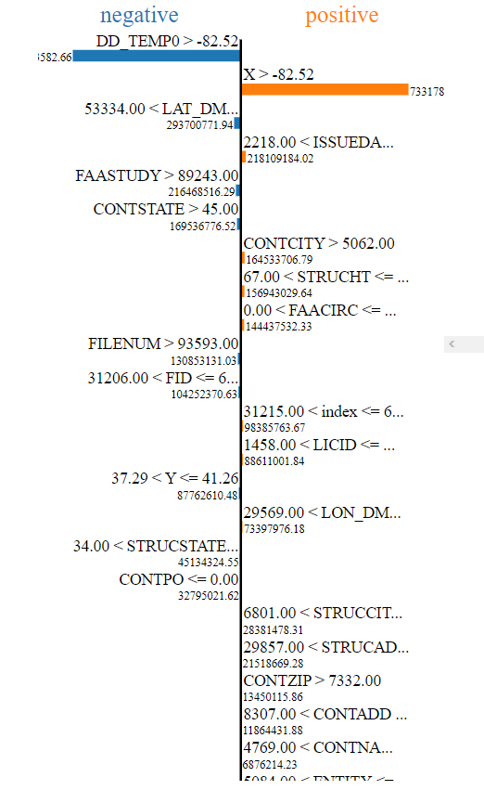

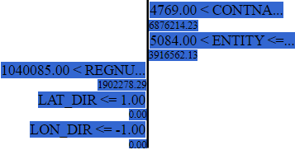

EQUATIONS:

DD_TEMP =-0.000012059667171 + -0.261829001805310 * X + 1.000000004981352 * Y + -0.000000000003293 * FID + 0.000000000000055 * REGNUM + 0.000000000000130 * FILENUM + 0.000000000005968 * ISSUEDATE + -0.000000000002411 * ENTITY + -0.000000000032615 * LAT_DMS + 0.000002784904611 * LAT_DIR + -0.000000000003766 * LON_DMS + -0.000000475028544 * LON_DIR + 0.261828997616792 * DD_TEMP0 + -0.000000000414901 * STRUCHT + 0.000000000000823 * STRUCADD + -0.000000000000130 * STRUCCITY + -0.000000000097739 * STRUCSTATE + 0.000000000000110 * FAASTUDY + 0.000000000734967 * FAACIRC + 0.000000000001024 * LICID + -0.000000000000816 * CONTNAME + 0.000000000000069 * CONTADD + 0.000000000008185 * CONTPO + -0.000000000009477 * CONTCITY + -0.000000001392464 * CONTSTATE + 0.000000000018000 * CONTZIP

ENCODING ONLY CATEGORICAL VARIABLES:

coefficient [-2.85937016e-03 5.26026629e-04 2.00064940e-01 9.24303619e-04

2.73070578e-05 -5.52084300e-05 -2.24224761e-05 4.41098847e-05

-2.67890341e-03 2.88533240e-06 -9.18019324e-04 4.56569199e-05

5.32466316e-04 2.85022909e-03 -1.44635458e-07 -9.40433790e-07

-1.54855636e-05 2.08190523e-05 5.53185336e-03 4.34067606e-04

4.50876951e-05 6.04134929e-05 4.78824311e-04 -1.74995865e-03

1.29813163e-04 2.10799229e-03 -1.52655666e-16 1.19542489e-05

-8.40296613e-14 -4.85722573e-17 5.55111512e-17 5.55111512e-17

2.43186547e-16 1.73472348e-18 2.30718222e-16 1.42968497e-03

2.77555756e-17 7.03356828e-09 -1.19542519e-05 3.42323283e-15

5.83300769e-17 3.72965547e-17 1.54490610e-14 -1.34441069e-17

-1.12167008e-14 -8.93382590e-17 1.83880688e-16 1.20129601e-16

2.83898339e-16 2.19008839e-17 -5.10429847e-15 1.71737624e-16

2.32364591e-03 -2.03431999e-04 -1.27497782e-05 -3.68218772e-07

3.48808141e-08 7.97121012e-06 -1.59477521e-06 3.14591584e-06

-2.72730567e-04 -1.03975762e-06 1.67973059e-06 -1.68748264e-06

-7.35583782e-04 1.17037429e-07 -1.70771551e-07 1.09511748e-04

1.03068816e-07 -4.44008038e-05 4.47539584e-06 5.65133755e-06

-1.48972398e-06 6.00045441e-07 3.51764261e-06 1.53401578e-04

3.42867601e-05 -4.11475445e-09 5.67662347e-14 -1.75887493e-13

-6.16732007e-14 -6.67530816e-13 -2.43690376e-13 2.28607655e-12

3.99967342e-01 -1.66370164e-13 2.82277026e-05 2.03428412e-04

-8.37226565e-11 -1.20916122e-14 -1.76425291e-14 -3.58194314e-10

8.91694962e-14 2.63237941e-10 2.83271956e-13 7.57752812e-13

-3.34941640e-13 -3.22991990e-12 3.48999342e-13 -2.73544758e-10

5.96683681e-12 -6.59194921e-17 6.93889390e-17 4.51028104e-17

2.27682456e-18 3.59955121e-17 -1.90819582e-17 -4.62151710e-04

-7.97972799e-17 -6.31867159e-09 1.27497814e-05 -7.17178731e-15

4.85722573e-17 -1.03216047e-16 1.61793474e-14 6.93889390e-18

1.86385994e-14 1.39536820e-16 5.89805982e-17 1.75640752e-17

-1.69731850e-16 6.03900610e-17 -1.86810118e-14 4.12430506e-16

9.71445147e-17 4.16333634e-17 4.33680869e-17 -1.99493200e-17

5.55111512e-17 -1.36535269e-05 -2.42861287e-17 -9.98612050e-12

3.68218832e-07 -1.94733552e-15 3.46944695e-17 6.24500451e-17

-8.24579798e-16 1.17961196e-16 3.16198585e-15 -1.34441069e-17

8.67361738e-19 -3.20923843e-17 -4.42354486e-17 -3.59955121e-17

1.45126559e-15 -5.33427469e-17 1.31838984e-16 -8.04478012e-17

-1.12757026e-17 0.00000000e+00 2.76042046e-05 2.42861287e-17

9.63121457e-12 -3.48808260e-08 8.76347063e-16 0.00000000e+00

1.00613962e-16 -3.89767971e-15 4.85722573e-17 -1.08556361e-14

-5.20417043e-18 -4.33680869e-18 -2.60208521e-17 2.64274280e-17

-1.09287579e-16 1.19292393e-15 -9.32413868e-17 -5.37757501e-16

7.25060203e-19 1.25116931e-16 1.12111656e-05 8.15252271e-17

-2.79583430e-10 -7.97121230e-06 7.68440233e-15 -7.09068221e-17

-1.79570985e-18 8.33206801e-15 -9.10729825e-18 -7.19495136e-14

1.02389343e-17 -3.83028299e-17 -3.65240607e-18 6.12909864e-16

-4.17194220e-16 3.78096771e-14 5.69907484e-16 3.42607887e-17

4.07660017e-17 -2.20549291e-05 1.30104261e-18 -2.20640831e-12

1.59477553e-06 -6.92174043e-16 -8.67361738e-18 -7.52436308e-17

-8.34046852e-15 -5.20417043e-17 2.14893918e-14 5.93600689e-17

-4.51299154e-17 -8.46219796e-17 4.53789431e-17 -3.52094656e-17

9.09067607e-15 -1.27366650e-16 4.85722573e-17 1.33945166e-03

-8.32667268e-17 -1.50134176e-07 -3.14591630e-06 6.23087939e-15

4.16333634e-17 1.38777878e-17 6.05226183e-14 -6.93889390e-18

-5.76807368e-14 -1.04083409e-17 -5.46437895e-17 5.46437895e-17

5.37296715e-16 3.10081821e-17 4.95512055e-14 -6.48569740e-16

4.94137455e-06 4.59009669e-04 8.99217964e-05 -2.56508785e-04

-1.42510691e-03 7.23146257e-08 4.70215044e-07 7.75091966e-06

-1.04095281e-05 -2.76592612e-03 -2.17033838e-04 -2.25439121e-05

-3.02067302e-05 -2.39412134e-04 8.74979277e-04 -6.49061108e-05

-1.05399650e-03 5.03069808e-17 -7.67253176e-08 1.03975778e-06

-2.76862714e-15 1.73472348e-17 2.27682456e-17 -5.08477690e-15

1.14491749e-16 -4.12463223e-16 -7.15573434e-18 3.45453917e-17

-1.10588622e-17 3.49113100e-17 -9.37834879e-18 -9.27975416e-17

1.53245201e-16 8.99218429e-05 4.02346811e-06 -1.41246157e-08

5.36801433e-12 3.32738233e-11 -8.85960232e-07 2.68682069e-12

2.02968018e-08 8.76214329e-11 1.50841087e-10 -9.89803290e-12

2.98149063e-10 1.17888930e-10 1.87698560e-08 8.29136223e-10

-2.32195897e-03 7.35583961e-04 -1.17037444e-07 1.70771565e-07

-1.09511682e-04 -1.03068841e-07 4.44009251e-05 -4.47539689e-06

-5.65133893e-06 1.48972438e-06 -6.00045564e-07 -3.51764366e-06

-1.53401690e-04 -3.42867677e-05 -1.14507321e-13 1.02804897e-15

1.23790032e-15 -1.31541990e-12 -8.64651233e-17 7.41357661e-13

1.38517306e-15 2.34734027e-15 3.66628756e-15 2.36716537e-14

1.00951504e-16 1.16759870e-13 1.90998476e-15 1.17961196e-16

2.77555756e-17 -6.30006166e-16 6.93889390e-18 -2.85410991e-15

-2.16840434e-17 -6.07153217e-17 -8.71698547e-17 6.45642394e-17

-9.49761103e-17 3.91146263e-16 -7.11236625e-17 -5.42101086e-17

1.58840976e-15 -1.56125113e-17 -1.80084549e-15 -4.01154804e-17

-6.36697726e-17 -6.28295159e-17 -2.50467643e-17 -1.09463762e-16

-1.41437943e-15 -5.33800163e-17 5.64290815e-12 3.20012436e-16

9.98544536e-12 1.19958916e-14 -2.57581512e-15 1.64372884e-15

-2.28724333e-14 -2.05634524e-14 2.42636750e-12 1.18032153e-13

7.63278329e-17 1.46821017e-15 -1.82145965e-17 -4.38017678e-17

-6.41847686e-17 -6.58991633e-18 -8.45677695e-17 -3.80175492e-16

-1.09829680e-16 5.40026822e-11 1.06521502e-14 -7.71418006e-15

-1.03991560e-14 -9.78716726e-14 3.63855696e-14 7.58441304e-12

2.12285270e-14 6.54316011e-17 3.12521276e-17 -3.37186876e-17

1.34909055e-16 -1.42979161e-17 -3.19855597e-15 2.81350464e-16

-3.93023288e-19 -6.07153217e-18 1.40406722e-16 -1.34644357e-17

1.39991790e-14 7.59551384e-17 1.54498810e-17 -1.46405410e-17

-1.17148045e-16 -3.16431890e-15 -3.37728977e-17 -2.29464592e-15

-4.20353653e-16 -1.21046919e-14 6.74305989e-17 3.38406603e-17

9.84862616e-14 -5.68935090e-17 2.17262903e-12 -1.74136847e-14

4.37184197e-16]

intercept -2.273924814488737e-05

Equation: DD_TEMP= -0.00002273924814488737 + 0.00052602662865129158 * X + 0.20006493980471073968 * Y + 0.00092430361918688126 * FID + 0.00002730705779010603 * REGNUM + -0.00005520843000511943 * FILENUM + -0.00002242247612391914 * ISSUEDATE + 0.00004410988473880875 * ENTITY + -0.00267890340813844692 * LAT_DMS + 0.00000288533240143518 * LAT_DIR + -0.00091801932394075048 * LON_DMS + 0.00004565691993775503 * LON_DIR + 0.00053246631642591682 * DD_TEMP0 + 0.00285022909392752084 * STRUCHT + -0.00000014463545756414 * STRUCADD + -0.00000094043378957588 * STRUCCITY + -0.00001548556362174028 * STRUCSTATE + 0.00002081905226988767 * FAASTUDY + 0.00553185335872829857 * FAACIRC + 0.00043406760602561327 * LICID + 0.00004508769506283045 * CONTNAME + 0.00006041349291266583 * CONTADD + 0.00047882431058625467 * CONTPO + -0.00174995864639957083 * CONTCITY + 0.00012981316272389130 * CONTSTATE + 0.00210799229236807630 * CONTZIP + -0.00000000000000015266 * index^2 + 0.00001195424891011961 * index^1*X^1 + -0.00000000000008402966 * index^1*Y^1 + -0.00000000000000004857 * index^1*FID^1 + 0.00000000000000005551 * index^1*REGNUM^1 + 0.00000000000000005551 * index^1*FILENUM^1 + 0.00000000000000024319 * index^1*ISSUEDATE^1 + 0.00000000000000000173 * index^1*ENTITY^1 + 0.00000000000000023072 * index^1*LAT_DMS^1 + 0.00142968497110787323 * index^1*LAT_DIR^1 + 0.00000000000000002776 * index^1*LON_DMS^1 + 0.00000000703356827742 * index^1*LON_DIR^1 + -0.00001195425185188876 * index^1*DD_TEMP0^1 + 0.00000000000000342323 * index^1*STRUCHT^1 + 0.00000000000000005833 * index^1*STRUCADD^1 + 0.00000000000000003730 * index^1*STRUCCITY^1 + 0.00000000000001544906 * index^1*STRUCSTATE^1 + -0.00000000000000001344 * index^1*FAASTUDY^1 + -0.00000000000001121670 * index^1*FAACIRC^1 + -0.00000000000000008934 * index^1*LICID^1 + 0.00000000000000018388 * index^1*CONTNAME^1 + 0.00000000000000012013 * index^1*CONTADD^1 + 0.00000000000000028390 * index^1*CONTPO^1 + 0.00000000000000002190 * index^1*CONTCITY^1 + -0.00000000000000510430 * index^1*CONTSTATE^1 + 0.00000000000000017174 * index^1*CONTZIP^1 + 0.00232364591494893698 * X^2 + -0.00020343199924590519 * X^1*Y^1 + -0.00001274977824306984 * X^1*FID^1 + -0.00000036821877173742 * X^1*REGNUM^1 + 0.00000003488081407746 * X^1*FILENUM^1 + 0.00000797121011887128 * X^1*ISSUEDATE^1 + -0.00000159477520685104 * X^1*ENTITY^1 + 0.00000314591584200732 * X^1*LAT_DMS^1 + -0.00027273056732701333 * X^1*LAT_DIR^1 + -0.00000103975761941967 * X^1*LON_DMS^1 + 0.00000167973059180217 * X^1*LON_DIR^1 + -0.00000168748263650914 * X^1*DD_TEMP0^1 + -0.00073558378185098971 * X^1*STRUCHT^1 + 0.00000011703742923890 * X^1*STRUCADD^1 + -0.00000017077155143172 * X^1*STRUCCITY^1 + 0.00010951174783339585 * X^1*STRUCSTATE^1 + 0.00000010306881639325 * X^1*FAASTUDY^1 + -0.00004440080378704384 * X^1*FAACIRC^1 + 0.00000447539583854924 * X^1*LICID^1 + 0.00000565133755019818 * X^1*CONTNAME^1 + -0.00000148972398407419 * X^1*CONTADD^1 + 0.00000060004544064387 * X^1*CONTPO^1 + 0.00000351764260591636 * X^1*CONTCITY^1 + 0.00015340157808438505 * X^1*CONTSTATE^1 + 0.00003428676006253668 * X^1*CONTZIP^1 + -0.00000000411475444936 * Y^2 + 0.00000000000005676623 * Y^1*FID^1 + -0.00000000000017588749 * Y^1*REGNUM^1 + -0.00000000000006167320 * Y^1*FILENUM^1 + -0.00000000000066753082 * Y^1*ISSUEDATE^1 + -0.00000000000024369038 * Y^1*ENTITY^1 + 0.00000000000228607655 * Y^1*LAT_DMS^1 + 0.39996734207588441334 * Y^1*LAT_DIR^1 + -0.00000000000016637016 * Y^1*LON_DMS^1 + 0.00002822770264378638 * Y^1*LON_DIR^1 + 0.00020342841236839048 * Y^1*DD_TEMP0^1 + -0.00000000008372265649 * Y^1*STRUCHT^1 + -0.00000000000001209161 * Y^1*STRUCADD^1 + -0.00000000000001764253 * Y^1*STRUCCITY^1 + -0.00000000035819431406 * Y^1*STRUCSTATE^1 + 0.00000000000008916950 * Y^1*FAASTUDY^1 + 0.00000000026323794065 * Y^1*FAACIRC^1 + 0.00000000000028327196 * Y^1*LICID^1 + 0.00000000000075775281 * Y^1*CONTNAME^1 + -0.00000000000033494164 * Y^1*CONTADD^1 + -0.00000000000322991990 * Y^1*CONTPO^1 + 0.00000000000034899934 * Y^1*CONTCITY^1 + -0.00000000027354475836 * Y^1*CONTSTATE^1 + 0.00000000000596683681 * Y^1*CONTZIP^1 + -0.00000000000000006592 * FID^2 + 0.00000000000000006939 * FID^1*REGNUM^1 + 0.00000000000000004510 * FID^1*FILENUM^1 + 0.00000000000000000228 * FID^1*ISSUEDATE^1 + 0.00000000000000003600 * FID^1*ENTITY^1 + -0.00000000000000001908 * FID^1*LAT_DMS^1 + -0.00046215170957877985 * FID^1*LAT_DIR^1 + -0.00000000000000007980 * FID^1*LON_DMS^1 + -0.00000000631867159023 * FID^1*LON_DIR^1 + 0.00001274978143280560 * FID^1*DD_TEMP0^1 + -0.00000000000000717179 * FID^1*STRUCHT^1 + 0.00000000000000004857 * FID^1*STRUCADD^1 + -0.00000000000000010322 * FID^1*STRUCCITY^1 + 0.00000000000001617935 * FID^1*STRUCSTATE^1 + 0.00000000000000000694 * FID^1*FAASTUDY^1 + 0.00000000000001863860 * FID^1*FAACIRC^1 + 0.00000000000000013954 * FID^1*LICID^1 + 0.00000000000000005898 * FID^1*CONTNAME^1 + 0.00000000000000001756 * FID^1*CONTADD^1 + -0.00000000000000016973 * FID^1*CONTPO^1 + 0.00000000000000006039 * FID^1*CONTCITY^1 + -0.00000000000001868101 * FID^1*CONTSTATE^1 + 0.00000000000000041243 * FID^1*CONTZIP^1 + 0.00000000000000009714 * REGNUM^2 + 0.00000000000000004163 * REGNUM^1*FILENUM^1 + 0.00000000000000004337 * REGNUM^1*ISSUEDATE^1 + -0.00000000000000001995 * REGNUM^1*ENTITY^1 + 0.00000000000000005551 * REGNUM^1*LAT_DMS^1 + -0.00001365352685793215 * REGNUM^1*LAT_DIR^1 + -0.00000000000000002429 * REGNUM^1*LON_DMS^1 + -0.00000000000998612050 * REGNUM^1*LON_DIR^1 + 0.00000036821883173389 * REGNUM^1*DD_TEMP0^1 + -0.00000000000000194734 * REGNUM^1*STRUCHT^1 + 0.00000000000000003469 * REGNUM^1*STRUCADD^1 + 0.00000000000000006245 * REGNUM^1*STRUCCITY^1 + -0.00000000000000082458 * REGNUM^1*STRUCSTATE^1 + 0.00000000000000011796 * REGNUM^1*FAASTUDY^1 + 0.00000000000000316199 * REGNUM^1*FAACIRC^1 + -0.00000000000000001344 * REGNUM^1*LICID^1 + 0.00000000000000000087 * REGNUM^1*CONTNAME^1 + -0.00000000000000003209 * REGNUM^1*CONTADD^1 + -0.00000000000000004424 * REGNUM^1*CONTPO^1 + -0.00000000000000003600 * REGNUM^1*CONTCITY^1 + 0.00000000000000145127 * REGNUM^1*CONTSTATE^1 + -0.00000000000000005334 * REGNUM^1*CONTZIP^1 + 0.00000000000000013184 * FILENUM^2 + -0.00000000000000008045 * FILENUM^1*ISSUEDATE^1 + -0.00000000000000001128 * FILENUM^1*ENTITY^1 + 0.00000000000000000000 * FILENUM^1*LAT_DMS^1 + 0.00002760420458983083 * FILENUM^1*LAT_DIR^1 + 0.00000000000000002429 * FILENUM^1*LON_DMS^1 + 0.00000000000963121457 * FILENUM^1*LON_DIR^1 + -0.00000003488082597957 * FILENUM^1*DD_TEMP0^1 + 0.00000000000000087635 * FILENUM^1*STRUCHT^1 + 0.00000000000000000000 * FILENUM^1*STRUCADD^1 + 0.00000000000000010061 * FILENUM^1*STRUCCITY^1 + -0.00000000000000389768 * FILENUM^1*STRUCSTATE^1 + 0.00000000000000004857 * FILENUM^1*FAASTUDY^1 + -0.00000000000001085564 * FILENUM^1*FAACIRC^1 + -0.00000000000000000520 * FILENUM^1*LICID^1 + -0.00000000000000000434 * FILENUM^1*CONTNAME^1 + -0.00000000000000002602 * FILENUM^1*CONTADD^1 + 0.00000000000000002643 * FILENUM^1*CONTPO^1 + -0.00000000000000010929 * FILENUM^1*CONTCITY^1 + 0.00000000000000119292 * FILENUM^1*CONTSTATE^1 + -0.00000000000000009324 * FILENUM^1*CONTZIP^1 + -0.00000000000000053776 * ISSUEDATE^2 + 0.00000000000000000073 * ISSUEDATE^1*ENTITY^1 + 0.00000000000000012512 * ISSUEDATE^1*LAT_DMS^1 + 0.00001121116556185008 * ISSUEDATE^1*LAT_DIR^1 + 0.00000000000000008153 * ISSUEDATE^1*LON_DMS^1 + -0.00000000027958343037 * ISSUEDATE^1*LON_DIR^1 + -0.00000797121230317001 * ISSUEDATE^1*DD_TEMP0^1 + 0.00000000000000768440 * ISSUEDATE^1*STRUCHT^1 + -0.00000000000000007091 * ISSUEDATE^1*STRUCADD^1 + -0.00000000000000000180 * ISSUEDATE^1*STRUCCITY^1 + 0.00000000000000833207 * ISSUEDATE^1*STRUCSTATE^1 + -0.00000000000000000911 * ISSUEDATE^1*FAASTUDY^1 + -0.00000000000007194951 * ISSUEDATE^1*FAACIRC^1 + 0.00000000000000001024 * ISSUEDATE^1*LICID^1 + -0.00000000000000003830 * ISSUEDATE^1*CONTNAME^1 + -0.00000000000000000365 * ISSUEDATE^1*CONTADD^1 + 0.00000000000000061291 * ISSUEDATE^1*CONTPO^1 + -0.00000000000000041719 * ISSUEDATE^1*CONTCITY^1 + 0.00000000000003780968 * ISSUEDATE^1*CONTSTATE^1 + 0.00000000000000056991 * ISSUEDATE^1*CONTZIP^1 + 0.00000000000000003426 * ENTITY^2 + 0.00000000000000004077 * ENTITY^1*LAT_DMS^1 + -0.00002205492908471865 * ENTITY^1*LAT_DIR^1 + 0.00000000000000000130 * ENTITY^1*LON_DMS^1 + -0.00000000000220640831 * ENTITY^1*LON_DIR^1 + 0.00000159477553019607 * ENTITY^1*DD_TEMP0^1 + -0.00000000000000069217 * ENTITY^1*STRUCHT^1 + -0.00000000000000000867 * ENTITY^1*STRUCADD^1 + -0.00000000000000007524 * ENTITY^1*STRUCCITY^1 + -0.00000000000000834047 * ENTITY^1*STRUCSTATE^1 + -0.00000000000000005204 * ENTITY^1*FAASTUDY^1 + 0.00000000000002148939 * ENTITY^1*FAACIRC^1 + 0.00000000000000005936 * ENTITY^1*LICID^1 + -0.00000000000000004513 * ENTITY^1*CONTNAME^1 + -0.00000000000000008462 * ENTITY^1*CONTADD^1 + 0.00000000000000004538 * ENTITY^1*CONTPO^1 + -0.00000000000000003521 * ENTITY^1*CONTCITY^1 + 0.00000000000000909068 * ENTITY^1*CONTSTATE^1 + -0.00000000000000012737 * ENTITY^1*CONTZIP^1 + 0.00000000000000004857 * LAT_DMS^2 + 0.00133945165912740236 * LAT_DMS^1*LAT_DIR^1 + -0.00000000000000008327 * LAT_DMS^1*LON_DMS^1 + -0.00000015013417641518 * LAT_DMS^1*LON_DIR^1 + -0.00000314591630053412 * LAT_DMS^1*DD_TEMP0^1 + 0.00000000000000623088 * LAT_DMS^1*STRUCHT^1 + 0.00000000000000004163 * LAT_DMS^1*STRUCADD^1 + 0.00000000000000001388 * LAT_DMS^1*STRUCCITY^1 + 0.00000000000006052262 * LAT_DMS^1*STRUCSTATE^1 + -0.00000000000000000694 * LAT_DMS^1*FAASTUDY^1 + -0.00000000000005768074 * LAT_DMS^1*FAACIRC^1 + -0.00000000000000001041 * LAT_DMS^1*LICID^1 + -0.00000000000000005464 * LAT_DMS^1*CONTNAME^1 + 0.00000000000000005464 * LAT_DMS^1*CONTADD^1 + 0.00000000000000053730 * LAT_DMS^1*CONTPO^1 + 0.00000000000000003101 * LAT_DMS^1*CONTCITY^1 + 0.00000000000004955121 * LAT_DMS^1*CONTSTATE^1 + -0.00000000000000064857 * LAT_DMS^1*CONTZIP^1 + 0.00000494137455093665 * LAT_DIR^2 + 0.00045900966932943104 * LAT_DIR^1*LON_DMS^1 + 0.00008992179642592877 * LAT_DIR^1*LON_DIR^1 + -0.00025650878488109785 * LAT_DIR^1*DD_TEMP0^1 + -0.00142510691433814598 * LAT_DIR^1*STRUCHT^1 + 0.00000007231462565691 * LAT_DIR^1*STRUCADD^1 + 0.00000047021504431317 * LAT_DIR^1*STRUCCITY^1 + 0.00000775091966358013 * LAT_DIR^1*STRUCSTATE^1 + -0.00001040952814803750 * LAT_DIR^1*FAASTUDY^1 + -0.00276592612447065832 * LAT_DIR^1*FAACIRC^1 + -0.00021703383781480947 * LAT_DIR^1*LICID^1 + -0.00002254391212212646 * LAT_DIR^1*CONTNAME^1 + -0.00003020673019605963 * LAT_DIR^1*CONTADD^1 + -0.00023941213367338678 * LAT_DIR^1*CONTPO^1 + 0.00087497927667741602 * LAT_DIR^1*CONTCITY^1 + -0.00006490611076780766 * LAT_DIR^1*CONTSTATE^1 + -0.00105399650130544699 * LAT_DIR^1*CONTZIP^1 + 0.00000000000000005031 * LON_DMS^2 + -0.00000007672531760764 * LON_DMS^1*LON_DIR^1 + 0.00000103975777936632 * LON_DMS^1*DD_TEMP0^1 + -0.00000000000000276863 * LON_DMS^1*STRUCHT^1 + 0.00000000000000001735 * LON_DMS^1*STRUCADD^1 + 0.00000000000000002277 * LON_DMS^1*STRUCCITY^1 + -0.00000000000000508478 * LON_DMS^1*STRUCSTATE^1 + 0.00000000000000011449 * LON_DMS^1*FAASTUDY^1 + -0.00000000000000041246 * LON_DMS^1*FAACIRC^1 + -0.00000000000000000716 * LON_DMS^1*LICID^1 + 0.00000000000000003455 * LON_DMS^1*CONTNAME^1 + -0.00000000000000001106 * LON_DMS^1*CONTADD^1 + 0.00000000000000003491 * LON_DMS^1*CONTPO^1 + -0.00000000000000000938 * LON_DMS^1*CONTCITY^1 + -0.00000000000000009280 * LON_DMS^1*CONTSTATE^1 + 0.00000000000000015325 * LON_DMS^1*CONTZIP^1 + 0.00008992184291393695 * LON_DIR^2 + 0.00000402346811271785 * LON_DIR^1*DD_TEMP0^1 + -0.00000001412461566906 * LON_DIR^1*STRUCHT^1 + 0.00000000000536801433 * LON_DIR^1*STRUCADD^1 + 0.00000000003327382329 * LON_DIR^1*STRUCCITY^1 + -0.00000088596023166897 * LON_DIR^1*STRUCSTATE^1 + 0.00000000000268682069 * LON_DIR^1*FAASTUDY^1 + 0.00000002029680183611 * LON_DIR^1*FAACIRC^1 + 0.00000000008762143288 * LON_DIR^1*LICID^1 + 0.00000000015084108709 * LON_DIR^1*CONTNAME^1 + -0.00000000000989803290 * LON_DIR^1*CONTADD^1 + 0.00000000029814906346 * LON_DIR^1*CONTPO^1 + 0.00000000011788893004 * LON_DIR^1*CONTCITY^1 + 0.00000001876985603139 * LON_DIR^1*CONTSTATE^1 + 0.00000000082913622252 * LON_DIR^1*CONTZIP^1 + -0.00232195896975922588 * DD_TEMP0^2 + 0.00073558396078029933 * DD_TEMP0^1*STRUCHT^1 + -0.00000011703744374918 * DD_TEMP0^1*STRUCADD^1 + 0.00000017077156531760 * DD_TEMP0^1*STRUCCITY^1 + -0.00010951168159223391 * DD_TEMP0^1*STRUCSTATE^1 + -0.00000010306884088310 * DD_TEMP0^1*FAASTUDY^1 + 0.00004440092512574779 * DD_TEMP0^1*FAACIRC^1 + -0.00000447539688753645 * DD_TEMP0^1*LICID^1 + -0.00000565133893423254 * DD_TEMP0^1*CONTNAME^1 + 0.00000148972438037532 * DD_TEMP0^1*CONTADD^1 + -0.00000060004556416550 * DD_TEMP0^1*CONTPO^1 + -0.00000351764365681543 * DD_TEMP0^1*CONTCITY^1 + -0.00015340168968329371 * DD_TEMP0^1*CONTSTATE^1 + -0.00003428676769268545 * DD_TEMP0^1*CONTZIP^1 + -0.00000000000011450732 * STRUCHT^2 + 0.00000000000000102805 * STRUCHT^1*STRUCADD^1 + 0.00000000000000123790 * STRUCHT^1*STRUCCITY^1 + -0.00000000000131541990 * STRUCHT^1*STRUCSTATE^1 + -0.00000000000000008647 * STRUCHT^1*FAASTUDY^1 + 0.00000000000074135766 * STRUCHT^1*FAACIRC^1 + 0.00000000000000138517 * STRUCHT^1*LICID^1 + 0.00000000000000234734 * STRUCHT^1*CONTNAME^1 + 0.00000000000000366629 * STRUCHT^1*CONTADD^1 + 0.00000000000002367165 * STRUCHT^1*CONTPO^1 + 0.00000000000000010095 * STRUCHT^1*CONTCITY^1 + 0.00000000000011675987 * STRUCHT^1*CONTSTATE^1 + 0.00000000000000190998 * STRUCHT^1*CONTZIP^1 + 0.00000000000000011796 * STRUCADD^2 + 0.00000000000000002776 * STRUCADD^1*STRUCCITY^1 + -0.00000000000000063001 * STRUCADD^1*STRUCSTATE^1 + 0.00000000000000000694 * STRUCADD^1*FAASTUDY^1 + -0.00000000000000285411 * STRUCADD^1*FAACIRC^1 + -0.00000000000000002168 * STRUCADD^1*LICID^1 + -0.00000000000000006072 * STRUCADD^1*CONTNAME^1 + -0.00000000000000008717 * STRUCADD^1*CONTADD^1 + 0.00000000000000006456 * STRUCADD^1*CONTPO^1 + -0.00000000000000009498 * STRUCADD^1*CONTCITY^1 + 0.00000000000000039115 * STRUCADD^1*CONTSTATE^1 + -0.00000000000000007112 * STRUCADD^1*CONTZIP^1 + -0.00000000000000005421 * STRUCCITY^2 + 0.00000000000000158841 * STRUCCITY^1*STRUCSTATE^1 + -0.00000000000000001561 * STRUCCITY^1*FAASTUDY^1 + -0.00000000000000180085 * STRUCCITY^1*FAACIRC^1 + -0.00000000000000004012 * STRUCCITY^1*LICID^1 + -0.00000000000000006367 * STRUCCITY^1*CONTNAME^1 + -0.00000000000000006283 * STRUCCITY^1*CONTADD^1 + -0.00000000000000002505 * STRUCCITY^1*CONTPO^1 + -0.00000000000000010946 * STRUCCITY^1*CONTCITY^1 + -0.00000000000000141438 * STRUCCITY^1*CONTSTATE^1 + -0.00000000000000005338 * STRUCCITY^1*CONTZIP^1 + 0.00000000000564290815 * STRUCSTATE^2 + 0.00000000000000032001 * STRUCSTATE^1*FAASTUDY^1 + 0.00000000000998544536 * STRUCSTATE^1*FAACIRC^1 + 0.00000000000001199589 * STRUCSTATE^1*LICID^1 + -0.00000000000000257582 * STRUCSTATE^1*CONTNAME^1 + 0.00000000000000164373 * STRUCSTATE^1*CONTADD^1 + -0.00000000000002287243 * STRUCSTATE^1*CONTPO^1 + -0.00000000000002056345 * STRUCSTATE^1*CONTCITY^1 + 0.00000000000242636750 * STRUCSTATE^1*CONTSTATE^1 + 0.00000000000011803215 * STRUCSTATE^1*CONTZIP^1 + 0.00000000000000007633 * FAASTUDY^2 + 0.00000000000000146821 * FAASTUDY^1*FAACIRC^1 + -0.00000000000000001821 * FAASTUDY^1*LICID^1 + -0.00000000000000004380 * FAASTUDY^1*CONTNAME^1 + -0.00000000000000006418 * FAASTUDY^1*CONTADD^1 + -0.00000000000000000659 * FAASTUDY^1*CONTPO^1 + -0.00000000000000008457 * FAASTUDY^1*CONTCITY^1 + -0.00000000000000038018 * FAASTUDY^1*CONTSTATE^1 + -0.00000000000000010983 * FAASTUDY^1*CONTZIP^1 + 0.00000000005400268224 * FAACIRC^2 + 0.00000000000001065215 * FAACIRC^1*LICID^1 + -0.00000000000000771418 * FAACIRC^1*CONTNAME^1 + -0.00000000000001039916 * FAACIRC^1*CONTADD^1 + -0.00000000000009787167 * FAACIRC^1*CONTPO^1 + 0.00000000000003638557 * FAACIRC^1*CONTCITY^1 + 0.00000000000758441304 * FAACIRC^1*CONTSTATE^1 + 0.00000000000002122853 * FAACIRC^1*CONTZIP^1 + 0.00000000000000006543 * LICID^2 + 0.00000000000000003125 * LICID^1*CONTNAME^1 + -0.00000000000000003372 * LICID^1*CONTADD^1 + 0.00000000000000013491 * LICID^1*CONTPO^1 + -0.00000000000000001430 * LICID^1*CONTCITY^1 + -0.00000000000000319856 * LICID^1*CONTSTATE^1 + 0.00000000000000028135 * LICID^1*CONTZIP^1 + -0.00000000000000000039 * CONTNAME^2 + -0.00000000000000000607 * CONTNAME^1*CONTADD^1 + 0.00000000000000014041 * CONTNAME^1*CONTPO^1 + -0.00000000000000001346 * CONTNAME^1*CONTCITY^1 + 0.00000000000001399918 * CONTNAME^1*CONTSTATE^1 + 0.00000000000000007596 * CONTNAME^1*CONTZIP^1 + 0.00000000000000001545 * CONTADD^2 + -0.00000000000000001464 * CONTADD^1*CONTPO^1 + -0.00000000000000011715 * CONTADD^1*CONTCITY^1 + -0.00000000000000316432 * CONTADD^1*CONTSTATE^1 + -0.00000000000000003377 * CONTADD^1*CONTZIP^1 + -0.00000000000000229465 * CONTPO^2 + -0.00000000000000042035 * CONTPO^1*CONTCITY^1 + -0.00000000000001210469 * CONTPO^1*CONTSTATE^1 + 0.00000000000000006743 * CONTPO^1*CONTZIP^1 + 0.00000000000000003384 * CONTCITY^2 + 0.00000000000009848626 * CONTCITY^1*CONTSTATE^1 + -0.00000000000000005689 * CONTCITY^1*CONTZIP^1 + 0.00000000000217262903 * CONTSTATE^2 + -0.00000000000001741368 * CONTSTATE^1*CONTZIP^1 + 0.00000000000000043718 * CONTZIP^2

ENCODING WITHOUT DMS:

DD_TEMP= 0.00010576230626213601 + -0.00000174095101137415 * X + 0.50000130403377274213 * Y + -0.00006511110488630435 * FID + -0.00000316087842277951 * REGNUM + 0.00000440755907304179 * FILENUM + 0.00000522239531959209 * ISSUEDATE + -0.00000223396633363449 * ENTITY + 0.00001054592131193315 * LAT_DMS + 0.00000723888823740212 * LAT_DIR + -0.00023386335143328228 * LON_DMS + 0.00004867207812449064 * LON_DIR + -0.00000443296812098102 * DD_TEMP0 + -0.00009467762825440859 * STRUCHT + 0.00000050154855025786 * STRUCADD + 0.00000054682394215625 * STRUCCITY + -0.00000029338273138416 * STRUCSTATE + -0.00000174636596068962 * FAASTUDY + -0.00000570040267122107 * FAACIRC + -0.00001675999538907090 * LICID + 0.00000131672343367331 * CONTNAME + -0.00000148766673947339 * CONTADD + -0.00000145259231411636 * CONTPO + 0.00022464540035893203 * CONTCITY + 0.00000695760544986160 * CONTSTATE + -0.00033408163777937295 * CONTZIP + 0.00000000000000059674 * index^2 + 0.00006864412035253760 * index^1*X^1 + 0.00000000000316765728 * index^1*Y^1 + 0.00000000000000006939 * index^1*FID^1 + 0.00000000000000005898 * index^1*REGNUM^1 + -0.00000000000000011102 * index^1*FILENUM^1 + 0.00000000000000061366 * index^1*ISSUEDATE^1 + 0.00000000000000007633 * index^1*ENTITY^1 + 0.00000000000000026368 * index^1*LAT_DMS^1 + -0.00017551137836102786 * index^1*LAT_DIR^1 + 0.00000000000000031225 * index^1*LON_DMS^1 + 0.00000000105944581893 * index^1*LON_DIR^1 + -0.00006864413752147434 * index^1*DD_TEMP0^1 + 0.00000000000001918284 * index^1*STRUCHT^1 + 0.00000000000000001605 * index^1*STRUCADD^1 + 0.00000000000000034001 * index^1*STRUCCITY^1 + -0.00000000000007507696 * index^1*STRUCSTATE^1 + 0.00000000000000002515 * index^1*FAASTUDY^1 + 0.00000000000012783470 * index^1*FAACIRC^1 + 0.00000000000000007329 * index^1*LICID^1 + 0.00000000000000044235 * index^1*CONTNAME^1 + -0.00000000000000000694 * index^1*CONTADD^1 + 0.00000000000000026839 * index^1*CONTPO^1 + 0.00000000000000015656 * index^1*CONTCITY^1 + -0.00000000000001644235 * index^1*CONTSTATE^1 + 0.00000000000000102696 * index^1*CONTZIP^1 + -0.00047354360387344543 * X^2 + 0.00004534485574031599 * X^1*Y^1 + -0.00007423459553249815 * X^1*FID^1 + -0.00000159447871112392 * X^1*REGNUM^1 + -0.00000066315100018271 * X^1*FILENUM^1 + -0.00000714945556567689 * X^1*ISSUEDATE^1 + -0.00001556784074416448 * X^1*ENTITY^1 + -0.00000018587636457738 * X^1*LAT_DMS^1 + 0.00000231886325348656 * X^1*LAT_DIR^1 + -0.00001918426821592109 * X^1*LON_DMS^1 + -0.00000246611014691395 * X^1*LON_DIR^1 + -0.00000079276145427020 * X^1*DD_TEMP0^1 + 0.00014866894967023979 * X^1*STRUCHT^1 + -0.00000049827874430482 * X^1*STRUCADD^1 + -0.00000282730216788391 * X^1*STRUCCITY^1 + -0.00002292352209385020 * X^1*STRUCSTATE^1 + -0.00000054972982783970 * X^1*FAASTUDY^1 + 0.00000836215019043474 * X^1*FAACIRC^1 + 0.00003665822018225841 * X^1*LICID^1 + 0.00003642371899628211 * X^1*CONTNAME^1 + -0.00001255416396715745 * X^1*CONTADD^1 + 0.00001085334788082865 * X^1*CONTPO^1 + 0.00003356907883732859 * X^1*CONTCITY^1 + -0.00002680908955299351 * X^1*CONTSTATE^1 + 0.00024656119727870364 * X^1*CONTZIP^1 + 0.00000001251236735875 * Y^2 + -0.00000000000549063542 * Y^1*FID^1 + 0.00000000000022671341 * Y^1*REGNUM^1 + -0.00000000000009706796 * Y^1*FILENUM^1 + -0.00000000000510647314 * Y^1*ISSUEDATE^1 + -0.00000000000331134716 * Y^1*ENTITY^1 + -0.00000000000437808480 * Y^1*LAT_DMS^1 + 0.50000274574337888467 * Y^1*LAT_DIR^1 + -0.00000000000279535422 * Y^1*LON_DMS^1 + 0.00000483828298438299 * Y^1*LON_DIR^1 + -0.00004535055271666296 * Y^1*DD_TEMP0^1 + 0.00000000008789835909 * Y^1*STRUCHT^1 + -0.00000000000013777202 * Y^1*STRUCADD^1 + -0.00000000000080953631 * Y^1*STRUCCITY^1 + 0.00000000099584666881 * Y^1*STRUCSTATE^1 + -0.00000000000045721241 * Y^1*FAASTUDY^1 + 0.00000000142046559607 * Y^1*FAACIRC^1 + 0.00000000000380806604 * Y^1*LICID^1 + 0.00000000000578271896 * Y^1*CONTNAME^1 + -0.00000000000187735176 * Y^1*CONTADD^1 + -0.00000000001385363982 * Y^1*CONTPO^1 + 0.00000000000269818949 * Y^1*CONTCITY^1 + -0.00000000205248493752 * Y^1*CONTSTATE^1 + 0.00000000004682335635 * Y^1*CONTZIP^1 + -0.00000000000000072164 * FID^2 + -0.00000000000000013184 * FID^1*REGNUM^1 + 0.00000000000000002776 * FID^1*FILENUM^1 + -0.00000000000000032461 * FID^1*ISSUEDATE^1 + -0.00000000000000001214 * FID^1*ENTITY^1 + 0.00000000000000002082 * FID^1*LAT_DMS^1 + 0.00006511053443755139 * FID^1*LAT_DIR^1 + -0.00000000000000043715 * FID^1*LON_DMS^1 + -0.00000000201508975500 * FID^1*LON_DIR^1 + 0.00007423461361159702 * FID^1*DD_TEMP0^1 + -0.00000000000002936831 * FID^1*STRUCHT^1 + -0.00000000000000020296 * FID^1*STRUCADD^1 + 0.00000000000000009714 * FID^1*STRUCCITY^1 + -0.00000000000005239133 * FID^1*STRUCSTATE^1 + -0.00000000000000023419 * FID^1*FAASTUDY^1 + 0.00000000000006464151 * FID^1*FAACIRC^1 + 0.00000000000000036342 * FID^1*LICID^1 + 0.00000000000000017954 * FID^1*CONTNAME^1 + 0.00000000000000010105 * FID^1*CONTADD^1 + -0.00000000000000087864 * FID^1*CONTPO^1 + -0.00000000000000015092 * FID^1*CONTCITY^1 + -0.00000000000017003096 * FID^1*CONTSTATE^1 + 0.00000000000000222999 * FID^1*CONTZIP^1 + -0.00000000000000002776 * REGNUM^2 + -0.00000000000000016653 * REGNUM^1*FILENUM^1 + 0.00000000000000008153 * REGNUM^1*ISSUEDATE^1 + -0.00000000000000008327 * REGNUM^1*ENTITY^1 + 0.00000000000000002776 * REGNUM^1*LAT_DMS^1 + 0.00000316091945676186 * REGNUM^1*LAT_DIR^1 + 0.00000000000000000000 * REGNUM^1*LON_DMS^1 + -0.00000000004156447970 * REGNUM^1*LON_DIR^1 + 0.00000159447902129931 * REGNUM^1*DD_TEMP0^1 + -0.00000000000000317389 * REGNUM^1*STRUCHT^1 + -0.00000000000000002776 * REGNUM^1*STRUCADD^1 + -0.00000000000000007980 * REGNUM^1*STRUCCITY^1 + -0.00000000000000324559 * REGNUM^1*STRUCSTATE^1 + 0.00000000000000013878 * REGNUM^1*FAASTUDY^1 + 0.00000000000000728377 * REGNUM^1*FAACIRC^1 + -0.00000000000000013704 * REGNUM^1*LICID^1 + -0.00000000000000004684 * REGNUM^1*CONTNAME^1 + 0.00000000000000001041 * REGNUM^1*CONTADD^1 + 0.00000000000000023679 * REGNUM^1*CONTPO^1 + 0.00000000000000014572 * REGNUM^1*CONTCITY^1 + -0.00000000000000304455 * REGNUM^1*CONTSTATE^1 + -0.00000000000000003816 * REGNUM^1*CONTZIP^1 + -0.00000000000000002776 * FILENUM^2 + 0.00000000000000005768 * FILENUM^1*ISSUEDATE^1 + -0.00000000000000008674 * FILENUM^1*ENTITY^1 + -0.00000000000000005551 * FILENUM^1*LAT_DMS^1 + -0.00000440755121025107 * FILENUM^1*LAT_DIR^1 + 0.00000000000000000000 * FILENUM^1*LON_DMS^1 + -0.00000000001871399786 * FILENUM^1*LON_DIR^1 + 0.00000066315116472401 * FILENUM^1*DD_TEMP0^1 + -0.00000000000000185605 * FILENUM^1*STRUCHT^1 + 0.00000000000000005551 * FILENUM^1*STRUCADD^1 + -0.00000000000000007286 * FILENUM^1*STRUCCITY^1 + -0.00000000000002013460 * FILENUM^1*STRUCSTATE^1 + -0.00000000000000004163 * FILENUM^1*FAASTUDY^1 + 0.00000000000000632000 * FILENUM^1*FAACIRC^1 + 0.00000000000000008500 * FILENUM^1*LICID^1 + -0.00000000000000003643 * FILENUM^1*CONTNAME^1 + -0.00000000000000008327 * FILENUM^1*CONTADD^1 + 0.00000000000000014450 * FILENUM^1*CONTPO^1 + -0.00000000000000009541 * FILENUM^1*CONTCITY^1 + -0.00000000000000408701 * FILENUM^1*CONTSTATE^1 + -0.00000000000000000607 * FILENUM^1*CONTZIP^1 + -0.00000000000000028542 * ISSUEDATE^2 + -0.00000000000000050380 * ISSUEDATE^1*ENTITY^1 + 0.00000000000000096949 * ISSUEDATE^1*LAT_DMS^1 + -0.00000522265658655712 * ISSUEDATE^1*LAT_DIR^1 + 0.00000000000000002914 * ISSUEDATE^1*LON_DMS^1 + -0.00000000013418338845 * ISSUEDATE^1*LON_DIR^1 + 0.00000714945766576693 * ISSUEDATE^1*DD_TEMP0^1 + 0.00000000000005196728 * ISSUEDATE^1*STRUCHT^1 + -0.00000000000000009498 * ISSUEDATE^1*STRUCADD^1 + -0.00000000000000013334 * ISSUEDATE^1*STRUCCITY^1 + 0.00000000000008548451 * ISSUEDATE^1*STRUCSTATE^1 + 0.00000000000000005248 * ISSUEDATE^1*FAASTUDY^1 + -0.00000000000028441671 * ISSUEDATE^1*FAACIRC^1 + 0.00000000000000039557 * ISSUEDATE^1*LICID^1 + 0.00000000000000080895 * ISSUEDATE^1*CONTNAME^1 + 0.00000000000000060141 * ISSUEDATE^1*CONTADD^1 + 0.00000000000000655791 * ISSUEDATE^1*CONTPO^1 + -0.00000000000000233300 * ISSUEDATE^1*CONTCITY^1 + 0.00000000000014128980 * ISSUEDATE^1*CONTSTATE^1 + 0.00000000000000277901 * ISSUEDATE^1*CONTZIP^1 + 0.00000000000000008110 * ENTITY^2 + 0.00000000000000034001 * ENTITY^1*LAT_DMS^1 + 0.00000223393752293879 * ENTITY^1*LAT_DIR^1 + -0.00000000000000008023 * ENTITY^1*LON_DMS^1 + -0.00000000040003238532 * ENTITY^1*LON_DIR^1 + 0.00001556784423160812 * ENTITY^1*DD_TEMP0^1 + 0.00000000000000608565 * ENTITY^1*STRUCHT^1 + -0.00000000000000006765 * ENTITY^1*STRUCADD^1 + -0.00000000000000014550 * ENTITY^1*STRUCCITY^1 + -0.00000000000005133362 * ENTITY^1*STRUCSTATE^1 + -0.00000000000000005898 * ENTITY^1*FAASTUDY^1 + 0.00000000000007289915 * ENTITY^1*FAACIRC^1 + 0.00000000000000026682 * ENTITY^1*LICID^1 + 0.00000000000000003838 * ENTITY^1*CONTNAME^1 + 0.00000000000000019049 * ENTITY^1*CONTADD^1 + -0.00000000000000020170 * ENTITY^1*CONTPO^1 + 0.00000000000000021595 * ENTITY^1*CONTCITY^1 + 0.00000000000003007101 * ENTITY^1*CONTSTATE^1 + 0.00000000000000006424 * ENTITY^1*CONTZIP^1 + 0.00000000000000015266 * LAT_DMS^2 + -0.00001057275165975765 * LAT_DMS^1*LAT_DIR^1 + 0.00000000000000019429 * LAT_DMS^1*LON_DMS^1 + -0.00000002696887039275 * LAT_DMS^1*LON_DIR^1 + 0.00000018587743723886 * LAT_DMS^1*DD_TEMP0^1 + -0.00000000000001402083 * LAT_DMS^1*STRUCHT^1 + -0.00000000000000005551 * LAT_DMS^1*STRUCADD^1 + 0.00000000000000014398 * LAT_DMS^1*STRUCCITY^1 + -0.00000000000018484561 * LAT_DMS^1*STRUCSTATE^1 + 0.00000000000000005551 * LAT_DMS^1*FAASTUDY^1 + -0.00000000000030104196 * LAT_DMS^1*FAACIRC^1 + -0.00000000000000025934 * LAT_DMS^1*LICID^1 + -0.00000000000000050220 * LAT_DMS^1*CONTNAME^1 + 0.00000000000000032092 * LAT_DMS^1*CONTADD^1 + 0.00000000000000281451 * LAT_DMS^1*CONTPO^1 + 0.00000000000000006549 * LAT_DMS^1*CONTCITY^1 + 0.00000000000035385606 * LAT_DMS^1*CONTSTATE^1 + -0.00000000000000546134 * LAT_DMS^1*CONTZIP^1 + -0.00000012724415322133 * LAT_DIR^2 + 0.00023388185670245438 * LAT_DIR^1*LON_DMS^1 + 0.00004638107339939518 * LAT_DIR^1*LON_DIR^1 + 0.00000035638887647786 * LAT_DIR^1*DD_TEMP0^1 + 0.00009467720615143546 * LAT_DIR^1*STRUCHT^1 + -0.00000050155425021323 * LAT_DIR^1*STRUCADD^1 + -0.00000054682106866862 * LAT_DIR^1*STRUCCITY^1 + 0.00000021138171054890 * LAT_DIR^1*STRUCSTATE^1 + 0.00000174636251649942 * LAT_DIR^1*FAASTUDY^1 + 0.00000564130828803707 * LAT_DIR^1*FAACIRC^1 + 0.00001676029881689953 * LAT_DIR^1*LICID^1 + -0.00000131642609509163 * LAT_DIR^1*CONTNAME^1 + 0.00000148755732955542 * LAT_DIR^1*CONTADD^1 + 0.00000145292708282536 * LAT_DIR^1*CONTPO^1 + -0.00022464498346261243 * LAT_DIR^1*CONTCITY^1 + -0.00000690000241796867 * LAT_DIR^1*CONTSTATE^1 + 0.00033408322247044619 * LAT_DIR^1*CONTZIP^1 + -0.00000000000000062277 * LON_DMS^2 + 0.00000001821047927867 * LON_DMS^1*LON_DIR^1 + 0.00001918427118026466 * LON_DMS^1*DD_TEMP0^1 + 0.00000000000000375161 * LON_DMS^1*STRUCHT^1 + 0.00000000000000001388 * LON_DMS^1*STRUCADD^1 + -0.00000000000000002212 * LON_DMS^1*STRUCCITY^1 + -0.00000000000001765971 * LON_DMS^1*STRUCSTATE^1 + 0.00000000000000000000 * LON_DMS^1*FAASTUDY^1 + 0.00000000000001753145 * LON_DMS^1*FAACIRC^1 + 0.00000000000000007026 * LON_DMS^1*LICID^1 + 0.00000000000000015656 * LON_DMS^1*CONTNAME^1 + -0.00000000000000005334 * LON_DMS^1*CONTADD^1 + -0.00000000000000005603 * LON_DMS^1*CONTPO^1 + 0.00000000000000025056 * LON_DMS^1*CONTCITY^1 + 0.00000000000001723009 * LON_DMS^1*CONTSTATE^1 + 0.00000000000000076065 * LON_DMS^1*CONTZIP^1 + -0.00000012515230997563 * LON_DIR^2 + -0.00000132039906229322 * LON_DIR^1*DD_TEMP0^1 + 0.00000000524745812092 * LON_DIR^1*STRUCHT^1 + -0.00000000001079355659 * LON_DIR^1*STRUCADD^1 + -0.00000000007767771833 * LON_DIR^1*STRUCCITY^1 + -0.00000001669208505289 * LON_DIR^1*STRUCSTATE^1 + -0.00000000001414732031 * LON_DIR^1*FAASTUDY^1 + -0.00000003198730638366 * LON_DIR^1*FAACIRC^1 + 0.00000000103918018367 * LON_DIR^1*LICID^1 + 0.00000000109628557079 * LON_DIR^1*CONTNAME^1 + -0.00000000036113721325 * LON_DIR^1*CONTADD^1 + 0.00000000031110045890 * LON_DIR^1*CONTPO^1 + 0.00000000111721027615 * LON_DIR^1*CONTCITY^1 + 0.00000004307331219250 * LON_DIR^1*CONTSTATE^1 + 0.00000000678564056121 * LON_DIR^1*CONTZIP^1 + 0.00047433591833243987 * DD_TEMP0^2 + -0.00014866899330102630 * DD_TEMP0^1*STRUCHT^1 + 0.00000049827880532496 * DD_TEMP0^1*STRUCADD^1 + 0.00000282730288937030 * DD_TEMP0^1*STRUCCITY^1 + 0.00002292316866353692 * DD_TEMP0^1*STRUCSTATE^1 + 0.00000054972994623536 * DD_TEMP0^1*FAASTUDY^1 + -0.00000836176482101934 * DD_TEMP0^1*FAACIRC^1 + -0.00003665822875463256 * DD_TEMP0^1*LICID^1 + -0.00003642372790861711 * DD_TEMP0^1*CONTNAME^1 + 0.00001255416701220747 * DD_TEMP0^1*CONTADD^1 + -0.00001085335254628254 * DD_TEMP0^1*CONTPO^1 + -0.00003356908761722463 * DD_TEMP0^1*CONTCITY^1 + 0.00002680848737377332 * DD_TEMP0^1*CONTSTATE^1 + -0.00024656125185020959 * DD_TEMP0^1*CONTZIP^1 + 0.00000000000029239553 * STRUCHT^2 + 0.00000000000000066870 * STRUCHT^1*STRUCADD^1 + 0.00000000000000460429 * STRUCHT^1*STRUCCITY^1 + 0.00000000000184333127 * STRUCHT^1*STRUCSTATE^1 + 0.00000000000000163061 * STRUCHT^1*FAASTUDY^1 + 0.00000000000660070169 * STRUCHT^1*FAACIRC^1 + 0.00000000000001477792 * STRUCHT^1*LICID^1 + 0.00000000000001350478 * STRUCHT^1*CONTNAME^1 + 0.00000000000000846564 * STRUCHT^1*CONTADD^1 + 0.00000000000014700593 * STRUCHT^1*CONTPO^1 + 0.00000000000001084881 * STRUCHT^1*CONTCITY^1 + -0.00000000000253635422 * STRUCHT^1*CONTSTATE^1 + 0.00000000000003414932 * STRUCHT^1*CONTZIP^1 + -0.00000000000000012490 * STRUCADD^2 + -0.00000000000000010408 * STRUCADD^1*STRUCCITY^1 + 0.00000000000000059483 * STRUCADD^1*STRUCSTATE^1 + 0.00000000000000004163 * STRUCADD^1*FAASTUDY^1 + -0.00000000000000657538 * STRUCADD^1*FAACIRC^1 + 0.00000000000000005898 * STRUCADD^1*LICID^1 + -0.00000000000000010061 * STRUCADD^1*CONTNAME^1 + -0.00000000000000008327 * STRUCADD^1*CONTADD^1 + -0.00000000000000001855 * STRUCADD^1*CONTPO^1 + -0.00000000000000008717 * STRUCADD^1*CONTCITY^1 + -0.00000000000000475838 * STRUCADD^1*CONTSTATE^1 + 0.00000000000000002342 * STRUCADD^1*CONTZIP^1 + -0.00000000000000010300 * STRUCCITY^2 + -0.00000000000000817757 * STRUCCITY^1*STRUCSTATE^1 + -0.00000000000000011276 * STRUCCITY^1*FAASTUDY^1 + -0.00000000000003658368 * STRUCCITY^1*FAACIRC^1 + -0.00000000000000003567 * STRUCCITY^1*LICID^1 + -0.00000000000000009069 * STRUCCITY^1*CONTNAME^1 + 0.00000000000000000163 * STRUCCITY^1*CONTADD^1 + 0.00000000000000029694 * STRUCCITY^1*CONTPO^1 + -0.00000000000000017157 * STRUCCITY^1*CONTCITY^1 + 0.00000000000000569471 * STRUCCITY^1*CONTSTATE^1 + 0.00000000000000000932 * STRUCCITY^1*CONTZIP^1 + 0.00000000005987727088 * STRUCSTATE^2 + 0.00000000000000110263 * STRUCSTATE^1*FAASTUDY^1 + 0.00000000006992085076 * STRUCSTATE^1*FAACIRC^1 + 0.00000000000009226288 * STRUCSTATE^1*LICID^1 + -0.00000000000005192722 * STRUCSTATE^1*CONTNAME^1 + 0.00000000000000915708 * STRUCSTATE^1*CONTADD^1 + -0.00000000000004762631 * STRUCSTATE^1*CONTPO^1 + -0.00000000000013282681 * STRUCSTATE^1*CONTCITY^1 + 0.00000000001237680814 * STRUCSTATE^1*CONTSTATE^1 + 0.00000000000078978785 * STRUCSTATE^1*CONTZIP^1 + 0.00000000000000004163 * FAASTUDY^2 + 0.00000000000000198331 * FAASTUDY^1*FAACIRC^1 + -0.00000000000000009281 * FAASTUDY^1*LICID^1 + -0.00000000000000004597 * FAASTUDY^1*CONTNAME^1 + -0.00000000000000002082 * FAASTUDY^1*CONTADD^1 + -0.00000000000000000535 * FAASTUDY^1*CONTPO^1 + -0.00000000000000002949 * FAASTUDY^1*CONTCITY^1 + -0.00000000000000770247 * FAASTUDY^1*CONTSTATE^1 + -0.00000000000000004684 * FAASTUDY^1*CONTZIP^1 + 0.00000000021881985360 * FAACIRC^2 + 0.00000000000010063057 * FAACIRC^1*LICID^1 + -0.00000000000000428773 * FAACIRC^1*CONTNAME^1 + -0.00000000000003672254 * FAACIRC^1*CONTADD^1 + -0.00000000000111818169 * FAACIRC^1*CONTPO^1 + 0.00000000000043546090 * FAACIRC^1*CONTCITY^1 + 0.00000000004785866957 * FAACIRC^1*CONTSTATE^1 + 0.00000000000015161313 * FAACIRC^1*CONTZIP^1 + 0.00000000000000047184 * LICID^2 + -0.00000000000000012436 * LICID^1*CONTNAME^1 + -0.00000000000000006451 * LICID^1*CONTADD^1 + -0.00000000000000018795 * LICID^1*CONTPO^1 + 0.00000000000000004025 * LICID^1*CONTCITY^1 + 0.00000000000003419803 * LICID^1*CONTSTATE^1 + 0.00000000000000134712 * LICID^1*CONTZIP^1 + -0.00000000000000010266 * CONTNAME^2 + 0.00000000000000011953 * CONTNAME^1*CONTADD^1 + 0.00000000000000145730 * CONTNAME^1*CONTPO^1 + -0.00000000000000054256 * CONTNAME^1*CONTCITY^1 + 0.00000000000013528052 * CONTNAME^1*CONTSTATE^1 + 0.00000000000000048477 * CONTNAME^1*CONTZIP^1 + 0.00000000000000020090 * CONTADD^2 + -0.00000000000000000382 * CONTADD^1*CONTPO^1 + -0.00000000000000055625 * CONTADD^1*CONTCITY^1 + -0.00000000000003190033 * CONTADD^1*CONTSTATE^1 + -0.00000000000000025285 * CONTADD^1*CONTZIP^1 + -0.00000000000001243002 * CONTPO^2 + -0.00000000000000322062 * CONTPO^1*CONTCITY^1 + -0.00000000000003709503 * CONTPO^1*CONTSTATE^1 + 0.00000000000000227687 * CONTPO^1*CONTZIP^1 + 0.00000000000000099026 * CONTCITY^2 + 0.00000000000066389578 * CONTCITY^1*CONTSTATE^1 + -0.00000000000000032523 * CONTCITY^1*CONTZIP^1 + 0.00000000000526906979 * CONTSTATE^2 + -0.00000000000015545706 * CONTSTATE^1*CONTZIP^1 + 0.00000000000000346911 * CONTZIP^2

ENCODING ONLY CATEGORICAL VARIABLES:

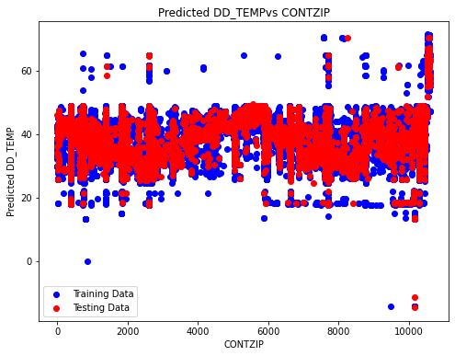

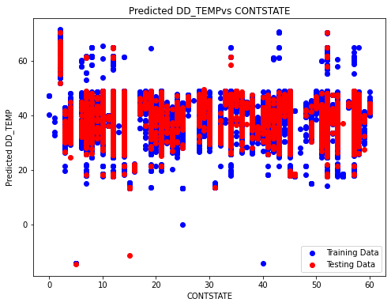

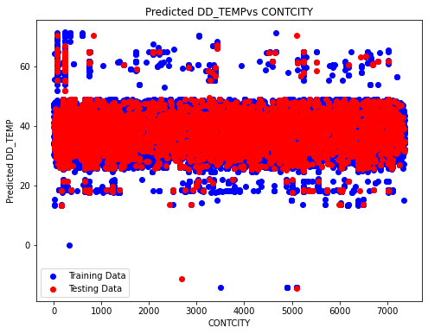

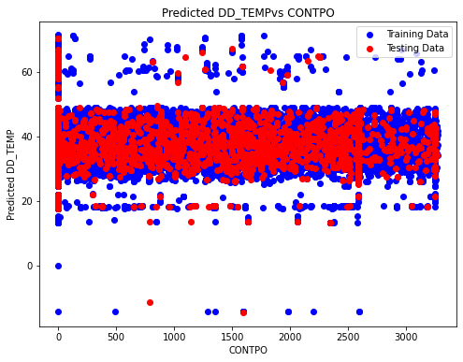

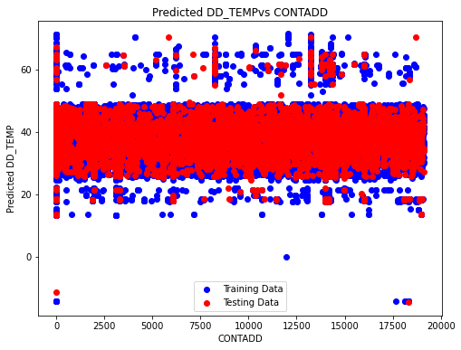

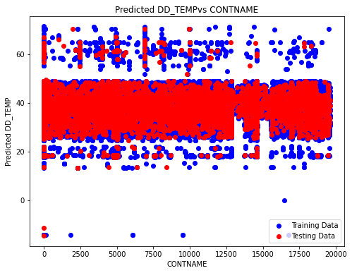

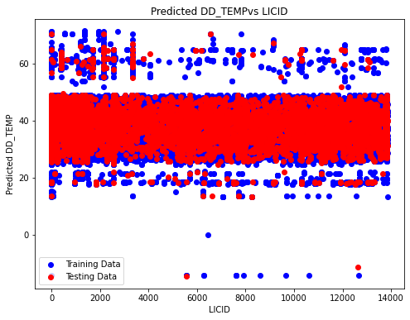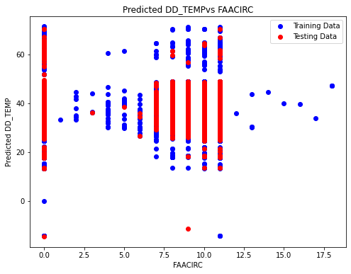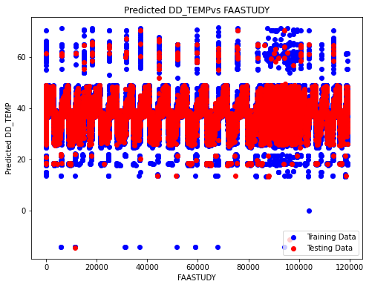

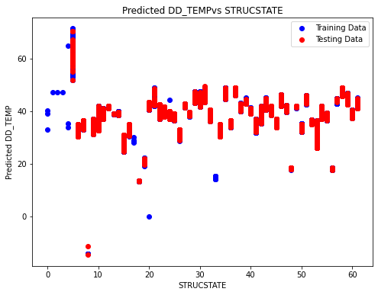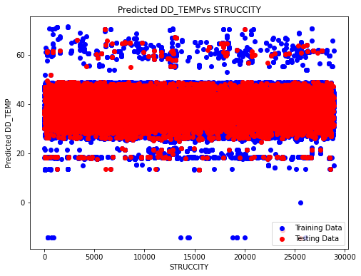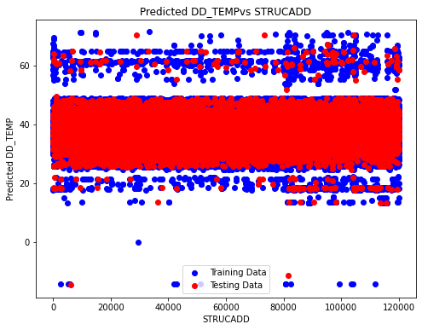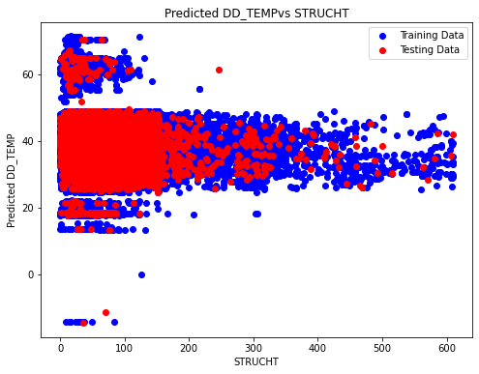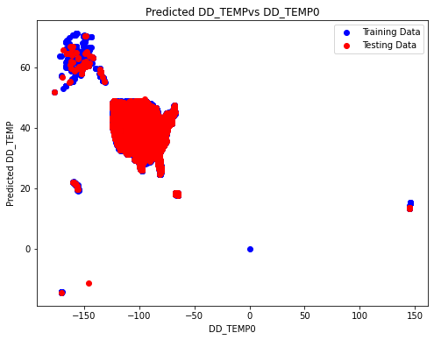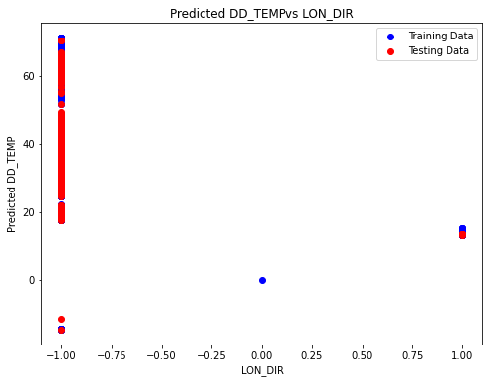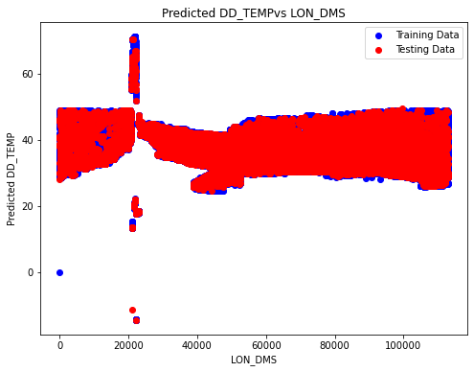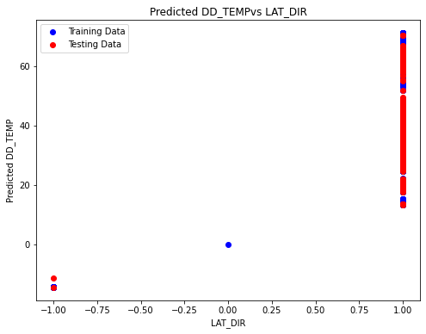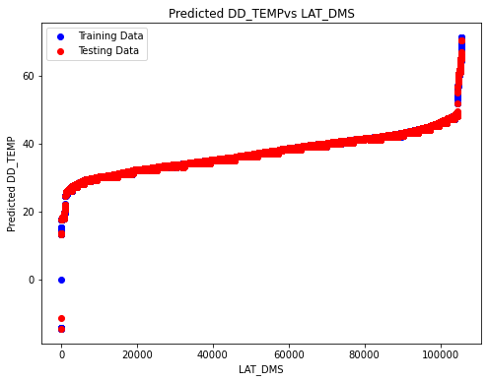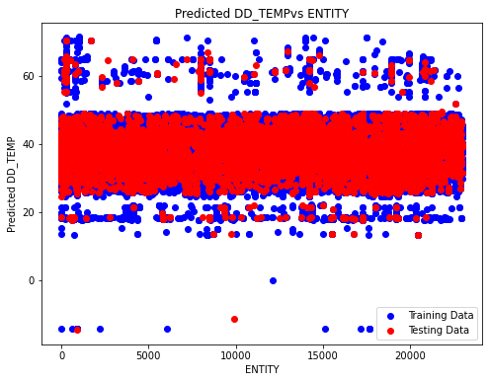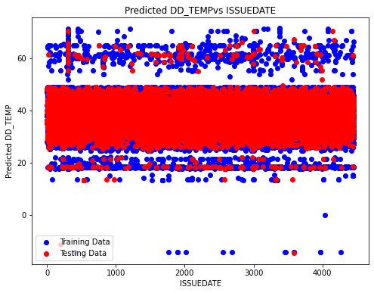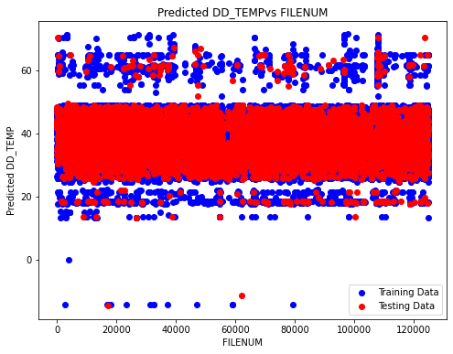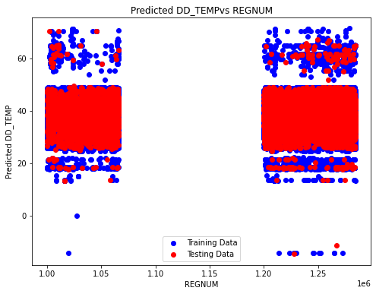

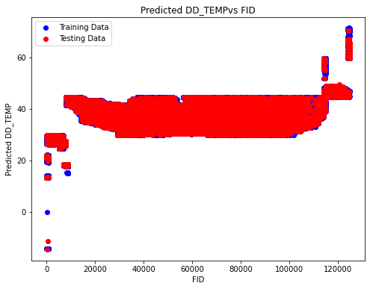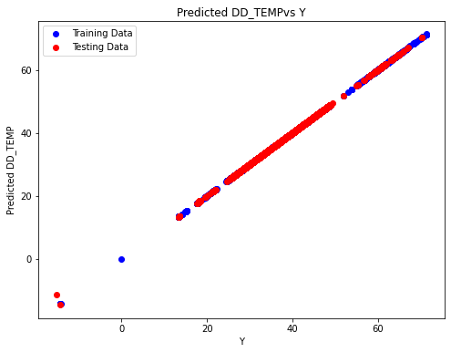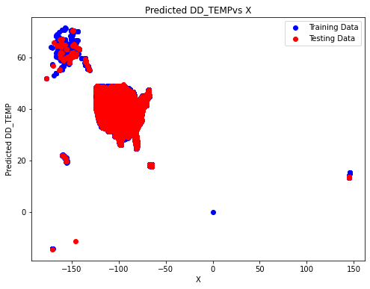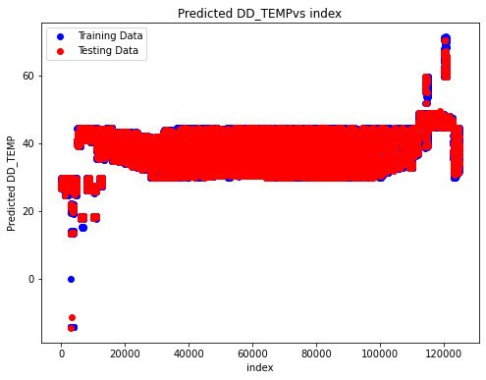

ENCODING EVERY VARIABLES :

GRAPH:

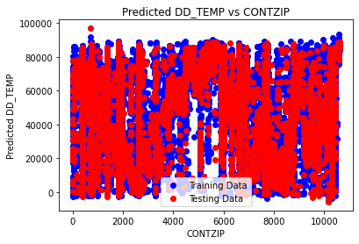

The x-axis, labeled "CONTZIP," likely represents a continuous independent variable. On the other hand, the y-axis, labeled "Predicted DD_TEMP,"

The plot consists of two lines:

1. The blue line illustrates (DD_TEMP) for the training data.

2. The red line represents (DD_TEMP) for the testing data.

Given that the plot displays the difference between predicted and actual values, rather than the predicted values themselves, a conclusive assessment of the model's performance is challenging. Ideally, both the blue and red lines would converge around zero, indicating that the model's predictions align closely with the actual values.

However, the plot reveals a trend where the model tends to produce positive predictions for lower values of CONTZIP and negative predictions for higher values of CONTZIP. This pattern suggests a potential bias in the model, where it underestimates DD_TEMP for lower CONTZIP values and overestimates it for higher CONTZIP values.

To gain a comprehensive understanding of the model's performance, additional visualizations such as scatter plots comparing predicted versus actual values for both training and testing data would be beneficial. These additional insights would provide a clearer assessment of the model's accuracy and any potential biases present in its predictions.

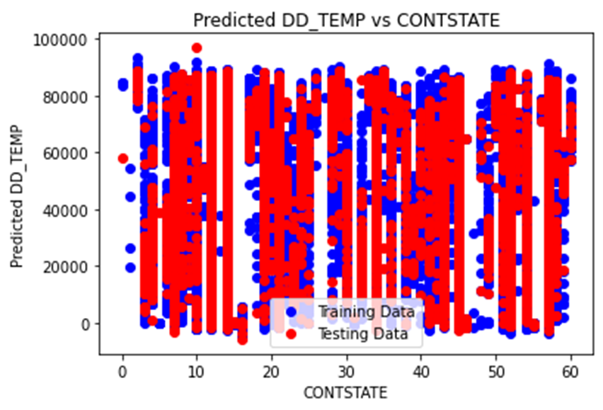

The x-axis, labeled "CONTSTATE," likely denotes a categorical independent variable. Conversely, the y-axis, labeled "Predicted DD_TEMP,"

The graph features two components:

1. The red line represents the (DD_TEMP) for the testing data.

2. Although labeled as "Training Data," there is no visible blue line depicting the (DD_TEMP) for the training data.

As the plot illustrates the disparity between predicted and actual values, rather than the predicted values themselves, determining the model's performance definitively poses a challenge. Ideally, the red line would center around zero, indicating that the model's predictions align closely with the actual values.

However, the plot suggests a trend where the model's predictions for the testing data tend to be positive for lower values of CONTSTATE and negative for higher values of CONTSTATE. This trend implies a potential bias in the model, where it underestimates DD_TEMP for lower CONTSTATE values and overestimates it for higher CONTSTATE values.

To comprehensively evaluate the model's performance, the following would be beneficial:

- Visualizing the blue line representing the predicted (DD_TEMP) for the training data.

- Examining a scatter plot comparing predicted versus actual values for both training and testing data.

These additional visualizations would offer deeper insights into the model's accuracy and any potential biases inherent in its predictions.

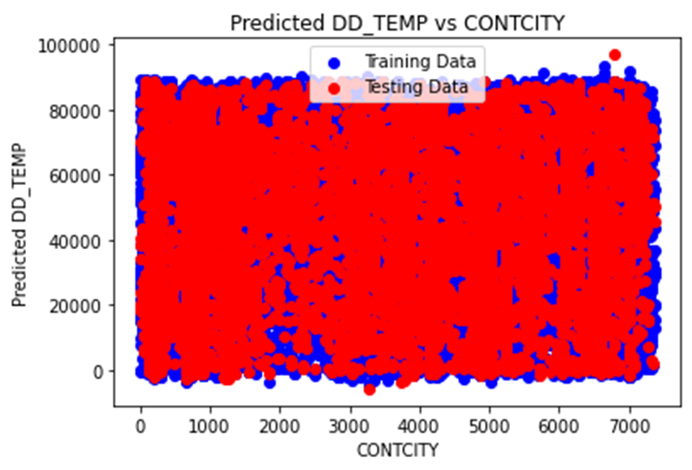

The x-axis, labeled "CONTCITY," is indicative of a categorical independent variable, likely denoting different cities. Conversely, the y-axis, labeled "Predicted DD_TEMP.

The plot comprises two distinct regions:

1. The red area illustrates the predicted (DD_TEMP) for the testing data.

2. Although labeled "Training Data," there is no discernible blue area representing the (DD_TEMP) for the training data.

As the plot showcases the deviation between predicted and actual values, rather than the predicted values themselves, definitively assessing the model's performance poses a challenge. Ideally, the red area would be centered around zero, indicating a close alignment between the model's predictions and the actual values.

However, it is apparent from the plot that the model's predictions for the testing data tend to exhibit a positive trend for lower values of CONTCITY and a negative trend for higher values of CONTCITY. This trend suggests a potential bias in the model, wherein it tends to underestimate DD_TEMP for cities with lower CONTCITY values and overestimate DD_TEMP for cities with higher CONTCITY values.

To comprehensively evaluate the model's performance, the following steps would be beneficial:

- Visualization of the blue line representing the predicted (DD_TEMP) for the training data.

- Examination of a scatter plot comparing predicted versus actual values for both training and testing data.

These additional visualizations would provide deeper insights into the accuracy of the model and any inherent biases in its predictions.

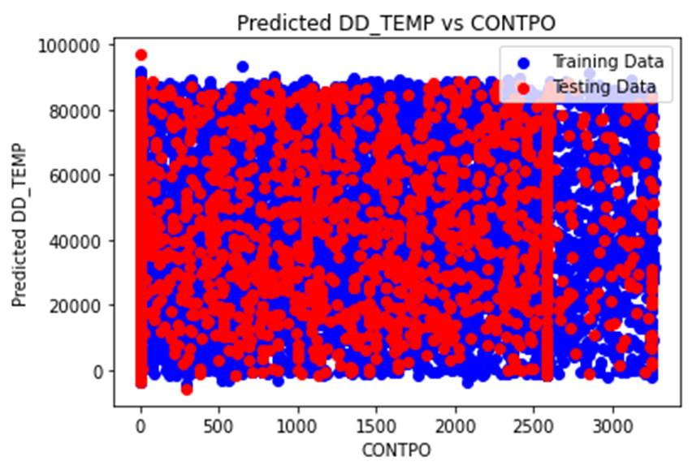

The x-axis, labeled "CONTPO," is likely indicative of some continuous independent variable. Conversely, the y-axis, labeled "Predicted DD_TEMP,".

Two lines are visible on the plot:

1. The red line represents the predicted (DD_TEMP) for the testing data.

2. The blue line represents the predicted (DD_TEMP) for the training data.

As the plot showcases the deviation between predicted and actual values, rather than the predicted values themselves, definitively assessing the model's performance poses a challenge. Ideally, both the blue and red lines would be centered around zero, indicating a close alignment between the model's predictions and the actual values.

However, it is apparent from the plot that the model's predictions for both the training and testing data tend to exhibit a positive trend for lower values of CONTPO and a negative trend for higher values of CONTPO. This trend suggests a potential bias in the model, wherein it tends to underestimate DD_TEMP for lower values of CONTPO and overestimate DD_TEMP for higher values of CONTPO.

To comprehensively evaluate the model's performance, additional visualizations such as scatter plots comparing predicted versus actual values for both training and testing data would be beneficial. These visualizations would provide deeper insights into the accuracy of the model and any inherent biases in its predictions.

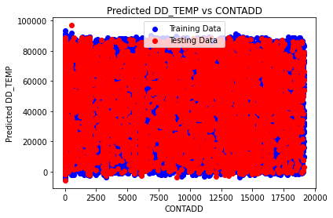

The x-axis, labeled "CONTADD," presumably denotes some continuous independent variable, potentially indicating a count or quantity of something. On the other hand, the y-axis labeled "Predicted DD_TEMP" represents the (DD_TEMP) as inferred by the model.

Two lines are discernible on the plot:

1. The blue line signifies the predicted (DD_TEMP) for the training data.

2. The red line indicates the predicted (DD_TEMP) for the testing data.

Both lines exhibit a similar trend, suggesting that the model anticipates a higher predicted (DD_TEMP) for lower values of CONTADD and a lower predicted difference for higher values of CONTADD.

However, assessing the model's performance conclusively from this plot is challenging. Ideally, both the blue and red lines would be centered around zero, indicative of the model's predictions aligning closely with the actual values.

In this plot, data points are concentrated in the upper left and lower right portions, and neither line is centered around zero. This implies a potential bias in the model, wherein it tends to overestimate positive values of predicted (DD_TEMP) and underestimate negative values.

To gain a more comprehensive understanding of the model’s performance, additional visualizations are warranted, including:

* A scatter plot comparing predicted values versus actual values for both training and testing data. This would elucidate the degree of alignment between the model's predictions and the actual values.

* A plot depicting the absolute error of the model's predictions for both training and testing data. This would provide insights into the magnitude of differences between predicted values and actual values.

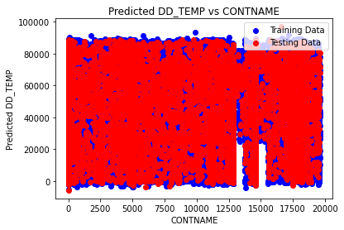

The x-axis, labeled "CONTNAME," presumably denotes some categorical independent variable, potentially representing names. Conversely, the y-axis labeled "Predicted DD_TEMP" represents the predicted (DD_TEMP) as inferred by the model.

Two lines are discernible on the plot:

1. The blue line signifies the predicted (DD_TEMP) for the training data.

2. The red line indicates the predicted (DD_TEMP) for the testing data.

Both lines exhibit a similar trend, indicating that the model predicts a (DD_TEMP) for lower alphabetical values of CONTNAME and a lower difference for higher alphabetical values of CONTNAME.

However, assessing the model's performance conclusively from this plot is challenging. Ideally, both the blue and red lines would be centered around zero, indicative of the model's predictions aligning closely with the actual values.

In this plot, neither line is centered around zero. The data points suggest a potential bias in the model, wherein it tends to overestimate positive values of the predicted (DD_TEMP) and underestimate negative values, particularly for certain alphabetical values of CONTNAME.

To gain a more comprehensive understanding of the model’s performance, additional visualizations are warranted, including:

* A scatter plot comparing predicted values versus actual values for both training and testing data. This would elucidate the degree of alignment between the model's predictions and the actual values.

* A plot depicting the absolute error of the model's predictions for both training and testing data. This would provide insights into the magnitude of differences between predicted values and actual values.

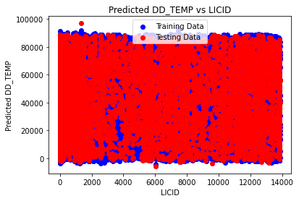

The plot provided compares predicted values from a model to actual values for antenna structure elevation, likely measured in meters.

The x-axis labeled "LICID" presumably represents a unique identifier for each antenna structure. On the other hand, the y-axis labeled "Predicted DD_TEMP" signifies the predicted difference in elevation (DD_TEMP) between the actual elevation and the model's prediction, based on the model.

Two lines are depicted on the plot:

1. The blue line represents the predicted difference in elevation (DD_TEMP) for the training data.

2. The red line represents the predicted difference in elevation (DD_TEMP) for the testing data.

While the plot illustrates the difference between predicted and actual values, rather than the predicted values themselves, assessing the model's performance definitively is challenging. Ideally, both the blue and red lines would be centered around zero, indicating that the model’s predictions are generally accurate.

However, from the plot, it is observable that the model's predictions tend to be positive for lower values of LICID and negative for higher values of LICID, for both the training and testing data. This implies a potential bias in the model towards underestimating the elevation of antenna structures with lower LICID values and overestimating the elevation of those with higher LICID values.

To comprehensively evaluate the model’s performance, additional visualizations would be beneficial, including:

* A scatter plot comparing predicted elevation to actual elevation for both the training and testing data. This would provide insights into the alignment between the model's predictions and the actual values.

* A plot showcasing the absolute error of the model's predictions for both the training and testing data. This would elucidate the magnitude of differences between the predicted values and the actual values.

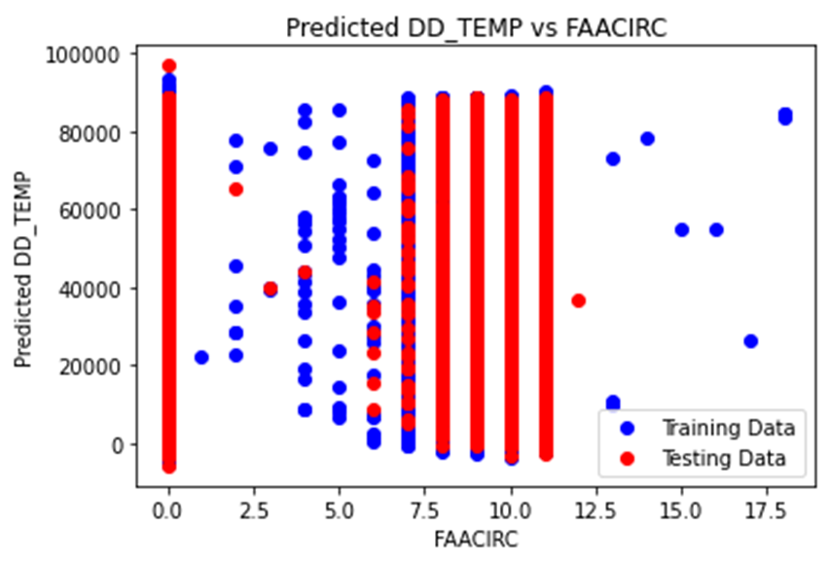

The plot provided compares predicted values from a model to actual values for antenna structure elevation, likely measured in meters.

The x-axis labeled "FAACIRC" presumably represents a continuous variable related to the antenna structure. On the other hand, the y-axis labeled "Predicted DD_TEMP" signifies the predicted difference in elevation (DD_TEMP) between the actual elevation and the model's prediction, based on the model.

Two lines are depicted on the plot:

1. The red line represents the predicted difference in elevation (DD_TEMP) for the testing data.

2. Although not visible, there should be a blue line representing the predicted difference in elevation (DD_TEMP) for the training data, as indicated by the blue text.

While the plot illustrates the difference between predicted and actual values, rather than the predicted values themselves, definitively assessing the model's performance is challenging. Ideally, the red line would be centered around zero, indicating that the model’s predictions are generally accurate.

However, it appears from the plot that the model's predictions for the testing data tend to be positive for lower values of FAACIRC and negative for higher values of FAACIRC. This suggests a potential bias in the model towards underestimating the elevation of antenna structures with lower FAACIRC values and overestimating the elevation of structures with higher FAACIRC values.

To comprehensively evaluate the model’s performance, additional visualizations would be beneficial, including:

* A plot showcasing the predicted difference in elevation (DD_TEMP) for the training data. This would provide insights into the model's performance during the training phase.

* A scatter plot comparing predicted elevation to actual elevation for both the training and testing data. This would elucidate how closely the model's predictions align with the actual values.

* A plot depicting the absolute error of the model's predictions for both the training and testing data. This would highlight the magnitude of differences between the predicted values and the actual values.

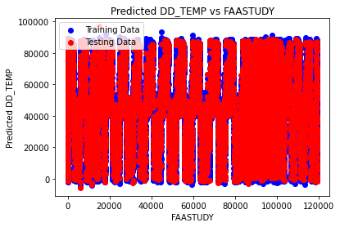

The provided plot illustrates a comparison between predicted values from a model and actual values for antenna structure elevation, presumably measured in meters. The x-axis is labeled "FAASTUDY," indicating a categorical variable likely associated with a study conducted by the Federal Aviation Administration (FAA). On the y-axis, "Predicted DD_TEMP" denotes the predicted difference in elevation (DD_TEMP) between the actual elevation and the model's prediction, based on the model.

Two areas are depicted on the plot:

- The red area illustrates the predicted difference in elevation (DD_TEMP) for the testing data.

- Although not visible, there should be a blue area representing the predicted difference in elevation (DD_TEMP) for the training data, as indicated by the blue text.

As the plot shows the difference between predicted and actual values, rather than the predicted values themselves, definitively assessing the model's performance is challenging. Ideally, the red area would be centered around zero, indicating that the model’s predictions align closely with the actual values.

However, from the plot, it's evident that the model’s predictions for the testing data lean towards positive values for lower categories of FAASTUDY and negative values for higher categories of FAASTUDY. This suggests a potential bias in the model towards underestimating the elevation of antenna structures in lower FAASTUDY categories and overestimating the elevation in higher categories.

To comprehensively evaluate the model’s performance, additional visualizations would be beneficial, including:

- The blue line representing the predicted difference in elevation (DD_TEMP) for the training data, providing insights into the model's performance during the training phase.

- A scatter plot comparing predicted elevation to actual elevation for both the training and testing data, elucidating the alignment between the model's predictions and the actual values.

- A plot illustrating the absolute error of the model's predictions for both the training and testing data, offering insights into the magnitude of differences between the predicted values and the actual values.

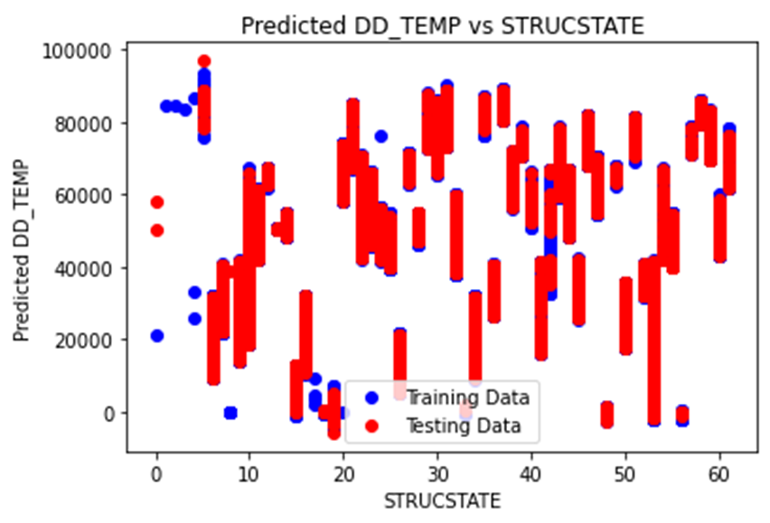

The provided plot illustrates a comparison between predicted values from a model and actual values for antenna structure elevation, presumably measured in meters. The x-axis is labeled "STRUCSTATE," representing a categorical variable likely associated with the state in which the antenna structure is located. On the y-axis, "Predicted DD_TEMP" denotes the predicted difference in elevation (DD_TEMP) between the actual elevation and the model's prediction, based on the model.

Two lines are depicted on the plot:

- The red line represents the predicted difference in elevation (DD_TEMP) for the testing data.

- The blue line represents the predicted difference in elevation (DD_TEMP) for the training data.

Both lines exhibit a similar trend, indicating that the model predicts a positive difference in temperature (DD_TEMP) for lower values of STRUCSTATE and a negative difference for higher values. However, it's challenging to conclusively assess the model's performance solely based on this plot. Ideally, both the blue and red lines would center around zero, indicating that the model's predictions align closely with the actual values.

Nevertheless, the concentration of data points in the upper left and lower right portions of the graph, coupled with the lack of centering around zero for both lines, suggests potential bias in the model. Specifically, the model may tend to overestimate positive values of the predicted difference in temperature (DD_TEMP) and underestimate negative values.

To comprehensively evaluate the model’s performance, additional visualizations would be beneficial, including:

- A scatter plot comparing predicted elevation to actual elevation for both the training and testing data, providing insights into the alignment between the model's predictions and the actual values.

- A plot illustrating the absolute error of the model's predictions for both the training and testing data, offering insights into the magnitude of differences between the predicted values and the actual values.

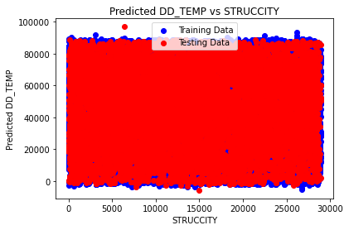

The provided plot depicts the relationship between predicted DD_TEMP, likely indicating elevation, and struckcity. The blue line corresponds to the training data, while the red line represents the testing data.

In principle, if the model has generalized well, the training and testing data should exhibit similar trends. In this plot, both the training and testing data show similar trends, indicating potential good generalization of the model. However, there are noticeable discrepancies between the two datasets, particularly evident at lower struckcity values. Assessing the significance of these differences solely based on this plot is challenging.

Further analysis is necessary to determine the significance of the disparities observed between the training and testing datasets. Additional evaluation metrics and visualizations, such as statistical tests or comparison of error distributions, would provide deeper insights into the model's performance and generalization ability.

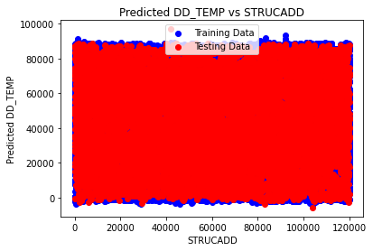

The provided plot illustrates the relationship between the difference in predicted DD_TEMP and STRUCADD values. STRUCADD likely denotes a measurement, potentially representing elevation. The red line signifies the predicted DD_TEMP, while the blue line represents the training data.

Key observations from the plot include:

- The x-axis indicates STRUCADD values, presumably ranging from 0 to 120,000.

- The y-axis displays the disparity between predicted DD_TEMP and STRUCADD values, with a range appearing to span from -20,000 to 100,000.

- The training data (blue line) exhibits a positive correlation between predicted DD_TEMP and STRUCADD. This implies that as the STRUCADD value increases, the predicted DD_TEMP value tends to increase as well.

- The testing data (red line) generally aligns with the trend observed in the training data, albeit with some deviations. Notably, at lower STRUCADD values, the predicted DD_TEMP values for the testing data tend to be lower compared to the training data.

- A cluster of points around the 60,000 mark on the x-axis demonstrates particularly high disparities between predicted DD_TEMP and STRUCADD values for both the training and testing data.

Overall, the plot suggests that the model can predict DD_TEMP from STRUCADD values to a certain degree. However, deviations between predicted and actual values, especially evident in the testing data, imply potential areas for model refinement.

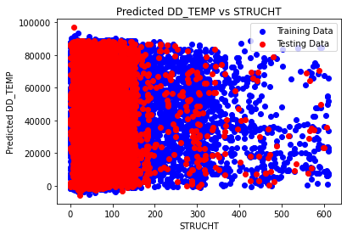

The image's text labels delineate the following:

- The x-axis denotes the variable "STRUCHT."

- The y-axis represents the predicted values of "DD_TEMP."

- The red region illustrates the predicted "DD_TEMP" values corresponding to the testing data.

- The blue region depicts the predicted "DD_TEMP" values corresponding to the training data.

General Trends:

The plot indicates a positive correlation between predicted "DD_TEMP" and "STRUCHT" for both the training and testing datasets. This correlation suggests that as "STRUCHT" values increase, the predicted "DD_TEMP" values also tend to increase.

A more pronounced linear trend is discernible in the training data (blue) compared to the testing data (red). This discrepancy implies that the model might have overfitted the training data, potentially hindering its ability to generalize effectively to unseen data.

Specific Observations:

Predicted "DD_TEMP" values span a range from approximately 20,000 to 80,000.

"STRUCHT" values vary between 0 and around 600.

Greater dispersion is evident in the testing data (red) compared to the training data (blue), suggesting less consistency in the model's predictions for unseen data.

A concentration of data points appears around the 200 mark on the x-axis, where predicted "DD_TEMP" values deviate from the overall trend for both training and testing data.

Possible Interpretations:

The model might inadequately capture the underlying relationship between "STRUCHT" and "DD_TEMP," particularly concerning unseen data.

High data scatter could impede accurate prediction of "DD_TEMP" values from "STRUCHT" values.

Potential outliers within the dataset may exert undue influence on the model's predictions.

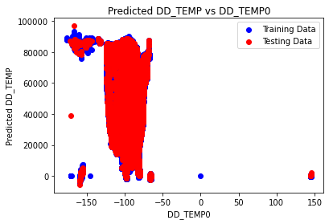

The image's text labels specify the following:

- The x-axis denotes "DD_TEMPO."

- The y-axis represents predicted "DD_TEMP."

- The red line illustrates the predicted "DD_TEMP" values corresponding to the testing data.

- The blue line represents the predicted "DD_TEMP" values for the training data.

General Trends:

The plot indicates a positive correlation between predicted "DD_TEMP" and "DD_TEMPO" for both the training and testing datasets. This correlation implies that as "DD_TEMPO" values increase, the predicted "DD_TEMP" values also tend to increase.

Consistency in trends between the training and testing data suggests that the model has successfully generalized to unseen data.

Specific Observations:

Predicted "DD_TEMP" values range from approximately -20,000 to 120,000.

"DD_TEMPO" values span from -150 to 150.

Data points are evenly distributed for both training (blue) and testing (red) datasets.

Possible Interpretations:

The model appears adept at capturing the relationship between "DD_TEMPO" and "DD_TEMP" across both training and testing datasets.

A linear relationship between the two variables is conceivable, although the scale on the y-axis may obscure finer details.

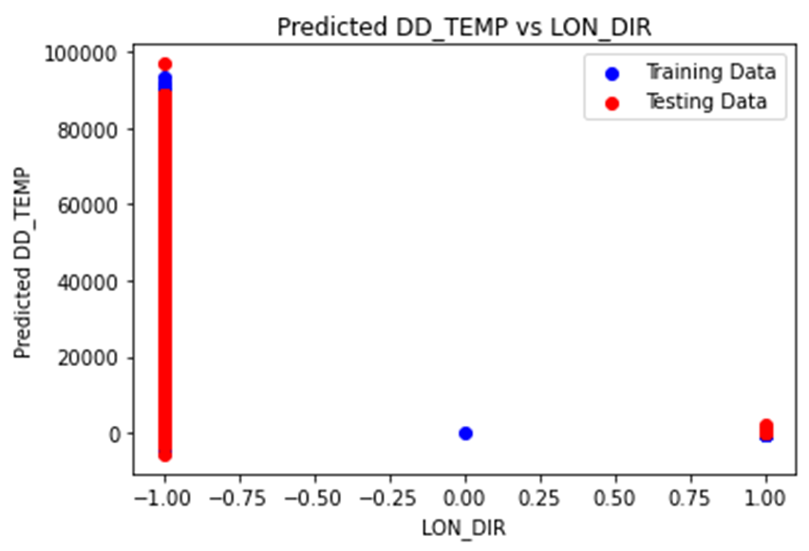

The text labels in the image delineate the following:

- The x-axis represents "LON_DIR."

- The y-axis denotes predicted "DD_TEMP."

- The red line illustrates predicted "DD_TEMP" values for the testing data.

- The blue line represents predicted "DD_TEMP" values for the training data.

General Trends:

The plot does not exhibit a discernible correlation between predicted "DD_TEMP" and "LON_DIR" for either the training or testing datasets. A scattered distribution of points is evident across the x-axis for both the red and blue lines.

Specific Observations:

Predicted "DD_TEMP" values range from approximately -20,000 to 100,000.

"LON_DIR" values span from -1 to 1.

No discernible pattern is apparent in the distribution of data points for either the training (blue) or testing (red) datasets.

Possible Interpretations:

The model may struggle to capture a meaningful relationship between "LON_DIR" and "DD_TEMP."

"LON_DIR" might not wield significant predictive power in determining "DD_TEMP."

The presence of noise or outliers in the dataset could potentially disrupt the model's predictive accuracy.

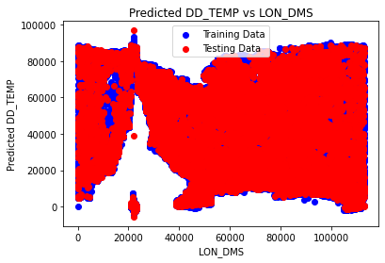

The image's text labels specify the following:

- The x-axis represents "LON_DMS."

- The y-axis indicates the difference between predicted "DD_TEMP" and "LON_DMS."

- The red line illustrates the difference between predicted "DD_TEMP" and "LON_DMS" for the testing data.

- The blue line represents the difference between predicted "DD_TEMP" and "LON_DMS" for the training data.

General Trends:

Overall, the plot indicates that predicted "DD_TEMP" values tend to be higher than the corresponding "LON_DMS" values, and "LON_DMS" values tend to be lower than the training data for most data points.

A weak positive correlation is observed between the predicted difference and "LON_DMS" for both the training and testing data. This implies that as "LON_DMS" values increase, the difference between predicted "DD_TEMP" and "LON_DMS" tends to increase as well.

However, significant scatter is evident in the data for both training and testing datasets, particularly at higher "LON_DMS" values.

Specific Observations:

The difference between predicted "DD_TEMP" and "LON_DMS" ranges from approximately -80,000 to 100,000.

"LON_DMS" values span from 0 to 100,000.

A cluster of points is noticeable around the 60,000 mark on the x-axis, where the difference between predicted "DD_TEMP" and "LON_DMS" is notably high for both training and testing data.

Possible Interpretations:

The model may exhibit a systematic tendency to overestimate "DD_TEMP" in comparison to "LON_DMS."

"LON_DMS" might not exert strong predictive influence on "DD_TEMP" independently.

The presence of noise or outliers in the dataset could potentially impact the model's predictive performance.

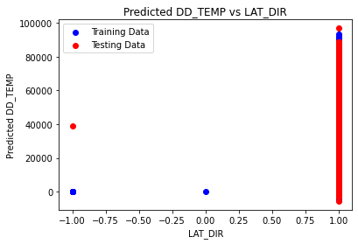

The image's text labels provide the following information:

- The x-axis represents "LAT_DIR."

- The y-axis indicates predicted "DD_TEMP."

- The red line illustrates predicted "DD_TEMP" values for the testing data.

- The blue line represents predicted "DD_TEMP" values for the training data.

General Trends:

Overall, the plot indicates a weak positive correlation between predicted "DD_TEMP" and "LAT_DIR" for both the training and testing data. This suggests that as "LAT_DIR" values increase, the predicted values of "DD_TEMP" also tend to increase. However, significant scatter is observed in the data for both training and testing datasets.

A stronger linear trend is apparent in the training data (blue) compared to the testing data (red), indicating potential overfitting of the model to the training data and less effective generalization to unseen data.

Specific Observations:

Predicted "DD_TEMP" values range from approximately 20,000 to 80,000.

"LAT_DIR" values span from -1 to 1.

Greater scatter is observed in the testing data (red) compared to the training data (blue), suggesting less consistency in the model's predictions for unseen data.

A cluster of points is noticeable around the 0 mark on the x-axis, where predicted "DD_TEMP" values deviate from the overall trend for both training and testing data.

Possible Interpretations:

The model may not fully capture the underlying relationship between "LAT_DIR" and "DD_TEMP," particularly for unseen data.

High data scatter may hinder accurate prediction of "DD_TEMP" values from "LAT_DIR" values.

The presence of outliers in the dataset could potentially influence the model's predictions.

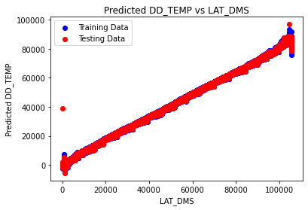

The provided plot illustrates the disparity between predicted elevation ("DD_TEMP") values, both from training and testing data, and the latitude expressed in decimal degrees, minutes, and seconds (LAT_DMS).

In the plot, training data is denoted by the color blue, while testing data is represented in red. The x-axis corresponds to LAT_DMS, while the y-axis displays the predicted DD_TEMP, ranging from 0 to 100,000 units.

Observations:

-It shows a linear function.

- Generally, predicted DD_TEMP values derived from the training data tend to exceed those from the testing data. This indicates a tendency of the model to overestimate DD_TEMP.

- Substantial variability is evident in both training and testing datasets, with predicted DD_TEMP fluctuating by up to 100,000 units for a given LAT_DMS value.

It's noteworthy that the efficacy of the model heavily relies on the quality and representativeness of the training data. If the training dataset fails to accurately mirror real-world conditions, the model's accuracy will consequently be compromised. In this context, it is plausible that the training data lacks diversity in LAT_DMS values, which could elucidate the model's inadequacy in accurately predicting DD_TEMP for certain LAT_DMS values.

This insight underscores the critical importance of comprehensive and diverse training data to ensure the model's robustness and accuracy across various scenarios.

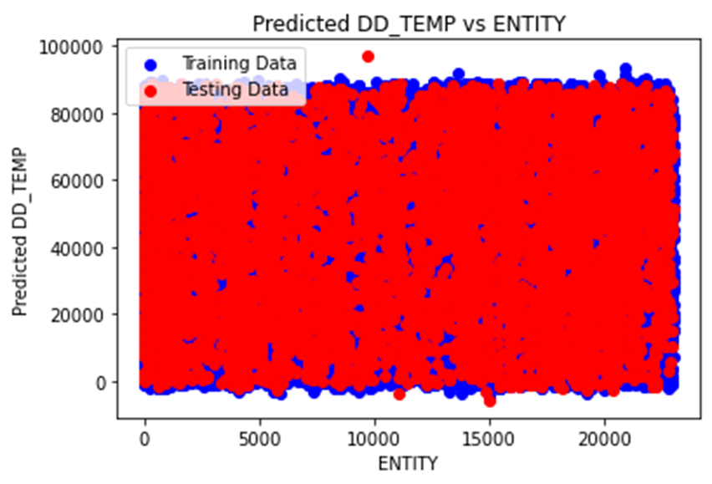

The provided plot illustrates a comparison between predicted and actual temperature (presumably representing elevation data). The x-axis is labeled as "ENTITY," likely serving as an identifier for each data point, while the y-axis is denoted as "Predicted DD_TEMP," likely signifying the predicted change in elevation in degrees.

The data is segregated into two sets: training data, depicted in blue, and testing data, indicated in red. The training data displays a generally positive correlation, albeit with some scatter, implying that as the value of "ENTITY" increases, the predicted change also increases. In contrast, the testing data exhibits a weaker positive correlation with greater scatter compared to the training data.

Overall, the model's predictions suggest that as the value of "ENTITY" increases, the elevation is expected to rise. However, the model's predictive accuracy is not flawless, and there is more variability observed in real-world data (testing data) than in the data used for model training (training data). This discrepancy implies potential limitations in the model's generalizability to real-world scenarios.

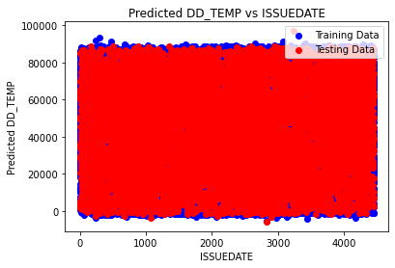

The plot illustrates the disparity between predicted and actual elevation values, with the training data depicted in blue and the testing data in red, over issuance date (ISSUEDATE).

Potential interpretations:

Model Performance: The model may be underestimating elevation if the y-axis denotes positive differences between predicted and actual elevation. In this scenario, the blue and red lines would trend below the x-axis, indicating that predicted values are consistently lower than actual values for most ISSUEDATE.

Calibration Issue: A consistent offset between predicted and actual elevations, regardless of being positive or negative, may indicate a bias in either the model or the data.

Error Type: If negative elevation values are present in the data (though this might be unlikely), the interpretation would need adjustment based on whether the y-axis represents absolute differences or signed differences between predicted and actual elevation.

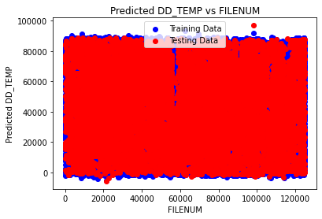

The provided plot illustrates the predicted difference between training and testing data for DD_TEMP (presumably representing elevation), with the x-axis labeled as FILENUM, likely signifying a unique identifier for each data point.

Interpretation:

General Trend: The predicted DD_TEMP (red line) consistently appears lower than the measured DD_TEMP (blue line) across most FILENUM values, indicating a bias in the model toward underestimating elevation.

Data Distribution: Both the training and testing data exhibit similar patterns, although slight variations may exist between the two datasets.

Possible Reasons for Underestimation:

Training Data Bias: It's conceivable that the training data used to construct the model contained more low-elevation values compared to high-elevation values, potentially leading to underestimation of elevation in new data.

Model Complexity: If the model lacks complexity, it might struggle to capture the intricate relationships between FILENUM and DD_TEMP, resulting in underestimation for certain FILENUM values.

Additional Considerations:

The plot does not display the actual range of DD_TEMP values, making it challenging to ascertain the magnitude of the underestimation. Incorporating this information would provide context for understanding the difference between predicted and measured values.

The y-axis lacks units, which would offer crucial context for interpreting the difference between predicted and measured values (e.g., meters, feet).

Overall, the plot suggests a consistent underestimation in predicted DD_TEMP values. Further investigation into the properties of the training data and model architecture is necessary to identify the precise cause of this bias.

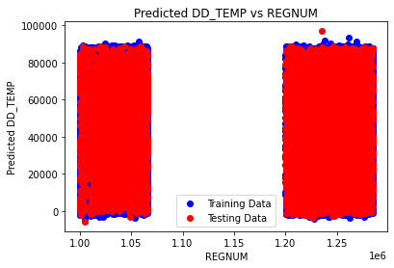

The plot illustrates the correlation between predicted elevation and actual elevation, with the x-axis likely denoting a reference elevation (REGNUM) and the y-axis representing the disparity between the predicted elevation (DD_TEMP) and the actual elevation. The training data is depicted by the blue line, while the red line signifies the testing data.

Observation:

In contrast to an ideal scenario where both lines would perfectly align, indicating precise predictions, a positive bias is evident. This implies a consistent overestimation of elevation by the model. For instance, at a reference elevation of 1.10 (on the x-axis), the predicted elevation difference is approximately 20,000 (on the y-axis), suggesting that the model tends to forecast a higher elevation than the actual observation.

Potential Explanations:

1. Training Data Bias: The training dataset may be skewed towards higher elevations compared to lower ones, leading to an inherent overestimation bias in the model's predictions.

2. Model Complexity: An overly complex model might inadvertently incorporate noise from the elevation data, resulting in an exaggerated estimation of elevation differences.

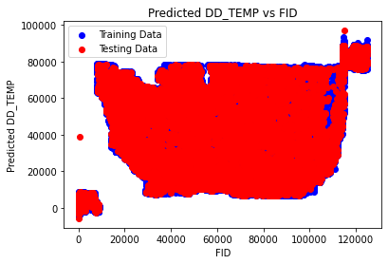

Based on the provided image and the clarification that DD_TEMP represents elevation, here's a interpretation of the plot:

The plot depicts the disparity between predicted and actual elevations across the United States. The x-axis, labeled FID, likely serves as a unique identifier for individual data points. Meanwhile, the y-axis, labeled Predicted DD_TEMP, represents the difference between the predicted elevation and the actual elevation. The blue line corresponds to the training data, while the red line signifies the testing data.

Observation:

In an ideal scenario, complete overlap between the training and testing data would signify optimal model performance. However, an evident positive bias is observed between the predicted and actual elevations. This indicates a consistent tendency of the model to overestimate elevation. For instance, at an FID value of approximately 60,000, the predicted difference in elevation exceeds 40,000 units, whereas the actual difference is closer to 0.

Possible Explanations:

1. Training Data Bias: It is plausible that the training data exhibits a bias towards higher elevations, leading to a systematic overestimation of elevation by the model.

2. Model Complexity: The model might be excessively complex, potentially fitting noise in the data and resulting in an exaggerated estimation of elevation differences.

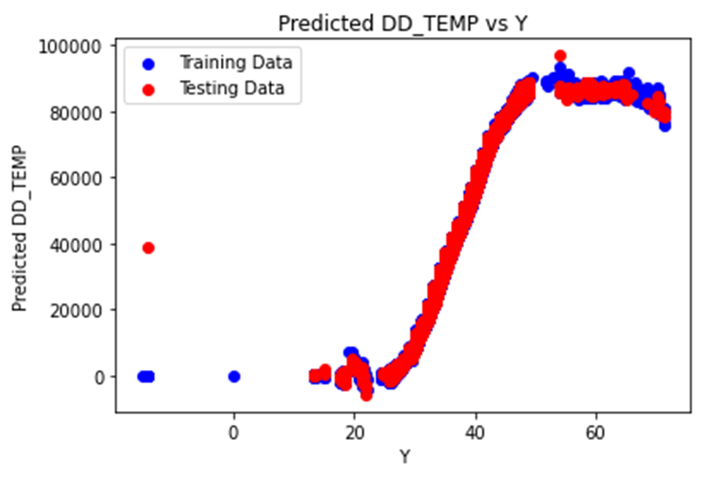

Based on the provided image and the clarification that DD_TEMP represents elevation, here is a interpretation of the plot:

The plot illustrates the relationship between predicted elevation and actual elevation, where the x-axis, labeled as Y, likely denotes a reference elevation. The y-axis, labeled as Predicted DD_TEMP, represents the predicted difference in elevation. The blue line corresponds to the training data, while the red line signifies the testing data.

Observation:

In an ideal scenario, complete overlap between the training and testing data would indicate optimal model performance. However, a discernible positive bias is observed between the predicted and actual elevations, suggesting a consistent overestimation of elevation by the model. For instance, at a reference elevation of 20 on the x-axis, the predicted difference in elevation exceeds 60,000 units, while the actual difference is closer to 0.

Possible Explanations:

1. Training Data Bias: It is conceivable that the training data exhibits a bias towards higher elevations, leading to a systematic overestimation of elevation by the model.

2. Model Complexity: The model might be overly complex, potentially fitting noise in the elevation data and resulting in an exaggerated estimation of elevation differences.

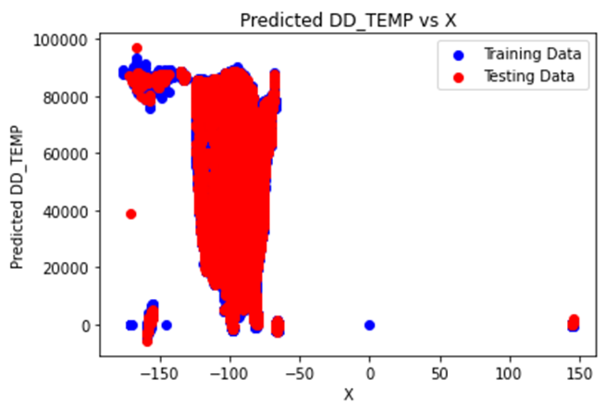

The plot visualizes the predicted DD_TEMP versus X values. It shows distinct clusters of training data (blue) and testing data (red), indicating a model’s performance in predicting temperatures. The clear separation and clustering of the data points suggest that the model may be performing well on the training data but not as well on the testing data. This could potentially indicate overfitting, where the model learns the training data too well and performs poorly on unseen data. However, without more context or data, this is just one possible interpretation.

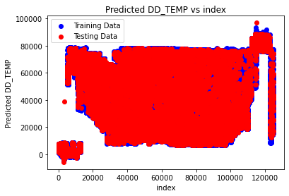

The plot provided offers a graphical representation of a machine learning model's performance. It juxtaposes predicted DD_TEMP values against an index, with blue points denoting the training data and red points representing the testing data.

From the plot, it is apparent that the model has been trained on a dense set of data points, as evidenced by the clustering of blue points. The dispersion of red points across the plot illustrates how effectively the model predicts DD_TEMP over various indices.

Such visualizations are commonly employed to assess a machine learning model's behavior and compare its performance on training versus testing data. They facilitate the identification of potential issues such as overfitting or underfitting, and provide insights into the model's generalization capabilities. However, to offer a more comprehensive interpretation, additional details or context regarding the data or the model would be necessary.

SHAP-INTERPRETATION:

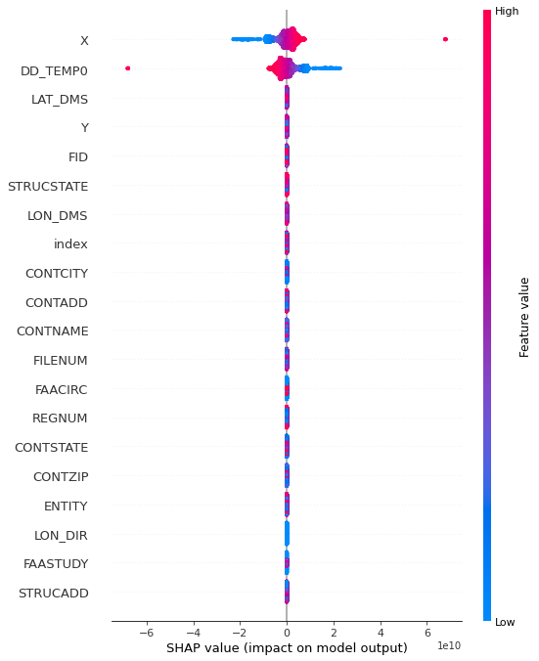

1. DD_TEMPO:

- This feature exhibits both positive and negative impacts on the model's output. Instances with higher DD_TEMPO values contribute positively (shown in red), while lower values have a negative impact (in blue).

2. LAT_DMS:

- Similar to DD_TEMPO, LAT_DMS influences the model in both directions. However, it tends to reduce the model's output more frequently.

3. Y:

- The Y feature demonstrates minimal influence, as its points predominantly cluster around zero. It does not significantly affect the model's predictions.

4. FID to STRUCADD:

- These features show little or no visible impact on the model's predictions. Their SHAP values are centered around zero.

5. Feature Value Gradient:

- A gradient bar on the right side represents feature values. Blue indicates low values, while red signifies high values.

Here’s another analysis:

|  |  |  |  |  |  |  |  |
| --- | --- | --- | --- | --- | --- | --- | --- |
| index | X | Y | OBJECTID | siteID | siteName | radarType | antennaElevation |
| 0 | -98.413046 | 45.455833 | 1 | KABR | ABERDEEN | NEXRAD | Unknown |
| 1 | -106.82388 | 35.149722 | 2 | KABX | ALBUQUERQUE | NEXRAD | Unknown |
| 2 | -77.007491 | 36.983889 | 3 | KAKQ | NORFOLK | NEXRAD | Unknown |
| 3 | -101.709269 | 35.233333 | 4 | KAMA | AMARILLO | NEXRAD | Unknown |
| 4 | -80.413048 | 25.610556 | 5 | KAMX | MIAMI | NEXRAD | Unknown |
| 5 | -84.719523 | 44.90635 | 6 | KAPX | NCL MICHIGAN | NEXRAD | Unknown |
| 6 | -91.191101 | 43.822778 | 7 | KARX | LA CROSSE | NEXRAD | Unknown |
| 7 | -122.495684 | 48.194611 | 8 | KATX | SEATTLE | NEXRAD | Unknown |
| 8 | -121.631658 | 39.496111 | 9 | KBBX | BEALE AFB | NEXRAD | Unknown |
| 9 | -75.984713 | 42.199694 | 10 | KBGM | BINGHAMTON | NEXRAD | Unknown |
| 10 | -124.292158 | 40.498333 | 11 | KBHX | EUREKA (BUNKER HILL) | NEXRAD | Unknown |
| 11 | -100.760268 | 46.770833 | 12 | KBIS | BISMARCK | NEXRAD | Unknown |
| 12 | -108.606796 | 45.853778 | 13 | KBLX | BILLINGS | NEXRAD | Unknown |
| 13 | -86.769713 | 33.171944 | 14 | KBMX | BIRMINGHAM | NEXRAD | Unknown |
| 14 | -71.136851 | 41.955778 | 15 | KBOX | BOSTON | NEXRAD | Unknown |
| 15 | -97.418603 | 25.915556 | 16 | KBRO | BROWNSVILLE | NEXRAD | Unknown |
| 16 | -78.736935 | 42.948611 | 17 | KBUF | BUFFALO | NEXRAD | Unknown |
| 17 | -81.703325 | 24.596944 | 18 | KBYX | KEY WEST | NEXRAD | Unknown |
| 18 | -81.118602 | 33.948611 | 19 | KCAE | COLUMBIA | NEXRAD | Unknown |
| 19 | -67.806407 | 46.039167 | 20 | KCBW | CARIBOU | NEXRAD | Unknown |
| 20 | -116.236023 | 43.490217 | 21 | KCBX | BOISE | NEXRAD | Unknown |
| 21 | -78.00388 | 40.923056 | 22 | KCCX | STATE COLLEGE | NEXRAD | Unknown |
| 22 | -81.859991 | 41.413056 | 23 | KCLE | CLEVELAND | NEXRAD | Unknown |
| 23 | -81.042186 | 32.655528 | 24 | KCLX | CHARLESTON, SC | NEXRAD | Unknown |
| 24 | -97.459991 | 35.238333 | 25 | KCRI | ROC FAA REDUNDANT (RDA 1) | NEXRAD | Unknown |
| 25 | -97.510825 | 27.783889 | 26 | KCRP | CORPUS CHRISTI | NEXRAD | Unknown |
| 26 | -73.166379 | 44.511111 | 27 | KCXX | BURLINGTON | NEXRAD | Unknown |
| 27 | -104.806102 | 41.151944 | 28 | KCYS | CHEYENNE | NEXRAD | Unknown |
| 28 | -121.677824 | 38.501111 | 29 | KDAX | SACRAMENTO | NEXRAD | Unknown |
| 29 | -99.96888 | 37.760833 | 30 | KDDC | DODGE CITY | NEXRAD | Unknown |
| 30 | -100.28027 | 29.2725 | 31 | KDFX | LAUGHLIN AFB | NEXRAD | Unknown |
| 31 | -89.984436 | 32.28 | 32 | KDGX | JACKSON/BRANDON, MS | NEXRAD | Unknown |
| 32 | -74.410713 | 39.946944 | 33 | KDIX | PHILADELPHIA | NEXRAD | Unknown |
| 33 | -92.209712 | 46.836944 | 34 | KDLH | DULUTH | NEXRAD | Unknown |
| 34 | -93.722852 | 41.731111 | 35 | KDMX | DES MOINES | NEXRAD | Unknown |
| 35 | -75.439991 | 38.825556 | 36 | KDOX | DOVER AFB | NEXRAD | Unknown |
| 36 | -83.471658 | 42.7 | 37 | KDTX | DETROIT | NEXRAD | Unknown |
| 37 | -90.580824 | 41.611667 | 38 | KDVN | QUAD CITIES | NEXRAD | Unknown |
| 38 | -99.254159 | 32.538333 | 39 | KDYX | DYESS AFB | NEXRAD | Unknown |
| 39 | -94.264463 | 38.81025 | 40 | KEAX | PLEASANT HILL | NEXRAD | Unknown |
| 40 | -110.63027 | 31.893611 | 41 | KEMX | TUCSON | NEXRAD | Unknown |
| 41 | -74.064074 | 42.586556 | 42 | KENX | ALBANY | NEXRAD | Unknown |
| 42 | -85.459381 | 31.460556 | 43 | KEOX | FT RUCKER | NEXRAD | Unknown |
| 43 | -106.697992 | 31.873056 | 44 | KEPZ | EL PASO | NEXRAD | Unknown |
| 44 | -114.891381 | 35.701111 | 45 | KESX | LAS VEGAS | NEXRAD | Unknown |
| 45 | -85.921659 | 30.565033 | 46 | KEVX | EGLIN AFB | NEXRAD | Unknown |
| 46 | -98.028603 | 29.704056 | 47 | KEWX | AUSTIN/SAN ANTONIO | NEXRAD | Unknown |
| 47 | -117.560741 | 35.097778 | 48 | KEYX | EDWARDS AFB | NEXRAD | Unknown |
| 48 | -80.274158 | 37.024167 | 49 | KFCX | ROANOKE | NEXRAD | Unknown |
| 49 | -98.976659 | 34.362194 | 50 | KFDR | ALTUS AFB | NEXRAD | Unknown |
| 50 | -103.618881 | 34.634167 | 51 | KFDX | CANNON AFB | NEXRAD | Unknown |
| 51 | -84.565825 | 33.363333 | 52 | KFFC | ATLANTA | NEXRAD | Unknown |
| 52 | -96.72888 | 43.587778 | 53 | KFSD | SIOUX FALLS | NEXRAD | Unknown |
| 53 | -111.198435 | 34.574333 | 54 | KFSX | FLAGSTAFF (RDA 1) | NEXRAD | Unknown |
| 54 | -104.545797 | 39.786639 | 55 | KFTG | DENVER | NEXRAD | Unknown |
| 55 | -97.303131 | 32.572778 | 56 | KFWS | DALLAS/FT WORTH | NEXRAD | Unknown |
| 56 | -106.624683 | 48.206361 | 57 | KGGW | GLASGOW | NEXRAD | Unknown |
| 57 | -108.213752 | 39.062222 | 58 | KGJX | GRAND JUNCTION (RDA 1) | NEXRAD | Unknown |
| 58 | -101.700269 | 39.366944 | 59 | KGLD | GOODLAND | NEXRAD | Unknown |
| 59 | -88.111101 | 44.498633 | 60 | KGRB | GREEN BAY | NEXRAD | Unknown |
| 60 | -97.38277 | 30.721667 | 61 | KGRK | FT HOOD | NEXRAD | Unknown |
| 61 | -85.54488 | 42.893889 | 62 | KGRR | GRAND RAPIDS | NEXRAD | Unknown |
| 62 | -82.219825 | 34.883306 | 63 | KGSP | GREER | NEXRAD | Unknown |
| 63 | -88.329186 | 33.896917 | 64 | KGWX | COLUMBUS AFB | NEXRAD | Unknown |
| 64 | -70.256351 | 43.891306 | 65 | KGYX | PORTLAND, ME | NEXRAD | Unknown |
| 65 | -106.120024 | 33.077 | 66 | KHDX | HOLLOMAN AFB | NEXRAD | Unknown |
| 66 | -95.078881 | 29.471944 | 67 | KHGX | HOUSTON | NEXRAD | Unknown |
| 67 | -119.63213 | 36.314167 | 68 | KHNX | SAN JOAQUIN VALY | NEXRAD | Unknown |
| 68 | -87.284991 | 36.736667 | 69 | KHPX | FT CAMPBELL | NEXRAD | Unknown |

1. index: This feature likely represents a unique identifier or index for each data point. It serves as a reference point to uniquely identify each observation in the dataset.

2. X: This feature represents the longitude coordinate of the radar site. Longitude measures the east-west position on the Earth's surface, with values ranging from -180 degrees (West) to +180 degrees (East).

3. Y: This feature represents the latitude coordinate of the radar site. Latitude measures the north-south position on the Earth's surface, with values ranging from -90 degrees (South) to +90 degrees (North).

4. OBJECTID: This feature is likely another identifier for each radar site. It could serve a similar purpose as the index feature, providing a unique identifier for each observation.

5. siteID: This feature likely represents a standardized identifier for each radar site. It could be used for reference and identification purposes.

6. siteName: This feature contains the name or label of each radar site. It provides descriptive information about the location or purpose of each radar site.

7. radarType: This feature describes the type or classification of radar used at each site. It could indicate whether the radar is a NEXRAD (Next Generation Radar) or another type of radar system.

8. antennaElevation: This feature likely represents the elevation angle of the radar antenna. It describes the angle at which the radar antenna is tilted above the horizontal plane. This angle is important for determining the coverage area and range of the radar.

Each of these features provides valuable information about the radar sites included in the dataset, including their geographic coordinates, identifiers, names, radar types, and antenna elevations. Together, they help characterize and distinguish the radar sites for further analysis or modeling purposes.

LIME-INTERPRETATION:

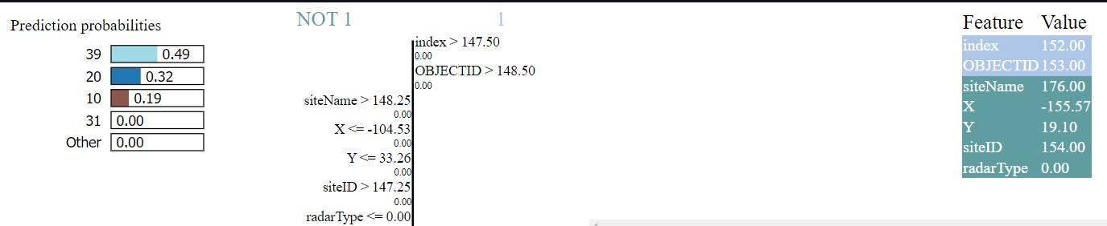

ENCODING ONLY CATEGORICAL VARIABLE:

coefficient [-1.30815881e+09 8.31558601e-02 7.02519998e-01 1.30815880e+09

5.77362424e+00 2.88645349e-02 -5.45748342e+01 -8.12590325e-03

2.04384146e-02 1.03057639e-01 -1.79694672e-02 4.47181913e-02

8.36653864e-03 5.12392179e+00 -2.47773426e-04 -3.31388868e-03

2.07602797e-02 -4.12616490e-02 -6.13230685e-06 4.43982075e-02

-1.36522439e-02 1.01907210e-01 -2.02399002e-01 -8.98596183e-04

-3.53260874e-01 -1.77593608e-02 4.27486453e-02 1.33136138e-02

5.12299004e+00 -4.34691385e-02 -2.15692308e-02 -9.66311887e+00

1.18447754e-05 -7.28725887e-02 -5.45775914e+01]

intercept 37.48010491265191

Equation: antennaElevation= 37.480104913 + 0.083155860 * X + 0.702519998 * Y + 1308158801.545084476 * OBJECTID + 5.773624240 * siteID + 0.028864535 * siteName + -54.574834193 * radarType + -0.008125903 * index**2 + 0.020438415 * index**1*X**1 + 0.103057639 * index**1*Y**1 + -0.017969467 * index**1*OBJECTID**1 + 0.044718191 * index**1*siteID**1 + 0.008366539 * index**1*siteName**1 + 5.123921786 * index**1*radarType**1 + -0.000247773 * X**2 + -0.003313889 * X**1*Y**1 + 0.020760280 * X**1*OBJECTID**1 + -0.041261649 * X**1*siteID**1 + -0.000006132 * X**1*siteName**1 + 0.044398207 * X**1*radarType**1 + -0.013652244 * Y**2 + 0.101907210 * Y**1*OBJECTID**1 + -0.202399002 * Y**1*siteID**1 + -0.000898596 * Y**1*siteName**1 + -0.353260874 * Y**1*radarType**1 + -0.017759361 * OBJECTID**2 + 0.042748645 * OBJECTID**1*siteID**1 + 0.013313614 * OBJECTID**1*siteName**1 + 5.122990037 * OBJECTID**1*radarType**1 + -0.043469139 * siteID**2 + -0.021569231 * siteID**1*siteName**1 + -9.663118874 * siteID**1*radarType**1 + 0.000011845 * siteName**2 + -0.072872589 * siteName**1*radarType**1 + -54.577591419 * radarType**2

Accuracy: 0.7888502842920684

coefficient [ 3.75329801e+07 -1.54207065e+00 7.29509724e+00 -3.75329540e+07

-2.55545123e+01 -4.87990431e-01 2.38297252e+03 2.92878671e+01

2.88806925e-01 -4.05785883e+00 3.12871972e+01 -9.19288988e+01

9.72579098e-02 -5.46762464e+02 -4.98597419e-03 8.03254802e-02

-3.81138014e-01 9.71067970e-02 -6.21224863e-03 -6.57952062e+00

-8.91717912e-02 -2.60278571e+00 6.61479277e+00 6.01932367e-03

3.56128341e+01 3.20696139e+01 -9.13852980e+01 8.81768794e-01

-5.47434000e+02 9.06745307e+01 -9.71943652e-01 1.04368502e+03

6.46259519e-04 3.74094691e+00 2.38215057e+03 -6.83670603e-02

2.49423523e-01 1.56735277e-01 -6.74416497e-02 1.82456927e-01

-5.70986741e-02 -1.56108861e+02 -3.52238670e-01 -1.14267614e-01

2.48625681e-01 -8.20912246e-01 -2.82883263e-01 -2.12180225e+00

8.55237199e-02 1.56294571e-01 -3.39943631e-01 -1.29506032e-01

-3.35174963e+00 -6.73751812e-02 1.82774028e-01 -5.75523418e-02

-1.56108492e+02 -1.46272152e-01 1.70478227e-01 4.75919787e+02

-5.47206961e-04 -6.13659347e-01 -5.47425813e+02 4.79691662e-05

5.47171454e-04 3.63073561e-01 -1.07053742e-02 -6.92168251e-05

-2.25732489e-02 2.61704947e-04 1.15474661e-01 -1.07350061e-03

-1.73628796e-04 7.19036019e-02 7.54702059e-02 -3.03402949e-01

2.89774443e-01 -2.12181215e+00 5.50916890e-01 -6.83772843e-03

4.28730423e+00 -1.08210370e-05 -3.13421858e-02 -6.59326635e+00

9.58204335e-04 -4.75144924e-02 -3.74907728e-02 -3.05247842e-04

-5.86837255e-03 2.93530554e-01 -8.23195360e-01 1.31610143e-01

-3.35175955e+00 5.56841034e-01 -2.09999830e-03 6.28853021e+00

-5.69131225e-06 5.98111689e-02 3.56004957e+01 -6.74092923e-02

1.82773688e-01 -5.75301293e-02 -1.56108518e+02 -1.46266085e-01

1.70475719e-01 4.75919792e+02 -5.48862852e-04 -6.13651695e-01

-5.47425803e+02 1.51084326e-02 -1.68790098e-01 -4.83165789e+02

1.09285768e-03 1.15271875e+00 1.04368563e+03 -5.31226397e-06

8.30008037e-03 3.74162320e+00 2.38215100e+03]

intercept -75.53946827782525

Equation: antennaElevation= -75.539468278 + -1.542070646 * X + 7.295097240 * Y + -37532954.032091662 * OBJECTID + -25.554512324 * siteID + -0.487990431 * siteName + 2382.972522247 * radarType + 29.287867121 * index**2 + 0.288806925 * index**1*X**1 + -4.057858827 * index**1*Y**1 + 31.287197206 * index**1*OBJECTID**1 + -91.928898810 * index**1*siteID**1 + 0.097257910 * index**1*siteName**1 + -546.762463931 * index**1*radarType**1 + -0.004985974 * X**2 + 0.080325480 * X**1*Y**1 + -0.381138014 * X**1*OBJECTID**1 + 0.097106797 * X**1*siteID**1 + -0.006212249 * X**1*siteName**1 + -6.579520619 * X**1*radarType**1 + -0.089171791 * Y**2 + -2.602785706 * Y**1*OBJECTID**1 + 6.614792774 * Y**1*siteID**1 + 0.006019324 * Y**1*siteName**1 + 35.612834085 * Y**1*radarType**1 + 32.069613912 * OBJECTID**2 + -91.385297952 * OBJECTID**1*siteID**1 + 0.881768794 * OBJECTID**1*siteName**1 + -547.434000108 * OBJECTID**1*radarType**1 + 90.674530689 * siteID**2 + -0.971943652 * siteID**1*siteName**1 + 1043.685022464 * siteID**1*radarType**1 + 0.000646260 * siteName**2 + 3.740946913 * siteName**1*radarType**1 + 2382.150571343 * radarType**2 + -0.068367060 * index**3 + 0.249423523 * index**2*X**1 + 0.156735277 * index**2*Y**1 + -0.067441650 * index**2*OBJECTID**1 + 0.182456927 * index**2*siteID**1 + -0.057098674 * index**2*siteName**1 + -156.108860920 * index**2*radarType**1 + -0.352238670 * index**1*X**2 + -0.114267614 * index**1*X**1*Y**1 + 0.248625681 * index**1*X**1*OBJECTID**1 + -0.820912246 * index**1*X**1*siteID**1 + -0.282883263 * index**1*X**1*siteName**1 + -2.121802249 * index**1*X**1*radarType**1 + 0.085523720 * index**1*Y**2 + 0.156294571 * index**1*Y**1*OBJECTID**1 + -0.339943631 * index**1*Y**1*siteID**1 + -0.129506032 * index**1*Y**1*siteName**1 + -3.351749629 * index**1*Y**1*radarType**1 + -0.067375181 * index**1*OBJECTID**2 + 0.182774028 * index**1*OBJECTID**1*siteID**1 + -0.057552342 * index**1*OBJECTID**1*siteName**1 + -156.108492326 * index**1*OBJECTID**1*radarType**1 + -0.146272152 * index**1*siteID**2 + 0.170478227 * index**1*siteID**1*siteName**1 + 475.919787338 * index**1*siteID**1*radarType**1 + -0.000547207 * index**1*siteName**2 + -0.613659347 * index**1*siteName**1*radarType**1 + -547.425812986 * index**1*radarType**2 + 0.000047969 * X**3 + 0.000547171 * X**2*Y**1 + 0.363073561 * X**2*OBJECTID**1 + -0.010705374 * X**2*siteID**1 + -0.000069217 * X**2*siteName**1 + -0.022573249 * X**2*radarType**1 + 0.000261705 * X**1*Y**2 + 0.115474661 * X**1*Y**1*OBJECTID**1 + -0.001073501 * X**1*Y**1*siteID**1 + -0.000173629 * X**1*Y**1*siteName**1 + 0.071903602 * X**1*Y**1*radarType**1 + 0.075470206 * X**1*OBJECTID**2 + -0.303402949 * X**1*OBJECTID**1*siteID**1 + 0.289774443 * X**1*OBJECTID**1*siteName**1 + -2.121812152 * X**1*OBJECTID**1*radarType**1 + 0.550916890 * X**1*siteID**2 + -0.006837728 * X**1*siteID**1*siteName**1 + 4.287304227 * X**1*siteID**1*radarType**1 + -0.000010821 * X**1*siteName**2 + -0.031342186 * X**1*siteName**1*radarType**1 + -6.593266349 * X**1*radarType**2 + 0.000958204 * Y**3 + -0.047514492 * Y**2*OBJECTID**1 + -0.037490773 * Y**2*siteID**1 + -0.000305248 * Y**2*siteName**1 + -0.005868373 * Y**2*radarType**1 + 0.293530554 * Y**1*OBJECTID**2 + -0.823195360 * Y**1*OBJECTID**1*siteID**1 + 0.131610143 * Y**1*OBJECTID**1*siteName**1 + -3.351759552 * Y**1*OBJECTID**1*radarType**1 + 0.556841034 * Y**1*siteID**2 + -0.002099998 * Y**1*siteID**1*siteName**1 + 6.288530210 * Y**1*siteID**1*radarType**1 + -0.000005691 * Y**1*siteName**2 + 0.059811169 * Y**1*siteName**1*radarType**1 + 35.600495709 * Y**1*radarType**2 + -0.067409292 * OBJECTID**3 + 0.182773688 * OBJECTID**2*siteID**1 + -0.057530129 * OBJECTID**2*siteName**1 + -156.108517557 * OBJECTID**2*radarType**1 + -0.146266085 * OBJECTID**1*siteID**2 + 0.170475719 * OBJECTID**1*siteID**1*siteName**1 + 475.919791938 * OBJECTID**1*siteID**1*radarType**1 + -0.000548863 * OBJECTID**1*siteName**2 + -0.613651695 * OBJECTID**1*siteName**1*radarType**1 + -547.425802755 * OBJECTID**1*radarType**2 + 0.015108433 * siteID**3 + -0.168790098 * siteID**2*siteName**1 + -483.165788513 * siteID**2*radarType**1 + 0.001092858 * siteID**1*siteName**2 + 1.152718752 * siteID**1*siteName**1*radarType**1 + 1043.685634689 * siteID**1*radarType**2 + -0.000005312 * siteName**3 + 0.008300080 * siteName**2*radarType**1 + 3.741623198 * siteName**1*radarType**2 + 2382.151003692 * radarType**3

Accuracy: 0.8559949888292026

ENCODING EVERY VARIABLE:

Equation: coefficient [7.15285855e-02 3.54303475e-02 -2.61882543e+09

-3.29718150e+00 -1.21567345e-03 -5.06867330e+01 -5.43255963e-02

-1.51496130e-02 5.92000916e-03 -6.23684678e-02 1.67640323e-01

3.37604862e-03 2.94709461e+00 -2.97894849e-04 2.11583434e-06

-8.30330430e-03 2.30727542e-02 1.65550422e-05 6.90031199e-02

-1.10687989e-04 -3.67287413e-03 -2.13581302e-03 -1.83949192e-04

3.87263064e-03 -5.63251231e-02 1.62487248e-01 -5.76348570e-03

2.94123911e+00 -1.56955974e-01 2.06984620e-03 -5.49952508e+00

1.92743967e-04 -8.42684431e-03 -5.06964870e+01]

intercept 39.903880479600694

Equation: antennaElevation= 39.903880480 + 0.071528585 * X + 0.035430348 * Y + -2618825427.105230808 * OBJECTID + -3.297181504 * siteID + -0.001215673 * siteName + -50.686732964 * radarType + -0.054325596 * index^2 + -0.015149613 * index^1*X^1 + 0.005920009 * index^1*Y^1 + -0.062368468 * index^1*OBJECTID^1 + 0.167640323 * index^1*siteID^1 + 0.003376049 * index^1*siteName^1 + 2.947094606 * index^1*radarType^1 + -0.000297895 * X^2 + 0.000002116 * X^1*Y^1 + -0.008303304 * X^1*OBJECTID^1 + 0.023072754 * X^1*siteID^1 + 0.000016555 * X^1*siteName^1 + 0.069003120 * X^1*radarType^1 + -0.000110688 * Y^2 + -0.003672874 * Y^1*OBJECTID^1 + -0.002135813 * Y^1*siteID^1 + -0.000183949 * Y^1*siteName^1 + 0.003872631 * Y^1*radarType^1 + -0.056325123 * OBJECTID^2 + 0.162487248 * OBJECTID^1*siteID^1 + -0.005763486 * OBJECTID^1*siteName^1 + 2.941239105 * OBJECTID^1*radarType^1 + -0.156955974 * siteID^2 + 0.002069846 * siteID^1*siteName^1 + -5.499525081 * siteID^1*radarType^1 + 0.000192744 * siteName^2 + -0.008426844 * siteName^1*radarType^1 + -50.696486974 * radarType^2

Accuracy: 0.817827613511193

DEGREE-3:

coefficient [-3.38992552e+05 -8.90561425e-02 8.06656095e-04 3.19181853e+05

1.98106840e+04 -1.11738867e-01 1.58813842e+03 -9.89821913e+03

-9.22377399e-02 3.51654352e-02 -9.89822208e+03 2.96947732e+04

6.88866638e-02 1.19422955e+04 2.54298221e-04 -2.64671190e-05

-9.24736799e-02 1.82484532e-01 2.02631503e-03 -1.27573786e-01

-7.98099683e-04 2.81899747e-02 -6.25319000e-02 7.28663757e-04

3.36444565e-01 -9.89821925e+03 2.96947753e+04 7.00773713e-02

1.19422917e+04 -2.96948878e+04 -1.37353548e-01 -2.39120252e+04

-2.96061374e-04 2.18922479e+00 1.58814125e+03 -2.47626460e+03

1.37083053e-02 1.85483705e-02 -2.47626460e+03 9.90500531e+03

-1.89343223e-02 3.58652538e+03 5.78146588e-04 -2.90548695e-04

1.37086269e-02 -4.07191591e-02 1.33448357e-05 -1.11230523e-01

-1.96423499e-04 1.85518211e-02 -5.49471393e-02 6.28408598e-05

-8.74008192e-02 -2.47626460e+03 9.90500531e+03 -1.89337400e-02

3.58652538e+03 -1.48574292e+04 5.57207054e-02 -1.07568024e+04

-1.03175418e-04 -1.03465516e-01 1.19422916e+04 8.25348252e-08

1.56437454e-06 5.85528469e-04 -1.15111213e-03 -7.54492794e-06

-3.75079007e-03 -5.48097887e-07 -2.88763454e-04 5.73585790e-04

-1.45615923e-06 2.25994412e-03 1.37066433e-02 -4.07197753e-02

1.34431302e-05 -1.11230542e-01 4.03221680e-02 -2.90854241e-05

2.26230035e-01 -1.08240238e-06 2.52219804e-04 -1.27563606e-01

4.05707397e-06 -1.95810634e-04 3.88275307e-04 -2.11632869e-06

1.14481659e-03 1.85511394e-02 -5.49470224e-02 6.09168710e-05

-8.74010123e-02 5.42493512e-02 -1.23155278e-04 1.67387270e-01

-2.15193722e-07 4.16567552e-04 3.36563836e-01 -2.47626460e+03

9.90500531e+03 -1.89340995e-02 3.58652538e+03 -1.48574292e+04

5.57207836e-02 -1.07568024e+04 -1.03456779e-04 -1.03464956e-01

1.19422916e+04 9.90490094e+03 -5.46522443e-02 1.07541868e+04

2.03655833e-04 1.80778116e-01 -2.39120252e+04 1.70675776e-06

2.82072518e-03 2.18922389e+00 1.58814125e+03]

intercept 51.93620512220595

Equation: antennaElevation= 51.936205122 + -0.089056143 * X + 0.000806656 * Y + 319181.852734038 * OBJECTID + 19810.683996571 * siteID + -0.111738867 * siteName + 1588.138424095 * radarType + -9898.219131128 * index^2 + -0.092237740 * index^1*X^1 + 0.035165435 * index^1*Y^1 + -9898.222076919 * index^1*OBJECTID^1 + 29694.773209746 * index^1*siteID^1 + 0.068886664 * index^1*siteName^1 + 11942.295462865 * index^1*radarType^1 + 0.000254298 * X^2 + -0.000026467 * X^1*Y^1 + -0.092473680 * X^1*OBJECTID^1 + 0.182484532 * X^1*siteID^1 + 0.002026315 * X^1*siteName^1 + -0.127573786 * X^1*radarType^1 + -0.000798100 * Y^2 + 0.028189975 * Y^1*OBJECTID^1 + -0.062531900 * Y^1*siteID^1 + 0.000728664 * Y^1*siteName^1 + 0.336444565 * Y^1*radarType^1 + -9898.219251254 * OBJECTID^2 + 29694.775251924 * OBJECTID^1*siteID^1 + 0.070077371 * OBJECTID^1*siteName^1 + 11942.291721741 * OBJECTID^1*radarType^1 + -29694.887809176 * siteID^2 + -0.137353548 * siteID^1*siteName^1 + -23912.025156738 * siteID^1*radarType^1 + -0.000296061 * siteName^2 + 2.189224794 * siteName^1*radarType^1 + 1588.141252649 * radarType^2 + -2476.264603361 * index^3 + 0.013708305 * index^2*X^1 + 0.018548371 * index^2*Y^1 + -2476.264601003 * index^2*OBJECTID^1 + 9905.005306197 * index^2*siteID^1 + -0.018934322 * index^2*siteName^1 + 3586.525381385 * index^2*radarType^1 + 0.000578147 * index^1*X^2 + -0.000290549 * index^1*X^1*Y^1 + 0.013708627 * index^1*X^1*OBJECTID^1 + -0.040719159 * index^1*X^1*siteID^1 + 0.000013345 * index^1*X^1*siteName^1 + -0.111230523 * index^1*X^1*radarType^1 + -0.000196423 * index^1*Y^2 + 0.018551821 * index^1*Y^1*OBJECTID^1 + -0.054947139 * index^1*Y^1*siteID^1 + 0.000062841 * index^1*Y^1*siteName^1 + -0.087400819 * index^1*Y^1*radarType^1 + -2476.264602899 * index^1*OBJECTID^2 + 9905.005310254 * index^1*OBJECTID^1*siteID^1 + -0.018933740 * index^1*OBJECTID^1*siteName^1 + 3586.525384435 * index^1*OBJECTID^1*radarType^1 + -14857.429227533 * index^1*siteID^2 + 0.055720705 * index^1*siteID^1*siteName^1 + -10756.802392854 * index^1*siteID^1*radarType^1 + -0.000103175 * index^1*siteName^2 + -0.103465516 * index^1*siteName^1*radarType^1 + 11942.291629467 * index^1*radarType^2 + 0.000000083 * X^3 + 0.000001564 * X^2*Y^1 + 0.000585528 * X^2*OBJECTID^1 + -0.001151112 * X^2*siteID^1 + -0.000007545 * X^2*siteName^1 + -0.003750790 * X^2*radarType^1 + -0.000000548 * X^1*Y^2 + -0.000288763 * X^1*Y^1*OBJECTID^1 + 0.000573586 * X^1*Y^1*siteID^1 + -0.000001456 * X^1*Y^1*siteName^1 + 0.002259944 * X^1*Y^1*radarType^1 + 0.013706643 * X^1*OBJECTID^2 + -0.040719775 * X^1*OBJECTID^1*siteID^1 + 0.000013443 * X^1*OBJECTID^1*siteName^1 + -0.111230542 * X^1*OBJECTID^1*radarType^1 + 0.040322168 * X^1*siteID^2 + -0.000029085 * X^1*siteID^1*siteName^1 + 0.226230035 * X^1*siteID^1*radarType^1 + -0.000001082 * X^1*siteName^2 + 0.000252220 * X^1*siteName^1*radarType^1 + -0.127563606 * X^1*radarType^2 + 0.000004057 * Y^3 + -0.000195811 * Y^2*OBJECTID^1 + 0.000388275 * Y^2*siteID^1 + -0.000002116 * Y^2*siteName^1 + 0.001144817 * Y^2*radarType^1 + 0.018551139 * Y^1*OBJECTID^2 + -0.054947022 * Y^1*OBJECTID^1*siteID^1 + 0.000060917 * Y^1*OBJECTID^1*siteName^1 + -0.087401012 * Y^1*OBJECTID^1*radarType^1 + 0.054249351 * Y^1*siteID^2 + -0.000123155 * Y^1*siteID^1*siteName^1 + 0.167387270 * Y^1*siteID^1*radarType^1 + -0.000000215 * Y^1*siteName^2 + 0.000416568 * Y^1*siteName^1*radarType^1 + 0.336563836 * Y^1*radarType^2 + -2476.264602978 * OBJECTID^3 + 9905.005310053 * OBJECTID^2*siteID^1 + -0.018934099 * OBJECTID^2*siteName^1 + 3586.525384401 * OBJECTID^2*radarType^1 + -14857.429226621 * OBJECTID^1*siteID^2 + 0.055720784 * OBJECTID^1*siteID^1*siteName^1 + -10756.802392921 * OBJECTID^1*siteID^1*radarType^1 + -0.000103457 * OBJECTID^1*siteName^2 + -0.103464956 * OBJECTID^1*siteName^1*radarType^1 + 11942.291629287 * OBJECTID^1*radarType^2 + 9904.900935437 * siteID^3 + -0.054652244 * siteID^2*siteName^1 + 10754.186798678 * siteID^2*radarType^1 + 0.000203656 * siteID^1*siteName^2 + 0.180778116 * siteID^1*siteName^1*radarType^1 + -23912.025226834 * siteID^1*radarType^2 + 0.000001707 * siteName^3 + 0.002820725 * siteName^2*radarType^1 + 2.189223888 * siteName^1*radarType^2 + 1588.141248422 * radarType^3

Accuracy: 0.858191071825885

GRAPH:

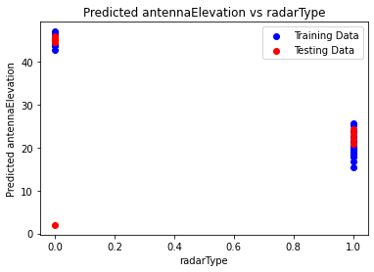

The plot provided illustrates the performance evaluation of a machine learning model deployed for a classification task, presumably predicting antenna elevation based on radar type.

On the x-axis, radar types are represented, ranging from 0.0 to 1.0, while the y-axis denotes the predicted antenna elevation. The blue line corresponds to the model's performance on the training data, reflecting its efficacy on the data it was trained on. Conversely, the red line depicts the model's performance on unseen testing data, showcasing its generalization ability.

Ideally, a close alignment between the blue and red lines would indicate robust generalization, suggesting that the model performs consistently well across both seen and unseen data. However, the noticeable gap between the blue and red lines suggests potential issues with generalization. This discrepancy implies that while the model may exhibit favorable performance on the training data, it fails to replicate this performance on unseen testing data, indicative of overfitting.

Overfitting occurs when a model excessively tailors itself to the idiosyncrasies of the training data, compromising its ability to discern broader patterns within the data. Consequently, despite performing well during training, overfitted models struggle to generalize effectively to new, unseen data. This discrepancy between training and testing performance underscores the need for model evaluation and potentially mitigative strategies to address overfitting.

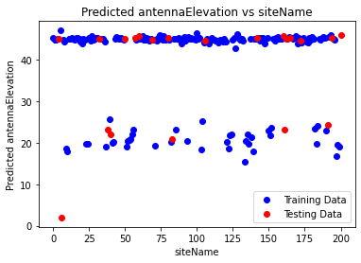

Based on the image provided, the plot illustrates the relationship between predicted antenna elevation and site names, with the training data represented in blue and the testing data in red.

Key observations from the plot include:

- The x-axis corresponds to the site names, indicating individual locations.

- Predicted antenna elevation is represented on the y-axis.

- Both the training and testing data exhibit a scattered distribution of points, indicating variability in predicted elevation across different sites.

- There is no discernible linear relationship between predicted antenna elevation and site name, as indicated by the lack of a clear trend in the data.

- The spread of data points appears wider for sites with higher predicted antenna elevation, suggesting greater variability in elevation predictions for these locations.

- Some overlap in data points between training and testing data suggests that the model predicts similar antenna elevation values for certain sites.

Overall, while the plot provides insights into the relationship between predicted antenna elevation and site names, it does not reveal a straightforward pattern or linear correlation. The presence of variability and overlap in data points suggests that site names may contribute to predicting antenna elevation, but other factors likely play a role as well. Further analysis and consideration of additional features may be necessary to fully understand the predictive relationship between site names and antenna elevation.

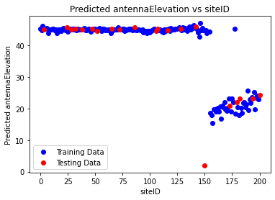

Based on the image provided, the scatter plot illustrates the relationship between predicted antenna elevation and siteID, with training data represented in blue and testing data in red.

Key observations from the plot include:

- The x-axis represents siteID, serving as a unique identifier for each site.

- Predicted antenna elevation is depicted on the y-axis.

- The plot does not exhibit a clear linear relationship between predicted antenna elevation and siteID, evident from the scattered distribution of data points across the plot.

- The spread of data points appears consistent across the range of siteIDs, suggesting uniform variability in predicted antenna elevation across different sites.

- Some overlap in data points between training and testing data indicates similarity in predicted antenna elevation values for certain sites.

Overall, while the plot provides insights into the relationship between predicted antenna elevation and siteID, it does not reveal a discernible pattern or linear correlation. This suggests that siteID alone may not be a significant predictor of antenna elevation. It is likely that other factors not depicted in this plot contribute more prominently to the model's predictions. Further analysis incorporating additional features may be necessary to better understand the predictive relationship between siteID and antenna elevation.

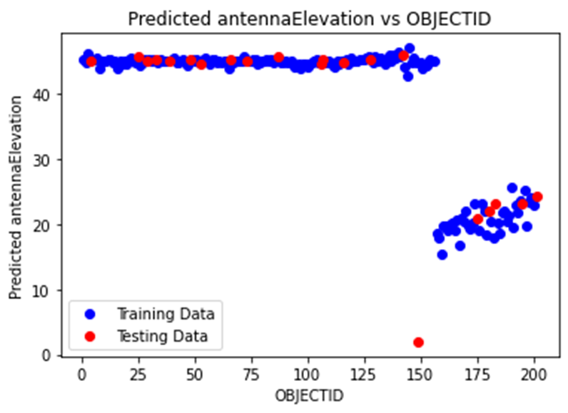

Based on the image you provided, the scatter plot illustrates the difference between predicted antenna elevation and objectid, with the predicted antenna elevation plotted on the y-axis and objectid on the x-axis. The training data is represented in blue, while the testing data is depicted in red.

Here are some observations from the plot:

- The x-axis displays the objectid, likely serving as a unique identifier for each data point.

- The y-axis represents the disparity between the predicted antenna elevation and the actual antenna elevation, indicated by objectid. Positive values denote instances where the model predicted a higher antenna elevation than the actual value, while negative values indicate instances where the model predicted a lower antenna elevation.

- The plot does not reveal a discernible pattern for either the training or testing data, suggesting that the model's predictions are not consistently biased towards over or underestimating antenna elevation.

- A spread of data points is observed around the zero line, indicating instances where the model's predictions closely align with the actual antenna elevation. However, deviations from the zero line suggest inaccuracies in the model's predictions.

- Some data points exhibit significant deviations from the zero line, both in the training and testing data, signifying substantial errors in the model's predictions for these specific sites.

Overall, the plot suggests that while the model's predictions of antenna elevation are not consistently accurate, it also does not exhibit a systematic bias towards over or underestimation. However, notable errors are evident for certain sites, indicating areas where the model's performance could be improved.

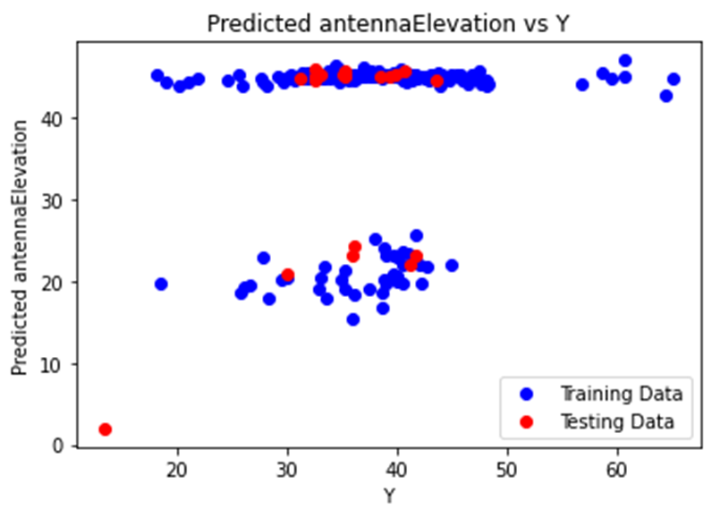

Based on the image provided, the plot illustrates the disparity between predicted and actual antenna elevations for both the training and testing datasets of a machine learning model.

- The x-axis denotes Y the difference between the predicted antenna elevation and the actual elevation, with positive values indicating overestimation by the model and negative values representing underestimation.

- The y-axis represents the predicted antenna elevation frequency or count of data points falling within each difference interval.

Here are key observations:

1. Concentration Around Zero Difference:

- A substantial concentration of data points is observed around the zero difference mark on the x-axis for both the training (blue) and testing (red) datasets. This indicates instances where the model's predictions closely aligned with the actual antenna elevations.

2. Spread of Data Points:

- The distribution of data points appears to be wider for the testing set compared to the training set. This suggests that the model's predictions exhibit more variability when applied to unseen data (testing set) as opposed to the data it was trained on (training set).

3. Assessment of Model Performance:

- Overall, the model seems to perform reasonably well, as evidenced by the concentration of data points around zero difference. However, the wider spread of points in the testing set raises concerns about the model's generalization capability.

- The wider spread observed in the testing set could potentially indicate overfitting, where the model fits the training data too closely and struggles to generalize to new, unseen data.

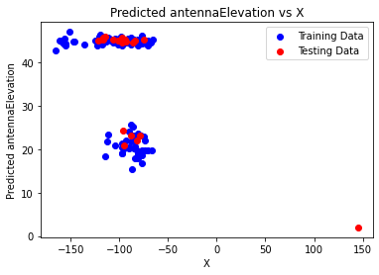

The plot provided illustrates the comparison between predicted antenna elevation and a variable X, with the training data depicted in blue and the testing data in red.

Key observations from the plot include:

1. Training vs. Testing Performance: A notable distinction is apparent between the performance of the model on the training data (blue) versus the testing data (red). While the model appears to align closely with the training data, its performance on the testing data seems to deviate, indicating potential disparities in predictive accuracy between the two datasets.

2. Potential Overfitting: The discrepancy in performance between the training and testing datasets suggests the possibility of overfitting. Overfitting occurs when a model captures noise or idiosyncrasies present in the training data, leading to reduced performance when applied to unseen data. The disparity observed in the plot could signify that the model has learned the training data too well, resulting in a lack of generalization to the testing data.

3. Dataset Disparities: Alternatively, differences in the characteristics or distribution of the training and testing datasets may contribute to the observed performance gap. If the datasets exhibit varying features or statistical properties, the model may struggle to accurately generalize from the training to the testing data.

while the plot provides valuable insights into the model's performance, further investigation into the cause of the observed disparities between the training and testing datasets is warranted. Understanding whether the discrepancies arise from overfitting, dataset disparities, or other factors is essential for refining the model and enhancing its predictive capabilities.

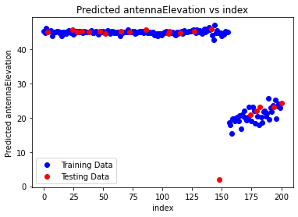

The provided plot depicts the relationship between predicted antenna elevation and an index variable. The blue line represents the predicted antenna elevation, while the red line represents the testing data.

Key observations from the plot include:

- The x-axis represents the index, which likely corresponds to a specific feature or variable utilized in predicting antenna elevation.

- The y-axis denotes the predicted antenna elevation.

- Training Data (Blue): The blue data points, representing the training data, are dispersed around the diagonal line. However, there appears to be a slight bias towards the upper left corner, indicating a tendency of the model to underestimate antenna elevation for the training data.

- Testing Data (Red): In contrast, the red data points, representing the testing data, exhibit greater dispersion and deviation from the diagonal line compared to the training data. This suggests that the model's performance on unseen data is less consistent, indicating potential issues with generalization.

the plot suggests that the model may exhibit a bias towards underestimating antenna elevation, and it demonstrates suboptimal generalization to unseen data. Possible reasons for these discrepancies could include inadequate training data or model complexity exceeding the variability present in the dataset.

SHAP-INTERPRETATION:

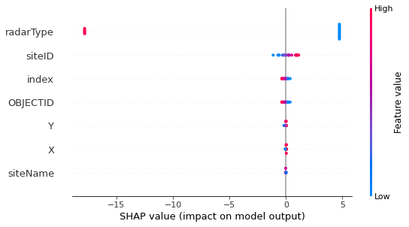

The image provided appears to be a SHAP (SHapley Additive exPlanations) value plot, commonly used for interpreting the impact of features on a machine learning model's predictions.

In this plot, each point represents a feature's influence on the model's output for a particular instance. The vertical position of the point corresponds to the feature, while the horizontal position represents the SHAP value, indicating the magnitude and direction of the feature's impact.

Positive SHAP values, located to the right on the x-axis, suggest that the feature contributes positively to the likelihood of a specific prediction. Conversely, negative values, positioned to the left, imply a negative impact on the prediction's likelihood. Additionally, the color of the points reflects the feature's value, ranging from low (blue) to high (red).

The features depicted in the plot, such as 'radarType', 'siteID', and others, exhibit varying degrees of influence on the model's predictions, as evidenced by the distribution of points along the x-axis.

However, it's important to note that without contextual information about the data and model, this interpretation remains general. For a more precise understanding, additional context would be required.

To apply Multilayer Perceptron Networks (MLPs) in Aviation Route Optimization using these equations would typically follow these steps:

1. Data Preparation: Collect and preprocess the data needed for route optimization. This data may include factors such as geographical coordinates, weather conditions, aircraft performance parameters, traffic patterns, and operational constraints.

2. Feature Selection: Identify relevant features from the dataset that can influence route optimization. These features may include variables such as antenna elevation, temperature, geographical coordinates, and other factors mentioned in the equations.

3. Model Training: Train an MLP model using the provided regression equations and the collected data. MLPs are a type of artificial neural network that can learn complex patterns in data and make predictions.

4. Model Evaluation: Evaluate the performance of the MLP model using appropriate metrics, such as mean squared error or coefficient of determination (R-squared). This step helps ensure that the model accurately captures the relationships between the input variables and the predicted outputs.

5. Route Optimization: Once the MLP model is trained and validated, you can use it to optimize aviation routes. This involves feeding relevant input data into the model, such as current weather conditions, aircraft characteristics, and operational constraints, and obtaining predictions for variables such as antenna elevation and temperature.

6. Decision Making: Based on the predictions generated by the MLP model, make informed decisions regarding route planning and optimization. These decisions may involve selecting the most efficient flight paths, considering factors such as fuel efficiency, safety, and passenger comfort.

7. Iterative Improvement: Continuously monitor the performance of the MLP model and aviation route optimization process, and make adjustments as needed to improve efficiency and effectiveness.

Overall, by leveraging MLPs and the provided regression equations, one can develop a data-driven approach to aviation route optimization that takes into account various factors and constraints to enhance the efficiency and safety of flight operations.

**PREDICTED EQUATIONS WITH ML TO CALCULATE PROPER ROUTE-PASS OF THE MODERN AIRCRAFT TRANSPORTATION**

**PHASE-7(AIR-SPEED TRAJECTORY:INTERPRETATION OF MAX SPEED IN KNOTS used as input in AIRCRAFT DAMAGE in part-1):**

|  |  |  |  |
| --- | --- | --- | --- |
| Model | Company | Engine Type | HP or lbs thr ea engine |
| 15 AC Sedan | Aeronca | Piston | 145 |
| 11 CC Super Chief | Aeronca | Piston | 85 |
| 7 CCM Champ | Aeronca | Piston | 90 |
| 7 DC Champ | Aeronca | Piston | 85 |
| 7 AC Champ | Aeronca | Piston | 65 |
| 11 AC Chief | Aeronca | Piston | 65 |
| PA-60-700P Aerostar (preliminary) | Aerostar Aircraft Corporation | Piston | 350 |
| PA-602P Aerostar | Aerostar Aircraft Corporation | Piston | 290 |
| PA-601P pressurized Aerostar ('77 service ceiling=26,350) | Aerostar Aircraft Corporation | Piston | 290 |
| PA-601B turbochg Aerostar (prior'80=less perf) | Aerostar Aircraft Corporation | Piston | 290 |
| PA-601, 601A, turbochg Aerostar | Aerostar Aircraft Corporation | Piston | 290 |
| PA-600,600A,-Aerostar | Aerostar Aircraft Corporation | Piston | 290 |
| G164B Turbine (spec for 680 hp) | Ag Cat Corp | Propjet | 680 |
| G164C-600 AG-CAT (design category) sprayer | Ag Cat Corp | Piston | 600 |
| G164B-600 AG-CAT (design category) sprayer | Ag Cat Corp | Piston | 600 |
| G164A-600 AG-CAT (design category) | Ag Cat Corp | Piston | 600 |
| G164B-525 (design-sprayer) prior'78=25/11 length | Ag Cat Corp | Piston | 525 |
| G164B-450 (hopper=325 gal) | Ag Cat Corp | Piston | 450 |
| G164B-450 AG CAT (design category) sprayer | Ag Cat Corp | Piston | 450 |
| G164A-450 AG CAT (design category) | Ag Cat Corp | Piston | 450 |
| G164A-300 AG CAT | Ag Cat Corp | Piston | 300 |
| G164A-275 AG CAT | Ag Cat Corp | Piston | 275 |
| G164A-245 AG CAT | Ag Cat Corp | Piston | 245 |
| G164A-220 AG CAT | Ag Cat Corp | Piston | 220 |

|  |  |  |  |  |
| --- | --- | --- | --- | --- |
| Max speed Knots | Rcmnd cruise Knots | Stall Knots dirty | Fuel gal/lbs | All eng service ceiling |
| 104 | 91 | 46 | 36 | 13000 |
| 89 | 83 | 44 | 15 | 12300 |
| 90 | 78 | 37 | 19 | 16000 |
| 88 | 78 | 37 | 19 | 13000 |
| 83 | 74 | 33 | 14 | 12500 |
| 78 | 72 | 33 | 15 | 11000 |
| 264 | 230 | 80 | 165 | 25000 |
| 262 | 247 | 77 | 165 | 28000 |
| 257 | 235 | 77 | 165 | 25000 |
| 257 | 237 | 77 | 165 | 30000 |
| 271 | 236 | 69 | 174 | 30100 |
| 220 | 212 | 74 | 165 | 21200 |
|  | 113 |  | 80 |  |
| 104 | 91 | 60 | 80 |  |
|  | 100 | 52 | 64 |  |
| 128 | 96 | 59 | 46 | 14500 |
| 128 | 91 | 52 | 46 |  |
|  | 100 |  | 64 |  |
| 128 | 91 | 52 | 46 | 14500 |
| 128 | 91 | 58 | 46 | 14000 |
| 128 | 74 | 54 | 46 | 11500 |
| 114 | 74 | 54 | 33 | 10250 |
| 114 | 70 | 54 | 33 | 8500 |
| 114 | 70 | 48 | 33 | 7000 |

|  |  |  |  |  |
| --- | --- | --- | --- | --- |
| Eng out service ceiling | All eng rate of climb | Eng out rate of climb | Takeoff over 50ft | Takeoff ground run |
|  | 450 |  | 900 |  |
|  | 600 |  | 720 |  |
|  | 650 |  | 475 |  |
|  | 620 |  | 500 |  |
|  | 370 |  | 632 |  |
|  | 360 |  | 583 |  |
| 14500 | 1820 | 320 | 3080 | 1950 |
| 12900 | 1755 | 302 | 2250 | 1800 |
| 8800 | 1460 | 240 | 2490 | 1900 |
| 8800 | 1460 | 240 | 2490 | 1900 |
| 10800 | 1700 | 370 | 2200 | 1800 |
| 6300 | 1800 | 360 | 1950 | 1550 |
|  |  |  | 900 |  |
|  |  |  | 2080 | 1080 |
|  | 1360 |  | 1050 | 430 |
|  | 1600 |  | 860 | 505 |
|  | 1350 |  |  | 1000 |
|  |  |  |  | 1300 |
|  | 1060 |  | 1090 | 585 |
|  | 990 |  | 1145 | 630 |
|  | 700 |  | 1200 | 750 |
|  | 600 |  | 1275 | 800 |
|  | 496 |  | 1300 | 825 |
|  | 435 |  | 1360 | 850 |

|  |  |  |  |  |  |
| --- | --- | --- | --- | --- | --- |
| Landing over 50ft | Landing ground roll | Gross weight lbs | Empty weight lbs | Length ft/in | Height ft/in |
| 1300 |  | 2050 | 1180 | 25/3 | 3-Oct |
| 800 |  | 1350 | 820 | 20/7 | 9-Aug |
| 850 |  | 1300 | 810 | 21/5 | 7-Aug |
| 850 |  | 1300 | 800 | 21/5 | 7-Aug |
| 885 |  | 1220 | 740 | 21/5 | 9-Aug |
| 880 |  | 1250 | 786 | 20/4 | 9-Aug |
| 2100 | 1425 | 6315 | 4275 | 34/10 | 1-Dec |
| 2076 | 1217 | 6000 | 4125 | 34/9 | 1-Dec |
| 2030 | 1230 | 6000 | 4056 | 34/10 | 1-Dec |
| 2030 | 1230 | 6000 | 3958 | 34/10 | 1-Dec |
| 1625 | 980 | 5700 | 3750 | 34/10 | 1-Dec |
| 1840 | 1040 | 5500 | 3737 | 34/10 | 1-Dec |
|  |  | 5200 | 3150 | 33/1 | 1-Dec |
| 1190 | 588 | 6300 | 3650 | 30/0 | 5-Nov |
| 1150 | 565 | 5200 | 3650 | 25/6 | 6-Nov |
| 770 | 410 | 4500 | 3160 | 24/4 | 10-Oct |
| 540 | 1150 | 567 | 4500 | 3150 | 26/1 |
|  |  | 5200 | 3325 | 24/2 | 6-Nov |
| 1150 | 567 | 4500 | 3100 | 25/7 | Nov-00 |
| 750 | 390 | 4500 | 2870 | 24/4 | Nov-00 |
| 1000 | 590 | 3750 | 2410 | 24/4 | 9-Oct |
| 1000 | 590 | 3750 | 2400 | 24/4 | 9-Oct |
| 1000 | 590 | 3750 | 2300 | 24/4 | 9-Oct |
| 1000 | 590 | 3600 | 2200 | 24/4 | 9-Oct |

|  |  |
| --- | --- |
| Wing span ft/in | Range N.M. |
| 37/5 | 370 |
| 36/1 | 190 |
| 35/0 | 210 |
| 35/0 | 210 |
| 35/0 | 175 |
| 36/1 | 180 |
| 36/8 | 868 |
| 36/7 | 1020 |
| 36/8 | 1101 |
| 36/8 | 1174 |
| 34/2 | 1174 |
| 34/2 | 1200 |
| 42/5 |  |
| 42/3 | 235 |
| 42/5 | 200 |
| 35/11 | 148 |
| 42/3 | 155 |
| 42/5 | 190 |
| 42/3 | 190 |
| 35/11 | 190 |
| 35/8 | 226 |
| 35/8 | 117 |
| 35/8 | 174 |
| 35/8 | 190 |
| 30/0 | 410 |

1. Model: The model name of the aircraft.

2. Company: The company that manufactures the aircraft.

3. Engine Type: The type of engine used in the aircraft, such as Piston or Propjet.

4. HP or lbs thr ea engine: The horsepower or pounds of thrust produced by each engine.

5. Max speed Knots: The maximum speed of the aircraft in knots, which is a unit of speed used in aviation.

6. Rcmnd cruise Knots: The recommended cruising speed of the aircraft in knots for optimal performance and fuel efficiency.

7. Stall Knots dirty: The stall speed of the aircraft when the flaps and landing gear are extended (dirty configuration) in knots.

8. Fuel gal/lbs: The fuel capacity of the aircraft in gallons or pounds.

9. All eng service ceiling: The service ceiling of the aircraft with all engines operating, which is the maximum altitude at which the aircraft can maintain a specified rate of climb.

10. Eng out service ceiling: The service ceiling of the aircraft with one engine out, indicating the maximum altitude it can reach under such conditions.

11. All eng rate of climb: The rate of climb of the aircraft with all engines operating, typically measured in feet per minute.

12. Eng out rate of climb: The rate of climb of the aircraft with one engine out, showing how fast it can ascend under those circumstances.

13. Takeoff over 50ft: The distance required for the aircraft to take off and clear a 50-foot obstacle.

14. Takeoff ground run: The distance needed for the aircraft to take off from the ground.

15. Landing over 50ft: The distance required for the aircraft to land and stop after clearing a 50-foot obstacle.

16. Landing ground roll: The distance needed for the aircraft to land and come to a stop on the ground.

17. Gross weight lbs: The maximum allowable weight of the aircraft, including passengers, cargo, and fuel.

18. Empty weight lbs: The weight of the aircraft when empty, without any payload.

19. Length ft/in: The length of the aircraft in feet and inches.

20. Height ft/in: The height of the aircraft in feet and inches.

21. Wing span ft/in: The wingspan of the aircraft in feet and inches.

22. Range N.M.: The maximum range of the aircraft in nautical miles, indicating how far it can fly without refueling.

These features provide important information about the aircraft's performance, capabilities, and specifications that are crucial for navigation and flight planning.

Equation:

ENCODING ONLY CATEGORICAL VARIABLES:

Equation: Max speed Knots= -91.98098318746494328479 + 0.31934922179598962400 * Company + 14.00722803413319006438 * Engine Type + 0.05782096815829170650 * HP or lbs thr ea engine + 0.40174974340024349750 * Rcmnd cruise Knots + -0.48268308116920788375 * Stall Knots dirty + -0.00194245209793558098 * Fuel gal/lbs + 0.00190477732433421212 * All eng service ceiling + 0.01687159366939789198 * Eng out service ceiling + 0.00123304655524404260 * All eng rate of climb + -0.04555631200996640429 * Eng out rate of climb + 0.02260251319867557368 * Takeoff over 50ft + 0.00005767659490027463 * Takeoff ground run + 0.00587921188232233723 * Landing over 50ft + 0.00392223420635380484 * Landing ground roll + -0.01433204206651608921 * Gross weight lbs + 0.02024722986360515120 * Empty weight lbs + 0.14583717072352356259 * Length ft/in + -0.00200491454800367933 * Height ft/in + -0.08927479634941978826 * Wing span ft/in + 0.02134465981975075186 * Range N.M.

Accuracy: 0.780751225691352

coefficient [-8.14890308e-02 3.85329550e+00 -7.95184739e+01 -5.59902233e-01

1.88566089e+00 -4.64942646e+00 8.67839475e-03 -5.08520565e-03

-1.91816726e-01 -1.29572611e+00 9.34971929e-01 2.53602323e-01

-2.23888636e-01 -2.01789345e-01 -3.44877006e-02 1.20194056e+00

8.08667861e-02 1.04483039e+00 -3.25574338e-01 -1.63625196e+00

8.48929439e-02 6.72000333e-06 -7.89833848e-04 -3.55209379e-03

1.93780085e-04 9.60311064e-05 1.95337452e-03 1.82334010e-05

7.92176042e-07 6.56142427e-04 2.56818343e-04 -4.54805526e-04

-5.04489865e-05 -3.07613438e-05 7.61117534e-05 3.38326632e-05

-3.63003597e-04 -2.13876821e-05 -4.10298068e-04 -7.23355045e-05

2.72785063e-04 8.26183125e-05 -3.32376444e-02 3.47944962e-01

4.71544013e-03 2.67304815e-03 -5.37449435e-02 1.37298612e-04

-8.05159703e-05 -3.64467314e-03 -3.87077505e-03 2.48916200e-03

4.42721677e-04 -8.96333808e-04 1.60853873e-04 2.24708402e-04

1.96804792e-03 -2.43909836e-03 1.05835119e-02 -2.68713553e-03

4.07315516e-03 -1.15067124e-03 3.64200479e+00 1.04972938e-01

-3.32712963e-02 5.84525534e-03 -5.19394595e-03 3.99913817e-04

-1.56470407e-01 1.74060941e-01 -2.12432600e-02 -1.49337292e-02

1.18045980e-02 1.75645958e-02 2.14376693e-02 -9.01822148e-02

-3.37734934e-03 -2.04868149e-01 1.59428095e-01 2.72819652e-01

-2.37992658e-02 -1.50065216e-03 2.70122994e-04 2.76924676e-03

2.40257775e-05 1.05962174e-05 8.14699510e-03 -1.45650410e-04

-4.37672253e-03 -1.69820967e-04 1.61869067e-05 -1.03265004e-04

2.27464493e-04 -5.87497509e-04 4.05594556e-04 -5.30060482e-03

-2.55969675e-03 7.15009687e-03 -1.18952443e-03 -6.92970881e-03

-2.34307638e-04 -6.64927264e-05 -2.06517201e-05 -4.21245942e-04

-3.68556043e-04 1.00596749e-03 2.33366107e-04 2.95400855e-04

1.56376397e-04 -3.84410114e-04 -2.06414896e-03 4.20269783e-04

6.18500497e-03 2.10479323e-04 -2.69856606e-03 -3.76756988e-04

5.44317317e-02 1.97811521e-04 2.60730974e-04 -1.38441939e-02

6.36913454e-03 9.97409903e-03 -5.42907144e-04 1.44891246e-03

-1.52747919e-03 -3.04341168e-03 5.83789717e-03 -1.87857415e-03

-1.94345735e-02 5.78717647e-03 -1.49900364e-02 -4.90212362e-04

-1.37338685e-07 -2.78918378e-07 -5.73915464e-05 -3.00555696e-06

1.62589784e-05 3.53176101e-06 -4.31500079e-07 -2.13077737e-06

-2.14245291e-06 -3.25272754e-06 1.75149864e-06 -3.61096023e-05

7.08542027e-05 4.20138695e-05 -4.05785999e-07 -7.55541407e-09

3.10528763e-05 -7.03062652e-06 -1.59147421e-05 -2.97173403e-06

-4.12997661e-06 2.00285563e-06 3.24144241e-06 -1.47507481e-05

7.75975218e-07 4.34727911e-05 -7.88425649e-06 -4.13161157e-05

4.83081588e-06 1.92790122e-04 7.39499889e-04 -2.52119856e-03

-9.42457110e-05 4.04806065e-04 1.08757370e-04 -1.71434232e-04

-2.56484342e-04 -4.07541122e-04 -1.70404390e-03 1.36400385e-03

9.14643883e-04 1.21439733e-04 3.06125754e-05 3.21189897e-04

3.12194279e-05 8.93884618e-05 5.88897196e-05 1.10708986e-04

-8.28490355e-04 -7.74778478e-06 -1.17988354e-03 4.24796131e-05

1.54227219e-03 6.15396264e-05 1.57415513e-03 -1.19511187e-04

-4.70092194e-05 -5.53003049e-05 -1.95082593e-04 -1.06863709e-04

-5.90575638e-04 3.53281285e-03 -2.05050443e-03 2.04010944e-04

-3.54870628e-04 -2.18610383e-05 -1.03362418e-05 1.17750297e-05

2.46172551e-05 -7.61284653e-05 -1.00876790e-04 4.59475812e-04

-1.03423547e-04 -3.05111574e-05 -4.07223308e-06 4.73230331e-07

6.66456965e-05 7.99374655e-05 7.81612484e-05 -5.29162953e-05

-1.64452406e-04 -2.25203732e-04 -1.42277555e-04 1.02850082e-04

6.37983206e-06 -5.33730062e-05 1.88002042e-04 7.00456866e-05

-1.15290959e-03 6.75176971e-05 9.32762906e-04 -1.10315402e-04

-2.14360698e-05 -3.42250453e-04 4.71287660e-05 3.61741168e-04

9.18180940e-04 -7.97092405e-04 8.59245019e-05 -3.06070632e-04

1.16721878e-04 2.58602597e-03 -3.78307605e-03 -7.11708057e-04

2.56077193e-04 3.72313810e-04 -2.94459376e-04 -1.39009253e-04

4.67324349e-04 1.07397788e-04 1.18311458e-03 -5.32019840e-04

-4.47073451e-04 7.12371232e-05 6.75794172e-04 3.60655200e-03

-9.60829933e-04 4.07979147e-04 -8.38409191e-04 3.01771136e-04]

intercept 335.12947171139876

Equation: Max speed Knots= 335.12947171139876445523 + 3.85329550091576855664 * Company + -79.51847387872463457370 * Engine Type + -0.55990223262399174686 * HP or lbs thr ea engine + 1.88566088774909501602 * Rcmnd cruise Knots + -4.64942646174203488840 * Stall Knots dirty + 0.00867839475328589273 * Fuel gal/lbs + -0.00508520564880828117 * All eng service ceiling + -0.19181672592200135763 * Eng out service ceiling + -1.29572611342957833003 * All eng rate of climb + 0.93497192935194461949 * Eng out rate of climb + 0.25360232299165463843 * Takeoff over 50ft + -0.22388863576264153576 * Takeoff ground run + -0.20178934462511338710 * Landing over 50ft + -0.03448770064454277640 * Landing ground roll + 1.20194055615850126095 * Gross weight lbs + 0.08086678606019617743 * Empty weight lbs + 1.04483039303165980982 * Length ft/in + -0.32557433831696397375 * Height ft/in + -1.63625196483865509300 * Wing span ft/in + 0.08489294389536186647 * Range N.M. + 0.00000672000332557765 * Model**2 + -0.00078983384846776500 * Model**1*Company**1 + -0.00355209378500949196 * Model**1*Engine Type**1 + 0.00019378008497041022 * Model**1*HP or lbs thr ea engine**1 + 0.00009603110635129919 * Model**1*Rcmnd cruise Knots**1 + 0.00195337452266714645 * Model**1*Stall Knots dirty**1 + 0.00001823340095763459 * Model**1*Fuel gal/lbs**1 + 0.00000079217604209703 * Model**1*All eng service ceiling**1 + 0.00065614242669240208 * Model**1*Eng out service ceiling**1 + 0.00025681834323404429 * Model**1*All eng rate of climb**1 + -0.00045480552563553767 * Model**1*Eng out rate of climb**1 + -0.00005044898652251106 * Model**1*Takeoff over 50ft**1 + -0.00003076134379553785 * Model**1*Takeoff ground run**1 + 0.00007611175338362308 * Model**1*Landing over 50ft**1 + 0.00003383266324541445 * Model**1*Landing ground roll**1 + -0.00036300359703811402 * Model**1*Gross weight lbs**1 + -0.00002138768211212838 * Model**1*Empty weight lbs**1 + -0.00041029806773393296 * Model**1*Length ft/in**1 + -0.00007233550446542059 * Model**1*Height ft/in**1 + 0.00027278506323334673 * Model**1*Wing span ft/in**1 + 0.00008261831245209850 * Model**1*Range N.M.**1 + -0.03323764439388408876 * Company**2 + 0.34794496185768875041 * Company**1*Engine Type**1 + 0.00471544012518105345 * Company**1*HP or lbs thr ea engine**1 + 0.00267304814838163199 * Company**1*Rcmnd cruise Knots**1 + -0.05374494349977804175 * Company**1*Stall Knots dirty**1 + 0.00013729861193901086 * Company**1*Fuel gal/lbs**1 + -0.00008051597031955016 * Company**1*All eng service ceiling**1 + -0.00364467313622854599 * Company**1*Eng out service ceiling**1 + -0.00387077505342049667 * Company**1*All eng rate of climb**1 + 0.00248916200307890047 * Company**1*Eng out rate of climb**1 + 0.00044272167676547014 * Company**1*Takeoff over 50ft**1 + -0.00089633380772942764 * Company**1*Takeoff ground run**1 + 0.00016085387259359707 * Company**1*Landing over 50ft**1 + 0.00022470840212513235 * Company**1*Landing ground roll**1 + 0.00196804792303862611 * Company**1*Gross weight lbs**1 + -0.00243909836232604916 * Company**1*Empty weight lbs**1 + 0.01058351188041955875 * Company**1*Length ft/in**1 + -0.00268713552997210808 * Company**1*Height ft/in**1 + 0.00407315516149947023 * Company**1*Wing span ft/in**1 + -0.00115067123597002371 * Company**1*Range N.M.**1 + 3.64200478538854266475 * Engine Type**2 + 0.10497293800927699758 * Engine Type**1*HP or lbs thr ea engine**1 + -0.03327129626321152778 * Engine Type**1*Rcmnd cruise Knots**1 + 0.00584525534116780900 * Engine Type**1*Stall Knots dirty**1 + -0.00519394595214812439 * Engine Type**1*Fuel gal/lbs**1 + 0.00039991381728469652 * Engine Type**1*All eng service ceiling**1 + -0.15647040692528815797 * Engine Type**1*Eng out service ceiling**1 + 0.17406094103596425615 * Engine Type**1*All eng rate of climb**1 + -0.02124326001042931358 * Engine Type**1*Eng out rate of climb**1 + -0.01493372922776077180 * Engine Type**1*Takeoff over 50ft**1 + 0.01180459796383127695 * Engine Type**1*Takeoff ground run**1 + 0.01756459582807831654 * Engine Type**1*Landing over 50ft**1 + 0.02143766934548499425 * Engine Type**1*Landing ground roll**1 + -0.09018221478522171763 * Engine Type**1*Gross weight lbs**1 + -0.00337734933568220813 * Engine Type**1*Empty weight lbs**1 + -0.20486814941182882044 * Engine Type**1*Length ft/in**1 + 0.15942809497673574026 * Engine Type**1*Height ft/in**1 + 0.27281965230203136796 * Engine Type**1*Wing span ft/in**1 + -0.02379926577228044099 * Engine Type**1*Range N.M.**1 + -0.00150065215513576090 * HP or lbs thr ea engine**2 + 0.00027012299416491567 * HP or lbs thr ea engine**1*Rcmnd cruise Knots**1 + 0.00276924676017071105 * HP or lbs thr ea engine**1*Stall Knots dirty**1 + 0.00002402577752607521 * HP or lbs thr ea engine**1*Fuel gal/lbs**1 + 0.00001059621744871342 * HP or lbs thr ea engine**1*All eng service ceiling**1 + 0.00814699509504223686 * HP or lbs thr ea engine**1*Eng out service ceiling**1 + -0.00014565040990554287 * HP or lbs thr ea engine**1*All eng rate of climb**1 + -0.00437672252552683255 * HP or lbs thr ea engine**1*Eng out rate of climb**1 + -0.00016982096699358525 * HP or lbs thr ea engine**1*Takeoff over 50ft**1 + 0.00001618690673779385 * HP or lbs thr ea engine**1*Takeoff ground run**1 + -0.00010326500410619451 * HP or lbs thr ea engine**1*Landing over 50ft**1 + 0.00022746449327144596 * HP or lbs thr ea engine**1*Landing ground roll**1 + -0.00058749750892396523 * HP or lbs thr ea engine**1*Gross weight lbs**1 + 0.00040559455627260199 * HP or lbs thr ea engine**1*Empty weight lbs**1 + -0.00530060482493618056 * HP or lbs thr ea engine**1*Length ft/in**1 + -0.00255969675042467312 * HP or lbs thr ea engine**1*Height ft/in**1 + 0.00715009686603278877 * HP or lbs thr ea engine**1*Wing span ft/in**1 + -0.00118952443410211359 * HP or lbs thr ea engine**1*Range N.M.**1 + -0.00692970880757850464 * Rcmnd cruise Knots**2 + -0.00023430763770916326 * Rcmnd cruise Knots**1*Stall Knots dirty**1 + -0.00006649272637504131 * Rcmnd cruise Knots**1*Fuel gal/lbs**1 + -0.00002065172006998628 * Rcmnd cruise Knots**1*All eng service ceiling**1 + -0.00042124594175805424 * Rcmnd cruise Knots**1*Eng out service ceiling**1 + -0.00036855604322647418 * Rcmnd cruise Knots**1*All eng rate of climb**1 + 0.00100596749040317204 * Rcmnd cruise Knots**1*Eng out rate of climb**1 + 0.00023336610660763812 * Rcmnd cruise Knots**1*Takeoff over 50ft**1 + 0.00029540085490496054 * Rcmnd cruise Knots**1*Takeoff ground run**1 + 0.00015637639700528949 * Rcmnd cruise Knots**1*Landing over 50ft**1 + -0.00038441011353507117 * Rcmnd cruise Knots**1*Landing ground roll**1 + -0.00206414896307626199 * Rcmnd cruise Knots**1*Gross weight lbs**1 + 0.00042026978346692916 * Rcmnd cruise Knots**1*Empty weight lbs**1 + 0.00618500496922549676 * Rcmnd cruise Knots**1*Length ft/in**1 + 0.00021047932331430931 * Rcmnd cruise Knots**1*Height ft/in**1 + -0.00269856606208445510 * Rcmnd cruise Knots**1*Wing span ft/in**1 + -0.00037675698828755488 * Rcmnd cruise Knots**1*Range N.M.**1 + 0.05443173165352390569 * Stall Knots dirty**2 + 0.00019781152099007486 * Stall Knots dirty**1*Fuel gal/lbs**1 + 0.00026073097385757860 * Stall Knots dirty**1*All eng service ceiling**1 + -0.01384419390887446297 * Stall Knots dirty**1*Eng out service ceiling**1 + 0.00636913453810368339 * Stall Knots dirty**1*All eng rate of climb**1 + 0.00997409903161593225 * Stall Knots dirty**1*Eng out rate of climb**1 + -0.00054290714397146715 * Stall Knots dirty**1*Takeoff over 50ft**1 + 0.00144891246209322838 * Stall Knots dirty**1*Takeoff ground run**1 + -0.00152747918838911051 * Stall Knots dirty**1*Landing over 50ft**1 + -0.00304341168007279776 * Stall Knots dirty**1*Landing ground roll**1 + 0.00583789717066151605 * Stall Knots dirty**1*Gross weight lbs**1 + -0.00187857415483379405 * Stall Knots dirty**1*Empty weight lbs**1 + -0.01943457349883992435 * Stall Knots dirty**1*Length ft/in**1 + 0.00578717646717182010 * Stall Knots dirty**1*Height ft/in**1 + -0.01499003636290794673 * Stall Knots dirty**1*Wing span ft/in**1 + -0.00049021236232764170 * Stall Knots dirty**1*Range N.M.**1 + -0.00000013733868531318 * Fuel gal/lbs**2 + -0.00000027891837817151 * Fuel gal/lbs**1*All eng service ceiling**1 + -0.00005739154635132915 * Fuel gal/lbs**1*Eng out service ceiling**1 + -0.00000300555695610660 * Fuel gal/lbs**1*All eng rate of climb**1 + 0.00001625897843992793 * Fuel gal/lbs**1*Eng out rate of climb**1 + 0.00000353176100853503 * Fuel gal/lbs**1*Takeoff over 50ft**1 + -0.00000043150007944526 * Fuel gal/lbs**1*Takeoff ground run**1 + -0.00000213077736521683 * Fuel gal/lbs**1*Landing over 50ft**1 + -0.00000214245290997006 * Fuel gal/lbs**1*Landing ground roll**1 + -0.00000325272754066186 * Fuel gal/lbs**1*Gross weight lbs**1 + 0.00000175149864385660 * Fuel gal/lbs**1*Empty weight lbs**1 + -0.00003610960232273280 * Fuel gal/lbs**1*Length ft/in**1 + 0.00007085420266871728 * Fuel gal/lbs**1*Height ft/in**1 + 0.00004201386950326153 * Fuel gal/lbs**1*Wing span ft/in**1 + -0.00000040578599885474 * Fuel gal/lbs**1*Range N.M.**1 + -0.00000000755541407216 * All eng service ceiling**2 + 0.00003105287630392195 * All eng service ceiling**1*Eng out service ceiling**1 + -0.00000703062651884190 * All eng service ceiling**1*All eng rate of climb**1 + -0.00001591474209483579 * All eng service ceiling**1*Eng out rate of climb**1 + -0.00000297173403218665 * All eng service ceiling**1*Takeoff over 50ft**1 + -0.00000412997661491943 * All eng service ceiling**1*Takeoff ground run**1 + 0.00000200285562890201 * All eng service ceiling**1*Landing over 50ft**1 + 0.00000324144240548829 * All eng service ceiling**1*Landing ground roll**1 + -0.00001475074812962163 * All eng service ceiling**1*Gross weight lbs**1 + 0.00000077597521759565 * All eng service ceiling**1*Empty weight lbs**1 + 0.00004347279109223612 * All eng service ceiling**1*Length ft/in**1 + -0.00000788425648790003 * All eng service ceiling**1*Height ft/in**1 + -0.00004131611572144589 * All eng service ceiling**1*Wing span ft/in**1 + 0.00000483081587976386 * All eng service ceiling**1*Range N.M.**1 + 0.00019279012172634025 * Eng out service ceiling**2 + 0.00073949988889739342 * Eng out service ceiling**1*All eng rate of climb**1 + -0.00252119855641331353 * Eng out service ceiling**1*Eng out rate of climb**1 + -0.00009424571096744785 * Eng out service ceiling**1*Takeoff over 50ft**1 + 0.00040480606477517889 * Eng out service ceiling**1*Takeoff ground run**1 + 0.00010875737012512338 * Eng out service ceiling**1*Landing over 50ft**1 + -0.00017143423180251451 * Eng out service ceiling**1*Landing ground roll**1 + -0.00025648434159422639 * Eng out service ceiling**1*Gross weight lbs**1 + -0.00040754112220404287 * Eng out service ceiling**1*Empty weight lbs**1 + -0.00170404389639070919 * Eng out service ceiling**1*Length ft/in**1 + 0.00136400384972352388 * Eng out service ceiling**1*Height ft/in**1 + 0.00091464388272666014 * Eng out service ceiling**1*Wing span ft/in**1 + 0.00012143973262197186 * Eng out service ceiling**1*Range N.M.**1 + 0.00003061257541628858 * All eng rate of climb**2 + 0.00032118989680787443 * All eng rate of climb**1*Eng out rate of climb**1 + 0.00003121942788585769 * All eng rate of climb**1*Takeoff over 50ft**1 + 0.00008938846179989274 * All eng rate of climb**1*Takeoff ground run**1 + 0.00005888971959099737 * All eng rate of climb**1*Landing over 50ft**1 + 0.00011070898578672064 * All eng rate of climb**1*Landing ground roll**1 + -0.00082849035542877959 * All eng rate of climb**1*Gross weight lbs**1 + -0.00000774778478489398 * All eng rate of climb**1*Empty weight lbs**1 + -0.00117988353891782406 * All eng rate of climb**1*Length ft/in**1 + 0.00004247961310121194 * All eng rate of climb**1*Height ft/in**1 + 0.00154227219084096361 * All eng rate of climb**1*Wing span ft/in**1 + 0.00006153962636760643 * All eng rate of climb**1*Range N.M.**1 + 0.00157415513065288569 * Eng out rate of climb**2 + -0.00011951118663200156 * Eng out rate of climb**1*Takeoff over 50ft**1 + -0.00004700921937315222 * Eng out rate of climb**1*Takeoff ground run**1 + -0.00005530030491526956 * Eng out rate of climb**1*Landing over 50ft**1 + -0.00019508259330974775 * Eng out rate of climb**1*Landing ground roll**1 + -0.00010686370910980604 * Eng out rate of climb**1*Gross weight lbs**1 + -0.00059057563808366173 * Eng out rate of climb**1*Empty weight lbs**1 + 0.00353281285041581565 * Eng out rate of climb**1*Length ft/in**1 + -0.00205050442760468243 * Eng out rate of climb**1*Height ft/in**1 + 0.00020401094382311614 * Eng out rate of climb**1*Wing span ft/in**1 + -0.00035487062831453774 * Eng out rate of climb**1*Range N.M.**1 + -0.00002186103827517272 * Takeoff over 50ft**2 + -0.00001033624181553949 * Takeoff over 50ft**1*Takeoff ground run**1 + 0.00001177502971050348 * Takeoff over 50ft**1*Landing over 50ft**1 + 0.00002461725509669832 * Takeoff over 50ft**1*Landing ground roll**1 + -0.00007612846528054495 * Takeoff over 50ft**1*Gross weight lbs**1 + -0.00010087679011755793 * Takeoff over 50ft**1*Empty weight lbs**1 + 0.00045947581152602432 * Takeoff over 50ft**1*Length ft/in**1 + -0.00010342354657677782 * Takeoff over 50ft**1*Height ft/in**1 + -0.00003051115740299384 * Takeoff over 50ft**1*Wing span ft/in**1 + -0.00000407223307828664 * Takeoff over 50ft**1*Range N.M.**1 + 0.00000047323033136593 * Takeoff ground run**2 + 0.00006664569647858720 * Takeoff ground run**1*Landing over 50ft**1 + 0.00007993746553691672 * Takeoff ground run**1*Landing ground roll**1 + 0.00007816124835625937 * Takeoff ground run**1*Gross weight lbs**1 + -0.00005291629531495312 * Takeoff ground run**1*Empty weight lbs**1 + -0.00016445240632731450 * Takeoff ground run**1*Length ft/in**1 + -0.00022520373163812529 * Takeoff ground run**1*Height ft/in**1 + -0.00014227755471769854 * Takeoff ground run**1*Wing span ft/in**1 + 0.00010285008186090849 * Takeoff ground run**1*Range N.M.**1 + 0.00000637983205942216 * Landing over 50ft**2 + -0.00005337300620354701 * Landing over 50ft**1*Landing ground roll**1 + 0.00018800204234498130 * Landing over 50ft**1*Gross weight lbs**1 + 0.00007004568655567117 * Landing over 50ft**1*Empty weight lbs**1 + -0.00115290959007609967 * Landing over 50ft**1*Length ft/in**1 + 0.00006751769709444511 * Landing over 50ft**1*Height ft/in**1 + 0.00093276290591056549 * Landing over 50ft**1*Wing span ft/in**1 + -0.00011031540153848274 * Landing over 50ft**1*Range N.M.**1 + -0.00002143606980227475 * Landing ground roll**2 + -0.00034225045327138798 * Landing ground roll**1*Gross weight lbs**1 + 0.00004712876595981685 * Landing ground roll**1*Empty weight lbs**1 + 0.00036174116788959682 * Landing ground roll**1*Length ft/in**1 + 0.00091818094047170333 * Landing ground roll**1*Height ft/in**1 + -0.00079709240480534821 * Landing ground roll**1*Wing span ft/in**1 + 0.00008592450191378248 * Landing ground roll**1*Range N.M.**1 + -0.00030607063243428233 * Gross weight lbs**2 + 0.00011672187772231168 * Gross weight lbs**1*Empty weight lbs**1 + 0.00258602597046218678 * Gross weight lbs**1*Length ft/in**1 + -0.00378307605015388172 * Gross weight lbs**1*Height ft/in**1 + -0.00071170805706013800 * Gross weight lbs**1*Wing span ft/in**1 + 0.00025607719317602765 * Gross weight lbs**1*Range N.M.**1 + 0.00037231380958222676 * Empty weight lbs**2 + -0.00029445937596693506 * Empty weight lbs**1*Length ft/in**1 + -0.00013900925329500113 * Empty weight lbs**1*Height ft/in**1 + 0.00046732434880462394 * Empty weight lbs**1*Wing span ft/in**1 + 0.00010739778778830894 * Empty weight lbs**1*Range N.M.**1 + 0.00118311458130092913 * Length ft/in**2 + -0.00053201984005332454 * Length ft/in**1*Height ft/in**1 + -0.00044707345111079898 * Length ft/in**1*Wing span ft/in**1 + 0.00007123712321249927 * Length ft/in**1*Range N.M.**1 + 0.00067579417244660600 * Height ft/in**2 + 0.00360655199769190690 * Height ft/in**1*Wing span ft/in**1 + -0.00096082993286176165 * Height ft/in**1*Range N.M.**1 + 0.00040797914722673096 * Wing span ft/in**2 + -0.00083840919129235525 * Wing span ft/in**1*Range N.M.**1 + 0.00030177113596661226 * Range N.M.**2

Accuracy: 0.6998414029381653

ENCODING EVERY VARIABLE:

coefficient [ 1.19618519e-01 8.57630079e-01 -1.35735667e+02 1.10160932e+00

4.40443641e-01 -4.33887814e+00 1.95910228e+00 -5.07824602e+00

-1.24957985e-01 -6.06068876e-01 -2.27628305e-01 4.12841209e-01

1.33207657e+00 -1.16729510e+00 4.83085340e-01 8.40058759e-01

-3.02121579e-01 1.40361244e+00 1.87410388e+00 -1.40567523e+00

-2.71188087e-01 4.85560686e-05 -5.10968485e-04 -1.87574490e-02

8.13191594e-04 7.32735634e-05 -1.44177625e-03 -3.71525670e-04

1.37215467e-05 1.17102926e-04 1.03561829e-04 -2.46608806e-04

-2.75598020e-04 -1.00057945e-04 3.49451059e-05 6.26225140e-04

4.66699731e-06 -1.40946863e-05 -5.44787439e-04 -3.58740196e-04

1.09334215e-03 -1.18993876e-05 7.80285696e-03 1.82340257e-01

-3.09806123e-03 8.32282696e-03 -5.68663425e-02 -6.83343208e-03

-5.67494296e-03 -4.51738746e-03 -2.59995122e-03 2.78397257e-03

2.56088781e-03 9.47550844e-04 4.00183186e-03 -1.03596918e-02

-1.79938801e-03 -2.92588088e-03 3.48533291e-02 5.28816915e-03

-5.88598869e-03 -2.94665521e-03 7.04174224e+00 7.34134248e-02

1.23976838e-01 8.91905553e-02 -1.77333070e-01 7.47436643e-01

1.95206641e-02 1.87379524e-02 1.31282749e-02 3.26593904e-02

-2.19797554e-01 1.63945469e-01 -1.73870401e-02 3.87957080e-02

-1.65228549e-03 -2.72022647e-01 -2.10594568e-01 2.36117411e-01

2.98232838e-03 -4.09970378e-03 -9.08038934e-04 -6.51491959e-03

-3.05091445e-03 -3.07820762e-03 1.55250096e-03 -2.82632832e-04

-3.93471543e-03 -4.67620267e-03 3.24038690e-03 2.42830465e-03

-1.79042738e-03 -5.00814584e-05 7.09200678e-04 -1.47164424e-02

8.39043893e-04 2.61137111e-02 -2.06196557e-03 -4.03726150e-03

-2.35830495e-03 2.17413659e-03 -3.11894676e-03 2.51195609e-03

-2.05930269e-04 -1.48494400e-03 1.57053919e-03 2.17450061e-03

1.31599902e-03 -1.37163607e-03 8.67413969e-05 3.74965492e-04

1.68658483e-03 -1.87982095e-03 -3.42400058e-03 -7.33717114e-04

1.23423239e-02 1.86414341e-02 1.39348883e-02 9.57948313e-03

1.81244034e-03 1.07574950e-02 -1.28801657e-02 1.33555614e-02

8.77537887e-03 -8.98817739e-03 5.12502924e-03 -6.70255557e-05

-8.46539350e-03 -5.93318776e-03 -1.65154669e-02 -8.08667381e-04

-1.09978705e-03 -3.33731877e-03 -5.97491999e-03 -1.24232193e-03

4.86778882e-03 -3.54359859e-03 -4.62296556e-04 -1.11462958e-03

6.25779902e-03 3.21505845e-03 -1.93097035e-03 -4.17801882e-03

-5.75339280e-03 3.42886178e-03 1.81461278e-03 3.94296335e-03

-4.55807805e-03 7.74771197e-06 6.78105064e-03 -2.14006999e-03

7.57244190e-04 2.20369751e-03 -4.35444844e-03 1.44847562e-03

7.40328773e-04 2.15583000e-03 4.89304360e-04 -3.50548617e-03

1.23164461e-03 1.25114416e-03 3.38165656e-03 -2.37812924e-03

5.03009122e-04 -1.38526035e-03 1.44324886e-03 -1.98020277e-03

-1.10707132e-04 -1.06149391e-03 1.02190856e-03 -1.52442052e-03

5.99766956e-03 3.86141236e-04 5.70302411e-05 -1.36493802e-03

-7.29427306e-04 7.17847333e-04 1.07887604e-03 -2.71206263e-04

-4.06424517e-04 6.40125981e-04 -1.34767209e-03 -7.66776976e-04

1.88576363e-03 5.32562554e-04 1.98289187e-04 2.96270585e-04

-9.63845449e-05 -5.45153202e-03 3.50733949e-03 4.47459774e-04

3.10371035e-04 -2.67499185e-03 2.02461817e-05 -3.99534303e-03

1.04624379e-04 -2.40526869e-04 3.90717659e-05 1.01895632e-03

7.66448272e-05 -5.11321361e-04 4.41610276e-06 6.19433959e-03

-1.08689948e-03 4.48431919e-04 3.40245786e-04 -1.72859291e-03

7.50003001e-04 -4.84521631e-05 -1.99512445e-03 -9.44505209e-04

-1.81245373e-03 -8.96903881e-04 3.71842675e-03 1.41715704e-04

2.07472413e-04 -1.25860731e-03 1.74400313e-03 1.93858166e-04

-8.35011728e-03 3.61112356e-03 4.93524038e-04 -7.20125974e-04

1.14527249e-03 1.95032525e-04 5.03160253e-04 4.52131652e-04

-1.72554801e-03 -2.00730568e-03 4.02667086e-04 -4.32625855e-03

-4.16857932e-06 -2.40337250e-03 -5.68273392e-04 -4.67284314e-04

9.41095460e-04 4.65842529e-04 1.14102021e-03 -3.87290176e-04

-9.78877354e-05 3.15635600e-04 1.16077428e-02 6.16123485e-03

-1.11856987e-02 -1.76931479e-03 6.97714570e-04 -3.69437136e-03

-6.71072439e-04 8.27317202e-05 -7.82654474e-06 2.44235253e-04]

intercept 534.5520756771917

Equation: Max speed Knots= 534.552075677 + 0.857630079 * Company + -135.735666661 * Engine Type + 1.101609319 * HP or lbs thr ea engine + 0.440443641 * Rcmnd cruise Knots + -4.338878140 * Stall Knots dirty + 1.959102277 * Fuel gal/lbs + -5.078246023 * All eng service ceiling + -0.124957985 * Eng out service ceiling + -0.606068876 * All eng rate of climb + -0.227628305 * Eng out rate of climb + 0.412841209 * Takeoff over 50ft + 1.332076571 * Takeoff ground run + -1.167295097 * Landing over 50ft + 0.483085340 * Landing ground roll + 0.840058759 * Gross weight lbs + -0.302121579 * Empty weight lbs + 1.403612443 * Length ft/in + 1.874103881 * Height ft/in + -1.405675233 * Wing span ft/in + -0.271188087 * Range N.M. + 0.000048556 * Model^2 + -0.000510968 * Model^1*Company^1 + -0.018757449 * Model^1*Engine Type^1 + 0.000813192 * Model^1*HP or lbs thr ea engine^1 + 0.000073274 * Model^1*Rcmnd cruise Knots^1 + -0.001441776 * Model^1*Stall Knots dirty^1 + -0.000371526 * Model^1*Fuel gal/lbs^1 + 0.000013722 * Model^1*All eng service ceiling^1 + 0.000117103 * Model^1*Eng out service ceiling^1 + 0.000103562 * Model^1*All eng rate of climb^1 + -0.000246609 * Model^1*Eng out rate of climb^1 + -0.000275598 * Model^1*Takeoff over 50ft^1 + -0.000100058 * Model^1*Takeoff ground run^1 + 0.000034945 * Model^1*Landing over 50ft^1 + 0.000626225 * Model^1*Landing ground roll^1 + 0.000004667 * Model^1*Gross weight lbs^1 + -0.000014095 * Model^1*Empty weight lbs^1 + -0.000544787 * Model^1*Length ft/in^1 + -0.000358740 * Model^1*Height ft/in^1 + 0.001093342 * Model^1*Wing span ft/in^1 + -0.000011899 * Model^1*Range N.M.^1 + 0.007802857 * Company^2 + 0.182340257 * Company^1*Engine Type^1 + -0.003098061 * Company^1*HP or lbs thr ea engine^1 + 0.008322827 * Company^1*Rcmnd cruise Knots^1 + -0.056866343 * Company^1*Stall Knots dirty^1 + -0.006833432 * Company^1*Fuel gal/lbs^1 + -0.005674943 * Company^1*All eng service ceiling^1 + -0.004517387 * Company^1*Eng out service ceiling^1 + -0.002599951 * Company^1*All eng rate of climb^1 + 0.002783973 * Company^1*Eng out rate of climb^1 + 0.002560888 * Company^1*Takeoff over 50ft^1 + 0.000947551 * Company^1*Takeoff ground run^1 + 0.004001832 * Company^1*Landing over 50ft^1 + -0.010359692 * Company^1*Landing ground roll^1 + -0.001799388 * Company^1*Gross weight lbs^1 + -0.002925881 * Company^1*Empty weight lbs^1 + 0.034853329 * Company^1*Length ft/in^1 + 0.005288169 * Company^1*Height ft/in^1 + -0.005885989 * Company^1*Wing span ft/in^1 + -0.002946655 * Company^1*Range N.M.^1 + 7.041742240 * Engine Type^2 + 0.073413425 * Engine Type^1*HP or lbs thr ea engine^1 + 0.123976838 * Engine Type^1*Rcmnd cruise Knots^1 + 0.089190555 * Engine Type^1*Stall Knots dirty^1 + -0.177333070 * Engine Type^1*Fuel gal/lbs^1 + 0.747436643 * Engine Type^1*All eng service ceiling^1 + 0.019520664 * Engine Type^1*Eng out service ceiling^1 + 0.018737952 * Engine Type^1*All eng rate of climb^1 + 0.013128275 * Engine Type^1*Eng out rate of climb^1 + 0.032659390 * Engine Type^1*Takeoff over 50ft^1 + -0.219797554 * Engine Type^1*Takeoff ground run^1 + 0.163945469 * Engine Type^1*Landing over 50ft^1 + -0.017387040 * Engine Type^1*Landing ground roll^1 + 0.038795708 * Engine Type^1*Gross weight lbs^1 + -0.001652285 * Engine Type^1*Empty weight lbs^1 + -0.272022647 * Engine Type^1*Length ft/in^1 + -0.210594568 * Engine Type^1*Height ft/in^1 + 0.236117411 * Engine Type^1*Wing span ft/in^1 + 0.002982328 * Engine Type^1*Range N.M.^1 + -0.004099704 * HP or lbs thr ea engine^2 + -0.000908039 * HP or lbs thr ea engine^1*Rcmnd cruise Knots^1 + -0.006514920 * HP or lbs thr ea engine^1*Stall Knots dirty^1 + -0.003050914 * HP or lbs thr ea engine^1*Fuel gal/lbs^1 + -0.003078208 * HP or lbs thr ea engine^1*All eng service ceiling^1 + 0.001552501 * HP or lbs thr ea engine^1*Eng out service ceiling^1 + -0.000282633 * HP or lbs thr ea engine^1*All eng rate of climb^1 + -0.003934715 * HP or lbs thr ea engine^1*Eng out rate of climb^1 + -0.004676203 * HP or lbs thr ea engine^1*Takeoff over 50ft^1 + 0.003240387 * HP or lbs thr ea engine^1*Takeoff ground run^1 + 0.002428305 * HP or lbs thr ea engine^1*Landing over 50ft^1 + -0.001790427 * HP or lbs thr ea engine^1*Landing ground roll^1 + -0.000050081 * HP or lbs thr ea engine^1*Gross weight lbs^1 + 0.000709201 * HP or lbs thr ea engine^1*Empty weight lbs^1 + -0.014716442 * HP or lbs thr ea engine^1*Length ft/in^1 + 0.000839044 * HP or lbs thr ea engine^1*Height ft/in^1 + 0.026113711 * HP or lbs thr ea engine^1*Wing span ft/in^1 + -0.002061966 * HP or lbs thr ea engine^1*Range N.M.^1 + -0.004037262 * Rcmnd cruise Knots^2 + -0.002358305 * Rcmnd cruise Knots^1*Stall Knots dirty^1 + 0.002174137 * Rcmnd cruise Knots^1*Fuel gal/lbs^1 + -0.003118947 * Rcmnd cruise Knots^1*All eng service ceiling^1 + 0.002511956 * Rcmnd cruise Knots^1*Eng out service ceiling^1 + -0.000205930 * Rcmnd cruise Knots^1*All eng rate of climb^1 + -0.001484944 * Rcmnd cruise Knots^1*Eng out rate of climb^1 + 0.001570539 * Rcmnd cruise Knots^1*Takeoff over 50ft^1 + 0.002174501 * Rcmnd cruise Knots^1*Takeoff ground run^1 + 0.001315999 * Rcmnd cruise Knots^1*Landing over 50ft^1 + -0.001371636 * Rcmnd cruise Knots^1*Landing ground roll^1 + 0.000086741 * Rcmnd cruise Knots^1*Gross weight lbs^1 + 0.000374965 * Rcmnd cruise Knots^1*Empty weight lbs^1 + 0.001686585 * Rcmnd cruise Knots^1*Length ft/in^1 + -0.001879821 * Rcmnd cruise Knots^1*Height ft/in^1 + -0.003424001 * Rcmnd cruise Knots^1*Wing span ft/in^1 + -0.000733717 * Rcmnd cruise Knots^1*Range N.M.^1 + 0.012342324 * Stall Knots dirty^2 + 0.018641434 * Stall Knots dirty^1*Fuel gal/lbs^1 + 0.013934888 * Stall Knots dirty^1*All eng service ceiling^1 + 0.009579483 * Stall Knots dirty^1*Eng out service ceiling^1 + 0.001812440 * Stall Knots dirty^1*All eng rate of climb^1 + 0.010757495 * Stall Knots dirty^1*Eng out rate of climb^1 + -0.012880166 * Stall Knots dirty^1*Takeoff over 50ft^1 + 0.013355561 * Stall Knots dirty^1*Takeoff ground run^1 + 0.008775379 * Stall Knots dirty^1*Landing over 50ft^1 + -0.008988177 * Stall Knots dirty^1*Landing ground roll^1 + 0.005125029 * Stall Knots dirty^1*Gross weight lbs^1 + -0.000067026 * Stall Knots dirty^1*Empty weight lbs^1 + -0.008465393 * Stall Knots dirty^1*Length ft/in^1 + -0.005933188 * Stall Knots dirty^1*Height ft/in^1 + -0.016515467 * Stall Knots dirty^1*Wing span ft/in^1 + -0.000808667 * Stall Knots dirty^1*Range N.M.^1 + -0.001099787 * Fuel gal/lbs^2 + -0.003337319 * Fuel gal/lbs^1*All eng service ceiling^1 + -0.005974920 * Fuel gal/lbs^1*Eng out service ceiling^1 + -0.001242322 * Fuel gal/lbs^1*All eng rate of climb^1 + 0.004867789 * Fuel gal/lbs^1*Eng out rate of climb^1 + -0.003543599 * Fuel gal/lbs^1*Takeoff over 50ft^1 + -0.000462297 * Fuel gal/lbs^1*Takeoff ground run^1 + -0.001114630 * Fuel gal/lbs^1*Landing over 50ft^1 + 0.006257799 * Fuel gal/lbs^1*Landing ground roll^1 + 0.003215058 * Fuel gal/lbs^1*Gross weight lbs^1 + -0.001930970 * Fuel gal/lbs^1*Empty weight lbs^1 + -0.004178019 * Fuel gal/lbs^1*Length ft/in^1 + -0.005753393 * Fuel gal/lbs^1*Height ft/in^1 + 0.003428862 * Fuel gal/lbs^1*Wing span ft/in^1 + 0.001814613 * Fuel gal/lbs^1*Range N.M.^1 + 0.003942963 * All eng service ceiling^2 + -0.004558078 * All eng service ceiling^1*Eng out service ceiling^1 + 0.000007748 * All eng service ceiling^1*All eng rate of climb^1 + 0.006781051 * All eng service ceiling^1*Eng out rate of climb^1 + -0.002140070 * All eng service ceiling^1*Takeoff over 50ft^1 + 0.000757244 * All eng service ceiling^1*Takeoff ground run^1 + 0.002203698 * All eng service ceiling^1*Landing over 50ft^1 + -0.004354448 * All eng service ceiling^1*Landing ground roll^1 + 0.001448476 * All eng service ceiling^1*Gross weight lbs^1 + 0.000740329 * All eng service ceiling^1*Empty weight lbs^1 + 0.002155830 * All eng service ceiling^1*Length ft/in^1 + 0.000489304 * All eng service ceiling^1*Height ft/in^1 + -0.003505486 * All eng service ceiling^1*Wing span ft/in^1 + 0.001231645 * All eng service ceiling^1*Range N.M.^1 + 0.001251144 * Eng out service ceiling^2 + 0.003381657 * Eng out service ceiling^1*All eng rate of climb^1 + -0.002378129 * Eng out service ceiling^1*Eng out rate of climb^1 + 0.000503009 * Eng out service ceiling^1*Takeoff over 50ft^1 + -0.001385260 * Eng out service ceiling^1*Takeoff ground run^1 + 0.001443249 * Eng out service ceiling^1*Landing over 50ft^1 + -0.001980203 * Eng out service ceiling^1*Landing ground roll^1 + -0.000110707 * Eng out service ceiling^1*Gross weight lbs^1 + -0.001061494 * Eng out service ceiling^1*Empty weight lbs^1 + 0.001021909 * Eng out service ceiling^1*Length ft/in^1 + -0.001524421 * Eng out service ceiling^1*Height ft/in^1 + 0.005997670 * Eng out service ceiling^1*Wing span ft/in^1 + 0.000386141 * Eng out service ceiling^1*Range N.M.^1 + 0.000057030 * All eng rate of climb^2 + -0.001364938 * All eng rate of climb^1*Eng out rate of climb^1 + -0.000729427 * All eng rate of climb^1*Takeoff over 50ft^1 + 0.000717847 * All eng rate of climb^1*Takeoff ground run^1 + 0.001078876 * All eng rate of climb^1*Landing over 50ft^1 + -0.000271206 * All eng rate of climb^1*Landing ground roll^1 + -0.000406425 * All eng rate of climb^1*Gross weight lbs^1 + 0.000640126 * All eng rate of climb^1*Empty weight lbs^1 + -0.001347672 * All eng rate of climb^1*Length ft/in^1 + -0.000766777 * All eng rate of climb^1*Height ft/in^1 + 0.001885764 * All eng rate of climb^1*Wing span ft/in^1 + 0.000532563 * All eng rate of climb^1*Range N.M.^1 + 0.000198289 * Eng out rate of climb^2 + 0.000296271 * Eng out rate of climb^1*Takeoff over 50ft^1 + -0.000096385 * Eng out rate of climb^1*Takeoff ground run^1 + -0.005451532 * Eng out rate of climb^1*Landing over 50ft^1 + 0.003507339 * Eng out rate of climb^1*Landing ground roll^1 + 0.000447460 * Eng out rate of climb^1*Gross weight lbs^1 + 0.000310371 * Eng out rate of climb^1*Empty weight lbs^1 + -0.002674992 * Eng out rate of climb^1*Length ft/in^1 + 0.000020246 * Eng out rate of climb^1*Height ft/in^1 + -0.003995343 * Eng out rate of climb^1*Wing span ft/in^1 + 0.000104624 * Eng out rate of climb^1*Range N.M.^1 + -0.000240527 * Takeoff over 50ft^2 + 0.000039072 * Takeoff over 50ft^1*Takeoff ground run^1 + 0.001018956 * Takeoff over 50ft^1*Landing over 50ft^1 + 0.000076645 * Takeoff over 50ft^1*Landing ground roll^1 + -0.000511321 * Takeoff over 50ft^1*Gross weight lbs^1 + 0.000004416 * Takeoff over 50ft^1*Empty weight lbs^1 + 0.006194340 * Takeoff over 50ft^1*Length ft/in^1 + -0.001086899 * Takeoff over 50ft^1*Height ft/in^1 + 0.000448432 * Takeoff over 50ft^1*Wing span ft/in^1 + 0.000340246 * Takeoff over 50ft^1*Range N.M.^1 + -0.001728593 * Takeoff ground run^2 + 0.000750003 * Takeoff ground run^1*Landing over 50ft^1 + -0.000048452 * Takeoff ground run^1*Landing ground roll^1 + -0.001995124 * Takeoff ground run^1*Gross weight lbs^1 + -0.000944505 * Takeoff ground run^1*Empty weight lbs^1 + -0.001812454 * Takeoff ground run^1*Length ft/in^1 + -0.000896904 * Takeoff ground run^1*Height ft/in^1 + 0.003718427 * Takeoff ground run^1*Wing span ft/in^1 + 0.000141716 * Takeoff ground run^1*Range N.M.^1 + 0.000207472 * Landing over 50ft^2 + -0.001258607 * Landing over 50ft^1*Landing ground roll^1 + 0.001744003 * Landing over 50ft^1*Gross weight lbs^1 + 0.000193858 * Landing over 50ft^1*Empty weight lbs^1 + -0.008350117 * Landing over 50ft^1*Length ft/in^1 + 0.003611124 * Landing over 50ft^1*Height ft/in^1 + 0.000493524 * Landing over 50ft^1*Wing span ft/in^1 + -0.000720126 * Landing over 50ft^1*Range N.M.^1 + 0.001145272 * Landing ground roll^2 + 0.000195033 * Landing ground roll^1*Gross weight lbs^1 + 0.000503160 * Landing ground roll^1*Empty weight lbs^1 + 0.000452132 * Landing ground roll^1*Length ft/in^1 + -0.001725548 * Landing ground roll^1*Height ft/in^1 + -0.002007306 * Landing ground roll^1*Wing span ft/in^1 + 0.000402667 * Landing ground roll^1*Range N.M.^1 + -0.004326259 * Gross weight lbs^2 + -0.000004169 * Gross weight lbs^1*Empty weight lbs^1 + -0.002403372 * Gross weight lbs^1*Length ft/in^1 + -0.000568273 * Gross weight lbs^1*Height ft/in^1 + -0.000467284 * Gross weight lbs^1*Wing span ft/in^1 + 0.000941095 * Gross weight lbs^1*Range N.M.^1 + 0.000465843 * Empty weight lbs^2 + 0.001141020 * Empty weight lbs^1*Length ft/in^1 + -0.000387290 * Empty weight lbs^1*Height ft/in^1 + -0.000097888 * Empty weight lbs^1*Wing span ft/in^1 + 0.000315636 * Empty weight lbs^1*Range N.M.^1 + 0.011607743 * Length ft/in^2 + 0.006161235 * Length ft/in^1*Height ft/in^1 + -0.011185699 * Length ft/in^1*Wing span ft/in^1 + -0.001769315 * Length ft/in^1*Range N.M.^1 + 0.000697715 * Height ft/in^2 + -0.003694371 * Height ft/in^1*Wing span ft/in^1 + -0.000671072 * Height ft/in^1*Range N.M.^1 + 0.000082732 * Wing span ft/in^2 + -0.000007827 * Wing span ft/in^1*Range N.M.^1 + 0.000244235 * Range N.M.^2

Accuracy: 0.7039790679538465

This equation appears to be a regression model designed to predict the maximum speed of an aircraft in knots based on various features or characteristics of the aircraft. Let's break down the equation:

- Max speed Knots: This is the dependent variable, representing the maximum speed of the aircraft in knots.

- 18.40: This is the intercept term, representing the baseline maximum speed when all other predictors are zero.

- Coefficients for each feature: The equation includes coefficients for several independent variables (features) that are believed to influence the maximum speed of the aircraft. Here's what each coefficient represents:

- Company: A coefficient indicating how the manufacturer or company of the aircraft affects the maximum speed.

- Engine Type: A coefficient representing the influence of the type of engine on the maximum speed.

- HP or lbs thr ea engine: A coefficient for the horsepower or thrust of each engine, indicating its impact on the maximum speed.

- Rcmnd cruise Knots: A coefficient for the recommended cruise speed in knots.

- Stall Knots dirty: A coefficient representing the stall speed of the aircraft in a dirty configuration (e.g., with flaps extended).

- Fuel gal/lbs: A coefficient indicating the influence of fuel capacity or weight on maximum speed.

- All eng service ceiling: A coefficient representing the service ceiling when all engines are operational.

- Eng out service ceiling: A coefficient for the service ceiling with one engine out.

- All eng rate of climb: A coefficient for the rate of climb when all engines are operational.

- Eng out rate of climb: A coefficient for the rate of climb with one engine out.

- Takeoff over 50ft: A coefficient indicating the distance required for takeoff over a 50-foot obstacle.

- Takeoff ground run: A coefficient for the ground run required for takeoff.

- Landing over 50ft: A coefficient for the distance required for landing over a 50-foot obstacle.

- Landing ground roll: A coefficient for the ground roll required for landing.

- Gross weight lbs: A coefficient representing the gross weight of the aircraft.

- Empty weight lbs: A coefficient for the empty weight of the aircraft.

- Length ft/in, Height ft/in, Wing span ft/in: Coefficients representing the physical dimensions of the aircraft.

- Range N.M.: A coefficient for the range of the aircraft in nautical miles.

The equation also includes interaction terms (e.g., Model^1*Company^1) and squared terms for some features, allowing for non-linear relationships between the predictors and the maximum speed.

Overall, this equation provides a comprehensive model for predicting the maximum speed of an aircraft based on its various characteristics.

LIME INTERPRETATION:

|  |  |
| --- | --- |
| Feature | Value |
| Eng out rate of climb | 212.00 |
| Empty weight lbs | 114.00 |
| Length ft/in | 47.00 |
| Range N.M. | 240.00 |
| All eng service ceiling | 47.00 |
| Landing ground roll | 35.00 |
| All eng rate of climb | 40.00 |
| Eng out service ceiling | 184.00 |
| Height ft/in | 119.00 |
| Takeoff over 50ft | 27.00 |
| HP or lbs thr ea engine | 40.00 |
| Takeoff ground run | 52.00 |
| Gross weight lbs | 121.00 |
| Engine Type | 5.00 |
| Landing over 50ft | 34.00 |
| Fuel gal/lbs | 24.00 |
| Company | 37.00 |
| Wing span ft/in | 73.00 |
| Model | 548.00 |
| Rcmnd cruise Knots | 36.00 |
| Stall Knots dirty | 16.00 |

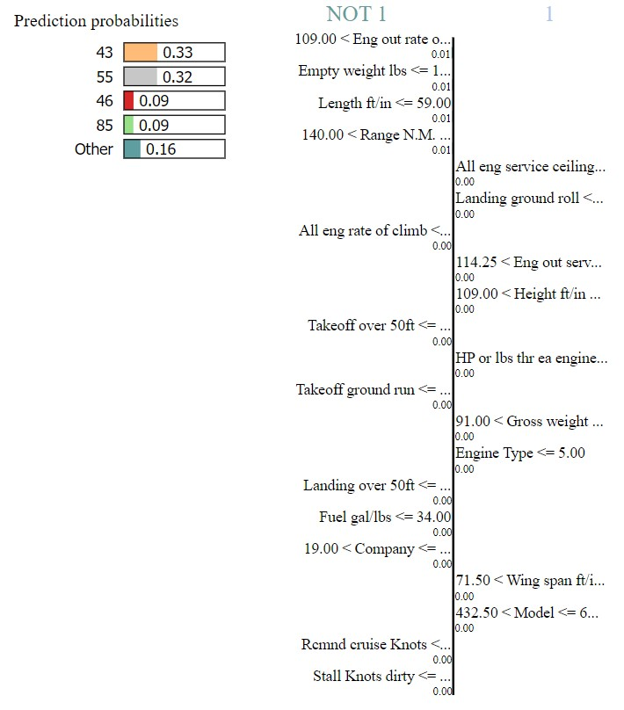

The provided spreadsheet contains performance specifications for an aircraft, likely a small, single-engine airplane. Several key features outlined in the spreadsheet are crucial for aircraft navigation and operational planning:

1. Engine Out Rate of Climb: This metric, listed as 212.00 feet per minute (ft/min), denotes the rate at which the aircraft can ascend with one engine inoperative, typically the less efficient one. A higher value indicates superior performance under such circumstances.

2. Empty Weight lbs: This figure, recorded as 114.00 lbs, represents the aircraft's weight exclusive of passengers, cargo, fuel, and crew. It serves as a fundamental parameter for calculating payload capacity, crucial for operational planning.

3. Length ft/in: At 47 ft/in, this measurement signifies the overall length of the aircraft. Understanding this dimension is vital for gauging ground clearance requirements during taxiing and maneuvering.

4. Range N.M.: Listed as 240 nautical miles (N.M.), this value denotes the maximum distance the aircraft can travel on a full tank of fuel. It is essential for flight planning, ensuring adequate fuel reserves for reaching intended destinations.

5. All Engine Service Ceiling: Although potentially a typographical error, the recorded value of 47,000 ft represents the maximum altitude at which the aircraft can maintain level flight with all engines operational. This parameter is critical for assessing the aircraft's performance in high-altitude operations.

6. Landing Ground Roll: Noted as 35.00 ft, this metric denotes the distance required for the aircraft to come to a complete stop after touchdown. A shorter roll indicates superior braking capabilities, influencing landing strategies and runway selection.

7. All Engine Rate of Climb: This figure, recorded as 40.00 ft/min, represents the rate of ascent achievable with all engines operating. It provides insight into the aircraft's climb performance under optimal conditions.

8. Wing Span ft/in: At 73 ft/in, this measurement signifies the distance from wingtip to wingtip. Understanding the wingspan is crucial for assessing ground clearance requirements during taxiing and maneuvering, particularly in constrained spaces.

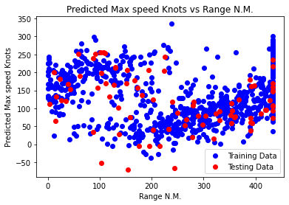

The provided scatter plot illustrates the relationship between predicted maximum speed (in knots) and range (in nautical miles) for a set of aircraft. In this plot, red dots represent predicted maximum speed values, while blue dots represent predicted range values.

Several observations can be made regarding the data depicted in the chart:

1. There seems to be a modest negative correlation between predicted maximum speed and range. This implies that as the predicted maximum speed increases, the range tends to decrease. This phenomenon is likely attributable to the fact that aircraft designed for higher speeds often prioritize performance over fuel efficiency, resulting in reduced range due to increased fuel consumption.

2. The distribution of red data points (representing predicted maximum speed) appears to be more dispersed across a wider range of values compared to the blue data points (representing range). This discrepancy suggests that there is greater variability in the predicted maximum speeds of the aircraft than there is in their respective ranges.

3. It is imperative to recognize that this scatter plot merely illustrates trends within the data and does not inherently establish a causal relationship between predicted maximum speed and range.

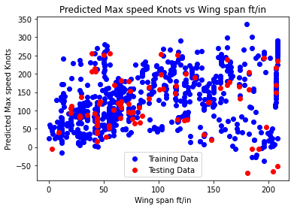

The provided scatter plot delineates the disparity between training and testing data for predicted maximum speed (in knots) and wing span (expressed in feet and inches) among various aircraft. The wing span (ft/in) is represented on the x-axis, while the predicted maximum speed knots are depicted on the y-axis.

Several observations can be derived from the data depicted in the plot:

1. No discernible correlation is evident between the disparity in training and testing data for predicted maximum speed knots and wing span ft/in. This suggests that the model's performance in predicting maximum speed does not significantly vary with different wing spans among the aircraft considered.

2. The dispersion of data points implies greater variability in the disparity between training and testing data for predicted maximum speed knots compared to wing span ft/in. This variability may stem from various factors, including the inherent complexity of accurately predicting maximum speed in contrast to wing span or variations in data quality employed for model training.

3. It is essential to acknowledge that the scatter plot solely illustrates the difference between training and testing data for two specific aircraft attributes. Consequently, it does not offer insights into the overall efficacy of the model in predicting maximum speed or wing span.

To provide a more definitive interpretation, access to the actual predicted values for maximum speed and wing span, rather than solely the difference between training and testing data, would be necessary.

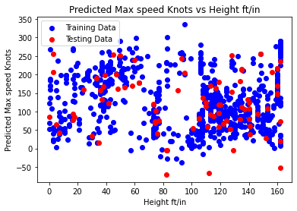

The provided scatter plot illustrates the relationship between predicted maximum speed (in knots) and height (expressed in feet and inches) for a selection of aircraft. On the plot, the y-axis represents predicted maximum speed, while the x-axis denotes height. The data points are divided into two sets: training data, depicted in blue, and testing data, represented in red.

Several observations can be made regarding the data presented in the chart:

1. A modest positive correlation is apparent between predicted maximum speed and height. This indicates that as the predicted maximum speed increases, the height tends to increase as well. This correlation may be attributed to the fact that aircraft designed for higher cruising speeds often necessitate more powerful engines, facilitating flight at higher altitudes.

2. Both the training data (blue dots) and testing data (red dots) exhibit similar trends, suggesting that the model's predictive capability is generalizable across unseen data.

3. It is crucial to acknowledge that the scatter plot merely illustrates trends within the data and does not inherently establish a causal relationship between predicted maximum speed and height.

the plot suggests that the model predicts a modest positive correlation between an aircraft's maximum speed and its flying height. Furthermore, there is indication that the model generalizes well to unseen data.

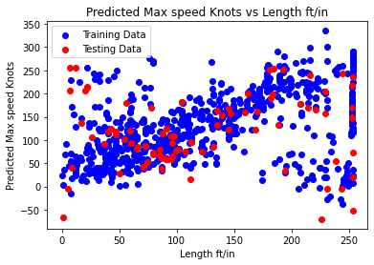

The provided scatter plot illustrates the relationship between predicted maximum speed (in knots) and length (expressed in feet and inches) for a range of aircraft.

Several observations can be derived from the data depicted in the plot:

1. A discernible correlation between predicted maximum speed and length is not evident. This implies the absence of a consistent trend wherein aircraft with longer lengths tend to exhibit higher predicted maximum speeds, or vice versa.

2. The data points exhibit dispersion across a broad spectrum of values for both predicted maximum speed and length. This variability suggests considerable diversity within the dataset.

3. It is imperative to acknowledge the inherent nature of scatter plots, which merely illustrate trends within the data and do not necessarily negate the possibility of a relationship between predicted maximum speed and length.

In summary, the scatter plot suggests a lack of a clear correlation between predicted maximum speed and length. However, without access to specific aircraft details or underlying data utilized for plot generation, drawing further nuanced conclusions is challenging.

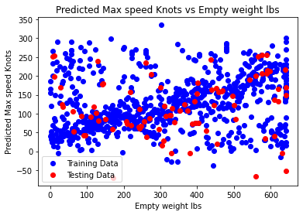

The provided scatter plot delineates the relationship between predicted maximum speed (in knots) and empty weight (expressed in pounds) for a selection of aircraft

Several observations can be made regarding the data presented in the plot:

1. A discernible correlation between predicted maximum speed and empty weight is not evident. This implies the absence of a consistent trend wherein heavier aircraft exhibit higher predicted maximum speeds, or vice versa.

2. The data points exhibit dispersion across a broad spectrum of values for both predicted maximum speed and empty weight. This variability suggests significant diversity within the dataset.

3. It is crucial to acknowledge the inherent nature of scatter plots, which merely illustrate trends within the data and do not necessarily negate the possibility of a relationship between predicted maximum speed and empty weight.

Moreover, several factors may contribute to the absence of a clear correlation. Aircraft design encompasses various considerations beyond empty weight, such as engine power and wing design, which significantly influence maximum speed.

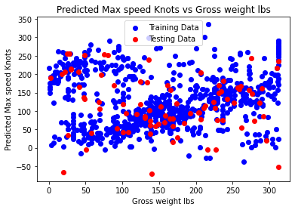

The provided scatter plot illustrates the relationship between fuel capacity (measured in gallons) and gross weight (measured in pounds) for a set of aircraft. On the plot, the x-axis denotes gross weight, while the y-axis represents fuel capacity. Additionally, a linear regression line is depicted in blue, alongside scattered data points in red.

Several observations can be deduced from the data presented in the chart:

1. A positive correlation is evident between fuel capacity and gross weight, as indicated by the trajectory of the linear regression line. This implies that as the gross weight of an aircraft increases, the fuel capacity also tends to increase. This relationship is attributed to the necessity for larger aircraft to carry more fuel to accommodate the additional weight of the aircraft itself, as well as passengers and cargo, especially over extended distances.

2. The scattered red data points exhibit variance around the regression line, signifying some deviation from the exact linear relationship. This variability suggests that not all aircraft strictly adhere to the observed correlation between fuel capacity and gross weight. Various factors, such as aircraft type, engine efficiency, and intended usage, may contribute to this variability.

In summary, the scatter plot demonstrates a positive correlation between fuel capacity and gross weight in aircraft, indicating that larger and heavier aircraft typically possess greater fuel capacity. However, the presence of scattered data points suggests that this relationship may not be absolute across all instances, with certain aircraft exhibiting deviations from the established trend.

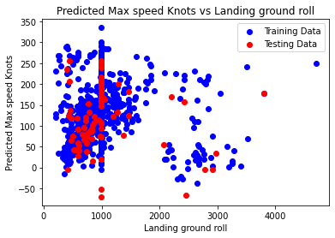

The provided scatter plot illustrates the relationship between landing ground roll (measured in feet) and predicted maximum speed (measured in knots) for a collection of aircraft. The x-axis represents landing ground roll, while the y-axis depicts predicted maximum speed. Additionally, the plot features a linear regression line in blue, accompanied by scattered data points in red.

Several observations can be gleaned from the data presented in the chart:

1. A negative correlation is apparent between landing ground roll and predicted maximum speed, as indicated by the trajectory of the linear regression line. This signifies that as the predicted maximum speed of an aircraft increases, the landing ground roll tends to decrease. This association is likely attributable to the characteristics of aircraft engineered for higher speeds, which typically feature more potent engines and superior aerodynamic properties, facilitating shorter landing distances.

2. The dispersed red data points exhibit variation around the regression line, denoting some deviation from the precise linear relationship. This variability suggests that not all aircraft strictly adhere to the observed correlation between landing ground roll and predicted maximum speed. Various factors, such as aircraft weight, wing design, and runway surface, may contribute to this variability.

In summary, the scatter plot demonstrates a negative correlation between landing ground roll and predicted maximum speed for aircraft, indicating that aircraft with higher predicted maximum speeds tend to necessitate shorter landing ground rolls. However, the presence of scattered data points implies that this relationship may not universally apply across all aircraft instances, with certain factors influencing deviations from the established trend.

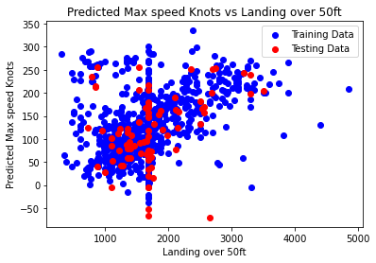

The provided scatter plot depicts the relationship between landing distance over 50 feet (measured in feet) and predicted maximum speed (measured in knots) for a selection of aircraft. The x-axis represents landing distance over 50 feet, while the y-axis illustrates predicted maximum speed. Additionally, the plot features a linear regression line in blue, accompanied by scattered data points in red.

Several observations can be derived from the data presented in the chart:

1. A weak positive correlation is discernible between landing distance over 50 feet and predicted maximum speed, as evidenced by the trajectory of the linear regression line. This suggests that as the predicted maximum speed of an aircraft increases, the landing distance over 50 feet also tends to increase. This correlation may stem from various factors, such as the larger size and increased weight of aircraft designed for higher speeds, which may necessitate longer landing distances.

2. The dispersed red data points exhibit variability around the regression line, indicating some deviation from the precise linear relationship. This variability implies that not all aircraft strictly adhere to the observed correlation between landing distance over 50 feet and predicted maximum speed. Several factors, including aircraft weight, wing design, and runway surface conditions, may contribute to this variability.

In summary, the scatter plot suggests a weak positive correlation between landing distance over 50 feet and predicted maximum speed for aircraft. However, the presence of scattered data points emphasizes the influence of additional factors on landing distance. Therefore, it is imperative to consider other pertinent variables that may impact landing distance when interpreting the relationship between landing distance over 50 feet and predicted maximum speed.

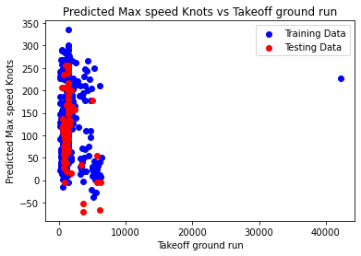

The provided plot illustrates the disparity between predicted maximum speed knots and takeoff ground run for a machine learning model, likely associated with aircraft. While the red line represents the model's predictions, the scattered distribution of blue dots around it indicates deviations between predicted and actual values. Despite a discernible positive correlation suggesting the model captures the general trend, there are instances of both underprediction and overprediction. Thus, while the model demonstrates efficacy in predicting maximum speed based on takeoff ground run, there's room for improvement to minimize errors through strategies such as augmenting training data, refining model complexity, and optimizing hyperparameters.

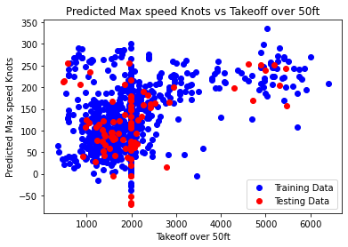

The provided scatter plot illustrates the relationship between predicted maximum speed (measured in knots) and takeoff distance over 50 feet (measured in feet) for a range of aircraft. On the plot, the y-axis represents predicted maximum speed, while the x-axis denotes takeoff distance over 50 feet. Two distinct datasets are depicted: training data in blue and testing data in red.

Several observations can be derived from the data presented in the chart:

1. A discernible correlation between predicted maximum speed and takeoff distance over 50 feet is not evident. This implies the absence of a consistent trend wherein aircraft with higher predicted maximum speeds exhibit shorter takeoff distances, or vice versa.

2. The scattered data points depict variability across a wide range of values for both predicted maximum speed and takeoff distance over 50 feet. This variability suggests considerable diversity within the dataset.

3. It is essential to acknowledge that the scatter plot solely illustrates trends within the data and does not inherently negate the possibility of a relationship between predicted maximum speed and takeoff distance over 50 feet.

Furthermore, several factors beyond predicted maximum speed, such as wing design and engine power, significantly influence aircraft takeoff performance. Thus, the absence of a clear correlation may be attributed to the multifaceted nature of aircraft design and operational considerations.

In summary, while the scatter plot does not reveal a distinct correlation between predicted maximum speed and takeoff distance over 50 feet, it underscores the influence of various factors on aircraft takeoffperformance. 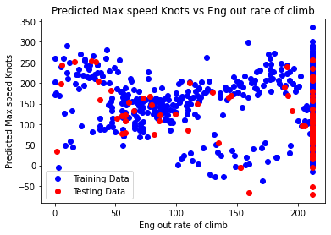

The provided scatter plot illustrates the relationship between predicted maximum speed (measured in knots) and ending out rate of climb (measured in feet per minute) for a range of aircraft. The y-axis represents predicted maximum speed, while the x-axis denotes ending out rate of climb.

The following observations can be derived from the plot:

1. A discernible positive correlation exists between predicted maximum speed and ending out rate of climb. This suggests that aircraft with higher predicted maximum speeds also tend to exhibit higher ending out rates of climb. This correlation is likely attributable to aircraft equipped with more powerful engines, enabling them to achieve both faster climb rates and higher top speeds.

2. The training data displays a wider range of ending out rate of climb values compared to the testing data. This disparity may indicate that the training data encompass a broader spectrum of aircraft types and operating conditions than the testing data.

3. The testing data points appear to cluster more tightly around the predicted trend line than the training data points. This clustering suggests that the testing data may exhibit less variability and adhere more closely to the established correlation between predicted maximum speed and ending out rate of climb.

It is essential to recognize that these observations are based solely on correlation analysis, and causation cannot be inferred directly. Other factors beyond engine power and climb rate may influence the predicted maximum speed and ending out rate of climb of an aircraft.

In summary, while the scatter plot illustrates a positive correlation between predicted maximum speed and ending out rate of climb, further investigation is necessary to elucidate the underlying factors contributing to this relationship. Additionally, consideration of other variables and conditions specific to aircraft types and operational contexts is crucial for a comprehensive understanding ofaircraftperformance characteristics. ofaircraftperformance characteristics.

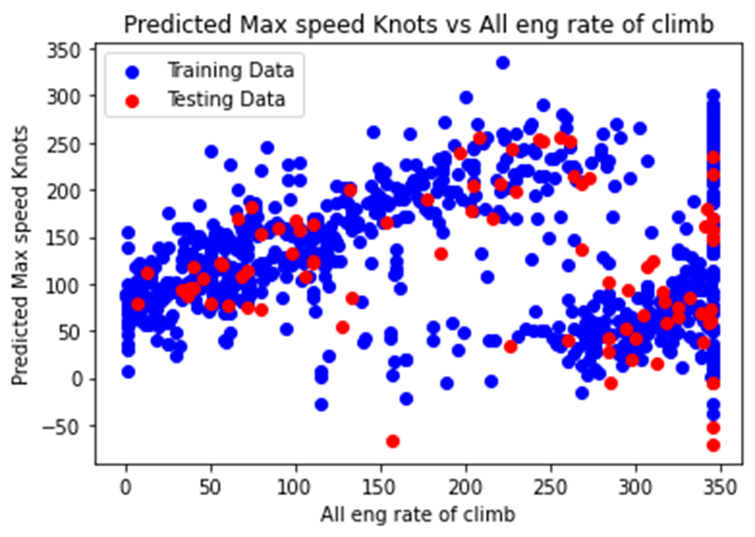

The provided scatter plot illustrates the relationship between predicted maximum speed (measured in knots) and all engine rate of climb (measured in feet per minute) for a range of aircraft. The y-axis represents predicted maximum speed, while the x-axis depicts all engine rate of climb

Several observations can be derived from the plot:

1. A discernible positive correlation exists between predicted maximum speed and all engine rate of climb. This suggests that aircraft with higher predicted maximum speeds also tend to exhibit higher all engine rates of climb. This correlation is likely attributable to aircraft equipped with more powerful engines, enabling them to achieve both faster climb rates and higher top speeds.

2. The training data displays a wider range of all engine rate of climb values compared to the testing data. This disparity may indicate that the training data encompass a broader spectrum of aircraft types and operating conditions than the testing data.

3. The testing data points appear to cluster more tightly around the predicted trend line than the training data points. This clustering suggests that the testing data may exhibit less variability and adhere more closely to the established correlation between predicted maximum speed and all engine rate of climb.

It is essential to recognize that these observations are based solely on correlation analysis, and causation cannot be inferred directly. Other factors beyond engine power and climb rate may influence the predicted maximum speed and all engine rate of climb of an aircraft.

In summary, while the scatter plot illustrates a positive correlation between predicted maximum speed and all engine rate of climb, further investigation is necessary to elucidate the underlying factors contributing to this relationship. Additionally, consideration of other variables and conditions specific to aircraft types and operational contexts is crucial for a comprehensive understanding of aircraft performance characteristics.

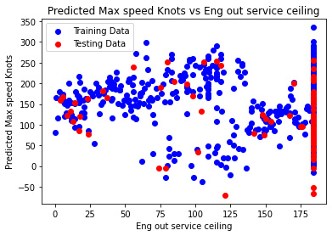

The provided plot depicts a positive correlation between predicted maximum speed (measured in knots) and engine out service ceiling (measured in altitude) for a range of aircraft. The red line represents the predicted maximum speed, while the blue line represents the predicted engine out service ceiling. The x-axis indicates the engine out service ceiling, which is the altitude an aircraft can attain and maintain level flight after losing one engine, while the y-axis represents the predicted maximum speed in knots.

The training data is utilized to construct the model predicting the engine out service ceiling and maximum speed, while the testing data is employed to assess the model's performance.

Several observations can be derived from the plot:

1. A positive correlation exists between predicted maximum speed and engine out service ceiling, implying that aircraft with higher predicted maximum speeds also tend to possess higher engine out service ceilings.

2. The training data (red dots) exhibits a broader range of engine out service ceiling values compared to the testing data (blue dots).

3. The testing data points (blue dots) are more closely clustered around the predicted trend line than the training data points (red dots).

It is imperative to acknowledge that the observed correlation does not imply causation, and there may be additional factors influencing the predicted maximum speed and engine out service ceiling of an aircraft.

In conclusion, while the plot demonstrates a positive correlation between predicted maximum speed and engine out service ceiling, further investigation is required to elucidate the underlying factors contributing to this relationship. Additionally, consideration of other variables and operational conditions specific to aircraft types is essential for a comprehensive understanding of aircraft performance characteristics.

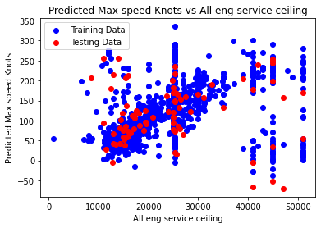

The provided plot illustrates a positive correlation between predicted maximum speed (measured in knots) and all-engine service ceiling (measured in altitude) for a range of aircraft. The red line represents the predicted maximum speed, while the blue line represents the predicted all-engine service ceiling. The x-axis denotes the all-engine service ceiling, which signifies the maximum altitude an aircraft can attain and maintain level flight with all engines operating normally. Conversely, the y-axis represents the predicted maximum speed in knots.

The training data is utilized to construct the model predicting the all-engine service ceiling and maximum speed, while the testing data is employed to assess the model's performance.

Several observations can be derived from the plot:

1. A positive correlation exists between predicted maximum speed and all-engine service ceiling, indicating that aircraft with higher predicted maximum speeds also tend to possess higher all-engine service ceilings. This relationship may be attributed to aircraft equipped with more powerful engines, enabling them to achieve both higher top speeds and cruising altitudes.

2. The training data (red dots) exhibits a broader range of all-engine service ceiling values compared to the testing data (blue dots). This disparity suggests that the model may have been trained on a more diverse set of aircraft than those utilized for testing purposes.

3. The testing data points (blue dots) are more closely clustered around the predicted trend line than the training data points (red dots). This clustering suggests that the model is performing better on the testing data than on the training data.

It is essential to acknowledge that the observed correlation does not imply causation, and other factors may influence the predicted maximum speed and all-engine service ceiling of an aircraft.

In conclusion, while the plot demonstrates a positive correlation between predicted maximum speed and all-engine service ceiling, further investigation is required to elucidate the underlying factors contributing to this relationship. Additionally, consideration of other variables and operational conditions specific to aircraft types is necessary for a comprehensive understanding of aircraft performance characteristics.

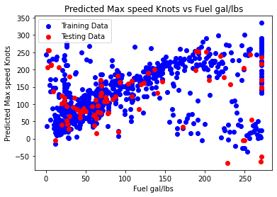

The provided plot illustrates the relationship between predicted maximum speed (measured in knots) and fuel consumption (measured in gallons per pound) for a range of aircraft.

Observations from the plot include:

1. A negative correlation exists between predicted maximum speed and fuel consumption. This implies that aircraft with higher predicted maximum speeds tend to exhibit lower fuel consumption rates (gallons per pound). This correlation is likely attributable to more aerodynamically efficient aircraft designs, which can achieve higher speeds while consuming less fuel.

2. The training data (red dots) demonstrates a wider range of fuel consumption values compared to the testing data (blue dots). This difference may suggest that the training data encompass a broader spectrum of aircraft types and operating conditions than the testing data.

3. The testing data points (blue dots) appear to cluster more tightly around the predicted trend line than the training data points (red dots). This clustering suggests that the model may perform better on the testing data compared to the training data.

In conclusion, while the plot demonstrates a negative correlation between predicted maximum speed and fuel consumption, further investigation is necessary to understand the underlying factors influencing this relationship. Additionally, consideration of other variables and operational conditions specific to aircraft types is crucial for a comprehensive understanding of aircraft performance characteristics.

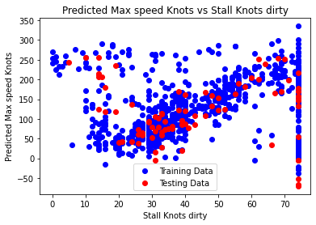

The provided plot illustrates a scatter plot comparing the difference between predicted and actual values for maximum speed (measured in knots) and stall speed dirty (measured in knots) for a range of aircraft. The x-axis represents the stall speed dirty, which denotes the speed at which an aircraft, with its landing gear down and flaps extended, will stall. Conversely, the y-axis represents the difference between predicted and actual maximum speed in knots.

Observations from the plot include:

1. There is no discernible correlation between the difference in predicted and actual maximum speed and stall speed dirty. This indicates that the discrepancy between predicted and actual maximum speed is not contingent upon an aircraft's stall speed dirty.

2. The data points are scattered around the zero line on the y-axis, implying that for some aircraft, the predicted maximum speed exceeds the actual maximum speed, while for others, the predicted maximum speed falls below the actual maximum speed.

3. There is a wider range of values for the stall speed dirty on the x-axis for the training data compared to the testing data. This disparity suggests that the model may have been trained on a more diverse set of aircraft in terms of stall speed dirty than those utilized for testing.

In conclusion, further analysis and consideration of additional factors are necessary to comprehend the relationship between predicted and actual maximum speed and stall speed dirty accurately. Additionally, the interpretation of the plot should be approached with caution, given its limitations in providing conclusive insights.

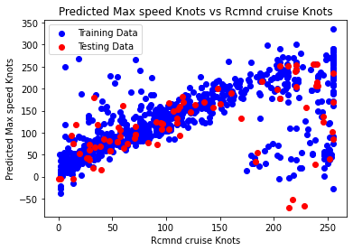

The provided plot illustrates a scatter plot of predicted maximum speed (measured in knots) against recommended cruise speed (measured in knots) for a variety of aircraft.

Observations from the plot include:

1. A weak positive correlation exists between predicted maximum speed and recommended cruise speed. This suggests that aircraft with higher predicted maximum speeds tend to have higher recommended cruise speeds. This correlation is likely due to aircraft designed for higher speeds being optimized for efficient flight at those speeds.

2. Recommended cruise speeds generally appear lower than predicted maximum speeds. This is likely because aircraft are typically not operated at their maximum speeds for extended periods due to considerations of fuel efficiency.

3. The training data exhibit a wider range of recommended cruise speed values compared to the testing data. This discrepancy suggests that the training data may encompass a broader spectrum of aircraft types and operating conditions than the testing data.

4. The testing data points appear to cluster more tightly around the predicted trend line than the training data points indicating potentially better model performance on the testing data.

It is important to note that these observations are based on correlation analysis, and causation cannot be inferred directly. Additionally, other factors may influence the relationship between recommended cruise speed and predicted maximum speed, such as aircraft design and operating conditions.

In conclusion, while the plot illustrates a weak positive correlation between predicted maximum speed and recommended cruise speed, further investigation is required to understand the underlying factors driving this relationship. Moreover, consideration of additional variables specific to aircraft types and operational contexts is essential for a comprehensive understanding of aircraft performance characteristics.

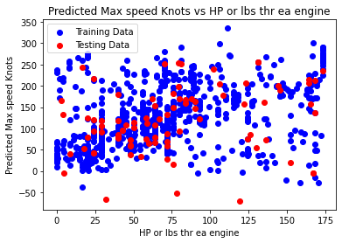

The provided plot depicts a scatter plot illustrating the relationship between predicted maximum speed (measured in knots) on the y-axis and horsepower or pounds of thrust per engine (measured in hp/lbs) on the x-axis for various aircraft.

Key observations from the plot include:

1. A positive correlation is evident between predicted maximum speed and horsepower or pounds of thrust per engine. This indicates that aircraft with higher predicted maximum speeds tend to feature higher horsepower or pounds of thrust per engine. This correlation is likely due to the capability of more powerful engines to achieve higher top speeds.

2. The training data exhibit a wider range of horsepower or pounds of thrust per engine values compared to the testing data .This suggests that the training data may encompass a broader spectrum of aircraft types and engine configurations than the testing data.

3. The testing data points appear to cluster more tightly around the predicted trend line than the training data points indicating potentially better model performance on the testing data.

However, it is imperative to recognize that these observations are based on correlation analysis and do not establish causation. Moreover, other factors may influence the relationship between predicted maximum speed and horsepower or pounds of thrust per engine, such as aircraft design and operational conditions.

In conclusion, while the plot demonstrates a positive correlation between predicted maximum speed and horsepower or pounds of thrust per engine, further investigation is necessary to comprehend the underlying factors driving this relationship. Additionally, consideration of additional variables specific to aircraft types and engine configurations is essential for a comprehensive understanding of aircraft performance characteristics.

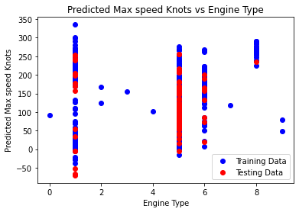

The provided plot illustrates a scatter plot depicting the relationship between predicted maximum speed (measured in knots) on the y-axis and engine type on the x-axis for various aircraft. Although the specific engine types are not labeled on the x-axis, it appears that there are four distinct categories.

Key observations from the plot include:

1. There is no discernible correlation between predicted maximum speed and engine type. This implies that engine type alone is not a reliable predictor of an aircraft's top speed. Numerous other factors, such as weight, wing design, and aerodynamic efficiency, significantly influence an aircraft's maximum speed.

2. The wide range of predicted maximum speeds for each engine type suggests that engine type is just one of several factors determining an aircraft's top speed.

3. Data points are scattered across the plot, without clear separation between different engine types. This further supports the notion that engine type alone is not indicative of an aircraft's maximum speed.

4. The training data exhibit a broader range of predicted maximum speed values compared to the testing data which may suggest a wider variety of aircraft types and operating conditions in the training dataset.

5. The testing data points appear to cluster more tightly around the predicted trend line than the training data points indicating potentially better model performance on the testing data.

However, it is crucial to acknowledge that these observations are based on correlation analysis, and causation cannot be inferred directly. Furthermore, other factors beyond engine type may influence an aircraft's maximum speed.

In conclusion, while the plot illustrates no clear correlation between predicted maximum speed and engine type, further investigation is necessary to understand the interplay between various factors affecting an aircraft's performance characteristics. Additionally, the interpretation of the plot should be approached with caution, given its limitations in providing conclusive insights.

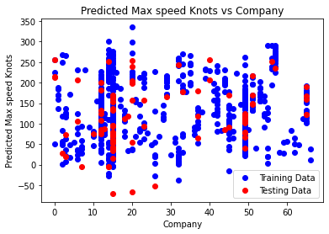

Based on the provided image, the plot displays a scatter plot representing the relationship between predicted maximum speed (measured in knots) on the y-axis and the manufacturer (company) of the aircraft on the x-axis.

Observations from the plot include:

1. There appears to be no evident correlation between predicted maximum speed and the aircraft manufacturer. This suggests that the manufacturer alone is not a reliable predictor of an aircraft's top speed. Numerous other factors, such as weight, wing design, and aerodynamic efficiency, significantly influence an aircraft's maximum speed.

2. The wide range of predicted maximum speeds across each manufacturer indicates that the company is not the sole determinant of an aircraft's top speed.

3. Data points are scattered across the plot, with no clear delineation between different aircraft manufacturers. This reinforces the notion that the manufacturer alone does not dictate an aircraft's maximum speed.

4. The training data exhibit a broader range of predicted maximum speed values compared to the testing data suggesting a more diverse set of aircraft types and operating conditions in the training dataset.

5. The testing data points seem to cluster more closely around the predicted trend line than the training data points implying potentially improved model performance on the testing data.

However, it is crucial to acknowledge that these observations are derived from correlation analysis, and causation cannot be directly inferred. Additionally, other factors beyond the aircraft manufacturer may influence an aircraft's maximum speed.

In conclusion, while the plot demonstrates no clear correlation between predicted maximum speed and aircraft manufacturer, further investigation is warranted to understand the myriad factors influencing an aircraft's performance characteristics. Furthermore, it is important to recognize the limitations of this visualization in providing conclusive insights without additional context and analysis.

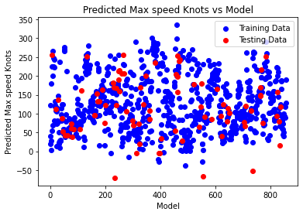

The provided scatter plot illustrates the relationship between predicted and actual maximum speed (knots) for a machine learning model's training data.

* The red dots depict the predicted maximum speed (knots) generated by the model.

* The blue dots represent the actual maximum speed (knots) from the training data.

The axes of the plot are labeled as follows:

* X-axis: Model - Presumably indicating the predicted maximum speed (knots) generated by the model.

* Y-axis: Predicted Max Speed Knots

Ideally, the red dots would align precisely along a diagonal line from the bottom left to the top right of the plot, signifying perfect agreement between the model's predictions and the actual training data.

However, there is some dispersion observed around this diagonal line in the plot, suggesting that while the model's predictions generally approximate the actual values, there are instances of deviation.

Additional observations:

* Some red dots appear notably below the diagonal line, indicating instances where the model underestimated the maximum speed (knots) for certain aircraft.

* Conversely, some red dots are situated significantly above the diagonal line, suggesting instances where the model overestimated the maximum speed (knots) for particular aircraft.

Overall, the plot suggests that the model demonstrates reasonable predictive performance regarding aircraft maximum speed (knots) but exhibits room for enhancement.

Potential avenues for improving the model include:

* Augmenting the training dataset with additional instances.

* Employing a more sophisticated machine learning model.

* Fine-tuning the model's hyperparameters to optimize performance.

These measures could potentially enhance the model's accuracy and reliability in predicting aircraft maximum speed (knots) more effectively.

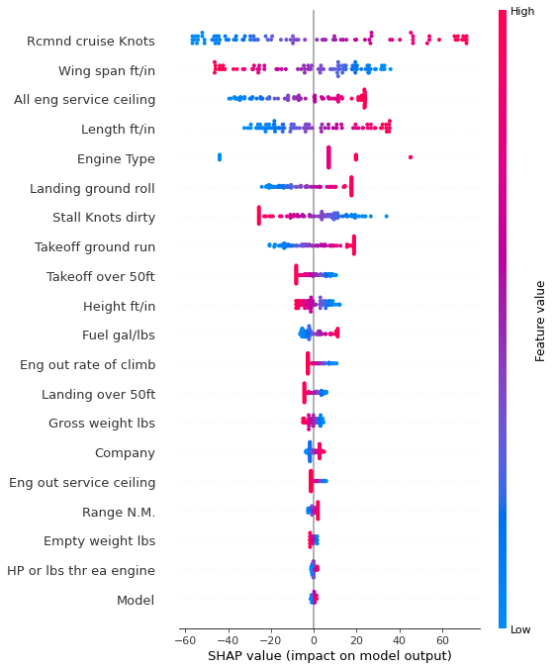

The image provided appears to offer a partial visualization of a machine learning model, likely aimed at predicting aircraft speed.

On the left side of the image, various features of an aircraft model are listed, including wing span, length, engine type, landing ground roll, stall knots dirty, takeoff ground run, takeoff over 50ft, height, fuel gal/lbs, gross weight, empty weight, and HP or lbs thr ea engine.

On the right side, the SHAP (SHapley Additive exPlanations) values for different feature values are displayed. SHAP is utilized to explain the impact of each feature on the model's output. In this context, the SHAP value appears to demonstrate how much a specific feature value contributes to the model's prediction of fuel consumption.

For instance, according to the SHAP value, a higher wing span corresponds to higher fuel gallons, which aligns with the notion that larger airplanes typically demand more fuel to operate.

However, it's crucial to acknowledge that this representation offers only a partial view of the machine learning model. Without access to the complete model, it remains challenging to definitively determine how each feature influences fuel consumption.

Nevertheless, this image provides valuable insights into the model's predictive process by illustrating the impact of various aircraft features on its fuel consumption predictions.

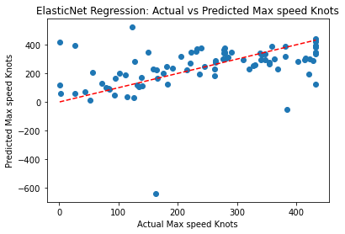

The provided scatter plot illustrates the relationship between the actual and predicted maximum speeds of aircraft, measured in knots. The red line represents the predicted maximum speed, while the blue line represents the actual maximum speed. Broadly, a positive correlation between predicted and actual maximum speeds is observed, implying that as the predicted maximum speed increases, so does the actual maximum speed. However, the scattered distribution of data points around the red line signifies that the predictions are not consistently precise, indicating variability between predicted and actual values. Additionally, the presence of data points that deviate notably from the red line suggests potential outliers within the dataset or limitations in the model's accuracy across all aircraft types. In summary, while the model can offer general predictions regarding aircraft maximum speed, it's crucial to acknowledge the inherent variability and potential limitations in prediction accuracy.

The provided equation represents a complex predictive model for determining the maximum speed in knots of aircraft based on various factors including company, engine type, horsepower, recommended cruise speed, stall speed, fuel capacity, service ceilings, rates of climb, takeoff and landing parameters, aircraft dimensions, and weight. Each coefficient in the equation reflects the relative importance of the corresponding variable in predicting the maximum speed. Understanding this equation is crucial for optimizing aircraft performance, informing design decisions, and enhancing safety measures by predicting the aircraft's capabilities under different conditions and configurations. It allows for comprehensive analysis and informed decision-making in the aviation industry, contributing to the efficiency and effectiveness of aircraft operations.

**PHASE-8(Interpretation of ‘ACTIVE STATUS’ of aircraft lanes used for air transportation mentioned in flowchart-3):**

|  |  |  |  |  |  |  |  |  |
| --- | --- | --- | --- | --- | --- | --- | --- | --- |
| index | Airline ID | Name | Alias | IATA | ICAO | Callsign | Country | Active |
| 0 | -1 | Unknown | \N | 1T | GNL | \N | \N | Y |
| 1 | 1 | Private flight | \N | 1T | GNL | \N | \N | Y |
| 2 | 2 | 135 Airways | \N | 1T | GNL | \N | United States | N |
| 3 | 3 | 1Time Airline | \N | 1T | RNX | NEXTIME | South Africa | Y |
| 4 | 4 | 2 Sqn No 1 Elementary Flying Training School | \N | 1T | WYT | NEXTIME | United Kingdom | N |
| 5 | 5 | 213 Flight Unit | \N | 1T | TFU | NEXTIME | Russia | N |
| 6 | 6 | 223 Flight Unit State Airline | \N | 1T | CHD | CHKALOVSK-AVIA | Russia | N |
| 7 | 7 | 224th Flight Unit | \N | 1T | TTF | CARGO UNIT | Russia | N |
| 8 | 8 | 247 Jet Ltd | \N | 1T | TWF | CLOUD RUNNER | United Kingdom | N |
| 9 | 9 | 3D Aviation | \N | 1T | SEC | SECUREX | United States | N |
| 10 | 10 | 40-Mile Air | \N | Q5 | MLA | MILE-AIR | United States | Y |
| 11 | 11 | 4D Air | \N | Q6 | QRT | QUARTET | Thailand | N |
| 12 | 12 | 611897 Alberta Limited | \N | Q7 | THD | DONUT | Canada | N |
| 13 | 13 | Ansett Australia | \N | AN | AAA | ANSETT | Australia | Y |
| 14 | 14 | Abacus International | \N | 1B | AAA | ANSETT | Singapore | Y |
| 15 | 15 | Abelag Aviation | \N | W9 | AAB | ABG | Belgium | N |
| 16 | 16 | Army Air Corps | \N | W10 | AAC | ARMYAIR | United Kingdom | N |
| 17 | 17 | Aero Aviation Centre Ltd. | \N | W11 | AAD | SUNRISE | Canada | N |
| 18 | 18 | Aero Servicios Ejecutivos Internacionales | \N | W12 | SII | ASEISA | Mexico | N |
| 19 | 19 | Aero Biniza | \N | W13 | BZS | BINIZA | Mexico | N |
| 20 | 20 | Aero Albatros | \N | W14 | ABM | ALBATROS ESPANA | Spain | N |
| 21 | 21 | Aigle Azur | \N | ZI | AAF | AIGLE AZUR | France | Y |
| 22 | 22 | Aloha Airlines | \N | AQ | AAH | ALOHA | United States | Y |
| 23 | 23 | Alaska Island Air | \N | AQ | AAK | ALASKA ISLAND | United States | N |
| 24 | 24 | American Airlines | \N | AA | AAL | AMERICAN | United States | Y |
| 25 | 25 | Aviation Management Corporation | \N | AA | AAM | AM CORP | United States | N |
| 26 | 26 | Atlantis Airlines (USA) | \N | AA | AAO | ATLANTIS AIR | United States | N |
| 27 | 27 | Aerovista Airlines | \N | AA | AAP | AEROVISTA GROUP | United Arab Emirates | N |
| 28 | 28 | Asiana Airlines | \N | OZ | AAR | ASIANA | Republic of Korea | Y |
| 29 | 29 | Askari Aviation | \N | 4K | AAS | AL-AAS | Pakistan | Y |
| 30 | 30 | Australia Asia Airlines | \N | 4K | AAU | AUSTASIA | Australia | N |
| 31 | 31 | Astro Air International | \N | 4K | AAV | ASTRO-PHIL | United States | N |
| 32 | 32 | Afriqiyah Airways | \N | 8U | AAW | AFRIQIYAH | Libya | Y |
| 33 | 33 | Afrinat International Airlines | \N | Q9 | AFU | AFRIQIYAH | Gambia | N |
| 34 | 34 | Afric'air Express | \N | Q10 | AAX | AFREX | Ivory Coast | N |
| 35 | 35 | Allegiant Air | \N | G4 | AAY | ALLEGIANT | United States | Y |
| 36 | 36 | Angus Aviation | \N | G5 | AAZ | ANGUS | Canada | N |
| 37 | 37 | Artem-Avia | \N | G6 | ABA | ARTEM-AVIA | Ukraine | N |
| 38 | 38 | African Business and Transportations | \N | G7 | ABB | AFRICAN BUSINESS- | Democratic Republic of the Congo | N |
| 39 | 39 | Aban Air | \N | K5 | ABE | ABAN | Iran | n |
| 40 | 40 | Aerial Oy | \N | K6 | ABF | SKYWINGS | Finland | N |
| 41 | 41 | Abakan-Avia | \N | K7 | ABG | ABAKAN-AVIA | Russia | N |
| 42 | 42 | ABSA - Aerolinhas Brasileiras | \N | M3 | TUS | ABSA Cargo | Brazil | Y |
| 43 | 43 | Abaet | \N | M4 | ABJ | Abaet | Brazil | N |
| 44 | 44 | Alberta Citylink | \N | M5 | ABK | ALBERTA CITYLINK | Canada | N |
| 45 | 45 | APSA Colombia | \N | M6 | ABO | AEROEXPRESO | Colombia | N |
| 46 | 46 | Aerovias Bueno | \N | M7 | ABU | AEROBUENO | Colombia | N |
| 47 | 47 | Aerocenter | \N | M8 | ACR | Escuela de Formacion de Pioltos Privados de Avion | AEROCENTER | N |
| 48 | 48 | Antrak Air | \N | 4 | ABV | ANTRAK | Ghana | N |
| 49 | 49 | Airborne Express | \N | GB | ABX | ABEX | United States | N |
| 50 | 50 | ABX Air | \N | GB | ABX | ABEX | United States | N |
| 51 | 51 | ATA Brasil | \N | GB | ABZ | ATA-BRAZIL | Brazil | N |
| 52 | 52 | Avcard Services | \N | GB | ACC | ATA-BRAZIL | United Kingdom | N |
| 53 | 53 | Academy Airlines | \N | GB | ACD | ACADEMY | United States | N |
| 54 | 54 | Aero Comondu | \N | GB | ACO | AERO COMONDU | Mexico | N |
| 55 | 55 | Astral Aviation | \N | 8V | ACP | ASTRAL CARGO | Kenya | Y |
| 56 | 56 | Air Cess | \N | 8V | ACS | ASTRAL CARGO | Liberia | N |
| 57 | 57 | Air Aurora | \N | 8V | AAI | BOREALIS | United States | N |
| 58 | 58 | Air Cargo Transportation System | \N | 8V | ACU | AFRISPIRIT | Kenya | N |
| 59 | 59 | Air Charter Service | \N | 8V | ACV | AFRISPIRIT | United Kingdom | N |
| 60 | 60 | Aero Asia International | \N | E4 | RSO | AERO ASIA | Pakistan | N |
| 61 | 61 | Air Charters | \N | E5 | ACX | PARAIR | Canada | N |
| 62 | 62 | Air Togo | \N | YT | TGA | AIR TOGO | Togo | N |
| 63 | 63 | Air Somalia | \N | YT | RSM | AIR SOMALIA | Somali Republic | N |
| 64 | 64 | Atlas Cargo Lines | \N | YT | ACY | ATLAS CARGOLINES | Morocco | N |
| 65 | 65 | Airservices Australia | \N | YT | ADA | AUSCAL | Australia | N |
| 66 | 66 | Advance Leasing Company | \N | 4G | ADA | AUSCAL | United States | N |
| 67 | 67 | Aztec Worldwide Airlines | \N | 7A | ADA | AUSCAL | United States | N |
| 68 | 68 | Air Tindi | \N | 8T | ADA | AUSCAL | Canadian Territories | Y |
| 69 | 69 | Antonov Airlines | \N | 8T | ADB | ANTONOV BUREAU | Ukraine | N |
| 70 | 70 | Air Atlantic Dominicana | \N | 8T | ADC | ATLAN-DOMINICAN | Dominican Republic | N |
| 71 | 71 | Advanced Air Co. | \N | 8T | ADD | ATLAN-DOMINICAN | Japan | N |
| 72 | 72 | Ada Air | \N | ZY | ADE | ADA AIR | Albania | Y |
| 73 | 73 | Aerea Flying Training Organization | \N | ZY | ADG | AEREA TRAINING | Spain | N |
| 74 | 74 | Audeli Air | \N | ZY | ADI | AUDELI | Spain | N |
| 75 | 75 | Abicar | \N | ZY | ADJ | ABICAR | Ivory Coast | N |
| 76 | 76 | ADC Airlines | \N | Z7 | ADK | ADCO | Nigeria | N |
| 77 | 77 | Aero Dynamics | \N | Z8 | ADL | COTSWOLD | United Kingdom | N |
| 78 | 78 | Aerolineas Dominicanas | \N | Z9 | ADM | DOMINAIR | Dominican Republic | N |
| 79 | 79 | Aerodienst GmbH | \N | Z10 | ADN | AERODIENST | Germany | N |
| 80 | 80 | Aerodiplomatic | \N | Z11 | ADP | AERODIPLOMATIC | Mexico | N |
| 81 | 81 | Aerodyne | \N | Z12 | ADY | AERODYNE | United States | N |
| 82 | 82 | Avion Taxi | \N | Z13 | ADQ | AIR DATA | Canada | N |
| 83 | 83 | Adria Airways | \N | JP | ADR | ADRIA | Slovenia | Y |
| 84 | 84 | Aviones de Sonora | \N | JP | ADS | SONORAV | Mexico | N |
| 85 | 85 | Air Dorval | \N | JP | ADT | AIR DORVAL | Canada | N |
| 86 | 86 | Airdeal Oy | \N | JP | ADU | AIRDEAL | Finland | N |
| 87 | 87 | Advance Air Charters | \N | JP | ADV | ADVANCE | Canada | N |
| 88 | 88 | Air Andaman | \N | JP | ADW | AIR ANDAMAN | Thailand | N |
| 89 | 89 | Anderson Aviation | \N | JP | ADX | ANDAX | United States | N |
| 90 | 90 | Air Europa | \N | UX | AEA | EUROPA | Spain | Y |
| 91 | 91 | Air Southwest Ltd. | \N | UX | ASW | AIRSOUTHWEST | Canada | N |
| 92 | 92 | Air Special | \N | UX | ASX | AIRSPEC | Czech Republic | N |
| 93 | 93 | Aero Benin | \N | EM | AEB | AEROBEN | Benin | Y |
| 94 | 94 | Aerocesar | \N | EM | AEC | Aerovias Del Cesar | AEROCESAR | N |
| 95 | 95 | Aerotrans Airlines | \N | EM | AED | Aerovias Del Cesar | Russia | N |
| 96 | 96 | Aegean Airlines | \N | A3 | AEE | AEGEAN | Greece | Y |
| 97 | 97 | Aerofumigaciones Sam | \N | A4 | AEG | FUMIGACIONES SAM | Chile | N |
| 98 | 98 | Aeroexpreso Interamericano | \N | A5 | AEI | INTERAM | Colombia | N |
| 99 | 99 | Air Express | \N | A6 | AEJ | KHAKI EXPRESS | Tanzania | N |
| 100 | 100 | Aerocon | \N | A7 | AEK | AEROCON | Bolivia | N |
| 101 | 101 | Aero Madrid | \N | A8 | AEM | AEROMADRID | Spain | N |
| 102 | 102 | Aeroenlaces Nacionales | \N | A9 | AEN | AEROMADRID | Mexico | N |
| 103 | 103 | Aeroservicios Ejecutivos Del Occidente | \N | A10 | AEO | AERO OCCIDENTE | Mexico | N |
| 104 | 104 | Aerotec | \N | A11 | AEP | AEROTEC | Spain | N |
| 105 | 105 | Air Atlantique | \N | KI | AAG | ATLANTIC | United Kingdom | N |
| 106 | 106 | Air Europe | \N | PE | AEL | AIR EUROPE | Italy | Y |
| 107 | 107 | Air Alma | \N | PE | AAJ | AIR ALMA | Canada | N |
| 108 | 108 | Air Express | \N | PE | AEQ | LUNA | Sweden | N |
| 109 | 109 | Alaska Central Express | \N | KO | AER | ACE AIR | United States | Y |
| 110 | 110 | ACES Colombia | \N | KO | AES | ACES | Colombia | Y |
| 111 | 111 | Aeronautical Radio of Thailand | \N | KO | AET | AEROTHAI | Thailand | N |
| 112 | 112 | Astraeus | \N | 5W | AEU | FLYSTAR | United Kingdom | Y |
| 113 | 113 | Aeroventas | \N | 5W | AEV | AEROVENTAS | Mexico | N |
| 114 | 114 | Aerosvit Airlines | \N | VV | AEW | AEROSVIT | Ukraine | Y |
| 115 | 115 | Airway Express | \N | VV | AEX | AVCO | United States | N |
| 116 | 116 | Air Italy | \N | I9 | AEY | AIR ITALY | Italy | Y |
| 117 | 117 | Aerial Transit Company | \N | I10 | AEZ | AERIAL TRANZ | United States | N |
| 118 | 118 | Alfa Air | \N | I11 | AFA | BLUE ALFA | Czech Republic | N |
| 119 | 119 | American Falcon | \N | WK | AFB | AMERICAN FALCON | Argentina | N |
| 120 | 120 | Alliance Airlines | \N | QQ | UTY | UNITY | Australia | Y |
| 121 | 121 | Air Universal | \N | QQ | UVS | UNI-LEONE | Sierra Leone | N |
| 122 | 122 | Auvia Air | \N | QQ | UVT | AUVIA | Indonesia | N |
| 123 | 123 | African West Air | \N | QQ | AFC | AFRICAN WEST | Senegal | N |
| 124 | 124 | Airfast Indonesia | \N | QQ | AFE | AIRFAST | Indonesia | N |
| 125 | 125 | Ariana Afghan Airlines | \N | FG | AFG | ARIANA | Afghanistan | Y |
| 126 | 126 | Air Fecteau | \N | FG | AFH | FECTO | Canada | N |
| 127 | 127 | Africaone | \N | FG | AFI | AFRICAWORLD | Uganda | N |
| 128 | 128 | Alliance | \N | FG | AFJ | JAMBO | Uganda | N |
| 129 | 129 | Africa Air Links | \N | FG | AFK | AFRICA LINKS | Sierra Leone | N |
| 130 | 130 | Aeroflot Russian Airlines | \N | SU | AFL | AEROFLOT | Russia | Y |
| 131 | 131 | Aero Empresa Mexicana | \N | SU | AFO | AERO EMPRESA | Mexico | N |
| 132 | 132 | Air Bosna | \N | JA | BON | AIR BOSNA | Bosnia and Herzegovina | Y |
| 133 | 133 | Air Bravo | \N | JA | BRF | AIR BRAVO | Uganda | N |
| 134 | 134 | Air Brasd'or | \N | JA | BRL | BRASD'OR | Canada | N |
| 135 | 135 | Air 500 | \N | JA | BRM | BOOMERANG | Canada | N |
| 136 | 136 | Alba Servizi Aerotrasporti | \N | JA | AFQ | ALBA | Italy | N |
| 137 | 137 | Air France | \N | AF | AFR | AIRFRANS | France | Y |
| 138 | 138 | Air Partner | \N | AF | ACG | AIR PARTNER | United Kingdom | N |
| 139 | 139 | Air Caledonie International | \N | SB | ACI | AIRCALIN | France | Y |
| 140 | 140 | Air Caledonia | \N | SB | ACM | WEST CAL | Canada | N |
| 141 | 141 | Air Guam | \N | SB | AGM | AIR GUAM | United States | N |
| 142 | 142 | Air Gabon | \N | GN | AGN | GOLF NOVEMBER | Gabon | N |
| 143 | 143 | Air Data | \N | GN | AFS | GOLF NOVEMBER | United Kingdom | N |
| 144 | 144 | Air Afrique Vacancies | \N | GN | AFV | AFRIQUE VACANCE | Ivory Coast | N |
| 145 | 145 | Air Cargo America | \N | GN | MVM | PEGASUS | United States | N |
| 146 | 146 | Air Salone | \N | 2O | MVM | PEGASUS | Sierra Leone | Y |
| 147 | 147 | Air-Angol | \N | 2O | NGO | AIR ANGOL | Angola | N |
| 148 | 148 | Air Nigeria | \N | 2O | NGP | REGAL EAGLE | Nigeria | N |
| 149 | 149 | Air Cargo Carriers | \N | 2Q | SNC | NIGHT CARGO | United States | Y |
| 150 | 150 | Air Samarkand | \N | 2Q | SND | ARSAM | Uzbekistan | N |
| 151 | 151 | Air Senegal International | \N | V7 | SNG | AIR SENEGAL | Senegal | N |
| 152 | 152 | Air Sandy | \N | V8 | SNY | AIR SANDY | Canada | N |
| 153 | 153 | Air Namibia | \N | SW | NMB | NAMIBIA | Namibia | Y |
| 154 | 154 | Air Intersalonika | \N | SW | NSK | INTERSALONIKA | Greece | N |
| 155 | 155 | Air Anatolia | \N | SW | NTL | AIR ANATOLIA | Turkey | N |
| 156 | 156 | Air Saigon | \N | SW | SGA | AIR SAIGON | Vietnam | N |
| 157 | 157 | Afrique Regional Airways | \N | SW | AFW | AFRAIR | Ivory Coast | N |
| 158 | 158 | Airfreight Express | \N | SW | AFX | AFRAIR | United Kingdom | N |
| 159 | 159 | Africa Chartered Services | \N | SW | AFY | AFRICA CHARTERED | Nigeria | N |
| 160 | 160 | Africa Freight Services | \N | SW | AFZ | AFREIGHT | Zambia | N |
| 161 | 161 | Aeronaves Del Centro | \N | SW | AGA | AFREIGHT | Venezuela | N |
| 162 | 162 | Air Service Gabon | \N | G8 | AGB | AFREIGHT | Gabon | N |
| 163 | 163 | Arab Agricultural Aviation Company | \N | G9 | AGC | AGRICO | Egypt | N |
| 164 | 164 | Atlantic Gulf Airlines | \N | G10 | AGF | ATLANTIC GULF | United States | N |
| 165 | 165 | Aerolitoral | \N | 5D | SLI | COSTERA | Mexico | Y |
| 166 | 166 | Algoma Airways | \N | 5D | AGG | ALGOMA | Canada | N |
| 167 | 167 | Altagna | \N | 5D | AGH | ALTAGNA | France | N |
| 168 | 168 | Angola Air Charter | \N | 5D | AGO | ANGOLA CHARTER | Angola | N |
| 169 | 169 | Angola Air Charter | \N | 5D | AGO | ANGOLA CHARTER | Angola | N |
| 170 | 170 | AERFI Group | \N | 5D | AGP | AIR TARA | Ireland | N |
| 171 | 171 | Aerogala | \N | 5D | AGQ | GALASERVICE | Chile | N |
| 172 | 172 | Amadeus Global Travel Distribution | \N | 1A | AGT | AMADEUS | Spain | N |
| 173 | 173 | Angara Airlines | \N | 1A | AGU | SARMA | Russia | N |
| 174 | 174 | Air Glaciers | \N | 7T | AGV | AIR GLACIERS | Switzerland | Y |
| 175 | 175 | Aero Gambia | \N | 7T | AGW | AERO GAMBIA | Gambia | N |
| 176 | 176 | Aviogenex | \N | 7T | AGX | GENEX | Serbia | Y |
| 177 | 177 | Atlantic Coast Airlines | \N | 7T | BLR | BLUE RIDGE | United States | N |
| 178 | 178 | Aero Barloz | \N | 7T | BLZ | AEROLOZ | Mexico | N |
| 179 | 179 | Aeroper | \N | PL | PLI | Aeroperu | Peru | Y |
| 180 | 180 | Atlas Blue | \N | 8A | BMM | ATLAS BLUE | Morocco | Y |
| 181 | 181 | Aero Banobras | \N | 8A | BNB | AEROBANOBRAS | Mexico | N |
| 182 | 182 | Aero Flight Service | \N | 8A | AGY | FLIGHT GROUP | United States | N |
| 183 | 183 | Agrolet-Mci | \N | 8A | AGZ | AGROLET | Slovakia | N |
| 184 | 184 | Air Alpha Greenland | \N | GD | AHA | AIR ALPHA | Denmark | N |
| 185 | 185 | Azal Avia Cargo | \N | GD | AHC | AZALAVIACARGO | Azerbaijan | N |
| 186 | 186 | Airport Helicopter Basel | \N | GD | AHE | Muller & Co. | AIRPORT HELICOPTER | N |
| 187 | 187 | Aeroservices Corporate | \N | GD | CJE | BIRD JET | France | N |
| 188 | 188 | Aspen Helicopters | \N | GD | AHF | ASPEN | United States | N |
| 189 | 189 | Aerochago Airlines | \N | GD | AHG | AEROCHAGO | Dominican Republic | N |
| 190 | 190 | Airplanes Holdings | \N | GD | AHH | AIRHOLD | Ireland | N |
| 191 | 191 | Air Hong Kong | \N | LD | AHK | AIR HONG KONG | Hong Kong | N |
| 192 | 192 | Aerochiapas | \N | LD | AHP | AEROCHIAPAS | Mexico | N |
| 193 | 193 | Air Adriatic | \N | LD | AHR | ADRIATIC | Croatia | N |
| 194 | 194 | Air Viggi San Raffaele | \N | LD | AHS | AIRSAR | Italy | N |
| 195 | 195 | ABC Air Hungary | \N | LD | AHU | ABC HUNGARY | Hungary | N |
| 196 | 196 | Aeromist-Kharkiv | \N | HT | AHW | AEROMIST | Ukraine | N |
| 197 | 197 | Azerbaijan Airlines | \N | J2 | AHY | AZAL | Azerbaijan | Y |
| 198 | 198 | Avies | \N | U3 | AIA | AVIES | Estonia | Y |
| 199 | 199 | Airbus Industrie | \N | AP | AIB | AIRBUS INDUSTRIE | France | N |
| 200 | 200 | Alpine Air Chile | \N | AP | AIH | ALPINE CHILE | Chile | N |
| 201 | 201 | Air Integra | \N | AP | AII | INTEGRA | Canada | N |
| 202 | 202 | ABC Aerolineas | \N | AP | AIJ | ABC AEROLINEAS | Mexico | N |
| 203 | 203 | African Airlines International Limited | \N | AP | AIK | AFRICAN AIRLINES | Kenya | N |
| 204 | 204 | African International Airways | \N | AP | AIN | FLY CARGO | Swaziland | N |
| 205 | 205 | Alpine Air Express | \N | 5A | AIP | ALPINE AIR | United States | N |
| 206 | 206 | Alicante Internacional Airlines | \N | 5A | AIU | ALIA | Spain | N |
| 207 | 207 | Aba Air | \N | 5A | ABP | BAIR | Czech Republic | N |
| 208 | 208 | Airblue | \N | ED | ABQ | PAKBLUE | Pakistan | Y |
| 209 | 209 | Airmark Aviation | \N | ED | THM | THAI AIRMARK | Thailand | N |
| 210 | 210 | Airlift International | \N | ED | AIR | AIRLIFT | United States | Y |
| 211 | 211 | Airest | \N | ED | AIT | AIRLIFT | Estonia | N |
| 212 | 212 | Air Baffin | \N | ED | BFF | AIR BAFFIN | Canada | N |
| 213 | 213 | Air Bandama | \N | ED | BDM | BANDAMA | Ivory Coast | N |
| 214 | 214 | Air Berlin | \N | AB | BER | AIR BERLIN | Germany | Y |
| 215 | 215 | Air Brousse | \N | AB | ABT | AIR BROUSSE | Canada | N |
| 216 | 216 | Air Contractors | \N | AG | ABR | CONTRACT | Ireland | N |
| 217 | 217 | Air Illinois | \N | AG | AIL | AIR ILLINOIS | United States | N |
| 218 | 218 | Air India Limited | \N | AI | AIC | AIRINDIA | India | Y |
| 219 | 219 | Air Inter Gabon | \N | AI | AIG | AIRINDIA | Gabon | N |
| 220 | 220 | Air Bourbon | \N | ZB | BUB | BOURBON | Reunion | Y |
| 221 | 221 | Air Atlanta Icelandic | \N | CC | ABD | ATLANTA | Iceland | Y |
| 222 | 222 | Air Inuit | \N | CC | AIE | AIR INUIT | Canada | N |
| 223 | 223 | Air Sureste | \N | CC | AIS | SURESTE | Spain | N |
| 224 | 224 | Air Srpska | \N | RB | SBK | Air Srpska | Bosnia and Herzegovina | N |
| 225 | 225 | Air Tahiti Nui | \N | TN | THT | TAHITI AIRLINES | France | Y |
| 226 | 226 | Airvias S/A Linhas Aereas | \N | TN | AIV | AIRVIAS | Brazil | N |
| 227 | 227 | Aero Services Executive | \N | W4 | BES | BIRD EXPRESS | France | N |
| 228 | 228 | Atlantic Island Airways | \N | W5 | AIW | TARTAN | Canada | N |
| 229 | 229 | Aircruising Australia | \N | W6 | AIX | CRUISER | Australia | N |
| 230 | 230 | Aircrew Check and Training Australia | \N | W7 | AIY | AIRCREW | Australia | N |
| 231 | 231 | Arkia Israel Airlines | \N | IZ | AIZ | ARKIA | Israel | Y |
| 232 | 232 | A J Services | \N | IZ | AJA | AYJAY SERVICES | United Kingdom | N |
| 233 | 233 | Aero JBR | \N | IZ | AJB | AERO JBR | Mexico | N |
| 234 | 234 | Aero Jet Express | \N | IZ | AJE | JET EXPRESS | Mexico | N |
| 235 | 235 | Avia Consult Flugbetriebs | \N | IZ | AJF | AVIACONSULT | Austria | N |
| 236 | 236 | Ameristar Jet Charter | \N | IZ | AJI | AMERISTAR | United States | N |
| 237 | 237 | A2 Jet Leasing | \N | IZ | AJJ | ATLANTIC JET | United States | N |
| 238 | 238 | Allied Air | \N | IZ | AJK | BAMBI | Nigeria | N |
| 239 | 239 | Air Jamaica | \N | JM | AJM | JAMAICA | Jamaica | Y |
| 240 | 240 | Air One | \N | AP | ADH | HERON | Italy | Y |
| 241 | 241 | Air Sahara | \N | S2 | RSH | SAHARA | India | Y |
| 242 | 242 | Air Malta | \N | KM | AMC | AIR MALTA | Malta | Y |
| 243 | 243 | Aeroejecutivo | \N | KM | AJO | AEROEXO | Mexico | N |
| 244 | 244 | Aero Jets Corporativos | \N | KM | AJP | AEROJETS | Mexico | N |
| 245 | 245 | Aeroejecutivos Colombia | \N | KM | AJS | AEROEJECUTIVOS | Colombia | N |
| 246 | 246 | Amerijet International | \N | M6 | AJT | AMERIJET | United States | N |
| 247 | 247 | Air Jetsul | \N | M7 | AJU | AIRJETSUL | Portugal | N |
| 248 | 248 | ANA & JP Express | \N | M8 | AJV | AYJAY CARGO | Japan | N |

**Here's an explanation of each column in the provided dataset:**

1. Index: This column seems to represent the index or identifier for each entry in the dataset.

2. Airline ID: An ID assigned to each airline. It uniquely identifies an airline within this dataset.

3. Name: The name of the airline. This column contains the full name of the airline company.

4. Alias: Any alias or alternative name used for the airline. It might contain alternative names or abbreviations.

5. IATA: International Air Transport Association (IATA) code. It's a two-character code assigned to each airline, helping to uniquely identify airlines in the airline industry.

6. ICAO: International Civil Aviation Organization (ICAO) code. Similar to IATA codes, ICAO codes are unique identifiers for airlines. They consist of three or four characters.

7. Callsign: The radio callsign used by the airline. It's the specific name used by pilots and air traffic control when communicating with a particular airline.

8. Country: The country associated with the airline. It indicates the country where the airline is based or registered.

9. Active: Indicates whether the airline is currently active or not. It contains 'Y' for active airlines and 'N' for inactive ones.

This dataset appears to contain information about various airlines, including their names, identification codes, country of operation, and active status. Each row represents a different airline, with specific details about its identification, location, and operational status.

LOGISTIC-EQUATION:

Accuracy: 0.8282009724473258

Coefficients: [0.0014888837900653693, 0.0014888837900653693, 0.002940846694653343, -0.0019009857228614222, 0.001450212602931048, 0.0020058713734052765, 0.0025775741975943844, 0.0010261230545502685]

Intercept: -0.0002163885304761421

Logistic Equation:

P(Active=1) = 1 / (1 + e^(-(-0.0002163885304761421 + 0.001488884*index + 0.001488884*Airline ID + 0.002940847*Name + -0.001900986*Alias + 0.001450213*IATA + 0.002005871*ICAO + 0.002577574*Callsign + 0.001026123*Country))

Accuracy: 0.8346839546191248

Coefficients: [0.002342848464305821, 0.002342848464305821, 0.0042163501969052705, -0.0016509220835420107, 0.0006884642979800578, 0.003068166564539872, 0.004143627517591879, 0.0011242492366517753]

Intercept: -0.00045813723866787795

Logistic Equation:

P(Active=1) = 1 / (1 + e^(-(-0.00045813723866787795 + 0.002342848*index + 0.002342848*Airline ID + 0.004216350*Name + -0.001650922*Alias + 0.000688464*IATA + 0.003068167*ICAO + 0.004143628*Callsign + 0.001124249*Country))

Logistic Equation: *σ*(*z*)= 1/(1+e^-z)

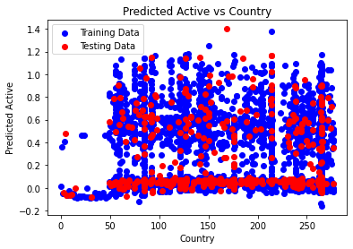

The provided scatter plot juxtaposes a model's predicted active cases against actual testing data for various countries. The x-axis, labeled "Country," lacks a numerical scale. Meanwhile, the y-axis, labeled "Predicted Active," spans from 0 to 1.4. The plot comprises two datasets.

A discernible positive correlation exists between the predicted active cases and the testing data, although the fit is not entirely precise. This indicates that the model generally forecasts higher values of active cases for countries with elevated actual active cases. However, considerable dispersion in the data implies that the model's predictions are not consistently accurate. Instances exist where the model overestimated active cases for countries with low actual counts and underestimated them for countries with high actual counts.

In summation, the plot intimates that while the model demonstrates some success in predicting active cases, it is not flawless. There remains scope for refinement and enhancement in its predictive accuracy.

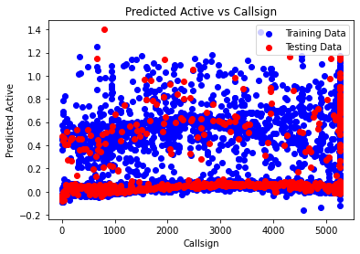

The provided scatter plot depicts the performance of a model in predicting the number of active calls, with the x-axis labeled "Callsign" ranging from 0 to 5000, and the y-axis labeled "Predicted Active" spanning from -0.2 to 1.4. Two datasets are visualized: a red line representing the model's predicted number of active calls and a blue line representing the actual number of calls in the training dataset.

The plot suggests that the model's predictions generally approximate the actual number of calls in the training dataset. However, notable scatter in the data indicates occasional discrepancies between the model's predictions and the actual counts. Instances exist where the model overestimates or underestimates the number of active calls relative to the actual counts associated with specific callsigns.

Additionally, the accompanying text atop the plot clarifies that the red line denotes the model's predictions for the training dataset, while the blue line signifies the actual call counts in the testing dataset. The discernible separation between the two lines implies that the model struggles to generalize effectively to unseen data, potentially indicative of overfitting to the training data.

In summary, while the plot illustrates some success in predicting the number of active calls, it also underscores limitations in the model's generalization capabilities to new data. There exists variability in the accuracy of predictions, and caution is warranted in relying solely on the model's outputs for decision-making purposes.

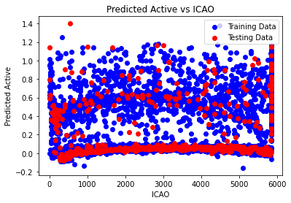

The provided scatter plot illustrates the disparity between a model's predicted and actual active cases across different countries, presumably identified by their ICAO codes. The x-axis is denoted as "ICAO" without a discernible scale, while the y-axis is labeled "Predicted Active - Testing Data," ranging from -0.2 to 1.4. Two datasets are represented: red dots depicting the variance between the model's predicted active cases and the actual testing data.

The scatter plot reveals no discernible trend, indicating that the model's predictions neither consistently overestimate nor underestimate the number of active cases. Instances occur where the model overestimates (positive y-axis values) or underestimates (negative y-axis values) the actual number of active cases for various countries.

It's crucial to acknowledge that the plot solely displays the discrepancy between predicted and actual values, precluding direct insights into the model's accuracy in absolute terms. Without visibility into the actual values, the plot cannot ascertain whether the model consistently tends to overestimate or underestimate active cases.

In summary, while the scatter plot highlights discrepancies between the model's predictions and actual data, it fails to discern a systematic pattern in the errors. Further analysis is imperative to comprehensively evaluate the model's performance and ascertain the factors contributing to prediction inaccuracies.

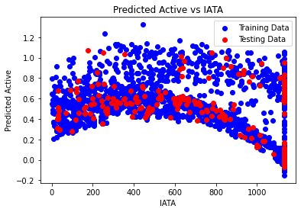

The provided scatter plot compares a model's predicted active cases to actual IATA training data across different countries. The x-axis is labeled "IATA" with a scale ranging from 0 to 1000, while the y-axis is labeled "Predicted Active" and spans from 0 to 1.2. Two datasets are depicted: red dots representing the model's predicted active cases, and blue text along the bottom axis indicating the IATA training data.

A discernible positive correlation is observed between the predicted active cases and the training data, indicating that the model generally predicts higher values for countries with higher IATA values in the training dataset. However, the relationship is not entirely precise, as evidenced by the considerable scatter in the data. This implies that the model's predictions occasionally deviate from the actual values. For instance, instances occur where the model predicts a high number of active cases despite corresponding low IATA values, and vice versa.

Overall, while the plot suggests some success in predicting active cases based on IATA training data, it also highlights areas for enhancement. The model's predictive accuracy could be further refined to minimize discrepancies between predicted and actual values. Continued optimization may lead to more reliable predictions in the future.

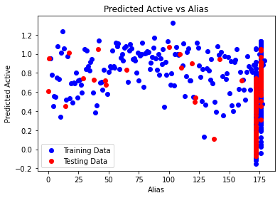

The provided scatter plot illustrates the relationship between predicted active cases and an unspecified variable referred to as "Alias." The plot features a red line representing predicted active cases and a blue line representing testing data. The x-axis is labeled "Alias" without a discernible scale, while the y-axis is labeled "Predicted Active," ranging from 0 to 1.4.

A positive correlation is observed between predicted active cases and the testing data, indicating that higher values of active cases are generally associated with higher values of the unspecified "Alias" variable in the testing data. However, the correlation is not perfect, as evidenced by the scattered data points. This variability suggests that the model's predictions do not consistently align with the actual testing data. Notably, instances exist where the model overestimates or underestimates the number of active cases relative to the corresponding values in the testing data.

Given the ambiguity surrounding the nature of the "Alias" variable, precise interpretation of the plot is challenging. However, the overall trend implies that the model exhibits some success in predicting active cases based on the "Alias" data, albeit with room for improvement. Further refinement of the model may enhance its predictive accuracy and reduce discrepancies between predicted and actual values.

The provided scatter plot illustrates the performance of a model for predicting active cases, with the x-axis labeled "Name" and the y-axis labeled "Predicted Active." The y-axis ranges from 0 to 1.2. The plot features two datasets: red dots representing the model's predicted active cases and blue text along the bottom axis representing the training data.

A weak positive correlation is observed between the predicted active cases and the training data, indicating that the model tends to predict higher values of active cases for entities (countries or other units represented by "Name") with higher values in the training data. However, significant scatter in the data suggests that the model's predictions are not consistently accurate. Instances exist where the model overestimates or underestimates the number of active cases relative to the corresponding values in the training data.

The text at the top of the plot clarifies that the blue labels on the x-axis represent the training data, indicating that the model's performance is evaluated based on this dataset. Ideally, a close alignment between the red dots and the blue labels would indicate strong performance on the training data. However, the presence of scatter suggests that the model's performance is imperfect, indicating potential limitations in its predictive accuracy on the training data.

It's essential to note that the plot does not provide insight into the model's performance on unseen data. Further analysis would be required to assess the model's generalization capabilities beyond the training data.

In summary, the plot suggests that the model exhibits some ability to predict active cases based on the training data, albeit with limited accuracy. Additional analysis is necessary to evaluate the model's performance on unseen data and identify potential areas for improvement.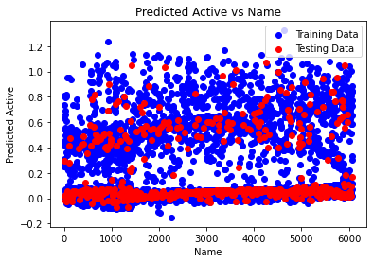

The provided scatter plot illustrates the performance of a predictive model for estimating active cases, with the x-axis labeled "Name" and the y-axis labeled "Predicted Active." The y-axis ranges from 0 to 1.2. The plot contains two datasets: red dots representing the model's predicted active cases and blue text along the bottom axis representing the training data.

A weak positive correlation is observed between the predicted active cases and the training data, indicating that the model tends to predict higher values of active cases for entities (countries or other units represented by "Name") with higher values in the training data. However, significant scatter in the data suggests that the model's predictions are not consistently accurate. Instances exist where the model overestimates or underestimates the number of active cases relative to the corresponding values in the training data.

The text at the top of the plot clarifies that the blue labels on the x-axis represent the training data, indicating that the model's performance is evaluated based on this dataset. Ideally, a close alignment between the red dots and the blue labels would indicate strong performance on the training data. However, the presence of scatter suggests that the model's performance is imperfect, indicating potential limitations in its predictive accuracy on the training data.

It's essential to note that the plot does not provide insight into the model's performance on unseen data. Further analysis would be required to assess the model's generalization capabilities beyond the training data.

In summary, the plot suggests that the model exhibits some ability to predict active cases based on the training data, albeit with limited accuracy. Additional analysis is necessary to evaluate the model's performance on unseen data and identify potential areas for improvement.

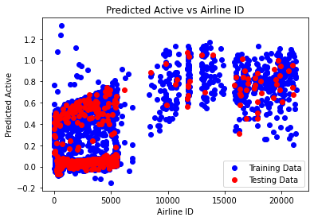

The provided scatter plot illustrates the relationship between a model's predicted active cases and airline ID. The x-axis is labeled "Airline ID," ranging from 0 to 20000, while the y-axis is labeled "Predicted Active," ranging from 0 to 1.2. Two datasets are plotted on the graph.

A positive correlation is observed between the predicted active cases and the testing data, indicating that the model tends to predict higher values for airlines with higher numbers of active cases in the testing data. However, significant scatter in the data suggests that the model's predictions are not consistently accurate. Instances exist where the model overestimates or underestimates the number of active cases relative to the corresponding values in the testing data.

The text at the top of the plot states "Predicted Active vs Airline ID," clarifying the variables being compared. Additionally, the presence of two datasets (red and blue dots) indicates the model's performance on unseen data, with the blue dots representing airline IDs not seen during training. Ideally, a close alignment between the red and blue dots would indicate strong generalization to unseen data. However, the observed scatter suggests imperfect generalization.

In summary, the plot suggests that the model exhibits some ability to predict active cases for airlines, although its accuracy is limited, and its generalization to unseen data is not perfect. Further analysis is necessary to evaluate the model's performance comprehensively and identify potential areas for improvement.

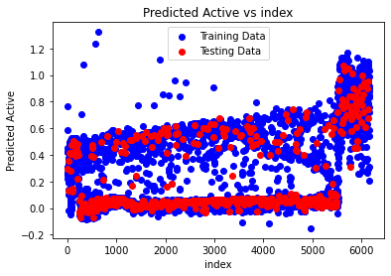

The plot is a scatter plot depicting the performance of a model in predicting active cases. The x-axis is labeled "Index," ranging from 0 to 6000, while the y-axis is labeled "Predicted Active," ranging from 0 to 1.4. It comprises two datasets.

A positive correlation between the predicted active cases and the testing data is observed, indicating that the model generally predicts higher values for entities (indexed by "Index") with higher values in the testing data. However, the correlation is not perfect, as evidenced by the significant scatter in the data. This implies that the model's predictions often deviate from the actual values. Instances exist where the model overestimates or underestimates the number of active cases relative to the corresponding values in the testing data.

The text at the top of the plot clarifies that it represents "Predicted Active vs Index *Testing Data*," indicating that the blue line represents the testing data, not the training data. Ideally, close alignment between the red dots and the blue line would signify strong performance of the model on unseen data. However, the presence of scatter indicates that the model's performance is not optimal on the testing data.

In summary, while the plot suggests that the model possesses some ability to predict active cases based on the testing data, its accuracy is limited. Further analysis is warranted to comprehensively assess the model's performance and identify potential areas for improvement.

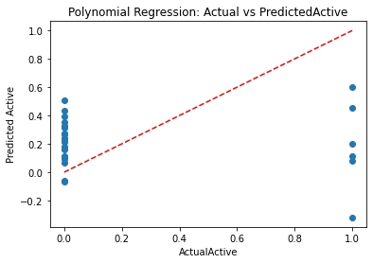

The plot a polynomial regression which shows the relationship between predicted active and actual active. The red line represents the predicted active, and the blue line represents the actual active.

In general, a good fit is indicated by a close correspondence between the red line (predicted values) and the blue line (actual values). The closer the two lines are throughout the range of the x-axis, the better the model is at predicting the actual values.

In this specific plot, it appears that the polynomial regression model fits the data well at higher values of actual active (on the right side of the axis), but not as well for lower values (on the left side of the axis). There seems to be a more significant spread of the blue points around the red line on the left side. This suggests that the model may be less accurate at predicting low values of active.

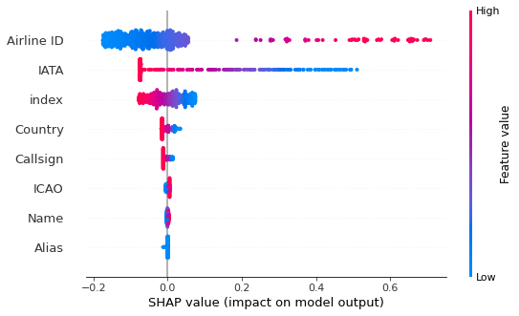

The provided image is a SHAP (SHapley Additive exPlanations) feature importance plot, which illustrates the influence of various features on a machine learning model. The model aims to predict a certain outcome, with the features representing different characteristics of airlines.

The y-axis enumerates the features considered by the model:

- Airline ID: a unique identifier assigned to each airline

- IATA: the International Air Transport Association code, a two-letter alphanumeric code designating airlines

- ICAO: the International Civil Aviation Organization code, a three-letter alphanumeric code assigned to airlines

- Country: the country where the airline is based

- Callsign: a unique identifier used by air traffic control to communicate with specific aircraft

- Name: the official name of the airline

- Alias: an alternative name associated with the airline

On the x-axis, SHAP values are displayed, indicating each feature's impact on the model's output. Positive SHAP values signify an increase in the model's prediction when the feature is present, whereas negative values indicate a decrease. The intensity of the color gradient, ranging from light blue to dark red, reflects the magnitude of the impact, with darker shades indicating higher influence.

According to the plot, "Country" emerges as the feature exerting the greatest impact on the model's predictions. This implies that the geographic location of an airline's base of operations significantly influences the model's output.

Further analysis reveals the following breakdown of feature impact:

- High Impact: Country

- Medium Impact: Callsign, IATA, ICAO

- Low Impact: Airline ID, Name, Alias

However, the specific prediction task of the model is not provided, necessitating additional context to fully interpret the plot's implications.

PREDICTIVE PARAMETERS OF ACTIVE:

0 1

1 1

2 0

3 1

4 0

..

244 0

245 0

246 0

247 0

248 0

Name: Active

**PHASE-9**

**ROUTE-SELECTION(INTERPRETATION OF AIRCRAFT STOPS used as input predicting AIRCRAFT DAMAGE in part-1):**

|  |  |  |  |  |  |  |  |  |
| --- | --- | --- | --- | --- | --- | --- | --- | --- |
| airline | airline ID | source airport | source airport id | destination apirport | destination airport id | codeshare | stops | equipment |
| 2B | 410 | AER | 2965 | KZN | 2990 |  | 0 | CR2 |
| 2B | 410 | ASF | 2966 | KZN | 2990 |  | 0 | CR2 |
| 2B | 410 | ASF | 2966 | MRV | 2962 |  | 0 | CR2 |
| 2B | 410 | CEK | 2968 | KZN | 2990 |  | 0 | CR2 |
| 2B | 410 | CEK | 2968 | OVB | 4078 |  | 0 | CR2 |
| 2B | 410 | DME | 4029 | KZN | 2990 |  | 0 | CR2 |
| 2B | 410 | DME | 4029 | NBC | 6969 |  | 0 | CR2 |
| 2B | 410 | DME | 4029 | TGK | \N |  | 0 | CR2 |
| 2B | 410 | DME | 4029 | UUA | 6160 |  | 0 | CR2 |
| 2B | 410 | EGO | 6156 | KGD | 2952 |  | 0 | CR2 |
| 2B | 410 | EGO | 6156 | KZN | 2990 |  | 0 | CR2 |
| 2B | 410 | GYD | 2922 | NBC | 6969 |  | 0 | CR2 |
| 2B | 410 | KGD | 2952 | EGO | 6156 |  | 0 | CR2 |
| 2B | 410 | KZN | 2990 | AER | 2965 |  | 0 | CR2 |
| 2B | 410 | KZN | 2990 | ASF | 2966 |  | 0 | CR2 |
| 2B | 410 | KZN | 2990 | CEK | 2968 |  | 0 | CR2 |
| 2B | 410 | KZN | 2990 | DME | 4029 |  | 0 | CR2 |
| 2B | 410 | KZN | 2990 | EGO | 6156 |  | 0 | CR2 |
| 2B | 410 | KZN | 2990 | LED | 2948 |  | 0 | CR2 |
| 2B | 410 | KZN | 2990 | SVX | 2975 |  | 0 | CR2 |
| 2B | 410 | LED | 2948 | KZN | 2990 |  | 0 | CR2 |
| 2B | 410 | LED | 2948 | NBC | 6969 |  | 0 | CR2 |
| 2B | 410 | LED | 2948 | UUA | 6160 |  | 0 | CR2 |
| 2B | 410 | MRV | 2962 | ASF | 2966 |  | 0 | CR2 |
| 2B | 410 | NBC | 6969 | DME | 4029 |  | 0 | CR2 |
| 2B | 410 | NBC | 6969 | GYD | 2922 |  | 0 | CR2 |
| 2B | 410 | NBC | 6969 | LED | 2948 |  | 0 | CR2 |
| 2B | 410 | NBC | 6969 | SVX | 2975 |  | 0 | CR2 |
| 2B | 410 | NJC | 2972 | SVX | 2975 |  | 0 | CR2 |
| 2B | 410 | NJC | 2972 | UUA | 6160 |  | 0 | CR2 |
| 2B | 410 | NUX | 4364 | SVX | 2975 |  | 0 | CR2 |
| 2B | 410 | OVB | 4078 | CEK | 2968 |  | 0 | CR2 |
| 2B | 410 | OVB | 4078 | SVX | 2975 |  | 0 | CR2 |
| 2B | 410 | SVX | 2975 | KZN | 2990 |  | 0 | CR2 |
| 2B | 410 | SVX | 2975 | NBC | 6969 |  | 0 | CR2 |
| 2B | 410 | SVX | 2975 | NJC | 2972 |  | 0 | CR2 |
| 2B | 410 | SVX | 2975 | NUX | 4364 |  | 0 | CR2 |
| 2B | 410 | SVX | 2975 | OVB | 4078 |  | 0 | CR2 |
| 2B | 410 | TGK | \N | DME | 4029 |  | 0 | CR2 |
| 2B | 410 | UUA | 6160 | DME | 4029 |  | 0 | CR2 |
| 2B | 410 | UUA | 6160 | LED | 2948 |  | 0 | CR2 |
| 2B | 410 | UUA | 6160 | NJC | 2972 |  | 0 | CR2 |
| 2G | 1654 | BTK | 2936 | IKT | 2937 |  | 0 | A81 |
| 2G | 1654 | BTK | 2936 | OVB | 4078 |  | 0 | A81 |
| 2G | 1654 | CEK | 2968 | OVB | 4078 |  | 0 | A81 |
| 2G | 1654 | HTA | 2935 | IKT | 2937 |  | 0 | AN4 |
| 2G | 1654 | IKT | 2937 | BTK | 2936 |  | 0 | A81 |
| 2G | 1654 | IKT | 2937 | HTA | 2935 |  | 0 | AN4 |
| 2G | 1654 | IKT | 2937 | KCK | \N |  | 0 | AN4 |
| 2G | 1654 | IKT | 2937 | ODO | 8944 |  | 0 | AN4 |
| 2G | 1654 | IKT | 2937 | OVB | 4078 |  | 0 | A81 |
| 2G | 1654 | IKT | 2937 | UKX | 6924 |  | 0 | AN4 |
| 2G | 1654 | IKT | 2937 | ULK | 9026 |  | 0 | AN4 |
| 2G | 1654 | IKT | 2937 | YKS | 2923 |  | 0 | A81 |
| 2G | 1654 | KCK | \N | IKT | 2937 |  | 0 | AN4 |
| 2G | 1654 | MJZ | 2925 | OVB | 4078 |  | 0 | A81 |
| 2G | 1654 | ODO | 8944 | IKT | 2937 |  | 0 | AN4 |
| 2G | 1654 | OVB | 4078 | BTK | 2936 |  | 0 | A81 |
| 2G | 1654 | OVB | 4078 | CEK | 2968 |  | 0 | A81 |
| 2G | 1654 | OVB | 4078 | IKT | 2937 |  | 0 | A81 |
| 2G | 1654 | UKX | 6924 | IKT | 2937 |  | 0 | AN4 |
| 2G | 1654 | ULK | 9026 | IKT | 2937 |  | 0 | AN4 |
| 2G | 1654 | YKS | 2923 | IKT | 2937 |  | 0 | A81 |
| 2I | 8359 | AYP | 2786 | LIM | 2789 |  | 0 | 142 |
| 2I | 8359 | CUZ | 2812 | LIM | 2789 |  | 0 | 142 141 |
| 2I | 8359 | CUZ | 2812 | PEM | 2808 |  | 0 | 142 |
| 2I | 8359 | HUU | 6067 | LIM | 2789 |  | 0 | 141 |
| 2I | 8359 | IQT | 2801 | PCL | 2781 |  | 0 | 143 |
| 2I | 8359 | IQT | 2801 | TPP | 2806 |  | 0 | 142 |
| 2I | 8359 | LIM | 2789 | AYP | 2786 |  | 0 | 142 |
| 2I | 8359 | LIM | 2789 | CUZ | 2812 |  | 0 | 142 141 |
| 2I | 8359 | LIM | 2789 | HUU | 6067 |  | 0 | 141 |
| 2I | 8359 | LIM | 2789 | PCL | 2781 |  | 0 | 143 146 |
| 2I | 8359 | LIM | 2789 | TPP | 2806 |  | 0 | 142 146 |
| 2I | 8359 | PCL | 2781 | IQT | 2801 |  | 0 | 143 |
| 2I | 8359 | PCL | 2781 | LIM | 2789 |  | 0 | 143 146 |
| 2I | 8359 | PCL | 2781 | TPP | 2806 |  | 0 | 146 |
| 2I | 8359 | PEM | 2808 | CUZ | 2812 |  | 0 | 142 |
| 2I | 8359 | TPP | 2806 | IQT | 2801 |  | 0 | 142 |
| 2I | 8359 | TPP | 2806 | LIM | 2789 |  | 0 | 142 146 |
| 2I | 8359 | TPP | 2806 | PCL | 2781 |  | 0 | 146 |
| 2J | 470 | ABJ | 253 | BOY | 247 |  | 0 | CRJ |
| 2J | 470 | ABJ | 253 | OUA | 246 |  | 0 | E70 CRJ M87 |
| 2J | 470 | ACC | 248 | OUA | 246 |  | 0 | CRJ |
| 2J | 470 | BKO | 1044 | ABJ | 253 |  | 0 | M87 |
| 2J | 470 | BKO | 1044 | DKR | 1084 |  | 0 | M87 |
| 2J | 470 | BKO | 1044 | OUA | 246 |  | 0 | CRJ |
| 2J | 470 | BOY | 247 | ABJ | 253 |  | 0 | CRJ |
| 2J | 470 | BOY | 247 | OUA | 246 |  | 0 | CRJ |
| 2J | 470 | COO | 245 | LFW | 298 |  | 0 | M87 |
| 2J | 470 | COO | 245 | OUA | 246 |  | 0 | M87 |
| 2J | 470 | DKR | 1084 | BKO | 1044 |  | 0 | M87 |
| 2J | 470 | DKR | 1084 | OUA | 246 |  | 0 | M87 |
| 2J | 470 | LFW | 298 | OUA | 246 |  | 0 | M87 CRJ |
| 2J | 470 | NIM | 280 | OUA | 246 |  | 0 | CRJ |
| 2J | 470 | OUA | 246 | ABJ | 253 |  | 0 | E70 CRJ M87 |
| 2J | 470 | OUA | 246 | ACC | 248 |  | 0 | CRJ |
| 2J | 470 | OUA | 246 | BKO | 1044 |  | 0 | M87 CRJ |
| 2J | 470 | OUA | 246 | BOY | 247 |  | 0 | CRJ |

|  |  |  |  |  |  |  |  |  |
| --- | --- | --- | --- | --- | --- | --- | --- | --- |
| 5T | 1623 | YFB | 55 | YGT | 5495 |  | 0 | BE1 DH8 |
| 5T | 1623 | YFB | 55 | YOW | 100 |  | 0 | 73M |
| 5T | 1623 | YFB | 55 | YRT | 132 |  | 0 | 73M |
| 5T | 1623 | YFB | 55 | YTE | 140 |  | 0 | BE1 DH8 |
| 5T | 1623 | YFB | 55 | YUX | 148 |  | 0 | BE1 DH8 |
| 5T | 1623 | YFB | 55 | YXP | 170 |  | 0 | DH8 |
| 5T | 1623 | YGT | 5495 | YFB | 55 |  | 0 | DH8 |
| 5T | 1623 | YGT | 5495 | YIO | 75 |  | 0 | DH8 |
| 5T | 1623 | YGT | 5495 | YUX | 148 |  | 0 | DH8 BE1 |
| 5T | 1623 | YHK | 69 | YYH | 183 |  | 0 | DH8 |
| 5T | 1623 | YHK | 69 | YZF | 196 |  | 0 | DH8 |
| 5T | 1623 | YIO | 75 | YCY | 40 |  | 0 | DH8 |
| 5T | 1623 | YIO | 75 | YGT | 5495 |  | 0 | DH8 |
| 5T | 1623 | YOW | 100 | YFB | 55 |  | 0 | 73M |
| 5T | 1623 | YRT | 132 | YBK | 29 | Y | 0 | AT4 |
| 5T | 1623 | YRT | 132 | YCS | 5487 | Y | 0 | ATR AT4 |
| 5T | 1623 | YRT | 132 | YEK | 50 |  | 1 | ATR |
| 5T | 1623 | YRT | 132 | YFB | 55 |  | 0 | 73M |
| 5T | 1623 | YRT | 132 | YUT | 147 | Y | 0 | AT4 |
| 5T | 1623 | YRT | 132 | YYQ | 187 | Y | 0 | ATR FRJ AT4 |
| 5T | 1623 | YRT | 132 | YZF | 196 |  | 0 | 73M |
| 5T | 1623 | YRT | 132 | YZS | 41 | Y | 0 | ATR AT4 |
| 5T | 1623 | YTE | 140 | YFB | 55 |  | 0 | BE1 DH8 |
| 5T | 1623 | YTH | 141 | YYQ | 187 | Y | 0 | ATR |
| 5T | 1623 | YUX | 148 | YFB | 55 |  | 0 | DH8 BE1 |
| 5T | 1623 | YUX | 148 | YGT | 5495 |  | 0 | BE1 DH8 |
| 5T | 1623 | YVM | 152 | YXP | 170 |  | 0 | DH8 |
| 5T | 1623 | YVQ | 155 | YEV | 54 |  | 0 | 73M 733 |
| 5T | 1623 | YVQ | 155 | YZF | 196 |  | 0 | 73M 733 |
| 5T | 1623 | YWG | 160 | YRT | 132 | Y | 0 | FRJ ATR |
| 5T | 1623 | YWG | 160 | YYQ | 187 | Y | 0 | FRJ |
| 5T | 1623 | YXN | 5534 | YRT | 132 | Y | 0 | ATR AT4 |
| 5T | 1623 | YXP | 170 | YFB | 55 |  | 0 | DH8 |

Based on the provided data, here's a description of each feature according to aircraft route transport:

1. airline: This feature represents the code of the airline operating the route. It identifies the airline company.

2. airline ID: This feature is likely an internal identifier assigned to each airline by the data management system. It helps uniquely identify airlines.

3. source airport: This feature denotes the IATA code of the airport where the flight originates.

4. source airport ID: This feature could be an internal identifier for the source airport, helping to uniquely identify airports in the dataset.

5. destination airport: This feature indicates the IATA code of the airport where the flight terminates.

6. destination airport ID: Similar to the source airport ID, this feature is probably an internal identifier for the destination airport.

7. codeshare: This feature specifies whether the flight is a codeshare flight, where multiple airlines share the same flight under their own designator code. It might contain a value indicating the presence or absence of codeshare agreements.

8. stops: This feature indicates the number of stops the flight makes between the source and destination airports. A value of 0 suggests a direct flight.

9. equipment: This feature refers to the type of aircraft used for the flight. It could include the code or name of the aircraft model.

Each feature provides essential information about the airline, airports, flight characteristics, and aircraft used for transportation on a given route.

LIME-INTERPRETATION:

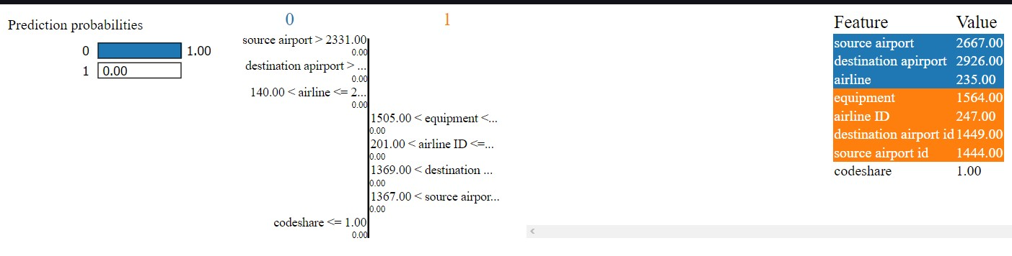

LOGISTIC-EQUATION:

Accuracy: 0.999852224028373

Coefficients: [0.0010115451537280806, -0.0029930924063770992, -4.6266347700244777e-05, -9.580147468241909e-06, 4.3084838421883484e-05, 0.000555387074495585, 1.0258248825484222, 0.0002449768157455802]

Intercept: -10.287257749037376

Logistic Equation:

P(STOPS=1) = 1 / (1 + e^(-(-10.287257749037376 + 0.001011545*AIRLINE + -0.002993092*AIRLINE-ID + -0.000046266*SOURCE-AIRPORT + -0.000009580*SOURCE-AIRPORT-ID + 0.000043085*DESTINATION-AIRPORT + 0.000555387*DESTINATION-AIRPORT-ID + 1.025824883*CODESHARE + 0.000244977*EQUIP))

Logistic equation= 1/1+e^-z

GRAPH:

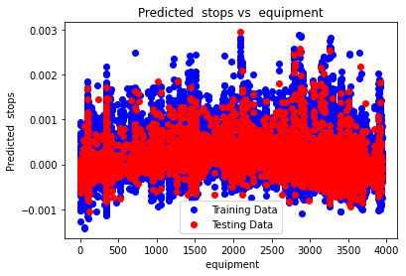

The plot illustrates a comparison between predicted stops and equipment, with training data depicted in blue and testing data in red.

Observations:

1. There appears to be a weak positive correlation between predicted stops and equipment for both training and testing data. As the equipment value increases, the predicted number of stops tends to increase. However, the data points are widely dispersed, particularly in the testing data.

2. The training data (blue points) exhibits a tighter clustering around a subtle upward trendline compared to the testing data (red points). This discrepancy suggests that while the model may effectively capture the relationship between equipment and predicted stops within the training dataset, it struggles to generalize to unseen data.

Potential reasons for the poor fit on the testing data:

1. Insufficient training data may hinder the model's ability to learn the underlying patterns effectively.

2. The complexity of the model might surpass the complexity of the dataset, leading to overfitting on the training data and reduced performance on unseen data.

3. Presence of outliers or noise in the dataset could distort the model's learning process, diminishing its predictive accuracy on testing data.

In summary, the plot indicates that the model's efficacy in predicting stops based on equipment data might be constrained by limitations in generalization to unseen data, potentially attributable to the aforementioned factors. Further analysis and refinement of the model architecture or dataset preprocessing may be warranted to improve predictive performance.

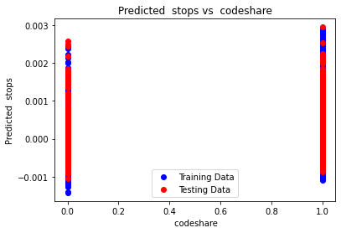

The plot illustrates the predicted number of stops versus codeshare agreements, with training data represented by blue dots and testing data by red dots.

Observations:

1. There is no discernible correlation between the predicted number of stops and codeshare agreements for either the training or testing data. The data points are widely dispersed across the plot, indicating a lack of clear trend or relationship between the two variables.

Potential reasons for the lack of correlation:

The model may suffer from underfitting or overfitting, failing to adequately capture the complexities of the relationship between codeshare agreements and the number of stops.

Noise or outliers within the dataset might be introducing disturbances that hinder the model's ability to discern a meaningful pattern between the features.

In summary, the plot indicates that the model is not effectively utilizing codeshare agreements to predict the number of stops in flight routes. Further investigation into feature importance and model optimization may be necessary to enhance predictive performance.

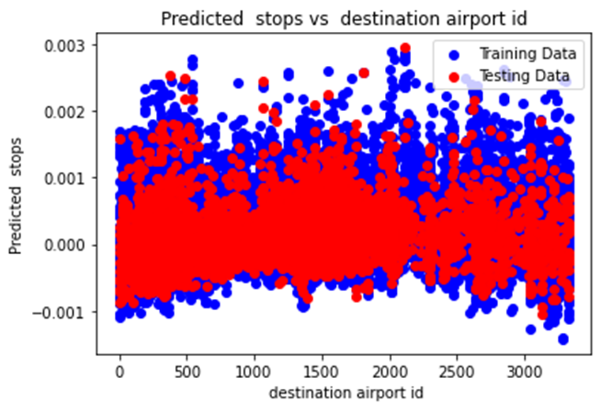

The plot illustrates the relationship between predicted stops and destination airport ID, with training data depicted in blue and testing data in red.

Observations:

1. No discernible pattern emerges between the predicted number of stops and destination airport ID for either the training or testing data. Data points are dispersed across the plot without exhibiting a clear trend or correlation.

Possible Explanations:

The model may suffer from underfitting or overfitting, thereby inadequately capturing the nuanced relationship between destination airport ID and predicted stops.

Noise or outliers present in the dataset might introduce disturbances that hinder the model's ability to identify a meaningful association between the features.

In summary, the plot suggests that the model struggles to effectively leverage destination airport ID as a predictor for the number of stops in flight routes. Further exploration into feature importance and model refinement may be necessary to enhance predictive accuracy.

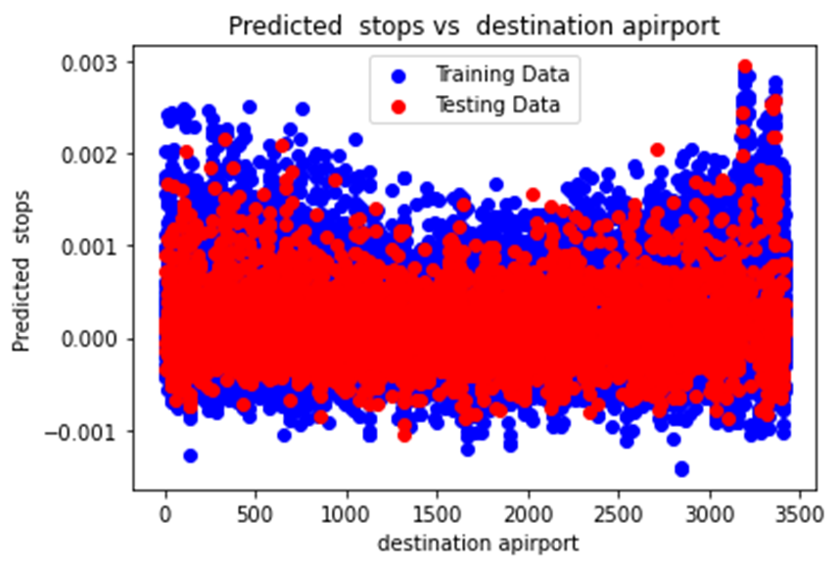

. The scatter plot compares the predicted number of stops with the destination airport for both the training and testing datasets. The x-axis represents the destination airport, while the y-axis represents the predicted number of stops.

* The blue data points correspond to the training data. Ideally, these points should exhibit a uniform distribution around a horizontal line, indicating consistent predicted stops across all airports. However, in this plot, the training data does not display a discernible pattern. Although there is some dispersion, there is no evident correlation between the destination airport and the predicted number of stops.

* The red data points represent the testing data, which serves as an assessment of the model's ability to generalize to new, unseen data. Ideally, these points should also demonstrate no correlation between the destination airport and predicted stops. In this plot, the red points exhibit a similar level of dispersion to the blue points. This suggests that the model is indeed generalizing adequately to unseen data in terms of the relationship between destination airport and predicted stops.

In summary, the plot indicates that the model is not effectively utilizing the destination airport to predict the number of stops. This may be attributed to the possibility that the destination airport alone does not significantly influence the predicted number of stops. Other unaccounted factors might exert stronger influence on stop predictions, which are not included in the dataset. Further investigation into feature importance and model refinement could enhance predictive performance.

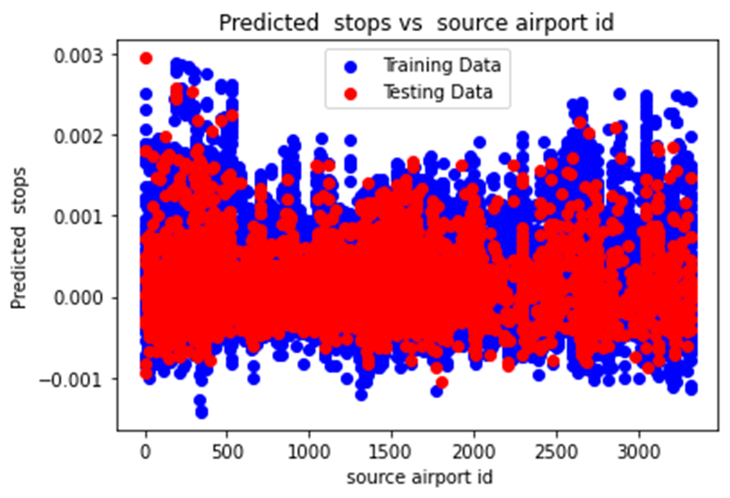

The plot illustrates the relationship between the predicted number of planes stopped and the source airport ID for both the training and testing datasets. The x-axis represents the source airport ID, while the y-axis represents the predicted number of planes stopped.

* The blue data points represent the training data. Ideally, these points should demonstrate a consistent distribution or a discernible trend, indicating a relationship between the source airport ID and the predicted number of planes stopped. However, in this plot, the training data does not exhibit a clear pattern. The points are scattered across the plot, and there is no evident correlation between the source airport ID and the predicted number of planes stopped.

* The red data points correspond to the testing data, serving as a validation of the model's generalization to new, unseen data. Similar to the training data, the red points also lack a discernible trend or pattern. They are dispersed throughout the plot without any clear relationship between the source airport ID and predicted stops.

Possible Explanations:

Model Performance: The model may be underfitting or overfitting the data, resulting in a failure to capture the relationship between the source airport ID and predicted stops accurately.

Data Noise or Outliers: Noise or outliers in the dataset could be affecting the model's ability to learn a meaningful relationship between the source airport ID and the predicted number of planes stopped.

Overall, the plot suggests that the model is not effectively utilizing the source airport ID to predict the number of planes stopped. Further investigation into feature importance, model refinement, and data quality assessment may be necessary to improve predictive performance.

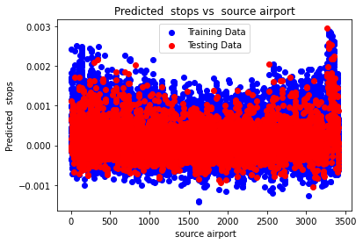

The plot illustrates the relationship between the predicted number of stops and the source airport for both the training and testing datasets. The x-axis represents the source airport, while the y-axis represents the predicted number of stops.

* The blue data points represent the training data. Ideally, these points should exhibit minimal dispersion around a consistent level, indicating a lack of correlation between the source airport and the predicted number of stops. However, although the training data points cluster more tightly compared to the testing data, they still display some degree of scatter around a horizontal line. This suggests that while the model may partially learn the relationship between the source airport and predicted stops during training, it struggles to generalize this learning to unseen data.

* The red data points correspond to the testing data, which serves as an evaluation of the model's performance on new, unseen instances. Similar to the training data, the testing data also shows scatter without a clear correlation between the source airport and predicted stops. This indicates that the model's predictive capability regarding stops based on the source airport is limited.

Possible Explanations:

Model Overfitting: The model might be overfitting to the training data, capturing noise or idiosyncrasies specific to the training set that do not generalize well to new data. This overfitting phenomenon could explain the tighter clustering of training data points compared to testing data points.

Limited Feature Relevance: The source airport feature might lack sufficient discriminatory power to accurately predict the number of stops. Additional features or more sophisticated modeling techniques may be required to improve predictive performance.

Overall, the plot suggests that the model's utilization of the source airport to predict the number of stops is suboptimal. Further investigation into feature relevance, model complexity, and generalization capabilities may be warranted to enhance predictive accuracy.

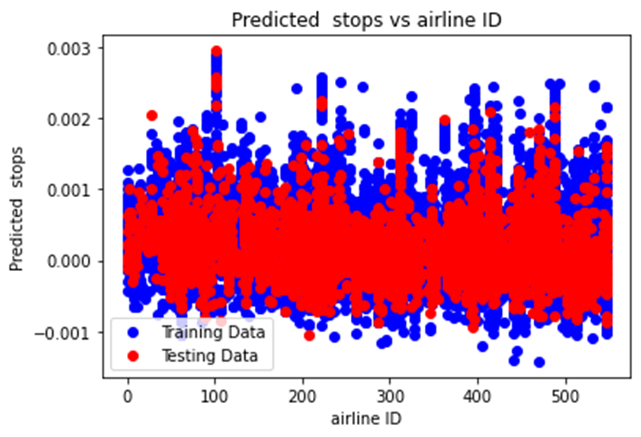

The plot illustrates the relationship between the predicted number of stops and the airline ID for both the training and testing datasets. The x-axis represents the airline ID, while the y-axis represents the predicted number of stops.

* The blue data points represent the training data. There is no discernible pattern or correlation between the predicted number of stops and the airline ID for the training data. The data points are scattered across the plot without any clear trend.

* The red data points correspond to the testing data. Similar to the training data, there is no evident pattern or correlation between the predicted number of stops and the airline ID for the testing data. The scatter of red data points mirrors that of the blue data points, suggesting that the model is generalizing adequately to unseen data concerning the relationship between airline ID and predicted stops.

Possible Explanations:

Both the axis changes according to the changes of value.

Model Generalization: Despite the lack of a discernible pattern in the training data, the model appears to generalize reasonably well to unseen data, as evidenced by the similar scatter patterns observed in the testing data. This suggests that the model's performance is consistent across different airline IDs.

Overall, the plot suggests that the model's utilization of airline ID to predict the number of stops is suboptimal. Further exploration into feature relevance and model refinement may be necessary to improve predictive performance.

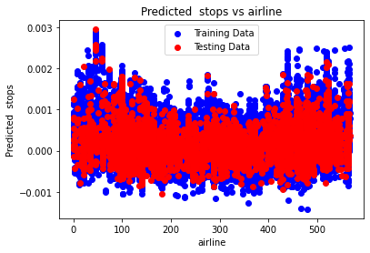

The provided scatter plot illustrates the relationship between the predicted number of stops and different airlines for both the training and testing datasets. The x-axis denotes the airline, while the y-axis represents the predicted number of stops.

In the plot:

- The blue data points represent the training data. Ideally, these points should exhibit a consistent horizontal distribution, indicating a uniform predicted number of stops across all airlines. However, the training data displays scattered points with no discernible pattern or strong correlation between the airline and predicted stops.

- The red data points represent the testing data, which evaluates the model's performance on unseen data. Similar to the training data, the testing data also shows scattered points without a clear correlation between the airline and predicted stops. Despite this, the distribution of red points mirrors that of the training data, indicating that the model generalizes reasonably well to unseen data regarding the relationship between airline and predicted stops.

Possible Explanations:

Both the axis changes according to the changes of value.

In conclusion, the plot indicates that the model's reliance on airline identity alone for predicting the number of stops is inadequate. Further investigation into feature relevance and model refinement is warranted to enhance predictive accuracy and account for additional factors influencing stop predictions.

SHAP-INTERPRETATION:

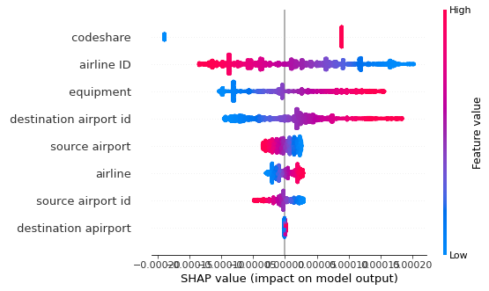

PHASE-10:

FLIGHT-CONTROL(A methodology to take control of number of passengers):

|  |  |  |  |
| --- | --- | --- | --- |
| Year | Month | Dom_Pax | Int_Pax |
| 2003 | 1 | 43,032,450 | 4,905,830 |
| 2003 | 2 | 41,166,780 | 4,245,366 |
| 2003 | 3 | 49,992,700 | 5,008,613 |
| 2003 | 4 | 47,033,260 | 4,345,444 |
| 2003 | 5 | 49,152,352 | 4,610,834 |
| 2003 | 6 | 52,209,516 | 5,411,504 |
| 2003 | 7 | 55,810,773 | 6,191,120 |
| 2003 | 8 | 53,920,973 | 6,272,332 |
| 2003 | 9 | 44,213,408 | 4,824,596 |
| 2003 | 10 | 49,944,931 | 4,920,822 |
| 2003 | 11 | 47,059,495 | 4,845,759 |
| 2003 | 12 | 49,757,124 | 5,358,991 |
| 2004 | 1 | 43,815,481 | 5,255,246 |
| 2004 | 2 | 45,306,597 | 4,941,629 |
| 2004 | 3 | 54,147,227 | 5,805,703 |
| 2004 | 4 | 53,253,194 | 5,664,027 |
| 2004 | 5 | 53,030,873 | 5,767,517 |
| 2004 | 6 | 56,959,142 | 6,405,771 |
| 2004 | 7 | 59,614,287 | 7,183,275 |
| 2004 | 8 | 57,380,873 | 6,986,797 |
| 2004 | 9 | 47,671,785 | 5,396,245 |
| 2004 | 10 | 54,167,489 | 5,629,964 |
| 2004 | 11 | 51,781,700 | 5,384,214 |
| 2004 | 12 | 52,639,838 | 6,041,853 |
| 2005 | 1 | 47,977,657 | 6,158,509 |
| 2005 | 2 | 47,074,882 | 5,499,590 |
| 2005 | 3 | 58,838,975 | 6,964,313 |
| 2005 | 4 | 54,908,859 | 6,388,741 |
| 2005 | 5 | 57,323,876 | 6,575,254 |
| 2005 | 6 | 59,724,061 | 7,123,126 |
| 2005 | 7 | 62,396,446 | 7,867,346 |
| 2005 | 8 | 59,110,633 | 7,419,187 |
| 2005 | 9 | 50,600,325 | 5,933,841 |
| 2005 | 10 | 53,738,093 | 5,873,755 |
| 2005 | 11 | 52,766,404 | 5,644,497 |
| 2005 | 12 | 52,801,276 | 6,395,022 |
| 2006 | 1 | 48,886,043 | 6,402,933 |
| 2006 | 2 | 47,348,142 | 5,706,909 |
| 2006 | 3 | 58,286,011 | 7,221,839 |
| 2006 | 4 | 55,828,555 | 7,036,629 |
| 2006 | 5 | 57,145,193 | 6,997,054 |
| 2006 | 6 | 59,297,121 | 7,625,061 |
| 2006 | 7 | 60,838,606 | 8,340,003 |
| 2006 | 8 | 58,303,233 | 7,843,848 |
| 2006 | 9 | 49,949,551 | 6,189,973 |
| 2006 | 10 | 55,088,983 | 6,281,017 |
| 2006 | 11 | 53,852,209 | 6,173,261 |
| 2006 | 12 | 53,538,970 | 6,917,055 |
| 2007 | 1 | 50,022,168 | 6,854,636 |

|  |  |  |  |
| --- | --- | --- | --- |
| Pax | Dom_Flt | Int_Flt | Flt |
| 47,938,280 | 785,160 | 57,667 | 842,827 |
| 45,412,146 | 690,351 | 51,259 | 741,610 |
| 55,001,313 | 797,194 | 58,926 | 856,120 |
| 51,378,704 | 766,260 | 55,005 | 821,265 |
| 53,763,186 | 789,397 | 55,265 | 844,662 |
| 57,621,020 | 798,351 | 58,225 | 856,576 |
| 62,001,893 | 831,619 | 62,957 | 894,576 |
| 60,193,305 | 830,737 | 63,760 | 894,497 |
| 49,038,004 | 781,804 | 54,017 | 835,821 |
| 54,865,753 | 818,308 | 54,272 | 872,580 |
| 51,905,254 | 765,842 | 53,817 | 819,659 |
| 55,116,115 | 798,392 | 57,578 | 855,970 |
| 49,070,727 | 787,237 | 58,293 | 845,530 |
| 50,248,226 | 761,618 | 55,822 | 817,440 |
| 59,952,930 | 834,476 | 60,649 | 895,125 |
| 58,917,221 | 817,899 | 60,455 | 878,354 |
| 58,798,390 | 833,350 | 62,596 | 895,946 |
| 63,364,913 | 836,916 | 64,256 | 901,172 |
| 66,797,562 | 871,049 | 69,890 | 940,939 |
| 64,367,670 | 882,979 | 68,332 | 951,311 |
| 53,068,030 | 819,294 | 56,541 | 875,835 |
| 59,797,453 | 861,291 | 58,659 | 919,950 |
| 57,165,914 | 820,048 | 58,312 | 878,360 |
| 58,681,691 | 836,232 | 63,469 | 899,701 |
| 54,136,166 | 807,338 | 64,803 | 872,141 |
| 52,574,472 | 760,955 | 59,351 | 820,306 |
| 65,803,288 | 866,593 | 68,802 | 935,395 |
| 61,297,600 | 838,122 | 66,430 | 904,552 |
| 63,899,130 | 872,961 | 68,225 | 941,186 |
| 66,847,187 | 863,422 | 69,814 | 933,236 |
| 70,263,792 | 887,084 | 74,818 | 961,902 |
| 66,529,820 | 890,938 | 73,164 | 964,102 |
| 56,534,166 | 814,935 | 61,812 | 876,747 |
| 59,611,848 | 831,265 | 61,017 | 892,282 |
| 58,410,901 | 797,460 | 59,265 | 856,725 |
| 59,196,298 | 802,067 | 65,240 | 867,307 |
| 55,288,976 | 785,364 | 66,236 | 851,600 |
| 53,055,051 | 715,843 | 60,661 | 776,504 |
| 65,507,850 | 823,793 | 70,264 | 894,057 |
| 62,865,184 | 794,390 | 68,537 | 862,927 |
| 64,142,247 | 824,051 | 68,676 | 892,727 |
| 66,922,182 | 820,310 | 71,424 | 891,734 |
| 69,178,609 | 852,114 | 76,301 | 928,415 |
| 66,147,081 | 866,551 | 74,735 | 941,286 |
| 56,139,524 | 799,777 | 62,710 | 862,487 |
| 61,370,000 | 828,218 | 63,105 | 891,323 |
| 60,025,470 | 792,523 | 61,823 | 854,346 |
| 60,456,025 | 805,058 | 68,978 | 874,036 |
| 56,876,804 | 803,924 | 69,634 | 873,558 |

|  |  |  |  |  |
| --- | --- | --- | --- | --- |
| Dom_RPM | Int_RPM | RPM | Dom_ASM | Int_ASM |
| 36,211,422 | 12,885,980 | 49,097,402 | 56,191,300 | 17,968,572 |
| 34,148,439 | 10,715,468 | 44,863,907 | 50,088,434 | 15,587,880 |
| 41,774,564 | 12,567,068 | 54,341,633 | 57,592,901 | 17,753,174 |
| 39,465,980 | 10,370,592 | 49,836,572 | 54,639,679 | 15,528,761 |
| 41,001,934 | 11,575,026 | 52,576,960 | 55,349,897 | 15,629,821 |
| 44,492,972 | 13,918,185 | 58,411,157 | 56,555,517 | 17,191,579 |
| 48,321,924 | 15,516,794 | 63,838,718 | 59,617,048 | 18,701,759 |
| 46,982,527 | 15,906,430 | 62,888,957 | 59,634,190 | 19,144,885 |
| 36,819,820 | 13,570,889 | 50,390,709 | 54,973,852 | 17,820,478 |
| 41,480,412 | 13,447,446 | 54,927,858 | 58,001,020 | 17,694,417 |
| 39,333,528 | 12,817,176 | 52,150,704 | 55,785,892 | 16,801,272 |
| 42,699,596 | 13,929,565 | 56,629,161 | 58,842,551 | 17,648,530 |
| 38,114,607 | 13,515,639 | 51,630,246 | 58,306,593 | 17,988,081 |
| 38,575,084 | 12,153,432 | 50,728,516 | 56,180,696 | 16,923,112 |
| 46,507,739 | 14,735,428 | 61,243,168 | 61,833,579 | 18,362,220 |
| 45,795,662 | 14,338,191 | 60,133,853 | 60,067,863 | 18,457,525 |
| 45,350,262 | 15,388,457 | 60,738,719 | 60,923,099 | 19,844,360 |
| 49,774,219 | 17,006,831 | 66,781,050 | 61,629,864 | 20,355,959 |
| 52,730,292 | 18,182,782 | 70,913,074 | 64,095,669 | 21,731,193 |
| 50,816,430 | 17,760,431 | 68,576,861 | 64,479,721 | 21,640,665 |
| 40,644,161 | 15,247,819 | 55,891,980 | 57,694,884 | 19,502,122 |
| 45,765,588 | 15,384,002 | 61,149,590 | 61,604,719 | 19,883,889 |
| 43,561,708 | 14,118,725 | 57,680,434 | 59,431,353 | 18,848,375 |
| 45,181,080 | 15,523,403 | 60,704,483 | 62,054,841 | 20,254,013 |
| 41,609,095 | 15,580,719 | 57,189,815 | 59,580,514 | 20,571,388 |
| 40,114,944 | 13,470,430 | 53,585,374 | 55,964,342 | 18,651,403 |
| 50,789,921 | 17,293,704 | 68,083,625 | 63,743,171 | 21,201,138 |
| 47,002,623 | 16,218,686 | 63,221,309 | 61,262,216 | 20,990,887 |
| 49,016,422 | 17,394,296 | 66,410,718 | 63,160,148 | 21,943,039 |
| 52,181,786 | 18,750,411 | 70,932,197 | 63,378,463 | 22,373,102 |
| 55,290,372 | 20,037,449 | 75,327,821 | 65,813,398 | 23,792,009 |
| 52,510,003 | 19,205,090 | 71,715,093 | 65,309,256 | 23,418,626 |
| 43,524,915 | 16,631,990 | 60,156,904 | 58,674,828 | 21,425,051 |
| 45,895,538 | 16,089,364 | 61,984,902 | 60,392,331 | 21,033,727 |
| 45,109,831 | 14,771,787 | 59,881,618 | 58,886,853 | 19,401,869 |
| 46,190,194 | 16,339,078 | 62,529,273 | 60,889,086 | 21,153,995 |
| 42,966,268 | 16,157,877 | 59,124,144 | 59,096,204 | 21,396,430 |
| 40,927,215 | 13,913,445 | 54,840,660 | 53,733,108 | 19,241,787 |
| 50,693,391 | 18,095,206 | 68,788,597 | 62,257,065 | 22,367,092 |
| 48,800,883 | 17,685,346 | 66,486,229 | 59,917,615 | 22,246,457 |
| 49,302,219 | 18,465,819 | 67,768,038 | 61,284,297 | 23,102,699 |
| 52,200,272 | 20,275,368 | 72,475,640 | 61,692,651 | 23,821,736 |
| 54,506,446 | 21,510,904 | 76,017,350 | 64,111,164 | 25,185,579 |
| 52,074,386 | 20,342,613 | 72,416,999 | 64,332,983 | 24,888,446 |
| 43,108,587 | 17,537,122 | 60,645,709 | 58,383,462 | 22,579,257 |
| 47,137,132 | 17,365,868 | 64,503,000 | 60,802,722 | 22,654,609 |
| 45,966,808 | 16,115,237 | 62,082,045 | 58,912,308 | 20,821,119 |
| 46,835,639 | 17,704,637 | 64,540,276 | 61,161,328 | 22,721,069 |
| 43,823,680 | 17,450,335 | 61,274,015 | 60,618,488 | 22,960,840 |

|  |  |  |  |
| --- | --- | --- | --- |
| ASM | Dom_LF | Int_LF | LF |
| 74,159,872 | 64.44 | 71.71 | 66.2 |
| 65,676,314 | 68.18 | 68.74 | 68.31 |
| 75,346,075 | 72.53 | 70.79 | 72.12 |
| 70,168,440 | 72.23 | 66.78 | 71.02 |
| 70,979,718 | 74.08 | 74.06 | 74.07 |
| 73,747,096 | 78.67 | 80.96 | 79.2 |
| 78,318,807 | 81.05 | 82.97 | 81.51 |
| 78,779,075 | 78.78 | 83.08 | 79.83 |
| 72,794,329 | 66.98 | 76.15 | 69.22 |
| 75,695,437 | 71.52 | 76 | 72.56 |
| 72,587,163 | 70.51 | 76.29 | 71.85 |
| 76,491,081 | 72.57 | 78.93 | 74.03 |
| 76,294,673 | 65.37 | 75.14 | 67.67 |
| 73,103,808 | 68.66 | 71.82 | 69.39 |
| 80,195,799 | 75.21 | 80.25 | 76.37 |
| 78,525,388 | 76.24 | 77.68 | 76.58 |
| 80,767,459 | 74.44 | 77.55 | 75.2 |
| 81,985,822 | 80.76 | 83.55 | 81.45 |
| 85,826,863 | 82.27 | 83.67 | 82.62 |
| 86,120,386 | 78.81 | 82.07 | 79.63 |
| 77,197,006 | 70.45 | 78.19 | 72.4 |
| 81,488,607 | 74.29 | 77.37 | 75.04 |
| 78,279,728 | 73.3 | 74.91 | 73.69 |
| 82,308,853 | 72.81 | 76.64 | 73.75 |
| 80,151,902 | 69.84 | 75.74 | 71.35 |
| 74,615,745 | 71.68 | 72.22 | 71.82 |
| 84,944,309 | 79.68 | 81.57 | 80.15 |
| 82,253,103 | 76.72 | 77.27 | 76.86 |
| 85,103,187 | 77.61 | 79.27 | 78.04 |
| 85,751,565 | 82.33 | 83.81 | 82.72 |
| 89,605,407 | 84.01 | 84.22 | 84.07 |
| 88,727,882 | 80.4 | 82.01 | 80.83 |
| 80,099,879 | 74.18 | 77.63 | 75.1 |
| 81,426,057 | 76 | 76.49 | 76.12 |
| 78,288,722 | 76.6 | 76.14 | 76.49 |
| 82,043,081 | 75.86 | 77.24 | 76.22 |
| 80,492,634 | 72.71 | 75.52 | 73.45 |
| 72,974,894 | 76.17 | 72.31 | 75.15 |
| 84,624,157 | 81.43 | 80.9 | 81.29 |
| 82,164,072 | 81.45 | 79.5 | 80.92 |
| 84,386,996 | 80.45 | 79.93 | 80.31 |
| 85,514,388 | 84.61 | 85.11 | 84.75 |
| 89,296,743 | 85.02 | 85.41 | 85.13 |
| 89,221,429 | 80.95 | 81.74 | 81.17 |
| 80,962,719 | 73.84 | 77.67 | 74.91 |
| 83,457,331 | 77.52 | 76.65 | 77.29 |
| 79,733,427 | 78.03 | 77.4 | 77.86 |
| 83,882,396 | 76.58 | 77.92 | 76.94 |
| 83,579,327 | 72.29 | 76 | 73.31 |

To describe each feature according to aircraft flight number, we can provide insights into the various columns present in the dataset:

1. Year: Indicates the year of the recorded data.

2. Month: Represents the month of the recorded data.

3. Dom_Pax: Refers to the number of domestic passengers (passengers traveling within the country).

4. Int_Pax: Denotes the number of international passengers (passengers traveling outside the country).

5. Pax: Represents the total number of passengers (sum of domestic and international passengers).

6. Dom_Flt: Indicates the number of domestic flights (flights within the country).

7. Int_Flt: Denotes the number of international flights (flights outside the country).

8. Flt: Represents the total number of flights (sum of domestic and international flights).

9. Dom_RPM: Stands for domestic revenue passenger miles (the number of miles flown by paying passengers on domestic flights).

10. Int_RPM: Denotes international revenue passenger miles (the number of miles flown by paying passengers on international flights).

11. RPM: Represents the total revenue passenger miles (sum of domestic and international revenue passenger miles).

12. Dom_ASM: Stands for available seat miles for domestic flights (total number of miles flown multiplied by the number of seats available on domestic flights).

13. Int_ASM: Denotes available seat miles for international flights (total number of miles flown multiplied by the number of seats available on international flights).

14. ASM: Represents the total available seat miles (sum of domestic and international available seat miles).

15. Dom_LF: Indicates the domestic load factor (percentage of available seats that are filled on domestic flights).

16. Int_LF: Denotes the international load factor (percentage of available seats that are filled on international flights).

17. LF: Represents the total load factor (percentage of available seats that are filled on all flights).

These features provide detailed information about passenger traffic, flight operations, revenue, and seat utilization for both domestic and international flights across different months and years. They are essential for analyzing airline performance, passenger demand, and operational efficiency in the aviation industry.

LIME-INTERPRETATION:

Feature Value

Dom_Flt 179.00

LF 71.85

Dom_LF 70.51

Int_Flt 22.00

Int_RPM 13.00

Pax 24.00

Dom_Pax 29.00

Int_ASM 12.00

Int_Pax 38.00

Int_LF 76.29

Year 2003.00

Dom_RPM 21.00

Month 11.00

RPM 22.00

ASM 53.00

Dom_ASM 51.00

0 183

1 78

2 193

3 170

4 184

244 74

245 69

246 100

247 107

248 48

Name: Flt, Length: 249, dtype: int64

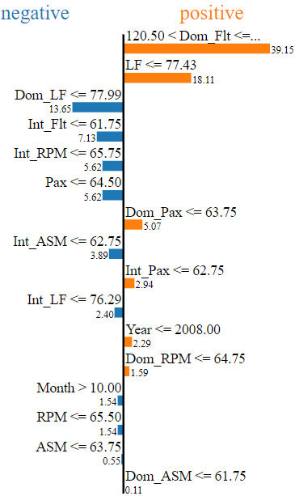

EQUATION:

ENCODING CATEGORICAL VARIABLE:

coefficient [ 1.73994109e+01 -2.17528178e+00 2.10096916e+01 -1.61998412e+00

-3.59893289e+01 9.83827257e-01 6.88161041e-01 5.23627233e+00

2.82804521e+00 8.92854725e+00 -2.16375266e+00 -3.15015616e+00

2.26266155e+00 3.03971756e+01 1.97733757e+01 -3.27577518e+01

-6.53804746e-02 3.62920674e-01 -2.01969885e-01 -2.84622921e-02

2.27452689e-01 -1.00335980e-02 1.38585761e-02 9.30016383e-02

-7.86122028e-02 -7.70448147e-02 -1.33182125e-02 7.67915318e-02

9.69209286e-03 1.73819931e+00 1.22337421e+00 -3.20165070e+00

1.74927785e-01 -1.87041369e-02 -1.88051646e-02 7.84164868e-03

1.72387383e-02 9.86605922e-03 5.34990332e-02 -9.66061836e-03

-2.53937021e-02 -2.26066638e-02 1.37256434e-02 -2.34426706e-03

-3.18163562e-01 1.63564589e-01 1.14170519e-01 -1.99124162e-02

-1.30575135e-02 4.44039597e-02 -8.09548154e-03 -1.67450859e-03

1.88933798e-02 -1.81819950e-02 2.33759741e-02 -2.49458791e-02

1.89697460e-02 2.43029544e-03 -1.33787748e+00 -4.04420956e-01

1.50119938e+00 -4.21541225e-04 1.52573854e-02 -3.72653795e-05

-2.53300921e-03 9.60473821e-03 -9.34370898e-03 -1.09925546e-02

8.95141785e-05 1.13747524e-02 4.06850782e-04 2.55737230e-01

1.38333545e-01 -3.69489219e-01 -4.24059209e-03 5.51063250e-03

-3.73121110e-03 -6.63872776e-02 -2.04910502e-03 -3.10063965e-02

2.77156642e-02 -5.40956464e-03 5.03707453e-03 6.19950032e-03

-2.96008946e-02 4.67886846e-01 2.05709828e-05 5.89165175e-04

6.65458752e-03 -4.12301575e-03 -6.03942406e-03 1.53171574e-03

4.74159178e-03 1.14327102e-03 2.48724376e-01 1.11728256e-01

-3.63511774e-01 3.91954389e-04 4.41711298e-03 2.02622389e-03

2.47847426e-03 -1.65162643e-03 -1.51958360e-03 -1.51580094e-04

-1.81882560e-01 -8.26700901e-02 2.56289469e-01 3.67412023e-02

-3.94509338e-03 -1.09640882e-02 -2.02619133e-02 -2.07770886e-03

2.26536910e-03 9.26969178e-01 4.30355955e-01 -1.45620547e+00

-1.52031450e-04 3.77469933e-02 3.76896570e-03 -4.92877249e-03

-2.16374859e-04 -1.27486750e-01 -7.65870391e-02 1.81247639e-01

5.83991781e-03 7.12346364e-03 -2.48486485e-02 8.42419413e-04

6.64631984e-01 9.45626631e-02 -8.55626800e-01 8.09780556e-03

-2.26390553e-03 -7.33698088e-03 -3.84916627e-01 -2.39295313e-01

6.59467575e-01 4.27225484e-03 -3.69220844e-04 -3.29760141e-01

-9.62883860e-02 4.49666063e-01 -8.88586270e-04 1.86519002e-01

1.08224227e-01 -3.29085187e-01 -6.47987012e+00 -5.83517179e+00

1.81040206e+01 -9.66600545e-01 7.30864612e+00 -1.22321717e+01]

intercept -714.0296277106224

Equation: Max speed Knots= -714.02962771062243518827 + -2.17528178064709942774 * Month + 21.00969158160951977266 * Dom_Pax + -1.61998412404601865866 * Int_Pax + -35.98932889109865129740 * Pax + 0.98382725659460812384 * Dom_Flt + 0.68816104086702001297 * Int_Flt + 5.23627233297510308319 * Dom_RPM + 2.82804520915935331260 * Int_RPM + 8.92854724876007210810 * RPM + -2.16375266453405146194 * Dom_ASM + -3.15015616417947175165 * Int_ASM + 2.26266154856276147100 * ASM + 30.39717561459866246310 * Dom_LF + 19.77337574675184939110 * Int_LF + -32.75775182351999603725 * LF + -0.06538047463369300871 * Year**2 + 0.36292067419258006167 * Year**1*Month**1 + -0.20196988538003823876 * Year**1*Dom_Pax**1 + -0.02846229212977768874 * Year**1*Int_Pax**1 + 0.22745268896960135763 * Year**1*Pax**1 + -0.01003359795782332586 * Year**1*Dom_Flt**1 + 0.01385857607902502009 * Year**1*Int_Flt**1 + 0.09300163825058585521 * Year**1*Dom_RPM**1 + -0.07861220278642466752 * Year**1*Int_RPM**1 + -0.07704481466158685787 * Year**1*RPM**1 + -0.01331821249863590628 * Year**1*Dom_ASM**1 + 0.07679153181677317308 * Year**1*Int_ASM**1 + 0.00969209285552066757 * Year**1*ASM**1 + 1.73819931142974826166 * Year**1*Dom_LF**1 + 1.22337420642612171306 * Year**1*Int_LF**1 + -3.20165069722646178363 * Year**1*LF**1 + 0.17492778499330985387 * Month**2 + -0.01870413689597705265 * Month**1*Dom_Pax**1 + -0.01880516464263271015 * Month**1*Int_Pax**1 + 0.00784164867599468352 * Month**1*Pax**1 + 0.01723873827557570459 * Month**1*Dom_Flt**1 + 0.00986605922408140268 * Month**1*Int_Flt**1 + 0.05349903318177456901 * Month**1*Dom_RPM**1 + -0.00966061836348576508 * Month**1*Int_RPM**1 + -0.02539370209133390288 * Month**1*RPM**1 + -0.02260666379620845934 * Month**1*Dom_ASM**1 + 0.01372564338538526801 * Month**1*Int_ASM**1 + -0.00234426706084467362 * Month**1*ASM**1 + -0.31816356247853305739 * Month**1*Dom_LF**1 + 0.16356458906545140453 * Month**1*Int_LF**1 + 0.11417051941569428264 * Month**1*LF**1 + -0.01991241620587747008 * Dom_Pax**2 + -0.01305751345676409159 * Dom_Pax**1*Int_Pax**1 + 0.04440395968394394988 * Dom_Pax**1*Pax**1 + -0.00809548154283223909 * Dom_Pax**1*Dom_Flt**1 + -0.00167450859029383281 * Dom_Pax**1*Int_Flt**1 + 0.01889337984429972916 * Dom_Pax**1*Dom_RPM**1 + -0.01818199499652595197 * Dom_Pax**1*Int_RPM**1 + 0.02337597409207692323 * Dom_Pax**1*RPM**1 + -0.02494587912954360220 * Dom_Pax**1*Dom_ASM**1 + 0.01896974598363820874 * Dom_Pax**1*Int_ASM**1 + 0.00243029543863038100 * Dom_Pax**1*ASM**1 + -1.33787748485121449349 * Dom_Pax**1*Dom_LF**1 + -0.40442095609445505300 * Dom_Pax**1*Int_LF**1 + 1.50119938062358215802 * Dom_Pax**1*LF**1 + -0.00042154122521775861 * Int_Pax**2 + 0.01525738540285281886 * Int_Pax**1*Pax**1 + -0.00003726537947912334 * Int_Pax**1*Dom_Flt**1 + -0.00253300921334176365 * Int_Pax**1*Int_Flt**1 + 0.00960473820797957956 * Int_Pax**1*Dom_RPM**1 + -0.00934370898313208187 * Int_Pax**1*Int_RPM**1 + -0.01099255458249004391 * Int_Pax**1*RPM**1 + 0.00008951417846603249 * Int_Pax**1*Dom_ASM**1 + 0.01137475237182083987 * Int_Pax**1*Int_ASM**1 + 0.00040685078158064769 * Int_Pax**1*ASM**1 + 0.25573723009497983938 * Int_Pax**1*Dom_LF**1 + 0.13833354486127036331 * Int_Pax**1*Int_LF**1 + -0.36948921903396758637 * Int_Pax**1*LF**1 + -0.00424059209256533176 * Pax**2 + 0.00551063249940675348 * Pax**1*Dom_Flt**1 + -0.00373121109980800725 * Pax**1*Int_Flt**1 + -0.06638727761881413336 * Pax**1*Dom_RPM**1 + -0.00204910502393507166 * Pax**1*Int_RPM**1 + -0.03100639653046166622 * Pax**1*RPM**1 + 0.02771566421899085420 * Pax**1*Dom_ASM**1 + -0.00540956464184261243 * Pax**1*Int_ASM**1 + 0.00503707452958845892 * Pax**1*ASM**1 + 0.00619950031850580174 * Pax**1*Dom_LF**1 + -0.02960089464990856012 * Pax**1*Int_LF**1 + 0.46788684585971118679 * Pax**1*LF**1 + 0.00002057098280250358 * Dom_Flt**2 + 0.00058916517524210121 * Dom_Flt**1*Int_Flt**1 + 0.00665458751884173694 * Dom_Flt**1*Dom_RPM**1 + -0.00412301574961304595 * Dom_Flt**1*Int_RPM**1 + -0.00603942405547819305 * Dom_Flt**1*RPM**1 + 0.00153171573778276837 * Dom_Flt**1*Dom_ASM**1 + 0.00474159177686317435 * Dom_Flt**1*Int_ASM**1 + 0.00114327101628397543 * Dom_Flt**1*ASM**1 + 0.24872437594757945689 * Dom_Flt**1*Dom_LF**1 + 0.11172825605054148568 * Dom_Flt**1*Int_LF**1 + -0.36351177388927791156 * Dom_Flt**1*LF**1 + 0.00039195438922234871 * Int_Flt**2 + 0.00441711298461733293 * Int_Flt**1*Dom_RPM**1 + 0.00202622388791517949 * Int_Flt**1*Int_RPM**1 + 0.00247847426037672847 * Int_Flt**1*RPM**1 + -0.00165162642888816436 * Int_Flt**1*Dom_ASM**1 + -0.00151958360253168223 * Int_Flt**1*Int_ASM**1 + -0.00015158009402860273 * Int_Flt**1*ASM**1 + -0.18188255959629540115 * Int_Flt**1*Dom_LF**1 + -0.08267009007613390636 * Int_Flt**1*Int_LF**1 + 0.25628946866135393634 * Int_Flt**1*LF**1 + 0.03674120228457303239 * Dom_RPM**2 + -0.00394509337673176752 * Dom_RPM**1*Int_RPM**1 + -0.01096408822533723182 * Dom_RPM**1*RPM**1 + -0.02026191328934356939 * Dom_RPM**1*Dom_ASM**1 + -0.00207770885781433101 * Dom_RPM**1*Int_ASM**1 + 0.00226536910327013175 * Dom_RPM**1*ASM**1 + 0.92696917813498069805 * Dom_RPM**1*Dom_LF**1 + 0.43035595514475571965 * Dom_RPM**1*Int_LF**1 + -1.45620546912179005261 * Dom_RPM**1*LF**1 + -0.00015203145022013587 * Int_RPM**2 + 0.03774699332219499937 * Int_RPM**1*RPM**1 + 0.00376896570268359099 * Int_RPM**1*Dom_ASM**1 + -0.00492877249148726548 * Int_RPM**1*Int_ASM**1 + -0.00021637485870718010 * Int_RPM**1*ASM**1 + -0.12748674953175775926 * Int_RPM**1*Dom_LF**1 + -0.07658703913544240294 * Int_RPM**1*Int_LF**1 + 0.18124763917254460566 * Int_RPM**1*LF**1 + 0.00583991780783499337 * RPM**2 + 0.00712346363795135495 * RPM**1*Dom_ASM**1 + -0.02484864848224876965 * RPM**1*Int_ASM**1 + 0.00084241941288620836 * RPM**1*ASM**1 + 0.66463198442589832560 * RPM**1*Dom_LF**1 + 0.09456266314301842169 * RPM**1*Int_LF**1 + -0.85562680014004921514 * RPM**1*LF**1 + 0.00809780555786243639 * Dom_ASM**2 + -0.00226390552977506765 * Dom_ASM**1*Int_ASM**1 + -0.00733698087882905803 * Dom_ASM**1*ASM**1 + -0.38491662714362828712 * Dom_ASM**1*Dom_LF**1 + -0.23929531303715917412 * Dom_ASM**1*Int_LF**1 + 0.65946757484227624957 * Dom_ASM**1*LF**1 + 0.00427225483696158648 * Int_ASM**2 + -0.00036922084421897594 * Int_ASM**1*ASM**1 + -0.32976014080047044708 * Int_ASM**1*Dom_LF**1 + -0.09628838597550826162 * Int_ASM**1*Int_LF**1 + 0.44966606314633361663 * Int_ASM**1*LF**1 + -0.00088858626981469513 * ASM**2 + 0.18651900178641811490 * ASM**1*Dom_LF**1 + 0.10822422742710136045 * ASM**1*Int_LF**1 + -0.32908518708551803833 * ASM**1*LF**1 + -6.47987011904220810976 * Dom_LF**2 + -5.83517178869347574732 * Dom_LF**1*Int_LF**1 + 18.10402058226442889577 * Dom_LF**1*LF**1 + -0.96660054477520795935 * Int_LF**2 + 7.30864611674364006433 * Int_LF**1*LF**1 + -12.23217168885895489439 * LF**2

Accuracy: 0.9968899300984555

coefficient [ 1.62356756e+00 -3.18533886e+00 1.42754482e+00 1.29737968e-01

2.54995214e-01 8.89694502e-01 -2.91268324e-02 -9.22874317e-02

1.04063965e-01 -1.65033359e+00 -1.60384858e-01 1.78808617e-01

-9.65288149e-02 7.63465431e-01 8.20052701e-01 -1.25816335e+00

-4.65492259e-02 2.54845074e-01 -1.77737694e-01 -2.65897310e-02

7.84927012e-02 -6.21023532e-03 1.42971210e-02 7.44126325e-04

9.88748481e-03 8.87775058e-02 3.04734432e-02 -3.67129172e-02

1.29517781e-02 -8.71356176e-02 -7.75168097e-02 1.48806220e-01

5.00902754e-02 7.93440230e-03 -4.33069831e-03 -4.80946458e-02

1.12365274e-02 1.15821069e-02 1.75463693e-02 -7.60960125e-03

-6.48242044e-03 1.06629180e-02 -4.61840497e-03 1.20740509e-03

-2.50413639e-04 -3.06143371e-03 1.48171089e-02 -1.10367686e-02

4.96514448e-03 -2.31908722e-02 -6.93777139e-04 -1.14788097e-02

1.97492076e-02 -4.75652155e-03 5.23528814e-02 -2.73357514e-03

-4.13273594e-03 1.77954565e-04 1.79863954e-02 1.54923371e-03

-2.93365553e-02 3.81457054e-04 -1.99118499e-02 -1.07369124e-03

-1.77780772e-03 2.73281007e-03 -2.17804141e-03 7.26687004e-03

6.49612504e-03 3.00390206e-03 6.28985998e-05 5.09352200e-04

-1.19291851e-03 1.50057725e-03 3.45097754e-02 -5.57997421e-03

9.45861201e-03 -1.88445233e-02 -4.48727113e-03 -3.34763515e-02

-2.85518878e-03 8.33309991e-03 9.12501426e-03 -2.09791586e-02

-1.28278110e-04 3.07141680e-02 -2.10516308e-04 1.38541658e-03

-7.41549314e-04 1.26230991e-03 4.16840855e-03 2.68826041e-03

-1.74247061e-03 9.00771136e-04 -1.50866657e-03 -2.59832006e-03

4.16078009e-03 3.14314077e-04 4.19328108e-03 4.76596136e-06

-1.68929962e-06 -2.09577169e-03 -8.73524850e-04 8.30925448e-05

-2.79534747e-03 -2.46469194e-03 4.74057797e-03 9.66783745e-03

4.43814696e-03 -2.46933061e-02 3.40909425e-03 3.85056206e-03

-9.77857831e-03 6.95209396e-04 2.22437698e-03 -3.78122706e-03

-1.10584930e-03 6.90640678e-03 -1.33747502e-03 -4.25391157e-04

-1.75399408e-04 1.48702988e-03 2.50375153e-03 -1.97359954e-03

-8.05752810e-03 2.60463850e-03 -7.28353154e-03 3.77577092e-03

1.66423512e-02 5.11472420e-03 -1.23605262e-02 -1.29866226e-03

7.32755007e-04 -1.79024004e-03 -5.99987622e-03 -2.52871806e-03

4.95340915e-03 1.81801544e-03 -7.18393202e-04 1.93067882e-03

1.72219047e-03 -5.71887728e-03 -1.19771224e-03 6.65598893e-06

6.97298789e-04 -1.39106078e-03 -7.43772900e-03 -9.22151917e-03

1.60603597e-02 -2.83566410e-03 9.20757463e-03 -9.19744666e-03]

intercept -5.023827083818205

Equation: Flt= -5.023827084 + -3.185338859 * Month + 1.427544822 * Dom_Pax + 0.129737968 * Int_Pax + 0.254995214 * Pax + 0.889694502 * Dom_Flt + -0.029126832 * Int_Flt + -0.092287432 * Dom_RPM + 0.104063965 * Int_RPM + -1.650333587 * RPM + -0.160384858 * Dom_ASM + 0.178808617 * Int_ASM + -0.096528815 * ASM + 0.763465431 * Dom_LF + 0.820052701 * Int_LF + -1.258163353 * LF + -0.046549226 * Year^2 + 0.254845074 * Year^1*Month^1 + -0.177737694 * Year^1*Dom_Pax^1 + -0.026589731 * Year^1*Int_Pax^1 + 0.078492701 * Year^1*Pax^1 + -0.006210235 * Year^1*Dom_Flt^1 + 0.014297121 * Year^1*Int_Flt^1 + 0.000744126 * Year^1*Dom_RPM^1 + 0.009887485 * Year^1*Int_RPM^1 + 0.088777506 * Year^1*RPM^1 + 0.030473443 * Year^1*Dom_ASM^1 + -0.036712917 * Year^1*Int_ASM^1 + 0.012951778 * Year^1*ASM^1 + -0.087135618 * Year^1*Dom_LF^1 + -0.077516810 * Year^1*Int_LF^1 + 0.148806220 * Year^1*LF^1 + 0.050090275 * Month^2 + 0.007934402 * Month^1*Dom_Pax^1 + -0.004330698 * Month^1*Int_Pax^1 + -0.048094646 * Month^1*Pax^1 + 0.011236527 * Month^1*Dom_Flt^1 + 0.011582107 * Month^1*Int_Flt^1 + 0.017546369 * Month^1*Dom_RPM^1 + -0.007609601 * Month^1*Int_RPM^1 + -0.006482420 * Month^1*RPM^1 + 0.010662918 * Month^1*Dom_ASM^1 + -0.004618405 * Month^1*Int_ASM^1 + 0.001207405 * Month^1*ASM^1 + -0.000250414 * Month^1*Dom_LF^1 + -0.003061434 * Month^1*Int_LF^1 + 0.014817109 * Month^1*LF^1 + -0.011036769 * Dom_Pax^2 + 0.004965144 * Dom_Pax^1*Int_Pax^1 + -0.023190872 * Dom_Pax^1*Pax^1 + -0.000693777 * Dom_Pax^1*Dom_Flt^1 + -0.011478810 * Dom_Pax^1*Int_Flt^1 + 0.019749208 * Dom_Pax^1*Dom_RPM^1 + -0.004756522 * Dom_Pax^1*Int_RPM^1 + 0.052352881 * Dom_Pax^1*RPM^1 + -0.002733575 * Dom_Pax^1*Dom_ASM^1 + -0.004132736 * Dom_Pax^1*Int_ASM^1 + 0.000177955 * Dom_Pax^1*ASM^1 + 0.017986395 * Dom_Pax^1*Dom_LF^1 + 0.001549234 * Dom_Pax^1*Int_LF^1 + -0.029336555 * Dom_Pax^1*LF^1 + 0.000381457 * Int_Pax^2 + -0.019911850 * Int_Pax^1*Pax^1 + -0.001073691 * Int_Pax^1*Dom_Flt^1 + -0.001777808 * Int_Pax^1*Int_Flt^1 + 0.002732810 * Int_Pax^1*Dom_RPM^1 + -0.002178041 * Int_Pax^1*Int_RPM^1 + 0.007266870 * Int_Pax^1*RPM^1 + 0.006496125 * Int_Pax^1*Dom_ASM^1 + 0.003003902 * Int_Pax^1*Int_ASM^1 + 0.000062899 * Int_Pax^1*ASM^1 + 0.000509352 * Int_Pax^1*Dom_LF^1 + -0.001192919 * Int_Pax^1*Int_LF^1 + 0.001500577 * Int_Pax^1*LF^1 + 0.034509775 * Pax^2 + -0.005579974 * Pax^1*Dom_Flt^1 + 0.009458612 * Pax^1*Int_Flt^1 + -0.018844523 * Pax^1*Dom_RPM^1 + -0.004487271 * Pax^1*Int_RPM^1 + -0.033476351 * Pax^1*RPM^1 + -0.002855189 * Pax^1*Dom_ASM^1 + 0.008333100 * Pax^1*Int_ASM^1 + 0.009125014 * Pax^1*ASM^1 + -0.020979159 * Pax^1*Dom_LF^1 + -0.000128278 * Pax^1*Int_LF^1 + 0.030714168 * Pax^1*LF^1 + -0.000210516 * Dom_Flt^2 + 0.001385417 * Dom_Flt^1*Int_Flt^1 + -0.000741549 * Dom_Flt^1*Dom_RPM^1 + 0.001262310 * Dom_Flt^1*Int_RPM^1 + 0.004168409 * Dom_Flt^1*RPM^1 + 0.002688260 * Dom_Flt^1*Dom_ASM^1 + -0.001742471 * Dom_Flt^1*Int_ASM^1 + 0.000900771 * Dom_Flt^1*ASM^1 + -0.001508667 * Dom_Flt^1*Dom_LF^1 + -0.002598320 * Dom_Flt^1*Int_LF^1 + 0.004160780 * Dom_Flt^1*LF^1 + 0.000314314 * Int_Flt^2 + 0.004193281 * Int_Flt^1*Dom_RPM^1 + 0.000004766 * Int_Flt^1*Int_RPM^1 + -0.000001689 * Int_Flt^1*RPM^1 + -0.002095772 * Int_Flt^1*Dom_ASM^1 + -0.000873525 * Int_Flt^1*Int_ASM^1 + 0.000083093 * Int_Flt^1*ASM^1 + -0.002795347 * Int_Flt^1*Dom_LF^1 + -0.002464692 * Int_Flt^1*Int_LF^1 + 0.004740578 * Int_Flt^1*LF^1 + 0.009667837 * Dom_RPM^2 + 0.004438147 * Dom_RPM^1*Int_RPM^1 + -0.024693306 * Dom_RPM^1*RPM^1 + 0.003409094 * Dom_RPM^1*Dom_ASM^1 + 0.003850562 * Dom_RPM^1*Int_ASM^1 + -0.009778578 * Dom_RPM^1*ASM^1 + 0.000695209 * Dom_RPM^1*Dom_LF^1 + 0.002224377 * Dom_RPM^1*Int_LF^1 + -0.003781227 * Dom_RPM^1*LF^1 + -0.001105849 * Int_RPM^2 + 0.006906407 * Int_RPM^1*RPM^1 + -0.001337475 * Int_RPM^1*Dom_ASM^1 + -0.000425391 * Int_RPM^1*Int_ASM^1 + -0.000175399 * Int_RPM^1*ASM^1 + 0.001487030 * Int_RPM^1*Dom_LF^1 + 0.002503752 * Int_RPM^1*Int_LF^1 + -0.001973600 * Int_RPM^1*LF^1 + -0.008057528 * RPM^2 + 0.002604638 * RPM^1*Dom_ASM^1 + -0.007283532 * RPM^1*Int_ASM^1 + 0.003775771 * RPM^1*ASM^1 + 0.016642351 * RPM^1*Dom_LF^1 + 0.005114724 * RPM^1*Int_LF^1 + -0.012360526 * RPM^1*LF^1 + -0.001298662 * Dom_ASM^2 + 0.000732755 * Dom_ASM^1*Int_ASM^1 + -0.001790240 * Dom_ASM^1*ASM^1 + -0.005999876 * Dom_ASM^1*Dom_LF^1 + -0.002528718 * Dom_ASM^1*Int_LF^1 + 0.004953409 * Dom_ASM^1*LF^1 + 0.001818015 * Int_ASM^2 + -0.000718393 * Int_ASM^1*ASM^1 + 0.001930679 * Int_ASM^1*Dom_LF^1 + 0.001722190 * Int_ASM^1*Int_LF^1 + -0.005718877 * Int_ASM^1*LF^1 + -0.001197712 * ASM^2 + 0.000006656 * ASM^1*Dom_LF^1 + 0.000697299 * ASM^1*Int_LF^1 + -0.001391061 * ASM^1*LF^1 + -0.007437729 * Dom_LF^2 + -0.009221519 * Dom_LF^1*Int_LF^1 + 0.016060360 * Dom_LF^1*LF^1 + -0.002835664 * Int_LF^2 + 0.009207575 * Int_LF^1*LF^1 + -0.009197447 * LF^2

Accuracy: 0.9970382882635946

ENCODING EVERY VARIABLE:

DEGREE-3:

coefficient [-4.80262662e-08 5.89413062e-09 2.53945222e-07 1.60580996e-08

2.20021842e-07 7.04620228e-07 1.34849005e-07 2.13169042e-07

7.95954340e-08 2.06289725e-07 2.05491785e-07 1.15441265e-10

1.54489890e-07 5.50729221e-08 1.20491292e-07 8.45041815e-08

-3.74513751e-07 2.09959117e-08 2.54696915e-07 -1.79336225e-06

1.43660344e-07 -5.34474755e-07 -1.08428503e-06 2.88228636e-08

-4.61524696e-07 7.65911778e-08 -2.52337849e-07 -1.36704224e-06

-1.56976306e-06 -9.59465837e-07 -4.79176892e-07 -5.42387796e-07

1.83282034e-07 1.53393472e-06 1.64159414e-06 1.30718904e-06

8.40690647e-07 1.99995719e-06 1.50266923e-06 1.68536617e-06

1.84519513e-06 1.16101094e-06 1.19190631e-06 1.15991154e-06

1.20964464e-06 1.68642834e-06 1.43803342e-06 1.25285262e-05

1.47334949e-05 1.22129319e-05 2.93198465e-05 1.43075786e-05

1.10753731e-05 1.18610377e-05 1.20256901e-05 1.01509425e-05

1.22787755e-05 1.52204127e-05 1.18046981e-05 1.25383010e-05

1.20934345e-05 7.79291813e-06 1.38537434e-05 3.27251319e-05

1.33308622e-05 1.31696917e-05 1.22512723e-05 1.46033143e-05

1.20914230e-05 7.30149697e-06 1.03372406e-05 7.73786939e-06

1.28077361e-05 1.04532580e-05 1.18626900e-05 2.77727980e-05

1.37994731e-05 1.08992632e-05 1.19382499e-05 1.15236969e-05

9.86360571e-06 1.14178777e-05 1.40267072e-05 1.11063237e-05

1.30058719e-05 1.20582807e-05 7.56896477e-05 3.56218292e-05

2.77020113e-05 2.28639235e-05 2.86718494e-05 2.56050179e-05

2.41294745e-05 3.88786927e-05 2.92455997e-05 2.88847824e-05

2.77724707e-05 1.68595461e-05 1.32852313e-05 1.45459705e-05

1.56622131e-05 1.41440530e-05 1.04777809e-05 1.47730662e-05

9.57434915e-06 1.62310488e-05 1.24071548e-05 9.58319759e-06

1.09570888e-05 1.06441843e-05 8.54615152e-06 1.13898956e-05

1.33043905e-05 1.03149945e-05 1.16316801e-05 1.09176319e-05

1.23142626e-05 1.28124985e-05 1.04998983e-05 9.04974065e-06

1.09958549e-05 9.86786043e-06 1.31024072e-05 1.15380754e-05

1.21442711e-05 9.51611863e-06 1.21455626e-05 1.39696413e-05

1.14915221e-05 1.37703061e-05 1.24109564e-05 9.48642013e-06

1.14760780e-05 1.28898761e-05 6.29037979e-06 1.02215620e-05

8.11020568e-06 4.18787193e-06 8.45987256e-06 7.01980047e-06

1.18861636e-05 9.61889141e-06 1.41042771e-05 7.41304029e-06

1.26613202e-05 9.65319425e-06 1.09691184e-05 9.25642695e-06

1.11546583e-05 9.38363380e-06 9.83253710e-06 1.13046733e-05

-2.68408916e-06 3.18331769e-07 -2.48921279e-06 -1.23346490e-05

-2.69631459e-06 -8.59195201e-06 -9.11719749e-06 -4.46161289e-06

-6.78945006e-06 -3.74053841e-06 -4.59047846e-06 -1.05245355e-05

-1.35098765e-05 -8.98948952e-06 -6.45452671e-06 -6.02219099e-06

1.46913854e-06 8.32077913e-06 9.40869772e-06 7.28725705e-06

1.41865107e-06 7.62941351e-06 8.26632680e-06 7.79170628e-06

9.91351775e-06 6.43709373e-06 6.22719710e-06 5.74612813e-06

6.12472440e-06 5.50693892e-06 7.08466646e-06 6.97830047e-06

1.82013805e-05 7.12930150e-06 4.36113824e-05 -1.09360284e-05

1.86922546e-06 4.98530142e-06 1.82288431e-06 -1.47242328e-05

1.15672691e-05 1.22660081e-05 3.35242765e-07 -2.84646094e-06

-3.00234053e-06 -2.14457415e-05 1.76290388e-05 1.63645052e-05

-4.71072836e-06 1.46748184e-05 2.25494690e-05 2.84924827e-05

6.30910305e-06 -7.60787585e-06 -3.49511833e-05 -3.27135900e-06

9.14748780e-06 1.35606151e-05 6.08515815e-06 4.77063079e-05

-1.08874731e-05 2.48289200e-06 1.29409355e-05 1.83262172e-06

-1.43729585e-05 1.23034800e-05 8.38777484e-06 -9.74836078e-07

3.81537585e-08 -1.03349384e-06 -2.88432904e-05 1.05188698e-05

4.60805310e-05 3.82789896e-05 6.13169326e-05 -1.73933248e-05

4.54229561e-06 3.35659663e-06 5.47137786e-05 4.68142003e-05

6.23759105e-05 -1.25034636e-05 -7.30529052e-06 2.01674894e-05

7.82946117e-06 -1.27591583e-06 -1.60378660e-05 -1.36254620e-05

-3.51661557e-05 4.23830190e-06 -1.54536326e-05 -6.84787788e-06

8.57603511e-06 -1.87180049e-06 -1.70330571e-05 1.83294237e-05

8.25189070e-06 -7.51122097e-06 -6.33023924e-06 -7.64994723e-06

-3.65101286e-06 1.44974867e-05 2.66018005e-06 -1.36983173e-05

-5.17736785e-06 9.01039988e-07 -3.96328343e-06 3.40765886e-06

6.10999622e-06 -8.58865472e-06 1.89453120e-05 1.07638367e-05

9.91513362e-07 4.30908203e-07 2.08891124e-06 -2.20745760e-05

2.24265495e-05 8.38481643e-06 -4.32550236e-05 -2.44265286e-05

-3.61710616e-05 -4.33282304e-05 -1.71535403e-05 -1.17612305e-05

-3.72877186e-07 3.37951506e-07 -2.97045601e-05 -3.76824109e-05

-1.94761603e-05 -2.70260218e-05 3.83475321e-05 -1.09520427e-05

3.25654874e-05 -3.84592103e-05 -1.42561060e-05 2.45450753e-05

3.00751845e-06 2.48825832e-05 3.30072335e-05 2.22266956e-05

1.91634369e-05 3.64670905e-05 2.43418898e-05 2.80916098e-05

2.95023809e-05 1.94857640e-05 2.45066672e-05 2.54407349e-05

2.55458644e-05 2.99106140e-05 2.77272394e-05 3.77091523e-05

8.55551558e-06 1.12140640e-05 5.24593510e-05 -5.83253689e-06

1.96285453e-05 -1.46736469e-05 2.35229061e-05 1.53343448e-05

-1.84826903e-05 8.37834961e-06 -1.11758628e-05 3.52356288e-05

4.12158633e-06 6.02716034e-05 -2.13203291e-05 7.26777515e-06

3.23138667e-05 1.30022473e-05 1.70887370e-05 3.24083012e-05

1.51129349e-06 1.94032864e-06 1.48617893e-05 -4.03962544e-06

2.25930049e-05 6.00997246e-06 -1.64648235e-05 7.55428357e-06

-4.00720482e-05 -2.79891241e-06 -4.07962583e-05 -3.59893897e-06

-8.15898110e-06 -4.80412643e-05 -2.56444348e-05 -3.63410944e-05

7.47539460e-06 -2.05855751e-05 -6.99982883e-05 6.27961450e-05

3.07658316e-05 3.54555967e-05 6.17111910e-05 -2.44683077e-05

-3.00557393e-05 -5.36459401e-05 1.51309207e-05 1.08278510e-04

4.31964156e-05 6.09779094e-05 -5.71004876e-06 1.20413578e-05

1.19245140e-05 -1.29389507e-05 8.15629704e-06 -1.22465121e-05

-1.98578218e-05 1.09002079e-05 -1.27771601e-05 8.85222913e-06

-1.49989002e-05 1.56750882e-05 1.04110523e-08 -1.38217079e-05

1.14774689e-06 -1.72568210e-05 2.18161644e-05 -4.05942521e-06

-2.11874188e-06 7.04410679e-07 -4.89437148e-06 -1.06280102e-05

-1.06954049e-05 -2.68985083e-05 -8.92642363e-06 -2.46271721e-05

2.62527015e-05 1.72817813e-05 2.76090318e-07 1.98817308e-05

-6.14089217e-06 2.85062850e-05 4.57462890e-06 -4.55323907e-05

-1.36450755e-05 -2.83338661e-05 6.49990764e-07 4.13059260e-05

1.51041226e-05 -1.71117195e-05 -3.66215013e-05 -3.13286896e-05

-1.84642419e-05 -2.69849527e-05 -1.22623446e-05 -2.23747033e-05

1.78700381e-05 -7.47042809e-06 -6.00233474e-05 -1.48238453e-05

-4.05296870e-05 2.13635400e-05 -4.93613956e-06 -2.61624022e-05

-1.22001327e-05 -1.36490033e-05 5.85709433e-06 -5.06319837e-08

-2.95286250e-05 3.39315416e-06 -2.90494145e-06 -5.70847435e-06

1.20308063e-06 -1.04646590e-05 -1.95430081e-05 4.87436522e-05

1.79765519e-06 4.21293388e-06 3.38995705e-05 3.68398734e-05

-1.17730079e-05 -1.72231117e-05 -1.49484764e-05 -2.34982381e-05

-2.64089920e-05 -2.24695749e-05 -9.85175318e-06 4.08970050e-05

2.74229005e-06 3.11910677e-05 2.32075206e-05 3.41704872e-06

1.56465680e-05 1.14720020e-05 1.69731365e-05 2.48030839e-05

-3.21006007e-06 -3.05007878e-06 3.20567136e-05 -1.06706522e-06

4.12060463e-05 3.33872270e-05 3.07989296e-05 4.22021024e-07

-6.01237661e-05 -3.91630014e-05 9.61346287e-06 2.24511117e-05

6.90062095e-05 1.42814041e-05 2.68829912e-05 -2.41441431e-05

-8.11692274e-05 -7.58977572e-06 -1.50942528e-05 -4.44494027e-06

6.01657078e-05 4.25462161e-05 -1.35214430e-05 3.19953929e-05

-3.01504510e-05 -2.05254744e-06 7.93847560e-05 7.81977360e-06

2.27306999e-05 1.12231953e-06 -3.28267922e-06 -1.97530944e-05

2.26282325e-05 -2.90497660e-05 1.51261900e-05 4.17254698e-06

-2.80708977e-05 -5.50299261e-06 -1.50733463e-06 8.87871636e-06

-2.98083516e-05 -1.71812359e-05 -1.77552907e-05 1.36687032e-06

-3.98259651e-05 4.24726609e-06 3.11906152e-05 -3.53945630e-05

-7.70190523e-06 -1.29060062e-05 2.83717008e-05 -2.41884113e-05

-4.63793415e-06 -3.09193017e-05 -2.88032642e-05 2.82785168e-05

-3.62762995e-05 -6.41392587e-06 -4.26783032e-05 -2.91105189e-05

-1.58266622e-05 2.06160582e-05 -9.21682200e-06 2.33444819e-05

7.13686185e-05 5.74475699e-05 9.29671149e-06 -3.86635836e-05

-2.11429913e-05 -2.09976171e-05 -5.66217018e-05 -1.02624356e-05

-7.68860741e-06 2.87841788e-05 -9.25570790e-06 -9.35384995e-06

-4.11239204e-06 2.58837401e-05 -1.10083780e-05 4.00278313e-05

-3.48790495e-05 -8.38213916e-06 -6.28789810e-05 -1.12154218e-05

-3.52028369e-05 -1.49943678e-05 3.53024867e-05 2.05702434e-05

-2.56540972e-05 1.35316843e-05 -2.72906942e-05 -4.50219735e-05

3.49340159e-06 9.81084386e-06 2.78035257e-05 6.34503393e-06

1.92627413e-05 3.12822903e-05 1.07177277e-05 9.00823874e-06

4.39923424e-05 2.63651742e-05 -4.91093261e-05 -8.46769156e-06

1.21370258e-05 8.29233911e-05 -3.15648585e-05 -2.63420632e-05

-4.72009990e-05 4.12386594e-05 -5.26294234e-05 -5.94599550e-06

4.98822941e-06 6.73825796e-05 -1.96368593e-05 4.21268970e-05

-7.46538331e-05 6.18281076e-05 -3.19262350e-05 -1.78140996e-05

-3.58757617e-05 -3.64228293e-05 -4.65024212e-05 2.57621337e-05

4.89546555e-05 2.41516568e-05 1.75296919e-05 2.75204106e-05

-1.10190804e-05 -4.01028409e-05 -1.70520444e-07 3.56006973e-05

2.77605064e-05 3.35672265e-05 -8.71178773e-06 -4.83158063e-07

-4.71001996e-05 -1.51563779e-05 -5.01559894e-06 6.10204618e-05

4.07543450e-05 5.52554178e-07 1.97775842e-05 7.07996541e-05

3.60654021e-05 2.31772701e-05 -5.42641045e-05 -4.32174265e-05

9.16285885e-07 9.87918331e-07 1.33342002e-05 -2.67871889e-05

4.06844132e-05 2.05236793e-05 -1.09297486e-04 -3.13752883e-05

-4.18585441e-05 -5.41500739e-05 -1.77818138e-05 1.22478872e-05

4.91462723e-05 -6.68935319e-05 1.87932159e-05 5.23927191e-05

-3.17766292e-05 2.71533869e-05 -2.45200965e-06 8.80371562e-07

5.44343651e-06 -4.16734141e-05 -2.38808990e-05 3.46090798e-05

-1.01204727e-05 -4.25722303e-06 1.51473139e-05 8.52157785e-06

-1.02705874e-04 8.18762618e-06 7.74360332e-06 -1.84360304e-05

-1.22502050e-05 1.18276621e-04 -1.63003920e-05 4.45446605e-05

-3.60114041e-05 -1.74348108e-05 3.06562745e-05 -5.72815252e-06

6.31491988e-07 4.91325336e-06 -1.43823918e-05 4.07685021e-05

1.31952512e-05 2.40965474e-05 -4.96358233e-05 1.35204105e-05

-3.73514581e-05 2.85101227e-05 7.13778036e-06 -1.31056602e-05

-2.05286949e-05 4.48846497e-05 -1.60362236e-05 4.86628289e-06

2.03596905e-05 -1.04936540e-05 3.69321656e-05 -3.28191839e-05

-1.18632102e-05 -6.32981919e-07 -1.38797914e-06 -1.20255153e-05

-5.93229865e-05 -4.61655128e-05 -3.90560699e-05 8.84263449e-06

-4.04944659e-05 -2.31666821e-05 -4.07134635e-05 -1.84834714e-05

-4.36529896e-05 3.93394682e-05 -3.79925124e-05 4.50580273e-06

-4.33691224e-05 -5.23558721e-05 -4.20345490e-05 2.60886768e-05

-9.21718812e-06 8.73460887e-06 -3.91637219e-06 1.43732769e-05

6.02248605e-06 3.41207117e-05 4.26278691e-05 5.56674689e-06

-1.55425485e-05 7.54334508e-06 2.45793219e-05 -3.34816451e-05

2.22786811e-05 4.39684632e-05 7.26380067e-07 2.88696430e-05

4.08454323e-05 -9.32952736e-05 -4.03707799e-05 2.57570052e-05

2.38666417e-05 5.28841958e-05 5.67541972e-05 6.25364646e-05

-2.15471266e-05 -6.32390432e-05 -3.70698129e-06 -2.02022753e-05

3.46542642e-05 2.40250752e-05 5.20309122e-05 -7.20000461e-05

1.90231144e-05 1.67936624e-05 3.43196931e-05 -3.30554125e-05

-1.98028177e-05 -1.46924697e-05 -2.78637343e-05 3.60202514e-05

1.61086119e-05 8.05576625e-06 -6.15343886e-05 1.25121797e-05

2.90213837e-05 1.42656099e-05 7.96288427e-05 2.29960465e-06

3.43638120e-05 -2.52059526e-05 4.35513636e-05 -5.44621224e-06

-5.02336387e-05 -3.95600434e-06 -2.65403034e-05 -7.09539093e-06

7.66774878e-06 5.79919506e-05 1.22302167e-05 2.47546794e-05

2.33769694e-05 -2.07118319e-04 -1.04883227e-04 -6.20057640e-05

5.66398082e-05 -2.62283054e-05 -3.06757756e-06 -4.09639642e-05

-4.20912051e-05 -1.18817887e-06 -7.19844864e-06 8.26266422e-06

7.24742302e-06 5.76334975e-05 7.89999988e-05 5.09536857e-05

-1.75765777e-06 -1.39476094e-05 5.05458740e-07 -7.92306619e-05

3.63080328e-05 -8.05277885e-05 -7.31696140e-05 5.82047956e-05

8.88305843e-06 -4.71565696e-05 4.31686882e-05 3.98417129e-05

8.56345439e-06 -3.23030331e-05 3.26431646e-06 -1.24616416e-05

8.58069036e-06 -2.37724756e-05 6.72306021e-06 -1.68816855e-05

1.80585011e-05 3.17794453e-05 -2.90392357e-06 -3.01757724e-07

-3.07291619e-05 -4.74520688e-05 4.08130392e-06 9.45396221e-06

6.11439624e-05 -7.45643414e-05 2.64129974e-05 -5.20729016e-06

1.99745179e-05 -9.34357188e-06 2.92056072e-05 3.93541019e-05

-1.16709838e-05 -7.27345854e-06 -1.24018715e-05 -4.88767719e-05

7.59601672e-06 3.62617365e-05 -5.05306939e-05 4.76824533e-05

3.73365347e-05 -3.87524855e-05 1.44266706e-05 1.24584180e-05

5.21492367e-05 -1.25181997e-07 -3.98072526e-05 -5.24003139e-06

-1.53878469e-05 -1.98658700e-05 -1.29731218e-05 -1.35807322e-05

-1.98233485e-05 3.22760264e-05 -1.76428775e-05 3.10161159e-05

2.44774809e-05 5.59127930e-06 -3.87513909e-05 6.26347427e-05

-3.91749171e-05 7.98160356e-06 4.31869429e-05 -2.53427156e-05

-1.56731044e-05 -2.70490231e-06 -1.31353739e-05 -4.40899231e-06

-3.25509437e-05 1.79357679e-05 -4.86392945e-05 -4.08139775e-05

-1.82193105e-06 3.83632149e-06 -2.90137775e-06 -2.88955919e-05

-1.01821792e-05 1.87686294e-05 -2.96847181e-05 2.12624528e-05

-2.15239507e-05 -1.99970570e-05 -4.40011377e-05 -3.29459289e-05

-5.60761737e-05 4.91045834e-05 1.68413884e-05 5.07395280e-05

-2.25495499e-05 1.66978449e-05 3.05331736e-05 4.60272707e-05

1.89430452e-05 -1.82763847e-05 -5.01550065e-06 -9.00293382e-06

1.25650921e-06 2.64053530e-05 1.01679701e-05 2.90578696e-06

-6.24660310e-06 -2.66984568e-06 -1.95827595e-05 4.94606992e-06

1.29574400e-05 1.84546899e-05 -5.76148825e-06 -2.13175504e-05

-7.52053892e-06 3.89581620e-05 3.53273602e-05 2.53234983e-05

2.34907529e-05 -4.36312361e-05 -4.57357620e-05 -1.43285363e-05

-1.17025580e-05 -1.45681844e-05 4.18557486e-05 4.52075462e-05

2.46948737e-05 3.22719665e-08 -1.49976686e-05 1.80891305e-05

1.50450148e-05 -5.16765548e-07 5.47897144e-05 5.06011374e-05

3.83520707e-05 9.00639328e-07 5.24927998e-06 1.69019343e-05

1.25827131e-05 6.71489664e-05 3.23730956e-05 -1.18894986e-05

2.85025320e-06 6.31740563e-05 -4.34267019e-05 1.27710839e-05

-8.42739384e-07 1.11187597e-06 -2.94725833e-05 2.16226910e-05

-2.24012384e-05 1.51152694e-06 3.98229048e-05 4.61073086e-05

4.13139754e-05 5.92289987e-05 -7.14061696e-06 8.70351663e-06

-5.35531902e-05 -3.06918261e-05 4.02308498e-05 7.59766571e-05

6.26981488e-05 2.30413254e-05 -1.60287990e-05 2.25864261e-05

9.20182972e-06 4.54788965e-05 2.76389719e-05 4.47742961e-06

3.31084589e-05 -3.39819107e-05 -8.72481776e-06 -2.52522823e-05

-3.27671345e-05 -7.50639082e-06 9.31831654e-06 1.69461464e-05

8.37071942e-06 1.15532900e-06 1.92181561e-05 -6.17089412e-05

3.44569370e-05 2.81062604e-05 2.77274499e-05 -7.23709307e-06

-7.78807043e-05 2.43720173e-05 8.51133986e-05 7.62682198e-06

6.43616174e-05 1.23937341e-05 -8.99672098e-05 -5.05353627e-05

1.96243397e-05 -1.56861950e-07 4.73982357e-05 -4.10964771e-05

-6.93380548e-06 -3.42233690e-05 -1.41736447e-05 -3.04916865e-05

2.09778113e-05 -1.88925470e-05 8.97297537e-06 2.12441176e-05

4.58788548e-05 -1.54607605e-05 -5.89145078e-05 -5.73469518e-05

-6.11768650e-05 -3.24138097e-05 -1.56092850e-05 -4.20999960e-05

-2.24334464e-05 -1.21472287e-05 3.51110328e-05 -7.21919512e-05

6.34335734e-06 1.11964132e-05 -1.08646908e-05 -6.71801112e-06

-2.17919678e-05 3.96350115e-05 1.26006225e-05 -3.09187631e-05]

intercept 54.629851702776264

Equation: Flt= 54.629851703 + 0.000000006 * Month + 0.000000254 * Dom_Pax + 0.000000016 * Int_Pax + 0.000000220 * Pax + 0.000000705 * Dom_Flt + 0.000000135 * Int_Flt + 0.000000213 * Dom_RPM + 0.000000080 * Int_RPM + 0.000000206 * RPM + 0.000000205 * Dom_ASM + 0.000000000 * Int_ASM + 0.000000154 * ASM + 0.000000055 * Dom_LF + 0.000000120 * Int_LF + 0.000000085 * LF + -0.000000375 * Year^2 + 0.000000021 * Year^1*Month^1 + 0.000000255 * Year^1*Dom_Pax^1 + -0.000001793 * Year^1*Int_Pax^1 + 0.000000144 * Year^1*Pax^1 + -0.000000534 * Year^1*Dom_Flt^1 + -0.000001084 * Year^1*Int_Flt^1 + 0.000000029 * Year^1*Dom_RPM^1 + -0.000000462 * Year^1*Int_RPM^1 + 0.000000077 * Year^1*RPM^1 + -0.000000252 * Year^1*Dom_ASM^1 + -0.000001367 * Year^1*Int_ASM^1 + -0.000001570 * Year^1*ASM^1 + -0.000000959 * Year^1*Dom_LF^1 + -0.000000479 * Year^1*Int_LF^1 + -0.000000542 * Year^1*LF^1 + 0.000000183 * Month^2 + 0.000001534 * Month^1*Dom_Pax^1 + 0.000001642 * Month^1*Int_Pax^1 + 0.000001307 * Month^1*Pax^1 + 0.000000841 * Month^1*Dom_Flt^1 + 0.000002000 * Month^1*Int_Flt^1 + 0.000001503 * Month^1*Dom_RPM^1 + 0.000001685 * Month^1*Int_RPM^1 + 0.000001845 * Month^1*RPM^1 + 0.000001161 * Month^1*Dom_ASM^1 + 0.000001192 * Month^1*Int_ASM^1 + 0.000001160 * Month^1*ASM^1 + 0.000001210 * Month^1*Dom_LF^1 + 0.000001686 * Month^1*Int_LF^1 + 0.000001438 * Month^1*LF^1 + 0.000012529 * Dom_Pax^2 + 0.000014733 * Dom_Pax^1*Int_Pax^1 + 0.000012213 * Dom_Pax^1*Pax^1 + 0.000029320 * Dom_Pax^1*Dom_Flt^1 + 0.000014308 * Dom_Pax^1*Int_Flt^1 + 0.000011075 * Dom_Pax^1*Dom_RPM^1 + 0.000011861 * Dom_Pax^1*Int_RPM^1 + 0.000012026 * Dom_Pax^1*RPM^1 + 0.000010151 * Dom_Pax^1*Dom_ASM^1 + 0.000012279 * Dom_Pax^1*Int_ASM^1 + 0.000015220 * Dom_Pax^1*ASM^1 + 0.000011805 * Dom_Pax^1*Dom_LF^1 + 0.000012538 * Dom_Pax^1*Int_LF^1 + 0.000012093 * Dom_Pax^1*LF^1 + 0.000007793 * Int_Pax^2 + 0.000013854 * Int_Pax^1*Pax^1 + 0.000032725 * Int_Pax^1*Dom_Flt^1 + 0.000013331 * Int_Pax^1*Int_Flt^1 + 0.000013170 * Int_Pax^1*Dom_RPM^1 + 0.000012251 * Int_Pax^1*Int_RPM^1 + 0.000014603 * Int_Pax^1*RPM^1 + 0.000012091 * Int_Pax^1*Dom_ASM^1 + 0.000007301 * Int_Pax^1*Int_ASM^1 + 0.000010337 * Int_Pax^1*ASM^1 + 0.000007738 * Int_Pax^1*Dom_LF^1 + 0.000012808 * Int_Pax^1*Int_LF^1 + 0.000010453 * Int_Pax^1*LF^1 + 0.000011863 * Pax^2 + 0.000027773 * Pax^1*Dom_Flt^1 + 0.000013799 * Pax^1*Int_Flt^1 + 0.000010899 * Pax^1*Dom_RPM^1 + 0.000011938 * Pax^1*Int_RPM^1 + 0.000011524 * Pax^1*RPM^1 + 0.000009864 * Pax^1*Dom_ASM^1 + 0.000011418 * Pax^1*Int_ASM^1 + 0.000014027 * Pax^1*ASM^1 + 0.000011106 * Pax^1*Dom_LF^1 + 0.000013006 * Pax^1*Int_LF^1 + 0.000012058 * Pax^1*LF^1 + 0.000075690 * Dom_Flt^2 + 0.000035622 * Dom_Flt^1*Int_Flt^1 + 0.000027702 * Dom_Flt^1*Dom_RPM^1 + 0.000022864 * Dom_Flt^1*Int_RPM^1 + 0.000028672 * Dom_Flt^1*RPM^1 + 0.000025605 * Dom_Flt^1*Dom_ASM^1 + 0.000024129 * Dom_Flt^1*Int_ASM^1 + 0.000038879 * Dom_Flt^1*ASM^1 + 0.000029246 * Dom_Flt^1*Dom_LF^1 + 0.000028885 * Dom_Flt^1*Int_LF^1 + 0.000027772 * Dom_Flt^1*LF^1 + 0.000016860 * Int_Flt^2 + 0.000013285 * Int_Flt^1*Dom_RPM^1 + 0.000014546 * Int_Flt^1*Int_RPM^1 + 0.000015662 * Int_Flt^1*RPM^1 + 0.000014144 * Int_Flt^1*Dom_ASM^1 + 0.000010478 * Int_Flt^1*Int_ASM^1 + 0.000014773 * Int_Flt^1*ASM^1 + 0.000009574 * Int_Flt^1*Dom_LF^1 + 0.000016231 * Int_Flt^1*Int_LF^1 + 0.000012407 * Int_Flt^1*LF^1 + 0.000009583 * Dom_RPM^2 + 0.000010957 * Dom_RPM^1*Int_RPM^1 + 0.000010644 * Dom_RPM^1*RPM^1 + 0.000008546 * Dom_RPM^1*Dom_ASM^1 + 0.000011390 * Dom_RPM^1*Int_ASM^1 + 0.000013304 * Dom_RPM^1*ASM^1 + 0.000010315 * Dom_RPM^1*Dom_LF^1 + 0.000011632 * Dom_RPM^1*Int_LF^1 + 0.000010918 * Dom_RPM^1*LF^1 + 0.000012314 * Int_RPM^2 + 0.000012812 * Int_RPM^1*RPM^1 + 0.000010500 * Int_RPM^1*Dom_ASM^1 + 0.000009050 * Int_RPM^1*Int_ASM^1 + 0.000010996 * Int_RPM^1*ASM^1 + 0.000009868 * Int_RPM^1*Dom_LF^1 + 0.000013102 * Int_RPM^1*Int_LF^1 + 0.000011538 * Int_RPM^1*LF^1 + 0.000012144 * RPM^2 + 0.000009516 * RPM^1*Dom_ASM^1 + 0.000012146 * RPM^1*Int_ASM^1 + 0.000013970 * RPM^1*ASM^1 + 0.000011492 * RPM^1*Dom_LF^1 + 0.000013770 * RPM^1*Int_LF^1 + 0.000012411 * RPM^1*LF^1 + 0.000009486 * Dom_ASM^2 + 0.000011476 * Dom_ASM^1*Int_ASM^1 + 0.000012890 * Dom_ASM^1*ASM^1 + 0.000006290 * Dom_ASM^1*Dom_LF^1 + 0.000010222 * Dom_ASM^1*Int_LF^1 + 0.000008110 * Dom_ASM^1*LF^1 + 0.000004188 * Int_ASM^2 + 0.000008460 * Int_ASM^1*ASM^1 + 0.000007020 * Int_ASM^1*Dom_LF^1 + 0.000011886 * Int_ASM^1*Int_LF^1 + 0.000009619 * Int_ASM^1*LF^1 + 0.000014104 * ASM^2 + 0.000007413 * ASM^1*Dom_LF^1 + 0.000012661 * ASM^1*Int_LF^1 + 0.000009653 * ASM^1*LF^1 + 0.000010969 * Dom_LF^2 + 0.000009256 * Dom_LF^1*Int_LF^1 + 0.000011155 * Dom_LF^1*LF^1 + 0.000009384 * Int_LF^2 + 0.000009833 * Int_LF^1*LF^1 + 0.000011305 * LF^2 + -0.000002684 * Year^3 + 0.000000318 * Year^2*Month^1 + -0.000002489 * Year^2*Dom_Pax^1 + -0.000012335 * Year^2*Int_Pax^1 + -0.000002696 * Year^2*Pax^1 + -0.000008592 * Year^2*Dom_Flt^1 + -0.000009117 * Year^2*Int_Flt^1 + -0.000004462 * Year^2*Dom_RPM^1 + -0.000006789 * Year^2*Int_RPM^1 + -0.000003741 * Year^2*RPM^1 + -0.000004590 * Year^2*Dom_ASM^1 + -0.000010525 * Year^2*Int_ASM^1 + -0.000013510 * Year^2*ASM^1 + -0.000008989 * Year^2*Dom_LF^1 + -0.000006455 * Year^2*Int_LF^1 + -0.000006022 * Year^2*LF^1 + 0.000001469 * Year^1*Month^2 + 0.000008321 * Year^1*Month^1*Dom_Pax^1 + 0.000009409 * Year^1*Month^1*Int_Pax^1 + 0.000007287 * Year^1*Month^1*Pax^1 + 0.000001419 * Year^1*Month^1*Dom_Flt^1 + 0.000007629 * Year^1*Month^1*Int_Flt^1 + 0.000008266 * Year^1*Month^1*Dom_RPM^1 + 0.000007792 * Year^1*Month^1*Int_RPM^1 + 0.000009914 * Year^1*Month^1*RPM^1 + 0.000006437 * Year^1*Month^1*Dom_ASM^1 + 0.000006227 * Year^1*Month^1*Int_ASM^1 + 0.000005746 * Year^1*Month^1*ASM^1 + 0.000006125 * Year^1*Month^1*Dom_LF^1 + 0.000005507 * Year^1*Month^1*Int_LF^1 + 0.000007085 * Year^1*Month^1*LF^1 + 0.000006978 * Year^1*Dom_Pax^2 + 0.000018201 * Year^1*Dom_Pax^1*Int_Pax^1 + 0.000007129 * Year^1*Dom_Pax^1*Pax^1 + 0.000043611 * Year^1*Dom_Pax^1*Dom_Flt^1 + -0.000010936 * Year^1*Dom_Pax^1*Int_Flt^1 + 0.000001869 * Year^1*Dom_Pax^1*Dom_RPM^1 + 0.000004985 * Year^1*Dom_Pax^1*Int_RPM^1 + 0.000001823 * Year^1*Dom_Pax^1*RPM^1 + -0.000014724 * Year^1*Dom_Pax^1*Dom_ASM^1 + 0.000011567 * Year^1*Dom_Pax^1*Int_ASM^1 + 0.000012266 * Year^1*Dom_Pax^1*ASM^1 + 0.000000335 * Year^1*Dom_Pax^1*Dom_LF^1 + -0.000002846 * Year^1*Dom_Pax^1*Int_LF^1 + -0.000003002 * Year^1*Dom_Pax^1*LF^1 + -0.000021446 * Year^1*Int_Pax^2 + 0.000017629 * Year^1*Int_Pax^1*Pax^1 + 0.000016365 * Year^1*Int_Pax^1*Dom_Flt^1 + -0.000004711 * Year^1*Int_Pax^1*Int_Flt^1 + 0.000014675 * Year^1*Int_Pax^1*Dom_RPM^1 + 0.000022549 * Year^1*Int_Pax^1*Int_RPM^1 + 0.000028492 * Year^1*Int_Pax^1*RPM^1 + 0.000006309 * Year^1*Int_Pax^1*Dom_ASM^1 + -0.000007608 * Year^1*Int_Pax^1*Int_ASM^1 + -0.000034951 * Year^1*Int_Pax^1*ASM^1 + -0.000003271 * Year^1*Int_Pax^1*Dom_LF^1 + 0.000009147 * Year^1*Int_Pax^1*Int_LF^1 + 0.000013561 * Year^1*Int_Pax^1*LF^1 + 0.000006085 * Year^1*Pax^2 + 0.000047706 * Year^1*Pax^1*Dom_Flt^1 + -0.000010887 * Year^1*Pax^1*Int_Flt^1 + 0.000002483 * Year^1*Pax^1*Dom_RPM^1 + 0.000012941 * Year^1*Pax^1*Int_RPM^1 + 0.000001833 * Year^1*Pax^1*RPM^1 + -0.000014373 * Year^1*Pax^1*Dom_ASM^1 + 0.000012303 * Year^1*Pax^1*Int_ASM^1 + 0.000008388 * Year^1*Pax^1*ASM^1 + -0.000000975 * Year^1*Pax^1*Dom_LF^1 + 0.000000038 * Year^1*Pax^1*Int_LF^1 + -0.000001033 * Year^1*Pax^1*LF^1 + -0.000028843 * Year^1*Dom_Flt^2 + 0.000010519 * Year^1*Dom_Flt^1*Int_Flt^1 + 0.000046081 * Year^1*Dom_Flt^1*Dom_RPM^1 + 0.000038279 * Year^1*Dom_Flt^1*Int_RPM^1 + 0.000061317 * Year^1*Dom_Flt^1*RPM^1 + -0.000017393 * Year^1*Dom_Flt^1*Dom_ASM^1 + 0.000004542 * Year^1*Dom_Flt^1*Int_ASM^1 + 0.000003357 * Year^1*Dom_Flt^1*ASM^1 + 0.000054714 * Year^1*Dom_Flt^1*Dom_LF^1 + 0.000046814 * Year^1*Dom_Flt^1*Int_LF^1 + 0.000062376 * Year^1*Dom_Flt^1*LF^1 + -0.000012503 * Year^1*Int_Flt^2 + -0.000007305 * Year^1*Int_Flt^1*Dom_RPM^1 + 0.000020167 * Year^1*Int_Flt^1*Int_RPM^1 + 0.000007829 * Year^1*Int_Flt^1*RPM^1 + -0.000001276 * Year^1*Int_Flt^1*Dom_ASM^1 + -0.000016038 * Year^1*Int_Flt^1*Int_ASM^1 + -0.000013625 * Year^1*Int_Flt^1*ASM^1 + -0.000035166 * Year^1*Int_Flt^1*Dom_LF^1 + 0.000004238 * Year^1*Int_Flt^1*Int_LF^1 + -0.000015454 * Year^1*Int_Flt^1*LF^1 + -0.000006848 * Year^1*Dom_RPM^2 + 0.000008576 * Year^1*Dom_RPM^1*Int_RPM^1 + -0.000001872 * Year^1*Dom_RPM^1*RPM^1 + -0.000017033 * Year^1*Dom_RPM^1*Dom_ASM^1 + 0.000018329 * Year^1*Dom_RPM^1*Int_ASM^1 + 0.000008252 * Year^1*Dom_RPM^1*ASM^1 + -0.000007511 * Year^1*Dom_RPM^1*Dom_LF^1 + -0.000006330 * Year^1*Dom_RPM^1*Int_LF^1 + -0.000007650 * Year^1*Dom_RPM^1*LF^1 + -0.000003651 * Year^1*Int_RPM^2 + 0.000014497 * Year^1*Int_RPM^1*RPM^1 + 0.000002660 * Year^1*Int_RPM^1*Dom_ASM^1 + -0.000013698 * Year^1*Int_RPM^1*Int_ASM^1 + -0.000005177 * Year^1*Int_RPM^1*ASM^1 + 0.000000901 * Year^1*Int_RPM^1*Dom_LF^1 + -0.000003963 * Year^1*Int_RPM^1*Int_LF^1 + 0.000003408 * Year^1*Int_RPM^1*LF^1 + 0.000006110 * Year^1*RPM^2 + -0.000008589 * Year^1*RPM^1*Dom_ASM^1 + 0.000018945 * Year^1*RPM^1*Int_ASM^1 + 0.000010764 * Year^1*RPM^1*ASM^1 + 0.000000992 * Year^1*RPM^1*Dom_LF^1 + 0.000000431 * Year^1*RPM^1*Int_LF^1 + 0.000002089 * Year^1*RPM^1*LF^1 + -0.000022075 * Year^1*Dom_ASM^2 + 0.000022427 * Year^1*Dom_ASM^1*Int_ASM^1 + 0.000008385 * Year^1*Dom_ASM^1*ASM^1 + -0.000043255 * Year^1*Dom_ASM^1*Dom_LF^1 + -0.000024427 * Year^1*Dom_ASM^1*Int_LF^1 + -0.000036171 * Year^1*Dom_ASM^1*LF^1 + -0.000043328 * Year^1*Int_ASM^2 + -0.000017154 * Year^1*Int_ASM^1*ASM^1 + -0.000011761 * Year^1*Int_ASM^1*Dom_LF^1 + -0.000000373 * Year^1*Int_ASM^1*Int_LF^1 + 0.000000338 * Year^1*Int_ASM^1*LF^1 + -0.000029705 * Year^1*ASM^2 + -0.000037682 * Year^1*ASM^1*Dom_LF^1 + -0.000019476 * Year^1*ASM^1*Int_LF^1 + -0.000027026 * Year^1*ASM^1*LF^1 + 0.000038348 * Year^1*Dom_LF^2 + -0.000010952 * Year^1*Dom_LF^1*Int_LF^1 + 0.000032565 * Year^1*Dom_LF^1*LF^1 + -0.000038459 * Year^1*Int_LF^2 + -0.000014256 * Year^1*Int_LF^1*LF^1 + 0.000024545 * Year^1*LF^2 + 0.000003008 * Month^3 + 0.000024883 * Month^2*Dom_Pax^1 + 0.000033007 * Month^2*Int_Pax^1 + 0.000022227 * Month^2*Pax^1 + 0.000019163 * Month^2*Dom_Flt^1 + 0.000036467 * Month^2*Int_Flt^1 + 0.000024342 * Month^2*Dom_RPM^1 + 0.000028092 * Month^2*Int_RPM^1 + 0.000029502 * Month^2*RPM^1 + 0.000019486 * Month^2*Dom_ASM^1 + 0.000024507 * Month^2*Int_ASM^1 + 0.000025441 * Month^2*ASM^1 + 0.000025546 * Month^2*Dom_LF^1 + 0.000029911 * Month^2*Int_LF^1 + 0.000027727 * Month^2*LF^1 + 0.000037709 * Month^1*Dom_Pax^2 + 0.000008556 * Month^1*Dom_Pax^1*Int_Pax^1 + 0.000011214 * Month^1*Dom_Pax^1*Pax^1 + 0.000052459 * Month^1*Dom_Pax^1*Dom_Flt^1 + -0.000005833 * Month^1*Dom_Pax^1*Int_Flt^1 + 0.000019629 * Month^1*Dom_Pax^1*Dom_RPM^1 + -0.000014674 * Month^1*Dom_Pax^1*Int_RPM^1 + 0.000023523 * Month^1*Dom_Pax^1*RPM^1 + 0.000015334 * Month^1*Dom_Pax^1*Dom_ASM^1 + -0.000018483 * Month^1*Dom_Pax^1*Int_ASM^1 + 0.000008378 * Month^1*Dom_Pax^1*ASM^1 + -0.000011176 * Month^1*Dom_Pax^1*Dom_LF^1 + 0.000035236 * Month^1*Dom_Pax^1*Int_LF^1 + 0.000004122 * Month^1*Dom_Pax^1*LF^1 + 0.000060272 * Month^1*Int_Pax^2 + -0.000021320 * Month^1*Int_Pax^1*Pax^1 + 0.000007268 * Month^1*Int_Pax^1*Dom_Flt^1 + 0.000032314 * Month^1*Int_Pax^1*Int_Flt^1 + 0.000013002 * Month^1*Int_Pax^1*Dom_RPM^1 + 0.000017089 * Month^1*Int_Pax^1*Int_RPM^1 + 0.000032408 * Month^1*Int_Pax^1*RPM^1 + 0.000001511 * Month^1*Int_Pax^1*Dom_ASM^1 + 0.000001940 * Month^1*Int_Pax^1*Int_ASM^1 + 0.000014862 * Month^1*Int_Pax^1*ASM^1 + -0.000004040 * Month^1*Int_Pax^1*Dom_LF^1 + 0.000022593 * Month^1*Int_Pax^1*Int_LF^1 + 0.000006010 * Month^1*Int_Pax^1*LF^1 + -0.000016465 * Month^1*Pax^2 + 0.000007554 * Month^1*Pax^1*Dom_Flt^1 + -0.000040072 * Month^1*Pax^1*Int_Flt^1 + -0.000002799 * Month^1*Pax^1*Dom_RPM^1 + -0.000040796 * Month^1*Pax^1*Int_RPM^1 + -0.000003599 * Month^1*Pax^1*RPM^1 + -0.000008159 * Month^1*Pax^1*Dom_ASM^1 + -0.000048041 * Month^1*Pax^1*Int_ASM^1 + -0.000025644 * Month^1*Pax^1*ASM^1 + -0.000036341 * Month^1*Pax^1*Dom_LF^1 + 0.000007475 * Month^1*Pax^1*Int_LF^1 + -0.000020586 * Month^1*Pax^1*LF^1 + -0.000069998 * Month^1*Dom_Flt^2 + 0.000062796 * Month^1*Dom_Flt^1*Int_Flt^1 + 0.000030766 * Month^1*Dom_Flt^1*Dom_RPM^1 + 0.000035456 * Month^1*Dom_Flt^1*Int_RPM^1 + 0.000061711 * Month^1*Dom_Flt^1*RPM^1 + -0.000024468 * Month^1*Dom_Flt^1*Dom_ASM^1 + -0.000030056 * Month^1*Dom_Flt^1*Int_ASM^1 + -0.000053646 * Month^1*Dom_Flt^1*ASM^1 + 0.000015131 * Month^1*Dom_Flt^1*Dom_LF^1 + 0.000108279 * Month^1*Dom_Flt^1*Int_LF^1 + 0.000043196 * Month^1*Dom_Flt^1*LF^1 + 0.000060978 * Month^1*Int_Flt^2 + -0.000005710 * Month^1*Int_Flt^1*Dom_RPM^1 + 0.000012041 * Month^1*Int_Flt^1*Int_RPM^1 + 0.000011925 * Month^1*Int_Flt^1*RPM^1 + -0.000012939 * Month^1*Int_Flt^1*Dom_ASM^1 + 0.000008156 * Month^1*Int_Flt^1*Int_ASM^1 + -0.000012247 * Month^1*Int_Flt^1*ASM^1 + -0.000019858 * Month^1*Int_Flt^1*Dom_LF^1 + 0.000010900 * Month^1*Int_Flt^1*Int_LF^1 + -0.000012777 * Month^1*Int_Flt^1*LF^1 + 0.000008852 * Month^1*Dom_RPM^2 + -0.000014999 * Month^1*Dom_RPM^1*Int_RPM^1 + 0.000015675 * Month^1*Dom_RPM^1*RPM^1 + 0.000000010 * Month^1*Dom_RPM^1*Dom_ASM^1 + -0.000013822 * Month^1*Dom_RPM^1*Int_ASM^1 + 0.000001148 * Month^1*Dom_RPM^1*ASM^1 + -0.000017257 * Month^1*Dom_RPM^1*Dom_LF^1 + 0.000021816 * Month^1*Dom_RPM^1*Int_LF^1 + -0.000004059 * Month^1*Dom_RPM^1*LF^1 + -0.000002119 * Month^1*Int_RPM^2 + 0.000000704 * Month^1*Int_RPM^1*RPM^1 + -0.000004894 * Month^1*Int_RPM^1*Dom_ASM^1 + -0.000010628 * Month^1*Int_RPM^1*Int_ASM^1 + -0.000010695 * Month^1*Int_RPM^1*ASM^1 + -0.000026899 * Month^1*Int_RPM^1*Dom_LF^1 + -0.000008926 * Month^1*Int_RPM^1*Int_LF^1 + -0.000024627 * Month^1*Int_RPM^1*LF^1 + 0.000026253 * Month^1*RPM^2 + 0.000017282 * Month^1*RPM^1*Dom_ASM^1 + 0.000000276 * Month^1*RPM^1*Int_ASM^1 + 0.000019882 * Month^1*RPM^1*ASM^1 + -0.000006141 * Month^1*RPM^1*Dom_LF^1 + 0.000028506 * Month^1*RPM^1*Int_LF^1 + 0.000004575 * Month^1*RPM^1*LF^1 + -0.000045532 * Month^1*Dom_ASM^2 + -0.000013645 * Month^1*Dom_ASM^1*Int_ASM^1 + -0.000028334 * Month^1*Dom_ASM^1*ASM^1 + 0.000000650 * Month^1*Dom_ASM^1*Dom_LF^1 + 0.000041306 * Month^1*Dom_ASM^1*Int_LF^1 + 0.000015104 * Month^1*Dom_ASM^1*LF^1 + -0.000017112 * Month^1*Int_ASM^2 + -0.000036622 * Month^1*Int_ASM^1*ASM^1 + -0.000031329 * Month^1*Int_ASM^1*Dom_LF^1 + -0.000018464 * Month^1*Int_ASM^1*Int_LF^1 + -0.000026985 * Month^1*Int_ASM^1*LF^1 + -0.000012262 * Month^1*ASM^2 + -0.000022375 * Month^1*ASM^1*Dom_LF^1 + 0.000017870 * Month^1*ASM^1*Int_LF^1 + -0.000007470 * Month^1*ASM^1*LF^1 + -0.000060023 * Month^1*Dom_LF^2 + -0.000014824 * Month^1*Dom_LF^1*Int_LF^1 + -0.000040530 * Month^1*Dom_LF^1*LF^1 + 0.000021364 * Month^1*Int_LF^2 + -0.000004936 * Month^1*Int_LF^1*LF^1 + -0.000026162 * Month^1*LF^2 + -0.000012200 * Dom_Pax^3 + -0.000013649 * Dom_Pax^2*Int_Pax^1 + 0.000005857 * Dom_Pax^2*Pax^1 + -0.000000051 * Dom_Pax^2*Dom_Flt^1 + -0.000029529 * Dom_Pax^2*Int_Flt^1 + 0.000003393 * Dom_Pax^2*Dom_RPM^1 + -0.000002905 * Dom_Pax^2*Int_RPM^1 + -0.000005708 * Dom_Pax^2*RPM^1 + 0.000001203 * Dom_Pax^2*Dom_ASM^1 + -0.000010465 * Dom_Pax^2*Int_ASM^1 + -0.000019543 * Dom_Pax^2*ASM^1 + 0.000048744 * Dom_Pax^2*Dom_LF^1 + 0.000001798 * Dom_Pax^2*Int_LF^1 + 0.000004213 * Dom_Pax^2*LF^1 + 0.000033900 * Dom_Pax^1*Int_Pax^2 + 0.000036840 * Dom_Pax^1*Int_Pax^1*Pax^1 + -0.000011773 * Dom_Pax^1*Int_Pax^1*Dom_Flt^1 + -0.000017223 * Dom_Pax^1*Int_Pax^1*Int_Flt^1 + -0.000014948 * Dom_Pax^1*Int_Pax^1*Dom_RPM^1 + -0.000023498 * Dom_Pax^1*Int_Pax^1*Int_RPM^1 + -0.000026409 * Dom_Pax^1*Int_Pax^1*RPM^1 + -0.000022470 * Dom_Pax^1*Int_Pax^1*Dom_ASM^1 + -0.000009852 * Dom_Pax^1*Int_Pax^1*Int_ASM^1 + 0.000040897 * Dom_Pax^1*Int_Pax^1*ASM^1 + 0.000002742 * Dom_Pax^1*Int_Pax^1*Dom_LF^1 + 0.000031191 * Dom_Pax^1*Int_Pax^1*Int_LF^1 + 0.000023208 * Dom_Pax^1*Int_Pax^1*LF^1 + 0.000003417 * Dom_Pax^1*Pax^2 + 0.000015647 * Dom_Pax^1*Pax^1*Dom_Flt^1 + 0.000011472 * Dom_Pax^1*Pax^1*Int_Flt^1 + 0.000016973 * Dom_Pax^1*Pax^1*Dom_RPM^1 + 0.000024803 * Dom_Pax^1*Pax^1*Int_RPM^1 + -0.000003210 * Dom_Pax^1*Pax^1*RPM^1 + -0.000003050 * Dom_Pax^1*Pax^1*Dom_ASM^1 + 0.000032057 * Dom_Pax^1*Pax^1*Int_ASM^1 + -0.000001067 * Dom_Pax^1*Pax^1*ASM^1 + 0.000041206 * Dom_Pax^1*Pax^1*Dom_LF^1 + 0.000033387 * Dom_Pax^1*Pax^1*Int_LF^1 + 0.000030799 * Dom_Pax^1*Pax^1*LF^1 + 0.000000422 * Dom_Pax^1*Dom_Flt^2 + -0.000060124 * Dom_Pax^1*Dom_Flt^1*Int_Flt^1 + -0.000039163 * Dom_Pax^1*Dom_Flt^1*Dom_RPM^1 + 0.000009613 * Dom_Pax^1*Dom_Flt^1*Int_RPM^1 + 0.000022451 * Dom_Pax^1*Dom_Flt^1*RPM^1 + 0.000069006 * Dom_Pax^1*Dom_Flt^1*Dom_ASM^1 + 0.000014281 * Dom_Pax^1*Dom_Flt^1*Int_ASM^1 + 0.000026883 * Dom_Pax^1*Dom_Flt^1*ASM^1 + -0.000024144 * Dom_Pax^1*Dom_Flt^1*Dom_LF^1 + -0.000081169 * Dom_Pax^1*Dom_Flt^1*Int_LF^1 + -0.000007590 * Dom_Pax^1*Dom_Flt^1*LF^1 + -0.000015094 * Dom_Pax^1*Int_Flt^2 + -0.000004445 * Dom_Pax^1*Int_Flt^1*Dom_RPM^1 + 0.000060166 * Dom_Pax^1*Int_Flt^1*Int_RPM^1 + 0.000042546 * Dom_Pax^1*Int_Flt^1*RPM^1 + -0.000013521 * Dom_Pax^1*Int_Flt^1*Dom_ASM^1 + 0.000031995 * Dom_Pax^1*Int_Flt^1*Int_ASM^1 + -0.000030150 * Dom_Pax^1*Int_Flt^1*ASM^1 + -0.000002053 * Dom_Pax^1*Int_Flt^1*Dom_LF^1 + 0.000079385 * Dom_Pax^1*Int_Flt^1*Int_LF^1 + 0.000007820 * Dom_Pax^1*Int_Flt^1*LF^1 + 0.000022731 * Dom_Pax^1*Dom_RPM^2 + 0.000001122 * Dom_Pax^1*Dom_RPM^1*Int_RPM^1 + -0.000003283 * Dom_Pax^1*Dom_RPM^1*RPM^1 + -0.000019753 * Dom_Pax^1*Dom_RPM^1*Dom_ASM^1 + 0.000022628 * Dom_Pax^1*Dom_RPM^1*Int_ASM^1 + -0.000029050 * Dom_Pax^1*Dom_RPM^1*ASM^1 + 0.000015126 * Dom_Pax^1*Dom_RPM^1*Dom_LF^1 + 0.000004173 * Dom_Pax^1*Dom_RPM^1*Int_LF^1 + -0.000028071 * Dom_Pax^1*Dom_RPM^1*LF^1 + -0.000005503 * Dom_Pax^1*Int_RPM^2 + -0.000001507 * Dom_Pax^1*Int_RPM^1*RPM^1 + 0.000008879 * Dom_Pax^1*Int_RPM^1*Dom_ASM^1 + -0.000029808 * Dom_Pax^1*Int_RPM^1*Int_ASM^1 + -0.000017181 * Dom_Pax^1*Int_RPM^1*ASM^1 + -0.000017755 * Dom_Pax^1*Int_RPM^1*Dom_LF^1 + 0.000001367 * Dom_Pax^1*Int_RPM^1*Int_LF^1 + -0.000039826 * Dom_Pax^1*Int_RPM^1*LF^1 + 0.000004247 * Dom_Pax^1*RPM^2 + 0.000031191 * Dom_Pax^1*RPM^1*Dom_ASM^1 + -0.000035395 * Dom_Pax^1*RPM^1*Int_ASM^1 + -0.000007702 * Dom_Pax^1*RPM^1*ASM^1 + -0.000012906 * Dom_Pax^1*RPM^1*Dom_LF^1 + 0.000028372 * Dom_Pax^1*RPM^1*Int_LF^1 + -0.000024188 * Dom_Pax^1*RPM^1*LF^1 + -0.000004638 * Dom_Pax^1*Dom_ASM^2 + -0.000030919 * Dom_Pax^1*Dom_ASM^1*Int_ASM^1 + -0.000028803 * Dom_Pax^1*Dom_ASM^1*ASM^1 + 0.000028279 * Dom_Pax^1*Dom_ASM^1*Dom_LF^1 + -0.000036276 * Dom_Pax^1*Dom_ASM^1*Int_LF^1 + -0.000006414 * Dom_Pax^1*Dom_ASM^1*LF^1 + -0.000042678 * Dom_Pax^1*Int_ASM^2 + -0.000029111 * Dom_Pax^1*Int_ASM^1*ASM^1 + -0.000015827 * Dom_Pax^1*Int_ASM^1*Dom_LF^1 + 0.000020616 * Dom_Pax^1*Int_ASM^1*Int_LF^1 + -0.000009217 * Dom_Pax^1*Int_ASM^1*LF^1 + 0.000023344 * Dom_Pax^1*ASM^2 + 0.000071369 * Dom_Pax^1*ASM^1*Dom_LF^1 + 0.000057448 * Dom_Pax^1*ASM^1*Int_LF^1 + 0.000009297 * Dom_Pax^1*ASM^1*LF^1 + -0.000038664 * Dom_Pax^1*Dom_LF^2 + -0.000021143 * Dom_Pax^1*Dom_LF^1*Int_LF^1 + -0.000020998 * Dom_Pax^1*Dom_LF^1*LF^1 + -0.000056622 * Dom_Pax^1*Int_LF^2 + -0.000010262 * Dom_Pax^1*Int_LF^1*LF^1 + -0.000007689 * Dom_Pax^1*LF^2 + 0.000028784 * Int_Pax^3 + -0.000009256 * Int_Pax^2*Pax^1 + -0.000009354 * Int_Pax^2*Dom_Flt^1 + -0.000004112 * Int_Pax^2*Int_Flt^1 + 0.000025884 * Int_Pax^2*Dom_RPM^1 + -0.000011008 * Int_Pax^2*Int_RPM^1 + 0.000040028 * Int_Pax^2*RPM^1 + -0.000034879 * Int_Pax^2*Dom_ASM^1 + -0.000008382 * Int_Pax^2*Int_ASM^1 + -0.000062879 * Int_Pax^2*ASM^1 + -0.000011215 * Int_Pax^2*Dom_LF^1 + -0.000035203 * Int_Pax^2*Int_LF^1 + -0.000014994 * Int_Pax^2*LF^1 + 0.000035302 * Int_Pax^1*Pax^2 + 0.000020570 * Int_Pax^1*Pax^1*Dom_Flt^1 + -0.000025654 * Int_Pax^1*Pax^1*Int_Flt^1 + 0.000013532 * Int_Pax^1*Pax^1*Dom_RPM^1 + -0.000027291 * Int_Pax^1*Pax^1*Int_RPM^1 + -0.000045022 * Int_Pax^1*Pax^1*RPM^1 + 0.000003493 * Int_Pax^1*Pax^1*Dom_ASM^1 + 0.000009811 * Int_Pax^1*Pax^1*Int_ASM^1 + 0.000027804 * Int_Pax^1*Pax^1*ASM^1 + 0.000006345 * Int_Pax^1*Pax^1*Dom_LF^1 + 0.000019263 * Int_Pax^1*Pax^1*Int_LF^1 + 0.000031282 * Int_Pax^1*Pax^1*LF^1 + 0.000010718 * Int_Pax^1*Dom_Flt^2 + 0.000009008 * Int_Pax^1*Dom_Flt^1*Int_Flt^1 + 0.000043992 * Int_Pax^1*Dom_Flt^1*Dom_RPM^1 + 0.000026365 * Int_Pax^1*Dom_Flt^1*Int_RPM^1 + -0.000049109 * Int_Pax^1*Dom_Flt^1*RPM^1 + -0.000008468 * Int_Pax^1*Dom_Flt^1*Dom_ASM^1 + 0.000012137 * Int_Pax^1*Dom_Flt^1*Int_ASM^1 + 0.000082923 * Int_Pax^1*Dom_Flt^1*ASM^1 + -0.000031565 * Int_Pax^1*Dom_Flt^1*Dom_LF^1 + -0.000026342 * Int_Pax^1*Dom_Flt^1*Int_LF^1 + -0.000047201 * Int_Pax^1*Dom_Flt^1*LF^1 + 0.000041239 * Int_Pax^1*Int_Flt^2 + -0.000052629 * Int_Pax^1*Int_Flt^1*Dom_RPM^1 + -0.000005946 * Int_Pax^1*Int_Flt^1*Int_RPM^1 + 0.000004988 * Int_Pax^1*Int_Flt^1*RPM^1 + 0.000067383 * Int_Pax^1*Int_Flt^1*Dom_ASM^1 + -0.000019637 * Int_Pax^1*Int_Flt^1*Int_ASM^1 + 0.000042127 * Int_Pax^1*Int_Flt^1*ASM^1 + -0.000074654 * Int_Pax^1*Int_Flt^1*Dom_LF^1 + 0.000061828 * Int_Pax^1*Int_Flt^1*Int_LF^1 + -0.000031926 * Int_Pax^1*Int_Flt^1*LF^1 + -0.000017814 * Int_Pax^1*Dom_RPM^2 + -0.000035876 * Int_Pax^1*Dom_RPM^1*Int_RPM^1 + -0.000036423 * Int_Pax^1*Dom_RPM^1*RPM^1 + -0.000046502 * Int_Pax^1*Dom_RPM^1*Dom_ASM^1 + 0.000025762 * Int_Pax^1*Dom_RPM^1*Int_ASM^1 + 0.000048955 * Int_Pax^1*Dom_RPM^1*ASM^1 + 0.000024152 * Int_Pax^1*Dom_RPM^1*Dom_LF^1 + 0.000017530 * Int_Pax^1*Dom_RPM^1*Int_LF^1 + 0.000027520 * Int_Pax^1*Dom_RPM^1*LF^1 + -0.000011019 * Int_Pax^1*Int_RPM^2 + -0.000040103 * Int_Pax^1*Int_RPM^1*RPM^1 + -0.000000171 * Int_Pax^1*Int_RPM^1*Dom_ASM^1 + 0.000035601 * Int_Pax^1*Int_RPM^1*Int_ASM^1 + 0.000027761 * Int_Pax^1*Int_RPM^1*ASM^1 + 0.000033567 * Int_Pax^1*Int_RPM^1*Dom_LF^1 + -0.000008712 * Int_Pax^1*Int_RPM^1*Int_LF^1 + -0.000000483 * Int_Pax^1*Int_RPM^1*LF^1 + -0.000047100 * Int_Pax^1*RPM^2 + -0.000015156 * Int_Pax^1*RPM^1*Dom_ASM^1 + -0.000005016 * Int_Pax^1*RPM^1*Int_ASM^1 + 0.000061020 * Int_Pax^1*RPM^1*ASM^1 + 0.000040754 * Int_Pax^1*RPM^1*Dom_LF^1 + 0.000000553 * Int_Pax^1*RPM^1*Int_LF^1 + 0.000019778 * Int_Pax^1*RPM^1*LF^1 + 0.000070800 * Int_Pax^1*Dom_ASM^2 + 0.000036065 * Int_Pax^1*Dom_ASM^1*Int_ASM^1 + 0.000023177 * Int_Pax^1*Dom_ASM^1*ASM^1 + -0.000054264 * Int_Pax^1*Dom_ASM^1*Dom_LF^1 + -0.000043217 * Int_Pax^1*Dom_ASM^1*Int_LF^1 + 0.000000916 * Int_Pax^1*Dom_ASM^1*LF^1 + 0.000000988 * Int_Pax^1*Int_ASM^2 + 0.000013334 * Int_Pax^1*Int_ASM^1*ASM^1 + -0.000026787 * Int_Pax^1*Int_ASM^1*Dom_LF^1 + 0.000040684 * Int_Pax^1*Int_ASM^1*Int_LF^1 + 0.000020524 * Int_Pax^1*Int_ASM^1*LF^1 + -0.000109297 * Int_Pax^1*ASM^2 + -0.000031375 * Int_Pax^1*ASM^1*Dom_LF^1 + -0.000041859 * Int_Pax^1*ASM^1*Int_LF^1 + -0.000054150 * Int_Pax^1*ASM^1*LF^1 + -0.000017782 * Int_Pax^1*Dom_LF^2 + 0.000012248 * Int_Pax^1*Dom_LF^1*Int_LF^1 + 0.000049146 * Int_Pax^1*Dom_LF^1*LF^1 + -0.000066894 * Int_Pax^1*Int_LF^2 + 0.000018793 * Int_Pax^1*Int_LF^1*LF^1 + 0.000052393 * Int_Pax^1*LF^2 + -0.000031777 * Pax^3 + 0.000027153 * Pax^2*Dom_Flt^1 + -0.000002452 * Pax^2*Int_Flt^1 + 0.000000880 * Pax^2*Dom_RPM^1 + 0.000005443 * Pax^2*Int_RPM^1 + -0.000041673 * Pax^2*RPM^1 + -0.000023881 * Pax^2*Dom_ASM^1 + 0.000034609 * Pax^2*Int_ASM^1 + -0.000010120 * Pax^2*ASM^1 + -0.000004257 * Pax^2*Dom_LF^1 + 0.000015147 * Pax^2*Int_LF^1 + 0.000008522 * Pax^2*LF^1 + -0.000102706 * Pax^1*Dom_Flt^2 + 0.000008188 * Pax^1*Dom_Flt^1*Int_Flt^1 + 0.000007744 * Pax^1*Dom_Flt^1*Dom_RPM^1 + -0.000018436 * Pax^1*Dom_Flt^1*Int_RPM^1 + -0.000012250 * Pax^1*Dom_Flt^1*RPM^1 + 0.000118277 * Pax^1*Dom_Flt^1*Dom_ASM^1 + -0.000016300 * Pax^1*Dom_Flt^1*Int_ASM^1 + 0.000044545 * Pax^1*Dom_Flt^1*ASM^1 + -0.000036011 * Pax^1*Dom_Flt^1*Dom_LF^1 + -0.000017435 * Pax^1*Dom_Flt^1*Int_LF^1 + 0.000030656 * Pax^1*Dom_Flt^1*LF^1 + -0.000005728 * Pax^1*Int_Flt^2 + 0.000000631 * Pax^1*Int_Flt^1*Dom_RPM^1 + 0.000004913 * Pax^1*Int_Flt^1*Int_RPM^1 + -0.000014382 * Pax^1*Int_Flt^1*RPM^1 + 0.000040769 * Pax^1*Int_Flt^1*Dom_ASM^1 + 0.000013195 * Pax^1*Int_Flt^1*Int_ASM^1 + 0.000024097 * Pax^1*Int_Flt^1*ASM^1 + -0.000049636 * Pax^1*Int_Flt^1*Dom_LF^1 + 0.000013520 * Pax^1*Int_Flt^1*Int_LF^1 + -0.000037351 * Pax^1*Int_Flt^1*LF^1 + 0.000028510 * Pax^1*Dom_RPM^2 + 0.000007138 * Pax^1*Dom_RPM^1*Int_RPM^1 + -0.000013106 * Pax^1*Dom_RPM^1*RPM^1 + -0.000020529 * Pax^1*Dom_RPM^1*Dom_ASM^1 + 0.000044885 * Pax^1*Dom_RPM^1*Int_ASM^1 + -0.000016036 * Pax^1*Dom_RPM^1*ASM^1 + 0.000004866 * Pax^1*Dom_RPM^1*Dom_LF^1 + 0.000020360 * Pax^1*Dom_RPM^1*Int_LF^1 + -0.000010494 * Pax^1*Dom_RPM^1*LF^1 + 0.000036932 * Pax^1*Int_RPM^2 + -0.000032819 * Pax^1*Int_RPM^1*RPM^1 + -0.000011863 * Pax^1*Int_RPM^1*Dom_ASM^1 + -0.000000633 * Pax^1*Int_RPM^1*Int_ASM^1 + -0.000001388 * Pax^1*Int_RPM^1*ASM^1 + -0.000012026 * Pax^1*Int_RPM^1*Dom_LF^1 + -0.000059323 * Pax^1*Int_RPM^1*Int_LF^1 + -0.000046166 * Pax^1*Int_RPM^1*LF^1 + -0.000039056 * Pax^1*RPM^2 + 0.000008843 * Pax^1*RPM^1*Dom_ASM^1 + -0.000040494 * Pax^1*RPM^1*Int_ASM^1 + -0.000023167 * Pax^1*RPM^1*ASM^1 + -0.000040713 * Pax^1*RPM^1*Dom_LF^1 + -0.000018483 * Pax^1*RPM^1*Int_LF^1 + -0.000043653 * Pax^1*RPM^1*LF^1 + 0.000039339 * Pax^1*Dom_ASM^2 + -0.000037993 * Pax^1*Dom_ASM^1*Int_ASM^1 + 0.000004506 * Pax^1*Dom_ASM^1*ASM^1 + -0.000043369 * Pax^1*Dom_ASM^1*Dom_LF^1 + -0.000052356 * Pax^1*Dom_ASM^1*Int_LF^1 + -0.000042035 * Pax^1*Dom_ASM^1*LF^1 + 0.000026089 * Pax^1*Int_ASM^2 + -0.000009217 * Pax^1*Int_ASM^1*ASM^1 + 0.000008735 * Pax^1*Int_ASM^1*Dom_LF^1 + -0.000003916 * Pax^1*Int_ASM^1*Int_LF^1 + 0.000014373 * Pax^1*Int_ASM^1*LF^1 + 0.000006022 * Pax^1*ASM^2 + 0.000034121 * Pax^1*ASM^1*Dom_LF^1 + 0.000042628 * Pax^1*ASM^1*Int_LF^1 + 0.000005567 * Pax^1*ASM^1*LF^1 + -0.000015543 * Pax^1*Dom_LF^2 + 0.000007543 * Pax^1*Dom_LF^1*Int_LF^1 + 0.000024579 * Pax^1*Dom_LF^1*LF^1 + -0.000033482 * Pax^1*Int_LF^2 + 0.000022279 * Pax^1*Int_LF^1*LF^1 + 0.000043968 * Pax^1*LF^2 + 0.000000726 * Dom_Flt^3 + 0.000028870 * Dom_Flt^2*Int_Flt^1 + 0.000040845 * Dom_Flt^2*Dom_RPM^1 + -0.000093295 * Dom_Flt^2*Int_RPM^1 + -0.000040371 * Dom_Flt^2*RPM^1 + 0.000025757 * Dom_Flt^2*Dom_ASM^1 + 0.000023867 * Dom_Flt^2*Int_ASM^1 + 0.000052884 * Dom_Flt^2*ASM^1 + 0.000056754 * Dom_Flt^2*Dom_LF^1 + 0.000062536 * Dom_Flt^2*Int_LF^1 + -0.000021547 * Dom_Flt^2*LF^1 + -0.000063239 * Dom_Flt^1*Int_Flt^2 + -0.000003707 * Dom_Flt^1*Int_Flt^1*Dom_RPM^1 + -0.000020202 * Dom_Flt^1*Int_Flt^1*Int_RPM^1 + 0.000034654 * Dom_Flt^1*Int_Flt^1*RPM^1 + 0.000024025 * Dom_Flt^1*Int_Flt^1*Dom_ASM^1 + 0.000052031 * Dom_Flt^1*Int_Flt^1*Int_ASM^1 + -0.000072000 * Dom_Flt^1*Int_Flt^1*ASM^1 + 0.000019023 * Dom_Flt^1*Int_Flt^1*Dom_LF^1 + 0.000016794 * Dom_Flt^1*Int_Flt^1*Int_LF^1 + 0.000034320 * Dom_Flt^1*Int_Flt^1*LF^1 + -0.000033055 * Dom_Flt^1*Dom_RPM^2 + -0.000019803 * Dom_Flt^1*Dom_RPM^1*Int_RPM^1 + -0.000014692 * Dom_Flt^1*Dom_RPM^1*RPM^1 + -0.000027864 * Dom_Flt^1*Dom_RPM^1*Dom_ASM^1 + 0.000036020 * Dom_Flt^1*Dom_RPM^1*Int_ASM^1 + 0.000016109 * Dom_Flt^1*Dom_RPM^1*ASM^1 + 0.000008056 * Dom_Flt^1*Dom_RPM^1*Dom_LF^1 + -0.000061534 * Dom_Flt^1*Dom_RPM^1*Int_LF^1 + 0.000012512 * Dom_Flt^1*Dom_RPM^1*LF^1 + 0.000029021 * Dom_Flt^1*Int_RPM^2 + 0.000014266 * Dom_Flt^1*Int_RPM^1*RPM^1 + 0.000079629 * Dom_Flt^1*Int_RPM^1*Dom_ASM^1 + 0.000002300 * Dom_Flt^1*Int_RPM^1*Int_ASM^1 + 0.000034364 * Dom_Flt^1*Int_RPM^1*ASM^1 + -0.000025206 * Dom_Flt^1*Int_RPM^1*Dom_LF^1 + 0.000043551 * Dom_Flt^1*Int_RPM^1*Int_LF^1 + -0.000005446 * Dom_Flt^1*Int_RPM^1*LF^1 + -0.000050234 * Dom_Flt^1*RPM^2 + -0.000003956 * Dom_Flt^1*RPM^1*Dom_ASM^1 + -0.000026540 * Dom_Flt^1*RPM^1*Int_ASM^1 + -0.000007095 * Dom_Flt^1*RPM^1*ASM^1 + 0.000007668 * Dom_Flt^1*RPM^1*Dom_LF^1 + 0.000057992 * Dom_Flt^1*RPM^1*Int_LF^1 + 0.000012230 * Dom_Flt^1*RPM^1*LF^1 + 0.000024755 * Dom_Flt^1*Dom_ASM^2 + 0.000023377 * Dom_Flt^1*Dom_ASM^1*Int_ASM^1 + -0.000207118 * Dom_Flt^1*Dom_ASM^1*ASM^1 + -0.000104883 * Dom_Flt^1*Dom_ASM^1*Dom_LF^1 + -0.000062006 * Dom_Flt^1*Dom_ASM^1*Int_LF^1 + 0.000056640 * Dom_Flt^1*Dom_ASM^1*LF^1 + -0.000026228 * Dom_Flt^1*Int_ASM^2 + -0.000003068 * Dom_Flt^1*Int_ASM^1*ASM^1 + -0.000040964 * Dom_Flt^1*Int_ASM^1*Dom_LF^1 + -0.000042091 * Dom_Flt^1*Int_ASM^1*Int_LF^1 + -0.000001188 * Dom_Flt^1*Int_ASM^1*LF^1 + -0.000007198 * Dom_Flt^1*ASM^2 + 0.000008263 * Dom_Flt^1*ASM^1*Dom_LF^1 + 0.000007247 * Dom_Flt^1*ASM^1*Int_LF^1 + 0.000057633 * Dom_Flt^1*ASM^1*LF^1 + 0.000079000 * Dom_Flt^1*Dom_LF^2 + 0.000050954 * Dom_Flt^1*Dom_LF^1*Int_LF^1 + -0.000001758 * Dom_Flt^1*Dom_LF^1*LF^1 + -0.000013948 * Dom_Flt^1*Int_LF^2 + 0.000000505 * Dom_Flt^1*Int_LF^1*LF^1 + -0.000079231 * Dom_Flt^1*LF^2 + 0.000036308 * Int_Flt^3 + -0.000080528 * Int_Flt^2*Dom_RPM^1 + -0.000073170 * Int_Flt^2*Int_RPM^1 + 0.000058205 * Int_Flt^2*RPM^1 + 0.000008883 * Int_Flt^2*Dom_ASM^1 + -0.000047157 * Int_Flt^2*Int_ASM^1 + 0.000043169 * Int_Flt^2*ASM^1 + 0.000039842 * Int_Flt^2*Dom_LF^1 + 0.000008563 * Int_Flt^2*Int_LF^1 + -0.000032303 * Int_Flt^2*LF^1 + 0.000003264 * Int_Flt^1*Dom_RPM^2 + -0.000012462 * Int_Flt^1*Dom_RPM^1*Int_RPM^1 + 0.000008581 * Int_Flt^1*Dom_RPM^1*RPM^1 + -0.000023772 * Int_Flt^1*Dom_RPM^1*Dom_ASM^1 + 0.000006723 * Int_Flt^1*Dom_RPM^1*Int_ASM^1 + -0.000016882 * Int_Flt^1*Dom_RPM^1*ASM^1 + 0.000018059 * Int_Flt^1*Dom_RPM^1*Dom_LF^1 + 0.000031779 * Int_Flt^1*Dom_RPM^1*Int_LF^1 + -0.000002904 * Int_Flt^1*Dom_RPM^1*LF^1 + -0.000000302 * Int_Flt^1*Int_RPM^2 + -0.000030729 * Int_Flt^1*Int_RPM^1*RPM^1 + -0.000047452 * Int_Flt^1*Int_RPM^1*Dom_ASM^1 + 0.000004081 * Int_Flt^1*Int_RPM^1*Int_ASM^1 + 0.000009454 * Int_Flt^1*Int_RPM^1*ASM^1 + 0.000061144 * Int_Flt^1*Int_RPM^1*Dom_LF^1 + -0.000074564 * Int_Flt^1*Int_RPM^1*Int_LF^1 + 0.000026413 * Int_Flt^1*Int_RPM^1*LF^1 + -0.000005207 * Int_Flt^1*RPM^2 + 0.000019975 * Int_Flt^1*RPM^1*Dom_ASM^1 + -0.000009344 * Int_Flt^1*RPM^1*Int_ASM^1 + 0.000029206 * Int_Flt^1*RPM^1*ASM^1 + 0.000039354 * Int_Flt^1*RPM^1*Dom_LF^1 + -0.000011671 * Int_Flt^1*RPM^1*Int_LF^1 + -0.000007273 * Int_Flt^1*RPM^1*LF^1 + -0.000012402 * Int_Flt^1*Dom_ASM^2 + -0.000048877 * Int_Flt^1*Dom_ASM^1*Int_ASM^1 + 0.000007596 * Int_Flt^1*Dom_ASM^1*ASM^1 + 0.000036262 * Int_Flt^1*Dom_ASM^1*Dom_LF^1 + -0.000050531 * Int_Flt^1*Dom_ASM^1*Int_LF^1 + 0.000047682 * Int_Flt^1*Dom_ASM^1*LF^1 + 0.000037337 * Int_Flt^1*Int_ASM^2 + -0.000038752 * Int_Flt^1*Int_ASM^1*ASM^1 + 0.000014427 * Int_Flt^1*Int_ASM^1*Dom_LF^1 + 0.000012458 * Int_Flt^1*Int_ASM^1*Int_LF^1 + 0.000052149 * Int_Flt^1*Int_ASM^1*LF^1 + -0.000000125 * Int_Flt^1*ASM^2 + -0.000039807 * Int_Flt^1*ASM^1*Dom_LF^1 + -0.000005240 * Int_Flt^1*ASM^1*Int_LF^1 + -0.000015388 * Int_Flt^1*ASM^1*LF^1 + -0.000019866 * Int_Flt^1*Dom_LF^2 + -0.000012973 * Int_Flt^1*Dom_LF^1*Int_LF^1 + -0.000013581 * Int_Flt^1*Dom_LF^1*LF^1 + -0.000019823 * Int_Flt^1*Int_LF^2 + 0.000032276 * Int_Flt^1*Int_LF^1*LF^1 + -0.000017643 * Int_Flt^1*LF^2 + 0.000031016 * Dom_RPM^3 + 0.000024477 * Dom_RPM^2*Int_RPM^1 + 0.000005591 * Dom_RPM^2*RPM^1 + -0.000038751 * Dom_RPM^2*Dom_ASM^1 + 0.000062635 * Dom_RPM^2*Int_ASM^1 + -0.000039175 * Dom_RPM^2*ASM^1 + 0.000007982 * Dom_RPM^2*Dom_LF^1 + 0.000043187 * Dom_RPM^2*Int_LF^1 + -0.000025343 * Dom_RPM^2*LF^1 + -0.000015673 * Dom_RPM^1*Int_RPM^2 + -0.000002705 * Dom_RPM^1*Int_RPM^1*RPM^1 + -0.000013135 * Dom_RPM^1*Int_RPM^1*Dom_ASM^1 + -0.000004409 * Dom_RPM^1*Int_RPM^1*Int_ASM^1 + -0.000032551 * Dom_RPM^1*Int_RPM^1*ASM^1 + 0.000017936 * Dom_RPM^1*Int_RPM^1*Dom_LF^1 + -0.000048639 * Dom_RPM^1*Int_RPM^1*Int_LF^1 + -0.000040814 * Dom_RPM^1*Int_RPM^1*LF^1 + -0.000001822 * Dom_RPM^1*RPM^2 + 0.000003836 * Dom_RPM^1*RPM^1*Dom_ASM^1 + -0.000002901 * Dom_RPM^1*RPM^1*Int_ASM^1 + -0.000028896 * Dom_RPM^1*RPM^1*ASM^1 + -0.000010182 * Dom_RPM^1*RPM^1*Dom_LF^1 + 0.000018769 * Dom_RPM^1*RPM^1*Int_LF^1 + -0.000029685 * Dom_RPM^1*RPM^1*LF^1 + 0.000021262 * Dom_RPM^1*Dom_ASM^2 + -0.000021524 * Dom_RPM^1*Dom_ASM^1*Int_ASM^1 + -0.000019997 * Dom_RPM^1*Dom_ASM^1*ASM^1 + -0.000044001 * Dom_RPM^1*Dom_ASM^1*Dom_LF^1 + -0.000032946 * Dom_RPM^1*Dom_ASM^1*Int_LF^1 + -0.000056076 * Dom_RPM^1*Dom_ASM^1*LF^1 + 0.000049105 * Dom_RPM^1*Int_ASM^2 + 0.000016841 * Dom_RPM^1*Int_ASM^1*ASM^1 + 0.000050740 * Dom_RPM^1*Int_ASM^1*Dom_LF^1 + -0.000022550 * Dom_RPM^1*Int_ASM^1*Int_LF^1 + 0.000016698 * Dom_RPM^1*Int_ASM^1*LF^1 + 0.000030533 * Dom_RPM^1*ASM^2 + 0.000046027 * Dom_RPM^1*ASM^1*Dom_LF^1 + 0.000018943 * Dom_RPM^1*ASM^1*Int_LF^1 + -0.000018276 * Dom_RPM^1*ASM^1*LF^1 + -0.000005016 * Dom_RPM^1*Dom_LF^2 + -0.000009003 * Dom_RPM^1*Dom_LF^1*Int_LF^1 + 0.000001257 * Dom_RPM^1*Dom_LF^1*LF^1 + 0.000026405 * Dom_RPM^1*Int_LF^2 + 0.000010168 * Dom_RPM^1*Int_LF^1*LF^1 + 0.000002906 * Dom_RPM^1*LF^2 + -0.000006247 * Int_RPM^3 + -0.000002670 * Int_RPM^2*RPM^1 + -0.000019583 * Int_RPM^2*Dom_ASM^1 + 0.000004946 * Int_RPM^2*Int_ASM^1 + 0.000012957 * Int_RPM^2*ASM^1 + 0.000018455 * Int_RPM^2*Dom_LF^1 + -0.000005761 * Int_RPM^2*Int_LF^1 + -0.000021318 * Int_RPM^2*LF^1 + -0.000007521 * Int_RPM^1*RPM^2 + 0.000038958 * Int_RPM^1*RPM^1*Dom_ASM^1 + 0.000035327 * Int_RPM^1*RPM^1*Int_ASM^1 + 0.000025323 * Int_RPM^1*RPM^1*ASM^1 + 0.000023491 * Int_RPM^1*RPM^1*Dom_LF^1 + -0.000043631 * Int_RPM^1*RPM^1*Int_LF^1 + -0.000045736 * Int_RPM^1*RPM^1*LF^1 + -0.000014329 * Int_RPM^1*Dom_ASM^2 + -0.000011703 * Int_RPM^1*Dom_ASM^1*Int_ASM^1 + -0.000014568 * Int_RPM^1*Dom_ASM^1*ASM^1 + 0.000041856 * Int_RPM^1*Dom_ASM^1*Dom_LF^1 + 0.000045208 * Int_RPM^1*Dom_ASM^1*Int_LF^1 + 0.000024695 * Int_RPM^1*Dom_ASM^1*LF^1 + 0.000000032 * Int_RPM^1*Int_ASM^2 + -0.000014998 * Int_RPM^1*Int_ASM^1*ASM^1 + 0.000018089 * Int_RPM^1*Int_ASM^1*Dom_LF^1 + 0.000015045 * Int_RPM^1*Int_ASM^1*Int_LF^1 + -0.000000517 * Int_RPM^1*Int_ASM^1*LF^1 + 0.000054790 * Int_RPM^1*ASM^2 + 0.000050601 * Int_RPM^1*ASM^1*Dom_LF^1 + 0.000038352 * Int_RPM^1*ASM^1*Int_LF^1 + 0.000000901 * Int_RPM^1*ASM^1*LF^1 + 0.000005249 * Int_RPM^1*Dom_LF^2 + 0.000016902 * Int_RPM^1*Dom_LF^1*Int_LF^1 + 0.000012583 * Int_RPM^1*Dom_LF^1*LF^1 + 0.000067149 * Int_RPM^1*Int_LF^2 + 0.000032373 * Int_RPM^1*Int_LF^1*LF^1 + -0.000011889 * Int_RPM^1*LF^2 + 0.000002850 * RPM^3 + 0.000063174 * RPM^2*Dom_ASM^1 + -0.000043427 * RPM^2*Int_ASM^1 + 0.000012771 * RPM^2*ASM^1 + -0.000000843 * RPM^2*Dom_LF^1 + 0.000001112 * RPM^2*Int_LF^1 + -0.000029473 * RPM^2*LF^1 + 0.000021623 * RPM^1*Dom_ASM^2 + -0.000022401 * RPM^1*Dom_ASM^1*Int_ASM^1 + 0.000001512 * RPM^1*Dom_ASM^1*ASM^1 + 0.000039823 * RPM^1*Dom_ASM^1*Dom_LF^1 + 0.000046107 * RPM^1*Dom_ASM^1*Int_LF^1 + 0.000041314 * RPM^1*Dom_ASM^1*LF^1 + 0.000059229 * RPM^1*Int_ASM^2 + -0.000007141 * RPM^1*Int_ASM^1*ASM^1 + 0.000008704 * RPM^1*Int_ASM^1*Dom_LF^1 + -0.000053553 * RPM^1*Int_ASM^1*Int_LF^1 + -0.000030692 * RPM^1*Int_ASM^1*LF^1 + 0.000040231 * RPM^1*ASM^2 + 0.000075977 * RPM^1*ASM^1*Dom_LF^1 + 0.000062698 * RPM^1*ASM^1*Int_LF^1 + 0.000023041 * RPM^1*ASM^1*LF^1 + -0.000016029 * RPM^1*Dom_LF^2 + 0.000022586 * RPM^1*Dom_LF^1*Int_LF^1 + 0.000009202 * RPM^1*Dom_LF^1*LF^1 + 0.000045479 * RPM^1*Int_LF^2 + 0.000027639 * RPM^1*Int_LF^1*LF^1 + 0.000004477 * RPM^1*LF^2 + 0.000033108 * Dom_ASM^3 + -0.000033982 * Dom_ASM^2*Int_ASM^1 + -0.000008725 * Dom_ASM^2*ASM^1 + -0.000025252 * Dom_ASM^2*Dom_LF^1 + -0.000032767 * Dom_ASM^2*Int_LF^1 + -0.000007506 * Dom_ASM^2*LF^1 + 0.000009318 * Dom_ASM^1*Int_ASM^2 + 0.000016946 * Dom_ASM^1*Int_ASM^1*ASM^1 + 0.000008371 * Dom_ASM^1*Int_ASM^1*Dom_LF^1 + 0.000001155 * Dom_ASM^1*Int_ASM^1*Int_LF^1 + 0.000019218 * Dom_ASM^1*Int_ASM^1*LF^1 + -0.000061709 * Dom_ASM^1*ASM^2 + 0.000034457 * Dom_ASM^1*ASM^1*Dom_LF^1 + 0.000028106 * Dom_ASM^1*ASM^1*Int_LF^1 + 0.000027727 * Dom_ASM^1*ASM^1*LF^1 + -0.000007237 * Dom_ASM^1*Dom_LF^2 + -0.000077881 * Dom_ASM^1*Dom_LF^1*Int_LF^1 + 0.000024372 * Dom_ASM^1*Dom_LF^1*LF^1 + 0.000085113 * Dom_ASM^1*Int_LF^2 + 0.000007627 * Dom_ASM^1*Int_LF^1*LF^1 + 0.000064362 * Dom_ASM^1*LF^2 + 0.000012394 * Int_ASM^3 + -0.000089967 * Int_ASM^2*ASM^1 + -0.000050535 * Int_ASM^2*Dom_LF^1 + 0.000019624 * Int_ASM^2*Int_LF^1 + -0.000000157 * Int_ASM^2*LF^1 + 0.000047398 * Int_ASM^1*ASM^2 + -0.000041096 * Int_ASM^1*ASM^1*Dom_LF^1 + -0.000006934 * Int_ASM^1*ASM^1*Int_LF^1 + -0.000034223 * Int_ASM^1*ASM^1*LF^1 + -0.000014174 * Int_ASM^1*Dom_LF^2 + -0.000030492 * Int_ASM^1*Dom_LF^1*Int_LF^1 + 0.000020978 * Int_ASM^1*Dom_LF^1*LF^1 + -0.000018893 * Int_ASM^1*Int_LF^2 + 0.000008973 * Int_ASM^1*Int_LF^1*LF^1 + 0.000021244 * Int_ASM^1*LF^2 + 0.000045879 * ASM^3 + -0.000015461 * ASM^2*Dom_LF^1 + -0.000058915 * ASM^2*Int_LF^1 + -0.000057347 * ASM^2*LF^1 + -0.000061177 * ASM^1*Dom_LF^2 + -0.000032414 * ASM^1*Dom_LF^1*Int_LF^1 + -0.000015609 * ASM^1*Dom_LF^1*LF^1 + -0.000042100 * ASM^1*Int_LF^2 + -0.000022433 * ASM^1*Int_LF^1*LF^1 + -0.000012147 * ASM^1*LF^2 + 0.000035111 * Dom_LF^3 + -0.000072192 * Dom_LF^2*Int_LF^1 + 0.000006343 * Dom_LF^2*LF^1 + 0.000011196 * Dom_LF^1*Int_LF^2 + -0.000010865 * Dom_LF^1*Int_LF^1*LF^1 + -0.000006718 * Dom_LF^1*LF^2 + -0.000021792 * Int_LF^3 + 0.000039635 * Int_LF^2*LF^1 + 0.000012601 * Int_LF^1*LF^2 + -0.000030919 * LF^3

Accuracy: 0.996462506628306

GRAPH:

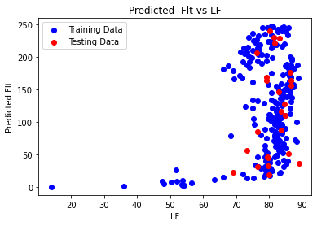 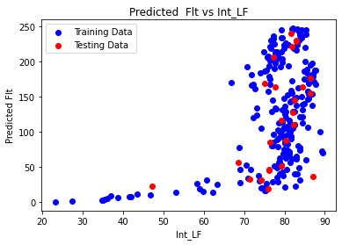 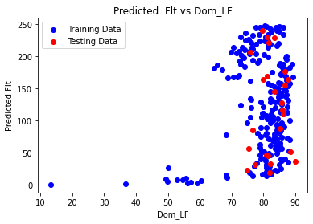 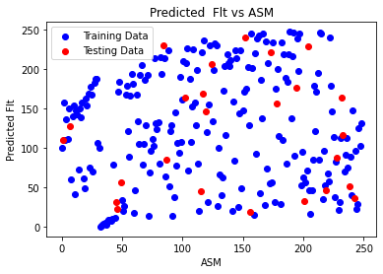 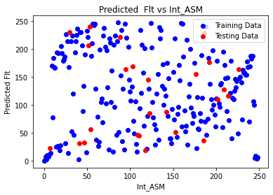 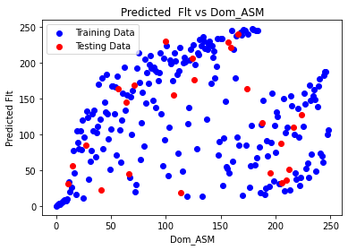 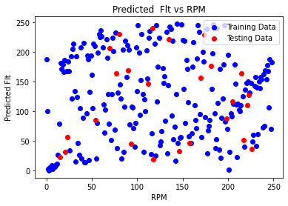 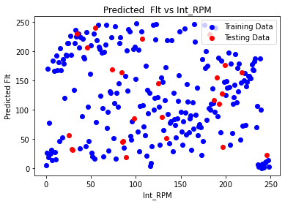 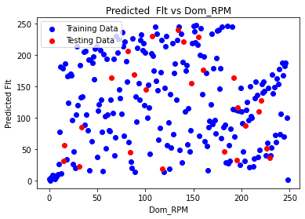 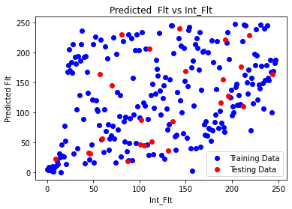 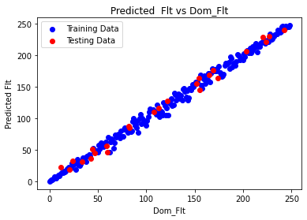 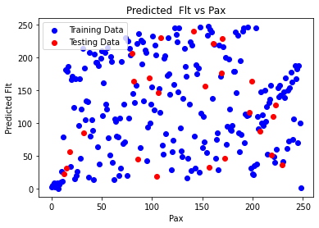 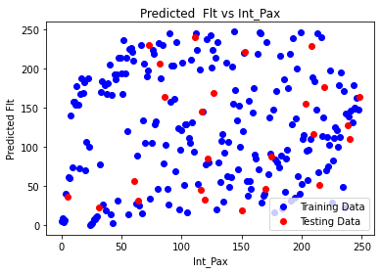 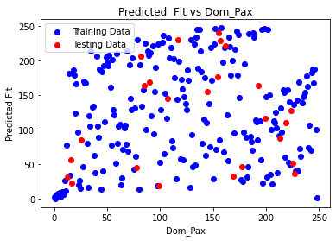 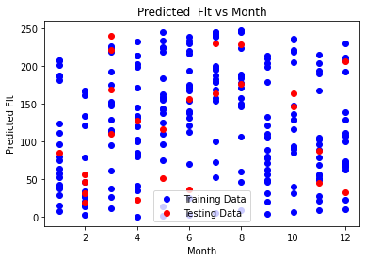 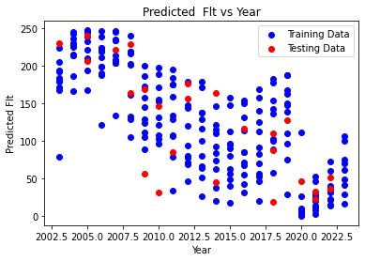

SHAP-FUNCTION:

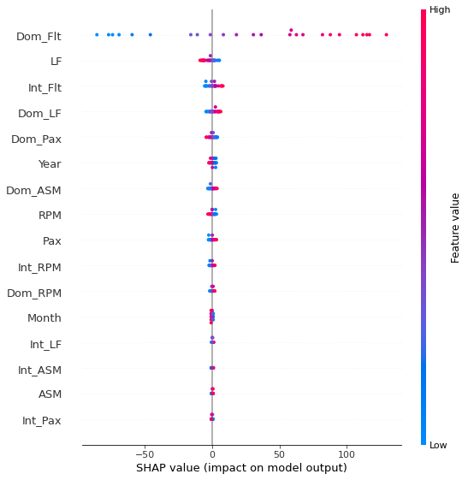

This type of plot is used to visualize the impact of various features on a model’s output. It indicates the contribution of each feature to the prediction with colors representing feature values and dots showing the distribution of these impacts for specific features.

In a SHAP plot:

* Each dot represents an individual prediction made by the model.
* The y-axis lists the features used in the model.
* The x-axis represents the SHAP value, which shows how much each feature changes the prediction.
* The color of the dots represents the value of the feature (high or low).

The Future of Predictive Equations Derived from Linear Regression Models:

The future trajectory of equations derived from linear regression models holds promise for advancements in predictive capabilities and model enhancement. Several key aspects shape the future landscape:

1. Model Enhancement:

- Ongoing efforts to refine predictive models will likely lead to advancements in modeling techniques, feature engineering, and the integration of additional relevant data.

- Improvements may involve enhanced feature selection, addressing multicollinearity, or incorporating interactions for a more nuanced understanding.

2. Data Augmentation:

- As new data becomes available or the problem domain is better understood, equations can be updated or expanded to integrate new variables or features, potentially elevating their predictive performance.

3. Model Interpretation:

- Future developments may focus on advanced techniques for more comprehensive model interpretation. This would facilitate a deeper understanding of how individual features impact predictions.

4. Advanced Modeling Techniques:

- While linear regression remains valuable, future models might explore more sophisticated algorithms, including ensemble methods, neural networks, or gradient-boosted models. These approaches could offer improved predictive accuracy, especially for complex relationships in data.

5. Deployment in Decision-Making Systems:

- Integrating these equations into decision-making systems for diverse applications, such as risk assessment, resource allocation, or operational planning within the airline industry or similar domains, is a foreseeable advancement.

6. Model Monitoring and Adaptation:

- Continuous monitoring of model performance and regular updates to adapt to evolving trends or patterns in the data will be crucial to maintain the accuracy and relevance of these equations over time.

7. Ethical and Regulatory Considerations:

- Given the critical role of predictive models in decision-making, there is an increasing focus on fairness, transparency, and accountability. Future advancements may involve ensuring adherence to ethical guidelines and regulatory standards.

In essence, the future of these equations lies in their adaptability, interpretability, and continuous improvement to meet evolving demands in predictive modeling and decision support.

**From the amalgamation of the theories based on data analysis and mathematical functions it can be summarized that this might be helpful in assisting the AI to produce proper suggestions for the pilot whether to move through the path or not .**

**SIGNAL BASED DEVELOPMENT WITH ARTIFICIAL INTELLIGENCE(DRONE)**:Our third and final approach to maintain proper signal is sending a drone from the body of air-plane until it gets the view of proper landing space or from the airport to locate the aircraft if it looses connection in the near destination .To establish this process the main objective must the proper control of drone from a certain distance ,altitude and height.

So to clarify this statement a similar type of experimental document is collected .

The passage describes a novel algorithm, called Stepwise Soft Actor-Critic (SeSAC), designed for efficient learning in environments with continuous state and action spaces. SeSAC adopts a stepwise learning approach to gradually increase the difficulty of tasks during training, which contrasts with traditional methods that start with challenging tasks from the beginning. This incremental approach aims to improve learning efficiency.

DRONE-SURVEILLANCE FOR SEARCH AND RESCUE IN

NATURAL DISASTER

In the realm of modern advancements, the utilization of drones for surveillance has garnered substantial attention, particularly in swiftly scanning vast areas during natural disasters, expediting search and rescue (SAR) operations, and ultimately preserving human lives. However, the application of autonomous drones in SAR missions remains an underexplored domain, necessitating the attention of researchers to craft highly efficient algorithms rooted in recent strides in deep learning.

The crux of developing an automated application harnessing the power of deep learning lies in the availability of robust datasets. Regrettably, the literature lacks comprehensive datasets tailored specifically for drone-based SAR activities. In response, this paper pioneers the creation of an image dataset designed explicitly for human action detection in SAR scenarios. Comprising 2000 meticulously curated images, meticulously filtered from a pool of 75,000, this dataset encapsulates 30,000 instances of human subjects engaged in various actions pertinent to SAR situations.

Furthermore, this study conducts a series of comprehensive experiments utilizing the newly proposed dataset alongside publicly available datasets and state-of-the-art detection methodologies. The findings underscore the inadequacy of existing models in addressing the critical demands of SAR applications. This revelation serves as a catalyst, inspiring the formulation of a novel model drawing inspiration from the pyramidal feature extraction paradigm akin to the Single Shot MultiBox Detector (SSD) for human detection and action recognition.

Remarkably, the proposed model achieves an impressive 0.98 mean Average Precision (mAP) when applied to the newly curated dataset, marking a substantial leap in the field. Moreover, when tested against the established Okutama dataset, the model exhibits a notable 7% improvement in mAP compared to prevailing state-of-the-art detection models documented in existing literature. This paradigm-shifting contribution lays a foundational milestone in the quest for more effective and specialized models tailored explicitly for SAR missions, reinforcing the potential of cutting-edge deep learning approaches in augmenting emergency response systems.

The key points:

1. **Reinforcement Learning (RL):** The review explains that reinforcement learning is a type of machine learning in which an agent learns to behave in an environment through trial and error, aiming to maximize its expected reward.
2. **Actor-Critic Algorithm:** The method proposes the use of the actor-critic algorithm, a combination of value-based and policy-based approaches, for training UAVs to perform autonomous flight control tasks.
3. **Soft Actor-Critic (SAC) Algorithm:** The SAC algorithm is a variant of the actor-critic algorithm that encourages exploration by adding an entropy term to the objective function.
4. **Components of the Reward Function:** The review details the components of the reward function used in the experiments, which include success rewards, failure rewards, distance rewards, and line-of-sight (LOS) rewards. These components were designed to motivate the UAV to complete specific missions.
5. **SeSAC Algorithm:** The method introduces the Stepwise Soft Actor–Critic (SeSAC) algorithm, a novel approach that combines SAC with two additional techniques: a positive buffer to store experiences from successful episodes and a cool-down alpha to control the entropy term as the agent learns. The algorithm aims to address challenges in high-dimensional state and action spaces.

**Experimental Setup:** The method conducted experiments on two missions: the Precise Approach Mission (PAM) and the Moving Target Chasing Mission (MTCM). The review highlights that SeSAC outperformed other baseline algorithms in both missions

Purpose of the passage

* The primary objectives of the paper are as follows:

1. **Algorithm Development:** This aims to develop and present the SeSAC algorithm, which is a modification and extension of the Soft Actor-Critic (SAC) algorithm. SeSAC is designed to overcome the inefficiencies in learning caused by attempting challenging tasks from the beginning, making it more suitable for training UAVs in complex environments.
2. **UAV Mission Accomplishment:** The method focuses on training UAV agents to successfully accomplish specific missions, such as precision approach and moving target chasing. These missions represent real-world applications for UAVs in disaster management and counter-terrorism scenarios.

**High-Dimensional State and Action Spaces:** It addresses the challenges associated with high-dimensional state and action spaces in UAV control. It introduces SeSAC as an algorithm that can efficiently train agents in such complex environments

Mission of UAV

**Precise Approach Mission (PAM):** In the Precise Approach Mission, the UAV's objective is to approach a fixed target with high precision. The success criteria for this mission involve the UAV reaching the target within a specific range (e.g., within 0.1 kilometers) while maintaining specific flight dynamics parameters. The precise approach mission is a representative scenario for tasks like precision landing or approaching a target location with great accuracy.

* **Moving Target Chasing Mission (MTCM):** In the Moving Target Chasing Mission, the UAV's task is to chase and maintain proximity to a moving target. The UAV must approach the target within a certain range (e.g., within 2.4 kilometers) and also maintain specific relative angles with respect to the moving target. This mission simulates scenarios such as tracking a moving object or vehicle, which can be applicable in applications like surveillance or search and rescue

**Results from each of the mission**

**Precise Approach Mission (PAM):**

* The goal of the PAM is for the UAV to approach a fixed target within 0.1 kilometers.
* SeSAC successfully completed the PAM with a high success rate. It was able to reach the target within the specified radius of 0.1 kilometers.
* The success was achieved even when the target radius was gradually reduced from 2.0 kilometers to 0.1 kilometers, demonstrating the algorithm's adaptability to changing task difficulty.
* SeSAC significantly outperformed other algorithms, such as PPO and SAC, in terms of mission success and efficiency.
* The results showed that SeSAC's stepwise learning approach and the incorporation of the positive buffer and cool-down alpha techniques were effective in achieving mission success in the PAM scenario

**Moving Target Chasing Mission (MTCM):**

* In the MTCM, the UAV's objective is to approach and chase a moving target within 2.4 kilometers while maintaining specific relative angles to the target.
* SeSAC achieved remarkable success in the MTCM, surpassing the performance of other algorithms.
* It achieved a high average score and was able to succeed in more than 1,000 episodes, indicating its efficiency in learning the mission.
* SeSAC demonstrated faster convergence and a stable score after convergence, highlighting its effectiveness in tackling complex tasks.
* Other baseline models, such as PPO and SAC, were unable to successfully complete the MTCM.
* The results demonstrated that SeSAC's stepwise learning approach, coupled with the positive buffer and cool-down alpha techniques, significantly improved the UAV's ability to accomplish the challenging mission of chasing a moving target.

Results from each of the mission

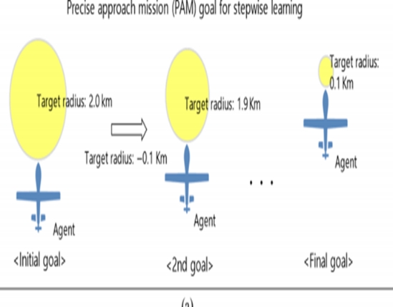

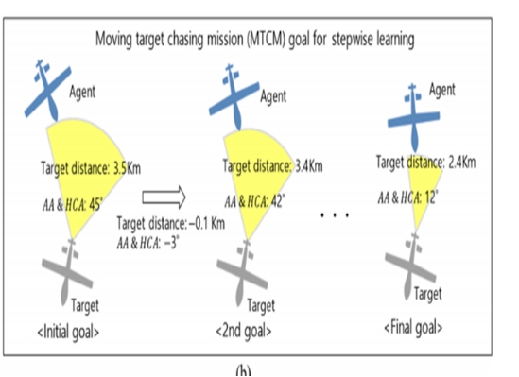

**Final decision made from the results**

The final decision based on the results of the method is that the SeSAC algorithm proves highly effective in autonomous UAV flight control. It successfully accomplished mission objectives in challenging scenarios with superior efficiency and learning speed, outperforming other algorithms. SeSAC exhibited adaptability to varying task difficulties. The results indicate its readiness for real-world applications, particularly in disaster management and counter-terrorism missions. Future research will focus on enhancing agent adaptability in new situations.

DEVELOPING THE SYSTEM WITH ML:

The analysis of historical evidence with machine learning (ML) techniques can help establish the effectiveness of the SeSAC (Self-Explaining, Self-Adapting Control) algorithm for autonomous UAV flight control.

1. Data Understanding: Before implementing any algorithm, thorough comprehension of the dataset is essential. Utilizing ML techniques facilitates exploration of the dataset, enabling identification of patterns, correlations, and anomalies within UAV flight data.

2. Feature Engineering: Effective ML models necessitate well-prepared features for accurate predictions. Techniques such as feature scaling, transformation, and selection are employed to refine input features for model training.

3. Model Selection: Depending on the problem's nature and dataset characteristics, ML practitioners can opt for suitable models for training and evaluation. In the context of autonomous UAV flight control, regression or classification models may be appropriate, contingent upon the specific task requirements (e.g., altitude prediction, obstacle detection).

4. Training and Evaluation: ML models are trained using the dataset to discern underlying patterns and relationships. Subsequently, evaluation of the trained models is performed using pertinent metrics to gauge their efficacy in accurately predicting flight parameters.

5. Algorithm Evaluation: A comparative analysis is conducted between the performance of ML models trained on the dataset and the anticipated performance of the SeSAC algorithm. Demonstrating high accuracy and reliability in predicting flight parameters, ML models can provide corroborating evidence of the SeSAC algorithm's effectiveness.

6. Iterative Improvement: ML analysis typically involves iterative processes. In instances where initial ML models fall short of desired performance metrics, refinement of feature engineering techniques, experimentation with different algorithms, or adjustment of hyperparameters can be pursued to enhance model performance.

Leveraging ML techniques on UAV flight data facilitates gaining insights into UAV behavior, identifying areas for enhancement, and potentially validating the efficacy of the SeSAC algorithm for autonomous flight control.

|  |  |  |  |  |
| --- | --- | --- | --- | --- |
| date | time | lat | lon | alt |
| 6/15/2020 | 18:14:34 | 22.9030258 | 120.2730977 | 0.089 |
| 6/15/2020 | 18:14:37 | 22.9030259 | 120.2730981 | 0.016 |
| 6/15/2020 | 18:14:40 | 22.9030259 | 120.2730987 | 5.015 |
| 6/15/2020 | 18:14:43 | 22.9030252 | 120.2730997 | 11.815 |
| 6/15/2020 | 18:14:46 | 22.903025 | 120.2730967 | 18.773 |
| 6/15/2020 | 18:14:49 | 22.903001 | 120.2730966 | 20.203 |
| 6/15/2020 | 18:14:52 | 22.9029491 | 120.2730909 | 20.051 |
| 6/15/2020 | 18:14:55 | 22.9028912 | 120.2730852 | 19.923 |
| 6/15/2020 | 18:14:58 | 22.902835 | 120.2730817 | 19.947 |
| 6/15/2020 | 18:15:01 | 22.9027797 | 120.2730753 | 20.047 |
| 6/15/2020 | 18:15:04 | 22.902729 | 120.2730695 | 20.028 |
| 6/15/2020 | 18:15:07 | 22.9026807 | 120.273045 | 20.007 |
| 6/15/2020 | 18:15:10 | 22.9026332 | 120.2730219 | 19.95 |
| 6/15/2020 | 18:15:13 | 22.902583 | 120.2729972 | 20.042 |
| 6/15/2020 | 18:15:16 | 22.9025387 | 120.272973 | 20.056 |
| 6/15/2020 | 18:15:19 | 22.9025469 | 120.272944 | 20.028 |
| 6/15/2020 | 18:15:22 | 22.9025755 | 120.2728914 | 20.26 |
| 6/15/2020 | 18:15:25 | 22.9026096 | 120.2728318 | 19.846 |
| 6/15/2020 | 18:15:28 | 22.9026362 | 120.2727818 | 19.896 |
| 6/15/2020 | 18:15:31 | 22.9026671 | 120.2727321 | 19.795 |
| 6/15/2020 | 18:15:34 | 22.9026778 | 120.2727022 | 19.956 |
| 6/15/2020 | 18:15:37 | 22.9026241 | 120.2727044 | 19.949 |
| 6/15/2020 | 18:15:40 | 22.9025773 | 120.2727118 | 19.946 |
| 6/15/2020 | 18:15:43 | 22.902528 | 120.2727165 | 20.116 |
| 6/15/2020 | 18:15:46 | 22.902473 | 120.2727201 | 20.094 |
| 6/15/2020 | 18:15:49 | 22.9024228 | 120.2727255 | 20.005 |
| 6/15/2020 | 18:15:52 | 22.9023713 | 120.272734 | 19.992 |
| 6/15/2020 | 18:15:55 | 22.9023671 | 120.272788 | 19.953 |
| 6/15/2020 | 18:15:58 | 22.9023738 | 120.2728434 | 19.995 |
| 6/15/2020 | 18:16:01 | 22.9023748 | 120.2729018 | 20.056 |
| 6/15/2020 | 18:16:04 | 22.9023755 | 120.2729619 | 20.097 |
| 6/15/2020 | 18:16:07 | 22.9023792 | 120.2730199 | 20.06 |
| 6/15/2020 | 18:16:10 | 22.9023811 | 120.273081 | 20.044 |
| 6/15/2020 | 18:16:13 | 22.9023837 | 120.2731379 | 20.063 |
| 6/15/2020 | 18:16:16 | 22.9023859 | 120.2731976 | 20.162 |
| 6/15/2020 | 18:16:19 | 22.9023886 | 120.2732075 | 24.492 |
| 6/15/2020 | 18:16:22 | 22.9023866 | 120.2732087 | 29.498 |
| 6/15/2020 | 18:16:25 | 22.9024375 | 120.2732028 | 30.131 |
| 6/15/2020 | 18:16:28 | 22.9025369 | 120.2731869 | 30.112 |

|  |  |  |  |  |  |  |  |  |  |  |
| --- | --- | --- | --- | --- | --- | --- | --- | --- | --- | --- |
| x_gyro | y_gyro | | z_gyro | | x_acc | | y_acc | | z_acc | |
| -4 | 4 | | -1 | | 22 | | 45 | | -998 | |
| 43 | -182 | | -106 | | 0 | | 48 | | -1157 | |
| -20 | 24 | | -3 | | -70 | | 129 | | -984 | |
| 87 | 39 | | 3 | | -6 | | 21 | | -1021 | |
| -94 | 84 | | 77 | | -49 | | 123 | | -866 | |
| -36 | -17 | | 857 | | -5 | | -21 | | -915 | |
| -14 | 12 | | -18 | | 0 | | -68 | | -1001 | |
| -9 | -28 | | 28 | | -25 | | -63 | | -1008 | |
| -8 | 18 | | -6 | | -86 | | -67 | | -1010 | |
| 48 | 12 | | -1 | | 14 | | -126 | | -1032 | |
| 17 | 19 | | 176 | | 10 | | -81 | | -986 | |
| 38 | -15 | | -45 | | -63 | | -85 | | -977 | |
| 8 | 5 | | -13 | | 5 | | -128 | | -1021 | |
| 19 | 37 | | -25 | | -20 | | -69 | | -997 | |
| 136 | 101 | | 366 | | -62 | | -170 | | -998 | |
| 26 | 66 | | 67 | | -56 | | -49 | | -1019 | |
| -4 | -39 | | 2 | | -38 | | 102 | | -996 | |
| -46 | 18 | | -93 | | -85 | | 72 | | -1070 | |
| -102 | 41 | | -67 | | -127 | | 76 | | -1027 | |
| -29 | -45 | | -25 | | -190 | | 70 | | -991 | |
| 118 | -29 | | -988 | | 32 | | -154 | | -1009 | |
| -54 | 51 | | 31 | | -1 | | -57 | | -995 | |
| -11 | -7 | | 87 | | 48 | | 21 | | -988 | |
| -23 | -21 | | 34 | | 7 | | -33 | | -964 | |
| -78 | -14 | | -31 | | 32 | | -21 | | -989 | |
| -51 | -5 | | 49 | | -84 | | 27 | | -988 | |
| -26 | -95 | | -1181 | | 26 | | 11 | | -1018 | |
| 48 | -76 | | -59 | | 25 | | 42 | | -1000 | |
| -43 | 0 | | 8 | | 5 | | 93 | | -983 | |
| 42 | 5 | | -13 | | -1 | | 13 | | -1023 | |
| -3 | -1 | | -174 | | 11 | | 95 | | -984 | |
| 78 | -40 | | -39 | | 7 | | 7 | | -994 | |
| 118 | 13 | | -201 | | 12 | | 46 | | -1009 | |
| -15 | 19 | | 121 | | 7 | | -52 | | -1015 | |
| 3 | 71 | | -1 | | 95 | | 35 | | -1106 | |
| 35 | -44 | | -13 | | 81 | | 50 | | -1000 | |
| 40 | 17 | | -25 | | 40 | | 0 | | -938 | |
| 116 | 19 | | -32 | | 18 | | 83 | | -1009 | |
| 25 | -5 | | 64 | | 82 | | 87 | | -951 | |
| north | | east | | down | | pitch | | yaw | | roll | |
| -0.178721428 | | -0.109012604 | | -0.08904624 | | 0.005118456 | | 0.326457202 | | -0.033887386 | |
| -0.177578926 | | -0.071496964 | | -0.021071553 | | 0.006675139 | | 0.299558282 | | 0.010362147 | |
| -0.168616295 | | -0.003566742 | | -5.015934467 | | -0.026431272 | | 0.248265535 | | -0.043720677 | |
| -0.254026413 | | 0.096460342 | | -11.8157053 | | -0.033754222 | | 0.263797075 | | -0.069073595 | |
| -0.267570496 | | -0.212194443 | | -18.7735939 | | -0.024325768 | | 0.297159463 | | -0.041972082 | |
| -2.941508293 | | -0.219352722 | | -20.20362282 | | -0.08394327 | | -3.138056993 | | 0.071486406 | |
| -8.71903038 | | -0.806114197 | | -20.05151367 | | -0.052909862 | | -3.11111474 | | 0.084253155 | |
| -15.17339134 | | -1.392827988 | | -19.9235363 | | -0.048999172 | | -3.127209663 | | 0.066950209 | |
| -21.43738556 | | -1.753440857 | | -19.94703865 | | -0.056422673 | | -3.042311192 | | 0.077979431 | |
| -27.59326553 | | -2.408336639 | | -20.04746819 | | -0.041417662 | | -3.095498323 | | 0.060462035 | |
| -33.23950577 | | -2.995754242 | | -20.02843285 | | -0.061178494 | | -2.792309761 | | 0.130727842 | |
| -38.60782623 | | -5.513391495 | | -20.00749779 | | -0.081274949 | | -2.785830736 | | 0.058763757 | |
| -43.90297318 | | -7.877988815 | | -19.95051956 | | -0.073590443 | | -2.744969606 | | 0.079943582 | |
| -49.49155807 | | -10.41348267 | | -20.0424633 | | -0.071700469 | | -2.700767994 | | 0.085012428 | |
| -54.41359329 | | -12.89558792 | | -20.05699539 | | 0.014778031 | | -2.488302708 | | 0.140237212 | |
| -53.50061417 | | -15.87321091 | | -20.02862167 | | -0.172868758 | | -1.132839441 | | -0.017086186 | |
| -50.32569122 | | -21.26254272 | | -20.26044464 | | -0.119155943 | | -1.061354041 | | -0.025530245 | |
| -46.52340698 | | -27.37445068 | | -19.84689331 | | -0.084614225 | | -1.057359338 | | -0.061797913 | |
| -43.56583405 | | -32.50157928 | | -19.89663124 | | -0.11701066 | | -0.949842095 | | -0.037593499 | |
| -40.12892151 | | -37.59619904 | | -19.79528809 | | -0.113164306 | | -1.03527081 | | -0.036390327 | |
| -38.93851471 | | -40.66326523 | | -19.95674324 | | -0.129009604 | | -2.75911355 | | -0.015486413 | |
| -44.91609573 | | -40.43406296 | | -19.94928551 | | -0.018710818 | | 2.952613115 | | 0.061298065 | |
| -50.11848068 | | -39.67950439 | | -19.9462719 | | -0.027777392 | | 3.068270445 | | 0.070720628 | |
| -55.60784149 | | -39.1963501 | | -20.11644173 | | -0.05513145 | | 3.085046291 | | 0.055180524 | |
| -61.72872162 | | -38.82914352 | | -20.09467888 | | -0.035057928 | | 3.043731451 | | 0.04068676 | |
| -67.32382965 | | -38.27110672 | | -20.00538445 | | -0.060901262 | | 3.052328825 | | 0.054816019 | |
| -73.05018616 | | -37.40316391 | | -19.99213219 | | 0.056571789 | | 2.48151207 | | -0.096663907 | |
| -73.51819611 | | -31.8638916 | | -19.95311165 | | -0.019851562 | | 1.356112361 | | -0.061750066 | |
| -72.77489471 | | -26.14609528 | | -19.99611473 | | -0.003010358 | | 1.558889031 | | -0.002699612 | |
| -72.66379547 | | -20.19419479 | | -20.05623436 | | -0.012751177 | | 1.52635479 | | -0.03393789 | |
| -72.58344269 | | -14.03455353 | | -20.09704971 | | 0.003692877 | | 1.469284654 | | -0.041951641 | |
| -72.17243195 | | -8.090351105 | | -20.06063461 | | 0.018744841 | | 1.483087897 | | -0.017310388 | |
| -71.96297455 | | -1.819366455 | | -20.04412842 | | -0.005560822 | | 1.460291386 | | -0.041184865 | |
| -71.67134094 | | 4.014570236 | | -20.06359673 | | -0.010140924 | | 1.459933281 | | -0.02007718 | |
| -71.42946625 | | 10.13886833 | | -20.1629715 | | 0.121443376 | | 1.459296107 | | -0.032363635 | |
| -71.12446594 | | 11.1536293 | | -24.49237251 | | 0.031546913 | | 1.481415749 | | -0.001175971 | |
| -71.34770203 | | 11.27278614 | | -29.49896431 | | 0.057687163 | | 1.467770338 | | -0.143049777 | |
| -65.67849731 | | 10.67443085 | | -30.13187408 | | 0.054860264 | | 1.380748034 | | -0.189445287 | |
| -54.61858749 | | 9.041142464 | | -30.11270905 | | 0.062889643 | | 1.381109953 | | -0.15370962 | |

|  |  |  |
| --- | --- | --- |
| wind_speed | wind_direction |  |
| 0 | 0 |  |
| 0 | 0 |  |
| 0 | 0 |  |
| 0 | 0 |  |
| 0 | 0 |  |
| 0 | 0 |  |
| 0 | 0 |  |
| 0 | 0 |  |
| 0 | 0 |  |
| 0 | 0 |  |
| 0 | 0 |  |
| 0 | 0 |  |
| 0 | 0 |  |
| 0 | 0 |  |
| 0 | 0 |  |
| 0 | 0 |  |
| 0 | 0 |  |
| 0 | 0 |  |
| 0 | 0 |  |
| 0 | 0 |  |
| 0 | 0 |  |
| 0 | 0 |  |
| 0 | 0 |  |
| 0 | 0 |  |

explain each feature according to the drone trajectory dataset:

1. Date: The date when the data was recorded.

2. Time: The time when the data was recorded.

3. Latitude (lat): The angular distance of the drone's position north or south of the equator, measured in degrees.

4. Longitude (lon): The angular distance of the drone's position east or west of the Prime Meridian, measured in degrees.

5. Altitude (alt): The height of the drone above a reference point, typically measured in meters.

6. X Gyro: The angular velocity of the drone around its x-axis, indicating its rotational movement in the horizontal plane.

7. Y Gyro: The angular velocity of the drone around its y-axis, indicating its rotational movement in the vertical plane.

8. Z Gyro: The angular velocity of the drone around its z-axis, indicating its rotational movement perpendicular to the ground.

9. X Acc: The acceleration of the drone along its x-axis, indicating its linear movement in the horizontal plane.

10. Y Acc: The acceleration of the drone along its y-axis, indicating its linear movement in the vertical plane.

11. Z Acc: The acceleration of the drone along its z-axis, indicating its linear movement perpendicular to the ground.

12. North: The magnetic north component of the drone's orientation, measured in degrees.

13. East: The magnetic east component of the drone's orientation, measured in degrees.

14. Down: The downward acceleration due to gravity experienced by the drone, typically measured in m/s².

15. Pitch: The angle between the drone's longitudinal axis and the horizontal plane, indicating its inclination forward or backward.

16. Yaw: The angle between the drone's longitudinal axis and the north direction, indicating its orientation.

17. Roll: The angle between the drone's lateral axis and the horizontal plane, indicating its inclination to the left or right.

18. Wind Speed: The speed of the wind affecting the drone's flight, typically measured in meters per second.

19. Wind Direction: The direction from which the wind is blowing, measured in degrees clockwise from true north.

These features collectively provide a comprehensive overview of the drone's trajectory, including its position, orientation, movement, and environmental conditions such as wind speed and direction.

LIME-INTERPRETTION:

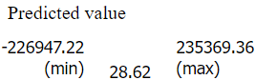

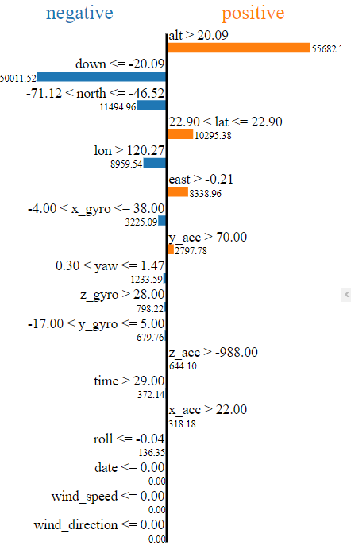

Lime values offer insights into how individual features influence a model's predictions.

In this plot:

1. Positive Contributions (Orange):

- Features that positively influence the model's output, pushing it higher, are depicted in red.

- These features contribute positively to the prediction.

- Specifically:

- "alt > 20.09": Altitudes greater than 20.09 have a positive impact on the prediction.

- "east > -0.21": Increased eastward movement positively contributes.

- "yaw <= 1.47": Smaller yaw angles positively affect the prediction.

- "z_acc > 70.00": Acceleration in the z-direction (vertical) above 70.00 positively influences predictions.

2. Negative Contributions (Blue):

- Features that negatively affect the model's output, pushing it lower, are represented in blue.

- These features contribute negatively to the prediction.

- Specifically:

- "down <= -20.09": Downward accelerations exceeding -20.09 have a strong negative impact.

- "north <= -46.52": Northern movement below -46.52 contributes negatively.

- "x_gyro <= 38.00": Smaller x-axis gyro values lead to a negative effect.

- "y_gyro <= 5.00": Lower y-axis gyro values also contribute negatively.

- "time > 29.00": Predictions decrease when the time exceeds 29.00.

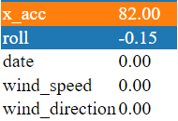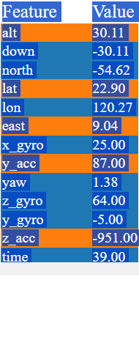

EQUATIONS:

ENCODING ONLY CATEGORICAL VARIABLES:

coefficient [ 7.39446528e-19 8.44716199e-09 -1.19590652e-14 5.19230770e-13

7.53320457e-09 3.07845586e-08 8.79201712e-08 1.54563344e-07

2.17862681e-08 -9.31884536e-08 4.94555270e-08 -1.25079679e-09

5.36452377e-08 -7.54199268e-09 3.92524909e-09 -1.12624884e-09

-2.45639555e-20 9.23265913e-20 -5.75982404e-20 -1.35525272e-20

-9.99498878e-20 -3.21872520e-20 3.38813179e-20 3.72694497e-20

1.72794721e-19 5.92923063e-20 1.45689667e-19 -4.02340650e-20

5.08219768e-21 -4.23516474e-20 -1.11808349e-19 -1.16890547e-19

2.96461532e-20 -3.38813179e-21 -3.38813179e-21 -1.35525272e-20

2.04592456e-06 1.93372779e-07 1.01594896e-06 3.93240534e-06

1.05269658e-06 6.01784775e-06 -5.52504526e-06 -4.47299082e-06

-2.89566424e-06 -4.27465220e-06 -1.03299095e-05 -1.77380025e-06

-3.93262615e-06 -3.08203552e-08 -6.50579498e-08 0.00000000e+00

0.00000000e+00 -5.46429386e-13 1.04539924e-11 1.72435025e-07

7.04909142e-07 2.01365798e-06 3.54005136e-06 4.98794449e-07

-2.13431516e-06 1.13264954e-06 -2.84944315e-08 1.22867521e-06

-1.72636299e-07 8.98951465e-08 -2.57933245e-08 0.00000000e+00

0.00000000e+00 1.24900419e-10 9.06073772e-07 3.70259174e-06

1.05744826e-05 1.85897623e-05 2.62039272e-06 -1.12081193e-05

5.94817751e-06 -1.50396949e-07 6.45218810e-06 -9.07130748e-07

4.72095811e-07 -1.35457630e-07 0.00000000e+00 0.00000000e+00

3.07058787e-06 9.67408327e-06 2.87516911e-06 1.74985342e-06

5.94921696e-06 -1.40482203e-05 1.59979156e-06 -1.09267865e-05

3.28074664e-06 -3.07082398e-06 2.20496956e-07 -4.01436179e-08

0.00000000e+00 0.00000000e+00 4.27422956e-06 4.56594909e-06

-5.28532389e-06 6.90073000e-06 -6.45573096e-06 2.07762669e-06

-1.67419151e-05 3.85891547e-06 -9.67437949e-06 -3.07698079e-06

-1.44158572e-07 0.00000000e+00 0.00000000e+00 -1.08373115e-05

1.02676364e-05 1.11517739e-05 -5.24212493e-06 1.50936462e-06

2.20660141e-06 5.24546632e-06 -2.87553690e-06 2.43184012e-06

1.26420795e-07 0.00000000e+00 0.00000000e+00 -7.01696506e-07

3.10256347e-06 -3.56003291e-07 1.92027281e-06 9.21463584e-06

-5.12298138e-06 -1.74873588e-06 2.83136249e-07 3.75143383e-07

0.00000000e+00 0.00000000e+00 -4.30862563e-06 8.31358466e-06

1.06701058e-06 -1.97090838e-05 9.29852514e-06 -5.94917742e-06

-4.60788665e-06 -1.73717077e-07 0.00000000e+00 0.00000000e+00

1.16392439e-06 -1.68488374e-06 -1.90990346e-06 -5.66683211e-06

1.40473637e-05 6.89783350e-06 -1.94856477e-07 0.00000000e+00

0.00000000e+00 7.29311851e-07 -3.61379241e-06 4.18675976e-07

-1.59096814e-06 -6.09022430e-06 1.05716286e-06 0.00000000e+00

0.00000000e+00 1.69890226e-05 4.10534030e-06 1.09268474e-05

-5.50350994e-07 1.31746824e-07 0.00000000e+00 0.00000000e+00

1.11847425e-05 -3.28111013e-06 -6.21324105e-07 -1.96507041e-08

0.00000000e+00 0.00000000e+00 3.07106013e-06 -2.20486705e-07

4.01458133e-08 0.00000000e+00 0.00000000e+00 2.60785613e-08

-7.59681410e-09 0.00000000e+00 0.00000000e+00 6.64438425e-10

0.00000000e+00 0.00000000e+00 0.00000000e+00 0.00000000e+00

0.00000000e+00]

intercept 0.006815643041003055

Equation: pitch= 0.00681564304100305482 + 0.00000000844716199134 * time + -0.00000000000001195907 * lat + 0.00000000000051923077 * lon + 0.00000000753320457136 * alt + 0.00000003078455863678 * x_gyro + 0.00000008792017116371 * y_gyro + 0.00000015456334363555 * z_gyro + 0.00000002178626807140 * x_acc + -0.00000009318845356086 * y_acc + 0.00000004945552696927 * z_acc + -0.00000000125079678816 * north + 0.00000005364523771101 * east + -0.00000000754199267919 * down + 0.00000000392524909323 * yaw + -0.00000000112624884072 * roll + -0.00000000000000000002 * wind_speed + 0.00000000000000000009 * wind_direction + -0.00000000000000000006 * date**2 + -0.00000000000000000001 * date**1*time**1 + -0.00000000000000000010 * date**1*lat**1 + -0.00000000000000000003 * date**1*lon**1 + 0.00000000000000000003 * date**1*alt**1 + 0.00000000000000000004 * date**1*x_gyro**1 + 0.00000000000000000017 * date**1*y_gyro**1 + 0.00000000000000000006 * date**1*z_gyro**1 + 0.00000000000000000015 * date**1*x_acc**1 + -0.00000000000000000004 * date**1*y_acc**1 + 0.00000000000000000001 * date**1*z_acc**1 + -0.00000000000000000004 * date**1*north**1 + -0.00000000000000000011 * date**1*east**1 + -0.00000000000000000012 * date**1*down**1 + 0.00000000000000000003 * date**1*yaw**1 + -0.00000000000000000000 * date**1*roll**1 + -0.00000000000000000000 * date**1*wind_speed**1 + -0.00000000000000000001 * date**1*wind_direction**1 + 0.00000204592455537606 * time**2 + 0.00000019337277941171 * time**1*lat**1 + 0.00000101594896029361 * time**1*lon**1 + 0.00000393240533890297 * time**1*alt**1 + 0.00000105269657779425 * time**1*x_gyro**1 + 0.00000601784774967873 * time**1*y_gyro**1 + -0.00000552504526087933 * time**1*z_gyro**1 + -0.00000447299081701096 * time**1*x_acc**1 + -0.00000289566424386846 * time**1*y_acc**1 + -0.00000427465219856270 * time**1*z_acc**1 + -0.00001032990953582816 * time**1*north**1 + -0.00000177380025087081 * time**1*east**1 + -0.00000393262614630370 * time**1*down**1 + -0.00000003082035515842 * time**1*yaw**1 + -0.00000006505794977468 * time**1*roll**1 + 0.00000000000000000000 * time**1*wind_speed**1 + 0.00000000000000000000 * time**1*wind_direction**1 + -0.00000000000054642939 * lat**2 + 0.00000000001045399244 * lat**1*lon**1 + 0.00000017243502526842 * lat**1*alt**1 + 0.00000070490914192813 * lat**1*x_gyro**1 + 0.00000201365798443611 * lat**1*y_gyro**1 + 0.00000354005136179606 * lat**1*z_gyro**1 + 0.00000049879444933005 * lat**1*x_acc**1 + -0.00000213431516396492 * lat**1*y_acc**1 + 0.00000113264953771057 * lat**1*z_acc**1 + -0.00000002849443145884 * lat**1*north**1 + 0.00000122867520503008 * lat**1*east**1 + -0.00000017263629899780 * lat**1*down**1 + 0.00000008989514653229 * lat**1*yaw**1 + -0.00000002579332446387 * lat**1*roll**1 + 0.00000000000000000000 * lat**1*wind_speed**1 + 0.00000000000000000000 * lat**1*wind_direction**1 + 0.00000000012490041884 * lon**2 + 0.00000090607377162524 * lon**1*alt**1 + 0.00000370259173859994 * lon**1*x_gyro**1 + 0.00001057448256522053 * lon**1*y_gyro**1 + 0.00001858976229455988 * lon**1*z_gyro**1 + 0.00000262039272267877 * lon**1*x_acc**1 + -0.00001120811928409089 * lon**1*y_acc**1 + 0.00000594817750719194 * lon**1*z_acc**1 + -0.00000015039694884188 * lon**1*north**1 + 0.00000645218810405539 * lon**1*east**1 + -0.00000090713074813712 * lon**1*down**1 + 0.00000047209581135672 * lon**1*yaw**1 + -0.00000013545762968041 * lon**1*roll**1 + 0.00000000000000000000 * lon**1*wind_speed**1 + 0.00000000000000000000 * lon**1*wind_direction**1 + 0.00000307058786825985 * alt**2 + 0.00000967408326747595 * alt**1*x_gyro**1 + 0.00000287516910769848 * alt**1*y_gyro**1 + 0.00000174985341911232 * alt**1*z_gyro**1 + 0.00000594921696458347 * alt**1*x_acc**1 + -0.00001404822027106686 * alt**1*y_acc**1 + 0.00000159979155957077 * alt**1*z_acc**1 + -0.00001092678653323329 * alt**1*north**1 + 0.00000328074664191947 * alt**1*east**1 + -0.00000307082398476502 * alt**1*down**1 + 0.00000022049695610458 * alt**1*yaw**1 + -0.00000004014361792358 * alt**1*roll**1 + 0.00000000000000000000 * alt**1*wind_speed**1 + 0.00000000000000000000 * alt**1*wind_direction**1 + 0.00000427422956223571 * x_gyro**2 + 0.00000456594909252054 * x_gyro**1*y_gyro**1 + -0.00000528532389282338 * x_gyro**1*z_gyro**1 + 0.00000690073000373870 * x_gyro**1*x_acc**1 + -0.00000645573096330275 * x_gyro**1*y_acc**1 + 0.00000207762668678488 * x_gyro**1*z_acc**1 + -0.00001674191506253212 * x_gyro**1*north**1 + 0.00000385891547186520 * x_gyro**1*east**1 + -0.00000967437949008218 * x_gyro**1*down**1 + -0.00000307698078845488 * x_gyro**1*yaw**1 + -0.00000014415857157068 * x_gyro**1*roll**1 + 0.00000000000000000000 * x_gyro**1*wind_speed**1 + 0.00000000000000000000 * x_gyro**1*wind_direction**1 + -0.00001083731145021929 * y_gyro**2 + 0.00001026763635869553 * y_gyro**1*z_gyro**1 + 0.00001115177387741191 * y_gyro**1*x_acc**1 + -0.00000524212492595320 * y_gyro**1*y_acc**1 + 0.00000150936461898485 * y_gyro**1*z_acc**1 + 0.00000220660140768183 * y_gyro**1*north**1 + 0.00000524546632159276 * y_gyro**1*east**1 + -0.00000287553690100673 * y_gyro**1*down**1 + 0.00000243184011601393 * y_gyro**1*yaw**1 + 0.00000012642079538516 * y_gyro**1*roll**1 + 0.00000000000000000000 * y_gyro**1*wind_speed**1 + 0.00000000000000000000 * y_gyro**1*wind_direction**1 + -0.00000070169650591624 * z_gyro**2 + 0.00000310256347153810 * z_gyro**1*x_acc**1 + -0.00000035600329131455 * z_gyro**1*y_acc**1 + 0.00000192027280753428 * z_gyro**1*z_acc**1 + 0.00000921463583827318 * z_gyro**1*north**1 + -0.00000512298137848599 * z_gyro**1*east**1 + -0.00000174873588154183 * z_gyro**1*down**1 + 0.00000028313624853534 * z_gyro**1*yaw**1 + 0.00000037514338264348 * z_gyro**1*roll**1 + 0.00000000000000000000 * z_gyro**1*wind_speed**1 + 0.00000000000000000000 * z_gyro**1*wind_direction**1 + -0.00000430862563186963 * x_acc**2 + 0.00000831358466369738 * x_acc**1*y_acc**1 + 0.00000106701057850546 * x_acc**1*z_acc**1 + -0.00001970908376131762 * x_acc**1*north**1 + 0.00000929852514179386 * x_acc**1*east**1 + -0.00000594917741584206 * x_acc**1*down**1 + -0.00000460788664775571 * x_acc**1*yaw**1 + -0.00000017371707706687 * x_acc**1*roll**1 + 0.00000000000000000000 * x_acc**1*wind_speed**1 + 0.00000000000000000000 * x_acc**1*wind_direction**1 + 0.00000116392438934765 * y_acc**2 + -0.00000168488373746254 * y_acc**1*z_acc**1 + -0.00000190990345561035 * y_acc**1*north**1 + -0.00000566683210537574 * y_acc**1*east**1 + 0.00001404736370173414 * y_acc**1*down**1 + 0.00000689783349547722 * y_acc**1*yaw**1 + -0.00000019485647720479 * y_acc**1*roll**1 + 0.00000000000000000000 * y_acc**1*wind_speed**1 + 0.00000000000000000000 * y_acc**1*wind_direction**1 + 0.00000072931185131042 * z_acc**2 + -0.00000361379241292030 * z_acc**1*north**1 + 0.00000041867597577156 * z_acc**1*east**1 + -0.00000159096814366426 * z_acc**1*down**1 + -0.00000609022430427843 * z_acc**1*yaw**1 + 0.00000105716285985253 * z_acc**1*roll**1 + 0.00000000000000000000 * z_acc**1*wind_speed**1 + 0.00000000000000000000 * z_acc**1*wind_direction**1 + 0.00001698902259013463 * north**2 + 0.00000410534029770553 * north**1*east**1 + 0.00001092684741984243 * north**1*down**1 + -0.00000055035099400877 * north**1*yaw**1 + 0.00000013174682419832 * north**1*roll**1 + 0.00000000000000000000 * north**1*wind_speed**1 + 0.00000000000000000000 * north**1*wind_direction**1 + 0.00001118474248841383 * east**2 + -0.00000328111012628417 * east**1*down**1 + -0.00000062132410510288 * east**1*yaw**1 + -0.00000001965070410939 * east**1*roll**1 + 0.00000000000000000000 * east**1*wind_speed**1 + 0.00000000000000000000 * east**1*wind_direction**1 + 0.00000307106012998470 * down**2 + -0.00000022048670509330 * down**1*yaw**1 + 0.00000004014581329811 * down**1*roll**1 + 0.00000000000000000000 * down**1*wind_speed**1 + 0.00000000000000000000 * down**1*wind_direction**1 + 0.00000002607856126103 * yaw**2 + -0.00000000759681409774 * yaw**1*roll**1 + 0.00000000000000000000 * yaw**1*wind_speed**1 + 0.00000000000000000000 * yaw**1*wind_direction**1 + 0.00000000066443842525 * roll**2 + 0.00000000000000000000 * roll**1*wind_speed**1 + 0.00000000000000000000 * roll**1*wind_direction**1 + 0.00000000000000000000 * wind_speed**2 + 0.00000000000000000000 * wind_speed**1*wind_direction**1 + 0.00000000000000000000 * wind_direction**2

Accuracy: 0.7643009049669058

GRAPH:

ENCODING ONLY CATEGORICAL VARIABLE :

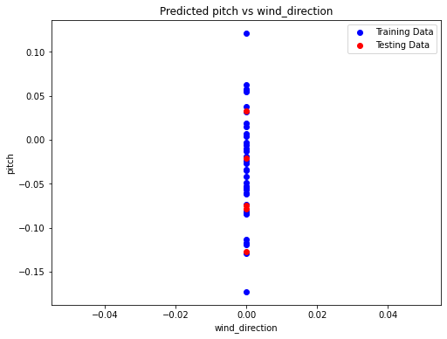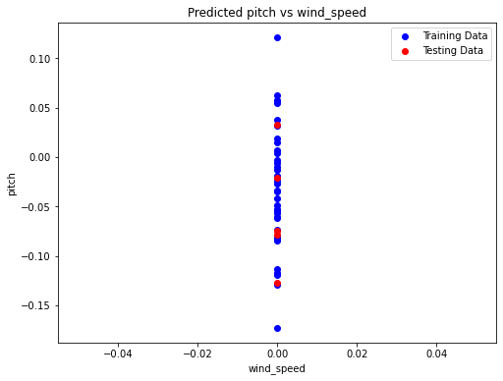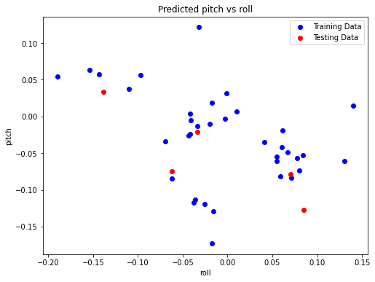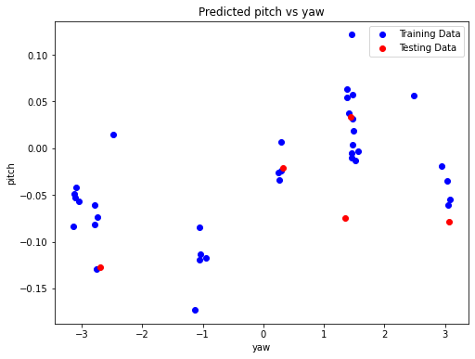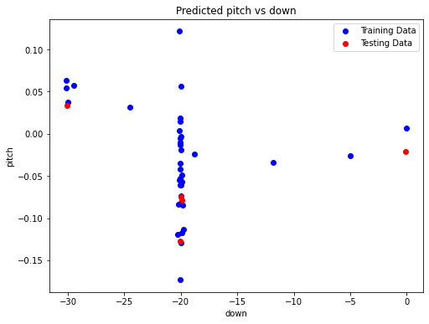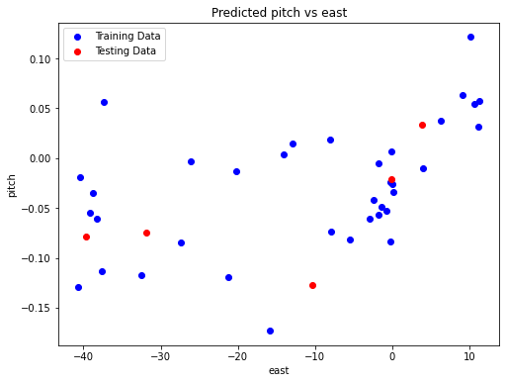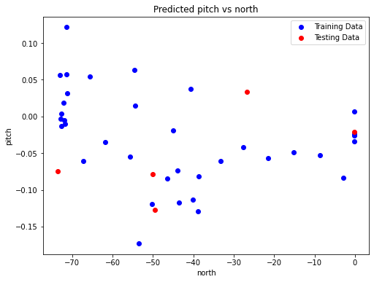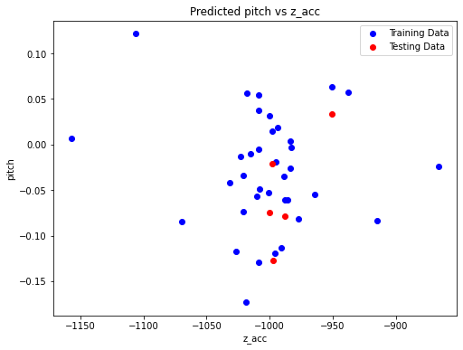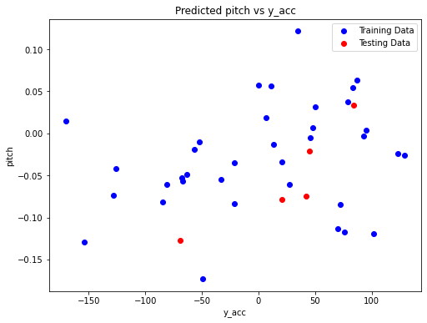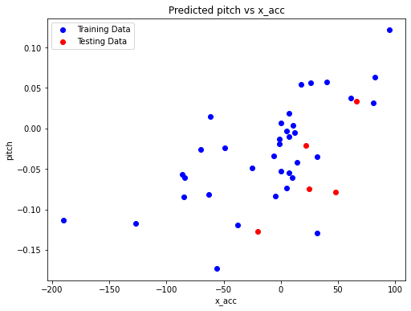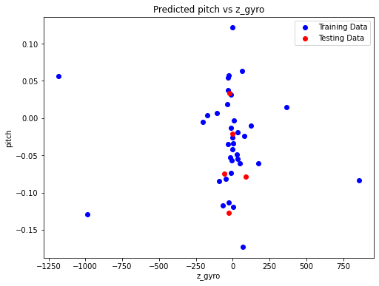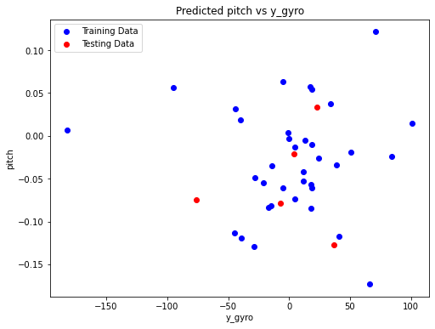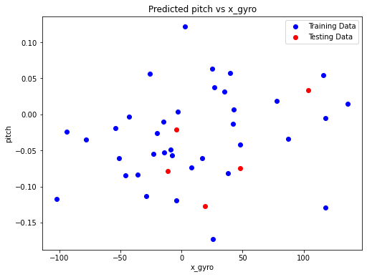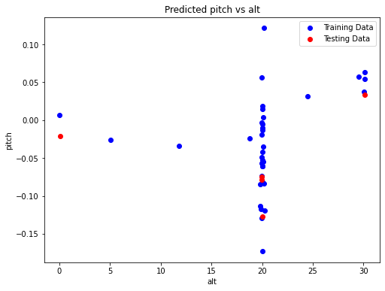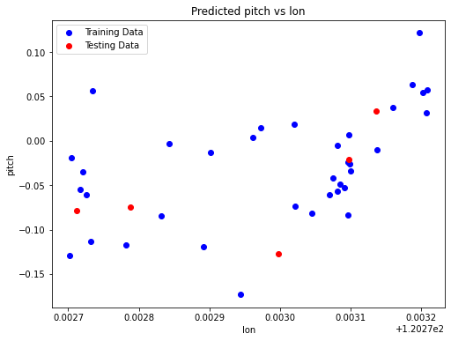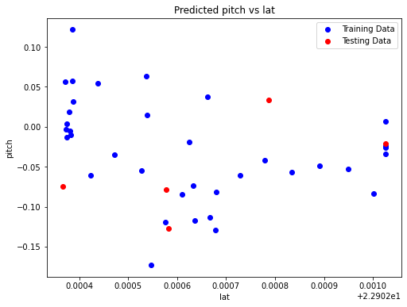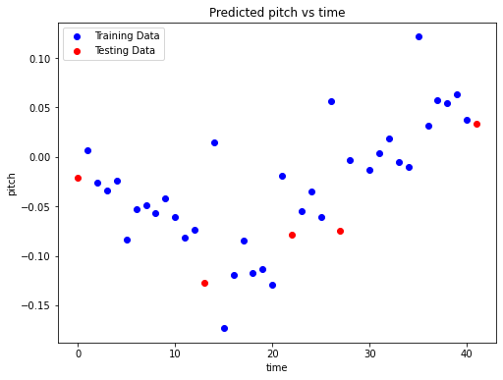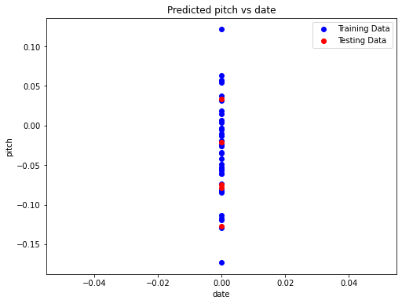

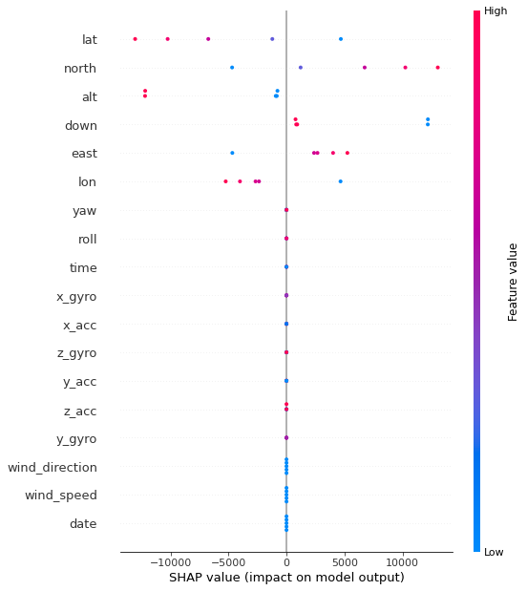

SHAP values elucidate how individual features influence the model's predictions. In this analysis:

1. Latitude:

- Shows a moderate positive impact on the model's output.

- Higher latitudes correspond to higher predictions.

- Implies that locations nearer to the equator (lower latitudes) contribute positively to the outcome.

2. Altitude:

- Demonstrates a significant influence on the model's prediction.

- Above a certain threshold (approximately 20.09), altitude strongly affects predictions positively.

- Suggests that higher altitudes result in more positive predictions.

3. Wind Speed:

- Plays a crucial role in determining the model's output.

- Higher wind speeds (exceeding -0.21) contribute positively to predictions.

- Indicates that windy conditions are associated with favorable outcomes.

4. Yaw Angle:

- Smaller yaw angles (yaw <= 1.47) positively affect predictions.

- Represents rotation around the vertical axis.

- Indicates that a more aligned orientation leads to positive predictions.

5. Vertical Acceleration (Z-Acc):

- Acceleration in the z-direction (above 70.00) positively impacts predictions.

- Strong upward acceleration results in positive predictions.

6. X-Axis Gyro:

- Lower x-axis gyro values (x_gyro <= 38.00) have a negative impact.

- Reduced rotational movement around the x-axis leads to less favorable predictions.

7. Y-Axis Gyro:

- Lower y-axis gyro values (y_gyro <= 5.00) also negatively influence predictions.

- Reduced rotational movement around the y-axis leads to negative outcomes.

8. Time:

- Predictions decrease beyond a time threshold of 29.00.

- Longer durations may result in less favorable predictions.

The parameters provided seems to be regression that relates the 'pitch' of a drone to various input features such as time, latitude, longitude, altitude, gyroscopic data, accelerometer data, wind speed, wind direction, and interactions between these features. The equation also includes terms with different powers and interactions between features.

To establish the system the process might give a hand to cover the lost aircraft with an automation process as the experiment proved to be affirmative in navigating the drone from a certain criteria," the regression can be used in the following ways:

1. Prediction: By utilizing the regression equation, one can predict the pitch of the drone based on the input features. This prediction can help in understanding how the drone is oriented or positioned in real-time, which is crucial for navigation and potentially locating a lost aircraft.

2. Automation: The equation can be integrated into an automation process to continuously monitor and adjust the drone's pitch based on the input features. This automation can assist in navigating the drone efficiently and effectively, especially in critical situations like searching for a lost aircraft.

3.Experimental Affirmation: If the regression model has been trained and validated using experimental data that supports successful drone navigation based on the provided features, it adds credibility to the statement. The model's accuracy of a high level of confidence in its predictions.

By leveraging the regression equation and the insights gained from it, along with experimental validation, it can indeed support the notion that the process could aid in covering the lost aircraft with an automated navigation system, as indicated in the statement.

The provided method seems to be an academic discussing the development of an intelligent control system for unmanned aerial vehicles (UAVs) using artificial neural networks (ANNs).

Main Topic: Development of an intelligent control system for UAVs using ANNs to reduce control time without relying on Global Satellite Navigation Systems (GNSS).

Problem Statement:

* Current UAV navigation systems rely heavily on GNSS, making them vulnerable to signal loss or jamming.
* Existing solutions using high-precision inertial navigation systems are expensive, bulky, and have limitations in autonomous operation time.
* This research aims to develop a method for UAV control using ANNs to address these limitations.

Research Objectives:

1. Develop a method for UAV control using an ANN to minimize platform-free inertial navigation system error.
2. Implement the developed method in the MatLab software environment.
3. Train the ANN in Python 3.6 and test the UAV model in the ROS simulator.

Review of Literature:

* Previous research explored various approaches for UAV control using ANNs and stabilization algorithms.
* These existing solutions demonstrate some success but still have limitations, particularly in GNSS-denied environments.

Further Research:

* The paper proposes to develop and test a novel method for UAV control using ANNs, addressing the aforementioned limitations.
* The research will involve implementation in MatLab and Python, followed by training and testing in a simulated environment.

.

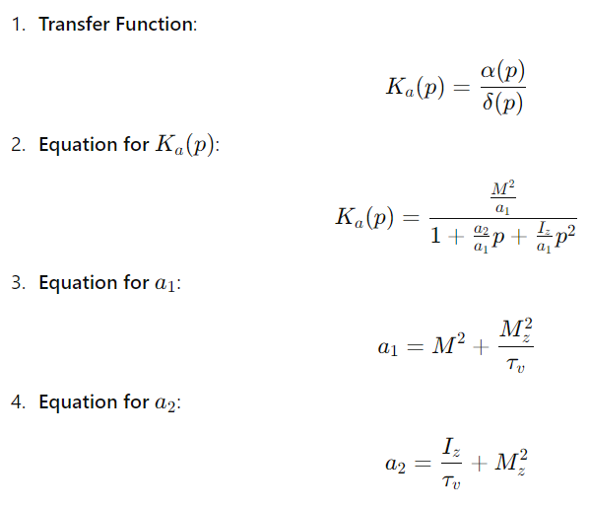

1. Transfer Function

- This equation is crucial for understanding the relationship between the input control signal and the aircraft's response, allowing for the analysis of system stability and performance.

2. Equation for ( Ka(p)

- This equation provides insight into the dynamic behavior of the aircraft, capturing how inertia and time constants influence the aircraft's response to control inputs, which is vital for control system design.

3. Equation for a1

- This equation highlights the significance of the aircraft's moment and mass distribution in determining the baseline characteristics of the control response.

4. Equation for a2

- This equation is important for understanding how the aircraft's moment of inertia and mass distribution affect its dynamic behavior, particularly in rotational control around an axis.

Ka(p) = δ(p)/α(p) = M²/a1 / [1 + a2/a1 p + Iz/a1 p²] This equation represents the characteristics of the UAA (Unaugmented Aircraft) control channel. Explanation: - Ka(p) represents the transfer function of the control channel, which relates the input (δ(p)) to the output (α(p)). - δ(p) is the input to the control channel, and α(p) is the output. - M² is a constant that represents the magnitude of the moment, which depends on the mass distribution with respect to the rotation axis. - a1 and a2 are constants derived from the previous equations: - a1 = M² + M²z/τv - a2 = Iz/τv + M²z - The denominator [1 + a2/a1 p + Iz/a1 p²] represents the transfer function of the control channel, which takes into account the dynamics of the UAA rotation around the axis.

Interpretation

The equation ( Ka(p) suggests that the response of the aircraft’s control channel is a function of its physical properties like mass distribution, moments of inertia, and dynamic characteristics like time constants. This transfer function helps in analyzing the stability and control characteristics of the UAA by considering how the aircraft responds to control inputs over time.

Application

This form of the transfer function is common in control theory and is used to understand the dynamics of aircraft or similar systems. By analyzing \( K_a(p) \), engineers can design control systems to ensure the desired performance and stability, even without augmentation (additional control systems like autopilots).

1. Equation :

ω(p) = 1/τvp α + α = α(1+τvp)/τvp This gives the pitch angle in the form, taking into account the angles v = θ + α from the original θ', i.e. θ = 1/τvp α.

- **Explanation:

- This equation expresses the pitch angle in terms of the angle of attack and a time constant

- ω (p) \): This represents the pitch angle in the Laplace domain.

- alpha : This is the angle of attack, a crucial parameter in aerodynamics that indicates the angle between the aircraft's wing and the oncoming airflow.

- v: A time constant related to the aircraft's velocity dynamics.

- Form Interpretation:

- The equation combines a proportional term alpha with a dynamic term introduces a lag based on the time constant ( tau_v ).

- the pitch angle ( omega) depends on both the angle of attack ( alpha ) and its rate of change, considering the system’s time constant.

- Significance:

- This form accounts for the relationship between pitch angle ( omega), angle of attack ( alpha ), and the aircraft’s dynamics. It highlights how the aircraft's pitch angle evolves based on changes in the angle of attack and the system's time response.

- The final part, ( theta = [1\ tau_v *p] *alpha ), indicates how the original pitch angle ( theta ) relates to the angle of attack, considering the time constant ( tau_v ). This is important for understanding the aircraft’s response to control inputs in the context of pitch dynamics.

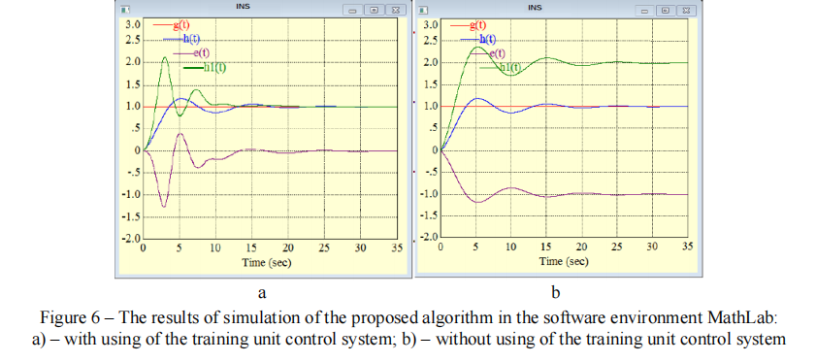

* Simulation Results: The experiment tested their new control system for the UAA navigation system using a computer simulation.
* Learning Unit Improves Performance: The system that included a learning unit had a smaller error (the difference between the desired output and the actual output) compared to the system without a learning unit.
* Parameters Align with Reference Model: The learning process helped the controller's parameters match those of the reference model, which is a good thing.
* Figure Visualizes Results: The graph shows three lines:
  + Green: The actual behavior of the controlled object (the UAA navigation system)
  + Blue: The desired behavior (the reference model)
  + Violet: The error between the actual and desired behavior
* Conclusion: The system with the learning unit performed more stably and accurately.

**Here's a simplified summary of the key points:**

**- UAV Control Systems:** - Traditional systems rely on encoders, inertial sensors, barometers, compasses, and GPS. - Controlled from a ground station via radio communication. - Limitations: Vulnerability to GPS loss or jamming, high cost of precision inertial systems.

**- Intelligent Decision Support System:** - Assists operators in making decisions under uncertain or fuzzy conditions. - Processes: - Digital model construction based on aerial photography - Sensor characteristic definition - Coordinates calculation - Navigation data analysis - Image transmission - Object detection and recognition - Instruction and recommendation generation - Sensor control for target tracking

**- Methodology for Building an Intelligent Control System:** - Guided by the principle of "guidance-stabilization." - Navigation method determines flight direction and coordinates. - Autopilot stabilizes the UAV. - Constant radio communication check is essential. - Involves three main blocks: 1. Model concept formation and initial data analysis 2. Model implementation in software environment 3. Knowledge base formation, system training, testing, and evaluation

**- Key Advantages of Intelligent Systems:** - Enhanced decision-making in uncertain conditions - Potential reduction in control time without relying on GPS - Improved accuracy and cost-effectiveness compared to traditional inertial systems

So finally it can asserted that the process might give a hand to cover the lost aircraft with an automation process as the experiment proved to be affirmative navigating the drone from a certain criteria.

**DEVELOPMENT OF PRE-EXISTING AI WITH ML**

**Artificial Intelligence Techniques for** **Pilot Approach Decision Aid Logic (PADAL) System**

This project aimed to enhance Landing Signal Officer (LSO) decision-making capabilities through the integration of Artificial Intelligence (AI) and various methodologies to create supportive tools for pilot trending analysis and ship oscillation recognition. While pursuing the primary goal, several complementary objectives were achieved. The endeavor delved into the realm of Fourier and wavelet transforms, neural networks, fuzzy logic, and other transformative techniques, amalgamating them with decision-centered design principles sourced from cognitive psychology.

Through meticulous research, it was established that the most effective approach involved a fusion of neural networks and fuzzy logic within a decision-centered design framework, thereby yielding promising outcomes. Identifying pivotal aircraft approach parameters, defining similarity measures, and discerning critical pilot considerations and their respective measures were pivotal achievements. Moreover, the project developed sophisticated pilot trending methodologies utilizing case-based reasoning, incorporating a blend of AI techniques for comprehensive analysis.

Collaborating extensively with numerous LSOs, optimal display options and logical presentation formats for the information generated by the pilot trending module were determined. Subsequently, a tailored LSO interface was conceptualized, designed, and implemented to seamlessly integrate the identified concepts. Rigorous iterative testing was conducted to refine and validate the design concepts, ensuring their efficacy and usability.

**LSO Challenges**

The Landing Signal Officer (LSO) faces immense pressure to ensure swift aircraft recoveries while prioritizing safety. With small intervals between landings and minimal radio communication due to operational constraints, LSOs face rapid decision-making, often waiting until the last moment to wave off planes. They juggle trade-offs between safety and effectiveness, navigating split-second choices.

During day operations without radar assistance, LSOs rely on visual cues to gauge aircraft attitude and throttle settings, predicting pilot actions crucial for decision-making. Considerations also encompass deck conditions and crew readiness. The LSO's challenge involves estimating the optimal wave-off moment amidst fluctuating conditions, considering deck status, crew capabilities, and deck movement.

Amidst limited precise data, unclear wave-off points, time pressure, and variable factors, LSOs must constantly adapt to changing conditions. Night recoveries, considered riskier, employ radar for accuracy but pose challenges in integrating visual and radar data. Additionally, LSOs manage pilot guidance, prioritizing critical instructions to avoid overwhelming pilots.

Every pilot's landing is graded, adding complexity as LSOs must not only manage the approach but also record observations for debriefing. The LSO's role demands quick decisions, balancing safety and efficiency amidst multifaceted challenges during day and night operations.

AIM OF THIS PROJECT:

This project aimed to merge Artificial Intelligence (AI) techniques with decision-centered principles from cognitive psychology. Combining SHAI's AI expertise and Klein Associates' knowledge in cognitive psychology, the project utilized various methods: decision-centered design, CTA tools (Critical Decision Method and Knowledge Audit), case-based reasoning (CBR), Fuzzy Logic, Neural Networks, and Neural Networks Based Fuzzy Inference System.

Understanding how Landing Signal Officers (LSOs) operate and aiming to improve their performance was central to Klein Associates' three-year research. Initial phases focused broadly on understanding aircraft recovery tasks, resulting in display recommendations for Controlling LSOs. Phase II concentrated on pilot trending and advanced decision aids.

The approach followed a decision-centered design, which prioritizes critical decisions and judgments required for tasks, in contrast to data-centered or system-centered approaches. The latter overload users with excessive information, while decision-centered design tailors information presentation to support thinking and action during critical decision-making.

Cognitive Task Analysis (CTA) methods were employed to delve into LSOs' expertise, focusing on understanding their decision-making patterns, challenges, and anticipations. This involved tools like the Critical Decision Method (CDM) and Knowledge Audit, aiming to comprehend experts' cognitive processes rather than breaking down tasks into isolated components.

RESULT:

The Critical Decision Method (CDM) is a critical incident technique and is employed in numerous decision-making studies. It involves interviewing individuals about specific incidents, minimizing interviewer biases by allowing interviewees to narrate incidents in an unstructured manner initially. This incident account serves as the foundation for the subsequent structured interview.

After the initial incident report, the CDM interviewer guides the participant through the incident multiple times, using focused probes to extract information about various aspects, such as cues noticed, situation assessment, expectations, challenges, and decision-making processes. This method captures context-specific details, preserving the decision-maker's operating environment within the data. The CDM has proven successful in extracting nuanced perceptual cues and decision strategies not typically revealed through conventional reporting methods. It yields detailed and specific information reflective of the decision-maker's perspective and grounded in experience

Neural-network:

A neural network based fuzzy inference system is a multi-layered network where nodes perform specific functions on incoming signals. Some nodes can adapt and learn (adaptive nodes), while others remain fixed (fixed nodes). These nodes are organized in layers, each serving different functions: the premise layer assesses input parameters using fuzzy membership functions, the next layers handle rule strengths and normalization, and the final layer computes results using Sugeno-type defuzzification.

This system operates based on fuzzy IF-THEN rules, either provided by human experts or automatically generated from training data. The learning process combines gradient descent and least square estimation to adjust parameters. During learning, signals move through layers, identifying consequent parameters through estimation, and then errors propagate backward, updating premise parameters through gradient descent.

This neural network based system was trained using various landing passes to anticipate future aircraft positions.

**Prediction of Plane Trajectory & Ship Motion**

The task aimed to assist Landing Signal Officers (LSOs) in guiding aircraft landings on carriers more safely. LSOs need to predict aircraft trajectory for guidance within one nautical mile from landing, typically slightly more than a minute in flight time. Radar records pilot trajectories, aiding a system to predict the plane's location two seconds ahead. Similarly, predicting the ship deck's motion four seconds ahead helps advise pilots accurately, avoiding potential crashes.

The problem involved predicting aircraft locations based on noisy time-series profiles provided by ship-based radar. Various techniques, including statistical, physics-based, Fourier, wavelet, neural networks, and fuzzy logic methods, were explored to address this challenge.

Two successful techniques were incorporated into the PADAL software: ANFIS (adaptive-network-based fuzzy inference system) and Velocity. ANFIS, a machine learning system, trained on past noisy profiles and categorized aircraft types for prediction. It modularized the design, training different systems based on aircraft categories and then aggregating them for predictions. This approach reduced computation time and complexity.

ANFIS efficiently mapped input-output relationships and was trained before online prediction tasks, handling unforeseen approaches effectively. Comparatively, polynomial prediction algorithms were also tested, with the ANFIS outperforming them, especially in handling noise and swiftly responding to changes in trajectory.

The ANFIS system's prediction capability was showcased through trajectory comparisons, indicating its effectiveness over polynomial algorithms. Its ability to handle noise and swiftly adapt to changes in trajectories made it the preferred choice for predicting aircraft positions during carrier landings.

PADAL:

PADAL: Prediction And Decision Aid for Landing(**Pilot Approach Decision Aid Logic (PADAL) System)**

* It mentions LSOs (Landing Signal Officers) and their interaction with PADAL during training, suggesting a connection to landing operations.
* The text discusses improvements like integrated displays with historical, actual, and predicted data, which aligns with an aid for decision-making during landing.

PADAL seems to be a system that uses predictions and data visualization to assist LSOs in making informed decisions during aircraft landing operations.

It's important to note that this interpretation is based on the limited information provided within the single paragraph.

Here is the described desired improvements for the PADAL system:

1. Continuous Training:

* Provide PADAL with continuous training alongside LSO training.
* Users can choose to view or use PADAL during training.
* Feedback from LSOs on PADAL's usefulness and future integration with VISUAL.

2. Sea/Carrier Landing Trial:

* Test PADAL in a real-world setting on an aircraft carrier or landing practice field.
* Ensure it's non-obtrusive and doesn't interfere with LSO tasks.

3. Ship Prediction Cone:

* Improve ship-motion prediction to show a cone of possible future locations instead of a single point.
* This cone can be color-coded based on likelihood.

4. Plane Prediction with More Data:

* Enhance plane prediction using more comprehensive landing data.
* Shift from point prediction to a range prediction showing a likely future region for the plane.

5. Offline Playback with Features:

* Create an offline version of PADAL for playback, debriefing, and training.
* Features include pause, random playback, speed control, network access, and password protection.

6. Ramp Motion Alarm:

* Implement alarms for excessive ramp motion (exceeding 8 ft/second) and significant changes in motion.

7. Adaptive LSO Shorthand Ranges:

* PADAL can learn and update the ranges associated with LSO shorthand comments based on actual data.
* This information can be used to generate training graphs showing aircraft location vs. LSO comments.

8. Unified Display with Predictions:

* Combine aircraft glideslope, lineup, and ship deck pitch into a single display with historical, actual, and predicted data.
* This helps LSOs quickly grasp critical information.

These improvements aim to make PADAL more realistic, useful, and integrated with LSO workflow for better training and carrier landing operations.

The project synergized artificial intelligence and cognitive task analysis to craft a sophisticated decision support tool guided by Landing Signal Officers (LSOs).

This initiative meticulously identified crucial aircraft approach parameters and similarity metrics, as well as pivotal pilot considerations and similarity measures. Leveraging this knowledge, the project cultivated pilot trending methodologies and software using case-based reasoning intricately interwoven with a fusion of other advanced AI techniques.

Collaborating extensively with LSOs, the project meticulously curated optimal display choices and refined display logic, aligning them seamlessly with the outputs generated by the pilot trending modules. Subsequently, the team meticulously conceived, crafted, and implemented the resultant LSO interface, harmonizing cutting-edge technological insights with the nuanced demands of LSO decision-making.

**A mathematical equation might be helpful to predict the way to find proper landing space to navigate the aircraft through AI .**

Mathematical equations can be incredibly useful in predicting and navigating proper landing spaces for aircraft, especially when coupled with AI techniques. In aviation, various mathematical models, equations, and algorithms are used to calculate and predict optimal trajectories, approach angles, landing positions, and other critical parameters for safe landings. These equations often take into account factors like wind speed, aircraft velocity, altitude, runway length, and environmental conditions to determine the best approach for landing.When combined with AI techniques like machine learning or reinforcement learning, these equations can be refined and optimized using historical flight data, real-time sensor inputs, and simulations. Machine learning models can learn from patterns in data to enhance the precision of predictions, adapt to changing conditions, and provide more accurate recommendations for safe landing spaces.Mathematical equations, when integrated into AI systems, serve as the foundation for decision-making processes, helping aircraft navigate and land safely by computing the most suitable paths and parameters for the given conditions.

**As our plan is to run the model on AI , so these models and provided algorithms can be helpful to give accurate predictions**

**FINAL OUTCOME OF THIS ENTIRE PROJECT:**

Solved problems in this project :

* 1. This project solved the traditional difficulties of identifying fraction before take-off.
  2. This method can identify any underlying facts which might cause plane damage.
  3. A drone method system can help the plane to detect specific path if the all system already prevail fails.

**Conclusion:**

In conclusion, the multifaceted landscape of in-flight signal monitoring and safety devices is integral to the ongoing evolution of aviation safety. The auto-pilot checking device, with its capacity to ensure the reliability of autonomous systems, contributes significantly to the mitigation of potential risks. Moreover, the enhancement of communication networks in adverse weather conditions represents a crucial stride towards fortifying the resilience of air travel against the unpredictable forces of nature.The deployment of drones in search and rescue operations introduces a paradigm shift in safety protocols, promising swifter and more efficient responses to emergencies. As we navigate the skies in an era marked by technological innovation, this paper underscores the imperative of continually advancing in-flight monitoring and safety devices to uphold the highest standards of safety and reliability in aviation. By addressing these three key components—auto-pilot checking devices, improved adverse weather networks, and drone-assisted search and rescue—we pave the way for a safer, more secure future in air travel.

**REFERENCE:**

Ben Khediri, I., Weihs, C., Limam, M., 2012. Kernel k-means clustering based local

support vector domain description fault detection of multimodal processes. Expert

Syst. Appl. 39 (2), 2166–2171.

Borguet, S., Leonard, O., 2009. Coupling principal component analysis and Kalman

filtering algorithms for on-line aircraft engine diagnostics. Control Eng. Pract. 17

(4), 494–502.

Camerini, V., Coppotelli, G., Bendisch, S., 2018. Fault detection in operating helicopter

drivetrain components based on support vector data description. Aerosp. Sci.

Technol. 73, 48–60.

Cha, M., Kim, J.S., Baek, J.G., 2014. Density weighted support vector data description.

Expert Syst. Appl. 41 (7), 3343–3350.

Chen, G.J., Zhang, X.Y., Wang, Z.J., Li, F.L., 2015. Robust support vector data

description for outlier detection with noise or uncertain data. Knowl. Based Syst.

90, 129–137.

Chung, Y., Oh, S., Lee, J., Park, D., Chang, H.H., Kim, S., 2013. Automatic detection

and recognition of pig wasting diseases using sound data in audio surveillance

systems. Sensors 13 (10), 12929–12942.

El Naqa, I., Irrer, J., Ritter, T.A., DeMarco, J., Al-Hallaq, H., Booth, J., Kim, G.,

Alkhatib, A., Popple, R., Perez, M., Farrey, K., Moran, J.M., 2019. Machine learning

for automated quality assurance in radiotherapy: A proof of principle using EPID

data description. Med. Phys. 46 (4), 1914–1921.

Eroglu, B., Sahin, M.C., Ure, N.K., 2020. Autolanding control system design with deep

learning based fault estimation. Aerosp. Sci. Technol. 102, 9.

Fink, O., Wang, Q., Svensen, M., Dersin, P., Lee, W.J., Ducoffe, M., 2020. Potential,

challenges and future directions for deep learning in prognostics and health

management applications. Eng. Appl. Artif. Intell. 92, 15.

Ge, Z.Q., Song, Z.H., 2014. Online monitoring and quality prediction of multiphase

batch processes with uneven length problem. Ind. Eng. Chem. Res. 53 (2), 800–811.

Hao, R., Liu, X.F., Niu, Y.B., Xiu, L., 2017. Improved SVDD for speech recognition and

simulation. J. Syst. Simul. 29 (5), 1014–1027.

He, C., Zhang, X.D., Jia, B.H., 2013. UIO Based robust fault diagnosis approach for aero

engine fiber-optic sensor. In: 2013 IEEE International Conference on Automation

Science and Engineering. IEEE Computer Society, Madison, WI, United states, pp.

550–553.

Kim, K.H., Chung, Y.S., Lee, S.W., 2010. Reconstructing occluded facial components

using support vector data description. J. KISS: Comput. Pract. 16 (4), 457–461.

Kobayashi, T., Simon, D.L., 2003. Application of a bank of Kalman filters for aircraft en

gine fault diagnostics. In: 2003 ASME Turbo Expo. American Society of Mechanical

Engineers, Atlanta, GA, United states, pp. 461–470.

Kumar, S., Choudhary, A.K., Kumar, M., Shankar, R., Tiwari, M.K., 2006. Kernel

distance-based robust support vector methods and its application in developing

a robust K-chart. Int. J. Prod. Res. 44 (1), 77–96.

Kyriazis, A., Mathioudakis, K., 2009. Gas turbine fault diagnosis using fuzzy-based

decision fusion. J. Propul. Power 25 (2), 335–343.

Lee, S., Kim, S.B., 2018. Time-adaptive support vector data description for nonstationary

process monitoring. Eng. Appl. Artif. Intell. 68, 18–31.

Lee, S.W., Park, J., Lee, S.W., 2006. Low resolution face recognition based on support

vector data description. Pattern Recognit. 39 (9), 1809–1812.

Liu, Y., Wang, J.Q., Hu, Z.Z., 2020. Lman-Filter-Group Based Aero-Engine Sensors Fault

Diagnosis and Verification. Springer.

Liu, B., Xiao, Y.S., Cao, L.B., Hao, Z.F., Deng, F.Q., 2013. SVDD-Based outlier detection

on uncertain data. Knowl. Inf. Syst. 34 (3), 597–618.

Ning, X.H., Tsung, F., 2013. Improved design of kernel distance–based charts using

support vector methods. IIE Trans. 45 (4), 464–476.

Seo, G.G., Kim, Y., Saderla, S., 2019. Kalman-filter based online system identification

of fixed-wing aircraft in upset condition. Aerosp. Sci. Technol. 89, 307–317.

Shin, J.H., Lee, B., Park, K.S., 2011. Detection of abnormal living patterns for elderly

living alone using support vector data description. Ieee Trans. Inf. Technol. Biomed.

15 (3), 438–448.

Simon, D.L., Garg, S., 2010. Optimal tuner selection for Kalman filter-based aircraft

engine performance estimation. J. Eng. Gas Turbines Power-Trans. Asme 132 (3),

659–671.

Sukchotrat, T., Kim, S.B., Tsung, F., 2009. One-class classification-based control charts

for multivariate process monitoring. IIE Trans. 42 (2), 107–120.

Tax, D.M.J., Duin, R.P.W., 1999. Support vector domain description. Pattern Recognit.

Lett. 20 (11–13), 1191–1199.

Tax, D., Duin, R., 2004. Support vector data description. Mach. Learn. 54 (1), 45–66.

Vanini, Z.N.S., Khorasani, K., Meskin, N., 2014. Fault detection and isolation of a

dual spool gas turbine engine using dynamic neural networks and multiple model

approach. Inform. Sci. 259, 234–251.

Wang, X.M., Chung, F.L., Wang, S.T., 2011. Theoretical analysis for solution of support

vector data description. Neural Netw. 24 (4), 360–369.

Wang, K.Z., Lan, H.B., 2020. Robust support vector data description for novelty

detection with contaminated data. Eng. Appl. Artif. Intell. 91, 10.

Wang, J.L., Liu, W.M., Qiu, K.P., Xiong, H., Zhao, L.Q., 2017. Dynamic hypersphere

SVDD without describing boundary for one-class classification. Neural Comput.

Appl. 31 (8), 3295–3305.

Wang, Z.T., Zhao, N.B., Wang, W.Y., Tang, R., Li, S.Y., 2015. A fault diagnosis approach

for gas turbine exhaust gas temperature based on fuzzy C-means clustering and

support vector machine. Math. Probl. Eng. 2015, 11.

Xi, P.P., Zhao, Y.P., Wang, P.X., Li, Z.Q., Pan, Y.T., Song, F.Q., 2019. Least squares

support vector machine for class imbalance learning and their applications to fault

detection of aircraft engine. Aerosp. Sci. Technol. 84, 56–74.

Xie, G.C., Jiang, Y., Chen, N., 2013. New medical image classification approach based

on hypersphere multi-class support vector data description. J. Comput. Appl. 33

(11), 3300–3304.

Zeng, Z.H., Fu, Y., Roisman, G.I., Wen, Z., Hu, Y.X., Huang, T.S., 2006. One-Class

Classification for Spontaneous Facial Expression Analysis. IEEE Computer Society,

Los Alamitos.

Zgarni, S., Keskes, H., Braham, A., 2018. Nested SVDD in DAG svm for induction motor

condition monitoring. Eng. Appl. Artif. Intell. 71, 210–215.

Zhao, Y.P., Song, F.Q., Pan, Y.T., Li, B., 2017. Retargeting extreme learning machines

for classification and their applications to fault diagnosis of aircraft engine. Aerosp.

Sci. Technol. 71, 603–618.

Zhou, Y.H., Zhang, X.W., Wang, J.M., Gong, Y., Zhou, Y., 2011. Speaker recognition

based on the combination of GMM and SVDD. Prz. Elektrotechniczny 87 (3),

329–332.

Zhou, D.J., Zhang, H.S., Weng, S.L., 2015. A new gas path fault diagnostic method of

gas turbine based on support vector machine. J. Eng. Gas Turbines Power-Trans.

Asme 137 (10), 6.

Remondino, F.; Barazzetti, L.; Nex, F.; Scaioni, M.; Sarazzi, D. UAV Photogrammetry for Mapping and 3d Modeling: Current

Status and Future Perspectives. *Int. Arch. Photogramm. Remote Sens. Spat. Inf. Sci.* **2011**, *38*, 25–31. [CrossRef]

2.

Zhang, C.; Kovacs, J.M. The Application of Small Unmanned Aerial Systems for Precision Agriculture: A Review. *Precis. Agric.*

**2012**, *13*, 693–712. [CrossRef]

3.

Gomez, C.; Purdie, H. UAV-Based Photogrammetry and Geocomputing for Hazards and Disaster Risk Monitoring—A Review.

*Geoenviron. Disasters* **2016**, *3*, 23. [CrossRef]

4.

Ling, G.; Draghic, N. Aerial Drones for Blood Delivery. *Transfusion* **2019**, *59*, 1608–1611. [CrossRef] [PubMed]

5.

Hii, M.S.Y.; Courtney, P.; Royall, P.G. An Evaluation of the Delivery of Medicines Using Drones. *Drones* **2019**, *3*, 52. [CrossRef]

6.

Gong, S.; Wang, M.; Gu, B.; Zhang, W.; Hoang, D.T.; Niyato, D. Bayesian Optimization Enhanced Deep Reinforcement Learning

for Trajectory Planning and Network Formation in Multi-UAV Networks. *IEEE Trans. Veh. Technol.* **2023**, 1–16. [CrossRef]

7.

Bose, T.; Suresh, A.; Pandey, O.J.; Cenkeramaddi, L.R.; Hegde, R.M. Improving Quality-of-Service in Cluster-Based UAV-Assisted

Edge Networks. *IEEE Trans. Netw. Serv. Manag.* **2022**, *19*, 1903–1919. [CrossRef]*Drones* **2023**, *7*, 549

20 of 21

8.

Yeduri, S.R.; Chilamkurthy, N.S.; Pandey, O.J.; Cenkeramaddi, L.R. Energy and Throughput Management in Delay-Constrained

Small-World UAV-IoT Network. *IEEE Internet Things J.* **2023**, *10*, 7922–7935. [CrossRef]

9.

Kingston, D.; Rasmussen, S.; Humphrey, L. Automated UAV Tasks for Search and Surveillance. In Proceedings of the IEEE

Conference on Control Applications, Buenos Aires, Argentina, 19–22 September 2016.

10.

Motlagh, N.H.; Bagaa, M.; Taleb, T. *IEEE Communications Magazine*; Institute of Electrical and Electronics Engineers Inc.:

New York, NY, USA, 2017; pp. 128–134.

11.

Masadeh, A.; Alhafnawi, M.; Salameh, H.A.B.; Musa, A.; Jararweh, Y. Reinforcement Learning-Based Security/Safety UAV

System for Intrusion Detection Under Dynamic and Uncertain Target Movement. *IEEE Trans. Eng. Manag.* **2022**, 1–11. [CrossRef]

12.

Tian, J.; Wang, B.; Guo, R.; Wang, Z.; Cao, K.; Wang, X. Adversarial Attacks and Defenses for Deep-Learning-Based Unmanned

Aerial Vehicles. *IEEE Internet Things J.* **2022**, *9*, 22399–22409. [CrossRef]

13.

Azar, A.T.; Koubaa, A.; Ali Mohamed, N.; Ibrahim, H.A.; Ibrahim, Z.F.; Kazim, M.; Ammar, A.; Benjdira, B.; Khamis, A.M.;

Hameed, I.A.; et al. Drone Deep Reinforcement Learning: A Review. *Electronics* **2021**, *10*, 999. [CrossRef]

14.

Davies, L.; Vagapov, Y.; Bolam, R.C.; Anuchin, A. Review of Unmanned Aircraft System Technologies to Enable beyond Visual

Line of Sight (BVLOS) Operations. In Proceedings of the International Conference on Electrical Power Drive Systems (ICEPDS),

Novocherkassk, Russia, 3–6 October 2018; pp. 1–6.

15.

Chen, H.; Wang, X.M.; Li, Y. A Survey of Autonomous Control for UAV. In Proceedings of the International Conference on

Artificial Intelligence and Computational Intelligence (AICI), Shanghai, China, 7–8 November 2009; Volume 2, pp. 267–271.

16.

Darbari, V.; Gupta, S.; Verman, O.P. Dynamic Motion Planning for Aerial Surveillance on a Fixed-Wing UAV. In Proceedings of

the International Conference on Unmanned Aircraft Systems (ICUAS), Miami, FL, USA, 13–16 June 2017; pp. 488–497.

17.

Polo, J.; Hornero, G.; Duijneveld, C.; García, A.; Casas, O. Design of a Low-Cost Wireless Sensor Network with UAV Mobile Node

for Agricultural Applications. *Comput. Electron. Agric.* **2015**, *119*, 19–32. [CrossRef]

18.

Hoa, S.; Abdali, M.; Jasmin, A.; Radeschi, D.; Prats, V.; Faour, H.; Kobaissi, B. Development of a New Flexible Wing Concept

for Unmanned Aerial Vehicle Using Corrugated Core Made by 4D Printing of Composites. *Compos. Struct.* **2022**, *290*, 115444.

[CrossRef]

19.

Prisacariu, V.; Boscoianu, M.; Circiu, I.; Rau, C.G. Applications of the Flexible Wing Concept at Small Unmanned Aerial Vehicles.

*Adv. Mater. Res.* **2012**, *463*, 1564–1567.

20.

Boris, V.; Jérôme, D.M.; Stéphane, B. A Two Rule-Based Fuzzy Logic Controller for Contrarotating Coaxial Rotors UAV. In

Proceedings of the IEEE International Conference on Fuzzy Systems, Vancouver, BC, Canada, 16–21 July 2006; pp. 1563–1569.

21.

Oh, H.; Shin, H.-S.; Kim, S. Fuzzy Expert Rule-Based Airborne Monitoring of Ground Vehicle Behaviour. In Proceedings of the

UKACC International Conference on Control, Cardiff, UK, 3–5 September 2012; pp. 534–539.

22.

Çolak, M.; Kaya,

˙

I.; Kara¸san, A.; Erdo ˘gan, M. Two-Phase Multi-Expert Knowledge Approach by Using Fuzzy Clustering and

Rule-Based System for Technology Evaluation of Unmanned Aerial Vehicles. *Neural. Comput. Appl.* **2022**, *34*, 5479–5495.

[CrossRef]

23.

Toubman, A.; Roessingh, J.J.; Spronck, P.; Plaat, A.; van den Herik, J. *Rapid Adaptation of Air Combat Behaviour*; National Aerospace

Laboratory NLR: Amsterdam, The Netherlands, 2016.

24.

Teng, T.H.; Tan, A.H.; Tan, Y.S.; Yeo, A. Self-Organizing Neural Networks for Learning Air Combat Maneuvers. In Proceedings of

the Proceedings of the International Joint Conference on Neural Networks, Brisbane, QLD, Australia, 10–15 June 2012.

25.

Pope, A.P.; Ide, J.S.; Micovic, D.; Diaz, H.; Rosenbluth, D.; Ritholtz, L.; Twedt, J.C.; Walker, T.T.; Alcedo, K.; Javorsek, D.

Hierarchical Reinforcement Learning for Air-to-Air Combat. In Proceedings of the International Conference on Unmanned

Aircraft Systems (ICUAS), Athens, Greece, 15–18 June 2021; Institute of Electrical and Electronics Engineers Inc.: New York, NY,

USA, 2021; pp. 275–284.

26.

Chen, Y.; Zhang, J.; Yang, Q.; Zhou, Y.; Shi, G.; Wu, Y. Design and Verification of UAV Maneuver Decision Simulation System

Based on Deep Q-Learning Network. In Proceedings of the IEEE International Conference on Control, Automation, Robotics and

Vision (ICARCV), Shenzhen, China, 13–15 December 2020; Institute of Electrical and Electronics Engineers Inc.: New York, NY,

USA, 2020; pp. 817–823.

27.

Xu, J.; Guo, Q.; Xiao, L.; Li, Z.; Zhang, G. Autonomous Decision-Making Method for Combat Mission of UAV Based on Deep

Reinforcement Learning. In Proceedings of the IEEE 4th Advanced Information Technology, Electronic and Automation Control

Conference (IAEAC), Chengdu, China, 20–22 December 2019; pp. 538–544.

28.

Yang, Q.; Zhang, J.; Shi, G.; Hu, J.; Wu, Y. Maneuver Decision of UAV in Short-Range Air Combat Based on Deep Reinforcement

Learning. *IEEE Access* **2020**, *8*, 363–378. [CrossRef]

29.

Wang, Z.; Li, H.; Wu, H.; Wu, Z. Improving Maneuver Strategy in Air Combat by Alternate Freeze Games with a Deep

Reinforcement Learning Algorithm. *Math. Probl. Eng.* **2020**, *2020*, 7180639. [CrossRef]

30.

Lee, G.T.; Kim, C.O. Autonomous Control of Combat Unmanned Aerial Vehicles to Evade Surface-to-Air Missiles Using Deep

Reinforcement Learning. *IEEE Access* **2020**, *8*, 226724–226736. [CrossRef]

31.

Yan, C.; Xiang, X.; Wang, C. Fixed-Wing UAVs Flocking in Continuous Spaces: A Deep Reinforcement Learning Approach. *Rob*

*Auton. Syst.* **2020**, *131*, 103594. [CrossRef]

32.

Bohn, E.; Coates, E.M.; Moe, S.; Johansen, T.A. Deep Reinforcement Learning Attitude Control of Fixed-Wing UAVs Using

Proximal Policy Optimization. In Proceedings of the International Conference on Unmanned Aircraft Systems (ICUAS), Atlanta,

GA, USA, 11–14 June 2019; Institute of Electrical and Electronics Engineers Inc.: New York, NY, USA, 2019; pp. 523–533.*Drones* **2023**, *7*, 549

21 of 21

33.

Tang, C.; Lai, Y.C. Deep Reinforcement Learning Automatic Landing Control of Fixed-Wing Aircraft Using Deep Deterministic

Policy Gradient. In Proceedings of the International Conference on Unmanned Aircraft Systems (ICUAS), Athens, Greece,

1–4 September 2020; Institute of Electrical and Electronics Engineers Inc.: New York, NY, USA, 2020; pp. 1–9.

34.

Yuan, X.; Sun, Y.; Wang, Y.; Sun, C. Deterministic Policy Gradient with Advantage Function for Fixed Wing UAV Automatic

Landing. In Proceedings of the Chinese Control Conference (CCC), Guangzhou, China, 27–30 July 2019; pp. 8305–8310.

35.

Rocha, T.A.; Anbalagan, S.; Soriano, M.L.; Chaimowicz, L. Algorithms or Actions? A Study in Large-Scale Reinforcement

Learning. In Proceedings of the International Joint Conference on Artificial Intelligence (IJCAI-18), Stockholm, Sweden,

13–19 July 2018; pp. 2717–2723.

36.

Imanberdiyev, N.; Fu, C.; Kayacan, E.; Chen, I.M. Autonomous Navigation of UAV by Using Real-Time Model-Based Reinforce

ment Learning. In Proceedings of the International Conference on Control, Automation, Robotics and Vision, ICARCV 2016,

Phuket, Thailand, 13–15 November 2016; Institute of Electrical and Electronics Engineers Inc.: New York, NY, USA, 2017.

37.

Wang, C.; Wang, J.; Wang, J.; Zhang, X. Deep-Reinforcement-Learning-Based Autonomous UAV Navigation with Sparse Rewards.

*IEEE Internet Things J.* **2020**, *7*, 6180–6190. [CrossRef]

38.

Wang, C.; Wang, J.; Shen, Y.; Zhang, X. Autonomous Navigation of UAVs in Large-Scale Complex Environments: A Deep

Reinforcement Learning Approach. *IEEE Trans. Veh. Technol.* **2019**, *68*, 2124–2136. [CrossRef]

39.

Berndt, J.S. JSBSim: An Open Source Flight Dynamics Model in C++. In Proceedings of the AIAA Modeling and Simulation

Technologies Conference and Exhibit, Providence, Rhode Island, 16–19 August 2004.

40.

Lillicrap, T.P.; Hunt, J.J.; Pritzel, A.; Heess, N.; Erez, T.; Tassa, Y.; Silver, D.; Wierstra, D. Continuous Control with Deep

Reinforcement Learning. *arXiv* **2015**, arXiv:1509.02971.

41.

Dong, H.; Ding, Z.; Zhang, S. *Deep Reinforcement Learning*; Springer: Singapore, 2020; ISBN 978-981-15-4095-0.

42.

Arulkumaran, K.; Deisenroth, M.P.; Brundage, M.; Bharath, A.A. *IEEE Signal Processing Magazine*; Institute of Electrical and

Electronics Engineers Inc.: New York, NY, USA, 2017; pp. 26–38.

43.

Konda, V.R.; Tsitsiklis, J.N. Actor-Critic Algorithms. In *Advances in Neural Information Processing Systems 12 (NIPS 1999)*; MIT

Press: Cambridge, MA, USA, 1999; Volume 12.

44.

Haarnoja, T.; Zhou, A.; Abbeel, P.; Levine, S. Soft Actor-Critic: Off-Policy Maximum Entropy Deep Reinforcement Learning

with a Stochastic Actor. In Proceedings of the 35th International Conference on Machine Learning (PMLR), Stockholm, Sweden,

10–15 July 2018; pp. 1861–1870.

45.

Haarnoja, T.; Zhou, A.; Hartikainen, K.; Tucker, G.; Ha, S.; Tan, J.; Kumar, V.; Zhu, H.; Gupta, A.; Abbeel, P.; et al. Soft Actor-Critic

Algorithms and Applications. *arXiv* **2018**, arXiv:1812.05905.

46.

Rennie, G. Autonomous Control of Simulated Fixed Wing Aircraft Using Deep Reinforcement Learning. Master’s. Thesis,

The University of Bath, Bath, UK, 2018.

47.

Wiering, M.A.; Van Otterlo, M. *Reinforcement Learning: State-of-the-Art*; Springer: Berlin/Heidelberg, Germany, 2012;

ISBN 9783642015267.

48.

Kiranyaz, S.; Avci, O.; Abdeljaber, O.; Ince, T.; Gabbouj, M.; Inman, D.J. 1D Convolutional Neural Networks and Applications: A

Survey. *Mech. Syst. Signal. Process* **2021**, *151*, 107398. [CrossRef]

49.

Sutton, R.S.; Barto, A.G. *Reinforcement Learning: An Introduction Second Edition*; The MIT Press: Cambridge, MA, USA, 2015.

50.

Schulman, J.; Wolski, F.; Dhariwal, P.; Radford, A.; Klimov, O. Proximal Policy Optimization Algorithms. *arXiv* **2017**,

arXiv:1707.06347.

Beaubien, J. M., & Baker, D. P. (2002). A review of selected aviation human factors taxon

omies, accident/incident reporting systems and data collection tools. International

Journal of Applied Aviation Studies 2002, 2(2), 11–36.

Boeing (2013). Statistical summary of commercial jet airplane accidents worldwide opera

tions, 1959–2012. Seattle: Boeing Available from www.boeing.com/news/techissues/

pdf/statsum.pdf [Accessed: 20th November 2017].

Bud, M. J., Mengert, P., Ransom, S., & Stearns, M. D. (1997). General Aviation Accidents,

1983-1994: Identification of Factors Related to Controlled-Flight-Into-Terrain (CFlT) Ac

cidents (No. DOT-VNTSC-FAA-97-8). JOHN A VOLPE NATIONAL TRANSPORTATION SYS

TEMS CENTER CAMBRIDGE MA.

Chen, S. T., Wall, A., Davies, P., Yang, Z., Wang, J., & Chou, Y. H. (2013). A human and

organisational factors (HOFs) analysis method for marine casualties using HFACS

maritime accidents (HFACS-MA). Safety Science, 60, 105–114.

Cintron, R. (2015). Human Factors Analysis and Classification System Interrater Reliability for

Biopharmaceutical Manufacturing Investigations, 1–146.

Cooper, J. (1995). Controlled flight. Aerospace, 22(2), 16–19.

Dekker, S. W. (2001). The re-invention of human error. Human Factors Aerospace,

247–266.

Dupont, G. (1997). The dirty dozen errors in aviation maintenance. Eleventh Federal Avi

ation Administration Meeting on Human Factors Issues in Aircraft Maintenance and

Inspection. Human Error in Aviation Maintenance, 45–49.

Endsley, M. R. (1995). Toward a theory of situation awareness in dynamic systems.

Human Factors, 37(1), 32–64.

Ergai, A., Cohen, T., Sharp, J., Wiegmann, D., Gramopadhye, A., & Shappell, S. (2016). As

sessment of the human factors analysis and classification system (HFACS): Intra

rater and inter-rater reliability. Safety Science, 82, 393–398.

FAA (2000). Installation of Terrain Awareness and Warning System Approved for Part 23

Airplanes. Available from https://www.faa.gov/documentlibrary/media/advisory_

circular/ac_23-18.pdf [Accessed: 24th November 2017].

Gore, A. (1997). White House Commission on Aviation Safety. Available from https://fas.

org/irp/threat/212fin~1.html [Accessed: 24th November 2017].

Gramopadhye, A. K., & Drury, C. G. (2000). Human factors in aviation maintenance: how

we got to where we are. International Journal of Industrial Ergonomics, 26, 125–131

ch26.

HFACS (2018). The HFACS Framework. Available from https://www.hfacs.com/hfacs-fra

mework.html [accessed: 4th November 2017].

IATA (2014). Controlled Flight Into Terrain (CFIT) Accident Analysis. Available from

http://www.iata.org/whatwedo/safety/Documents/CFIT-Report-1st-Ed-2015.pdf

[accessed: 20th November 2017].

IATA (2017). Controlled Flight Into Terrain (CFIT). , 3 Available from http://www.iata.org/

whatwedo/safety/Pages/controlled-flight-into-terrain.aspx [Accessed: 20th Novem

ber 2017].

ICAO (1993). Investigation of human factors in accidents and incidents. ICAO: International

Civil Aviation Organization. Montreal.

ICAO (1995). Human Factors and Organisational Issues in CFIT Accidents 1984–1994.

Available from: www.faa.gov/training_testing/training/media/cfit/volume2/pdf/pa

ges/page5_03.pdf.

ICAO (2013). Annual Report of the Council, 2012. Available from www.icao.int/publica

tions/Documents/10001_en.pdf [accessed: 22nd November 2017].

Leveson (2004). A new accident model for engineering safer systems. Safety Science, 42

(4), 237–270.

Leveson, N. (2012). Engineering a safer world: Systems thinking applied to safety. Cam

bridge, MA: The MIT Press.

Liu, H., Sun, R., & LV, R. (2011). Qualitative analysis method of civil aviation information

sources. Information and Communication Technology for Intelligent Systems, 2011,

2149–2156.

Lower, M., Magott, J., & Skorupski, J. (2018). A system-theoretic accident model and pro

cess with human factors analysis and classification system taxonomy. Safety Science,

110, 393–410.

Matthews, S. (1997). Proposals for improving aviation safety and changing the system. In

ternational conference on aviation safety and security in the twenty-first century, Wash

ington D.C., U.S. January 13 (pp. 1997).

Maurino, D. (1992). Human factors and Training Issues in CFIT accidents and incidents.

Available from www.faa.gov/training_testing/training/media/cfit/volume2/pdf/pa

ges/page5_04.pdf [Accessed: 5th December 2017].

NTSB, D. (1995). NTSB Identification: DCA96RA020. Available from https://www.ntsb.

gov/_layouts/ntsb.aviation/brief2.aspx?ev_id=20001207X04990&ntsbno=

DCA96RA020&akey=1 [Accessed: 12th December 2017].

NTSB (2012). Aviation statistical reports Table 9: Accidents, fatalities, and rates, 1992

through 2011, for U.S. air carriers operating under 14 CFR 135, on-demand opera

tions. Available from www.ntsb.gov/data/table9_2012.html [accessed: 20th Novem

ber 2017].

Omole, H., & Walker, G. (2015). Offshore transport accident analysis using HFACS.

Procedia Manufacturing, 3, 1264–1272.

Phillips, R. O. (1999). Descriptions of flight paths for selected controlled flight into terrain

(CFIT) aircraft accidents 1985–1997. McGraw Hill.

Rasmussen, J. (1997). Risk management in a dynamic society: A modelling problem.

Safety Science, 27(2/3), 183–213.

Reason, J. (1990). Human Error. New York: Cambridge University Press.

Reason, J. (1995). Understanding adverse events: Human factors. Quality in Health Care,

80–89.

Reinach, S., & Viale, A. (2006). Application of a human error framework to conduct train

accident/incident investigations. Aviation Space Environmental Medicine., 30, 396–406.

Salmon, P. M., Cornelissen, M., & Trotter, M. J. (2011). Systems-based accident analysis

methods: A comparison of Accimap, HFACS, and STAMP. Safety Science, 50(4),

1158–1170.

Scott, W. B. (1996). New technology, Training Target CFIT Losses. Aviation Week & Space

Technology, 6, 68–72.

Shappell, S., Detwiler, C., Holcomb, K., Hackworth, C., Boquet, A., & Wiegmann, D. A.

(2007). Human error and commercial aviation accidents: An analysis using the

human factors analysis and classification system. Human Factors and Ergonomics

Society, 49(2), 227–242.

Stolzer, A. J. (2017). Safety Management Systems in Aviation. London: Routledge.

Wickfield E., 1997. Cockpit leadership: big picture. National Associations Newsletter,

September/October 1996.

Wiegmann, D., & Shappell, S. (2005). Human error and general aviation accidents: A com

prehensive, fine-grained analysis using HFACS. FAA: Washington D.C.

Wiegmann, D. A., & Shappell, S. A. (2017). A human error approach to aviation accident

analysis: The human factors analysis and classification system. London: Routledge.

Wiegmann, D., & Shappell, S. (1996). U.S. naval aviation mishaps 1977-92: Differences be

tween single- and dual-piloted aircraft. Aviation, Space and Environmental Medicine,

67(1), 65–69.

Wiegmann, D., & Shappell, S. (2000). The human factors analysis and classification system

(HFACS). Washington DC: FAA.

Wiegmann, D., & Shappell, S. (2001). Applying reason: the human factors analysis and

classification system. (HFACS): Human Factors and Aerospace Safety, 59–86.

Wiegmann, D., & Shappell, S. (2003). A human error approach to aviation accident analysis.

Surrey: Ashgate

Airclaims. (2012). World aircraft accident summary (WAAS), 1990e2012. CAP 479,

issue 167. London: Airclaims Ltd.

Barnett, A. I. (2010). Cross-national differences in aviation safety records. Trans

portation Science, 44(3), 322e332.

Barnett, A. I., & Higgins, M. K. (1989). Airline safety: the last decade. Management

Science, 35(1), 1e21.

Barnett, A. I., & Wang, A. (2000). Passenger-mortality risk estimates provide

perspectives about airline safety. Flight Safety Digest, 19(4), 1e12.

Boeing. (2012). Statistical summary of commercial jet airplane accidents: Worldwide

operations, 1959e2011. Seattle, Washington: Aviation Safety, Boeing Commercial

Airplanes.

Coughlin, C., Cohen, J., & Khan, S. (2008). Aviation security and terrorism: a review

of the economic issues. In A. R. Thomas (Ed.), Aviation security management. The

elements of aviation security management, Vol. 2 (pp. 1e24). Westport, CT:

Praeger Security International.

Dionne, G., Gagné, R., Gagnon, F., & Vanasse, C. (1997). Debt, moral hazard and

airline safety: an empirical evidence. Journal of Econometrics, 79, 379e402.

Federal Aviation Administration. (2008). Federal Aviation Administration: A historical

perspective, 1903e2008 [online]. Washington, D.C.: U.S. Department of Trans

portation, Available at

http://www.faa.gov/about/history/historical_

perspective/ Accessed 28.12.11.

Federal Aviation Administration. (2012a). Aviation safety information analysis and

sharing system (ASIAS) [online]. Available at http://www.asias.faa.gov/portal/

page/portal/asias_pages/asias_home/datainfo:databases:k-o Accessed 11.09.12.

Federal Aviation Administration. (2012b). Aviation safety action program [website].

Available at http://www.faa.gov/about/initiatives/asap/ Accessed 11.09.11.

Federal Aviation Administration. (2012c). FAA historical chronology, 1926e1996 [pdf].

Available at http://www.faa.gov/about/media/b-chron.pdf Accessed 11.09.12.

Federal Aviation Administration. (2012d). Flight operational quality assurance (FOQA)

[website]. Available at http://www.faa.gov/about/initiatives/atos/air_carrier/

foqa/ Accessed 11.09.11.

Federal Aviation Administration, Air Traffic Organization. (2009). National runway

safety plan, 2009e2011 [pdf]. Washington, D.C.: U.S. Department of Trans

portation, Available at http://www.faa.gov/airports/runway_safety/publications/

media/RunwaySafetyReport-kh10-plan.pdf Accessed 28.12.11.

Flight Safety Foundation, Aviation Safety Network. (2012) [online]. Available at

http://aviation-safety.net/database/events/event.php?code¼SE

Accessed

11.09.12.

Golbe, D. L. (1986). Safety and profits in the airline industry. Journal of Industrial

Economics, 34, 305e318.

Hersman, D. A. P. (8 December 2011). Assuring safety in aviation’s second century

[online] Montreal, Quebec 8th annual Assad Kotaite lecture, Available at http://

www.ntsb.gov/news/speeches/hersman/daph111208.html Accessed 30.12.11.

International Civil Aviation Organization. (2009). Safety management manual [pdf]

(2nd ed.). Montreal, Quebec: ICAO, Available at http://legacy.icao.int/anb/

safetymanagement/DOC_9859_FULL_EN.pdf Accessed 11.09.12.

International Civil Aviation Organization, Co-operative Development of Operational

Safety and Continuing Airworthiness Programme. (2012). Safety management

system (SMS)

[online]. Available at

http://coscapsa.org/Safety/Safety%

20Management%20System.htm Accessed 11.09.12.

Jackson, B. A., LaTourrette, T., Chan, E. W., Lundberg, R., Morral, A. R., & Freling, D. R.

(2012). Efficient aviation security: Strengthening the analytic foundation for

making air transportation security decisions [pdf]. Santa Monica, CA: RAND

C.V. Oster Jr. et al. / Research in Transportation Economics 43 (2013) 148e164

163Corporation, Available at http://www.rand.org/pubs/monographs/MG1220.

html Accessed 31.08.12.

Lofquist, E. A. (2010). The art of measuring nothing: the paradox of measuring safety

in a changing civil aviation industry using traditional safety metrics. Safety

Science, 48(10), 1520e1529.

McCullagh, D. (10 August 2006). Liquid explosives threaten air travel [online]. CNET

News, Available at http://news.cnet.com/Liquid-explosives-threaten-air-travel/

2100-7348_3-6104475.html Accessed 11.09.12.

Madsen, P. M. (April 6 2011). Perils and profits: a reexamination of the link between

profitability and safety in U.S. aviation [online]. Journal of Management, Avail

able at http://jom.sagepub.com/content/early/2011/04/05/0149206310396374

Accessed 10.08.12.

Marais, K. B., & Robichaud,M. R. (2012). Analysis of trends in aviation maintenance risk:

an empirical approach. Reliability Engineering and System Safety, 106, 104e118.

Michaels, D., & Pasztor, A. (28 December 2011). Airlines count down to safest year

on record [online]. Wall Street Journal, Available at http://online.wsj.com/article/

SB10001424052970204296804577124583734872946.html?

KEYWORDS¼airlinesþcountþdown Accessed 28.12.11.

Military History Encyclopedia on the Web. (2012).

Hijacking [online]. Available at

http://www.historyofwar.org/articles/concepts_hijacking.html Accessed 11.09.12.

National Research Council, National Academies of Science, Committee on Assess

ment of Security Technologies for Transportation. (2006). Defending the U.S. air

transportation system against chemical and biological threats. Washington, D.C:

National Academies Press.

Nelson, R. A., & Drews, J. N. (2008). Strict product liability and safety: evidence from

the general aviation market. Economic Inquiry, 46(3), 425e437.

Netjasov, F., & Janic, M. (2008). A review of research on risk and safety modeling in

civil aviation. Journal of Air Transport Management, 14(4), 213e220.

Noronha, G., & Singal, V. (2004). Financial health and airline safety. Managerial and

Decision Economics, 25(1), 1e16.

NYC Aviation. (2012). On this day in aviation history [online]. Available at http://

nycaviation.com/2010/10/on-this-day-in-aviation-history-october-10th

Accessed 11.09.12.

Oster, C. V., & Strong, J. S. (2008a). An assessment of aviation security costs and

funding in the united states. In A. R. Thomas (Ed.), Aviation security manage

ment. Perspectives on aviation security management, Vol. 3 (pp. 172e189).

Westport, CT: Praeger Security International.

Oster, C. V., & Strong, J. S. (2008b). Managing the skies: Public policy, organization, and

financing of air navigation. Aldershot, United Kingdom: Ashgate Publishing.

Oster, C. V., Strong, J. S., & Zorn, C. K. (1992). Why airplanes crash: Aviation safety in

a changing world. Oxford, United Kingdom: Oxford University Press.

Oster, C. V., Strong, J. S., & Zorn, C. K. (March 2010). Why airplanes crash: causes of

accidents worldwide [presented paper] Transportation research forum, annual

forum (pp. 11e13), Arlington, VA.

Pasztor, A. (23 December 2011). The new frontier in air safety [online]. Wall Street

Journal, Available at

http://online.wsj.com/article/SB100014240529702036

86204577113693683788110.html?KEYWORDS¼TheþNewþFrontierþinþAirþ

Safety Accessed 27.12.11.

President’s Commission on Aviation Security and Terrorism. (1990). Report to the

president. Washington, D.C. [online]. Available at http://books.google.com/

books?id¼PU2gl3TwFQ4C&printsec¼frontcover&source¼gbs_ge_summary_

r&cad

¼0#v¼onepage&q&f¼false Accessed 31.08.12.

Raghavan, S., & Rhoades, D. L. (2005). Revisiting the relationship between pro

fit

ability and air carrier safety in the U.S. airline industry. Journal of Air Transport

Management, 11, 283e290.

Reason, J. (1990). Human error. New York: Cambridge University Press.

Reason, J. (1995). Understanding adverse events: human factors. Quality in Health

Care, 4, 80e89.

Reason, J. (1997). Maintenance-related errors: the biggest threat to aviation safety

after gravity? In H. M. Soekkha (Ed.), Aviation safety, proceedings of the IASC-97

international safety conference (pp. 465e470), Utrecht, The Netherlands.

Reason, J. (2000). Human error: models and management. British Medical Journal,

320, 768e770.

Reason, J. (2005). Safety in the operating theatre e part 2: human error and

organisational failure. Quality & Safety in Health Care, 14, 56e61.

Rodrigues, C., & Cusick, S. (2012). Commercial aviation safety (5th ed.). New York:

McGraw-Hill.

Roelen, A. (2008). Causal risk models of air transport: Comparison of user needs and

model capabilities. Fairfax, VA: IOS Press, Inc.

Rose, N. L. (1990). Profitability and product quality: economic determinants

of airline safety performance. Journal of Political Economy, 98(5 Pt 1), 944e

964.

Savage, I. (1999). Aviation deregulation and safety in the United States: the evidence

after twenty years. In M. Gaudry, & R. Mayes (Eds.), Taking stock of air liber

alization. Norwell, MA: Kluwer Academic Publishers.

Savage, I. (2012). Competition on the basis of safety?. In J. People (Ed.). Pricing

behavior and non-price characteristics in the airline industry, advances in

airline economics, Vol. 3 (pp. 297e323) Bingley, United Kingdom: Emerald

Books.

Shappell, S., Boquet, A., Wiegmann, D., Detwiler, C., Holcomb, K., Hackworth, C.,

et al. (2004). Human error and commercial aviation accidents: A comprehensive,

fine-grained analysis using hfacs [pdf]. Available at http://www.hf.faa.gov/docs/

508/docs/gaFY05HFACS.pdf Accessed 31.08.12.

Shappell, S. A., & Wiegmann, D. A. (2000). The human factors analysis and classifi-

cation system e HFACS (Technical report no. DOT/FAA/AM-00/7). Washington,

DC: Federal Aviation Administration, Office of Aerospace Medicine.

Stewart, M. G., & Mueller, J. (2008). A risk and cost-benefit assessment of United

States aviation security measures. Journal of Transportation Security, 1(3),

143e159.

Stolzer, A., Halford, C., & Goglia, J. (2008). Safety management systems in aviation.

Surrey, UK: Ashgate.

The 9/11 Commission Report. (2004). Final report of the national commission on

terrorist attacks upon the United States. Available at http://www.911commission.

gov/report/911Report.pdf Accessed 28.12.11.

Transportation Security Administration. (2012). 3-1-1 for carry-ons [online]. Avail

able at www.tsa.gov/311/ Accessed 11.09.12.

U.S. Department of Transportation, Bureau of Transportation Statistics. (2000). The

changing face of transportation (BTS00-007). Washington, D.C.

U.S. Department of Transportation, Bureau of Transportation Statistics. (2012). T1:

U.S. air carrier traffic and capacity summary by service class [online]. Available at

http://www.transtats.bts.gov/Tables.asp?DB_ID¼130&DB_Name¼Air%20Carrier

%20Summary%20Data%20(Form%2041%20and%20298C%20Summary%20Data)

&DB_Short_Name

¼Air%20Carrier%20Summary

Accessed 11.09.12.

United States General Accounting Of

fice. (1996). Aviation security: Immediate action

needed to improve security (GAO/T-RCED/NSIAD-96-237). Washington, D.C.

United States Government Accountability Office. (2000). Aviation security: Vulner

abilities still exist in the aviation security system (GAO/T-RCED/AIMD-00-142).

Washington, D.C.

United States Government Accountability Office. (2007). Aviation security: DHS has

made progress in securing the commercial aviation system, but key challenges

remain (GAO-08-139T). Washington, D.C.

United States Government Accountability Office. (2010a). Aviation safety: Improved

data quality and analysis capabilities are needed as FAA plans a risk-based

approach to safety oversight (GAO-10-414). Washington, D.C.

United States Government Accountability Office. (2010b). Aviation security: Efforts to

validate TSA’s passenger screening behavior detection program underway, but

opportunities exist to strengthen validation and address operational challenges

(GAO-10-763). Washington, D.C.

United States Government Accountability Office. (2011a). Aviation security: TSA has

enhanced its explosives detection requirements for checked baggage, but additional

screening actions are needed (GAO-11-740). Washington, D.C.

United States Government Accountability Office. (2011b). Aviation security: TSA has

made progress, but additional efforts are needed to improve security (GAO-11-

938T). Washington, D.C.

United States Government Accountability Office. (2012). Aviation safety: FAA is

taking steps to improve data, but challenges for managing safety risks remain.

Testimony Before the Subcommittee on Aviation, Committee on Trans

portation and Infrastructure, House of Representatives (GAO-12-660T).

Washington, D.C.

Wiegmann, D., Shappell, S., Boquet, A., Detwiler, C., Holcomb, K., & Faaborg, T.

(2005). Human error and general aviation accidents: A comprehensive, fine

grained analysis using HFACS (Technical report no. DOT/FAA/AM-05/24).

Washington, D.C: Federal Aviation Administration, Office of Aerospace

Medicine.

Ding, S.X., (2008). Model-based Fault Diagnosis Techniques.

Design Schemes, Algorithms, and Tools. Springer,

Heidelberg, Berlin, 2008.

Kim, S., J. Choi, and Y. Kim, (2008). Fault detection and

diagnosis of aircraft actuators using fuzzy-tuning IMM

filter. IEEE Trans. Aerosp. Electron. Syst., vol. 44, no.

3, pp. 940–952, 2008.

Chun-Liang L., L. Chun-Te Liu (2007). Failure Detection

and Adaptive Compensation for Fault Tolerable Flight

Control Systems IEEE Transactions on Industrial

Informatics. Vol. 3, No. 4, November 2007.

Bennett J.W., Atkinson G.J., Mecrow B.C, Atkinson D.

(2012). Fault-Tolerant Design Considerations and

Control Strategies for Aerospace Drives. IEEE

Transactions on Industrial Electronics, 59(5).

Lo, C.H., Fung, E.H.K., Wong, Y.K. (2009). Intelligent

Automatic Fault Detection for Actuator Failures in

Aircraft. IEEE Transactions on Industrial Informatics.

VOL. 5, NO. 1, FEBRUARY 2009.

Han, Y., Oh, S., Choi, B., Kwak, D., Kim, H.J., Kim, Y.

(2012). Fault detection and identification of aircraft

control surface using adaptive observer and input bias

estimator. Control Theory & Applications, IET, 6(10).

Hecker S., A. Varga, D. Ossmann (2011). Diagnosis of

actuator faults using LPV-gain scheduling techniques.

AIAA GNC Conf., Portland, Oregon, USA, August.

Vanek, B., Szabo, Z., Edelmayer, A., and Bokor, J. (2011).

Geometric LPV Fault Detection Filter Design for

Commercial Aircraft. AIAA Guidance, Navigation and

Control Conference (GNC'11), Portland, Oregon, USA.

Van Eykeren, L., & Chu, Q. P. (2013). Fault Detection and

Isolation for Inertial Reference Units. In AIAA

Guidance, Navigation, and Control (GNC), Boston, MA.

Goupil P. (2010). Oscillatory failure case detection in the

A380 electrical flight control system by analytical

redundancy. Control Engineering Practice, 18(9), 2010

Goupil P. (2011). AIRBUS state of the art and practices on

FDI and FTC in flight control system, Control

Engineering Practice 19, pp. 524-539.

Efimov D., A. Zolghadri (2012). Optimization of fault

detection performance for a class of nonlinear systems.

International Journal of Nonlinear and Robust Control.

Volume 22, Issue 17, November 2012.

Efimov D., Fridman L. (2011). A hybrid robust non

homogeneous finite-time differentiator. IEEE Trans. on

Automatic Control, 56(5), 2011, pp. 1213−1219.

Gheorghe, A., Zolghadri, A., Cieslak, J., Goupil, P., Dayre,

R., Le Berre, H., (2013a). Model-based approaches for

fast and robust fault detection in an aircraft control

surface servo loop: From theory to flight tests, IEEE

Control Systems, 33(3), pages 20-30+84.

Levant A., (2003),

Higher order sliding modes,

differentiation and output-feedback control, International

Journal of Control, **76**(9), pages 924-941.

Gheorghe, A., Zolghadri, A., Cieslak, J., Henry D., Goupil,

P., Dayre, R., Le Berre, H. (2013b), Detection of

abnormal aircraft control surface positions using a robust

parametric test, *2nd CEAS Specialist Conference on*

*Guidance, Navigation & Control*, Delft, Netherlands.

Efimov D., Zolghadri A., Simon P. Improving Fault

Detection Abilities of Extended Kalman Filters by

Covariance Matrices Adjustment. Proc. IEEE SysTol,

Nice, 2010.

Zolghadri A., D. Henry, J. Cieslak, D. Efimov, P. Goupil

(2013). Fault Diagnosis and Fault-Tolerant Control and

Guidance for Aerospace Vehicles, from theory to

application. Springer, Series: Advances in Industrial

Control.

Cieslak, D. Effimov, A. Zolghadri, D. Henry, Ph. Goupil

(2015). Design of a Non-Homogeneous Differentiator

for Actuator Oscillatory Failure Case Reconstruction in

Noisy Environment. SAGE Journal of Systems and

Control Engineering. vol. 229, no 3, pp. 266-275.

Cieslak J., D. Efimov, A. Zolghadri, A. Gheorghe, P. Goupil,

R. Draye (2014). A Method for Actuator Lock-In-Place

Failure Detection in Aircraft Control Surface Servo

Loops. 19th IFAC World Congress, 24-29 August 2014,

Cape Town, South Africa.

Efimov D., Fridman L. (2011). A hybrid robust non

homogeneous finite-time differentiator. IEEE Trans. on

Automatic Control, 56(5), 2011, pp. 1213−1219.

Zolghadri A., (1996). An algorithm for real-time failure

detection in Kalman filters. IEEE Transactions on

Automatic Control 41 (10), 1537-1540.

Simon P., Détection robuste et précoce des pannes

oscillatoires dans le système de commandes de vol,

Ph.D. dissertation, Univ. of Bordeaux I, 2011.

1. Kim, J. T., and Stubbs, N., “Improved Damage Identification Method Based on Modal Information,” Journal

of Sound and Vibration, Vol. 252, pp. 223–238, 2002.

2. Mal, A. K., Ricci, F., Banerjee, S., and Shih, F., “A Conceptual Structural Health Monitoring System Based on

Vibration and Wave Propagation,” Structural Health Monitoring: An International Journal, Vol. 4, pp. 283 - 293,

2005.

3. Wang, L., and Yuan, F. G., “Active Damage Localization Technique Based on Energy Propagation of Lamb

Waves,” Smart Structures and Systems, Vol. 3, pp. 201-217, 2007.

4. Yang, X. X., Chen, S. L., Jin, S. J., and Chang, W. S., “Crack Orientation and Depth Estimation in a Low

Pressure Turbine Disc using a Phased Array Ultrasonic Transducer and an Artificial Neural Network,” Sensors,

13, pp. 12375–12391, 2013.

5. Jeanne, L. S., Kuo, T. W., Cheng, K. J., Chun, H. C., Jing, C. T., and Jiunn, W. L., “Applications of Flexible

Ultrasonic Transducer Array for Defect Detection at 150 °C,” Sensors, 13, pp. 975–983, 2013.

6. Castaings, M., Le, C. E., and Hosten, B., “Modal Decomposition Method for Modeling the Interaction of Lamb

Waves with Cracks,” J. Acoust. Soc. Am., 112, pp. 2567–2582, 2002.

7. Olson, S. E., Derriso, M. M., DeSimio, M. P., and Thomas, D. T., “Analytical Modeling of Lamb Waves for

Structural Health Monitoring,” Proceedings of the 3rd European Workshop on Structural Health Monitoring,

Granada, Spain, 5-7 July, 2006.

8. Krishnamurthy, T., and Gallegos, A. M., “Damage Characterization Using the Extended Finite Element

Method for Structural Health Management,” AIAA, 2011.

9. Krishnamurthy, T., Hochhalter, J. D., and Gallegos, A. M., “Damage Characterization Method for Structural

Health Management Using Reduced Number of Sensor Inputs,” AIAA, 2012.

10. Mal, A., “Structural Health Monitoring,” American Academy of Mechanics, Vol 33, No 11-12, pp. 1-4, 2004.

11. Krautkramer, J., “Emerging Technology - Guided Wave Ultrasonics,” NDTnet, Vol 3, No 6, 1998.

12. Wait, J., R., Park, G., and Farrar, C., R., “Integrated Structural Health Assessment Using Piezoelectric Active

Sensors,” Shock and Vibration, 12, pp. 389-405, 2005.

13. Castaings, M., Le, C. E., and Hosten, B., “Modal Decomposition Method for Modeling the Interaction of

Lamb Waves with Cracks,” J. Acoust. Soc. Am., 112, pp. 2567–2582, 2002.

14. Le, C. E., Castaings, M., and Hosten, B., “The Interaction of the S0 Lamb Mode with Vertical Cracks in an

Aluminum Plate,” Ultrasonics, 40, pp. 187–192, 2002.

15. Wang, L. G., and Shen, J. Z., “Scattering of Elastic Waves by a Crack in an Isotropic Plate,” Ultrasonics, 35,

pp. 451–457, 1997.

16. Lu, Y., Ye, L., Su, Z. Q., and Yang, C. H., “Quantitative Assessment of Through-Thickness Crack Size Based

on Lamb Wave Scattering in Aluminum Plates,” NDT&E International, 41, pp. 59–68, 2008.

12

American Institute of Aeronautics and Astronautics

17. Dutta, D., Sohn, H., and Harries, K. A., “A Nonlinear Acoustic Technique for Crack Detection in Metallic

Structures,” Struct. Health Monit., 8, pp. 251–262, 2009.

18. Soshu H., and Toshihiko S., “Detection of a Closed Crack by Nonlinear Acoustics using Ultrasonic

Transducers,” Review of Progress in Quantitative Nondestructive Evaluation, 32nd ed.; Thompson, D. O., Ed.;

Book News, Inc.: New York, NY, pp. 277–282, 2006.

19. Shen, Y., and Giurgiutiu, V., “An Analytical Model for PWAS-generated 2D Ultrasonic Guided Wave

Propagation ,” Proceedings of the Health Monitoring of Structural and Biological Systems Conference, San Diego,

CA, March 2012.

20. Shen Y., and Giurgiutiu V., “Predictive Modeling of Nonlinear Wave Propagation for Structural Health

Monitoring with Piezoelectric Wafer Active Sensors,” J. Intell. Mater. Syst. Struct., 25, pp. 506–520, 2014.

21. Wan, X., Zhang, Q., Xu. G., and Tse. P. W., “Numerical Simulation of Nonlinear Lamb Waves used in a Thin

Plate for Detecting Buried Micro-Cracks,” Sensors, 14, pp. 8528-8546, 2014.

22. Jia, X., “Model Analysis of Lamb Wave Generation in Elastic Plates by Liquid Wedge Transducers,”

Acoustical Society of America, Vol 101, No 2, pp. 834-842, February, 1997.

23. Seshadri, B. R., Krishnamurthy, T., and Ross, R. W., “Characterization of Aircraft Structural Damage using

Guided Wave Based Finite Element Analysis for in-Flight Structural Health Management,” AIAA/SCITECH,

AIAA 2016-1790, 2016.

24. Abaqus Documentations, Version 6.12, Abaqus, Inc., Providence, RI, 2012.

25. Shen, Y., and Giurgiutiu, V., “Predictive Simulation of Nonlinear Ultrasonics.” Proceedings of the Health

Monitoring of Structural and Biological Systems Conference, San Diego, CA, March 2012.

26. Moser, F., Jacobs, L.J., and Qu, J., “Modeling Elastic Wave Propagation in Waveguides with the Finite

Element Method,” NDT&E International, 32(4), pp. 225-234, 1999.

27. Math Works, http://www.mathworks.com/help/toolbox/ga/.

28. Python, http://www.python.org/home/.

1.

Blanchard, B.S. *System Engineering Management*; John Wiley & Sons: Hoboken, NJ, USA, 2004.

2.

Strogatz, S.H. Exploring complex networks. *Nature* **2001**, *410*, 268.

3.

Latora, V.; Nicosia, V.; Russo, G. *Complex Networks: Principles, Methods and Applications*; Cambridge University

Press: Cambridge, UK, 2017.

4.

Wood, M.F.; DeLoach, S.A. An overview of the multiagent systems engineering methodology. In *International*

*Workshop on Agent-Oriented Software Engineering*; Springer: Berlin, Germany, 2000; pp. 207–221.

5.

Wooldridge, M. *An Introduction to Multiagent Systems*; John Wiley & Sons: Hoboken, NJ, USA, 2009.

6.

Winkler, J.; Dueñas-Osorio, L.; Stein, R.; Subramanian, D. Interface network models for complex urban

infrastructure systems. *J. Infrastruct. Syst.* **2011**, *17*, 138–150.

7.

Nekovee, M.; Moreno, Y.; Bianconi, G.; Marsili, M. Theory of rumour spreading in complex social networks.

*Phys. A Stat. Mech. Appl.* **2007**, *374*, 457–470.

8.

Wong, A.S.; Huck, W.T. Grip on complexity in chemical reaction networks. *Beilstein J. Org. Chem.* **2017**,

*13*, 1486–1497.

9.

Gosak, M.; Markoviˇc, R.; Dolenšek, J.; Rupnik, M.S.; Marhl, M.; Stožer, A.; Perc, M. Network science of

biological systems at different scales: A review. *Phys. Life Rev.* **2018**, *24*, 118–135.

10. Demazeau, Y.; Müller, J.P. *Decentralized AI*; Elsevier: Amsterdam, The Netherlands, 1990.

11. van Steen, M.; Tanenbaum, A.S. A brief introduction to distributed systems. *Computing* **2016**, *98*, 967–1009.

12. Yang, T.; Yi, X.; Wu, J.; Yuan, Y.; Wu, D.; Meng, Z.; Hong, Y.; Wang, H.; Lin, Z.; Johansson, K.H. A survey of

distributed optimization. *Annu. Rev. Control* **2019**, *47*, 278–305.

13. Huet, S.; Dumoulin, N.; Deffuant, G. A Calibration to Properly Design a Model Integrating Residential

Mobility and Migration in a Rural Area. In *Advances in Social Simulation 2015*; Springer: Berlin, Germany,

2017; pp. 163–179.

14. Charyyev, B.; Gunes, M.H. Complex network of United States migration. *Comput. Soc. Netw.* **2019**, *6*, 1.

15. Jin, X.; Li, J.; Zhang, L. Online social networks based on complex network theory and simulation analysis.

In *Proceedings of the 4th International Conference on Computer Engineering and Networks*; Springer: Berlin,

Germany, 2015, pp. 1129–1138.

16. Del Vicario, M.; Bessi, A.; Zollo, F.; Petroni, F.; Scala, A.; Caldarelli, G.; Stanley, H.E.; Quattrociocchi, W.

The spreading of misinformation online. *Proc. Natl. Acad. Sci. USA* **2016**, *113*, 554–559.

17. Manuel, P. Computational aspects of carbon and boron nanotubes. *Molecules* **2010**, *15*, 8709–8722.

18. Obrovac, M. Chemical Computing for Distributed Systems: Algorithms and Implementation. Ph.D. Thesis,

Université Rennes 1, Rennes, France, 2013.

19. Hinkelmann, F.; Murrugarra, D.; Jarrah, A.S.; Laubenbacher, R. A mathematical framework for agent based

models of complex biological networks. *Bull. Math. Biol.* **2011**, *73*, 1583–1602.

20. Feinerman, O.; Korman, A. Theoretical distributed computing meets biology: A review. In *International*

*Conference on Distributed Computing and Internet Technology*; Springer: Berlin, Germany, 2013; pp. 1–18.

21. Zhao, J.; Yu, H.; Luo, J.; Cao, Z.; Li, Y. Complex networks theory for analyzing metabolic networks.

*Chin. Sci. Bull.* **2006**, *51*, 1529–1537.

22. Borer, B.; Ataman, M.; Hatzimanikatis, V.; Or, D. Modeling metabolic networks of individual bacterial agents

in heterogeneous and dynamic soil habitats (IndiMeSH). *PLoS Comput. Biol.* **2019**, *15*, e1007127.

23. Morstyn, T.; Hredzak, B.; Agelidis, V.G. Network topology independent multi-agent dynamic optimal power

flow for microgrids with distributed energy storage systems. *IEEE Trans. Smart Grid* **2016**, *9*, 3419–3429.

24. Kiesling, E.; Günther, M.; Stummer, C.; Wakolbinger, L.M. Agent-based simulation of innovation diffusion:

A review. *Cent. Eur. J. Oper. Res.* **2012**, *20*, 183–230.

25. Nair, A.S.; Hossen, T.; Campion, M.; Selvaraj, D.F.; Goveas, N.; Kaabouch, N.; Ranganathan, P. Multi-Agent

Systems for Resource Allocation and Scheduling in a Smart Grid. *Technol. Econ. Smart Grids Sustain. Energy*

**2018**, *3*, 15.

26. Bollobás, B. *Modern Graph Theory*; Springer Science & Business Media: Berlin, Germany, 2013; Volume 184.

27. Bornholdt, S.; Schuster, H.G.

*Handbook of Graphs and Networks: From the Genome to the Internet*;

John Wiley & Sons: Hoboken, NJ, USA, 2006.

28. Scott, J. *Social Network Analysis*; Sage: Thousand Oaks, CA, USA, 2017.*Processes* **2020**, *8*, 312

20 of 29

29.

Brintrup, A.; Wang, Y.; Tiwari, A. Supply networks as complex systems: A network-science-based

characterization. *IEEE Syst. J.* **2015**, *11*, 2170–2181.

30.

Guimera, R.; Amaral, L.A.N. Functional cartography of complex metabolic networks. *Nature* **2005**, *433*, 895.

31.

Zio, E. From complexity science to reliability efficiency: A new way of looking at complex network systems

and critical infrastructures. *Int. J. Crit. Infrastruct.* **2007**, *3*, 488–508.

32.

Erdos, P.; Rényi, A. On the evolution of random graphs. *Publ. Math. Inst. Hung. Acad. Sci.* **1960**, *5*, 17–60.

33.

Watts, D.J.; Strogatz, S.H. Collective dynamics of ’small-world’ networks. *Nature* **1998**, *393*, 440.

34.

Barabási, A.L. Scale-free networks: A decade and beyond. *Science* **2009**, *325*, 412–413.

35.

Viana, M.P.; Strano, E.; Bordin, P.; Barthelemy, M. The simplicity of planar networks. *Sci. Rep.* **2013**, *3*, 3495.

36.

Boeing, G. Planarity and street network representation in urban form analysis. *Environ. Plan. B Urb.*

*Anal. City Sci.* **2018**, doi:10.1177/2399808318802941.

37.

Diet, A.; Barthelemy, M. Towards a classification of planar maps. *Phys. Rev. E* **2018**, *98*, 062304.

38.

Strano, E.; Nicosia, V.; Latora, V.; Porta, S.; Barthélemy, M. Elementary processes governing the evolution of

road networks. *Sci. Rep.* **2012**, *2*, 296.

39.

Giudicianni, C.; Di Nardo, A.; Di Natale, M.; Greco, R.; Santonastaso, G.F.; Scala, A. Topological taxonomy

of water distribution networks. *Water* **2018**, *10*, 444.

40.

Bowden, R.; Nguyen, H.X.; Falkner, N.; Knight, S.; Roughan, M. Planarity of data networks. In Proceedings

of the IEEE 2011 23rd International Teletraffic Congress (ITC), San Francisco, CA, USA, 6–9 Septemebr 2011;

pp. 254–261.

41.

Nussbaum, Y. Network Flow Problems in Planar Graphs. Ph.D. Thesis, Tel-Aviv University, Tel-Aviv, Israel, 2014.

42.

Girvan, M.; Newman, M.E. Community structure in social and biological networks. *Proc. Natl. Acad.*

*Sci. USA* **2002**, *99*, 7821–7826.

43.

Rieckmann, J.C.; Geiger, R.; Hornburg, D.; Wolf, T.; Kveler, K.; Jarrossay, D.; Sallusto, F.; Shen-Orr, S.S.;

Lanzavecchia, A.; Mann, M.; et al. Social network architecture of human immune cells unveiled by

quantitative proteomics. *Nat. Immunol.* **2017**, *18*, 583.

44.

Kurvers, R.H.; Krause, J.; Croft, D.P.; Wilson, A.D.; Wolf, M. The evolutionary and ecological consequences

of animal social networks: emerging issues. *Trends Ecol. Evol.* **2014**, *29*, 326–335.

45.

Brentan, B.; Campbell, E.; Goulart, T.; Manzi, D.; Meirelles, G.; Herrera, M.; Izquierdo, J.; Luvizotto, E., Jr.

Social Network Community Detection and Hybrid Optimization for Dividing Water Supply into District

Metered Areas. *J. Water Resour. Plan. Manag.* **2018**, *144*, 04018020.

46.

Palau, A.S.; Liang, Z.; Lütgehetmann, D.; Parlikad, A.K. Collaborative prognostics in Social Asset Networks.

*Future Gener. Comput. Syst.* **2019**, *92*, 987–995.

47.

Prokhorenkova, L.O.; Prałat, P.; Raigorodskii, A. Modularity of complex networks models. In *International*

*Workshop on Algorithms and Models for the Web-Graph*; Springer: Berlin, Germany, 2016; pp. 115–126.

48.

Lee, S.H.; Cucuringu, M.; Porter, M.A. Density-based and transport-based core-periphery structures in

networks. *Phys. Rev. E* **2014**, *89*, 032810.

49.

Verma, T.; Russmann, F.; Araújo, N.; Nagler, J.; Herrmann, H.J. Emergence of core–peripheries in networks.

*Nat. Commun.* **2016**, *7*, 10441.

50.

Opsahl, T.; Agneessens, F.; Skvoretz, J. Node centrality in weighted networks: Generalizing degree and

shortest paths. *Soc. Netw.* **2010**, *32*, 245–251.

51.

Freeman, L.C. A set of measures of centrality based on betweenness. *Sociometry* **1977**, 35–41.

52.

Wuchty, S.; Stadler, P.F. Centers of complex networks. *Theor. Biol.* **2003**, *223*, 45–53.

53.

Bonacich, P. Factoring and weighting approaches to status scores and clique identification. *Math. Soc.* **1972**,

*2*, 113–120.

54.

Brin, S.; Page, L. Reprint of: The anatomy of a large-scale hypertextual web search engine. *Comput. Netw.*

**2012**, *56*, 3825–3833.

55.

Katz, L. A new status index derived from sociometric analysis. *Psychometrika* **1953**, *18*, 39–43.

56.

Serrano Moral, M.; Boguñá, M. Clustering in complex networks. I. General formalism. *Phys. Rev. E* **2006**, *74*,

056114-1-056114-9.

57.

Suchecki, K.; Eguíluz, V.M.; San Miguel, M. Voter model dynamics in complex networks: Role of

dimensionality, disorder, and degree distribution. *Phys. Rev. E* **2005**, *72*, 036132.

58.

Noldus, R.; Van Mieghem, P. Assortativity in complex networks. *J. Complex Netw.* **2015**, *3*, 507–542.

59.

Albert, R.; Barabási, A.L. Statistical mechanics of complex networks. *Rev. Mod. Phys.* **2002**, *74*, 47.*Processes* **2020**, *8*, 312

21 of 29

60. Gao, J.; Barzel, B.; Barabási, A.L. Universal resilience patterns in complex networks. *Nature* **2016**, *530*, 307.

61. Stauffer, D.; Aharony, A.

*Introduction to Percolation Theory: Revised Second Edition*; CRC Press:

Boca Raton, FL, USA, 2014.

62. Li, D.; Zhang, Q.; Zio, E.; Havlin, S.; Kang, R. Network reliability analysis based on percolation theory.

*Reliab. Eng. Syst. Saf.* **2015**, *142*, 556–562.

63. Gao, J.; Liu, X.; Li, D.; Havlin, S. Recent progress on the resilience of complex networks. *Energies* **2015**,

*8*, 12187–12210.

64. Chen, X.G. A novel reliability estimation method of complex network based on Monte Carlo. *Clust. Comput.*

**2017**, *20*, 1063–1073.

65. Kroese, D.P.; Brereton, T.; Taimre, T.; Botev, Z.I. Why the Monte Carlo method is so important today.

*Wiley Interdiscip. Rev. Comput. Stat.* **2014**, *6*, 386–392.

66. Newman, M.E.; Ziff, R.M. Fast Monte Carlo algorithm for site or bond percolation. *Phys. Rev. E* **2001**,

*64*, 016706.

67. Li, D.; Fu, B.; Wang, Y.; Lu, G.; Berezin, Y.; Stanley, H.E.; Havlin, S. Percolation transition in dynamical traffic

network with evolving critical bottlenecks. *Proc. Natl. Acad. Sci. USA* **2015**, *112*, 669–672.

68. Carvalho, R.; Buzna, L.; Bono, F.; Masera, M.; Arrowsmith, D.K.; Helbing, D. Resilience of natural gas

networks during conflicts, crises and disruptions. *PLoS ONE* **2014**, *9*, e90265.

69. Torres, J.M.; Duenas-Osorio, L.; Li, Q.; Yazdani, A. Exploring topological effects on water distribution system

performance using graph theory and statistical models. *J. Water Resour. Plan. Manag.* **2016**, *143*, 04016068.

70. Facchini, A.; Scala, A.; Lattanzi, N.; Caldarelli, G.; Liberatore, G.; Dal Maso, L.; Di Nardo, A. Complexity

science for sustainable smart water grids. In *Italian Workshop on Artificial Life and Evolutionary Computation*;

Springer: Berlin, Germany, 2016; pp. 26–41.

71. Chen, Y.; Li, Y.; Li, W.; Wu, X.; Cai, Y.; Cao, Y.; Rehtanz, C. Cascading Failure Analysis of Cyber Physical

Power System With Multiple Interdependency and Control Threshold. *IEEE Access* **2018**, *6*, 39353–39362.

72. Hui, K.P. Monte Carlo network reliability ranking estimation. *IEEE Trans. Reliab.* **2007**, *56*, 50–57.

73. Piraveenan, M.; Prokopenko, M.; Hossain, L. Percolation centrality: Quantifying graph-theoretic impact of

nodes during percolation in networks. *PLoS ONE* **2013**, *8*, e53095.

74. Liao, H.; Mariani, M.S.; Medo, M.; Zhang, Y.C.; Zhou, M.Y. Ranking in evolving complex networks. *Phys. Rep.*

**2017**, *689*, 1–54.

75. Morone, F.; Makse, H.A. Influence maximization in complex networks through optimal percolation. *Nature*

**2015**, *524*, 65.

76. Lü, L.; Chen, D.; Ren, X.L.; Zhang, Q.M.; Zhang, Y.C.; Zhou, T. Vital nodes identification in complex

networks. *Phys. Rep.* **2016**, *650*, 1–63.

77. Jalili, M.; Yu, X. Enhancement of synchronizability in networks with community structure through adding

efficient inter-community links. *IEEE Trans. Netw. Sci. Eng.* **2016**, *3*, 106–116.

78. Jalili, M.; Perc, M. Information cascades in complex networks. *J. Complex Netw.* **2017**, *5*, 665–693.

79. Chen, D.; Lü, L.; Shang, M.S.; Zhang, Y.C.; Zhou, T. Identifying influential nodes in complex networks.

*Phys. A Stat. Mech. Appl.* **2012**, *391*, 1777–1787.

80. Lawyer, G. Understanding the influence of all nodes in a network. *Sci. Rep.* **2015**, *5*, 8665.

81. Zhang, Z.K.; Liu, C.; Zhan, X.X.; Lu, X.; Zhang, C.X.; Zhang, Y.C. Dynamics of information diffusion and its

applications on complex networks. *Phys. Rep.* **2016**, *651*, 1–34.

82. Loecher, M.; Kadtke, J. Critical Infrastructures, Scale-Free˜ Networks, and the Hierarchical Cascade of

Generalized Epidemics. In *Applications of Nonlinear Dynamics*; Springer: Berlin, Germany, 2009; pp. 211–223.

83. Dai, X.; Hu, M.; Tian, W.; Xie, D.; Hu, B. Application of Epidemiology Model on Complex Networks in

Propagation Dynamics of Airspace Congestion. *PLoS ONE* **2016**, *11*, e0157945.

84. Pastor-Satorras, R.; Castellano, C.; Van Mieghem, P.; Vespignani, A. Epidemic processes in complex networks.

*Rev. Mod. Phys.* **2015**, *87*, 925.

85. Bardet, J.P.; Little, R. Epidemiology of urban water distribution systems.

*Water Resour. Res.* **2014**,

*50*, 6447–6465.

86. Ding, L.; Li, K.; Zhou, Y.; Love, P.E. An IFC-inspection process model for infrastructure projects: Enabling

real-time quality monitoring and control. *Autom. Construct.* **2017**, *84*, 96–110.

87. Barrat, A.; Barthelemy, M.; Vespignani, A. *Dynamical Processes on Complex Networks*; Cambridge University

Press: Cambridge, UK, 2008.*Processes* **2020**, *8*, 312

22 of 29

88.

Kim, H.; Anderson, R. Temporal node centrality in complex networks. *Phys. Rev. E* **2012**, *85*, 026107.

89.

Braha, D.; Bar-Yam, Y. From centrality to temporary fame: Dynamic centrality in complex networks.

*Complexity* **2006**, *12*, 59–63.

90.

Shekhtman, L.M.; Danziger, M.M.; Havlin, S. Recent advances on failure and recovery in networks of

networks. *Chaos Solitons Fractals* **2016**, *90*, 28–36.

91.

Kivelä, M.; Arenas, A.; Barthelemy, M.; Gleeson, J.P.; Moreno, Y.; Porter, M.A. Multilayer networks. *J. Complex*

*Netw.* **2014**, *2*, 203–271.

92.

Choi, J.H.; Vishwanathan, S. DFacTo: Distributed factorization of tensors. In *Advances in Neural Information*

*Processing Systems*; NIPS: Montréal, Canada; pp. 1296–1304.

93.

De Domenico, M.; Solé-Ribalta, A.; Cozzo, E.; Kivelä, M.; Moreno, Y.; Porter, M.A.; Gómez, S.; Arenas, A.

Mathematical formulation of multilayer networks. *Phys. Rev. X* **2013**, *3*, 041022.

94.

Rahmede, C.; Iacovacci, J.; Arenas, A.; Bianconi, G. Centralities of nodes and influences of layers in large

multiplex networks. *J. Complex Netw.* **2018**, *6*, 733–752.

95.

Gomez, S.; Diaz-Guilera, A.; Gomez-Gardenes, J.; Perez-Vicente, C.J.; Moreno, Y.; Arenas, A. Diffusion

dynamics on multiplex networks. *Phys. Rev. Lett.* **2013**, *110*, 028701.

96.

Zhao, D.; Li, L.; Peng, H.; Luo, Q.; Yang, Y. Multiple routes transmitted epidemics on multiplex networks.

*Phys. Lett. A* **2014**, *378*, 770–776.

97.

De Domenico, M.; Granell, C.; Porter, M.A.; Arenas, A. The physics of spreading processes in multilayer

networks. *Nat. Phys.* **2016**, *12*, 901–906.

98.

Cellai, D.; López, E.; Zhou, J.; Gleeson, J.P.; Bianconi, G. Percolation in multiplex networks with overlap.

*Phys. Rev. E* **2013**, *88*, 052811.

99.

Osat, S.; Faqeeh, A.; Radicchi, F. Optimal percolation on multiplex networks. *Nat. Commun.* **2017**, *8*, 1540.

100. He, W.; Chen, G.; Han, Q.L.; Du, W.; Cao, J.; Qian, F. Multiagent systems on multilayer networks:

Synchronization analysis and network design. *IEEE Trans. Syst. Man Cybern. Syst.* **2017**, *47*, 1655–1667.

101. Milanovi´c, J.V.; Zhu, W. Modeling of Interconnected Critical Infrastructure Systems Using Complex Network

Theory. *IEEE Trans. Smart Grid* **2018**, *9*, 4637–4648.

102. Konolige, K.; Nilsson, N.J. Multiple-agent planning systems. *Proc. AAAI* **1980**, *80*, 138–142.

103. Cammarata, S.; McArthur, D.; Skeeb, R.

*Strategies of Cooperation in Distributed Problem Solving*;

Technical Report; The Defense Advanced Research Projects Agency: Arlington, VI, USA, 1983.

104. Nwana, H.S. Software agents: An overview. *Knowl. Eng. Rev.* **1996**, *11*, 205, doi:10.1017/s026988890000789x.

105. Macal, C.M.; North, M.J. Agent-based modeling and simulation. In Proceedings of

the 2009 Winter Simulation Conference (WSC), Orlando, FL, USA, 4 December 2009; pp. 86–98,

doi:10.1109/WSC.2009.5429318.

106. Macal, C.M.; North, M.J. Tutorial on agent-based modelling and simulation. *J. Simul.* **2010**, *4*, 151–162,

doi:10.1057/jos.2010.3.

107. Gazi, V.; Fidan, B. Coordination and control of multi-agent dynamic systems: Models and approaches.

In *International Workshop on Swarm Robotics*; Springer: Berlin, Germany, 2006; pp. 71–102.

108. Bonabeau, E. Agent-based modeling: Methods and techniques for simulating human systems. *Proc. Natl.*

*Acad. Sci. USA* **2002**, *99*, 7280–7287, doi:10.1073/pnas.082080899.

109. Belsare, A.V.; Gompper, M.E. A model-based approach for investigation and mitigation of disease spillover

risks to wildlife: Dogs, foxes and canine distemper in central India. *Ecol. Model.* **2015**, *296*, 102–112.

110. Raberto, M.; Cincotti, S.; Focardi, S.M.; Marchesi, M. Agent-based simulation of a financial market. *Phys. A*

*Stat. Mech. Appl.* **2001**, *299*, 319–327.

111. Barbosa, J.; Leitao, P. Simulation of multi-agent manufacturing systems using agent-based modelling

platforms. In Proceedings of the IEEE International Conference on Industrial Informatics (INDIN),

Lisbon, Portugal, 26–29 July 2011; pp. 477–482, doi:10.1109/INDIN.2011.6034926.

112. Kiss, G. Agent Dynamics. In *Foundations of Distributed Artificial Intelligence*; O’Hare, G.M., Jennings, N.R.,

Eds.; John Wiley & Sons: New York, NY, USA, 1996; Chapter 9, pp. 247–267.

113. Wooldridge, M.; Jennings, N.R. Inteligent Agents: Theory And Practice. *Knowl. Eng. Rev.* **1995**, *10*, 115–152.

114. Haddadi, A.; Sundermeyer, K. Belief-desire-intention agent architectures. In *Foundations of Distributed*

*Artificial Intelligence*; John Wiley & Sons, Inc.: New York, NY, USA, 1996; pp. 169–185.*Processes* **2020**, *8*, 312

23 of 29

115. Drogoul, A.; Vanbergue, D.; Meurisse, T.; Université, L.; Place, P.; Cedex, J.P. Multi-Agent Based Simulation:

Where are the Agents? Multi-Agent-Based Simulation. In *Proceedings of Third International Worshop on MABS*

*2002*; Sichman, J.S., II, Bousquet, F., Davidsson, P., Eds.; Springer: Berlin/Heidelberg, Germany, 2002;

pp. 89–104.

116. Iba, H. *Agent-Based Modeling and Simulation with Swarm*; Chapman and Hall/CRC: Boca Raton, FL, USA, 2013.

117. Franklin, S.; Graesser, A. Is it an Agent, or just a Program? A Taxonomy for Autonomous Agents. In *Intelligent*

*Agents III Agent Theories, Architectures, and Languages*; Springer: Berlin/Heidelberg, Germany, 1997; pp. 21–35,

doi:10.1007/BFb0013570.

118. Hexmoor, H. A model of absolute autonomy and power: Toward group effects. *Connect. Sci.* **2002**,

*14*, 323–333, doi:10.1080/0954009021000068727.

119. Castelfranchi, C.; Falcone, R. From Automaticity to Autonomy: The Frontier of Artificial Agents. In *Agent*

*Autonomy*; Springer: Berlin, Germany, 2003; pp. 103–136, doi:10.1007/978-1-4419-9198-0.

120. Brewka, G.

*Artificial Intelligence—A Modern Approach by Stuart Russell and Peter Norvig*; Series in

Artificial Intelligence; Prentice Hall: Englewood Cliffs, NJ, USA, 1996; pp. 78–79, Volume 11,

doi:10.1017/s0269888900007724.

121. Wooldridge, M. Intelligent Agents: The Key Concepts. In *Proceedings of the 9th ECCAI-ACAI/EASSS 2001,*

*AEMAS 2001, HoloMAS 2001 on Multi-Agent-Systems and Applications II-Selected Revised Papers*; Springer:

Berlin, Germany, 2002; pp. 3–43.

122. Holcombe, M. *A General Framework for Agent-Based Modelling of Complex Systems*; European Complex Systems

Society: Paris, France, 2006; pp. 1–6.

123. Sakellariou, I. Agent based modelling and simulation using state machines. In Proceedings of the 2nd

International Conference on Simulation and Modeling Methodologies, Technologies and Applications

(SIMULTECH 2012), Rome, Italy, 28–31 July 2012; pp. 270–279, doi:10.5220/0004164802700279.

124. Miao, C.Y.; Goh, A.; Miao, Y.; Yang, Z.H. Agent that models, reasons and makes decisions. *Knowl. Based Syst.*

**2002**, *15*, 203–211, doi:10.1016/S0950-7051(01)00157-5.

125. Laclavík, M.; Balogh, Z.; Babík, M.; Hluchý, L. Agentowl: Semantic knowledge model and agent architecture.

*Comput. Inf.* **2006**, *25*, 421–439.

126. Dibley, M.; Li, H.; Rezgui, Y.; Miles, J. An integrated framework utilising software agent reasoning

and ontology models for sensor based building monitoring.

*J. Civ. Eng. Manag.* **2015**, *21*, 356–375,

doi:10.3846/13923730.2014.890645.

127. González, E.J.; Hamilton, A.F.; Moreno, L.; Marichal, R.L.; Muñoz, V. Software experience when using

ontologies in a multi-agent system for automated planning and scheduling.

*Softw. Pract. Exp.* **2006**,

*36*, 667–688.

128. Ward, J.A.; Evans, A.J.; Malleson, N.S. Dynamic calibration of agent-based models using data assimilation.

*R. Soc. Open Sci.* **2016**, *3*, 150703.

129. Dennett, D.C. *The Intentional Stance 1987*; MIT Press: Cambridge, MA, USA, 1987.

130. Kennedy, W.G. Modelling human behaviour in agent-based models. In *Agent-Based Models of Geographical*

*Systems*; Springer: Berlin, Germany, 2012; pp. 167–179.

131. Wooldridge, M.; Jennings, N.R. Agent theories, architectures, and languages: A survey. *Lect. Notes Comput.*

*Sci.* **1995**, *890*, 1–39, doi:10.1007/3-540-58855-8_1.

132. Rao, A.; Georgeff, M. BDI Agents: From Theory to Practice. In Proceedings of the First International

Conference on Multi-Agent Systems (ICMAS-95), San Francisco, CA, USA, 12–14 June 1995.

133. Consoli, A.; Tweedale, J.; Jain, L. The link between agent coordination and cooperation. *IFIP Int. Fed. Inf.*

*Proces.* **2006**, *228*, 11–19, doi:10.1007/978-0-387-44641-7_2.

134. Foundation For Intelligent Physical Agents. FIPA ACL Message Structure Specification. 2002. Available

online: http://www.fipa.org/specs/fipa00061/SC00061G.html (accessed on 8 March 2020).

135. Kibble, R. Speech acts, commitment and multi-agent communication. *Comput. Math. Organ. Theory* **2006**,

*12*, 127–145, doi:10.1007/s10588-006-9540-z.

136. Hadeli.; Valckenaers, P.; Kollingbaum, M.; Van Brussel, H. Multi-agent coordination and control using

stigmergy. *Comput. Ind.* **2004**, *53*, 75–96, doi:10.1016/S0166-3615(03)00123-4.

137. Olfati-Saber, R.; Fax, J.A.; Murray, R.M. Consensus and cooperation in networked multi-agent systems.

*Proc. IEEE* **2007**, *95*, 215–233.*Processes* **2020**, *8*, 312

24 of 29

138. Gulzar, M.M.; Rizvi, S.T.H.; Javed, M.Y.; Munir, U.; Asif, H. Multi-Agent Cooperative Control Consensus:

A Comparative Review. *Electronics* **2018**, *7*, 22, doi:10.3390/electronics7020022.

139. Nwana, H.; Lee, L.; Jennings, N.; Mary, Q.; College, W. Coordination in Software Agent Systems. *BT Technol.*

*J.* **1996**, *14*, 79–89.

140. Bedrouni, A.; Mittu, R.; Boukhtouta, A.; Berger, J. *Distributed Intelligent Systems: A Coordination Perspective*;

Springer Science & Business Media: Berlin, Germany, 2009.

141. Zambonelli, F.; Omicini, A.; Anzengruber, B.; Castelli, G.; De Angelis, F.L.; Serugendo, G.D.M.; Dobson, S.;

Fernandez-Marquez, J.L.; Ferscha, A.; Mamei, M.; et al. Developing pervasive multi-agent systems with

nature-inspired coordination. *Pervasive Mob. Comput.* **2015**, *17*, 236–252, doi:10.1016/j.pmcj.2014.12.002.

142. Crooks, A.T.; Castle, C.J. The integration of agent-based modelling and geographical information for

geospatial simulation. In *Agent-Based Models of Geographical Systems*; Springer: Berlin, Germany, 2012;

pp. 219–251.

143. Severins, M.; Klinkenberg, D.; Heesterbeek, H. Effects of heterogeneity in infection-exposure history

and immunity on the dynamics of a protozoan parasite.

*J. R. Soc. Interface* **2007**, *4*, 841–849,

doi:10.1098/rsif.2007.1061.

144. Šperka, R.; Spišák, M. Transaction costs influence on the stability of financial market: Agent-based simulation.

*J. Bus. Econ. Manag.* **2013**, *14*, 1–12, doi:10.3846/16111699.2012.701227.

145. Bellifemine, F.L.; Caire, G.; Poggi, A.; Rimassa, G. *Jade A White Paper*; Technical Report; Telecom Italia Lab:

Torino, Italy, 2003.

146. Jong, J.D.; Stellingwerff, L.; Pazienza, G.E. Eve: A Novel Open-Source Web-Based Agent Platform.

In Proceedings of the 2013 IEEE International Conference on Systems, Man, and Cybernetics, Manchester,

UK, 13–16 October 2013; pp. 1537–1541, doi:10.1109/SMC.2013.265.

147. Al-Sakran, H.O. Intelligent traffic information system based on integration of Internet of Things and Agent

technology. *Int. J. Adv. Comput. Sci. Appl.* **2015**, *6*, 37–43.

148. Singh, M.P.; Chopra, A.K. The Internet of Things and Multiagent Systems: Decentralized Intelligence in

Distributed Computing. In Proceedings of the 2017 IEEE 37th International Conference on Distributed

Computing Systems (ICDCS), Atlanta, GA, USA, 5–8 June 2017; pp. 1738–1747.

149. Kilkki, O.; Kangasrääsiö, A.; Nikkilä, R.; Alahäivälä, A.; Seilonen, I. Agent-based modeling and simulation

of a smart grid: A case study of communication effects on frequency control. *Eng. Appl. Artif. Intell.* **2014**,

*33*, 91–98.

150. Malik, F.H.; Lehtonen, M. A review: Agents in smart grids. *Electr. Power Syst. Res.* **2016**, *131*, 71–79.

151. Bernhardt, K. Agent-based modeling in transportation. *Artif. Intell. Transp.* **2007**, *72*.

152. Wise, S.; Crooks, A.; Batty, M. Transportation in agent-based urban modelling. In *International Workshop on*

*Agent Based Modelling of Urban Systems*; Springer: Berlin, Germany, 2016; pp. 129–148.

153. Izquierdo, J.; Herrera, M.; Montalvo, I.; Pérez-García, R. Agent-based Division of Water Distribution Systems

into District Metered Areas. In Proceedings of the ICSOFT, Sofia, Bulgaria, 26–29 July 2009; pp. 83–90.

154. Nikolic, I.; Dijkema, G. On the development of Agent-Based Models for infrastructure evolution. *Int. J.*

*Crit. Infrastruct.* **2010**, *6*, doi:10.1109/INFRA.2008.5439640.

155. Cardellini, V.; Casalicchio, E.; Galli, E. Agent-based modeling of interdependencies in critical infrastructures

through UML. In *Proceedings of the 2007 Spring Simulation Multiconference*; Society for Computer Simulation

International: San Diego, CA, USA, 2007; Volume 2, pp. 119–126.

156. Setola, R.; Bologna, S.; Casalicchio, E.; Masucci, V. An integrated approach for simulating interdependencies.

In *International Conference on Critical Infrastructure Protection*; Springer: Berlin, Germany, 2008; pp. 229–239.

157. Iturriza, M.; Labaka, L.; Sarriegi, J.M.; Hernantes, J. Modelling methodologies for analysing critical

infrastructures. *J. Simul.* **2018**, *12*, 128–143.

158. Miciolino, E.E.; Bernieri, G.; Pascucci, F.; Setola, R. Communications network analysis in a SCADA system

testbed under cyber-attacks. In Proceedings of the 23rd IEEE Telecommunications Forum Telfor (TELFOR),

Belgrade, Serbia, 24–26 November 2015; pp. 341–344.

159. Yao, J.; Venkitasubramaniam, P.; Kishore, S.; Snyder, L.V.; Blum, R.S. Network topology risk assessment of

stealthy cyber attacks on advanced metering infrastructure networks. In Proceedings of the IEEE 2017 51st

Annual Conference on Information Sciences and Systems (CISS), Baltimore, MD, USA, 22–24 March 2017;

pp. 1–6.*Processes* **2020**, *8*, 312

25 of 29

160. Zhu, B.; Joseph, A.; Sastry, S. A taxonomy of cyber attacks on SCADA systems. In Proceedings of the

IEEE 2011 International Conference on Internet of Things and 4th International Conference on Cyber,

Physical and Social Computing, Dalian, China, 19–22 October 2011; pp. 380–388.

161. Ryu, D.H.; Kim, H.; Um, K. Reducing security vulnerabilities for critical infrastructure. *J. Loss Prev. Process*

*Ind.* **2009**, *22*, 1020–1024.

162. Parvez, B.; Ali, J.; Ahmed, U.; Farhan, M. Framework for implementation of AGA 12 for secured SCADA

operation in Oil and Gas Industry. In Proceedings of the 2nd IEEE International Conference on Computing

for Sustainable Global Development (INDIACom), New Delhi, India, 11–13 March 2015; pp. 1281–1284.

163. Bernieri, G.; Miciolino, E.E.; Pascucci, F.; Setola, R. Monitoring system reaction in cyber-physical testbed

under cyber-attacks. *Comput. Electr. Eng.* **2017**, *59*, 86–98.

164. Taormina, R.; Galelli, S.; Tippenhauer, N.O.; Salomons, E.; Ostfeld, A.; Eliades, D.G.; Aghashahi, M.;

Sundararajan, R.; Pourahmadi, M.; Banks, M.K.; et al. Battle of the Attack Detection Algorithms: Disclosing

Cyber Attacks on Water Distribution Networks. *J. Water Resour. Plan. Manag.* **2018**, *144*, 04018048.

165. Sgouras, K.I.; Birda, A.D.; Labridis, D.P. Cyber attack impact on critical smart grid infrastructures.

In Proceedings of the 2014 IEEE Innovative Smart Grid Technologies Conference (ISGT), Washington,

DC, USA, 19–22 February 2014; pp. 1–5.

166. Bretas, A.S.; Bretas, N.G.; Carvalho, B.; Baeyens, E.; Khargonekar, P.P. Smart grids cyber-physical security as

a malicious data attack: An innovation approach. *Electr. Power Syst. Res.* **2017**, *149*, 210–219.

167. Cui, L.; Hu, J.; Park, B.B.; Bujanovic, P. Development of a simulation platform for safety impact analysis

considering vehicle dynamics, sensor errors, and communication latencies: Assessing cooperative adaptive

cruise control under cyber attack. *Transp. Res. Part C Emerg. Technol.* **2018**, *97*, 1–22.

168. Liang, G.; Weller, S.R.; Zhao, J.; Luo, F.; Dong, Z.Y. A Framework for Cyber-topology Attacks: Line-switching

and New Attack Scenarios. *Trans. Smart Grid* **2017**, *10*, 1704–1712.

169. He, D.; Chan, S.; Guizani, M. Mobile application security: Malware threats and defenses. *IEEE Wirel. Commun.*

**2015**, *22*, 138–144.

170. Silk, H.; Homer, M.; Gross, T. Design of self-organizing networks: Creating specified degree distributions.

*IEEE Trans. Netw. Sci. Eng.* **2016**, *3*, 147–158.

171. Chen, Y.; Guo, Z.; Yang, X.; Hu, Y.; Zhu, Q. Optimization of Coverage in 5G Self-Organizing Small Cell

Networks. *Mob. Netw. Appl.* **2017**, *23*, 1502–1512.

172. Yang, W.; Fung, C. A survey on security in network functions virtualization. In Proceedings of the 2016

IEEE NetSoft Conference and Workshops (NetSoft), Seoul, Korea, 6–10 June 2016; pp. 15–19.

173. Kuo, T.W.; Liou, B.H.; Lin, K.C.J.; Tsai, M.J. Deploying chains of virtual network functions: On the relation

between link and server usage. *IEEE/ACM Trans. Netw. (TON)* **2018**, *26*, 1562–1576.

174. Bernini, G.; Giardina, P.G.; Carrozzo, G.; Celdrán, A.H.; Pérez, M.G.; Calero, J.M.A.; Wang, Q.;

Koutsopoulos, K.; Neves, P. Combined NFV and SDN Applications for Mitigation of Cyber-Attacks

Conducted by Botnets in 5G Mobile Networks. In Proceedings of the ICN 2017, Berlin, Germany,

26–28 September 2017; p. 159.

175. Liang, C.; Wen, F.; Wang, Z. Trust-based distributed Kalman filtering for target tracking under malicious

cyber attacks. *Inf. Fus.* **2019**, *46*, 44–50.

176. Zañudo, J.G.T.; Yang, G.; Albert, R. Structure-based control of complex networks with nonlinear dynamics.

*Proc. Natl. Acad. Sci. USA* **2017**, *114*, 7234–7239.

177. Ding, J.; Wen, C.; Li, G.; Chen, Z. Key Nodes Selection in Controlling Complex Networks via Convex

Optimization. *IEEE Trans. Cybern.* **2019**, 1–12, doi:10.1109/TCYB.2018.2888953.

178. Venkatesh, S.; Ramesh, A.; Shyama, U.; Iyengar, S. Landmark Identification in Complex Networks.

In Proceedings of the 2012 IEEE/ACM International Conference on Advances in Social Networks Analysis

and Mining, Istanbul, Turkey, 26–29 August 2012; pp. 1335–1340.

179. Tretyakov, K.; Armas-Cervantes, A.; García-Bañuelos, L.; Vilo, J.; Dumas, M. Fast fully dynamic

landmark-based estimation of shortest path distances in very large graphs. In Proceedings of the 20th ACM

International Conference on Information and Knowledge Management, Glasgow, UK, 24–28 October 2011;

pp. 1785–1794.

180. Fushimi, T.; Saito, K.; Ikeda, T.; Kazama, K. Estimating node connectedness in spatial network under

stochastic link disconnection based on efficient sampling. *Appl. Netw. Sci.* **2019**, *4*, 1–24.*Processes* **2020**, *8*, 312

26 of 29

181. Giudicianni, C.; di Nardo, A.; Scala, A.; Herrera, M. Multiscale shortest path algorithm for big-size utility

networks. *arXiv* **2019**, arXiv:1903.11710.

182. Zhang, X.; Mahadevan, S.; Sankararaman, S.; Goebel, K. Resilience-based network design under uncertainty.

*Reliab. Eng. Syst. Saf.* **2018**, *169*, 364–379.

183. Fu, C.; Wang, Y.; Gao, Y.; Wang, X. Complex networks repair strategies: Dynamic models. *Phys. A Stat.*

*Mech. Appl.* **2017**, *482*, 401–406.

184. Gu, J.; Zhu, Y.; Guo, L.; Jiang, J.; Chi, L.; Li, W.; Wang, Q.; Cai, X. Recent Progress in Some Active Topics on

Complex Networks. *J. Phys. Conf. Ser.* **2015**, *604*, 012007.

185. Van Mieghem, P. *Performance Analysis of Complex Networks and Systems*; Cambridge University Press:

Cambridge, UK, 2014.

186. Li, G.; Deng, L.; Xiao, G.; Tang, P.; Wen, C.; Hu, W.; Pei, J.; Shi, L.; Stanley, H.E. Enabling controlling complex

networks with local topological information. *Sci. Rep.* **2018**, *8*, 4593.

187. Dilts, D.; Boyd, N.; Whorms, H. The evolution of control architectures for automated manufacturing systems.

*J. Manuf. Syst.* **1991**, *10*, 79–93, doi:10.1016/0278-6125(91)90049-8.

188. Van Brussel, H.; Wyns, J.; Valckenaers, P.; Bongaerts, L.; Peeters, P. Reference architecture for holonic

manufacturing systems: PROSA. *Comput. Ind.* **1998**, *37*, 255–274, doi:10.1016/S0166-3615(98)00102-X.

189. Bongaerts, L.; Monostori, L.; McFarlane, D.; Kádár, B. Hierarchy in distributed shop floor control. *Comput. Ind.*

**2000**, *43*, 123–137, doi:10.1016/S0166-3615(00)00062-2.

190. Cai, K.; Wonham, W.M. Supervisor Localization: A top-down approach to distributed control of

discrete-event systems. *IEEE Trans. Autom. Control* **2015**, *55*, 605–618, doi:10.1007/978-3-319-20496-3.

191. Neil, D.; Rex, P. Non-Hierarchical Control of A Flexible Manufacturing Cell. *Robot. Comput. Integr. Manuf.*

**1987**, *3*, 175–179.

192. McFarlane, D.C.; Bussmann, S. Holonic Manufacturing Control: Rationales, Developments and Open Issues.

*Agent-Based Manuf.* **2003**, 303–326, doi:10.1007/978-3-662-05624-0_13.

193. Koestler, A. *The Ghost in the Machine.*; Macmillan: Oxford, UK, 1968; p. xvi-384.

194. Ottens, B.; Faltings, B. Global optimization for multiple agents. In Proceedings of the 11th International

Conference on Autonomous Agents and Multiagent Systems, Hong Kong, China, 1–6 June 2012.

195. Kollingbaum, M.; Heikkilä, T.; Peeters, P.; Matson, J.; Valckenaers, P.; McFarlane, D.; Bluemink, G.J.

Emergent flow shop control based on MASCADA agents.

*IFAC Proc. Vol.*

**2000**, *33*, 187–192,

doi:10.1016/S1474-6670(17)38047-3.

196. McFarlane, D.; Chirn, J.; Jarvis, D.; Matson, J.; Jarvis, J. *Holonic Production Control to Support Mass*

*Customisation*. Technical Report Mass Customisation; Institute for Manufacturing: Cambridge, UK, 2002.

197. McFarlane, D.; Sarma, S.; Chirn, J.L.; Wong, C.; Ashton, K. Auto ID systems and intelligent manufacturing

control. *Eng. Appl. Artif. Intell.* **2003**, *16*, 365–376, doi:10.1016/S0952-1976(03)00077-0.

198. Leitão, P. Agent-based distributed manufacturing control: A state-of-the-art survey. *Eng. Appl. Artif. Intell.*

**2009**, *22*, 979–991, doi:10.1016/j.engappai.2008.09.005.

199. Brintrup, A.; McFarlane, D.; Ranasinghe, D.; Sánchez López, T.; Owens, K. Will intelligent assets take off?

Toward self-serving aircraft. *IEEE Intell. Syst.* **2011**, *26*, 66–75, doi:10.1109/MIS.2009.89.

200. Bussmann, S.; Jennings, N.R.; Wooldridge, M. *Multiagent Systems for Manufacturing Control: A Design*

*Methodology*; Springer Science & Business Media: Berlin, Germany, 2013.

201. Brintrup, A.; Ledwoch, A. Supply network science: Emergence of a new perspective on a classical field.

*Chaos Interdiscipl. J. Nonlinear Sci.* **2018**, *28*, 033120.

202. Ledwoch, A.; Brintrup, A.; Mehnen, J.; Tiwari, A. Systemic risk assessment in complex supply networks.

*IEEE Syst. J.* **2016**, *12*, 1826–1837.

203. Hearnshaw, E.J.; Wilson, M.M. A complex network approach to supply chain network theory. *Int. J. Oper.*

*Prod. Manag.* **2013**, *33*, 442–469.

204. Marik, V.; McFarlane, D. Industrial adoption of agent-based technologies. *IEEE Intell. Syst.* **2005**, *20*, 27–35.

205. Leitão, P.; Karnouskos, S.; Ribeiro, L.; Lee, J.; Strasser, T.; Colombo, A.W. Smart Agents in Industrial

Cyber-Physical Systems. *Proc. IEEE* **2016**, *104*, 1086–1101, doi:10.1109/JPROC.2016.2521931.

206. Suda, H. Future factory System formulated in Japan. *J. Adv. Autom. Technol.* **1989**, *1*, 15–25.

207. Mcfarlane, D.; Sarma, S.; Chirn, J.L.; Wong, C.Y.; Ashton, K. *The Intelligent Product in Manufacturing Control*;

In Proceedings of the 15th Triennial World Congress, Barcelona, Spain, 21 July 2002; pp. 49–54.*Processes* **2020**, *8*, 312

27 of 29

208. McFarlane, D.; Giannikas, V.; Wong, A.C.; Harrison, M. Product intelligence in industrial control: Theory

and practice. *Annu. Rev. Control* **2013**, *37*, 69–88, doi:10.1016/j.arcontrol.2013.03.003.

209. Pagani, G.A.; Aiello, M. The power grid as a complex network: A survey. *Phys. A Stat. Mech. Appl.* **2013**,

*392*, 2688–2700.

210. Albert, R.; Albert, I.; Nakarado, G.L. Structural vulnerability of the North American power grid. *Phys. Rev. E*

**2004**, *69*, 025103.

211. Pagani, G.A.; Aiello, M. Power grid complex network evolutions for the smart grid. *Phys. A Stat. Mech. Appl.*

**2014**, *396*, 248–266.

212. Moussawi, A.; Derzsy, N.; Lin, X.; Szymanski, B.K.; Korniss, G. Limits of predictability of cascading overload

failures in spatially-embedded networks with distributed flows. *Sci. Rep.* **2017**, *7*, 11729.

213. Das, H.; Jena, A.; Rath, P.; Muduli, B.; Das, S. Grid computing-based performance analysis of power system:

A graph theoretic approach. In *Intelligent Computing, Communication and Devices*; Springer: Berlin, Germany,

2015; pp. 259–266.

214. Roche, R.; Blunier, B.; Miraoui, A.; Hilaire, V.; Koukam, A. Multi-agent systems for grid energy management:

A short review. In Proceedings of the IECON Proceedings (Industrial Electronics Conference), Glendale, AZ,

USA, 7–10 November; pp. 3341–3346, doi:10.1109/IECON.2010.5675295.

215. Dimeas, A.; Hatziargyriou, N. A multi-agent system for microgrids. In *Hellenic Conference on Artificial*

*Intelligence*; Springer: Berlin, Germany, 2004; pp. 447–455.

216. Dimeas, A.L.; Hatziargyriou, N.D. Operation of a multiagent system for microgrid control. *IEEE Trans.*

*Power Syst.* **2005**, *20*, 1447–1455, doi:10.1109/TPWRS.2005.852060.

217. Jiang, Z. Agent-Based Control Framework for Distributed Energy Resources Microgrids. In Proceedings of

the International Conference on Intelligent Agent Technology, Hong Kong, China, 18–22 December 2006.

218. Lin, J.; Ban, Y. Complex network topology of transportation systems. *Transp. Rev.* **2013**, *33*, 658–685.

219. Lordan, O.; Sallan, J.M.; Simo, P. Study of the topology and robustness of airline route networks from

the complex network approach: A survey and research agenda. *Transp. Geogr.* **2014**, *37*, 112–120.

220. Crucitti, P.; Latora, V.; Porta, S. Centrality measures in spatial networks of urban streets. *Phys. Rev. E* **2006**,

*73*, 036125.

221. Scellato, S.; Cardillo, A.; Latora, V.; Porta, S. The backbone of a city. *Eur. Phys. J. B-Condens. Matter*

*Complex Syst.* **2006**, *50*, 221–225.

222. Boeing, G. OSMnx: New methods for acquiring, constructing, analyzing, and visualizing complex street

networks. *Comput. Environ. Urb. Syst.* **2017**, *65*, 126–139.

223. Zheng, J.F.; Gao, Z.Y.; Zhao, X.M. Clustering and congestion effects on cascading failures of scale-free

networks. *Europhys. Lett.* **2007**, *79*, 58002.

224. Jiménez, J.A. Smart Transportation Systems. In *Smart Cities*; Springer: Berlin, Germany, 2018; pp. 123–133.

225. Tian, W.; Dai, X.; Hu, M. Systemic Congestion Propagation in the Airspace Network. *Math. Probl. Eng.* **2018**,

*2018*, 7171486.

226. Baronti, F.; Vazquez, S.; Chow, M.Y. Modeling, Control, and Integration of Energy Storage Systems in

E-Transportation and Smart Grid. *IEEE Trans. Ind. Electron.* **2018**, *65*, 6548–6551.

227. Lygeros, J.; Godbole, D.N.; Broucke, M. A Fault Tolerant Control Architecture for Automated Highway

Systems. *Control* **2000**, *8*, 205–219.

228. Herrera, M. Improving Water Network Management by Efficient Division Into Supply Clusters. Ph.D.

Thesis, Universitat Politècnica de València (Spain), Valencia, Spain, 2011.

229. Herrera, M.; Abraham, E.; Stoianov, I. A graph-theoretic framework for assessing the resilience of sectorised

water distribution networks. *Water Resour. Manag.* **2016**, *30*, 1685–1699.

230. di Nardo, A.; Giudicianni, C.; Greco, R.; Herrera, M.; Santonastaso, G.F. Applications of graph spectral

techniques to water distribution network management. *Water* **2018**, *10*, 45.

231. Candelieri, A.; Archetti, F. Smart water in urban distribution networks: limited financial capacity and Big

Data analytics. *WIT Trans. Built Environ.* **2014**, *139*, doi:10.2495/UW140061.

232. Herrera, M.; Izquierdo, J.; Pérez-García, R.; Montalvo, I. Multi-agent adaptive boosting on semi-supervised

water supply clusters. *Adv. Eng. Softw.* **2012**, *50*, 131–136.

233. Herrera, M.; Izquierdo, J.; Pérez-García, R.; Ayala-Cabrera, D. Water supply clusters by multi-agent based

approach. In *Water Distribution Systems Analysis 2010*; ASCE: Reston, VI, USA, 2010; pp. 861–869.*Processes* **2020**, *8*, 312

28 of 29

234. Hajebi, S.; Barrett, S.; Clarke, A.; Clarke, S. Multi-agent simulation to support water distribution network

partitioning. In Proceedings of the 27th European Simulation and Modelling Conference—ESM’2013,

Lancaster, UK, 23–25 October 2013.

235. Ayala-Cabrera, D.; Herrera, M.; Izquierdo, J.; Pérez-García, R. GPR data analysis using multi-agent

and clustering approaches: A tool for technical management of water supply systems. *Dig. Signal Process.*

**2014**, *27*, 140–149.

236. Figueiredo, J.; Botto, M.A.; Rijo, M. SCADA system with predictive controller applied to irrigation canals.

*Control Eng. Pract.* **2013**, *21*, 870–886.

237. Garcia, C.E.; Prett, D.M.; Morari, M. Model predictive control: Theory and practice—A survey. *Automatica*

**1989**, *25*, 335–348.

238. Szoplik, J. The Gas Transportation in a Pipeline Network. In *Advances in Natural Gas Technology*; InTech:

London, UK, 2012; pp. 339–358.

239. Crisostomi, E.; Raugi, M.; Franco, A.; Giunta, G. The smart gas grid: State of the art and perspectives.

In Proceedings of the 2013 IEEE 4th Innovative Smart Grid Technologies Europe (ISGT EUROPE), Lyngby,

Denmark, 6–9 October 2013; pp. 1–5.

240. Bliek, F.W.; van den Noort, A.; Roossien, B.; Kamphuis, R.; de Wit, J.; van der Velde, J.; Eijgelaar, M. The role

of natural gas in smart grids. *J. Nat. Gas Sci. Eng.* **2011**, *3*, 608–616.

241. Brown, H.E.; Suryanarayanan, S.; Heydt, G.T. Some characteristics of emerging distribution systems

considering the smart grid initiative. *Electr. J.* **2010**, *23*, 64–75.

242. Chacón, E.; Besembel, I.; Hennet, J.C. Coordination and optimization in oil and gas production complexes.

*Comput. Ind.* **2004**, *53*, 17–37, doi:10.1016/j.compind.2003.06.001.

243. Ameli, H.; Qadrdan, M.; Strbac, G. Value of gas network infrastructure flexibility in supporting cost effective

operation of power systems. *Appl. Energy* **2017**, *202*, 571–580.

244. Newman, M.E. Analysis of weighted networks. *Phys. Rev. E* **2004**, *70*, 056131.

245. Holme, P.; Saramäki, J. Temporal networks. *Phys. Rep.* **2012**, *519*, 97–125.

246. Schaub, M.T.; Delvenne, J.C.; Lambiotte, R.; Barahona, M. Multiscale dynamical embeddings of complex

networks. *Phys. Rev. E* **2019**, *99*, 062308.

247. D’Agostino, G.; Scala, A. *Networks of Networks: The Last Frontier of Complexity*; Springer: Berlin, Germany,

2014; Volume 340.

248. Pilo, F.; Lama, R.; Valtorta, G. Special Report—Session 5, Planning of power distribution systems. In *25th*

*International Conference on Electricity Distribution*; Technical Report; IET: London, UK, 2019.

249. Raab, A.F.; Lauth, E.; Strunz, K.; Göhlich, D. Implementation schemes for electric bus fleets at depots with

optimized energy procurements in virtual power plant operations. *World Electr. Veh. J.* **2019**, *10*, 5.

250. Giudicianni, C.; Herrera, M.; di Nardo, A.; Carravetta, A.; Ramos, H.M.; Adeyeye, K. Zero-net energy

management for the monitoring and control of dynamically-partitioned smart water systems. *J. Clean. Prod.*

**2020**, *252*, 119745.

251. Xie, R.; Wang, Z.; Bai, S.; Ma, P.; Zhong, W. Online decentralized leverage score sampling for streaming

multidimensional time series. *Proc. Mach. Learn. Res.* **2019**, *89*, 2301.

252. Porto, S.; Quiles, M.G. Clustering Data Streams: A Complex Network Approach. In *International Conference*

*on Computational Science and Its Applications*; Springer: Berlin, Germany, 2019; pp. 52–65.

253. Zhang, S.; Tong, H.; Xu, J.; Maciejewski, R. Graph convolutional networks: A comprehensive review.

*Comput. Soc. Netw.* **2019**, *6*, 11.

254. Manessi, F.; Rozza, A.; Manzo, M. Dynamic graph convolutional networks. *Pattern Recognit.* **2020**, *97*, 107000.

255. Chen, S.H.; Venkatachalam, R. Agent-based modelling as a foundation for big data. *J. Econ. Methodol.* **2017**,

*24*, 362–383.

256. Kavak, H.; Padilla, J.J.; Lynch, C.J.; Diallo, S.Y. Big data, agents, and machine learning: Towards a data-driven

agent-based modeling approach. In *Proceedings of the Annual Simulation Symposium*; Society for Computer

Simulation International: San Diego, CA, USA, 2018; p. 12.

257. Omidshafiei, S.; Kim, D.K.; Liu, M.; Tesauro, G.; Riemer, M.; Amato, C.; Campbell, M.; How, J.P. Learning to

teach in cooperative multiagent reinforcement learning. In Proceedings of the AAAI Conference on Artificial

Intelligence, Honolulu, HI, USA, 29 January–1 February 2019; Volume 33, pp. 6128–6136.

258. Da Silva, F.L.; Warnell, G.; Costa, A.H.R.; Stone, P. Agents teaching agents: A survey on inter-agent transfer

learning. *Auton. Agents Multi-Agent Syst.* **2020**, *34*, 9.*Processes* **2020**, *8*, 312

29 of 29

259. Leitao, P.; Colombo, A.W.; Karnouskos, S. Industrial automation based on cyber-physical systems

technologies: Prototype implementations and challenges. *Comput. Ind.* **2016**, *81*, 11–25.

260. Yao, X.; Zhou, J.; Lin, Y.; Li, Y.; Yu, H.; Liu, Y. Smart manufacturing based on cyber-physical systems

and beyond. *J. Intell. Manuf.* **2019**, *30*, 2805–2817.

261. Airlangga, G.; Liu, A. Initial Machine Learning Framework Development of Agriculture Cyber Physical

Systems. *J. Phys. Conf. Ser.* **2019**, *1196*, 012065.

262. Whyte, J.; Coca, D.; Fitzgerald, J.; Mayfield, M.; Pierce, K.; Shah, N.; Chen, L.; Gamble, C.; Genes, C.; Babovic,

F.; et al. *Analysing Systems Interdependencies Using a Digital Twin*; Technical Report; Centre for Digital Built

Britain: Cambridge, UK, 2019.

263. Crosby, M.; Pattanayak, P.; Verma, S.; Kalyanaraman, V.; others. Blockchain technology: Beyond bitcoin.

*Appl. Innov.* **2016**, *2*, 71.

264. Salah, K.; Rehman, M.H.U.; Nizamuddin, N.; Al-Fuqaha, A. Blockchain for AI: Review and open research

challenges. *IEEE Access* **2019**, *7*, 10127–10149, doi:10.1109/ACCESS.2018.2890507.

[**https://www.kaggle.com/datasets**](https://www.kaggle.com/datasets)

Airclaims. (2012). World aircraft accident summary (WAAS), 1990e2012. CAP 479,

issue 167. London: Airclaims Ltd.

Barnett, A. I. (2010). Cross-national differences in aviation safety records. Trans

portation Science, 44(3), 322e332.

Barnett, A. I., & Higgins, M. K. (1989). Airline safety: the last decade. Management

Science, 35(1), 1e21.

Barnett, A. I., & Wang, A. (2000). Passenger-mortality risk estimates provide

perspectives about airline safety. Flight Safety Digest, 19(4), 1e12.

Boeing. (2012). Statistical summary of commercial jet airplane accidents: Worldwide

operations, 1959e2011. Seattle, Washington: Aviation Safety, Boeing Commercial

Airplanes.

Coughlin, C., Cohen, J., & Khan, S. (2008). Aviation security and terrorism: a review

of the economic issues. In A. R. Thomas (Ed.), Aviation security management. The

elements of aviation security management, Vol. 2 (pp. 1e24). Westport, CT:

Praeger Security International.

Dionne, G., Gagné, R., Gagnon, F., & Vanasse, C. (1997). Debt, moral hazard and

airline safety: an empirical evidence. Journal of Econometrics, 79, 379e402.

Federal Aviation Administration. (2008). Federal Aviation Administration: A historical

perspective, 1903e2008 [online]. Washington, D.C.: U.S. Department of Trans

portation, Available at

http://www.faa.gov/about/history/historical_

perspective/ Accessed 28.12.11.

Federal Aviation Administration. (2012a). Aviation safety information analysis and

sharing system (ASIAS) [online]. Available at http://www.asias.faa.gov/portal/

page/portal/asias_pages/asias_home/datainfo:databases:k-o Accessed 11.09.12.

Federal Aviation Administration. (2012b). Aviation safety action program [website].

Available at http://www.faa.gov/about/initiatives/asap/ Accessed 11.09.11.

Federal Aviation Administration. (2012c). FAA historical chronology, 1926e1996 [pdf].

Available at http://www.faa.gov/about/media/b-chron.pdf Accessed 11.09.12.

Federal Aviation Administration. (2012d). Flight operational quality assurance (FOQA)

[website]. Available at http://www.faa.gov/about/initiatives/atos/air_carrier/

foqa/ Accessed 11.09.11.

Federal Aviation Administration, Air Traffic Organization. (2009). National runway

safety plan, 2009e2011 [pdf]. Washington, D.C.: U.S. Department of Trans

portation, Available at http://www.faa.gov/airports/runway_safety/publications/

media/RunwaySafetyReport-kh10-plan.pdf Accessed 28.12.11.

Flight Safety Foundation, Aviation Safety Network. (2012) [online]. Available at

http://aviation-safety.net/database/events/event.php?code¼SE

Accessed

11.09.12.

Golbe, D. L. (1986). Safety and profits in the airline industry. Journal of Industrial

Economics, 34, 305e318.

Hersman, D. A. P. (8 December 2011). Assuring safety in aviation’s second century

[online] Montreal, Quebec 8th annual Assad Kotaite lecture, Available at http://

www.ntsb.gov/news/speeches/hersman/daph111208.html Accessed 30.12.11.

International Civil Aviation Organization. (2009). Safety management manual [pdf]

(2nd ed.). Montreal, Quebec: ICAO, Available at http://legacy.icao.int/anb/

safetymanagement/DOC_9859_FULL_EN.pdf Accessed 11.09.12.

International Civil Aviation Organization, Co-operative Development of Operational

Safety and Continuing Airworthiness Programme. (2012). Safety management

system (SMS)

[online]. Available at

http://coscapsa.org/Safety/Safety%

20Management%20System.htm Accessed 11.09.12.

Jackson, B. A., LaTourrette, T., Chan, E. W., Lundberg, R., Morral, A. R., & Freling, D. R.

(2012). Efficient aviation security: Strengthening the analytic foundation for

making air transportation security decisions [pdf]. Santa Monica, CA: RAND

C.V. Oster Jr. et al. / Research in Transportation Economics 43 (2013) 148e164

163Corporation, Available at http://www.rand.org/pubs/monographs/MG1220.

html Accessed 31.08.12.

Lofquist, E. A. (2010). The art of measuring nothing: the paradox of measuring safety

in a changing civil aviation industry using traditional safety metrics. Safety

Science, 48(10), 1520e1529.

McCullagh, D. (10 August 2006). Liquid explosives threaten air travel [online]. CNET

News, Available at http://news.cnet.com/Liquid-explosives-threaten-air-travel/

2100-7348_3-6104475.html Accessed 11.09.12.

Madsen, P. M. (April 6 2011). Perils and profits: a reexamination of the link between

profitability and safety in U.S. aviation [online]. Journal of Management, Avail

able at http://jom.sagepub.com/content/early/2011/04/05/0149206310396374

Accessed 10.08.12.

Marais, K. B., & Robichaud,M. R. (2012). Analysis of trends in aviation maintenance risk:

an empirical approach. Reliability Engineering and System Safety, 106, 104e118.

Michaels, D., & Pasztor, A. (28 December 2011). Airlines count down to safest year

on record [online]. Wall Street Journal, Available at http://online.wsj.com/article/

SB10001424052970204296804577124583734872946.html?

KEYWORDS¼airlinesþcountþdown Accessed 28.12.11.

Military History Encyclopedia on the Web. (2012).

Hijacking [online]. Available at

http://www.historyofwar.org/articles/concepts_hijacking.html Accessed 11.09.12.

National Research Council, National Academies of Science, Committee on Assess

ment of Security Technologies for Transportation. (2006). Defending the U.S. air

transportation system against chemical and biological threats. Washington, D.C:

National Academies Press.

Nelson, R. A., & Drews, J. N. (2008). Strict product liability and safety: evidence from

the general aviation market. Economic Inquiry, 46(3), 425e437.

Netjasov, F., & Janic, M. (2008). A review of research on risk and safety modeling in

civil aviation. Journal of Air Transport Management, 14(4), 213e220.

Noronha, G., & Singal, V. (2004). Financial health and airline safety. Managerial and

Decision Economics, 25(1), 1e16.

NYC Aviation. (2012). On this day in aviation history [online]. Available at http://

nycaviation.com/2010/10/on-this-day-in-aviation-history-october-10th

Accessed 11.09.12.

Oster, C. V., & Strong, J. S. (2008a). An assessment of aviation security costs and

funding in the united states. In A. R. Thomas (Ed.), Aviation security manage

ment. Perspectives on aviation security management, Vol. 3 (pp. 172e189).

Westport, CT: Praeger Security International.

Oster, C. V., & Strong, J. S. (2008b). Managing the skies: Public policy, organization, and

financing of air navigation. Aldershot, United Kingdom: Ashgate Publishing.

Oster, C. V., Strong, J. S., & Zorn, C. K. (1992). Why airplanes crash: Aviation safety in

a changing world. Oxford, United Kingdom: Oxford University Press.

Oster, C. V., Strong, J. S., & Zorn, C. K. (March 2010). Why airplanes crash: causes of

accidents worldwide [presented paper] Transportation research forum, annual

forum (pp. 11e13), Arlington, VA.

Pasztor, A. (23 December 2011). The new frontier in air safety [online]. Wall Street

Journal, Available at

http://online.wsj.com/article/SB100014240529702036

86204577113693683788110.html?KEYWORDS¼TheþNewþFrontierþinþAirþ

Safety Accessed 27.12.11.

President’s Commission on Aviation Security and Terrorism. (1990). Report to the

president. Washington, D.C. [online]. Available at http://books.google.com/

books?id¼PU2gl3TwFQ4C&printsec¼frontcover&source¼gbs_ge_summary_

r&cad

¼0#v¼onepage&q&f¼false Accessed 31.08.12.

Raghavan, S., & Rhoades, D. L. (2005). Revisiting the relationship between pro

fit

ability and air carrier safety in the U.S. airline industry. Journal of Air Transport

Management, 11, 283e290.

Reason, J. (1990). Human error. New York: Cambridge University Press.

Reason, J. (1995). Understanding adverse events: human factors. Quality in Health

Care, 4, 80e89.

Reason, J. (1997). Maintenance-related errors: the biggest threat to aviation safety

after gravity? In H. M. Soekkha (Ed.), Aviation safety, proceedings of the IASC-97

international safety conference (pp. 465e470), Utrecht, The Netherlands.

Reason, J. (2000). Human error: models and management. British Medical Journal,

320, 768e770.

Reason, J. (2005). Safety in the operating theatre e part 2: human error and

organisational failure. Quality & Safety in Health Care, 14, 56e61.

Rodrigues, C., & Cusick, S. (2012). Commercial aviation safety (5th ed.). New York:

McGraw-Hill.

Roelen, A. (2008). Causal risk models of air transport: Comparison of user needs and

model capabilities. Fairfax, VA: IOS Press, Inc.

Rose, N. L. (1990). Profitability and product quality: economic determinants

of airline safety performance. Journal of Political Economy, 98(5 Pt 1), 944e

964.

Savage, I. (1999). Aviation deregulation and safety in the United States: the evidence

after twenty years. In M. Gaudry, & R. Mayes (Eds.), Taking stock of air liber

alization. Norwell, MA: Kluwer Academic Publishers.

Savage, I. (2012). Competition on the basis of safety?. In J. People (Ed.). Pricing

behavior and non-price characteristics in the airline industry, advances in

airline economics, Vol. 3 (pp. 297e323) Bingley, United Kingdom: Emerald

Books.

Shappell, S., Boquet, A., Wiegmann, D., Detwiler, C., Holcomb, K., Hackworth, C.,

et al. (2004). Human error and commercial aviation accidents: A comprehensive,

fine-grained analysis using hfacs [pdf]. Available at http://www.hf.faa.gov/docs/

508/docs/gaFY05HFACS.pdf Accessed 31.08.12.

Shappell, S. A., & Wiegmann, D. A. (2000). The human factors analysis and classifi-

cation system e HFACS (Technical report no. DOT/FAA/AM-00/7). Washington,

DC: Federal Aviation Administration, Office of Aerospace Medicine.

Stewart, M. G., & Mueller, J. (2008). A risk and cost-benefit assessment of United

States aviation security measures. Journal of Transportation Security, 1(3),

143e159.

Stolzer, A., Halford, C., & Goglia, J. (2008). Safety management systems in aviation.

Surrey, UK: Ashgate.

The 9/11 Commission Report. (2004). Final report of the national commission on

terrorist attacks upon the United States. Available at http://www.911commission.

gov/report/911Report.pdf Accessed 28.12.11.

Transportation Security Administration. (2012). 3-1-1 for carry-ons [online]. Avail

able at www.tsa.gov/311/ Accessed 11.09.12.

U.S. Department of Transportation, Bureau of Transportation Statistics. (2000). The

changing face of transportation (BTS00-007). Washington, D.C.

U.S. Department of Transportation, Bureau of Transportation Statistics. (2012). T1:

U.S. air carrier traffic and capacity summary by service class [online]. Available at

http://www.transtats.bts.gov/Tables.asp?DB_ID¼130&DB_Name¼Air%20Carrier

%20Summary%20Data%20(Form%2041%20and%20298C%20Summary%20Data)

&DB_Short_Name

¼Air%20Carrier%20Summary

Accessed 11.09.12.

United States General Accounting Of

fice. (1996). Aviation security: Immediate action

needed to improve security (GAO/T-RCED/NSIAD-96-237). Washington, D.C.

United States Government Accountability Office. (2000). Aviation security: Vulner

abilities still exist in the aviation security system (GAO/T-RCED/AIMD-00-142).

Washington, D.C.

United States Government Accountability Office. (2007). Aviation security: DHS has

made progress in securing the commercial aviation system, but key challenges

remain (GAO-08-139T). Washington, D.C.

United States Government Accountability Office. (2010a). Aviation safety: Improved

data quality and analysis capabilities are needed as FAA plans a risk-based

approach to safety oversight (GAO-10-414). Washington, D.C.

United States Government Accountability Office. (2010b). Aviation security: Efforts to

validate TSA’s passenger screening behavior detection program underway, but

opportunities exist to strengthen validation and address operational challenges

(GAO-10-763). Washington, D.C.

United States Government Accountability Office. (2011a). Aviation security: TSA has

enhanced its explosives detection requirements for checked baggage, but additional

screening actions are needed (GAO-11-740). Washington, D.C.

United States Government Accountability Office. (2011b). Aviation security: TSA has

made progress, but additional efforts are needed to improve security (GAO-11-

938T). Washington, D.C.

United States Government Accountability Office. (2012). Aviation safety: FAA is

taking steps to improve data, but challenges for managing safety risks remain.

Testimony Before the Subcommittee on Aviation, Committee on Trans

portation and Infrastructure, House of Representatives (GAO-12-660T).

Washington, D.C.

Wiegmann, D., Shappell, S., Boquet, A., Detwiler, C., Holcomb, K., & Faaborg, T.

(2005). Human error and general aviation accidents: A comprehensive, fine

grained analysis using HFACS (Technical report no. DOT/FAA/AM-05/24).

Washington, D.C: Federal Aviation Administration, Office of Aerospace

Medicine.

[[1] Stephen B. Johnson, "Introduction to System Health Engineering and Management in Aerospace," First International Forum on Integrated Systems Health Engineering and Management, Napa,CA; 7-10 Nov. 2005. [2] ***Zhang***, Zhaoyang, ***Zhang Yong*** Ren, and Yueqin Wu. "Research on indexes and verification technology of airborne PHM system." Prognostics and Health Management Conference, 2010. PHM'10.. IEEE, 2010. [3] Fanny Zuniga, Douglas Maclise, Dennis Romano, Nicholas Jize, Philip Wysocki, David Lawrence, "Integrated Systems Health Management for Exploration Systems," 1st Space Exploration Conference: Continuing the Voyage of Discovery, AIAA paper 2005- 2586, Orlando, Florida, 30 January - 1 February, 2005.](https://www.google.com/search?sca_esv=596363404&authuser=0&sxsrf=ACQVn09pXQg3s6ZzVSceyXXfCEASGGgPVA:1704635462445&q=%5b1%5d+Stephen+B.+Johnson,+)

[4] Stephen Massam, Sean McQuillan, "Verification of PHM Capabilities: a Joint Customer/Industrial Perspective," Aerospace Conference Proceedings, 2002. IEEE, vol. 6, pp. 2799 2813, 2002.

[5] Robert Aguilar, Chuong Luu, Louis M. Santi, and T. Shane Sowers. "Real-Time Simulation for Verification and Validation of Diagnostic and Prognostic Algorithms," AIAA 2005-3717, 2005.

[6] Tang, Liang, et al. "Novel metrics and methodologies for the verification and validation of prognostic algorithms." Aerospace Conference, 2011 IEEE. IEEE, 2011.

[7] Michael J. Roemer, Jim Dzakowic, Rolf F. Orsagh, and George Vachtsevanos, "Validation and Verification of Prognostic and Health Management Technologies," Aerospace Conference, 2005 IEEE, pp. 3941-3947, 5-12 March. 2005.

[8] Dzakowic, James E., and G. Scott Valentine. "Advanced Techniques for the verification and validation of prognostics & health management capabilities." Machinery Failure Prevention Technologies (MFPT 60) (2007): 1-11.

[9] Thomas E. Munns, Renee M. Kent, and Antony Bartolini, "Health Monitoring for Airframe Structural Characterization," NASA/CR-2002-211428, 2002.

[10] Raymond Beshears, and Larry Butler, "Designing for Health; A Methodology for Integrated Diagnostics/Prognostics," Autotestcon, 2005. IEEE, pp. 90-95, 26-29 Sept. 2005.

[11] Montalvao, Diogo, Nuno Manuel Mendes Maia, and António Manuel Relógio Ribeiro. "A review of vibration-based structural health monitoring with special emphasis on composite materials." Shock and Vibration Digest 38.4 (2006): 295-326.

[12] Doebling, Scott W., Charles R. Farrar, and Michael B. Prime. "A summary review of vibration-based damage identification methods." Shock and vibration digest 30.2 (1998): 91-105.

1. Information technology. Vocabulary. Part 28. Artificial

intelligence. Basic сoncepts and expert systems : ISO/IEC

2382–28:1995. [Effective from 1995-12-15]. Geneve, 1995,

36 p.

2. Avtomatyzovani systemy. Terminy ta vyznachennja : DSTU

2226–93. [Chynnyj vid 1993-04-01]. Kyev, Derzhstandart

Ukrai’ny, 1993, 86 p. (Nacional’nyj standart Ukrai’ny).

3. Subbotin S. O., Olijnyk A. O. (Ukrai’na). Pat. 18294

Ukrai'na, MPK2006 G06F 19/00. Sposib vidboru

informatyvnyh oznak dlja diagnostyky vyrobiv / zajavnyk

Zaporiz'kyj nacional'nyj tehnichnyj universytet. №

u200603087; Zajavl. 22.03.06; Opubl.15.11.06, Bjul. №11.

4 p.

4. Akaike H. A new look at the statistical model identification,

*IEEE Transactions on Automatic Control,* 1974, Vol. 19, No. 6,

pp. 716–723.

5. Babak O. V., Tatarinov A. E’. Ob odnom podxode k

resheniyu zadach klassifikacii v usloviyax nepolnoty

informacii, Kibernetika i sistemnyj analiz, 2005, No. 6,

pp. 116–123.

6. Slyusar V. I. Voyennaya svyaz’ stran NATO: problemy

sovremennykh tekhnologiy,

*Elektronika: Nauka,*

*Tekhnologiya, Biznes,* 2008, No. 4, pp. 66–71.

7. Slyusar V. I. Peredacha dannykh s borta BPLA: standarty

NATO, *Elektronika: nauka, tekhnologiya, biznes,* 2010,

No. 3, pp. 80–86.

8. Slyusar V. I. Radiolinii svyazi s BPLA: primery realizatsii,

*Elektronika: nauka, tekhnologiya, biznes,* 2010, No. 5,

pp. 56–60.

9. Romanyuk V. A., Stepanenko Ê. O., Panchenko Í. V.,

Voskolovich O. Í. Lítayuchí samoorganízuyuchí

radíomerezhí, *Zbírnik naukovikh prats*’ *VÍTÍ,* 2017, No. 1,

pp. 104–114.

10. Romanyuk V. A., Stepanenko Ê. O. Zadachí sintezu

topologíy merezh mobíl’noí komponenti z vikoristannyam

telekomuníkatsíynikh ayeroplatform, *Zbírnik naukovikh*

*prats*’ *VÍTÍ*, 2017, No. 3, pp. 149–157.

11. Suyi L., Wang S. Machine health monitoring and

prognostication via vibration information, *Intelligent*

*systems design and applications : Sixth international*

*conference, Jinan, 16–18 October 2006 : proceedings.* Los

Alamitos, IEEE, 2006, P. 879.

12. Subbotin S. O. Programni zasoby syntezu diagnostychnyh i

rozpiznaval’nyh modelej za precedentamy, *Suchasni*

*problemy i dosjagnennja v galuzi radiotehniky,*

*telekomunikacij ta informacijnyh tehnologij : VI*

*Mizhnarodna naukovo-praktychna konferencija,*

*Zaporizhzhja, 19–21 veresnja 2012 r. : tezy dopovidej.*

Zaporizhzhja, ZNTU, 2012, P. 21–22.

13. Neagu C.-D. Using artificial neural networks in fuzzy

reasoning : abstract of the dissertation ... doctor of

philosophy in computer science. Galati, University of Galati,

2000, 42 p.

14. Snytjuk V. Je. Evoljucijni tehnologii’ pryjnjattja rishen’ v

umovah nevyznachenosti : avtoref. dys. ... d-ra tehn. nauk :

05.13.06 / NAN Ukrai’ny; Instytut problem matematychnyh

mashyn i system. Kyiv, 2009, 36 p.

15. Li S. Automated tool condition monitoring in machining

using fuzzy neural networks : thesis doctor of Ph. Hamilton,

McMaster University, 1995, 187 p.

16. Voronkin R. A. Matematicheskoe modelirovanie processov

geneticheskogo poiska dlya povysheniya kachestva

obucheniya nejronnyx setej pryamogo rasprostraneniya : dis.

kand. texn. nauk : 05.13.18. Stavropol’, 2004, 237 p.

17. Abraham A., Grosan C., Pedrycz W.. Engineering

evolutionary intelligent systems. Berlin, Springer, 2008,

444 p.

18. Boguslaev A. V., Olejnik Al. A., Olejnik An. A.,

Pavlenko D. V., Subbotin S. A.; pod red. D. V. Pavlenko,

S. A. Subbotina. Progressivnye texnologii modelirovaniya,

optimizacii i intellektual’noj avtomatizacii e’tapov

zhiznennogo cikla aviacionnyx dvigatelej : monografiya.

Zaporozh’e, OAO “Motor Sich”, 2009, 468 p.

19. Klyuev V. V., Sosnin F. R., Filinov V. N. i dr.; pod obshh.

red. V. V. Klyueva. Mashinostroenie : e’nciklopediya / ped.

sovet: K.V. Frolov (pred.) i dr. Moscow, Mashinostroenie,

Vol. III-7, Izmereniya, kontrol’, ispytaniya i diagnostika,

1996, 464 p.

20. UCI machine learning repository [Electronic resource].

Access mode: http://archive.ics.uci.edu/ml/datasets/

21. Shuvakin Yu. A. Simulation of the kinematics and flight

dynamics of an unmanned aerial vehicle, *Problems of*

*modern science and education: Olympus. Ivanovo*, 2016,

No. 16 (58), pp. 44–47.

22. Lebedev A. A., Chernobrovkin L. S. under redaction of

V. K. Salnik Dynamics of flight of unmanned aerial

vehicles: Textbook for High Schools. Moscow, 2010, 618 p.

23. Chernodub A. N. Training of neuroemulators with use of

pseudoregularization for model reference adaptive

neurocontrol, *Intellеktual'nye systemy*, 2012, No. 4, pp. 602–

614.

24. Mu C., Wang D. Neural-network-based adaptive guaranteed

cost control of nonlinear dynamical systems with matched

uncertainties, *Neurocomputing,* 2017, Vol. 245, pp. 46–54.

25. Lin Z., Ma D., Meng J., Chen L. Relative ordering learning

in spiking neural network for pattern recognition,

*Neurocomputing,* 2018, Vol. 275, pp. 94–106.

26. Yu J., Sang J., Gao X. Machine learning and signal

processing for big multimedia analysis, *Neurocomputing*,

2017, Vol. 257, pp. 1–4.

27. Lv Y., Na J., Yang Q., Wu X., Guo Y. Online adaptive

optimal control for continuous-time nonlinear systems with

completely unknown dynamics, *International Journal of*

*Control,* 2016, Vol. 89, pp. 99–112.

28. Sun Y., Xue B., Zhang M., Yen G. G. Automatically

Designing CNN Architectures Using Genetic Algorithm for

Image Classification, *Cornell University Libreri, Electronic*

*data,* 2018. Mode of access:

https://arxiv.org/abs/1808.03818 (viewed on Aug 11, 2018).

Title from the screen.

29. Zela A., Klein A., Falkner S., Hutter F. Towards Automated

Deep Learning: Efficient Joint Neural Architecture and

Hyperparameter Search, *Cornell University Libreri.* Elec

tronic data, 2018. Mode of access:

https://arxiv.org/abs/1807.06906 (viewed on Jul 18, 2018).

Title from the screen.

[1] ZACC DUKOWITZ. Drones in search and rescue: 5 stories showcasing ways search and rescue uses drones to

save lives, 2019 (accessed Dec 3, 2019) https://uavcoach.com/search-and-rescue-drones/.

[2] Khurram Soomro, Amir Roshan Zamir, and Mubarak Shah. Ucf101: A dataset of 101 human actions classes from

videos in the wild. *arXiv preprint arXiv:1212.0402*, 2012.

[3] Mohammadamin Barekatain, Miquel Martí, Hsueh-Fu Shih, Samuel Murray, Kotaro Nakayama, Yutaka Matsuo,

and Helmut Prendinger. Okutama-action: An aerial view video dataset for concurrent human action detection. In

*Proceedings of the IEEE Conference on Computer Vision and Pattern Recognition Workshops*, pages 28–35, 2017.

[4] Joao Carreira and Andrew Zisserman. Quo vadis, action recognition, a new model and the kinetics dataset. In

*proceedings of the IEEE Conference on Computer Vision and Pattern Recognition*, pages 6299–6308, 2017.

[5] Soo Min Kang and Richard P Wildes. Review of action recognition and detection methods. *arXiv preprint*

*arXiv:1610.06906*, 2016.

[6] Pramod Kumar Pisharady and Martin Saerbeck. Recent methods and databases in vision-based hand gesture

recognition: A review. *Computer Vision and Image Understanding*, 141:152–165, 2015.

[7] Amir Soleimani and Nasser M Nasrabadi. Convolutional neural networks for aerial multi-label pedestrian detection.

In *2018 21st International Conference on Information Fusion (FUSION)*, pages 1005–1010. IEEE, 2018.

[8] Asanka G Perera, Yee Wei Law, and Javaan Chahl. Uav-gesture: a dataset for uav control and gesture recognition.

In *Proceedings of the European Conference on Computer Vision (ECCV)*, pages 0–0, 2018.

[9] Jasper RR Uijlings, Koen EA Van De Sande, Theo Gevers, and Arnold WM Smeulders. Selective search for

object recognition. *International journal of computer vision*, 104(2):154–171, 2013.

[10] Pulak Purkait, Cheng Zhao, and Christopher Zach. Spp-net: Deep absolute pose regression with synthetic views.

*arXiv preprint arXiv:1712.03452*, 2017.

[11] Ross Girshick. Fast r-cnn. In *Proceedings of the IEEE international conference on computer vision*, pages

1440–1448, 2015.

[12] Shaoqing Ren, Kaiming He, Ross Girshick, and Jian Sun. Faster r-cnn: Towards real-time object detection with

region proposal networks. In *Advances in neural information processing systems*, pages 91–99, 2015.

[13] Linzhao Wang, Lijun Wang, Huchuan Lu, Pingping Zhang, and Xiang Ruan. Saliency detection with recurrent

fully convolutional networks. In *European conference on computer vision*, pages 825–841. Springer, 2016.

[14] Joseph Redmon, Santosh Divvala, Ross Girshick, and Ali Farhadi. You only look once: Unified, real-time object

detection. In *Proceedings of the IEEE conference on computer vision and pattern recognition*, pages 779–788,

2016.

[15] Wei Liu, Dragomir Anguelov, Dumitru Erhan, Christian Szegedy, Scott Reed, Cheng-Yang Fu, and Alexander C

Berg. Ssd: Single shot multibox detector. In *European conference on computer vision*, pages 21–37. Springer,

2016.

[16] Pedro F Felzenszwalb, Ross B Girshick, David McAllester, and Deva Ramanan. Object detection with dis

criminatively trained part-based models. *IEEE transactions on pattern analysis and machine intelligence*,

32(9):1627–1645, 2009.

[17] Lars Wilko Sommer, Tobias Schuchert, and Jürgen Beyerer. Fast deep vehicle detection in aerial images. In *2017*

*IEEE Winter Conference on Applications of Computer Vision (WACV)*, pages 311–319. IEEE, 2017.

14

[18] Tao Qu, Quanyuan Zhang, and Shilei Sun. Vehicle detection from high-resolution aerial images using spatial

pyramid pooling-based deep convolutional neural networks. *Multimedia Tools and Applications*, 76(20):21651–

21663, 2017.

[19] Lars Sommer, Tobias Schuchert, and Jürgen Beyerer. Comprehensive analysis of deep learning based vehicle

detection in aerial images. *IEEE Transactions on Circuits and Systems for Video Technology*, 2018.

[20] Kang Liu and Gellert Mattyus. Fast multiclass vehicle detection on aerial images. *IEEE Geoscience and Remote*

*Sensing Letters*, 12(9):1938–1942, 2015.

[21] Zhipeng Deng, Hao Sun, Shilin Zhou, Juanping Zhao, and Huanxin Zou. Toward fast and accurate vehicle

detection in aerial images using coupled region-based convolutional neural networks. *IEEE Journal of Selected*

*Topics in Applied Earth Observations and Remote Sensing*, 10(8):3652–3664, 2017.

[22] Diulhio de Oliveira and Marco Wehrmeister. Using deep learning and low-cost rgb and thermal cameras to detect

pedestrians in aerial images captured by multirotor uav. *Sensors*, 18(7):2244, 2018.

[23] A Jindal, N Aggarwal, and S Gupta. An obstacle detection method for visually impaired persons by ground plane

removal using speeded-up robust features and gray level co-occurrence matrix. *Pattern Recognition and Image*

*Analysis*, 28(2):288–300, 2018.

[24] Huy-Hieu Pham, Thi-Lan Le, and Nicolas Vuillerme. Real-time obstacle detection system in indoor environment

for the visually impaired using microsoft kinect sensor. *Journal of Sensors*, 2016, 2016.

[25] Sahil Garg, Amritpal Singh, Shalini Batra, Neeraj Kumar, and Laurence T Yang. Uav-empowered edge computing

environment for cyber-threat detection in smart vehicles. *IEEE Network*, 32(3):42–51, 2018.

[26] Puneet Kumar, Sahil Garg, Amritpal Singh, Shalini Batra, Neeraj Kumar, and Ilsun You. Mvo-based 2-d

path planning scheme for providing quality of service in uav environment. *IEEE Internet of Things Journal*,

5(3):1698–1707, 2018.

[27] Sahil Garg, Gagangeet Singh Aujla, Neeraj Kumar, and Shalini Batra. Tree-based attack–defense model for risk

assessment in multi-uav networks. *IEEE Consumer Electronics Magazine*, 8(6):35–41, 2019.

[28] Yang Liu, Peng Sun, Max R Highsmith, Nickolas M Wergeles, Joel Sartwell, Andy Raedeke, Mary Mitchell,

Heath Hagy, Andrew D Gilbert, Brian Lubinski, et al. Performance comparison of deep learning techniques for

recognizing birds in aerial images. In *2018 IEEE Third International Conference on Data Science in Cyberspace*

*(DSC)*, pages 317–324. IEEE, 2018.

[29] Matija Radovic, Offei Adarkwa, and Qiaosong Wang. Object recognition in aerial images using convolutional

neural networks. *Journal of Imaging*, 3(2):21, 2017.

[30] Mohamed ElMikaty and Tania Stathaki. Car detection in aerial images of dense urban areas. *IEEE Transactions*

*on Aerospace and Electronic Systems*, 54(1):51–63, 2017.

[31] Željko Maruši

´

c, Dunja Boži

´

c-Štuli

´

c, Sven Gotovac, and Ton

´

co Maruši

´

c. Region proposal approach for human

detection on aerial imagery. In *2018 3rd International Conference on Smart and Sustainable Technologies*

*(SpliTech)*, pages 1–6. IEEE, 2018.

[32] Michael S Ryoo and Jake K Aggarwal. Spatio-temporal relationship match: video structure comparison for

recognition of complex human activities. In *ICCV*, volume 1, page 2. Citeseer, 2009.

[33] Yale Song, David Demirdjian, and Randall Davis. Tracking body and hands for gesture recognition: Natops

aircraft handling signals database. In *Face and Gesture 2011*, pages 500–506. IEEE, 2011.

[34] Sangmin Oh, Anthony Hoogs, Amitha Perera, Naresh Cuntoor, Chia-Chih Chen, Jong Taek Lee, Saurajit

Mukherjee, JK Aggarwal, Hyungtae Lee, Larry Davis, et al. A large-scale benchmark dataset for event recognition

in surveillance video. In *CVPR 2011*, pages 3153–3160. IEEE, 2011.

[35] Hueihan Jhuang, Juergen Gall, Silvia Zuffi, Cordelia Schmid, and Michael J Black. Towards understanding action

recognition. In *Proceedings of the IEEE international conference on computer vision*, pages 3192–3199, 2013.

[36] Margherita Bonetto, Pavel Korshunov, Giovanni Ramponi, and Touradj Ebrahimi. Privacy in mini-drone based

video surveillance. In *2015 11th IEEE International Conference and Workshops on Automatic Face and Gesture*

*Recognition (FG)*, volume 4, pages 1–6. IEEE, 2015.

[37] Alexandre Robicquet, Amir Sadeghian, Alexandre Alahi, and Silvio Savarese. Learning social etiquette: Human

trajectory understanding in crowded scenes. In *European conference on computer vision*, pages 549–565. Springer,

2016.

[38] Md Atiqur Rahman and Yang Wang. Optimizing intersection-over-union in deep neural networks for image

segmentation. In *International symposium on visual computing*, pages 234–244. Springer, 2016.

15

A PREPRINT - MARCH 11, 2020

[39] Paul Henderson and Vittorio Ferrari. End-to-end training of object class detectors for mean average precision. In

*Asian Conference on Computer Vision*, pages 198–213. Springer, 2016.

Crandall, B. (1989, June). A comparative study ofthink-aloud and critical decision knowledge elicitation

methods. ACM SIGART. 108.144-146.

Flanagan, J. C. (1954). The critical incident technique. Psychological Bulletin, 51. 327-358.

Hoffman, R. R., Crandall, B. W., & Shadbolt, N. R. (June, 1998). Use ofthe Critical Decision Method to

elicit expert knowledge: A case study in cognitive task analysis methodology. Journal of Human Factors

and Ergonomics Society. 40 (2) pp 254-276.

Kaempf, G. L., Miller, T. E. (1993). Decision requirements for the design of human-computer interfaces.

10th Annual JDL Conference on Command and Control Decision Aids. Washington, DC.

Klein, G. (1993). Naturalistic decision making: Implications for design. SOAR 93-01 (Contract No.

DLA900-88-0393). (pp 103-122). Dayton, OH: CSERIAC.

Klein, G. A., Calderwood, R., & MacGregor, D. (1989). Critical decision method for eliciting

knowledge. IEEE Transactions on Systems. Man, and Cybernetics. 19(3). 462-472.

Klein, G., Kaempf, G., Wolf, S., Thordsen, M., & Miller, T. (1997). Applying decision requirements to

user-centered design. International Journal ofHuman-Computer Studies. 46.1-15.

Militello, L. G., Hutton, R. J. B., Pliske, R. M., Knight, B. J., & Klein, G. (1997). Applied Cognitive

Task Analysis (ACTA) Methodology (Final Report) (Contract No. N66001-94-C-7034 prepared for Navy

Personnel Research and Development Center). Fairborn, OH: Klein Associates, Inc.

Stottler, R., & Thordsen, M. L. (1997). Artificial intelligence techniques for the Pilot Approach Decision

Aid Logic (PAPAL) System. Final report prepared under Contract No. 68335-96-C-0205 for Naval Air

Warfare Center, Aircraft Division, Lakehurst, NJ.

* S.S. Adav*et al.*

[Aerobic granular sludge: recent advances](https://www.sciencedirect.com/science/article/pii/S0734975008000438)

Biotechnol. Adv.

(2008)

* R.D.G. Franca*et al.*

[Stability of aerobic granules during long-term bioreactor operation](https://www.sciencedirect.com/science/article/pii/S0734975017301337)

Biotechnol. Adv.

(2018)

* Y.V. Nancharaiah*et al.*

[Aerobic granular sludge technology: mechanisms of granulation and biotechnological applications](https://www.sciencedirect.com/science/article/pii/S0960852417316966)

Bioresour. Technol.

(2018)

* B. Long*et al.*

[Rapid cultivation of aerobic granular sludge in a pilot scale sequencing batch reactor](https://www.sciencedirect.com/science/article/pii/S0960852414006981)

Bioresour. Technol.

(2014)

* Y.-Q. Liu*et al.*

[Fast formation of aerobic granules by combining strong hydraulic selection pressure with overstressed organic loading rate](https://www.sciencedirect.com/science/article/pii/S0043135415002985)

Water Res.

(2015)

* D. Wu*et al.*

[Optimization of F/M ratio for stability of aerobic granular process via quantitative sludge discharge](https://www.sciencedirect.com/science/article/pii/S0960852417322393)

Bioresour. Technol.

(2018)

* S.F. Corsino*et al.*

[Aerobic granular sludge treating high strength citrus wastewater: analysis of {pH} and organic loading rate effect on kinetics, performance and stability](https://www.sciencedirect.com/science/article/pii/S0301479718302044)

J. Environ. Manage.

(2018)

* R.M.L.D. Rathnayake*et al.*

[Effects of dissolved oxygen and {pH} on nitrous oxide production rates in autotrophic partial nitrification granules](https://www.sciencedirect.com/science/article/pii/S0960852415011608)

Bioresour. Technol.

(2015)

* S.J. Sarma*et al.*

[Finding knowledge gaps in aerobic granulation technology](https://www.sciencedirect.com/science/article/pii/S0167779916301093)

Trends Biotechnol.

(2017)

* B.-J. Ni*et al.*

[Mathematical modeling of aerobic granular sludge: a review](https://www.sciencedirect.com/science/article/pii/S0734975010001060)

Biotechnol. Adv.

(2010)

* M.S. Zaghloul*et al.*

[Performance prediction of an aerobic granular SBR using modular multilayer artificial neural networks](https://www.sciencedirect.com/science/article/pii/S004896971832624X)

Sci. Total Environ.

(2018)

* H. Seshan*et al.*

[Support vector regression model of wastewater bioreactor performance using microbial community diversity indices: effect of stress and bioaugmentation](https://www.sciencedirect.com/science/article/pii/S0043135414000426)

Water Res.

(2014)

* W.-M. Xie*et al.*

[Simulation and optimization of a full-scale Carrousel oxidation ditch plant for municipal wastewater treatment](https://www.sciencedirect.com/science/article/pii/S1369703X11001136)

Biochem. Eng. J.

(2011)

* M.M. Hamed*et al.*

[Prediction of wastewater treatment plant performance using artificial neural networks](https://www.sciencedirect.com/science/article/pii/S1364815203002172)

Environ. Model. Softw.

(2004)

* M.W. Lee*et al.*

[Real-time remote monitoring of small-scaled biological wastewater treatment plants by a multivariate statistical process control and neural network-based software sensors](https://www.sciencedirect.com/science/article/pii/S1359511308001840)

Process Biochem.

(2008)

* L. Corominas*et al.*

[Transforming data into knowledge for improved wastewater treatment operation: a critical review of techniques](https://www.sciencedirect.com/science/article/pii/S1364815217302359)

Environ. Model. Softw.

(2018)

* S. Mazhar*et al.*

[Sequential treatment of paper and pulp industrial wastewater: prediction of water quality parameters by Mamdani Fuzzy Logic model and phytotoxicity assessment](https://www.sciencedirect.com/science/article/pii/S004565351930668X)

Chemosphere

(2019)

* O. Bello*et al.*

[Fuzzy dynamic modelling and predictive control of a coagulation chemical dosing unit for water treatment plants](https://www.sciencedirect.com/science/article/pii/S2314717214000270)

J. Electr. Syst. Inf. Technol.

(2014)

* A.A. Nadiri*et al.*

[Prediction of effluent quality parameters of a wastewater treatment plant using a supervised committee fuzzy logic model](https://www.sciencedirect.com/science/article/pii/S0959652618301616)

J. Clean. Prod.

(2018)

* S. Kar*et al.*

[Applications of neuro fuzzy systems: a brief review and future outline](https://www.sciencedirect.com/science/article/pii/S1568494613003487)

Appl. Soft Comput.

(2014)

* S. Makridakis

[Accuracy measures: theoretical and practical concerns](https://www.sciencedirect.com/science/article/pii/0169207093900793)

Int. J. Forecast.

(1993)

* R.J. Hyndman*et al.*

[Another look at measures of forecast accuracy](https://www.sciencedirect.com/science/article/pii/S0169207006000239)

Int. J. Forecast.

(2006)

* M.K. Goyal*et al.*

[Modeling of daily pan evaporation in sub tropical climates using {ANN}, {LS}-{SVR}, Fuzzy Logic, and {ANFIS}](https://www.sciencedirect.com/science/article/pii/S0957417414001237)

Expert Syst. Appl.

(2014)

* A.K. Pani*et al.*

[Soft sensing of particle size in a grinding process: application of support vector regression, fuzzy inference and adaptive neuro fuzzy inference techniques for online monitoring of cement fineness](https://www.sciencedirect.com/science/article/pii/S003259101400518X)

Powder Technol.

(2014)

* R.A. Hamza*et al.*

Rapid formation and characterization of aerobic granules in pilot-scale sequential batch reactor for high-strength organic wastewater treatment

J. Water Process Eng.

(2018)

* X. Zhao*et al.*

Performance of aerobic granular sludge in different bioreactors

Environ. Technol.

(2014)

* B.-M. Wilén*et al.*

The mechanisms of granulation of activated sludge in wastewater treatment, its optimization, and impact on effluent quality

Appl. Microbiol. Biotechnol.

(2018)

* E. Szabó*et al.*

Microbial population dynamics and ecosystem functions of Anoxic/Aerobic granular sludge in sequencing batch reactors operated at different organic loading rates

Front. Microbiol.

(2017)

* M. Jungles*et al.*

Effects of inoculum type and aeration flowrate on the performance of aerobic granular {SBRs}

Processes

(2017)

[1] J. Allen, Towards a general theory of action and time, Artificial Intelligence 23 (1984), pp. 123–154. [2] D. Apostolou, G. Mentzas, B. Klein, A. Abecker, and W. Maass, Interorganizational knowledge exchanges, IEEE Intelligent Systems (2008), pp. 65–74. [3] J. Bajo, V. Juli´an, J.M. Corchado, C. Carrascosa, Y. Pazade , V. Bottib, and J.F. Pazde , An execution time planner for the artis agent architecture, IEEE Intelligent Systems 21 (2008), pp. 769–784. [4] P. Chang and C. Lai, A hybrid system combining self-organizing maps with case-based reasoning in wholesaler’s new-release book forecasting, Expert Systems with Applications 29 (2005), pp. 183–192. [5] J. Corchado, J. Bajo, and A. Abraham, Gerami: Improving the delivery of health care, IEEE Intelligent Systems. Special Issue on Ambient Intelligence 3 (2008), pp. 19–25. [6] J. Corchado and R. Laza, Constructing deliberative agents with case-based reasoning technology, International Journal of Intelligent Systems 18 (2003), pp. 1227–1241. [7] J. Cr´eput and A. Koukama, A memetic neural network for the euclidean traveling salesman problem, Neurocomputing (In Press). [8] D. Gamboa, C. Rego, and F. Glover, Implementation analysis of efficient heuristic algorithms for the traveling salesman problem, Computers and Operations Research 33 (2006), pp. 1154–1172. [9] F. Gandon, A. Poggi, G. Rimassa, and P. Turci, Multi-agent corporate memory management system, IEEE Intelligent Systems 16 (2002), pp. 699–720. [10] M. Guerini, O. Stock, and M. Zancanaro, A taxonomy of strategies for multimodal persuasive message generation, Applied Artificial Intelligence 21 (2007), pp. 99 – 136. [11] M. Kianga and D. Fisherc, Selecting the right mba schools an application of self-organizing map networks, Expert Systems with Applications 35 (2008), pp. 946–955. [12] O. Kwona, J.M. Shinb, and S.W. Kimc, Context-aware multi-agent approach to pervasive negotiation support systems, Expert Systems with Applications 31 (2006), pp. 275–285. [13] K. Leung, H. Jin, and Z. Xu, An expanding self-organizing neural network for the traveling salesman problem, Neurocomputing 62 (2004), pp. 267–292. [14] H.M. Avilanoz and M. Cox, Case-based plan adaptation: An analysis and review, IEEE Intelligent Systems. Special Issue on Ambient Intelligence 23 (2008), pp. 75–81. [15] M. Shiomi, T. Kanda, H. Ishiguro, and N. Hagita, Interactive humanoid robots for a science museum, IEEE Intelligent Systems 22 (2007), pp. 25–32. [16] L. Spalazzi, A survey on case-based planning, Artificial Intelligence Review 16 (2001), pp. 3–36. [17] P. Vrba, F. Mac˙urek, and V. Maˇr´ık, Using radio frequency identification in agent-based control systems for industrial applications, Engineering Applications of Artificial Intelligence 21 (2008), pp. 331–342. April 15, 2009 9:49 International Journal of Computer Mathematics gCOMguide 10 REFERENCES Table 1. Route followed by a security guard under 9 time restrictions O CP Position Distance Arrival IT FT ST 0 0 (140.0, 250.0) 22.36068 0.0 0.0 100.0 5.0 1 23 (130.0, 230.0) 151.20847 27.36068 1.0 500.0 5.0 2 18 (38.0, 110.0) 111.8034 183.56915 1.0 2000.0 5.0 3 7 (148.0, 90.0) 314.42966 300.37256 120.0 500.0 5.0 4 8 (427.0, 235.0) 106.06602 619.80225 1.0 700.0 5.0 5 10 (442.0, 130.0) 316.58963 730.8683 1.0 1500.0 5.0 6 14 (140.0, 225.0) 95.33625 1052.4579 100.0 1200.0 5.0 7 11 (148.0, 320.0) 114.14027 1152.7942 1.0 14400.0 5.0 8 24 (126.0, 432.0) 82.0975 1271.9344 1.0 14400.0 5.0 9 2 (130.0, 350.0) 173.10402 1359.032 1.0 14400.0 5.0 10 20 (136.0, 177.0) 38.600517 1537.136 1.0 14400.0 5.0 11 3 (147.0, 140.0) 125.57468 1580.7365 1600.0 2300.0 5.0 12 17 (135.0, 15.0) 97.128784 1730.5747 1.0 14400.0 5.0 13 21 (232.0, 20.0) 7.81025 1832.7035 1.0 2500.0 5.0 14 16 (238.0, 25.0) 85.09406 1845.5138 1.0 14400.0 5.0 15 13 (242.0, 110.0) 120.9504 1935.6079 1.0 14400.0 5.0 16 15 (344.0, 45.0) 70.028564 2061.5583 1.0 14400.0 5.0 17 12 (342.0, 115.0) 95.12623 2136.587 1.0 14400.0 5.0 18 9 (435.0, 135.0) 18.681541 2236.7131 1.0 14400.0 5.0 19 6 (453.0, 130.0) 120.20815 2260.3948 1.0 14400.0 5.0 20 19 (538.0, 215.0) 206.32256 2385.603 1.0 14400.0 5.0 21 5 (350.0, 130.0) 16.763054 2596.9255 2500.0 3000.0 5.0 22 22 (334.0, 125.0) 109.38464 2618.6885 1.0 14400.0 5.0 23 1 (228.0, 152.0) 85.86617 2733.0732 1.0 14400.0 5.0 24 4 (250.0, 235.0) 111.01801 2823.9395 1.0 14400.0 5.0 2795.6938 2939.9575 April 15, 2009 9:49 International Journal of Computer Mathematics gCOMguide REFERENCES 11 Figure 1. Planned routes for one (left) and two (right) security guards Figure 2. Distance calculated for one security guard with 9 and 4 time restrictions Figure 3. Average number of estimated security guards. Percentage of replanning. Route in the PDA